Therapeutic efficacy of Ocimum sanctum L. and anti-mastitis herbal paste on subclinical mastitis in cow in different housing systems

ABSTRACT
Background and Aims: Mastitis, mammary gland inflammation, is one of the most important diseases affecting dairy cattle globally, causing significant losses to farmers. Therefore, preventive techniques, including managemental practices, need to be applied to reduce mastitis. The current study was conducted to assess prophylactic potential of O. sanctum and anti-mastitis herbal paste in subclinical mastitis in cow.
Methodology: Twenty-four HF crossbred cows diagnosed with subclinical mastitis were selected for therapeutic evaluation, while twelve healthy cows served as controls. The affected cows were randomly allocated into four treatment groups (n=6) based on housing system. Groups I (conventional housing) and II (loose housing) received Ocimum sanctum leaf powder orally, twice daily for five consecutive days. Similarly, Groups III (conventional housing) and IV (loose housing) were treated topically with an anti-mastitis paste containing Aloe vera, Curcuma longa, and lime, applied twice daily for five days.
Results: Somatic cell count (SCC) values of infected quarters showed a marked decline (P <0.05) by day 28 post-treatment with O. sanctum compared to pre-therapy levels in both conventional and loose housing systems. Similarly, SCC values were significantly reduced (P <0.05) on day 28 following herbal paste application relative to baseline values in both housing systems. Administration of powdered O. sanctum leaves resulted in therapeutic efficacies of 83.33% and 83.83% in conventional and loose housing systems, respectively. Likewise, the herbal paste demonstrated efficacy rates of 81.81% in the conventional system and 53.84% in the loose housing system. Importantly, no adverse effects or behavioral abnormalities were observed in any treated animals throughout the study period.
Conclusion: In conclusion, treatment with Ocimum sanctum leaf powder and anti-mastitis paste containing Aloe vera, Curcuma longa, and lime demonstrated promising prophylactic and therapeutic potential for managing subclinical mastitis in cows under both conventional and loose housing systems.
Key words: Mastitis, Cow, Anti-mastitis paste, Ocimum sanctum, Curcuma longa, Housing system, Herbal
1. INTRODUCTION
Mastitis, mammary gland inflammation, is one of the most serious diseases affecting dairy cattle globally which causes considerable losses to farmers hence preventive strategies including managemental practices need to be implemented to control of mastitis (Stanek et al., 2024). Based on clinical manifestation, mastitis is broadly categorized as clinical and subclinical. Generally, increased somatic cells count (SCC) in the milk due quarter(s) inflammation without obvious clinical symptoms is called subclinical mastitis (Constable et al., 2017). Subclinical mastitis is of greater concern as it results in substantial economic losses, estimated at approximately ₹832.517 crores (Singh et al., 2021). The prevalence of subclinical mastitis in cows is approximately four times higher than that of clinical mastitis, and the housing system plays a significant role in its occurrence (Shaikh et al., 2018).
Traditionally, various antibiotics are used to treat the mastitis (Shelke et al., 2025). But use of antibiotics has emerged challenges like antibiotics resistance, bacterial bio-film formation and intracellular localization of bacteria which are critical health issues affecting humans and animals (Sahoo et al., 2023). In veterinary therapeutic practice, the presence of microorganisms that are tolerant to routinely used antibiotics has been found (Darby et al., 2023). As a result, the idea of employing non-antibiotic approaches for alleviating mastitis is becoming more popular. One such tactic entails enhancing the animal's natural defense system through the use of non-specific immunomodulators, such as plant components. Various non-antibiotic and ethnoveterinary preparations have been used for management of mastitis in animals (Shaikh et al., 2019; Shaikh et al. 2024).
Ocimum sanctum L. (Tulsi) is a medicinal plant native to the Indian subcontinent belongs to Lamiaceae family. The herb is used for the treatment of skin diseases, arthritis, and inflammation due to antioxidant, antimicrobial and anti-inflammatory pharmacological actions (Sareen et al., 2024). It contains tannins, glycosides, saponins and phenol (Kumar et al., 2022). Tulsi leaves are rich source of essential oil containing Eugenol and ursolic acid active ingredients which are having antioxidant, antimicrobial, anesthetic, anti-inflammatory, neuroprotective, anti-diabetic, and anti-cancer activities (Taleuzzaman et al, 2021). Leave of O. sanctum demonstrated potential antibacterial efficacy against Gram-positive pathogens including S. aureus and S. argenteus plus Gram-negative pathogens E. coli, S. typhi (Golani, et al., 2025). Also, O. sanctum showed antimicrobial activity against isolated multidrug-resistant Staphylococcus aureus from mastitis infected cow (Hosen et al., 2024).
Curcuma longa (Turmeric) is a rhizomatous herbaceous plant commonly used for management of various diseases like cancer, diabetes, arthritis, diarrhea, inflammation, psoriasis, hepatobiliary diseases, gastric and peptic ulcers (Iweala et al., 2023). Curcumin is the major bioactive constituent of C. longa which contains various pharmacological properties including anticancer, antidiabetic, anti-osteoarthritis, antidiarrheal, cardioprotective, anti-oxidative, neuroprotective, hepatoprotective, anti-microbial, renoprotective and anti-inflammatory activities (Anas et al., 2024). C. longa demonstrated in vitro efficacy against S. aureus in subclinical mastitis (Singh et al., 2024). Aloe vera is a xerophyte plant belongs to the Liliaceae family. It demonstrated potential analgesic, anticancer, wound and burn healing, hypoglycemic, gastro-protective, antifungal, and anti-inflammatory properties due to its anthraquinones, enzymes, organic and inorganic contents (Sharma and Kaur, 2024). Aloe vera showed potential antibacterial effect against the different strains of bacteria of S. aureus and Enterobacterales (Naik et al., 2025).
Considering the above facts, the present research work was conducted to evaluate the efficacy of O. sanctum and anti-mastitis paste on subclinical mastitis in cows in different housing systems.
2. MATERIALS AND METHODS
In the present research work, cow population in and around Parbhani area in different housing systems were screened using suitable diagnostic tests for detection of mastitis and various therapeutic regimen were employed for treatment of subclinical mastitis in selected cows. The research conducted with approval from Animal Ethical Committee of College of Veterinary and Animal Sciences, Parbhani and the experiment was performed in accordance with standard ethical guidelines for animal use and care. The plants used in the study were collected from local shop having botanical garden. The plant species was identified from the Department of Veterinary Pharmacology and Toxicology, College of Veterinary and Animal College, Parbhani.
2.1 Sampling and diagnosis
Milk samples were collected from each quarter of individual selected cows in sterilized bottles under hygienic conditions and performed various diagnostic tests viz. MCMT, EC, pH and SCC. Milk samples were analyzed to determine the health status of the quarter at days '0', 7th, 14th, and 28th in each group, for comparative evaluation of treatments.
2.2 Selection of animals
In the current study, 24 sub-clinical mastitis affected HF crossbred cows, identified by MCMT, EC, pH and SCC diagnostic tests, from conventional (n=12) and loose (n=12) housing systems, from the same region and herd were selected for treatment. 12 apparently healthy cows from conventional (n=6) and loose (n=6) housing systems were selected for control. The cows were in the early to mid-stage of lactation, and weighing around 400 kg.
2.3 Dose of O. sanctum
The dose of O. sanctum leaves powder was calculated based on the following calculations: 1) when administered as a crude powder, the herb’s dose was taken as four times the dose of herbal pure extract (Wynn et al., 2007); 2) for safety reasons, the maximum dose of a chemical should not be more than 1/10 of the 50% lethal dose (LD₅₀) dose of that particular chemical; 3) the LD₅₀ dose of O. sanctum (eugenol) pure extract was found to be 2 g/kg body weight in rats (Shokeen et al., 2008). To ensure safety, the dose was therefore set at 1/13 of the LD50, or 150 mg/kg body weight. The dosage of the herb was four times higher than that of pure extract since it was provided as a raw powder. The calculated dose was administered separately from the animals' usual feed in the morning and the evening, and the treatment had no negative impact on the health of the cows.
2.4 Preparation and application of herbal paste
The anti-mastitis herbal paste was prepared by proper mixing of 200g of Aloe vera, 50 g of C. longa powder, and 5 g of lime. Aloe vera leaves were chopped and pulp was collected. The pulp blended consistently in a glass cup with C. longa powder and lime. This paste was put in a bowel and diluted with 100 ml of potable water. The paste changed into an herbal solution after a short period with a pleasant bright red coloration (Fig. 1-5). A freshly prepared herbal paste was used daily for the study and any leftover solution from the previous day was discarded.
2.5 Treatment protocol
The selected cows were randomly divided into six groups, each group having six cows. Groups I and II constitute cows from conventional and loose housing systems, respectively, received a regimen of O. sanctum leaves powder @ 300 mg/kg BW orally twice a day for five days. While, anti-mastitis herbal paste containing C. longa 50 gm, Aloe vera 200 gm, and lime 5 gm applied twice a day for five days on cows from groups III and IV from conventional housing and loose housing systems, respectively. Groups V and VI were healthy control groups from conventional and loose housing systems, respectively, and they were kept on a regular diet without any treatment.
2.6 Statistical analysis
The data collected in the research work was statistically evaluated using WASP (Web Agricultural Statistics Package) software (version 2.0) by CRD and presented as mean and standard error (Snedecor, Cochran 1994).
3. RESULTS AND DISCUSSION
The results of comparative efficacy of O. sanctum and anti-mastitis paste therapies on improvement in SCC, pH and EC values in subclinical mastitis affected cows in different housing systems is presented in Table 1 - 3. In subclinical mastitis affected cows of all treatment groups, in both conventional and loose housing systems, the values of SCC, pH and EC were higher at day ‘0’ (pre-treatment). The SCC values of the infected LH and RH quarters in the conventional housing system were significantly (P <0.05) lower, near to the control group values, on day 28 after O. sanctum therapy as compared to the values on day '0' before therapy and indicating marked improvement in udder health. MCMT and SCC are reliable and efficient diagnostic tests for pinpoint diagnosis of sub-clinical mastitis in dairy animals (Shaikh and Siddiqui, 2024).
Similarly, in a loose housing system, the SCC values of infected LH and RH quarters were considerably (P <0.05) lower on day 28 following O. sanctum therapy compared to value on day '0' prior to therapy. The O. sanctum therapy successfully converted the subclinical quarter to a normal, healthy quarter with a significant drop in SCC.
When compared to the corresponding control and from day '0' pre-treatment to day '28' post-treatment, therapy with O. sanctum leaf powder demonstrated a substantial (P <0.05) reduction in values of SCC, MCMT, pH, and EC in both conventional and loose housing systems (Table 1-3). After therapy with O. sanctum, no adverse effects were noticed.
In both conventional and loose housing systems, application of an anti-mastitis paste containing C. longa, Aloe vera, and lime resulted in a significant (P <0.05) decrease in values of SCC, MCMT, pH, and EC when compared to the corresponding control and from day '0' pre-treatment to day '28' post-treatment (Table 1). After applying the anti-mastitis paste, no negative effects were noticed.
In a traditional housing arrangement, the SCC values of the infected LH and RH quarters were significantly (P<0.05) lower on day 28 following the administration of the anti-mastitis paste than they were on day 'O' before therapy. The SCC values of the infected LH and RH quarters in the loose housing system were also significantly (P<0.05) lower on day 28 following the administration of the anti-mastitis paste than they were on day 'O' before therapy.
India is one of the top nations in the world for producing milk and has an abundance of dairy cows. Maharashtra is home to approximately 13.99 million cows and produced 16.63 million tons of milk during the 2024–25 period (BAHS-2025). Subclinical mastitis is one of the most expensive and hazardous conditions affecting the quality and quantity of milk in dairy animals while showing no outward signs of infection. Therefore, preventative measures and early diagnosis are crucial for the diary sector to succeed (Siddiqui, 2024).
According to Prakash and Gupta (2005) and Sarah and Lamia (2015), eugenol, flavonoids, and triterpenes are present in O. sanctum and have the ability to modulate immune function and reduce inflammation. According to Singh et al., (2012) and Ali et al., (2014), eugenol (1-hydroxy-2-methoxy-4-allylbenzene) is the principal bioactive constituent of Ocimum sanctum, responsible for its medicinal efficacy, particularly its notable anti-inflammatory properties. As reported by Bhatt et al., (2012), Mishra and Mishra (2011) discovered that O. sanctum leaf extract was equally effective against pathogenic gram-positive and gram-negative bacteria.
Mukherjee et al., (2005) suggest that the crude aqueous extract of O. sanctum leaves possesses some biological active principals that are antibacterial and immunomodulatory in nature which enhance the mammary immunity. Moreover, Ocimum sanctum leaf powder possesses antibacterial, anti-inflammatory, and immunomodulatory properties, which may help eliminate intramammary infections and reduce milk SCC (Johri et al., 2017).
Aloe vera is utilized as an antiseptic, anti-microbial, anti-ulcer, and anti-inflammatory agent and has the ability to actively repair the skin cells that have been injured. In order to treat a variety of skin diseases, it is frequently used externally (Dagne et al., 2000). Anthraquinones and their derivatives, which have analgesic and antibacterial characteristics, are found in Aloe vera (Thiruppathi et al., 2001). Turmeric powder, also known as Curcuma longa, has antibacterial, anti-inflammatory, antioxidant, and immunomodulatory effects (Mukherjee et al., 2014; Neamah et al., 2016). Although sesquiterpenes have also been identified from the rhizome of C. longa, curcuminoides are the main component of this plant. In addition, C. longa has demonstrated antibacterial activity against a wide range of microorganisms (Rakshit and Ramalingam, 2010). Swaroop et al., (2014) reported that Aloe vera and Curcuma longa extracts act synergistically to inhibit drug-resistant E. coli. Similar findings about Curcuma longa rhizome's antibacterial activity against Staphylococcus aureus were reported by Bhatt et al., (2013) and Gupta et al., (2015).
According to research by Minwuyelet et al., (2017), bradykinase, which lowers vascular permeability, neutrophil migration, and leukocyte adhesion and decreases edema production, is responsible for Aloe vera's anti-inflammatory effects. It has also been discovered to inhibit PGF2 and TB4 and reduce TNF production. According to reports, the active ingredient in C. longa, curcumin, inhibits NF-B, which reduces TNF, superoxides, COX-2, iNOS, and NO. Leukotriene production is reduced as a result of its inhibition of the LOX pathway (Rakshit and Ramalingam, 2010). It is well known that calcium hydroxide has anti-inflammatory properties, lessens the development of edema, promotes healing and repair (Agrawal, 2011; Ghoddusi et al., 2006). As a result, all three components work in concert to create immunomodulatory and antioxidant activity at different points along the inflammatory pathway.
Punniamurthy and Ramakrishnan (2015) investigated several extracts of the herbal remedy for mastitis that contain Aloe vera, Curcuma longa, and calcium oxide. E. coli, S. aureus, and P. aurogenosa did not grow when the extracts were diluted in water, ethanol, or ethyl acetate. Chloroform extract exclusively inhibited the growth of S. aureus, whereas petroleum ether extract inhibited both S. aureus and P. aurogenosa.
As reported by Susanti and Wizia (2021), compression using Aloe vera helps lessen breast engorgement-related pain. In a double-blind clinical experiment, Afshariani et al., (2014) discovered that topical curcumin formulations successfully reduced lactational mastitis symptoms such as pain, breast tension, and erythema after 72 hours of dosing without causing any negative side effects. According to Punniamurthy et al., (2017) and Shrivastava et al., (2016) mastitis can be treated with a topical application of C. longa, Aloe vera, and lime. Groot et al., (2015) and Thangadurai et al., (2017) achieved similar results using a combination of Aloe vera, C. longa powder, and lime paste, which was found to be effective in treating mastitis in cows without any negative side effects.
The percent efficacy of groups I and II is 83.33 and 83.83, respectively, showing that intramammary infection could be cured with herbal therapy using O. sanctum leaf powder. According to the percent efficacy of groups III and IV, which are 81.81 and 53.84, respectively, an herbal paste containing C. longa, Aloe vera, and lime might be effective in eliminating of intramammary infection (Table 4). Therefore, it is evident that the effectiveness of O. sanctum leaf powder in a loose housing system is nearly equivalent to that in a conventional housing system, whereas the effectiveness of anti-mastitis paste in a conventional housing system is superior to that in a loose housing system.
4. CONCLUSIONS
The treatments of O. sanctum leave powder and anti-mastitis paste containing Aloe vera, C. longa and lime are having prophylactic potential to manage subclinical mastitis in cows under conventional and loose housing systems.
Ethical Approval:
The research conducted with approval from Animal Ethical Committee of College of Veterinary and Animal Sciences, Parbhani and the experiment was performed in accordance with standard ethical guidelines for animal use and care.
Disclaimer (Artificial Intelligence)
Author(s) hereby declare that NO generative AI technologies such as Large Language Models (ChatGPT, COPILOT, etc.) and text-to-image generators have been used during the writing or editing of this manuscript.

REFERENCES
- Siddiqui MFMF (2024) Mastitis: An important disease in dairy animals. Acta Scientific Veterinary Sciences 6(8): 01–02
- Afshariani R, Farhadi P, Ghaffarpasand F, Roozbeh J (2014) Effectiveness of topical Curcumin for treatment of mastitis in breastfeeding women: A randomized, double-blind, placebo-controlled clinical trial. Oman Med J 29: 330-334. DOI 10.5001/omj.2014.89
- Agrawal V (2011) Calcium Hydroxide: A Miracle Munition. Ind J Den Res Rev 16-18
- Ali R, Chauhan V, Farooq S, Khan A, Farooq U (2014) In vitro analysis of antibacterial activity of Ocimum sanctum against pathogenic bacteria and qualification of ursolic acid and oleanic acid. Int J Phar Sci Rev Res 25: 13-17
- Anas M, Falak A, Khan A, Khattak WA, Nisa SG, Aslam Q, Khan KA, Saleem MH, Fahad S (2024) Therapeutic potential and agricultural benefits of curcumin: a comprehensive review of health and sustainability applications. J Umm Al-Qura Uni App Sci 1-15. https://doi.org/10.1007/s43994-024-00200-7
- Bhatt MK, Shankar, MB, Saluja AK, Dholwani KK, Captain AD (2012) Evaluation of anti-microbial activity of Ocimum sanctum methanolic extract. J Phar Sci Inno 1: 39-41
- Bhatt VD, Pandya BB, Joshi CG, Kunjadia AP (2013) Curcuma longa: An alternative to antibiotics to combat mastitis in cattle. Way J Ani Sci 582-589
- Constable PD, Hinchcliffk W, Done SH, Grunberg W (2017) Veterinary Medicine: A Textbook of the Diseases of Cattle, Horses, Sheep, Pigs, and Goats. 11(2), Elsevier, USA
- Dagne E, Bisrata D, Viljoenb A, Van WB (2000) Chemistry of Aloe Species. Curr Org Chem 4: 1055- 1078
- Darby E, Trampari E, Siasat P, Gaya MS, Alav I, Webber MA, Blair JMA (2023) Molecular mechanisms of antibiotic resistance revisited. Nat Rev Micro 21: 280- 295
- Department of Animal Husbandry and Dairying. (2025) Basic Animal Husbandry Statistics 2025. Ministry of Fisheries, Animal Husbandry & Dairying, Government of India.
- Ghoddusi J, Javidi M, Zarrabi MH, Bagheri H (2006) Flare-ups incidence and severity after using calcium hydroxide as intracanal dressing. New York State Den J 72: 24-8
- Groot M, Raeijmaeckers L, Thybautr Nij BH, Vreriks M, Vant HK (2015) Medical efficacy of ayurvedic herbs in reducing SCC of dairy cattle under Dutch conditions. Planta Medica 81: SL3C -01
- Hossen MS, Parvez MM, Islam R, Rashid MB, Hasan MM, Rahman MG (2024) Antibacterial Effects of Tulsi (Ocimum Sanctum) On Isolated Resistant Bacteria Staphylococcus Aureus from Infected Cow. Int J Res Inno Soci Sci 9(8): 223-232. https://doi.org/10.51584/IJRIAS.2024.908021
- Iweala EJ, Uche ME, Dike ED, Etumnu LR, Dokunmu TM, Oluwapelumi AE, Okoro BC, Dania OE, Adebayo AH, Ugbogu EA (2023) Curcuma longa (Turmeric): Ethnomedicinal uses, phytochemistry, pharmacological activities and toxicity profiles —A review. Phar Res Mod Chi Medi 6: 100222. https://doi.org/10.1016/j.prmcm.2023.100222
- Johri A, Singh AP, Gaur A, Kachhawaj P, Sharma A, Sharma P, Joshi RK (2017) Study of the potential of Ocimum sanctum in sub clinical mastitis in Rathi cattle. Vet Prac 18: 15-17
- Kumar R, Saha P, Lokare P, Datta K, Selvakumar P, Chourasia A (2022) A Systemic Review of Ocimum sanctum (Tulsi): Morphological Characteristics, Phytoconstituents and Therapeutic Applications. Int J Res App Sci Biotech 9(2): 121-126. https://doi.org/10.31033/ijrasb.9.2.15
- Minwuyelet T, Sewalem M, Gashe M (2017) Review on therapeutic uses of Aloe vera. Glo J Phar 11: 14-20
- Mukherjee R, Dash PK, Ram GC (2005) Immunotherapeutic potential of Ocimum sanctum L. in bovine subclinical mastitis. Res Vet Sci 79: 37-43
- Mukherjee R, Jadhav RK, Sharma N, De UK (2014) Milk leukocyte adhesion molecules in response to Curcuma longa plus α-tocopherol and selenium in mastitic riverine buffaloes. Bufflo Bull 33: 215-220
- Naik VV, Rao P, Suman E, Jeppu U (2025) Antibacterial effect of Aloe vera on Bacteria Isolated from Cases of Wound Infection. Infect Disord Drug Targets 25(1): e280624231439. DOI: 10.2174/0118715265301138240605071106
- Neamah SR, Qasim MT, Al-Janabi LM, Jaber ASH (2016) In vitro evaluation antimicrobial activities of two medicinal plants extracts and compared with some antibiotics. Eur J Phar Med Res 3: 676-684
- Prakash P, Gupta N (2005) Therapeutic uses of Ocimum sanctum Linn (Tulsi) with a note on eugenol and its pharmacological actions: A short review. Ind J Phy Phar 49: 125-131
- Punniamurthy N, Ramakrishnan N (2015) Antimicrobial activity of ethnoveterinary herbal fresh preparation for mastitis. Kerala Vet Sci Congress – Proceedings 398-401
- Punniamurthy N, Sujatha PL, Preethas P, Ramakrishan N (2017) Analysis of the mechanism of action of molecular docking studies of one ethno veterinary herbal preparation used in bovine mastitis. Inter J Agri Nat Sci 6: 23-30
- Rakshit M, Ramalingam C (2010) Health Benefits of Spices with Special Reference to Antimicrobial Activity and Bio Active Components. J Exp Sci 1: 12-18
- Sahoo S, Behera MR, Mishra B, Sahoo P, Kar S (2023) Antibiotic-resistant bacteria in bovine milk in India. J Adv Vet Anim Res 10(1):21–29
- Sarah SMA, Lamia AM (2015) Estimation of the phytochemical constituents and biological activity of Iraqi Ocimum sanctum L. extracts. Inter J Phar Bio Sci 6: 999-1007
- Sareen A, Shah S, Patil S (2024) A Review on Indian Plant Tulsi (Ocimum sanctum) and its Medicinal Uses. Sys Rev Pharm 15(5): 176-182
- Seegers H, Fourichon C, Beaudeau F (2003) Production effects related to mastitis and mastitis economics in dairy cattle herds. Vet Res 34: 475-491
- Shaikh SR, Digraskar SU, Siddiqui MFMF, Borikar ST, Rajurkar SR, Suryawanshi PR (2018) Epidemiological studies of mastitis in cows reared under different managemental system in and around Parbhani. Phar. Inno. J. 8:01-05
- Shaikh SR, Siddiqui MFMF (2024) Epidemiological Investigation of Some Indirect and Reference Tests for Screening of Bovine Subclinical Mastitis. Acta Sci. Vet. Sci. 6: 30-37
- Shaikh, SR, Digraskar SU, Siddiqui MFMF, Syed AM, Ajabe JS (2019) Prophylactic Potential of Tri-sodium Citrate on Subclinical Mastitis in Cow in Different Housing System. IJLR 9(9), 198-206. doi: 10.5455/ijlr.20190414063438
- Shaikh, SR, Siddiqui MFMF, Syed AM (2024) Therapeutic Management of Clinical Mastitis in a Buffalo with Herbal Paste Adjuvant: A Case Report. Buff. Bull. 43(2): 273-280. https://doi.org/10.56825/bufbu. 2024.4324522
- Sharma N, Srivastava AK, Bacic G, Jeong DK, Sharma RK (2012) Bovine Mastitis 1st Edition. Satish Serial Publishing House, Delhi, India
- Sharma P, Kaur R (2024) A Comprehensive Review of Aloe vera: Composition, Properties, Processing, and Applications. Nat Prod J 20(20): 1-12
- Shelke AA, Siddiqui MFMF, Sakhare MP, Shafi TA, Suryawanshi PR, Shaikh SR (2025) Therapeutic efficacy of moxifloxacin and marbofloxacin against mastitis in buffalo. Trop Anim Health Prod 57: 76
- Shokeen P, Ray K, Bala M, Tandon V (2008) Preliminary studies on activity of Ocimum sanctum, Drynaria quercifolia and Annona squamosa against Neisseria gonorrhoeae. Sex Tran Dis 32: 106–111
- Shrivastava S, Jain AK, Tomar RS (2016) Patho-physiological ailments of cattle and treatment by traditional herbal practices in Gwalior region of Madhya Pradesh. Biophar J 2: 116‐119
- Singh A, Singh S, Singh J P, Kumar R, Singh NK (2024) In Vitro Efficacy of Curcuma longa in Combating Staphylococcus aureus Subclinical Mastitis in Buffalo. Ind J Vet Sci Biotech 20(2): 107-110
- Singh E, Sharma S, Dwivedi J, Sharma S (2012) Diversified potentials of Ocimum sanctum L. (Tulsi): An exhaustive survey. J Nat Prod Plant Res 2: 39-48
- Singh SV, Singh JP, Ramakant, Niyogi D, Kumar YD, Gupta R, Maurya SK (2021) Analysis of Economic Losses due to Mastitis in Cattle of Uttar Pradesh, India. Int J Curr Microbiol App Sci 10(03): 1571-1576
- Sinha MK, Thombare NN, Mondal B (2014) Subclinical Mastitis in Dairy Animals: Incidence, Economics, and Predisposing Factors. Sci World J Article ID 523984, 4 pages
- Snedecor GW, Cochran WG (1994) Statistical Methods, 8th Edn. Iowa State University Press, Ames, Iowa, USA.
- Stanek P, Zółkiewski P, Janu´s E (2024) A Review on Mastitis in Dairy Cows Research: Current Status and Future Perspectives. Agriculture 14: 1292. https://doi.org/10.3390/agriculture14081292
- Susanti E, Wizia L (2021) Aloe vera Gel Compression as Breast Engorgement Pain Relief. Women, Midwives and Midwifery 1. https://doi.org/10.36749/wmm.1.3.13-19.2021
- Taleuzzaman M, Jain P, Verma R, Iqbal Z, and Mirza MA (2021) Eugenol as a Potential Drug Candidate: A Review. Cur Top Medi Chem 21(20): 1804 – 1815
- Thangadurai R, Venilla MA, Shanmugam PS (2017) Management of Mastitis in Dairy Cattle using Herbal Combination. J Kri Vig 5: 164-167
- Thiruppathi S, Ramasubramanian V, Sivakumar T, Thirumalaiarasu V (2001) Antimicrobial activity of Aloe vera (L.) Burm. f. against pathogenic Microorganisms. J Biosci 1: 251-258
- Wynn S, Fougere B (2007) Veterinary Herbal Medicine. St. Louis, MO, USA: Mosby Elsevier

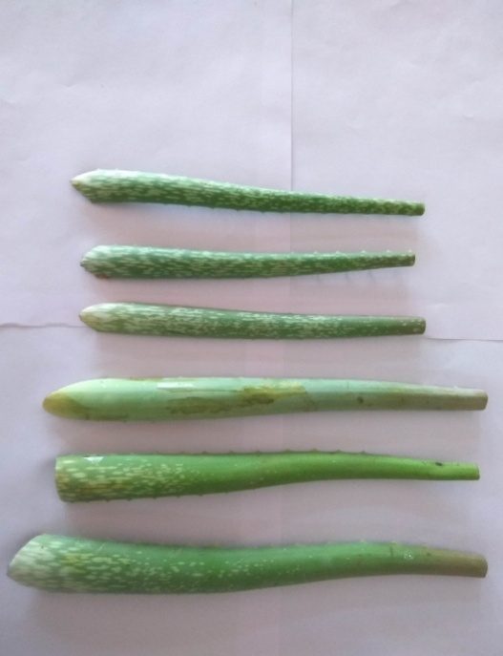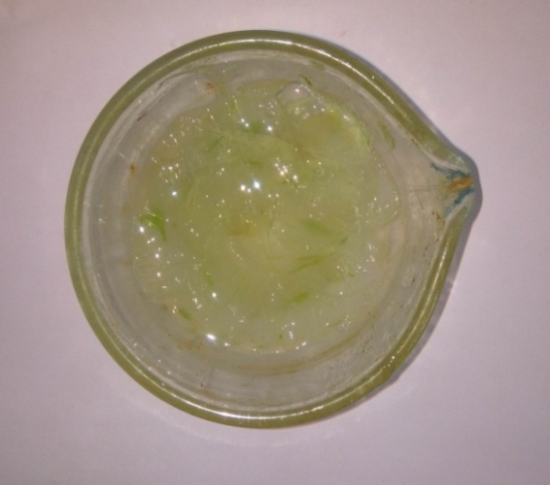
Fig. 1: Aloe vera leaves Fig. 2: Pulp of Aloe vera
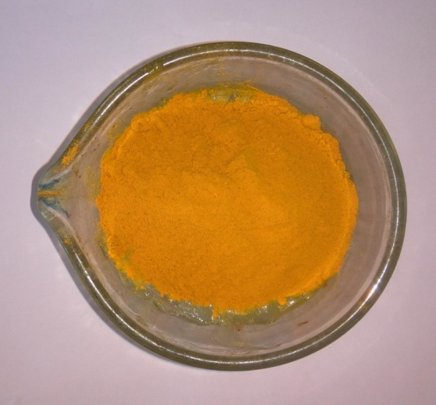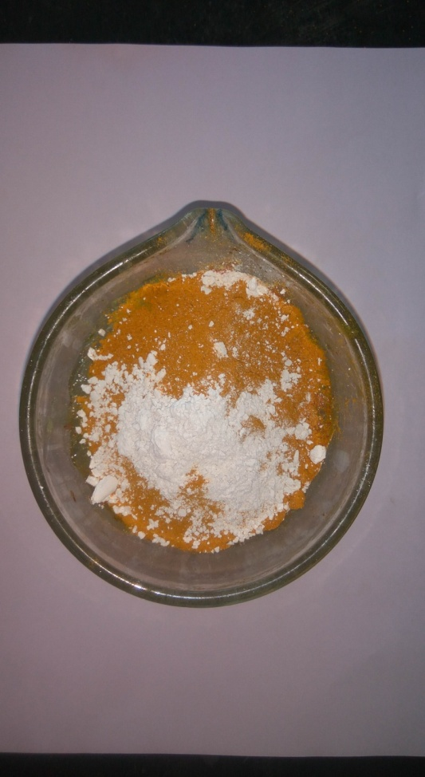
Fig. 3: Pulp of Aloe vera plus C. longa Fig. 4: Mixture of Aloe vera pulp, C. longa and lime
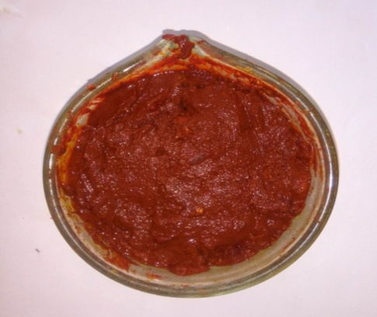
Fig. 5: Anti-mastitis paste containing Aloe vera pulp, C. longa powder and lime

Table 1: Comparative efficacy of O. sanctum and Anti-mastitis paste on reduction in SCC (x10³) in cows in different housing systems
Group | 0 Day |  |  |  |  | 7 Day |  |  |  |  | 14 Day |  |  |  |  | 28 Day |  |  |  |  | CD  (5 %)
Group | LF | LH | RF | RH | LF |  | LH | RF | RH | LF |  | LH | RF | RH | LF |  | LH | RF | RH
I | cde  225.123 ±  22.26 | ab  283.22  ±  29.22 | bcd  236.02  ±  19.01 | a  294.11 ±  25.62 | cdefg  203.34 ±  13.39 |  | bcd  236.02 ±  19.82 | cdefg  203.34 ±  16.56 | abc  254.18 ± 22.96 | fgh  170.66  ± 8.74 |  | cdef  210.61  ± 12.15 | defgh  185.18 ±  15.66 | cdef  210.60 ±  20.79 | fg  145.24 ±  7.26 |  | efgh  177.93 ±  6.69 | fg  156.13 ±  21.35 | efgh  174.29 ±  18.65 | 52.39
II | cd  228.76  ±  21.60 | a  319.53 ±  27.36 | cde  221.49 ±  13.09 | ab  308.64  ± 32.02 | defg  192.44 ±  8.74 |  | bc  261.44 ±  19.48 | defg  192.44 ±  14.24 | bc  261.44 ±  23.86 | efg  174.29 ±  7.95 |  | cde  221.49 ±  14.24 | fg  167.02 ±  10.77 | cdef  214.24 ±  15.31 | ef  156.13 ±  13.09 |  | defg  188.81 ±  15.57 | ef  152.50 ±  13.77 | efg  174.29 ±  20.28 | 51.09
III | cdef  214.24  ±  15.31 | ab  265.07  ±  19.01 | bcd  228.76 ±  21.60 | a  283.221 ±  28.12 | defg  192.44 ±  8.74 |  | bcde  221.49 ±  14.24 | cdefg  199.70 ±  15.31 | abc  243.28 ±  22.08 | efg  177.93  ±  8.74 |  | defg  196.07 ±  9.74 | efg  177.93 ±  8.74 | cdef  217.87 ±  19.48 | fg  167.02 ±  10.77 |  | fg  174.29  ±  13.77 | fg  156.13 ±  6.69 | defg  196.07 ±  21.04 | 46.01
IV | abcde  236.02  ±  22.08 | ab  272.33 ±  28.54 | abcd  246.91 ±  20.02 | a  283.22  ±  22.50 | cdef  206.97  ± 18.44 |  | abcde  239.65  ±  23.86 | abcdef  228.76  ±  18.44 | abc  254.17  ±  19.21 | ef  185.18  ±  16.63 |  | bcdef  221.49 ±  17.26 | cdef  206.98 ±  13.48 | bcdef  217.87  ±  18.65 | efg  174.29  ±  18.65 |  | ef  188.81  ±  15.57 | def  196.07  ±  16.87 | cdef  203.35  ±  26.78 | 56.83
V | 163.39  ± 14.61 | 174.29  ±  9.74 | 163.39 ±  12.25 | 177.92 ± 8.74 | 174.29 ± 11.25 |  | 170.66 ± 8.74 | 156.13  ±  6.69 | 185.18 ±  4.87 | 177.92  ±  8.74 |  | 167.02  ±  4.59 | 163.39± 7.44 | 199.70  ± 10.39 | 181.55 ±  11.63 |  | 156.13  ± 8.74 | 159.76 ±  9.18 | 185.18 ±  19.28
VI | 174.29  ±  7.95 | 196.07 ±  7.95 | 181.55 ±  12.15 | 188.82  ±  9.18 | 177.93 ±  11.82 |  | 185.19 ±  10.89 | 159.76 ±  12.15 | 192.44 ±  6.69 | 188.81 ±  10.77 |  | 192.44 ±  10.39 | 170.67 ±  8.74 | 206.97 ±  14.61 | 185.18 ±  16.63 |  | 181.56 ±  9.18 | 159.76 ±  9.18 | 210.61 ±  20.79
- Similar superscript indicates non-significant (p<0.05) variations

Table 2: Comparative efficacy of O. sanctum & Anti-mastitis paste on reduction in pH in cows in different housing systems
Group | 0 Day |  |  |  | 7 Day |  |  |  | 14 Day |  |  |  | 28 Day |  |  |  | CD  (5 %)
Group | LF | LH | RF | RH | LF | LH | RF | RH | LF | LH | RF | RH | LF | LH | RF | RH | CD  (5 %)
I | bcd  6.650  ±  0.05 | a  6.817  ±  0.05 | cde  6.667  ±  0.04 | a  6.750  ±  0.07 | de  6.600  ±  0.04 | abc  6.650  ±  0.05 | de  6.600  ±  0.04 | ab  6.750  ±  0.05 | de  6.533  ±  0.02 | bcd  6.617  ±  0.04 | e  6.550  ±  0.05 | bcd  6.617  ±  0.04 | e  6.533  ±  0.02 | de  6.567  ±  0.02 | e  6.567  ±  0.05 | de  6.567  ±  0.05 | 0.126
II | bcd  6.650  ±  0.05 | a  6.833  ±  0.05 | cde  6.633  ±  0.03 | a  6.783  ±  0.06 | de  6.550  ±  0.02 | abc  6.750  ±  0.05 | de  6.567  ±  0.05 | ab  6.767  ±  0.05 | de  6.533  ±  0.02 | bcd  6.650  ±  0.05 | e  6.517  ±  0.02 | bcd  6.650  ±  0.05 | e  6.517  ±  0.02 | de  6.567  ±  0.05 | e  6.517  ±  0.02 | de  6.567  ±  0.05 | 0.126
III | cde  6.617  ±  0.04 | ab  6.733  ±  0.04 | bcd  6.650  ±  0.05 | a  6.783  ±  0.06 | de  6.550  ±  0.02 | bcd  6.650  ±  0.05 | cde  6.600  ±  0.04 | abc  6.683  ±  0.05 | de  6.550  ±  0.02 | cde  6.583  ±  0.02 | de  6.550  ±  0.02 | bcd  6.650  ±  0.05 | de  6.550  ±  0.02 | de  6.550  ±  0.02 | e  6.517  ±  0.02 | bcd  6.633  ±  0.05 | 0.115
IV | abcd  6.683  ±  0.05 | ab  6.733  ±  0.06 | abc  6.700  ±  0.04 | a  6.767  ±  0.05 | cde  6.600  ±  0.04 | abcd  6.683  ±  0.05 | abcd  6.683  ±  0.05 | ab  6.733  ±  0.04 | cde  6.583  ±  0.05 | bcde  6.633  ±  0.04 | e  6.550  ±  0.03 | bcde  6.633  ±  0.05 | e  6.533  ±  0.03 | de  6.567  ±  0.05 | cde  6.583  ±  0.03 | bcde  6.633  ±  0.06 | 0.133
V | 6.533  ±  0.02 | 6.550  ±  0.02 | 6.533  ±  0.02 | 6.550  ±  0.02 | 6.550  ±  0.02 | 6.533  ±  0.02 | 6.517  ±  0.02 | 6.567  ±  0.02 | 6.55  ±  0.02 | 6.517  ±  0.02 | 6.517  ±  0.02 | 6.583  ±  0.02 | 6.550  ±  0.02 | 6.517  ±  0.02 | 6.517  ±  0.02 | 6.600  ±  0.04
VI | 6.533  ±  0.02 | 6.583  ±  0.02 | 6.550  ±  0.02 | 6.567  ±  0.02 | 6.567  ±  0.02 | 6.567  ±  0.02 | 6.517  ±  0.02 | 6.583  ±  0.02 | 6.550  ±  0.02 | 6.567  ±  0.02 | 6.517  ±  0.02 | 6.617  ±  0.04 | 6.567  ±  0.05 | 6.567  ±  0.02 | 6.517  ±  0.02 | 6.650  ±  0.05
- Similar superscript indicates non-significant (p<0.05) variations

Table 3: Comparative efficacy of O. sanctum & Anti-mastitis paste on reduction in EC (mS/cm) in cows in different housing systems
Group | 0 Day |  |  |  | 7 Day |  |  |  | 14 Day |  |  |  | 28 Day |  |  |  | CD  (5 %)
Group | LF | LH | RF | RH | LF | LH | RF | RH | LF | LH | RF | RH | LF | LH | RF | RH | CD  (5 %)
I | bcdef  4.848  ±  0.19 | ab  5.242  ±  0.17 | bcde  4.935  ±  0.16 | a  5.360  ±  0.18 | defgh  4.675  ±  0.14 | abcd  4.997  ±  0.16 | defgh  4.647  ±  0.16 | abc  5.130  ±  0.19 | gh  4.425  ±  0.04 | cdefg  4.793  ±  0.13 | defgh  4.592  ±  0.16 | cdefgh  4.735  ±  0.16 | h  4.325  ±  0.04 | fgh  4.467  ±  0.03 | fgh  4.428  ±  0.19 | efgh  4.525  ±  0.15 | 0.423
II | bcde  5.048  ±  0.18 | a  5.543  ±  0.17 | bcde  5.048  ±  0.19 | ab  5.442  ±  0.20 | fgh  4.587  ±  0.09 | abc  5.168  ±  0.16 | efgh  4.611  ±  0.14 | abcd  5.127  ±  0.19 | fgh  4.427  ±  0.05 | cdef  4.805  ±  0.17 | fgh  4.550  ±  0.15 | cdefg  4.777  ±  0.16 | h  4.327  ±  0.05 | fgh  4.522  ±  0.16 | gh  4.331  ±  0.05 | defgh  4.688  ±  0.24 | 0.449
III | bcde  4.805  ±  0.14 | a  5.283  ±  0.12 | bcdef  4.755  ±  0.14 | a  5.307  ±  0.19 | cdefg  4.622  ±  0.10 | bc  4.888  ±  0.15 | bcdefg  4.697  ±  0.14 | ab  5.027  ±  0.18 | efg  4.458  ±  0.03 | cdefg  4.635  ±  0.08 | defg  4.487  ±  0.05 | bcd  4.838  ±  0.17 | fg  4.423  ±  0.06 | defg  4.500  ±  0.09 | g  4.355  ±  0.035 | bcdefg  4.708  ±  0.18 | 0.357
IV | abc  4.953  ±  0.19 | ab  5.197  ±  0.22 | ab  5.028  ±  0.17 | a  5.287  ±  0.16 | abc  4.790  ±  0.22 | ab  5.147  ±  0.21 | abc  4.923  ±  0.20 | abc  4.930  ±  0.19 | c  4.453  ±  0.14 | bc  4.728  ±  0.18 | c  4.445  ±  0.16 | bc  4.678  ±  0.13 | c  4.452  ±  0.15 | c  4.463  ±  0.15 | bc  4.690  ±  0.18 | bc  4.742  ±  0.25 | 0.519
V | 4.473  ±  0.09 | 4.480  ±  0.05 | 4.430  ±  0.06 | 4.515  ±  0.06 | 4.527  ±  0.09 | 4.429  ±  0.05 | 4.368  ±  0.04 | 4.492  ±  0.01 | 4.537  ±  0.08 | 4.440  ±  0.02 | 4.423  ±  0.03 | 4.632  ±  0.09 | 4.543  ±  0.07 | 4.385  ±  0.04 | 4.398  ±  0.04 | 4.618  ±  0.16
VI | 4.458  ±  0.05 | 4.625  ±  0.09 | 4.522  ±  0.08 | 4.572  ±  0.07 | 4.467  ±  0.05 | 4.563  ±  0.08 | 4.447  ±  0.10 | 4.582  ±  0.08 | 4.600  ±  0.11 | 4.632  ±  0.10 | 4.428  ±  0.04 | 4.757  ±  0.15 | 4.560  ±  0.14 | 4.473  ±  0.04 | 4.365  ±  0.04 | 4.855  ±  0.18
- Similar superscript indicates non-significant (p<0.05) variations

Table 4: Efficacy of O. sanctum and Anti-mastitis paste therapy in conventional and loose housing systems
Group | Housing system | Prophylactic therapy | Infected Quarters Recovery |  |  |  | Efficacy (%)
Group | Housing system | Prophylactic therapy | 0 Day | 7 Day | 14 Day | 28 Day | Efficacy (%)
I | Conventional | O. sanctum leaves powder | 12 | 8 | 3 | 2 | 83.33
II | Loose | O. sanctum leaves powder | 12 | 9 | 3 | 2 | 83.83
III | Conventional | Anti-mastitis paste (Aloe vera + C. longa + Lime) | 11 | 6 | 2 | 2 | 81.81
IV | Loose | Anti-mastitis paste (Aloe vera + C. longa + Lime) | 13 | 11 | 6 | 6 | 53.84

