Study of the microbiological quality of artisanal soft drinks (Bissap, Gnamankoudji) produced in the Haut Sassandra region, Daloa department, Ivory Coast
Abstract :
The consumption of non-alcoholic artisanal beverages is increasing rapidly in African cities. This study aimed to investigate the microbiological quality of the artisanal beverages Bissap and Gnamankoudji, produced and sold in the Daloa health district. The results revealed that the pH of Gnamankoudji varies, reaching a value of 10.6. The pH of Bissap, on the other hand, reaches a value of 9.1. The loss of acidity, combined with high sugar content (17.35° Brix), creates an environment conducive to microbial growth. Microbiological analyses revealed a high level of contamination. The bissap from Zaibo showed the highest concentration of mesophilic aerobic bacteria (12,570 CFU/mL), while the Gnamankoudji from Bediala exhibited the highest concentrations of psychrophilic bacteria (8,478 CFU/mL) and yeasts/molds in Gboguhe (1,150 CFU/mL). Thermotolerant coliform and enterobacteria counts reached 539 CFU/mL and 4,278 CFU/mL, respectively, in the Gnamankoudji from Gadouan. The analysis also revealed a scattered presence of Bacillus cereus at some study sites. In contrast, Listeria monocytogenes was detected at the majority of study sites. These results confirm the urgent need for corrective measures, including training producers in good hygiene practices and strengthening quality controls to ensure consumer safety.
Keywords : Microbiological quality, Soft drinks, good hygiene practices, quality control, Daloa health district

- INTRODUCTION
The consumption of refreshing artisanal drinks such as Bissap (Hibiscus sabdariffa) and Gnamankoudji (Zingiber officinale) is experiencing considerable growth in the Haut Sassandra region of Ivory Coast (Kouame et al., 2024).This enthusiasm stems from consumers' perception of these products as nutritious, healthy, and socially appealing beverages (Aka et al., 2020). Furthermore, the accessibility and low cost of these drinks allow a large majority of the population of the Daloa district (students, civil servants, employees, the unemployed, and shopkeepers) to easily refresh themselves (Kouassi et al., 2018). However, the safety of these drinks, sold along roadsides, in markets and densely populated areas, is not always guaranteed.(Attchelouwa et al., 2017)Indeed, their production method is based on artisanal processes that require little technical expertise and equipment (Attchelouwa et al., 2017). The preparation kit, staff hygiene, and the condition of the production site are major causes of contamination of these beverages, negatively influencing their microbiological quality (Ahon et al., 2022). Studies conducted in Daloa revealed the presence of spoilage and contamination microbial flora, including thermotolerant coliforms, in samples of Bissap juice (Sangare-Tigori et al., 2006). Similarly, studies on Gnamankoudji and Bissap have revealed mycotoxin contamination (Sangare-Tigori et al., 2006).The levels of these beverages, which sometimes exceed European recommendations, pose a risk to consumer health. They constitute a veritable reservoir of pathogenic microorganisms, causing various illnesses in consumers (Ahon et al., 2022). Foodborne illnesses (FBIs) are a major cause of morbidity and mortality worldwide, and particularly in sub-Saharan Africa (WHO, 2015).The World Health Organization (WHO) estimates that nearly a third of deaths from FBIs occur in Africa, particularly affecting children under five (WHO, 2024). In the specific context of the Daloa district, surveys reported that consumers of artisanal beverages experienced illnesses characterized by diarrhea, vomiting, fever, and stomach bloating (Kouame et al., 2024).The situation in the Daloa health district illustrates the broader challenges related to the food safety of artisanal beverages in sub-Saharan Africa, particularly in the context of street food. This study therefore aims to identify the microbial flora in Bissap and Gnamankoudji sold in the Daloa health district (Haut Sassandra region).

- MATERIALS AND METHODS
  - Raw material
This experimental study focused on artisanal non-alcoholic beverages sold in the Daloa health district (Ivory Coast), namely Bissap and Gnamankoudji.
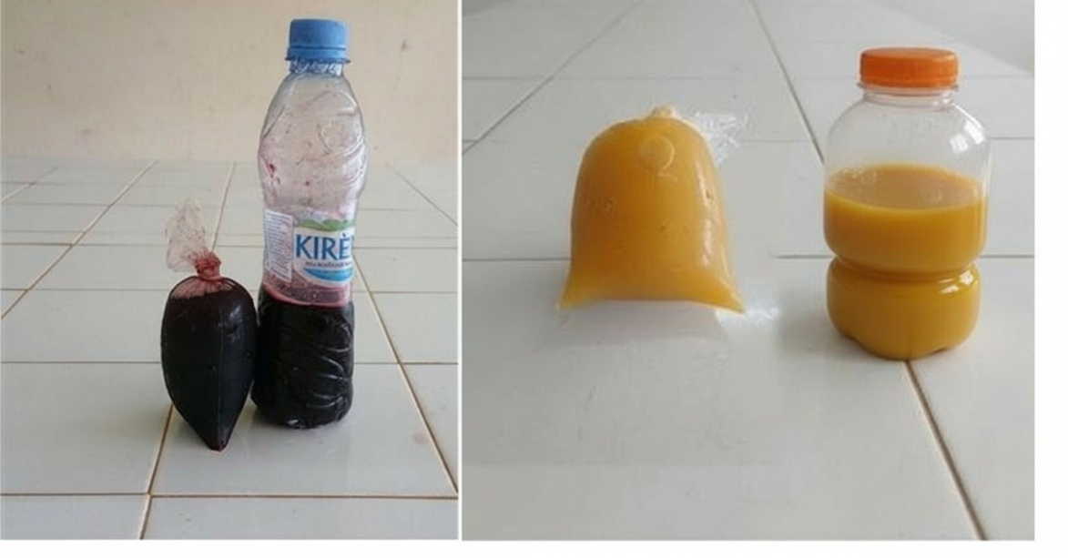
Figure 1: Samples of artisanal beverages (A:Gnamankoudji; B: Bissap)
  - Study area
The Daloa health district, in west-central Côte d'Ivoire, was selected as the study area (Fig. 2) due to reports of foodborne illnesses potentially linked to the consumption of artisanal beverages. This densely populated region has a population of 1,430,960 (INS, 2015). The region's capital is the city of Daloa, the third largest urban area in the country in terms of population, area, and density. These characteristics make it a relevant area of ​​investigation for studying the food safety of traditional beverages.
  - Sampling
The study focused on the non-alcoholic artisanal beverages Bissap and Gnamankoudji, with systematic sampling covering 26 sites across the six sub-prefectures of the Daloa department: Daloa, Zaibo, Gonaté, Bédiala, Gboguhé, and Gadouan. The sampling strategy consisted of collecting three samples of each beverage type at each site, for a total of 156 samples. Each sample was uniquely identified before being placed in coolers with ice packs, thus maintaining the cold chain during transport to the laboratory and ensuring analytical reliability.
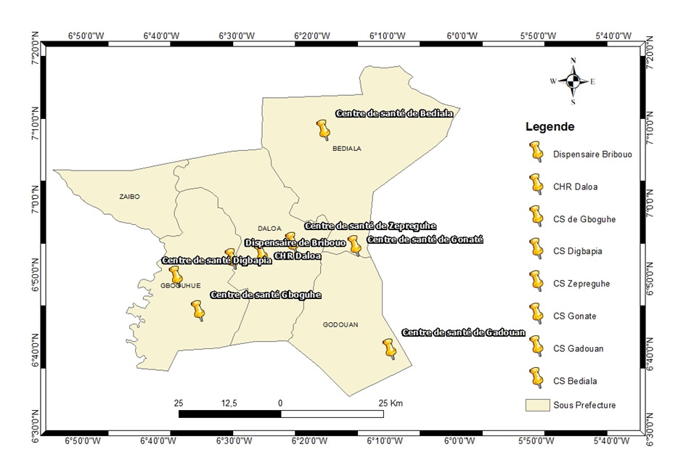
Figure 2 : Map of the study area
  - Physicochemical analyses
The physicochemical analyses concerned two parameters, namely pH and sugar content, according to standard methods.The sugar content was calculated using the following formula:
$$sugar content= M x f$$
M: value read on the refractometer
f: dilution factor
  - Microbiological analyses
    - Preparation of the stock solution and decimal dilutions
Microbiological analyses followed a standardized protocol to quantify and identify microorganisms. A stock suspension was prepared by mixing 25 mL of each sample with 225 mL of buffered peptone water. Successive decimal dilutions were then performed on this suspension.
    - Listeria monocytogenes testing
The isolation of Listeria monocytogenes followed a three-step protocol, in accordance with current standards. An initial 24-hour pre-enrichment at 30°C in 1/2 Fraser broth was performed. This was followed by a 48-hour secondary enrichment at 37°C in Fraser broth. The final isolation on Palcam agar, after 24 hours of incubation at 37°C, revealed characteristic Listeria monocytogenes colonies. These colonies exhibited a typical olive-green coloration with a distinctive black halo, facilitating their identification.
    - Bacillus cereus testing
A 0.1 mL aliquot, taken from the stock suspension and each decimal dilution, was surface-plated onto solid culture media. These Petri dishes contained 15 mL of pre-prepared, poured, and dried Mossel agar (according to ISO 7932 protocol). After inoculation, the dishes were incubated at 30°C for 24 to 48 hours.
    - Expression of the results of the count
The number N, which represents the estimated microbial population, was calculated using the following equation:
$$N=\frac{\sum{C_{i}}}{\left(N_{1 }+0,1N_{2}\right)d.V)}$$
N (CFU/mL):Number of germs per millilitre of non-alcoholic artisanal beverages;
∑Ci: Sum of colonies counted on all the retained boxes of successive dilutions;
V: Volume of inoculum applied to each box (in mL);
N1: Number of boxes retained at the first dilution considered;
N2Number of boxes retained at the second dilution considered;
d: Dilution factor corresponding to the first dilution retained.
    - Statistical analyses
The data were analyzed using one-way analysis of variance (ANOVA) to assess variability between samples. Duncan's test was then used to identify significant differences between groups. The threshold for statistical significance was set at p < 0.05 for all analyses.
- RESULTS
  - Physicochemical analyses
Physicochemical analyses revealed significant variations in pH and sugar content depending on the beverage and location. pH ranged from 5.18 (Bissap, Daloa School Health Service) to 10.6 (Gnamankoudji, Daloa Antilope Clinic). Gnamankoudji exhibited the highest pH levels, with values ​​such as 10.6 at the Antilope Clinic and 9.25 at the Daloa Regional Hospital. Bissap showed the highest sugar content, notably 17.35 at Zepreguhe (Daloa) and 16.37 at Zaibo, for Gnamankoudji. These significant variations reflect considerable heterogeneity in the beverages' composition depending on their production site.
Table 1: Physico-chemical characteristics of Bissap and Gnamankoudji drinks sold in the Daloa health district.
- Bissap
Study areas |  |  | Sites |  | pH |  | Brix degree
 |  |  | Sanitary district |  | 8.61 ± 0.22ab |  | 12.15±0.05bcdefg
 |  |  | urban dispensary |  | 8.77 ± 0.04ab |  | 10.9±0.1abcdefg
 |  |  | Maternal and Child Protection |  | 9.1±1.89ab |  | 9.61 ± 0.46 abcdef
 |  |  | Civil Prison Infirmary |  | 8.08 ± 0.08ab |  | 5.88 ± 3.21ab
 |  |  | INHP Antenna |  | 5.83 ± 3.17a |  | 9.91 ± 0.08 abcdef
 |  |  | School and University Health Service |  | 5.18±2.67a |  | 8.33 ± 1.67abcde
 |  |  | Leprosarium |  | 5.22 ± 2.65a |  | 7.73 ± 2.27abcde
 |  |  | Regional Hospital Center |  | 6.63 ± 1.63ab |  | 13±2cdefg
 |  |  | Antilope Clinic |  | 7.82 ± 0.53ab |  | 9.33±1.23abcde
Daloa |  |  | Rural Maternity Ward - Groguhe |  | 6.73 ± 0.03ab |  | 10.07±0.95abcdef
 |  |  | Rural Dispensary - Zepreguhe |  | 7.2 ± 0.7ab |  | 17.35±0.35g
 |  |  | Zokoguhe Rural Health Center |  | 8.55 ± 0.95ab |  | 6.59 ± 0.20 abc
 |  |  | rural dispensary-Tagoura |  | 6.4±00ab |  | 7.75±2.75abcde
 |  |  | rural dispensary-Tahiraguhe |  | 8.03 ± 1.26ab |  | 9.04 ± 1.055abcde
 |  |  | Rural Dispensary - Niouboua |  | 6.44 ± 0.02ab |  | 4.57±1.92a
 |  |  | Rural Dispensary-Seria |  | 7.6±0.5ab |  | 10.22 ± 1.77 abcdef
 |  |  | Medical and Social Center |  | 5.49 ± 2.96a |  | 5.94±2.61ab
Gboguhe |  |  | Rural Dispensary - Bribouo |  | 8.65 ± 0.65ab |  | 10.17±0.82abcdef
 |  |  | Digbapia Integrated Health Center Type 2  Urban health center |  | 8.03 ± 0.23ab  7.21 ± 0.66ab |  | 10.82 ± 0.97 abcdefg  11.5±2.5abcdefg
 |  |  | Urban health center |  | 7.69 ± 1.16ab |  | 7±0.29abc
Bediala |  |  | Rural dispensary |  | 7.46 ± 0.98ab |  | 10.81 ± 4.43 abcdefg
 | Zaibo | Urban health center |  | 6.20 ± 0.4ab |  | 11.22 ± 2.57 abcdefg
 | Gadouan | Urban health center |  | 8.3±0.2ab |  | 11.85±0.95bcdef
 | Gonate | Rural dispensary |  | 7.14±0.52ab |  | 10.97±5.02abcdefg
 |  | Rural Health Center |  | 6.51 ± 1.48ab |  | 11±1abcdefg

- Gnamankoudji
Study areas | Sites | pH | Brix degree
 | Sanitary district | 7.92 ± 0.07ab | 7.42 ± 0.12 abcd
 | urban dispensary | 8.54 ± 0.01ab | 10.25±0.25abcdef
 | Maternal and Child Protection | 7.99±0.01ab | 10.8±0.59abcdefg
 | Civil Prison Infirmary | 5.97±1.62a | 8.87 ± 0.12 abcde
 | INHP Antenna | 6.26 ± 2.4ab | 11±00abcdefg
 | School and University Health Service | 5.58±2.26a | 7.96±5.03abcde
 | Leprosarium | 5.84±2.43a | 6.26 ± 0.73 abc
 | Regional Hospital Center | 9.25 ± 0.75ab | 12.05±0.05bcdefg
 | Antilope Clinic | 10.6±2.4b | 10.68±0.32abcdefg
Daloa | Rural Maternity Ward - Groguhe | 7.68 ± 1.32ab | 9.92 ± 2.07 abcdef
 | Rural Dispensary - Zepreguhe | 7.39 ± 0.95ab | 8.72 ± 5.47 abcdefg
 | Zokoguhe Rural Health Center | 6.85 ± 0.39ab | 10.9±2.35abcdefg
 | rural dispensary-Tagoura | 6.71 ± 0.21ab | 11±4abcdefg
 | rural dispensary-Tahiraguhe | 6.91 ± 0.43ab | 14.02±1.47defg
 | Rural Dispensary - Niouboua | 6.57 ± 0.03ab | 6.7 ± 0.6 abc
 | Rural Dispensary-Seria | 7.25 ± 0.05ab | 14.5±0.5efg
 | Medical and Social Center | 6.18±2.52a  7.92 ± 0.07ab | 5.55 ± 3.15ab  7.42 ± 0.12 abcd
 | Urban health center | 6.18±2.52a  7.92 ± 0.07ab | 5.55 ± 3.15ab  7.42 ± 0.12 abcd
 | Urban health center | 6.94 ± 0.24ab | 10.5±0.5abcdefg
Gboguhe | Rural Dispensary - Bribouo | 6.3±0.4ab | 10±2abcdef
 | Digbapia Integrated Health Center Type 2 | 8.35 ± 0.65ab | 11.4±1.4abcdefg
Bediala | Urban health center | 6.62 ± 0.28ab | 8.26±1.73abcde
 | Rural dispensary | 6.43 ± 0.11ab | 8.1±1.3abcde
Zaibo | Urban health center | 7.87 ± 0.83ab | 16.37±1.52fg
Gadouan | Urban health center | 5.9 ± 0.9a | 11.45 ± 0.45 abcdefg
Gonate | Rural dispensary | 6.97±0.5ab | 12.12 ± 0.12 bcdefg
 | Rural Health Center | 7.31 ± 1.31ab | 13±2cdefg
pH: potential of hydrogen
In the columns, the values ​​assigned to the same letter are not significantly different from (P>0.05).

  - Microbiological analyses
Microbiological analysis revealed distinct contamination profiles between the two beverages and the six zones. Bissap showed its highest microbial load of mesophilic aerobic bacteria in Zaibo (12570 CFU/mL), while Gnamankoudji showed its highest concentrations of psychrophilic aerobic bacteria in Bediala (8478 CFU/mL) and yeasts/molds in Gboguhe (1150 CFU/mL). Fecal contamination was generally more pronounced in Gnamankoudji, with significantly higher values ​​of thermotolerant coliforms (539 CFU/mL in Gadouan) and enterobacteria (4278 CFU/mL in Gadouan). In contrast, Bissap showed more limited fecal contamination, mainly localized in Daloa. Analysis revealed a scattered presence of Bacillus cereus at some study sites, with a distinct distribution in Bissap and Gnamankoudji. In contrast, Listeria monocytogenes showed much more widespread contamination, being detected in the majority of study sites. Its presence was frequently observed in both types of beverages, although some sites showed contamination specific to Bissap or Gnamankoudji. Only a few isolated sites, notably the INHP ​​branch and the Daloa Regional Hospital Center, as well as the Seria Rural Dispensary, showed a complete absence of Listeria monocytogenes.
A Principal Component Analysis (PCA) was performed on the sample and microorganism data. Figure 3 shows the first axis, explaining 37.69% of the variation; this axis is related to enterobacteria and coliforms. The second axis, which explains 18.62%, is associated with aerobic bacteria, fecal streptococci, and yeasts. The Gnamankoudji from Daloa (677G) presents a unique profile. The classification of the samples formed two main groups: one group with high contamination by enterobacteria and coliforms, and another with low levels of these bacteria as well as streptococci (Figure 4). Some beverages have similar microbiological profiles, while others show atypical contamination; several samples played a decisive role in structuring the results (Figure 5).
Table 2 : Average loads of germs counted in non-alcoholic artisanal beverages
Study area | GAM (UFC/mL) | GAP (UFC/mL) | L/M (CFU/mL) | Cthe (UFC/mL) | CT (CFU/mL) | Entero (UFC/mL) | SF (CFU/mL) | E. coli(CFU/mL)
Bediala B | 1587±392ab | 778±426a | 282±146 ab | 0a | 0a | 416±289 | 0a | 0a
Gonate B | 807±545a | 1046±701a | 196±97ab | 0±0a | 0±0a | 443±240ab | 0±0a | 0±0a
Daloa B | 4006±2827abc | 3480±1642a | 306±98ab | 43±5ab | 7±2a | 141±100abc | 218±55abd | 0±0a
Zaibo B | 12570±43903bc | 6818±6000a | 248±112ab | 00±00 a | 00±00 a | 00±00 a | 00±00 a | 00±00 a
Gadouan B | 2800±2390ab | 1091±182a | 114±22 | 00±00 a | 00±00 a | 00±00 a | 00±00 a | 00±00 a
Gboguhe B | 2429±2208abc | 699±241a | 282±162ab | 00±00 a | 00±00 a | 00±00 a | 00±00 a | 00±00 a
Bediala G | 8329±4101abc | 8478±3205a | 482±188ab | 0±0a | 100±57a | 494±347ab | 0±0a | 0±0a
Gonate G | 3148±603ab | 3148±57a | 386± 195ab | 00±00 a | 00±00 a | 00±00 a | 00±00 a | 00±00 a
Daloa G | 5774±2528abc | 7430±4981ab | 430±207ab | 277±270a | 260±31a | 934±270a | 152±61ab | 556±83a
Zaibo G | 3050±545ab | 2228±637a | 221±15 a | 00±00 a | 00±00 a | 1863±1772 abc | 00±00 a | 00±00 a
Gadouan G | 7386±4341 abc | 7591±4091a | 164±50a | 539±179ab | 00±00 a | 4278±3813cd | 00±00 a | 00±00 a
Gboguhe G | 2762±2224abc | 2685±2043a | 1150±220abc | 93±55ab | 0±0a | 92±2a | 0±0a | 0±0a
Criteria | m = 103 M = 105 | m = 103 M = 105 | m = 103 M = 104 | m = 10 M = 102 | m = 10 M = 102 | m = 102 M = 103 | Absence | m = 1 M = 10
G: Gnamankoudji
B: Bissap
Values ​​with the same letters are not significantly different (p>0.05).
Table 3 : Presence of suspected strains of Listeria monocytogenes and Bacillus cereus in Gnamankoudji and Bissap
Study areas |  |  | Samples | Bacillus cereus |  |  | Listeria monocytogenes
 |  |  | 677 B  677 G | -  - |  |  | +  ⁺
 |  |  | 672 B  672 G | -  - |  |  | +  +
 |  |  | 674 B  674 G | -  - |  |  | -  +
 |  |  | 920 G  920 B | +  - |  |  | +  +
 |  |  | 1575 B  1575 G | -  - |  |  | -  -
 |  |  | 675 G  675 B | -  - |  |  | -  -
 |  |  | 2532 G  2532 B | -  - |  |  | +  -
 |  |  | 294 G  294 B | -  - |  |  | -  -
 |  |  | 2790 B  2790 G | +  - |  |  | +  +
Daloa |  |  | 667 B  667 G | -  - |  |  | +  -
 |  |  | 2679 B  2679 G | -  - |  |  | +  +
 |  |  | 2680 B  2680 G | -  - |  |  | +  +
 |  |  | 684 B  684 G | -  - |  |  | +  +
 |  |  | 214 B  214 G | +  - |  |  | +  +
 |  |  | 290 B  290 G | -  - |  |  | +  +
 |  |  | 2483 B  2483 G | -  - |  |  | -  -
 |  |  | 680 B  680 G | +  - |  |  | +  -
Gboguhe |  |  | 1663 G  1663 B  300g  300 B | -  -  -  + |  |  | +  -  +  +
 |  |  | 38 G  38 B | -  - |  |  | +  ⁻
 |  |  | 666 G  666 B | -  - |  |  | +  +
Bediala |  |  | 205 G  205 B | +  + |  |  | +  -
 | Zaibo | 1171 B  1171 G |  |  | +  - | +  +
 | Gadouan | 1663 G  1663 B |  |  | -  - | -  +
 | Gonate | 668 G  668 B |  |  | +  - | +  +
 |  | 542 G  542 B |  |  | -  + | +  -
G: Gnamankoudji; B: Bissap; Presence: +; Absence: -
666 (urban health center) -205 (rural dispensary): Bediala; 542 (rural dispensary) -668 (rural health center): Gonate; 677 (Health District) - 672 (Urban Dispensary) - 674 (Maternal and Child Protection) - 920 (Civil Prison Infirmary) - 1575 (INHP Branch) - 675 (School and University Health Service) - 2532 (Leprosarium) - 294 (Regional Hospital Center) - 2790 (Antilope Clinic) - 667 (Rural Maternity Hospital - Groguhe) - 2679 (Rural Dispensary - Zepreguhe) - 2680 (Rural Health Center - Zokoguhe) - 684 (Rural Dispensary - Tagoura) - 214 (Rural Dispensary - Tahiraguhe) - 290 (Rural Dispensary - Niouboua) - 2483 (Rural Dispensary - Seria) - 680 (Medical and Social Center): Daloa; 1171 (Urban Health Center): Zaibo; 682 (Urban Health Center): Gadouan; 1663 (urban health center-Gboguhe) -38 (rural dispensary-Bribouo) -300 (integrated health center type 2 Digbapia): Gboguhe
The same letters in the same column show that there is no significant difference between the means. However, there is a significant difference when the letters are different.

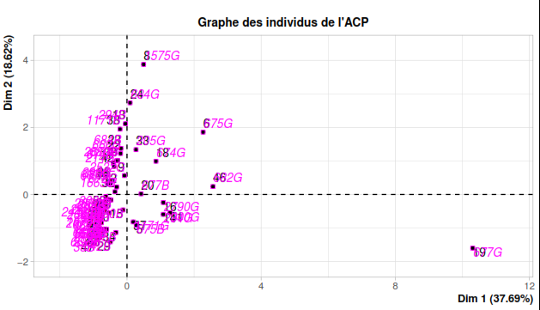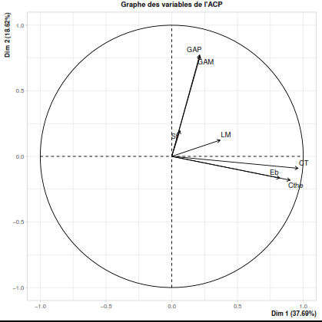
Figure 3 : PCA of the different beverages studied and the microorganisms sought
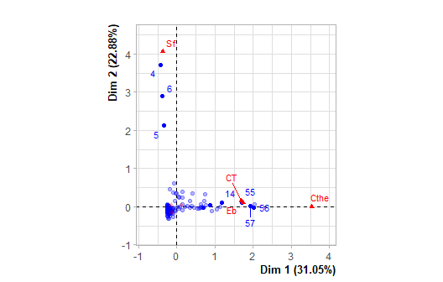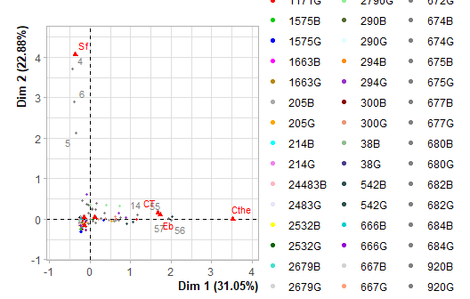
Figure 4 : Grouping of non-alcoholic artisanal beverages by hierarchical classification and correspondence factor analysis based on microbiological quality
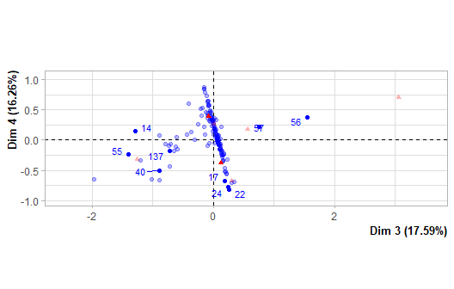
Figure 5 : Correspondence factor analysis (CFA) applied to microbiological data of artisanal non-alcoholic beverages
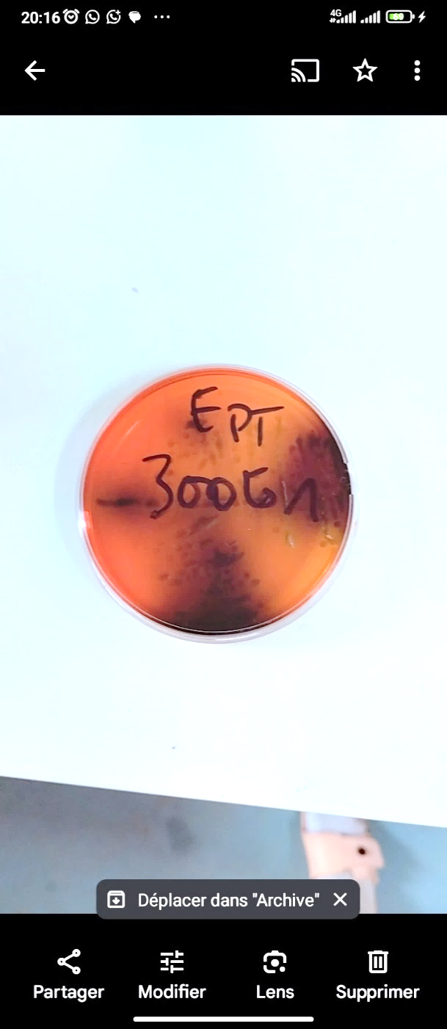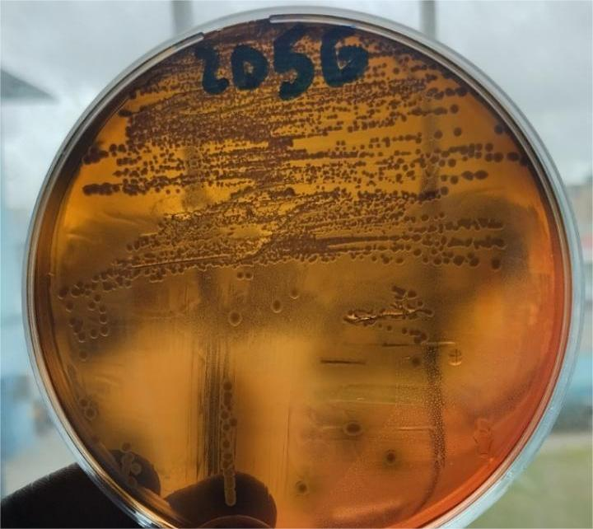
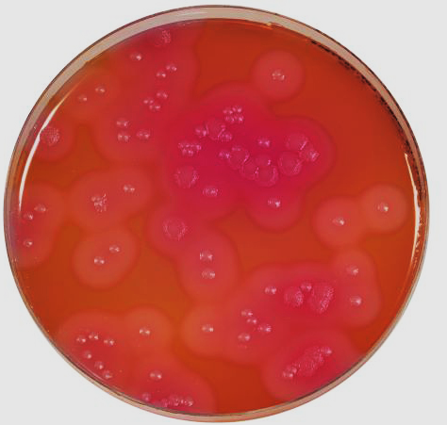
b

b
Fig 6 Appearance of suspected pathogenic germs (a : Listeria monocytogenes ; b : Bacillus cereus)
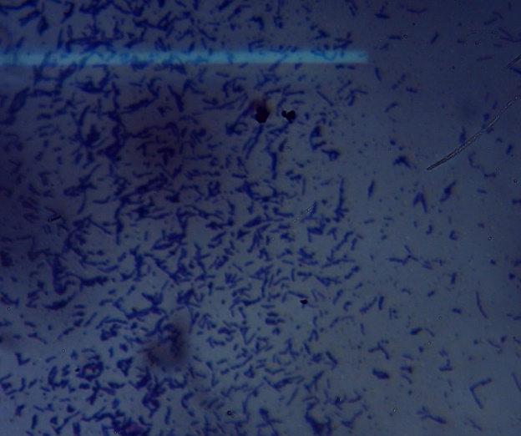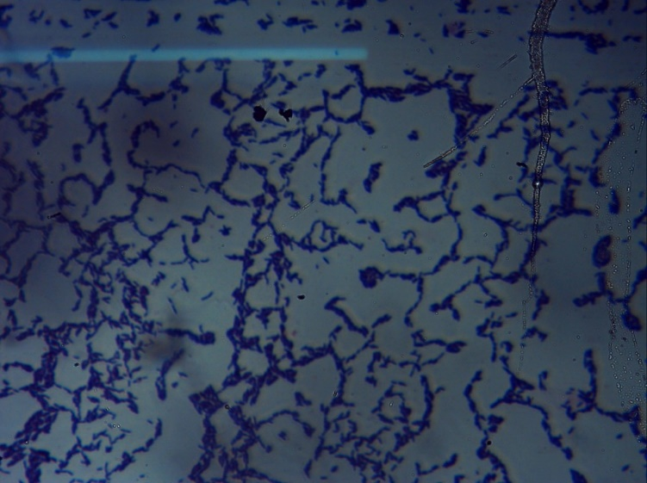
Fig 7 Morphological characterization by Gram staining of potentially pathogenic bacteria
4. Discussion
This study, conducted in the Daloa health district, aimed to investigate the microbiological quality of two non-alcoholic artisanal beverages, Bissap and Gnamankoudji. While their growing consumption in the Haut-Sassandra region is driven by deep-rooted socio-cultural habits, the results confirmed significant health concerns. The physicochemical results reveal high variability between sites. The pHj of Bissap ranges from 5.18±2.67 to 9.1±1.89, while for Gnamankoudji it varies from 5.58±2.26 to 10.6±2.4, covering an exceptional range from acidic to basic, far from the expected naturally acidic profile (Da-Costa-Rocha et al., 2014) : typically 2.47 for Bissap and 3.71 for Gnamankoudji in Abidjan (Ahon et al., 2022), 2.252-2.79 in Burkina Faso (Compaore et al., 2021), or 2.96-3.08 (Micheline et al., 2011) ; for processed ginger, 4.4-4.8 (Bayoï, 2024). These deviations are explained by incomplete fermentations favoring alkalinizing bacteria like Bacillus, the use of well water rich in alkaline salts for dilution, or additives (colorants for Bissap), neutralizing natural organic acids (citric, malic, ascorbic) and eroding the protective barrier against pathogens (Ndiaye et al., 2015 ; Ehouman et al., 2020). A pH > 4.5, critical in the food industry (Program, 2024), allows increased microbial growth, particularly in combination with high sugars of 4.57± 1.92° Brix (minimum Bissap Niouboua) to 17.35± 0.35° Brix ( maximum Bissap Zepreguhe) or 16.35± 1.52° Brix (Gnamankoudji Zaibo), comparable to sodas (WHO, 2015) and providing an abundant substrate (695 mg/mL Bissap, 812 mg/mL Gnamankoudji) (Ahon et al., 2022). Conversely, an acidic pH (3.5-4.5) proves protective against most enterobacterial and spore-forming pathogens, as demonstrated by (Cissé et al., 2009) for Ivorian Bissap (optimal pH 2.5-3.5 inhibiting coliforms), and confirmed by studies on hibiscus juices in West Africa where organic acidity limits bacterial loads to less than 10³ CFU/mL. The microbiological analysis clearly distinguishes between the two artisanal beverages. Bissap shows its maximum aerobic load at Zaibo (12 570 CFU/mL), while Gnamankoudji reveals specific contamination peaks : psychrophiles at Bediala (8 478 CFU/mL) and yeats at Gboguhe (1150 CFU/mL). Fecal contamination, marked by entobacteria (4278 CFU/mL at Gadouan), is overwhelmingly dominant in Gnamankoudji, reflecting poor hygiene during preparation or storage. These microbial loads align with regional data (Anin et al., 2016) report similar levels in street food in Abidjan, (Youbouet, 2016) in Ivorian attieke, and Millogo et al., (2018) in Burkinabè artisanal yogurts, where enterobacteria consistently signal water or manual contamination. More alarmingly, the near-systematic presence of Listeria monocytogenes exceeds usual West African prevalence rates, surpassing the 20.13 % found in raw milk (Oluwafemi et al., 2023) or the 8 % in dairy products (Youbouet, 2016). This omnipresence suggests chronic environmental contamination, linked to Listeria biofilms on reused plastic containers : the observed alkalinity (pH up to 10.6) and residual sugars (17.35° Brix) create protective niches, promoting spore persistence and resistance to superficial rinsing, amplified by the absence of a cold chain in a humid tropical climate. The Principal Component Analysis (PCA), explaining 56.31 % of the variance, finely structures thes risks : axis F1 (37.69 %), driven by enterobacteria and coliforms, marks hygiene and replicates the gradients observed by (Kouassi et al., 2018) and (Cissé et al., 2009) ; axis F2 (18.62 %) captures fermentation/storage flora (psychrophiles, yeats), aligning with (Humblot et al., 2012) for fermented cereal products. Daloa and Gadouan emerge as critical hotspots, where failing hygiene and biofilms coincide, increasing the risk for vulnerable populations (children, immunocompromised individuals). Given this confirmed risk, targeted measures are imperative : systematic acidification to pH< 4.5 using lemon juice to inhibit Listeria and enterobacteria ; replacement of plastic containers with appropriate hygienic equipment (reducing biofilms by 90 %) ; and deployment of a localized HACCP plan, prioritizing Daloa/Gadouan based on the PCA, with vendor training and weekly monitoring. Prospective studies integrating antibiotic resistance profiles and could quantify the true incidence, thereby protecting an essential cultural consumption practice.
5. Conclusion
In many developing countries, artisanal beverages such as Bissap and Gnamankoudji play a vital role, both nutritionally and economically. However, their widespread consumption raises significant concerns regarding their safety. This study aimed to investigate the microbiological quality of non-alcoholic artisanal beverages, Bissap and Gnamankoudji, in the Daloa health district. The results revealed that Bissap and, especially, Gnamankoudji sold in the Daloa health district pose high health risks to consumers. The quality is highly heterogeneous, with high pH and sugar levels, creating an ideal environment for microbial growth. Analyses revealed widespread and concerning contamination; high loads of Enterobacteriaceae, mesophilic aerobic bacteria, and psychrophilic bacteria frequently exceeded standards. Major pathogens, including Listeria monocytogenes and Bacillus cereus, were detected in the beverages. The risk is not uniform, however; certain highly contaminated points of sale have been identified, particularly in Daloa, allowing for targeted interventions. It is therefore urgent to implement strict corrective measures and radically improve the hygiene of water and containers. With appropriate technical guidance based on this evidence, it is possible to drastically reduce these risks and preserve the socio-economic value of these artisanal beverages.

Disclaimer (Artificial intelligence)
Author(s) hereby declare that NO generative AI technologies such as Large Language Models (ChatGPT, COPILOT, etc.) and text-to-image generators have been used during the writing or editing of this manuscript.

REFERENCES
- Ahon G.M., Bolou G.E.-K., Fofana M. & Amoikon K.E. (2022). Physicochemical and Microbiological Properties of Bissap (&lt;i&gt;Hibiscus sabdariffa&lt;/i&gt;) and Ginger (&lt;i&gt;Zingiber officinale&lt;/i&gt; (L) Rose) Juices Sold in the Western Part of Abidjan (C&#244;te d’Ivoire). Open Journal of Applied Sciences, 12(06): 964–976.
- Aka S., Dridi B., Bolotin A., Yapo E.A., Koussemon-Camara M., Bonfoh B. & Renault P. (2020). Characterization of lactic acid bacteria isolated from a traditional Ivoirian beer process to develop starter cultures for safe sorghum-based beverages. International Journal of Food Microbiology, 3(22): 108-547.
- Anin L.A., Assoi Yapi P.D.Y., Monnet Y.T., Yiwo Yapi M.-A., Soro C.L. & Kouadio K.A.K. (2016). Evaluation Microbiologique Et Origines De La Contamination Des Produits De 4ème Gamme Vendus Sur Les Marchés D’abidjan, Cote D’ivoire. European Scientific Journal, ESJ, 12(36): 273.
- Attchelouwa C., Aka-Gbézo S., N’guessan F., Kouakou C. & Djè M. (2017). Biochemical and Microbiological Changes during the Ivorian Sorghum Beer Deterioration at Different Storage Temperatures. Beverages, 3(3): 43.
- Bayoï J. (2024). Unveiling the traditional preparation, biochemical, phytochemical components, antioxidant and microbial properties of “jenja”, a ready-to-serve ginger-based beverage vended and consumed in northern Cameroon. Applied Food Research, 4(2): 100–495.
- Cissé M., Dornier M., Sakho M., Augustin N., Reynes M.R. & Oumar C. (2009). (PDF) Le bissap (Hibiscus sabdariffa L.) : composition et principales utilisations. ResearchGate, 64: 179–193.
- Compaore M.K.A., Kpoda D.S., Bazie B.S.R., Ouedraogo M., Yakoro A., Nikiema F., Belemlougri A., Meda R., Bande M., Barro N. & Kabre E. (2021). Microbiological quality assessment of five common foods sold at different points of sale in Burkina-Faso. Journal of Food Quality and Hazards Control, 8(3): 108-115.
- Da-Costa-Rocha I., Bonnlaender B., Sievers H., Pischel I. & Heinrich M. (2014). Hibiscus sabdariffa L. - a phytochemical and pharmacological review. Food Chemistry, 165: 424–443.
- Ehouman S.A.G., Benjamin Y.N., Edith K.-K.N., Sory T.K. & Kablan T. (2020). Evaluation of The Patulin Content of Certain Non-Alcoholic Beverages (Gnamankoudji, Bissap And Tomi) Sold on The Streets of Daloa (Côte d’Ivoire). European Journal of Agriculture and Food Sciences, 2(4): 1-5
- Humblot C., Perez-Pulido R., Akaki D., Loiseau G. & Guyot J.-P. (2012). Prevalence and Fate of Bacillus cereus in African Traditional Cereal-Based Foods Used as Infant Foods. Journal of Food Protection, 75(9): 1642–1645.
- INS (2015). Répertoire des localités Région du Haut Sassandra (INS, 2015). Institut National de la Statisque, Abidjan (Côte d'Ivoire), 72p.
- Kouame C.A.B.M.-A., Clement K.K., Athanase K.K. & Ibrahim K. (2024). Assessment of Production and Risks of Consumption of Artisanal Refreshing Drinks (Bissap, Gnamankoudji) in Haut Sassandra (Daloa-Côte d’Ivoire). International Journal of TROPICAL DISEASE & Health, 45(6): 139–153.
- Kouassi K.C., Voko Bi D.-R.R., Koffi A.C. & KOUAME K.B.E.-B. (2018a). Microbial contamination of the non-alcoholic beverage Gnamakoudji made from Zingiber officinale in Daloa. Cote d'Ivoire. African Journal of Microbiology Research, 12(35): 857–865
- Kouassi K.C., Voko D.-R.R.B., Koffi A.C., Kouame K.B.E.-B. & Koffi-Nevry R. (2018b). Microbial contamination of the non-alcoholic beverage Gnamakoudji made from Zingiber officinale in Daloa, Cte dIvoire. African Journal of Microbiology Research, 12(35): 857–865.
- Micheline A.T., Bada F., Ahanhanzo C., Adisso S.A., Fatiou T. & Souza C. (2011). Effets des huiles essentielles sur les qualites hygieniques et organoleptiques de la boisson ‘Bissap’. Rev. Microbiol. Ind. San et Environn., 5(1): 1–23.
- Nandkangre H., Ouedraogo M. & Sawadogo M. (2015). Caractérisation du système de production du gingembre (Zingiber officinale Rosc.) au Burkina Faso : Potentialités, contraintes et perspectives. International Journal of Biological and Chemical Sciences, 9(2): 861.
- Ndiaye N. Dieng, M., Kane, A. Cisse, M., Montet, D. & Touré, N. (2015). Diagnostic et caractérisation microbiologique des procédés artisanaux de fabrication de boissons et de concentrés d’Hibiscus sabdariffa L. au Ssénégal. Afrique Science. 11(3): 197–210.
- Oluwafemi Y.D., Igere B.E., Ekundayo T.C. & Ijabadeniyi O.A. (2023). Prevalence of Listeria monocytogenes in milk in Africa: a generalized logistic mixed-effects and meta-regression modelling. Scientific Reports, 13: 12-46.
- OMS (2015). WHO estimates of the global burden of foodborne diseases: foodborne diseases burden epidemiology reference group 2007-2015.
- OMS (2024). Food safety. Organisation mondiale de la Santé, Genève (Suisse), 6p
- Program H.F. (2024). Quantitative Assessment of Relative Risk to Public Health from Foodborne Listeria monocytogenes Among Selected Categories of Ready-to-Eat Foods. Food and Drug Administration, 100 p.
- Sangare-Tigori B., Dem A.A., Kouadio H.J., Betbeder A.-M., Dano D.S., Moukha S. & Creppy E.E. (2006). Preliminary survey of ochratoxin A in millet, maize, rice and peanuts in Côte d’Ivoire from 1998 to 2002. Human & Experimental Toxicology, 25(4): 211–216.
- Youbouet B.A. (2016). Contamination du lait cru et de l’attiéké vendus sur les marchés informels à Abidjan (Côte d’Ivoire) par le groupe Bacillus cereus et analyse des risques. Thèse de Doctorat en Qualité et Sécurité Alimentaire des Aliments, Faculté Sciences et Technologies des Aliments, Université Nangui Abrogoua, Abidjan (Côte d'Ivoire), 17(3): 358.

