Monitoring Mangrove Ecosystem Change over Two Decades: A Remote Sensing and Participatory Perspective (2002–2024)

ABSTRACT

Mangrove ecosystems are strategic areas that provide a significant number of ecosystem services to communities. However, they are becoming increasingly fragile due to natural and anthropogenic phenomena. It is therefore important to characterize mangrove ecosystems in order to implement strategies for the protection and conservation of biodiversity. The objective of this study was to contribute to a better understanding of the land use/cover dynamic and factors of change in the mangrove ecosystem of the Saloum Delta. To do this, a methodological approach combining remote sensing and surveys was used. Survey, processing and analysis of Landsat 7 and Landsat 8 satellite images were used to document the state, dynamics, and factors of change in the mangrove. The results showed a different pattern of land use/cover change between 2002 and 2024. Mangrove and urban area increased while other vegetation, tan and mudflat area decreased. Mangrove area increased by 8.81% in GMPA and 1.5% in SMPA between 2002 and 2024. The higher increase of urban area was recorded in Gandoule (23.58%) compared to Sangomar (2.07%). Other vegetation declined by 11.87% in Gandoule and 5.38% in Sangomar. Tan (-2.68%) and mudflat (-19.86%) in Gandoule lost surface area. Surveys revealed that the factors contributing to mangrove degradation were anthropogenic or natural. The primary cause of mangrove degradation is the exploitation of mangrove resources (90.1%), followed by coastal erosion (38.9%), decreased rainfall (3.8%), and salinization (3.8%). Reforestation (29.1%), prohibition of mangrove logging (22.5%), awareness-raising and monitoring with the involvement of local communities (17.9%), and prohibition of certain fishing nets (15.9%) are the main conservation policies recommended by management services and local communities. Despite these threats, mangrove ecosystems have been able to maintain an increase of mangrove.

Keywords: Ecosystems, mangrove, land use/cover, dynamic, change, factors, degradation

1. INTRODUCTION

Mangrove ecosystems provide numerous ecosystem services that are essential to the livelihoods of millions of people, made possible by their high-quality diversity (Aubry, 2021). Mangrove is vital both for wildlife and local communities that depend directly on their natural goods and services (Francoeur, 2009). For local communities, mangrove ecosystems are a source of livelihood, particularly through small-scale fishing and aquaculture (Jelibseda et al., 2025).
Unfortunately, mangrove ecosystems are undergoing continuous degradation from various anthropogenic and natural sources (Francoeur, 2009). These include deforestation, land use change, direct exploitation of resources (particularly fish), pollution, and population growth (Matoko et al., 2025). Land conversion for aquaculture and agriculture, industrial pollution, timber extraction, climate change, and sea level rise are also factors contributing to the degradation of mangrove ecosystems (Jelibseda et al., 2025). Anthropogenic pressures are the main cause of these changes, which lead to degradation and consequently hurt the ecosystem services provided by mangrove and its productivity (Ranaivojaona & Ranarijaona, 2021). The exploitation and development of the coastal fringe by a multitude of ethnic groups has reached a level of perfection that demonstrates remarkable mastery of a difficult environment (Salomon, 1987). Declining health indicators reflect the state or dynamics of mangrove ecosystems and can serve as a proxy for their degradation (Wei et al., 2025). These various factors constantly lead to changes in the structure of mangrove ecosystems, sometimes leaving marks that make the restoration of these ecosystems particularly problematic (Proisy and Mougin, 1998; Fousseni et al., 2017). In Senegal, beyond the constraints linked to human presence and activity, coastal area is also subject to natural phenomena (Dièye et al., 2013). In Saloum Delta, declining rainfall and fishing and harvesting activities are suffering the consequences of the scarcity of resources (Fall, 2009).
In response to these threats to mangrove ecosystems, a multitude of mangrove reforestation projects are being carried out around the world, mainly by civil society organizations working with local communities (Bocquet, 2018). Environmental protection solutions have been implemented with the support of biodiversity protection and conservation projects in Saloum Delta Biosphere Reserve, “mangrove reforestation, tree planting, restoration of devastated natural habitats, adoption of less predatory production techniques, and environmental education in villages bordering Saloum Delta National Park (PNDS) and villages on the outskirts of the reserve”. Training has also been provided on the need to avoid cutting the roots of mangrove trees when harvesting and, above all, on the reforestation or cultivation of degraded areas (Fall, 2009).
Weighing the importance of factors influencing the spatial dynamics of mangroves has been a scientific challenge (Lombard, 2023). However, these changes have a significant impact on the sustainability of mangrove resource exploitation. The objective of this study was to analyze the spatio-temporal changes in mangrove ecosystems of the Saloum Delta. Specifically, it aimed to characterize land use/cover and document dynamic factors contributing to mangrove ecosystem degradation.
2. material and methods

  - Presentation of the study area
The region studied (Saloum Delta) is located west of a line between Foundiougne and Missirah, between latitudes 13° 5 and 14°. It is bordered to the north by the Saloum River and to the south by the Gambian border (Figure 1) (Marius 1973). Located in central-western Senegal in the natural region of Sine Saloum, and covers approximately 500,000 ha (Dia, 2003). The study area is bounded to the north by the Saloum River and to the south by the Gambian border (Figure 1). Saloum Delta is a reverse estuary now classified as a wetland of international importance (Guissé et al., 2007). The soils of the Saloum Estuary, known as tans, cover a relatively large area (Marius, 1973). The vegetation covers an area of approximately 80,000 ha (Guissé et al., 2007). A dry season characterized by the Harmattan and maritime trade winds (8 to 9 months) and a wet season or winter characterized by the monsoon (3 to 4 months). The area experiences fairly wide temperature variations ranging from 15°C to 35°C, depending on the season. Low temperatures can even reach 15°C, while in the region, there are variations of 25°C to 40°C for the same period (MPA_Gandoule 2023). Meanwhile, the Sangomar area has average monthly temperatures above 32°C during the rainy season and an average temperature of 27°C during the dry season (MPA_Sangomar 2014). Rainfall recorded in the Gandoule MPA over the last five (5) years (2019-2023) shows low precipitation, averaging 686 mm. For the Sangomar area, rainfall is much higher, averaging 722 mm (MPA_Gandoule 2023, MPA_Sangomar 2014). The Saloum Delta Biosphere Reserve (SDBR) has at least 188 species, representing 9% of Senegal's woody and herbaceous plant species, grouped into 50 families, including 30% of Senegal's higher plant families (DIA, 2005). Six woody mangrove species, which are Rhizophora mangle, Rhizophora racemosa, Rhizophora harrisonii, Laguncularia racemosa, Avicennia germinans, and Conocarpus erectus, were recorded (Ndour et al., 2012).
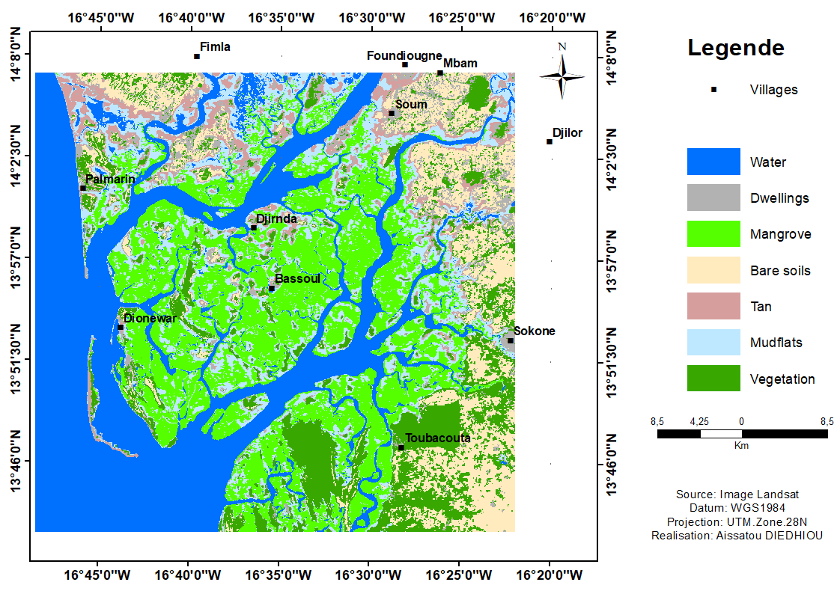

Fig. 1. Location of the study area

  - Data collection
2.2.1 Acquisition and processing of satellite images
Landsat7 and Landsat8 satellite images were used for this study (Table 1). These data were acquired during the dry season when cloud cover is reduced to a minimum due to variations in the phenological phase of vegetation (Clerici et al., 2007; Sambou et al., 2016).
Table 1. Acquisition of Landsat satellite images
Satellites | Sensors | Dates | Resolution
Landsat7 | +ETM | 18/04/2002 | 30m
Landsat8 | OLI-TIRS | 24/04/2013. | 30m
Landsat8 | OLI-TIRS | 10/02/2024 | 30m

ENVI version 5.6 and ArcGIS version 10.8 software were used for image processing. Color composition, supervised classification, and classification validation are the three steps performed for image processing. A segmentation-based method was used to represent mangroves. For color composition, bands 5-4-3 for 2002 and 6-5-4 for 2013 and 2024 were used. These were chosen because they provide good discrimination between different types of land cover and natural colors. Supervised classification consisted of constructing a classifier and transforming the images into a thematic map (Mephu Nguifo & Njiwoua, 2005; Dibi Nda et al., 2019). The maximum likelihood algorithm method was adopted due to knowledge of the study area. The maximum likelihood classification of Landsat8 images from 2024 was first performed, followed by Landsat8 images from 2013 and Landsat7 images from 2002 based on color composite images. The classification made it possible to distinguish the different spectral signatures that characterize the study area. Seven land cover units or classes were identified: mangrove, other vegetation, dwelling, bare soil, tan, mudflat, and water surface. A post-classification comparison was used to analyze the states and changes of the different land cover units. Image classification and change detection provided general statistics on the states, changes, spatial structure, and dynamics of the different land cover units. RStudio was used to represent the state and evolution of the land cover classes. To understand the evolution of each land use unit over time and space, the ensemble method of Poulon (2015) was used. Let U1 be the set of pixels on date 1, U2 the set of pixels on date 2, and ΔU the variation of a pixel of any land use unit between dates U1 and U2. ΔU = 0 reflects a stable state (no change); ΔU < 0 indicates regression (decrease, loss, etc.) and ΔU > 0 reflects progression (increase, gain, etc.). The accuracy of the image classification was evaluated and reported using overall accuracy and kappa statistic or coefficient (Appendix). This information on land use/cover was then used to validate the classification and to deduce the spatio-temporal dynamic of land cover units in the study area (Top et al., 2024). The overall accuracy of the image classification was 97.80%, 96.65%, and 93.44% for 2002, 2013, and 2024, respectively, with a kappa coefficient between 0.93 and 0.98 (Appendix).

2.2.2 Surveys
Perception surveys were conducted using a questionnaire to identify the factors driving land use dynamics. An interview guide was developed for the population of villages bordering the Gandoule and Sangomar MPAs. A total of nine villages from Palmarin and Niodior in the department of Foundiougne were sampled for the surveys. These were Ndonrogu Longu, Soum, Baout, Djirnda, Diamniadio, Palmarin, Dionewar, Niodior, and Falia. Regarding sampling, Fisher's method was used to determine the number of people to be surveyed. The formula used is as follows:
Nf= n/1+ (n/N) with n=1/d^2 and a margin of error of 10%.
Applying this formula, 178 people, over 2192 fishermen, were selected for the interviews. The survey was conducted using a questionnaire to document people's perception on state, dynamics over 20 years, causes of degradation, and protection strategies of mangrove ecosystems.
The survey data were collected and analyzed using Sphinx Plus version 5 and Excel, then transferred to RStudio for graphical representation.

3. results

  - Land use status
A spatiotemporal variation of land use/cover was noticed between 2002 and 2024 (Figure 2). Statistics revealed variations in area between the different land use units in Gandoule Marine Protected Area (GMPA). In 2002, mangrove occupied the largest area (29.10%), followed by water (25.37%), mudflats (20.62%), other vegetation (14.95%), tans (8.56%), and bare soil (1.4%). In 2013, land use/cover was dominated by mangroves (32.94%), water (31.33%), mudflats (20.81%) and dwellings (9.56%). However, more recently in 2024, mangrove (37.91%), water (27.93%) and dwelling (23.59%) occupied the largest areas in Gandoule. While tans (5.88%), other vegetation (3.09%), bare soil (0.83%), and mudflats (0.77%) occupied smaller areas.
In Sangomar Marine Protected Area (SMPA), more than half of the total area was covered by water. In 2002, 76.88% of the total area was covered by water, followed by mangrove (10.43%), other vegetation (9.30%), and mudflats (1.57%). Bare soil (1.35%) and tans (0.46%) were represented small area. Changes in land use were observed in 2013, with water occupying the largest area (78.33%), followed by mangroves (12.27%), dwellings (2.91%) and other vegetation (2.78%). The area occupied by water (77.14%), mangrove (11.93%), and other vegetation (3.92%) remained larger in 2024. The area occupied by mudflats (3.36%), dwellings (2.07%), bare soil (0.86%) and tanning areas (0.72%) was small.

a
b

Fig. 2 . Land use/cover status from 2002 to 2024 in Gandoule MPA (a) and Sangomar MPA (b)

  - Changes in land use/cover classes
Changes in land use/cover have occurred over time and spatially (Figures 3 and 4). In Gandoule MPA, land use/cover between 2002 and 2013 was marked by a gradual increase in mangrove (3.84%), dwellings (9.56%), bare soil (0.35%), water (5.96%) and mudflats (0.19%). In contrast, other vegetation (-12.29%) and tans (-7.61%) saw a decrease in area. Between 2013 and 2024, mangrove area (4.98%), other vegetation (0.43%), tans (4.93%) and dwellings (14.03%) increased. Meanwhile, mudflats (-20.05%) and bare soil (-0.92%) saw a decrease in area. Between 2002 and 2024, the dynamic showed a decrease in area for most classes. Mudflats (-19.86%), other vegetation (-11.87%), tans (-2.68%) and bare soil (-0.57%) recorded losses in area. In fact, the area occupied by buildings (23.58%) and mangrove (8.81%) increased.
In Sangomar MPA, changes in land use/cover have resulted in an overall increase in mangrove and dwellings and a loss of vegetation and bare soil. Mangrove (1.83%), dwellings (2.91%), tans (0.22%), and bare soil (0.16%) increased between 2002 and 2013. Vegetation (-6.52%) and mudflats (-0.07%) lost area between 2002 and 2013. Land use/cover between 2013 and 2024 was characterized by a decline of mangrove (-0.33%) and dwellings (-0.84%) area. The change in land use/cover between 2013 and 2024 indicated an increase of mudflats (1.86%), other vegetation (1.13%), tans (0.03%), and bare soil (0.66%). The observed dynamics of land cover/use between 2002 and 2024 showed an increase in mangroves (1.5%), dwellings (2.07%), mudflats (0.18%) and tans (0.26%). On the other hand, other vegetation (-5.38%) and bare soil (-0.49%) have lost area.
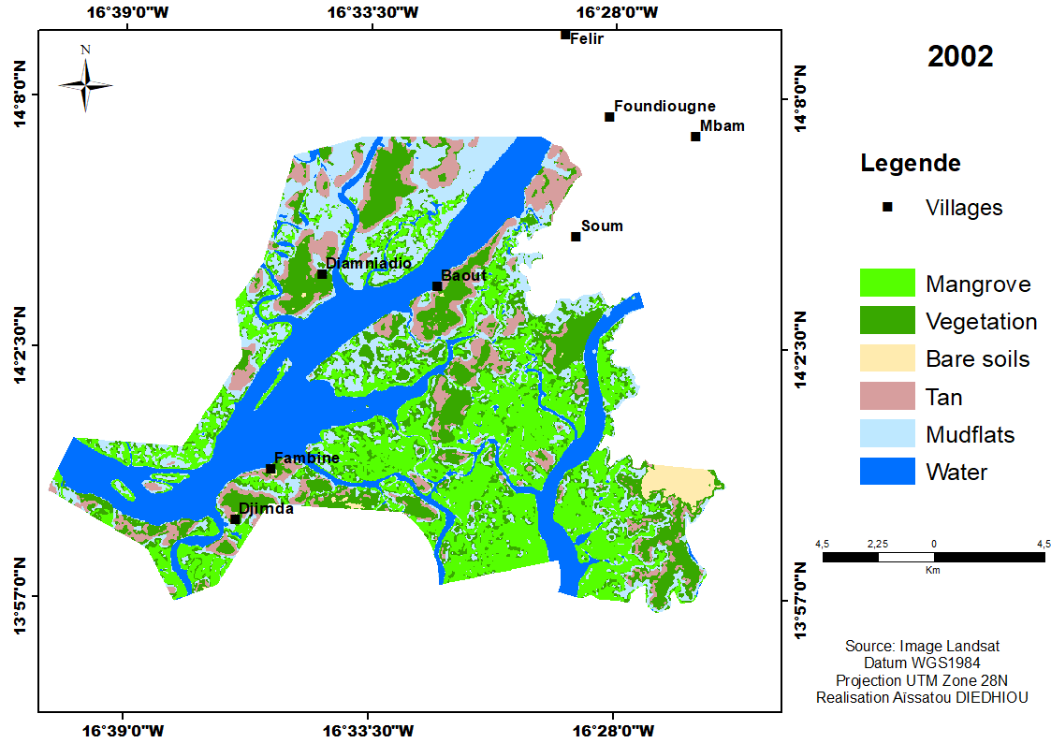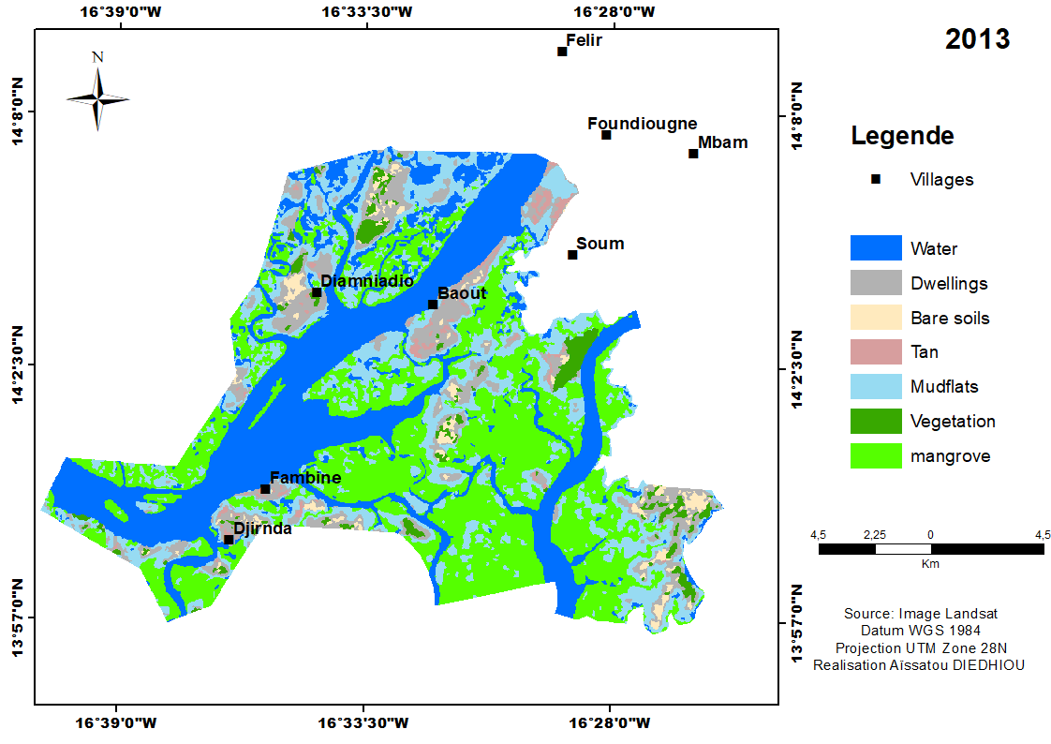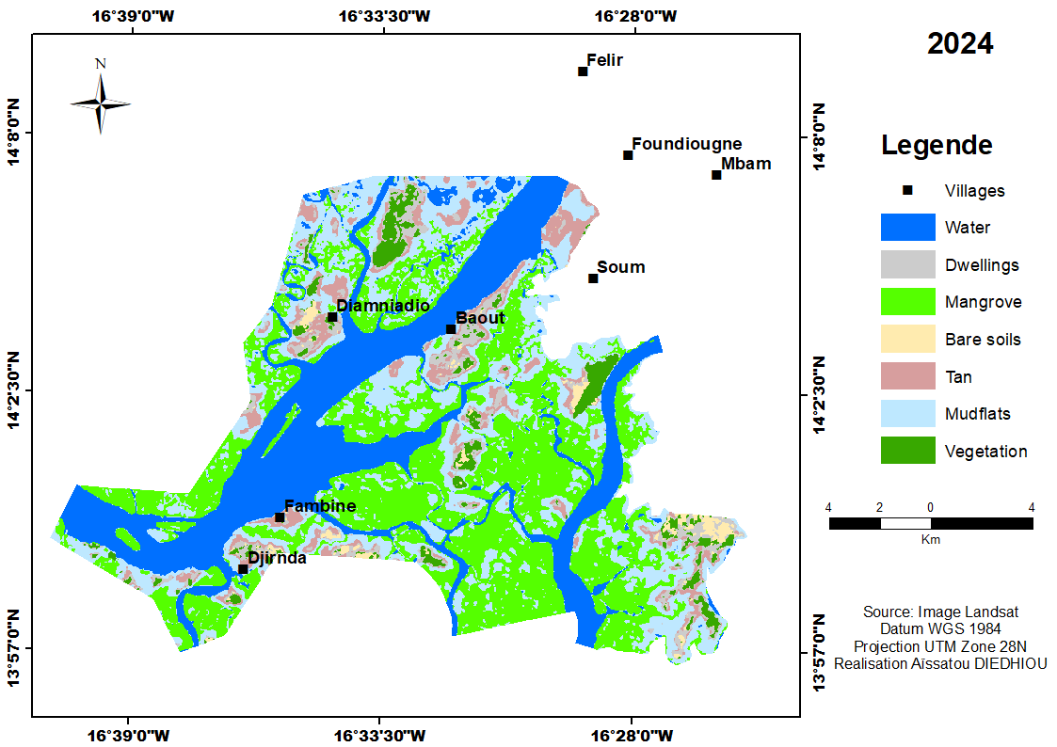

a

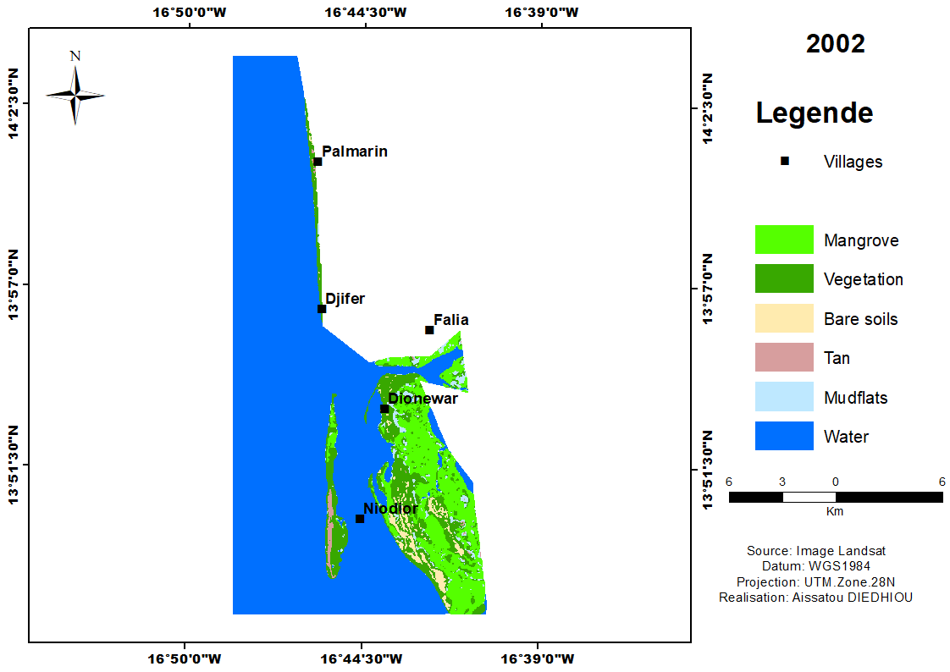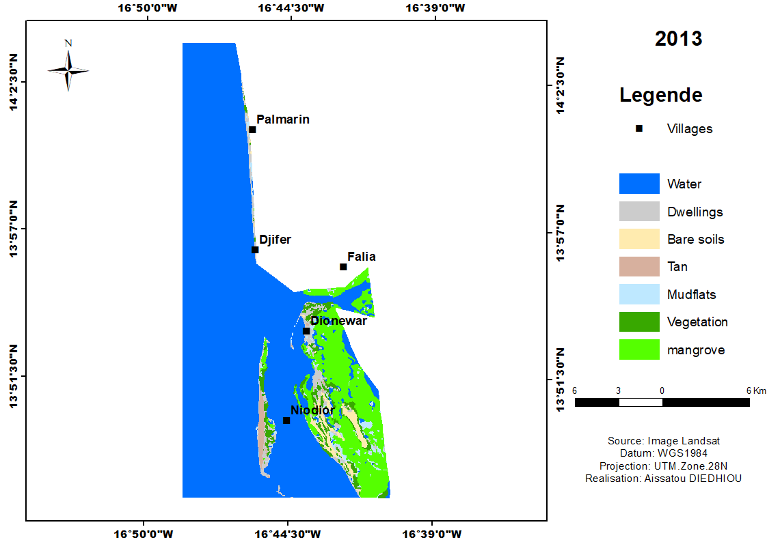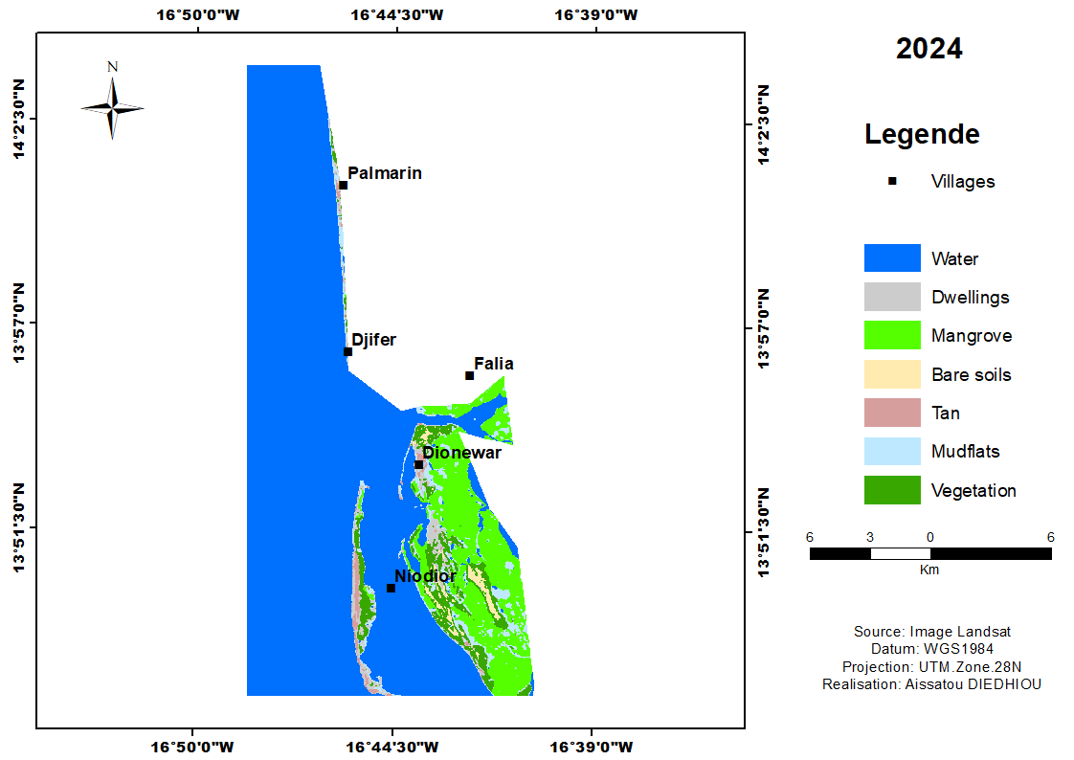

b

Fig. 3. Land use/cover dynamic in Gandoule MPA (a) and in Sangomar MPA (b)
b
a

Fig. 4. Changes in land use/cover units in Gandoule MPA (a) and in Sangomar MPA (b)

3.3 Local populations' perception of changes in land use
The surveys revealed that mangrove area has overall increased. 71.6% of respondents reported an increase, while 28.5% observed a decrease in mangrove area (Figure 5).
The factors contributing to mangrove degradation were anthropogenic (exploitation of mangrove resources) and natural (coastal erosion and climate change). The surveys revealed that the main factor contributing to mangrove degradation is the exploitation of mangrove resources (90.1%). The exploitation of mangrove resources in the Saloum Delta mainly involves cutting mangrove wood for smoking, cooking oysters, cooking, and construction. Poor fishing and harvesting practices not only destroy habitats but also degrade mangrove ecosystems. The overexploitation of mangrove resources and the use of certain fishing nets that catch juveniles (purse seines) were cited as the most significant factors causing the degradation and imbalance in mangrove ecosystems, with increasing loss of biodiversity and scarcity of resources. Some fishing nets abandoned at sea, such as monofilament nets, can trap fish but also damage mangrove roots and make them vulnerable. Seawater pollution and poor waste management were also mentioned as a result of human activities in mangrove areas, subsequently harming fish stocks and mangroves. Coastal erosion (38.9%) was one of the main factors cited by local populations contributing to mangrove degradation. In Saloum Delta, islanders were facing sea encroachment as a result of rising water levels, tidal phenomena, and the breach of the Sangomar spit. This breach has altered the topography with sedimentation downstream of the estuary and the disappearance of the mangrove. Upstream, the submersion of the mangrove is also remarkable. Climate change (7.6%) also contributed to the degradation of mangrove ecosystems. Among the factors caused by climate change, surveys have indicated that low rainfall was responsible for the degradation of the mangrove. The latter has increased the salinity gradient of the water as a result of evaporation processes, which was also raised during the surveys and has consequently caused the mortality of the mangrove (Figure 6).
To address these threats, strategies for mangrove conservation, preservation, and restoration were recommended (Figure 7). Among these strategies, reforestation (29.33%) was the most frequently cited by local communities. Local populations have proposed reforestation as a restoration measure with the help of MPA services and civil society (Figure 8). Another strategy for preserving mangrove was to ban the cutting of mangrove wood (22.67%). The involvement of the population in the preservation of mangrove resources through awareness-raising campaigns on their importance (18%) is also mentioned. Bans (16%) on certain monofilament fishing nets and purse seines are also recommended because they do not comply with regulations and do not allow for resource renewal. A six-month biological rest period for night fishing with purse seines is approved by fishermen, even with a total ban on fishing. For shrimp fishing, a biological rest period (8.6%) has been recommended for better management and conservation of fishery resources. Finally, to reduce the threats caused by the exploitation of fishery products, the populations have proposed improving market gardening and poultry farming (6%).

Fig. 5. Mangrove evolution according to population perceptions
Fig. 6. The main factors contributing to the degradation of the mangrove ecosystem in the Saloum Delta

Fig. 7. Strategies for the conservation, preservation, and restoration of mangroves

Figure 8 : Reforested mangrove

(a) (b)
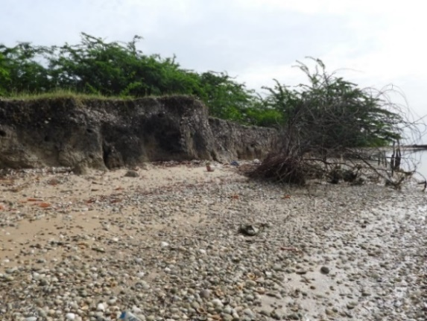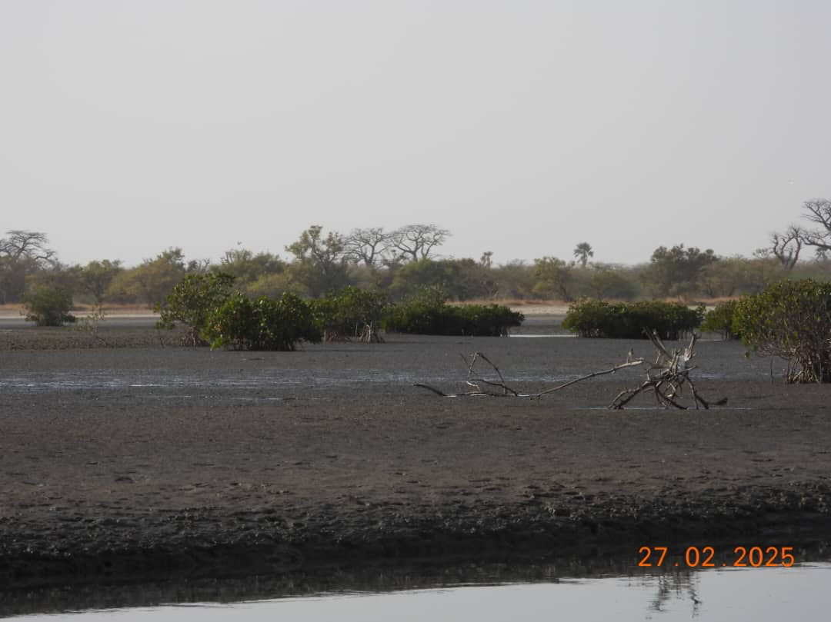

Fig. 9. Images of mangrove ecosystem degradation: coastal erosion (a) and drying up of mudflats (b)

4. Discussion
- Occupancy status and dynamics of the mangrove ecosystem
The results showed that water and mangrove were the units that occupied the largest area, followed by other vegetation and mudflats in Gandoule and Sangomar over the three years. These results corroborate those of; in mangrove ecosystems, water occupied the largest areas (32.60%) followed by mangrove (22.12%) (Sow et al. 2025). According to BONOU et al. (2021), mangrove occupied 37.89% of the area, followed by water bodies at 27.69% of the area. Analysis of mangrove dynamics revealed a spatio-temporal change characterized by a decline and an increase in surface area. In Sangomar MPA, a period of mangrove regression was observed between 2013 and 2024 and an increase between 2002 and 2013 and 2002 and 2024. Meanwhile, in Gandoule MPA, an increase was observed between 2002 and 2024. The same trend was observed for almost the same periods in the studies by Dièye et al. (2013) between 1986 and 2001, with regressions mainly occurring in the northwestern part of the estuary and the Sangomar spit break zone. Dieng et al. (2022) demonstrated an upward trend in mangrove cover between 1980 and 2021, with the area increasing from 1,105.82 ha to 1,482.32 ha. However, between 2001 and 2010, it reappeared in concentrated and significant numbers in the northern and northwestern parts of the estuary (Gandoule MPA). A more significant appearance of mangrove was observed mainly in Sangomar spit break zone (Sangomar MPA). Observations made on the increase of tans depended on the degradation of the mangrove, while their disappearance was marked by the development of other vegetation. According to Andrieu (2017), mangrove deforestation areas were tanns, sometimes covered with dead shrubs or even senescent vegetation. In Sangomar, the area of tans increased between 2002 and 2024, covering 69.34 ha. This result corroborated those of Faye et al. (2022), who stated that the area covered by tans has expanded significantly in recent decades in Haut-Saloum, primarily due to long periods of drought. The built-up area is expanding more rapidly in Gandoule AMP during the period 2013-2024 than in Sangomar AMP, where there has been a slowdown in construction by the population during the same period. The demographic change can be explained on the one hand by the spatial expansion of the city of Mbour-Saly and on the other hand by the development of trade towards Kaolack and, above all, by the development of activities related to fishery resources in Joal-Fadiouth (Ackermann et al., 2006).
- Factors contributing to the degradation of the mangrove ecosystem in the Saloum Delta
The exploitation of mangrove resources was one of the most frequently cited factors. Indeed, the most significant form of exploitation remained the cutting of mangrove wood. As Diouf (2017) indicated in his work within Gandoule MPA, smoking activities contributed more to the destruction of mangrove and other vegetation cover, with 55% of wood being used. Over-exploitation was also a factor in degradation caused by population growth, with fishing efforts increasing over time. Activity was relatively high in the area (on average, 93% of registered canoes were in operation and 1 in 3 canoes made a daily trip) (Bousso, 2000). Demersal resources were practically exhausted (4,000 tons in the 1980s compared to only 700 tons in 2000 (Dème et al., 2001; Failler & Dème, 2010). According to Dahou (2010), fishing was much more intensive at the estuarine mouths of Saloum, Diombos, and Bandiala rivers. Domestic wastewater, plastics, industrial waste, pesticides, and agricultural fertilizers are the main sources of marine pollution. Coastal areas that have been heavily impacted by human activity, such as aquaculture, fishing, and maritime transport, offer habitats that are less suitable for fish development and survival (Amara, 2011; Fonty, 2021). According to (AKABASSI et al., 2025), The threats to mangroves are mainly population pressure (56%), wood collection for domestic use (14%), fishing (10%), and the use of prohibited fishing methods (13%). fishing (10%), the use of prohibited fishing methods (13%). The Saloum estuary is marked by significant sea encroachment, causing coastal erosion. The results of the study by Prost and Charron (1994) in French Guiana showed that mangroves are not an obstacle to shoreline retreat. Their death is not the cause of coastal erosion but rather the effect of erosion. Similarly, the results of Barry (2017) reveal that among the consequences of erosion, mangrove degradation is estimated at 8.51% between 2000 and 2015. Rainfall in the Saloum Delta between 2019 and 2023 shows a low average precipitation of 700 mm per year. This regressive dynamic is largely linked to the decline in rainfall and its associated effects (Sow and Ba, 2019). These low rainfall levels led to drought and an increase in the salinity gradient of seawater in the estuary. From a chemical point of view, the effects of drought lead to a general decrease in pH in the surface layer and deep horizons of mangroves. Most plant species disappear, with Rhizophora largely replaced by the Avicennia-Sesuvium association, which seems well adapted to a very wide range of salinity levels (Marius, 1979). Concerning salinization, these observations corroborate those of (Tine et al., 2025), the pH indicates a broad predominance of acidic to slightly acidic soils. The most acidic areas (pH 3.10-4.80) are mainly found in hydromorphic areas with salt gley and halomorphic soils, particularly concentrated in the centre and east of the region The pH shows a predominance of slightly acidic to moderately acidic areas, with pH values ranging from 4.6 to 6.0 in most regions. (Tine et al., 2025). According to Faye et al. (2007), high salinity and coarse textures (medium sand) are not conducive to the healthy development of mangroves, particularly Rhizophora. The results of Faye et al. (2019) showed that salt-affected land increased by 21,000 ha between 1994 and 2014.
- Strategies for the conservation, preservation, and restoration of mangrove ecosystems
To address the degradation of these ecosystems, strategies are being implemented to support ecosystem balance and promote the return of mangrove resources. Reforestation is the main focus, along with raising awareness about resource exploitation. This is confirmed in the work of Bocquet (2018), which shows that there is a growing trend towards mangrove preservation, with increased participation in reforestation and lower consumption of green wood compared to dead wood. The ban on cutting mangrove wood and the ban on certain fishing nets are being observed. According to Macera (2024), wood cutting is prohibited, and fishing activities are regulated. Managing the RDBS is complex due to the need to comply with a diverse set of policies, laws, and regulations, as well as to collaborate with several institutions.
Initially, the study was to cover ten-year period (2002-2012-2022), but when downloading the satellite images, we found that the 2012 images were not good, hence the use of the 2013 and 2024 images.
Also, during the supervised classification of the 2002 image, we found that the housing class was not visible to the naked eye, hence the absence of housing in the 2002 images.

4. Conclusion
The mangrove ecosystem of Saloum Delta is home to a thriving and productive biodiversity. Water and mangrove areas occupied the largest area, followed by other vegetation and mudflats. Analysis of the dynamics of mangrove ecosystems in protected areas (GMPA and SMPA) showed a more or less significant increase despite urban expansion between 2002 and 2024. Mangrove experienced negligible losses of area compared to an increase at the SMPA over the period 2013-2024. However, other vegetation continued to disappear. The mangrove ecosystems were disrupted by natural phenomena and human activities such as declining rainfall, coastal erosion, salinization, and pressure caused by the uncontrolled exploitation of resources. Reforestation, a ban on mangrove logging, awareness-raising and monitoring with the involvement of local communities, a ban on certain fishing nets, the adoption of biological rest periods, and conversion to market gardening and poultry farming are the strategies recommended by local populations to preserve and restore mangrove ecosystems. Despite these constraints, the resilience of mangrove ecosystems was strengthened by community efforts and restoration actions carried out with MPAs and civil society.

Acronyms
MPA: Marine Protected Area
GMPA: Gandoule Marine Protected Area
SMPA: Sangomar Marine Protected Area

Disclaimer (Artificial intelligence)

Author(s) hereby declare that NO generative AI technologies such as Large Language Models (ChatGPT, COPILOT, etc.) and text-to-image generators have been used during the writing or editing of this manuscript.

References

Ackermann, G., Alexandre, F., Andrieu, J., Mering, C., et Olivier, C. (2006). Landscape dynamics and prospects for sustainable development on the Petite-Côte and in the Sine-Saloum Delta (Senegal). VertigO - the electronic journal of environmental sciences, no. 7-2 (September), pp.1-18. https://doi.org/10.4000/vertigo.2206.
AKABASSI, G. C., AVOCEVOU-AYISSO, C., PADONOU, E. A., IDOHOU, R., AGBODAINON, P. S. B., & QUENUM, I. A. (2025). Local populations' perceptions of factors contributing to the degradation of mangrove ecosystems and mitigation measures. Sciences and Technologies for Sustainable Agriculture (STSA), 4(2), 230‑251.
Amara, R. (2011). Impact of pollution on coastal ecosystems: the example of the eastern English Channel. VertigO - the electronic journal of environmental sciences, Special Issue 9 (July): Special Issue 9, pp.1-12. https://doi.org/10.4000/vertigo.10990.
Andrieu, J. (2017). Methodological contribution to the spatial analysis of terrestrial vegetation. From quantitative biogeography to geography applied to the fight against plant biodiversity erosion. Biodiversity and Ecology, University of Paris 13, p.192. https://shs.hal.science/tel-02500883v1
Aubry, A. (2021). A world without mangroves: global decline in ecosystem services in an era of increasing anthropogenic pressure. Master's thesis, Free University of Brussels, p.96.
BARRY, M. (2017). Coastal erosion and its impacts in the municipality of Kafountine (Lower Casamance). Thesis, Assane Seck University of Ziguinchor (UASZ), p.123.
Bocquet, E. (2018). Mangrove reforestation in the Saloum Delta, Senegal: Ecological and social assessment. Master's thesis, University of Liège/Gembloux Agro-bio Tech, p.86. http://hdl.handle.net/2268.2/5182.
BONOU, C. T., SAHGUI, E. M. C., KARIMOU, S., YAYA, I., IMOROU, & MICHA, J. C. (2021). Dynamics of mangrove ecosystems in the Bouche du Roy Community Biodiversity Conservation Area in southwestern Benin. Geo-Eco-Trop., 45(4), 711‑723.
Bousso, T. (2000). Fishing in the Sine-Saloum estuary (Senegal): types of fishing villages and camps. ResearchGate, fishing areas, pp.350–370
Clerici, N., Bodini, A., Hugh, E., Grégoire, J.-M., Dulieu, D., et Paolini, C. (2007). Increased isolation of two Biosphere Reserves and surrounding protected areas (WAP ecological complex, West Africa). Journal for Nature Conservation 15 (1): 26‑40. https://doi.org/10.1016/j.jnc.2006.08.003.
Dahou, T. (2010). Managing space without governing people: the dilemma of marine protected areas (Saloum, Senegal). Anthropology and Societies 34 (1): 75‑93. https://doi.org/10.7202/044197ar
Dème, M., Diadhiou, H.D., Thiam, D. (2001). Fishing effort, specific catches, and economic values of inland fishery landings in the Senegal River and Sine Saloum. Sustainable Use of Wild Resources in Senegal Project, CRODT/IUCN/ISRA.
Dia, I.M. (2005). The Saloum Delta Biosphere Reserve, pp. 9–10. https://aquadocs.org/bitstream/handle/1834/2458/;jsessionid=B658A147EB97E6991BD313F89E220D54?sequence=1 (Accessed on 8/21/2023)
Dia, I.M.M. (2003). Development and implementation of an integrated management plan - Saloum Delta Biosphere Reserve, Senegal. IUCN, Senegal, p 145. https://portals.iucn.org/library/sites/library/files/documents/WTL-027.pdf.
Dibi Nda, H., Kouassi, K., Tra Bi, F., Konan, K., et Bohoussou, N. (2019 Contribution of SPOT satellite imagery to the sustainable management of mangrove ecosystems in Toukouzou-Hozalem, Grand-Lahou and Jacqueville departments, southern Côte d'Ivoire. In OSFACO Conference: Satellite images for sustainable land management in Africa, edited by Mertens Benoit and Orekan Vincent. Proceedings of the OSFACO Conference: Satellite images for sustainable land management in Africa. Cotonou, Benin, pp.1-16. https://hal.science/hal-02189383.
Dieng, D., Sow, M., Sow, E.H., et Ba, T. (2022). Spatio-temporal dynamics of the mangrove forest in the lower Senegal River delta from 1980 to 2021: An approach using remote sensing and geographic information systems, pp.117-137. https://eujournal.org/index.php/esj/article/view/16094
Dièye, E. B, Diaw, A.T., Sané, T., et Ndour, N. (2013). Dynamics of the mangrove forest in the Saloum estuary (Senegal) between 1972 and 2010. Cybergeo: European Journal of Geography, early online publication, January 9. p.1-22. https://doi.org/10.4000/cybergeo.25671.
Diouf, S. N. (2017). Study of the effect of wood energy consumption on mangrove forest dynamics: the case of fish processing in the rural community of Djirnda. Publibook Publishing, p.64.
Failler, P., et Dème, M. (2010). Dynamics of exploitation and valorization of fishery resources in the Saloum Delta Biosphere Reserve (RBDS). Senegalese Journal of Agricultural and Agri-Food Research 7 (January): 1‑23.
Fall, M. (2009). Adapting to environmental degradation in the Saloum Delta: Variability in strategies among Socés and Niominkas women in Senegal. VertigO - the electronic journal of environmental sciences, Volume 9 Number 2 (September): Volume 9 Number 2, pp.1-6. https://doi.org/10.4000/vertigo.8651.
FAYE, C.A.T., NIANG, S., et THIOR, M. (2022). The Haut-Saloum tannes in southwestern Senegal: static or dynamic geomorphological sequences? Journal of Geography of the University of Ouagadougou, 2 (11): 189–208.
Faye, B., D. Tine, Ndiaye, D., Diop, C., Faye, G., et Ndiaye, A. (2019 Changes in salt marshes in the northern part of the Saloum estuary (Senegal). Geomorphology: relief, processes, environment 25 (2): 2, pp.81-90 https://doi.org/10.4000/geomorphologie.13125.
Faye, M. N., Guissé, A., et Diallo, N. (2007). Influence of pH, water salinity, and soil texture on vegetation in the Saloum Estuary mangrove forest in Senegal. Journal of Science and Technology – vol. 5 (no. 1): 8‑17.
FONTY, G. (2021). The effect of plastics on marine ecosystems, La Revue du Centre Michel de L'Hospital [Online], 23 | 2021, published online on March 28, 2022, accessed on August 29, 2025., p.13. URL: http://revues-msh.uca.fr/revue-cmh/index.php?id=425.
Fousseni, F., Andrianamenoso, R., Kperkouma, W., et al. (2017). Ecology and spatio-temporal dynamics of mangroves in Togo. VertigO: the electronic journal of environmental sciences 17 (3), pp.1-23. https://www.erudit.org/fr/revues/vertigo/2017-v17-n3-vertigo04476/1058386ar/.
Francoeur, M. (2009). Shrimp farming: a threat to mangroves? Master's thesis, Faculty of Science, University of Sherbrooke, p.103.
Guissé, A., Faye, M.N., Diallo, N. (2007). Influence of pH, water salinity, and soil texture on mangrove vegetation in the Saloum estuary in Senegal. Journal of Science and Technology vol. 5, pp 8–17.
Jelibseda, J., Rahayu, Y. G., S, S. H., Muhayatul, M., Syah, N., Barlian, E., Umar, I., Dewata, I., & Kamal, E. (2025, June 14). Ecological and socioeconomic importance of mangrove ecosystems: a case study of Muar Johor, Malaysia [Pentingnya ekosistem mangrove secara ekologis dan sosial ekonomi: studi kasus di Muar Johor, Malaysia]. Jelibseda | Al-Ihtiram: Multidisciplinary Journal of Counselling and Social Research. https://jurnal.pabki.org/index.php/alihtiram/article/view/961/330
Lombard, F. (2023). Spatio-temporal dynamics of the Senegalese mangrove: Characterization of plant species resilience through spatial modeling of biological processes. PhD Thesis, Université Côte d’Azur, p.300. https://hal.science/tel-04431000.
Macera, L. (2024, May 22). Restoration of mangrove ecosystems: evaluation and improvement of practices through a comparative study of projects worldwide. p. 358. https://theses.hal.science/tel-04652570
Marius, C. The soils of the Saloum estuary. ORSTOM. 1973, p.40 https://core.ac.uk/download/pdf/39884173.pdf (Accessed on 8/20/2024).
Marius, C. (1979). Effect of drought on the phytogeographic and pedological evolution of the Lower Casamance mangrove. Bulletin of the Institut Fondamental d'Afrique Noire (IFAN) series A (4): 669‑691.
Matoko, J. B., Malanda, G. S., Kinkela, J. M., & Shutcha, M. N. (2025). Stakeholder perceptions of ecosystem services in the Mangrove Marine Park in the Democratic Republic of Congo. African Journal of Environment and Agriculture, 8(2), 89–99. https://doi.org/10.4314/rafea.v8i2.8
Mephu Nguifo, E., et Njiwoua, P. (2005). Concept lattices and supervised classification. ResearchGate, Computer Science and Technology, vol. 24 (4) : 449‑488. https://doi.org/DOI: 10.3166/tsi.24.449-488.
MPA_Gandoule. Management and Development Plan for the Gandoule Marine Protected Area (2023-2027). Directorate of Community Marine Protected Areas, Senegal. 2023, p. 86
MPA_Sangomar. Management and Development Plan of the Sangomar Marine Protected Area (2014-2017) (Final Version). Directorate of Community Marine Protected Areas, Senegal. 2014, p. 62.
Ndour, N., Dieng, S.D., Fall, M., 2012. Roles of mangroves, management methods and prospects in the Saloum Delta (Senegal). VertigO - the electronic journal of environmental sciences, p. 15. https://doi.org/10.4000/vertigo.11515
Poulon, F. (2015). 1. The ensemble method. In General Economics (Vol. 8, pp. 9–43). https://shs.cairn.info/economie-generale--9782100722433-page-9. (Consulte le 20/08/2025)
Proisy, C. et Mougin, E. (1998). Radar remote sensing of mangroves in French Guiana, Center for Space Studies of the Biosphere, France, p. 26
Prost, M., et Charron, C. (1994). Coastal erosion in French Guiana. Cahiers Du Centre Nantais De Recherche Pour l’Aménagement Régional (Journal of the Nantes Center for Regional Development Research), 41(1), pp.70–81. https://doi.org/10.3406/canan.1994.1581.
Ranaivojaona, S.B., et Ranarijaona, H.L.T. (2021). Ecological dynamics of the peri-urban mangrove forest of Mahajanga: an ecosystem-based and remote sensing approach. Journal of Science, Technology, and Environment 4 : 16‑23.
Salomon, J-N. (1987). Traditional exploitation and development of mangrove lands in West Africa. Les Cahiers d’Outre-Mer 40 (160): 313‑342. https://doi.org/10.3406/caoum.1987.3235.
Sambou, A., Theilade, I., Fensholt, R., & Ræbild, A. (2016). Decline of woody vegetation in a saline landscape in the Groundnut Basin, Senegal. Regional environmental change, 16(6), 1765-1777.
Sow, M., Bendu, D., & Sow, E. H. (2025). Analyse de la séparabilité spectrale des classes d’occupation du sol pour la cartographie de la mangrove de la Réserve de biosphère du delta du Saloum, Sénégal. International Journal of Biological and Chemical Sciences, 19(1), 225–239. https://doi.org/10.4314/ijbcs.v19i1.17
Sow, E. H., et Ba, T. (2019). Analysis of the spectral separability of land cover classes for mapping the mangrove forest of the Saloum Delta Biosphere Reserve, Senegal. European Scientific Journal 15 (NO.15 ISSN: 1857 – 7881 (Print) e): 20. https://doi.org/10.19044/esj.2019.v15n15p467.
TINE, D., Moustapha, M., Ndour, M., & DIEDHIOU, C. (2025). Satellite imagery and spatial analysis of physical and chemical parameters for studying mangrove dynamics in the Saloum estuary. 46, 50‑70.
Top, O., Sambou, H., Diédhiou, Y.M. (2024). Dynamics and Factors in the Evolution of Landscape Units in the Casuarina equisetifolia Strip of the Dakar Region (Great Coast, Senegal). Journal of Geoscience and Environment Protection 12 (12): 12, pp.164-182. https://doi.org/10.4236/gep.2024.1212011.
Wei, S., Zhang, H., & Ling, J. (2025). A review of mangrove degradation assessment using remote sensing: advances, challenges, and opportunities. GIScience & Remote Sensing, 62(1). https://doi.org/10.1080/15481603.2025.2491920

Table 2: Confusion matrix for the different land cover classes in the Saloum Delta in 2002.
Land use units | Mangrove | Vegetation | Bare soil | Tans | Mudflats | Water | Production accuracy | Error of omission
Mangrove | 98.07 |  | 0.03 |  |  | 0.08 | 98.07 | 1.93
Vegetation | 1.47 | 97.77 | 1.04 | 7.69 | 2.41 | 0.11 | 97.77 | 2.23
Bare soil |  | 2.23 | 98.9 |  |  |  | 98.9 | 1.10
Tans |  |  |  | 92.32 | 0.10 |  | 92.32 | 7.68
Mudflats | 0.46 |  | 0.03 |  | 97.49 | 1.75 | 97.49 | 2.51
Water |  |  |  |  |  | 98.05 | 98.05 | 1.95
User accuracy | 99.84 | 96.88 | 95.39 | 99.77 | 93.96 | 100
Commission error | 0.16 | 3.13 | 4.61 | 0.23 | 6.04

Table 3: Confusion matrix of the different land use classes in the Saloum Delta in 2013.
Land use units | Mangrove | Vegetation | Bare soil | Dwellings | Tans | Mudflats | Water | Production accuracy | Error of omission
Mangrove | 99.32 | 0.04 |  |  |  |  |  | 99.32 | 0.68
Vegetation | 0.10 | 88.6 |  | 3,27 |  |  |  | 88.6 | 11.40
Bare soil |  | 0.40 | 95.02 | 9.66 |  |  |  | 95.02 | 4.98
Dwellings |  | 10.96 | 4.82 | 86.55 | 1.47 |  |  | 86.55 | 13.45
Tans | 0.55 |  | 0.17 | 0.52 | 98.53 |  |  | 98.53 | 1.47
Mudflats | 0.03 |  |  |  |  | 100 | 0.03 | 100
Water |  |  |  |  |  |  | 99.97 | 99.97 | 0.03
User accuracy | 99.98 | 99.29 | 97.03 | 42.39 | 98.95 | 89.27 | 99.97
Commission error | 0.02 | 0.71 | 2.97 | 57.61 | 1.05 | 10.73 | 0.03

Table 4: Confusion matrix of the different land use classes in the Saloum Delta in 2024.
Land use units | Mangrove | Vegetation | Bare soil | Dwellings | Tans | Mudflats | Water | Production accuracy | Error of omission
Mangrove | 98.57 |  |  |  |  |  |  | 98.57 | 1.43
Vegetation |  | 97.88 | 5.81 | 12.85 |  | 1.13 |  | 97.88 | 2.12
Bare soil |  | 1.13 | 94.15 | 3.40 | 0.49 | 4.79 |  | 94.15 | 5.85
Dwellings |  | 0.99 | 0.04 | 79.91 | 25.73 | 0.47 |  | 79.91 | 20.09
Tans |  |  |  | 3.55 | 73.79 | 0.28 |  | 73.79 | 26.21
Mudflats | 1.30 |  |  | 0.30 |  | 93.33 | 0.32 | 93.33 | 6.67
Water | 0.13 |  |  |  |  |  | 99.68 | 98.68 | 0.32
User accuracy | 100 | 74.54 | 96.40 | 89.13 | 84.92 | 96.50 | 99.76
Commission error |  | 25.46 | 3.60 | 10.87 | 15.08 | 3.50 | 0.24

