Microscopic Evaluation of the use of a combination of Vitamin C and Activated Charcoal as Ameliorating Agent against Paraquat-induced hepatotoxicity

.
ABSTRACT

Background: Paraquat is a highly toxic, non-selective herbicide that induces severe oxidative stress and multiorgan damage, particularly affecting the liver, lungs, and kidneys, with high mortality in cases of acute poisoning. Owing to the lack of a specific antidote, antioxidant therapy such as Vitamin C and toxin adsorption with activated charcoal have been explored as potential protective strategies against paraquat-induced hepatotoxicity.
Aims: The study aims to evaluate the ameliorative effect and the safety of Vitamin C/ Activated Charcoal combination on Paraquat-induced hepatotoxicity. It is also to evaluate the safety of this combination at this dosage and duration, on hepatocytes. To investigate the relationship between the level of tissue damage with the duration of paraquat exposure. To investigate the synergistic effect of the combination of Vitamin C and activated charcoal, on clinical manifestations associated with oral paraquat toxicity in Wistar rats.
Study design: This is an experimental study
Place and Duration of Study: National Veterinary Research Institute, Vom, Nigeria, 2025.
Methodology: A total of 40 female Wistar rats, aged eight weeks and weighing between 150 and 200 g, were utilised in the present study. The animals were randomly allocated into four experimental groups, each comprising ten rats. Group I (normal control) received 1 ml of normal saline orally once daily for 28 consecutive days. Group II was administered paraquat at a dose of 50 mg/kg body weight, dissolved in 1 ml of distilled water, once daily for 28 days. Group III received paraquat at 50 mg/kg body weight daily, followed after a 5-minute interval by 1 ml of a combination consisting of vitamin C (250 mg/kg body weight) and activated charcoal (0.175 g/kg body weight) suspended in distilled water, administered once daily for 28 days. Group IV was treated with 1 ml of the combination of vitamin C (250 mg/kg body weight) and activated charcoal (0.175 g/kg body weight) in distilled water once daily for the same duration. All animals were monitored weekly for clinical signs and any observable changes in general condition. Liver tissues were harvested at weekly intervals from randomly selected animals within each group for histopathological processing and microscopic evaluation. Histopathological assessment was conducted through detailed examination of tissue morphology, with particular emphasis on both intracellular and extracellular alterations and the manifestation of pathological changes.
Results: Group 1 and 4 animals present with normal physical behavior, water/ feed consumption. Group 2 animals present with severe reduction in feed/ water intake, respiratory distress and other physical abnormalities, which worsened with duration of the experiment. A mortality was recorded on each of days 8, 17 and 25. Group 3 animals present with milder signs of what was observed in group 2, with a mortality on day 23. Microscopically, Liver sections of groups 1 and 4 remain histologically normal throughout the experiment. Group 2 liver shows massive degeneration and hepatic haemorrhage. Group 3 shows microscopically normal tissue, with mild hypertrophy and mild central vein congestion on days 21 and 28. This has shown that this combination is effective in ameliorating paraquat-induced hepatotoxicity. It has also shown that that at this dosage, Vitamin C and activated charcoal is safe on the hepatocytes.

Keywords: Paraquat toxicity, Liver necrosis, Liver congestion, hepatic haemorrhage, One health, Vitamin C and Activated charcoal, Paraquat antidote, Wistar rats.

1. INTRODUCTION

Paraquat (1,1′-dimethyl-4,4′-bipyridylium dichloride), also known as methyl viologen is a globally widely used, inexpensive nonselective contact herbicide, (Zhang et al., 2025). It is the world’s second largest selling weed-killer in over 100 countries (Kim et al., 2009), discovered in 1955 and developed in the early 1960s by Imperial Chemical Industries, now Syngenta (Robert et al., 2002). This liquid herbicide was primarily used for weed and grass control but due to its highly poisonous nature was soon categorized as a “restricted-use” herbicide (Wesseling et al., 2005). As a result of its toxicity, paraquat has been banned in several countries, but is still being used extensively in developing countries, including Nigeria. Acute paraquat poisoning (APP) is associated with high case fatality (Kota et al., 2025). When either accidentally, intentionally or maliciously ingested, paraquat selectively accumulates in the lungs resulting in the production of oxygen-free radicals, causing in membrane damage and cell death (Okolonkwo et al., 2023). Ingestion of even a minimal quantity of paraquat, particularly in the context of delayed medical intervention, may precipitate severe multiorgan dysfunction and can be rapidly fatal (Mehta et al., 2025). Although an extensive body of literature has addressed paraquat intoxication in developed countries, notable gaps persist in the global research agenda, especially with regard to the development and evaluation of effective antidotal therapies (Baradaran Rahimi et al., 2019; Jain et al., 2022). This underscores the continued need for translational and therapeutic research in paraquat poisoning. The principal target organs of paraquat toxicity are the lungs, liver, and kidneys (Ahmed et al., 2008). Nevertheless, other organs, including the heart, adrenal glands, central nervous system, skeletal muscles, and spleen, may also be affected, ultimately contributing to multiple organ failure (Tan et al., 2013). At the cellular level, paraquat-induced cytotoxicity is primarily mediated through mitochondrial dysfunction, with a predilection for tissues rich in mitochondria (Griffin et al., 2002). Oxidative stress has been identified as a central pathogenic mechanism, with subsequent inflammatory responses and apoptosis playing significant roles in paraquat-induced hepatic injury (Kavianinia et al., 2025; Eftekhari et al., 2020). Paraquat is actively secreted by the kidneys, leading to its preferential accumulation within proximal tubular epithelial cells at elevated concentrations. The toxic effects of paraquat are largely attributed to redox cycling, a metabolically catalysed single-electron oxidation–reduction reaction that results in depletion of intracellular nicotinamide adenine dinucleotide phosphate (NADPH) and excessive generation of reactive oxygen species, particularly the superoxide radical (Shimada et al., 2009). Experimental and clinical studies have demonstrated that paraquat intoxication induces acute liver injury, characterised by sustained elevation of serum aminotransferases and distinct histopathological alterations (Costa et al., 2013; Han et al., 2014). Although fulminant hepatic failure secondary to paraquat poisoning is relatively uncommon, cases have been reported in which severe hepatic injury and toxic encephalopathy occurred following oral ingestion, with comparatively minimal pulmonary involvement (Gao et al., 2022).
Vitamin C (ascorbic acid) is a water-soluble essential micronutrient with potent antioxidant properties, present in both plant and animal tissues; however, it cannot be synthesised endogenously in humans and must therefore be obtained through dietary intake (Carr and Maggin, 2017; Okolonkwo, 2022). It exerts significant antioxidant effects by directly scavenging reactive oxygen and nitrogen species, thereby mitigating lipid peroxidation and preventing oxidative damage to DNA and proteins (Vissers and Das, 2018). In addition to its redox-regulating capacity, vitamin C plays a crucial role in several biosynthetic pathways, including the synthesis of collagen, L-carnitine, and specific neurotransmitters, as well as in overall protein metabolism (Li and Schellhorn, 2007). Beyond its direct free radical scavenging activity, vitamin C enhances endogenous antioxidant defence systems and modulates key molecular pathways, including the nuclear factor kappa B (NF-κB)/tumour necrosis factor alpha (TNF-α) axis, thereby influencing inflammatory responses and apoptosis (Mazurek and Pankiewicz, 2012; Ang et al., 2018). Its immunomodulatory effects are multifaceted and include enhancement of leukocyte chemotaxis, promotion of neutrophil phagocytosis and oxidative microbial killing, attenuation of neutrophil extracellular trap (NET) formation (NETosis), and reduction of excessive pro-inflammatory cytokine production within the alveolar space. Furthermore, vitamin C supports the differentiation and proliferation of B and T lymphocytes, augments antibody production, and influences the synthesis of cortisol and interferon-γ. It has also been associated with downregulation of interleukin-6 (IL-6) and endothelin-1, reinforcement of the pulmonary epithelial barrier, and modulation of susceptibility to, and outcomes of, lower respiratory tract infections (Neeth et al., 2022; Mortaz et al., 2021).

Additionally, vitamin C has been shown to restore vascular responsiveness to vasoconstrictors and to preserve endothelial barrier integrity through maintenance of cyclic guanosine monophosphate signalling and inhibition of pathological phosphorylation processes, thereby reducing apoptotic cell death (Oudemans-van Straaten et al., 2014). Owing to these diverse biological actions, vitamin C has frequently been employed in combination with other therapeutic agents to ameliorate toxicity induced by endogenous metabolic disturbances as well as exogenous toxicants (Vetvicka and Vetvickova, 2012). Activated charcoal (AC) is an odourless, tasteless, and finely powdered black substance that functions as a potent adsorbent for a wide range of poisons, gases, toxicants, and impurities. It has been extensively utilised in human medicine, veterinary practice, and aquaculture as a so-called “universal antidote” for various toxic exposures and environmental contaminants. Notably, activated charcoal is included in the World Health Organization List of Essential Medicines, reflecting its recognised clinical importance (Boonanuntanasarn et al., 2014; World Health Organization, 2023). The mechanism of action of activated charcoal is primarily based on adsorption rather than absorption. In vitro studies have demonstrated its high affinity for binding and facilitating the elimination of numerous toxicants, including aflatoxins and pesticide residues (Abdel-Tawwab et al., 2017). Activated charcoal is produced by heating carbonaceous materials in the presence of activating gases, a process that creates an extensive network of internal pores. This highly porous structure confers an exceptionally large surface area, enabling the physical adsorption of diverse chemicals, drugs, and toxins within the gastrointestinal tract. Clinically, activated charcoal is employed in the management of acute poisoning, reduction of intestinal gas (flatulence), lowering of serum cholesterol levels, prevention of hangover symptoms, and treatment of cholestasis during pregnancy (Olson, 2010). The standard recommended dose in cases of acute intoxication is generally 0.5–1 g/kg body weight in children or approximately 50 g in adults, or an amount 10–40 times the estimated quantity of the ingested toxin. Repeated dosing may be indicated in cases involving substances with prolonged gastric retention, sustained-release formulations, or agents undergoing significant enterohepatic or entero-enteric recirculation (Zellner et al., 2019). Beyond its extensive surface area, the porous structure of activated charcoal also possesses a negative electrical charge, which enhances its capacity to attract and bind positively charged toxins and gases. These molecules become entrapped within the intricate network of pores and crevices, thereby preventing their absorption into the systemic circulation and reducing their overall toxic effects (Hassen and Abdulkadir, 2022).

The aim of this work is to assess the efficacy of a combination of Vitamin C and Activated charcoal as an ameliorative agent against paraquat-induced hepatotoxicity in Wistar rats. The work will also investigate the relationship between the severities of paraquat histotoxicity in relation to duration of exposure. The work will also investigate the safety of this combination on the Liver of Wistar rats so as to open way for compounding different formulations of the combination for better results.

2.0 material and methods

2.1 Study Location
This research work was conducted at National Veterinary Research Institute, Vom, Plateau state, latitude 9° 53' N, and longitude 8° 51' E, an altitude of 1,217m above sea level (National Population Commission, 2006).
2.3 Experimental Animals
A total number of 40 female 8 week old Wistar rats that weigh between 150 to 200 grams were obtained from the small animal Experimental station of the National Veterinary Research institute (NVRI) Vom, Plateau State, Nigeria, and used for the experiment. All experimental activities were carried out conformity with internationally acceptable guidelines on the ethical use of experimental animals in research (Haripriya et al., 2017; Reddy et al., 2019). The rats were housed in the Animal Experimental station of the Federal College of Veterinary and Medical Laboratory Technology, NVRI, Vom in cages during the experiment period (Edo, 2022; Ijaz et al., 2023). The rats were allowed to adjust in accordance with favorable conditions for two (2) weeks that would allow them to adapt to their new environment and fed with a standard grower’s mash obtained from Grand Cereal Ltd and water to meet the nutritional requirements for growth and maintenance in rats (Lewis et al., 2006). The constant environmental condition was maintained with proper ventilation and a good source of light (12h light -12h dark and 20ºC ± 30ºC) (Nwafor et al., 2020) with free access to food and water (Amin et al., 2025). Excrement and spillage were changed frequently (Reed et al., 2011). A veterinarian ascertained the health status of as well as provided care and ensure the health of the laboratory animals throughout the experiment so as to maintain a standard experimental protocol (Debnath et al., 2024; Pedroso et al., 2025). Animals were divided into 4 groups of 10 animals each.
2.4 Chemical and treatment compounds sources
Paraquat was purchased under the trade name ‘KINGRAMO’, from Agricultural Services and Training Centre, Vom Station, Jos Plateau State. Vitamin C (Ascorbic Acid) was obtained from Lamed Pharmacy Ltd, Jos under the brand name ‘Nature’s Field Vitamin C 1000mg, manufactured by Bactolac Pharmaceuticals Incorporated, USA (Lot 2503034). Activated charcoal was obtained from Lamed Pharmacy Ltd, Jos under the brand name ‘Kunimed Activated Charcoal Powder Anti-poison’ (Batch number KAC10). Distilled water and deionised water were obtained from the Cell culture Laboratory of the Viral Vaccine production Division, National Veterinary Research Institute, Vom.
2.5 Experimental Design
The experiment is designed in line with the guideline of the Organisation for Economic Co-operation and Development (OECD) where the dose is repeated daily for 28 days (OECD, 2025; OECD 2008), modified based on existing research (Akinloye et al., 2016). The rats were randomly assigned into 4 groups, containing 10 rats each. Group 1 served as normal control were exposed to normal atmospheric and nutritional condition, and received 1ml of normal saline solution daily (0.9% NaCl) throughout the experiment period (Hernandez-Baixauli, et al., 2024). Group 2 animals were administered paraquat solution at 50mg/kg body weight dissolved in 1ml of distilled water once daily, for 28 days. Group 3 animals were administered paraquat solution at 50mg/kg body weight daily, followed after 5 minutes by 1ml of a combination of a solution of Vitamin C at 250mg/ kg body weight and a suspension of activated charcoal in distilled water at 0.175g/kg body weight, once daily for 28 days. Group 4 animals were administered 1ml of a combination of a solution of Vitamin C at 250mg/ kg body weight and a suspension of activated charcoal in distilled water at 0.175g/kg body weight, once daily for 28 days. All solutions of the compounds were administered via oral gavage route. Although activated charcoal can bind some of the vitamin C and reduce its efficacy, the activated charcoal also binds the paraquat hence a significant quantity of the vitamin C will still be available to perform its antioxidant ability. The dose of Paraquat was chosen to model occupational exposure to paraquat. Doses of Activated Charcoal and Vitamin C were chosen based on previous related studies (Reddy et al., 2019).
2.6 Procedure for paraquat and treatment solutions administration
The rats were held at the skin over the head and turned so that the mouth was faced upward and the body lowered towards the holder. The syringe needle bevel was then placed into the mouth of the rat a bit laterally in a way to avoid the teeth which are located centrally. The content in the syringe was then emptied into the mouth of the rat gradually (Okolonkwo, 2022).
2.7 Experimental Protocol
Animals were observed before and after the administration of the Paraquat solution across the treatments groups (Turner et al., 2011). During the experimental period, clinical signs and behaviors of all rats such as physical activity, diarrhea, tremor, paralysis, food/water consumption, injury and death were monitored daily. At the end of the each week (that is, day 7, day 14, day 21 and day 28), animals from each group were randomly selected, and sacrificed by cervical dislocation after 12 hours of fasting. The liver were observed, harvested and fixed immediately in 10% buffered formalin, for histopathology processing (Adefola et al., 2024).
2.8 Histopathological Processing and Evaluation: Tissues (liver) from all groups were subjected to standard routine histopathological procedures, using the conventional paraffin wax method (Avwioro, 2011), embedded, sectioned and stained using the haematoxylin and Eosin Staining technique (Choji et al., 2015). They were read microscopically: A commercially available web camera (QHM495 LM, Shenzhen Hiper Song Electronic Limited, Hong Kong, China) with complementary metal oxide semiconductor sensor which yield interpolated 25 mega pixel images was used for micrograph capture after slide reading and interpretation (Mondal et al., 2019)

3.0 results

This research was designed to study, microscopically, the ameliorative effect of a combination of Vitamin C and activated charcoal on Paraquat-induced hepatotoxicity in Wistar rats at definite time intervals in different groups, alongside clinical signs. This approach was aimed at studying what happens at cellular level, when vitamin C and Activated charcoal are combined in an effort to ameliorate hepatotoxicity caused by paraquat oral exposure.
3.1 CLINICAL SIGNS
Clinical signs and behaviors of all rats such as physical activity, diarrhea, tremor, paralysis, food/water consumption, injury and death were observed daily across the groups, with group 1 and 4 showing normal physical presentation and feed consumption. Severe reduction in feed/ water intake, respiratory distress, squeaking sound and generalized weakness of the body, anorexia and bloody nasal discharges were observed in group 2 animals especially as from day 12 to 28, with 3 mortalities, one recorded on each of day 8, day 17 and day 25. Group 3 animals, showed mild weakness of the body, mild reduction in feed consumption and respiratory distress, especially from the 7th to 14th day, with no bloody nasal discharge and are more active compared to group 2 animals. There was one mortality recorded in group 3 on day 23.
3.2 Histopathology
The liver from groups 1 and 4, microscopically, shows normal morphology throughout the experiment, with clearly defined Kidney architecture, while morphological variation manifest across the groups 2 and 3 as seen in the photomicrographs.
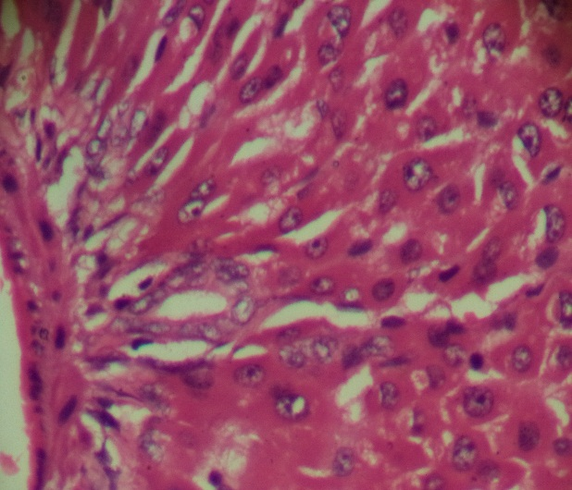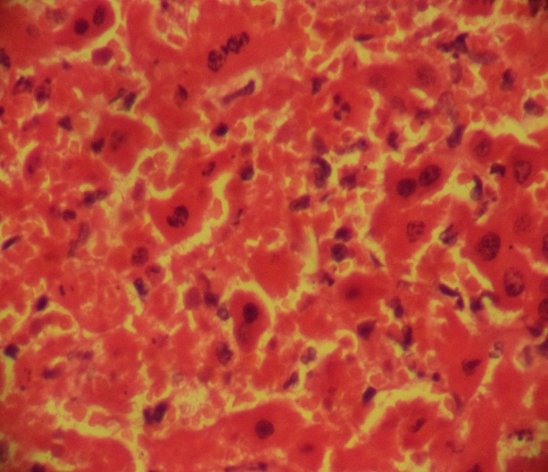
Group 2

Group 1
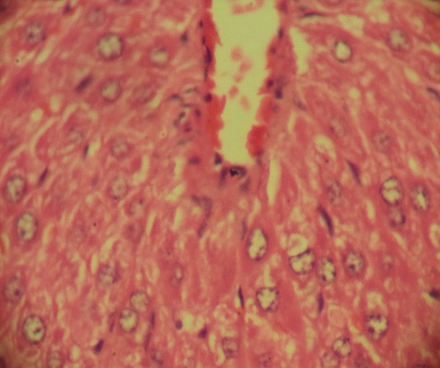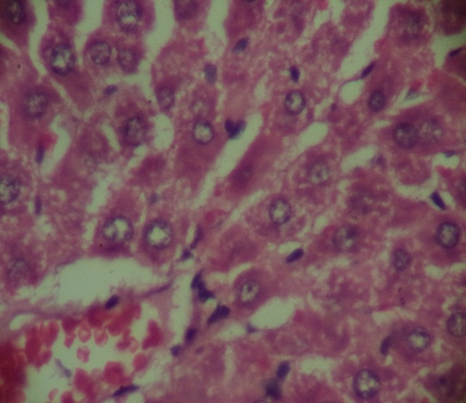
Group 4
Group 3

Plate 1: Liver of Wistar rat from the four groups on day 7. Groups 1, 3 and 4 show normal histology with hepatocytes presenting with their characteristic polygonal shape and interspersed by hepatic sinusoids (black arrows) which are linked to the central vein (black stars). Group 3 shows mid reduction in sinusoidal spaces, an evidence of mild hypertrophy. The nuclei (white arrows) are intact. Group 2 shows generalised tissue degeneration (necrosis) as seen by loss of both nuclear and cytoplasmic components. Some nuclei appear naked (white arrows) while some appear pyknotic (white arrowheads). Hepatic haemorrhage is presented by the presence of red blood cells (black arrowheads) within the hepatic sinusoids. H&E X400

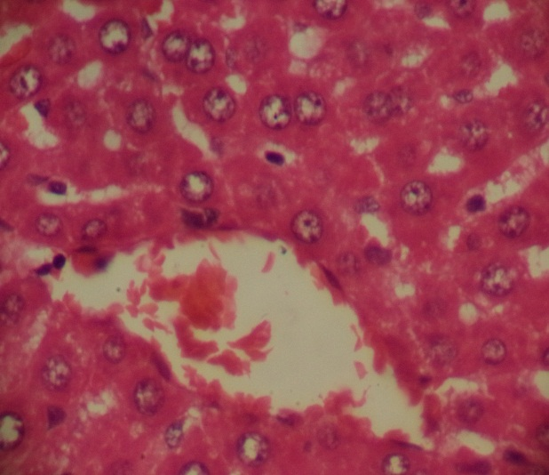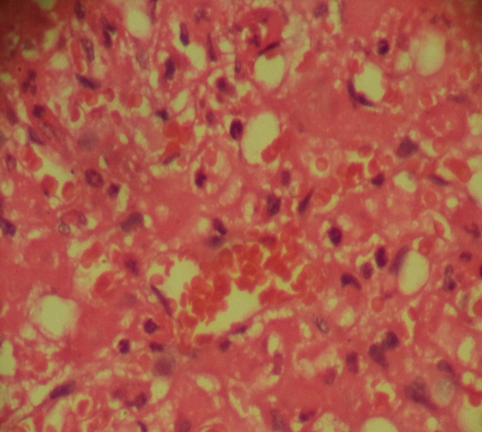
Group 2

Group 1
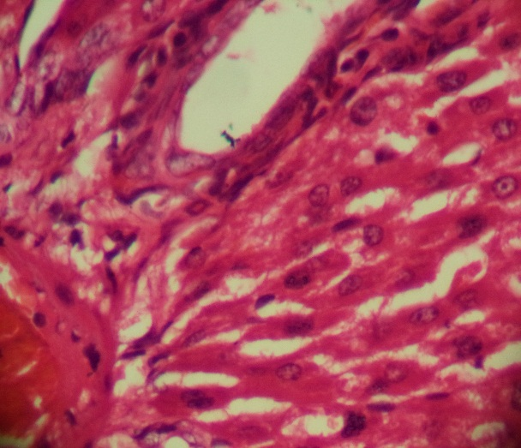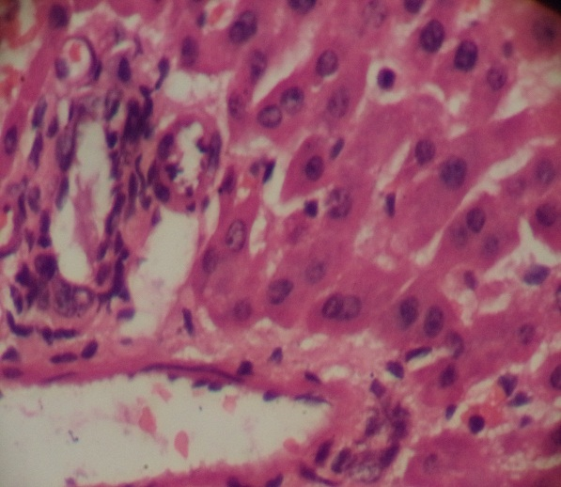
Group 4
Group 3

Plate 2 Liver of Wistar rat from the four groups on day 14. Groups 1, 3 and 4 show normal histology with hepatocytes presenting with their characteristic polygonal shape and interspersed by hepatic sinusoids (black arrows) which are linked to the central vein (black stars). Group 2 shows generalised tissue degeneration (necrosis) as seen by loss of both nuclear and cytoplasmic components. Some nuclei appear naked (white arrows) while some appear pyknotic (white arrowheads). Hepatic haemorrhage is presented by the presence of red blood cells (black arrowheads) within the hepatic sinusoids H & E X400.

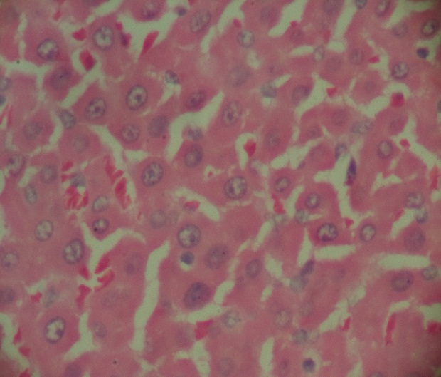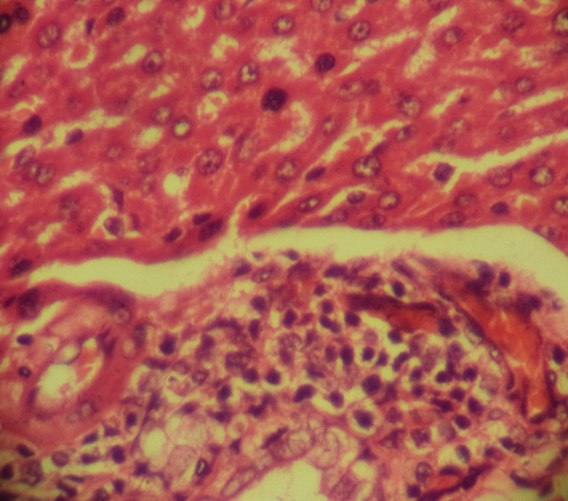
Group 2

Group 1
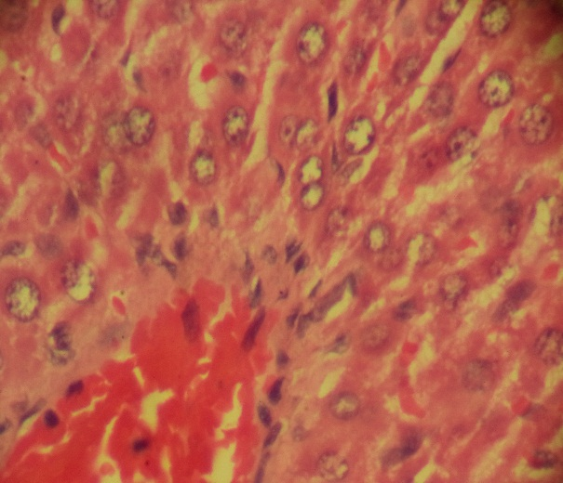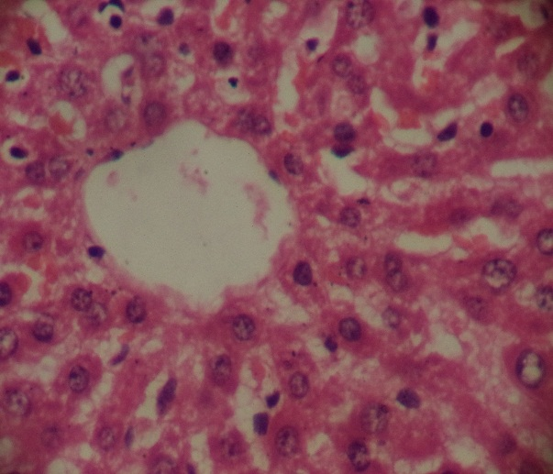
Group 4
Group 3

Plate 3: Liver of Wistar rat from the four groups on day 21. Groups 1, 3 and 4 show normal histology with hepatocytes presenting with their characteristic polygonal shape and interspersed by hepatic sinusoids (black arrows) which are linked to the central vein (black stars). The central vein in group 3 is congested. Group 2 shows tissue degeneration and inflammation as seen by the presence of inflammatory cells (white arrowheads) within the tissue. There is also mild haemorhage (black arrowheads) in group 2. H&E X400.

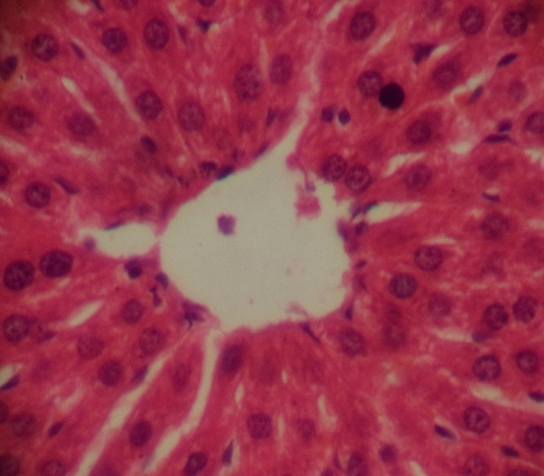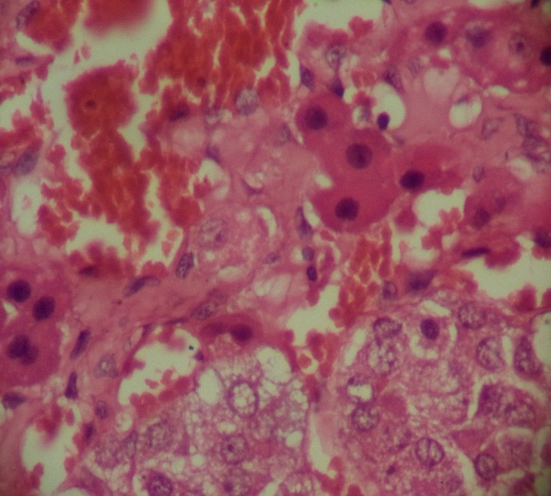
Group 2

Group 1
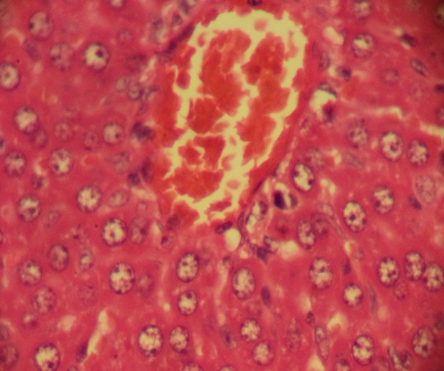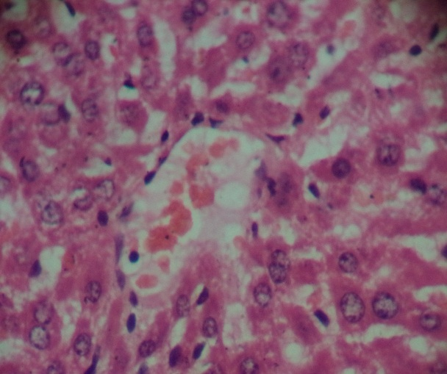
Group 4
Group 3

Plate 4: Liver of Wistar rat from the four groups on day 28. Groups 1, 3 and 4 show normal histology with hepatocytes presenting with their characteristic polygonal shape and interspersed by hepatic sinusoids (black arrows) which are linked to the central vein (black stars). The central vein in group 3 is congested. Group 2 shows generalised tissue degeneration (necrosis) as seen by loss of both nuclear and cytoplasmic components. Some nuclei appear naked (white arrows) while some appear pyknotic (white arrowheads). Hepatic haemorrhage is presented by the presence of red blood cells (black arrowheads) within the hepatic sinusoids. H&E X400.

4. discussion
Paraquat is a highly toxic bipyridyl compound widely utilised as a non-selective herbicide, particularly in developing countries such as Nigeria (Wesseling et al., 2001), although it has been banned or severely restricted in many developed nations (Akram, 2014). Paraquat poisoning may occur either intentionally, most commonly in cases of self-harm, or unintentionally through occupational or accidental exposure. It has been estimated that between 2010 and 2014 there were approximately 110,000 deaths annually due to pesticide self-poisoning, accounting for 13.7% of all global suicides (Mew et al., 2017). Acute paraquat intoxication is associated with a high case-fatality rate, largely owing to the absence of a specific antidote and the limited efficacy of currently available therapeutic interventions (Costa et al., 2013). Consequently, the search for effective antidotal strategies against paraquat toxicity remains an active area of investigation, involving the evaluation of single agents as well as combination therapies (Fan et al., 2013). Experimental evidence indicates that paraquat-induced toxicity is predominantly mediated through oxidative stress–related mechanisms, suggesting that certain natural bioactive compounds with antioxidant properties may attenuate its deleterious effects (Karimi-Khouzani et al., 2017; Nouri et al., 2019). Although pulmonary injury is the most recognised manifestation of paraquat poisoning, the liver represents another major target organ. Paraquat exposure has been shown to induce morphological alterations in hepatic tissue and significant changes in liver enzyme profiles (Edward et al., 2024). Experimental studies in rats have demonstrated histopathological damage accompanied by elevated serum aminotransferase levels, further confirming the hepatotoxic potential of paraquat (Liu et al., 2020). As the world shifts attention towards the one health concept, giving priority to the 3 pillars of Human, animal and environmental safety, there is a need to evaluate paraquat toxicity, with the aim of developing antidotes against it. Research has shown that Vitamin C has the ability to neutralize the free radicals produced following PQ exposure (Awadalla, 2012; Choudhary et al., 2025). The ameliorative effect of vitamin C against Paraquat-induced hepatotoxicity either as a single component, or in combination with other components like , garlic and glutathione have been studied (Ujowundu et al., 2018), but the combination of vitamin C and activated charcoal has not been evaluated. Activated charcoal has been used either as a single compound or in combination with other compounds to manage paraquat toxicity (Wang et al., 2015) but it has not been combined with Vitamin C. Microscopic study on the ameliorative effect of a combination of Vitamin C and activated charcoal on the liver of Wistar rats was carried out to see if the combination would ameliorate Paraquat-induced toxicity on the liver to fill the gap in the quest for finding an antidote against paraquat toxicity (Zhang et al., 2019). It is also aimed at investigating the safety of the combination, so as to create a pathway for further studies, using the same combination.
Liver microscopic architecture in Groups 1 and 4 remained histologically normal throughout the experiment, while group 2 and 3 present different morphological outlook, from day 7, to day 28. From days 7, 14, 21 up to 28, liver from group 2 show massive degeneration (necrosis) and nuclear pyknosis and hepatic haemorrhage ( Plates 1, 2, 3 and 4). The Liver in group 3 showed normal morphology on days 7, 14, 21 and 28 with mild hepatic hypertrophy and central vein congestion on days 21 and 28. Group 3 animals remain physically stable, with normal consumption of feed and water, in comparison with group 2 animals that shows weakness of the body, general reduction in feed and water consumption, paralysis, bloody nasal discharges as well as respiratory distress as from day 24. This agrees with other research that Paraquat also causes alterations in the liver, kidneys, and lungs as well as causes esterification and entry of fatty acids into hepatocytes, leading, eventually, to fatty liver (Pourahmad et al., 2016). The liver constitutes the principal source of endogenous antioxidant systems and plays a central role in enzymatic metabolism and detoxification processes. Owing to its high metabolic activity and continuous exposure to xenobiotics, it is particularly susceptible to injury mediated by reactive oxygen species (ROS). Excessive oxidative stress may overwhelm intrinsic antioxidant defences, resulting in hepatocellular damage and impaired functional integrity. Previous investigations have demonstrated that paraquat (PQ) intoxication induces acute hepatic injury, characterised by sustained elevation of serum aminotransferases and distinct histopathological alterations (Gawarammana and Buckley, 2011; Han et al., 2014). In the present study, mortality was observed predominantly in the paraquat-treated group (Group 2), which recorded three deaths occurring on days 8, 17, and 25, respectively. In contrast, Group 3, which received paraquat followed by adjunctive treatment, recorded a single mortality on day 23, suggesting a comparatively reduced severity of toxic effects. This research has shown that the combination of Vitamin C and Activated charcoal, gives a good result in ameliorating paraquat toxicity. An evaluation of the tissue architecture in the Vitamin C/ Activated charcoal group, shows massive recovery of hepatocytes, as compared to the paraquat group. This has proven that a combination of the antioxidant properties of vitamin C, with the adsorbent properties of activated charcoal, ameliorates paraquat-induced hepatotoxicity. This work agrees with the research done by other researchers who used this combination in evaluating its synergistic ameliorating effect on paraquat-induced toxicity in the lungs and kidney of Wistar rats (Choji et al., 2026^{a,b}).
5. CONCLUSION
This is a novel finding as no such combination has been used before, as ameliorating against paraquat-induced hepatotoxicity. The combination has been proved to be safe at this dosage as seen in group 4 animals which presented with normal tissue architecture as well as physical behavior, throughout the experiment. Further work on adjustment of the dosage is recommended. Also, since activated charcoal is an adsorbent, it is possible it interferes with some portions of the vitamin C, thereby reducing is efficacy. It is recommended that in future work, the administration of the two substance should not be concurrent or the vitamin C can be administered via other routes apart from the oral route, while the activated charcoal is administered via the oral route.
Ethical Approval
Ethical Clearance was obtained from the National Veterinary Research Institute, Vom, Animal Ethics Committee (AEC), where they gave an Animal Ethics Number AEC/02/173/24 after an application and a thorough interview, before the commencement of the work with periodic unannounced visits to the experimental station by members of the ethics committee, until the termination of the experiment.

COMPETING INTERESTS DISCLAIMER:
Authors have declared that they have no known competing financial interests OR non-financial interests OR personal relationships that could have appeared to influence the work reported in this paper.

Disclaimer (Artificial intelligence)
Author(s) hereby declare that NO generative AI technologies such as Large Model (ChatGPT, COPILOT, etc) and text-to-image generators have been used during the writing or editing of this manuscript

References

Adefola, E.T., John, A.A., Sunday, E.S., & Ugochukwu, U. (2024). Histological and Biochemical Effects of Lutein on Paraquat-induced Renal Toxicity in Wistar Rats. Asian Journal of Medicine and Health, 22(11), 56-67. https://doi.org/10.9734/ajmah/2024/v22i111117
Abdel-Tawwab, M., El-Sayed, G. O., Shady, S. H. (2017). Effect of dietary active charcoal supplementation on growth performance, biochemical and antioxidant responses, and resistance of Nile tilapia, Oreochromis niloticus (L.) to environmental heavy metals exposure. Aquaculture, 479, 17-24.
Ahmad, I., Kumar, A., Shukla, S., Prasad Pandey, H., Singh, C. (2008). The involvement of nitric oxide in maneb- and paraquat-induced oxidative stress in rat polymorphonuclear leukocytes. Free Radic Res 42(10):849–862. DOI: 10.1080/10715760802513733.
Akram, R. (2014). Evidence of oxidative damage in paraquat toxicity. Zahedan Journal of Research in Medical Sciences, 16(12), 1-7
Amin, F., Basirat, H., Parvaz, N., Khademalhosseini, M., Hakimizadeh, E., & Fatemi, I. (2025). Protective effects of myrtenol against paraquat-induced toxicity in rats. BMC Pulmonary Medicine. https://doi.org/10.1186/s12890-025-03484-5
Ang, A., Pullar, J. M., Currie, M. J., Vissers, M. C. (2018). Vitamin C and immune cell function in inflammation and cancer. Biochemical Society Transactions, 46(5), 1147-1159.
Avwioro, O. G. (2011). Staining reactions of microwave processed tissues compared with conventional paraffin wax processed tissues. European Journal of Experimental Biology, 1(1), 57-62. https://www.primescholars.com/articles/staining-reactions-of-microwave-processed-tissues-compared-w-90613.html
Awadalla, E. A. (2012). Efficacy of vitamin C against liver and kidney damage induced by paraquat toxicity. Experimental and Toxicologic Pathology, 64(5), 431-434. https://doi.org/10.1016/j.etp.2010.10.009
Baradaran Rahimi, V., Rakhshandeh, H., Raucci, F., Buono, B., Shirazinia, R., Samzadeh Kermani, A., Maione, F., Mascolo, N., & Askari, V. R. (2019). Anti-inflammatory and anti-oxidant activity of Portulaca oleracea extract on LPS-induced rat lung injury. Molecules, 24(1), 139. https://doi.org/10.3390/molecules24010139.
Boonanuntanasarn, S., Khaomek, P., Pitaksong, T., Hua, Y. (2014). The effects of the supplementation of activated charcoal on the growth, health status and fillet composition-odor of Nile tilapia (Oreochromis niloticus) before harvesting. Aquac. Int. 2014;22: 1417–1436.
Carr, A.C., Maggini, S. (2017). Vitamin C and immune function. Nutrients 9 (11): 1211.
Choji , T. P. P., Ogenyi , S. I., Chollom , S. C., Agandu , S. M., Davou , G. I., Moses , G. D., Rimfa, A.G., Obi , E. (2026). Histopathological Assessment of the Ameliorative Effect of a Combination of Vitamin C and Activated Charcoal on Paraquat-Induced Kidney Toxicity in Wistar Rats. Medical and Health Sciences European Journal, 11(1), 24–40. https://doi.org/10.5281/zenodo.18429223
Choji, T.P.P., Ogenyi, S. I., Bot, D.Y., Ahmed, J.S., Teme, R.E., Vandu, C.D., Gyang, J.B., Obi, E. (2026). “Synergistic Ameliorative Effect of Vitamin C and Activated Charcoal on Paraquat-Induced Lung Histotoxicity in Wistar Rats”. Biotechnology Journal International 30 (1):45-57. https://doi.org/10.9734/bji/2026/v30i1821
Choji, T. P. P., Ngokere, A. A., Ogenyi, S. I., & Kumbish, P. R. (2015). Histo-architechtural Evaluation of Conventional Versus Two Rapid Microwave Processing Techniques. British Biotechnology Journal, 8(3), 1-19. https://doi.org/10.9734/BBJ/2015/18948
Choudhary, S., Kanwar, A., Mathur, P., Saini, M.K. , Gupta, P. (2025). Protective Effect of Vitamin C Against the Paraquat-Mediated Toxic Effects on Different Morphometric and Biochemical Parameters in Chick Embryos of Gallus Domesticus. Journal of Chemical Health risk. 15(4), 770-779
Costa, M. D., de Freitas, M. L., Dalmolin, L., Oliveira, L. P., Fleck, M. A., Pagliarini, P., & Brandão, R. (2013). Diphenyl diselenide prevents hepatic alterations induced by paraquat in rats. Environmental Toxicology and Pharmacology, 36(3), 750-758.
Debnath, A., Ali, M.A., Newmai, K., Madhuri, P., Azyu, R.Z., Malsawmsangi (2024). Effective management of wistar rats in laboratory research: A Brief Review. Int. J. Adv. Biochem. Res. 8(12S):654-659.
Edo, G. I. (2022). Effects of paraquat dichloride on adult male wistar rat. An approach in the toxicity of body weights and hematological tissues. Journal of Analytical & Pharmaceutical Research, 11(1), 1–7. https://doi.org/10.15406/japlr.2022.11.00394
Edward, T.A., Ajibade, A.J., Edward, S.S., Umeaku U. (2024). Histological and biochemical effects of Lutein on the liver of adult Wistar rats following Paraquat-induced toxicity. Journal of Experimental and Clinical Anatomy, 21(2), 317-323. https://doi.org/10.4314/jeca.v21i2.24
Eftekhari, A., Hasanzadeh, A., Khalilov, R., Hosainzadegan, H., Ahmadian, E., Eghbal, M.E (2020). Hepatoprotective role of berberine against paraquat-induced liver toxicity in rat. Environ Sci Pollut Res 27, 4969–4975 (2020). https://doi.org/10.1007/s11356-019-07232-1
Fan, H. N., Wang, H. J., Yang-Dan, C. R., Ren, L., Wang, C., Li, Y. F., & Deng, Y. (2013). Protective effects of hydrogen sulfide on oxidative stress and fibrosis in hepatic stellate cells. Molecular Medicine Reports, 7(1), 247-253.
Gao, Y., Zhang, B., Yuna, D.,Che, L., Sun, C., Duan, G., Xu, Z. (2022) Successful Treatment of Severe Toxic Hepatitis and Encephalopathy Without Respiratory Failure Caused by Paraquat Intoxication. The American Journal of the Medical Sciences, 363 (3), 267 - 272
Gawarammana, I. B., & Buckley, N. A. (2011). Medical management of paraquat ingestion. British Journal of Clinical Pharmacology, 72(5), 745-755. https://doi.org/10.1111/j.1365-2125.2011.04026.x
Griffin, J.B., Stanley, J.S., Zempleni, J. (2002): Synthesis of a rabbit polyclonal antibody to the human sodium-dependent multivitamin transporter. Int J Vitam Nutr Res. 72(4):195-198.
Han, J., Zhang, Z., Yang, S., Wang, J., Yang, X., & Tan, D. (2014). Betanin attenuates paraquat-induced liver toxicity through a mitochondrial pathway. Food and chemical toxicology, 70, 100-106.
Haripriya, B., Lakshman, M., & Sudha, V. (2017). Influence of Paraquat (PQ) Induced Acute Toxicity On Body Weights And Haemotobiochemical Parameters In Experimental Rats. International Journal of Scientific Research, 6(7), 396–398. https://doi.org/10.36106/ijsr.
Hassen, J., Abdulkadir, H. (2022). Recent developments in the use of activated charcoal in medicine. Journal of Medical Science https://doi.org/10.20883/medical.e647.
Hernandez-Baixauli, J., Chomiciute, G., Tracey, H., Mora, I., Cortés-Espinar, A. J., Ávila-Román, J., Abasolo, N., Palacios-Jordan, H., Foguet-Romero, E., Suñol, D., Galofré, M., Alcaide-Hidalgo, J. M., Baselga-Escudero, L., Del Bas, J. M., & Mulero, M. (2024). Exploring Metabolic and Gut Microbiome Responses to Paraquat Administration in Male Wistar Rats: Implications for Oxidative Stress. Antioxidants, 13(1), 67. https://doi.org/10.3390/antiox13010067
Ijaz, M.U., Qamer, M., Hamza, A. Ahmed, H., Sfsar, T., Abulmeaty, M., Ayub, A., & Razak, S. (2023). Sciadopitysin mitigates spermatological and testicular damage instigated by paraquat administration in male albino rats. Sci Rep 13, 19753.
Jain, R., Bhalla, A. S., Naranje, P., Vyas, S., Rewari, V., Banday, I. A., & Jana, M. (2022). Ingestion poisoning related lung injury- a pictorial review. Emergency Radiology, 29(4), 757-767. https://doi.org/10.1007/s10140-022-02044-2.
Karimi-Khouzani, O., Heidarian, E. & Amini, S.A. (2017) Anti-inflammatory and ameliorative effects of gallic acid on fluoxetine-induced oxidative stress and liver damage in rats. Pharmacol. Rep 69, 830–835. https://doi.org/10.1016/j.pharep.2017.03.011
Kavianinia, M., Kalantar, H., Salehcheh, M., Khorsandi, L., Shariati, S., Mohtadi, S., Khodayar, M.J. (2025) et al. Dimethyl fumarate effects on paraquat-induced hepatotoxicity in mice via anti-oxidative, anti-inflammatory, and anti-apoptotic activities. Sci Rep 15, 3897 (2025). https://doi.org/10.1038/s41598-025-88461-y
Kim, S. J., Gil, H. W., Yang, J. O., Lee, E. Y., & Hong, S. Y. (2009). The clinical features of acute kidney injury in patients with acute paraquat intoxication. Nephrology Dialysis Transplantation, 24(4), 1226-1232.
Kotal, S., Chatterjee, S., Pain, S., Kundu, A.K. (2025) A Prospective Study to Assess the Profile and Outcome of Acute Paraquat Poisoning in a Tertiary Care Hospital of West Bengal. Indian J Crit Care Med; 29 (8):677-683. DOI: 10.5005/jp-journals-10071-25026.
Lewis, S. M., Ullrey, D. E., Barnard, D. E., & Knapka, J. J. (2006). Nutrition. In M. A. Suckow, S. H. Weisbroth, & C. L. Franklin (Eds.), The laboratory rat (pp. 219-301). Elsevier Academic Press. https://doi.org/10.1016/B978-012074903-4/50012-1
Li, Y., & Schellhorn, H. E. (2007). New developments and novel therapeutic perspectives for vitamin C. The Journal of nutrition, 137(10), 2171–2184. https://doi.org/10.1093/jn/137.10.2171
Liu, Z., Wang, X., Li, L., Wei, G., & Zhao, M. (2020). Hydrogen Sulfide Protects against Paraquat-Induced Acute Liver Injury in Rats by Regulating Oxidative Stress, Mitochondrial Function, and Inflammation. Oxidative medicine and cellular longevity, 2020, 6325378. https://doi.org/10.1155/2020/6325378
Mazurek, A., Pankiewicz, U. (2012). Changes of dehydroascorbic acid content in relation to total content of vitamin C in selected fruits and vegetables. Acta Scientiarum Polonorum. Hortorum Cultus, 11(6).
Mehta, P., Annam, R.S., & Hadiyel, I. (2025). Catastrophic Outcomes: Rapid Multi-Organ Failure from Paraquat Poisoning- A Case Report. Nigerian Medical Journal, 66(2), 811–817. https://doi.org/10.71480/nmj.v66i2.730
Mew, E. J., Padmanathan, P., Konradsen, F., Eddleston, M., Chang, S. S., Phillips, M. R., & Gunnell, D. (2017). The global burden of fatal self-poisoning with pesticides 2006-15: systematic review. Journal of affective disorders, 219, 93-104.
Mondal, H., Mondal, S., Saha, K., & Roul, B. (2019). Development of a Low-cost Smartphone-connected Digital Microscope. Journal of Microscopy and Ultrastructure, 8(2), 51–54. https://doi.org/10.4103/JMAU.JMAU_35_19
Mortaz, E., Bezemer, G., Alipoor, S.D., Varahram, M., Mumby, S., Folkerts, G., Garssen, J., Adcock, I.M. (2021) “Nutritional impact and its potential consequences on COVID-19 severity”, Frontiers in Nutrition, 8. 698617.
National Population Commission (2006). 2006 Population and Housing Census, Priority Table IV. National Population Commission, Nigeria. http://www.population.gov.ng
Neeth, R.S., Reddy, M.J., Batra, S., Srivastava, S.K., Syal, K. (2022) “Vitamin C and its therapeutic potential in the management of COVID19”, Clinical Nutrition ESPEN, 50. 8-14.
Nouri, A., Heidarian, E., Amini-Khoei, H., Abbaszadeh, S., & Basati, G. (2019). Quercetin through mitigation of inflammatory response and oxidative stress exerts protective effects in rat model of diclofenac-induced liver toxicity. J Pharm Pharmacogn Res, 7(3), 200-212.
Nwafor, J., Umudu, J., Oviosun, A., & Uchewa, O. (2020). Effect of virgin coconut oil on the kidney of wistar rats exposed to toxic dose of paraquat. International Journal of Medical Reviews and Case Reports, 4(5), 136-140. https://doi.org/10.5455/IJMRCR.virgin-coconut-oil-the-kidney-wistar-rats
Okolonkwo, B. N., Brisibe, N., & George-Opuda, I. M. (2023). Ameliorative Effect of Vitamin E and C on Paraquat Induced Nephrotoxicity in Rat. Healthcare Studies, 1(1), 1–6. https://doi.org/10.58612/hs111
Okolonkwo, B. N. (2022). The effect of combined vitamin treatment on paraquat-inflicted liver damage. Asian Journal of Biochemistry, Genetics and Molecular Biology, 12(4), 132-138. https://doi.org/10.9734/ajbgmb/2022/v12i4278.
Olson, K. R. (2010). Activated charcoal for acute poisoning: one toxicologist's journey. Journal of medical toxicology: official journal of the American College of Medical Toxicology, 6(2), 190–198.
Oudemans-van Straaten, H.M., Man, A.M.Sd. & de Waard, M.C. Vitamin C revisited. Crit Care 18, 460 (2014). https://doi.org/10.1186/s13054-014-0460-x.
Pedroso, A. L., Canal, R., Gehrke, S. A., da Costa, E. M., Scarano, A., Zanelatto, F. B., & Pelegrine, A. A. (2025). The Validation of an Experimental Model in Wistar Female Rats to Study Osteopenia and Osteoporosis. Bioengineering, 12(7), 702. https://doi.org/10.3390/bioengineering12070702
Pourahmad, M., Jahromi, H.K., Jahromi, Z.K., Sameni, M.H., Abedi, H., Kherameh, Z.K., Mohammadi, S & Hosseini, M.A. (2016). The protective effect of Aloe vera on paraquat hepatotoxicity. International Journal of Medical Research & Health Sciences, 5, 5(S):253-258
Reddy, K. B. A. K., Jeevanalatha, M., Lakshman, M., & Rani, M. U. (2019). The toxic effects of Paraquat on body weights and haematological parameters in male albino wistar rats and its amelioration with vitamin C. International Journal of Current Microbiology and Applied Sciences, 8(11), 314–320. https://doi.org/10.20546/ijcmas.2019.811.039
Reed, D. R., Duke, F. F., Ellis, H. K., Rosazza, M. R., Lawler, M. P., Alarcon, L. K., & Tordoff, M. G. (2011). Body fat distribution and organ weights of 14 common strains and a 22-strain consomic panel of rats. Physiology & Behavior, 103(5), 523–529. https://doi.org/10.1016/j.physbeh.2011.04.006
Roberts, T. R., Dyson, J. S., & Lane, M. C. (2002). Deactivation of the biological activity of paraquat in the soil environment: a review of long-term environmental fate. Journal of Agricultural and Food Chemistry, 50(13), 3623-3631.
Shimada, H., Hirai, K., Simamura, E., Hatta, T., Iwakiri, H., Mizuki, K., Hatta, T., Sawasaki, T., Matsunaga, S., Endo, Y., Shimizu, S. (2009). Paraquat toxicity induced by voltage-dependent anion channel 1 acts as an NADH dependent oxidoreductase. J Biol Chem.;284 (42):28642-28649.
Tan, J. T., Letchuman Ramanathan, G. R., Choy, M. P., Leela, R., & Lim, B. K. (2013). Paraquat poisoning: experience in hospital taiping (year 2008-october 2011). Med J Malaysia, 68(5), 384-8.
Turner, P. V., Pekow, C., Vasbinder, M. A., & Brabb, T. (2011). Administration of substances to laboratory animals: Equipment considerations, vehicle selection, and solute preparation. Journal of the American Association for Laboratory Animal Science, 50(5), 614–627. https://www.ncbi.nlm.nih.gov/pmc/articles/PMC3189663/
Ujowundu, C.O., Nwaogu, L.A., Ujowundu, F.N., Oparaeche, N.N., Oyarebu, A.O. (2018) Hepatotoxicity of Paraquat Dichloride and Ameliorative Effect of Nutritional Supplements. Biochem Mol Biol J 4(3):21.
Wesseling, C., Corriols, M., & Bravo, V. (2005). Acute pesticide poisoning and pesticide registration in Central America. Toxicology and Applied Pharmacology, 207(2 Suppl), 697–705. https://doi.org/10.1016/j.taap.2005.03.033
Vetvicka, V., & Vetvickova, J. (2012). Glucan–Resveratrol–Vitamin C Combination Offers Protection against Toxic Agents. Toxins, 4(11), 1301-1308.
Wang, W., Li, J., Ma, G., Li, N., Wang, P., Xiao, Q., & Li, W. (2015). Effect of rhubarb as the main composition of sequential treatment in patients with acute paraquat poisoning: a prospective clinical research. Zhonghua wei zhong bing ji jiu yi xue, 27(4), 254-258.
Wesseling, C., De Joode, B. V. W., Ruepert, C., León, C., Monge, P., Hermosillo, H., & Partanen, L. J. (2001). Paraquat in developing countries. International journal of occupational and environmental health, 7(4), 275-286.
World Health Organization (2023). The selection and use of essential medicines 2023: web annex A: World Health Organization model list of essential medicines: 23rd list (2023). Geneva: World Health Organization. hdl:10665/371090. WHO/MHP/HPS/EML/2023.02.
Zellner, T., Prasa, D., Färber, E., Hoffmann-Walbeck, P., Genser, D., Eyer, F. (2019). The Use of Activated Charcoal to Treat Intoxications. Deutsches Arzteblatt international, 116(18), 311–317.
Zhang, L., Xu, C., Han, H., Askew, S., Ervin, E., Yu, Q., & Wang, K. (2025). What Is New for the Mechanisms of Plant Resistance to Paraquat After Decades of Research? Agriculture, 15(12), 1288. https://doi.org/10.3390/agriculture15121288.
Zhang, X., Xu, X., Li, S., Li, L., Zhang, J., & Wang, R. (2019). A Synthetic Receptor as a Specific Antidote for Paraquat Poisoning. Theranostics, 9(3), 633–645. https://doi.org/10.7150/thno.31485

