Diversity and distribution of ecto and gastrointestinal parasites in domestic rabbits from the Grand-Ouaga, Burkina Faso

Abstract :
In Burkina Faso, livelihoods rely strongly on the primary sector such as livestock farming. Owing to their high reproductive potential, rapid growth, and relatively low production costs, rabbit farming appeared increasingly as a sustainable source of income and animal protein. However, rabbits are frequently affected by parasitic infections, which can impede their productivity. In Burkina Faso, data on the parasite fauna associated with rabbit remains scarce. The present study aimed to assess the diversity of parasites infecting domestic rabbits in Ouagadougou and its surrounding peri-urban areas. From June to October 2025, 30 domestic rabbits were examined for parasite collection. A total of 438 individuals parasites were collected. Two species of gastrointestinal Nematoda (Passalurus ambiguruus, Passalurus sp.) and one species of ectoparasitic Achnida (Rhipicephalus sp.) were identified. The overall prevalence and mean intensity of infection were 33.33% and 43.8 parasites per infected host, respectively. The Infection level varied significantly among digestive tract organs, with the cecum and colon exhibiting the highest infection, while no infection was observed in stomach and small intestine. The Nematoda Passalurus ambiguruus was both the most frequent and the most abundant species recorded. The results revealed substantial parasite loads in the rabbit cecum, which may negatively affect rabbit farming given the central role of this organ in digestion and nutrient absorption. These findings highlight the importance of gastrointestinal parasitism in domestic rabbits and provide baseline data on rabbit parasitism. They may contribute to supporting future research on rabbit farming and to improving sustainable development of rabbit production in Burkina Faso.
Keywords : Domestic rabbit, Burkina Faso, gastrointestinal parasite, ectoparasite

- Introduction
Burkina Faso is a landlocked country where the majority of the population lives in the rural areas and is engaged in primary sector (MARAH, 2021). Rural livelihoods depend on the primary sector such as agricultural activities for both economic stability and social well-being (FAO, 2019; Zoma-Traoré et al., 2020; Valerio, 2020; Dimon et al., 2025). Within the primary sector, livestock farming represents the second most important economic activity after crop production, particularly cotton (Sanou et al., 2024) and accounting for about 10 to 20 percent of the country’s Gross Domestic Product (GDP) (FAO, 2018). Livestock farming including a great potential common animal resources such as cattle, sheep, goats, and poultry aims among other objectives to provide the organic element to enrich cropland, to make optimal use of crop residues and household by-products and above all, to contribute to animal protein supply, to generate income for healthcare expenses, children education and family’s daily needs (Zoma-Traoré et al., 2020; Valerio, 2020; Dimon et al., 2025). However, facing challenges including climate change and population growth, rabbit farming emerged as a promising alternative to strengthen food security and improve nutrition worldwide (Serem et al., 2013; Mutsami and Karl, 2020; Devaki, 2021). Rabbit farming represents an important component of small-scale livestock production in many developing countries, including Burkina Faso, where it contributes to food security, household income, and nutritional diversification (Giovannini et al., 2024). Due to their high reproductive potential, rapid growth, and relatively low production costs, farmed rabbits are increasingly promoted in urban and peri-urban areas as a sustainable source of animal protein (Mutsami and Karl, 2020 ; Wongnaa et al., 2023; Johnson et al., 2024). However, rabbit farming is often constrained by several sanitary challenges, among which parasitic infections represent a major threat to animal health and farm productivity (Licois and Marlier, 2008). Ectoparasites and mesoparasites are ubiquitous pathogens affecting farmed rabbits. These parasites can cause dermatological lesions, anemia, tissue damage, immunosuppression, diarrhea and can also favorit secondary bacterial infections, ultimately leading to reduced growth performance and increased mortality. Thereby, these pathogen require particular attention in terms of diagnosis, prevention, and treatment. Despite these conditions, data on the diversity, prevalence, and distribution of ectoparasites and mesoparasites associated with farmed rabbits in Burkina Faso remain scarce or fragmented. A comprehensive understanding of parasite communities affecting farmed rabbits is essential for improving animal health management, optimizing production, and designing effective control strategies. Therefore, the present study aims to investigate the ectoparasite and mesoparasite fauna associated with farmed rabbits in Ouagadougou and its peri-urban areas, with a focus on assessing parasite diversity and prevalence.
- Materials and Methods
2.1 study site
The study was conducted in Ouagadougou and its surrounding areas which represent the Grand-Ouaga.
2.2 Sample collection
Host rabbit sampling
Rabbit of different ages, sexes and physiological categories were purchased from farmers at each sampling site from June to October 2025. Animals were transported to the Laboratory of Animal Biology and Ecology (LBEA) at Université Joseph KI-ZERBO. In the laboratory, each specimen was first observed to collect external parasites, then it was slaughtered and it digestive tract was removed for observation.
Collection and identification of external parasites
Rabbit bodies were carefully inspected for external parasites collection. Observed ectoparasites were removed using fine forceps and preserved in Eppendorf tubes containing 70% alcohol for further identification. Some Ticks were collected and identified following the taxonomic keys of Walker et al. (2014).

Collection and identification of internal parasites
Once the rabbit is slaughtered, digestive tract was removed. The stomach, small intestine, cecum and colon of each rabbit were detached and immersed in saline water (9‰) in a separate container. Each part was fully examined. Any parasites found were collected. Parasites were first sorted according to major groups (phyla). While some specimens were mounted fresh under the microscope between a slide and coverslip for measurement and observation of some structures not observable in fixed worms. All parasite individuals were preserved in Eppendorf tubes containing 70% alcohol and labeled for further processing.
Morphometric measurements of the collected gastrointestinal parasites were taken using a ZEISS optical microscope equipped with an optical micrometer. Nematoda were identified following the taxonomic keys of Gibbons (2010).
Data Processing and Statistical Analysis
The data obtained were entered into Microsoft Excel 2013 and analyzed using SPSS (SPSS Inc., 2010). Species richness was defined as a compiled list of parasite species recorded for the all sample, while abundance represented the sum of total parasite individuals. Parasitic infestation parameters defined according to Bush et al. (1997) were determined, namely prevalence (P), intensity (I).
Prevalence is defined as the number of hosts infected by one or more individuals of the parasite (N) divided by the number of hosts examined (H). It is calculated using the following formula 1:
P (%) = N* 100/H (1)
Intensity (I) is the total number of parasites (A) found in host species divided by the number of parasitized hosts (N). It is calculated using the following formula 2:
I = A/N (2)
The regularity of the parasite is an important measure of infection rarity and commonness. It is estimated by the occurrence rate (F) and used to evaluate parasitic composition in the examined rabbits. F is calculated using formula (3) based on a presence/absence matrix. Species were classified as constant (F>50%), accessory (25% <F< 50%), and occasional (F<25%) (Dajoz, 1983).
F= n_{i}*100/N (3)
(N= total number of examined host; n_{i}= number of host where the parasite i is recorded)
Tables and figures were used to illustrate the trends of these parameters according to the attachment sites of the parasites
Differences in prevalence according to attachment site were assessed using Fisher’s Exact Test. The level of statistical significance for analysis was set at 5%.

- Results
3.1 Prevalence, diversity and abundance of parasites
In total, thirty (30) rabbits were examined for parasite infection. Of these, ten rabbits were infected, which represented a prevalence of 33.33%. The rest of the animals were parasite free. A total of 438 individuals of parasites were collected, resulting in a mean intensity of 43.8 parasites per infected host. The collected parasites are presented in Table 1. Overall, two parasite genera were identified: Rhipicephalus and Passalurus, comprising one genus of ectoparasites and one genus of gastrointestinal parasites, respectively.
The ectoparasite comprised one species, namely Rhipicephalus sp., whereas two species were identified in the gastrointestinal tract : Passalurus ambiguus and Passalurus sp.
Table 1 : Overview of the recorded parasites
Classes | Parasites | abundances
Nematoda | Passalurus ambiguus | 377
Nematoda | Passalurus sp. | 56
Arachnida | Rhipicephalus sp. | 5

  - Relative frequency of parasites
Figure 1 presents the relative distribution of parasite species collected during this study. The results showed a strong dominance of the gastrointestinal parasite Passalurus ambiguus, which accounts for 86.07% of the total recorded parasites (Figure 1b). It was followed by Passalurus sp (12.78). The ectoparasite, Rhipicephalus sp. was less represented, accounting for only 1.14%.
The results of Figure 1a revealed a marked predominance of gastrointestinal parasites, which account for 98.86% of the total recorded parasites. Ectoparasites are poorly represented in the studied animals.
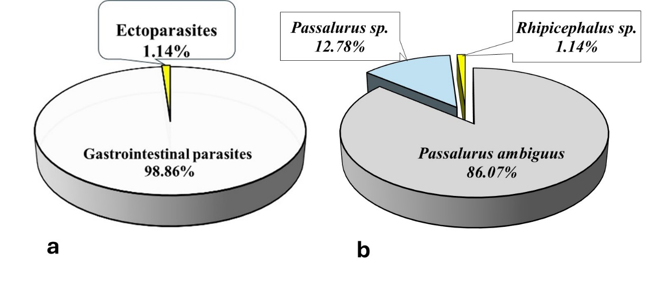
Figure 1: structure of the parasite community in the examined rabbits

  - Occurrences of Parasites
Figure 2 shows the occurrence of parasites in the examined rabbits. Passalurus ambiguus was the most frequently encountered species during this study (26.67%), followed by Passalurus sp. (13.33%). In contrast, Rhipicephalus sp. exhibited the lowest occurrence (6.67%). With an occurrence rate greater than 25%, Passalurus ambiguus can be classified as an accessory parasite species in rabbits. The two remaining parasites recorded occurrence rates less than 25% and are therefore considered accidental species.

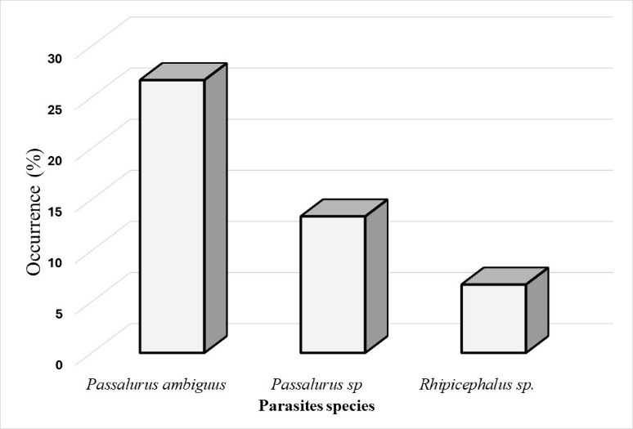
Figure 2 : Occurrence of parasites in the examined rabbits

  - Gastrointestinal parasites distribution
Regarding gastrointestinal parasite distribution along the digestive tract, both species (Passalurus ambiguus, Passalurus sp.) were observed in both the cecum and the colon. No parasites were recorded in the other section of the digestive tract. In total, 400 individuals of parasites were recorded from the ceca of eight rabbits, resulting in a mean intensity of 50 parasites per infected cecum, whereas, 33 individuals of parasites were detected in the colons of six rabbits, corresponding to a mean intensity of 5.5 parasites per infected colon.
Statistical analysis revealed significant differences in parasite infection among the four organs (stomach, small intestine, cecum and colon) of the digestive tract examined (Fisher’s Exact Test, P=0.000<0.05). Pairwise comparisons using Fisher’s Exact Test showed that the cecum and colon were significantly more likely to be infected than stomach and small intestine. However, no significant difference was observed between parasite infections of cecum and colon (Fisher’s Exact Test, P=0.76˃0.05).

- Discussion
The present study provides a comprehensive overview of parasites infecting rabbits in the sampling area. The results revealed that parasitic infection is common in the studied population (33.33%), although not all individuals were affected. However, these findings are relatively lower than those reported in previous studies conducted in wild rabbits (Frank et al., 2013 ; Marhoon et al., 2018) and farmed rabbits (Kornaś et al., 2015 ; Mokhoro et al., 2023). Differences in prevalence among studies are often attributed to environmental conditions, management practices, seasonality, host age, and diagnostic methods (Bush et al., 1997 ; Jansen et al., 2020).
Previous studies have reported that infection with nematode Passalurus are generally considered non-pathogenic (Elshahawy and Elgoniemy 2018 ; Hughes, 2024). However, the substantial parasite burdens observed in the present study, characterized by a the high total number of parasites collected (438 individuals) and the high mean intensity (43.8 parasites per infected host), suggest that mechanical irritation of the intestinal mucosa and disruption of normal digestive processes may occur. These high parasite intensities may also negatively affect host health by impairing nutrient absorption, growth, and overall productivity.
In the present study, the parasite fauna identified was characterized by low taxonomic diversity, with only two genera recorded, namely Passalurus (gastrointestinal parasites) and Rhipicephalus (ectoparasites). These results contrast with previous studies conducted in Osun State, southwestern Nigeria (Ola-Fadunsin et al., 2018) and in other parts of the world, reported higher parasite diversity in rabbits, including various genera of Helminths, Protozoa and ectoparasites (Frank et al., 2013 ; Szkucik et al., 2014 ; Hajipour and Zavarshani, 2020).
The high relative frequency of P. ambiguus and the marked predominance of gastrointestinal parasites (98.86%) highlight the central role of endoparasites in rabbit parasitism. This dominance is likely related to the direct life cycle of P. ambiguus, which facilitates transmission through ingestion of embryonated eggs from contaminated environments during cecotrophy (Hughes, 2024). The analysis of parasite occurrence further supports this pattern : P. ambiguus was classified as an accessory parasite (F˃25%), whereas the remaining species were considered accidental due to their lower occurrence rates (F<25). These findings are in consistent with previous studies which highlighted the predominance of P. ambiguus among nematode infecting rabbits (Kornaś et al., 2015 ; Marhoon et al., 2018). The low occurrence of Rhipicephalus sp. suggests limited exposure of rabbits to tick-infested habitats. However, the epidemiological importance of ticks should not be underestimated given their role as vectors of pathogens (Walker et al., 2014).
The study revealed that gastrointestinal parasites were present exclusively in the cecum and colon, with no parasites detected in the stomach or small intestine. These findings are in line with previous studies which detected nematoda Passalurus exclusively in the cecum and colon (Frank et al., 2013 ; Szkucik et al., 2014 ; Kornaś et al., 2015 ; Marhoon et al., 2018 ; Hajipour and Zavarshani, 2020 ; Mokhoro et al., 2023). The cecum represented the primary site of infection, showing the highest parasite abundance and intensity. This observation aligns with the physiology of the rabbit digestive system, in which the cecum serves as the main site of microbial fermentation and provides favorable conditions for parasite survival due to its nutrient-rich content and slow transit time (Hu et al., 2021). Statistical analyses revealed significant differences in parasite infection along digestive tract sections, with the cecum and colon being significantly more infected than the stomach and small intestine. The absence of parasites in the upper digestive tract may be attributed to unfavorable conditions such as acidic pH, digestive enzymes, and rapid intestinal transit, which limit parasite establishment. Although no significant difference was observed between infections of the cecum and colon, the cecum harbored a substantially higher parasite load, confirming its favorable environment for parasites development.

Conclusion
The present study demonstrates that domestic rabbits are affected by both ectoparasites and gastrointestinal parasites. It highlights that rabbit parasite fauna is particularly dominated by Passalurus ambiguus, with a marked aggregation in the cecum. The high mean intensity of parasites in the cecum, a critical organ for rabbit digestion and nutrient absorption undercores the potential impact on rabbit farming and calls for improving sanitary management of the rearing environment.
Disclaimer (artificial intelligence)
Author(s) hereby declare that NO generative AI technologies such as Large Language Models (ChatGPT, COPILOT, etc.) and text-to-image generators have been used during the writing or editing of this manuscript.

References
Bush, A. O., Lafferty, K. D., Lotz, J. M., & Shostak, A. W. (1997). Parasitology Meets Ecology on Its Own Terms: Margolis et al. Revisited. The Journal of Parasitology, 83(4), 575–583. https://doi.org/10.2307/3284227
Dajoz, R. (1983). Ecologia Geral. Vozes, Petrópolis: 471 p.
Devaki, K., Senthilkumar, K. & Nisha, P. (2021) ‘Impact of backyard rabbit rearing among rural youth to enhance the livelihood status in Kancheepuram district of Tamil Nadu’, International Journal of Current Microbiology and Applied Science, 10, pp. 491–6.
Dimon, E., Toukourou, Y., Diogo, R. V. C., Kinkpe L., Assogba, B. C. G., Seidou, A. A., Bougouma-Yameogo, V. M. C., & Traoré, I. A. (2025). Women’s Contributions to Livestock in West Africa. J. Anim. Health Prod. 13(1): 1-11. DOI: 10.17582/journal.jahp/2025/13.1.1.11
Elshahawy, I, Elgoniemy, A. (2018). An epidemiological study on endoparasites of domestic rabbits (Oryctolagus cuniculus) in Egypt with special reference to their health impact. Sains Malays, 47 (1), 9-18, DOI : http://dx.doi.org/10.17576/jsm-2018-4701-02
FAO (2018). Élevage durable en Afrique 2015. Transformation du Secteur de l’élevage au Burkina Faso. Que révèlent les projections à long terme ? https://www.fao.org/3/CA2681FR/ca2681fr.pdf
FAO (2019). Le devenir de l’élevage au Burkina Faso. Opportunités et défis face aux incertitudes. Rome. 56 p. Licence: CC BY-NC-SA 3.0 IGO
Frank, R., Kuhn, T., Mehlhorn, H., Rueckert, S., Pham, D., & Klimpel, S. (2013). Parasites of wild rabbits (Oryctolagus cuniculus) from an urban area in Germany, in relation to worldwide results. Parasitol Res 112:4255–4266 DOI 10.1007/s00436-013-3617-7
Gibbons, L. M. (2010). Keys to the nematode parasites of vertebrates: Supplementary volume. CABI. https://www.cabi.org/bookshop/book/9781845935719
Giovannini, S., Chiattelli, D., Mancinelli, C. A., Dal Bosco, A., Sarti, M. F., Sunzini, P., Bedini, F., & Castellini, C. (2024) Unlocking the potential of local rabbit population : morphological insights for sustainable rabbit farming in Burkina Faso’s challenging environments, Italian Journal of Animal Science, 23:1, 523-531, DOI: 10.1080/1828051X.2024.2329719
Hajipour, N., & Zavarshani, M. (2020) Ectoparasites and endoparasites of New Zealand white rabbits from North West of Iran. Iran J Parasitol. 15(2):266.
Hu, X. F., Wang, F., Yang, S. S., Yuan, X., Yang, T.Y., Zhou, Y. X., & Li, Y., (2021). Rabbit microbiota across the whole body revealed by 16S rRNA gene amplicon sequencing. BMC Microbiol ;21:312 DOI : https://doi.org/10.1186/s12866-021-02377-x
Hughes, K. (2024). Endoparasites of rabbits and hares. Journal of Veterinary Diagnostic Investigation 36, (5), 599-616 https://doi.org/10.1177/10406387241261991
Jansen, M. S., Nyangiwe, N., Yawa, M., Dastile, M., Mabhece, V., Muchenje, V., & Mpendulo, T. C. (2020). Prevalence and seasonal variation of gastrointestinal nematodes and coccidia infection ovine grazing on communal rangelands in the Eastern Cape, South Africa. Parasitol Res.119:4169- 4175.
Johnson, K. E., Hayes, J., Davidson, P., Tinago, C. B., & Anguyo, G. (2024). ‘Never cry for food’: food security, poverty, and recurring themes in news media regarding rabbit farming in East Africa. Renewable Agriculture and Food Systems 39, e2, 1–12. https://doi.org/10.1017/S1742170523000480
Kornaś, S., Kowal, J., Wierzbowska, I., Basiaga, M., Nosal, P., & Niedbała, P. (2015). The Alice –Follow the White Rabbit” – parasites of farm rabbits based on coproscopy. Annals of Parasitology, 61(4), 257–261, DOI : doi: 10.17420/ap6104.16
Licois, D. & Marlier, D. (2008). Pathologies infectieuses du lapin en élevage rationnel. INRA Prod. Anim., 21 (3), 257-268
MARAH (2021). Enquête nationale sur le cheptel (ENC1) (2018). Rapport d’analyse. Burkina Faso.
Marhoon, A.I., Mattar, Th. K., & Mohammad, I.F. (2018). Parasitic Infection in Wild Rabbits Oryctolagus Cuniculus . Eurasian Journal of Analytical Chemistry, 13(5), DOI : https://doi.org/10.29333/ejac/95252
Mokhoro, G., M., Moiloa, J., M., Letsie, D., M., Senoko, C., S., & Maphathe, P., L. (2023). Rabbit Gastrointestinal Parasites Prevalence and Farmer’s Knowledge in Maseru District, Lesotho. Asian J. Res. Animal Vet. Sci., vol. 6, no. 3, pp. 231-240
Mutsami, C., & Karl, S. (2020). Commercial rabbit farming and poverty in Urban and peri-urban Kenya. Front Vet Sci. 7:353. doi: 10.3389/fvets.2020.00353.
Ola-Fadunsin, S., D., Hussain, K., Rabiu, M., & Ganiyu, I., A. (2018). Parasitic conditions of domestic owned rabbits in Osun State, southwestern Nigeria: Retrospective evaluation, risk factors and co-infestations. Int J Vet Sci Med., 6(2):208-212. doi: 10.1016/j.ijvsm.2018.06.002.
Sanou, L., Delma, J., Barry, F., Diawara, S., Thiombiano, N., Yamkoulga, M., & Koala, J. (2024). Factors influencing agropastoralists’ adoption of fodder banks in the Central West Region of Burkina Faso, West Africa. Ethnobotany Research and Applications 29:23, DOI :http://dx.doi.org/10.32859/era.29.23.1-14
Serem, J. K., Wanyoike, M. M., Gachuiri, C. K., Mailu, S. K., Gathumbi, P. K., Mwanza, R. N. & Borter, D. K. (2013) ‘Characterization of rabbit production systems in Kenya’, Journal of Agricultural Science and Applications, 2, pp. 155–9.
SPSS Inc., (2010. IBM SPSS Statistics 19 Algorithms. Chapter CROSSTABS Algorithms 153-172.
Szkucik, K., Pyz-Łukasik, R., Szczepaniak, O.,K., & Paszkiewicz, W. (2014). Occurrence of gastrointestinal parasites in slaughter rabbits. Parasitol Res, 113:59–64 DOI 10.1007/s00436-013-3625-7
Valerio, V. C. (2020). “The Structure of Livestock Trade in West Africa”, West African Papers, No. 29, OECD Publishing, Paris
Walker, A. R., Bouattour, A., Camicas, J.-L., Estrada-Peña, A., Horak, I. G., Latif, A. A., Pegram, R. G., & Preston, P.M., (2014). Ticks of Domestic Animals in Africa: a Guide to Identification of Species. Bioscience Reports, Edinburgh Scotland, U.K. www.biosciencereports.pwp.blueyonder.co.uk
Wongnaa, C. A., Afful-Kwadam, K., Asempah, M. K., Hagan, M. A. S., & Awunyo-Vitor, D. (2023). Is it profitable and viable to invest in commercialization of rabbit production? Implication on rural enterprise development. Sustain Technol Entrepreneur. 2(3):100048. doi: 10.1016/j.stae.2023.100048.
Zoma-Traoré, B., Soudré, A., Ouédraogo-Koné, S., Khayatzadeh, N., Probst, L., Sölkner, J., Mészáros, G., Burger, P. A., Traoré, A., Sanou, M., Ouédraogo, G. M. S., Traoré, L., Ouédraogo, D. B., Yougbaré, B., & Wurzinger, M. (2020). From farmers to livestock keepers: a typology of cattle production systems in south-western Burkina Faso. Tropical Animal Health and Production, 52: 2179–2189, DOI: 10.1007/s11250-020-02241-6

