Morphometric characteristics of Holstein x local breed and Montbéliard x local breed crossbreeds in peri-urban livestock farming

ABSTRACT
Mali is a tropical country with an agrosylvopastoral vocation. The livestock sub-sector in Mali is the primary source of livelihood for more than 30% of the population and is a productive activity for more than 85% of the country's population. Despite this large population, Mali still has a deficit in animal products (especially milk), mainly due to the breeds’ low productivity. This study aimed to determine the morphometric characteristics of crossbreds aged 0–6 months. This study was conducted in the peri-urban area of the Bamako district. Measurements were taken on 55 calves born due to artificial insemination. These measurements included variables such as TP, WH, and SIL. Live weights increased gradually and proportionally with the age of the animal. Holstein crossbreds had slightly higher weight gains than Montbéliard crossbreds. The analysis of variance revealed that age had a highly significant influence on live weight values (p<0.05). Strong positive correlations were observed between various morphometric parameters and live weight in crossbred Montbéliard x local breed crossbreds. TP as the best indicator for live weight estimation (r=0.996; p<0.05).
Keywords: Holstein; Montbéliard; local breed; crossbred calves; live weight

1. INTRODUCTION
Mali is a tropical country with an agrosylvopastoral vocation. It has a rich and diverse animal capital. The national livestock population consisted of 13,631,181 cattle, 23,317,666 sheep, 32,194,191 goats, 632,341 horses, 1,238,666 donkeys, 1,343,399 camels, 90,394 pigs, and 60,310,469 poultry (DNPIA, 2023). The livestock sub-sector in Mali is the primary source of livelihood for more than 30% of the population and is a productive activity for more than 85% of the country's population (Touré, 2020). It contributes 19% to the national gross domestic product (GDP) and is the third largest contributor to Mali's export earnings, after gold and cotton (INSAT, 2021). Despite this large population, Mali still has a deficit in the availability of animal products (especially milk), mainly due to low breed productivity (Mrode et al., 2025; Alary, 2026).
To address this issue, the government has implemented genetic improvement programs by creating research centers for selection and crossbreeding (Camara et al., 2020). Since 2015, Mali has launched a comprehensive program to enhance animal production (milk and meat) through the establishment of an Animal Artificial Insemination Center (CNIA), which aims to increase cattle production and productivity in Mali. From 2015 to the present, the CNIA has introduced 20 Holstein and Montbéliard bulls.
New genes have led to the emergence of new genetic types with significant dairy performance in offspring (Touré et al., 2019). However, to understand the strategies developed by breeders, the socioeconomic aspects of introducing these new genetic types should be studied (Tamboura et al., 1982). The peri-urban context includes a market with growing demand for animal products, in contrast to the extensive production system in northern and central Mali, which is based on live animal exports and self-consumption. The increase in demand for livestock products (milk) is pushing farmers to replace unproductive local breeds with a limited number of high-yield breeds as an alternative to increase milk production (Touré et al., 2019). Therefore, the farmer is driven to maximize profits.
However, despite the growing use of crossbreeding in peri-urban areas of Mali, limited data are available on the early morphometric development and live weight prediction of crossbred calves during the first six months of life.
Thus, bovine genetic capital is being eroded by the numerous crossbreeding practices between local and imported breeds that have been conducted for several decades (Touré et al., 2019). To better understand and promote this new biotechnology, this study aims to determine the morphometric characteristics of crossbreds aged 0–6 months.

2. MATERIALS AND METHODS

2.1 Study Area
This study was conducted in the peri-urban area of the Bamako district in the Zougoumé and Samayana areas. These areas are part of the Kati district in the Koulikoro region and are located approximately 25 and 31 km from the city of Bamako on the Niger River right bank. Straddling the Niger River, the city of Bamako is located between 12°40' north latitude and 7°59' west longitude. It stretches 22 km from north to south and 12 km from east to west, covering an area of 264 km², of which 8,700 ha is occupied by water bodies, orchards, and land reserves.

2.2. Data collection
Interviews with CNIA agents were conducted before the selection of farms. These interviews enabled the definition of specific criteria, including the farmer's availability, the farm's accessibility, farming method, and number of crossbred calves. Based on these criteria, two farms were selected for this study.
As part of this study, measurements were taken once a week for 4 months from May to August 2023. The morphometric characteristics of 55 crossbred calves were determined. The local breed females were mainly Maure zebu.
These included: withers height (WH), scapulo-ischial length (SIL), and thoracic perimeter (TP). Scapulo-ischial length: measured using a measuring rod, this is the distance between the tip of the scapula and the tip of the ischium. Thoracic perimeter is the most commonly used parameter in calculating live weight (LW). Calves' weight was checked once a week. Withers height is the distance between the ground and the part just behind the hump (used to judge whether the animal is tall, medium-sized, or stocky).
In the field, at each farm where data were collected, a flat surface was first selected. Then, with two shepherds, the calves were restrained with firmly secured leg restraints, and we proceeded to take various measurements. The data obtained were recorded on pre-established forms for each farm. To measure the thoracic perimeter, the tape was placed just behind the nipple, brought down the other side, picked up close to the sternum, and brought back to the starting point. The withers height was measured using a measuring stick, which involved placing the stick on the ground and pulling it up to the point just behind the hump. The scapulo-ischial length was measured using a measuring rod between the tip of the scapulum and the tip of the ischium. Other parameters were observed for each calf, including coat color, profile, and sex. Interviews were conducted with owners or shepherds to gather information about the calves' parents and age.

2.3. Statistical Analysis
The data collected were analyzed according to sex, type of calving, month of birth during the year, genotype, and profile. Student's t-tests, Kruskal-Wallis tests, and chi-square tests were used to highlight any differences between proportions and/or means. All statistical analyses were performed using R software (R 4.4.2, http://www.r-project.org) at a significance level of 5%.
3. RESULTS AND DISCUSSION

3.1. Variation in the crossbred calf profiles
Fig. 1 shows the main types of profiles of crossbred calves. The heads of breeding bulls are massive, with mostly straight (64%), followed by concave profiles (28%). Only 9% of the crossbred calves in this study had convex profiles.
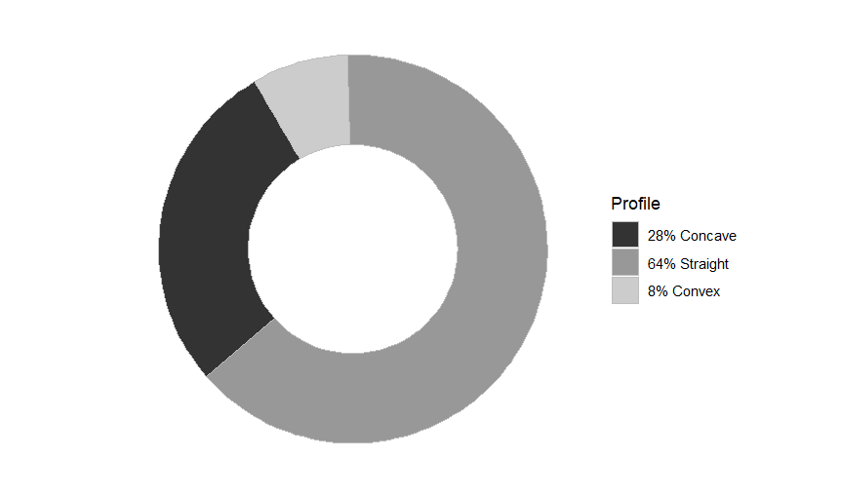
Fig. 1. Crossbred calf forehead profiles
The different coat colors of crossbred calves tracked in this study are represented by red piebald (26%), followed by black piebald (15%) and red (4%). For the remaining crossbred calf population (55%), several shades of color were observed (Fig. 2).
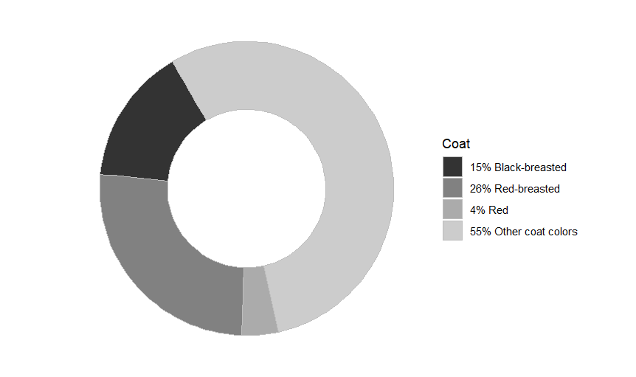
Fig. 2. Color of the coat of crossbred calves

3.2. Variation in the live weight of crossbred calves with age
Table 1 shows the variation in the initial weight of the calves monitored with age. For the 1-3 month age group, the average weight of the Montbéliard crossbreds (53.6±11.78 kg) was slightly higher than that of the Holstein crossbreds (51.7±6.93 kg). The average weight of Holstein crossbreds aged 3 to 6 months was 105.76±35.88 kg, which is higher than that of Montbéliard crossbreds aged 3 to 6 months (82.33±25.55 kg). This difference was also significant at a 5% threshold.
Table 1. Change in initial calf weight with age
Types | Age | Average weight (kg) | p-value
Montbéliard | 1–3 months | 53.6 ± 11.78 | p<0.05
Montbéliard | 3–6 months | 82.33 ± 25.55 | p<0.05
Holstein | 1–3 months | 51.7 ± 6.93 | p<0.05
Holstein | 3–6 months | 105.76 ± 35.88 | p<0.05

3.3. Weight gain in crossbred calves
Fig. 3 shows the variation in the live weight of crossbred calves according to age. Live weights increased gradually and proportionally with the age of the animal. The shape of the curves shows that the Holstein crossbreds have a slightly higher weight gain than the Montbéliard crossbreds. The analysis of variance showed that age had a highly significant influence on live weight values (p<0.05). The average ADG of Montbéliard crossbreds was approximately 436 g/day during the 4 weeks of monitoring, 679 g/day from the 5th to the 8th week, 827 g/day from the 9th to the 12th week, and 576 g/day between the 13th and 16th week. For Holstein crossbreds, the average ADG was 462 g/day during the first four weeks, 705 g/day from the fifth to the eighth week, 747 g/day from the ninth to the twelfth week, and 573 g/day between the thirteenth and sixteenth weeks. This higher weight gain observed in Holstein crossbreds may be explained by their higher genetic potential for growth (Roessler et al., 2019; Gibson et al., 2022).
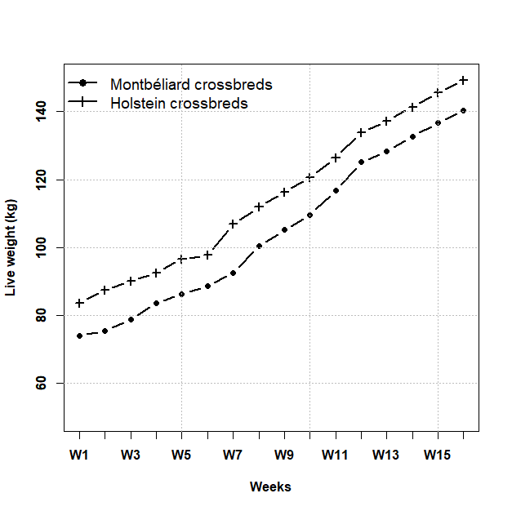
Fig. 3. Weight gain curve for crossbred calves aged 1-16 weeks

3.4. Correlations between body measurements and weight in bulls
Table 2 presents the Pearson correlation coefficients between the various measurements taken in crossbreds of Montbéliard × local breed.
Table 2. Pearson’s correlation coefficient between variables measured in Montbéliard x local breed crossbreds (n=55)
 | Live weight | WH | SIL | TP
Live weight | 1
WH | 0.846 | 1
SIL | 0.971 | 0.886 | 1
TP | 0.996 | 0.864 | 0.963 | 1
Strong positive correlations were observed between various morphometric parameters and LW in Montbéliard x local breed crossbreds. The strongest correlation was observed between the live weight of the animals and the thoracic parameter (r = 0.996; p < 0.05), whereas the weakest correlation was observed between WH and live weight (r = 0.846; p < 0.05). Strong positive correlations were also observed between various morphological parameters and the live weight of Holstein x local breed crosses (Table 3).
Table 3. Pearson’s correlation coefficient between variables measured in Holstein x local breed crossbreds (n=55)
 | Live weight | WH | SIL | TP
Live weight | 1
WH | 0.974 | 1
SIL | 0.983 | 0.966 | 1
TP | 0.998 | 0.974 | 0.973 | 1
The strongest correlation was observed between live weight and chest circumference (r=0.998; p<0.05), whereas a slightly weaker correlation was observed between ischial scapula length and thoracic perimeter (r=0.973; p<0.05). SIL was also positively correlated with live weight (r = 0.983; p < 0.05).

3.5. Live weight regression
Table 4 presents the regression equations established between the measured variables and live weight in crossbred calves.
Table 4. Regression equations for the live weight (n=55)
Crossbred | Parameter | Equation | r | RMSE
Montbéliard | WH | LW=3.2692 WH – 208.07 | 0.85 | 11.78
Montbéliard | SIL | LW = 2.356 SIL – 115.47 | 0.97 | 5.24
Montbéliard | TP | LW = 2.655 TP – 170.59 | 0.99 | 1.75
Holstein | WH | LW=3.1925 WH – 201.98 | 0.97 | 4.84
Holstein | SIL | LW = 2.1409 SIL – 90.87 | 0.98 | 3.87
Holstein | TP | LW = 2.7126 TP – 174.16 | 0.99 | 1.35
The thoracic perimeter is the best estimator for determining barymetric formulas due to its higher correlation with live weight (r=0.99) compared to height at the withers (r=0.85 for Montbéliard crossbreds; r=0.97 for Holstein crossbreds). SIL is also a good live weight estimator, with coefficients of r = 0.97 and r = 0.98 for Montbéliard and Holstein crossbreds, respectively.
The average weight of Holstein crossbreds is slightly higher than that of Montbéliard crossbreds, with a significant difference at the 5% threshold. The shape of the curves shows that the Holstein crossbreds have a slightly higher weight gain than the Montbéliard crossbreds. The analysis of variance shows a highly significant influence of age on live weight values (p<0.05). This result is similar to those of Planchenault et al. (1984) and Akouango et al. (2014).
Thoracic perimeter, height at the withers, and scapulo-ischial length are often used as standard morphometric measurements because they are directly related to the live weight of the animal. Live weight was strongly correlated with these parameters (p<0.05). This result is consistent with those of several authors (Planchenault et al., 1984; Akouango et al., 2014; Touré et al., 2019).
The following formulas can be used to estimate the live weight (LW) of crossbred calves aged 0 to 6 months based on thoracic perimeter (TP): LW = 2.665 TP – 170.59 for Montbéliard crossbreds and LW = 2.7126 TP – 174.16 for Holstein crossbreds (Budianto et al., 2022). The scapulo-ischial length is also a good estimator of the live weight of crossbred calves, as shown by the good linear regressions (Wansink, 2017).
4. CONCLUSIONS
This study aimed to improve crossbreeding patterns by selecting breeding bulls. The live weight of the monitored animals increased significantly between 1 and 16 weeks. This study highlights strong correlations between various morphological parameters and live weight in crossbreeds of the Montbéliard x local breed and Holstein x local breed. Chest circumference is the best estimator of live weight. The various regressions provided sufficient accuracy for the weight monitoring of animals growing faster and more frequently on larger herds compared with a conventional weighing system. These results provide practical tools for farmers and technicians to estimate calf live weight in the absence of weighing scales.
Disclaimer (Artificial Intelligence)
Author(s) hereby declare that generative AI technologies such as Large Language Models, etc have been used during writing or editing of this manuscript.
Competing Interests
Authors have declared that no competing interests exist.

REFERENCES
- Akouango, P., Mopoundza, P., Ewomango, R.P. (2014). Study of the measurements of Ndama cattle (Bos taurus) in the semi-flooded natural pastures of the Abo farm in Congo-Brazzaville. Journal of Animal & Plant Sciences, Vol. 20, Issue 3: 3137-3143.
- Alary, V. (2006). Study of the regional trade of livestock and animal products in West Africa (ECOWAS zone) and East Africa (IGAD zone). CIRAD Report, 136 p.
- Budianto, D., Widi, T. S. M., Panjono, P., Budisatria, I. G. S., & Hartatik, T. (2022). Estimation of Body Weight Using Linear Body Measurements in Two Crossbred Beef Cattle. 332‑337. https://doi.org/10.2991/absr.k.220207.070
- Camara, Y., Sissokho, M.M., Sall, M., Farnir, F., Antoine-Moussiaux, N. (2020). N’Dama cattle breeding programs in West Africa: the case of Senegal, Mali and Gambia. Cah. Agric. 29, 11. https://www.cahiersagricultures.fr/10.1051/cagri/2020010
- DNPIA. (2023). Annual Report (Bamako: National Directorate of Animal Production and Industries). Avenue de la Liberté, Route de Koulouba. BP: 265; Bamako – Mali, Annual Report 2023, 118 p.
- Gibson, M. J., Adams, B. R., Back, P. J., Hickson, R. E., Dittmer, K. E., & Rogers, C. W. (2022). Live Weight and Bone Growth from Birth to 23 Months of Age in Holstein–Friesian, Jersey and Crossbred Heifers. Dairy, 3(2), 333‑344. https://doi.org/10.3390/dairy3020026
- INSTAT. (2021). Report on the main final results of the integrated agriculture module in the mapping phase of the general population and housing census (Census Report No. 5; p. 97).
- Mrode, R., Mbah, D.A., Tawah, C.L., Ojango, J.M., Peters, S.O., Ibeagha-Awemu, E. M. & Rege, J.E. (2025). Defining breeding goals and breeding strategies for improving the productivity of cattle breeds and buffaloes in African production systems. In African Livestock Genetic Resources and Sustainable Breeding Strategies: Unlocking a Treasure Trove and Guide for Improved Productivity (pp. 705-758). Cham: Springer Nature Switzerland. https://link.springer.com/chapter/10.1007/978-3-031-92076-9_16
- Roessler, R., Mpouam, S. E., & Schlecht, E. (2019). Genetic and nongenetic factors affecting on-farm performance of peri-urban dairy cattle in west Africa. Journal of Dairy Science, 102(3), 2353-2364. https://www.sciencedirect.com/science/article/pii/S0022030219300396
- Planchenault, D., Tall, S.H., Traoré, M.T. (1984). Genetic improvement of N’Dama cattle. Rev. Elev. Méd. vét. Pays trop., 37 (4): 488-495. https://agritrop.cirad.fr/446760/1/ID446760.pdf
- Tamboura, T., Bibe, B., Rabile, R., Petit, J.P. (1982). Experimental results on crossbreeding between local and improved breeds.
- Touré, A., Kouriba, A., Bakary, T., Benoît, G., Leroy, P., Antoine-Moussiaux, N. & Moula, N. (2019). Practices and zootechnical aspects of dairy cattle farming in the peri-urban area of ​​Bamako and in northern Mali. Revue Agriculture, 10 (2): 14–26.
- Touré, A. (2020). Analysis of livestock farming typologies and cattle performance with a view to evaluating strategies for developing bovine genetic resources in Mali. Doctoral thesis in Veterinary Sciences, University of Liège, Belgium, 148 pp.
- Wansink, M.A. (2017). The correlation between the growth of body measurements, age, breed and the growth of pelvic sizes of beef cattle in South Africa. Master's Thesis. https://studenttheses.uu.nl/handle/20.500.12932/28217

