Original Research Article
Macroscopic and microscopic detection of fungal diseases of green bean (Phaseolus vulgaris) in the Gourma province of Burkina Faso

Abstract
The common bean (Phaseolus vulgaris L.) is a legume that faces numerous biotic constraints that hinder its production. Among these are fungal diseases that attack both leaves and pods, reducing yields. The objective of this study is to contribute to improving green bean production in the Gourma province. Macroscopic and microscopic identifications were carried out using plant pathology tools. As a result of the work, four pathogens were identified: Aspergillus niger, Botrytis cinerea, Colletotrichum lindemuthianum, and Alternaria alternata. These pathogens are responsible for various symptoms observed on the leaves and fruits, all contributing to a decrease in green bean productivity. This study allowed us to identify the different fungal pathogens of the common bean, which opens up possibilities for developing an appropriate control method.
Keywords: Phaseolus vulgaris, fungus, symptomatology, yield, Burkina Faso.

Introduction
In Africa, green beans (Phaseolus vulgaris) are cultivated in several mid- and high-altitude agro-ecological zones (Snapp et al., 2018). In developing countries, they represent a key food source in the fight against malnutrition for millions of smallholder farmers (Meziadi et al., 2016 ; Boudreau, 2013). The main producing countries in West Africa are Burkina Faso, Mali, Niger, and Côte d'Ivoire (Sidibé et al., 2020).
However, despite its nutritional importance, green bean cultivation faces numerous biotic constraints that severely limit its productivity. Among these biotic factors, diseases play a dominant role. They are caused by various pathogens, particularly fungi, which are responsible for several fungal diseases that significantly reduce yields (Martins et al., 2018; Beebe et al., 2013). In addition, bacterial diseases (Manju et al., 2023; Djeugap et al., 2014) and those caused by viruses (Mwaipopo et al., 2018 ; Martha et al. 2017) exacerbate losses and compromise crop productivity.
In the Gourma province, green bean production is very low, a trend also observed throughout the eastern region compared to other provinces of Burkina Faso. This low production is due to a lack of knowledge about the crop, the absence of suitable pest control methods, and the limited availability of varieties adapted to the region's agro-climatic conditions. Foliar diseases and pod rot also lead farmers to abandon the crop, as they require extensive treatment. Identifying the pathogens present is therefore a key step in promoting sustainable and profitable production.

Materials and Methods
Study Site Overview
The study was conducted in a peri-urban area of ​​the city of Fada N’Gourma, located at latitude 12°03′41″N and longitude 0°21′30″E. The climate is Sudano-Sahelian, with temperatures generally ranging from 18°C ​​to 39°C, rarely falling below 16°C or exceeding 42°C. It is characterized by two seasons: a long dry season of seven months (October to April) and a rainy season of five months (May to September), with an average annual rainfall of 831.11 mm. The vegetation consists of shrub savanna in the north and wooded savanna in the south. The area features three types of vegetation: steppe, savanna, and gallery forests (INSD, 2023), and its terrain is generally flat, although hills appear around Nalambou and Namoungou. The soils are fertile and suitable for agriculture, composed of several types, including ferruginous and alluvial soils. The region is rich in wildlife reserves and national parks. It also contains several rivers, such as the Pendjari and the Sirba, as well as numerous ponds.
Plant material for disease identification
The plant material for disease identification consists of leaves, stems, and pods of the green bean.
Sampling and Collection Methods
Samples were collected from blocks exhibiting foliar symptoms. Each sample consisted of several leaves, placed in a transparent bag, and then labeled. Upon arrival at the laboratory, an initial sorting took place. Subsequently, only samples showing severe and clearly visible symptoms were retained for incubation.
Preparation of the Culture Medium
PDA (Potato-Dextrose-Agar) culture medium was used for the isolation of fungi. In the case of certain obligate parasites, direct observations were made under a microscope. The culture medium was prepared by taking 39 g of synthetic PDA powder, weighing it using an electronic balance, and adding it to 1 liter of distilled water in a jar. The mixture was stirred to obtain a homogeneous solution. The jar was then placed in an autoclave at a pressure of 1 bar and 121 °C for 15 minutes. The jar was removed from the autoclave and cooled to between 45 °C and 50 °C to prevent condensation. Finally, the medium was transferred under a sterile fume hood into sterile 9 cm diameter Petri dishes, adding approximately 15 ml of medium per dish.
Incubation
The samples were first washed thoroughly under running water. They were then cut into small fragments of approximately 25 mm² (5 mm on each side), selecting areas close to the spots or lesions, near necrotic zones (Moreau-Moulds, 1991). These fragments were then disinfected for a few seconds in a 2% sodium hypochlorite solution, followed by 30 seconds of rinsing with sterile distilled water. This rinsing was repeated three times to remove as much sodium hypochlorite as possible. This disinfection process eliminated exogenous microflora. Afterward, the fragments were placed on sterile Watmann filter paper to dry for 30 seconds under a fume hood. Finally, the cut fragments were placed on culture media prepared beforehand in Petri dishes. The incubation was done under alternating light (12h) and darkness (12h) to induce better fungal development.
Isolation
After colony development during incubation, successive subculturing was carried out under the same conditions to obtain pure colonies in Petri dishes. The pure colonies obtained using the Moreau-Moulds method (1991), which consisted of taking a thin portion of the mycelium with a scalpel blade and then depositing it in a new Petri dish containing a PDA-based medium, were subjected to macroscopic and microscopic identification (Soura et al. 2019).
Symptomatology
Symptomatology consists of the study of symptoms. Symptoms are the visible manifestation of disease. They are characterized by changes in different parts of the plant, such as leaves and stems. Several symptoms are characteristic of diseases. Necrosis is the death of cells, chlorosis is the degradation of chlorophyll, wilting is the loss of turgor, and yellowing is a change in color. Galls and many other symptoms can also appear on the plant.
Macroscopic Identification
Macroscopic identification of fungi is performed by observing pure colonies with the naked eye after successive subculturing on culture medium. Two criteria are considered: the appearance and color of the colonies. The first criterion is based on the appearance of the colonies, which may appear downy, woolly, cottony, velvety, powdery, or granular. As for the second criterion, color, the most common colors are white, cream, yellow, orange, brown, and even black. The pigments may be localized within the mycelium or diffused throughout the culture medium (Rapio and Fons, 2006).
Microscopic Identification
Microscopic examination consisted of using a scalpel to remove a thin portion of mycelium from a cultured colony and placing it on a slide with a drop of sterile water. Observation under 40x and 100x objectives (400x and 1000x magnification) allowed for the distinction of the main morphological elements, including the presence of spores (shape, size, color) and the structure of the hyphae (presence or absence of septa), in accordance with the identification keys proposed by Barnet and Hunter (1987).

Result & Discussion

Symptomatology
During the study conducted at the experimental site, several symptoms of fungal diseases were observed on green bean (Phaseolus vulgaris) plants. Visual observation of the different varieties allowed for the identification of various types of foliar and structural alterations characteristic of the main fungal diseases of this crop. The main symptoms observed are:
• Presence of small, brown to orange pustules, mainly on the underside of the leaves, leading to progressive yellowing and drying of the leaf (Photo 1).
• Presence of an elongated, circular, black necrotic spot surrounded by a yellow halo (Photo 2).
• Grayish felt-like growth accompanied by organ death (Photo 3).
• Necrotic spots with a light center, beginning with yellowing that spreads across the entire leaf (Photo 4).
• Presence of necrotic, chlorotic spots with progressive leaf discoloration (Photo 5).

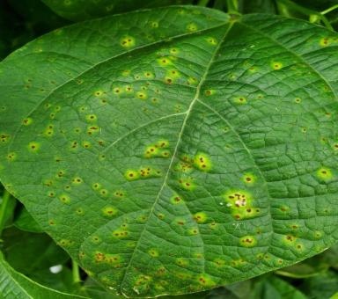
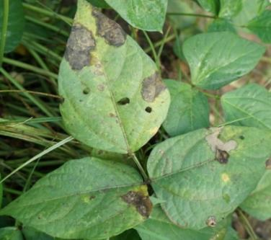

Photo 2 : Black necrotic spots on leaves
Photo 1: Small reddish pustules on leaves

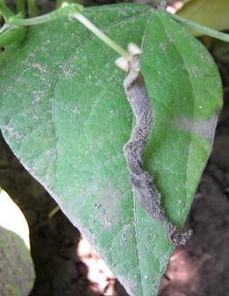
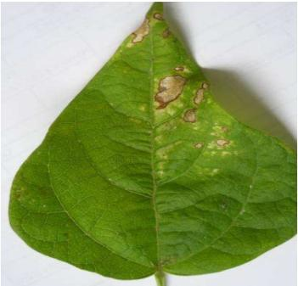

Photo 4: Brown necrotic spot on leaf
Photo 3: Tissue wilting

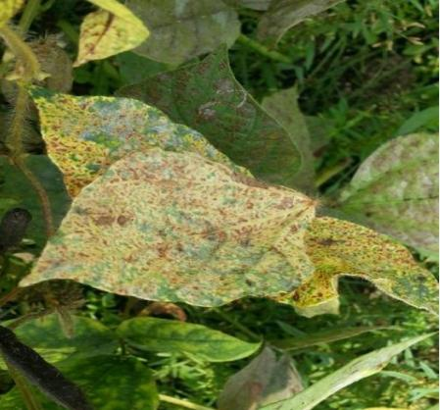
Photo 5: Complexe symptomatologique

Identification of Pathogens
Identifications were performed both macroscopically and microscopically. Several types of pathogenic fungi were observed. The majority of these pathogens caused various symptoms on the leaves. Overall, four (4) pathogenic fungi were identified in the collected samples.
Aspergillus niger, responsible for black mold
Macroscopically, a dense, well-developed black colony covers the entire surface of the container (Photo 6A) with a velvety to slightly powdery mycelium. However, its underside is black to dark brown on the 30th day after subculturing (Photo 6B).
Under the microscope, these spores are spherical to ovoid, light to dark brown in color (Photo 6C). The mycelium is hyaline (transparent) and septate (Photo 6D). Based on the information gathered during identification, this is Aspergillus niger.

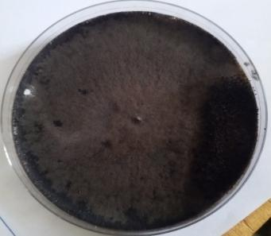
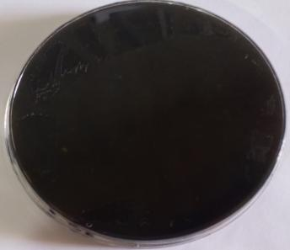
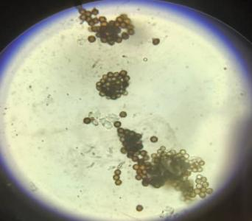
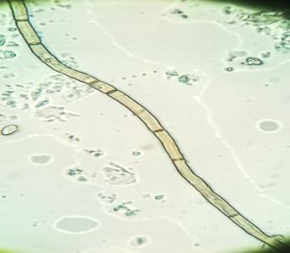
A
B
C
D

Photo 6: Macroscopic and microscopic identification of Aspergilus Niger

Colletotrichum lindemuthianum: responsible for green bean anthracnose
Macroscopic observation of Colletotrichum lindemuthianum shows a dark gray to blackish tint towards the periphery, with a darker to black central zone, and a slightly brown to whitish center (Photo 7A), with a cottony-looking colony. However, it has a black underside with a whitish center (Photo 7B).
Under the microscope, the spores are hyaline, elongated to cylindrical or slightly curved, with rounded ends (Photo 7C). The mycelium is filamentous and septate (Photo 7D). Based on the information gathered during identification, this is Colletotrichum lindemuthianum.

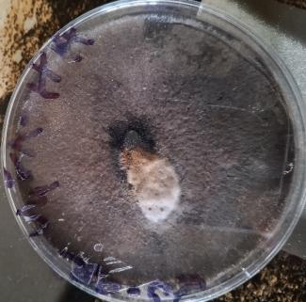
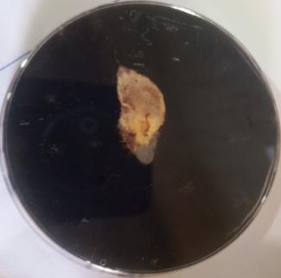
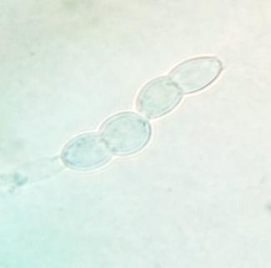
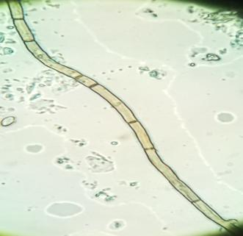
A
B
C
D

A
B

Photo 7: Macroscopic and microscopic identification of Colletotrichum lindemuthianum

Causative agent of gray mold: Botrytis cinerea
On the plate, we observe a white, cottony colony at the beginning of growth, which gradually becomes grayish to ash-brown with age (Photo 8A). The underside of the plate is light brown and slightly yellowish (Photo 8B).
Under the microscope, the spores are ovoid to elliptical (photo 8C), unicellular. The mycelium is filamentous and septate (Photo 8D). Based on the information gathered during identification, this is Botrytis cinerea.

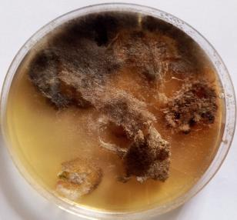
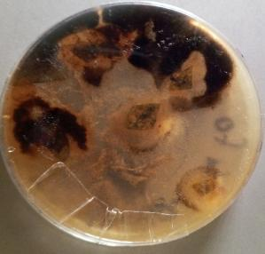
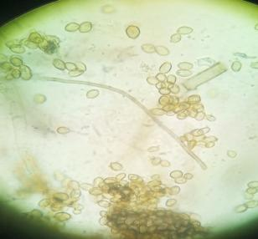
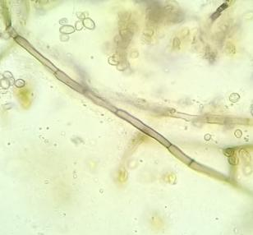
A
B
C
D

Photo 8: Macroscopic and microscopic identification of Botrytis cinerea

Alternaria alternata, responsible for brown spot disease
Macroscopic observation reveals a dense, downy, gray colony with concentric zones (Photo 9A). The underside of the container is dark gray to black (Photo 9B).
Microscopic observation shows oblong, bicellular spores with a transverse septum (Photo 9C) and a septate mycelium (Photo 9D). Based on the information gathered during identification, this is Alternaria alternata.

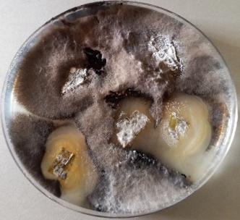
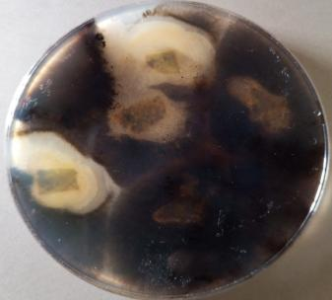
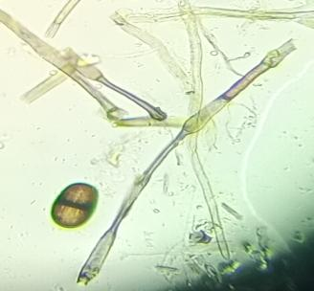
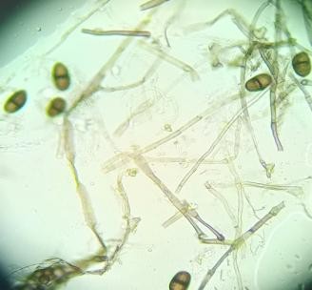
A
B
C
D

Photo 9: Macroscopic and microscopic identification of Alternaria alternata

Identification of Fungal Diseases
The diversity of symptoms and identified pathogens, such as Aspergillus niger, Colletotrichum lindemuthianum, Botrytis cinerea, and Alternaria alternata, reveals a high level of fungal parasitism in our study area, indicating that fungal diseases are the dominant phytosanitary constraint affecting green bean production in the Gourma province. These results are consistent with the work of Goundjo et al. (2023) and Degu et al. (2020), who emphasize that fungal diseases constitute the main category of diseases affecting green beans.
The presence of a complex of symptoms suggests the coexistence of several pathogens on the same plant, making diagnosis and control more difficult due to interactions that exacerbate symptoms and accelerate leaf tissue degradation. This aligns with the observations of Rakotozoely (2024) ; Deng and al. (2022), who found that such interactions can amplify damage to plant tissues and significantly reduce photosynthesis, leading to yield losses exceeding 50%. Thus, these observations confirm that fungal diseases, by disrupting photosynthetic activity, constitute a major factor limiting green bean productivity in the region. This corroborates the work of El-Karkouri and al. (2019) ; Govardhani and al. (2022), who indicated that 83% of plant diseases are attributable to fungi.
Light and electron microscopy studies of the B. cinerea host plant relationship have shown that the cuticle is dissolved enzymatically rather than broken mechanically (Foucher, 2020). Indeed, due to its ability to infect different plant species, B. cinerea must employ numerous pathogenicity mechanisms to overcome host defense systems and establish infection (Adam and al. 2018). Some of these mechanisms have been studied, such as the production of hydrolytic enzymes secreted during germination and degrading the cell wall, such as polygalacturonases (Burger and Chory, 2019), hexokinase and MAP kinase (Carter and al. 2020), pectin methylesterase (Ding and al. 2018), expansin (Gervasi and al. 2018), cutinase and esterase (Hnatuszko-Konka and al., 2019). It has been shown that B. cinerea also produces phytotoxic metabolites that suppress plant defense responses or induce cell death at infection sites (Jacques and al. 2016), and ethylene, a gaseous phytohormone, which promotes infection and tissue senescence by inducing chlorophyll loss and a decrease in the rate of photosynthesis (Hou and al. 2019). In turn, bean plants develop natural defenses following infection by B. cinerea, such as hypersensitivity and the secretion of fungitoxic compounds like α-tomatine. However, B. cinerea is resistant to this glycoalkaloid and can utilize dead tissue (Kremer and al. 2019).
Ingesting food contaminated with Alternaria alternata can trigger severe allergic reactions in patients with respiratory sensitivities, especially for products like green beans, which are eaten raw (Saliby et al. 2025). Therefore, it is important to have healthy produce in the field before harvest.

Conclusion
This study, entitled “Identification of fungal diseases of green bean (Phaseolus vulgaris) in the Gourma province, aimed to contribute to the improvement of green bean production in this region. More specifically, it sought to identify the main fungal diseases affecting the crop. Field observations and analyses identified the main pathogens responsible for fungal diseases, such as Aspergillus niger, Botrytis cinerea, Colletotrichum lindemuthianum, and Alternaria alternata, which pose a major constraint to green bean production in the Gourma province.
Analyzing pathogens and their dynamics is of paramount importance, as plant diseases are a major limiting factor in agricultural productivity. Studying these diseases not only helps reduce yield losses but also improves the resilience of production systems to increasing pest and disease pressures. A better understanding of pathogens also helps guide integrated management strategies, select resistant varieties, and optimize farming practices.

Disclaimer (Artificial intelligence)

Author(s) hereby declare that NO generative AI technologies such as Large Language Models (ChatGPT, COPILOT, etc.) and text-to-image generators have been used during the writing or editing of this manuscript.

References

- Ádám, A. L., Nagy, Z., Kátay, G., Mergenthaler, E., and Viczián, O. 2018. Signals of systemic immunity in plants: Progress and open questions. Int. J. Mol. Sci. 19, 1–21. doi:10.3390/ijms19041146
- Barnett, H.L., Hunter, B.B. 1987. Illustrated genera of imperfect fungi. Fourt edition. 240p. https://fr.scribd.com/document/325199387/Barnett-Hunter-Illustrated-Genera-of-Imperfect-Fungi
- Beebe, S.E., Rao, I.M., Blair, M.W., & Acosta-Gallegos, J.A., 2013. Phenotyping common beans for adaptation to drought. Frontiers in Physiology, 4, 35p. https://doi.org/10.3389/fphys.2013.00035.
- Boudreau, M.A. 2013. Disease in intercropping systems. Annual review of Phytopathology 51(1): 499-519. https://doi.org/10.1146/annurev-phyto-082712-102246.
- Bürger, M., and Chory, J. 2019. Stressed Out About Hormones: How Plants Orchestrate Immunity. Cell Host Microbe 26, 163–172. doi:10.1016/j.chom.2019.07.006.
- Carter, M. E., Carpenter, S. C. D., Dubrow, Z. E., Sabol, M. R., Rinaldi, F. C., Lastovetsky, O. A., 2020. A TAL effector-like protein of an endofungal bacterium increases the stress tolerance and alters the transcriptome of the host. Proc. Natl. Acad. Sci. U. S. A. doi:10.1073/pnas.2003857117.
- Degu T., Yaregal W., & Gudisa T. 2020. Status of Common Bean (Phaseolus vulgaris L.). Diseases in Metekel Zone, North West Ethiopia. J Plant Pathol Microbiol 11:494. doi.org/10.35248/21577471.20.11.494.
- Deng D., Sun S., Wu W., Duan C., Wang Z., Zhang S., & Zhu Z. 2022. Identification of Causal Agent Inciting Powdery Mildew on Common Bean and Screening of Resistance Cultivars. Plants 2022, 11,874. doi.org/10.3390/.
- Ding, Y., Sun, T., Ao, K., Peng, Y., Zhang, Y., Li, X., 2018. Opposite Roles of Salicylic Acid Receptors NPR1 and NPR3/NPR4 in Transcriptional Regulation of Plant Immunity. Cell 173, 1454-1467.e10. doi:10.1016/j.cell.2018.03.044.
- Djeugap, F.J., Mefire, M.H., Nguefack, J., Gueguim, M. and Fontem, D.A., 2014. Varietal and fungicide treatment effect on angular leaf spot disease severity and common bean (Phaseolus vulgaris L.) yield in Western Cameroon. International Journal of Biological and Chemical Sciences. 8(3): 1221-1233. DOI: http://dx.doi.org/10.4314/ijbcs.v8i3.33.
- El-Karkouri A, Assou SA, El-Hassouni M. 2019. Isolation and screening of actinomycetes producing antimicrobial substances from an extreme Moroccan biotope. Pan Afr Med J. 29 :33:329. doi: 10.11604/pamj.2019.33.329.19018.
- Foucher, F. 2020. Role of TAL effectors in the Xanthomonas-bean interaction and contributions to the fight against common fat. National Institute of Higher Education for Agriculture, Food and the Environment, NNT : 2020AGROC151. Thèse. 349p. https://theses.hal.science/tel-03578354v1/file/fix_bdDZ1eLl-foucher.pdf.
- Gervasi, F., Ferrante, P., Dettori, M. T., Scortichini, M., and Verde, I. 2018. Transcriptome reprogramming of resistant and susceptible peach genotypes during Xanthomonas arboricola pv. pruni early leaf infection. PLoS One 13, 1–21. doi:10.1371/journal.pone.0196590.
- Goudjo, E.C., Soura, HS, Gnacadja, CK, Iacomi, BM, Baba-Moussa, F.A.K. & Gnancadja, A.S.L., 2023. Analytical Review of Fungal Diseases Affecting Green Bean (Phaseolus vulgaris) Production. European Scientific Journal, ESJ, 19 (36), 67. https://doi.org/10.19044/esj.2023.v19n36p67.
- Govardhani P., Tiwari S., Supriya V., & Patthi Lakshmi Sindu P.L. 2022. Efficacy of Selected Bioagents against Alternaria Leaf Spot of French Bean (Phaseolous vulgaris L.), International Journal of Plant & Soil Science 34(20): 458-463. doi:10.9734/IJPSS/2022/v34i2031176.
- Hnatuszko-Konka, K., Kowalczyk, T., Gerszberg, A., Glińska, S., and Grzegorczyk-Karolak, I. 2019. Regeneration of Phaseolus vulgaris from epicotyls and hypocotyls via direct organogenesis. Sci. Rep. 9, 1–12. doi:10.1038/s41598-019-42723-8
- Hou, S., Liu, Z., Shen, H., and Wu, D. 2019. Damage-associated molecular pattern-triggered immunity in plants. Front. Plant Sci. 10. doi:10.3389/fpls.2019.00646
- INSD, 2023. Statistical Yearbook for the Central Region. Avenue Pascal ZAGRE, Ouaga 2000, 01 BP 374 Ouagadougou 01, Burkina Faso; Website: www.insd.bf. http://cns.bf/IMG/pdf/dr-est_annuaire_statistique_2023_de_la_region_du_centre.pdf. 191p.
- Jacques, M.-A., Arlat, M., Boulanger, A., Boureau, T., Carrère, S., Cesbron, S., 2016. Using Ecology, Physiology, and Genomics to Understand Host Specificity in Xanthomonas : French Network on Xanthomonads (FNX). Annu. Rev. Phytopathol. 54, annurev-phyto-080615-100147. doi:10.1146/annurev-phyto-080615-100147.
- Kremer, F. S., Guimarées, A. M., Sanchez, C. D., and Da Silva Pinto, L. 2019. TargeTALE:
- A web resource to identify TALEs in xanthomonas genomes and their respective targets. Mol. Plant-Microbe Interact. 32, 1577–1580. doi:10.1094/MPMI-08-19-0227-A.
- Manju, E.B, Mbong, G.A., Kohongong, S.M., and Tonjock, R.K. 2023. Effect of Angular Leaf Spot Disease on Bean Inter-cropped with Maize in Foumbot and Bambili, Cameroon. Journal of the cameroon academy of sciences. 19(2) :209-220. DOI: https://dx.doi.org/10.4314/jcas.v19i3.2.
- Martha, R., Josaphat, M., Montero-Vargas., Soledad, S.A., Anna, V., Salvador, C., Ordaz-Ortiz1, O., Mario, A.R.P., Vianello-Brondani, M., Santalla., Luis D., Toni, A., Paul, G., Robert, W., Roderic, G., Delgado-Salinas .and Herrera-Estrella, A 2017. Genomic history of the origin and domestication of common bean unveils its closest sister species. Genome Biology. DOI 10.1186/s13059-017-1190-6.
- Martins, SA., DA, S., Seabra, SS., Martins, SJ., Ramalho, MAP., DeMoreira, S.FM., Silva D. JCP., da Silva JAG & de Medeiros, FHV., 2018. Common bean (Phaseolus vulgaris L.) growth promotion and biocontrol by rhizobacteria under Rhizoctonia solani suppressive and conducive soils. Appl Soil Ecol 127 :129-13. https://doi.org/10.1016/j.apsoil.2018.03.007.
- Meziadi, C., Richard, M.M.S., Derquennes, A., Thareau, V., Blanchet, S., Gratias, A., Pflieger, S., & Geffroy, V., 2016. Development of molecular markers linked to disease resistance genes in common bean based on whole genome sequence. Plant Sci 242 :351-357. DOI: 10.1016/j.plantsci.2015.09.006.
- Moreau-Moulds, C., 1991. Techniques of analyses and control in the food industries. Microbiological control. B.E.D.M. Gembloux (1991) Chap 6, 222-24.
- Mwaipopo B., Nchimbi-Msolla S., Njau P.J.R., Deogratius Mark D., & Mbanzibwa D.R., 2018. Comprehensive Surveys of Bean common mosaic virus and Bean common mosaic necrosis virus and Molecular Evidence for Occurrence of Other Phaseolus vulgaris Viruses in Tanzania, Plant Disease - 102 :2361-2370. doi.org/10.1094/PDIS-01-18-0198-RE.
- Rakotozoely, THD. 2025. Phytosanitary diagnosis of bean (Phaseolus spp) crops in the urban commune of Mbatolampy. Magis University, Master's thesis. 22p. https://fr.scribd.com/document/880020549/1-Protection-Des-Plantes.
- Rapio, S. and Fons, S. 2007. The classification of fungi. Laboratory of Botany, Phytochemistry and Mycology / UMR - CNRS 5175 CEFE, Faculty of Pharmacy, 15 avenue Charles Flahault, University of Montpellier I, BP 14491, 34093 Montpellier cedex 5, France. file:///C:/Users/HP%20840/Downloads/Rapior2006Fons_SHHNH_146-41.pdf/
- Saliby N., Maury F., Barakat L., Le Brun M., Garinat M., Huth E., Laborier F., Roland Nicaise P., Taillé C., Neukirch C. 2025. Food allergy to Alternaria: a rare cause of anaphylaxis. Revue Francaise d’allergologie. Doi : 10.1016/j.reval.2025.104415
- Sidibe, A.O., Diallo, H., & N. P. Sanogo, 2020. Study of the behavior of three varieties of green bean (Phaseolus vulgaris) under growing conditions in Katibougou, Koulikoro, Mali, Agronomie Africaine 32 (3): 365 - 373. https://fr.scribd.com/document/868325106/ajol-file-journals-7-articles-202552-submission-proof-202552-73-507071-1-10-20210104-1.
- Snapp, S., Rahmanian, M., & Batello, C., 2018. Pulse and sustainable farming in subSaharan Africa, under the direction of T. Calles. Rome, FAO 16-40. https://openknowledge.fao.org/server/api/core/bitstreams/ccde443c-c244-4f05-8bd3-734194c022bd/content.
- Soura B. Hervé., Gnancadja L. S. André., Zandjanakou-Tachin Martine., Koita Kadidia. 2019. Diagnostic de l’incidence des pathogènes fongiques du riz au Sud-Bénin et Identification Morphologique de Cercospora oryzae. European Scientific Journal. 15 (12) : 346-358. DOI : 10.19044/esj.2019.v15n12p346

