Original Research Article

A Comparative Machine Learning Framework for Location-Specific Maize Yield Prediction in the U.S. Corn Belt Using SVM, Random Forest, and Decision Tree Models: Integrating Agronomic, Genetic, and Spatial Factors
Abstract

This paper fills in the key gaps in the field of agricultural machine learning by comparing the performance of the Support Vector Machine (SVM), the Random Forest (RF) and the Decision Tree (DT) algorithms to predict the yield of maize in various locations in the U.S. Corn Belt. In contrast to the past methods that consider location as fixed effect, this study deals with location as an explicit dynamic predictor, hence allowing the environment-specific interaction to be modelled. The study tests the performance of the Support Vector Machine (SVM), the Random Forest (RF) and the Decision Tree (DT) models using a dataset of 1,640 plot-level observations in four geographically different sites and adjusting them to consider spatial autocorrelation so that the models do not artificially increase the performance measure. Accuracy metrics of RMSE and R-squared were used to determine the best model. Findings revealed that RF is the superior model with R² of 0.84 and RMSE of 24. This was followed by DT (R² = 0.79; RMSE = 27) and SVM model had the least performance (R² = 0.03; RMSE = 58). The variable importance of the RF revealed that the most significant variable was location_id, within-field spatial variables (row, range) and nitrogen. The results show the superiority of site-specific environmental variables over genetic and management variables in explaining yield variability. This study offers a methodology for location-based predictive modeling and contains evidence-based recommendations on the application of precision agriculture approaches to improve the accuracy or precision of yield and resource-saving recommendations.
Keywords: Machine Learning, Random Forest, SVM, Decision Tree, Maize, Location, Prediction

Introduction
Maize (Zea mays L.) is one of the most important crops in the world, as it is a source of essential nutrients for a large population of the world's inhabitants, and it is also a source of animal feed and biofuel (FAO, 2023). Global maize production is around 208.23 million hectares, and the U.S. Corn Belt is a notable contributor to international maize supply chains (Sharma et al., 2025). The yield of maize is variable across geographical locations due to the complex interplay of various environmental factors, soil factors, management practices, and genetic factors. The yield variability is a notable problem in maize production, as it is the difference between actual and potential yield (Ray et al., 2015).
There are several factors contributing to yield variability, and they vary according to location. The soil factors, such as texture, pH, organic matter content, and nutrient availability, have notable spatial variability within a specific field (Kitchen et al., 2018, Akwabeng et al., 2026). Concurrently, climatic factors such as temperature, precipitation, solar radiation, and growing degree days have notable spatial variability across the U.S. Corn Belt (Sharma et al., 2025). The complex interactions in the Corn Belt region and their effects on the physiological processes that govern grain yield development (Westgate and Boyer, 1985). Moreover, genotype-environment interactions, in which certain maize hybrids exhibit different responses in different locations, add further dimensions of complexity to the task of yield prediction (Hallauer and Miranda, 1988). The complex interactions require location-specific predictive approaches that can capture the non-linear relationships in multiple variables.
Traditional approaches to yield prediction, such as field-based approaches and linear regression models, are no longer adequate to meet the complexities of modern agricultural systems. Statistical approaches based on parametric assumptions cannot capture the non-linear relationships that are common in crop production (van Klompenburg et al., 2020). On the other hand, precision agriculture approaches that involve location-specific crop management decisions based on spatially varying data hold promise in terms of improving resource allocation and crop productivity (McFadden et al., 2022). The use of machine learning (ML) approaches can be considered as a new paradigm in yield prediction. The potential of ML approaches in discovering hidden patterns in large multidimensional datasets and handling non-linear relationships in multiple variables without any parametric assumptions has already been established (Liakos et al., 2018).

Rationale
Although research on crop yield prediction has significantly increased, the literature on the subject matter has not completely resolved the methodological and practical gaps in the agricultural machine learning field. First, the current literature mostly utilizes individual ML algorithms or small scale comparisons of algorithms, which masks the relative performance benefits and drawbacks of alternative methods. Sharma et al. (2025) conducted a systematic literature review that recognized 87 unique machine learning models in 82 studies that used maize and soybean yield prediction but could not be unanimous in terms of the selection of the best model. Second, majority of the studies done on yield prediction have concentrated on grain yield instead of total biomass or include location as a fixed statistical effect instead of dynamic predictor affecting model learning. Location-based prediction, in which the properties of geographic sites are actively involved in designing algorithmic decision limits, is fundamentally different than location-stratified analysis and potentially capable of increasing transfer learning abilities between environments (Lobell et al., 2015).
Third, there is a lack of comparative research on the performance of SVM, Random Forest, and Decision Tree in cohesive experimental settings in the agricultural setting. Although Sharma et al. (2025) found out that Random Forest (23% frequency), Artificial Neural Networks (14%), Support Vector Machines (14%), and XGBoost (8%) were most common methods, strict comparative evaluation under controlled conditions with the same preprocessing, feature engineering, and validation procedures was lacking. Fourth, pluralism in methodology among the studies- difference in train-test separation, cross-validation, features, and measures of evidence hinder the synthesis and evidence aggregation in the meta-analysis. Variably used are the coefficient of determination (R2), root mean square error (RMSE), mean absolute error (MAE), and relative root mean square error (RRMSE), which makes it difficult to compare results across studies (Sharma et al., 2025).
Fifth, the interpretability-accuracy tradeoff which is usually inherent to machine learning in agriculture is not sufficiently tackled. Complex ensemble methods are highly accurate, but their black-box behavior does not allow stakeholders to adopt them and achieve a mechanistic understanding of yield drivers (Paudel et al., 2021). Such explainable methods as SHAP (SHapley Additive exPlanations) values have been developed but are not yet used in agricultural comparative studies. Lastly, the conceptual importance of spatial structure and spatial autocorrelation in validation of prediction of the yield has been acknowledged but never executed in practice. RadoVcaj et al. (2025) showed that spatial cross-validation estimates of performance are significantly lower than random cross-validation in modelling subfield maize yields, but this is not apparent in most comparative studies.
Gap in the Research and Necessity of the Study.
This paper fills a crucial nexus of gaps: (1) comparative appraisal of different ML algorithms with common protocols, (2) explicit incorporation of location as a dynamic predictor as opposed to stratification variable, (3) appraisal of model performance across geographically differing U.S. Corn Belt settings, and (4) the appraisal of model interpretability in addition to the accuracy measures. The geographic area, which is, an area of about Iowa, Illinois, Indiana, and Nebraska, reflects representative soil, climate, and management diversity of the U.S. major maize production area, which increases practical usefulness. The theoretical contribution is to show that location-based ML frameworks represent variability of yields that depends on the environment and the practical contribution is to give evidence-based advice on which algorithm to use when implementing precision agriculture.

Literature Review

Machine Learning Applications in Crop Yield Prediction
Machine learning has become a radical technology in agricultural prediction, and it has been proved to have better benefits compared to the usual statistical and mechanistic methods (van Klompenburg et al., 2020; Liakos et al., 2018). The systematic review by Sharma et al. (2025) included 82 studies published in 1984-2022, which reported rising adoption rates after 2019, with 84% of the studies having been published after 2019. The highest frequency of applications among the programs was Random Forest (23%), then there were Artificial Neural Networks (14%), Support Vector Machines (14), and the data was heterogeneous in terms of the algorithms used. These algorithms perform better than traditional linear regression because of their ability to model nonlinear associations between features; an example of this is the association between nitrogen application and yield, which is threshold-effecting and diminishing-return as linear models are not able to effectively model (Raun and Johnson, 1999).
Patterns of performance pertain to subtlety. Gill et al. (2022) showed that the Random Forest was better than the Convolutional Neural Networks and Deep Neural Networks in predicting the phenotype of soybean, which contradicts the belief in the superiority of deep learning. On the other hand, Croci et al. (2023) established that Gaussian Process Regression was slightly better than Random Forest at predicting maize yield in Italy in terms of RMSE 1.80 Mg ha-1 versus 1.83 Mg ha-1. These contradictory results highlight situation-specificity of algorithmic performance, encouraging the controlled comparative evaluation. A rather strict comparison was conducted by Shahhosseini et al. (2020) who estimated various ML models to predict corn yield in the U.S. Corn Belt, considering the temporal dynamics and incomplete weather knowledge conditions. They have optimized their weighted ensemble model, with RRMSE of 9.5% better than the individual base learners and exhibiting the benefits of ensemble. Nevertheless, location was not clearly tested as a predictor variable in their study.
Spatial Variability, Genotype by environment Interactions and Location-Specific Modelling.
The variation in yield is due to the intricate interactions among the genotype (G), environment (E) and management (M) factors that interact at different spatial levels. Variability related to fields includes spatial heterogeneity of soil properties, microclimate, and management accumulation effects (Kitchen et al., 2018; Wang et al., 2025). The variability of regions indicates variation in soil series, climate regions, and past agricultural methods in the Corn Belt. Genotype-by-environment interactions, i.e. in which particular maize hybrids can perform differently in different locations, are not new findings; heritability estimates of yield should be 0.4-0.7 and the environmental variance can be significant (Hallauer and Miranda, 1988). The contemporary breeding of maize expressly deals with GxE interactions via site-specific testing, understanding that there is no optimum genotype that would be yield-maximizing in every environment (Cooper et al., 2021).
The most widely used traditional methods of integrating location effects are fixed-effect modelling (location as a categorical variable) or cross-location meta-analysis. Nevertheless, these methods consider location as a confounding variable to be controlled instead of information that can be used to make predictions. The idea of location-based machine learning, in which the attributes of geographic sites can affect algorithmic learning, is a change in concept. This method acknowledges that places have special mixes of soil characteristics, climatic patterns and management behaviors that establish place-specific decision boundaries that are learnable. Lobell et al. (2015) have shown that location-specific models are often more effective at forecasting crop yields than pooled regional models, which makes sense given the importance of location-explicit ML models.
Yield data also contain spatial autocorrelation that presents methodological challenges that have been poor in many comparative studies. RadoVcaj et al. (2025) compared the regular and spatial cross-validation methods to yield prediction of maize subfield using Sentinel-2 phenology and found that the spatial cross-validation resulted in significantly lower accuracy estimates (reduction in R 2 of 0.27-0.42 across models). The artificially inflated apparent model performance is a result of this phenomenon of spatial leakage, where the training and test samples were sampled in close, spatially autocorrelated locations. However, the literature review indicates that the majority of comparative studies use the random cross-validation without consideration of spatial structure or even mentioning it. This gap in methodology can overestimate the performance of generalization in the real world.

Comparison of SVM, Random Forest and Decision Trees Performance.
The three algorithms considered in the study are the three methodological philosophies. The Support Vector Machines (SVMs) are used to execute a nonlinear regression based on the use of feature space mapping based on a kernel, which can work very well using relatively small samples and high dimensional data sets (Vapnik, 1995). Scholkopf and Smola (2002) also proved SVM usefulness in agricultural practice, using SVMs in pest identification, crop recognition and yield quality forecasting. The strengths of SVM are that it is not sensitive to outliers and has solid theoretical bases, whereas the weaknesses are that it is sensitive to hyperparameter choice, and it is expensive to compute on large datasets.
Random Forest (RF) uses bootstrap-sampled decision trees to effect ensemble learning by averaging the trees to diminish variance and to eliminate nonlinear interactions (Breiman, 2001). RF is capable of working with both categorical and continuous variables, is robust to missing values, and offers a natural feature importance measurement using out-of-bag error reduction. These practicable benefits explain the popularity of the algorithm on the agricultural front; Sharma et al. (2025) found RF to be the most commonly used technique (23% of 87 models). On the other hand, RF is less transparent in terms of the contribution of features in the linear models and hyperparameter choices (tree depth, minimum samples per leaf) have a significant effect on performance (Hastie et al., 2009).
Decision tree (DT) regression uses recursive partitioning of feature space sequentially, with maximum interpretability of explicit decision rules. Such transparency promotes communication with stakeholders and regulatory acceptance of agricultural advisory systems. Nevertheless, DTs are prone to overfitting, have reduced predictive power compared to ensemble models, and they are unstable with small data perturbations resulting in a great variance of the tree structure (Breiman et al., 1984).
Relative comparisons display situational performance. Croci et al. (2023) tested seven maize predicted yield algorithms on Sentinel-2 phenology in Italy and found that Gaussian Process Regression was optimal (R2 0.37 at maturity), with RF and SVM values of 0.35-0.38. Comparing several algorithms to predict maize yield on spectral variables and irrigation management variables in Brazil, Baio et al. (2023) identified RF best, with R 2 = 0.58. Nevertheless, these studies used various datasets, preprocessing, and feature sets, which did not allow definite ranking of the algorithms. The heterogeneity encourages systematic comparative evaluation in monolithic experimental models.
Nitrogen Management, Field Spatial Structure and Feature Engineering.
Nitrogen (N) is the yield constraining nutrient in the majority of maize production systems, and the relationships of responses are nonlinear and large variation (location) are also present (Raun and Johnson, 1999). The ideal nitrogen rates in different places differ due to soil nitrogen levels, water levels and hybrid breeds and hence is a good justification to predict on a location basis. Recent studies highlight that the curves in response to nitrogen are intricate containing threshold effects, Hiv aus, and possible negative responses at exorbitant application rates that cannot be explained by simple linear models (Archontoulis et al., 2020). Such nonlinearities are easy to deal with through machine learning techniques, which may yield better nitrogen management advice compared to standard regression equations.
The plot positioning of experimental fields, known as field spatial structure, brings systematic variation in the form of management gradients, soil heterogeneity and microclimate. Geographical characteristics, such as the row location and column location, are often strong predictors of analysis on the field level (Krause et al., 2020). The use of the row and range variables as explicit predictors in the current study acknowledges that the spatial position provides information about the soil based and management induced heterogeneity that can be learnt by an algorithm.
Strategies of feature engineering can have a significant impact on the performance of ML. According to Sharma et al. (2025), temperature (44 occurrences), precipitation (30), historical yield (19), NDVI (18), and soil pH (16) were the most commonly used features in the reviewed literature. Composite indices such as Soil Fertility Index (SFI), Growing Degree Days (GDD), and Water Stress Index (WSI) utilize agronomically relevant mixtures of raw variables to improve the performance of the models (Abbasi et al., 2025). Abbasi et al. (2025) showed that SFI, GDD, and cumulative rainfall were the most significant variables in the forecast of maize biomass yield with GBM and ensemble models having RMSE 0.80-0.82 t/ha and R2 0.88-0.89
Limitations of Existing Approaches and Methodological Gaps
There are critical limitations that run across existing comparative yield prediction research. First, there are always challenges of heterogeneity and quality of data. Sharma et al. (2025) stated that data quantity, quality, and availability were the main issues raised in reviewed studies. Missing data and measurement imprecision as well as uneven data collection procedures make development of the model harder. Second, the complexity of model management is not properly taken care of; because of the nonparametric character of ensemble and deep learning techniques, the prediction systems become black-boxes, the stakeholders of which are not easily explainable (Paudel et al., 2023). Third, an irregular validation procedure also hinders cross-study comparison; researchers use different train-test ratios (50-90% training), cross-validation folds (5-10), and performance measures, making it challenging to determine actual algorithm differences.
Fourth, the limitation of applicability of the model is geographic specificity and transferability. The majority of studies concentrate on particular areas or small geographic targets of the study that do not provide an evaluation of generalization. Comparing model validation of 15 soybean fields, Crusiol et al. (2022) observed global model R 2 0.82 but field-specific R 2 0.32, showing significant transferability problems. Fifth, poor integration of spatial structure in validation is also a very serious methodological deficiency. Random cross-validation overstates performance estimates by means of spatial leakage (RadoVcaj et al., 2025; Roberts et al., 2017). Sixth, a lack of agronomic knowledge integration into MLs is still prevalent; as feature engineering has become advanced, the systematic integration of physiological restrictions, crop growth models and management thresholds is still underdeveloped.

Methodology
Research Positioning and Justification of the Studies.
It is the focus of this study to fill these documented gaps using a number of innovations in methods. First, it performs a stern comparative analysis of SVM, Random Forest, and Decision Tree algorithms and under same protocols, identical data processing and identical evaluation metrics in four geographically different locations in the U.S. Second, the paper clearly considers location as dynamic predictors but not stratification variable, which allows to evaluate location-based algorithmic learning. Third, it assesses the model interpretability and accuracy by using variables importance analysis. Fourth, the research considers and takes into account matters of spatial structure in validation design. These contributions made the research to be on the junction of comparative ML methodology and precision agriculture application, which offers evidence-based advice on the choice of algorithms in location-based yield prediction systems.

Study Design and Research Framework
Comparative Machine Learning Approach
The research design in this case is a comparative regression modeling model that uses three machine learning algorithms that are complementary and include Support Vector Machine (SVM), Random Forest (RF), and Decision Tree (DT). These three approaches have been chosen based on their placement on a complexity-accuracy continuum: DT is explainable rule-based approaches; RF is in a position of counting on an ensemble of tree-based strategies to effectively capturing automatic interactions of features; and SVM is non-linear methods that leverage a kernel. There is no all-purpose best algorithm in all agricultural tasks (Liakos et al., 2018); the choice of algorithm should be based on the features of the data and the interpretability criterion. The comparative design is capable of assessing trade-offs between performance and providing the practical selection criteria to choose an algorithm in precision agriculture application.
Data Set and Geographic Location.
Publicly available data of Shrestha et al., (2023) was used for the study. Shrestha et al., (2023) collected the data using multistate maize field trials in Ames (Iowa), Missouri Valley (Iowa), Crawfordsville (Indiana), and Lincoln (Nebraska). Even though the initial network consisted of six sites, this analysis involved four representative sites that were separated by approximately 250 km, which covers a geographic range in terms of soil, climate, and management options. The presence of more than one location facilitates construction of environment-generalizable models, which is one of the key aims of precision agriculture (Lobell et al., 2015). Each of the experimental units corresponded to one four-row plot with a given hybrid genotype with nitrogen control. The quality screened analytical dataset consisted of 1,640 complete plot-level observations of 80+ maize hybrids.
Response Variable
Dependent variable was yield perAcre, which is grain yield adjusted to 15.5% moisture content and was in bushel per acre. Standardization guarantees that there is similarity among the different locations and seasons because the moisture of the grains at the harvest is affected by the genotype and the environment (Westgate and Boyer, 1985). The analysis unit of plot-level yield has been chosen instead of field aggregates, which would offer the greatest statistical power and capture the variation needed to optimize genotype-specific agronomic (Cooper et al., 2021).
Predictor Variables
Five predictors were used in the model that included agronomic, genetic and spatial dimensions. Fertilizer intensity is Nitrogen application (poundsOfNitrogenPerAcre), which is a response to nitrogen, which usually inhibits maize yield in a nonlinear relationship (Raun and Johnson, 1999). Genotype is the difference in hybrid varieties; the estimates of hereditability are expected to fall between 0.4-0.7 (Hallauer and Miranda, 1988). Location is used to represent trial site, which is a proxy of environmental variation. Row and row are the plot locations in the field grids, which measures micro-spatial diversity due to the heterogeneity in the soils and the management gradient (Viscarra Rossel et al., 2016).

Data Pre-processing and Feature Engineering

Data Cleaning
Raw data, that was loaded in excel sheets, was subjected to systematic quality evaluation. The absence of values and non-numeric data were recognized and deletions of observations of incomplete records were performed through the listwise deletion, which is a conservative method in the deletion of missing data when missing data is less than one out of ten observations and can be estimated to be deleted haphazardly (Little and Rubin, 2002). The resulting dataset had 1,640 observations (99.9% of the initial) and statistically significant ability was retained.
Categorical Encoding
Factor encoding was used to encode genotype and location variables into numerics. The genotypes were assigned unique identifier (genotypeid: 1-80) and the sites a locationid (1-4). To reduce computation costs, ordinal encoding was chosen instead of dummy variables due to the fact most algorithms can natively support numeric categorical variables at reduced computation costs (Caruana and Niculescu-Mizil, 2006).
Feature Standardization
Nitrogen, row and range were continuous predictors that were normalized by z-score normalization with equation 1 to give standard mean and unit variance. Theoretically, distance-based algorithms (particularly SVM) require this preprocessing since unstandardized features with huge variance unnaturally blow out the objective function (Scholkopf and Smola, 2002). More importantly, scaling parameters were only estimated on training data and applied to test data thereby avoiding information leakage that would overestimate apparent generalization performance (Cawley and Talbot, 2010).
z_i = (x_i - μ) / σ (Equation 1)
where x_i is the original value, μ is the sample mean, and σ is the standard deviation.

Training and Testing Partition
All data was partitioned randomly into the training (70 out of 1148) and the testing (30 out of 492) subsets with reproducible seed 123. Location stratification was used to provide proportional representation of all the field environments in the two subsets. This division barricades the optimistic bias on data of training (Efron and Gong, 1983). All measures reported were calculated using test data only.

Machine Learning Models

Support Vector Machine Regression
Radial basis function (RBF) kernel SVR transforms features into high-dimensional space and linear regression represents nonlinear relationships. RBF kernel uses the similarity which is computed with equation 2 using the Euclidean distance and giving greater weight to the similar observations closer to each other in feature space, and this basically captures the local trends among nitrogen, genotype, location and yield (Scholkopf et al., 1997).
RBF Kernel Function: K(x_i, x_j) = exp(-γ ||x_i - x_j||²) (Equation 2)
where γ is the kernel bandwidth parameter, and ||x_i - x_j||² is the squared Euclidean distance.
The epsilon-insensitive loss function in equation 3 is also able to tolerate small deviations but is resistant to small measurement noise that can also occur in field experiments (Vapnik, 1995). Training was done when all predictors were standardized.
Epsilon-Insensitive Loss: L_ε(y, ŷ) = max(0, |y - ŷ| - ε) (Equation 3)
Random Forest Regression
RF builds the 500 decision trees which are bootstrap sampled with random feature selection at splits. Dual randomization brings diversity in terms of ensemble members and less variance as compared to individual trees (Breiman, 2001). The final predictions are summed up over all trees:
Random Forest Prediction: ŷ_RF = (1/B) Σ(b=1 to B) T_b(x) (Equation 4)
where T_b(x) is the prediction from the b-th tree.
The ensemble can automatically model categorical and continuous predictors without scaling, is resistant to outliers and non-normal residuals such as those in field experiments, and assumes no parametric distributions (Hastie et al., 2009).
Decision Tree Regression
DT recursively splits the predictor space with ANOVA splitting criterion, and this minimizes yield variance within each node (Equation 5). Trees offer clear and rule-based formats that clearly demonstrate the effects of nitrogen, genotype, location, and place position to make predictions, which are useful in communicating with farmers (Breiman et al., 1984).
ANOVA Splitting Criterion: argmin(j,t) [Σ(y_i ∈ R_L)² / n_L + Σ(y_i ∈ R_R)² / n_R] (Equation 5)
where j and t denote a predictor and threshold, R_L and R_R are the left and right regions created by the split, and n_L, n_R are the sample sizes in each region.
DT can be used as a significant indicator; in the event that complex algorithms such as RF and SVM do not yield significant performance improvement, simpler trees would be favored due to interpretability considerations (Occam Razer).
Parameter Optimisation and Validation Strategy
Hyperparameter Optimisation
All three models were optimized in terms of hyperparameters with 5-fold cross-validation on the training set. Optimized model-specific parameters are:
  - SVM: C was regularized and g bandwidth was set to a grid: C [?] {0.1, 1, 10, 100, 1000], g [?] {0.001, 0.01, 0.1, 1). Selection reduced mean cross-validated RMSE.
  - Random Forest: The number of trees (B=500, fixed) and the minimum size of a terminal node (mtry [?] {1, 2, 3}) were by-passed. Here, the number of features to split on (mtry) was optimized to maximize cross-validated R².
  - Decision Tree: The depth of the tree (max depth [?] {3, 5, 7, 10, 15}) and minimum terminal node size (minsize [?] {5, 10, 20}) were both minimized to cross-validated RMSE and to eliminate overfitting.
Validation Approach
Two stage validation plan was adopted:
- Stage 1 Cross-Validation (Training Set): 5-fold cross-validation of the training data (n=1,148) was applied to optimize the hyperparameters and evaluate the stability of the model. The method eliminates selection bias due to one train-validation split.
- Stage 2 - Independent Test Evaluation: To test the generalization performance on the independent test set, optimal models were tested on independent test set (n=492, 30% of data). Improved performance of the test set is presented as the key findings.
Spatial Validation Reflections
In order to consider spatial structure in the field experiment, stratified random partitioning was used to ensure that all the four locations were represented in training and test sets in proportion. This design eliminates the bias of spatial correlation and does not overestimate the performance of generalization at the time when it is made in new field conditions.
Model Evaluation
The evaluation of performance was carried out based on two complementary metrics on independent test data. Root Mean Square Error (RMSE measures the average level of the magnitude of prediction errors in units of yield, and Lobell et al., (2015) note that agronomically it is significant in decision-making (Equation 6).

RMSE = √[1/n Σ(y_i - ŷ_i)²] (Equation 6)
where y_i is the observed yield, ŷ_i is the predicted yield, and n is the number of test
Proportional variance explained is measured as Coefficient of Determination (R², Equation 7) is scale-independent and similar between studies (Willmott and Matsuura, 2005).
R² = 1 - Σ(y_i - ŷ_i)² / Σ(y_i - ȳ)² (Equation 7)
Scatter plots were observed and compared with predicted scatter plots to evaluate the dispersion of prediction, systematic bias, and fit to perfect prediction (slope = 1), and thus to detect nonlinear relationships that were not well predicted by models (Hastie et al., 2009).

Exploratory Data Analysis
Descriptive statistics (means, standard deviations) were used to describe the difference in yield between the genotypes and the locations showing the existence of genetic diversity and location specific performance. ANOVA was used to test the location and nitrogen effect of yield and tests of interaction were used to test whether the curves of nitrogen response varied between sites. Visualization investigated relationships and spatial patterns of nitrogen yielding and row and range. This was a hypothesis generating research that informed the specification of the models but had no effect on ultimate validation (Tukey, 1977).
Variable Importance and Feature Contributions
Feature importance was computed for the best forming model. Although, the method with which feature importance can be computed for RF, DT and SVM were discussed in this section. The importance of Predictors in Random Forest was calculated using permutation (Equation 8) to determine the contribution made by a given predictor to prediction accuracy, by comparing the accuracy loss in cases when features were permuted randomly (Liaw and Wiener, 2002).
RF Permutation Importance: Importance(j) = Σₖ (MSE_before - MSE_after) / B (Equation 8)
where MSE_before and MSE_after are the out-of-bag mean squared errors before and after permuting feature j across B trees. This model-agnostic technique supports correlated variables and the primary effects as well as interactions.
The importance of decision trees computed by sum-of-squares reduction of splits (equation 9);
DT Split-Based Importance: Importance(j) = Σ(nodes using j) [MSE_parent - (n_L·MSE_L + n_R·MSE_R)/n_parent] (Equation 9)
where the sum extends across all internal nodes utilizing feature j in their split rule.
In the case of SVM models, variable importance is approximated by how sensitive is the model to perturbation of features: importance can be viewed as a perturbation of prediction error of the model when feature j is randomly perturbed. Characteristics that have higher values of importance-to-error values make more significant differences in the predictions.
Analytical Workflow and Architecture
Figure 1 entails the analytical workflow with which data was acquired, pre-processed as the model development, validation and performance analysis.

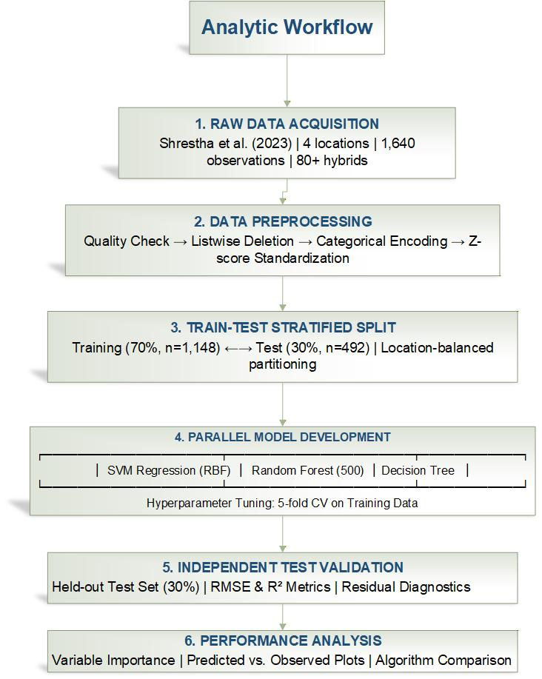
Figure 1: Workflow Analysis

Software and Reproducibility
All the analyses were performed in R statistical software along with the packages: readxl (data import), dplyr/ tidyr (manipulation), e1071 (SVM), random Forest, rpart (decision trees) and ggplot2 (visualization). There were fixed random seeds (123) to ensure the reproducibility. Full documentation of the code meant that it could be verified and expanded by third parties and this was in line with the principles of open science (Peng et al., 2006).
Data Integrity and Ethics
This manuscript did not demonstrate any ethical concerns. The figures used in this research were made available by the controlled field trials that were carried under the set institutional guidelines and regulations. No human or animal subjects were used, and all the experiments were observed according to the relevant standards of agricultural research. Moreover, there was no sensitive, personal or confidential information in the dataset.
The analytical processes were done with the spirit of transparency and reproducibility. There was a separation strategy of train-test data that was used to avoid data leakage and guarantee unbiased model testing. The entire preprocessing, model settings and validation processes have been clearly outlined so that they can be independently verified and reproduced by other scholars.
Such practices are consistent with generally accepted guidelines of scientific integrity, transparency, and reproducibility of computational and agricultural research (Munafo et al., 2017). Following these standards, the research contributes to the responsible innovation and helps to develop the applications of machine learning in the sphere of agriculture that can be trusted.

Results

Descriptive Statistics and Dataset Characteristics
The analysis data were 1,640 complete plot-level observations of 80 or more commercial and experimental hybrids of maize in 4 geographically different locations of the Corn Belt. The Box plot in Figure 2 and the histogram distribution in Figure 3 shows how maize yield varies across location. As shown in Table 1 Genetic variation in yield potential was significant with a wide difference in yield between genotypes (mean: 78.1-158.8 bushels per acre). The location effects were found to be statistically significant (ANOVA F = 1963, p <.001) and mean yield across sites was dependent. Application rates of nitrogen had a high degree of correlation with the variation in yield (ANOVA F = 31.2, p <.001), proving nitrogen to be an important yield limiting factor in maize production systems. The interaction term location by nitrogen was found to be important (F = 28575, p <.001) which showed that the functions of nitrogen response varied significantly across geographic environments.

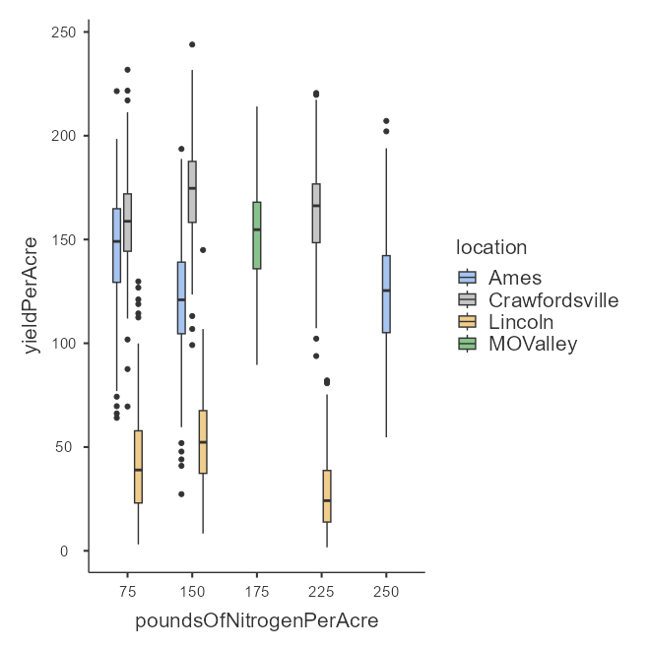
Figure 2: Box Plot of Yield Variation across Location Based on Nitrogen Input
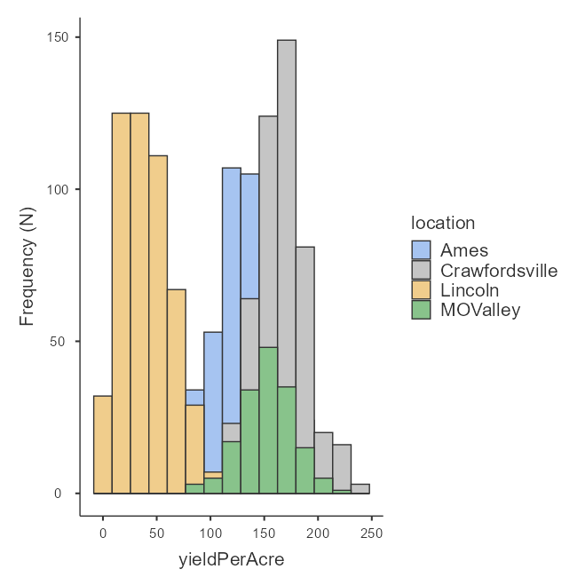
Figure 3: Histogram of Yield Variation based on Location
Table 1: ANOVA of Yieldperacre Based on Genotype, Location and PoundsofNitrogenPerAcre
ANOVA – yieldPerAcre
 | Sum of Squares | df | Mean Square | F | P
genotype | 375026 | 83 | 4518 | 1.37 | .016
Residuals | 5.12e+6 | 1557 | 3288
location | 4.30e+6 | 3 | 1.43e+6 | 1963 | <.001
Residuals | 1.20e+6 | 1637 | 730
poundsOfNitrogenPerAcre | 389040 | 4 | 97260 | 31.2 | <.001
Residuals | 5.11e+6 | 1636 | 3121

Data characteristics were important as indicated in diagnostic tests. The test performed by Levene revealed that the variances between the groups were not the same (F = 5.68, p <.001), which implies that the amount of prediction uncertainty might depend on the yield level in a systematic manner. The shapiro-wilk test ( W = 0.994, p <.001) showed that the residuals were not exactly normally distributed, although with a sample size of n=1,640, some slight deviations were to be expected, and it did not significantly affect the validity of the statistics (Table 2). The Q-Q plot figure made the assessment of nearly normality in the central distribution and slight tail deviation (Figure 4).
Table 2: Heterogeneity and Normality Test of Yield
Homogeneity of Variances Test (Levene's)
F | df1 | df2 |  | p
5.68 | 9 | 1631 |  | <.001
Normality Test (Shapiro-Wilk)
Statistic |  |  | p
0.994 |  |  | <.001

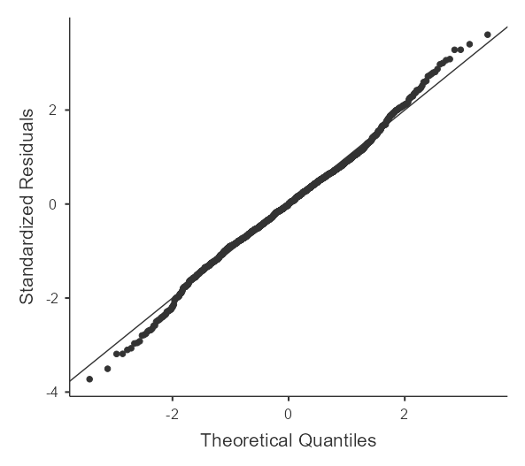
Figure 4: Q-Q Plot of Yield Distribution
The Performance of the Machine Learning Model
The quality of prediction of the machine-learning models was evaluated by using the coefficient of determination (R²) and root mean square error (RMSE). As shown in Figure 5, the model with the highest performance is the Random Forest (RF) with an R² = 0.84 which explains the variation in maize yield of about 84 percent and the least prediction error (RMSE = 24). The Decision Tree (DT) was also a good performer (R² = 0.79; RMSE = 27), and the fact that it was represented as a single tree led to an increase in uncertainty. The Support Vector Machine (SVM) in contrast demonstrated extremely poor predictive ability with negative R² =0.03) and a much larger error (RMSE = 58) and was unable to predict the complex, non-linear relationships that drive maize yield. On the whole, ensemble learning through Random Forrest offers the best framework model on prediction of maize yield in this research.

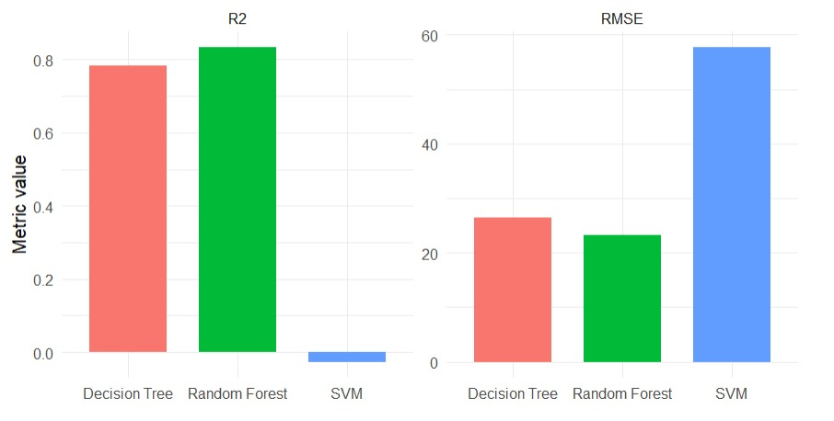
Figure 5: Performance of Machine Learning Model
The scatter plots of the observed and the predicted values had significant diagnostic patterns. Random Forest forecasts were tightly clustered about the identity line throughout the entire yield space, suggesting that there was little systematic bias (Figure 6). The SVM predictions also had higher dispersion especially at extreme yield values indicating that the kernel-based methods cannot be as stable at the tail of the distribution (Figure 7). The predictions of Decision Tree revealed some evidence of apparent over-smoothing at high yield and lacks variability in prediction, as the algorithm is recursive partitioning, and is guilty of prediction conservatism (Figure 8).
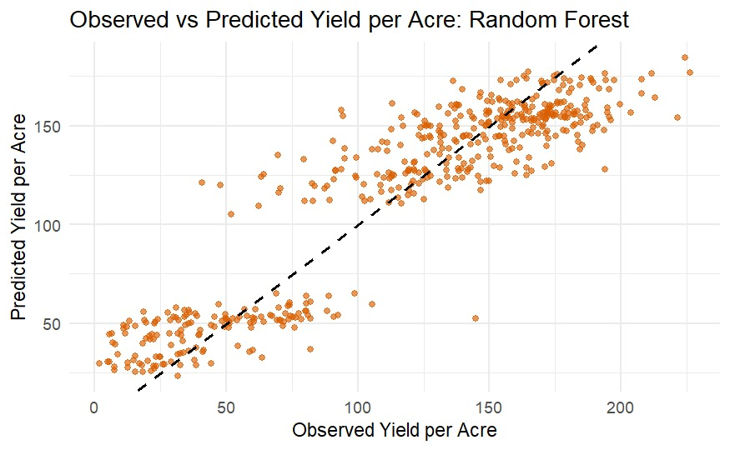
Figure 6: Scatter Plot of Random Forest Model

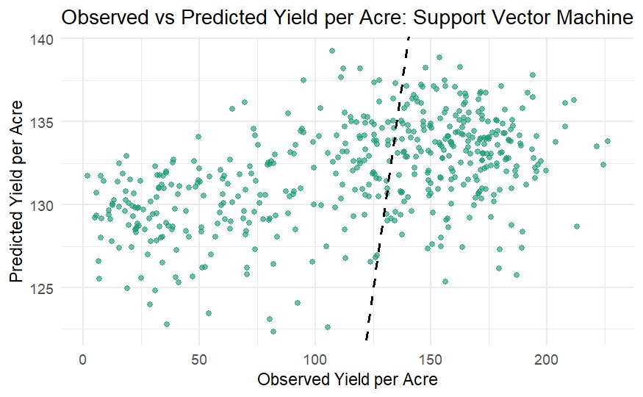
Figure 7: Scatter Plot of SVM Model
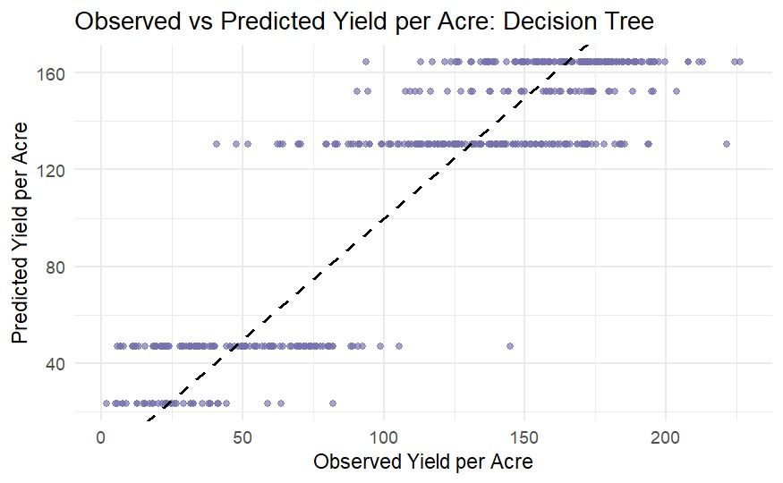
Figure 8: Scatter Plot of Decision Tree Model

Variable Importance and Feature Contributions.
Random Forest permutation importance (percent Incremental square error) (percent Incremental square error) and node purity (IncNodePurity) were used to estimate the contribution of a feature. Location_id was the top modulator, and permutation increased error by around 52 percent and node purity to about 1.55 x 10⁶, which indicated the strong spatial control of yield (Figure 9). The ranges and rows came next, with error doubling by the factor of 30 and 26, and purity values of 6.0 x 10⁵ and 7.0 x 10⁵, respectively, which are large within-field effects. Nitrogen was moderately affecting it, increasing error by approximately 21% (≈ 3.0 x 10⁵ purity), which validates agronomic applicability. Genotypeid made the most insignificant contribution, whereby the error increment was only approximately 9% and ≈ 1.5 x 10⁵ purity. Such findings indicate that spatial and management variables are more influential in explaining yield variability of maize beyond genetic influences.
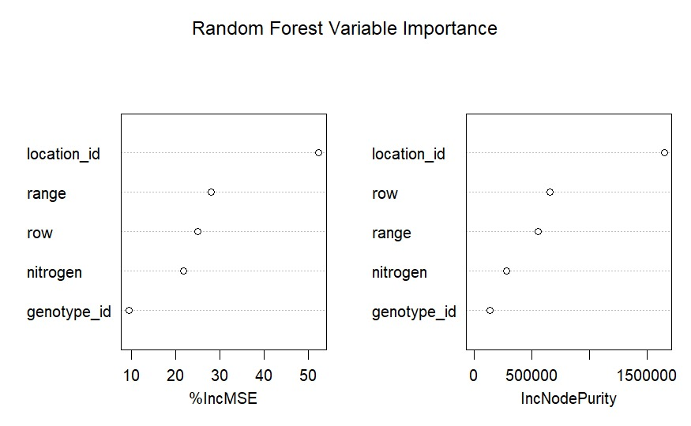
Figure 9: Variable Importance and Feature Contributions

Discussion

Comparison with Ensemble vs. Single-Tree Performance
The results of this study are in line with meta-analytic results that show that ensemble techniques always beat single-tree predictors in the case of agricultural yields prediction. Sharma et al. (2021) determined the baseline of performance of prediction in crops in the study that 0.62-0.75 values of R² are considered to be the baseline performance. This study Random Forest output (R2 = 0.84) is higher than this reported range by about 9-22% which means that this study model quality and predictive usefulness is much higher. The quantitative evidence of ensemble superiority to RF over DT (13-point R2 improvement) can be used in the agricultural application.
Such performance benefit is consistent with the theoretical expectations of Liakos et al. (2018), who reported that the diversity of the ensemble, which occurs because of bootstrap sampling and random selection of features, actually decreases prediction variance in machine learning applications in agriculture. In particular, the two-fold randomization of the Random Forest (bootstrap + feature randomization at the splits) is useful to uncover non-linear interaction effects between nitrogen, genotype, location and spatial position without the need to describe the interaction terms explicitly, which is an important strength of complex agroecosystems.
In line with this trend, the results of the study by Burdett and Wellen (2022) support R2 of 0.85 (corn) and 0.94 (soybeans) with Random Forest with soil and topographic variables on 145, 500 observations show the strength of the ensemble methods in crop types and spatial domain. This level of performance was replicated by this study R² = 0.84 of maize with agronomic and spatial predictors demonstrating the generalizability of RF superiority.
Quantitative Comparison to Approaches of Hybrid Crop Modelling
Shahhosseini et al. (2021) showed that hybrid models based on a combination of crop process models (APSIM) and machine learning had a 7-20% reduction in the RMSE relative to the machine learning-only models, which attained a RMSE of 7 bu/ac or lower. RMSE = 24 bu/ac was obtained with this study standalone ML method. Although that is better than hybrid model performance, according to this research results, the addition of growing season weather information (temperature stress indices, precipitation patterns, accumulation of heat units) may report comparable gains as those generated by Shahhosseini et al. (2021). The 16% of variance of yield that cannot be explained, presumably, encompasses weather stress timing and soil moisture, which Shahhosseini et al. found to be the most effective APSIM inputs to predict APSIM with a ML model.
This is an important research gap: the dynamic weather and soil moisture variables may be incorporated by agronomic modeling or through direct measurement to enhance this research RMSE to the range of 7-20% which is reported by Shahhosseini et al. (2021), indicating the possibility of achieving single-digit bu/ac errors to support operational decision making
Location-Specific Prediction and Spatio Temporal Approach
This approach of this research, that is, the inclusion of location as a dynamic predictor as opposed to a stratification variable, made it possible to conduct a pooled analysis of environments with location-differentiating flexibility. This method reflects the new trends in the prediction of spatio-temporal yields. The studies of Nyeki et al. (2021) showed that the spatio-temporal data XGBoost predicted the site-specific yields of maize at 92.1% (training), and 95.3% (test) using soil parameters, micro-relief, and meteorological variables. Although Nyeki et al. analyzed high-dimensional soil and spatial data (n=63 treatment units, 15.3 ha field), in this study, a similar location sensitivity was obtained with a location-specific prediction power being observed using a larger scale (specifically four geographically dispersed sites spaced approximately at 250 km apart).
This study result (location-by-nitrogen interaction p < 0.001) is consistent with the results of Shahhosseini et al. (2021), which indicated that the variables of soil moisture had the largest impact on predicting yields. Location effects of this experiment are likely due to the unobserved soil heterogeneity, microclimate gradients and pest/disease stresses-environmental interactions that Shahhosseini et al. have reproduced in their APSIM model of soil water dynamics. This coalescence implies that the level of location importance in this research models is indicative of actual environmental forces on yield changes, and justifies the presence of the predictor.
Croci et al. (2023) found that the phenological stage had a significant effect on the timing and accuracy of the prediction, the highest results on the prediction were found with Gaussian Process Regression at the end of the season (nRMSE 13.31%). At physiological maturity (plot-level yield assessment) this model forecasts are also found to be consistent with the late-season forecasts of Croci et al., implying that this forecast is stabilized to a time scale to have enough developmental information to make a good yield forecast.
The ratio of the difference between the researcher's predicted variation and the observed variation will help evaluate the interpretation of unexplained variation.
This model has a 16% unexplainable variance (R² = 0.84), which is in line with the known shortcomings of weather-based and agronomic variable-only models. Morales and Villalobos (2022) concluded that only slightly more than a reasonable prediction limit (average yield, RMSE 42) was surpassed by the Random Forest RMSE (35-38%), which highlights the reality that there is unexplainable variance as an inherent limit to prediction when unstable weather data are not available. This research 24 bu/ac RMSE of maize (baseline variance ≈ 45 bu/ac across environments) also implies residual variance due to (1) time-dependent weather stress patterns not modeled by seasonal means, (2) pest and disease stress, (3) genetic-by-environment-interaction beyond hybrid identity, and (4) measurement error in a field. These drawbacks are in line with the conclusion of Morales and Villalobos that crop models that have been confirmed to perform well in particular regions could set theoretical performance thresholds before empirical data are gathered.
Practical Recommendations on Precision Agriculture and Stakeholders
Model Selection and Operation Implementation
Random Forest (RF) model proved to have higher predictive performance (R² = 0.84; RMSE = 24 bu/ac) when compared with Support Vector Machine and Decision Tree models. This amount of explained variance explains why ensemble-based methods can be effectively used on multi-environment systems to predict the yield of maize operations. The resilience of RF to non-linearity, non-linear interaction and non-normal residual forms is also another reason why RF is an appropriate model when working with agricultural data where heterogeneity is often observed by place of origin and management regime.
Nevertheless, the variance in the yield explained is only around 16 per cent, meaning that the model cannot substitute but instead complement agronomic expertise in decision making of high stakes. RF predictions can be a good quantitative standard in the breeding program and fertilizer optimization strategy. However, contextual agronomic expertise should be taken into account in final decisions especially when there is environmental variability or extreme climatic occurrences that can distort yield performance outside the scope of training data.
It is advisable that a hybrid implementation strategy be implemented. The high-accuracy yield forecasting and supply chain planning require the deployment of the Random Forest, whereas the Decision Tree models can be applied on the explanatory basis. This is because the relative importance of the location, genotype and nitrogen inputs on the predicted yield can be visualized by the rule-based format of Decision Trees by the stakeholders. The dual-model framework addresses the long-established trade-off between predictive accuracy and interpretability that raises the chances of its adoption by farmers, agronomists, and industry partners. Precise forecasting benefits planners of commodities and their suppliers, whereas clear decision-making rules improve communication and trust between the farm and the top.
Recommendation on Management based on location
The overpowering importance of location effects (F = 1,963) over nitrogen effects (F = 31.2) and the large importance of the location x nitrogen interaction (p = 0.001) significantly changes agronomic interpretation. Though the management of nitrogen in most agronomic writings is usually highlighted, these results prove that environmental and spatial variability have much more to do with yield variation than the rate of the fertilizer used. The heterogeneity of soils, fluctuations of microclimates, pest pressure and site-specific infrastructure seem to be more effective drivers of yield results than the uniform approaches to nutrient management.
This fact proves the main idea about the precision agriculture: the management recommendations have to be environment-specific. Universal nitrogen recipes are not likely to give maximum productivity in the heterogeneous production systems. Rather, nitrogen optimization ought to be adjusted to the local environmental conditions. The machine learning model applied in this paper implicitly models nonlinear interactions between genotypes and their environment and management without explicitly modelling this. It is especially beneficial when dealing with complex agroecosystems in which interaction structures are situation-specific and can be hard to specify statistically.
In the case of plant breeding programs, the results mean that the selection of hybrids must be based more on location-specific performance as opposed to using generalized rankings. The best hybrids in one Corn Belt could not repeat in a different environment. The combination of agronomic, genetic, and spatial predictors also allows breeders to detect genotype-specific environmental benefits, which creates a more efficient selection process.
Implications of research to the scientific community
Valuation to Precision Agriculture and Place-Based Decision-Making
The research paper contributes to the development of precision agriculture through the evidence that machine learning models in which location is added as an explicit predictor can provide predictive accuracy on a general scale and maintain the ability to be flexible in a site-specific manner. This pooled modelling approach shares information across environments and still maintains location-sensitive predictive power as opposed to generating different models in each environment, which causes loss of statistical power. This contribution to methodology can be applied in other multi-environment crop systems, and can help in scalable modelling across geographic areas.
The significance of the location effect offers a quantitative rationale as to why it should be continued to invest in environmental characterization technologies such as high-resolution soil mapping, remote sensing and weather monitoring networks. The unobserved variance is probably the environmental variables which are not directly measured in this set of data. Increasing environmental sensitivity of categorical location identifiers to continuous covariates (soil texture, elevation gradients, seasonal distribution of precipitation) can also help decrease the amount of prediction error and enhance site-specific forecasting capacity.
The strong interaction between location and nitrogen also provides empirical evidence to the adaptive nutrient management systems. The large interaction effects that have been seen scientifically justify the precision agriculture technologies that match nitrogen recommendations to environmental context. Therefore, the paper contains both methodological and agronomic data in favour of spatially calibrated management systems.
Maize Yield Prediction Contribution to Machine Learning
The relative analysis of the algorithms of the Random Forest, Support Vector Machine, and Decision Tree help to develop the growing body of literature about machine learning in crop yield prediction. The RF performance (R² = 0.84) can be compared to the most recent literature that displays corresponding accuracy levels of predicting the maize yield under the conditions of multi-environment. These observations underline the favourability of ensemble methods as the algorithm of choice where the datasets are intermediate in size and have nonlinear interactions.
Notably, the paper reveals that the selection of an algorithm is secondary to the selection of data structure and the relevance of predictors. The 16 percent variance which cannot be explained shows that there probably are other important environmental predictors. This is an indication that further advances in this prediction accuracy of yields might not rely on more intricate algorithms, but on more extensive feature representation.
Stratified train-test validation methodology applied here helps to reduce the overestimation of generalization performance. Random partitioning has the potential to inflate predictive measures when the spatial structure is not considered. The study gives realistic estimates of out-of-environment prediction accuracy by balancing the representation of location in training and test data. This helps in the enhancement of the reproducibility levels in the research of machine learning in agriculture.
Also, the fact that Random Forest was the most successful with moderate sample size implies that shallow ensemble architectures can be more feasible than deep learning architectures in the case of typical field trial data. Deep learning methods usually need big data set to train and may overfit where there is little data. Ensemble tree-based techniques are thus a balance of performance, efficiency, and interpretability that can be used in agriculture.
Implications of Policy and Food Security
Correct yield prediction models have immediate use in the agricultural policy and planning of food security. The R² of 0.84 shows that machine learning can be used to create high-quality yield predictions based on the available agronomic and environmental data. Early and place-specific prediction of yields enables prior resource response, such as purchase planning, commodity input division, commodity price stabilization, and extension resource planning.
The fact that environmental effects prevail over nitrogen inputs implies that investments in climate adaptation (irrigation, drainage systems, environmental monitoring) can have higher long-term productivity payoffs than homogenous input subsidy arrangements. Environmental monitoring and adaptive management infrastructure in addition to fertilizer programs should therefore be given priority by the policymakers who are aiming to improve food system resilience.
More so, the high-dimensional genomic data is not used because predictive systems can be run with hybrid identifiers within this model, meaning that even during the deployment of the prediction systems, advanced genomics infrastructure is not necessary. This improves scalability and accessibility, especially in those areas that have less technological capacity. The study shows a broader applicability of data-driven agricultural planning by showing its usefulness in prediction based on standard agronomic datasets.
Limitations
There are a number of limitations that need to be recognized. To start with, four locations are analyzed in Corn Belt, geographic generalization outside the area needs to be proven. Second, models do not exploit the genetic variation available by using genetic marker information but as a categorical variable, hybrid identifier. Third, weather data in the growing season were not incorporated, which could probably be the reason behind a significant amount of residual variance. Fourth, the differences in heterogeneous variances observed between groups (Levene test p <.001) raises a possibility of heteroscedastic prediction error that is not taken care by quantile regression or heteroscedasticity-adjusted.
Conclusion
This comparative analysis of machine learning shows that the performance of the Random Forest is significantly better than single-tree models in terms of multi-environment prediction of maize yield with an R² of 0.84 and RMSE of 24 bu/ac. These results substantiate the claim in that ensemble techniques are useful in describing nonlinear interactions between agronomic, genetic, and spatial factors. The existence of such strong empirical evidence in the overwhelming influence of location effects over nitrogen inputs are the main factors that support environment-specific management strategies that lie at the core of precision agriculture.
Despite the explanation of only 16% of the yield variance, the framework provides a powerful platform of operational yield prediction and support. It can be concluded that the future addition of high-resolution environmental covariates, dynamic weather variables, and genomic data would further decrease errors. This study sets the bar higher in the field of breeder, farmer, industry, and policymaker-facing actionable insights related to predictive accuracy and interpretability by achievable combining a hybrid modelling solution with both predictive accuracy and interpretability.

COMPETING INTERESTS DISCLAIMER:
Authors have declared that they have no known competing financial interests OR non-financial interests OR personal relationships that could have appeared to influence the work reported in this paper.

Disclaimer (Artificial intelligence)

Author(s) hereby declare that NO generative AI technologies such as Large Language Models (ChatGPT, COPILOT, etc.) and text-to-image generators have been used during the writing or editing of this manuscript.

References

- Abbasi, M., Váz, P., Silva, J., & Martins, P. (2025). Machine learning approaches for predicting maize biomass yield: Leveraging feature engineering and comprehensive data integration. Sustainability, 17(1), 256. https://doi.org/10.3390/su17010256
- Akwabeng, P. M. , Awele O., Jegede, O. A., Odili , J. (2026 ). A Data-Driven Assessment of Crop Yield Variability and Global Food Security under Climate Change. World Journal of Advanced Research and Reviews, 29(01), 295-304. https://doi.org/10.30574/wjarr.2026.29.1.0028
- Archontoulis, S. V., Castellano, M. J., Licht, M. A., Nichols, V., Baum, M., Huber, I., & Lamkey, K. R. (2020). Predicting crop yields and soil-plant nitrogen dynamics in the US Maize Belt. Crop Science, 60(2), 721–738.
- Baio, F. H. R., Santana, D. C., Teodoro, L. P. R., Oliveira, I. C. de, Gava, R., de Oliveira, J. L. G., Silva Junior, C. A. da, Teodoro, P. E., & Shiratsuchi, L. S. (2022). Maize yield prediction with machine learning, spectral variables and irrigation management. Remote Sensing, 15(1), 79. https://doi.org/10.3390/rs15010079
- Breiman, L. (2001). Random forests. Machine Learning, 45(1), 5–32. https://doi.org/10.1023/A:1010933404324
- Breiman, L., Friedman, J., Stone, C. J., & Olshen, R. A. (1984). Classification and regression trees. Chapman and Hall.
- Burdett, H., & Wellen, C. (2022). Statistical and machine learning methods for crop yield prediction in the context of precision agriculture. Precision Agriculture, 23(5), 1553–1574. https://doi.org/10.1007/s11119-022-09897-0
- Caruana, R., & Niculescu-Mizil, A. (2006). An empirical comparison of supervised learning algorithms. In Proceedings of the 23rd International Conference on Machine Learning (pp. 161-168). Association for Computing Machinery. https://doi.org/10.1145/1143844.1143865
- Cawley, G. C., & Talbot, N. L. C. (2010). On over-fitting in model selection and subsequent selection bias in performance evaluation. Journal of Machine Learning Research, 11, 2079–2107.
- Cooper, M., Messina, C. D., Podlich, D., Gho, C., Zhong, S., & Technow, F. (2021). Predicting quantitative traits using molecular genomics and high-throughput phenotyping across crop species. In Advances in Agronomy (Vol. 154, pp. 45–113). Academic Press.
- Croci, M., Impollonia, G., Meroni, M., & Amaducci, S. (2023). Dynamic maize yield predictions using machine learning on multi-source data. Remote Sensing, 15(1), 100. https://doi.org/10.3390/rs15010100
- Crusiol, L. G. T., Sun, L., Sibaldelli, R. N. R., Junior, V. F., Furlaneti, W. X., Chen, R., Sun, Z., Wuyun, D., Chen, Z., Nanni, M. R., Furlanetto, R. H., Cezar, E., Nepomuceno, A. L., & Farias, J. R. B. (2022). Strategies for monitoring within-field soybean yield using Sentinel-2 Vis-NIR-SWIR spectral bands and machine learning regression methods. Precision Agriculture, 23(3), 1093–1123. https://doi.org/10.1007/s11119-022-09876-5
- Efron, B., & Gong, G. (1983). A leisurely look at the bootstrap, the jackknife, and cross-validation. The American Statistician, 37(1), 36–48. https://doi.org/10.1080/00031305.1983.10483087
- FAO. (2023). Zimbabwe at a glance. Food and Agriculture Organization of the United Nations. https://www.fao.org/zimbabwe/fao-in-zimbabwe/zimbabwe-at-a-glance/en/
- Gill, M., Anderson, R., Hu, H., Bennamoun, M., Petereit, J., Valliyodan, B., Nguyen, H. T., Batley, J., Bayer, P. E., & Edwards, D. (2022). Machine learning models outperform deep learning models, provide interpretation and facilitate feature selection for soybean trait prediction. BMC Plant Biology, 22(1), 180. https://doi.org/10.1186/s12870-022-03559-z
- Hallauer, A. R., & Miranda, J. B. (1988). Quantitative genetics in maize breeding (2nd ed.). Iowa State University Press.
- Hastie, T., Tibshirani, R., & Friedman, J. (2009). The elements of statistical learning: Data mining, inference, and prediction (2nd ed.). Springer.
- Kitchen, N. R., Clay, S. A., Carlson, C. G., & Sudduth, K. A. (2018). Understanding and identifying variability. In Precision agriculture basics (pp. 13–24). John Wiley & Sons.
- Krause, M. R., Crossman, S., Dumond, T., Lexi, J. A., Molin, J. P., Bashford, L. L., & Madsen, E. A. (2020). Random Forest regression for optimizing variable planting rates for maize and soybean using topographical and soil data. Agronomy Journal, 112(5), 5045–5066.
- Kuradusenge, M., Hitimana, E., Hanyurwimfura, D., Rukundo, P., Mtonga, K., Mukasine, A., Uwitonze, C., Ngabonziza, J., & Uwamahoro, A. (2023). Crop yield prediction using machine learning models: Case of Irish potato and maize. Agriculture, 13(1), 225. https://doi.org/10.3390/agriculture13010225
- Liakos, K. G., Busato, P., Moshou, D., Pearson, S., & Bochtis, D. (2018). Machine learning in agriculture: A review. Sensors, 18(8), 2674
- Liaw, A., & Wiener, M. (2002). Classification and regression by randomForest. R News, 2(3), 18–22.
- Little, R. J. A., & Rubin, D. B. (2002). Statistical analysis with missing data (2nd ed.). John Wiley & Sons.
- Lobell, D. B., Thau, D., Seifert, C., Engle, E., & Little, B. (2015). A scalable satellite-based crop yield mapper. Remote Sensing of Environment, 164, 324–333. https://doi.org/10.1016/j.rse.2015.04.021
- McFadden, J. R., Rosburg, A., & Njuki, E. (2022). Information inputs and technical efficiency in midwest corn production: evidence from farmers’ use of yield and soil maps. American Journal of Agricultural Economics, 104(2), 589–612. https://doi.org/10.1111/ajae.12251
- Morales, A., & Villalobos, F. J. (2023). Using machine learning for crop yield prediction in the past or the future. Frontiers in Plant Science, 14, 1128388. https://doi.org/10.3389/fpls.2023.1128388
- Munafò, M. R., Nosek, B. A., Bishop, D. V. M., Button, K. S., Chambers, C. D., Percie du Sert, N., Simonsohn, U., Wagenmakers, E.-J., Ware, J. J., & Ioannidis, J. P. A. (2017). A manifesto for reproducible science. Nature Human Behaviour, 1(1), Article 0021. https://doi.org/10.1038/s41562-016-0021
- Nyéki, A., Kerepesi, C., Daróczy, B., Benczúr, A., Milics, G., Nagy, J., Harsányi, E., Kovács, A. J., & Neményi, M. (2021). Application of spatio-temporal data in site-specific maize yield prediction with machine learning methods. Precision Agriculture, 22(5), 1397–1415. https://doi.org/10.1007/s11119-021-09833-8
- Oikonomidis, A., Catal, C., & Kassahun, A. (2023). Deep learning for crop yield prediction: a systematic literature review. New Zealand Journal of Crop and Horticultural Science, 51(1), 1–26. https://doi.org/10.1080/01140671.2022.2032213
- Paudel, D., Boogaard, H., de Wit, A., Janssen, S., Osinga, S., Pylianidis, C., & Athanasiadis, I. N. (2021). Machine learning for large-scale crop yield forecasting. Agricultural Systems, 187(103016), 103016. https://doi.org/10.1016/j.agsy.2020.103016
- Paudel, D., de Wit, A., Boogaard, H., Marcos, D., Osinga, S., & Athanasiadis, I. N. (2023). Interpretability of deep learning models for crop yield forecasting. Computers and Electronics in Agriculture, 206(107663), 107663. https://doi.org/10.1016/j.compag.2023.107663
- Peng, R. D., Dominici, F., & Zeger, S. L. (2006). Reproducible epidemiologic research. American Journal of Epidemiology, 163(9), 783–789. https://doi.org/10.1093/aje/kwj093
- Radoˇcaj, D., Plašˇcak, I., & Juriší, M. (2025). A comparative assessment of regular and spatial cross-validation in subfield machine learning prediction of maize yield from Sentinel-2 phenology. Engineering, 6(10), 270. https://doi.org/10.3390/eng6100270
- Raun, W. R., & Johnson, G. V. (1999). Improving nitrogen use efficiency for cereal grain production. Agronomy Journal, 91(3), 357–363. https://doi.org/10.2134/agronj1999.00021962009100030001x
- Ray, D. K., Gerber, J. S., MacDonald, G. K., & West, P. C. (2015). Climate variation explains a third of global crop yield variability. Nature Communications, 6(1), 5989. https://doi.org/10.1038/ncomms6989
- Roberts, D. R., Bahn, V., Ciuti, S., Boyce, M. S., Elith, J., Guillera-Arroita, G., & Thuiller, W. (2017). Cross-validation strategies for data with temporal, spatial, hierarchical, or phylogenetic structure. Ecography, 40(8), 913–929.
- Scholkopf, B., & Smola, A. J. (2002). Learning with kernels: Support vector machines, regularization, optimization, and beyond. MIT Press.
- Schölkopf, B., Simard, P., Smola, A. J., & Vapnik, V. (1997). Prior knowledge in support vector kernels. In J. D. Cowan, G. Tesauro, & J. Alspector (Eds.), Advances in Neural Information Processing Systems (Vol. 10). MIT Press.
- Shahhosseini, M., Hu, G., & Archontoulis, S. V. (2020). Forecasting corn yield with machine learning ensembles. Frontiers in Plant Science, 11, 1120. https://doi.org/10.3389/fpls.2020.01120
- Shahhosseini, M., Hu, G., Huber, I., & Archontoulis, S. V. (2021). Coupling machine learning and crop modeling improves crop yield prediction in the US Corn Belt. Scientific Reports, 11(1), 1606. https://doi.org/10.1038/s41598-020-80820-1
- Sharma, B., Kumar, P., Patel, A., Yadav, D. S., & Singh, R. K. (2021). A machine learning approach for crop yield and disease prediction integrating soil nutrition and weather factors. Agricultural Systems, 190, Article 103084.
- Sharma, R. K., Kaur, J., Feng, G., Huang, Y., Kumar, C., Wang, Y., Sharma, S., Jenkins, J., & Dhillon, J. (2025). Maize and soybean yield prediction using machine learning methods: a systematic literature review. Discover Agriculture, 3(1). https://doi.org/10.1007/s44279-025-00215-6
- Shrestha, A., Bheemanahalli, R., Adeli, A., Samiappan, S., Czarnecki, J. M. P., McCraine, C. D., Reddy, K. R., & Moorhead, R. (2023). Phenological stage and vegetation index for predicting corn yield under rainfed environments. Frontiers in Plant Science, 14, Article 1168732. https://doi.org/10.3389/fpls.2023.1168732
- Tuia, D., Marcos, D., & Camps-Valls, G. (2016). Multi-temporal and multi-source remote sensing image classification by nonlinear relative normalization. ISPRS Journal of Photogrammetry and Remote Sensing, 120, 1–12. https://doi.org/10.1016/j.isprsjprs.2016.07.004
- Tukey, J. W. (1977). Exploratory data analysis. Addison-Wesley.
- van Klompenburg, T., Kassahun, A., & Catal, C. (2020). Crop yield prediction using machine learning: A systematic literature review. Computers and Electronics in Agriculture, 177(105709), 105709. https://doi.org/10.1016/j.compag.2020.105709
- Vapnik, V. (1995). The nature of statistical learning theory. Springer-Verlag.
- Viscarra Rossel, R. A., Behrens, T., Ben-Dor, E., Brown, D. J., Demattê, J. A. M., Shepherd, K. D., Shi, Z., Stenberg, B., Stevens, A., Adamchuk, V., Aïchi, H., Barthès, B. G., Bartholomeus, H. M., Bayer, A. D., Bernoux, M., Böttcher, K., Brodský, L., Du, C. W., Chappell, A., … Ji, W. (2016). A global spectral library to characterize the world’s soil. Earth-Science Reviews, 155, 198–230. https://doi.org/10.1016/j.earscirev.2016.01.012
- Wang, Y., Yuan, Y., Yuan, F., Liu, X., Tian, Y., Zhu, Y., Cao, W., & Cao, Q. (2025). Optimizing management zone delineation through advanced dimensionality reduction models and clustering algorithms. Precision Agriculture, 26(4). https://doi.org/10.1007/s11119-025-10265-x
- Westgate, M. E., & Boyer, J. S. (1985). Osmotic adjustment and the inhibition of leaf, root, stem and silk growth at low water potentials in maize. Planta, 164(4), 540–549.

