Original Research Article
EPIDEMIOLOGICAL INVESTIGATION AND MORPHOLOGICAL CHARACTERIZATION OF Rhipicephalus microplus IN CATTLE

ABSTRACT

Tick infestation is a major constraint to cattle health and productivity in tropical and subtropical regions. The present study was conducted to determine the prevalence, associated risk factors and species composition of ticks infesting cattle at the Livestock Farm Complex of Nanaji Deshmukh Veterinary Science University, Jabalpur, Madhya Pradesh, from July to December 2025. A total of 201 cattle were screened based on history and clinical examination, of which 118 were found positive, yielding an overall prevalence of 58.70%. The highest prevalence was recorded in August, followed by July and September. Cattle below one year of age, female cattle and crossbred animals showed significantly higher infestation. Loose housing and irregular deworming were identified as important predisposing factors. Common clinical signs included pruritus, alopecia and erythema. Morphological examination of 60 adult ticks confirmed all specimens as Rhipicephalus microplus, indicating its predominance in the study area. Statistical analysis revealed significant associations between tick infestation and factors such as month age sex breed duration of illness deworming status and housing system. The findings highlight the high prevalence of tick infestation in cattle under field conditions and emphasize the need for effective and regular tick control measures to reduce economic losses and improve animal health.
Keywords: Cattle, tick infestation, Prevalence, Rhipicephalus microplus
- INTRODUCTION
Livestock production plays a vital role in ensuring food security and supporting rural livelihoods; however, animal health remains continually challenged by infectious diseases, suboptimal management practices, nutritional deficiencies and parasitic infestations. Among parasitic constraints, ectoparasites particularly ticks represent one of the most significant threats to cattle production systems worldwide. Tick infestation is widely recognised as a major veterinary and economic concern, especially in tropical and subtropical regions where climatic conditions favour their survival, reproduction and dissemination (Okello Onen et al., 2011).
Ticks adversely affect host animals through both direct and indirect mechanisms. Direct effects include persistent irritation, blood loss, skin damage, hypersensitivity reactions and reduced weight gain, all of which compromise productivity. Indirectly, ticks act as competent vectors of numerous pathogenic organisms, thereby amplifying their impact on animal health. Heavy infestations can lead to marked reductions in milk yield, deterioration in body condition and, in severe cases, mortality (Eskezia and Desta, 2016).
Among the various tick species infesting cattle, Rhipicephalus (Boophilus) microplus is considered one of the most economically important worldwide. This species is a well-established vector of haemoprotozoan pathogens such as Babesia bigemina and Babesia bovis, the causative agents of bovine babesiosis, as well as Anaplasma marginale, responsible for bovine anaplasmosis (Grisi et al., 2014). Given its widespread distribution and vectorial capacity, effective, affordable and sustainable tick control strategies are urgently required to mitigate production losses and limit the transmission of tick-borne diseases (Benelli, 2016).
- MATERIALS AND METHODS
The present study was carried out at the Department of Veterinary Medicine, Livestock Farm Complex, College of Veterinary Science and Animal Husbandry, Nanaji Deshmukh Veterinary Science University, Adhartal, Jabalpur (Madhya Pradesh). The investigation was conducted over a period of six months, from July to December 2025. During this period, a total of 201 cattle of different age groups and of either sex maintained at the Livestock Farm Complex were screened for tick infestation. Screening was performed based on detailed history and thorough clinical examination suggestive of tick infestation. Out of the 201 cattle examined, 118 animals were found positive for ticks.
A comprehensive clinical evaluation was undertaken in each case. Detailed history including age, body weight, sex, breed, duration of illness, status of mucous membranes and degree of dehydration was systematically recorded. Preliminary diagnosis of tick infestation was made through careful visual examination of common predilection sites such as the dorsum, ears, interdigital spaces, perineum and tail region, followed by a thorough whole-body inspection (Plate 01). Additionally, both acute and chronic dermatological lesions were assessed. Acute lesions such as erythematous macules, papules, nodules, ulcers and areas of tissue necrosis were recorded, while chronic manifestations including alopecia, lichenification, tick-bite granulomas and signs of secondary bacterial infection were also evaluated.
. 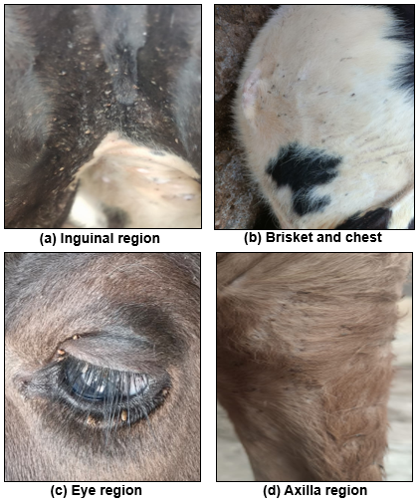
Plate 01: Site of tick attachment in cattle
Tick collection and morphological identification
Ticks were collected manually by gently detaching them from the calf skin using gloved fingers, taking care to avoid rupture and to retain the mouthparts intact for accurate identification. Since the samples were processed immediately and the laboratory was located in close proximity to the collection site, the specimens were placed in clean, labelled containers and temporarily stored under refrigeration to maintain their structural integrity until processing (Plate 02). Laboratory examination followed the standard procedure described by Soulsby (1982).
Tick specimens were washed in distilled water to remove debris and then cleared in 10% potassium hydroxide (KOH) to dissolve soft tissues and enhance visibility of morphological structures (Plate 03). After thorough rinsing in distilled water, the specimens were dehydrated through graded alcohol concentrations (50%, 70%, 90% and absolute alcohol) to prevent structural distortion (Plate 03). The dehydrated ticks were subsequently cleared in lactophenol to improve transparency and visualization of diagnostic characters and mounted on glass slides using DPX mounting medium (Plate 04). Morphological identification was carried out using standard taxonomic keys with the aid of a Leica DM 1000 LED microscope and LAS V4.10 software, based on diagnostic features such as the basis capituli, scutum, festoons and coxal spurs(Plate 04).
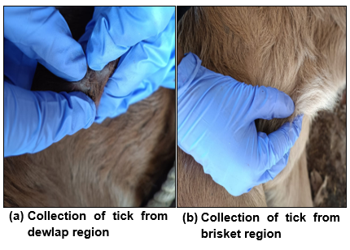
Plate 02: Collection of ticks for morphological identification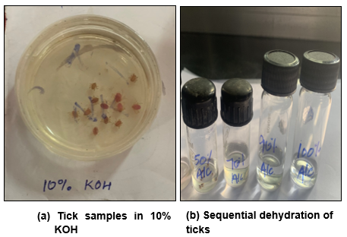
Plate 03: Processing of tick sample
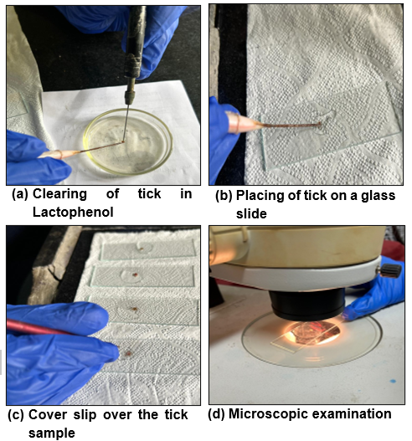
Plate 04: Processing of tick sample
Statistical analysis
Statistical analysis was carried out to evaluate the association between different qualitative variables included in the prevalence study. The chi-square test of significance was applied to compare categorical data and to determine whether observed differences in prevalence were statistically significant. A probability level of P < 0.05 was considered statistically significant for all analyses.
RESULT AND DISCUSSION
Overall prevalence
An epidemiological study was conducted to determine the prevalence of tick infestation in cattle over a six-month period, from July to December 2025. A total of 201 cattle suspected of tick infestation were screened at the Livestock Farm Complex, N.D.V.S.U., Adhartal, Jabalpur, during the study period. Out of the total cattle examined, 118 animals were found positive for tick infestation. The overall prevalence of tick infestation in cattle was recorded as 58.70% (Table 01).

Table 01: Overall prevalence of tick infestation in cattle
Particulars | No. Screened | No. positive | Prevalence (%)
Cows suspected for tick infestation | 201 | 118 | 58.70
The findings of the present study are in complete agreement with the observations reported by Patel et al. (2012), Mandloi et al. (2016) and Abdeta et al. (2024). The results of the present investigation are partially correlated with the findings of Girma et al. (2024) and Manmod and Jumade (2025). The prevalence observed in the present study was lower than that reported by Kemal et al. (2016), Kumar et al. (2022), Negi and Arunachalam (2019) and Jaliparthi et al. (2023). On the contrary, the prevalence recorded in the present study was higher than that reported by Debbarma et al. (2017) and Dehuri et al. (2017).
Variations in prevalence among different studies may be attributed to differences in geographical location, climatic conditions, seasonal influence, host factors and effectiveness of tick control practices.
Month wise distribution of tick infestation
The month wise distribution of tick infestation revealed variation in the prevalence of tick infestation among cattle. The highest prevalence was recorded in the month of August with 25.40%. This was followed by July with 22.00% and September with 20.30%. A declining trend in tick infestation was observed during the subsequent months with 15.30% cases in October, 10.20% in November and 06.80% in December (Table 02).
Table 02: Month wise distribution of tick infestation in cattle
Month | No. Positive (n=118) | Per cent (%)
July | 26 | 22.00
August | 30 | 25.40
September | 24 | 20.30
October | 18 | 15.30
November | 12 | 10.20
December | 08 | 06.80
$χ$² =18.47*
*Significant at p <0.05
The findings of the present investigation are in complete agreement with those reported by Khajuria et al. (2013) and Patel et al. (2012). Partial agreement with the present findings has been reported by Vatsya et al. (2008), Kumar et al. (2022) and Debbarma et al. (2018).
The higher prevalence of tick infestation observed during the late monsoon month of August may be attributed to favourable environmental conditions such as increased humidity and moderate ambient temperature which support tick survival, development and host seeking activity. Elevated moisture levels during this period create suitable microclimatic conditions for egg hatching, larval survival and successful attachment of ticks to the host resulting in increased infestation rates.
Age wise distribution of tick infestation
The age wise distribution of tick infestation revealed variation in prevalence among different age groups. Out of the total 118 tick-positive cattle, the highest number of cases was recorded in the 0–1 year age group, with 52 animals accounting for 44.07%. This was followed by the 1–3 years age group with 32.40%. The lowest prevalence was observed in animals aged above 3 years, with 23.73% (Table: 03).
Table 03: Age wise distribution of tick infestation in cattle
Age group | Number positive (n=118) | Per cent (%)
0- 1 year | 52 | 44.07
1-3 years | 38 | 32.40
>3 years | 28 | 23.73
$χ$² =10.74*
*Significant at p <0.05
The findings of the present study are in complete agreement with the observations reported by Patel et al. (2012) and Dehuri et al. (2017), who reported a higher prevalence of tick infestation in younger cattle compared to adult animals. In contrast, variation from the present findings has been reported by Kumar et al. (2022) and Jaliparthi et al. (2023), who observed different age-related patterns of tick infestation.
The higher prevalence observed in younger cattle in the present study may be attributed to immature immune response, limited prior exposure and reduced acquired resistance compared to older animals. The comparatively lower prevalence in adult cattle may be due to the development of partial immunity following repeated exposure and improved resistance to tick infestation.
Gender wise distribution of tick infestation
The overall gender wise distribution of tick infestation in cattle revealed a marked difference between males and females. Out of the total 118 tick positive cattle, 09 males infested with ticks accounted for 07.63%, whereas 109 were females that were infested with ticks accounted for 92.37%. The gender wise prevalence of tick infestation was found to be significantly higher in female cattle than in male cattle (p < 0.05) (Table 04).
Table 04: Gender wise distribution of tick infestation in cattle
Gender | Number positive (n=118) | Per cent (%)
Male | 09 | 07.63
Female | 109 | 92.37
$χ$² = 84.75*
*Significant at p <0.05
Studies consistent with the present findings, i.e., higher prevalence in females, include Sajid et al. (2010), Patel et al. (2012), Kemal et al. (2016), Dehuri et al. (2017), Farooqi et al. (2017), Kumar et al. (2022) and Jaliparthi et al. (2023), who all reported a higher tick prevalence in female cattle than males. Studies not consistent with the present findings include Khajuria et al. (2013) and Abdeta et al. (2024) who reported higher infestation in male cattle.
The higher prevalence of tick infestation observed in female cattle may be attributed to their longer retention in herds for breeding and milk production, which increases cumulative exposure to tick-infested environment. Physiological stress associated with pregnancy and lactation may reduce immune resistance, thereby increasing susceptibility to tick infestation compared to male cattle as stated by Patel et al. (2012).
Breed wise distribution of tick infestation
Out of the total 118 tick-positive cattle, the highest number of positive cases was recorded in crossbred cattle, accounting for 46.61%. This was followed by Sahiwal cattle with 27.11% positive cases. Nondescript cattle accounted for 14.41%, while Gir cattle showed 09.32% positive cases. The lowest prevalence was observed in Malvi cattle, accounting for 02.54%. The breed wise prevalence of tick infestation was found to be significant (p < 0.05). (Table 05).

Table 05: Breed wise distribution of tick infestation in cattle
Breed | No. positive (n=118) | Percentage (%)
Crossbred (CB) | 55 | 46.61
Sahiwal | 32 | 27.11
Gir | 11 | 09.32
Nondescript (ND) | 17 | 14.41
Malvi | 03 | 02.54
$χ$² =71.23*
*Significant at p <0.05
The present findings are in close agreement with Sajid et al. (2010) and Patel et al. (2012), who reported higher tick infestation in crossbred and exotic cattle compared to indigenous breeds. Similar observations were also reported by Farooqi et al. (2017) and Jaliparthi et al. (2023), who documented greater susceptibility of crossbred cattle under intensive management systems. However, the present findings are at variance with Dehuri et al. (2017) and Kumar et al. (2022), who recorded higher tick prevalence in indigenous or non-descript cattle.
These variations in breed wise prevalence may be attributed to differences in breed representation and region-specific preferences for particular cattle breeds.
Duration of illness wise distribution of tick infestation in cattle
The duration wise distribution of tick infestation revealed variation in prevalence among different duration categories. The highest number of positive cases was recorded in cattle with a duration of illness of 3–4 weeks, accounting for 26.27%, followed by 2–3 weeks with 24.58%. Cattle with a duration of 1–2 weeks accounted for 19.46%, while those with an illness duration of more than one month were 17.80%. The lowest prevalence was observed in cattle with a duration of 0–1-week, accounting for 11.86%.The duration wise prevalence of tick infestation was found to be significant (Table 06).
Table 06: Duration of illness wise distribution of tick infestation in cattle
Duration of illness | Positive cases (n=118) | Per cent (%)
0-1 week | 14 | 11.86
1-2 week | 23 | 19.46
2-3 week | 29 | 24.58
3-4 week | 31 | 26.27
> 1 month | 21 | 17.80
$χ$²=13.28*
*Significant at p <0.05
The higher prevalence observed in cattle with a longer duration of illness may be due to gradual accumulation of tick burden over time and delayed presentation for treatment, while animals with a shorter duration of illness likely represent early detection and recent infestation resulting in lower observed prevalence.
Predisposing factors for tick infestation based on housing type
The housing system wise distribution of tick infestation revealed that all 118 tick-positive cattle (100%) were maintained under a loose housing system. This indicates that tick infestation in the present study was exclusively observed in cattle reared under loose housing conditions.
Predisposing factors for tick infestation based on tick control
During the study, tick infestation was recorded in 52.5% of cattle where tick control was not done, while 47.5% of cases were observed in cattle where tick control measures were practiced. (Table 07).
Table 07: Predisposing factors for tick infestation based on tick control
Category | Number of cattle (n =118) | Per cent (%)
Tick control not done | 62 | 52.50
Tick control done | 56 | 47.50
$χ$²= 0.31^{NS}
*Significant at p <0.05
The lack of a significant difference between cattle with and without tick control may be due to irregular or improper application of acaricides, use of sub-optimal doses and possible development of tick resistance, which can reduce the effectiveness of tick control measures under field conditions.
Deworming status wise distribution of cattle with tick infestation
The prevalence of tick infestation based on deworming status was found to be statistically significant (p < 0.05). Out of the total 118 tick-positive cattle, the highest prevalence was recorded in animals with irregular deworming, accounting for 45.76%, followed by cattle with regular deworming at 32.20% and cattle with no history of deworming, accounting for 22.03% (Table 8).

Table 08: Deworming status wise distribution of cattle with tick infestation
Deworming status | Positive cases (n=118) | Per cent (%)
Regular | 38 | 32.20
Irregular | 54 | 45.76
No deworming | 26 | 22.03
$χ$² =6.27*
*Significant at p <0.05
The higher prevalence of tick infestation in cattle with irregular deworming may be due to compromised general health and immunity associated with internal parasitism, which can increase susceptibility to ectoparasite infestation, while regular deworming helps maintain better host resistance.
Distribution of skin lesion in tick-infested cattle
The occurrence of clinical signs associated with tick infestation differed significantly among the affected cattle (p < 0.05). Among the 118 tick-positive cattle, pruritus was the most common clinical sign observed, accounting for 46.61%, followed by alopecia in 14.41% and erythema in 13.56%. Scales were observed in 11.02% while nodules or tick bite granulomas were recorded in 10.17%. Rough coat was seen in 8.47% whereas lichenification was the least observed clinical sign, accounting for 1.69% (Table 09).
Table 09: Distribution of skin lesion in tick infested cattle
Clinical sign | No. of animals affected (n = 118) | Per cent (%)
Pruritus | 55 | 46.61
Erythema | 16 | 13.56
Alopecia | 17 | 14.41
Scales | 13 | 11.02
Rough coat | 10 | 08.47
Nodules/ tick bite granuloma | 12 | 10.17
Lichenification | 02 | 01.69
$χ$² =104.56*
*Significant at p <0.05
Pruritus was the most common clinical sign observed due to irritation and hypersensitivity reactions caused by tick attachment and feeding, while alopecia, erythema and scaling may result from repeated scratching, inflammation and localized skin damage. Nodules or tick bite granulomas develop at sites of prolonged attachment, whereas rough coat and lichenification occur in chronic cases due to persistent infestation and skin thickening.
Distribution of behavioral changes among tick-infested cattle
Out of 118 tick-infested cattle, 68 animals exhibited pruritic behavioural changes such as excessive scratching, biting, rubbing and restlessness, accounting for 58% of the affected cattle. This indicates that more than half of the infested cattle showed noticeable behavioural alterations associated with tick infestation.
Morphological Identification of tick species
60 adult ticks were collected from infested cattle and all collected specimens were subjected to morphological identification using standard taxonomic keys. Identification was carried out based on characteristic morphological features, including the scutum, basis capituli and hypostome dentition. Based on these criteria, all examined ticks were identified as Rhipicephalus microplus and no other tick species were encountered during the course of the study (Table 10; Plate 05-06).
Table 10: Morphologically identified tick species in cattle screened
Number of cows infested | Number of ticks collected | Tick species identified
118 | 60 | Rhipicephalus microplus
In the present study all examined ticks were identified as Rhipicephalus microplus, indicating its complete predominance. Similar findings were reported by Ghosh et al. (2019), Mushahary et al. (2019), Negi and Arunachalam (2019), Kumar et al. (2022), Jaliparthi et al. (2023) and Manmod and Jumade (2025), who documented Rhipicephalus microplus as the predominant or exclusive ixodid tick species in cattle. In partial agreement, Sajid et al. (2010) and Farooqi et al. (2017) reported the presence of multiple ixodid species, with R. microplus being the dominant species. In contrast, Komtangi et al. (2025), Girma et al. (2024) and Abdeta et al. (2024) reported a predominance of other ixodid species such as Amblyomma variegatum, Hyalomma anatolicum, Hyalomma dromedarii, Rhipicephalus decoloratus and Rhipicephalus sanguineus indicating variation in tick fauna across different ecological settings.

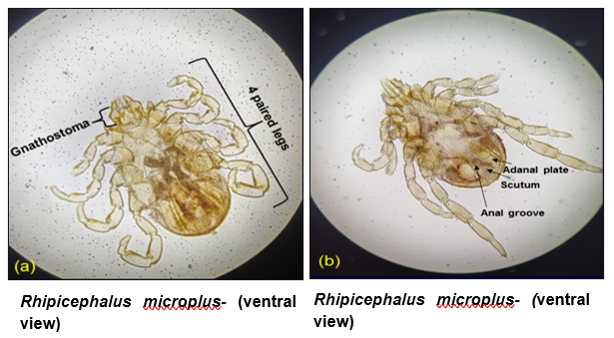
Plate 05: Microscopic examination of ticks (4X)
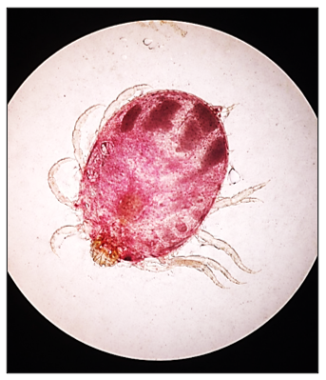
Plate 6: Microscopic examination of Rhipicephalus microplus female tick (ventral view) (4X)
CONCLUSION
The study documented a high prevalence (58.70%) of tick infestation in cattle at the Livestock Farm Complex, NDVSU, Jabalpur, with significant associations observed with month, age, sex, breed, housing system and deworming status. Infestation was highest during the monsoon period, particularly in August and was more common in calves, female and crossbred cattle. Pruritus was the predominant clinical sign. Morphological identification confirmed Rhipicephalus microplus as the exclusive tick species infesting cattle in the study area. These findings highlight the need for regular monitoring, improved management practices and effective tick control strategies to reduce infestation and associated economic losses.
DISCLAIMER (ARTIFICIAL INTELLIGENCE)
Author(s) hereby declares that no generative AI technologies such as Large Language Models (ChatGPT, COPILOT, etc.) and text-to-image generators have been used during writing or editing of this manuscript.
REFERENCES
Benelli, G., Pavela, R., Canale, A. and Mehlhorn, H. (2016). Tick repellents and acaricides of botanical origin: a green roadmap to control tick-borne diseases? Parasitology Research, 115(7): 2545–2560.
Debbarma A, Pandit S, Jas R, Baidya S, Mandal SC, Jana PS. Prevalence of hard tick infestations in cattle of West Bengal, India (2018). Biological Rhythm Research. 49(5):655-662.
Dehuri M, Panda MR, Mohanty B, Hembram A, Mahapatra T, Sahu A. Ixodid ticks infesting cattle and associated risk factors in coastal districts of Odisha. Journal of Entomology and Zoology Studies. 2017;5(4):129-132.
Eskezia, B. and Desta, A. (2016). Review on the impact of ticks on livestock health and productivity. Journal of Biology, Agriculture and Healthcare, 6(22): 1-7.
Farooqi, S.H., Ijaz, M., Saleem, M.H., Rashid, M.I., Oneeb, M., Khan, A., Aqib, A.I. and Mahmood, S. (2017). Distribution of ixodid tick species and associated risk factors in temporal zones of Khyber Pakhtunkhwa province, Pakistan. Pakistan Journal of Zoology, 49(6): 2011-2017.
Girma, A., Abdu, I., Teshome, K., Genet, A. and Tamir, D. (2024). Prevalence, trend comparisons, and identification of ixodid ticks (Acari: Ixodoidea) among cattle in Ethiopia: A systematic review and meta-analysis. Parasite Epidemiology and Control, 25: e00356.
Grisi, L., Leite, R. C., Martins, J. R. S., Barros, A. T. M., Andreotti, R., Cançado, P. H. D., León, A. A. P. de, Pereira, J. B., & Villela, H. S. (2014). Reassessment of the potential economic impact of cattle parasites in Brazil. Revista Brasileira de Parasitologia Veterinária, 23(2), 150–156.
Jaliparthi, J., Manchukonda, U.K., Sreenivasa Murthy, G., Putty, K. and Gonepudi, N.K. (2023). Influence of animal factors on the prevalence of ixodid ticks on cattle in Telangana State, India. Journal of Animal Research, 13(3): 451-455.
Kemal, J., Tamerat, N. and Tuluka, T. (2016). Infestation and identification of ixodid tick in cattle: The case of Arbegona District, Southern Ethiopia. Journal of Veterinary Medicine, 2016: 9618291.
Khajuria, V., Godara, R., Yadav, A. and Katoch, R. (2013). Prevalence of ixodid ticks in dairy animals of Jammu region. Journal of Parasitic Diseases, 39(3): 418-421.
Komtangi, M.C., Detsi, P.J., Nsah, B.K. and Awah-Ndukum, J. (2025). Prevalence, intensity and risk factors of tick infestation of cattle in northwest region Cameroon. Veterinary Sciences: Research and Reviews, 11(1): 39-53.
Kumar, J., Manzer, H., Punia, V. and Kumar, P. (2022). Prevalence of cattle tick infestation in three villages of Vallabhnagar tehsil of Udaipur district (Rajasthan). The Pharma Innovation Journal, 11(3): 376-380.
Mandloi, U.K., Jayraw, A.K., Haque, M. and Jamra, N. (2016). Prevalence of ixodid ticks in cattle population of Indore, Madhya Pradesh. Indian Journal of Veterinary Science and Biotechnology, 12(2): 62-65.
Mushahary, D., Bhattacharjee, K., Sarmah, P.C., Deka, D.K., Upadhyaya, T.N. and Saikia, M. (2019). Prevalence of ixodid ticks in cattle of Assam. International Journal of Current Microbiology and Applied Sciences, 8(5): 2168-2183.
Negi, T., and Arunachalam, K. (2019). Study on prevalence of ixodid tick infestation on bovines of Dehradun district, Uttarakhand. Biological Rhythm Research, 51(8), 1288–1297.
Patel, G., Shanker D., Jaiswal A.K., Sudan V. and Verma S.K. (2013). Prevalence and seasonal variation in ixodid ticks on cattle of Mathura district, Uttar Pradesh. Journal of Parasitic Diseases. 37(2):173–176.
Manmod, P., Jumade, P. and Kolte, S.W. (2025). Detection of deltamethrin resistance in Rhipicephalus microplus ticks infesting cattle by adult immersion test. International Journal of Advanced Biochemistry Research, 9: 83-87.
Abdeta, T., Mulisa, G. and Gemechu, Z. (2024). Study on the prevalence of tick infestation of cattle presented at Guder Mamo Mezemir Campus Veterinary Teaching Clinic, Guder, Oromia Regional State, Ethiopia. International Journal of Veterinary Science and Medicine, 5: 1-5.
Okello Onen, J., Tukahirwa, E.M., Perry, B.D., Rowlands, G.J., Nagda, S.N., Musisi, G., Bode, E., Heinonen, R., Mwayi, W. and Opuda-Asibo, J. (2003). The impact of tick control on the productivity of indigenous cattle under ranch conditions in Uganda. Tropical Animal Health and Production, 35(3): 237-247.
Sajid, M.S., Khan, M.N., Ashraf, M., Khan, A., Ahmad, I., Ullah, Z., and Iqbal, Z. (2010). Prevalence and associated risk factors for bovine tick infestation in two districts of lower Punjab, Pakistan. Preventive Veterinary Medicine, 93(3): 220-225.
Soulsby EJL, Helminths, arthopords and protozoa of domesticated animals. 7th Edition. The Bailliere Tindall, London, 1982.
Vatsya, S., Yadav, C.L., Kumar, R.R. and Garg, R. (2008). Prevalence of ixodid ticks on bovines in foothills of Uttarakhand state: a preliminary report. Indian Journal of Animal Sciences, 78: 40-42.

