Demonstration of Yield and Economics under High Density Planting System in Cotton in Sangareddy district, Telangana, India

Abstract
Cotton (Gossypium hirsutum L.) is a major fibre and cash crop that plays a crucial role in sustaining India’s national economy. Telangana contributes substantially to the national cotton area (15.67%) and production (21%). A field study was conducted during the kharif seasons of 2024–25 and 2025–26 at farmers’ fields under ICAR–ATARI, Zone X, Krishi Vigyan Kendra (KVK), Medak–1, to evaluate the impact of Front-Line Demonstrations (FLDs) on cotton productivity and profitability under a High-Density Planting System (HDPS). A total of 20 FLDs were conducted over 8 hectares across five villages in the Narayankhed and Zaheerabad talukas of Sangareddy district, Telangana, using the high-yielding cotton hybrid RCH-97 BG-II. The improved practice, comprising the recommended package of practices, was compared with the existing farmer’s practice, which served as the local check. Pooled analysis of two years’ data indicated that the improved practice recorded a mean seed cotton yield of 2905 kg ha⁻¹, representing a 20.27 % increase over the local check yield of 2410 kg ha⁻¹. The demonstrated technology resulted in an average extension gap of 495 kg ha⁻¹, technology gap of 595 kg ha⁻¹, and technology index of 16.99 %, indicating considerable scope for improving productivity through better adoption of recommended practices. Economic analysis revealed higher profitability under the improved practice, with a net return of Rs 128,987.12 ha⁻¹ and a benefit–cost ratio of 2.46, compared to Rs. 93,831.25 ha⁻¹ and 2.08, respectively, under farmer’s practice. The study demonstrates that adoption of HDPS with improved varieties significantly enhances cotton yield and farm income.
Keywords: Cotton, Frontline demonstrations, High density planting system, Yield and Benefit–cost ratio.

Introduction
cotton is an important cash crop. In certain countries, it is recognized as “white gold” Because of its growing role in boosting the country’s GDP and foreign exchange earnings. In the world, cotton fiber is a distinguished fiber that serves as a raw material for textile industries having a yearly significant economic impact of at least $600 billion (Khan et al., 2020). Cotton supports the livelihoods of 95 million people in India. It is the only country in the world wherein all the four cultivated species are grown (Gossypium arboreum, Gossypium herbaceum, Gossypium hirsutum and Gossypium barbadense). Historically, the Asiatic cotton (G. arboreum and G. herbaceum) cultivars were grown in India (Kulkarni et al., 2009). It plays a pivotal role in sustaining the livelihoods of approximately 6 million cotton farmers and provides employment to 40–50 million people engaged in allied activities such as processing, marketing, and trade. The major cotton-growing states include Gujarat, Maharashtra, Telangana, Andhra Pradesh, Karnataka, and Tamil Nadu. Among these, Gujarat is the largest cotton-producing state, covering about 2.60 million hectares with a production of nearly 9.50 million bales, and ranks first in national cotton production (Gandhi and Jain, 2019)
Cotton growth and productivity are strongly influenced by climatic conditions, particularly temperature. An optimum temperature range of 21–27 °C is essential for favorable vegetative growth, influencing leaf expansion, internodes elongation, dry matter accumulation, and assimilate partitioning. Despite increasing competition from synthetic and blended fibres, cotton continues to occupy a dominant position in the textile industry. Gossypium hirsutum alone accounts for nearly 90% of hybrid cotton production in India, and all commercially cultivated Bt cotton hybrids belong to this species. The cotton-growing regions of India are broadly categorized into three zones: the North Zone (Punjab, Haryana, Rajasthan), Central Zone (Madhya Pradesh, Maharashtra, Gujarat), and South Zone (Telangana, Andhra Pradesh, Karnataka, Tamil Nadu).
The High Density Planting System (HDPS) is an advanced cotton production technology characterized by closer plant spacing to achieve higher plant populations per unit area. Also referred to as ultra-narrow row cotton, HDPS was developed by the Central Institute for Cotton Research (CICR), Nagpur, in 2010. This system has gained considerable attention due to its ability to enhance productivity, improve resource-use efficiency, reduce production costs, and minimize risks associated with conventional cotton cultivation. Rapid canopy closure under HDPS reduces soil moisture loss through evaporation, making it particularly suitable for water-limited environments. Although several studies have documented the performance of conventional planting systems and different cotton species, empirical evidence on the field-level performance, yield advantage, and economic feasibility of HDPS under farmers’ conditions—particularly in Gossypium hirsutum remains limited. Moreover, region-specific validation of HDPS through Front Line Demonstrations is scarce in Telangana. This gap in the existing literature provided the motivation for the present study, which aimed to evaluate the yield and economic benefits of HDPS in cotton under real farm conditions in Sangareddy district of Telangana.
MATERIALS AND METHODS
A field experiment was conducted during the kharif seasons of 2024–25 and 2025–26 at farmers’ fields located in Nagoor K, Rehmathnagar, Godegarpally, Nyalkal, and Raikode villages of Zaheerabad and Narayankhed talukas in Sangareddy district, Telangana, under the aegis of ICAR–ATARI, Zone X, DDS–Krishi Vigyan Kendra (KVK), Medak–1. The study aimed to evaluate the yield and economics of cotton under a High Density Planting System (HDPS) through Front Line Demonstrations (FLDs). The experimental area falls under the semi-arid agro-climatic zone of the Telangana Deccan Plateau. The soils of the study area ranged from sandy to sandy loam, were mostly saline, with soil pH values between 7.5 and 8.5 and electrical conductivity (EC) ranging from 0.6 to 2.5 dS m⁻¹. The soils were low in available nitrogen and potassium, medium in phosphorus, and deficient in organic carbon and essential micronutrients. Geographically, the district lies between 17°37′29″ N latitude and 78°05′12″ E longitude, at an elevation of 374–694 m above mean sea level.
A total of five villages were randomly selected for conducting FLDs across the two talukas. Twenty FLDs were implemented over a total area of 8 hectares, with individual demonstrations covering 0.4 ha each, as detailed in Tables 1 and 2. Prior to execution of the FLDs, baseline information on existing crop production practices, soil fertility status, varieties grown, and incidence of insect pests and diseases was collected through Participatory Rural Appraisal (PRA) surveys and farmer meetings. This facilitated identification of major constraints in cotton cultivation and formulation of suitable interventions. The improved practice (IP) involved cultivation of the high-yielding cotton hybrid RCH-97 BG-II along with the recommended package of practices, including optimum plant spacing, balanced fertilizer application, and need-based plant protection measures. Farmers maintained a portion of their land under farmer’s practice (FP) using their existing cultivation methods for comparison. Sowing was carried out between mid-June and the second week of July under rainfed conditions, while cotton picking commenced from the last week of November to December. Cotton was harvested manually as bolls opened, which is the common practice in India.
Table 1: Comparison between HDPS Cotton and Traditional Cotton (Average of 20 Farmers)
Package and Practice | HDPS Cotton | Traditional Cotton
Soil Type | Light Red, Chalka Soils | Black Soils
Rainfed /Irrigated | Rainfed | Rainfed
Seed Rate (Kg/acre) | 2.5 | 1
Date of Sowing | June | June
Spacing(cm) | 90x 15 | 90x 60
Sowing Method Adopted | Manual | Manual
Number of Plants per Meter Row Length | 6 | 2
Spraying of PGR(Mepiquat Chloride) | Yes | No
Average Number of Sympodial Branches/Plant | 7-8 | 11-12
Average Number of Monopodial Branches/Plant | 1 | 2-4
Major Insect Pests Noticed Above ETL | Jassids, Aphids, Whiteflies | Pink Boll worm, Tobacco Bollworm
Number of Pickings | 1-2 | 3-4
Crop Duration | 150 days | 180 days
Second Crop | Bengal gram, Safflower and Sorghum | -
As part of the FLDs, farmers were provided with critical inputs such as quality seed, fertilizers, and plant protection chemicals, along with technical guidance from KVK scientists. Awareness programmers on the importance of improved varieties and advanced cotton production technologies were organized in the adopted villages prior to the cropping season. For evaluation, data on seed cotton yield, insect pest incidence, and disease occurrence were recorded separately from IP and FP plots. The collected data were compiled and analyzed using descriptive statistical tools such as frequency and percentage. The extension gap, technology gap, technology index, and percentage increase in yield were calculated using the methodology suggested by Samui et al., (2000) as follows:
- Per cent increase in yield (%)
Per cent increase in yield = Yield gain in IP plot (kg/ha) – Yield gain in FP plot (kg/ha) x 100 / Yield gain in FP plot (kg/ha)
- Technology gap (kg ha⁻¹)
Technology gap = Potential yield – Demonstration yield
- Extension gap (kg ha⁻¹)
Extension gap=Demonstration yield – Local check
- Technology index (%)
Technology index (%) = [(Potential yield – Demonstration yield)/Potential yield] x 100

RESULTS AND DISCUSSION

Yield Analysis
The yield of cotton was significantly higher in the demonstration plots compared to farmers’ local practices during the kharif seasons of 2024–25 and 2025–26. As presented in Table 2, the adoption of improved technical interventions resulted in a 20.27% increase in cotton yield, recording 2905 kg ha⁻¹ as against 2410 kg ha⁻¹ under the existing farmers’ practices (local check). Similar yield advantages of improved technologies over traditional practices have also been reported by Feng et al. (2017) and Singh et al. (2024). The lower yield observed under farmers’ practices in the adopted villages may be attributed to the use of local varieties, traditional cultivation methods, imbalanced fertilizer application, and inadequate weed management. In contrast, the Front Line Demonstrations (FLDs) conducted by KVK scientists involved the use of high-yielding varieties along with an improved package of practices, including timely sowing, recommended spacing, balanced nutrient management, timely weed control, and the adoption of Integrated Disease Management (IDM) and Integrated Pest Management (IPM) strategies, which collectively contributed to enhanced cotton productivity.
Table 2. Effect of frontline demonstration on yield and percentage increase of cotton
Years | No. of Farmers/ Demos | Area in ha | Potential yield (kg/ha) | Demo (kg/ha) | Local (kg/ha) | %Increase in yield
2024-25 | 10 | 4.0 | 3500 | 3175 | 2530 | 25.49
2025-26 | 10 | 4.0 | 3500 | 2635 | 2290 | 15.06
Average | 10 | 4.0 | 3500 | 2905 | 2410 | 20.27

Economics Analysis
The economic analysis of cotton cultivation, as presented in Table 3, clearly demonstrated the economic superiority of scientific production technologies over farmers’ local practices. The analysis was carried out based on the prevailing costs of inputs and market prices of produce and was expressed in terms of cost of cultivation, net returns, and benefit–cost (B:C) ratio. The two-year average cost of cultivation was Rs. 86,905 ha⁻¹ under farmers’ practices and Rs. 88,542.5 ha⁻¹ under the demonstration plots. Despite the slightly higher cost of cultivation in the demonstrations, substantially higher net returns of Rs. 1,28,987.12 ha⁻¹ were realized compared to Rs. 93,831.25 ha⁻¹ under local practices. Consequently, the B:C ratio was higher in the demonstration plots (2.46) than in farmers’ practices (2.08). The higher net returns and B:C ratio obtained under improved practices may be attributed to enhanced yields and better market prices resulting from superior quality produce achieved through the adoption of recommended production technologies. These results are in agreement with the findings of Patil et al. (2018).

Table 3. Economic comparison between improved practice and farmers practice
Years | Gross Cost(Rs./ha) |  | Gross Return  (Rs./ha) |  | Net Return(Rs./ha) |  | BCR
 | IP | FP | IP | FP | IP | FP | IP | FP
2024-25 | 85,860 | 84,910 | 230187.5 | 1,83,425 | 1,44,328 | 98,515 | 2.68 | 2.16
2025-26 | 91,225 | 88,900 | 2,04,871.25 | 1,78,047.5 | 1,13,646.25 | 89,147.5 | 2.24 | 2.00
Average | 88,542.5 | 86,905 | 2,17,529.37 | 1,80,736.25 | 1,28,987.12 | 93,831.25 | 2.46 | 2.08

Technological Gap Analysis
The difference between the yield obtained under demonstration plots and that recorded under existing farmers’ practices is termed the extension gap. The extension gap exhibited a decreasing trend over successive years of the study, as presented in Table 4. During the experimental period, the extension gap ranged from 345 to 654 kg ha⁻¹, with a mean value of 495 kg ha⁻¹. This declining trend highlights the effectiveness of Front Line Demonstrations and underscores the need to further motivate farmers to adopt improved agricultural production technologies for narrowing the yield gap. Similar trends have also been reported by Singh et al., (2024).
The difference between the potential yield of the variety and the yield realized under demonstration plots is referred to as the technology gap. The technology gap during the study period ranged from 325 to 865 kg ha⁻¹, with an average of 595 kg ha⁻¹. The persistence of technology gaps, despite yield improvements in demonstration plots, indicates scope for further refinement and location-specific adaptation of recommended technologies. The observed technology gap may be attributed to variations in soil fertility status, imbalanced nutrient management—particularly inadequate use of organic inputs—partial adoption of Integrated Pest Management (IPM) and Integrated Disease Management (IDM) practices, and climatic variability such as fluctuations in rainfall and temperature. Similar observations emphasizing the importance of farming situation-specific interventions for enhancing system productivity were also reported by Wasnik et al., (2013).

Table - 4. Effect of FLDs on extension gap, technology gap and technology index in cotton
Years | Extension gap kg/ha | Technology gap kg/ha | Technology index %
2024-25 | 645 | 325 | 9.28
2025-26 | 345 | 865 | 24.71
Average | 495 | 595 | 16.99

The results indicated that the cluster front line demonstrations (CFLDs) had a positive impact on the farming community in the demonstrated villages by motivating farmers to adopt improved agricultural practices and by clearly illustrating the yield gap between recommended technologies and existing practices in Sangareddy district. The technology index, which represents the ratio of the technology gap to the potential yield expressed as a percentage, serves as an indicator of the feasibility of the demonstrated technology under farmers’ field conditions. A lower technology index value signifies greater feasibility and adaptability of the technology, whereas a higher value reflects inadequate transfer of technology and extension support. During the study period, the technology index varied widely from 9.28% to 24.71%, which may be attributed to variations in soil fertility status, prevailing weather conditions, limited availability of irrigation water, and incidence of insect–pest attacks. The average technology index was recorded as 16.99% during 2024–25 to 2025–26 (Table 4), indicating reasonable feasibility of the demonstrated technologies at the farmers’ fields. These findings are in agreement with the reports of Kumar et al., (2019).

CONCLUSION
The findings of the present study revealed a considerable gap between the potential yield and the demonstration yield of high-yielding cotton varieties in Sangareddy district of Telangana, primarily due to existing technology and extension gaps. The results clearly indicated that Front Line Demonstrations (FLDs) on High Density Planting System (HDPS) technologies significantly enhanced cotton productivity compared to prevailing farmer practices. The adoption of improved HDPS technologies demonstrated substantial potential for increasing cotton yield, thereby improving farm income and livelihood security of the farming community. The observed yield gaps highlight the need for a multi-pronged strategy that emphasizes wider dissemination and adoption of improved production technologies to enhance cotton productivity in the region. Effective horizontal spread of these technologies can be achieved through systematic implementation of FLDs, supported by strong extension interventions. Capacity-building activities such as training programmes, field demonstrations, farmer field visits, kisan gosthis, and exposure visits played a crucial role in improving farmers’ awareness, knowledge, and confidence in adopting improved practices. Overall, FLDs proved to be an effective extension tool for bridging yield gaps, accelerating adoption of improved technologies, and contributing to the sustainable agricultural development and economic stability of cotton farmers in Sangareddy district.

REFERENCES

Kulkarni, V. N., Khadi, B. M., Maralappanavar, M. S., Deshapande, L. A., & Narayanan, S. S. (2009). The worldwide gene pools of Gossypium arboreum L. and G. herbaceum L., and their improvement. In Genetics and genomics of cotton (pp. 69-97). New York, NY: Springer US.

Feng, L., Dai, J., Tian, L., Zhang, H., Li, W., & Dong, H. (2017). Review of the technology for high-yielding and efficient cotton cultivation in the northwest inland cotton-growing region of China. Field Crops Research, 208, 18-26.

Gandhi, V. P., & Jain, D. (2016). Cotton cultivation in Gujarat. In Introduction of biotechnology in India’s agriculture: Impact, performance and economics (pp. 131–149). Springer Singapore.

Khan, M. A., Wahid, A., Ahmad, M., Tahir, M. T., Ahmed, M., Ahmad, S., & Hasanuzzaman, M. (2020). World cotton production and consumption: An overview. In Cotton production and uses: Agronomy, crop protection, and postharvest technologies (pp. 1–7). Springer.

Patil, S. S., Mahale, M. M., & Chavan, S. S. (2018). Impact of frontline demonstrations (FLDs) on oilseed crops in South Konkan coastal zone of Maharashtra. Current Agriculture Research Journal, 6(3), 355–364.

Samui, S. K., Roy, D. K., Mandal, A. K., & Saha, D. (2000). Evaluation of front line demonstration on groundnut. Journal of the Indian Society of Coastal Agricultural Research, 18, 180–183.

Singh, T., Tetarwal, A. S., & Dev, R. (2024). Assessment of cluster front line demonstration on yield and economics of summer sesame. Indian Journal of Agronomy, 69(2), 195–199.

Tetarwal, A. S., & Singh, T. (2021). Evaluation of cluster frontline demonstrations (CFLDs) on the productivity of kharif groundnut in Kachchh district of Gujarat. Annals of Agricultural Research, 42(4), 451–457.

Wasnik, S. M., Raju, A. R., Palve, S. M., Majumdar, G., & Parwale, P. P. (2013). Technology intervention performance under front line demonstration in Bt hybrid cotton (Gossypium hirsutum L.). Journal of Cotton Research and Development, 27, 126–133.

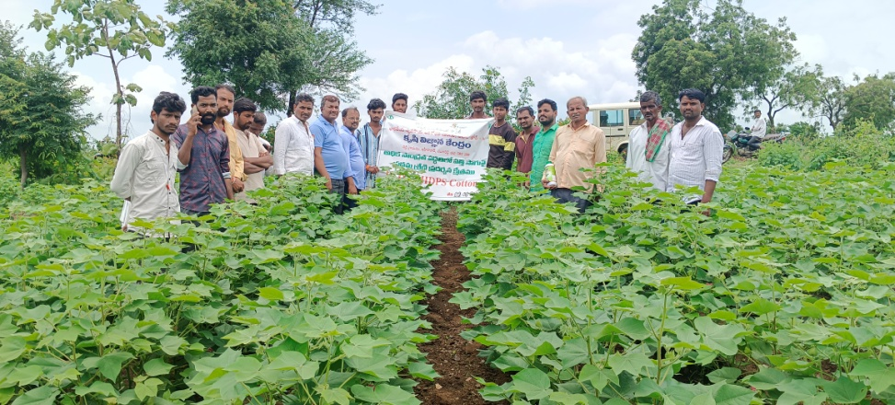
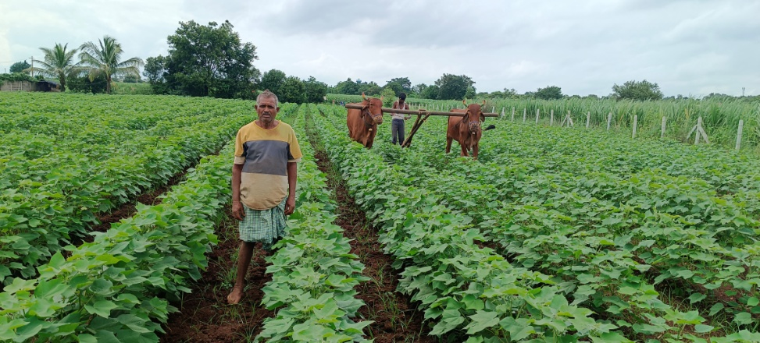
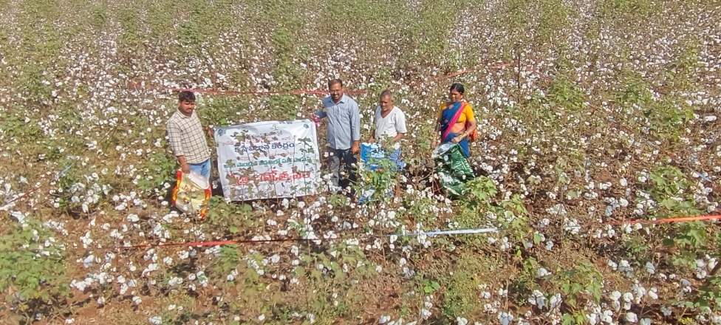
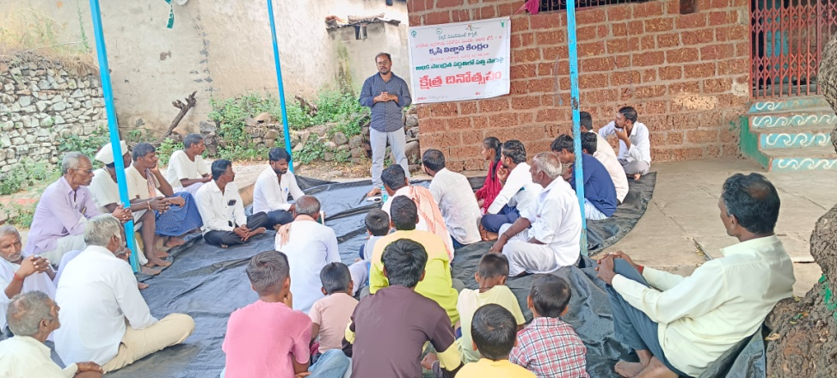
Plate 1 : Field demonstrations and farmers’ field visits

