Original Research Article
Population dynamics of the rose aphid Macrosiphum rosae (Hemiptera: Aphididae),and its management under protected conditions in Kashmir

.
ABSTRACT

Aims: To correlate the aphid population with the weather parameters, i.e., temperature (minimum and maximum), minimum relative humidity, maximum relative humidity. Bio-efficacy of different molecules against aphid population.
Study design: RCBD (Randomized Complete Block Design) was used for the experiment. A polyhouse that was separated into three equal-sized blocks (14.6 m × 1.52 m) was used to plant a variety of roses. Eleven subplots, each measuring 1.11 meters by 1.52 meters, were created from each block. Five plants were cultivated at the specified spacing of 35 cm by 25 cm in each plot.
Location and Study Period: The current study was conducted under protected conditions in the Division of Floriculture & Landscaping Architecture's experimental block at SKUAST-K's Shalimar campus in Srinagar from March 2022 to December 2022.
Methodology: Under polyhouse conditions, ten randomly chosen rose plants were used to record the seasonal occurrence of rose aphids. The observations were made with a 10X hand lens. RCBD design were used to assess bio-efficacy of different molecules. Two spray rounds were sprayed in the polyhouse at 14-day intervals after the aphid population on roses was counted the day before the spray. Following both treatments, observations were made of two randomly chosen plants from each treatment at 1, 3, 7, and 15 DAS (days after spraying) (3 leaves and one flower bud from each plant). A statistical analysis was conducted on the recorded data.
Results: Aphid population build-up began in the second week of April (14th SMW) and peaked in June and July (26th and 27th SMW), but the initial incidence of aphid population began in March (12th SMW). Aphid populations have been found to positively correlate with both minimum and maximum temperatures. Aphid population and relative humidity (minimum and maximum) were shown to be negatively correlated. The study revealed a significant positive correlation between aphid population density and both minimum and maximum temperatures (r = 0.546–0.586, p < 0.01), whereas relative humidity exhibited a significant negative association. Among the evaluated treatments, Thiamethoxam 25% WDG at a rate of 0.3 g/L achieved the highest level of aphid population suppression (>90%) under protected cultivation conditions.
Conclusion: The initial incidence of aphid population started from March- 12th SMW and reaching the peak in June- July (26nd and 27th SMW). A positive correlation was reported between aphid population and minimum & maximum temperature and negative correlation was observed between aphid population and relative humidity. Treatment Thiamethoxam 25% WDG @0.3 g/L was found as the most effective treatment for suppressing the aphid populations.

Keywords: Rose, aphids, Population dynamics, polyhouse.

1. INTRODUCTION

In recent years, numerous entrepreneurs have shown interest in the agricultural industry and floriculture has developed as an economically feasible and diverse choice in Indian agribusiness with the potential for substantially better returns than other Agri-horticultural crops (Dalal and Alhasan, 2025). Floriculture, the cultivation and marketing of flowers and ornamental plants, is a significant branch of horticulture with immense potential for generating employment and profit, especially in India. The floriculture industry has seen substantial growth due to increased global demand for flowers, driven by higher living standards and environmental awareness. The Government of India has identified floriculture as a sunrise industry, emphasizing its export potential. India, with a significant area under rose cultivation, is a major player in the global floriculture market. Annual domestic industry growth of 15-20 per cent as made floriculture a very attractive vocation. The Jammu & Kashmir UT having a diverse climate makes it ideal for floriculture commercialization yet the potential has been fully exploited. With the efforts of SKUAST-K and government of Jammu & Kashmir, the state’s floriculture area has risen to 0.75 thousand hectares with a production of 0.42 thousand MT of loose flower and 1.82 thousand MT of cut flower (Sheikh et al., 2015). Due to susceptibility of rose to insect pests which cause economic damage to the crop. It has become imperative to manage the insect pests using various chemicals. Several insecticides like Monocrotophos, Spiromesifen, Fenazaquin, Fipronil, Acetamiprid and Thiacloprid have been recommended for managing the pests (Mehrparvar el al., 2016). The rose aphids Macrosiphum rosae (Hemiptera:Aphididae) damage leaves directly by sucking cell sap and indirectly by excreting honeydew, which encourages sooty mould growth. This direct and indirect damage affect plant growth and development (Rasib and Razzaq, 2021). Therefore, the present study was undertaken to (i) investigate the seasonal population dynamics of Macrosiphum rosae under protected conditions, (ii) determine its relationship with key weather parameters, and (iii) evaluate the bio-efficacy of selected chemical and biological treatments.

2. material and methods
The current study was done using the rose variety ‘Top-Secret’ which was planted in polyhouse at a spacing of 35 cm× 20 cm in the floriculture experimental field, Faculty of Horticulture (FOH), SKUAST-K, Shalimar campus, Srinagar. Incidence of rose aphid was recorded from March, 2022 to December, 2022 at weekly intervals. Ten rose plants were randomly selected for taking the observations of aphids. A 10X hand lens was used for taking observations and influence of the weather parameters i.e., minimum and maximum temperature andmaximum and minimum relative humidity on the incidence of aphids of rose was assessed during the course of study. The temperature (ºC) and relative humidity (%) were recorded on daily basis using digital humidity and temperature meter. Simple correlation studies were worked out between the incidence of rose aphids with temperature and relative humidity under protected conditions in Kashmir.
Picture 1 : Development of sooty mould on aphid-infested

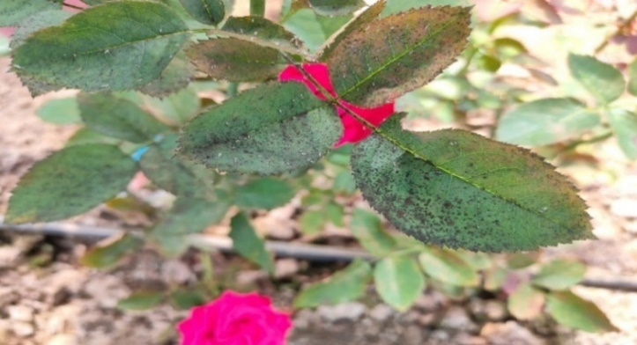

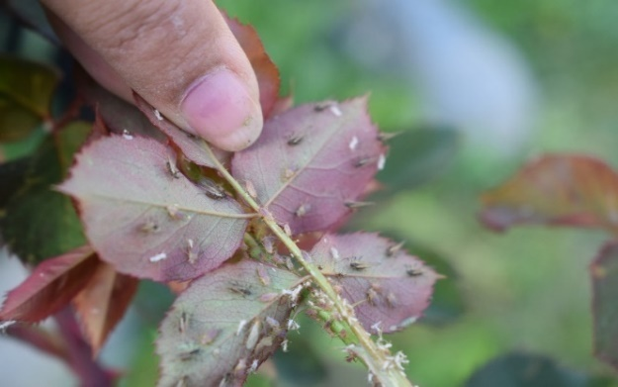

Picture 2: Aphid infestation on underside of leaf

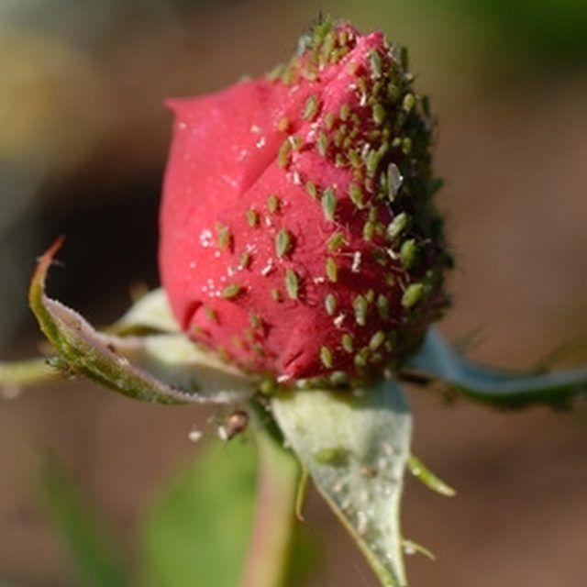

Picture 3: Aphid infestation on flower bud and flower
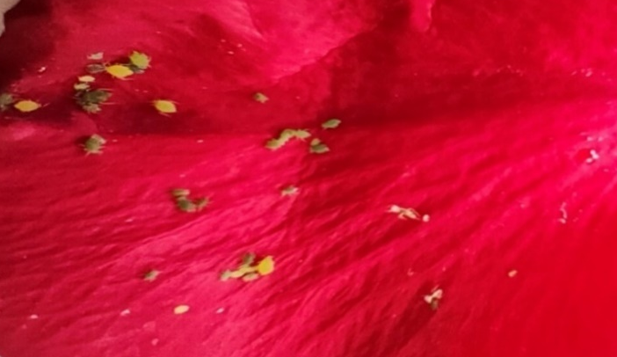

Picture 4: Aphid infestation on rose petal

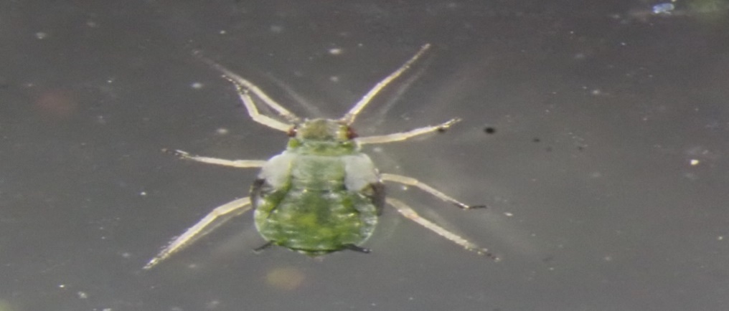

Picture 5: Microscopic image of aphids

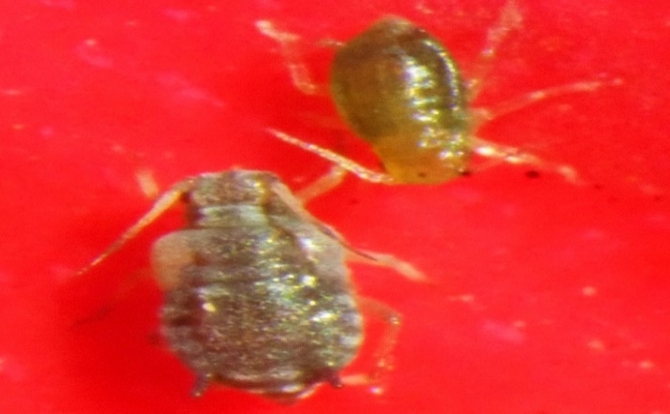

Picture 6: rose aphid, Macrosiphum rosae

For managing rose aphids, polyhouse of dimensions 14.6m × 6m was divided in three blocks of equal size (17m × 1.52m) each representing a replication. These each block was further divided into eleven sub-plots each of equal size 1.11m × 1.52m. Each plot represented a treatment and consisted of four plants grown at a recommended spacing of 35cm × 20cm. The experiment was set up in RCBD (Randomized Complete Block Design) with a total of eleven treatments comprising of botanical, entomopathogen and newer molecular insecticides including an untreated control and were replicated thrice (Table 1).The aphid population on rose was counted one day before to the spray followed by the two spray rounds that were sprayed at 14 days interval in polyhouse. After both sprays observations were recorded at 1, 3, 7 and 15 DAS (Days after spraying) from randomly selected two plants of each treatment (3 leaves and 1 flower bud from each plant). Statistical analysis of these observations. The data were subjected to analysis of variance (ANOVA) under a randomized complete block design (RCBD). Treatment means were separated using the critical difference (CD) test at p = 0.05. Correlation and regression analyses were performed using OP stat software.

3. results and discussion
Aphids were found on leaves in densities ranging 0.15 to 5.15/leaf during the investigation period, as shown in Table 1. The occurrence of aphids on leaves began during 12th SMW (March), when 0.45 aphids/leaf were recorded, which was a relatively low population. There were 1.1 aphids per leaf during the 14th SMW (April) reaching a peak of 5.15 aphids per leaf during 26th SMW (June) when the maximum mean temperature was 36.5°C. Thereafter, population began to fluctuate up to the 35th SMW (August), after which it gradually decreased. The incidence of aphids on rose flowers ranged 0.10 to 11.55 aphids/flower during the period of investigation. There was no incidence of aphids on flower during 12th SMW (March) to 15thSMW (March), which gradually started increasing from 16th SMW (April) with 0.10 aphids/flower reaching the peak in 27th SMW (1st week of July) with 11.55 aphids/flower at a maximum mean temperature of 34°C followed by an abrupt decline during 28th SMW (July) with 1.15 aphids/flower. Thereafter, aphid population fluctuated with gradual decline from 38th SMW (August) with 5.15 aphids/flower till 44th SMW (February) with 0.60 aphids/flower was observed. There was no incidence of aphids on flower during 45th SMW (November) to 52nd SMW (December).
Table 1. Treatment details (different molecules) against rose aphids under protected conditions.
T₁ | Spiromesifen 240% SC @0.4ml/L
T₂ | Fenazaquin 10% EC @0.4ml/L
T₃ | Abamectin 1.9% EC@0.5ml/L
T₄ | Fipronil 5%SC @ 1 ml/L
T₅ | Thiacloprid 21.7% SC @0.5ml/L
T₆ | Acetamiprid 20%SP@ 0.2g/L
T₇ | Thiamethoxam 25%WDG @ 0.3g/L
T₈ | Lecanicillium lecanii (1x10⁸ CFU’s/ml) @ 5ml/L
T₉ | Chlorfenpyr 10% SC @ 1ml/L
T₁₀ | Nimbecidine 0.03% @5ml/L
T₁₁ | Untreated control

It was observed that a positive and highly significant correlation between aphid population and temperature (minimum and maximum) while the highest aphid population (5.15 aphids/leaf and 11.55 aphids/flower) was observed at a mean maximum temperature of 36.5 and 34°C respectively and the findings are consistent with Singh (8), who observed a positive correlation between aphid population and minimum and maximum temperature. This might be caused by insects' accelerated metabolism in response to a rise in temperature, which would have a direct effect on their activity.

Table-2: Relationship between population of rose aphid on rose and weather parameters (temperature, °C and relative humidity, %) under protected conditions
Pest | Correlation coefficient values (r) |  |  |  | R² | Multiple Regression Equation
Pest | Temperature (°C) |  | Relative Humidity (%) |  | R² | Multiple Regression Equation
Pest | Minimum (X₁) | Maximum (X₂) | Minimum (X₃) | Maximum (X₄) | R² | Multiple Regression Equation
Number of aphids/leaves | 0.546** | 0.586** | -0.389* | -0.544** | 0.450 | Y=6.407+0.057X1+0.052X2-0.100X3+0.029X4
Number of aphids/flowers | 0.461** | 0.469** | -0.194 | -0.305 | 0.560 | Y=-0.708+0.243X1-0.008X2-0.102X3+0.085X4
* Correlation is significant at 0.05 level, ** Correlation is significant at 0.01 level
A negative correlation was observed between aphid population and relative humidity (minimum and maximum) and the results shows similarity with findings of Pandey (2025), who also found a negative correlation between aphid population and relative humidity (minimum and maximum). The reason behind this negative correlation against increased humidity level is due to its declined mechanical and also biological activities including growth and development.
A day before the spray, an aphid count on leaves was made; the population density of aphid ranged 2.77 to 5.55 aphids/leaf. (Table 3)

Table-3: Comparative bio-efficacy of treatments against aphids infesting rose leaves
Treatments | Number of aphids/leaf (1st spray) |  |  |  |  | Number of aphids/ leaf (2nd spray) |  |  |  | Per cent protection
Treatments | 1DBS | 1DAS | 3DAS | 7DAS | 15DAS | 1DAS | 3DAS | 7DAS | 15DAS | Per cent protection
T₁: Spiromesifen 240%SC @0.4 ml/L | 4.22 (2.28)* | 3.55 (2.12) | 3.11 (2.02) | 3.11 (2.02) | 2.66 (1.90) | 2.55 (1.87) | 3.00 (1.99) | 3.22 (2.05) | 3.11 (2.02) | 41.65
T₂: Fenazaquin 10% EC @0.4 ml/L | 5.55 (2.55) | 5.22 (2.49) | 3.44 (2.10) | 3.55 (2.13) | 2.44 (1.84) | 2.33 (1.81) | 2.55 (1.88) | 2.11 (1.746) | 2.55 (1.87) | 52.15
T₃: Abamectin 1.9 % EC @ 0.5 ml/L | 5.11 (2.47) | 4.77 (2.40) | 4.66 (2.38) | 4.33 (2.28) | 3.88 (2.21) | 3.66 (2.16) | 5.22 (2.50) | 3.89 (2.21) | 4.33 (2.31) | 18.76
T₄: Fipronil 5% SC @ 1 ml/L | 3.33 (2.07) | 4.22 (2.26) | 4.11 (2.26) | 3.89 (2.21) | 3.22 (2.05) | 3.22 (2.05) | 3.55 (2.12) | 2.66 (1.90) | 3.00 (2.00) | 43.71
T₅: Thiacloprid 21.7 % SC @ 0.5 ml/L | 4.77 (2.40) | 2.88 (1.97) | 2.33 (1.82) | 2.55 (1.88) | 1.44 (1.56) | 1.22 (1.48) | 1.88 (1.69) | 1.33 (1.52) | 1.44 (1.53) | 72.98
T₆: Acetamiprid 20 % SP @ 0.2 g/L | 4.11 (2.25) | 2.66 (1.91) | 2.55 (1.88) | 2.33 (1.82) | 1.77 (1.66) | 1.66 (1.62) | 1.33 (1.52) | 1.11 (1.45) | 1.00 (1.40) | 81.23
T₇: Thiamethoxam 25% WDG @ 0.3 g/L | 2.77 (1.93) | 2.33 (1.82) | 2.22 (1.79) | 2.00 (1.73) | 1.11 (1.43) | 1.00 (1.41) | 0.89 (1.36) | 1.66 (1.63) | 0.44 (1.19) | 91.74
T₈:Lecanicillium lecanii @ 5ml/L | 3.88 (2.21) | 6.33 (2.70) | 4.33 (2.30) | 3.77 (2.18) | 3.55 (2.12) | 3.00 (2.00) | 4.22 (2.28) | 3.00 (2.00) | 3.44 (2.10) | 35.45
T₉: Chlorfenpyr 10 % SC @ 1ml/L | 3.11 (2.02) | 6.66 (2.77) | 3.66 (2.16) | 4.22 (2.28) | 3.00 (2.00) | 3.44 (2.11) | 4.77 (2.40) | 3.55 (2.13) | 2.00 (1.73) | 62.47
T₁₀: Nimbecidine 0.03 % @ 5 ml/L | 4.55 (2.35) | 3.11 (2.01) | 2.89 (1.97) | 2.88 (1.97) | 2.11 (1.78) | 2.00 (1.72) | 2.11 (1.75) | 1.77 (1.66) | 4.00 (2.23) | 24.95
T₁₁: Control | 4.88 (2.42) | 5.77 (2.60) | 5.22 (2.49) | 5.89 (2.62) | 6.22 (2.68) | 6.33 (2.69) | 5.77 (2.60) | 5.66 (2.58) | 5.33 (2.51) | -
C.D at 5% | 0.40 | 0.38 | 0.26 | 0.33 | 0.33 | 0.32 | 0.31 | 0.26 | 0.34 | -
S.E(m)± | 0.14 | 0.13 | 0.09 | 0.11 | 0.11 | 0.11 | 0.10 | 0.09 | 0.11 | -
C.V. | 10.65 | 9.85 | 7.09 | 9.10 | 9.89 | 9.70 | 8.89 | 7.93 | 10.50 | -

DBS- Day before spray, DAS- Days after spray and ( )*figures in parentheses are square root transformations and NS-Non-significant

At 1DAS, T₇ (Thiamethoxam 25% WDG @ 0.3g/L) showed the lowest aphid population with 2.33 aphids/leaf followed by T₆ (Acetamiprid 20% SP@ 0.2g/L) with 2.66 aphids/leaf and T₅ (Thiacloprid 21.7 % SC @ 0.5 ml/L) with 2.88 aphids/leaf that did not differ significantly with each other followed by T₁₀ (Nimbecidine 0.03 % @ 5 ml/L) and T₁ (Spiromesifen 240SC @0.4 ml/L) with 3.11 and 3.55 aphids/leaf respectively and were at par with each other. T₃ (Abamectin 1.9 % EC @ 0.5 ml/) with 4.77 aphids/leaf showed the least efficacy in reducing the pest population. The highest population was observed in T₁₁ (Control) with 5.77 aphids/leaf. At 3DAS, the lowest aphid population was reported in T₇ which was at par with T₅ followed by T₆, T₁₀, T₁. T₃ showed poor efficacy against aphids. At 7DAS, T₇ recorded the lowest aphid population followed by T₆ and T₅ exhibiting non-significant variation between each other followed by T₁₀. In T₃, 4.33 aphids/leaf were recorded and was found to be least effective among all the treatments.
Table-4: Comparative bio-efficacy of treatments against aphids infesting rose flowers
Treatments | Number of aphids/flower (1st spray) |  |  |  |  | Number of aphids/ flower (2nd spray) |  |  |  | Per cent protection
Treatments | 1DBS | 1DAS | 3DAS | 7DAS | 15DAS | 1DAS | 3DAS | 7DAS | 15DAS
T₁: Spiromesifen 240%SC @0.4 ml/L | 10.55 (4.00)* | 7.33 (2.88) | 8.00 (3.00) | 7.78 (2.96) | 5.77 (2.60) | 6.22 (2.68) | 5.89 (2.62) | 3.55 (2.12) | 4.22 (2.27) | 56.31
T₂: Fenazaquin 105 EC @0.4 ml/L | 4.77 (2.39) | 6.89 (2.81) | 7.00 (2.82) | 7.44 (2.89) | 6.55 (2.74) | 5.22 (2.49) | 5.00 (2.45) | 4.66 (2.38) | 4.00 (2.23) | 58.59
T₃: Abamectin 1.9 % EC @ 0.5 ml/L | 8.66 (3.11) | 5.66 (2.57) | 6.44 (2.72) | 5.78 (2.60) | 5.11 (2.45) | 6.00 (2.64) | 5.55 (2.55) | 3.99 (2.23) | 4.55 (2.36) | 52.89
T₄: Fipronil 5% SC @ 1 ml/L | 9.22 (3.20) | 6.00 (2.64) | 8.00 (3.00) | 7.33 (2.88) | 4.77 (2.40) | 4.55 (2.34) | 4.66 (2.36) | 4.22 (2.28) | 3.33 (2.07) | 62.11
T₅: Thiacloprid 21.7 % SC @ 0.5 ml/L | 5.44 (2.53) | 5.11 (2.47) | 5.44 (2.53) | 4.33 (2.30) | 3.66 (2.16) | 3.44 (2.11) | 3.22 (2.03) | 2.00 (1.73) | 1.66 (1.63) | 82.81
T₆: Acetamiprid 20 % SP @ 0.2 g/L | 8.33 (3.05) | 5.44 (2.53) | 5.89 (2.62) | 4.89 (2.42) | 4.00 (2.23) | 3.89 (2.21) | 3.55 (2.11) | 2.44 (1.85) | 1.44 (1.55) | 85.09
T₇: Thiamethoxam 255 WDG @ 0.3 g/L | 7.00 (2.82) | 5.22 (2.48) | 5.00 (2.44) | 3.33 (2.08) | 3.11 (2.02) | 3.00 (2.00) | 2.77 (1.93) | 1.66 (1.63) | 0.89 (1.34) | 90.78
T₈:Lecanicillium lecanii @ 5ml/L | 7.77 (2.96) | 7.66 (2.94) | 6.55 (2.75) | 6.00 (2.64) | 6.22 (2.68) | 4.77 (2.40) | 4.22 (2.28) | 4.44 (2.33) | 4.33 (2.29) | 55.17
T₉: Chlorfenpyr 10 % SC @ 1ml/L | 9.00 (3.15) | 8.00 (3.00) | 6.33 (2.70) | 6.77 (2.77) | 4.33 (2.30) | 5.22 (2.49) | 5.22 (2.49) | 3.22 (2.05) | 3.22 (2.03) | 66.66
T₁₀: Nimbecidine 0.03 % @ 5 ml/L | 7.12 (2.83) | 6.33 (2.70) | 6.00 (2.64) | 4.89 (2.40) | 5.44 (2.54) | 4.22 (2.28) | 3.99 (2.23) | 2.88 (1.97) | 3.55 (2.13) | 63.25
T₁₁: Control | 11.89 (3.58) | 8.22 (3.03) | 10.55 (3.38) | 10.78 (3.43) | 7.22 (2.86) | 7.33 (2.87) | 7.66 (2.94) | 9.22 (3.20) | 9.66 (3.26) | -
C.D at 5% | NS | 0.37 | 0.41 | 0.40 | 0.35 | 0.34 | 0.40 | 0.27 | 0.32 | -
S.E(m)± | 0.12 | 0.12 | 0.14 | 0.13 | 0.12 | 0.11 | 0.14 | 0.09 | 0.11 | -
C.V. | 7.16 | 7.83 | 8.50 | 8.71 | 8.25 | 8.11 | 9.93 | 7.43 | 8.83 | -
DBS- Day before spray, DAS- Days after spray and ( )* figures in parentheses are square root transformations and NS-Non-significant
At 15 DAS, lowest population was observed in T₇ followed by T₅ followed by T₆ followed by T₁₀. From the data, T₃ was again observed to be the least effective treatment with 3.88 aphids/leaf. After second round spray the data presented in Table 2 revealed that on first day after the second spray i.e., 1DAS, T₇ with a population count of 1.00 aphids/leaf was found to be the best treatment followed by T₅ (1.22 aphids/leaf) and T₆ (1.66 aphids/leaf) that exhibited non-significant variation with each other followed by T₁₀ with 2.00 aphids/leaf. T₃ was observed to be least efficient in reducing the aphid populations with 3.66 aphids/leaf. At 3 DAS, T₇ and T₆ were found to be the best treatments among all the treatments, followed by T₅ followed by T₉. Amongst the treatments, lowest efficacy was shown by T₃ that recorded the highest population of aphids (5.22 aphids/leaf). At 7DAS, T₆ and T₅ recorded the lowest aphid populations and did not differ significantly with each other followed by T₇ followed by T₁₀. At 15DAS, least infestation was observed in T₇, followed by T₆ followed by T₅ and T₉ that differ significantly with each other. All the treatments outperformed the control (5.22 aphids/leaf) significantly.
Pre-treatment count of aphids on flowers was recorded a day before the spray and the population density ranged 4.77 to 11.89 aphids/flower and exhibited non-significant variation among different treatments. At 1DAS, T₅ recorded the least population followed by T₇ and T₆ followed by T₃. Among all the treatments, T₉ proved to be the least effective in reducing the aphid populations with 8.00 aphids/flower. At 3 DAS and 7 DAS, T₇ proved to be the best treatment followed by T₅ which was at par with T₆ followed by T₁₀. The lowest efficacy was observed in T1.
At 15DAS, T₇ again proved to be superior to all other treatments followed by T₅followed by T₆ followed by T₉. T₂ proved to be least effective in suppressing the aphid populations. After second round of spray, 1DAS, T₇ and T₅ continued to be superior to all other treatments and exhibited significant variation with each other followed by T₆ followed by T₁₀ which was at par with T₄. T₁ was found to be the least effective at suppressing aphid populations. At 3 DAS and 7 DAS, T₇ continued to record the least aphid population followed by T₅ and T₆ that showed non-significant variation with each other followed by T₁₀ and T₈ that did not differ significantly with each other. T₁ continued the trend of being least efficient among all the treatments recording 5.89 aphids/flower. At 15 DAS, T₇ again proved to be superior to all other treatments in which lowest aphid population (0.89 aphids/flower) was recorded followed by T₆ (1.44 aphids/flower) followed by T₅ (1.66 aphids/flower) followed by T₉ (3.22 aphids/flower). T₃ proved to be least effective in suppressing the aphid populations (4.55 aphids/flower).
However, all the treatments outperformed the control (9.66 aphids/flower) significantly. From the per cent protection values, it was found that the highest per cent protection from aphids on rose leaves and flowers was provided with T₇ (Thiamethoxam 25% WDG @0.3g/L) i.e., 91.74 and 90.78per cent respectively followed by T₆ (Acetamiprid 20%SP @0.2 g/L) i.e., 81.23 and 85.09 per cent.
The results of this study are in accordance with Singh (2019) who reported thiamethoxam as an effective insecticide against aphid. The results are also confirmed by Awasthi et al. (2013) who also found acetamiprid as the most effective insecticide in controlling the aphid population. Further, the research findings are in line with the study of Bharpoda et al. (2014) which reported thiacloprid as an effective treatment for aphid control in Bt-cotton.
Fig-1: Seasonal incidence of aphids on leaves and flowers in rose under protected conditions during March 2022- December 2022
Fig-2: Effect of different treatments against aphids in leaves and flowers of Rose (% Protection)
4. Conclusion

The initial incidence of aphid population started from March- 12th SMW while the population of aphid build-up was recorded from second week of April (14th SMW) reaching the peak in June- July (26nd and 27th SMW). A positive correlation was reported between aphid population and minimum and maximum temperature. This might be caused by insects' accelerated metabolism in response to a rise in temperature, which would have a direct effect on their activity. A negative correlation was observed between aphid population and relative humidity (minimum and maximum). T₇ (Thiamethoxam 25% WDG @0.3 g/L) was found as the most effective treatment for suppressing the aphid populations followed byT₆ (Acetamiprid 20% SP @0.2g/L) andT₅ (Thiacloprid 21.7 % SC @ 0.5 ml/L).
DECLARATION
No conflicts of interest are disclosed by the authors.

Disclaimer (Artificial intelligence)

Author(s) hereby declare that NO generative AI technologies such as Large Language Models (ChatGPT, COPILOT, etc.) and text-to-image generators have been used during the writing or editing of this manuscript.

REFERENCES
- Awasthi, N. S., Barkhade, U. P., Patil, S. R. & Lande, G. K. (2013). Comparative toxicity of some commonly used insecticides to cotton aphid and their safety to predatory coccinellids. The Bioscan, 8(3): 1007-1010.
- Bharpoda, T.M., Patel, N.B., Thumar, R.K., Bhatt, N.A., Ghetiya, L.V., Patel, H.C. & Borad, P.K., (2014). Evaluation of insecticides against sucking insect pests infesting Bt cotton BG-II. The bioscan, 9(3): 977-980.
- Dalal T. A. and Alhasan A. S., 2025. Comparative Insecticidal Efficacy of Selected Essential Oils Against the Rose Aphid (Macrosiphum Rosae). International Journal of Environmental Sciences, 11(6): 3433-3441.
- Mehrparvar M, Mobli M, Hatami B. (2016). Seasonal population fluctuations of the rose aphid, Macrosiphum rosae (L.) (Hemiptera: Aphididae) on different cultivars of roses and nastaran. Journal of Science and Technology of Agriculture Research and Natural Resources, 12(45B):711–719.
- Pandey R., Saxsena A.K., Tiwari H. & Kumar Y. (2025). Population dynamics of major insect pests including Macrosiphum rosae on rose under protected conditions. International Journal of Agriculture and Food Science, 7(11):163–165.
- Rasib, K.Z. & Razzaq, M., (2021). Biological control of rose aphid (Macrosiphum rosae) using coccinellid beetle (Coccinella septempunctata) under field conditions in Gujranwala, Pakistan. Journal of Biological Control, 35 (1):44-47.
- Sheikh, M. Q., Bhat, Z. A., Sidddique, M. A. A., Singh, K. P. & Saha, T. N. (2015). Present status and prospects of floriculture in Jammu and Kashmir. Journal of pharmacognosy and Phytochemistry, 13:1-38.
- Singh, T. S. P. (2010). Impact of weather parameters on aphid population in cotton. Indian Journal of Agricultural Research, 44(2): 125-130.

