Incidence and risk factors of subclinical mastitis in dairy cattle in and around Jabalpur, Madhya Pradesh, India

Abstract
Subclinical mastitis (SCM) is a prevalent and economically significant disease in dairy cattle, causing hidden losses through reduced productivity and milk quality. Elevated somatic cell count (SCC) is a key indicator of SCM, which is influenced by factors like age, parity, and lactation stage, but region-specific data is limited in central India. A field-based epidemiological study was conducted to determine the incidence and major risk factors associated with SCM in dairy cattle maintained in and around Jabalpur, Madhya Pradesh. Following baseline screening, only newly detected cases of SCM occurring during a six-month study period (July–December 2025) were included. A total of 204 lactating cattle from organized and unorganized dairy units were monitored using the Modified California Mastitis Test (MCMT) and somatic cell count (SCC). Animals showing a positive MCMT reaction along with SCC values greater than 2.5 × 10⁵ cells/mL were considered SCM-positive. Animal-wise incidence of SCM during the study period was 26.96%, while quarter-wise incidence was 20.74%. Hind quarters were more frequently affected than fore quarters, with the right hind quarter showing the highest involvement. Incidence was significantly higher in cattle aged 5–8 years, in third and fourth parity animals, and during early lactation. The findings reveal a considerable hidden burden of SCM under field conditions and highlight the need for routine field-level screening and targeted mastitis control strategies focusing on high-risk groups in smallholder dairy systems.
Key words: Subclinical mastitis, incidence, risk factors, dairy cattle, somatic cell count

INTRODUCTION
Subclinical mastitis (SCM) is one of the most prevalent and economically important diseases affecting dairy cattle. Unlike clinical mastitis, SCM does not manifest visible signs of udder inflammation; however, it is characterized by elevated somatic cell count (SCC), altered milk composition and reduced milk yield. Due to its silent nature, SCM often remains undetected for prolonged periods, allowing chronic inflammation of the mammary gland to persist and increasing the risk of recurrent intramammary infections. Consequently, SCM results in substantial hidden economic losses through reduced productivity, compromised milk quality and increased culling rates (Kavitha et al., 2009).
Somatic cell count is widely accepted as a reliable indicator of udder health and mammary inflammation. Elevated SCC reflects leukocyte infiltration into the mammary gland in response to infection or tissue injury, leading to impaired secretory activity of mammary epithelial cells. Persistent elevation of SCC has been associated with reduced lactose synthesis, altered milk constituents and overall decline in milk yield, adversely affecting herd profitability (Joshi and Gokhale, 2006).
In India, SCM has been reported to be more prevalent than clinical mastitis, with incidence varying widely depending on region, production system, management practices and diagnostic criteria. Higher incidence is commonly reported in peri-urban and intensive dairy systems, where increased milk production, environmental contamination and management stress predispose animals to intramammary infections (Malik and Verma, 2017; Maramulla et al., 2024).
Several host-related factors such as age, parity and stage of lactation have been shown to influence susceptibility to SCM. Older and multiparous cows, as well as animals in early lactation are considered more vulnerable due to cumulative udder stress, negative energy balance and transient immunosuppression (Santman-Berends et al., 2012; McDougall et al., 2022). However, region-specific epidemiological data remain limited for central India, particularly for Madhya Pradesh. Furthermore, understanding the incidence of SCM provides insight into ongoing disease dynamics and aids in designing timely preventive interventions under field conditions.
Therefore, the present study was undertaken to determine the incidence of subclinical mastitis and to evaluate the association of major risk factors such as quarter involvement, age, parity and stage of lactation in dairy cattle maintained in and around Jabalpur, Madhya Pradesh.
MATERIALS AND METHODS
Study area and duration
The study was conducted in and around Jabalpur district of Madhya Pradesh from July to December 2025. Animals were screened at organized dairy farms, private dairies and the Veterinary Clinical Complex, College of Veterinary Science and Animal Husbandry, NDVSU, Jabalpur.
Animals screened
A total of 204 lactating cattle, irrespective of breed, age, parity and stage of lactation, were included in the study. Animals showing clinical signs of mastitis were excluded. A total of 810 functional quarters were examined (six blind teats excluded). Prior to initiation of the present investigation, lactating dairy cattle in the study area had been screened for subclinical mastitis as part of routine field surveillance to establish baseline prevalence. Animals identified as subclinical mastitis–negative during this initial screening were subsequently included for follow-up. Only newly detected cases of subclinical mastitis occurring during the six-month study period (July–December 2025) were recorded; therefore, the present investigation represents a longitudinal field-based study aimed at estimating incidence.
Diagnosis of subclinical mastitis
Milk samples were screened using the Modified California Mastitis Test (MCMT) as shown in Figure 1. Somatic cell count was estimated using an automated milk analyser (Figure 2). Animals showing a positive Modified California Mastitis Test (MCMT) reaction along with a somatic cell count greater than 2.5 × 10⁵ cells/mL were considered positive for subclinical mastitis.
Recording of risk factors
Information regarding age, parity, stage of lactation and quarter involvement was recorded for each animal at the time of screening.
Statistical analysis
Incidence was expressed as percentage. Association of SCM with age, parity, stage of lactation and quarter involvement was analysed using Chi-square test. Differences were considered significant at P < 0.05.

RESULTS AND DISCUSSION
Overall incidence of subclinical mastitis
In the present investigation, out of 204 lactating dairy cattle screened using Modified California Mastitis Test (MCMT) and somatic cell count (SCC), 55 animals were found positive for subclinical mastitis, resulting in an animal-wise incidence of 26.96%. On a quarter basis, 168 out of 810 functional quarters (20.74%) were affected by SCM. These findings clearly indicate that more than one-fourth of apparently healthy lactating cattle in and around Jabalpur were harbouring subclinical intramammary infections without showing any overt clinical signs. (Table 1; Figure 3A).
The incidence recorded aligns with earlier Indian studies documenting SCM prevalence ranging between 30 and 45 per cent (Kavitha et al., 2009 and Malik and Verma, 2017) under field. Variability across study may reflect differences in management practices, diagnostic criteria, production intensity, environmental exposure.
Higher incidence of subclinical mastitis has been consistently reported in improved and peri-urban dairy systems. Joshi and Gokhale (2006) documented SCM incidence ranging from approximately 40 per cent to over 70 per cent in improved and peri-urban herds, emphasizing the predominance of subclinical infections over clinical mastitis. Similarly, Maramulla et al. (2024) reported a high incidence of 63.41 per cent in dairy herds around Hyderabad, which was attributed to intensive management practices, higher milk production and increased physiological stress.
In contrast, markedly lower incidence rates have been reported in well-managed dairy systems. McDougall et al. (2025) recorded an incidence of only 0.08 new high-SCC cases per cow per month in New Zealand herds, while Busanello et al. (2017) observed an average incidence of 0.17 new SCM cases per cow per month across 517 Brazilian herds, values considered low to moderate. These differences are largely attributable to variations in management quality, with poor hygiene, inconsistent milking routines and inadequate teat sanitation being associated with higher SCM incidence in developing regions (Yohannis and Molla, 2013 and Kavitha et al., 2009), whereas structured mastitis control programs, improved milking hygiene and regular teat disinfection contribute to substantially lower incidence rates in organized dairy systems.
The moderate incidence observed in the present study highlights the hidden burden of SCM under field conditions, where routine mastitis screening is seldom practised. The absence of overt clinical signs in affected animals highlights the silent nature of the disease and underscores the importance of routine screening for early detection under field conditions.

Quarter-wise distribution
Analysis of quarter-wise distribution revealed that hind quarters were more frequently affected than fore quarters, with the right hind quarter showing the highest involvement, followed by the left hind, right fore and left fore quarters. Out of the total 168 affected quarters, 100 (59.52%) belonged to hind quarters, whereas only 68 (40.48%) were fore quarters (Table 2; Figure 3B).
Comparable distribution patterns have been reported in previous studies as well. Biffa et al. (2005) and Sharma et al. (2012) documented a higher prevalence of subclinical mastitis in hindquarters, attributing this to greater exposure of hind teats to environmental contaminants such as feces, urine and mud. Similarly, Sori et al. (2005) and Sharma and Sindhu (2007) reported the RH quarter as the most commonly affected, possibly due to anatomical positioning of the udder and milking-related factors such as incomplete milk evacuation.
In contrast, the forequarters, particularly the Left Fore (LF) quarter, showed the lowest incidence of infection in the present study. Radostits et al. (2000) suggested that comparatively lower milk yield, better accessibility during milking and ease of cleaning of the forequarters may contribute to their reduced susceptibility. The higher involvement of the RH quarter observed in the present study is further supported by Shittu et al. (2008), who noted that cattle frequently lie on their right side after feeding, increasing the likelihood of contact between the RH teat and contaminated ground surfaces. Such risks may be further amplified in unorganized dairy management systems characterized by suboptimal hygiene and housing conditions.
The higher susceptibility of hind quarters observed in the present study may be attributed to several anatomical and management-related factors. Hind quarters are more exposed to environmental contamination from dung, urine and wet flooring, particularly under field conditions where animals are often housed on unpaved or poorly drained floors. Additionally, during recumbency, hind quarters are more likely to come in direct contact with contaminated bedding material, increasing the risk of environmental mastitis pathogens gaining access to the teat canal.

Age-wise incidence
Age had a significant influence on SCM incidence. The highest incidence was recorded in cattle aged 5–6 years (42.50%) and 7–8 years (38.09%), whereas the lowest incidence was observed in the 3–4 year age group (7.54%). A decline in incidence was again observed in animals aged above 10 years. (Table 3; Figure 3C).
The results indicated a higher incidence of subclinical mastitis in mid-aged cattle, particularly between 5 to 8 years of age. Similar observations have been reported by Maramulla et al. (2024), who documented higher SCM incidence in cows aged 5-7 years. Ali et al. (2021) and Mramba and Mohamed (2024) also reported increased susceptibility in mature cows, attributing it to repeated lactations, cumulative udder stress and prolonged exposure to environmental pathogens. Mulugeta and Wassie (2013) further associated higher SCM prevalence in older cattle with compromised teat-end integrity and declining milking hygiene over successive lactations.
In contrast, the comparatively low incidence observed in younger cattle (3-4 years) agrees with the findings of Khasapane et al. (2023), who reported better teat sphincter tone and more effective immune responses in younger animals.
These findings indicate that age is an important host-related risk factor for SCM and that middle-aged, high-producing cows represent a critical target group for mastitis prevention programmes.

Parity-wise incidence
Parity exerted a significant effect on SCM occurrence. The highest incidence was recorded in third parity (62.50%), followed by fourth parity (52.17%) and sixth parity (38.46%), whereas the lowest incidence (6.06%) was shown by primiparous cows (Table 4; Figure 3D).
The present study indicated that the occurrence of subclinical mastitis increased after the first parity and peaked during the mid-parity period. This trend is supported by the findings of Mazreku et al. (2025) and Ali et al. (2021), who reported a significantly higher prevalence of subclinical mastitis in multiparous cows than in primiparous animals. The increased susceptibility during mid-parity has been associated with cumulative teat-end wear, repeated exposure to mastitis pathogens and higher milk yield coupled with increased metabolic demand during peak production stages (Mramba and Mohamed, 2024).
The comparatively lower occurrence of subclinical mastitis in primiparous cows observed in the present study is in agreement with Khasapane et al. (2023), who attributed this to stronger teat sphincter tone, healthier udder tissue and minimal prior exposure to intramammary infections. Similarly, the reduced incidence noted in late-parity cows (7th and 8th parity) may be related to lower milk yield and reduced physiological stress, which could limit pathogen proliferation and udder tissue damage.
The present findings clearly indicate that mid-parity cows (3rd–5th lactation) constitute the most vulnerable group and should receive priority attention in mastitis surveillance and control programmes.
Stage of lactation
Stage of lactation significantly influenced SCM incidence. The highest incidence was recorded during early lactation (44.26%), followed by mid lactation (30.50%), whereas the lowest incidence was observed during late lactation (11.90%) (Table 5; Figure 3E).
Early lactation is a physiologically critical period characterized by negative energy balance, hormonal fluctuations and transient immunosuppression, which collectively reduce the animal’s ability to combat intramammary infections. Additionally, the periparturient period is associated with increased exposure to environmental pathogens, especially under field conditions where calving hygiene may be suboptimal.
The higher incidence of subclinical mastitis observed during early lactation in the present study is in close agreement with several earlier reports. Patel et al. (2023) documented the highest SCM prevalence during early lactation in Gir cows whereas Tanvi et al. (2024) reported increased SCM occurrence immediately after calving, attributing it to transition stress, negative energy balance and transient immunosuppression. Yadav et al. (2019) also observed greater udder susceptibility during early lactation due to physiological strain and peak milk production.
The moderate incidence recorded during mid-lactation corresponds with the findings of Bhuiyan et al. (2020), who suggested that sustained milk yield and prolonged exposure to environmental pathogens may increase infection risk during this stage. In contrast, the comparatively lower incidence observed during late lactation may be related to reduced milk secretion and partial recovery of immune function, as reported by Patel et al. (2023) and Yadav et al. (2019).
The present findings emphasize the importance of periparturient mastitis management, including pre-calving hygiene, dry period management and early lactation monitoring, to reduce the incidence of SCM in dairy herds.
Epidemiological significance and field implications
The overall findings of the present study clearly demonstrate that subclinical mastitis is widely prevalent in dairy cattle in and around Jabalpur, with significant associations observed with quarter involvement, age, parity and stage of lactation. The use of MCMT in combination with SCC estimation proved effective for detection of SCM under field conditions, reinforcing its suitability as a routine screening tool in resource-limited settings.
The moderate incidence observed in this study suggests that a substantial proportion of milk produced in the region may have compromised quality due to elevated SCC, posing both economic and public health concerns. Elevated SCC not only reduces milk yield and alters milk composition but also negatively affects processing characteristics and shelf life of dairy products (Joshi and Gokhale, 2006; Sharma et al., 2012).
From an epidemiological perspective, the identification of high-risk groups such as hind quarters, middle-aged cows, mid-parity animals and early lactation stage provides valuable insights for designing targeted mastitis control strategies. Risk-based screening and management interventions are likely to be more cost-effective than blanket approaches, particularly in smallholder and peri-urban dairy systems.
CONCLUSION
The present study contributes region-specific epidemiological data on subclinical mastitis from central India, where such information is limited. The findings corroborate earlier reports from other regions while highlighting local risk factors under prevailing management conditions. The identification of high-risk groups such as middle-aged, multiparous cows and animals in early lactation provides a basis for targeted mastitis surveillance programmes. Routine MCMT-based screening at field level may help reduce the hidden burden of SCM and improve milk quality in smallholder dairy systems.

Disclaimer (Artificial intelligence)

Author(s) hereby declare that NO generative AI technologies such as Large Language Models (ChatGPT, COPILOT, etc.) and text-to-image generators have been used during the writing or editing of this manuscript.

REFERENCES
Ali A, Ganie SA, Mir MR, Ahmad SB, Bhat RR, Mir BA. (2021). Risk factors associated with subclinical mastitis in dairy cows reared in district Ganderbal, Jammu and Kashmir. Journal of Veterinary and Animal Sciences 52(4): 418-422.
Bhuiyan MU, Shahadat HM, Chakma SS, Islam F, Islam R, Islam T, Mahfuz S. (2020). Prevalence of subclinical mastitis of dairy cows in Bijoynagar Upazila under Brahmanbaria District of Bangladesh. Advances in Animal and Veterinary Sciences 8(4): 364-369.
Biffa D, Debela E, Beyene F. (2005). Prevalence and risk factors of mastitis in lactating dairy cows in Southern Ethiopia. International Journal of Applied Research in Veterinary Medicine 3(3): 189-198.
Busanello M, Rossi RS, Cassoli LD, Pantoja JC, Machado PF. (2017). Estimation of prevalence and incidence of subclinical mastitis in a large population of Brazilian dairy herds. Journal of Dairy Science 100(8): 6545-6553.
Joshi S, Gokhale S. (2006). Status of mastitis as an emerging disease in improved and peri-urban dairy farms in India. Annals of the New York Academy of Sciences 1081(1): 74-83.
Kavitha KL, Rajesh K, Suresh K, Satheesh K, Sundar NS. (2009). Buffalo mastitis-risk factors. Buffalo Bulletin 28(3): 134-137.
Khasapane NG, Byaruhanga C, Thekisoe O, Nkhebenyane SJ, Khumalo ZTH. (2023). Prevalence of subclinical mastitis, its associated bacterial isolates and risk factors among cattle in Africa: A systematic review and meta-analysis. BMC Veterinary Research 19: 123.
Malik MH, Verma HK. (2017). Prevalence, economic impact and risk factors associated with mastitis in dairy animals of Punjab. Indian Journal of Animal Sciences 87(12): 1452-1456.
Maramulla A, Ambica G, Lakshmi K, Swathi B. (2024). Milk composition and haematological changes in subclinical mastitis affected cows. Journal of Experimental Zoology India 27(1): 605.
Mazreku N, Sylejmani D, Robaj A. (2025). Prevalence of subclinical mastitis, related risk factors, and antimicrobial susceptibility of bacteria isolated from the milk of dairy cows in Kosovo. Veterinarni Medicina 70(4): 117-123.
McDougall S, Williamson J, Gohary K, Lacy-Hulbert J. (2022). Risk factors for clinical or subclinical mastitis following infusion of internal teat sealant alone at the end of lactation in cows with low somatic cell counts. New Zealand Veterinary Journal 70(2): 79-87.
McDougall S, Williamson J, Lacy-Hulbert J, Steele N, Eastwood C. (2025). Clinical and subclinical mastitis incidence in pasture-based dairy cows. New Zealand Veterinary Journal 73(5): 316-327.
Mramba RP, Mohamed MA. (2024). The prevalence and factors associated with mastitis in dairy cows kept by small-scale farmers in Dodoma, Tanzania. Heliyon 10(13): e34122. https://doi.org/10.1016/j.heliyon.2024.e34122
Mulugeta Y, Wassie M. (2013). Prevalence, risk factors and major bacterial causes of bovine mastitis in and around Wolaita Sodo, Southern Ethiopia. African Journal of Microbiology Research 7(48): 5400-5405.
Patel BR, Vagh AA, Vala KB, Patel AC. (2023). Prevalence of subclinical mastitis in Gir Cows in and around Junagadh District of Gujarat. Indian Journal of Veterinary Sciences and Biotechnology 19(4): 50-54.
Radostits OM, Gay CC, Blood DC, Hinchcliff KW, Gay C. (2000). Veterinary Medicine: A Textbook of the Diseases of Cattle, Sheep, Pigs, Goats and Horses. 9th edn. Saunders Ltd., London, UK. pp. 1877.
Rendel, J., and Sundberg, T. (1962). Factors influencing the type and incidence of mastitis in Swedish dairy cattle. Acta Veterinaria Scandinavica, 3(1), 13-32.
Santman-Berends IMGA, Riekerink RO, Sampimon OC, Van Schaik G, Lam TJGM. (2012). Incidence of subclinical mastitis in Dutch dairy heifers in the first 100 days in lactation and associated risk factors. Journal of Dairy Science 95(5): 2476-2484.
Sharma A, Sindhu N. (2007). Occurrence of clinical and subclinical mastitis in buffaloes in the State of Haryana (India). Italian Journal of Animal Science 6(2): 965-967.
Sharma N, Rho GJ, Hong YH, Kang TY, Lee HK, Hur TY, Jeong DK. (2012). Bovine mastitis: an Asian perspective. Asian Journal of Animal and Veterinary Advances 7(6): 454-476.
Shittu A, Chafe UM, Buhari S, Junaidu AU, Magaji A, Salihu MD, Lawal MD. (2008). An overview of mastitis in Sokoto Red goat, Nigeria. Sokoto Journal of Veterinary Sciences 7(1): 65-70.
Sori H, Zerihun A, Abdicho S. (2005). Dairy cattle mastitis in and around Sebeta, Ethiopia. International Journal of Applied Research in Veterinary Medicine 3(4): 332-338.
Steeneveld, W., Hogeveen, H., Barkema, H. W., van den Broek, J., & Huirne, R. B. (2008). The influence of cow factors on the incidence of clinical mastitis in dairy cows. Journal of dairy science, 91(4), 1391-1402.
Tanvi TZ, Sahidul Islam M, Asaduzzaman Lovelu M, Akter Mir D, Bahar F. (2024). Prevalence of bovine subclinical mastitis and associated risk factors at Sylhet district in Bangladesh. Asian Journal of Research in Animal and Veterinary Sciences 7(3): 208-215.
Yadav R, Kumar P, Sandeep. (2019). Prevalence of bovine subclinical mastitis in Mahendergarh and Rewari districts of south Haryana. Haryana Veterinarian 58(1): 97-100.

Table 1: Incidence of subclinical mastitis in cattle at Jabalpur
Particulars | No. Screened | No. Affected with SCM | Incidence (%)
Total number of cattle | 204 | 55 | 26.96
Total number of quarters | 810 (6 blind) | 168 | 20.74

Table 2: Quarter-wise incidence of subclinical mastitis in cattle at Jabalpur
Quarter’s position |  | No. of quarters affected (n=168) | Percentage (%)
Right | Fore | 41 | 24.40
Right | Hind | 52 | 30.95
Right | Total | 93 | 55.35
Left | Fore | 27 | 16.07
Left | Hind | 48 | 28.57
Left | Total | 75 | 44.64

Table 3: Age wise incidence of subclinical mastitis at Jabalpur
Age group | Cattle screened | Cattle affected with SCM | SCM (%)
3-4 years | 53 | 4 | 7.54
5-6 years | 40 | 17 | 42.50
7-8 years | 42 | 16 | 38.09
9-10 years | 35 | 13 | 37.14
11-12 years | 34 | 5 | 14.70
$χ^{2}$ value |  | 15.83*
*significant at p < 0.0

Table 4: Parity wise incidence of subclinical mastitis at Jabalpur
Parity Number | Cattle screened | SCM affected | SCM (%)
1st | 33 | 2 | 6.06
2nd | 36 | 8 | 22.22
3rd | 24 | 15 | 62.50
4th | 23 | 12 | 52.17
5th | 24 | 8 | 33.33
6th | 13 | 5 | 38.46
7th | 30 | 3 | 10.00
8th | 21 | 2 | 9.52
${ χ}^{2}$ value | 28.88*
*significant at p < 0.05

Table 5: Lactation stage wise incidence of subclinical mastitis in cattle at Jabalpur
Lactation Stage | Cattle Screened | SCM Affected | SCM (%)
Early | 61 | 27 | 44.26
Mid | 59 | 18 | 30.50
Late | 84 | 10 | 11.90
${ χ}^{2}$ value |  | 14.11*
*significant at p < 0.05

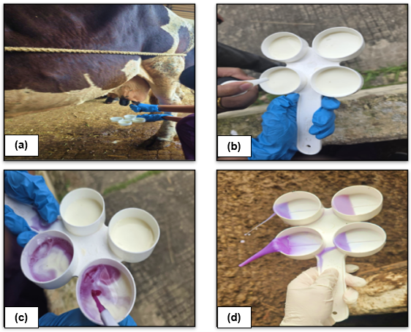
Figure 1. Modified California Mastitis Test (MCMT) showing detection of subclinical mastitis: (a) milk collection, (b) milk in MCMT paddle chambers, (c) addition of MCMT reagent and (d) positive reaction with gel formation
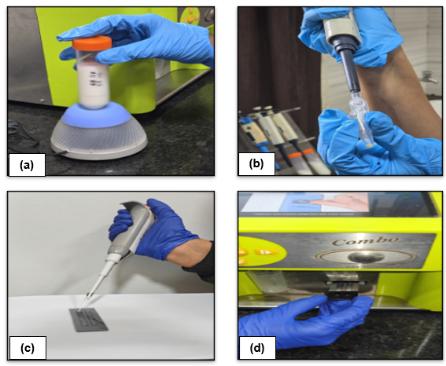
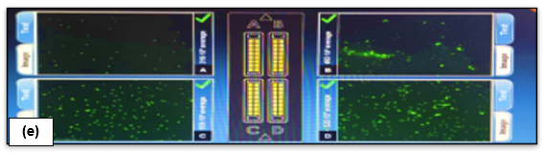
Figure 2. Somatic cell count estimation using Lactoscan analyzer: (a) sample homogenization, (b) pipetting of milk sample, (c) cartridge loading, (d) insertion of cartridge into analyzer slot and (e) result display on screen

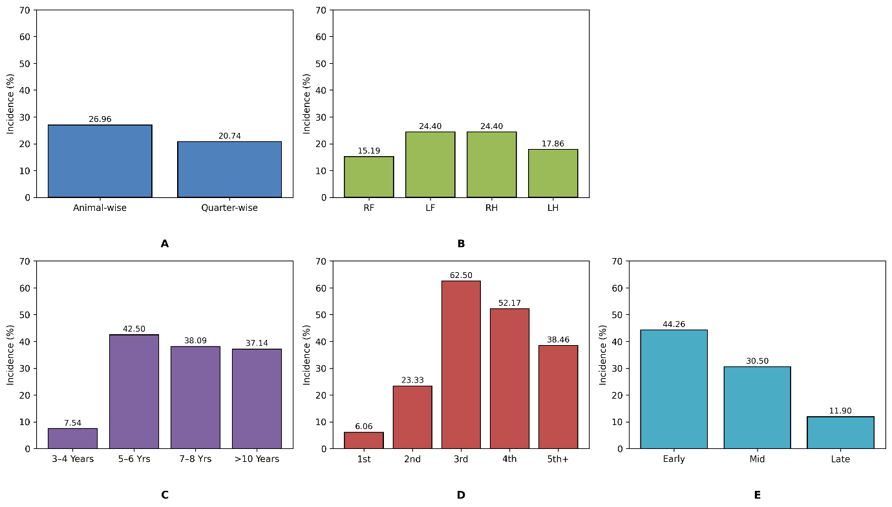

Figure 3.Prevalence of subclinical mastitis in dairy cattle showing (A) overall animal-wise and quarter-wise distribution, (B) quarter-wise distribution, (C) age-wise distribution, (D) parity-wise distribution and (E) stage of lactation-wise distribution.

