Effect of Auxin Treatments and Seasonal Variation on Stem cuttings propagation of Hildegardia populifolia (DC.) Schott & Endl.

Abstract
Aims:
To evaluate the effect of different concentrations of indole-3-butyric acid (IBA) and naphthalene acetic acid (NAA) on rooting and sprouting of stem cuttings of Hildegardia populifolia during spring and rainy seasons.
Study Design:
A field-based greenhouse experiment was carried out under nursery conditions.
Place and Duration of Study:
Forest College and Research Institute, Mulugu, Telangana, during 2022-2025 duration of research work.
Methodology:
Stem cuttings (30 cm long, 2–3 nodes) were treated with seven auxin-based formulations (IBA 1000, 2000, 3000 ppm; NAA 1000, 2000, 3000 ppm; and control) and planted in polybags containing red soil, black soil and sand (2:1:1) supplemented with cocopeat. Observations on sprouting percentage, rooting percentage, mean number of roots and root length were recorded for both spring and rainy seasons.
Results:
IBA at 3000 ppm produced the highest sprouting (40% in spring, 33.33% in rainy), rooting (33% in spring, 26.66% in rainy), number of roots (11.66 in spring, 3.0 in rainy) and root length (12.95 cm in spring, 2.33 cm in rainy). Overall, the spring season recorded significantly higher rooting and growth compared to the rainy season.
Conclusion:
IBA at 3000 ppm applied during spring is the most effective treatment for vegetative propagation of Hildegardia populifolia. Seasonal variation strongly influences rooting success, and the spring season is recommended for large-scale nursery multiplication.
Keywords: Hildegardia populifolia, IBA, NAA, stem cuttings, vegetative propagation, seasonal variation.

1. Introduction
Medicinal plants have been a basic part of traditional healing systems for centuries, contributing therapeutic benefits that modern science continues to explore. However, several of the valuable species are now critically endangered, and some are even extinct and listed in the IUCN (International Union for Conservation of Nature) due to overharvesting, habitat destruction and climate change. These plant species comprise unique bioactive compounds that have been used in traditional and modern medicine for treating various ailments, which include diabetes, cancer and infectious diseases etc. Conservation effects, such as in situ and ex-situ cultivation programs, seed banking, and laws, are crucial for protecting these species from extinction. Role of scientific research, such as research on sustainable harvesting methods, the discovery of synthetic alternatives, can help reduce pressure on wild populations. “The success of afforestation and reforestation programmes largely depends on efficient forest nursery practices. Producing high-quality seedlings demands skilled technical management, including careful selection of quality seeds, appropriate growing media, suitable containers, strict nursery hygiene, and adequate plant protection.” One of the examples of Hildegardia populifolia (DC.) Schott & Endl. is a medicinally important tree species of the family Malvaceae (sub-family Sterculioideae), narrowly endemic to South India and restricted to parts of Andhra Pradesh, Tamil Nadu, and Karnataka (Singh et al., 2015). As per IUCN category, it is assessed as Near Threatened (IUCN Red List, 2015). It is a medium-sized deciduous tree adapted to xeric, dry deciduous forest habitats, typically occurring on rocky slopes and stony red or calcareous soils under semi-arid to sub-humid climatic conditions (Lavanya et al., 2014). The species holds considerable ethnomedicinal value, with bark and leaves traditionally used to treat ailments such as malaria, dog bites, and inflammatory disorders, and contains bioactive compounds exhibiting antioxidant, antimicrobial, antidiabetic, and anticancer properties. Despite its ecological and medicinal importance, natural regeneration is poor due to low seed viability and high anthropogenic pressure. Although basal sprouting indicates potential for clonal propagation, systematic studies on vegetative propagation through stem cuttings remain limited, highlighting the need for developing effective propagation protocols for conservation and restoration (Raju et al., 2014). Previous studies reported that despite its conservation importance, stem cutting propagation of Hildegardia populifolia has received limited scientific attention, with very few studies reported to date. The opportunities for its propagation and improvement are limited due to its hard seed coat and seed germination rate is not at an appreciable level. So, in order to conserve species the objective was framed to examine the effect of spring and rainy seasons on stem cutting propagation.
Auxins such as indole-3-butyric acid (IBA) and naphthalene acetic acid (NAA) are widely known to stimulate adventitious root formation in woody species. Saradha and Paulsamy (2012) reported that semi-hardwood cuttings of H. populifolia treated with IBA and NAA at 3000 ppm produced up to 70% rooting.
Seasonal variation also plays a crucial role in rooting response due to changes in temperature, humidity and physiological activity of cuttings. Hence, the present study was undertaken to evaluate the effect of auxin concentration and season (spring vs rainy) on performance of H. populifolia stem cuttings at the nursery stages.

2. Materials and Methods

Table 1. Plant material and rooting medium.

Stem cuttings were collected from phenotypically superior trees from the Chekrayapeta forest, YSR Kadapa district, Andhra Pradesh. Cuttings were 30 cm long, about 3 cm in diameter, with long inter-nodes with 2–3 nodes. The study was carried out in the field nursery of the Forest College and Research Institute (FCRI), Mulugu, Siddipet district, Telangana, India. The experimental site is located at approximately 17.73° N latitude and 78.63° E longitude. The region is characterised by red shallow gravelly soils, red clayey soils, and deep calcareous and colluvial soils. The mean annual temperature of the area ranges from 18 °C to 42 °C, with an average annual rainfall of about 905.3 mm. They were planted in 8 × 12-inch polybags for sufficient space and rot growth then filled with red soil, black soil and sand (2:1:1) supplemented with cocopeat.Red soil was in high ratio as the tree is adapted to dry deciduous forests habits with red gravelly and rocky soils.

2.1 Treatments
Seven treatments were tested and are discussed in detail under the application of treatments subheading. Details of the seed treatments used in this study are given in Table 1.

Table 1. Plant material and rooting medium.

Treatment. No | Details of treatments
T₁ | IBA 1000ppm+5%sucrose+5%captaf+Talc powder
T₂ | IBA2000ppm+5%sucrose+5%captaf+Talc powder
T₃ | IBA3000ppm+5%sucrose+5%captaf+Talc powder
T₄ | NAA1000ppm+5%sucrose+5%captaf+Talc powder
T₅ | NAA2000ppm+5%sucrose+5%captaf+Talc powder
T₆ | NAA3000ppm+5%sucrose+5%captaf+Talc powder
T₇ | Control (5%sucrose+5%captaf+Talc powder)

2.2 Treatment details for Stem cuttings:

IBA and NAA rooting powders were prepared by dissolving 1, 2, and 3 g of the respective hormone in 5 ml of ethyl alcohol, followed by the addition of 5% captaf (0.5 g) and 5% sucrose (0.5 g). Talc powder was added to obtain approximately 10 g of formulation, which was shade-dried at room temperature and powdered. The basal ends of the cuttings were quick-dipped in the hormone powder before planting. Cow dung was applied above the cuttings after planting to minimise pest and disease incidence and to maintain surface moisture. Control cuttings received no hormone treatment. Cuttings were planted in polybags containing a rooting medium of red soil, black soil, and sand in a 2:1:1 ratio supplemented with cocopeat, with two basal nodes inserted into the medium.

2.3 Experimental design
The experiment was conducted in a Completely Randomized Design with three replications for every seven treatments in both the spring and rainy seasons.

2.4 Observations
Sprouting percentage, rooting percentage, mean number of roots, and mean root length were recorded from the day of commencement of sprouting. The parameters investigated in the present study are listed below.
Sprouting percentage
Sprouting percentage = $\frac{No. of cuttings sprouted}{Total no. of cuttings planted}× 100$
Rooting percentage
Rooting percentage = $\frac{No. of cuttings rooted}{Total no. of cuttings planted}× 100$
Number of roots per cutting
The planted cuttings were gently pricked out, and the roots were washed to clearly observe the number of roots and then counted to know the number of roots per cutting.
Root length (cm)
Root length was measured at the end, and the mean was recorded as root length in centimetres. For this observation, cuttings from each treatment were uprooted, and root length was measured from the collar region to the tip of the taproot.
2.5 Statistical analysis
The experiment was laid out in a completely randomized design with three replications per treatment. Data on stem cuttings were subjected to analysis of variance (ANOVA) using R Studio software (version 2025.09.0) to test the effect of auxin concentration and season (spring vs rainy) on the performance of H. populifolia.

3. Results and Discussion
The experiment assessed rooting potential under different concentrations of IBA and NAA and revealed distinct seasonal variations in growth and rooting performance. The results demonstrated that auxin application significantly enhanced rooting and sprouting, with IBA treatments consistently outperforming NAA in both seasons represented in Figure 1,2.
During the spring season, the highest rooting percentage (33%), sprouting percentage (40%), mean number of roots (11.66), and mean root length (12.95 cm) were recorded in T₃ (IBA 3000 ppm), whereas the lowest response was observed in T₆ (NAA 3000 ppm) summarized in Table 2 and graphically represented in Figure 3 Treatments T₁ (IBA 1000 ppm) and T₄ (NAA 1000 ppm) also showed appreciable responses. These findings agree with earlier studies reporting superior rooting with IBA in forest tree species (Saradha and Paulsamy, 2012; Husen, 2007; Azad et al., 2016).
In the rainy season, IBA 3000 ppm again produced the highest rooting (26.66%), sprouting (33%), mean number of roots (3.0), and root length (2.33 cm), though overall performance was lower than in spring. (Shintu and Jothish 2025, Zamora et al., 2022) summarised in Table 3, graphically represented in Figure 4. Control cuttings showed no response. Reduced rooting during the rainy season may be attributed to excess moisture and poor drainage, which adversely affect root initiation and development (Sahoo et al., 2021).
The absence of sprouting and rooting in T₆ (NAA 3000 ppm) and T₇ (control) during the rainy season indicates that both insufficient and supra-optimal hormonal conditions are unfavourable for adventitious root induction in Hildegardia populifolia. In the control, lack of external auxin resulted in inadequate stimulation for callus formation and root primordia development, while the poor response at higher NAA concentration may be due to hormonal toxicity and auxin overdose, which suppresses cell differentiation, disrupts metabolic activity and causes tissue damage (Hartmann et al., 2011; De Klerk et al., 1999). Excess NAA can also enhance ethylene and phenolic compound accumulation, leading to cellular stress and inhibition of root initiation (Taiz et al., 2015). These negative effects were likely aggravated by rainy season conditions such as excess moisture and poor aeration, promoting basal tissue decay rather than root development (Leakey, 2004; Sahoo et al., 2021), suggesting that H. populifolia requires a narrow optimal auxin range for successful vegetative propagation.
The superiority of IBA over NAA observed in this study is consistent with reports in Juniperus communis, Pongamia pinnata, Morus alba, Ceiba pentandra, Sterculia urens, Dalbergia sissoo, and Garcinia afzelii (Reddy et al., 1994; Gupta et al., 1993; Singh et al., 2014; Wani et al., 2018; Rajendran et al., 2020; Antwi-Wiredu et al., 2025). Seasonal influence on rooting has also been widely documented, with spring providing optimal conditions for root initiation (Wani et al., 2018; Abshahi et al., 2022; Shoo et al., 2021).

3.1 Spring season
Table 2. Hormonal treatments effecting stem cuttings of Hildegardia populifolia in Spring

Treatments | Sprouting% | Rooting% | Mean no. of roots | Mean root length
T₁ IBA 1000ppm | 26.66±11.54^{abc} | 20.00±0.00^{abc} | 2.00±2.64^{c} | 3.95±1.34^{b}
T₂IBA2000ppm | 20.00±20.00^{abcd} | 13.33±11.54^{bcd} | 1.00±1.00e | 3.66±3.18^{b}
T₃IBA3000ppm | 40.00±20.00ª | 33.00±11.54ª | 11.66±2.88ª | 12.95±6.62ª
T₄NAA1000ppm | 33.33±11.54^{ab} | 26.66±11.54^{ab} | 7.5±2.50^{b} | 11.86±1.70ª
T₅NAA2000ppm | 13.33±11.54^{bcd} | 6.66±11.54^{cd} | 1.00±1.73^{c} | 3.03±5.25^{b}
T₆NAA3000ppm | 6.66±11.54^{cd} | 6.66±11.54^{cd} | 1.00±1.73^{c} | 2.85±4.93^{b}
T₇Control | 0.00±0.00^{d} | 0.00±0.00^{d} | 0.00±0.00^{c} | 0.00±0.00^{b}
SE(m) ± | 7.968 | 5.63 | 1.16 | 2.29
CD (< 0.05) | 24.40 | 17.2 | 3.57 | 7.03

3.2 Rainy season

Table 3. Hormonal treatments effecting stem cuttings of Hildegardia populifolia in Rainy season.
Treatments | Sprouting% | Rooting% | Mean no. of roots | Mean root length
T₁ IBA 1000ppm | 13.33±6.66^{bc} | 13.33±6.66^{abc} | 1.00±0.57^{b} | 0.66±0.33^{bc}
T₂IBA2000ppm | 13.33±6.66^{bc} | 6.66±6.66^{bc} | 0.33±0.33^{b} | 0.67±0.66^{bc}
T₃IBA3000ppm | 33.33±6.67ª | 26.66±6.66ª | 3.00±1.15ª | 2.33±0.33ª
T₄NAA1000ppm | 26.66±6.66^{ab} | 20.00±0.00^{ab} | 2.00±0.57^{ab} | 1.66±0.33^{ab}
T₅NAA2000ppm | 6.67±6.66^{c} | 6.67±6.66^{bc} | 0.67±0.66^{b} | 0.33±0.33^{c}
T₆NAA3000ppm | 0.00±0.00^{c} | 0.00±0.00^{c} | 0.00±0.00^{b} | 0.33±0.33^{c}
T₇Control | 0.00±0.00^{c} | 0.00±0.00^{c} | 0.00±0.00^{b} | 0.00±0.00^{c}
SE(m) ± | 5.634 | 5.04 | 0.60 | 0.35
CD (< 0.05) | 17.25 | 15.43 | 1.85 | 1.09

Among all treatments, IBA at higher concentrations (especially T3 – IBA 3000 ppm) consistently recorded superior values for root length, shoot length, collar diameter and number of leaves, indicating more vigorous and healthy plant development, and this was highest in the spring season raised cuttings represented in Figure 5. In contrast, lower concentrations and control treatments exhibited comparatively poor growth responses.
The seasonal comparison graph Figure 6, clearly demonstrates that the growth performance of Hildegardia populifolia stem cuttings was markedly superior in the spring season compared to the rainy season across all parameters studied. Spring recorded higher sprouting (40%), rooting (33%), mean number of roots (11.66) and mean root length (12.95 cm), whereas the corresponding values in the rainy season were considerably lower. This indicates that favourable spring conditions such as moderate temperature, better aeration and optimal physiological activity of cuttings enhanced root initiation and subsequent growth. Overall, the graph highlights that seasonal timing is a critical factor influencing propagation success, with spring providing a significantly more conducive environment for vegetative establishment than the rainy season.
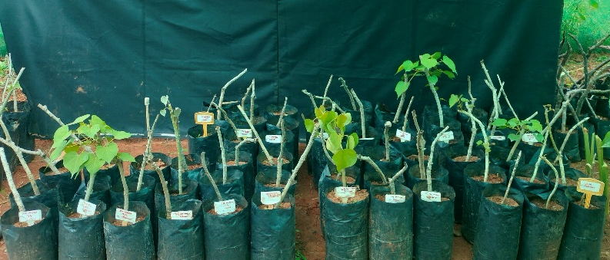
Figure 1. Stem cuttings in Spring season

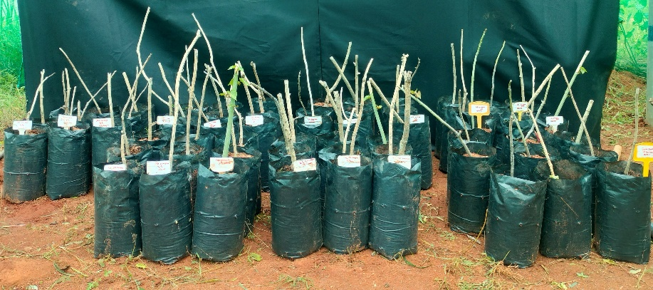
Figure 2. Stem cuttings in Rainy season

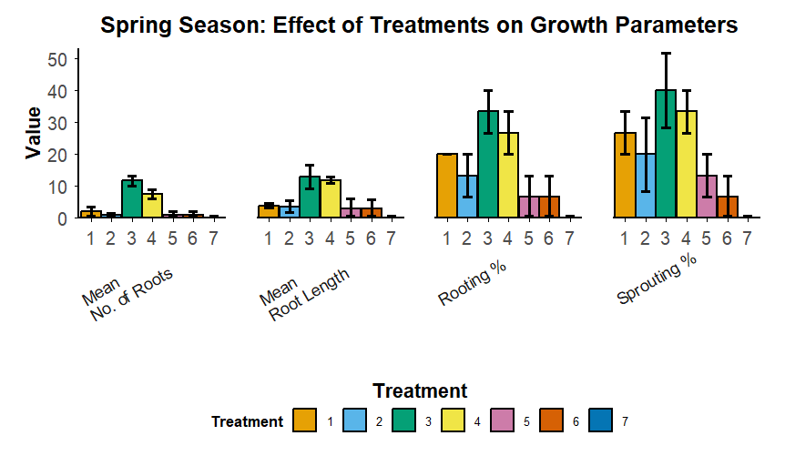
Figure 3. Effect of treatments on growth parameters in Spring season.

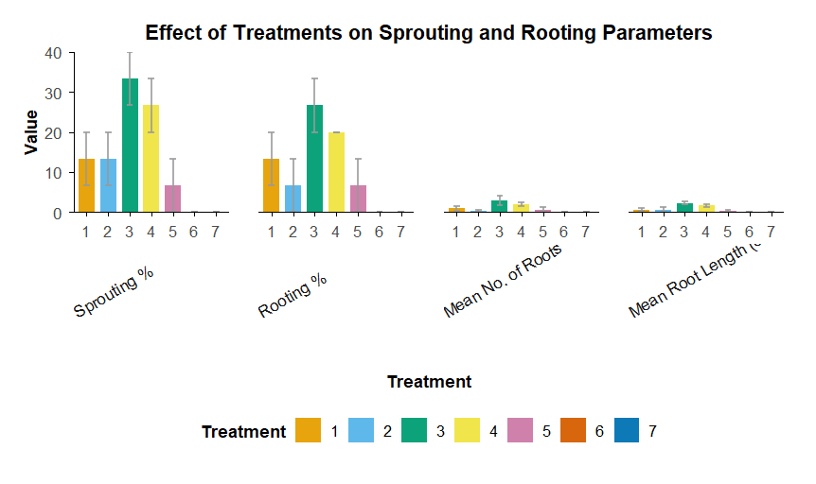
Figure 4. Effect of treatments on growth parameters in Rainy season.

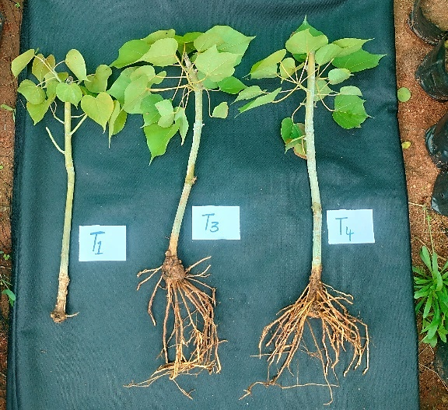
Figure 5. Stem cuttings response in spring season
Stem Cuttings: Spring *T₃ IBA 3000 ppm T₄ NAA 1000 ppm, T₁IBA1000 ppm.

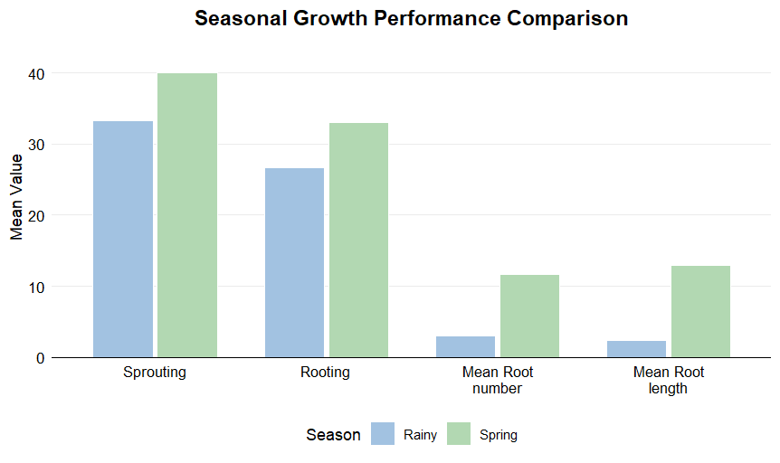
Figure 6. Seasonal growth performance of Hildegardia populifolia stem cuttings

4. Conclusion
Overall, the study confirms that spring season combined with IBA 3000 ppm is the most effective protocol for stem cutting propagation of Hildegardia populifolia. This approach is strongly recommended for large-scale nursery production and conservation programmes of this threatened forest tree species.
IBA at 3000 ppm was consistently superior in both seasons, producing the highest rooting, sprouting and root growth. However, all parameters were markedly higher in spring than in rainy season. This seasonal advantage is attributed to favourable temperature, humidity and physiological activity of shoots during spring, which promotes callus formation and root initiation.
For large-scale nursery production and conservation of Hildegardia populifolia, stem cuttings treated with IBA 3000 ppm during spring should be adopted as the standard protocol. Seasonal timing is as important as hormone concentration, and spring provides the most favourable environment for rooting success.

Disclaimer (Artificial intelligence)
I hereby declare that NO generative AI technologies such as Large Language Models (ChatGPT, COPILOT, etc.) and text-to-image generators have been used during the writing or editing of this manuscript.
References:
Abshahi M, García-Morote FA, Zarei H, Zahedi B, Nejad AR. 2022. Improvement of rooting performance in stem cuttings of savin juniper (Juniperus sabina L.) as a function of IBA pretreatment, substrate, and season. Forests. 13(10):1705.
Antwi-Wiredu A, Mensah JK, Ofori E, Boateng-Ansah P, Fosu NA, Asomaning JM. 2025. Effect of rooting hormone on stem-cutting propagation of economically important Garcinia afzelii tree species. Sustainability Science and Resources. 9:1–17.
Azad MS, Alam MJ, Mollick AS, Matin MA. 2016. Responses of IBA on rooting, biomass production and survival of branch cuttings of Santalum album L., a wild threatened tropical medicinal tree species. Journal of Science, Technology and Environment Informatics. 2(3):195–206.
De Klerk GJ, Van der Krieken W, De Jong JC. 1999. The formation of adventitious roots: new concepts, new possibilities. In Vitro Cellular & Developmental Biology – Plant. 35:189–199.
Gupta BB, Kumar A, Negi DS. 1993. Vegetative propagation through branch cuttings in Dalbergia sissoo Roxb. Indian Forester. 119:529–535.
Hartmann HT, Kester DE, Davies FT, Geneve RL. 2011. Plant Propagation: Principles and Practices. 8th ed. Prentice Hall, New Jersey.
Husen A, Pal M. 2007. Effect of branch position and auxin treatment on clonal propagation of Tectona grandis Linn. f. New Forests. 34(3):223–233.
Lavanya AR, Muthukrishnan S, Muthukumar M, Benjamin JF, Kumar TS, Kumaresan V, Rao MV. 2014. Indirect organogenesis from various explants of Hildegardia populifolia (Roxb.) Schott and Endl., a threatened tree species from the Eastern Ghats of Tamil Nadu, India. Journal of Genetic Engineering and Biotechnology. 12(2):95–101.
Leakey RRB. 2004. Physiology of vegetative reproduction. In: Encyclopedia of Forest Sciences. Elsevier, London, pp. 1655–1668.
Rajendran P, Dasthagir MG, Yassin MM, Divakara BN. 2020. Vegetative propagation of Ceiba pentandra (L.) Gaertn. by stem cuttings. Journal of Tropical Forest Science. 32(4):410–418.
Raju AJS, Chandra PH, Krishna JR. 2014. Monoecy, anemophily, anemochory and regeneration ecology of Hildegardia populifolia (Roxb.) Schott and Endl. (Malvaceae), an economically important endemic and endangered dry deciduous tree species of southern Eastern Ghats, India. Journal of Threatened Taxa. 6(2):5434–5446.
Reddy KK, Venkaiah K, Bramaramba B. 1994. Rooting experiments of stem cuttings of Sterculia urens Roxb. Indian Forester. 120(2):168–170.
Sahoo G, Swamy SL, Singh AK, Mishra A. 2021. Propagation of Pongamia pinnata (L.) Pierre: Effect of auxins, age, season and C/N ratio on rooting of stem cuttings. Trees, Forests and People. 5:100091.
Saradha M, Paulsamy S. 2012. Effect of growth hormones on rooting attributes of stem cuttings of endangered plant species Hildegardia populifolia (Roxb.) Schott and Endl. (Sterculiaceae). International Journal of Biology, Pharmacy and Allied Sciences. 1(8):1145–1152.
Shintu, S., & Jothish, P. S. (2025). Propagation through stem cutting and air layering of a Critically Endangered tree< Humboldtia unijuga> Bedd. var.< trijuga> J. Joseph & V. Chandras.(Magnoliopsida: Fabales: Fabaceae). Journal of Threatened Taxa, 17(9), 27426-27432.
Singh KK, Choudhary T, Kumar A. 2014. Effect of various concentrations of IBA and NAA on the rooting of stem cuttings of mulberry (Morus alba L.) under mist house conditions in the Garhwal hill region. Indian Journal of Hill Farming. 27(1):74–77.
Taiz L, Zeiger E, Møller IM, Murphy A. 2015. Plant Physiology and Development. 6th ed. Sinauer Associates, Sunderland, USA.
Wani MA. 2018. Rooting responses of hardwood stem cuttings of juniper to exogenous hormone treatment. Journal of Forest Science. 64(6):251–258.
Zamora, L. M. V., Aguila, S. R. D., Abad, J. C. G., Torres, G. V., Correa, S. A. I., Flores, E. T., ... & Guivin, M. A. C. (2022). Propagation of Theobroma cacao by Rooted Cuttings in Mini‐Tunnels. Advances in Agriculture, 2022(1), 1196381.

