Influence of Solanaceous Rootstocks on Bacterial Wilt Resistance, Growth and Productivity of Sweet Pepper
Abstract
Bacterial wilt is one of the most devastating soil borne disease of solanaceous crops particularly sweet pepper, chilli, tomato and brinjal in the tropics and subtropics. The present study was conducted to evaluate the best rootstock for sweet pepper variety California Wonder for bacterial wilt resistance under artificial inoculation and to assess growth, yield, quality and bacterial wilt resistance of sweet pepper grafts under field condition. Artificial inoculation of Ralstonia solanacearum was carried out by root dipping method. California Wonder grafted on Haritha rootstock found highly resistant to bacterial wilt but grafting parameters and mean performance of this graft was found poor. The graft combinations of sweet pepper on the rootstocks Capsicum chinense variety Vellayani Thejus and Capsicum annuum variety Ujwala were found superior for grafting parameters, flowering and yield parameters and were resistant to bacterial wilt under artificial inoculation and field condition. So, these rootstocks can be recommended in areas with higher bacterial wilt incidence as well as to get higher yield.
Keywords: Bacterial wilt, sweet pepper, grafting, Ralstonia solanacearum, rootstocks, artificial inoculation
Introduction
Sweet pepper commonly referred to as capsicum, is a significant and adaptable crop valued for its appealing, mild-flavored fruits. Known by various names such as bell pepper, shimla mirch, green pepper or cherry pepper, this crop has gained prominence in recent times due to its attractive appearance, non-spicy taste and versatility. Its pleasant flavor, delicate taste, and vibrant colors have elevated it to the status of a high-value crop.
The production of sweet pepper faces challenges from both biotic and abiotic stress factors, including soil-borne diseases, nematodes, suboptimal temperatures, drought, waterlogging, and physiological disorders. Biotic stresses involve bacterial wilt caused by Ralstonia solanacearum (Kumar et al., 2016), crown rot and blight by Phytophthora capsici (Kousik et al., 2019), and root knot nematode-induced galls by Meloidogyne spp. (Morra and Bilotto, 2006). In Kerala conditions, bacterial wilt is a particularly severe disease that adversely affects the yield of sweet pepper and other solanaceous vegetables.
The bacterial wilt pathogen, Ralstonia solanacearum, is highly invasive and significantly disrupts the cultivation of sweet peppers by entering plants through wounds and natural root openings. Once the bacteria invade the cortical tissue, they rapidly multiply within the xylem, causing blockage of the water-conducting vascular bundles and leading to the development of wilt symptoms (Meng, 2013).
Integrated management strategies to control soil borne diseases especially bacterial wilt includes cultivation of resistant varieties, crop rotation, cultural methods, fumigation using chemicals, field sanitation and use of plant protection chemicals (Rivero et al., 2003 and Yetisir and Sari, 2007). Developing cultivars with disease resistance is a time consuming process and the emergence of new pathogen strains can break the developed resistance. Soil fumigation with chemicals may have negative effects on the environment and could be extremely dangerous to humans and may leave toxic residues in plant products. Cultural practices such as crop rotation have limited impact on disease management. The rising expenses and residual effects of plant protection chemicals make chemical control a non viable option (Kacjan-Marsic and Osvald, 2004). Hence a potential strategy to combat these problems especially, bacterial wilt disease is grafting of desirable scion onto resistant rootstocks (Narayanankutty et al., 2015).
Grafting is the art of joining together two plant parts (a rootstock and a scion) by means of tissue regeneration, in which the resulting combination of plant parts achieves physical reunion and grows as a single plant (Janick, 1986). It is a centuries old technique but a relatively new one in vegetable cultivation. Grafting has attained worldwide recognition as an imperative and sustainable tool for mitigating the challenges by both biotic and abiotic stresses in vegetable crops (Kyriocou et al., 2016). The success of grafting depends on the fast formation of vascular connections between the rootstocks and scion with immediate renewal of root and canopy growth. Since grafting changes root system in vegetable crops, it is becoming an important tool not only to manage soil borne diseases but also to improve crop response to a variety of abiotic stresses such as drought, flood, salinity and extreme temperature stresses. The performance of grafted plants depends on the nature of root system used as rootstock. In general, rootstocks are selected based on their growth, tolerance to abiotic and biotic stresses and compatibility with scions.
Sweet peppers are decorative and nutritive vegetable with high consumer preferences; hence its cultivation has been extended in Kerala also. Scientific information related to grafting in sweet pepper is limited and studies have not been done under climatic and edaphic conditions of Kerala. Keeping this background in view, the present research was conducted with the objectives to identify the best rootstock for sweet pepper variety California Wonder, to assess sweet pepper grafts for bacterial wilt resistance under artificial inoculation and to evaluate its growth, yield, quality and bacterial wilt resistance under open field condition.

Materials and methods
Experimental site
The experiment was conducted in the Department of Vegetable Science, College of Agriculture, Vellayani, Thiruvananthapuram, Kerala Agricultural University, during 2022-2023. The experimental site was located at 8.5°30’ North latitude and 76.9° 54' East longitude at an altitude of 29 m above mean sea level. Predominant soil type of the experimental site was red loam to Vellayani series, texturally classified as sandy clay loam. The region experiences a warm humid tropical climate. Average temperature varied from 20.25 ᵒC to 31.94 ᵒC, relative humidity varies from 69.27% to 91.27%, rainfall 1.08 mm and evaporation 3.44 mm.
Plant materials
The experimental materials consisted of sweet pepper variety California Wonder as scion and Capsicum annuum var. Ujwala, Capsicum chinense var. Vellayani Thejus, Capsicum frutescens var. Vellayani Samrudhi, Capsicum frutescens local cultivar and Solanum melongena var. Haritha as rootstocks (Table 1). A tomato cultivar Pusa Ruby was used as a susceptible check for bacterial wilt screening.
Production of sweet pepper grafts and assessment for bacterial wilt resistance
Grafting method
The scion, California Wonder was grafted onto five rootstocks and non grafted sweet pepper plants were used as control. Cleft method of grafting was adopted. Grafted plants were kept in grafting chamber for graft healing. After the formation of graft union, the plants were kept for acclimatization for five days and hardening for three days before transplanting (Plate 1).
Artificial inoculation
Sweet pepper grafts along with non grafted control after hardening were artificially inoculated with Ralstonia solanacearum suspension by root dip method (Gopimony and George, 1979). The roots of grafts and non-grafts were washed free of soil and was dipped in 100 ml suspension of bacterial ooze (OD _{600 nm} = 1) for 10 min (Gopimony and George, 1979). They were transplanted to the pots filled with sterilized medium composed of soil, coirpith and dried cowdung in 1:1:1 ratio and laid out in Completely Randomized Design with four replications (plate 2). Daily observation was carried out for bacterial wilt incidence. Plants which showed wilting symptoms were collected and bacterial wilt disease was tested by ooze test. A viscous milky white exudate streaming out from the cut end of the stem indicated the bacterial wilt pathogen (Saddler et al., 2005) and bacteria were isolated on TTC (2,3,5-Triphenyl Tetrazolium Chloride) medium for confirmation of Ralstonia solanacearum (Chaudhary and Rashid, 2011). The virulent colonies appeared white with pink centres and non virulent colonies appeared dark red in TTC medium (Gitaitis et al., 1992).
Bacterial wilt incidence was recorded based on the visual observation upto 90 DAT (plate 3).
The number of plants showing bacterial wilt disease incidence was expressed in terms of percentage disease incidence (PDI). It was calculated by the following formula,
Number of plants wilted
Percentage disease incidence (%) =
Total number of plants
×100

The wilted plants in different treatments were classified into five categories based on the score chart for bacterial wilt incidence by Hussain et al., 2005 (Table 2).
Confirmation of bacterial wilt pathogen
Grafted and non grafted control plants of sweet pepper variety California Wonder were monitored for bacterial wilt incidence. The plants showing the typical symptoms of bacterial wilt were collected and examined for bacterial ooze and bacteria were isolated on TTC medium, specific for Ralstonia solanacearum (Chaudhary and Rashid, 2011).
Wilted plant samples were cut into bits of approximately 0.5 cm size and surface sterilized with 0.1 per cent HgCl₂ or NaOCl @ 1.0% (w/v) for 1 minute. The sterilized stem bits were washed repeatedly in sterile water and later crushed in a slide using glass rod. Bacterial exudate containing suspension was streaked on TTC media and incubated for 48 hours at room temperature (27±3ᵒC). The bacterial colonies appeared white with pink centres in TTC media. It indicated virulent Ralstonia solanacearum colonies and after confirmation, pure culture of bacteria was prepared (plate 4).
Evaluation of sweet pepper grafts for growth, yield and quality
After 7-10 days of hardening, the grafts and non grafted plants were transplanted to the main field at 60 cm x 30 cm spacing. The crop was grown as per package of practices recommendations of Kerala Agricultural University (KAU, 2016). Bacterial wilt infected sick plot was selected for the cultivation of sweet pepper and plants was laid out in Randomized Block Design with four replications and the different treatments were evaluated under field condition. Mean performance of sweet pepper grafts and non-grafts on growth parameters, flowering, yield and quality parameters were evaluated for 120 days after transplanting (plate 5).

Statistical analysis
For comparison among different treatments and to estimate variance components, the recorded observations were subjected to ANOVA (Panse and Sukhatme, 1985). Wherever significant difference was found, CD values were calculated using GRAPES AGRI 1 (Gopinath et al., 2020). Simple correlation of various characters with yield was also calculated.

Results and Discussion
Performance of sweet pepper grafts for grafting parameters
The number of days taken for germination of seeds of rootstocks and scions are crucial to adjust the sowing time in order to ensure the uniform stem size of rootstock and scion for grafting. In the present study, there was no significant difference for the number of days taken for germination among the rootstocks and varied from 7.25 days to 7.62 days whereas, the scion, sweet pepper variety California Wonder took 12.80 days for germination (Table 3). A range of 5.00 to 15.25 days taken for germination of rootstocks and scion was reported by Rathod (2017) and a range of 5.33 to 13.67 days in sweet pepper was observed by Yuvaraj (2023).
The appropriate stage of rootstock and scion for grafting was determined by the grafting technique adopted and their thickness at the time of grafting. The number of days taken to attain graftable size ranged between 41.75 and 54.06 days. Observation on the number of days taken to attain graftable stage of both rootstocks and scion was found significantly different. Among the rootstocks, minimum days taken to attain graftable size was recorded in Vellayani Thejus (41.75 days) which was on par with Haritha (43.69 days) and bird’s eye chilli (44.81 days). The scion, sweet pepper variety California Wonder took 28.44 days to attain graftable size (Table 3). Praveenkumar (2019) stated that faster seed germination of rootstock and scion resulted in minimum days to reach graftable size and reported a range of 41.03 days to 69.98 days to attain graftable stage.
Significant difference was observed among the five rootstocks with respect to height of rootstock at grafting. The height of rootstock at grafting recorded the highest in Ujwala (17.36 cm) which was on par with Vellayani Thejus (16.44 cm) (Table 4). In the present study, it was observed that seedlings with good height and girth at grafting showed early graft union and highest graft success percentage, whereas Dev (2019) and Nair (2023) reported reduced height of rootstocks at grafting improved grafting success percentage in cucurbits.
It is crucial to match the girth of both scion and rootstock while grafting. In order to obtain successful graft, the vascular cambium of both rootstock and scion must be lined up and wound healing process should be carried out. Significant difference was noticed among the treatments for girth of rootstock at grafting and Vellayani Thejus (10.30 mm) recorded the highest and Ujwala (7.94 mm) recorded the lowest (Table 4). Kumar et al. (2018) opined direct contact of cambial layer as the first and foremost step towards successful graft union.
In grafting, compatibility of rootstocks and scion resulted in early graft union. The number of days taken for graft union varied significantly among the treatments and ranged from 3.67 to 5.60 days. Sweet pepper variety California Wonder grafted onto Vellayani Thejus (3.67 days) resulted in early graft union, whereas the same grafted onto Ujwala took maximum number of days for graft union (5.60 days) (Table 5). Similarly, Rathod (2017) reported a range of 4 to 5 days for graft healing in brinjal and Jose (2021) reported a range of 3.67 to 5.67 days in tomato. This is also in conformity with the study of Yuvaraj (2023) where chilli rootstocks grafted onto sweet pepper took 5.33 days to 8.33 days for graft union.
The success of grafting is influenced by the factors viz., quality of the seedlings, compatibility between rootstock and scion, formation of healthy callus, establishment of a strong connection at the graft interface, grafting techniques adopted, post grafting management and environmental condition (Gisbert et al., 2011and Singh et al., 2019). The graft success percentage was observed significantly different among treatments and ranged between 31.25% and 95.00% . The highest percentage of graft success was observed in graft combination of California Wonder with chilli rootstock Vellayani Thejus (95.00%) and the lowest with brinjal rootstock Haritha (31.25%) (Table 5). Rodriquez and Bosland (2010) reported 100% graft success when Capsicum cultivars grafted on tomato rootstock by cleft method of grafting, whereas a range of 49% to 66% was recorded by tube method of grafting. Similar results were reported by Ives et al. (2012), Praveenkumar (2019), Surve (2022) and Yuvaraj (2023).
Performance of sweet pepper grafts and non-grafts for bacterial wilt resistance
The occurrence of bacterial wilt through artificial inoculation methods is influenced by factors such as the concentration of the inoculum, age of the plants, environmental conditions in which the plants are maintained and response of the host. Therefore, it is essential to check disease reaction of different grafts and non-grafts under artificial inoculated condition and field condition to identify resistant rootstocks for bacterial wilt.
Under artificial inoculation, the grafted plants withstand better compared to non-grafted control plants. Wilting was not observed in the graft combination of California Wonder with Haritha rootstock. The number of plants wilted in the graft combination of California Wonder with Ujwala, Vellayani Thejus, bird’s eye chilli and Vellayani Samrudhi were 2, 2, 4 and 5 respectively, whereas that in non-grafted control was 16 out of 20 plants (Table 6).
Late incidence of bacterial wilt was found in the graft combination of California Wonder with Ujwala (39.50 days) followed by that on Vellayani Thejus (35.25 days). Non-grafted California Wonder recorded the lowest number of days for bacterial wilt incidence (7.25 days) (Table 6). The differences in the number of days taken for wilting could be attributed to the formation of mechanical barriers in the roots. These barriers may restrict the diffusion of bacterial population from the roots to the stem through the collar, thereby limiting their ability to proliferate within the stem. Similar results were reported by Hussain et al. (2005), Rahman et al. (2011), Kumar et al. (2014), Kumbar et al. (2021) and Jose (2021).
The artificial inoculation of root clipped grafts and non-grafts in bacterial suspension was done and disease reaction was recorded as per Hussain et al. (2005). California Wonder grafted on Haritha recorded 0.00 percent disease incidence which was categorized as highly resistant. California Wonder grafted onto Ujwala and Vellayani Thejus recorded 10 percent disease incidence which were classified as resistant. California Wonder grafted onto bird’s eye chilli and Vellayani Samrudhi exhibited 20 and 25 percent disease incidence which were grouped as resistant and moderately resistant disease reaction respectively. Non-grafted California Wonder showed 80 percent disease incidence which was reported as susceptible to bacterial wilt (Table 6 and Fig. 1). Such diverse reactions to bacterial wilt incidence under artificial inoculation have been reported by Singh and Sood (2004), Rivard and Louws (2008), Rahman et al. (2011), Pavithra et al. (2014) and Sadarunnisa et al. (2018). Kumbar et al. (2021) reported that artificial inoculation of bacterial wilt pathogen in susceptible genotypes by root dipping method exhibited the highest percentage of disease incidence.
Evaluation of sweet pepper grafts for growth, yield and quality
Growth parameters
The highest field establishment rate of grafts depends on the ability of particular rootstock to withstand both biotic and abiotic stresses. Better field establishment rate was recorded on grafts using chilli rootstock whereas that in brinjal rootstock was the lowest. Sweet pepper variety California Wonder grafted onto Vellayani Thejus and bird’s eye chilli recorded 100% graft establishment followed by grafts in Ujwala (96.25%) and Vellayani Samrudhi (93.75%). The lowest graft establishment percentage was observed in sweet pepper grafted on brinjal rootstock Haritha (36.00%) (Table 7). Yetisir and Sari (2004) reported a positive relationship with the survival rate of grafted plant with strong graft union. Kumar et al. (2016) reported that sweet pepper scion was more compatible with chilli rootstock compared to that of brinjal rootstocks.
Plant height is one of the crucial parameters of growth which decides the overall structure and vigour of the plant. Plant height was found significantly different among the treatments. The mean value for plant height ranged between 39.49 cm and 51.00 cm. It was the highest in non-grafted California Wonder (51.00 cm) which was on par with California Wonder grafted onto Vellayani Thejus (48.31 cm). The lowest value was observed in the graft combination of sweet pepper with Haritha (39.49 cm) (Table 7). Similar result was reported by Saporta and Gisbert (2013). This is in line with the findings of Kumar et al. (2016) where sweet pepper grafted on chilli rootstocks recorded the highest and that on brinjal rootstock recorded the lowest plant height. The variation in plant height was attributed by various factors viz., characteristics of rootstock and scion, rootstock-scion relation, growth habits of rootstock and enhanced nutrient absorption. Slight variation in plant height among grafted and non-grafted plants was observed by Ergun and Aktas (2018). Plant height in a range of 52.52 cm to 37.74 cm in sweet pepper was reported by Sarswat et al. (2020). The findings were in contradictory to Lopez-Marin et al. (2009) and Yuvaraj (2023) who reported greater plant height in grafted plants while lowest value in non-grafted control plants.
Internodal length of grafted and non-grafted sweet pepper variety California Wonder plants showed significant difference among treatments and it ranged between 4.04 cm to 3.04 cm. California Wonder grafted on bird’s eye chilli, recorded the highest internodal length (4.04 cm) and the lowest onto Haritha (3.04 cm) (Table 7). The decrease in internodal length is linked to a reduction in the overall height of the plant. Similar result was reported by Dev (2019).
Primary branches per plant is one of the important parameters for determining vegetative growth. Sweet pepper variety California Wonder grafted onto Ujwala recorded the highest number of primary branches per plant (4.58), whereas grafts on Haritha recorded the lowest (2.15) (Table 7). Increased primary branches per plant is attributed due to increased vigour. Salehi-Mohammadi et al. (2009) reported that vigorous root system of the rootstock improved scion growth which leads to increase in number of branches in grafted plants. Similar results were observed by Rathod (2017), Praveenkumar (2019), Phukon et al. (2020) and Yuvaraj (2023).
Leaves are a vital plant organ that plays a crucial role in photosynthesis, that enables plants to produce carbohydrates. These carbohydrates are of paramount importance for supporting the growth and development of plants. Among the six treatments, leaf area was observed the highest in California Wonder grafted onto Vellayani Thejus (56.91 cm²) and the lowest in the graft combination of sweet pepper on Vellayani Samrudhi (42.36 cm²) (Table 7). Similarly, Yetisir et al. (2007) and Surve (2022) found that grafted plants showed greater number of leaves compared to non-grafted control plants. Ives et al. (2012) reported self-grafted Capsicum cultivar showed greater leaf area compared to other graft combinations.
The combination of rootstock and scion plays a significant role in enhancing the uptake of minerals, water and nutrients within the plant system, leading to improved vegetative growth. This improvement can be attributed to the strong root systems of rootstocks, which have a greater capacity for efficient water and nutrient absorption compared to scion roots and they also contribute by supplying essential endogenous hormones (Kato and Lou, 1989). Plants grafted onto vigorous rootstocks have the ability to absorb nutrients more effectively compared to non-grafted plants (Ruiz and Romero, 1999). There was a significant difference among the grafts and control with respect to the length of primary roots. The results of present study revealed that the highest mean primary root length was observed in sweet pepper variety California Wonder grafted on Haritha (20.58 cm) which was on par with that on Ujwala (18.58 cm). The lowest length of primary root was observed in California Wonder grafted onto Vellayani Samrudhi (10.05 cm) (Table 7 and plate 6). The grafted treatments recorded the highest primary root length compared to that of non-grafted plants. The results are in conformity with Kumbar et al. (2021) and Surve et al. (2022).
The strong root system of the rootstock enhanced the growth, vigour and yield of the scion. The mean value of root weight varied significantly and ranged from 4.99 g to 10.82 g. The highest root weight was recorded in sweet pepper variety California Wonder grafted onto Ujwala (10.82 g), whereas the lowest root weight was observed in sweet pepper grafted on Vellayani Samrudhi (4.99 g) (Table 7). Similar finding was observed by Duan et al. (2017).
Flowering parameters
The results revealed that the height at flowering differed significantly among grafted and non-grafted plants of sweet pepper variety California Wonder. The lowest height at flowering is preferred. Among all the treatments, California Wonder grafted onto Vellayani Thejus recorded the lowest height at flowering (29.43 cm) which was on par with the graft combinations of California Wonder with bird’s eye chilli (30.19 cm) and Ujwala (30.94 cm) (Table 8). The highest value was observed in the control plants of California Wonder (35.58 cm). These results are in conformity with Passam et al. (2005) and Jose (2021).
The onset of flowering plays a pivotal role in determining the early maturation of a crop variety, facilitating early harvest. The mean number of days to first flowering lies between 23.83 days and 32.21 days. The earliest flowering was observed in California Wonder grafted on Ujwala (23.83 days) which was statistically on par with sweet pepper grafted on Vellayani Thejus (23.90 days). Late flowering was exhibited by the control plants (32.21 days) (Table 8). Grafted plants exhibited an early and more abundant flowering pattern compared to non-grafted plants, likely due to their enhanced vigour enabling them to attain a significant accelerated growth rate and early flowering. Sweet pepper grafted on chilli rootstock took minimum number of days to first flowering whereas that grafted on brinjal rootstock took maximum number of days (Kumar et al., 2016). Sarswat et al. (2020) reported more number of flowers in grafted plants compared to non grafted. Results of the present study are contradictory to that of Praveenkumar (2019), who reported non-grafted plants took less number of days to first flowering compared to grafted plants.
Flowers per plant is an important trait that influence yield of the plant. The mean value for flowers per plant of grafted and non-grafted plants varied significantly and ranged from 24.23 to 44.34. California Wonder grafted on Ujwala produced the highest number of flowers per plant (44.34) which was statistically on par with sweet pepper grafted onto Vellayani Thejus (44.18) and Vellayani Samrudhi (38.33). Graft combination of California Wonder with Haritha rootstock produced the lowest number of flowers per plant (24.23) (Table 8). Plant hormones regulate sex expression and flowering. The choice of rootstock and scion combination can modify the production of flowering hormones in grafted plants, leading to a higher number of flowers in grafted plants (Satoh, 1996 and Salehi-Mohammadi et al., 2009). Similar result was also reported by Lardizabal and Thompson (1990), who observed more number of flowers as a result of grafting process. These findings are in line with Rathod (2017) and Praveenkumar (2019).
Days to first harvest differed significantly and ranged from 63.80 to 80.79 days. Minimum number of days to first harvest was recorded in sweet pepper variety California Wonder grafted onto Vellayani Thejus (63.80 days) which was on par with the graft combination of sweet pepper on Ujwala (64.55 days). The non-grafted California Wonder took maximum number of days to first harvest (80.79 days) (Table 8). The grafts of sweet pepper on chilli rootstocks took less number of days to first harvest compared to brinjal rootstocks. The result is in line with that of Kumar et al. (2016). In contrast, Surve (2022) reported that non-grafted plants took minimum number of days to first harvest while grafted plants took maximum number of days.
Duration of the crop has significant effect on yield parameters. The mean value for duration of the crop varied from 119.94 to 128.96 days. Graft combination of California Wonder on Vellayani Thejus (128.96 days) recorded the longest crop duration and the non-grafted control plants of California Wonder recorded minimum crop duration of 119.94 days (Table 8). The results are in conformity with Lee (1994) and King et al. (2010). Increase in duration of grafted sweet pepper was reported by Kumar et al. (2016). The extended period of harvesting in grafted plants may be attributed to increased absorption of nutrients and water by the rootstocks (Sharma et al. 2018).

Yield parameters
Fruit length is one of the important parameters which influences the fruit quality and marketability. Significant differences were observed among grafted and non-grafted plants for fruit length and it varied between 8.63 and 11.53 cm. Sweet pepper variety California Wonder grafted on Vellayani Thejus recorded maximum fruit length (11.53 cm) which was statistically on par with sweet pepper graft combination on Ujwala (11.33 cm) and that on bird’s eye chilli (10.26 cm). California Wonder grafted on Haritha recorded minimum fruit length of 8.63 cm (Table 9). Fruit length was maximum when sweet pepper was grafted on chilli rootstock whereas it was minimum when brinjal rootstock was used. Similar result was reported by Kumar et al. (2016). Fruit length of grafted plants was found to be higher than that of non-grafted plants. This is in line with the findings of Donas-Ucles et al. (2014) and Sarswat et al. (2020). This is contradictory to Gisbert et al. (2010), who reported non-grafted and self- grafted plants having longer fruits compared to that of grafted.
The mean value for fruit girth was significantly different among graft combinations and non-grafted plant. Sweet pepper variety California Wonder grafted onto Vellayani Thejus, recorded maximum fruit girth (23.34 cm) and minimum fruit girth was observed in the graft combination of sweet pepper on Haritha (19.16 cm) (Table 9). Similar results were reported by Gisbert et al. (2010), Donas-Ucles et al. (2014), Kumar et al. (2016) and Sarswat et al. (2020).
The average fruit weight is one of the important yield attributing characters. The highest average fruit weight was observed in sweet pepper variety California Wonder grafted on Vellayani Thejus (73.16 g) which was statistically on par with sweet pepper grafted on Ujwala (72.90 g). The lowest fruit weight was recorded in the graft combination of sweet pepper on Haritha (48.13 g) (Table 9). The results corroborate with that of Donas-Ucles et al. (2014), Kumar et al. (2016) and Sarswat et al. (2020). The enhanced absorption of water and nutrients facilitated by the use of vigorous rootstocks leads to improved photosynthetic efficiency in plants, resulting in an increase in the yield attributes of fruits such as length, girth and weight.
Pericarp thickness is a favourable quality attribute that enhances the shelf life of sweet pepper. Fruits with a thicker pericarp are well suited for extended transportation, experiencing fewer postharvest losses compared to those with a thinner pericarp. Consequently, fruits exhibiting high pericarp thickness are firmer in texture. Among different treatments, the highest pericarp thickness was obtained in the graft combination of California Wonder on Vellayani Thejus (7.99 mm) and the lowest pericarp thickness in sweet pepper grafted on Haritha (5.53 mm) (Table 9). The augmented pericarp thickness observed in grafted plants may be attributed to complex interactions among different combinations of rootstocks and scions. Similar findings were reported by Gisbert et al. (2010), Donas-Ucles et al. (2014), Kumar et al. (2016) and Yuvaraj (2023).
The number of fruits per plant significantly impacts the yield. California Wonder grafted on Ujwala, recorded the highest number of fruits per plant (7.35) which was on par with the graft combinations of California Wonder on the rootstocks, Vellayani Thejus (6.93) and bird’s eye chilli (6.57). Sweet pepper grafted on Haritha recorded the lowest number of fruits per plant (2.76) (Table 9). These results corroborate with that of Gisbert et al. (2010), Penella et al. (2016) and Sanchez-Torres et al. (2016). Kumar et al. (2016) reported that the highest number of fruits per plant was obtained when sweet pepper was grafted on chilli rootstock, whereas the lowest was recorded on brinjal rootstock. Enhancing the phytohormone levels in scion plants by grafting on vigorous rootstocks is achieved through the transport of these hormones from rootstock to the scion via the xylem. Consequently, this increase in cytokinins significantly boosts the fruit load per plant.
Yield is the most important character for assessing the best rootstock for grafting. Yield per plant and yield per plot was the highest in California Wonder grafted onto Ujwala (494.24 g, 5.35 kg) which was on par with graft combination of sweet pepper onto Vellayani Thejus (484.65 g, 5.33 kg). The lowest value was recorded in sweet pepper grafted on Haritha rootstock (168.38 g, 2.86 kg) (Table 9). These findings are in line with Oka et al. (2004), Colla et al. (2008), Palada and Wu (2006), Lopez-Marin et al. (2009), Gebologlu et al. (2011), Donas-Ucles et al. (2014), Gisbert-Mullor et al. (2020) and Sarswat et al. (2020). Kumar et al. (2016) reported the highest yield in sweet pepper when chilli rootstocks were used, whereas the lowest was recorded when brinjal rootstock was used. Similar result was reported by Loewen et al. (2019). The increased yield in grafted plants can be attributed to their resistance against soil-borne diseases, efficient uptake of water and nutrients, increased vigor, vigorous root systems, tolerance to low soil temperatures and enhanced photosynthesis.
The maximum B:C ratio was obtained in California Wonder grafted on Vellayani Thejus (1.48) which was followed by sweet pepper grafted onto bird’s eye chilli (1.40) and Ujwala (1.34) respectively (Table 9). It was the lowest in the graft combination of sweet pepper on Haritha (0.76). Similar result was reported by Yuvaraj (2023).
Quality parameters
The mean value for TSS ranged from 2.80 ºBrix to 3.34 ºBrix. The highest TSS was recorded in sweet pepper variety California Wonder grafted onto Vellayani Samrudhi (3.34 ºBrix), whereas the lowest was observed in the graft combination of sweet pepper on Ujwala (2.80 ºBrix) (Table 10). Increased TSS on grafting were reported by Kumar et al. (2016), Sanchez-Torres et al. (2016), Paikra et al. (2022) and Yuvaraj (2023) while Colla et al. (2006) and Camacho et al. (2011) observed no difference in TSS content among grafts and non-grafts. The highest TSS content in the graft combinations may be due to increase in phenolic compounds and it varies based on varieties of both rootstocks and scion.
The ascorbic acid content of grafted plants and non-grafted control ranged from 82.85 to 90.97 mg 100g⁻¹. California Wonder grafted on Ujwala recorded the highest ascorbic acid content (90.97 mg 100g⁻¹) and California Wonder grafted on Haritha (82.85 mg 100g⁻¹) recorded the lowest (Table 10). Similar findings were reported by Gisbert et al. (2010), Chavez-Mendoza et al. (2013), Bogoescu et al. (2019) and Paikra et al. (2022).
The mean value of titratable acidity ranged between 0.13% and 0.19%. It was found the highest in non-grafted California Wonder (0.19%) and the lowest titratable acidity was recorded in sweet pepper grafted on Haritha (0.13%) (Table 10). The results are in line with Paikra et al. (2022) and Yuvaraj (2023).
Incidence of pests, diseases and physiological disorders
All the graft combinations were found resistant to bacterial wilt under field condition whereas non-grafted California Wonder exhibited 61.25 percent of bacterial wilt incidence, which was susceptible (Table 11 and Fig. 2). Similar result was reported by Kumbar (2019).
The lowest incidence of leaf curl was observed in the graft combination of California Wonder on Haritha (50.00%), followed by that on Ujwala (52.50%), Vellayani Thejus (53.75%) and Vellayani Samrudhi (55.00%). The highest incidence was observed in non-grafted control (63.75%) (Table 11). All the graft combinations and non-grafted plants were affected by leaf curl disease.
Correlation analysis
Correlation analysis gives the extent of interaction, either positive or negative between yield and its contributing characters. Selection based on a particular trait of interest will lead to the improvement of other correlated characteristics in the same direction of selection. The results revealed that, yield per plant exhibited a significant positive correlation with primary branches per plant (0.835), fruits per plant (0.829), fruit weight (0.734), fruit girth (0.716), flowers per plant (0.708), fruit length (0.671), root weight (0.452) and plant height (0.570) and had a significant negative correlation with days to first flower (-0.625), node to first flower (-0.533) and days to first harvest (-0.417) (Table 12). These results are in accordance with Rathod et al. (2016), who reported yield per plant in brinjal grafts showed significant positive correlation with fruit weight, fruit girth, fruit length and fruits per plant. Kumbar (2019) observed that yield per plant exhibited significant positive correlation with number of fruits per plant, fruit length, fruit girth, plant height, number of primary branches, average fruit weight and root length. Jose (2021) recorded significant positive correlation of yield with fruit weight, fruit girth, fruit length and fruits per plant.

Conclusion
The study demonstrated that grafting is an effective strategy for enhancing bacterial wilt resistance and improving yield performance in sweet pepper. Among the rootstocks evaluated, chilli varieties Vellayani Thejus and Ujwala exhibited superior graft compatibility, higher graft success and better field establishment. Sweet pepper grafted onto these rootstocks demonstrated resistance to bacterial wilt under both artificial inoculation and natural field conditions, while non-grafted plants were highly susceptible. Furthermore, grafting onto these rootstocks improved yield and economic returns without compromising fruit quality. Consequently, the use of chilli varieties Vellayani Thejus and Ujwala as rootstocks may be recommended for sweet pepper cultivation in bacterial wilt-affected areas as a sustainable, non-chemical disease management strategy.
Disclaimer (Artificial intelligence)

Author(s) hereby declare that NO generative AI technologies such as Large Language Models (ChatGPT, COPILOT, etc.) and text-to-image generators have been used during the writing or editing of this manuscript.

References
Bogoescu, M., Doltu, M., Sora, D., and Iordache, B. 2019. Grafting bell peppers an alternative for growers. Bull. UASVM Hortic. 76(1): 19-24.
Camacho, F., Ricardez, M., and Huitron, M.V. 2011. Watermelon and melon grafting in Colima, Mexico as an alternative to soil disinfection with methyl bromide. Acta Hortic. 898: 265-269.
Chaudhry, Z. and Rashid, H. 2011. Isolation and characterisation of Ralstonia solanacearum from infected tomato plants of Soan Skesar valley of Punjab. Pakist. J. Bot. 43 (6): 2979-2985.
Chavez-Mendoza, C., Sanchez, E., Carvajal-Millan, E., Munoz-Marquez, E., and Guevara-Aguilar, A. 2013. Characterization of the nutraceutical quality and antioxidant activity in bell pepper in response to grafting. Molecules 18(12): 15689-15703.
Colla, G., Rouphael, Y., Cardarelli, M., and Rea, E. 2006. Effect of salinity on yield, fruit quality, leaf gas exchange and mineral composition of grafted watermelon plants. Hortic. Sci. 41: 622–627.
Colla, G., Rouphael, Y., Cardarelli, M., Temperini, O., Rea, E., Salerno, A., and Pierandrei, F. 2008. Influence of grafting on yield and fruit quality of pepper (Capsicum annuum L.) grown under greenhouse conditions. Acta Hortic. 782: 359–364.
Dev, K.P.A.V. 2019. Standardisation of grafting in bitter gourd (Momordica charantia L.). M.Sc.(Hort.) thesis, Kerala Agricultural University, Thrissur, 107p.
Donas-Ucles, F., Jimenez-Luna, M.D.M., Gongora-Corral, J.A., Perez-Madrid, D., Verde-Fernandez, D., and Camacho-Ferre, F. 2014. Influence of three rootstocks on yield and commercial quality of "Italian Sweet" pepper. Ciencia e Agrotecnologia 38: 538-545.
Du, H.S., Chen, B., Zhang, X.F., Zhang, F.L., Miller, S.A., Rajashekara, G., Xu, X.L., and Geng, S.S. 2017. Evaluation of Ralstonia solanacearum infection dynamics in resistant and susceptible pepper lines using bioluminescence imaging. Plant Dis. 101: 272–278.
Duan, X., Bi, H.G., Li, T., Wu, G.X., Li, Q.M., and Ai, X.Z. 2017. Root characteristics of grafted peppers and their resistance to Fusarium solani. Biol. Plant. 61: 579-586.
Ergun, V. and Aktas, H. 2018. Effect of grafting on yield and fruit quality of pepper (Capsicum annuum L.) grown under open field conditions. Sci. Pap. Ser. B-Hortic. 62: 463-466.
Gebologlu, N., Yanar, Y., Yanar, D., Akyazi, F., and Cakmak, P. 2011. Role of different rootstocks on yield and resistance for Fusarium oxysporium, Verticillium dahliae and Meloidogyne incognita in grafted peppers. Eur. J. Hortic. Sci. 76(2): 41-44.
Gisbert, C., Prohensa, J., Maria, D., John, R.S., and Fernando, N. 2011. Eggplant relatives as sources of variation for developing new rootstocks: Effects of grafting on eggplant yield and fruit apparent quality and composition. Sci. Hortic. 128: 14-22.
Gisbert, M.C., Sanchez-Torres, P., Raigon Jimenez, M., and Nuez Vinals, F. 2010. Phytophthora capsici resistance evaluation in pepper hybrids. Agronomic performance and fruit quality of pepper grafted plants. J. Food Agric. Environ. 8(1): 116-121.
Gisbert-Mullor, R., Pascual-Seva, N., Martinez-Gimeno, M.A., Lopez-Serrano, L., Badal-Marin, E., Perez-Perez, J.G., Bonet, L., Padilla, Y.G., Calatayud, A., Pascual, B., and Lopez-Galarza, S. 2020. Grafting onto an appropriate rootstock reduces the impact on yield and quality of controlled deficit irrigated pepper crops. Agron. 10(10): 1529.
Gitaitis, R., McCarter, S., and Jones, J. 1992. Disease control in tomato transplants produced in Georgia and Florida. Plant Dis. 76(7): 651-656.
Gopimony, R. and George, M.K. 1979. Screening brinjal varieties for wilt resistance. Agric. Res. J. Kerala 17(1): 7-10.
Gopinath, P.P., Parsad, R., Joseph, B., and Adarsh, V.S. 2020. GRAPES: General Rshiny Based Analysis Platform Empowered Statistics. https://www.kaugrapes.com/home.version1.0.0. DOI: 0.5281/ZENODO.4923220.
Hoyos, P. 2001. Influence of different rootstocks on the yield and quality of greenhouses grown cucumbers. Acta Hortic. 559: 139-143.
Hussain, M.Z., Rahman, M.A., and Bashar, M.A. 2005. Screening of brinjal accessions for bacterial wilt caused by Ralstonia solanacearum. Bangladesh J. Bot. 34(1): 53-58.
Ives, L., Brathwaite, R., Barclay, G., Isaac, W.A., Bowen-O’Connor, C., and Bekele, I. 2012. Graft compatibility of scotch bonnet (Capsicum chinense Jacq) with selected salt-tolerant solanaceous. J. Agric. Sci. Technol. 2(1): 81-92.
Janick, J. 1986. Horticultural Crops. In: Janick, J. (ed.), Horticultural Science (4th Ed.), WH Freeman and Company, New York, pp.620-680.
Jose, A. 2021. Evaluation of tomato (Solanum lycopersicum L.) grafts for yield, quality and bacterial wilt resistance. M.Sc. (Hort.) thesis, Kerala Agricultural University, Thrissur, 102p.
Kacjan-Marsic, N. and Osvald, J. 2004. The influence of grafting on yield of two tomato cultivars (Lycopersicon esculentum Mill.) grown in a plastic house. Acta Agric. Slovenica 83(2): 243-249.
Kato, T. and Lou, H. 1989. Effects of rootstock on the yield, mineral nutrition and hormone level in xylem sap in eggplant. J. Jpn. Soc. Hortic. Sci. 58(2): 345-352.
KAU (Kerala Agricultural University). 2016. Package of practices Recommendations: Crops (15th Ed.). Kerala Agricultural University, Thrissur, 392p.
King, S. R., Davis, A. R., Zhang, X., and Crosby, K. 2010. Genetics, breeding and selection of rootstocks for Solanaceae and Cucurbitaceae. Sci. Hortic. 127: 106-11.
Kumar, P., Rana, S., Sharma, P., Singh, A., and Updhyay, S.K. 2016. Evaluation of chilli and brinjal rootstocks for growth, yield and quality of bell pepper (Capsicum annuum L. var. grossum Sendt.) under protected conditions. Agric. Res. J. 53(2): 180-183.
Kumar, R., Kumari, A., Singh, A. K., and Maurya, V. 2014. Screening of bacterial wilt resistant accessions of brinjal for Jharkhand region of India. Ecoscan. 8(2): 67-70.
Kumar, S., Bharti, N., and Saravaiya, S.N. 2018. Vegetable Grafting: A surgical approach to combat biotic and abiotic stresses - A review. Agric. Rev. 39(1): 1-11.
Kumbar, S. 2019. Rootstock evaluation and grafting studies in brinjal (Solanum melongena L.). M.Sc. (Hort.) thesis, Kerala Agricultural University, Thrissur, 145p.
Kumbar, S., Narayanankutty, C., Kurian, P.S., Sreelatha, U., and Barik, S. 2021. Evaluation of eggplant rootstocks for grafting eggplant to improve fruit yield and control bacterial wilt disease. Eur. J. Plant Pathol. 161(1): 73-90.
Kyriacou, M.C., Soteriou, G.A., Rouphael, Y., Siomos, A.S., and Gerasopoulos, D. 2016. Configuration of watermelon fruit quality in response to rootstock mediated harvest maturity and postharvest storage. J. Sci. Food Agric. 96: 2400–2409.
Lardizabal, R.D. and Thompson, P.G. 1990. Growth regulators combined with grafting increase flower number and seed production in sweet potato. Hortic. Sci. 25: 79-81.
Lee, J.M. 1994. Cultivation of grafted vegetables. Current status, grafting methods and benefits. Hortic. Sci. 29(4): 235-239.
Loewen, D.E., Pliakoni, E., and Rivard, C.L. 2019. Evaluating Capsicum and Solanum rootstocks for fresh-market bell pepper production. In II International Symposium on Vegetable Grafting 1302: 259-264.
Lopez-Marin, J., Galvez, A., Gonzalez, A., and Fernandez, J.A. 2009. Agronomic behaviour of grafted sweet pepper grown in a greenhouse in Mediterranean area. Acta Hortic. 807: 655–660.
Meng, F. 2013. Ralstonia solanacearum species complex and bacterial wilt disease. J. Bacteriol. Parasitology 4: 2.
Morra, L. and Bilotto, M. 2006. Evaluation of new rootstocks for resistance to soilborne pathogens and productive behaviour of pepper (Capsicum annuum L.). J. Hortic. Sci. Biotechnol. 81(3): 518–524.
Narayanankutty, C., Sreelatha, U., and Jaikumaran, U. 2015. Grafting to combat soil borne diseases in vegetables. Indian Hortic. 60(6): 9-10.
Oka, Y., Offenbach, R., and Pivonia, S. 2004. Pepper rootstock graft compatibility and response to Meloidogyne javanica and M. incognita. J. Nematology 36(2): 137.
Paikra, S., Srivastav, S., and Verma, A. 2022. Interactive effects of scion-rootstock combinations on biochemical and quality parameters of tomato. Pharma Innovation J. 11(8): 1763-1769.
Palada, M.C. and Wu, D.L. 2006. Evaluation of chili rootstocks for grafted sweet pepper production during the hot-wet and hot-dry seasons in Taiwan. In XXVII International Horticultural Congress-IHC2006: International Symposium on Sustainability through Integrated and Organic 767: 151-158.
Panse, V.G. and Sukhatme, P.V. 1985. Statistical Methods for Agricultural Workers (4th Ed.). Indian Council of Agricultural Research, New Delhi, 347p.
Passam, H. C. Stylianou, M., and Kotsiras, A. 2005. Performance of eggplant grafted on tomato and eggplant rootstocks. Eur. J. Hortic. Sci. 70: 130-134.
Pavithra, S., Ravichandra, N. G., and Suresh, S. R. 2014. Evaluation of brinjal genotypes against Meloidogyne incognita and Ralstonia solanacearum. Trends Biosci. 7(23): 3932-3935.
Penella, C., Landi, M., Guidi, L., Nebauer, S.G., Pellegrini, E., San Bautista, A., Remorini, D., Nali, C., Lopez-Galarza, S., and Calatayud, A. 2016. Salt-tolerant rootstock increases yield of pepper under salinity through maintenance of photosynthetic performance and sinks strength. J. Plant Physiol. 193: 1-11.
Phukon, R.M., Saikia, S., Borah, P., Das, S., Bhagowati, S., and Bezbaruah, R. 2020. Vegetable Grafting for Enhancing Yield and Combating Biotic Stress in Bhut Jolokia (Capsicum chinense) under Protected Condition. Int. J Curr. Microbiol. App. Sci. 9(9): 3051-3055.
Praveenkumar, N. R. 2019. Evaluation of different brinjal (Solanum melongena L.) grafts for bacterial wilt resistance. M.Sc.(Hort.) thesis, University of Horticultural Sciences, Bagalkot, 148p.
Rahman, M. A., Ali, F., Hossain, K. A., and Laila, L. 2011. Screening of different eggplant cultivars against wilt disease caused by fungi, bacteria and nematodes. J. Exp. Sci. 2(1): 6-10.
Rathod, H., Saravaiya, S. N., Patel, A. I., and Patel, K. 2016. Genetic variability, correlation and path coefficient analysis in tomato (Solanum lycopersicum). The Bioscan 11(3): 1969-1974.
Rathod, T. 2017. Evaluation of rootstock and scion in brinjal (Solanum melongena L.) for growth, yield and fruit quality. M.Sc. (Hort.) thesis, Dr. Y. S. R. Horticultural University, Venkataramannagudem, Andhra Pradesh . 93p.
Rivard, C. L. and Louws, F. J. 2008. Grafting to manage soil borne diseases in heirloom tomato production. Hort. Sci. 43(7): 2104-2111.
Rivero, R.M., Ruiz, J.M., and Romero, L. 2003. Role of grafting in horticultural plants under stress conditions. J. Food Agric. Environ. 1(1): 70-74.
Rodriquez, M.M. and Bosland, P.W. 2010. Grafting capsicum to tomato rootstocks. J. Young Investigators 20(2): 1-6.
Ruiz, J. M. and Romero, L. 1999. Nitrogen efficiency and metabolism in grafted melon plants. Sci. Hortic. 81(2): 113-123.
Sadarunnisa, S., Reddy, R. V. S. K., Begum, H., Reddy, N., and Reddy, M. K. 2018. Identification of sources of bacterial wilt resistance in brinjal (Solanum melongena L.). Vegetos Int. J. Plant Res. 31(2):33-38.
Saddler, G.S. 2005. Management of bacterial wilt disease. In: Allen, C., Prior, P., and Hayward, A.C. (eds.), Bacterial wilt disease and the Ralstonia solanacearum species complex. APS press, St. Paul, pp. 121-132.
Salehi-Mohammadi, R., Khasi, A., Lee, S.G., Huh, Y.C., Lee, J.M., and Delshad, M. 2009. Assessing survival and growth performance of Iranian melon to grafting onto Cucurbita rootstocks. Korean J. Hortic. Sci. Technol. 27(1): 1-6.
Sanchez-Torres, P., Raigon, M.D., Gammoudi, N., and Gisbert, C. 2016. Effects of grafting combinations on the nutritional composition of pepper fruit. Fruits 71(4): 249-256.
Saporta, R. and Gisbert, C. 2013. Growth and fruit production in pepper grafted on C. annuum, C. baccatum and C. pubescens genotypes. Breakthroughs in the genetics and breeding of Capsicum and eggplant, 641p.
Sarswat, S., Kumar, P., Sharma, P., and Thakur, V. 2020. Standardization of robotic grafting in bell pepper (Capsicum annuum L.var. grossum Sendt.) Int. J. Curr. Microbiol. Appl. Sci. 9(3): 1410-1418.
Satoh, S. 1996. Inhibition of flowering of cucumber grafted on rooted squash stocks. Physiol. Plant 97: 440-444.
Sharma, V., Kumar, P., Sharma, P., Singh, A., Sharma, P.K., and Negi, N.D. 2018. Performance of grafted tomato for horticultural and quality traits under polyhouse conditions. Himachal J. Agric. Res. 44(1&2): 54-59.
Singh, L., Singh, P., and Singh, J. 2019. Grafting influence on physio-chemical characters of tomato on brinjal root stock. Int. J. Bio-resour. Stress Manag. 10(5): 539-544.
Singh, Y. and Sood, S. 2004. Screening of sweet pepper germplasm for resistance to bacterial wilt (Ralstonia solanacearum). Capsicum & Eggplant Newsl. 23: 121–124.
Smith, E. F. 1896. A bacterial disease of the tomato, eggplant and Irish potato. US Department of Agriculture, Division of Vegetable Physiology and Pathology Bulletin 12, 32p.
Surve, N.R. 2022. Studies on grafting and field performance of brinjal (Solanum melongena L.) and chilli (Capsicum annuum L.), M.Sc. (Hort.) thesis, Dr. Balasaheb Sawant Konkan Krishi Vidyapeeth, Dapoli, Ratnagiri, 255p.
Yetisir, H. and Sari, N. 2004. Effect of hypocotyl morphology on survival rate and growth of watermelon seedlings grafted on rootstocks with different emergence performance at various temperatures. Turkish J. Agric. For. 28(4): 231-237.
Yetisir, H., Kurt, S., Sari, N., and Tok, F.M. 2007. Rootstock potential of Turkish Lagenaria siceraria germplasm for watermelon: plant growth, graft compatibility and resistance to Fusarium. Turkish J. Agric. For. 31(6): 381-388.
Yuvaraj, M.V. 2023. Standardization of rootstocks for yield, quality and major diseases in sweet pepper (Capsicum annuum L.). M.Sc. (Hort.) thesis, Mahatma Phule Krishi Vidyapeeth, Rahuri, Maharashtra, India. 92 p.

Table 1. Details of scion and rootstocks used for the study
Sl. No. | Common Name | Scientific Name | Variety
Scion
1. | Sweet pepper | Capsicum annuum var. grossum | California Wonder
Rootstocks
1. | Chilli | Capsicum annuum | Ujwala
2. | Chilli | Capsicum chinense | Vellayani Thejus
3. | Bird’s eye chilli | Capsicum frutescens | Vellayani Samrudhi
4. | Bird’s eye chilli | Capsicum frutescens | Local cultivar
5. | Brinjal | Solanum melongena | Haritha
Table 2. Score chart for bacterial wilt incidence

Disease reaction | Percentage of wilt incidence
Highly Resistant (HR) | Plants do not show any wilt symptom
Resistant (R) | 1-20 % wilted plants
Moderately Resistant (MR) | 21-40% wilted plants
Moderately Susceptible (MS) | 41- 60 % wilted plants
Susceptible (S) | 61-80% wilted plants
Highly Susceptible (HS) | More than 80% wilted plants

Hussain et al.(2005)

Table 3. Days taken for germination and to attain graftable size of rootstocks and scion

Treatment | Days taken for germination | Days taken to attain graftable size
Rootstock
Ujwala | 7.43^{b} | 48.13^{b}
Vellayani Thejus | 7.29^{b} | 41.75^{c}
Vellayani Samrudhi | 7.32^{b} | 54.06ª
Bird’s eye chilli | 7.25^{b} | 44.81^{c}
Haritha | 7.62^{b} | 43.69^{c}
Scion
California Wonder | 12.80ª | 28.44^{d}
S.E (m±) | 0.620 | 1.100
CD (0.05) | 1.834 | 3.261

Rootstocks | Height of rootstock at grafting (cm) | Girth of rootstock at grafting (mm)
Ujwala | 17.36ª | 7.94^{c}
Vellayani Thejus | 16.44^{ab} | 10.30ª
Vellayani Samrudhi | 14.33^{d} | 9.07^{b}
Bird’s eye chilli | 16.09^{bc} | 9.20^{b}
Haritha | 15.11^{cd} | 8.90^{bc}
S.E (m±) | 0.372 | 0.355
CD (0.05) | 1.120 | 1.071
Table 4. Height and girth of rootstock at grafting
Table 5. Performance of sweet pepper grafts for grafting parameters
Treatments |  | Days taken for graft union (days) | Grafting success (%)
T1 | California Wonder- Ujwala | 5.60^{c} | 75.63^{b}
T2 | California Wonder-Vellayani Thejus | 3.67ª | 95.00ª
T3 | California Wonder-Vellayani Samrudhi | 5.10^{bc} | 73.75^{b}
T4 | California Wonder- Bird’s eye chilli | 3.99^{ab} | 93.13ª
T5 | California Wonder-Haritha | 4.78^{abc} | 31.25^{c}
S.E (m±) |  | 0.378 | 2.110
CD (0.05) |  | 1.138 | 6.361

Treatment |  | Number of plants wilted | Days taken for wilting | Disease incidence (%) | Disease Reaction
T1 | California Wonder-Ujwala | 2 | 39.50 | 10 | Resistant (R)
T2 | California Wonder-Vellayani Thejus | 2 | 35.25 | 10 | Resistant (R)
T3 | California Wonder-Vellayani Samrudhi | 5 | 17.63 | 25 | Moderately Resistant (MR)
T4 | California Wonder- Bird’s eye chilli | 4 | 24.50 | 20 | Resistant (R)
T5 | California Wonder- Haritha | 0 | 0.00 | 0 | Highly Resistant (HR)
T6 | Control | 16 | 7.25 | 80 | Susceptible (S)

Table 6. Performance of sweet pepper grafts and non-grafts on bacterial wilt incidence

Treatments |  | Establishment of grafts (%) | Plant height (cm) | Internodal length (cm) | Primary branches per plant | Leaf area (cm²) | Length of primary root (cm) | Root weight (g)
T1 | California Wonder-Ujwala | 96.25^{ab} | 45.61^{b} | 3.15^{b} | 4.58ª | 43.98^{c} | 18.58^{ab} | 10.82ª
T2 | California Wonder- Vellayani Thejus | 100.00ª | 48.31^{ab} | 3.30^{b} | 4.15^{ab} | 56.91ª | 17.58^{bc} | 8.21^{b}
T3 | California Wonder- Vellayani Samrudhi | 93.75^{b} | 46.31^{b} | 3.13^{b} | 3.65^{bc} | 42.36^{c} | 10.05^{d} | 4.99^{c}
T4 | California Wonder- Bird’s eye chilli | 100.00ª | 46.13^{b} | 4.04ª | 4.13^{ab} | 53.14^{ab} | 15.80^{c} | 5.42^{c}
T5 | California Wonder-Haritha | 36.00^{c} | 39.49^{c} | 3.04^{b} | 2.15^{d} | 45.52^{bc} | 20.58ª | 7.20^{b}
T6 | Control | -- | 51.00ª | 3.60^{ab} | 3.45^{c} | 52.62^{ab} | 11.50^{d} | 7.16^{b}
S.E (m±) |  | 1.525 | 0.907 | 0.189 | 0.195 | 2.601 | 0.776 | 0.721
CD (0.05) |  | 4.700 | 2.735 | 0.570 | 0.589 | 7.840 | 2.339 | 1.716
Table 7. Mean performance of sweet pepper grafts and non-grafts on growth parameters

Table 8. Evaluation of sweet pepper grafts and non-grafted plants on flowering characters
Treatments |  | Height at flowering (cm) | Days to first flowering | Node to first flower | Flowers per plant | Days to first harvest | Duration of the crop
T1 | California Wonder-Ujwala | 30.94^{bc} | 23.83^{c} | 2.80^{bc} | 44.34ª | 64.55^{c} | 127.49^{ab}
T2 | California Wonder-Vellayani Thejus | 29.43^{c} | 23.90^{c} | 2.39^{c} | 44.18ª | 63.80^{c} | 128.96ª
T3 | California Wonder-Vellayani Samrudhi | 32.45^{b} | 27.65^{b} | 3.35^{abc} | 38.33^{ab} | 72.66^{b} | 121.80^{bc}
T4 | California Wonder- Bird’s eye chilli | 30.19^{bc} | 28.24^{b} | 2.99^{abc} | 35.77^{b} | 74.58^{ab} | 122.01^{bc}
T5 | California Wonder-Haritha | 32.48^{b} | 30.66ª | 3.70^{ab} | 24.23^{c} | 73.46^{ab} | 125.40^{abc}
T6 | Control | 35.58ª | 32.21ª | 3.95ª | 35.47^{b} | 80.79ª | 119.94^{c}
S.E (m±) |  | 0.769 | 0.757 | 0.335 | 2.634 | 2.460 | 2.002
CD (0.05) |  | 2.319 | 2.281 | 1.009 | 7.939 | 7.415 | 6.035
Table 9. Performance of sweet pepper grafts and non-grafted plants on yield parameters
Treatments |  | Fruit length (cm) | Fruit girth (cm) | Fruit weight (g) | Pericarp thickness (mm) | Fruits per plant | Yield per plant (g) | Yield per plot (kg) | Seeds per fruit | B:C ratio
T1 | California Wonder-Ujwala | 11.33ª | 22.67ª | 72.90ª | 7.64ª | 7.35ª | 494.24ª | 5.35ª | 295.07ª | 1.34
T2 | California Wonder-Vellayani Thejus | 11.53ª | 23.34ª | 73.16ª | 7.99ª | 6.93^{ab} | 484.65ª | 5.33ª | 285.30^{ab} | 1.48
T3 | California Wonder-Vellayani Samrudhi | 9.23^{bc} | 19.50^{b} | 50.38^{bc} | 5.88^{b} | 5.38^{b} | 285.48^{c} | 3.91^{ab} | 245.77^{bc} | 1.30
T4 | California Wonder- Bird’s eye chilli | 10.26^{ab} | 21.25^{ab} | 60.49^{b} | 6.80^{ab} | 6.57^{ab} | 381.04^{b} | 4.94ª | 240.44^{c} | 1.40
T5 | California Wonder-Haritha | 8.63^{c} | 19.16^{b} | 48.13^{c} | 5.53^{b} | 2.76^{c} | 168.38^{d} | 2.86^{b} | 255.99^{abc} | 0.76
T6 | Control | 9.42^{bc} | 20.99^{ab} | 60.90^{b} | 6.63^{ab} | 5.45^{b} | 370.46^{b} | 4.27^{ab} | 285.83^{ab} | 1.28
S.E (m±) |  | 0.498 | 0.887 | 3.809 | 0.499 | 0.521 | 11.289 | 0.489 | 13.460 | -
CD (0.05) |  | 1.502 | 2.675 | 11.483 | 1.506 | 1.570 | 34.027 | 1.475 | 40.574 | -

Table 10. Evaluation of sweet pepper grafts and non-grafts on quality characters
Treatments |  | TSS (ºBrix) | Ascorbic acid (mg 100g⁻¹) | Titratable acidity (%)
T1 | California Wonder- Ujwala | 2.80^{b} | 90.97ª | 0.18ª
T2 | California Wonder- Vellayani Thejus | 3.14ª | 89.12^{ab} | 0.18ª
T3 | California Wonder- Vellayani Samrudhi | 3.34ª | 85.35^{bc} | 0.14^{c}
T4 | California Wonder- Bird’s eye chilli | 3.20ª | 89.72^{ab} | 0.17^{b}
T5 | California Wonder- Haritha | 3.33ª | 82.85^{c} | 0.13^{c}
T6 | Control | 2.83^{b} | 86.87^{abc} | 0.19ª
S.E (m±) |  | 0.067 | 1.483 | 0.004
CD (0.05) |  | 0.202 | 4.470 | 0.011

Table 11. Natural incidence of bacterial wilt disease and leaf curl disease
Treatments |  | Percent disease incidence (%) | Leaf curl incidence (%)
T1 | California Wonder- Ujwala | 0 | 52.50
T2 | California Wonder- Vellayani Thejus | 0 | 53.75
T3 | California Wonder- Vellayani Samrudhi | 0 | 55.00
T4 | California Wonder- Bird’s eye chilli | 0 | 62.50
T5 | California Wonder- Haritha | 0 | 50.00
T6 | California Wonder- Control | 61.25 | 63.75

Table 12. Correlation between yield and yield components of different graft combinations of sweet pepper

 | X1 | X2 | X3 | X4 | X5 | X6 | X7 | X8 | X9 | X10 | X11 | X12 | X13 | X14 | X15
X1 | 1 | 0.510* | -0.553** | 0.238 | 0.384 | -0.034 | -0.017 | 0.499* | 0.152 | -0.119 | 0.232 | 0.279 | 0.464* | 0.555** | 0.570**
X2 |  | 1 | -0.074 | 0.213 | -0.212 | -0.641*** | -0.526** | 0.643*** | -0.352 | 0.141 | 0.536** | 0.496* | 0.644*** | 0.799*** | 0.835***
X3 |  |  | 1 | 0.334 | -0.444* | -0.245 | -0.234 | -0.222 | -0.388 | 0.578** | 0.102 | 0.195 | 0.156 | -0.098 | 0.033
X4 |  |  |  | 1 | 0.084 | -0.231 | 0.085 | 0.126 | -0.260 | 0.301 | 0.214 | 0.400 | 0.601** | 0.252 | 0.452*
X5 |  |  |  |  | 1 | 0.591** | 0.402 | -0.017 | 0.577** | -0.302 | -0.302 | -0.133 | -0.206 | -0.245 | -0.177
X6 |  |  |  |  |  | 1 | 0.652*** | -0.558** | 0.776*** | -0.504* | -0.664*** | -0.396 | -0.584** | -0.627** | -0.625**
X7 |  |  |  |  |  |  | 1 | -0.357 | 0.428* | -0.382 | -0.517** | -0.479* | -0.301 | -0.436* | -0.533**
X8 |  |  |  |  |  |  |  | 1 | -0.375 | 0.197 | 0.547** | 0.536** | 0.482* | 0.586** | 0.708***
X9 |  |  |  |  |  |  |  |  | 1 | -0.394 | -0.476* | -0.481* | -0.381 | -0.458* | -0.417*
X10 |  |  |  |  |  |  |  |  |  | 1 | 0.380 | 0.274 | 0.437* | 0.225 | 0.277
X11 |  |  |  |  |  |  |  |  |  |  | 1 | 0.304 | 0.621** | 0.571** | 0.671***
X12 |  |  |  |  |  |  |  |  |  |  |  | 1 | 0.476* | 0.469* | 0.716***
X13 |  |  |  |  |  |  |  |  |  |  |  |  | 1 | 0.723*** | 0.734***
X14 |  |  |  |  |  |  |  |  |  |  |  |  |  | 1 | 0.829***
X15 |  |  |  |  |  |  |  |  |  |  |  |  |  |  | 1
(*significant at 5%, **significant at 1%, ***significant at 0.1%)

X1-Plant height (cm), X2- Primary branches per plant, X3- Length of primary root (cm), X4- Root Weight (g), X5- Height at flowering (cm), X6- Days to first flower, X7- Node to first flower, X8- Flowers per plant, X9- Days to first harvest, X10- Duration of the crop, X11- Fruit length(cm), X12- Fruit girth (cm), X13- Fruit weight (g), X14- Fruits per plant, X15- Yield per plant (g)

Fig. 1. Percentage of bacterial wilt incidence of different treatments under artificial inoculation

Fig. 2. Natural incidence of bacterial wilt under field condition

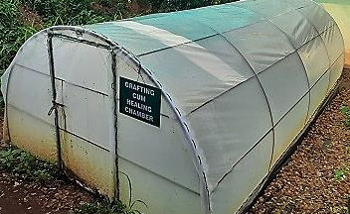
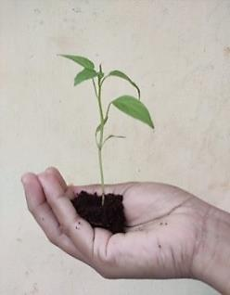
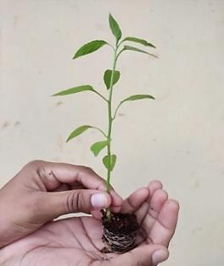
Seedling used for scion
Seedling used for rootstock
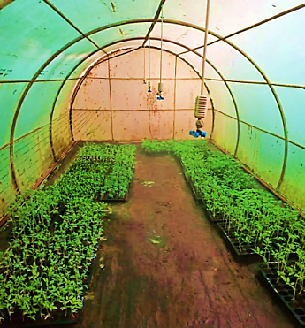
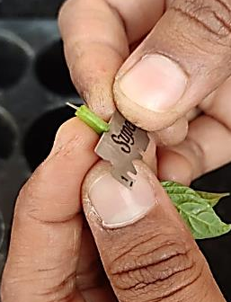
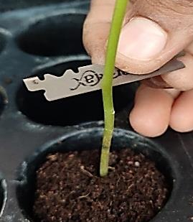

Grafted plants were kept under grafting chamber for graft healing
The top part of scion plants were cut

Top portion of rootstock removed retaining 5-6 cm of stem portion

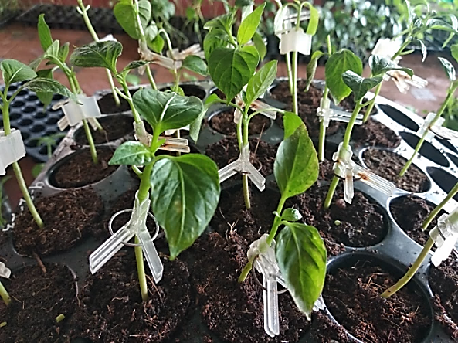
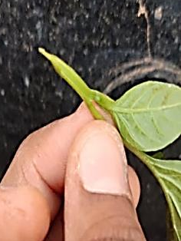
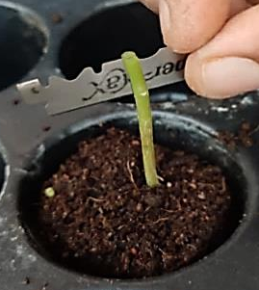

Vertical slit was made in the rootstock

Wedge shaped cut was made in the scion

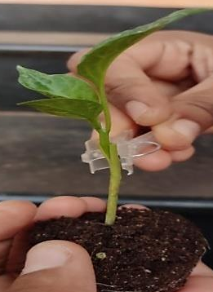
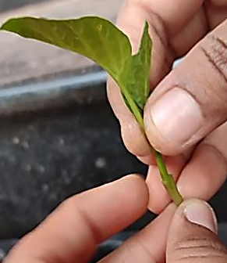
Acclimatization of sweet pepper grafts

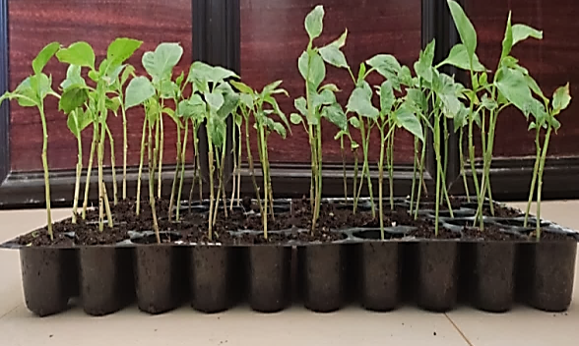
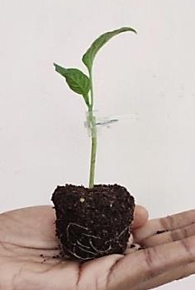
Wedge shaped scion was inserted into the vertical slit made on the rootstock

The joint secured by using a grafting clip

Grafted plant
Hardening of grafts

Plate 1. Steps of cleft grafting
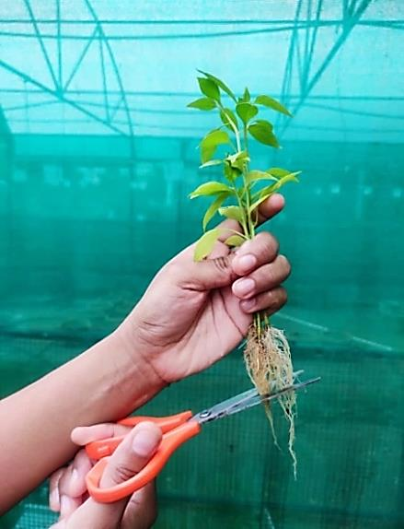
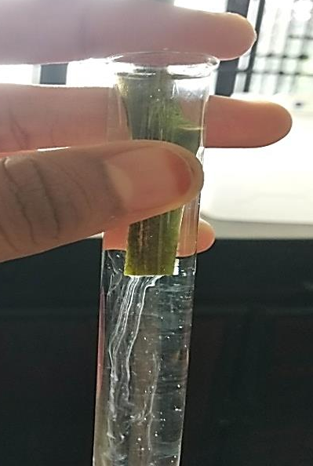
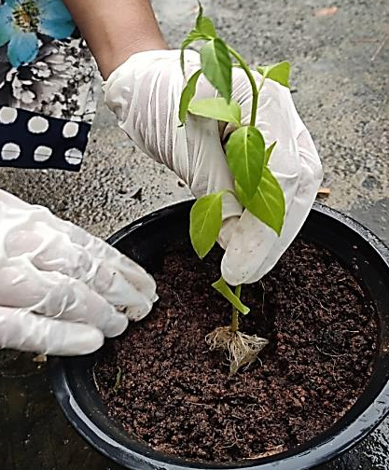
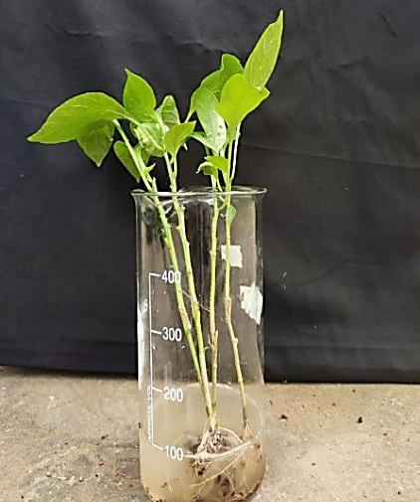
Collecting ooze from bacterial wilt affected plant

Clipping the root of grafts and non-grafts for artificial inoculation of bacterial wilt pathogen

Artificial inoculation by root dipping in 100 ml of bacterial suspension (OD _{600 nm} = 1) for 10 min

Planting artificially inoculated plant in sterilized media

Plate 2. Procedure for artificial inoculation of bacterial wilt pathogen by root dipping method

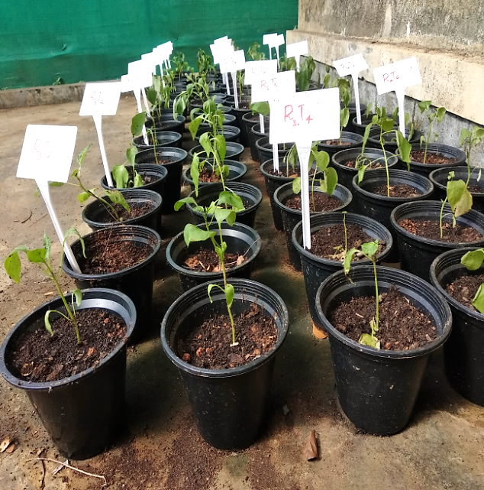
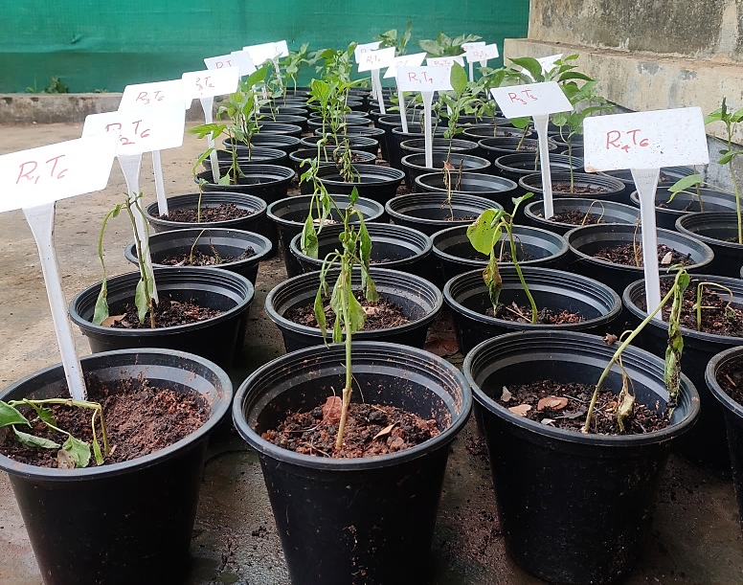
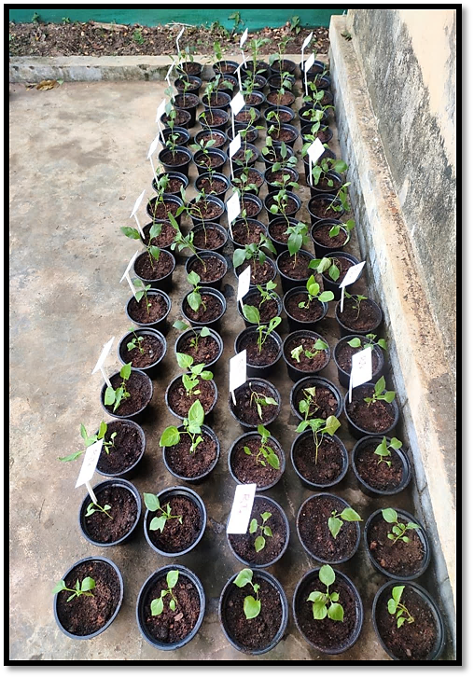
10 days after artificial inoculation

30 days after artificial inoculation

60 days after artificial inoculation

Plate 3. View of sweet pepper plants artificially inoculated with bacterial wilt pathogen

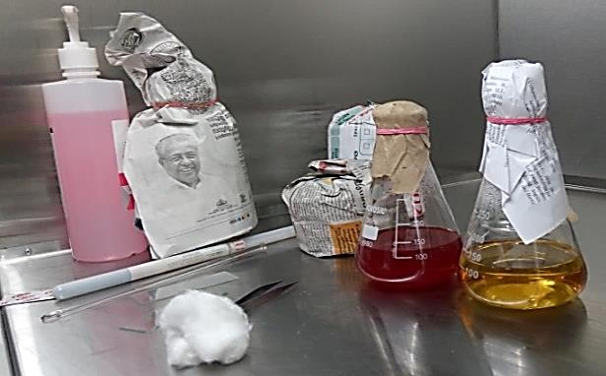
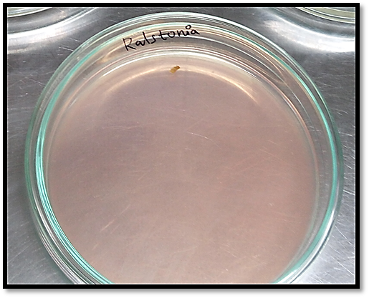
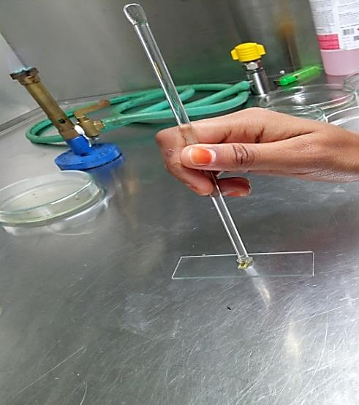
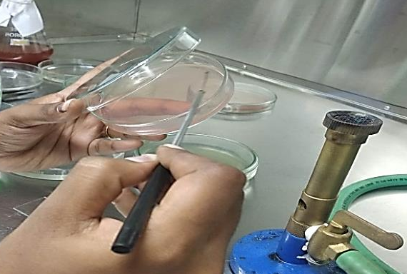
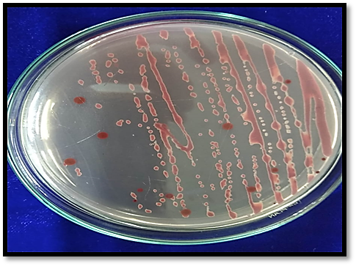
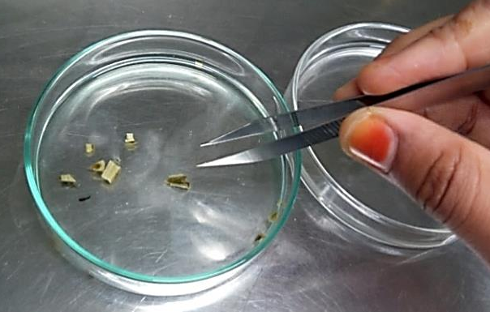
Small bits were cut from wilted plant and surface sterilized by dipping in NaOCl @ 1.0% solution for 1min

Plant bits were smashed using glass rod

Streaking of bacteria in TTC media

Streaked plate
Presence of Ralstonia was confirmed by the appearance of white bacterial colonies with pink centres in TTC media

TTC media was taken for the isolation of Ralstonia solanacearum

Plate 4. Confirmation of bacterial wilt pathogen Ralstonia solanacearum in TTC media

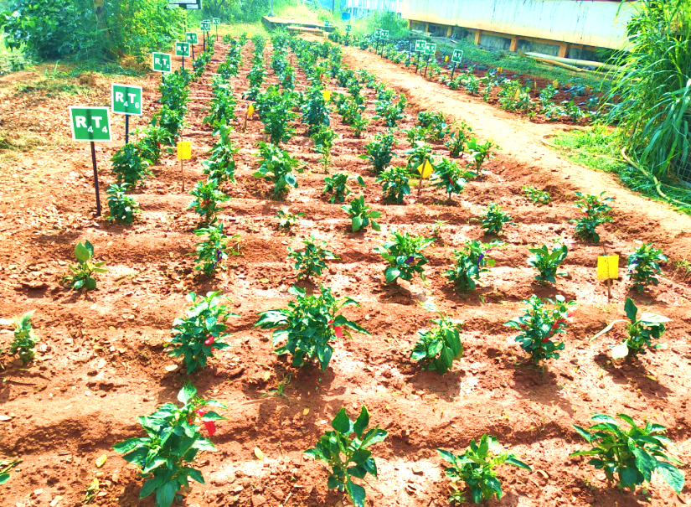
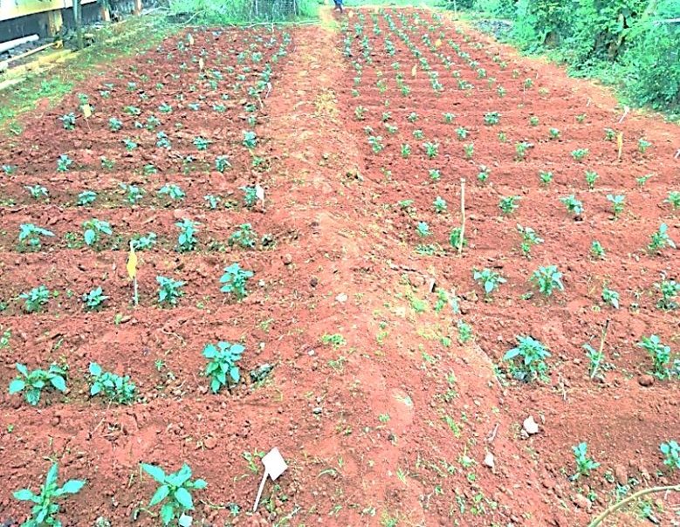
Plate 5. General view of experimental plot

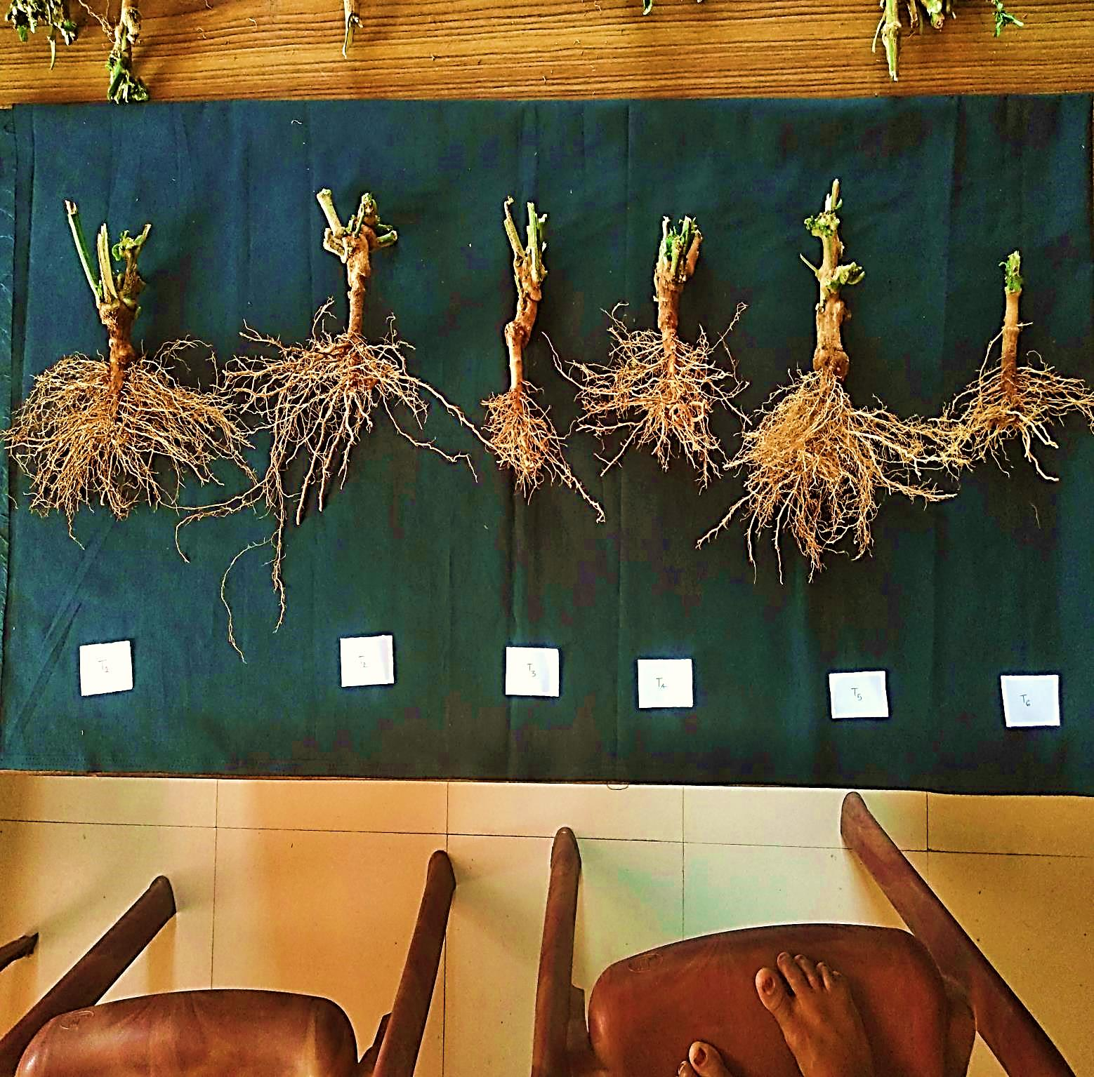
T1
T2
T6
T5
T4
T3
Plate 6. Length of primary root ; T1 : California Wonder grafted on Ujwala, T2 : California Wonder grafted on Vellayani Thejus, T3 : California Wonder grafted on Vellayani Samrudhi, T4 : California Wonder grafted on bird’s eye chilli (local cultivar), T5 : California Wonder grafted on Haritha, T6 : Non-grafted California Wonder

