Original Research Article

Assessment of Genetic Divergence in Mungbean Genotypes (Vigna radiata) using Multivariate Analysis for Crop Improvement

ABSTRACT
Aim: Mungbean (Vigna radiata (L.) Wilczek) is an essential short-duration, self-pollinated, annual herbaceous bean primarily planted for nutritional quality, adaptability and role in sustainable agriculture. However, low genetic variety within cultivated germplasm prevents progress toward yield improvement. Assessing genetic diversity between genotypes is thus essential for identifying diverse parents for successful breeding programs.
Study Design: The study used three replications in randomized complete block design (RCBD).
Place and Duration: The experiment was conducted during kharif, 2023, at the Breeder Seed Production Unit, Department of Genetics and Plant Breeding, College of Agriculture, JNKVV, Jabalpur, Madhya Pradesh.
Methodology: In the present study, 35 mungbean genotypes were analysed for genetic diversity using Mahalanobis's D² statistics and principal component analysis (PCA). 13 key quantitative traits were recorded and genotypes were grouped into 14 clusters based on genetic distance using tocher’s procedure.
Result: Genotypes from clusters XII and XIV had the greatest inter-cluster distance, whereas Cluster V had the greatest intra-cluster distance. The traits with the highest percentage contribution to the overall variance were determined to be the number of pod clusters per plant (22.35%). PCA analysis found that, of the 13 principal components, four had eigenvalues of more than 1.30, accounting for 71.17% of total variance. The first principal component accounted for 31.36% of the variability and was mainly associated with yield-related traits. Using multivariate analysis, it was found that MH-2-15, IC 103821, and IC 373199 were genetically varied genotypes that were utilized to promote genetic recombination and to create a more resilient hybrid.
Conclusion: The study demonstrated considerable genetic diversity among the mungbean genotypes, highlighting the effectiveness of D² statistics and PCA in parental selection. The identified diverse and high-performing genotypes can be strategically utilized in hybridization programmes to enhance genetic recombination and improve yield potential in mungbean.
Keywords: Clusters, D² statistics, genetic diversity, mungbean, principal components
- INTRODUCTION
Mungbean (Vigna radiata (L.) Wilczek), commonly known as green gram or moong is an important short-duration, self-pollinated pulse crop widely cultivated in tropical and subtropical regions. It matures within 60–90 days and is valued for its high protein content, digestibility, and adaptability to diverse agro-climatic conditions (Jahan et al. 2020; Aski et al. 2021; Sandhu and Singh 2021). They are mostly cultivated in low- to mid-elevation, well-drained, rainfed areas, and thrive throughout India's summer and kharif seasons. Its chromosomal count is 2n=2x=22, and its genome size is around 543 Mb (Parida et al. 1990; Kang et al. 2014). In addition to its nutritional importance, it contributes to soil fertility through symbiotic nitrogen fixation using rhizobium bacteria, making it an integral component of sustainable cropping systems.
India is the largest producer and consumer of pulses, accounting for 25-28% of all global production (annual report Pulses in India, 2022-23), with mungbean ranking third next to chickpeas and pigeon peas in terms of area and production (Nalajala et al. 2022). Globally, mungbean is cultivated on about 7 million hectares, producing approximately 5.11 million tonnes with an average productivity of 730 kg ha⁻¹ (Silva Volpato et al. 2025). Despite its economic and nutritional significance, mungbean productivity remains relatively low due to narrow genetic diversity, complex inheritance of yield and yield-related traits, and susceptibility to abiotic stresses such as heat and drought (Cao et al. 2011; Singh et al. 2022).
Mungbean genetic improvement can be hindered by the lack of diversity in parental gene pool, which limits the potential for selecting better recombinants (Kumar and Kumar 2014). Therefore, effective crop development requires utilizing the genetic diversity already present. Breeders can find genetically diverse parents to utilize in hybridization programs to produce transgressive segregants and improve heterosis for yield and related variables by using genetic divergence analysis.
Systematic analyses are necessary to enhance mungbean genetics for higher seed production. Plant breeders working to create high-performing cultivars maintain a high value on identifying the variability of both qualitative and quantitative attributes (Yirga et al. 2020; Saroj et al. 2021; Sarker and Ercisli 2022; Meena et al. 2024). More specifically, multivariate approaches make it easier to classify large genotype collections into homogeneous groups, measure genetic distances within and between clusters. Complementary to this, principal component analysis (PCA) reduces data dimensionality and identifies the most influential traits contributing to overall variation, thereby facilitating efficient selection decisions. The combined use of D² analysis and PCA provides a comprehensive understanding of genetic relationships and trait associations among genotypes.
In order to identify genetically divergent and agronomically superior genotypes for use in future mungbean breeding programs, the current study was conducted to evaluate the degree of genetic diversity among 35 mungbean genotypes using principal component analysis and Mahalanobis's D² statistics.
- MATERIALS AND METHODS
2.1 Experimental material and location
The study was conducted during kharif 2023 at the Breeder Seed Production (FC) Unit, College of Agriculture, Jawaharlal Nehru Krishi Vishwa Vidyalaya, Jabalpur, Madhya Pradesh. The 35 superior mungbean genotypes including three checks that were previously chosen from field trials based on yield performance were the focus of the current study, sourced from JNKVV, Jabalpur; the Indian Institute of Pulses Research (IIPR), Kanpur; and Punjab Agricultural University (PAU), Ludhiana (Table 1).
2.2 Experimental design and crop management
The experiment was laid out in a randomized complete block design (RCBD) with three replications under timely sown, irrigated field conditions. Each genotype was sown in two rows of 2 m length, maintaining a spacing of 30 cm between rows and 10 cm between plants. Recommended agronomic and cultural practices were followed throughout the cropping period to ensure uniform crop growth and to minimize environmental variation and preserve a robust plant stand.
2.3 Traits recorded
Observations were recorded on thirteen quantitative traits. Two phenological traits, namely days to flower initiation and days to maturity, were recorded on a plot basis. Eleven yield and yield-related traits were recorded by randomly selecting five competitive plants from the middle rows of each plot. These traits included plant height (cm), number of branches per plant, number of nodes per plant, number of pod clusters per plant, number of pods per plant, pod length (cm), number of seeds per pod, 100-seed weight (g), biological yield per plant (g), harvest index (%), and seed yield per plant (g).
2.4 Statistical analysis
Using Mahalanobis's D² statistics, genetic divergence between mungbean genotypes was evaluated (Mahalanobis, 1936). To find the pattern of genetic diversity, genotypes were grouped into various clusters using Tocher's approach based on the computed D² values. To determine the degree of divergence within and between clusters, intra- and inter-cluster distances were calculated.

Using standard data, principal component analysis (PCA) was used to reduce dimensionality and determine the proportional contributions of specific variables to overall genetic variance. The principal components were interpreted using eigenvalues, component loadings, and percentage of variance explained. To examine the genetic relationships and phenotypic contributions among the genotypes, PCA scatter plots and scree plots were generated.

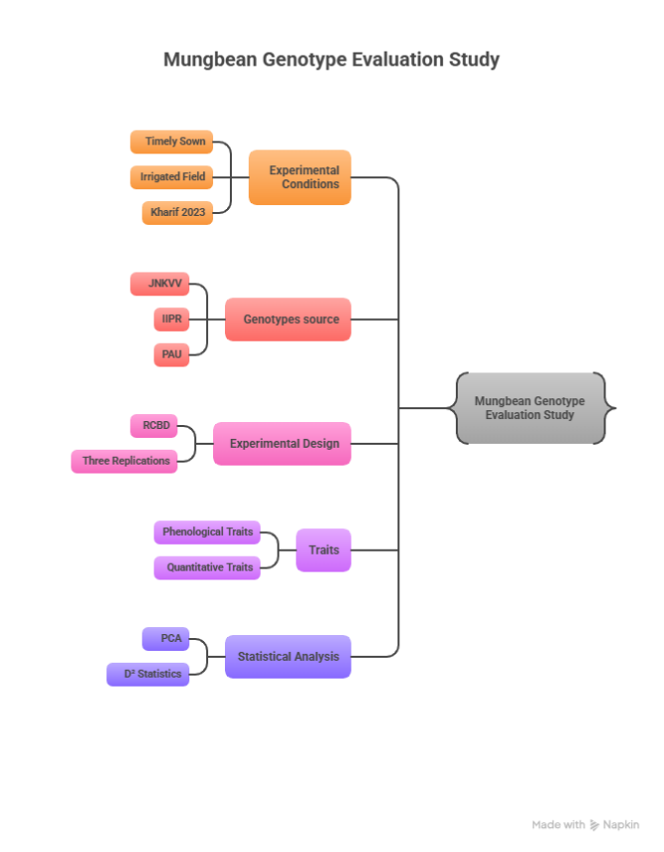

Fig. 1 Field evaluation of mungbean genotypes under randomized complete block design

Table 1 Mungbean genotypes used in present study
S. No. | Genotypes | S. No. | Genotypes | S. No. | Genotypes | S. No. | Genotypes
1. | KH 2241 | 10. | IC 76499 | 19. | EC 396399 | 28. | PDM-139
2. | IC 314523 | 11. | IC 103821 | 20. | OMG-1045 (PMR) | 29. | EC 520026
3. | IC 348964 | 12. | MH-2-15 | 21. | CO 6 | 30. | EC 520029
4. | IPM 99-125 | 13. | IC 305291 | 22. | HUM-1 | 31. | EC 520038
5. | TARM 2 | 14. | IPM 312-2 | 23. | IC 373199 | 32. | EC 520041
6. | COGG 8 | 15. | PANT MUNG 6 | 24. | IC 417873 | 33. | VIRAT (CHECK 1)
7. | RMG-1028 | 16. | PUSA 9531 | 25. | IC 73395 | 34. | SHIKHA (CHECK 2)
8. | PDM-54 | 17. | IPM 302-2 | 26. | LGG-460 | 35. | MH 421 (CHECK 3)
9. | PDM-11 | 18. | IC 12130 1 | 27. | IC 119033
- RESULTS AND DISCUSSION
The assessment of genetic diversity is fundamental for the effective evaluation, conservation, and utilization of crop germplasm in breeding programmes. Knowledge of the magnitude and pattern of genetic variation among genotypes facilitates the identification of suitable parents for hybridization and the development of superior recombinants (Salgotra et al. 2015; Sarkar and Kundagrami 2016). In the present study, multivariate statistical approaches were employed to elucidate the extent of genetic divergence among 35 mungbean genotypes.
3.1 Genetic divergence analysis using Mahalanobis D² statistics
3.1.1 Clustering pattern of genotypes
Based on Mahalanobis’s D² analysis, the 35 mungbean genotypes were grouped into 14 distinct clusters using Tocher’s method, indicating the presence of substantial genetic diversity among the studied material (Fig. 2, Table 2). Cluster I was the largest, comprising nine genotypes, followed by cluster V with seven genotypes, cluster III with five genotypes, and cluster XI with four genotypes. The remaining ten clusters were mono-genotypic, each containing a single genotype. The occurrence of several solitary clusters suggests the presence of unique and highly divergent genotypes, which may serve as valuable parental sources in breeding programmes.
Similar clustering patterns and the existence of solitary clusters in mungbean have been reported earlier by Sarkar and Kundagrami (2016), Abbas et al. (2018), Mahalingam et al. (2018), Tahir et al. (2020), Yoseph et al. (2021), Tiwari et al. (2022), Rahangdale et al. (2023), Sonaniya et al. (2024), Srivastava et al. (2024), and Meena et al. (2025), confirming the effectiveness of D² statistics in assessing genetic divergence.

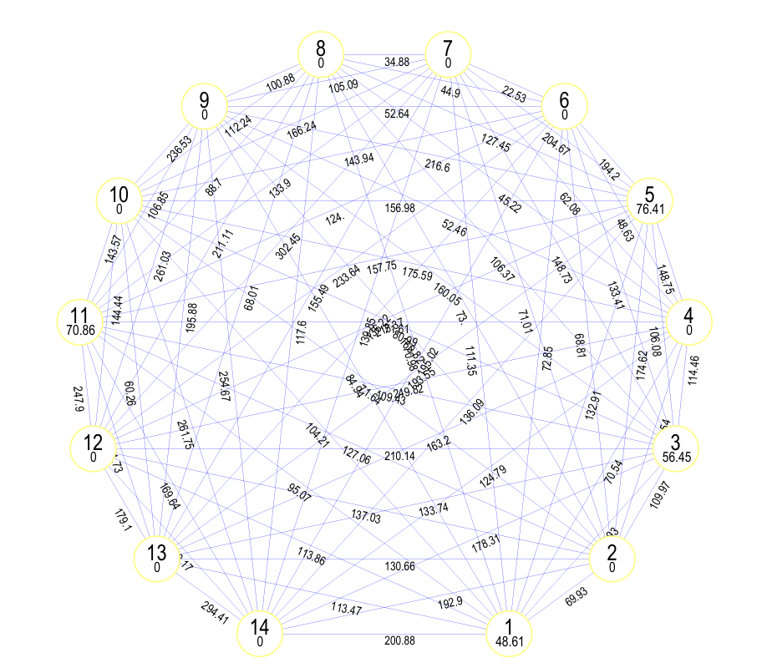

Fig. 2 Intra- and inter-cluster genetic divergence among mungbean genotypes based on Mahalanobis’s D² analysis
Table 2 Distribution of mungbean genotypes in different clusters using Tocher’s approach
Cluster No. | No. of genotypes | Name of genotypes
I | 9 | TARM 2, COGG 8, RMG-1028, PDM-54, PDM-11, IC 76499, IC 305291, IPM 302-2, EC 520041
II | 1 | IC 103821
III | 5 | PANT MUNG 6, IC 121301, PDM-139, HUM-1, IPM 312-2
IV | 1 | IC 348964
V | 7 | PUSA 9531, EC 520038, Virat (check 1), IC 417873, IC 73395, LGG-460, CO 6
VI | 1 | OMG-1045 (PMR)
VII | 1 | KH 2241
VIII | 1 | Shikha (check 2)
IX | 1 | IPM 99-125
X | 1 | IC 373199
XI | 4 | EC 520026, EC 520029, IC 314523, IC 119033
XII | 1 | MH-2-15
XIII | 1 | MH 421 (check 3)
XIV | 1 | EC 396399
    - Intra- cluster divergence
The magnitude of intra-cluster distance reflects the genetic variability among genotypes within a cluster. In the present investigation, the highest intra-cluster distance was observed in cluster V (D² = 76.41), followed by cluster XI (70.86), cluster III (56.45), and cluster I (48.61). These clusters exhibited considerable internal genetic diversity, suggesting that hybridization among genotypes within these clusters may still yield useful recombinants. In contrast, no intra-cluster divergence was observed in the mono-genotypic clusters due to the presence of a single genotype (Fig. 3, Table 3).
    - Inter- cluster divergence
Inter-cluster distances provide a measure of genetic divergence between clusters and are crucial for selecting parents for hybridization. The maximum inter-cluster distance was recorded between clusters XII and XIV (380.17), indicating extreme genetic divergence between these genotypes. The minimum inter-cluster distance was observed between clusters VI and VII (22.53), suggesting close genetic relatedness (Fig. 3, Table 3).
Other notable high inter-cluster distances were observed between cluster VII and XII (302.45), cluster XIII and XIV (294.41), cluster X and XIV (261.75), cluster IX and XII (261.03), cluster IX and XIV (254.67), and cluster IV and XII (249.82). Hybridization between genotypes belonging to such divergent clusters is expected to produce transgressive segregants with enhanced variability and heterotic effects. These findings are consistent with earlier reports by Garg et al. (2017), Sen and De (2017), Kanavi et al. (2020), Saroj et al. (2021), Azam et al. (2023), and Meena et al. (2025).

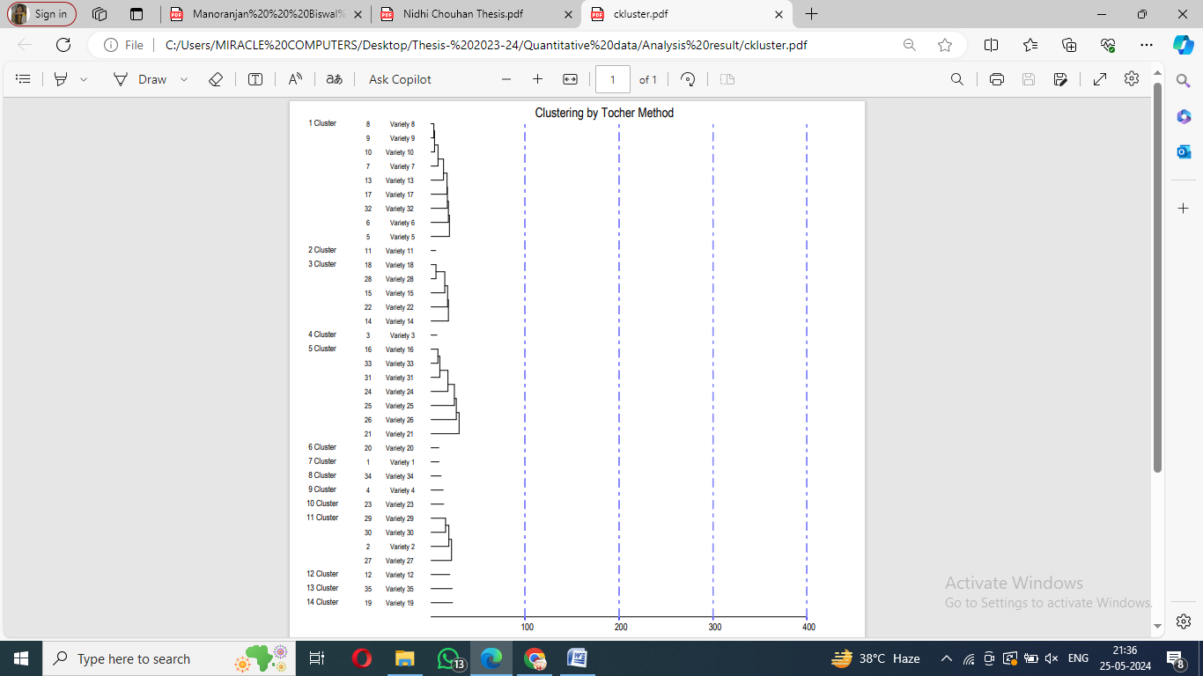

Fig. 3 Distribution of mungbean genotypes across different clusters based on Mahalanobis’s D² statistics.
Clusters | I | II | III | IV | V | VI | VII | VIII | IX | X | XI | XII | XIII | XIV
I | 48.61 | 69.93 | 97.93 | 70.54 | 132.91 | 72.85 | 111.35 | 70.98 | 84.94 | 104.21 | 95.07 | 113.86 | 113.47 | 200.88
II |  | 0.00 | 109.97 | 91.54 | 174.62 | 68.81 | 71.01 | 73.00 | 160.82 | 71.64 | 127.06 | 137.03 | 130.66 | 192.90
III |  |  | 56.45 | 114.46 | 106.08 | 133.41 | 148.73 | 106.37 | 160.05 | 80.99 | 109.43 | 210.14 | 133.74 | 178.31
IV |  |  |  | 0.00 | 148.75 | 48.63 | 62.08 | 45.22 | 52.46 | 175.59 | 71.61 | 249.82 | 163.20 | 124.79
V |  |  |  |  | 76.41 | 194.20 | 204.67 | 127.45 | 216.60 | 156.98 | 157.75 | 215.37 | 193.55 | 136.09
VI |  |  |  |  |  | 0.00 | 22.53 | 44.90 | 52.64 | 143.94 | 124.00 | 233.64 | 136.22 | 195.02
VII |  |  |  |  |  |  | 0.00 | 34.88 | 105.09 | 166.24 | 133.90 | 302.45 | 155.49 | 139.85
VIII |  |  |  |  |  |  |  | 0.00 | 100.88 | 112.24 | 88.70 | 211.11 | 68.01 | 117.60
IX |  |  |  |  |  |  |  |  | 0.00 | 236.53 | 106.85 | 261.03 | 195.88 | 254.67
X |  |  |  |  |  |  |  |  |  | 0.00 | 143.57 | 144.44 | 60.26 | 261.75
XI |  |  |  |  |  |  |  |  |  |  | 70.86 | 247.90 | 141.73 | 169.64
XII |  |  |  |  |  |  |  |  |  |  |  | 0.00 | 179.10 | 380.17
XIII |  |  |  |  |  |  |  |  |  |  |  |  | 0.00 | 294.41
XIV |  |  |  |  |  |  |  |  |  |  |  |  |  | 0.00
Table 3 Inter and Intra Cluster D² Value for different clusters
    - Cluster mean analysis
The analysis of cluster means revealed significant differences among clusters for various phenological, yield, and yield-related traits (Table 4). Cluster XII exhibited the highest mean value for days to flowering (44.33 days), whereas cluster XIII recorded the lowest (33.00 days). For days to maturity, cluster II showed the maximum mean (79.33 days), while cluster VIII exhibited the minimum (62.67 days). The tallest plants were recorded in cluster IV (56.03 cm), while cluster VII had the shortest plants (32.33 cm). Cluster XII recorded the highest seed yield per plant (13.43 g), whereas the lowest seed yield was observed in cluster XIV (9.20 g). These variations in cluster means highlight the existence of considerable genetic diversity for yield and its component traits, which can be exploited for targeted trait improvement.
Comparable trends in cluster mean performance for mungbean traits have been reported by Sarkar and Kundagrami (2016), Kaur et al. (2017), Sofia et al. (2017), Sharma et al. (2018), Ghosh et al. (2019), Gupta et al. (2021), Yoseph et al. (2021), Tiwari et al. (2022), Rahangdale et al. (2023), Sonaniya et al. (2024), Srivastava et al. (2024), and Meena et al. (2025).

Table 4 Cluster mean for yield and its component traits of mungbean genotypes
Characters |  | dtf | dtm | ph | bpp | nnpp | npcp | npp | pl | spp | 100sw | by | hi | syp
Clusters | I | 40.81 | 72.22 | 43.85 | 6.00 | 6.56 | 11.77 | 15.67 | 5.08 | 7.55 | 4.34 | 38.50 | 31.43 | 12.05
Clusters | II | 37.00 | 79.33 | 46.33 | 5.17 | 7.30 | 15.47 | 20.20 | 4.07 | 6.00 | 4.60 | 42.67 | 29.80 | 12.70
Clusters | III | 40.20 | 73.20 | 43.33 | 5.27 | 6.76 | 12.11 | 31.93 | 4.93 | 7.37 | 4.32 | 47.28 | 25.63 | 12.13
Clusters | IV | 36.33 | 64.67 | 56.03 | 6.47 | 8.40 | 9.77 | 11.87 | 5.87 | 7.87 | 4.50 | 35.23 | 34.00 | 12.00
Clusters | V | 39.95 | 70.86 | 43.35 | 5.35 | 5.54 | 10.42 | 23.15 | 8.24 | 8.59 | 4.18 | 43.03 | 28.97 | 12.34
Clusters | VI | 36.67 | 64.33 | 34.73 | 5.53 | 8.73 | 11.50 | 15.23 | 5.30 | 7.90 | 4.47 | 36.17 | 31.90 | 11.57
Clusters | VII | 34.00 | 64.00 | 32.33 | 3.53 | 7.60 | 10.60 | 15.23 | 5.60 | 7.67 | 4.23 | 32.80 | 32.57 | 10.63
Clusters | VIII | 34.67 | 62.67 | 42.73 | 4.43 | 6.70 | 11.10 | 15.97 | 7.03 | 10.33 | 4.57 | 34.43 | 33.40 | 11.50
Clusters | IX | 41.33 | 64.67 | 32.37 | 5.63 | 7.00 | 5.00 | 7.47 | 4.87 | 7.93 | 4.50 | 33.20 | 33.20 | 11.07
Clusters | X | 33.67 | 74.00 | 43.60 | 5.97 | 7.33 | 17.50 | 34.40 | 4.60 | 8.47 | 4.40 | 45.50 | 25.67 | 11.70
Clusters | XI | 34.33 | 70.00 | 42.23 | 4.72 | 5.29 | 6.80 | 14.25 | 4.76 | 7.42 | 3.72 | 29.71 | 35.86 | 10.28
Clusters | XII | 44.33 | 78.33 | 48.07 | 6.77 | 4.80 | 16.83 | 16.67 | 5.17 | 7.77 | 5.40 | 46.53 | 28.83 | 13.43
Clusters | XIII | 33.00 | 63.00 | 41.67 | 5.13 | 6.37 | 14.40 | 25.53 | 6.27 | 12.93 | 4.77 | 42.10 | 28.07 | 11.80
Clusters | XIV | 35.00 | 65.00 | 48.53 | 3.60 | 5.70 | 9.80 | 14.97 | 8.23 | 6.50 | 3.50 | 22.37 | 41.37 | 9.20
Note: dtf: days to flowering, dtm: days to maturity, ph: plant height, bpp : number branches per plant, nnpp: number of nodes per plant, npcp: number of pod clusters per plant, npp: number of pods per plant, pl: pod length, spp : number of seeds per pod, 100sw : 100 seed weight, by : biological yield per plant, hi: harvest index, syp: seed yield per plant.
    - Contribution of traits towards genetic divergence
The relative contribution of individual traits to total genetic divergence revealed that number of pod clusters per plant contributed the highest percentage (22.35%), followed by number of nodes per plant (20.00%), pod length (15.97%), number of pods per plant (13.11%), and number of seeds per pod (12.27%) (Table 5). These results emphasize the dominant role of yield-contributing traits in determining genetic divergence among mungbean genotypes. Traits such as number of branches per plant (6.39%), days to maturity (5.04%), and days to flowering (1.51%) contributed moderately, whereas seed yield per plant (1.01%), biological yield per plant (0.84%), 100-seed weight (0.67%), plant height (0.50%), and harvest index (0.34%) contributed marginally.
Similar observations regarding trait contributions have been reported in mungbean by Sarkar and Kundagrami (2016), Garg et al. (2017), Yoseph et al. (2021), Chauhan et al. (2024) and Meena et al. (2025).

Table 5 Contribution (%) of different characters towards clustering
Source | Times ranked 1st | Contribution %
Number of pod clusters per plant | 133 | 22.35
Number of nodes per plant | 119 | 20.00
Pod length | 95 | 15.97
Number of pods per plant | 78 | 13.11
Number of seeds per pod | 73 | 12.27
Number of branches per plant | 38 | 6.39
Days to maturity | 30 | 5.04
Days to flowering | 9 | 1.51
Seed yield per plant | 6 | 1.01
Biological yield per plant | 5 | 0.84
100 seed weight | 4 | 0.67
Plant height | 3 | 0.50
Harvest index | 2 | 0.34
3.2 Principal Component Analysis (PCA)
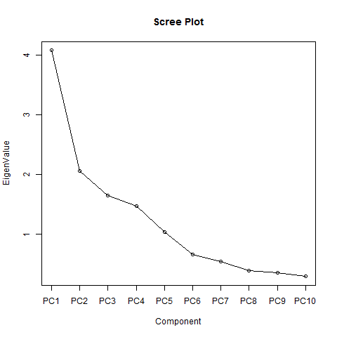
Principal component analysis was performed to further elucidate the structure of genetic variation among the 35 mungbean genotypes based on 13 quantitative traits. With an Eigen value more than 1.30, and together accounted for 71.17% of the total variation (Table 6, Fig. 4). The first principal component (PC1) explained the maximum variability (31.36%), followed by PC2 (15.81%), PC3 (12.68%), and PC4 (11.30%).

Fig. 4 Scree plot showing the relationship between eigenvalues and principal components derived from principal component analysis (PCA)

Table 6 Principal Components of Different Traits
Principal components | Eigen values | Variability % | Cumulative %
PC1 | 4.077 | 31.361 | 31.361
PC2 | 2.056 | 15.819 | 47.18
PC3 | 1.65 | 12.689 | 59.869
PC4 | 1.469 | 11.302 | 71.172
PC5 | 1.037 | 7.978 | 79.15
PC6 | 0.66 | 5.079 | 84.229
PC7 | 0.543 | 4.174 | 88.402
PC8 | 0.384 | 2.957 | 91.359
PC9 | 0.358 | 2.754 | 94.113
PC10 | 0.292 | 2.247 | 96.36
PC11 | 0.262 | 2.019 | 98.379
PC12 | 0.203 | 1.563 | 99.942
PC13 | 0.007 | 0.058 | 100
PC1 was primarily associated with days to maturity, number of branches per plant, number of pod clusters per plant, biological yield per plant, and seed yield per plant, indicating that these traits contributed most to overall variability. PC2 was mainly influenced by number of pods per plant, while PC3 was dominated by days to flowering and pod length. PC4 showed high loadings for number of nodes per plant, number of seeds per pod, and 100-seed weight (Table 7, Table 9). These results suggest that multiple yield-attributing traits collectively govern genetic variation in mungbean.
Table 7 Principal Components Values of Rotation Component Matrix (>0.25)
S. No. | Traits | Principle Components
S. No. | Traits | PC1 | PC2 | PC3 | PC4
1. | Days to flowering | 0.216 | -0.376 | 0.362 | -0.137
2. | Days to maturity | 0.252 | -0.334 | -0.017 | -0.415
3. | Plant height | 0.108 | -0.062 | -0.027 | -0.132
4. | Number of branches per plant | 0.31 | -0.376 | 0.055 | 0.229
5. | Number of nodes per plant | 0.09 | -0.094 | -0.493 | 0.445
6. | Number of pod clusters per plant | 0.34 | 0.16 | -0.309 | 0.158
7. | Number of pods per plant | 0.31 | 0.413 | -0.099 | -0.216
8. | Pod length | -0.058 | 0.293 | 0.537 | 0.032
9. | Number of seeds per pod | 0.044 | 0.258 | 0.403 | 0.522
10. | 100 seed weight | 0.317 | -0.233 | 0.129 | 0.414
11. | Biological yield | 0.439 | 0.254 | 0.017 | -0.127
12. | Harvest index | -0.333 | -0.344 | 0.073 | 0.075
13. | Seed yield per plant | 0.391 | -0.079 | 0.208 | -0.052
The PCA scores revealed substantial variation among genotypes, with both positive and negative values across principal components (Table 8, Table 9). Genotype MH-2-15 recorded the highest PC score (3.47), indicating its distinct genetic makeup. Other promising genotypes identified through PCA included IC 103821, IC 305291, PANT MUNG 6, PUSA 9531, IC 373199, and IC 417873. These genotypes were associated with favorable yield-related traits and may serve as valuable parental lines.
Table 8 List of Different PCA Scores of the Mungbean Genotypes (> 1.50)
S. No. | Genotypes | PC 1 | PC 2 | PC 3 | PC 4
1 | KH 2241 | -2.43109 | 0.969218 | -1.19396 | 1.014423
2 | IC 314523 | -2.87588 | -0.43935 | 0.335568 | -1.41145
3 | IC 348964 | -0.35167 | -1.16254 | -0.62045 | 1.731879
4 | IPM 99-125 | -1.88088 | -1.50618 | 0.336904 | 1.356111
5 | TARM 2 | 1.210945 | -1.43297 | 1.119369 | 1.786538
6 | COGG 8 | 0.013495 | -1.84748 | -0.96263 | 0.847121
7 | RMG-1028 | -1.0175 | -0.19361 | 0.640605 | 0.885329
8 | PDM-54 | 1.657505 | -1.86907 | -0.09851 | -0.32652
9 | PDM-11 | 0.966436 | -0.78269 | -0.03302 | -0.99332
10 | IC 76499 | 0.39894 | -0.77376 | -1.00157 | -1.11001
11 | IC 103821 | 1.676418 | -0.99804 | -1.93818 | -0.83682
12 | MH-2-15 | 3.473859 | -1.85979 | 0.924458 | -0.0682
13 | IC 305291 | 2.386764 | -0.78804 | -1.38628 | 0.163028
14 | IPM 312-2 | 1.685351 | 1.025799 | 0.127607 | -1.94947
15 | PANT MUNG 6 | 3.442257 | 0.377447 | -0.74941 | -0.79521
16 | PUSA 9531 | 1.75403 | 1.700716 | 1.366608 | 0.163273
17 | IPM 302-2 | -0.51486 | -2.55586 | 0.722011 | -0.39081
18 | IC 121301 | 2.166576 | 0.665002 | -1.60318 | -0.52258
19 | EC 396399 | -4.59004 | 0.471248 | -0.05642 | -0.71429
20 | OMG-1045 (PMR) | -0.90652 | -0.04464 | -1.13624 | 2.228451
21 | CO 6 | 0.758055 | 0.764095 | 2.944899 | 0.233592
22 | HUM-1 | 0.861977 | 0.70918 | 0.596684 | -1.45385
23 | IC 373199 | 2.293785 | 1.336423 | -1.86013 | 0.357252
24 | IC 417873 | 2.135458 | 1.854793 | 0.239218 | 0.308844
25 | IC 73395 | 0.383327 | -1.58472 | 1.822063 | 0.262051
26 | LGG-460 | 0.093253 | -1.55803 | 3.196573 | -1.38039
27 | IC 119033 | -3.32144 | -1.24349 | -0.8961 | 0.029417
28 | PDM-139 | 0.732146 | 0.800758 | -2.25286 | 0.27378
29 | EC 520026 | -1.98467 | 0.680161 | -0.79068 | -0.66454
30 | EC 520029 | -3.90295 | -0.44421 | -0.41936 | -1.19591
31 | EC 520038 | -1.20636 | 2.983648 | 0.154277 | -1.95989
32 | EC 520041 | -1.73823 | 0.206647 | -0.74469 | -0.45193
33 | Virat (check 1) | -0.60605 | 2.638631 | 1.49916 | -0.50771
34 | Shikha (check 2) | -1.39926 | 1.249509 | 0.767016 | 2.095962
35 | MH421 (check 3) | 0.63681 | 2.651201 | 0.950657 | 2.995871

Table 9 Promising genotypes and the quantitative traits on the basis of scores of principal components
Principal Components | Traits (Rotation Component Matrix) | Genotypes (Scores of PCs)
PC1 | Days to maturity, number of branches per plant, number of pod clusters per plant, biological yield per plant and seed yield per plant | PDM-54, IC 103821, MH-2-15, IC 305291, IPM 312-2, PANT MUNG 6, PUSA 9531, IC 121301, IC 373199 and IC 417873
PC2 | Number of pods per plant | PUSA 9531, IC 417873, EC 520038, Virat (check 1) and MH421 (check 3)
PC3 | Days to flowering and pod length | CO 6, IC 73395 and LGG-460
PC4 | Number of nodes per plant, number of seeds per pod and 100 seed weight | IC 348964, TARM 2, OMG-1045 (PMR), Shikha (check 2) and MH421 (check 3)
The present findings are in agreement with previous PCA-based diversity studies in mungbean reported by Jakhar et al. (2018), Samyuktha et al. (2019), Kanavi et al. (2020), Gayacharan et al. (2020), Mwangi et al. (2021), Benlioglu and Ozkan (2022), Paliwal et al. (2022), Gupta et al. (2023), Azam et al. (2023), Chauhan et al. (2024), Mishra et al. (2025), and Meena et al. (2025).
Overall, superior, genetically diverse mungbean genotypes were identified and genetic divergence was revealed by the combined use of principal component analysis and Mahalanobis D² statistics. In mungbean improvement programs, the integration of these multivariate approaches offers a strong framework for strategic hybridization and informed parental selection. In order to evaluate their combining capacity and produce transgressive segregants for yield and associated traits, future research should concentrate on using the identified genetically divergent and agronomically superior genotypes in planned hybridization programs. Furthermore, combining phenotypic divergence analysis with molecular marker-based methods may improve parent selection efficiency and provide additional insight on the genetic foundations of important yield-contributing traits.
- CONCLUSION
The present study revealed substantial genetic diversity among the 35 mungbean genotypes evaluated using multivariate statistical approaches. Mahalanobis’s D² analysis effectively grouped the genotypes into distinct clusters, indicating wide genetic divergence, while principal component analysis further clarified the contribution of yield and yield-related traits to overall variability. Pod-related traits, particularly number of pod clusters per plant, number of nodes per plant, pod length, and number of pods per plant, played a dominant role in determining genetic divergence, highlighting their importance in selection strategies for yield improvement.
The integration of D² clustering and PCA consistently identified MH-2-15, IC 103821, and IC 373199 as genetically diverse and agronomically superior genotypes. These genotypes represent valuable parental resources for hybridization programmes aimed at generating transgressive segregants and enhancing yield potential in mungbean. The convergence of results from both analytical approaches strengthens the reliability of parental selection and minimizes the risk associated with single-trait-based selection.
Overall, the combined use of Mahalanobis’s D² statistics and principal component analysis proved to be a robust and efficient approach for assessing genetic diversity and guiding parent selection. The findings of this study provide a strong foundation for the development of high-yielding, genetically diverse, and adaptable mungbean cultivars, thereby contributing to sustainable mungbean improvement programmes.
Disclaimer (Artificial intelligence)
Author(s) hereby declares that NO generative AI technologies such as Large Language Models (ChatGPT, COPILOT, etc.) and text-to-image generators have been used during the writing or editing of this manuscript.
REFERENCES
Abbas, G., Asghar, M. J., Rizwan, M., Akram, M., Hussain, J., & Ahmad, F. (2018). Genetic analysis of yield and yield components for the improvement of mungbean germplasm. Pakistan Journal of Agricultural Research, 31(2), 158-165. http://dx.doi.org/10.17582/journal.pjar/2018/31.2.158.165
Agbeleye, O. A., Akinyosoye, S. T., & Adetumbi, J. A. (2020). Correlation, path coefficient and principal component analysis of yield components in mung bean (Vigna radiata (L.) Wilcezk) accessions. Journal of Tropical Agriculture, 97:4. https://journals.sta.uwi.edu/ojs/index.php/ta/article/view/8035
Aski, M. S., Rai, N., Reddy, V. R. P., Gayacharan, Dikshit, H. K., Mishra, et al. (2021). Assessment of root phenotypes in mungbean mini-core collection (MMC) from the World Vegetable Center (AVRDC) Taiwan. PLoS One, 16(3), e0247810.Benlioglu B and Ozkan U. 2022. Multivariate analysis and its application for screening mungbean [Vigna radiata (L.) wilczek] landraces. Legume Research, 45(3), 299-304. https://doi.org/10.1371/journal.pone.0247810
Cao, D., Li, H., Yi, J., Zhang, J., Che, H., Cao, J., et al. (2011) Antioxidant properties of the mung bean flavonoids on alleviating heat stress. PLoS ONE 6:e21071. https://doi.org/10.1371/journal.pone.0021071
Chauhan, D. S., Verma, S. K., Panwar, R. K., Arora, A., Pragati, K., Bhatt, A., et al. (2024). Multivariate Analysis of Genetic Diversity in Mung Bean (Vigna radiata (L.) Wilczek) Using Mahalanobis Statistic. International Journal of Plant & Soil Science, 36(8), 1138–1145. https://doi.org/10.9734/ijpss/2024/v36i84945
Dahiya, P. K., Linnemann, A. R., Boekel, M. A. J. S., Khetarpaul, N., Grewal, R. B., & Nout, M. J. R. (2015) Mung bean: technological and nutritional potential. Critical Reviews in Food Science and Nutrition, 55, 670–688. https://doi.org/10.1080/10408398.2012.671202
Garg, G. K., Verma, P. K., Kesh, H., & Kumar, A. (2017). Genetic variability, character association and genetic divergence for seed quality traits in mungbean (Vigna radiata (L.) Wilczek). Indian Journal of Agricultural Research, 51(6). https://doi.org/10.18805/IJARe.A-4929
Gayacharan, Tripathi, K., Meena, S. K., Panwar, B. S., Lal, H., Rana, J. C., & Singh, K. (2020). Understanding genetic variability in the mungbean (Vigna radiata L.) genepool. Annals of Applied Biology ,177(3), 346-357. https://doi.org/10.1111/aab.12624
Ghorbani, H. (2019). Mahalanobis distance and its application for detecting multivariate outliers. Facta Universitatis, Series: Mathematics and Informatics (FU Math Inform), 583-595. https://doi.org/10.22190/FUMI1903583G
Ghosh, S., Roy, A., & Kundagrami, S. (2019). Diversity analysis of mungbean (Vigna radiata (L.) Wilczek) genotypes for bruchid resistance. Indian Journal of Agricultural Research, 53(3),309-314. https://doi.org/10.18805/IJARe.A-5155
Gupta, D., Muralia, S., Gupta, N. K., Gupta, S., Jakhar, M. L., & Sandhu, J. S. (2023). Genetic diversity and principal component analysis in mungbean (Vigna radiata (L.) Wilczek) under Rainfed Condition. Legume Research, 46(3),265-272. https://doi.org/10.18805/LR-4568
Jahan, I., Rahman, M. M., Tuzzohora, M. F., Hossain, M. A., Begum, S. N., Burritt, D. J., & Hossain, M. A. (2020). Phenotyping of mungbean (Vigna radiata L.) genotypes against salt stress and assessment of variability for yield and yield attributing traits. Journal of Plant Stress Physiology, 6, 7-17. https://doi.org/doi:10.25081/jpsp.2020.v6.6111
Jakhar, N. K., & Kumar, A. (2018). Principal component analysis and character association for yield components in greengram (Vigna radiata (L.) Wilczek) genotypes. Journal of Pharmacognosy Phytochemistry, 7(2), 3665- 3669.
Kanavi, M. S. P., Somu, G., Marappa, N., Rangaiah, S., & Koler, P. (2020). Evaluation of germplasm accessions for drought tolerance in green gram (Vigna radiata (L.)). International Journal of Current Microbiology and Applied Sciences 9, 1011–1024. https://doi.org/10.20546/ijcmas.2020.903.119
Kang, Y. J., Kim, S. K., Kim, M. Y., Lestari, P., Kim, K. H., Ha, B., et al. (2014). Genome sequence of mungbean and insights into evolution within Vigna species. Nature Communications, 5, 1-9. https://doi.org/10.1038/ncomms6443
Kaur, S., Bains, T. S., & Singh, P. (2017). Creating variability through interspecific hybridization and its utilization for genetic improvement in mungbean (Vigna radiata (L.) Wilczek). Journal of Applied and Natural Science, 9,1101–1106. https://doi.org/10.31018/jans.v9i2.1329
Kim, S. K., Nair, R. M., Lee, J., & Lee, S. H. (2015). Genomic resources in mungbean for future breeding programs. Frontiers in Plant Science, 6,626. https://doi.org/10.3389/fpls.2015.00626
Kumar, S., & Kumar, R. (2014). Genetic improvement of mungbean for yield, nutrition and resistance to stresses- A review. International Journal of Tropical Agriculture, 32(3-4), 683-687.
Kumar, V. U., & Sarkar, K. K. (2018). Tailoring the genetic diversity of mung bean through cluster analysis for yield attributing traits to obtain efficient hybrids. International Journal of Current Microbiology and Applied Science, 7(7), 1101-1108. https://doi.org/10.20546/ijcmas.2018.707.134
Mahalanobis, P. C. (1928). A statistical study at Chinese head measurement. Journal of the Asiatic Society of Bangladesh, 25, 301-337.
Mahalingam, A., Manivanan, N., Kumar, K. B., Ramakrishnan, P., & Vadivel, K. (2020). Character association and principal component analysis for seed yield and its contributing characters in greengram (Vigna radiata (L.) Wilczek). Electronic Journal of Plant Breeding, 11(1), 259-262. https://doi.org/10.37992/2020.1101.043
Mahalingam, A., Manivannan, A., Ragul, S., & Narayanan, S. L. (2018). Genetic divergence among greengram (Vigna radiata (L.) Wilczek) germplasm collections. Electronic Journal of Plant Breeding, 9(1), 350-354. https://doi.org/10.5958/0975-928X.2018.00045.5
Meena, V. K., Chand, S., Patel, M. K., Taak, Y., Saini, N., Vasudev, S., & Yadava, D. K. (2024). Exploring genetic variation and diversity patterns in Indian mustard (Brassica juncea L.) germplasm for tocopherol content. Journal of Oil seed Brassica, 15(2), 279–283. https://doi.org/10.5958/0975-9325.2024.00045.1
Meena, V. K., Meena, V. S., Kumar, S., Shekhawat, H. S., Choudhary, K., Sharma, J. K., Meal, L., Bhardwaj, R., & Kumawat, S. (2025). Integrating multi-traits mixed model and multivariate statistics for genetic diversity assessment in mungbean (Vigna radiata L.). Genetic Resources and Crop Evolution, 72(8), 10489-10511. https://doi.org/10.1007/s10722-025-02573-y
Mishra, A., Singh, C. M., Sharma, V., Kumar, H., Shukla, G., & Kumar, M. (2025). Genetic variability, association and principal component analysis for agronomical traits in mungbean (Vigna radiata L. Wilczek). Journal of Environmental Biology, 46(3), 373-381. http://doi.org/10.22438/jeb/46/3/MRN-5446
Mishra, G. P., Dikshit, H. K., SVR, Tripathi, K., Kumar, R. R., Aski, M., Singh, A., et al. (2020). Yellow mosaic disease (YMD) of mungbean (Vigna radiata (L.) Wilczek): current status and management opportunities. Frontiers in Plant Science, 11, 544079. https://doi.org/10.3389/fpls.2020.00918
Mwangi, J. W., Okoth, O. R., Kariuki, M. P., & Piero, N. M. (2021). Genetic and phenotypic diversity of selected Kenyan mung bean (Vigna radiata L. Wilckzek) genotypes. Journal of Genetic Engineering and Biotechnology, 19, 1-14. https://doi.org/10.1186/s43141-021-00245-9
Nair, R., & Schreinemachers, P. (2020). Global status and economic importance of mungbean. In: RM Nair, R Schafleitner & SH Lee (Eds.), The mungbean genome (pp. 1–8). Springer, Cham. https://doi.org/10.1007/978-3-030-20008-4_1
Nalajala, S., Singh, N. B., Jeberson, M. S., Sastry, E. V. D., Yumnam, S., Sinha, B., & Singh, O. (2022). Genetic Variability, Correlation and Path Analysis in Mung Bean Genotypes (Vigna radiata L. Wilczek): An Experimental Investigation. International Journal of Environment and Climate Change, 12(11), 1846–1854. https://doi.org/10.9734/ijecc/2022/v12i1131170
Nalajala, S., Singh, N. B., Jeberson, M. S., Yumnam, S., & Sinha, B. (2023). Genetic divergence studies for yield and its component traits in Mung bean (Vigna radiata L. Wilczek). Environment Conservation Journal, 24(3),14-20. https://doi.org/10.36953/ECJ.14422436
Paliwal, S., Sharma, S., & Pathak, N. (2022). Principal component analysis in mungbean (Vigna radiata L. Wilczek) genotypes under two seasons. The Pharma Innovation Journal, 11(3),1500-1505.
Parida, A., Raina, S. & Narayan, R. (1990). Quantitative DNA variation between and within chromosome complements of Vigna species (Fabaceae). Genetica, 82, 125–133. https://doi.org/10.1007/BF00124642
Rahangdale, S., Lakhani, J. P., Singh, S. K., Barela, A., Kumar, P., & Prajapati, S. S. (2023). Multivariate analysis for study of genetic divergence in mungbean (Vigna radiata (L.) Wilczek) genotypes. Environment Conservation Journal, 24(3), 40-46. https://doi.org/10.36953/ECJ.15472494
Salgotra, R. K., Gupta, B. B., Bhat, J. A., & Sharma, S. (2015). Genetic diversity and population structure of basmati rice (Oryza sativa L.) germplasm collected from north western Himalayas using trait-linked SSR markers. PLoS ONE 10:e0131858. https://doi.org/10.1371/journal.pone.0131858
Samyuktha, S. M. (2019). Trait selection by path and principal component analysis for yield improvement in mungbean (Vigna radiata (L.) Wilczek). International Journal of Agricultural Science 11(24), 9365-9367. https://doi.org/10.9735/0975-3710.11.24
Sandhu, K., & Singh, A. (2021). Strategies for the utilization of the USDA mung bean germplasm collection for breeding outcomes. Crop Science, 61, 422–442. https://doi.org/10.1002/csc2.20322
Sarkar, M., & Kundagrami, S. (2016). Multivariate analysis in some genotypes of mungbean (Vigna radiata (L.) Wilczek) on the basis of agronomic traits of two consecutive growing cycles. Legume Research, 39, 523–527. https://doi.org/10.18805/lr.v0iOF.11037
Sarker, U., & Ercisli, S. (2022). Salt eustress induction in red amaranth (Amaranthus gangeticus) augments nutritional, phenolic acids and antiradical potential of leaves. Antioxidants, 11, 2434. https://doi.org/10.3390/antiox11122434
Saroj, R., Soumya, S. L., Singh, S., Sanker, S. M., Chaudhary, R., Yashpal, et al. (2021). Unraveling the relationship between seed yield and yield-related traits in a diversity panel of Brassica juncea using multi-traits mixed model. Frontiers in Plant Science. https://doi.org/10. 3389/fpls. 2021. 651936
Sen, M., & De, D. K. (2017). Genetic divergence in mungbean. Legume Research International Journal, 40, 16–21. https://doi.org/10.18805/lr.v0i0.7012
Sharma, S. R., Singh, D., Kumar, P., Khedar, O. P., & Varshnay, N. 2018. Assessment of genetic diversity in mungbean (Vigna Radiata L Wilczek) genotypes. International Journal of Genetics and Molecular Biology, 10(7), 471-474.
Silva Volpato, N. D., Gomez, F. M., Giménez, V. D., & Ciampitti, I. A. (2025). A global dataset on mungbean for managing seed yield and quality. Scientific Data 12(1), 658. https://doi.org/10.1038/s41597-025-05016-6
Singh, G., Gudi, S., Amandeep, Upadhyay, P., Shekhawat, P. K., Nayak, G., et al. (2022). Unlocking the hidden variation from wild repository for accelerating genetic gain in legumes. Frontiers in Plant Science, 13, 1035878. https://doi.org/10.3389/fpls.2022.10358 78
Sofia, S., Reddy, D. M., Shanti Priya, M., & Latha, P. (2017). Parental selection for varietal improvement through genetic divergence analysis in mungbean (Vigna radiata (L.) Wilczek). International Journal of Current Microbiology and Applied Science, 6(10), 1592-1599. https://doi.org/10.20546/ijcmas.2017.610.191
Sonaniya, P., Ram, L., Soumith, G., Solanki, R., Bamaniya, G., & Sonaniya, R. (2024). Assess the magnitude of genetic diversity in advance breeding line of mungbean with respect to seed yield and component traits. Journal of Scientific Research and Reports, 30(5), 959-969. https://doi.org/10.9734/jsrr/2024/v30i52013
Srivastava, M., H. G. M., & Singh, A. (2024). Analysis of genetic diversity in greengram (Vigna radiata L. Wilczek). Journal of Experimental Agriculture International, 46(4), 1-7. https://doi.org/10.9734/jeai/2024/v46i42334
Tahir, A., Ilyas, M. K., Sardar, M. M., Pouya, A. K., Rasouli, F., Bibi, A., et al. (2020). Selection criteria for yield potential in a large collection of Vigna radiata (L.) accessions. Euphytica, 216, 138. https://doi.org/10.1007/s10681-020-02675-x
Tiwari, P., Sharma, S., & Thakur, S. (2022). Diversity analysis of mungbean (Vigna radiata L.) germplasm under different seasons. Pharma Innovation, 11(1), 52-57.
Varadaraju, A., Raja Ramadoss, B., Joel, J., Ganesamurthy, K., & Ganesh Ram, S. (2017). Selection of Genotype/Mutant through Mutation Breeding Approach for Establishment of Mung Bean (Vigna radiata (L.) Wilczek) Tilling Population. Advances in Research, 12(2), 1–6. https://doi.org/10.9734/AIR/2017/37248.
Wesly, K. C., Madala, N., & Lavanya, G. (2020). Estimation of genetic variability and divergence in Greengram (Vigna radiata (L.) Wilczek) germplasm. Journal of Pharmacognosy and Phytochemistry, 9(2), 1890- 1893.
Yirga, B. K., Dargie, G., Alem, A., Asefa, A., Weres, N., Gebremedhin, G., & Zerabruk, G. (2020). Morphological characterization and evaluation of mungbean (Vigna radiata (L.) Wilczek) genotypes in western Tigray. Journal of Experimental Agriculture International, 42, 25–37. https://doi.org/10.9734/jeai/2020/v42i930584
Yoseph, T., Mekbib, F., Amsalu, B., & Tadele, Z. (2021). Multivariate diversity analysis of quantitative traits of mung bean (Vigna radiata (L.) Wilczek) genotypes. Research Square, https://doi.org/10.21203/rs.3.rs-733186/v1

