Original Research Article

Occurrence, clinical findings and ultrasonographic evaluation of hepatitis in dogs in the Jabalpur region,India
ABSTRACT
The present study was undertaken to determine the occurrence of hepatitis in dogs and to evaluate the associated clinical findings and ultrasonographic changes in affected animals presented to a Veterinary Clinical Complex. Over a period of six months, 260 dogs suspected of hepatic disorders were screened based on history and clinical examination. Dogs diagnosed with hepatitis were further evaluated for age, breed and sex-wise occurrence, along with assessment of clinical abnormalities, pre-treatment history and abdominal palpation findings. Ultrasonographic examination of the liver was performed in dogs diagnosed with acute hepatitis to evaluate changes in liver size, margins and parenchymal echogenicity. The data generated were analysed to identify occurrence patterns and clinico-diagnostic trends. Out of the 260 suspected cases, 63 dogs were diagnosed with hepatitis, indicating an overall occurrence of 24.23%, while on the basis of history, clinical signs, abdominal pain on palpation and duration of illness, acute hepatitis accounted for 13.07% of cases. A higher occurrence was observed in dogs below four years of age, with no marked variation among breeds or sexes. Common clinical signs included vomiting, weakness, anorexia and jaundice. Ultrasonographic examination of dogs with acute hepatitis revealed hepatomegaly, irregular liver margins, altered echogenicity and presence of ascites in several cases. The study concludes that hepatitis is a common hepatic disorder in dogs and that ultrasonography, in conjunction with clinical evaluation, is a useful diagnostic aid for early detection and effective clinical management. All procedures were conducted following institutional ethical guidelines and informed consent was obtained from all dog owners.
Keywords: Clinical signs, dogs, hepatitis, occurrence, ultrasonography
1. INTRODUCTION
The liver is the largest glandular organ in dogs and plays a crucial role in metabolic homeostasis, detoxification, bile secretion, nutrient storage and immune regulation (Center, 2019). Owing to its central metabolic functions and continuous exposure to toxins and pathogens, the liver is highly vulnerable to pathological insults. Hepatitis is an important hepatobiliary disorder in dogs, characterized by inflammation of the hepatic parenchyma and occurring in acute or chronic forms. Acute hepatitis is of particular clinical significance due to its rapid onset and potentially life-threatening nature (Segev and Cowgill, 2021). Affected dogs commonly present with non-specific clinical signs, which may progress to icterus, ascites, coagulopathies and hepatic encephalopathy, often delaying diagnosis. Diagnosis relies on a combination of clinical evaluation, biochemical assessment of liver enzymes and function parameters, and imaging, with ultrasonography serving as a reliable non-invasive tool (Watson, 2018). The occurrence and clinical expression of hepatitis may vary with age, breed, sex and management practices; however, systematic field-level data are limited. Therefore, the present study was undertaken to determine the occurrence of hepatitis in dogs presented to a Veterinary Clinical Complex and to evaluate the associated clinical and ultrasonographic findings.
2. MATERIALS AND METHODS
The present investigation was conducted in the Department of Veterinary Medicine, Veterinary Clinical Complex (VCC), College of Veterinary Science and Animal Husbandry, Nanaji Deshmukh Veterinary Science University, Jabalpur, Madhya Pradesh, India.
The study was carried out over a period of six months from July to December 2025. A total of 260 dogs presented to the Veterinary Clinical Complex, Jabalpur, and various private veterinary clinics in and around Jabalpur were screened for suspected hepatitis based on clinical history and observable clinical signs. Dogs exhibiting manifestations suggestive of hepatic disorders, including anorexia or inappetence, vomiting, diarrhoea, constipation, weakness, fever, polydipsia and polyuria, were included in the screening.
Out of the 260 dogs screened, 63 dogs were confirmed to be affected with hepatitis, of which 34 dogs were diagnosed with acute hepatitis. Confirmation was based on a combination of clinical history, characteristic clinical signs such as severe vomiting, abdominal pain on deep palpation and duration of illness within seven days, elevated serum alanine aminotransferase (ALT) levels exceeding 100 U/L and supportive ultrasonographic findings indicative of hepatic involvement.
A detailed history of each dog was recorded, including age, breed, sex, deworming and vaccination status, type of diet, presence of anorexia or inappetence, vomiting and duration of illness. Thorough clinical examination was carried out in all suspected and confirmed cases. Rectal temperature was recorded using a clinical thermometer, heart rate was assessed by auscultation as described by Thompson (1984) and respiratory rate was determined by observing thoracic movements for one minute. Hydration status was assessed using the skin tenting test by noting the time required for the skin to return to its normal position. The presence of jaundice was evaluated by visual examination of the skin, conjunctival and buccal mucous membranes for yellowish discoloration, and variations in mucous membrane colour were also recorded. Deep abdominal palpation was performed behind the right costal arch to assess pain response suggestive of hepatic inflammation in dogs suspected of acute hepatitis.
Ultrasonographic examination was performed in dogs diagnosed with acute hepatitis using a Toshiba Famio 5 ultrasonography machine equipped with a 3–12 MHz transducer, following the procedure described by Nyland et al. (2002). Dogs were prepared by shaving the cranio-ventral abdominal region extending from the costal arch to the inguinal area and were gently restrained in dorsal recumbency. Acoustic coupling gel was applied liberally over the abdomen to ensure adequate acoustic contact. The transducer was positioned immediately caudal to the xiphisternum on the midline and angled cranio-dorsally to obtain transverse images of the liver, after which it was rotated by 90° to obtain longitudinal images. Additional imaging was performed by moving the transducer laterally along the caudal aspect of the costal arch on both sides of the midline wherever gastric gas did not interfere.
The echogenicity of the liver parenchyma and identifiable lesions was assessed on two-dimensional grey-scale images and subjectively categorized as normal, hyperechoic, hypoechoic, anechoic or mixed echogenicity in comparison with the normal canine liver. Liver margins and the presence of free abdominal fluid were also evaluated. Ultrasonographic parameters recorded included size of liver lesions, liver margins, echotexture of liver parenchyma and presence of ascites.
Qualitative data related to disease occurrence were analysed using the chi-square test of significance. Quantitative data were analysed using one-way analysis of variance (ANOVA) in R software (R Core Team, 2013), and mean comparisons were performed using Fisher’s least significant difference test at a 5% level of significance.
3. RESULTS & DISCUSSION
Overall occurrence of hepatitis in dogs
Out of 260 hepatitis suspected dogs, 63 dogs were found positive for hepatitis. The overall occurrence of hepatitis in dogs was 24.23% (63/260).
The findings in the present study correlate with earlier published reports, Chohan et al. (2007) reported that 19% of dogs suffered from hepatitis, 28.57% Tantary et al. (2014) from acute hepatitis and 14.40% Mahor et al. (2023) dogs suffer from hepatitis. Sevelius (1995) reported ascites in 43 dogs with chronic hepatitis and recorded 37.21% with chronic progressive hepatitis and Favier (2009) reported 21% cases of acute hepatitis among 101 primary hepatitis cases. Dixit et al. (2010) observed 21% and Hiblu (2015) observed 8.57% hepatitis among different hepatic disorders in dogs. However, observations recorded in the present study are at variance with Sumathi et al. (2017), Sultana et al. (2022), Verma et al. (2022) and Kumar (2024) who detected hepatic disorders in 0.15%, 0.73%, 3.36% and 1.88%, dogs respectively. Alternatively, Dixit et al. (2010) and Meyer and Rothuizen (2013) reported that chronic hepatitis and hepatitis occurrence were 67% and 1%, respectively.
The present investigation revealed that hepatitis is a commonly occurring condition among dogs in the Jabalpur region. The frequency observed in this study shows variation when compared with earlier reports, which may be due to differences in regional husbandry practices, nutritional management and prevailing environmental factors. In addition, disparities in study population, diagnostic criteria and methodological approaches adopted by different researchers may have influenced the reported differences in the occurrence of hepatitis in dogs.
Occurrence of acute hepatitis amongst suspected cases of hepatitis in dogs
The results showed that on the basis of history, clinical signs, abdominal pain on palpation and duration of illness, 34 out of 260 suspected hepatitis cases were positive for acute hepatitis. The occurrence of acute hepatitis amongst suspected cases for hepatitis in dogs was 13.07% (34/260).
The results were consistent with the recordings of Kilpatrick et al. (2016), Dirksen et al. (2017) and Lakshmi et al. (2023) who reported the occurrence of acute hepatitis to be 14.29%, 11.16% and 25%, respectively. However, observations recorded in the present study are at variance with Chohan et al. (2007) who detected acute hepatitis in 42% dogs, among the cases of primary hepatopathies. The variations in the findings may be attributed to differences in temporal, topographical and geo-environmental conditions that might alter the gene expression for acute hepatitis in dogs.
Table 01: Occurrence of hepatitis in dogs
Age wise
Age group  (years) |  | No. screened  (n=260) |  |  | No. affected  (n=63) |  | Occurrence  (%)
0 to less than 4 |  | 73 |  |  | 24 |  | 32.87
4 to 8 |  | 111 |  |  | 33 |  | 29.72
More than 8 |  | 76 |  |  | 06 |  | 07.89
χ² = 15.85, P < .001
Breed wise
Breed |  |  | No. examined  (n=260) |  |  | No. affected  (n=63) |  |  | Occurrence  (%)
Golden Retriever |  |  | 21 |  |  | 09 |  |  | 42.85
Dachshund |  |  | 06 |  |  | 02 |  |  | 33.33
Rottweiler |  |  | 14 |  |  | 04 |  |  | 28.75
Saint Bernard |  |  | 18 |  |  | 05 |  |  | 27.77
Non-descript |  |  | 48 |  |  | 12 |  |  | 25.00
Others,  (French mastiff, Lhasa apso, Belgian malinois etc.) |  |  | 08 |  |  | 02 |  |  | 25.00
Labrador Retriever |  |  | 38 |  |  | 09 |  |  | 23.68
Pug |  |  | 17 |  |  | 04 |  |  | 23.52
Spitz/Pomerian |  |  | 28 |  |  | 06 |  |  | 21.42
German shepherd |  |  | 31 |  |  | 06 |  |  | 19.35
Beagle |  |  | 21 |  |  | 03 |  |  | 14.28
Doberman |  |  | 10 |  |  | 01 |  |  | 10.00
χ² = 7.29, P = .78
Gender wise
Sex | No. screened (n=260) |  |  | No. affected  (n=63) |  |  |  | Occurrence  (%)
Male | 154 |  |  | 41 |  |  |  | 26.62
Female | 106 |  |  | 22 |  |  |  | 20.75
χ² = 1.18, P = .28
Age wise occurrence was highest in age group between 0 to less than 4 years age i.e., 32.87% (24/73), followed by 29.72% between 4 to 8 years age (33/111) and 7.89% in more than 8 years age (06/76). The results were statistically highly significant (p<0.05) and are mentioned in table 01.
Our findings corroborate with those of Greene (2012), Hiblu (2015), Agnihotri et al. (2019), Bhatt (2021) and Verma et al. (2022) who reported that the highest occurrence was in dogs of age group 0–4 years, 1–4 years, 1–3 years and <4 years, respectively. Alternatively, Pradeep et al. (2017), Sultana et al. (2022), Mahor et al. (2023) and Verma et al. (2024) reported the highest occurrence of acute liver failure and various hepatic disorders in dogs of age group 2–7 years, 4 to <8 years and 4–8 years, respectively.
The increased susceptibility of dogs aged between 0 to less than 4 years age to hepatitis may be attributed to several factors. Immaturity of the immune system, inadequate development of hepatocellular defence mechanisms and absence or waning of maternally derived antibodies are considered important predisposing factors in young dogs. In addition, increased exposure to infectious agents such as canine adenovirus-1, stress associated with weaning, poor nutritional status and incomplete or absent vaccination schedules may further enhance the risk of hepatic inflammation in this age group. These findings support the present study and emphasize that young dogs constitute a high-risk population for the development of hepatitis.
The highest occurrence was recorded in Golden Retriever, 42.85% (09/21), followed by Dachshund, 33.33% (02/06), Rottweiler, 28.75% (04/14) and Saint Bernard, 27.77% (05/18), Non-descript, 25% (12/48) and others (French mastiff, Lhasa apso, Belgian malinois etc.), 25% (02/08), Labrador Retriever, 23.68% (09/38), Pug, 23.52% (04/17), Spitz/Pomerian, 21.42% (06/28), German shepherd (GSD), 19.35% (06/31), Beagle, 14.28% (03/21). The lowest occurrence was noted in Doberman, 10% (01/10). A non- significant difference was observed in the breed wise occurrence of hepatitis in dogs at VCC, Jabalpur. The results are mentioned in table 01.
These findings are in agreement with the observation of Poldervaart et al. (2009), Gori et al. (2021), Mahor et al. (2023), Kumar (2024) who reported higher occurrence of hepatitis in Golden Retriever dogs i.e., 20.79%, 21.48%, 5.88% and 26.08% respectively. However, Lester et al. (2016), Pradeep et al. (2017), Jeena (2019), Sultana et al. (2022), Verma et al. (2024) reported highest occurrence of hepatitis and various hepatic disorders in Labrador Retriever.
Although breed-wise differences in hepatitis occurrence were observed, the higher proportion of Golden Retrievers, followed by Dachshunds and Rottweilers, likely reflects local breed population, owner preference and referral patterns rather than true breed susceptibility. Variations in management, environment, immunity and regional factors may also influence disease occurrence; therefore, the findings should be interpreted with caution.
Out of the total clinically screened dogs, 154 were males and 106 were females. 41 male dogs (26.62%) and 22 female dogs (20.75%) were affected with hepatitis. Non-significant difference was observed in gender related occurrence of hepatitis. The results are mentioned in table 01. The results of the present study correlates well with the findings of Hiblu (2015), Lester et al. (2016), Jeena (2019), Sultana et al. (2022), Mahor et al. (2023) and Kumar (2024), whose findings depicted an increased occurrence of hepatitis and various hepatic dysfunction among male dogs i.e., 64.86%, 57.14%, 59.63%, 61.11%, 1.14% and 60.86%, respectively. On the contrary, Kumbhkar (2017), Verma et al. (2022) and Verma et al. (2024) reported a higher occurrence in females than in males.
The higher occurrence of hepatitis observed in male dogs in the present study may be associated with behavioural and population-related factors rather than inherent sex-linked susceptibility. Male dogs are more likely to exhibit increased roaming and territorial behaviour, which enhances their exposure to infectious agents, environmental toxins and contaminated food or water sources that can precipitate hepatic injury. Additionally, the comparatively greater proportion of male dogs presented at the Veterinary Clinical Complex, Jabalpur, may have contributed to their increased representation among affected cases.
Pre-treatment profile of dogs with hepatitis
Out of these 63 dogs, 52.38% (33) were regular and proper deworming history, 20.63% (13) had irregular dewormed, in 14.28% dogs (09), no deworming was done. The rest 12.69% (08) had unknown history of deworming while 68.25% (43) had regular and proper vaccination, 14.28% (09) had irregular vaccination, 11.11% (07) were not vaccinated, while 06.34% (04) had no known history of vaccination. Also, 69.84% (44) dogs had a history of mixed (veg + non-veg) diet feeding, 17.46% (11) dogs had a history of vegetable diet and 12.69% dogs (08) had a commercial diet.
Most of the dogs i.e., 41.26% (26) were presented with a history of illness for the last 2-3 days, 31.74% (20) for the last 3-7 days and 26.98% (17) cases had developed symptoms of disease for more than 7 days. The results are mentioned in table 02.
Table 02: Pre-treatment profile of dogs with hepatitis
Parameters | Category | No. of dogs | Occurrence  (%)
Deworming | Regular and proper | 33 | 52.38
Deworming | Irregular | 13 | 20.63
Deworming | Not done | 09 | 14.28
Deworming | Unknown | 08 | 12.69
Vaccination | Regular and proper | 43 | 68.25
Vaccination | Irregular | 09 | 14.28
Vaccination | Not done | 07 | 11.11
Vaccination | Unknown | 04 | 06.34
Type of diet | Vegetarian | 11 | 17.46
Type of diet | Mixed | 44 | 69.84
Type of diet | Commercial | 08 | 12.69
Duration of illness | Within 2-3 days | 26 | 41.26
Duration of illness | 3-7 days | 20 | 31.74
Duration of illness | >7 days | 17 | 26.98

In the present study, a higher occurrence of hepatitis was recorded in dogs with a history of regular and proper deworming and vaccination, followed by those with irregular preventive care. This observation may reflect increased survival, longer life expectancy and greater likelihood of veterinary presentation among well-maintained dogs, rather than a direct adverse effect of preventive measures. Additionally, hepatic insults in such dogs may arise from non-preventable causes including dietary indiscretion, drug-induced hepatotoxicity, environmental toxins and immune-mediated mechanisms. Therefore, the distribution observed in this study underscores that hepatitis in dogs can occur despite adherence to routine preventive healthcare and is influenced by multiple host and environmental factors (Sagar, 2025).
In the present study, dogs maintained on a mixed diet showed a higher occurrence of hepatitis, followed by those fed a predominantly vegetarian diet. This pattern may be associated with dietary imbalance, variable quality of feed ingredients and exposure to dietary contaminants or toxins, which can impose metabolic stress on the liver and predispose dogs to hepatic injury.
In the present study, dogs presenting with a shorter duration of illness (within 2–3 days) showed a higher occurrence of hepatitis, followed by those with illness lasting 3–7 days. This likely reflects the rapid clinical manifestation of hepatic injury in true acute cases, whereas longer durations may represent progression or overlapping subacute disease. Hepatic insult often presents with abrupt signs such as anorexia, vomiting and depression within a few days of onset, underscoring the importance of early recognition and intervention in affected dogs.
The canine liver has a substantial functional reserve, allowing early hepatic injury to remain clinically silent. Thus, even a brief duration of clinical signs may not reflect the true onset of disease, as hepatitis often becomes apparent only when compensatory mechanisms are overwhelmed (Center et al., 2023).
Clinical abnormalities in dogs with hepatitis
During the study, a variety of clinical aberrations were observed among the affected dogs. Vomition was observed in 100% (63) of the dogs, followed by weakness in 88.88% (30), inappetence/anorexia, 79.36% (50), jaundice signs, 55.55% (35), polyuria/polydipsia in 47.61% (30), constipation and fever in 30.15% (19) and diarrhoea in 23.80% (15) dogs. The results are mentioned in table 03.
Table 03: Clinical abnormalities in dogs with hepatitis
Clinical abnormalities | Frequency (n=63) | Occurrence  (%)
Vomition | 63 | 100
Weakness | 56 | 88.88
Inappetence/Anorexia | 50 | 79.36
Jaundice signs | 35 | 55.55
Polyuria/ Polydipsia | 30 | 47.61
Constipation | 19 | 30.15
Fever | 19 | 30.15
Diarrhoea | 15 | 23.80

The observations recorded in the present study are similar with the earlier reports of Schmid and Hovda (2016), Jeena (2019), Bhatt (2021), Verma et al. (2022), Verma et al. (2024) who reported that more distinctive indications of liver disorders were vomiting while other symptoms like, inappetance/anorexia, icterus, abdominal discomfort, jaundice signs and weakness were non-specific.
In dogs with hepatic injury, vomiting and liver pain are among the most consistent clinical signs, regardless of the cause. Hepatocellular damage leads to the accumulation of toxins and metabolic byproducts, which can stimulate the chemoreceptor trigger zone (CRTZ) in the brain, resulting in nausea and vomiting. This illustrates how impaired liver function directly contributes to the emergence of clinical signs in hepatitis, making these features reliable indicators of hepatic insult (Center et al., 2023).
In the present study, inappetence progressing to anorexia was frequently noted among dogs with hepatitis, reflecting a common and early clinical response to hepatic dysfunction. Reduced appetite in affected dogs may be due to systemic metabolic disturbances and gastrointestinal discomfort associated with hepatocellular injury. This often coincides with lethargy and weakness, likely exacerbated by delayed veterinary presentation and insufficient early care by owners (Verma et al., 2023).
Lester et al., (2016) and Kumar (2024) reported that inappetance/anorexia were seen in most of the cases of liver failure in dogs.
The clinical presentation of hepatitis in dogs reflects the severity and rapidity of liver injury, with more severe cases showing sudden and pronounced signs such as anorexia, vomiting, lethargy and jaundice. Although these signs overlap with other hepatopathies, hepatic cases are distinguished by their abrupt onset and intensity (Center et al., 2023).
Polyuria and polydipsia have been attributed to impaired adrenal steroid metabolism, altered portal vein osmoreceptor, loss of renal medullary concentration gradient and encephalopathy (Mahor et al., 2023).
Constipation was also observed in dogs with hepatitis in this study, which may be related to reduced food intake and impaired gastrointestinal function associated with liver dysfunction, a pattern commonly noted in canine hepatic disorders presenting with diverse clinical signs (Pathan et al., 2025).
Fever was commonly observed in dogs with hepatitis, likely due to pyrogens released from necrotic hepatic tissue and reduced clearance of endotoxins. Pyrexia may also reflect concurrent infectious or inflammatory processes, emphasizing the systemic impact of hepatic injury (Sagar, 2025).
In the present study, diarrhoea was least commonly observed in dogs with hepatitis, likely reflecting systemic effects of liver dysfunction on gastrointestinal motility and metabolism, where hepatocellular injury and associated inflammatory responses disturb normal gut function (Pandya et al., 2022).
Clinical examination in dogs with hepatitis
In the present study, 100% of the dogs exhibited vomiting. 41.26% dogs (26/63) vomited three to five times a day, 34.92% (22/63) vomited once to twice a day and 23.80% (15/63) more than five times a day. The results are mentioned in table 04. Further, 38.09% (24/63) dogs had yellow coloured vomitus, 34.92% (22/63), white coloured and 26.98% (17/63), brownish-red vomitus, 52.38% dogs (33/63) had thin or watery consistency vomitus and 47.61% (30/63), thick or viscous consistency vomitus. Considering the hydration status, 31.74% dogs exhibited moderate degree of dehydration (20/63), 26.98% (17/63) of severe degree, undetectable was observed in 23.80% dogs (15/63) and mild degree in 17.46% (11/63). Pale mucous membrane was observed in 50.79% (32/63) dogs, pink and icteric in 20.63% dogs (13/63), while congested in 7.93% (05/63) dogs. The results are mentioned in table 04.
In the present study, vomiting was observed in 100% of dogs affected with hepatitis, with variation in frequency, colour and consistency of vomitus. Similar observations were reported by Center et al. (2023), who described vomiting as one of the most consistent and early clinical signs of hepatic injury in dogs, often presenting with multiple daily episodes and bile-stained or food-mixed vomitus due to impaired hepatic detoxification and gastric hypomotility. Likewise, Verma et al. (2022) documented that the majority of dogs with hepatic dysfunction exhibited frequent vomiting, commonly yellowish and viscous in nature, reflecting bile reflux and gastrointestinal involvement. These findings closely resemble the vomiting pattern recorded in the present investigation, reinforcing vomiting as a key clinical indicator of hepatitis.
In the present study, moderate to severe dehydration was more common in dogs with hepatitis, indicating marked fluid imbalance due to hepatic dysfunction. Disturbed hepatic metabolism, along with vomiting, diarrhoea, anorexia, pyrexia and icterus, may contribute to dehydration. Similar findings have been reported in dogs with hepatic disorders by (Patel et al., 2023).

Table 04: Clinical examination in dogs with hepatitis
Particulars | Category | Sub - category | No. of animals affected  (n=63) | Occurrence  (%)
Vomition | Frequency | Once to twice | 22 | 34.92
Vomition | Frequency | 3-5 times | 26 | 41.26
Vomition | Frequency | >5 times | 15 | 23.80
Vomition | Colour | Yellow | 24 | 38.09
Vomition | Colour | White | 22 | 34.92
Vomition | Colour | Brownish-red | 17 | 26.98
Vomition | Consistency | Thick/viscous | 30 | 47.61
Vomition | Consistency | Thin/watery | 33 | 52.38
Dehydration | Mild |  | 11 | 17.46
Dehydration | Moderate |  | 20 | 31.74
Dehydration | Severe |  | 17 | 26.98
Dehydration | Undetectable |  | 15 | 23.80
Colour of Mucous membrane | Pink |  | 13 | 20.63
Colour of Mucous membrane | Pale |  | 32 | 50.79
Colour of Mucous membrane | Yellow/Icteric |  | 13 | 20.63
Colour of Mucous membrane | Congested |  | 05 | 07.93

In the present investigation, alterations in mucous membrane colour were commonly recorded in dogs affected with hepatitis, with pallor being the predominant finding, followed by icteric, pink and congested appearances. Pallor may indicate anaemia resulting from hepatic impairment, increased erythrocyte breakdown or concurrent gastrointestinal blood loss. Icteric discoloration is suggestive of hyper bilirubinaemia due to defective hepatic processing or biliary flow disturbances. Congestion of mucous membranes may be associated with systemic inflammatory responses accompanying hepatic insult. Comparable observations have been documented in canine hepatic disorders by (Verma et al., 2022).
Abdominal palpation in dogs with hepatitis
Pain perception on abdominal palpation was observed in 35 out of the 260 dogs screened (13.46%). Among the 34 dogs diagnosed with acute hepatitis, pain was observed in 97.05%, (33/34) dogs.
In the present study, abdominal pain on palpation was recorded in almost all dogs diagnosed with acute hepatitis, indicating marked hepatic discomfort. This finding may be attributed to rapid hepatic inflammation, congestion and stretching of the liver capsule, which commonly elicits pain during physical examination. Sudden onset of hepatic injury is often associated with cranial abdominal pain due to hepatomegaly or capsular distension. Similar observations of pronounced abdominal pain in dogs with acute hepatic disorders have been reported by (Singh et al., 2022).
Ultrasonographic observation in dogs with acute hepatitis
Ultrasonography was performed in dogs affected with acute hepatitis and in healthy control dogs. The ultrasonographic findings of healthy control dogs were normal liver parenchyma have a uniform, medium echogenicity.
Out of 34 dogs examined, 13 dogs presented with distinct measurable focal liver lesions (small = 02, medium = 04 and large = 07). The remaining 21 dogs did not show discrete focal lesions and exhibited either diffuse hepatic involvement or no measurable localized liver injury. 15 out of 34 affected dogs had irregular liver margins and 08 out of 34 affected dogs showed hepatomegaly with round liver margins (Fig 01). 19 out of 34 affected dogs have shown mixed hepatic echotexture, 09 out of 34 affected dogs showed hyperechoic hepatic echotexture and 06 out of 34 affected dogs had diffuse hypoechoic hepatic echotexture (Fig 02-04). Moreover, 19 out of 34 affected dogs have shown anechoic peritoneal fluid during ultrasonographic observations (Fig 01). The results are mentioned in table 05.
The results of present study correlates well with the findings of Resende et al. (2011), Tantary et al. (2014), Bera (2016), Jeena (2019), Patel et al. (2022), Bhavya (2023), Mahor (2022). Moreover, Lamb (1995) and Resende et al. (2011) also observed that large liver lobes in hepatomegaly in acute hepatic insults often have rounded margins, whereas the normal liver lobes have sharp edges seen in radiographic image.
In the present study, ultrasonography served as an important adjunct tool for confirming acute hepatitis in dogs. As a non-invasive diagnostic modality, ultrasonography allows real-time assessment of liver size, margins and parenchymal architecture. Altered hepatic echogenicity and irregular margins observed in affected dogs may reflect inflammatory changes, congestion or early fibrotic alterations associated with hepatic injury. These findings highlight the clinical utility of ultrasonography as a reliable supportive diagnostic aid in canine hepatitis.

Table 05: Ultrasonographic observation in dogs with acute hepatitis
Particulars | Ultrasonographic observation | No. of affected dogs (n=34)
Size of liver lesion | Small (<1cm) | 02
Size of liver lesion | Medium (1-3cm) | 04
Size of liver lesion | Large (>3cm) | 07
Liver margins | Rounded with hepatomegaly | 08
Liver margins | Irregular | 15
Echogenicity | Hypoechoic | 06
Echogenicity | Hyperechoic | 09
Echogenicity | Mixed echotexture | 19
Ascites | Anechoic peritoneal fluid | 19

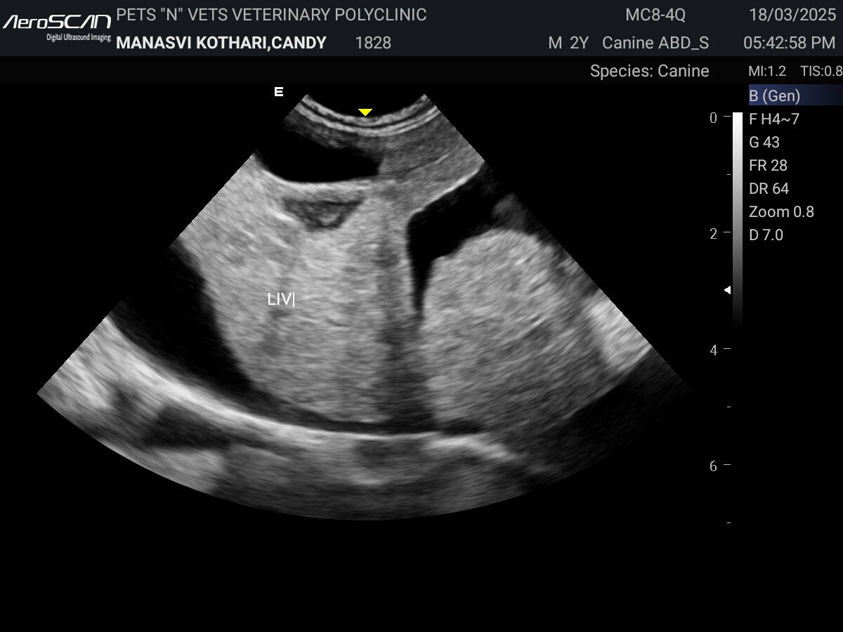

Figure 01: Ultrasonogram showing hyperechoic echogenicity of liver parenchyma with rounding of liver edges suggestive of hepatomegaly with accumulation of anechoic fluid

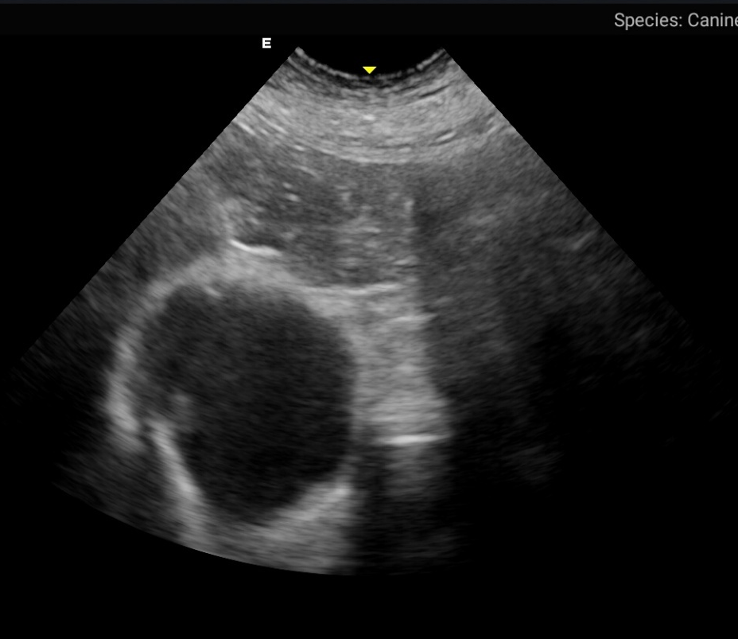

Figure 02: Ultrasonogram showing hypoechoic to hyperechoic echogenicity of the liver parenchyma with cholecystitis

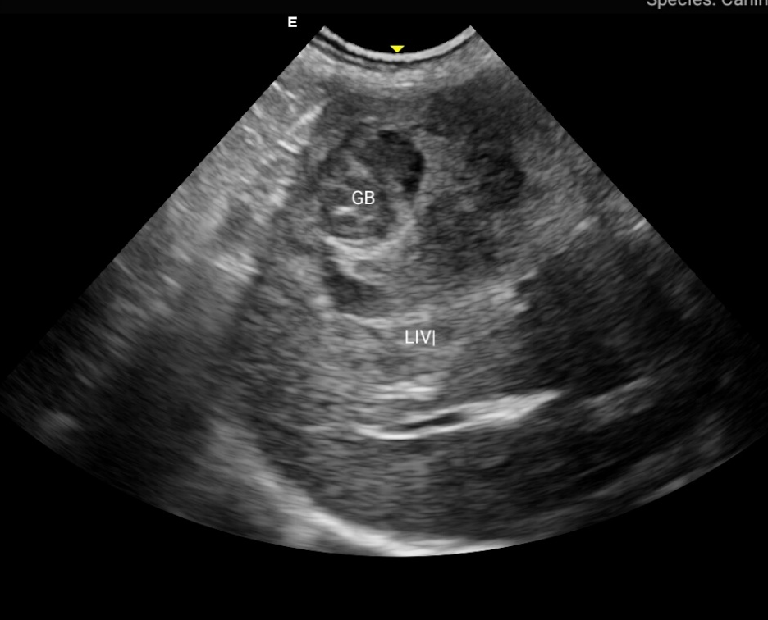

Figure 03: Ultrasonogram showing mixed echogenicity of liver parenchyma

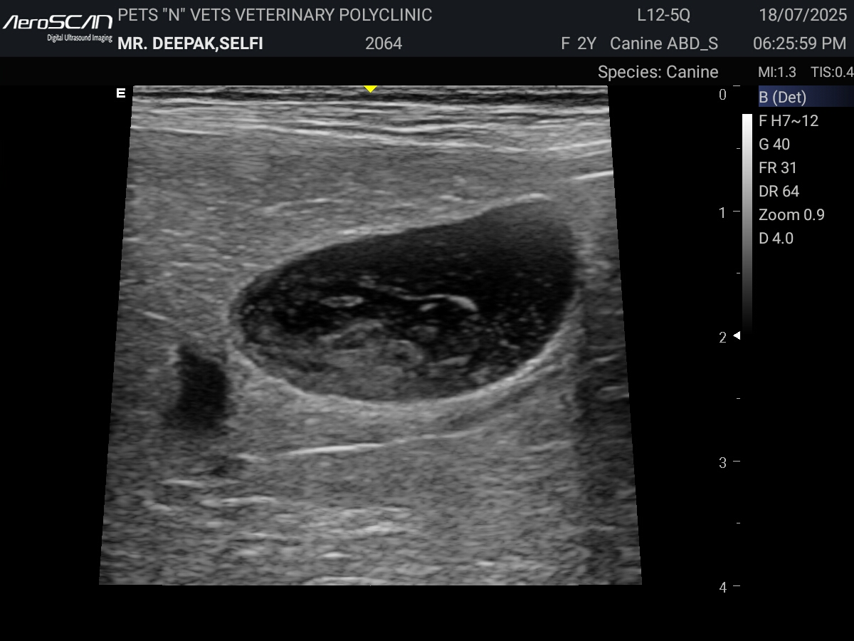

Figure 04: Ultrasonogram showing hyperechoic echogenicity of liver parenchyma with distinct gall bladder sludge

4. CONCLUSION
The present investigation demonstrated that hepatitis is a frequently encountered hepatic disorder among dogs presented to the Veterinary Clinical Complex, with an overall occurrence of 24.23%, highlighting its clinical importance in routine veterinary practice. Younger dogs, particularly those below four years of age, exhibited a significantly higher occurrence, while variations related to breed and sex were statistically non-significant, suggesting the influence of multiple host and environmental factors rather than inherent predisposition. Most affected dogs were presented within a short duration of illness and commonly exhibited nonspecific yet consistent clinical manifestations such as vomiting, weakness, anorexia, jaundice and polyuria–polydipsia, reflecting the systemic consequences of hepatic dysfunction. Ultrasonographic evaluation revealed characteristic changes including hepatomegaly, irregular liver margins, altered parenchymal echogenicity and ascites, underscoring the diagnostic value of ultrasonography as a reliable, non-invasive adjunct to clinical examination. The findings emphasize the necessity of early clinical assessment and incorporation of imaging techniques for timely diagnosis and effective management of hepatitis in dogs. The study provides valuable region-specific epidemiological, clinical and ultrasonographic data that can assist clinicians in improving diagnostic accuracy and therapeutic decision-making. Future studies should focus on advanced diagnostic biomarkers, etiological confirmation and long-term follow-up to better understand disease progression and develop preventive strategies to reduce the burden of canine hepatitis.
Consent
Informed consent was obtained from all owners before participation in the study.
Ethical Approval
All procedures involving animals in this study were conducted in accordance with the ethical standards of the Institutional Animal Ethics Committee (IAEC) of [Nanaji Deshmukh Veterinary Science University, NDVSU], following national and international guidelines for the care and use of animals in research. Prior approval for the study was obtained from the IAEC (Approval No.: [33/IAEC/Vety/2025]). Clinical examinations, sample collections and ultrasonographic evaluations were performed with minimal discomfort to the animals.

CONFLICT OF INTEREST
The authors declare that there are no conflicts of interest regarding the publication of this article.

Disclaimer (Artificial intelligence)

Author(s) hereby declare that NO generative AI technologies such as Large Language Models (ChatGPT, COPILOT, etc.) and text-to-image generators have been used during the writing or editing of this manuscript.

REFFERENCE
Agnihotri D, Singh Y and Sharma A. 2019. Clinical occurrence and therapeutic management of infectious canine hepatitis in dogs. Indian Journal of Canine Practice 11 (2): 17–21.
Bera A. 2016. Studies on liver disorders in dogs and therapy with special reference to herbal component (Cajanus cajan). M.V.Sc. thesis (Veterinary Medicine, Ethics and Jurisprudence), West Bengal University of Animal and Fishery Sciences, Kolkata.
Bhatt S. 2021. Therapeutic efficacy of Ocimum sanctum and Tinospora cordifolia for acute hepatitis in young dogs. M.V.Sc. thesis (Veterinary Medicine), Nanaji Deshmukh Veterinary Science University, Jabalpur.
Bhavya U. 2023. Clinico-diagnostic studies and therapeutic management of ascites with hepatic involvement in dogs. M.V.Sc. thesis (Veterinary Medicine), Sri Venkateswara Veterinary University, Tirupati.
Center S A. 2019. Diagnostic and therapeutic approach to hepatobiliary disease. Veterinary Clinics of North America: Small Animal Practice 36 (3): 543–580.
Center S A, Sharp N J and Marks S L. 2023. Hepatic disease in dogs and cats: pathophysiology and clinical manifestations. Veterinary Clinics of North America: Small Animal Practice 53 (2): 235–254.
Chohan A S, Bansal B K, Randhawa C S and Dhaliwal P S. 2007. Liver dysfunctions in dogs. Indian Veterinary Journal 84: 1042–1044.
Dixit P, Varshney J P, Dixit A K and Shukla P C. 2010. Liver disease in dog: a prospective study. Intas Polivet 11 (2): 360–365.
Dirksen K, Burgener L A, Rothuizen J, Van den Ingh T S G A M, Penning L C, Spee B and Fieten H. 2017. Sensitivity and specificity of plasma ALT, ALP and bile acids for hepatitis in Labrador Retrievers. Journal of Veterinary Internal Medicine 31 (4): 1017–1027.
Favier R P. 2009. Idiopathic hepatitis and cirrhosis in dogs. Veterinary Clinics of North America: Small Animal Practice 39 (3): 481–488.
Gori E, Pinna S and Mandrioli L. 2021. Hepatic lead and copper concentrations in dogs with primary hepatitis: prevalence and clinical impact. Journal of Veterinary Internal Medicine 35 (5): 2110–2118.
Greene C E. 2012. Infectious canine hepatitis. In: Greene C E (ed.). Infectious Diseases of the Dog and Cat, 4th Edn., Elsevier Saunders, St. Louis, pp 42–48.
Hiblu M A M. 2015. Clinico-pathological and therapeutic studies on hepatic insufficiency in dogs. Ph.D. thesis (Veterinary Medicine), Guru Angad Dev Veterinary and Animal Sciences University, Ludhiana.
Jeena A. 2019. Diagnosis and clinico-therapeutic studies on canine hepatic dysfunction. M.V.Sc. and A.H. thesis (Veterinary Medicine), G.B. Pant University of Agriculture and Technology, Pantnagar.
Kilpatrick S, Dreistadt M, Frowde P, Powell R, Milne E, Smith S, Morrison L, Gow A G, Handel I and Mellanby R J. 2016. Presence of systemic inflammatory response syndrome predicts a poor clinical outcome in dogs with a primary hepatitis. PLoS One 11 (1): e0146560.
Kumar S. 2024. Comparative study on diagnostic importance of hepatic markers and therapeutic efficacy in hepatic insufficiency. M.V.Sc. thesis (Veterinary Medicine), Karnataka Veterinary, Animal and Fisheries Sciences University, Bidar.
Lakshmi K, Padmaja K and Madhuri D. 2023. Acute hepatitis in dogs – a histopathological study. Journal of Animal Research 13 (5): 855–858.
Lamb C R. 1995. Abdominal ultrasonography in small animals. In: Goddard P J (ed.). Veterinary Ultrasonography, CAB International, Wallingford, UK, pp 21–54.
Lester C, Cooper J, Peters R M and Webster C R. 2016. Retrospective evaluation of acute liver failure in dogs (1995–2012), 49 cases. Journal of Veterinary Emergency and Critical Care 26 (4): 559–567.
Mahor B S, Tiwari A, Pratap A, Pathak S K, Singh B, Jatav R S, Rakesh S and Singh S. 2023. Epidemiology and clinical abnormalities of hepatitis in dogs. The Pharma Innovation Journal 12 (5): 659–662.
Meyer H P and Rothuizen J. 2013. History and physical examination: liver. In: Washabau R J and Day M J (eds.). Canine and Feline Gastroenterology, Elsevier Health Sciences, St. Louis, Missouri, pp 856–863.
Nyland T G, Mattoon J S and Herrgesell E J. 2002. Liver. In: Nyland T G and Mattoon J S (eds.). Small Animal Diagnostic Ultrasound, W.B. Saunders, Philadelphia, Pennsylvania, pp 93–127.
Pandya P B, Vagh A A, Joseph J P, Bilwal A K and Parmar V L. 2022. Assessment of hepatobiliary ultrasound score with haemato-biochemical alterations in dogs with hepatobiliary dysfunction. The Pharma Innovation Journal 12 (5): 659–662.
Patel D M, Joshi B P, Parmar J J and Modi C M. 2023. Clinical and haemato-biochemical evaluation of dogs suffering from hepatic dysfunction. The Indian Journal of Veterinary Sciences and Biotechnology 19 (1): 45–49.
Patel M D, Parikh P V and Barot H M. 2022. Clinical, ultrasonographic and haemato-biochemical assessment of liver and gall bladder affections in dogs. The Indian Journal of Veterinary Sciences and Biotechnology 18 (1): 66.
Poldervaart J H, Favier R P, Penning L C, Van den Ingh T S G A M and Rothuizen J. 2009. Primary hepatitis in dogs: a retrospective review (2002–2006). Journal of Veterinary Internal Medicine 23 (1): 72–80.
Resende C, Lessa A and Goldenberg R C. 2011. Ultrasonic imaging in liver disease: from bench to bedside. Ultrasound Imaging Medical Applications 131: 131–132.
Sagar S. 2025. Comprehensive review of hepatitis in canines: etiology, pathogenesis, diagnosis, treatment and management. International Journal of Advanced Biochemistry Research 9 (12): 427–432.
Segev G and Cowgill L D. 2021. Hepatic disorders in dogs and cats: diagnosis and therapy. Israel Journal of Veterinary Medicine 76 (2): 81–89.
Singh R, Kumar A, Saxena A C and Tiwari A. 2022. Clinical evaluation of dogs affected with hepatic disorders. Indian Journal of Veterinary Medicine 42 (1): 37–41.
Sumathi D, Prathaban S, Selvaraj P, Dhanapalan P, Murali Manohar B and Kumanan K. 2017. Two-dimensional and three-dimensional ultrasonographic study of hepatobiliary disorders in dogs and their etiological pattern. Indian Journal of Veterinary Medicine 37 (1–2): 1–8.
Tantary H A, Soodan J S, Chirag S, Ansari M M, Kumar S and Imtiyaz T. 2014. Diagnostic studies in dogs with hepatic disorders. International Journal of Veterinary Science 3 (4): 210–215.
Thompson D J. 1984. A practitioner’s approach to canine cardiology. British Veterinary Journal 140 (2): 138.
Verma A, Tripathi A K, Singh S, Panigrahi P N and Bhatt S. 2024. Evaluation of therapeutic efficacy of Moringa oleifera leaves on acute liver failure in dogs. Journal of Animal Research 14 (2): 139–145.
Verma P, Arora N, Mrigesh M, Singh A K, Kalita J C and Prasad A. 2022. Prevalence, clinical manifestations and etiology of canine hepatic dysfunction in and around Pantnagar. Indian Journal of Animal Health 62 (1): 88–94.
Watson P J. 2018. Liver diseases in dogs: investigations and treatment. In Practice 40 (2): 47–58.

