Novel Artificial Diet Formulations on Colony Strength of Apis mellifera During Floral Dearth in Pantnagar, Uttarakhand, India

Abstract
Several protein-rich dietary items, including defatted soy flour, parched gram, brewer's yeast, sucrose, skimmed milk powder, natural pollen and sugar, glucose, honey, Vitamin B, and Vitamin C, were combined to create eight diet formulations. These diets were administered to colonies of Apis mellifera at the Honey Bee Research and Training Centre in Pantnagar, during a time of dearth in the rainy season. The quantification of food consumption by bees was conducted at regular intervals of 5 days. The most favourable outcomes were achieved with a dietary composition consisting of Soya Bari flour, Pollen, Skimmed milk powder, Honey, and Dry yeast, with an average intake of 65.98 g per colony, sealed brood (3374.56 cm² per colony) and maximum bee population (15329 bees per colony) in dry form of diet while in patty form of the same composition maximum consumption of (34.06 gm per colony), sealed brood (3114.42 cm² per colony) and maximum bee population of(14278.92 bees per colony) was observed. The colonies consumed prepared diet in July and August, a period that lacked natural pollen. The study demonstrates a link between protein source quality and the physiological well-being of honey bees. These findings suggest that strategic nutritional supplementation is a critical variable in successful colony management and population expansion.
Keywords: Apis mellifera, Soya Bari flour, Diets, Pollen
Introduction
The honeybee (Apis mellifera) is the most significant managed pollinator globally, underpinning the reproductive success of numerous wild plant species and the yield of high-value agricultural crops (Gallai et al., 2009). Despite their ecological importance, honeybee colonies are currently facing a multifactorial decline driven by habitat loss, pesticide exposure, and emerging pathogens (Goulson et al., 2015). At the centre of these stressors lies nutritional stress. The conversion of diverse landscapes into monocultures has created a sort of "floral deserts" where bees lack access to the diverse pollen sources which are required to satisfy their physiological needs like essential amino acids and lipids (Brodschneider & Crailsheim, 2010; Wright et al., 2018). In the absence of natural forage, beekeepers rely on pollen supplements or substitutes. Despite their importance, the global variety of specialized protein feeds is quite limited, and many of these products have yet to achieve widespread international availability (Güneşdoğdu et al., 2024). Pollen is the sole source of protein for honeybees, and its absence triggers a reduction in vitellogenin titers, a key glycol-lipoprotein that regulates honeybee longevity and nursing behaviour (Amdam et al., 2003). Optimal honey bee health and reproduction require a balanced intake of macronutrients—specifically carbohydrates, amino acids, and lipids—supplemented by essential vitamins, minerals, and hydration (Nicolson, 2011). Bees require carbohydrates as their dietary requirements in which glucose is used as energy source and remaining excess is stored as fats (Hrassnigg and Crailsheim, 2005; Naveen et al., 2024). To maintain colony vigour (Huang, 2010) during these critical windows, the development of an effective artificial "pollen substitute" is essential. The beekeeping industry has prioritized the advancement of pollen substitutes to enhance colony output through targeted protein supplementation. These artificial diets are particularly vital during the winter-to-spring transition; by compensating for the lack of natural forage, they stimulate early brood rearing and support the development of robust offspring (Zahra and Talal, 2008). However, creating a diet that honeybees will readily consume and successfully metabolize remains a significant challenge in apicultural science.
This experimental research aims to study and evaluate different dietary formulations on bee colonies during periods of nectar scarcity. This is important due to two main reasons viz availability of a good source of food for bees during dearth period to aid beekeepers during lean season when honey production is almost nil and maintaining a good colony strength is essential. As the land availability is decreasing, so is the availability of flora for pollen availability. There is a need to formulate alternatives to sustain optimum bee strength both for economic aspects of beekeepers and ecological reasons.
Methodology:
The experiment was conducted during the dearth period of July to August at Modern Bee Research and Training centre, Pantnagar to evaluate colony performance under forage scarcity. Eighteen nutritional treatments were prepared using varying ratios of soy bari and parched gram, which were sieved to a fine mesh to mimic pollen grain size and rested for 3–4 hours as per the ratios described in table 1. Colony with no supplement served as the control. Equal amount 100 gm of each combination were taken as one treatment. Half of the treatments are fed as in dry form(powder) and other half treatments are used in patty form. Super chambers are placed on the selected colonies to facilitate the meeting and to protect the feed from moisture and other factors. Feed is placed on the top of the frames inside the hive by placing it on the butter paper above the
polythene sheet. Quantity of given pollen substitute were recorded initially and after five days and difference were calculated to find the fed quantity of pollen substitute by bees. The brood area in the colonies was recorded with the help of wire grid method (Seeley and Mikhetev, 2003; Amir and Peveling, 2004). The bee population in the colonies were recorded by photographic method (Jeffree,1951). The experimental design used is Randomised Block Design(RBD). The data was tabulated, transformed and statistically analysed by two-way ANOVA. Means were compared using critical differences(CD) at 0.05 % level of significance.
Table 1: Percent constituents in each diet.
Diet No. | Form | Soya Bari Flour | Parched Gram | Brewer Yeast | Sugar | Sucrose | Pollen | Glucose | Honey | Skimmed Milk Powder | Vit B | Vit C
Diet 1 | Powder | 33.4 | — | 16.7 | 30.3 | 11.7 | 7.72 | — | — | — | 0.18 | —
Diet 2 | Powder | 33.4 | — | 16.7 | 30.3 | 11.7 | 7.72 | — | — | — | — | 0.18
Diet 3 | Powder | 33.4 | — | 16.7 | 30.3 | 11.7 | 7.9 | — | — | — | — | —
Diet 4 | Powder | 33.4 | — | 16.7 | — | — | 7.9 | — | 30.3 | 11.7 | — | —
Diet 5 | Powder | — | 33.4 | 16.7 | 30.3 | 11.7 | 7.72 | — | — | — | 0.18 | —
Diet 6 | Powder | — | 33.4 | 16.7 | 30.3 | 11.7 | 7.72 | — | — | — | — | 0.18
Diet 7 | Powder | — | 33.4 | 16.7 | 30.3 | 11.7 | 7.9 | — | — | — | — | —
Diet 8 | Powder | — | 33.4 | 16.7 | — | — | 7.9 | — | 30.3 | 11.7 | — | —
Diet 9 | Powder | 16.7 | 16.7 | 16.7 | 33.3 | — | — | 16.7 | — | — | — | —
Diet 10 | Patty | 33.4 | — | 16.7 | 30.3 | 11.7 | 7.72 | — | — | — | 0.18 | —
Diet 11 | Patty | 33.4 | — | 16.7 | 30.3 | 11.7 | 7.72 | — | — | — | — | 0.18
Diet 12 | Patty | 33.4 | — | 16.7 | 30.3 | 11.7 | 7.9 | — | — | — | — | —
Diet 13 | Patty | 33.4 | — | 16.7 | — | — | 7.9 | — | 30.3 | 11.7 | — | —
Diet 14 | Patty | — | 33.4 | 16.7 | 30.3 | 11.7 | 7.72 | — | — | — | 0.18 | —
Diet 15 | Patty | — | 33.4 | 16.7 | 30.3 | 11.7 | 7.72 | — | — | — | — | 0.18
Diet 16 | Patty | — | 33.4 | 16.7 | 30.3 | 11.7 | 7.9 | — | — | — | — | —
Diet 17 | Patty | — | 33.4 | 16.7 | — | — | 7.9 | — | 30.3 | 11.7 | — | —
Diet 18 | Patty | 16.7 | 16.7 | 16.7 | 33.3 | — | — | 16.7 | — | — | — | —

Fig 1- Patty Diet Fig2- Powdered Diet
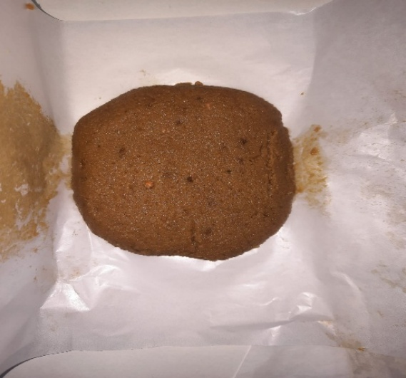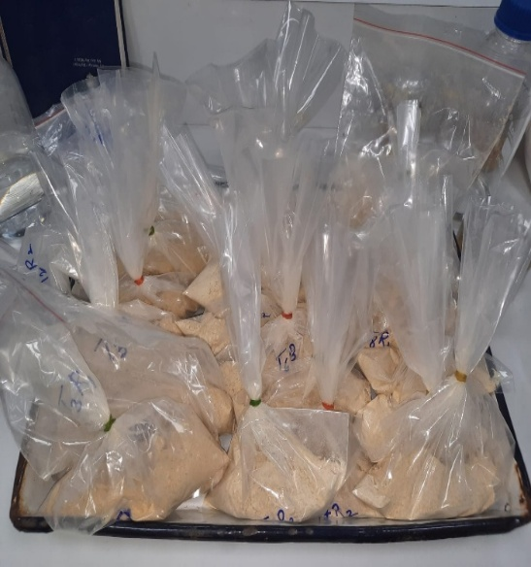

Fig 3- Powdered Diet consumed by bees Fig 4- Patty Diet consumed by bees

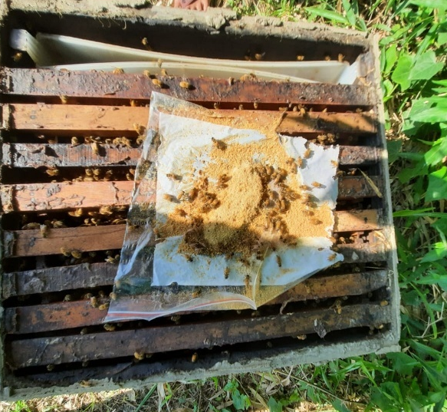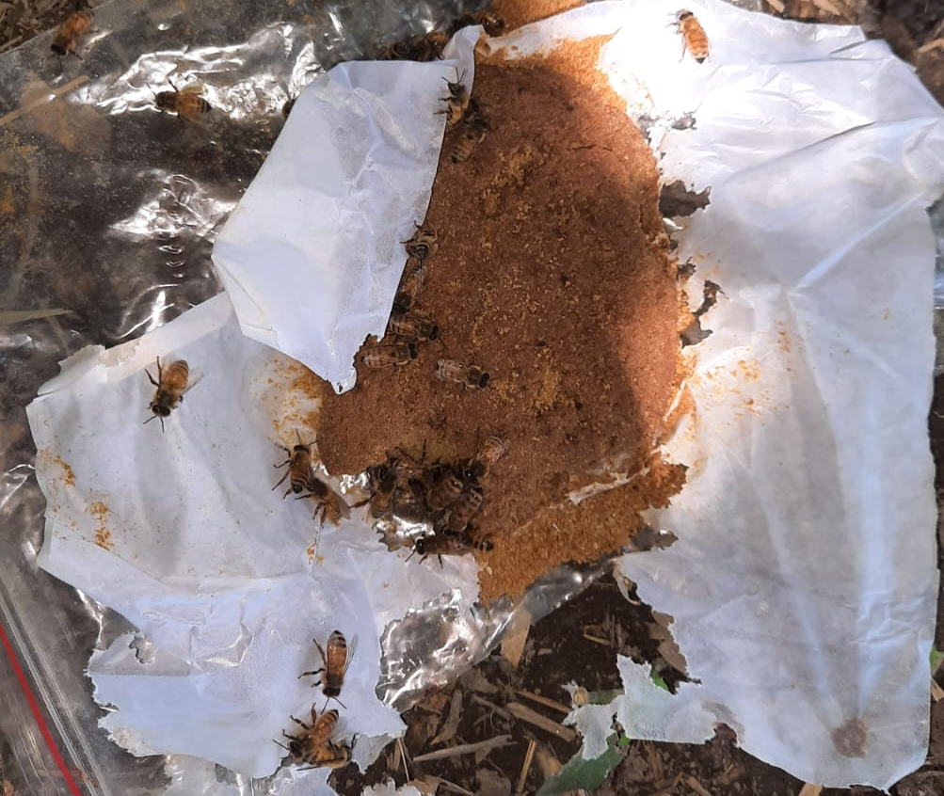

Fig 5- Colony strength and Brood area measurement by Grid method

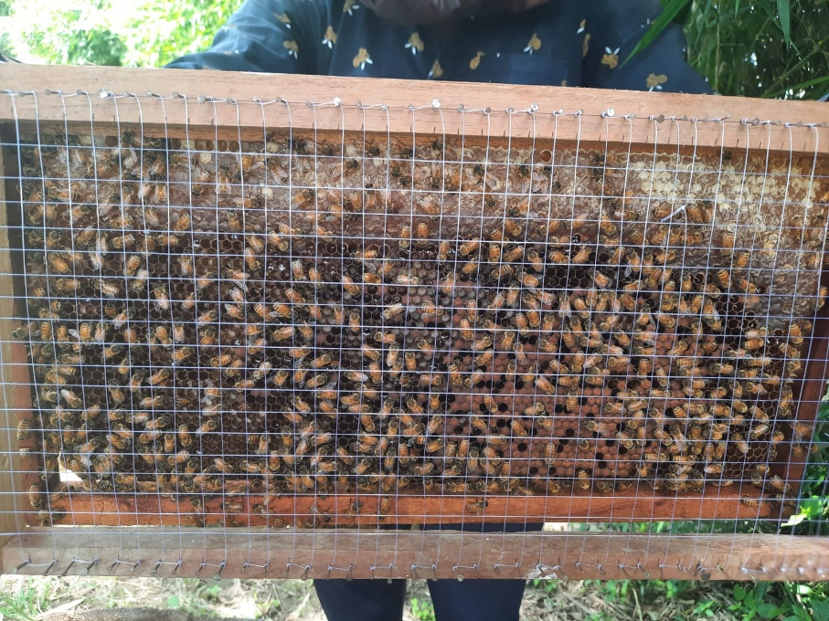

Table 2 Evaluation of mean brood cell area of colony enriched with vitamins and minerals (dry form)
Mean Brood cell area (cm²)
Interval | Diet 1 | Diet 2 | Diet 3 | Diet 4 | Diet 5 | Diet 6 | Diet 7 | Diet 8 | Diet 9 | Control
3rd July | 2389.59  (49.56) | 2486.64  (49.87) | 2214.63  (47.06) | 3149.47  (56.12) | 1695.75  (41.19) | 1893.67  (43.52) | 1298.65  (36.04) | 2661.41  (51.59) | 849.77  (29.16) | 456.21  (21.38)
8th July | 2413.84  (49.90) | 2591.19  (50.91) | 2286.21  (47.82) | 3187.32  (56.46) | 1736.26  (41.68) | 1941.05  (44.06) | 1342.46  (36.65) | 2748.77  (52.43) | 874.89  (29.59) | 516.31  (22.74)
13th July | 2455.87  (50.35) | 2599.93  (50.99) | 2299.22  (47.96) | 3215.07  (56.70) | 1799.87  (42.43) | 1966.51  (44.35) | 1386.93  (37.25) | 2778.84  (52.72) | 976.9  (31.27) | 645.51  (25.42)
18th July | 2489.68  (50.46) | 2681.99  (51.79) | 2310.97  (48.08) | 3233.68  (56.86) | 1817.48  (42.64) | 2005.08  (44.78) | 1424.84  (37.75) | 2857.98  (53.46) | 989.97  (31.47) | 714.71  (26.75)
23rd July | 2534.96  (50.54) | 2789.9  (52.82) | 2346.46  (48.44) | 3275.36  (57.23) | 1848.82  (43.00) | 2019.01  (44.94) | 1458.35  (38.20) | 2896.98  (53.83) | 1015.47  (31.88) | 789.97  (28.12)
28th July | 2546.37  (50.89) | 2855.5  (53.44) | 2385.63  (48.84) | 3326.78  (57.67) | 1915.85  (43.78) | 2096.09  (45.79) | 1535.06  (39.18) | 2946.87  (54.29) | 1065.98  (32.66) | 868.67  (29.49)
2nd Aug | 2554.32  (51.08) | 2879.6  (53.67) | 2401.19  (49.00) | 3399.08  (58.30) | 1976.36  (44.46) | 2117.05  (46.01) | 1597.93  (39.98) | 3078.84  (55.49) | 1123.98  (33.54) | 888.81  (29.82)
7th Aug | 2589.23  (51.72) | 2912.34  (53.97) | 2435.05  (49.35) | 3446.87  (58.71) | 2016.85  (44.91) | 2147.25  (46.34) | 1636.39  (40.46) | 3167.57  (56.29) | 1178.46  (34.34) | 891.97  (29.88)
12th Aug | 2609.04  (51.86) | 2943.85  (54.26) | 2469.01  (49.69) | 3514.56  (59.28) | 2064.08  (45.43) | 2187.95  (46.78) | 1674.96  (40.93) | 3197.64  (56.55) | 1234.95  (35.15) | 941.91  (30.70)
17th Aug | 2674.96  (51.94) | 2967.06  (54.47) | 2487.04  (49.87) | 3543.76  (59.53) | 2095.49  (45.78) | 2213.89  (47.06) | 1714.84  (41.41) | 3245.76  (56.97) | 1296.57  (36.02) | 963.71  (31.05)
22nd Aug | 2689.59  (52.04) | 2997.05  (54.75) | 2499.03  (50.00) | 3587.94  (59.90) | 2147.57  (46.35) | 2247.87  (47.42) | 1789.68  (42.31) | 3308.87  (57.52) | 1355.98  (36.83) | 989.04  (31.46)
27th Aug | 2697.5  (52.60) | 3024.89  (55.00) | 2503.4  (50.03) | 3614.87  (60.13) | 2168.9  (46.58) | 2278.96  (47.74) | 1825.85  (42.74) | 3374.38  (58.09) | 1406.978  (37.52) | 993.03  (31.52)
Mean | 2553.746 | 2810.828 | 2386.487 | 3374.563 | 1940.273 | 2092.865 | 1557.162 | 3021.993 | 1114.158 | 804.9875
CD at 5% T (Treatment) 0.26
I (Period) 0.29
T× I (Treatment× Period) 0.92

Figures in parentheses are log transformed values.

Table 3 Evaluation of mean brood cell area of colony enriched with vitamins and minerals (patty form)
Mean Brood cell area (cm²)
Interval | Diet 10 | Diet 11 | Diet 12 | Diet 13 | Diet 14 | Diet 15 | Diet 16 | Diet 17 | Diet 18 | Control
3rd July | 1846.74  (42.98) | 2135.15  (46.21) | 1587.81  (39.85) | 2886.86  (53.73) | 1658.33  (40.73) | 1733.61  (41.64) | 1456.06  (38.16) | 2776.19  (52.69) | 703.99  (26.55) | 456.21  (21.38)
8th July | 1859.19  (43.13) | 2177.70  (46.67) | 1615.84  (40.21) | 2897.98  (53.83) | 1699.3  (41.23) | 1752.96  (41.87) | 1521.84  (39.02) | 2894.17  (53.79) | 739.17  (27.20) | 516.31  (22.74)
13th July | 1896.91  (43.56) | 2197.71  (46.88) | 1656.96  (40.71) | 2931.12  (54.14) | 1710.09  (41.36) | 1785.76  (42.27) | 1548.248  (39.36) | 2919.94  (54.04) | 786.76  (28.06) | 645.51  (25.42)
18th July | 1941.20  (44.06) | 2209.05  (47.00) | 1697.41  (41.21) | 2977.97  (54.57) | 1746.19  (41.79) | 1804.17  (42.48) | 1560.454  (39.51) | 2974.84  (54.54) | 809.81  (28.47) | 714.71  (26.75)
23rd July | 1987.71  (44.59) | 2233.83  (47.27) | 1737.05  (41.68) | 3103.01  (55.71) | 1763.17  (42.00) | 1854.07  (43.07) | 1611.381  (40.15) | 2998.87  (54.76) | 836.77  (28.94) | 789.97  (28.12)
28th July | 2010.91  (44.85) | 2261.97  (47.56) | 1783.00  (42.23) | 3137.98  (56.02) | 1792.21  (42.34) | 1893.54  (43.52) | 1616.56  (40.21) | 3027.65  (55.03) | 879.03  (29.66) | 868.67  (29.49)
2nd Aug | 2079.88  (45.60) | 2286.43  (47.82) | 1829.51  (42.78) | 3157.95  (56.20) | 1811.37  (42.57) | 1935.61  (44.00) | 1670.355  (40.88) | 3059.64  (55.32) | 910.87  (30.19) | 888.81  (29.82)
7th Aug | 2097.99  (45.81) | 2311.37  (48.08) | 1877.69  (43.34) | 3189.76  (56.48) | 1861.15  (43.14) | 1988.67  (44.60) | 1699.94  (41.23) | 3137.43  (56.02) | 956.67  (30.94) | 891.97  (29.88)
12th Aug | 2156.05  (46.43) | 2339.11  (48.37) | 1926.07  (43.895) | 3215.56  (56.71) | 1887.69  (43.45) | 2017.73  (44.92) | 1725.96  (41.55) | 3148.97  (56.11) | 978.65  (31.29) | 941.91  (30.70)
17th Aug | 2186.56  (46.77) | 2368.13  (48.67) | 1968.48  (44.37) | 3249.6  (57.01) | 1923.96  (43.87) | 2045.06  (45.23) | 1748.05  (41.81) | 3189.65  (56.48) | 1017.73  (31.91) | 963.71  (31.05)
22nd Aug | 2224.06  (47.17) | 2394.74  (48.94) | 1994.96  (44.67) | 3296.08  (57.41) | 1956.63  (44.24) | 2097.48  (45.80) | 1778.47  (42.17) | 3248.67  (57.00) | 1096.83  (33.13) | 989.04  (31.46)
27th Aug | 2279.67  (47.75) | 2451.81  (49.51) | 2079.65  (45.61) | 3329.16  (57.70) | 1997.58  (44.70) | 2143.96  (46.31) | 1789.64  (42.31) | 3265.09  (57.14) | 1145.58  (33.85) | 993.03  (31.52)
Mean | 2047.24 | 2280.58 | 1812.87 | 3114.42 | 1817.31 | 1921.05 | 1643.91 | 3053.43 | 905.16 | 804.9875
CD at 5% T (Treatment) 0.25
I (Period) 0.29
T× I (Treatment ×Period) 0.89

Figures in parentheses are log transformed values.

Table 4 Evaluation of mean strength of colony enriched with vitamins and minerals (dry form)

Mean Strength of colony (numbers)
Interval | Diet 1 | Diet 2 | Diet 3 | Diet 4 | Diet 5 | Diet 6 | Diet 7 | Diet 8 | Diet 9 | control
3rd July | 11746.00  (108.37) | 12071.00  (109.85) | 10622.00  (103.06) | 15175.00  (123.18) | 8752.00  (93.54) | 9126.00  (95.53) | 7742.00  (87.99) | 13475.00  (116.07) | 6410.00  (80.05) | 5552.00  (74.51)
8th July | 11792.00  (108.59) | 12110.00  (110.04) | 10689.00  (103.38) | 15199.00  (123.28) | 8788.00  (93.74) | 9210.00  (95.96) | 7789.00  (88.24) | 13489.00  (116.13) | 6422.00  (80.14) | 5610.00  (74.90)
13th July | 11806.00  (108.65) | 12174.00  (110.33) | 10710.00  (103.48) | 15210.00  (123.31) | 8801.00  (93.81) | 9234.00  (96.08) | 7810.00  (88.37) | 13507.00  (116.20) | 6436.00  (80.22) | 5623.00  (74.99)
18th July | 11832.00  (108.77) | 12121.00  (110.09) | 10735.00  (103.60) | 15245.00  (123.46) | 8825.00  (93.94) | 9246.00  (96.16) | 7825.00  (88.46) | 13527.00  (116.29) | 6465.00  (80.40) | 5652.00  (75.18)
23rd July | 11856.00  (108.88) | 12189.00  (110.40) | 10758.00  (103.71) | 15274.00  (123.59) | 8836.00  (93.99) | 9275.00  (96.30) | 7845.00  (88.56) | 13545.00  (116.36) | 6479.00  (80.49) | 5671.00  (75.31)
28th July | 11895.00  (109.05) | 12209.00  (110.48) | 10796.00  (103.89) | 15289.00  (123.65) | 8875.00  (94.21) | 9298.00  (96.42) | 7861.00  (88.66) | 13580.00  (116.53) | 6497.00  (80.6) | 5689.00  (75.42)
2nd Aug | 11910.00  (109.12) | 12231.00  (110.59) | 10805.00  (103.94) | 15332.00  (123.81) | 8910.00  (94.39) | 9331.00  (96.59) | 7891.00  (88.83) | 13621.00  (116.70) | 6510.00  (80.68) | 5732.00  (75.71)
7th Aug | 11936.00  (109.24) | 12287.00  (110.84) | 10836.00  (104.10) | 15374.00  (123.99) | 8935.00  (94.53) | 9352.00  (96.70) | 7911.00  (88.93) | 13648.00  (116.82) | 6536.00  (80.85) | 5754.00  (75.85)
12th Aug | 11955.00  (109.33) | 12313.00  (110.96) | 10867.00  (104.24) | 15410.00  (124.14) | 8942.00  (94.56) | 9388.00  (96.88) | 7939.00  (89.10) | 13696.00  (117.02) | 6569.00  (81.04) | 5774.00  (75.99)
17th Aug | 11976.00  (109.42) | 12313.00  (110.95) | 10922.00  (104.51) | 15456.00  (124.32) | 8965.00  (94.68) | 9410.00  (96.99) | 7945.00  (89.13) | 13727.00  (117.15) | 6591.00  (81.18) | 5819.00  (76.28)
22nd Aug | 11976.00  (109.43) | 12379.00  (111.25) | 10967.00  (104.72) | 15478.00  (124.39) | 8987.00  (94.80) | 9455.00  (97.22) | 7997.00  (89.43) | 13729.00  (117.15) | 6623.00  (81.38) | 5856.00  (76.52)
27th Aug | 12017.00  (109.60) | 12481.00  (111.70) | 10997.00  (104.86) | 15511.00  (124.54) | 9005.00  (94.88) | 9498.00  (97.46) | 8038.00  (89.65) | 13824.00  (117.57) | 6654.00  (81.57) | 5889.00  (76.73)
Mean | 11891.42 | 12239.83 | 10808.67 | 15329.42 | 8885.08 | 9318.58 | 7882.75 | 13614.00 | 6516.00 | 5718.42
CD at 5% T (Treatment) 0.68
I (Period) 0.74
T× I (Treatment Period) N/A

Figures in parentheses are log transformed values.

Table 5 Evaluation of mean strength of colony enriched with vitamins and minerals (patty form)
Mean Strength of colony (numbers)
Interval | Diet 10 | Diet 11 | Diet 12 | Diet 13 | Diet 14 | Diet 15 | Diet 16 | Diet 17 | Diet 18 | control
3rd July | 10271.50  (101.34) | 11023.00  (104.99) | 9225.00  (96.03) | 14104.00  (118.75) | 7632.00  (87.36) | 8812.00  (93.87) | 7104.00  (84.28) | 12576.00  (112.14) | 6512.00  (80.69) | 5552.00  (74.51)
8th July | 10319.75  (101.58) | 11067.00  (105.19) | 9289.00  (96.37) | 14135.00  (118.89) | 7681.00  (87.63) | 8839.00  (94.02) | 7122.00  (84.39) | 12619.00  (112.33) | 6529.00  (80.80) | 5610.00  (74.90)
13th July | 10379.00  (101.87) | 11048.00  (32.38) | 9330.00  (96.59) | 14166.00  (119.02) | 7714.00  (87.83) | 8849.00  (94.06) | 7154.00  (84.58) | 12648.00  (112.46) | 6567.00  (81.04) | 5623.00  (74.99)
18th July | 10423.75  (102.10) | 11056.00  (105.15) | 9388.00  (96.88) | 14199.00  (119.15) | 7764.00  (88.11) | 8859.00  (94.11) | 7189.00  (84.78) | 12697.00  (112.68) | 6619.00  (81.36) | 5652.00  (75.18)
23rd July | 10466.00  (102.29) | 11089.00  (105.30) | 9421.00  (97.06) | 14215.00  (119.21) | 7789.00  (88.26) | 8889.00  (94.28) | 7224.00  (84.99) | 12742.00  (112.88) | 6673.00  (81.68) | 5671.00  (75.31)
28th July | 10499.00  (102.45) | 11110.00  (105.40) | 9498.00  (97.45) | 14264.00  (119.43) | 7799.00  (88.31) | 8910.00  (94.39) | 7256.00  (85.18) | 12786.00  (113.07) | 6725.00  (82.00) | 5689.00  (75.42)
2nd Aug | 10500.00  (102.47) | 11135.00  (105.52) | 9526.00  (97.60) | 14289.00  (119.52) | 7816.00  (88.41) | 8924.00  (94.46) | 7296.00  (85.42) | 12821.00  (113.21) | 6735.00  (82.07) | 5732.00  (75.71)
7th Aug | 10557.00  (102.75) | 11168.00  (105.68) | 9586.00  (97.90) | 14309.00  (119.62) | 7832.00  (88.50) | 8939.00  (94.53) | 7346.00  (85.71) | 12858.00  (113.38) | 6769.00  (82.27) | 5754.00  (75.85)
12th Aug | 10587.00  (102.89) | 11191.00  (105.78) | 9623.00  (98.10) | 14356.00  (119.81) | 7894.00  (88.85) | 8950.00  (94.59) | 7367.00  (85.83) | 12898.00  (113.57) | 6811.00  (82.53) | 5774.00  (75.99)
17th Aug | 10616.00  (103.03) | 11231.00  (105.97) | 9677.00  (98.36) | 14396.00  (119.98) | 7923.00  (89.01) | 8972.00  (94.72) | 7418.00  (86.12) | 12928.00  (113.70) | 6849.00  (82.76) | 5819.00  (76.28)
22nd Aug | 10672.00  (103.31) | 11272.00  (106.17) | 9716.00  (98.56) | 14427.00  (120.10) | 7987.00  (89.37) | 8998.00  (94.86) | 7489.00  (86.53) | 12976.00  (113.91) | 6891.00  (83.00) | 5856.00  (76.52)
27th Aug | 10714.00  (103.51) | 11298.00  (106.29) | 9749.00  (98.72) | 14487.00  (120.36) | 8016.00  (89.53) | 9002.00  (94.88) | 7529.00  (86.76) | 13064.00  (114.29) | 6913.00  (83.14) | 5889.00  (76.73)
Mean | 10500.42 | 10307.33 | 9502.33 | 14278.92 | 7820.58 | 8911.92 | 7291.17 | 12801.08 | 6716.08 | 5718.42
CD at 5% T (Treatment) 0.57
I (Period) 0.66
T× I (Treatment× Period) 2.00
Figures in parentheses are log transformed values.

Table 6 Quantity of feed consumed in different time intervals of various diets (dry form).
Feeding interval | Qt. given | Diet 1 | Diet 2 | Diet 3 | Diet 4 | Diet 5 | Diet 6 | Diet 7 | Diet 8 | Diet 9
3rd July | 100 | 25.37  (5.13) | 39.04  (6.32) | 41.30  (6.50) | 79.14  (8.95) | 28.84  (5.46) | 23.94  (4.99) | 40.94  (6.47) | 69.80  (8.41) | 11.54  (3.54)
8th July | 100 | 59.70  (7.79) | 72.84  (8.59) | 44.34  (6.73) | 87.27  (9.39) | 55.37  (7.50) | 54.92  (7.47) | 34.20  (5.93) | 73.94  (8.65) | 33.84  (5.90)
13th July | 100 | 24.79  (5.07) | 41.23  (6.49) | 40.71  (6.45) | 50.86  (7.20) | 49.78  (7.12) | 34.80  (5.98) | 23.87  (4.98) | 48.80  (7.05) | 8.70  (3.11)
18th July | 100 | 65.86  (8.17) | 30.18  (5.58) | 55.76  (7.53) | 54.37  (7.44) | 36.86  (6.15) | 45.80  (6.84) | 21.76  (4.77) | 51.73  (7.26) | 10.47  (3.38)
23rd July | 100 | 20.78  (4.66) | 31.74  (5.72) | 8.76  (3.12) | 43.87  (6.69) | 30.54  (5.61) | 39.76  (6.38) | 37.66  (6.21) | 43.87  (6.69) | 21.46  (4.73)
28th July | 100 | 49.76  (7.12) | 49.76  (7.12) | 38.79  (6.30) | 68.70  (8.34) | 21.71  (4.76) | 20.86  (4.67) | 19.84  (4.56) | 60.43  (7.83) | 9.86  (3.29)
2nd Aug | 100 | 60.76  (7.85) | 38.76  (6.30) | 50.49  (7.17) | 65.98  (8.18) | 11.78  (3.57) | 14.76  (3.96) | 19.17  (4.49) | 62.71  (7.98) | 22.79  (4.87)
7th Aug | 100 | 39.04  (6.32) | 64.79  (8.11) | 48.76  (7.05) | 79.46  (8.96) | 26.48  (5.24) | 25.86  (5.18) | 14.86  (3.98) | 70.87  (8.47) | 24.81  (5.08)
12th Aug | 100 | 21.76  (4.77) | 48.76  (7.05) | 47.85  (6.98) | 72.86  (8.59) | 20.79  (4.66) | 11.79  (3.57) | 28.84  (5.46) | 70.41  (8.45) | 6.76  (2.78)
17th Aug | 100 | 50.86  (7.20) | 66.76  (8.23) | 21.86  (4.78) | 60.50  (7.84) | 8.76  (3.12) | 10.40  (3.37) | 6.76  (2.78) | 55.87  (7.54) | 5.70  (2.58)
22nd Aug | 100 | 9.76  (3.28) | 68.79  (8.35) | 19.16  (4.48) | 48.06  (7.00) | 14.89  (3.98) | 17.89  (4.34) | 11.44  (3.52) | 40.77  (6.46) | 25.97  (5.19)
27th Aug | 100 | 41.79  (6.54) | 49.71  (7.12) | 37.87  (6.23) | 80.70  (9.03) | 31.75  (5.72) | 16.79  (4.21) | 10.76  (3.42) | 49.79  (7.12) | 14.76  (3.96)
Mean | 100 | 39.19 | 50.19 | 37.97 | 65.98 | 28.12 | 26.46 | 22.50 | 58.24 | 16.38
CD at 5% T (Treatment) 0.03
I (Period) 0.04
T× I (Treatment× Period) 0.12

Figures in parentheses are log transformed values.

Table 7 Quantity of feed consumed in different time intervals of various diets (patty form).
Feeding interval | Qt. given | Diet 10 | Diet 11 | Diet 12 | Diet 13 | Diet 14 | Diet 15 | Diet 16 | Diet 17 | Diet 18
3rd July | 100 | 20.77  (4.66) | 9.50  (3.24) | 22.40  (4.83) | 49.84  (7.13) | 6.14  (2.67) | 30.17  (5.54) | 26.37  (5.23) | 7.30  (2.88) | 7.87  (2.97)
8th July | 100 | 20.04  (4.58) | 57.17 (7.62) | 38.80  (6.30) | 48.17  (7.01) | 35.90  (6.07) | 31.97  (5.68) | 73.00  (8.60) | 56.97  7.613 | 28.84  5.463
13th July | 100 | 39.1  (6.33) | 41.46 (6.51) | 41.80  (6.54) | 31.06  (5.66) | 10.11  (3.33) | 41.86  (6.54) | 30.09  (5.57) | 19.48  (4.52) | 6.76  (2.78)
18th July | 100 | 48  (7.00) | 39.76 (6.38) | 41.76  (6.53) | 14.17  (3.89) | 14.86  3.982 | 31.18  (5.57) | 14.19  (3.89) | 31.79  (5.72) | 4.76  (2.4)
23rd July | 100 | 38.76  (6.33) | 38.89 (6.31) | 39.00  (6.32) | 25.86  (5.18) | 21.80  (4.77) | 19.17  (4.18) | 15.00  (4) | 24.86  (5.08) | 8.49  (3.08)
28th July | 100 | 29.06  (5.48) | 12.71 (3.70) | 38.76  (6.30) | 39.76  (6.38) | 22.79  (4.87) | 14.71  (3.74) | 18.79  (4.44) | 23.79  (4.97) | 5.46  (2.54)
2nd Aug | 100 | 19.66  (4.54) | 36.18 (6.09) | 30.86  (5.64) | 41.70  (6.53) | 28.80  (5.45) | 11.78  (3.49) | 18.07  (4.36) | 20.79  (4.66) | 19.76  (4.55)
7th Aug | 100 | 8.71  (3.11) | 24.98 (5.09) | 12.01  (3.60) | 43.86  (6.69) | 29.18  (5.49) | 10.00  (3.31) | 22.76  (4.87) | 19.86  (4.56) | 14.01  (3.87)
12th Aug | 100 | 10.11  (3.33) | 21.79 (4.77) | 10.76  (3.42) | 40.00  (6.40) | 30.71  (5.63) | 9.04  (3.16) | 24.89  (5.08) | 17.49  (4.3) | 10.09  (3.33)
17th Aug | 100 | 14.86  (3.98) | 25.84 (5.18) | 15.86  (4.10) | 38.71  (6.30) | 41.00  (6.48) | 12.81  (3.70) | 31.72  (5.72) | 25.46  (5.14) | 4.76  (2.4)
22nd Aug | 100 | 15.86  (4.11) | 10.00 (3.31) | 18.71  (4.44) | 9.76  (3.28) | 18.71  (4.44) | 20.86  (4.65) | 3.86  (2.20) | 21.96  (4.79) | 2.30  (1.81)
27th Aug | 100 | 18.71  (4.44) | 18.91 (4.46) | 9.76  (3.28) | 25.78  (5.17) | 31.48  (5.69) | 31.81  (5.65) | 12.96  (3.73) | 48.71  (7.05) | 7.60  (2.93)
Mean | 100 | 23.63 | 28.10 | 26.71 | 34.06 | 24.29 | 22.11 | 24.31 | 26.54 | 10.06
CD at 5% T (Treatment) 0.15
I (Period) 0.18
T× I (Treatment ×Period) 0.54

Figures in parentheses are log transformed values.

Results and Discussion
Results obtained in dry form of pollen substitute diet revealed that maximum consumption was observed in case of Diet 4 having Soya Bari flour 33.4 gm+ Pollen 7.9 gm+ Skimmed milk powder 11.7 gm + Honey 30.3 gm + Dry yeast 16.7 gm (65.98 gm per colony). The amount of consumption of Diet 8 having Parched gram 33.4 gm+ Pollen 7.9 gm+ Skimmed milk powder 11.7 gm+ Honey 30.3+ Dried Yeast 16.7 gm (58.24 gm per colony) was next followed by Diet 2 and Diet 1 values being 49.53 and 39.18 gm per colony respectively. Consumption of Diet 9 was significantly lowest i.e., 16.38 gm than all the other pollen substitute diets in dry form. The quality and effect of a particular diet form can be determined by its consumption pattern (Kim et al 2024). Güneşdoğdu and Buluş (2025) reported that dry diets supplemented with brewer's yeast were preferred by bees.
Likewise in patty form of pollen substitute diet, results revealed that maximum consumption was observed in case of Diet 13 (34.06 gm per colony). The amount of consumption of Diet 11 (28.10 gm per colony) was next followed by Diet 17 and Diet 12 values being 26.74 and 26.71gm per colony respectively. Consumption of Diet 18 was significantly lowest i.e., 10.06 gm than all the other pollen substitute diets in patty form. The current findings mirror those of several previous researchers who have explored supplemental feeding in apiculture (Wahl, 1963; Forster, 1966, 1968; Stanger & Gripp, 1972; Alexandru et al., 1977). Similarly, our results align with more recent observations by Ericsson and Herbert (1980), Silva (1985), Farooqui (1986), DeGrandi-Hoffman et al. (2008), and Sihag (2011). Research by Islam et al. (2020) and Aly et al. (2014) noted a wide range in weekly bee cake consumption, with recorded averages of 384.9 g, 49.53 g, 71.90 g, and 47.42 g per colony. Further studies highlight how ingredients influence these rates: Amro et al.(2019) found that cakes made with brewer’s yeast were the most frequently consumed, while Taha (2015) observed that bees showed a strongest preference for mixtures containing honey and pollen.
This research provides a detailed look at how bee colonies react to different protein-based diets. It evaluates success through several key metrics, including how much the bees eat, their honey output, the size of the brood area, and overall growth in the colony's population. In dry form of pollen supplement diet, the maximum amount (3374.56 cm² per colony) of sealed brood was observed in colonies given Diet 4. This value was stastistally at par with the sealed brood area (3021.99 cm² per colony) in the colonies fed on diet 8. Minimum sealed brood area (804.98 cm² per colony) was observed in control colonies. In patty form of pollen substitute diet, the maximum amount (3114.42 cm² per colony) of sealed brood was observed in colonies given Diet 13. This value was stastistally at par with the sealed brood area (3053.43 cm² per colony) in the colonies fed on diet 17. The results of this study demonstrate that colonies fed artificial diets produced significantly more brood than the control group. These findings align with previous research that observed increased brood rearing when bees were provided with pollen supplements or substitutes (Chhuneja et al.1993, Nabors 2000, Castagnino et al. 2004, Saffari et al. 2010, and Sihag and Gupta 2011).
Results from the dry form of pollen substitute diet revealed that the maximum bee population (15329 bees per colony) was observed in the colonies given Diet 4 which was statistically at par, to the colonies fed Diet 8 i.e.,13614 bees per colony. Similarly, from the patty form of pollen substitute diet, the maximum bee population (14278.92 bees per colony) was observed in the colonies given Diet 13 which was statistically at par, to the colonies fed Diet 17 i.e.,12801 bees per colony. Bee population was recorded to be minimum (5718.42 bees per colony) in the control colonies. The findings of this investigation indicate that supplementing diets with pollen or its extracts significantly boosts bee populations. These results are consistent with prior research by Peng et al. (1984), DeGrandi-Hoffman et al. (2008), Saffari et al. (2010), and Sihag et al. (2011), all of whom noted that colonies receiving artificial diets maintained substantially larger populations than unfed control groups. Also pollen plays an essential role in determining lifespan and colony strength of bees (Gregory, 2006).
Conclusion
The study confirms that nutritional intervention is important for maintaining colony vigor during the Pantnagar floral dearth, a dry blend of Soya Bari flour, Pollen, Skimmed milk powder, Honey, and Dry yeast emerging as the effective diet formulation. By significantly outperforming both the control and patty-based formulations, this specific dry diet led to a robust physiological response, resulting in a peak bee population of 15,329 and a superior sealed brood area of 3374.56 cm². For beekeeping farmers in the Tarai region and similar climates, the key takeaway is moving away from simple sugar-water feeding toward a complex protein substitute—specifically one utilizing Soya Bari and yeast—is essential. By adopting the Diet formulation, beekeepers can ensure their colonies emerge from the monsoon season not just survivors, but strong, populous units ready for the succeeding honey flow.

Disclaimer (Artificial intelligence)

Author(s) hereby declare that NO generative AI technologies such as Large Language Models (ChatGPT, COPILOT, etc.) and text-to-image generators have been used during the writing or editing of this manuscript.

References
Alexandru, V., Nicolaide, N., & Matache, G. (1977). Research on the biological value of some protein substitutes for pollen. Apicultura, 2, 5–8.
Aly, M.Z.Y.; Osman, K.S.M.; Mohanny, K.M.; Elsayeh,W.A. (2014). New formula of pollen supplemental diet to study honey bee (Apis mellifera carnica) attractiveness. Egyptian Academic Journal of Biological Sciences, 7, 47–55.
Amdam, G. V., Simões, Z. L. P., Guidugli, K. R., Norberg, K., & Omholt, S. W. (2003). Hormonal control of honey bee germ-line differentiation and longevity. Nature, 424(6944), 63–66.
Amir, A. M., & Peveling, R. (2004). Effect of dietary protein on the development of the hypopharyngeal glands of the honeybee (Apis mellifera L.). Journal of Apicultural Research, 43(4), 185–188.
Amro, A.M.; Younis, M.S.; Ghania, A.A. (2019). Physiological effects of some pollen substitutes diet on caged honey bee workers Apis mellifera (Hymenoptera: Apidae). Egypt. J. Plant Prot. Res. Inst. 2, 741–750.
Brodschneider, R., & Crailsheim, K. (2010). Nutrition and health in honey bees. Apidologie, 41(3), 278–294.
Castagnino, G. L. B., Message, D., Monteiro, A. S., & Guedes, R. N. C. (2004). Protéicos de substituição para a abelha Apis mellifera L. (Hymenoptera: Apidae). Revista Ceres, 51, 211–220.
Chhuneja, P. K., Brar, H. S., & Goyal, N. P. (1993). Studies on some pollen substitutes for Apis mellifera L. Indian Bee Journal, 55(3-4), 17–25.
DeGrandi-Hoffman, G., Wardell, G., Ahumada-Segura, F., Rinderer, T., Frakes, R., & Foster, S. (2008). Comparisons of pollen substitute diets for honey bees: Consumption rates by colonies and effects on brood rearing and adult survivor ship. Journal of Apicultural Research, 47(4), 265–270.
Ericsson, J. M., & Herbert, E. W. (1980). Development of a pollen substitute for honey bees. American Bee Journal, 120(2), 122–123.
Farooqui, T. M. (1986). Studies on the nutritional requirements of Apis mellifera L. [Doctoral dissertation]. G.B. Pant University of Agriculture and Technology, Pantnagar, India.
Forster, I. W. (1966). Pollen supplements for honey bees. New Zealand Journal of Agricultural Research, 9, 590–597.
Forster, I. W. (1968). Further studies on pollen supplements and substitutes for honey bees. New Zealand Journal of Agricultural Research, 11, 657–664.
Gallai, N., Salles, J. M., Settele, J., & Vaissière, B. E. (2009). Economic valuation of the vulnerability of world agriculture confronted with pollinator decline. Ecological Economics, 68(3), 810–821.
Goulson, D., Nicholls, E., Botías, C., & Rotheray, E. L. (2015). Bee declines driven by combined stress from parasites, pesticides, and lack of flowers. Science, 347(6229), 1255957.
Gregory, P. G. (2006). Protein diets and their effects on worker weight, longevity, consumption and hemolymph protein levels of Apis mellifera. Proceedings of the American Bee Research Conference.
Güneşdoğdu, M., & Buluş, İ. Y. (2025). Honeybee preferences for pollen substitute diets: A climatic perspective. In IV. International Congress of the Turkish Journal of Agriculture – Food Science and Technology (pp. 117–121), Niğde, Türkiye.
Güneşdoğdu, M., Şekeroğlu, A., & Abacı, S. H. (2025). Effects of homemade diets on Apis mellifera caucasica: Body weight and colony productivity. Bee Studies, 17(1), 9–17. http://doi.org/10.51458/BSTD.2025.45
Güneşdoğdu, M.; Sarıoğlu-Bozkurt, A.; Şekeroğlu, A.; Abacı, S. H. (2024). Changes in vitellogenin, abdominal lipid content, and hypopharyngeal gland development in honey bees fed diets with different protein sources. Insects, 15, 215. https://doi.org/10.3390/insects15040215
Hrassnigg, N.; Crailsheim, K. (2005). Differences in drone and worker physiology in honeybees (Apis mellifera L.). Apidologie, 36,255–277.
Huang, Z. (2010).Honey bee nutrition. American Bee Journal., 150, 773–776.
Islam, N.; Mahmood, R.; Sarwar, G.; Ahmad, S.; Abid, S. (2020) Development of pollen substitute diet for Apis mellifera ligustica colonies and their impact on brood development and honey production. Pakistan Journal of Agricultural Research, 33, 381–388.
Jeffree, E. P. (1951). A photographic method of recording breeding and settling areas in the honeybee colony. Annual Review of Applied Biology, 38(1), 253–256.
Kim, H.; Frunze, O.; Maigoro, A.Y.; Lee, M.L.; Lee, J.H.; Know, H.W (2024). Comparative study of the effect of pollen substitute diets on honey bees during early spring. Insects, 15, 101.
Kumar, R., Mishra, R. C., & Agrawal, O. P. (2013). A study on consumption of some artificial diet formulations by Apis mellifera colonies. Journal of Entomological Research, 37(2), 143–146.
Nabors, R. (2000). The effects of spring feeding on honey bee colonies. American Bee Journal, 140(3), 221–223.
Nicolson, S.W. (2011). Bee food: The chemistry and nutritional value of nectar, pollen and mixtures of the two. Afr. Zool., 46,197–204.
Peng, Y. S., Nasr, M. E., Marston, J. M., & Fang, Y. (1984). The effects of pollen substitutes on the development of the honeybee (Apis mellifera L.). Journal of Apicultural Research, 23(3), 125–131.
Ricigliano, V. A., Mott, B. M., Floyd, A. S., Copeland, D. C., Carroll, M. J., & Anderson, K. E. (2017). Nutri-epigenetics and longevity in honey bees. Current Opinion in Insect Science, 22, 144–154.
Saffari, A., Kevan, P. G., & Atkinson, J. L. (2010). A comparative study of three artificial protein diets for honey bees. Journal of Apicultural Research, 49(2), 193–198.
Schmidt, J. O., Thoenes, S. C., & Levin, M. D. (1987). Survival of honey bees, Apis mellifera (Hymenoptera: Apidae), fed various pollen sources. Annals of the Entomological Society of America, 80(2), 176–183.
Seeley, T. D., & Mikheyev, A. S. (2003). Reproductive decisions by honey bee colonies: Tuning investment in male production in relation to colony size. Behavioral Ecology and Sociobiology, 54(1), 19–27.
Sihag, R. C., & Gupta, M. (2011). Development of an artificial pollen substitute for the honeybee Apis mellifera L. Journal of Apicultural Science, 55(2), 25–35.
Silva, I. C. (1985). Effect of protein supplements on honey bee colony performance. [Master’s thesis]. University of California, Davis.
Stanger, W., & Gripp, H. (1972). Protein feeding of honey bees. American Bee Journal, 112, 296–297.
Wahl, O. (1963). Analysis of the biological value of different pollen and pollen substitutes for the honey bee. Zeitschrift für Bienenforschung, 6(8), 209–272.
Wright, G. A., Nicolson, S. W., & Shafir, S. (2018). The nutritional ecology of pollinating insects. Annual Review of Entomology, 63, 41–67.
Zahra, A., & Talal, M. (2008). Impact of pollen supplements and vitamins on the development of hypopharyngeal glands and brood area in honey bees. Journal of Apiculture Science, 52(2), 5–12.
Naveen, Yadav, A. S., Singh, U., & Tomar, S. (2024). Consumption of Different Artificial Diets by Apis mellifera L. Colonies During Dearth Period in Morena, M.P., India. UTTAR PRADESH JOURNAL OF ZOOLOGY, 45(15), 379–386. https://doi.org/10.56557/upjoz/2024/v45i154254

