Original Research Article
Endophytic entomopathogenic fungi: A potential tool for biological control of fall armyworm in maize

ABSTRACT
Aims: To evaluate the lethal and sublethal effects of maize-derived fungal endophytes on Spodoptera frugiperda and assess their potential as sustainable biological control agents based on larval survival, feeding performance, growth, and developmental parameters.
Study Design: Laboratory-based experimental study conducted in a completely randomized design.
Place and Duration of Study: Maize Research Center, Agricultural Research Institute (ARI), Rajendranagar, Hyderabad, Telangana, India, during 2024-2025 under controlled laboratory conditions.
Methodology: Fungal endophytes were isolated from maize stem samples collected across Telangana using a modified surface sterilization protocol. Bioefficacy was evaluated through leaf bioassays using second-instar larvae of S. frugiperda. Each treatment consisted of three replications with 10 larvae per replication (n = 30). Parameters recorded included larval mortality, relative growth rate (RGR), efficiency of conversion of ingested food (ECI), feeding deterrence index (FDI), larval and pupal developmental periods, pupation, and adult emergence. Biochemical characterization of isolates was carried out for plant growth-promoting traits. Molecular identification of the most effective isolate was performed using ITS rDNA sequencing.
Results: Marked differences were observed among fungal isolates. ESF-8 recorded the highest larval mortality (61.40 ± 0.57%), lowest RGR (0.152 ± 0.001), lowest ECI (12.04 ± 0.51%), and highest feeding deterrence (38.94 ± 2.80%). It also prolonged larval (17.13 ± 1.18 days) and pupal periods (8.60 ± 0.49 days), and reduced pupation (55.56 ± 7.59%) and adult emergence (57.86 ± 3.24%). Biochemical analysis revealed high indole-3-acetic acid production (13.19 µg ml⁻¹) along with multiple growth-promoting traits. ITS sequencing identified ESF-8 as Talaromyces verruculosus (GenBank Accession No. PV876225).
Conclusion: Maize-associated fungal endophytes, particularly T. verruculosus, demonstrated strong potential for incorporation into sustainable fall armyworm management programs, warranting further validation under field conditions.
Keywords:
Spodoptera frugiperda, fungal endophytes, Talaromyces verruculosus, sublethal effects, feeding efficiency, developmental duration

- INTRODUCTION
Maize (Zea mays L.) is among the most versatile cereal crops globally, valued for its broad adaptability, high genetic yield potential, and diverse applications as food, feed, and industrial raw material. In India, maize ranks third after rice and wheat, contributing nearly 10% to total food grain production and serving as a critical input for starch, oil, ethanol, and biofuel industries (APEDA, 2019; Swati et al., 2024; Togola et al., 2025). Despite its economic and strategic importance, maize productivity is increasingly threatened by biotic stresses, particularly insect pests, whose incidence and severity are strongly modulated by agroecological and climatic factors.
Among the emerging pest challenges, the fall armyworm (S. frugiperda J.E. Smith; Lepidoptera: Noctuidae) has become one of the most destructive invasive pests of maize worldwide. This highly polyphagous insect attacks more than 80 host plant species and causes severe yield losses across tropical and subtropical regions (Day et al., 2017). In maize, infestations during early crop stages can result in yield losses ranging from 20–70%, depending on pest pressure, crop stage, and environmental conditions (Hruska, 2019; Sisay et al., 2019). The pest damages leaves, whorls, tassels, and ears, leading to reduced photosynthetic efficiency and compromised grain filling. Originally native to the Americas, S. frugiperda spread rapidly to Africa in 2016 and subsequently to Asia and the Indian subcontinent. In India, its first detection in 2018 marked a major shift in maize pest dynamics, with rapid establishment across all major maize-growing regions (Prasanna et al., 2018; Suby et al., 2020). Studies on pest population dynamics have demonstrated that FAW outbreaks are strongly influenced by temperature, rainfall, and cropping patterns, with warmer climates and erratic precipitation favouring rapid population build-up and extended seasonal activity (Anjorin et al., 2021; Yan et al., 2022; Zanzana et al., 2024). Similar climate-driven changes in insect pest population dynamics have been documented across cropping systems, emphasizing the need for resilient and ecologically compatible management strategies (Srinivas et al., 2023; Mir et al., 2024). Current FAW management relies largely on chemical insecticides, including diamides, avermectins, and spinosyns, which are often applied under emergency recommendations. However, the concealed feeding behaviour of FAW larvae within maize whorls significantly limits insecticide contact, while repeated applications have led to resistance development, environmental contamination, and disruption of natural enemy complexes (Koskey et al., 2021; Chandrakumara et al., 2022; Srinivas et al., 2022; Yao et al., 2023). Resistance to multiple insecticide classes and even Bt maize has already been reported from different regions, raising serious concerns about the long-term sustainability of chemical-based control approaches (Prasanna et al., 2018).
In agroecosystems, natural enemies such as predators and parasitoids play a crucial role in regulating herbivore populations and stabilizing pest dynamics. However, intensive pesticide use often disrupts these beneficial arthropods, weakening biological control services and exacerbating pest resurgence. Integrating pest-suppressive microbes with conservation of natural enemies is therefore central to sustainable pest management under changing climatic conditions. In this context, fungal endophytes have emerged as promising biological agents with dual functionality enhancing plant fitness while exerting direct and indirect effects on insect pests. Endophytic fungi colonize internal plant tissues asymptomatically and can influence herbivore performance through the production of bioactive secondary metabolites, alteration of plant nutritional quality, induction of systemic resistance, and modification of plant-insect interactions. Several fungal genera, including Beauveria, Metarhizium, Fusarium, and Trichoderma, have been reported to reduce insect survival, feeding, growth, and reproduction when present as endophytes, offering sustained and systemic pest suppression (Sood et al., 2020; Lanzuise et al., 2022; Waleed et al., 2024). Compared to externally applied entomopathogens, endophytic fungi provide a distinct ecological advantage by persisting within plant tissues, thereby offering prolonged protection against cryptic feeders such as FAW larvae. Moreover, their compatibility with natural enemies and reduced non-target effects make them suitable candidates for integration into ecologically based pest management programs. Despite these advantages, information on maize-associated fungal endophytes and their effects on S. frugiperda under Indian agroecological conditions remains limited.
Therefore, the present study was undertaken to evaluate the effects of maize-derived endophytic fungi on the survival, feeding behaviour, growth, and development of S. frugiperda. By linking endophyte-mediated effects with insect developmental and nutritional parameters, the study aims to generate insights into the potential role of fungal endophytes as eco-friendly, locally adaptable components of integrated fall armyworm management strategies.
- MATERIAL AND METHODS
2.1 Isolation of fungal endophytes
Stem samples collected from various locations across Telangana (Supplementary file) were processed for endophyte isolation following a modified surface sterilization procedure based on Hallmann et al. (1997). Plant tissues were thoroughly cleaned, treated with Tween 80, and sequentially disinfected using 80% ethanol, 4% sodium hypochlorite, and 70% ethanol, with repeated rinsing in sterile distilled water between steps. Fungal endophytes were recovered using both direct tissue plating and tissue homogenization techniques, wherein sterilized internal tissue portions were plated on nutrient agar and tryptic soy agar media. Plates were incubated at 30 ± 2 °C for 24-48 h for fungal growth. The effectiveness of surface sterilization was verified by plating aliquots of the final rinse water, which showed no microbial growth, confirming successful elimination of epiphytic contaminants (Schulz et al., 1998).
2.2 Bioassay of inoculated plants against fall armyworm S. frugiperda
Larvae of S. frugiperda were collected from maize fields at the Maize Research Center, Agricultural Research Institute, Hyderabad, Telangana, and maintained in the laboratory on a Kabuli gram–based semi-synthetic diet under controlled conditions (27 ± 1 °C, 70 ± 5% RH, and 14:10 h L:D photoperiod) following standard rearing procedures (Gopalakrishnan & Kalia, 2022). Emerged adults were housed in cylindrical mating jars (20 × 15 cm) and provided with 10% honey solution, with blotting paper strips supplied as an oviposition substrate. Egg masses were collected daily, and second-instar larvae were used for bioassay studies.
The bioefficacy of maize-derived fungal endophytes against S. frugiperda was evaluated using a leaf bioassay technique. Leaf bits (approximately 1 inch²) were excised from endophyte-inoculated maize plants and untreated control plants at 14 days after inoculation. Bioassays were conducted to assess multiple biological parameters, including larval mortality (%), relative growth rate (RGR), efficiency of conversion of ingested food (ECI), feeding deterrence index (FDI), pupation (%), and adult emergence (%), providing an integrated assessment of lethal and sublethal effects on larval feeding, growth, and development. Each treatment consisted of three replications with 10 larvae per replication. Fresh leaf material was supplied daily, larval mortality was recorded for 10 days, and surviving larvae were individually weighed to evaluate treatment effects on the biological performance of S. frugiperda.
Larval Mortality (%)
$$Mortality (\%)=\frac{Number of dead larvae}{Total number of larvae}×100$$

Relative Growth Rate (RGR)
$$RGR=\frac{W2-W1}{t×W1}$$
Where: W₁ = Initial larval weight (mg); W₂ = Final larval weight (mg); t = Duration of feeding period (days)

Efficiency of Conversion of Ingested Food (ECI)
$$ECI \left(\%\right)=\frac{Weight gain of larva \left(mg\right)}{Food ingested (mg)}×100$$
Feeding Deterrence Index (FDI)
$$FDI (\%)=\frac{C-T}{C+T}×100$$
Where: C = Amount of food consumed in control; T = Amount of food consumed in treatment
Pupation (%)
$$Pupation (\%)=\frac{Number of larvae pupated}{Total number of larvae}×100$$
Adult Emergence (%)
$$Adult Emergence (\%)=\frac{Number of adults emerged}{Total number of pupae}×100$$
2.3 Biochemical and molecular characterisation of fungal endophytes
Plant growth–promoting traits of fungal endophytes were evaluated using a combination of qualitative and quantitative assays. Siderophore production was assayed on Chrome Azurol S (CAS) agar, where the development of yellow to orange zones surrounding bacterial colonies was considered a positive response (Schwyn & Neilands, 1987). Phosphate solubilization ability was assessed on Pikovskaya’s agar medium based on the formation of clear halo zones around colonies (Pikovskaya, 1948). Hydrogen cyanide (HCN) production was detected using glycine-supplemented nutrient agar and alkaline picrate-soaked filter paper following the method of Castric and Castric (1983). Ammonia production was estimated by growing isolates in peptone water and adding Nessler’s reagent as described by Gupta and Pandey (2019). Indole-3-acetic acid (IAA) production was quantified spectrophotometrically at 530 nm after reaction with the Salkowski reagent as described by Gordon and Weber (1951). Protease and amylase activities were determined on agar and starch agar media, respectively, based on visible substrate hydrolysis, while pectinolytic activity was examined on PSAM medium using Gram’s iodine staining following Oumer and Abate (2018). Biochemical characterization of promising isolates, including the indole test, was carried out using standard microbiological procedures outlined by Borkar (2018).
Molecular identification of selected fungal endophytes was performed by amplifying the internal transcribed spacer (ITS) region using a protocol adapted from Lee (1990) with slight modifications. Genomic DNA was isolated using a CTAB-based extraction method, and PCR amplification was carried out in a 25 µL reaction volume employing universal primers ITS-1 (5′-TCCGTAGGTGAACCTGCGG-3′) and ITS-4 (5′-TCCTCCGCTTATTGATATGC-3′). The thermal cycling program included an initial denaturation at 96 °C for 4 min, followed by 35 cycles of denaturation at 94 °C for 40 s, annealing at 57 °C for 1 min, and extension at 72 °C for 80 s, with a final extension step at 72 °C for 10 min. The amplified products (~1.5 kb) were verified by agarose gel electrophoresis and subjected to Sanger sequencing. Resulting sequences were compared with reference sequences in the NCBI GenBank database using the BLAST tool for taxonomic assignment, and validated sequences were subsequently submitted to GenBank.
2.4 Statistical Analysis
The experimental data were analyzed using one-way analysis of variance (ANOVA) in SPSS software (version 22.0; IBM Corp., USA) with a sample size of n = 30. Treatment effects were tested at a 5% level of significance (p ≤ 0.05). When significant differences were detected, Duncan’s Multiple Range Test (DMRT) was applied for post-hoc mean separation
- RESULTS
3.1 Effect of maize-derived fungal endophytes on larval mortality
Larval mortality of S. frugiperda differed significantly among the endophytic fungal treatments (one-way ANOVA; F = 874.80; df = 8; p < 0.05). ESF-8 (61.40±0.57) recorded the highest larval mortality and was significantly superior to all other treatments. The next best treatment was ESF-2 (36.84±0.57), followed by ESF-4 (29.82±0.57), which showed moderate larvicidal activity. In contrast, ESF-5 (12.28±0.57) resulted in the lowest larval mortality among fungal isolates and was comparable to the control (5±0.57), indicating minimal effect (Fig. 1).
3.2 Effect of maize-derived fungal endophytes on the relative growth rate of larvae
A significant effect of endophytic fungal treatments on larval relative growth rate was observed (one-way ANOVA; F = 7.01; df = 8; p < 0.05). Larvae exposed to ESF-8 (0.152±0.001) exhibited a markedly lower RGR compared to all other treatments, indicating pronounced growth inhibition. In contrast, larvae treated with ESF-1 to ESF-7 maintained similar growth rates and did not differ significantly from the control (0.182±0.005) (Fig. 2).
3.3 Effect of maize-derived fungal endophytes on larval ECI and feeding deterrence
Significant variation was observed among endophytic fungal treatments for both ECI (F = 3.79; df = 8; p = 0.009) and FDI (F = 16.72; df = 8; p < 0.05). Among the tested isolates, ESF-8 recorded the lowest ECI (12.04±0.51) and the highest FDI (38.94±2.80), and differed significantly from all other treatments. ESF-1 and ESF-7 exhibited moderate reductions in ECI and intermediate FDI values. In contrast, ESF-4 and ESF-5 showed comparatively higher ECI (13.26±0.22; 13.40±0.71 respectively) and lower FDI (6.63±1.03; 6.07±1.03 respectively) which were statistically comparable to the control (Fig. 3).The remaining isolates produced intermediate responses for both parameters.
3.4 Effect of maize-derived fungal endophytes on larval and pupal developmental periods Larval and pupal developmental periods of S. frugiperda were significantly affected by endophytic fungal treatments (larval period: F = 3.27; df = 8; p = 0.01; pupal period: F = 8.62; df = 8; p < 0.05). Among all treatments, ESF-8 recorded the longest larval (17.13±1.18) and pupal durations (8.60±0.49) and differed significantly from the remaining isolates. ESF-1, ESF-3, ESF-4, and ESF-7 also showed extended larval (14.26±0.75, 13.83±0.49, 13.56±1.41 and 13.83±0.80 respectively) and pupal periods (7.30±0.61, 6.73±0.26, 7.30±0.30 and 6.56±0.29 respectively) but were statistically inferior to ESF-8. In contrast, ESF-5 (11.33±0.86 and 6.33±0.08 respectively) and ESF-6 (12.06±1.35 and 7.30±0.35 respectively) exhibited shorter developmental durations that were comparable to the control (13.76±0.31 and 5.81±0.12 respectively). The remaining isolates produced intermediate effects on both larval and pupal developmental periods, indicating isolate-specific variation in developmental responses (Fig. 4).
3.5 Effect of maize-derived fungal endophytes on pupation and adult emergence
Pupation and adult emergence of S. frugiperda were significantly influenced by endophytic fungal treatments (pupation: F = 4.82; df = 8; p = 0.003; adult emergence: F = 28.13; df = 8; p < 0.05). Among all isolates, ESF-8 recorded the lowest pupation (55.56±7.59) and adult emergence (57.86±3.24) percentages and differed significantly from the remaining treatments. ESF-6 and ESF-7 also showed reduced pupation (88.23±4.33; 89.16±4.79 respectively) and adult emergence (76.96±3.29; 76.10±1.02 respectively) compared to the control (97.10±0.99; 98.38±0.12 respectively) but were statistically inferior to ESF-8. In contrast, ESF-1 (83.30±4.36 and 94.03±2.94), ESF-2 (87.70±7.32 and 92.86±3.71), and ESF-5 (86.73±2.24 and 97.06±2.30) exhibited higher pupation and adult emergence rates that were comparable to the control. The remaining isolates produced intermediate responses, indicating differential effects of endophytic fungi on post-larval development (Fig. 5).
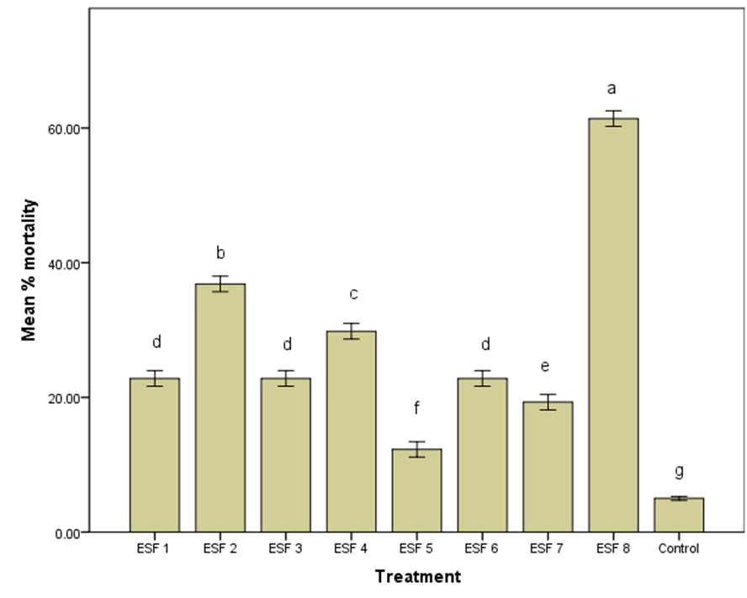
Figure 1. Effect of maize-derived fungal endophytes on larval mortality of S. frugiperda under in vitro conditions (one-way ANOVA, n=30, α = 0.05, DMRT was used for treatment comparison. Different letters indicate significant differences among treatments).

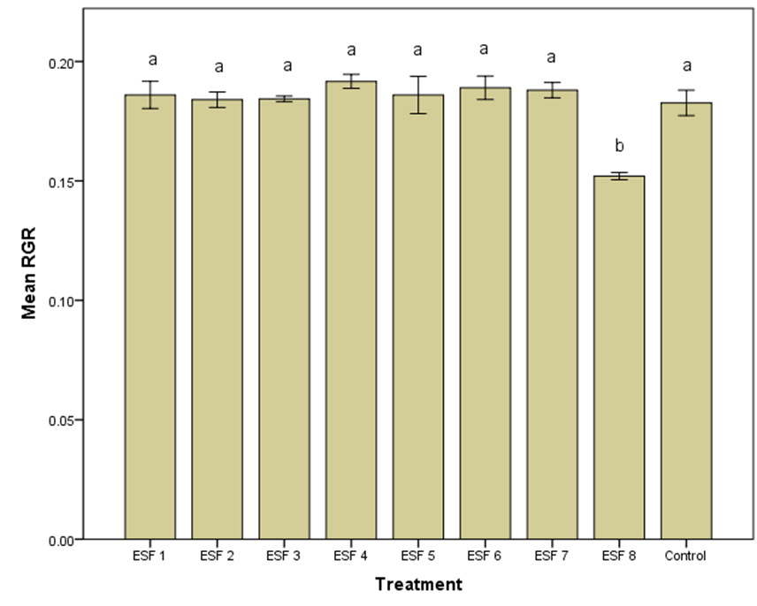
Figure 2. Effect of maize-derived fungal endophytes on relative growth rate (RGR) of S. frugiperda larvae under in vitro conditions (one-way ANOVA, n=30, α = 0.05, DMRT was used for treatment comparison. Different letters indicate significant differences among treatments).

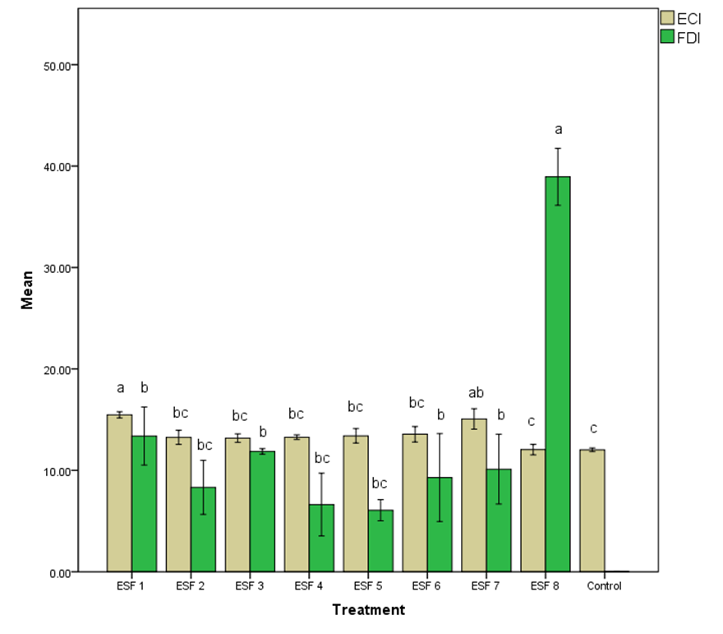
Figure 3. Effect of maize-derived fungal endophytes on S. frugiperda larvae’s Efficiency of Conversion of Ingested food (ECI) and Feeding Deterrence Index (FDI) (one-way ANOVA, n=30, α = 0.05, DMRT was used for treatment comparison. Different letters indicate significant differences among treatments).

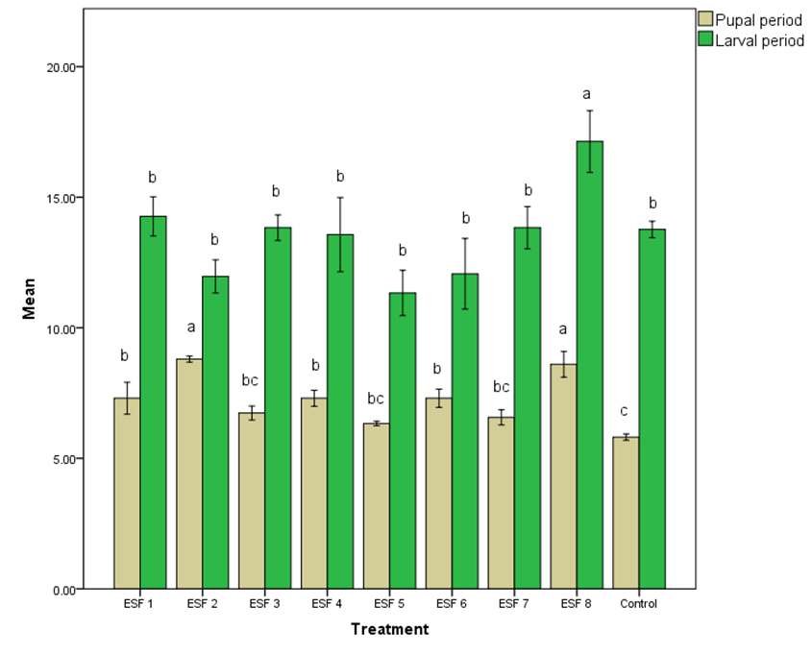
Figure 4. Effect of maize-derived fungal endophytes on larval and pupal developmental periods of S. frugiperda (one-way ANOVA, n=30, α = 0.05, DMRT was used for treatment comparison. Different letters indicate significant differences among treatments).

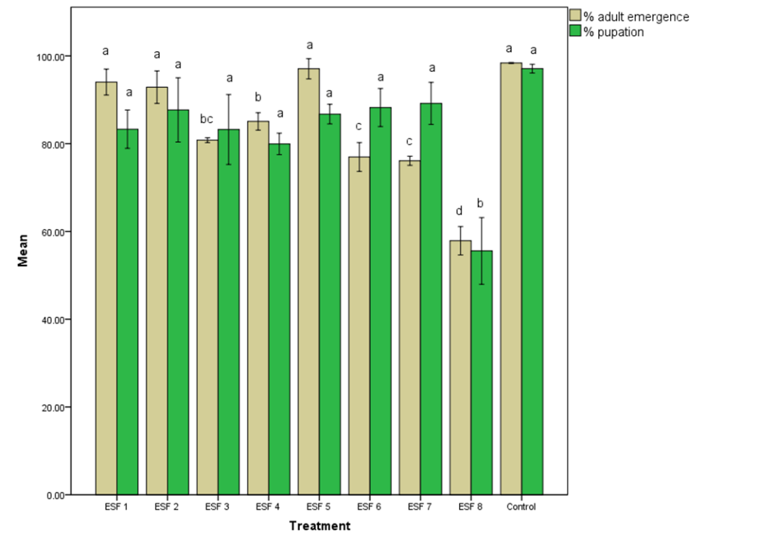
Figure 5. Effect of maize-derived fungal endophytes on pupation and adult emergence of S. frugiperda (one-way ANOVA, n=30, α = 0.05, DMRT was used for treatment comparison. Different letters indicate significant differences among treatments).
3.6 Biochemical and molecular characterisation of fungal endophytes
Considerable variation was observed among fungal endophytic isolates with respect to plant growth–promoting and enzymatic activities. ESF-8 exhibited the highest IAA production (13.19 µg ml⁻¹) along with strong siderophore, HCN, ammonia, phosphate-solubilizing, and pectolytic activities. Moderate IAA production was recorded in ESF-6 (7.37 µg ml⁻¹) and ESF-1 (6.67 µg ml⁻¹), which also expressed multiple biochemical traits. In contrast, ESF-4 and ESF-5 showed the lowest IAA levels and limited biochemical activity. The remaining isolates displayed isolate-specific and partial expression of growth-promoting and hydrolytic traits (Table 1).
Molecular characterization of the most effective endophytic isolate ESF-8, was carried out using ITS sequencing. Sequence analysis revealed that ESF-8 showed a high level of similarity with Talaromyces verruculosus. The nucleotide sequence of ESF-8 was successfully deposited in the NCBI GenBank database under the accession number PV876225, confirming its taxonomic identity as T. verruculosus.
Table 1. Biochemical characterization of bacterial endophytes associated with maize
Isolate ID | 1 | 2 | 3 | 4 | 5 | 6 | 7 | 8
ESF 1 | + | + | - | + | 6.67 | - | + | +
ESF 2 | - | - | + | + | 3.70 | - | + | -
ESF 3 | - | + | - | - | 4.85 | - | - | -
ESF 4 | + | - | - | - | 2.63 | + | - | -
ESF 5 | - | - | + | + | 1.80 | - | - | -
ESF 6 | + | - | + | - | 7.37 | - | - | -
ESF 7 | - | + | - | - | 5.69 | - | - | -
ESF 8 | + | ++ | + | + | 13.19 | ++ | - | -
1. Siderophore production; 2. HCN production; 3. Ammonia production; 4. Phosphate solubilisation; 5. IAA production (μg/ml); 6. Pectolytic activity; 7. Amylolytic activity; 8. Proteolytic activity

- DISCUSSION
The present study demonstrates that maize-derived fungal endophytes exert significant lethal and sublethal effects on S. frugiperda, with clear isolate-specific variation across all measured biological parameters. Among the tested isolates, ESF-8, identified as T. verruculosus, consistently exhibited superior efficacy by inducing high larval mortality, suppressing growth, reducing food utilization efficiency, delaying development, and lowering pupation and adult emergence. Such multi-dimensional impacts suggest that endophytic fungi can influence insect performance beyond acute toxicity, acting through sustained physiological and nutritional stress. The pronounced larval mortality observed under T. verruculosus treatment aligns with earlier reports that endophytic fungi can negatively affect herbivorous insects by producing bioactive secondary metabolites or by altering host plant chemistry (Vega et al., 2008; Jaber & Ownley, 2018).
Unlike externally applied entomopathogens, endophytes persist within plant tissues, enabling continuous exposure of feeding larvae to fungal metabolites, which is particularly relevant for cryptic feeders such as S. frugiperda larvae that remain concealed within maize whorls (Krishnamoorthy et al., 2024). Similar endophyte-mediated reductions in survival of lepidopteran pests have been reported for Beauveria, Metarhizium, and Trichoderma spp. colonizing maize, cotton, and tomato (Bamisile et al., 2018; Panwar et al., 2024; Monica et al., 2024). Because they directly affect pest fitness and population growth potential, the sublethal effects seen in this study-such as decreased relative growth rate, decreased efficiency of conversion of ingested food, and enhanced feeding deterrence-are ecologically significant. Reduced ECI and elevated FDI under T. verruculosus treatment indicate impaired digestion and assimilation of nutrients, likely arising from fungal metabolites that interfere with midgut physiology or modify plant nutritional quality (Krishnamoorthy et al., 2024).
Such effects have been shown to prolong larval development and increase vulnerability to natural enemies, thereby strengthening biological regulation in agroecosystems. The extension of larval and pupal developmental periods and the marked reduction in pupation and adult emergence further highlight the cumulative impact of fungal endophytes on post-larval development. Delayed development is a well-recognized outcome of chronic exposure to sublethal microbial metabolites and is often associated with hormonal imbalance, metabolic disruption, and oxidative stress in insects (Herlinda et al., 2025). From a population dynamics perspective prolonged immature stages and reduced adult emergence can substantially lower intrinsic rates of increase, thereby contributing to long-term pest suppression even in the absence of high immediate mortality.
The biochemical characterization of fungal endophytes revealed that T. verruculosus expressed multiple plant growth-promoting traits, including high IAA production and positive siderophore, phosphate-solubilizing, ammonia, HCN, and pectolytic activities. Such multifunctionality is recognized as a key attribute of effective endophytes, enabling simultaneous enhancement of plant vigor and suppression of herbivores (Manathunga et al., 2024). Improved plant growth and nutritional status may also contribute indirectly to pest resistance through induced systemic responses, further reinforcing the protective role of endophytes. Molecular identification confirmed ESF-8 as T. verruculosus, a genus was reported for the production of biologically active secondary metabolites with antimicrobial and insect-affecting properties.
Although studies on Talaromyces as insect-suppressive endophytes remain limited, related species have been shown to produce polyketides, alkaloids, and enzyme complexes capable of disrupting insect development and feeding (Nicoletti & Trincone, 2016). The present findings therefore expand the functional relevance of Talaromyces spp. in insect pest management, particularly against invasive pests such as S. frugiperda. Importantly, endophytic fungi are generally compatible with predators and parasitoids and pose minimal risk to non-target organisms compared to broad-spectrum insecticides (Vega et al., 2008; Jaber & Ownley, 2018). Given the increasing challenges of insecticide resistance and climate-driven pest outbreaks, integrating fungal endophytes into pest management programs could enhance system resilience while conserving natural enemy communities.
However, laboratory efficacy does not always translate directly to field success. Therefore, further studies are required to assess colonization stability, persistence across crop growth stages, interactions with native microbiota, and performance under variable field conditions.
- CONCLUSION
The present investigation establishes that maize-associated fungal endophytes exert pronounced lethal and sublethal effects on S. frugiperda, reflected in increased larval mortality, suppressed relative growth rate, reduced efficiency of food utilization, extended larval and pupal durations, and lowered pupation and adult emergence. The isolate ESF-8, molecularly identified as T. verruculosus, was the most bioactive, indicating strong endophyte-mediated interference with larval nutrition, metabolism, and developmental progression. The expression of multiple plant growth-promoting and enzymatic traits by this isolate further supports its role in endophyte-induced plant-insect antagonism. Overall, the results highlight the potential of T. verruculosus as a biological control agent of integrated fall armyworm management which has to be subjected to validation under semi-field and field conditions.
AcknowledgEments
The authors gratefully acknowledge Professor Jayashankar Telangana State Agricultural University (PJTAU), Hyderabad, for providing the necessary laboratory facilities and institutional support to carry out this study. The authors also thank the Department of Plant Pathology, Maize Research Center-ARI, Rajendranagar, RARS, Warangal, the AINP on Pesticide Residue Laboratory, and the Institute of Biotechnology, PJTAU, for their cooperation and technical assistance.

Disclaimer (Artificial intelligence)

Author(s) hereby declare that NO generative AI technologies such as Large Language Models (ChatGPT, COPILOT, etc.) and text-to-image generators have been used during the writing or editing of this manuscript.

REFERENCES
Agricultural and Processed Food Products Export Development Authority (2019). APEDA 2018-19 report. Ministry of Commerce and Industry, Government of India. https://apeda.gov.in
Anjorin, F. B., Odeyemi, O. O., Akinbode, O. A., & Kareem, K. T. (2022). Fall armyworm infestation: maize yield depression and physiological basis of tolerance. Journal of Plant Protection Research, 62(1), 12-21. https://doi.org/10.24425/jppr.2022.140294
Bamisile, B. S., Dash, C. K., Akutse, K. S., Keppanan, R., & Wang, L. (2018). Fungal endophytes: Beyond herbivore management. Frontiers in Microbiology, 9, 544.
https://doi.org/10.3389/fmicb.2018.00544
Borkar, S.G. (2018). Biochemical tests used in identification of bacteria. In S.G. Borkar- Laboratory techniques in plant bacteriology. CRC Press. 93-109.
Castric, K.F. & Castric, P.A. (1983). Method for rapid detection of cyanogenic bacteria. Applied and Environmental Microbiology. 45 (2): 701-702
Chandrakumara, K., Kirankumar, G. N., Srinivas, K., Kumar, A., & Hadimani, B. (2022). Cyantraniliprole toxicity to Indian honey bees. The Pharma Innovation Journal, 11(11), 556-558.
Day, R., Abrahams, P., Bateman, M., Beale, T., Clottey, V., Cock, M., Colmenarez, Y., Corniani, N., Early, R., Godwin, J., Gomez, J., Moreno, P. J., Murphy, S. T., Mensah, B. O., Phiri, N., Pratt, C., Silvestri, S., & Witt, A. (2017). Fall armyworm: impacts and implications for Africa. Outlooks on Pest Management, 28, 196-201. https://doi.org/10.1564/v28_oct_02
Gopalakrishnan, R., & Kalia, V. K. (2022). Biology of Spodoptera frugiperda on different hosts. Pest Management Science, 78(5), 2043-2051. https://doi.org/10.1002/ps.6830
Gordon, S.A. & Weber, R.P. (1951). Colorimetric estimation of indoleacetic acid. Plant physiology. 26 (1): 192.
Gupta, S. & Pandey, S. (2019). ACC deaminase producing bacteria with multifarious plant growth promoting traits alleviates salinity stress in French bean (Phaseolus vulgaris) plants. Frontiers in Microbiology. 10: 1506.
Hallmann, J., Quadt-Hallmann, A., Mahaffee, W. F., & Kloepper, J. W. (1997). Bacterial endophytes in agricultural crops. Canadian Journal of Microbiology, 43(10), 895-914. https://doi.org/10.1139/m97-131
Herlinda, S., Sari, J. M. P., Elfita, Suwandi, Anggraini, E., Lau, W., Arrwais, R., Irsan, C., Hamidson, H., Hasyim, H., & Verawaty, M. (2025). Endophytic entomopathogenic fungi negatively impact on growth and development of Spodoptera frugiperda J.E. Smith (Lepidoptera: Noctuidae). HAYATI Journal of Biosciences, 32(6), 1564-1576. https://doi.org/10.4308/hjb.32.6.1564-1576
Hruska, A. J. (2019). Fall armyworm (Spodoptera frugiperda) management by smallholders. CAB Reviews, 14, 1-11. https://doi.org/10.1079/PAVSNNR201914043
Jaber, L. R., & Ownley, B. H. (2018). Can we use entomopathogenic fungi as endophytes for dual biological control of insect pests and plant pathogens? Biological Control, 116, 36-45.
https://doi.org/10.1016/j.biocontrol.2017.01.018
Koskey, G., Mburu, S. W., Awino, R., Njeru, E. M., & Maingi, J. M. (2021). Potential use of beneficial microorganisms. Frontiers in Sustainable Food Systems, 5, 606308. https://doi.org/10.3389/fsufs.2021.606308
Krishnamoorthy, A., Mookiah, S., Murugan, M., Ramasamy, S., Maxwell, L., Boopathi, N., & Anandham, R. (2024). Endophytic entomopathogenic fungi: Their role in enhancing plant resistance, managing insect pests, and synergy with management routines. Journal of Fungi, 10(12), 865. https://doi.org/10.3390/jof10120865
Lee, S.B. 1990. Isolation of DNA from fungal mycelia and single spores. PCR Protocols, A Guide to Methods and Applications. 282-287.
Manathunga, K. K., Gunasekara, N. W., Meegahakumbura, M. K., Ratnaweera, P. B., Faraj, T. K., & Wanasinghe, D. N. (2024). Exploring Endophytic Fungi as Natural Antagonists against Fungal Pathogens of Food Crops. Journal of Fungi, 10(9), 606. https://doi.org/10.3390/jof10090606
Mir, W., Manda, P., & Das, R. (2024). Pesticide resistance in insects. International Journal of Agricultural and Food Science, 6(2), 121-127. https://doi.org/10.33545/2664844X.2024.v6.i2b.215
Monica, S. S., Rajanikanth, P., Duraimurugan, P., Ameer Basha, S., & Srinivasa Chary, D. (2024). Characterization of endophytic entomopathogenic fungal isolates: Growth dynamics, viability, density, and morphological attributes. Journal of Scientific Research and Reports, 30(7), 74–81. https://doi.org/10.9734/jsrr/2024/v30i72124
Nicoletti, R., & Trincone, A. (2016). Bioactive compounds produced by strains of Penicillium and Talaromyces of marine origin. Marine Drugs, 14(2), 37.
https://doi.org/10.3390/md14020037
Oumer, O.J. & Abate, D. (2018). Screening and molecular identification of pectinase producing microbes from coffee pulp. BioMed research international.
Panwar, N., & Szczepaniec, A. (2024). Endophytic entomopathogenic fungi as biological control agents of insect pests. Pest Management Science, 80(12), 6033–6040
Pikovskaya, R.I. (1948). Mobilization of phosphorous in soil connection with the vital activity of some microbial species. Microbiologiya. 17: 362-370
Prasanna, B. M. (Ed.). (2018). Host plant resistance to fall armyworm. In Fall armyworm in Africa: a guide for integrated pest management (1st ed., pp. 45-62). CIMMYT, Mexico. https://doi.org/10.1007/s00122-022-04073-4
Schwyn, B & Neilands, J.B. (1987). Universal chemical assay for the detection and determination of siderophores. Analytical biochemistry. 160 (1): 47-56.
Sisay, B., Simiyu, J., Mendesil, E., Likhayo, P., Ayalew, G., Mohamed, S., Subramanian, S., & Tefera, T. (2019). Fall armyworm, Spodoptera frugiperda infestations in East Africa: assessment of damage and parasitism. Insects, 10, 195. https://doi.org/10.3390/insects10070195
Srinivas, K., Raghuraman, M., & Anil, K. S. (2023). Evaluation of flonicamid against rice ear head bug Leptocorisa acuta (Thunberg).
Srinivas, K., Raghuraman, M., Kumar, G. N., Kumar, S. T., & Kumar, E. U. (2022). Management of paddy yellow stem borer with flonicamid. Pesticide Research Journal, 1, 93-96.
Suby, S. B., Soujanya, P. L., Yadava, P., Patil, J., Subaharan, K., Prasad, G. S., & Rakshit, S. (2020). Invasion of fall armyworm in India: nature, distribution, management and potential impact. Current Science, 119, 44-51. https://doi.org/10.18520/cs/v119/i1/44-51
Swati, P., Rasane, P., Kaur, J., Kaur, S., Ercisli, S., Assouguem, A., Ullah, R., Alqahtani, A., & Singh, J. (2024). The nutritional, phytochemical composition, and utilisation of different parts of maize: A comparative analysis. Open Agriculture, 9(1), 20220358. https://doi.org/10.1515/opag-2022-0358
Togola, A., Beyene, Y., Bocco, R., Tepa-Yotto, G., Gowda, M., Too, A., & Boddupalli, P. (2025). Fall armyworm (Spodoptera frugiperda) in Africa: insights into biology, ecology and impact on staple crops, food systems and management approaches. Frontiers in Agronomy, 7, 1538198. https://doi.org/10.3389/fagro.2025.1538198
Vega, F. E., Posada, F., Aime, M. C., Pava-Ripoll, M., Infante, F., & Rehner, S. A. (2008). Entomopathogenic fungal endophytes. Biological Control, 46(1), 72-82.
https://doi.org/10.1016/j.biocontrol.2008.01.008
Yan, X. R., Wang, Z. Y., Feng, S. Q., Zhao, Z. H., & Li, Z. H. (2022). Impact of temperature change on fall armyworm. Insects, 13(11), 981. https://doi.org/10.3390/insects13110981
Yao, X., Kaixuan, Z., Mengyu, Z., & Jie, C. (2023). Trichoderma and its role in biological control. Frontiers in Microbiology, 14, 1160551. https://doi.org/10.3389/fmicb.2023.1160551
Zanzana, K., Dannon, E. A., & Sinzogan, A. A. (2024). Fall armyworm management in a changing climate. Egyptian Journal of Biological Pest Control, 34, 54. https://doi.org/10.1186/s41938-024-00814-3

