Selection of Superior Traits and Diverse Parents in Maize (Zea mays L.) Based on Multivariate Analysis

Abstract
An experiment comprising 40 maize (Zea mays L.) genotypes was conducted in a randomized complete block design with three replications at research farm of Faculty of Agriculture Science and Technology, AKS University, Satna (M.P.) India. Highly significant (p ≤ 0.05) differences among genotypes were observed for all the traits studied. The genotypic and phenotypic coefficients of variation ranged from 2.40-32.34% and 2.89-32.68%, respectively, with relatively higher estimates for seed yield per plant, tassel length and seed index, indicating substantial genetic dispersion for these traits. Broad-sense heritability was high to very high for most characters (65.00–99.20%), and genetic advance as percent of mean ranged from 4.12 to 65.91%. Correlation analysis revealed that seed yield per plant was positively and highly significantly associated with cob length, cob diameter, cob weight, number of seeds per cob, number of cobs per plant and days to maturity, whereas days to 50% silking was negatively associated with yield, indicating the importance of sink traits and flowering synchrony in yield expression. Path analysis showed high explanatory power at both genotypic and phenotypic levels (R² = 0.9102 and 0.9018), with days to maturity, cob length/cob diameter and number of seeds per cob exhibiting positive direct effects on yield, confirming these as robust indirect selection criteria. Mahalanobis $D^{2}$ analysis grouped genotypes into six clusters with maximum divergence between Cluster IV and Cluster VI, indicating scope for exploiting heterosis by selecting parents from highly divergent clusters.
Keywords: maize, genetic variability, correlation, path coefficient, genetic divergence.

1. Introduction
Maize (Zea mays L.) is among the most widely grown and versatile cereal crops, cultivated across diverse agro-climatic regions for food, feed and industrial uses, and therefore sustained genetic enhancement of yield and adaptation remains a major breeding priority (Tasnim et al., 2025; Fayyad et al., 2025). Improvement of grain yield is challenging because it is a complex quantitative trait governed by many component characters viz., cob weight, seed index, no. of seeds per cob and seed yield per plant and their interactions, and thus the identification of reliable secondary traits can improve selection efficiency (Fayyad et al., 2025; Yadav et al., 2025). In this context, quantifying genetic variability (GCV, PCV, heritability and genetic advance) in breeding materials provides essential evidence for selecting traits amenable to improvement through phenotypic selection and for prioritizing characters in breeding pipelines (Tasnim et al., 2025).​
Trait association studies further support breeding decisions by revealing whether yield improvement can be achieved indirectly through correlated component traits, but correlation alone may be misleading because associations may arise through indirect effects via other characters (Fayyad et al., 2025). Path coefficient analysis resolves this limitation by partitioning correlation into direct and indirect effects, thereby identifying traits with true causal influence on yield and enabling breeders to construct more effective selection indices (Fayyad et al., 2025; Yadav et al., 2025). Recent maize studies applying correlation and path analysis have consistently highlighted the importance of yield components (ear traits and kernel number) and phenology-related traits in determining grain yield variation under field conditions (Fayyad et al., 2025; Yadav et al., 2025).
The genetic divergence analysis is critical for parent selection, as crossing genetically diverse parents can increase heterosis and generate broader segregation in subsequent generations. Multivariate approaches based on Mahalanobis $D^{2}$ statistics and Tocher’s clustering remain widely used to classify genotypes into clusters, estimate inter- and intra-cluster distances and identify divergent parents for hybridization, particularly in maize improvement programmes (Singh & Chaudhary, 1977). Integrating variability parameters, correlation–path analysis and $D^{2}$-based diversity analysis therefore provides a comprehensive framework to (i) quantify exploitable variation, (ii) identify key causal traits for yield improvement and (iii) select genetically diverse parents for developing superior maize hybrids and populations (Fayyad et al., 2025; Tasnim et al., 2025).​
Accordingly, the present investigation was undertaken to estimate genetic variability and heritability, to elucidate genotypic and phenotypic relationships among yield and its component traits through correlation and path coefficient analysis, and to assess genetic divergence among maize genotypes using Mahalanobis $D^{2}$ and Tocher’s clustering, with the objective of identifying reliable selection criteria and diverse parents for yield improvement (Fayyad et al., 2025).​
2. Materials and Methods
2.1. Experimental material and site
The experiment comprised 40 maize genotypes (inbred lines) evaluated under field conditions during the Kharif 2023-24 at the research farm of Faculty of Agriculture Science and Technology, AKS University, Satna (M.P.) India. The crop was raised following recommended agronomic practices for maize, and observations were recorded on representative plants in each plot for phenological, vegetative, ear, and yield traits.
2.2. Experimental design and observations
The trial was laid out in a randomized complete block design (RCBD) with three replications (df: replication = 2, treatment = 39, error = 38, as per ANOVA structure). Data were collected on phenological traits (days to anthesis, days to 50% silking, and days to maturity), vegetative traits (plant height and number of internodes per plant), reproductive and ear traits (tassel length, number of cobs per plant, cob length, cob diameter, and cob weight), as well as yield attributes (seed index, number of seeds per cob, harvest index, and seed yield per plant).
2.3. Statistical analysis
Statistical analyses were performed in R and Python. ANOVA (RCBD) and variability parameters (GCV, PCV, $h^{2}$, GAM) were computed in R, and correlation coefficients were partitioned into direct and indirect effects on seed yield using the path.analysis () function from the agricolae package. Genetic divergence was quantified using Mahalanobis $D^{2}$ distances and genotypes were grouped by Tocher’s optimization clustering using the tocher() routine available in the biotools package. Python was used for data cleaning, reshaping, and reproducible data handling using pandas dataframes prior to statistical computations. Data analysis was performed using R 4.4.1 (agricolae, metan packages) and Python 3.12 (statsmodels, pandas, scipy). Mean comparisons were made using LSD test at 5% level of significance.
3. Results and Discussion
3.1. Analysis of variance
The ANOVA revealed highly significant mean squares (p ≤ 0.01) for treatments across phenological traits (days to anthesis, 50% silking, and maturity), vegetative traits (plant height and number of internodes per plant), reproductive traits (tassel length, number of cobs per plant, and cob dimensions), yield components (cob weight, seed index, number of seeds per cob), and seed yield per plant (Table 1) (Reddy et al., 2025; Tasnim et al., 2025; Rahman et al., 2024). These results indicate adequate variability among the evaluated inbred lines, suggesting scope for effective selection and/or heterosis breeding for yield improvement, as also documented in recent maize variability and trait association studies that reported significant genotypic mean squares for yield and component traits under replicated field designs (Reddy et al., 2025; Tasnim et al., 2025; Sharmin et al., 2024). The comparatively low error mean squares across traits further indicate acceptable experimental precision under the adopted design and replications, consistent with recent RCBD-based maize evaluations where replication helped separate genotypic effects from environmental noise (Sharmin et al., 2024; Reddy et al., 2025).
3.2. Mean performance
Significant differences among genotypes were also evident from the descriptive statistics, as wide and practically meaningful ranges were observed for all characters (Table 2), indicating the presence of exploitable variability for both adaptation- and yield-related traits (Kiran et al., 2025; Prakash et al., 2025; Yadav et al., 2023). Days to anthesis showed a mean of 66.28 days with a range of 61.00 (DKC 9144) to 71.33 days (POP 61, K 25 and HKLC-78), while days to 50% silking averaged 70.63 days and ranged from 62.00 (CML-163) to 79.00 days (K 25), confirming ample scope for manipulating flowering behavior and maturity adaptation through selection (Hasan et al., 2025; Prakash et al., 2025; Yadav et al., 2023). Plant height displayed substantial variability (mean 147.16 cm; range 95.60 cm in BML-6 to 179.62 cm in HKLC-78), supporting opportunities for improving plant architecture and lodging tolerance depending on the target environment (Kiran et al., 2025; Prakash et al., 2025; Kumar et al. 2022a).​
For yield component traits, cob length varied from 10.16 cm (POP 61) to 15.22 cm (DKC 9099) with a mean of 12.59 cm, while tassel length ranged from 22.00 cm (Popcorn) to 49.00 cm (DMH 1301) with a mean of 36.09 cm, indicating differential allocation to reproductive structures among genotypes (Prakash et al., 2025; Tasnim et al., 2025). The number of cobs per plant ranged from 1.26 (V-351) to 2.02 (LAXMI 108 and CML-41) with a mean of 1.64, and cob diameter ranged from 7.99 cm (RASHI 4118) to 13.62 cm (DKC 7044) with a mean of 11.82 cm, reflecting variability in sink size and ear morphology that can contribute to yield improvement (Kiran et al., 2025; Prakash et al., 2025). Likewise, maturity ranged from 87.00 days (HKI-1105) to 99.00 days (POP 61) with a mean of 93.63 days, demonstrating the possibility of selecting early- and late-maturing ideotypes to match different production windows (Hasan et al., 2025; Prakash et al., 2025).​
Kernel and yield traits also exhibited pronounced variability, with cob weight ranging from 14.78 g (HARIT-VMH 180) to 16.69 g (P-3377) (mean 15.68 g) and seed index ranging from 15.06 g (RASHI 4118; HARIT-VMH 180) to 26.09 g (K 25) (mean 20.66 g), supporting the presence of diversity in grain size and yield-contributing traits (Kiran et al., 2025; Tasnim et al., 2025). Harvest index ranged from 22.52% (CML-165 and HKI-163) to 35.78% (Real Nano) (mean 29.57%), and number of seeds per cob ranged from 326.87 (DHOLI M10) to 478.31 (HKLC-78) (mean 417.22), implying differential efficiency of biomass partitioning and kernel set among genotypes (Tasnim et al., 2025; Kiran et al., 2025). Ultimately, seed yield per plant ranged from 65.98 g (Real Nano and CML-161) to 223.99 g (V-351) with a mean of 142.05 g, corroborating the existence of high-yielding and low-yielding groups that can be exploited as potential parents for yield improvement and further association/path analyses (Tasnim et al., 2025; Kiran et al., 2025; Kumar et al. 2022a).
3.3. Genetic parameters
Genetic parameter estimates revealed substantial and statistically meaningful variability among the maize genotypes, with genotypic (GCV) and phenotypic (PCV) coefficients ranging from 2.40% and 2.89% (days to maturity) to 32.34% and 32.68% (seed yield per plant), respectively, indicating that yield and several yield-contributing traits possessed wide genetic dispersion and hence greater scope for improvement through selection (Table 3) (Alam et al., 2022; Magar et al., 2021; Yadav et al., 2023). In general, PCV values were marginally higher than the corresponding GCV values for all traits, suggesting that environmental influence on expression was present but relatively small, and that observed phenotypic variability largely reflected underlying genetic differences (Alam et al., 2022; Magar et al., 2021; Kumar et al. 2022a). The highest GCV and PCV were recorded for seed yield per plant (32.34% and 32.68%), followed by tassel length (23.47% and 23.56%), seed index (13.78% and 14.01%), and number of cobs per plant (12.84% and 13.02%), demonstrating that these traits are highly variable and are therefore promising targets for effective selection and population improvement (Alam et al., 2022; Magar et al., 2021; Yadav et al., 2023). Conversely, low variability for days to maturity (2.40% and 2.89%), cob weight (2.83% and 3.16%), and days to anthesis (3.36% and 4.17%) indicates a relatively narrow genetic base for these traits in the present material, implying comparatively slower progress through direct selection alone (Magar et al., 2021; Pranay et al., 2022; Kumar et al. 2022a).
Environmental coefficient of variation (ECV) estimates further clarified the extent of environmental contribution to trait expression, ranging from 0.26% (harvest index) to 8.76% (plant height). The very low ECV for harvest index (0.26%) and the comparatively low ECV for tassel length (3.68%) suggest that these traits were minimally affected by environmental fluctuations in the present trial, and thus phenotypic performance is expected to be a reliable indicator of genetic potential. In contrast, relatively higher ECV values for plant height (8.76%), seed yield per plant (8.22%), and number of seeds per cob (6.33%) indicate greater environmental sensitivity, implying that selection for these traits should preferably be practiced across environments and/or replications to improve selection accuracy (Dogar et al., 2023; Kumar et al. 2022a).
Broad-sense heritability (h²) was high to very high for most traits (65.00–99.20%), reflecting strong genetic control of phenotypic expression in the evaluated set. Very high heritability was observed for tassel length (99.20%), harvest index (98.56%), seed yield per plant (97.90%), number of cobs per plant (97.30%), and days to 50% silking (97.00%), indicating that phenotypic selection for these traits would be highly effective under similar testing conditions (Alam et al., 2022; Magar et al., 2021). Moderate heritability for days to maturity (69.10%) and days to anthesis (65.00%) suggests comparatively greater environmental influence and/or non-additive effects, thereby necessitating cautious selection strategies, multi-environment testing, or delayed-generation selection to capture stable genetic gains (Magar et al., 2021; Singh et al., 2023; Kumar et al. 2022a). Importantly, interpretation of heritability becomes most meaningful when considered together with expected response to selection, because high heritability alone does not guarantee large improvement unless sufficient genetic variability (and additive variance) is present (Sher et al., 2012; Singh et al., 2023).
Genetic advance as percent of mean (GAM) ranged from 4.12% (days to maturity) to 65.91% (seed yield per plant), showing large differences among traits in expected selection response. The highest GAM for seed yield per plant (65.91%), tassel length (48.15%), seed index (27.94%), and number of cobs per plant (26.10%), particularly when coupled with their high heritability, indicates predominance of additive gene action and strong prospects for rapid improvement through direct selection (Magar et al., 2021; Pranay et al., 2022). In contrast, low GAM for days to maturity (4.12%), cob weight (5.21%), and days to anthesis (5.58%) indicates limited expected progress from simple phenotypic selection, suggesting that these traits may require alternative breeding approaches (e.g., exploiting heterosis, recurrent selection, or selection under targeted environments) to achieve meaningful gains (Magar et al., 2021; Pranay et al., 2022).
3.4. Character associations analysis
At the genotypic level, seed yield per plant exhibited positive and highly significant correlations (Fig 1 and 2) with cob length (0.4646**), cob diameter (0.4979**), cob weight (0.4107**), number of seeds per cob (0.4262**), number of cobs per plant (0.4010**), and days to maturity (0.4626**), suggesting that genetic improvement in yield is strongly linked with enhanced sink size (ear dimensions), cob biomass, kernel number, and crop duration. In contrast, days to 50% silking showed a negative and highly significant association with seed yield (−0.4155**), implying that earlier silking/flowering synchrony is genetically favorable for yield expression in the tested material, which aligns with evidence that delayed silking and poor flowering synchrony can penalize yield (Rácz et al., 2024; Kumar et al. 2022b). Further, cob weight showed a strong positive association with number of seeds per cob (0.5622**) and yield (0.4107**), while cob length was positively associated with cob diameter (0.3241*) and harvest index (0.3073*) but negatively associated with number of cobs per plant (−0.4722**) and tassel length (−0.3977*), indicating genetic trade-offs between ear size vs prolificacy and tassel size vs sink development in this germplasm (Hasan et al., 2025; Yadav et al., 2025).​
At the phenotypic level, seed yield per plant showed significant positive correlations with number of internodes per plant (0.2638**), cob length (0.2322**), days to maturity (0.3782**), harvest index (0.3071**), and number of seeds per cob (0.2479**), confirming that the observed (field-expressed) yield variation was also largely driven by plant architecture (internodes), ear size, kernel number, and partitioning efficiency. Days to anthesis was negatively and significantly correlated with yield (−0.2364**), indicating that delayed anthesis reduced realized yield under the study environment, consistent with the importance of flowering dynamics for productivity (Rácz et al., 2024). In contrast to genotypic results, days to 50% silking showed a significant positive association with tassel length (0.3009**) and cob weight (0.1842*), but its association with yield was non-significant (0.0206), suggesting that environmental variation likely influenced how silking translated into final yield expression in this dataset (Yadav et al., 2025; Kumar et al. 2022b). Phenotypic inter-trait relationships further showed cob diameter as a central component trait (positively associated with cob weight, seed index, harvest index, and seeds per cob), along with an evident kernel size–kernel number trade-off (seed index vs seeds per cob, −0.3222**), which is commonly observed in yield-component relationships (Hasan et al., 2025; Kumar et al. 2022b).
3.5. Path analysis
Genotypic and phenotypic path analyses jointly demonstrated that the fitted causal models explained a very high proportion of the variation in seed yield per plant (R² = 0.9102 at genotypic level and R² = 0.9018 at phenotypic level), confirming that the included component traits captured most of the yield determination in the present material and that only a comparatively smaller share of variation was attributable to residual/unmeasured factors (Vijaya Kumar, 2025; Yadav et al., 2025; Kumar et al. 2022b) (Table 4 & 5). Across both levels, days to maturity consistently emerged as the most influential determinant, showing the highest positive direct effect on yield at the genotypic level (0.5022) and a strong positive direct effect at the phenotypic level (0.3553), indicating that longer crop duration (within the evaluated environment) directly enhanced yield potential through improved yield realization. Similarly, cob length, cob diameter and number of seeds per cob expressed positive direct effects at both levels, confirming that sink size (ear size) and kernel set are stable causal drivers of yield improvement and therefore represent robust selection targets in maize breeding, as supported by recent correlation–path studies emphasizing ear traits and kernel number as primary contributors to yield (Yadav et al., 2025; Fayyad et al., 2025; Kumar et al. 2022b).​
Outcome common to both analyses was that several traits showed negative direct effects despite having some favorable indirect contributions, reinforcing that correlation alone can be misleading and that path analysis is necessary to separate true causal effects from mediated associations (Vijaya Kumar, 2025; Yadav et al., 2025; Kumar et al. 2022b). Days to anthesis had a negative direct effect on yield at both levels (−0.1773 genotypic; −0.2779 phenotypic), indicating that delayed anthesis directly reduced yield, although part of its association was compensated through positive indirect routes via days to maturity and number of cobs per plant. Number of cobs per plant also exerted negative direct effects at both levels (−0.2649 genotypic; −0.3218 phenotypic), suggesting that prolificacy alone did not enhance yield unless accompanied by improvements in ear size and kernel number, which was evident from its positive indirect contributions through cob length, tassel length and maturity duration. Plant height showed a negative direct effect at both levels (−0.1348 genotypic; −0.0530 phenotypic), implying that taller stature was not a direct yield enhancer in this dataset, although it contributed indirectly through seeds per cob and maturity-related pathways. Notably, cob weight and seed index expressed negative direct effects at the phenotypic level (−0.1372 and −0.1304, respectively), while cob weight showed a small positive direct effect at the genotypic level (0.0562) and seed index showed a negative direct effect genotypically (−0.2055), indicating that these traits were more prone to mediation and environment-dependent compensation and thus should be selected only in combination with primary causal traits (ear size and kernel number) rather than in isolation (Yadav et al., 2025; Vijaya Kumar, 2025; Kumar et al. 2022b).​
3.7. Diversity Analysis
Genetic diversity assessment based on Mahalanobis $D^{2}$ statistics and Tocher’s clustering indicated substantial divergence among the 40 maize genotypes, demonstrating that the experimental material contained multiple genetically distinct groups suitable for parent selection in hybridization programs (Table 6-8, Figure: 3-4). This approach is widely used in crop diversity studies to maximize intra-cluster homogeneity and inter-cluster heterogeneity, and higher inter-cluster distances are generally interpreted as greater divergence with better prospects for heterosis and transgressive segregation in subsequent generations (Singh & Chaudhary, 1977).
Using Tocher’s method, the genotypes were grouped into six clusters, with Cluster I (16 genotypes) and Cluster II (13 genotypes) forming the largest groups, suggesting comparatively closer genetic affinity among their members, whereas Cluster V was monogenotypic (Pop-65), reflecting its unique divergence from the rest of the material. The intra-cluster distance was lowest in Cluster V (0.00) because it contained only one genotype, while Cluster IV recorded the highest intra-cluster distance (43.03), indicating comparatively greater divergence among genotypes within this cluster. Inter-cluster distances showed the greatest divergence between Cluster IV and Cluster VI (162.14), followed by Cluster III and Cluster IV (120.15), and Cluster II and Cluster IV (94.18), implying that crosses involving parents from these widely separated clusters are expected to generate maximum variability and higher heterotic response. In contrast, the lowest inter-cluster distance between Cluster I and Cluster II (31.58) suggested close relatedness and therefore limited heterotic potential if parents are selected only within these two clusters (Singh & Chaudhary, 1977).
Cluster mean analysis further clarified trait-specific strengths of each group, enabling targeted parent choice for simultaneous improvement of yield and adaptive traits. Cluster V contributed earliness for days to anthesis (63.33) and days to 50% silking (64.67) and also recorded the highest mean seed yield per plant (176.42 g), indicating that Pop-65 can serve as a valuable donor for earliness with yield potential. Cluster IV exhibited superior harvest index (34.96%) and the highest cob weight (15.88 g) but showed the lowest mean seed yield (114.72 g), suggesting that its genotypes may be useful as donors for partitioning efficiency and cob biomass but require complementation with high-yielding divergent parents. Cluster VI expressed superiority for cob diameter (12.73 cm), tassel length (39.67 cm), and seed index (24.90 g), indicating potential for improving cob girth and kernel boldness, particularly when crossed with highly divergent Cluster IV (largest inter-cluster distance). Cluster III recorded the highest number of seeds per cob (437.62) and late flowering means (anthesis 69.00; silking 74.11), suggesting usefulness for kernel number improvement combined with earlier and high-yielding parents from divergent clusters.
Conclusion
The evaluated maize genotypes exhibited substantial and significant variability for all traits, indicating adequate scope for selection and hybridization to improve yield and its components. Estimates of variability parameters and genetic advance suggested that improvement through direct selection would be most effective for traits showing higher genetic variability and strong expected response, particularly seed yield per plant and important yield-related traits. Correlation and path analyses together indicated that seed yield was primarily influenced by maturity duration and sink-related traits, with cob length, cob diameter and number of seeds per cob emerging as the most reliable selection criteria due to their consistent positive direct effects, while flowering time (anthesis) and cob number required balanced consideration because of negative direct effects despite some favorable indirect contributions. Mahalanobis $D^{2}$ divergence and Tocher’s clustering revealed distinct genetic groups, with the widest inter-cluster distances suggesting that selecting parents from highly divergent clusters (notably Cluster IV with Cluster VI and Cluster III with Cluster IV) would be promising for exploiting heterosis and generating broad variability. Overall, the study supports using maturity duration, cob size and kernel number as primary selection targets and recommends crossing genetically distant clusters to develop high-yielding, improved maize breeding populations and hybrids.
Disclaimer (Artificial intelligence)

Author(s) hereby declare that NO generative AI technologies such as Large Language Models (ChatGPT, COPILOT, etc.) and text-to-image generators have been used during the writing or editing of this manuscript.

Reference
Alam, M. A., Hasan, M. M., Rahman, M. M., & Islam, M. S. (2022). Genetic variability, heritability and genetic advance in maize (Zea mays L.). Journal of Crop Improvement, 36(4), 512–524.
Dogar, R. A., Ahmad, M., Iqbal, M., & Hussain, T. (2023). Environmental influence on yield and related traits in maize under field conditions. Pakistan Journal of Agricultural Sciences, 60(2), 321–329.
Fayyad, R. A., El-Sayed, A. A., & Abdelrahman, M. (2025). Correlation and path coefficient analysis for yield improvement in maize. Maydica, 70(1), 1–12.
Hasan, M. N., Rahman, M. H., & Karim, D. (2025). Yield component relationships and flowering behavior in maize genotypes. Journal of Plant Breeding and Crop Science, 17(2), 45–58.
Kiran, U., Verma, S. K., & Singh, R. K. (2025). Assessment of genetic variability and mean performance in maize germplasm. Indian Journal of Genetics and Plant Breeding, 85(1), 72–80.
Kumar, D., Gaur, R. S., Pandey, A. P., Singh, B., Verma, N. (2022a). Variability, Heritability and Genetic advance Studies of Maize (Zea mays L.) Genotypes at Satna District of Vindhya Region. International Journal of Food and Nutritional Sciences, 11(11), 18583-18594.
Kumar, D., Gaur, R. S., Pandey, A. P., Singh, B., Verma, N. (2022b). Estimates on characters association and path coefficient analysis in maize (Zea mays L.) varieties in district satna of Madhya Pradesh. International Journal of Food and Nutritional Sciences, 11(11), 18564-18582.
Magar, B. T., Acharya, P., & Dhakal, R. (2021). Genetic variability, heritability and genetic advance in maize (Zea mays L.). Nepalese Journal of Agricultural Sciences, 20, 84–92.
Prakash, R., Meena, R. K., & Yadav, O. P. (2025). Evaluation of maize hybrids for phenology, yield attributes and adaptability. International Journal of Agriculture Sciences, 17(1), 102–110.
Pranay, P., Singh, P., & Kumar, A. (2022). Genetic parameters and selection indices in maize breeding populations. Electronic Journal of Plant Breeding, 13(3), 620–629.
Rácz, F., Nagy, Z., & Pepó, P. (2024). Effect of flowering synchrony on grain yield performance of maize hybrids. Agronomy, 14(3), 455.
Rahman, M. A., Islam, M. R., & Hossain, M. A. (2024). Variability and association studies in maize under subtropical conditions. Bangladesh Journal of Agricultural Research, 49(1), 89–101.
Reddy, V. R., Naidu, T. C. M., & Kumar, S. (2025). Analysis of variance and yield contributing traits in maize. Journal of Research ANGRAU, 53(1), 12–20.
Sharmin, S., Sultana, N., & Islam, M. S. (2024). Genetic diversity and trait association in maize genotypes. Asian Journal of Agriculture and Biology, 12(2), 78–86.
Sher, H., Ali, M., & Khan, A. (2012). Heritability estimates and genetic advance in maize. Sarhad Journal of Agriculture, 28(3), 379–385.
Singh, R. K., & Chaudhary, B. D. (1977). Biometrical methods in quantitative genetic analysis. Kalyani Publishers.
Singh, D., Patel, J. B., & Verma, P. (2023). Interpretation of heritability and genetic advance in crop improvement. Indian Journal of Agricultural Sciences, 93(6), 642–648.
Tasnim, R., Hossain, M. S., & Alam, M. K. (2025). Genetic variability and diversity analysis in maize inbred lines. Journal of Crop Science and Biotechnology, 28(1), 33–45.
Vijaya Kumar, P. (2025). Path coefficient analysis for yield improvement in maize. International Journal of Plant Sciences, 20(1), 15–24.
Yadav, S. K., Meena, H. R., & Sharma, R. (2025). Correlation and path analysis of yield and its components in maize. Journal of Plant Breeding, 44(2), 210–220.
Yadav, V. P., Yadav, R. K., Pandey, A. P., Gaur, R. S., Yadav, V. K. (2023). Assessment of genetic variability, correlation and path coefficient in maize (Zea mays L). International Journal of Food and Nutritional Sciences, 12(1), 5341-5355. https://www.ijfans.org/uploads/paper/32990283f200b1cc4d7fe10e0aa40b1a.pdf
Table: 1: Skeleton of ANOVA table for the experiment design of Maize inbred lines
Traits | Source of Variation
Traits | Replication (df=2) | Treatment (df=39) | Error (df=38)
Days to Anthesis | 32.86 | 22.93** | 8.03
Days to 50% Silking | 41.76 | 44.28** | 1.35
Plant Height | 499.88 | 1018.27** | 166.18
Number of internodes/plant | 0.26 | 8.73** | 0.44
Cob length | 1.33 | 4.16** | 0.52
Tassel length | 0.36 | 216.97** | 1.76
Number of Cobs/Plant | 0.07 | 0.13** | 0.00
Cob Diameter | 12.24 | 3.89** | 0.26
Days to maturity | 24.03 | 22.01** | 6.81
Cob weight | 2.48 | 0.73** | 0.15
Seed index | 33.32 | 25.12** | 0.80
Harvest index | 54.28 | 23.19** | 0.01
No. of seeds per cob | 708.22 | 3682.95** | 697.49
Seed yield per plant | 466.75 | 6465.62** | 136.34

Table: 2. Mean and range of 40 inbred lines of maize
Genotypes | DA | DFS | PH | NIP | CL | TL | NCP | CD | DM | CW | SI | HI | NSP | SYP
Pop-65 | 63.33 | 64.67 | 102.53 | 12.00 | 12.91 | 37.00 | 1.38 | 12.59 | 95.67 | 15.52 | 20.73 | 32.31 | 377.01 | 176.42
Pop-147 | 68.33 | 74.00 | 128.49 | 14.00 | 13.64 | 24.67 | 1.75 | 11.50 | 93.67 | 15.46 | 19.81 | 31.16 | 428.72 | 166.29
BML-6 | 68.67 | 73.33 | 95.60 | 11.67 | 11.51 | 48.33 | 1.47 | 11.60 | 90.00 | 16.39 | 20.87 | 29.01 | 388.94 | 112.38
HKI-163 | 66.33 | 72.00 | 127.80 | 15.00 | 10.76 | 43.00 | 1.37 | 12.55 | 94.00 | 15.97 | 25.41 | 22.52 | 435.25 | 167.39
CML-165 | 66.67 | 71.00 | 143.03 | 12.33 | 12.43 | 24.33 | 1.68 | 11.39 | 92.33 | 15.46 | 18.97 | 27.50 | 385.12 | 67.66
HKI-1105 | 70.00 | 76.00 | 143.69 | 16.00 | 11.83 | 41.00 | 1.48 | 10.83 | 87.00 | 15.42 | 17.63 | 29.32 | 397.08 | 108.69
CML-471 | 64.33 | 69.67 | 171.01 | 12.33 | 11.94 | 45.33 | 1.78 | 13.38 | 96.00 | 15.62 | 21.76 | 28.74 | 341.77 | 137.29
CML-224 | 67.33 | 72.33 | 137.13 | 13.67 | 13.35 | 29.00 | 1.85 | 13.50 | 94.00 | 16.18 | 19.75 | 30.13 | 344.94 | 151.87
LM-14 | 67.33 | 73.33 | 143.34 | 13.33 | 13.99 | 46.33 | 1.40 | 13.16 | 98.00 | 16.26 | 25.27 | 30.70 | 398.92 | 168.17
CML-465 | 71.00 | 73.33 | 106.52 | 15.33 | 11.98 | 35.67 | 1.77 | 12.73 | 95.67 | 14.99 | 19.35 | 27.99 | 416.80 | 152.05
CML-411 | 68.67 | 72.67 | 142.83 | 11.33 | 11.39 | 44.67 | 1.93 | 12.10 | 98.67 | 15.60 | 23.19 | 29.83 | 389.68 | 122.50
POP 61 | 71.33 | 75.00 | 155.97 | 17.00 | 10.16 | 29.67 | 1.62 | 12.49 | 99.00 | 16.12 | 24.98 | 30.09 | 439.50 | 221.08
HKI-323-B | 65.00 | 71.00 | 152.97 | 11.67 | 10.56 | 47.00 | 1.43 | 11.77 | 95.67 | 16.09 | 22.86 | 28.83 | 374.77 | 114.62
CML-161 | 64.67 | 69.00 | 163.29 | 14.00 | 12.58 | 36.33 | 1.85 | 12.92 | 92.67 | 15.44 | 24.38 | 23.89 | 420.47 | 65.98
BML-7 | 67.33 | 72.33 | 150.18 | 13.00 | 11.99 | 32.00 | 1.67 | 10.44 | 89.00 | 14.93 | 21.30 | 26.28 | 448.95 | 185.98
K 25 | 71.33 | 79.00 | 160.36 | 15.00 | 13.34 | 47.33 | 1.58 | 11.12 | 93.67 | 15.75 | 15.87 | 26.07 | 435.97 | 126.99
DHOLI M10 | 64.33 | 67.00 | 158.76 | 16.33 | 13.90 | 30.00 | 1.75 | 12.42 | 91.00 | 15.27 | 21.66 | 28.27 | 326.87 | 143.35
CML-468 | 65.00 | 68.33 | 155.66 | 11.67 | 12.09 | 30.33 | 1.85 | 11.42 | 95.67 | 15.32 | 19.79 | 29.15 | 406.53 | 132.10
LAXMI 108 | 64.33 | 69.33 | 142.01 | 13.33 | 12.73 | 27.67 | 2.02 | 12.21 | 93.33 | 15.66 | 20.41 | 29.77 | 397.29 | 123.39
DKC 9099 | 63.00 | 65.00 | 139.44 | 14.33 | 15.22 | 26.33 | 1.40 | 12.56 | 93.00 | 15.41 | 26.09 | 28.04 | 435.35 | 216.61
P-3396 | 68.00 | 72.00 | 159.29 | 10.67 | 13.05 | 38.00 | 1.60 | 10.95 | 92.00 | 16.07 | 16.94 | 29.88 | 397.48 | 112.74
P-3404 | 62.67 | 63.33 | 167.99 | 14.33 | 11.58 | 28.67 | 1.68 | 11.82 | 95.33 | 16.56 | 17.40 | 34.27 | 420.85 | 161.60
HKLC-78 | 71.33 | 78.00 | 179.62 | 13.00 | 13.56 | 34.33 | 1.60 | 13.03 | 98.00 | 16.36 | 19.31 | 29.79 | 478.31 | 204.16
CML-41 | 64.33 | 69.00 | 144.20 | 16.00 | 12.32 | 22.33 | 2.02 | 11.08 | 92.00 | 15.93 | 16.65 | 35.12 | 444.93 | 69.95
HARITA-VMH 150 | 66.33 | 72.00 | 152.31 | 13.67 | 14.24 | 32.33 | 1.27 | 11.51 | 97.00 | 15.40 | 19.37 | 29.94 | 444.89 | 195.90
V-351 | 68.33 | 76.00 | 165.21 | 11.67 | 12.64 | 44.00 | 1.26 | 12.76 | 94.33 | 15.89 | 21.06 | 28.23 | 458.10 | 223.99
DMH 1301 | 66.33 | 71.00 | 165.94 | 12.67 | 13.26 | 49.00 | 1.51 | 10.63 | 94.33 | 15.23 | 20.07 | 29.26 | 416.78 | 216.65
KARANTI | 67.00 | 72.00 | 168.72 | 15.33 | 13.36 | 27.33 | 1.53 | 12.84 | 92.67 | 16.12 | 25.14 | 27.93 | 446.09 | 67.66
BMI-45 | 67.67 | 71.33 | 140.33 | 17.33 | 12.61 | 40.00 | 1.52 | 12.51 | 92.00 | 15.61 | 22.97 | 34.94 | 356.56 | 108.69
CML-163 | 62.00 | 62.00 | 156.68 | 14.00 | 13.96 | 33.67 | 1.93 | 12.80 | 92.33 | 15.41 | 19.65 | 28.95 | 465.78 | 137.29
DKC 7044 | 61.33 | 65.00 | 166.74 | 12.33 | 10.97 | 27.33 | 1.93 | 13.62 | 89.33 | 16.49 | 20.66 | 27.48 | 456.52 | 151.87
P-3377 | 64.67 | 71.00 | 161.76 | 13.33 | 11.21 | 46.33 | 1.85 | 11.48 | 90.33 | 16.69 | 17.24 | 31.23 | 446.82 | 114.62
Real Nano | 68.67 | 71.33 | 144.53 | 15.00 | 11.48 | 45.67 | 1.85 | 9.90 | 93.33 | 16.24 | 23.15 | 35.78 | 440.87 | 65.98
RASHI 4118 | 63.67 | 70.33 | 133.78 | 16.00 | 12.51 | 44.33 | 1.45 | 7.99 | 94.67 | 15.55 | 15.06 | 29.15 | 440.06 | 185.98
P-3522 | 66.00 | 72.33 | 158.96 | 11.33 | 14.76 | 43.00 | 1.82 | 11.92 | 89.33 | 15.72 | 17.05 | 31.28 | 433.56 | 112.38
LAXMI 333 | 66.33 | 70.33 | 139.86 | 14.00 | 14.20 | 38.33 | 1.29 | 9.73 | 92.00 | 15.04 | 17.08 | 34.66 | 434.42 | 167.39
Popcorn | 66.33 | 69.00 | 155.38 | 13.33 | 11.44 | 22.00 | 1.52 | 11.00 | 94.33 | 15.28 | 18.65 | 30.37 | 432.00 | 67.66
HARIT- VMH 180 | 68.33 | 71.00 | 124.02 | 15.67 | 11.98 | 23.33 | 1.52 | 11.09 | 93.67 | 14.78 | 23.00 | 26.74 | 427.96 | 108.69
DKC 9144 | 61.00 | 65.00 | 138.58 | 12.00 | 13.14 | 46.33 | 1.78 | 11.57 | 95.33 | 14.98 | 23.95 | 28.37 | 424.89 | 195.90
PAC 751 | 62.67 | 65.00 | 141.73 | 14.33 | 13.06 | 31.33 | 1.52 | 11.82 | 95.00 | 15.03 | 21.89 | 29.92 | 432.00 | 152.05
Mean | 66.28 | 70.63 | 147.16 | 13.73 | 12.59 | 36.09 | 1.64 | 11.82 | 93.63 | 15.68 | 20.66 | 29.57 | 417.22 | 142.05
Min. | 61.00 | 62.00 | 95.60 | 10.67 | 10.16 | 22.00 | 1.26 | 7.99 | 87.00 | 14.78 | 15.06 | 22.52 | 326.87 | 65.98
Max. | 71.33 | 79.00 | 179.62 | 17.33 | 15.22 | 49.00 | 2.02 | 13.62 | 99.00 | 16.69 | 26.09 | 35.78 | 478.31 | 223.99
C.V. | 4.28 | 1.64 | 8.76 | 4.82 | 5.71 | 3.68 | 3.68 | 4.34 | 2.79 | 2.45 | 4.32 | 0.26 | 6.33 | 8.22
C.D. 5% | 4.61 | 1.89 | 20.95 | 1.08 | 1.17 | 2.16 | 0.10 | 0.83 | 4.24 | 0.62 | 1.45 | 0.12 | 42.93 | 18.98

Table 3. Genetic parameters of maize inbred lines
Traits | GCV | PCV | ECV | h² (Broad Sense) | GA as % of Mean
Days to Anthesis | 3.36 | 4.17 | 4.28 | 65.00 | 5.58
Days to 50% Silking | 5.36 | 5.44 | 1.64 | 97.00 | 10.87
Plant Height | 11.45 | 12.52 | 8.76 | 83.70 | 21.58
Number of internodes/plant | 12.11 | 12.43 | 4.82 | 95.00 | 24.32
Cob length | 8.75 | 9.35 | 5.72 | 87.60 | 16.87
Tassel length | 23.47 | 23.56 | 3.68 | 99.20 | 48.15
Number of Cobs/Plant | 12.84 | 13.02 | 3.68 | 97.30 | 26.10
Cob Diameter | 9.31 | 9.64 | 4.34 | 93.20 | 18.52
Days to maturity | 2.40 | 2.89 | 2.79 | 69.10 | 4.12
Cob weight | 2.83 | 3.16 | 2.45 | 80.00 | 5.21
Seed index | 13.78 | 14.01 | 4.32 | 96.80 | 27.94
Harvest index | 9.40 | 9.40 | 0.26 | 98.56 | 19.36
No. of seeds per cob | 7.56 | 8.40 | 6.33 | 81.10 | 14.02
Seed yield per plant | 32.34 | 32.68 | 8.22 | 97.90 | 65.91

Table 4. Estimates of genotypic direct (diagonal bold) and indirect path coefficient between 13 characters in maize inbred line
Traits | DA | DFS | PH | NIP | CL | TL | NCP | CD | DM | CW | SI | HI | NSP
DA | -0.1773 | -0.1928 | 0.0164 | -0.0443 | 0.0276 | -0.0326 | 0.0458 | 0.0034 | 0.0032 | -0.0215 | 0.0032 | 0.0072 | -0.011
DFS | 0.0091 | 0.0083 | 0.0005 | 0.0006 | -0.0008 | 0.0026 | -0.0021 | -0.0008 | 0.0006 | 0.0017 | -0.0009 | -0.0011 | 0.0007
PH | 0.0125 | -0.0085 | -0.1348 | 0.0168 | -0.0112 | 0.0049 | -0.0309 | -0.0212 | -0.0115 | -0.0454 | 0.0131 | 0.0056 | -0.0344
NIP | 0.0331 | 0.0097 | -0.0165 | 0.1325 | -0.0074 | -0.0368 | -0.0088 | -0.0182 | -0.0157 | -0.0196 | 0.0131 | 0.0154 | 0.0116
CL | -0.0458 | -0.0286 | 0.0244 | -0.0164 | 0.2942 | -0.0287 | -0.0507 | 0.0231 | -0.035 | -0.1141 | -0.0393 | 0.0316 | 0.0103
TL | 0.0364 | 0.0614 | -0.0072 | -0.0549 | -0.0193 | 0.1979 | -0.0438 | -0.0308 | 0.0123 | 0.0423 | 0.0015 | -0.0054 | -0.0254
NCP | 0.0684 | 0.0666 | -0.0607 | 0.0176 | 0.0456 | 0.0586 | -0.2649 | -0.0517 | 0.0436 | -0.0356 | 0.034 | -0.0232 | 0.0179
CD | -0.0036 | -0.0178 | 0.029 | -0.0253 | 0.3474 | -0.0287 | 0.0361 | 0.1847 | 0.0497 | 0.0599 | 0.091 | -0.0465 | -0.046
DM | -0.009 | 0.0376 | 0.0428 | -0.0595 | -0.0597 | 0.0311 | -0.0826 | 0.1351 | 0.5022 | -0.013 | 0.1864 | 0.0276 | 0.0017
CW | 0.0068 | 0.0118 | 0.0189 | -0.0083 | -0.0218 | 0.012 | 0.0075 | 0.0182 | -0.0015 | 0.0562 | -0.0016 | 0.0138 | 0.0035
SI | 0.0038 | 0.0231 | 0.02 | -0.0203 | 0.0275 | -0.0016 | 0.0264 | -0.1013 | -0.0763 | 0.006 | -0.2055 | 0.0647 | 0.025
HI | 0.0073 | 0.0232 | 0.0074 | -0.0207 | -0.0191 | 0.0049 | -0.0156 | 0.0449 | -0.0098 | -0.0437 | 0.0562 | -0.1784 | 0.0137
NSP | 0.016 | 0.0214 | 0.066 | 0.0226 | 0.009 | -0.0332 | -0.0175 | -0.0644 | 0.0009 | 0.0161 | -0.0315 | -0.0199 | 0.2586

Table 5. Phenotypic direct (diagonal bold) and indirect path coefficient between 13 characters in maize inbred line
Traits | DA | DFS | PH | NIP | CL | TL | NCP | CD | DM | CW | SI | HI | NSP
DA | -0.2779 | -0.2507 | 0.0258 | -0.0527 | 0.0386 | -0.0397 | 0.0575 | 0.0163 | -0.0379 | -0.0242 | 0.0112 | 0.009 | -0.0098
DFS | 0.123 | 0.1364 | 0.0052 | 0.0097 | -0.0127 | 0.041 | -0.033 | -0.0131 | 0.0102 | 0.0251 | -0.0161 | -0.0174 | 0.0098
PH | 0.0049 | -0.002 | -0.053 | 0.0053 | -0.0037 | 0.0015 | -0.01 | -0.008 | -0.0015 | -0.0142 | 0.0048 | 0.002 | -0.0125
NIP | 0.0082 | 0.0031 | -0.0043 | 0.0435 | -0.002 | -0.0116 | -0.0029 | -0.0054 | -0.0028 | -0.0052 | 0.0039 | 0.0049 | 0.0024
CL | -0.0171 | -0.0114 | 0.0085 | -0.0057 | 0.1231 | -0.0113 | -0.0192 | 0.006 | -0.0074 | -0.0372 | -0.0133 | 0.0123 | 0.0054
TL | 0.0247 | 0.0521 | -0.005 | -0.0463 | -0.0159 | 0.173 | -0.0381 | -0.0263 | 0.0099 | 0.0325 | 0.0015 | -0.0047 | -0.0208
NCP | 0.0666 | 0.0779 | -0.0607 | 0.0213 | 0.0503 | 0.0708 | -0.3218 | -0.0606 | 0.0476 | -0.0378 | 0.0387 | -0.0278 | 0.0203
CD | -0.0147 | -0.0242 | 0.0379 | -0.0314 | 0.0122 | -0.0383 | 0.0474 | 0.2519 | 0.0509 | 0.0713 | 0.123 | -0.0614 | -0.0526
DM | 0.0484 | 0.0265 | 0.0099 | -0.023 | -0.0214 | 0.0203 | -0.0526 | 0.0718 | 0.3553 | 0.0073 | 0.1058 | 0.0164 | -0.004
CW | -0.0119 | -0.0253 | -0.0367 | 0.0163 | 0.0415 | -0.0258 | -0.0161 | -0.0388 | -0.0028 | -0.1372 | 0.0044 | -0.0301 | -0.0097
SI | 0.0053 | 0.0154 | 0.0117 | -0.0117 | 0.014 | -0.0011 | 0.0157 | -0.0637 | -0.0388 | 0.0042 | -0.1304 | 0.0405 | 0.0159
HI | 0.0011 | 0.0042 | 0.0012 | -0.0037 | -0.0033 | 0.0009 | -0.0028 | 0.0079 | -0.0015 | -0.0071 | 0.0101 | -0.0326 | 0.0023
NSP | 0.0092 | 0.0187 | 0.0615 | 0.0146 | 0.0114 | -0.0315 | -0.0165 | -0.0546 | -0.003 | 0.0185 | -0.0319 | -0.0182 | 0.2613

Table 6. Inter and Intra cluster values for maize inbred
Cluster | I | II | III | IV | V | VI
I | 20.93
II | 31.58 | 20.78
III | 54.47 | 33.18 | 20.84
IV | 70.91 | 94.18 | 120.15 | 22.6
V | 34.65 | 56.09 | 82.28 | 43.03 | 0.00
VI | 95.33 | 71.78 | 46.35 | 162.14 | 123.81 | 24.1

Table 7. Cluster values for chickpea genotypes
Cluster | DA | DFS | PH | NIP | CL | TL | NCP | CD | DM | CW | SI | HI | NSP | SYP
I | 67.12 | 71.96 | 151.51 | 13.29 | 12.74 | 35.6 | 1.66 | 11.85 | 94.35 | 15.74 | 20.08 | 30.11 | 417.78 | 148.14
II | 65.1 | 69.28 | 145.93 | 13.49 | 12.62 | 36.92 | 1.63 | 12.11 | 93.26 | 15.67 | 21.31 | 28.35 | 412.39 | 146.67
III | 69 | 74.11 | 144.85 | 14.56 | 12.44 | 34.22 | 1.59 | 10.88 | 92.11 | 15.15 | 20.06 | 26.37 | 437.62 | 140.55
IV | 65.93 | 69.07 | 147.38 | 15.33 | 12.44 | 35 | 1.67 | 11.01 | 92.93 | 15.88 | 19.45 | 34.96 | 419.52 | 114.72
V | 63.33 | 64.67 | 102.53 | 12 | 12.91 | 37 | 1.38 | 12.59 | 95.67 | 15.52 | 20.73 | 32.31 | 377.01 | 176.42
VI | 65.5 | 70.5 | 145.55 | 14.5 | 11.67 | 39.67 | 1.61 | 12.73 | 93.33 | 15.7 | 24.9 | 23.21 | 427.86 | 116.69

Table 8. Percent contribution of 14 traits of maize inbred
Trait | Times Ranked 1st | Contribution %
Days to Anthesis | 92 | 24.6
Days to 50% Silking | 10 | 1.22
Plant Height | 19 | 21.5
Number of internodes/plant | 1 | 0.13
Cob length | 1 | 0.13
Tassel length | 86 | 11.01
Number of Cobs/Plant | 11 | 1.41
Cob Diameter | 10 | 1.28
Days to maturity | 4 | 0.51
Cob weight | 6 | 0.4
Seed index | 15 | 1.92
Harvest index | 61 | 8.85
No. of seeds per cob | 47 | 23.6
Seed yield per plant | 27 | 3.44

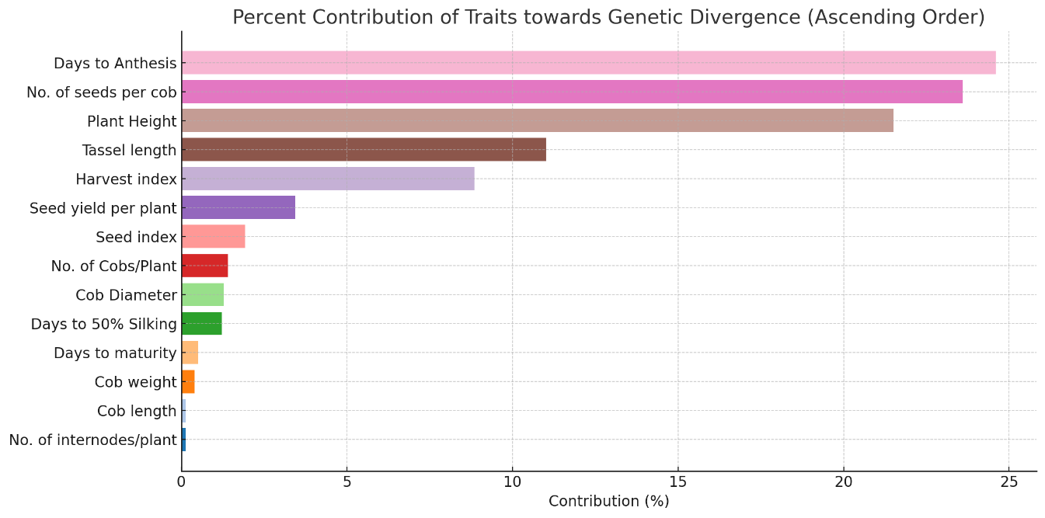
Figure 1. Percent contribution of 14 traits of maize inbred (Descending order)
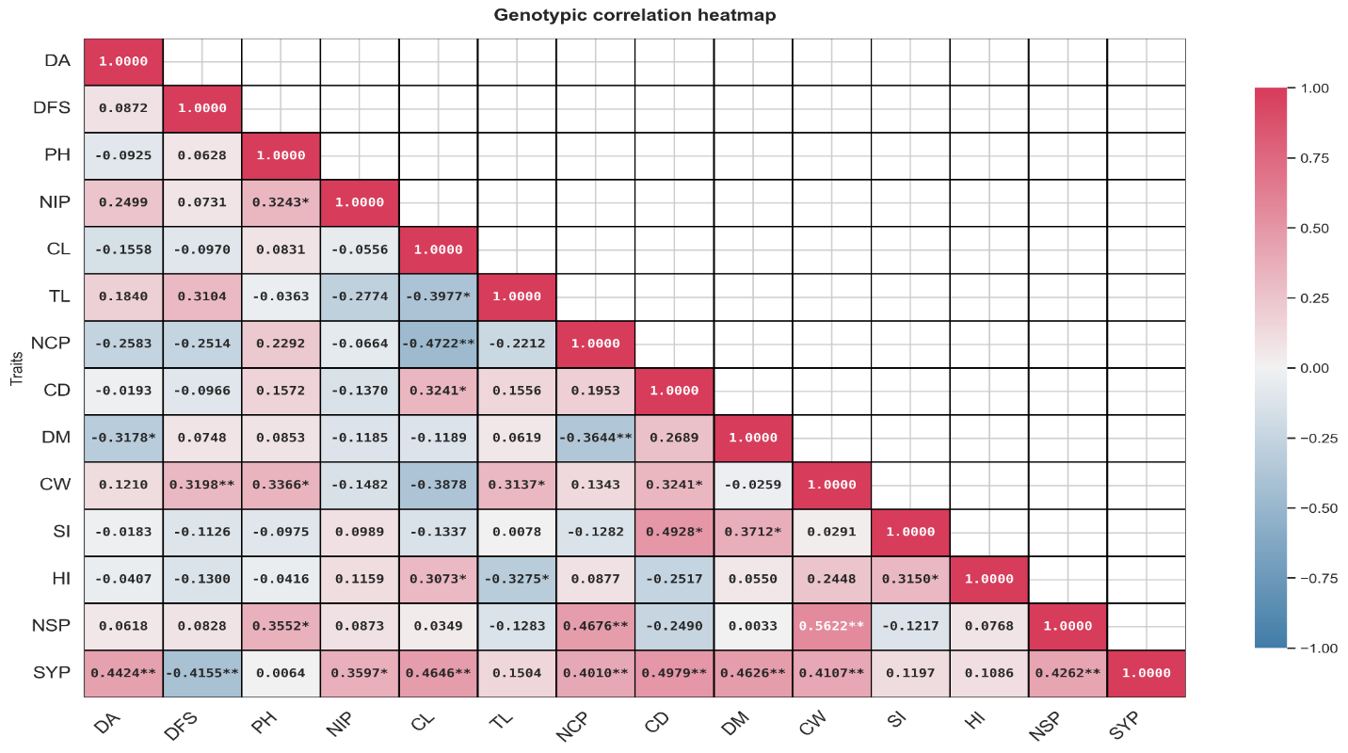
Figure 2. Genotypic correlation heatmap in maize inbred lines
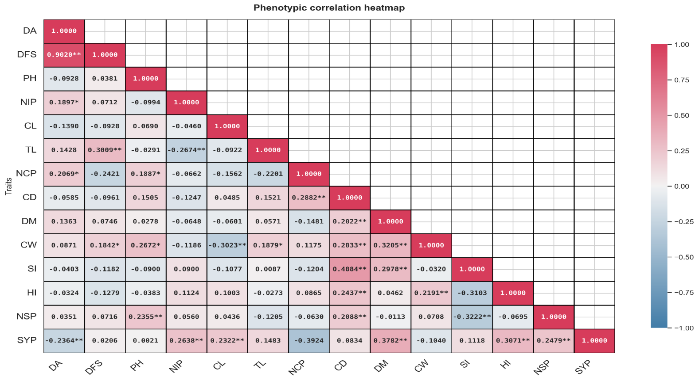
Figure 3. Phenotypic correlation heatmap in maize inbred lines
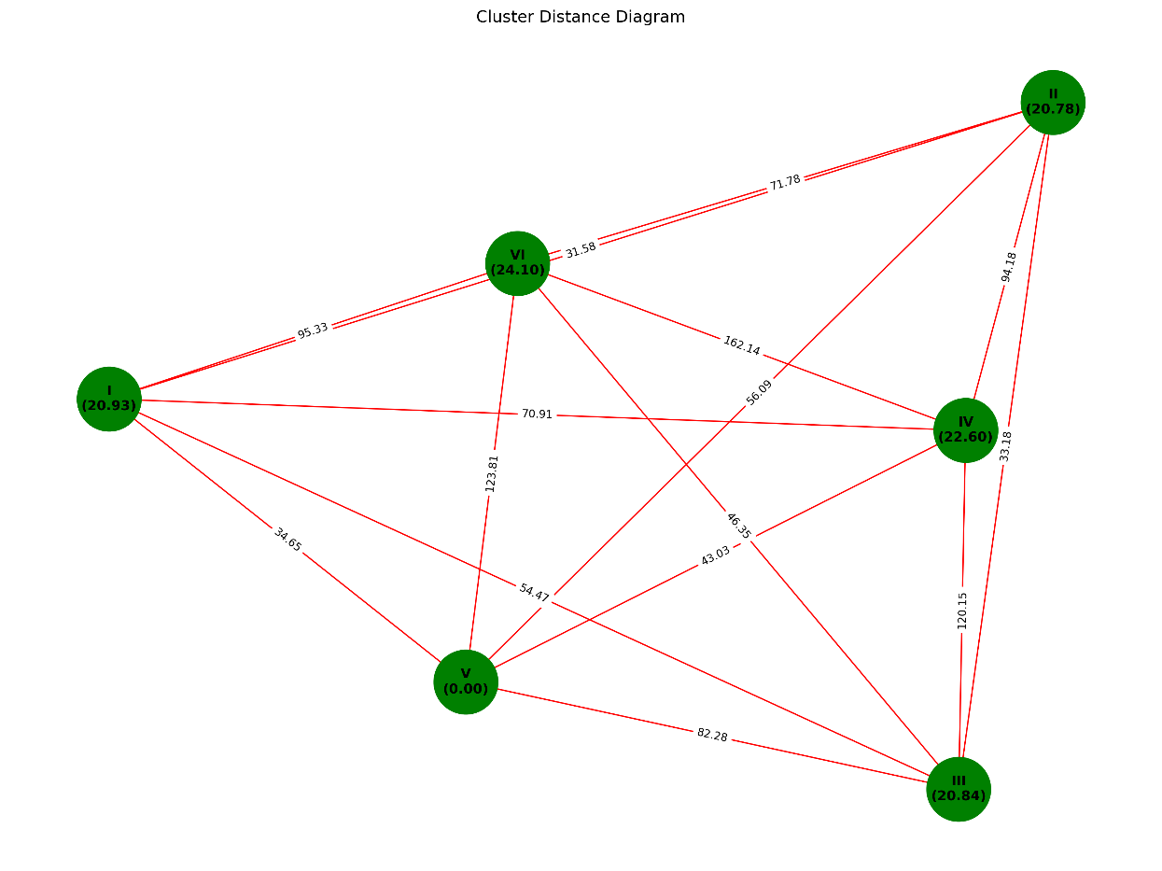
Figure 4. Cluster diagram of 40 maize inbred lines

