Phytochemical screening and in-silico drug-likeness study of Passiflora edulis seed extracts
ABSTRACT
Passiflora edulis is a fruiting vine plant from family passifloraceae. This fruit is known for its unique taste and aromatic juice. Generally, the seeds of this fruit are ignored, but they are known to be rich in fibre and oil content. However, limited literature is available on the scientific studies of the bioactive compounds present in these seeds. Hence, this study has showed the presence of several phytochemicals in the aqueous, methanol and chloroform extracts obtained from these seeds. Thin layer chromatography of these extracts was also performed using two solvent systems and spots were identified. The UV- Vis scanning of extracts produced peaks at specific wavelengths indicating the presence of alkaloids, flavonoids, carotenoids and phenolic compounds. Further, due to the presence of several peaks in the methanolic extract during the preliminary analysis, the same extract was used in the Gas Chromatography Mass Spectroscopy. This analysis revealed the presence of six major bioactive compounds. These compounds were subjected to SwissADME software tool and critical parameters were selected for analysis. Upon analysing the results obtained for their critical parameters, three compounds like butanedioic acid- 2 cyano-2,3-dimethyl-diethyl ester, acetaldehyde-hydroxyl and trimethylene oxide were identified to possess drug likeliness properties. These compounds are also known for their sedative, antibiotic, antiviral and anticancerous properties. Hence these compounds can be considered as potential lead molecules in drug development process.
Keywords: Passiflora edulis; TLC; UV-Vis spectroscopy; GCMS; ADME.

1. Introduction:
Passiflora edulis commonly referred to as passion fruit from the Passifloraceae class is a vine that originated in southern Brazil. This fruit has an economic and medicinal importance (He et al 2020). In the traditional system of medicines, all the parts of this fruit play an important role in the management or treatment of various ailments. The medicinal properties of the fruit include being an anxiolytic, anti-inflammatory, sedative, antioxidant, antibacterial, antifungal, anticancer, neuroprotective, promoting skin condition, fat burning, and hypoglycaemic effects (Kawakami et al 2021). The seeds of passion fruits contain omega-6 fatty acids, and linoleic acid that have benefits for the skin, fight inflammation, and improve heart health. Hence consumption of these fruits have been said to reduce blood pressure, facilitate digestion, support healthy cholesterol, and serve a host of cardiovascular benefits. (Taiwe et al 2017). The seeds contain an abundant specialized polyphenol piceatannol and is also named after the fruit (Bhat et al 2024, Ramaiya et al. 2018). This study follows a systematic and sequential protocol for identifying and validating the phytochemicals present in the Passiflora edulis seeds.
2. Materials and methods:
2.1 Sample preparation:
Fresh and healthy passion fruits were procured naturally and the seeds were separated from the pulp. The seeds were then washed thoroughly and dried in partial sunlight for three days. Then they were powdered using a pestle and mortar. 0.1 g of this seed powder was mixed with methanol, distilled water, and chloroform in three separate tubes. These tubes were placed in a shaker incubator for 72 hours at 35 °C. After 72 hours, the extract was filtered and the filtrate was air dried to obtain the extract to be used in further analysis. All the chemicals used in the extraction procedure were of analytical grade.

2.2 Phytochemical analysis:
The Passiflora edulis seed extracts from methanol, chloroform, and aqueous solutions were subjected to various phytochemical tests to identify the presence of different classes of phytochemicals. The standard protocols were followed for testing the phytochemicals in various plant extracts (Kokate 2008).

2.3 Thin-layer chromatography:
The extracts prepared were spotted onto the thin layer chromatographic plates. Two types of mobile phases were considered. The mobile phase 1was made of ethyl acetate: formic acid: acetic acid and water (10:1:11:26) whereas the mobile phase 2 was chloroform: acetic acid: methanol: water (60:32:12:8) with a spray of visualizing agent anisaldehyde. Both the spotted TLC plates were kept in the saturated TLC chamber and eluted until the mark of the solvent front. The second plate was dried and sprayed with anisaldehyde and kept in the hot air oven for 10 minutes. (Meyer et al 2013)

2.4 UV-Visible spectroscopy:
The extracts prepared as mentioned earlier were used for scanning in the UV-visible spectrophotometer. The instrument used was Shimadzu Corp UV-1780 UV-Visible spectrophotometer sl. no. A119159 31618 and the wavelength range for the scan was 200 to 800 nm with 5 nm as the gap length. Quartz cuvettes were filled with respective solvents (for blanks) or samples and placed in the slots for scanning. The spectral graph obtained on the screen was observed and the wavelengths of maximum peaks were recorded by Akash et al 2019 and Akash et al 2020.

2.5 Gas Chromatography-Mass Spectroscopy (GCMS):
Performing GCMS analysis helps in revealing the various phytochemicals present in the extract (Quirós-Cubillo et al 2025). The extracts prepared, were subjected to the GCMS analysis at Bangalore Test House – Rajajinagar - Bengaluru. Only the methanolic extract was selected for GCMS analysis since methanolic extract showed the presence of many peaks in the UV-Vis spectral studies. The GCMS analysis was performed in column RTX-5MS length of 30m. The injection temperature was 250℃ with helium as the carrier gas at a flow rate of 1mL/min with an injection of 1µL. The MS was scanned at a mass range of 40-600 m/z. The data was identified using the NIST 23 mass spectral library.

2.6 Absorption, Distribution, Metabolism, and Excretion (ADME) Analysis:
The compounds identified from GCMS analysis were subjected to ADME profiling in SwissADME software tool. In the hexagonal spider web display, the parameters considered for analysis were Lipophilicity (LIPO), size (SIZE), flexibility (FLEX), polarity (POLAR), insolubility (INSOLU) in water, and insaturation (INSATU) of the compound (Raj et al 2025). The results were obtained as shown in spider web format in Figure 4 (Kamble et al 2023). Further, from the spider web display, eligible compounds were recognized as lead like molecules by studying the crucial parameters and its acceptable ranges viz. its molecular weight (150.0 to 500 g/mol), lipophilicity Log P (acceptable or unacceptable), GI absorption (high or low), water solubility Log S (highly, moderately or low soluble), drug likeliness with respect to Lipinski rules being followed (yes or no), blood brain barrier (BBB) being permeant (yes or no) and synthetic accessibility of the compound rating (1 to 10 from easy to difficult respectively) in synthesizing the compound.
3. Results and Discussions
3.1 Phytochemical analysis:
The preliminary phytochemical analysis of methanolic extract revealed the presence of alkaloids, carbohydrates, oils, fats, saponins, flavonoids, phenolic compounds, tannins, and proteins. Meanwhile, the chloroform extract had alkaloids, carbohydrates, flavonoids, phenolic compounds, tannins, and proteins. Whereas, the aqueous extract had oils, fats, saponins, phenolic compounds, and tannins Figure 1 and Table 1.

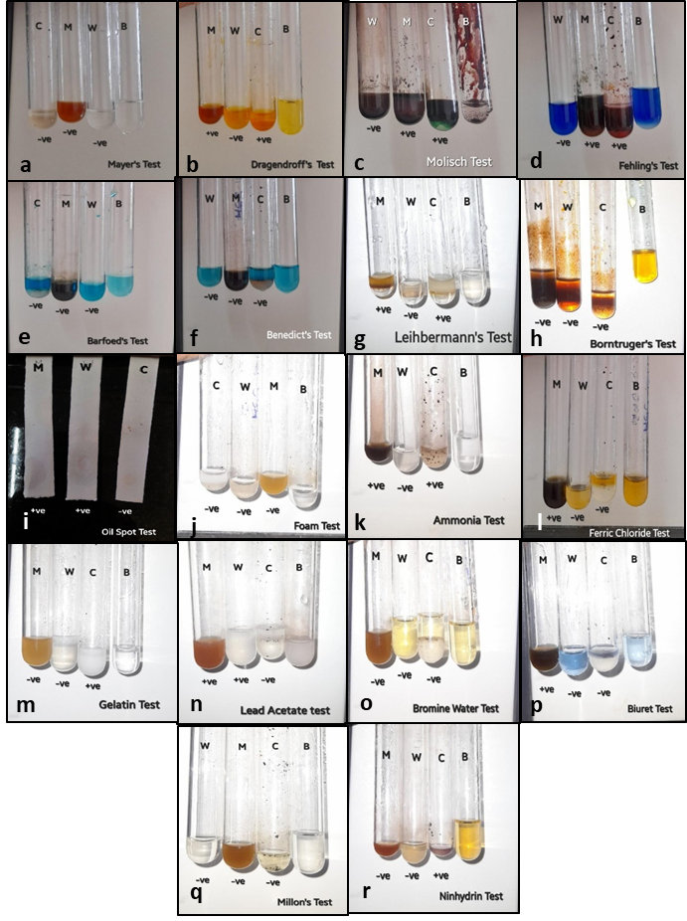
Figure 1: Phytochemical tests performed on Passiflora edulis seed extracts. 1a,1b - Test for alkaloids, 1c,1d,1e,1f,1g,1h - Test for carbohydrates, 1i,1j - Test for fixed oils, fats, and saponins 11.1k - Test for flavonoids, 1l,1m,1n,1o - Test for phenolic compounds and tannins, 1p,1q,1r - Test for proteins (M: Methanolic extract, W- Water (aqueous) extract, C: Chloroform extract, B: Blank).

Table 1: Results of Phytochemical tests performed on Passiflora edulis seed extracts.
 | Methanolic | Chloroform | Aqueous
Test for alkaloids:
Meyers test | - | - | -
Dragendorff test | + | + | -
Test for Carbohydrates
Molisch test | + | + | -
Fehling test | + | + | -
Barfoed test | - | - | -
Benedict test | - | - | -
Liebermann’s test | + | + | -
Borntrager's test | - | - | -
Test for fixed oils, fats, and saponins
Oil spot test | + | - | +
Foam test | - | - | -
Test for flavonoids
Ammonia test | + | + | -
Test for phenolic compounds and tannins:
Ferric chloride test | + | - | -
Gelatin test | - | - | +
Lead acetate test | - | + | -
Bromine water test | - | - | -
Test for proteins
Millon’s test | - | - | -
Biuret test | + | - | -
Ninhydrin test | - | + | -
3.2 Thin layer chromatography:
The spots developed on the TLC plates were visualized in UV illuminator chambers under 254nm and 365nm. The bands were marked, and Rf values were calculated and mentioned in Table 2.
Table 2: Rf value of Passiflora edulis extract in different solvents
Extract | Mobile phase | Rf Value
Aqueous | Mobile phase 1 | 0.8
Aqueous | Mobile phase 2 | 0.43
Methanol | Mobile phase 1 | 0.61
Methanol | Mobile phase 2 | 0.47
Chloroform | Mobile phase 1 | 0.41
Chloroform | Mobile phase 2 | 0.6

3.3 UV-Visible Spectroscopy
The spectral graph obtained from the UV-Vis scanning of extracts is shown in Figure 2. The methanolic extracts had 5 peaks, the chloroform extract had 4 peaks and the aqueous extracts had 5 peaks. Only the major peaks were recorded from the scanning display. Along with these major peaks, several minor peaks were also observed but due to their low absorbance values, they are not considered. Literature search was carried out to classify the various phytocompounds and their corresponding wavelength maxima into different class of phytochemicals. The predicted phytochemical class of the phytocompounds present in the sample is mentioned in Table 3.
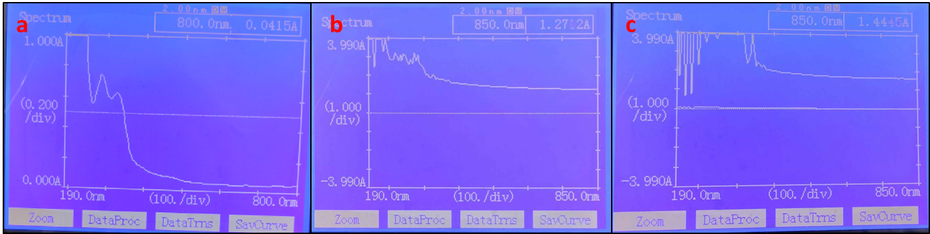
Figure 2: UV-Vis spectral scan of a) methanolic extract b) aqueous extract c) chloroform extract

Table 3: Wavelengths of peaks and possible phytochemicals in methanolic (M), aqueous (A), chloroform (C) extract.
Extracts | Wavelength maxima λ _{max} (U) | Phytochemical class
Methanolic | 744 (0.05) 666 (0.06)  332 (4.00) 290 (2.96)  240 (3.25) | Chlorophyll  Flavonoids and derivatives
Aqueous | 734 (0.48) 618 (0.49)  600 (0.50) 226 (3.89)  252 (2.31) | Alkaloids and phenolic compounds
Chloroform | 635 (1.75) 590 (1.78)  420 (2.3) 250 (4.00) | Flavonoids

3.4 GCMS analysis:
Due to several positive results in qualitative tests viz. phytochemical analysis, thin layer chromatography and UV-Visible spectroscopy, only the methanolic extract was subjected to the GCMS analysis. 6 peaks with maximum intensity were observed in the GCMS analysis of the methanolic extract. The spectral graph of GCMS is shown in the Figure 3 and the list of phytocompounds with their R match value is mentioned in the Table 4.
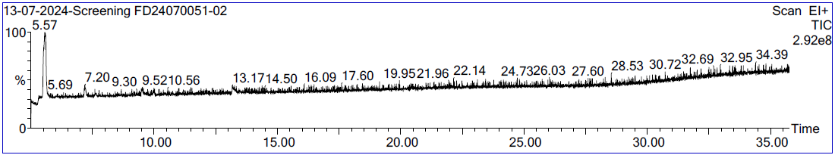
Figure 3: Spectral graph of methanolic extract of seeds from Passiflora edulis.

Table 4: List of compounds (IUPAC name) from GCMS analysis of methanolic extract of Passiflora edulis seeds and their Retention Time.
Sl. No. | Compound | R. Match
1 | Nickel-tetracarbonyl  (carbon-monoxide;nickel) | 808
2 | Butanedioic-acid-2-cyano-2,3-dimethyl-diethyl-ester  (diethyl (2R,3R)-2-cyano-2,3-dimethylbutanedioate) | 714
3 | Acetaldehyde-hydroxy-  (2-hydroxyacetaldehyde) | 825
4 | Vanadium, pentacarbonyl(u3-2-propenyl)- | 582
5 | Trimethylene-oxide  (oxetane) | 561
6 | Cobalt, tetracarbonylsilyl-  (silyl(tetracarbonyl)cobalt) | 526
3.5 ADME Analysis
The phytocompounds subjected to ADME profiling resulted in the graph as shown in the figure 4. A hexagonal spider web with each parameter forming an end was used to depict the acceptance limits of the phytocompounds. The points (edges of the polygon) lying within the shaded area denotes the compound to be satisfying the parameters considered (Figure 4). Among the 6 compounds, Butanedioic acid- 2 cyano-2,3-dimethyl-diethyl ester, Acetaldehyde-hydroxyl and Trimethylene oxide were observed to have all 6 edges in shaded region and also the values of selected parameters were in the acceptable ranges.

The compound Butanedioic acid, 2 cyano-2,3-dimethyl-diethyl ester, had a molecular weight 227.26 g/mol, Log P of 2.49, Log S(ESOL) being very soluble, with high GI absorption and not permeant through BBB. The compound also satisfies all the Lipinski rules, with 3.39 as synthetic accessibility. Acetaldehyde-hydroxy had a molecular weight of 60.05 g/mol, Log P of 0.29, Log S being highly soluble, with high GI absorption and not permeant through the BBB. It also satisfied all the Lipinski rules with 0 violations and 1.00 as synthetic accessibility. The compound Trimethylene oxide had molecular weight of 58.08 g/mol, Log P of 1.30, Log S being very soluble, with low GI absorption, but not permeable through the BBB. It satisfied all the Lipinski rules, with synthetic accessibility of 1.00. Hence, these three compounds can be considered to possess drug likeliness properties and be lead molecules.

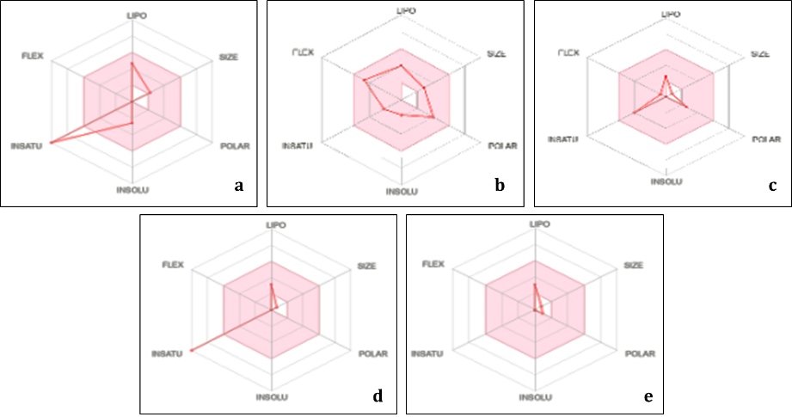
Figure 4: Spider web view of phytocompounds in the seed extract a. Cobalt, tetracarbonylsilyl-b. Butanedioic acid, 2 cyano-2,3-dimethyl-diethyl ester, c. Acetaldehyde, hydroxy, d. Nickel tetracarbonyl, e. Trimethylene oxide

Acetaldehyde, hydroxyl is naturally found in fruits, coffee and fermented products. It is known to be used as a flavouring agent in the food and beverages (Alexander et al 2023). This compound is also used in cosmetics and personal care products as a fragrance ingredient. In the pharmaceutical field, it is used in the production of sedatives, tranquillizers and sedatives. Higher doses of acetaldehyde is known to act as sedatives, however, at optimal concentrations it is known to induce behavioural effects. Hence this compound was also used on the patients to prevent their addiction towards alcohol consumption (Quertemont et al 2006, 2005).

The derivatives of butanedioic acid, 2 cyano-2,3-dimethyl-diethyl ester and trimethylene oxide is a major component of several medicines. Trimethylene oxide also known as oxetane is used as an antiviral (Grosse et al 2022, Juan et al 2023). Several reports have mentioned the derivatives of oxetane to be the building blocks of many pharmaceutical products, and possess antibiotic, neurotrophic, and anticancerous properties (Satoshi et al 2006, Nobuyoshi 1986, Dembitsky et al 2024).

4. CONCLUSION
The phytochemical profile analysis of Passiflora edulis seed extract revealed the presence of myriad varieties of phytochemicals in different solvent extracts, giving credence to the plant's medicinal uses. The presence of several major phytocompounds in the fruits has been reported by Ankit et al 2024, Echeverri et al 2001, Bendini et al 2006, Revathy et al 2019). Ankit et al 2024, Rashed et al 2021 have mentioned a detailed information on the presence of several biological properties like anti-proliferative, antioxidant, antimicrobial and anti-inflammatory effects in the extracts of the fruit. However, the preliminary phytochemical analysis on the extracts obtained from the seeds of these fruits were not available. In this study, the methanolic extract of seeds has shown to be highly endowed with alkaloids, flavonoids, phenolic content, and tannins, oils, fats, and saponins. The presence of all these compounds have suggested the extract to contain potential for usage in skin care, cardiovascular diseases, and in other immunological effects. Meanwhile, the GCMS analysis of the methanolic extract from the seeds of Passiflora edulis has revealed the presence of novel phytocompounds. Yashmitha et al 2025, Chassagne D. et al 1998, Macoris et al 2011 have also identified the presence of certain phytochemicalsand other aromatic phytocompounds in the extracts of passion fruits by GCMS technique. However, the phytocompounds reported in this study is unique and has not been cited by these other literatures. The further studies was carried out by ADME analysis to identify the pharmacological properties of these phytocompounds. Amongst these, three compounds viz. Butanedioic acid- 2 cyano-2-3-dimethyl-diethyl ester, Acetaldehyde-hydroxy, and Trimethylene oxide were in the acceptable range of considered parameters and inferred as possessing drug likeliness properties. Further, these three compounds can be considered as candidate lead like molecules in the drug development process.

Moreover, future research should concentrate on the additional identification of each of the active compounds that possess drug-like properties. The present work adds understanding to the literature about the presumed health-benefiting compounds to be present in passion fruit seeds. This indicates the potential for the usage of these seeds for health-enhancing products such as antioxidant supplements or in regular healthy diet foods as neutraceuticals.

Disclaimer (Artificial intelligence)

Author(s) hereby declare that NO generative AI technologies such as Large Language Models (ChatGPT, COPILOT, etc.) and text-to-image generators have been used during the writing or editing of this manuscript.

References
- X He, F. Luan, Y. Yang, Z. Wang, Z. Zhao, J. Fang, M. Wang, M. Zuo, and Y. Li. Passiflora edulis: An Insight into Current Researches on Phytochemistry and Pharmacology. Frontiers in Pharmacology, 2020; 11. doi:https://doi.org/10.3389/fphar.2020.00617.
- Kawakami S, Morinaga M, Tsukamoto-Sen S, Mori S, Matsui Y, Kawama T. Constituent Characteristics and Functional Properties of Passion Fruit Seed Extract. Life (Basel, Switzerland), 2021; 12(1): 38-53. doi:https://doi.org/10.3390/life12010038.
- Ankit K, Jagruti W, Dnyaneshwari Sakhare. A review: Pharmacological and phytochemical update of Passiflora edulis F. Flavicarpa, GSC biol. pharm. sci., 2024; 27(02), 143–153
- Echeverri F, Arango V, Quinones W, Torres F, Escobar G, Rosero Y, et al. Passifloricins, polyketides alpha pyrones from Passiflora foetida resin. Phytochem. 2001; 56(8): 881-885.
- Taïwe GS, Kuete V. Passiflora edulis. MSVFA, 2017: 513–526. doi: https://doi.org/10.1016/b978-0-12-809286-6.00024-8.
- Revathy S, Sunilkumar T. Phytochemical and nutritional studies on the fruit pulp extract of Passiflora foetida Linn. , J. Pharmacogn. Phytochem. 2019; 8(4): 732-734.
- David C, Jean C, Claude LB, Raymond LB. Identification of Passion Fruit Glycosides by Gas Chromatography/Mass Spectrometry. J. Agric. Food Chem. 1998 46 (10): 4352-4357, DOI: 10.1021/jf980416k.
- Bhat D, Raj YS, Patil A. Passiflora edulis seeds: Phytochemical Analysis and Therapeutic Properties. IJRR. 2024; 11(9): 284–291. doi: https://doi.org/10.52403/ijrr.20240930.
- Khaled R. Phytochemical and biological effects of Passiflora foetida: A review, SAJAS. 2021; 1(2): 106-108.
- Ramaiya S, Bujang J, Zakaria M. Nutritive Values of Passion Fruit (Passiflora Species) Seeds and Its Role in Human Health. JAFSCD, 2018; 4(1): 23–30. https://doi.org/10.30635/2415-0142.2018.04.4.
- Raj YS, Patil A, Bhat D, Achar SS. GCMS and ADME Profiling of Extract from Seeds of Passiflora edulis Int. J. Biol. Res., 2025; 5(1): 1–5. Doi: https://journals.worldbiologica.com/ib/article/view/144
- Macoris LC, Vianna GS, Alencar SM. Volatile compounds from organic and conventional passion fruit (Passiflora edulis F. Flavicarpa) pulp. Ciência e Tecnologia de Alimentos, 2011; 31(2): 430–435. Doi: https://www.researchgate.net/publication/262595930
- Kokate CK, Purohit AP, Gokhale SB. Pharmacognosy. Nirali Prakashan: India; 2008.
- Quirós-Cubillo M, Valdés-Díaz S, Oviedo-Quirós J, Álvarez-Valverde V, Syedd-León R. Antioxidant, and antibacterial potential of Passiflora edulis (Passion Fruit) at three ripening stages for waste valorization. Molecules. 2025; 22(30):3454.
- Meyer VR. Chromatography, Overview. Reference Module in Chemistry, Molecular Sciences and Chemical Engineering. EMPA St Gallen, St Gallen, Switzerland: 2013. doi:https://doi.org/10.1016/b978-0-12-409547-2.00080-9.
- Akash MSH, Rehman K. Ultraviolet-Visible (UV-VIS) Spectroscopy. Ess. Pharm. Anal. 2019; 29–56. doi:https://doi.org/10.1007/978-981-15-1547-7_3.
- Akash MSH, Rehman K. Ultraviolet-Visible (UV-Vis) Spectroscopy. In: Essentials of Pharmaceutical Analysis. Springer: Singapore; 2020. https://doi.org/10.1007/978-981-15-1547-7_3
- Kamble ANS, Mitkar AA. Swiss ADME predictions of pharmacokinetics and drug-likeness properties of secondary metabolites present in Trigonella foenum-graecum. J. Pharmacogn. Phytochem. 2023; 12(5): 341–349. doi:https://doi.org/10.22271/phyto.2023.v12.i5d.14745.
- Quertemont E, Didone V. Role of acetaldehyde in mediating the pharmacological and behavioral effects of alcohol. Alcohol research & health. ARCR, 2006; 29(4): 258–265.
- Quertemont E, Tambour S, Tirelli E. The role of acetaldehyde in the neurobehavioral effects of ethanol: A comprehensive review of animal studies. Prog. Neurobiol. 2005; 75: 247–274. doi: 10.1016/j.pneurobio.2005.03.003.
- Alexander TC, Dirk WL, Sabine G, Angelika R, Matthias B, Patrick D et al. Acetaldehyde as a Food Flavoring Substance: Aspects of Risk Assessment. Mol. Nutr. Food Res. 2023; 67: 2200661. https://doi.org/10.1002/mnfr.202200661.
- Grosse S, Tahri A, Raboisson P, Houpis Y, Stoops B, Jacoby E, From Oxetane to Thietane: Extending the Antiviral Spectrum of 2′-Spirocyclic Uridines by Substituting Oxygen with Sulfur. ACS Med. Chem. Lett. 2022; 13: 1879– 1884, DOI: 10.1021/acsmedchemlett.2c00372
- Juan JR, James AB. Oxetanes in Drug Discovery Campaigns. J. Med. Chem. 2023; 66 (18): 12697-12709. DOI: 10.1021/acs.jmedchem.3c01101
- Gabko P, Kalník M, Bella M. Oxetanes: formation, reactivity and total syntheses of natural products. Beilstein J. Org. Chem. 2025, 21, 1324–1373. doi:10.3762/bjoc.21.101.
- Satoshi O, Masatsune M, Nobutaka I, Yuzuru I, Haruo T, Akio F, et al. Oxetin, A new antimetabolite from an actinomycete, J. Antibiot., (1986). 2006; 37(11): 1324-1332. Doi: https://doi.org/10.7164/antibiotics.37.1324.
- Nobuyoshi S, Shigeru H, Takashi H, Takayuki T, Akio F, Tomohisa T. Oxetanocin, A Novel Nucleoside From Bacteria, J. Antibiot., (1986). 2006; 39(11): 1623-1625. Doi: https://doi.org/10.7164/antibiotics.39.1623.
- Dembitsky VM. Highly Oxygenated Cyclobutane Ring in Biomolecules: Insights into Structure and Activity. Oxygen, 2024; 4(2): 181-235. https://doi.org/10.3390/oxygen4020012.

