Morphological Characterization of Field Pea (Pisum sativum L.Var. arvense) Genotypes based on DUS descriptors
Abstract
The main trust of this article was Morphological Characterization of Field Pea (Pisum sativum L.Var. arvense) Genotypes based on DUS descriptors.Field pea is an important rabi pulse crop requiring productivity enhancement to meet increasing demand. Morphological characterization is a cost-effective and reliable approach for assessing genetic diversity essential for varietal identification, germplasm evaluation, and crop improvement. The present study evaluated fifty-seven field pea genotypes, including two checks (Pant P 554 and JM 6), at the Seed Breeding Farm, JNKVV, Jabalpur during rabi 2024–25 in a Randomized Complete Block Design with two replications. Observations were recorded on twenty morphological and visual traits at plant and seed levels following DUS guidelines. Most traits exhibited considerable variability. Stem anthocyanin colouration, leaf axil colour, flower standard petal colour, seed testa mottling, seed parchment, and foliage waxy bloom showed dimorphic expression, while traits such as foliage colour, flower opening days, pod curvature, pod intensity of green colour, plant height, seed shape, seed surface, seed cotyledon colour, and 1000-seed weight displayed polymorphism. Stipule type was monomorphic across all genotypes. The substantial morphological diversity observed among the genotypes indicates their potential utility in varietal identification, germplasm characterization, and future field pea improvement programmes.
Keywords: Field pea, crop ,Morphological Characterization, DUS descriptors,
INTRODUCTION-
Field pea (Pisum sativum L. var. arvense) is one of the most important pulse crops cultivated in India, primarily during the winter season. It is an annual, herbaceous, self-pollinating legume extensively grown across temperate regions. Field pea has a diploid chromosome number of 2n = 14 and a genome size of approximately 4.5 Gb (Arumuganathan and Earle, 1991). The crop belongs to the family Fabaceae, the largest family of flowering plants, which comprises about 450 genera and 1200 species (Luitel et al.,2021). The genus Pisum includes two species: Pisum fulvum Sibth. and Pisum sativum. According to Vavilov (1949), the primary centres of origin of field pea are Ethiopia, the Mediterranean, and Central Asia.
Globally, field pea is cultivated across a wide range of agro-climatic regions, with major producers including Canada, Russia, China, and India. In India, it is primarily grown in Uttar Pradesh, Madhya Pradesh, and Bihar, with Uttar Pradesh being the leading producer. Due to its high nutritional value and wide adaptability, field pea is gaining importance as a food legume; however, its yield potential remains constrained by multiple production and breeding challenges.
Morphological traits reflect inherent genetic variation within germplasm, and are readily observable and serve as valuable indicators of the genetic composition of plant materials. Field pea plants generally attain a length of 120 to 150 cm (approximately 4 to 5 feet). Flowers of field pea are hermaphroditic and cleistogamous, with self-pollination, it features the characteristic papilionaceous structure, comprising a standard petal, two wing petals and a keel. Floral coloration can range from white, pink, purple, blue or red. The seeds display variation in coat colour, including green yellow or creamy and are morphologically classified into three types: spherical, cylindrical and dimpled. Morphological characterization is universally acknowledged as the initial and fundamental step in the description, classification, and identification of genotypes. To facilitate accurate evaluation and utilization of genetic resources, plant breeders have established crop-specific descriptors based on DUS guidelines issued by PPV & FRA for all crops (Muhammad et al., 2009; Naghavi and Jahansouz, 2005; Able et al., 2007).
MATERIAL AND METHODS
The Experimental materials consist of fifty-seven field pea genotypes including two checks received from Department of Genetics and Plant Breeding, College of Agriculture, JNKVV, Jabalpur and IIPR, Kanpur. The experiment took place during the Rabi season of 2024-25 at the Seed breeding farm, College of Agriculture, Jawaharlal Nehru Krishi Vishwa Vidyalaya, Jabalpur, Madhya Pradesh in Randomized Complete Block Design with two replications. Each genotype had been sown in 5 meters row while plant to plant distance was 8-10 cm and row to row distance was 45 cm. From each replication, five plants were chosen to record observations on twenty morphological traits as per DUS guidelines (Table 1).
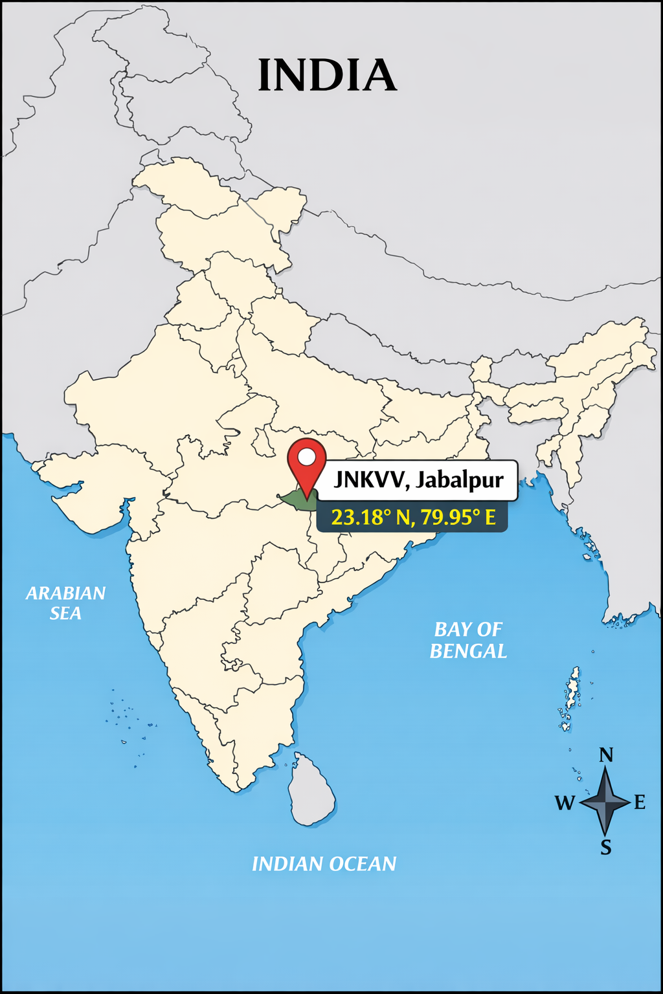
Figure 1. Geographical location of Jawaharlal Nehru Krishi Vishwa Vidyalaya (JNKVV), Jabalpur, Madhya Pradesh, India (23.18° N latitude and 79.95° E longitude).
Table 1: Characterization based on DUS traits in fifty-seven genotypes of Field pea
S.  No. | Characteristics | Stage of observation | Expression/ States | Note/  Score
1. | Stem: Anthocyanin colouration | Initiation of first flower | Absent | 1
1. | Stem: Anthocyanin colouration | Initiation of first flower | Present | 9
2. | Foliage: Colour | Initiation of first flower | Light green | 3
2. | Foliage: Colour | Initiation of first flower | Green | 5
2. | Foliage: Colour | Initiation of first flower | Dark green | 7
3. | Foliage: Waxy bloom | Initiation of first flower | Absent | 1
3. | Foliage: Waxy bloom | Initiation of first flower | Present | 9
4. | Leaf: Leaflets | Initiation of first flower | Absent  (Afila type) | 1
4. | Leaf: Leaflets | Initiation of first flower | Present | 9
5. | Leaf: Axil colour | Initiation of first flower | Green | 1
5. | Leaf: Axil colour | Initiation of first flower | Purple | 2
6. | Stipule: Rabbit eared stipule | Initiation of first flower | Absent | 1
6. | Stipule: Rabbit eared stipule | Initiation of first flower | Present | 9
7. | Stipule: Type | Initiation of first flower | Normal | 1
7. | Stipule: Type | Initiation of first flower | Vestigial | 3
8. | Flower: Opening(days) | 50% of the plants with at least  one open flower | Extra early  (< 40) | 1
8. | Flower: Opening(days) | 50% of the plants with at least  one open flower | Early (40-50) | 2
8. | Flower: Opening(days) | 50% of the plants with at least  one open flower | Medium (51-70) | 3
8. | Flower: Opening(days) | 50% of the plants with at least  one open flower | Late (>70) | 4
9. | Flower: Standard petal color | 50% flowering | White | 1
9. | Flower: Standard petal color | 50% flowering | Blue | 2
9. | Flower: Standard petal color | 50% flowering | Pink | 3
9. | Flower: Standard petal color | 50% flowering | Red | 4
9. | Flower: Standard petal color | 50% flowering | Purple | 5
10. | Pod: Number/Axil | Fully developed green pod stage | Single | 1
10. | Pod: Number/Axil | Fully developed green pod stage | Double | 2
10. | Pod: Number/Axil | Fully developed green pod stage | Multiple | 3
11. | Pod: Curvature | Fully developed green pod stage | Absent | 1
11. | Pod: Curvature | Fully developed green pod stage | Weak | 3
11. | Pod: Curvature | Fully developed green pod stage | Medium | 5
11. | Pod: Curvature | Fully developed green pod stage | Strong | 7
12. | Pod: Shape of distal part | Fully developed green pod stage | Pointed | 1
12. | Pod: Shape of distal part | Fully developed green pod stage | Blunt | 9
13. | Pod: Intensity of green colour | Fully developed green pod stage | Light green | 3
13. | Pod: Intensity of green colour | Fully developed green pod stage | Green | 5
13. | Pod: Intensity of green colour | Fully developed green pod stage | Dark green | 7
14. | Plant: Height | Peak flowering | Short (<60 cm) | 3
14. | Plant: Height | Peak flowering | Medium (60-80 cm) | 5
14. | Plant: Height | Peak flowering | Long (>80 cm) | 7
15. | Seed: Shape | Mature Seed | Spherical | 1
15. | Seed: Shape | Mature Seed | Cylindrical | 2
15. | Seed: Shape | Mature Seed | Dimpled | 3
16. | Seed: Surface | Mature Seed | Smooth | 1
16. | Seed: Surface | Mature Seed | Wrinkled | 2
17. | Seed: Cotyledon colour | Mature Seed | Creamy | 3
17. | Seed: Cotyledon colour | Mature Seed | Green Yellow | 5
18. | Seed: Weight of 1000 seed | Mature Seed | Small  (<150 gm) | 3
18. | Seed: Weight of 1000 seed | Mature Seed | Medium (150-200 g) | 5
18. | Seed: Weight of 1000 seed | Mature Seed | Large (>200g) | 7
19. | Seed: Testa mottling | Mature Seed | Absent | 1
19. | Seed: Testa mottling | Mature Seed | Present | 9
20. | Seed: Parchment | Fully developed green pod stage | Absent | 1
20. | Seed: Parchment | Fully developed green pod stage | Present | 9

RESULTS AND DISCUSSION
The expression and frequency distribution of different morphological and visual characteristics were examined at the plant and seed levels in fifty-seven field pea genotypes in accordance with the DUS criteria. Twenty different morphological traits served as the basis for this assessment. Below are the findings from these evaluations.
Plant level
Stem: Anthocyanin colouration
Anthocyanin pigmentation in the stem was recorded at the time of first flower initiation. Among the fifty-seven field pea genotypes evaluated, anthocyanin colouration in the stem was absent in fifty-four genotypes and present in only three genotypes.
Foliage: Colour
Based on foliage color, the field pea genotypes were classified into three groups: light green, green and dark green. This observation was made at the time of first flower initiation. It was found that fifteen genotypes had light green foliage, twenty-four had green, and eighteen exhibited dark green foliage.
Foliage: Waxy bloom
Field pea genotypes were classified based on the presence or absence of foliage waxy bloom. This trait was observed at the time of first flower initiation, and it was found that foliage waxy bloom was present in fifty-four genotypes and absent in three genotypes.
Leaf: Leaflets
Leaflets were observed at the time of first flower initiation and classified into two types: absent (Afila type) or present. In ten genotypes, leaflets were absent (Afila type), while in the remaining forty-seven genotypes, they were present.
Leaf: Axil color
Leaf axil color was recorded at the time of first flower initiation and classified into two types: green or purple. Fifty-three genotypes exhibited green axil color, while four genotypes showed purple axil color.
Stipule: Rabbit eared stipule
At the time of first flower initiation, rabbit-eared stipules were observed and classified into two types: absent or present. Rabbit-eared stipules were found to be absent in thirty-nine genotypes and present in eighteen genotypes.
Stipule: Type
At the time of first flower initiation, stipule type was observed and classified into two types: normal or vestigial. All fifty-seven genotypes were found to have normal stipules.
Flower: Opening (days)
Flower opening days were recorded when 50% of the plants had at least one open flower. Based on this, genotypes were classified into four categories: extra early (<40 days), early (40–50 days), medium (51–70 days), and late (>70 days). Among the field pea genotypes, two were classified as early (40–50 days), fifty as medium (51–70 days), and five as late (>70 days).
Flower: Standard petal colour
At the 50% flowering stage, the standard petal color of the flower was recorded and classified into five categories: white, blue, pink, red and purple. Among the field pea genotypes, only five exhibited purple-colored petals, while the remaining fifty-two genotypes had white-colored petals.
Pod: Number / axil
At the fully developed green pod stage, the number of pods per axil was recorded and classified into three categories: single, double and multiple. Among the field pea genotypes, seven exhibited single pods per axil, while the remaining fifty genotypes had double pods per axil.
Pod: Curvature
Pod curvature was observed at the fully developed green pod stage and classified into four categories: absent, weak, medium and strong. Curvature was absent in thirty-one genotypes, weak in twenty-three, and medium in three genotypes.
Pod: Shape of distal part
The shape of the distal part of the pod was observed at the fully developed green pod stage and classified as either pointed or blunt. Among the genotypes, thirty-nine had blunt pods, while eighteen had pointed pods.
Pod: Intensity of green color
Pod intensity of green color was observed at the fully developed green pod stage and classified into three categories: light green, green and dark green. Among the genotypes, twenty-eight were light green, twenty-four were green and five were dark green.
Plant: Height (cm)
Plant height was measured at the peak flowering stage and classified into three categories: short (<60 cm), medium (60–80 cm) and long (>80 cm). Among the field pea genotypes, seventeen were short, nineteen were medium and twenty-one were long.
Seed Parchment
Seed parchment was observed at the fully developed green pod stage and classified as either absent or present. It was present in only five genotypes and absent in the remaining fifty-two genotypes.
Seed level
Seed: Shape
Seed shape was observed after harvest at the mature seed stage and classified into three groups: spherical, cylindrical, and dimpled. Among the genotypes, thirty-five were spherical, three were cylindrical and nineteen were dimpled.
Seed: Surface
Seed shape was observed after harvest at the mature seed stage and classified into two groups: smooth and wrinkled. Among the genotypes, forty-three were smooth, while the remaining fourteen were wrinkled.
Seed: Cotyledon colour
Seed cotyledon color was observed after harvest at the mature seed stage and classified into two groups: creamy and green-yellow. Among the genotypes, forty-seven had creamy cotyledons, while ten had green-yellow cotyledons.
Seed: Weight of 1000 seeds (gm)
The weight of 1000 seeds were measured after harvest at the mature seed stage and classified into three groups: small (<150 g), medium (150–200 g), and large (>200 g). Among the genotypes, five were small, thirty-five were medium, and seventeen were large.
Seed: Testa mottling
Seed testa mottling was observed after harvest at the mature seed stage and classified based on its presence or absence. Testa mottling was absent in fifty-two genotypes and present in only five genotypes.

Table 2: Frequency Distribution of Morphological Traits in Field pea Genotypes
S.  No. | Characteristics | Stage of observation | Expression/ States | Note/  Score | Genotype frequency | Percentage contribution (%) | Name of genotypes
1. | Stem: Anthocyanin colouration | Initiation of first flower | Absent | 1 | 54 | 94.73 | Ambika, Pant P-243, Adarsh, Pant P-554, IPFD11-5, IPFD12-2, IPFD10-12, HFP1904, PANT P574, PANT P568, HFP 20-506, HFP 20-67, RFP 2021-1, HUTP2202, Pant P562, Pant P559, IPFD 23-11, HFP1962, SKNFP 2008, HFP2029, JP885, AP2, G-10, HUP-2, Azad Pea-1, VRP-7, HFP-8909, JP-180, VL-3, PantP42, IM9102, VL42, PantP5, HFP529, KPMR144-1, PG3, SKNP-4-9, KPMR400, VL-1, VL-46, JM-6, HFP9907B, IFP4-26, HFP-9426, IM9101, IPFD99-13, HUDP15, DDR-44, IPF48, IPFD6-3, JAYANTI, HFP4, IPFD1-10
1. | Stem: Anthocyanin colouration | Initiation of first flower | Present | 9 | 3 | 5.26 | IPFD14-2, B22, INDIRA MATAR-1.
2. | Foliage: Colour | Initiation of first flower | Light green | 3 | 15 | 26.13 | Ambika, Adarsh, PANT P574, RFP 2021-1, HUTP2202, SKNFP 2008, AP2, HUP-2, PantP5, KPMR400, VL-46, IFP4-26, HUDP15, IPFD6-3, JAYANTI
2. | Foliage: Colour | Initiation of first flower | Green | 5 | 24 | 42.10 | Pant P-243, Pant P-554, IPFD11-5, IPFD12-2, IPFD10-12, IPFD14-2, PANT P568, HFP 20-506, HFP 20-67, Pant P562, JP885, HFP-8909, JP-180, PantP42, IM9102, VL42, KPMR144-1, JM-6, HFP9907B, HFP-9426, IM9101, DDR-44, IPF48, HFP529
2. | Foliage: Colour | Initiation of first flower | Dark green | 7 | 18 | 31.57 | HFP1904, Pant P559, IPFD 23-11, HFP1962, HFP2029, B22, G-10, Azad Pea-1, VRP-7, VL-3, HFP529, PG3, SKNP-4-9, VL-1, IPFD99-13, HFP4, IPFD1-10, INDIRA MATAR-1
3. | Foliage: Waxy bloom | Initiation of first flower | Absent | 1 | 3 | 5.26 | IPFD12-2, SKNFP 2008, IFP4-26
3. | Foliage: Waxy bloom | Initiation of first flower | Present | 9 | 54 | 94.73 | Ambika, Pant P-243, Adarsh, Pant P-554, IPFD11-5, IPFD10-12, IPFD14-2, HFP1904, PANT P574, PANT P568, HFP 20-506, HFP 20-67, RFP 2021-1, HUTP2202, Pant P562, Pant P559, IPFD 23-11, HFP1962, HFP2029, B22, JP885, AP2, G-10, HUP-2, Azad Pea-1, VRP-7, HFP-8909, JP-180, VL-3, PantP42, IM9102, VL42, PantP5, HFP529, KPMR144-1, PG3, SKNP-4-9, KPMR400, VL-1, VL-46, JM-6, INDIRA MATAR-1, HFP9907B, HFP-9426, IM9101, IPFD99-13, HUDP15, DDR-44, IPF48, IPFD6-3, JAYANTI, HFP4, IPFD1-10, DMR-7
4. | Leaf: Leaflets | Initiation of first flower | Absent  (Afila type) | 1 | 10 | 17.54 | Pant P-554, IPFD12-2, AP2, HUP-2, KPMR400, JAYANTI, HFP4, IPFD6-3, HUDP15, DDR-44
4. | Leaf: Leaflets | Initiation of first flower | Present | 9 | 47 | 82.45 | Ambika, Pant P-243, Adarsh, IPFD11-5, IPFD10-12, IPFD14-2, HFP1904, PANT P574, PANT P568, HFP 20-506, HFP 20-67, RFP 2021-1, HUTP2202, Pant P562, Pant P559, IPFD 23-11, HFP1962, SKNFP 2008, HFP2029, B22, JP885, G-10, Azad Pea-1, VRP-7, HFP-8909, JP-180, VL-3, PantP42, IM9102, VL42, PantP5, HFP529, PG3, SKNP-4-9, VL-1, VL-46, JM-6, INDIRA MATAR-1, HFP9907B, IFP4-26, HFP-9426, IM9101, IPFD99-13, IPF48, HFP4, IPFD1-10, DMR-7
5. | Leaf: Axil colour | Initiation of first flower | Green | 1 | 53 | 92.98 | Ambika, Pant P-243, Adarsh, Pant P-554, IPFD11-5, IPFD12-2, IPFD10-12, PANT P574, PANT P568, HFP 20-506, HFP 20-67, RFP 2021-1, HUTP2202, Pant P562, Pant P559, IPFD 23-11, HFP1962, SKNFP 2008, HFP2029, JP885, AP2, G-10, HUP-2, Azad Pea-1, VRP-7, HFP-890 internationalization, JP-180, VL-3, PantP42, IM9102, VL42, PantP5, HFP529, KPMR144-1, PG3, SKNP-4-9, KPMR400, VL-1, VL-46, JM-6, HFP9907B, IFP4-26, HFP-9426, IM9101, IPFD99-13, HUDP15, DDR-44, IPF48, IPFD6-3, JAYANTI, HFP4, IPFD1-10
5. | Leaf: Axil colour | Initiation of first flower | Purple | 2 | 4 | 7.01 | IPFD14-2, HFP1904, B22, INDIRA MATAR-1
6. | Stipule: Rabbit eared stipule | Initiation of first flower | Absent | 1 | 39 | 68.42 | Ambika, Pant P-243, Adarsh, Pant P-554, IPFD11-5, IPFD14-2, PANT P574, PANT P568, RFP 2021-1, HUTP2202, Pant P562, IPFD 23-11, HFP1962, SKNFP 2008, B22, JP885, AP2, G-10, HUP-2, VRP-7, PantP42, IM9102, VL42, PantP5, HFP529, PG3, KPMR400, VL-1, VL-46, JM-6, INDIRA MATAR-1, HFP9907B, IFP4-26, HFP-9426, IM9101, IPFD99-13, JAYANTI, HFP4
6. | Stipule: Rabbit eared stipule | Initiation of first flower | Present | 9 | 18 | 31.57 | IPFD12-2, IPFD10-12, HFP1904, HFP 20-506, HFP 20-67, Pant P559, HFP2029, Azad Pea-1, HFP-8909, JP-180, SKNP-4-9, HUDP15, DDR-44, IPF48, IPFD6-3, IPFD1-10, KPMR144-1, DMR-7
7. | Stipule: Type | Initiation of first flower | Normal | 1 | 57 | 100 | Ambika, Pant P-243, Adarsh, Pant P-554, IPFD11-5, IPFD12-2, IPFD10-12, IPFD14-2, HFP1904, PANT P574, PANT P568, HFP 20-506, HFP 20-67, RFP 2021-1, HUTP2202, Pant P562, Pant P559, IPFD 23-11, HFP1962, SKNFP 2008, HFP2029, B22, JP885, AP2, G-10, HUP-2, Azad Pea-1, VRP-7, HFP-8909, JP-180, VL-3, PantP42, IM9102, VL42, PantP5, HFP529, KPMR144-1, PG3, SKNP-4-9, KPMR400, VL-1, VL-46, JM-6, INDIRA MATAR-1, HFP9907B, IFP4-26, HFP-9426, IM9101, IPFD99-13, HUDP15, DDR-44, IPF48, IPFD6-3 , JAYANTI, HFP4, IPFD1-10, DMR-7
7. | Stipule: Type | Initiation of first flower | Vestigial | 3 | 0 | 0 | NIL
8. | Flower: Opening(days) | 50% Plants with at least  one open flower | Extra early  (< 40) | 1 | 0 | 0 | NIL
8. | Flower: Opening(days) | 50% Plants with at least  one open flower | Early (40-50) | 2 | 2 | 3.50 | HFP2029, JP-180
8. | Flower: Opening(days) | 50% Plants with at least  one open flower | Medium (51-70) | 3 | 50 | 87.71 | Ambika, Pant P-243, Adarsh, Pant P-554, IPFD11-5, IPFD12-2, IPFD10-12, IPFD14-2, HFP1904, PANT P574, PANT P568, HFP 20-506, RFP 2021-1, HUTP2202, Pant P562, Pant P559, HFP1962, SKNFP 2008, B22, JP885, AP2, G-10, HUP-2, Azad Pea-1, VRP-7, HFP-8909, VL-3, PantP42, IM9102, VL42, HFP529, KPMR144-1, PG3, SKNP-4-9, KPMR400, VL-1, VL-46, JM-6, INDIRA MATAR-1, HFP9907B, IFP4-26, HFP-9426, IM9101, HUDP15, DDR-44, IPF48, JAYANTI, HFP4, IPFD1-10, DMR-7
8. | Flower: Opening(days) | 50% Plants with at least  one open flower | Late (>70) | 4 | 5 | 8.77 | HFP 20-67, IPFD 23-11, PantP5, IPFD99-13, IPFD6-3
9. | Flower: Standard petal color | 50% flowering | White | 1 | 52 | 91.22 | Ambika, Pant P-243, Adarsh, Pant P-554, IPFD11-5, IPFD12-2, IPFD10-12, PANT P574, PANT P568, HFP 20-506, HFP 20-67, RFP 2021-1, HUTP2202, Pant P562, Pant P559, IPFD 23-11, HFP1962, SKNFP 2008, HFP2029, JP885, AP2, G-10, HUP-2, Azad Pea-1, VRP-7, HFP-8909, VL-3, PantP42, IM9102, VL42, PantP5, HFP529, KPMR144-1, PG3, SKNP-4-9, KPMR400, VL-1, VL-46, JM-6, HFP9907B, IFP4-26, HFP-9426, IM9101, IPFD99-13, HUDP15, DDR-44, IPF48, IPFD6-3, JAYANTI, HFP4, IPFD1-10, DMR-7
9. | Flower: Standard petal color | 50% flowering | Blue | 2 | 0 | 0 | NIL
9. | Flower: Standard petal color | 50% flowering | Pink | 3 | 0 | 0 | NIL
9. | Flower: Standard petal color | 50% flowering | Red | 4 | 0 | 0 | NIL
9. | Flower: Standard petal color | 50% flowering | Purple | 5 | 5 | 8.77 | IPFD14-2, HFP1904, B22, JP-180, INDIRA MATAR-1
10. | Pod: Number/Axil | Fully developed green pod stage | Single | 1 | 7 | 12.28 | HFP 20-506, RFP 2021-1, HUTP2202, Pant P562, IPFD 23-11, JP-180, VL42
10. | Pod: Number/Axil | Fully developed green pod stage | Double | 2 | 50 | 87.71 | Ambika, Pant P-243, Adarsh, Pant P-554, IPFD11-5, IPFD12-2, IPFD10-12, IPFD14-2, HFP1904, PANT P574, PANT P568, HFP 20-67, Pant P559, HFP1962, SKNFP 2008, HFP2029, B22, JP885, AP2, G-10, HUP-2, Azad Pea-1, VRP-7, HFP-8909, VL-3, PantP42, IM9102, PantP5, HFP529, KPMR144-1, PG3, SKNP-4-9, KPMR400, VL-1, VL-46, JM-6, HFP9907B, IFP4-26, HFP-9426, IM9101, IPFD99-13, HUDP15, DDR-44, IPF48, IPFD6-3, JAYANTI, HFP4, IPFD1-10, DMR-7, INDIRA MATAR-1
10. | Pod: Number/Axil | Fully developed green pod stage | Multiple | 3 | 0 | 0 | NIL
11. | Pod: Curvature | Fully developed green pod stage | Absent | 1 | 31 | 54.31 | Ambika, Pant P-554, IPFD12-2, IPFD10-12, IPFD14-2, HFP1904, PANT P568, HFP 20-506, HFP 20-67, RFP 2021-1, Pant P562, Pant P559, HFP1962, SKNFP 2008, HFP2029, G-10, PantP42, HFP529, KPMR144-1, PG3, SKNP-4-9, VL-46, JM-6, INDIRA MATAR-1, DMR-7, IM9101, IPF48, IPFD1-10, PantP5, VL-1, IPFD99-13
11. | Pod: Curvature | Fully developed green pod stage | Weak | 3 | 23 | 40.35 | Pant P-243, IPFD11-5, PANT P574, HUTP2202, IPFD 23-11, B22, HUP-2, Azad Pea-1, VRP-7, JP-180, VL-3, IM9102, VL42, KPMR400, HFP9907B, IFP4-26, HFP-9426, IPFD6-3, JAYANTI, HFP4, HUDP15, DDR-44, IPFD99-13
11. | Pod: Curvature | Fully developed green pod stage | Medium | 5 | 3 | 5.26 | Adarsh, JP885, AP2
11. | Pod: Curvature | Fully developed green pod stage | Strong | 7 | 0 | 0 | NIL
12. | Pod: shape of distal part | Fully developed green pod stage | Pointed | 1 | 18 | 31.57 | Adarsh, IPFD11-5, B22, HUP-2, Azad Pea-1, VRP-7, JP-180, VL-3, AP2, KPMR400, HFP9907B, IFP4-26, HFP-9426, JAYANTI, HFP4, HUDP15, DDR-44, IPF48
12. | Pod: shape of distal part | Fully developed green pod stage | Blunt | 9 | 39 | 68.42 | Ambika, Pant P-243, Pant P-554, IPFD12-2, IPFD10-12, IPFD14-2, HFP1904, PANT P574, PANT P568, HFP 20-506, HFP 20-67, RFP 2021-1, HUTP2202, Pant P562, Pant P559, IPFD 23-11, HFP1962, SKNFP 2008, HFP2029, JP885, G-10, PantP42, HFP529, KPMR144-1, PG3, SKNP-4-9, VL-46, JM-6, INDIRA MATAR-1, DMR-7, IM9101, IPFD6-3, IPFD1-10, PantP5, VL-1, IPFD99-13, VL42, HFP-8909, HFP 20-506
13. | Pod: Intensity of green colour | Fully developed green pod stage | Light green | 3 | 28 | 49.12 | Pant P-243, IPFD10-12, IPFD14-2, HFP1904, HFP 20-506, RFP 2021-1, Pant P562, Pant P559, HFP1962, SKNFP 2008, HFP2029, JP885, HUP-2, VL-3, VL42, KPMR400, JM-6, HFP9907B, IPFD6-3, JAYANTI, HFP4, DDR-44, IPFD1-10, HFP-8909, HFP 20-506, VL-46, KPMR144-1, IPFD 23-11
13. | Pod: Intensity of green colour | Fully developed green pod stage | Green | 5 | 24 | 42.10 | Ambika, Adarsh, Pant P-554, IPFD11-5, IPFD12-2, PANT P574, PANT P568, HFP 20-67, HUTP2202, IPFD 23-11, B22, G-10, PantP42, HFP529, PG3, SKNP-4-9, INDIRA MATAR-1, DMR-7, IM9101, IPF48, HFP-9426, IFP4-26, VL-1, IPFD1-10
13. | Pod: Intensity of green colour | Fully developed green pod stage | Dark green | 7 | 5 | 8.77 | Azad Pea-1, IM9102, PantP5, HUDP15, IPFD99-13
14. | Plant: Height | Peak flowering | Short (<60 cm) | 3 | 17 | 29.82 | IPFD11-5, IPFD10-12, IPFD14-2, HFP1904, IPFD 23-11, AP2, G-10, HFP529, KPMR144-1, PG3, SKNP-4-9, DDR-44, IPFD6-3, JAYANTI, KPMR400, IPF48, IPFD1-10
14. | Plant: Height | Peak flowering | Medium (60-80 cm) | 5 | 19 | 3.33 | Pant P-554, IPFD12-2, HFP 20-506, HFP 20-67, Pant P559, HFP1962, HFP2029, Azad Pea-1, VRP-7, VL-3, PantP42, IM9101, DMR-7, JM-6, VL-1, HFP-9426, HFP4, HUDP15, IPFD99-13
14. | Plant: Height | Peak flowering | Long (>80 cm) | 7 | 21 | 36.84 | Ambika, Pant P-243, Adarsh, PANT P574, PANT P568, RFP 2021-1, HUTP2202, Pant P562, SKNFP 2008, B22, JP885, HUP-2, IM9102, VL42, HFP9907B, IFP4-26, INDIRA MATAR-1, JP-180, VL-46, HFP-8909, PantP5
15. | Seed: Shape | Mature Seed | Spherical | 1 | 35 | 61.40 | Adarsh, Pant P-554, IPFD11-5, PANT P574, PANT P568, RFP 2021-1, IPFD 23-11, HFP1962, B22, JP885, HUP-2, Azad Pea-1, VRP-7, JP-180, VL-3, PantP42, IM9102, VL42, PantP5, HFP529, KPMR400, VL-1, VL-46, DMR-7, HUDP15, JAYANTI, HFP4, IPFD1-10, HFP-8909, IFP4-26, HFP-9426, IM9101, IPFD99-13, DDR-44, AP2
15. | Seed: Shape | Mature Seed | Cylindrical | 2 | 3 | 5.26 | Pant P562, INDIRA MATAR-1, IPF48
15. | Seed: Shape | Mature Seed | Dimpled | 3 | 19 | 33.33 | Ambika, Pant P-243, IPFD12-2, IPFD10-12, IPFD14-2, HFP1904, HFP 20-506, HFP 20-67, HUTP2202, Pant P559, SKNFP 2008, HFP2029, G-10, KPMR144-1, PG3, SKNP-4-9, JM-6, HFP9907B, IPFD6-3
16. | Seed: Surface | Mature Seed | Smooth | 1 | 43 | 75.43 | Ambika, Pant P-243, Adarsh, Pant P-554, IPFD11-5, IPFD12-2, IPFD10-12, PANT P574, PANT P568, HFP 20-506, RFP 2021-1, HUTP2202, IPFD 23-11, HFP1962, SKNFP 2008, HFP2029, JP885, HUP-2, G-10, PantP42, IM9102, VL42, PantP5, HFP529, KPMR144-1, PG3, SKNP-4-9, KPMR400, VL-1, VL-46, JM-6 , DMR-7, IM9101, IPFD6-3, IPFD1-10, HFP9907B, IFP4-26, JP-180, VL-3, IPF48, IPFD99-13, HFP-9426, HFP4, JAYANTI
16. | Seed: Surface | Mature Seed | Wrinkled | 2 | 14 | 24.56 | IPFD14-2, HFP1904, HFP 20-67, Pant P562, Pant P559, B22, Azad Pea-1, VRP-7, AP2, INDIRA MATAR-1, HUDP15, DDR-44, HFP-8909
17. | Seed: Cotyledon colour | Mature Seed | Creamy | 3 | 47 | 82.45 | Ambika, Pant P-243, Adarsh, Pant P-554, IPFD11-5, IPFD12-2, IPFD14-2, HFP1904, PANT P574, PANT P568, HFP 20-506, RFP 2021-1, HUTP2202, Pant P559, IPFD 23-11, HFP1962, SKNFP 2008, HFP2029, JP885, HUP-2, Azad Pea-1, PantP42, IM9102, VL42, PantP5, HFP529, KPMR144-1, PG3, KPMR400, VL-1, VL-46, JM-6, INDIRA MATAR-1, DMR-7, HFP9907B, IFP4-26, IM9101, IPFD6-3, IPFD1-10, HUDP15, DDR-44, JAYANTI, HFP4, AP2, VL-3, HFP-8909
17. | Seed: Cotyledon colour | Mature Seed | Green Yellow | 5 | 10 | 17.54 | IPFD10-12, HFP 20-67, Pant P562, B22, VRP-7, JP-180, SKNP-4-9, IPF48, HFP-9426, G-10
18. | Seed: Weight of 1000 seed | Mature Seed | Small  (<150 gm) | 3 | 5 | 8.77 | Pant P-243, HFP1904, B22, JP-180, HFP-8909
18. | Seed: Weight of 1000 seed | Mature Seed | Medium (150-200 g) | 5 | 35 | 61.40 | Ambika, Pant P-554, IPFD11-5, IPFD12-2, IPFD10-12, IPFD14-2, HFP 20-506, HFP 20-67, RFP 2021-1, HUTP2202, Pant P559, HFP1962, SKNFP 2008, JP885, HUP-2, Azad Pea-1, VRP-7, VL-3, PantP42, IM9102, VL42, PantP5, KPMR400, JM-6, IM9101, IPFD6-3, HFP4, HUDP15, DDR-44, AP2, G-10, IPFD1-10, HFP-9426, IPFD99-13, IPFD 23-11
18. | Seed: Weight of 1000 seed | Mature Seed | Large (>200g) | 7 | 17 | 29.82 | Adarsh, PANT P574, PANT P568, HFP2029, HFP529, PG3, SKNP-4-9, VL-1, VL-46, INDIRA MATAR-1, DMR-7, HFP9907B, IFP4-26, JAYANTI, KPMR144-1, IPF48, IPFD99-13
19. | Seed: Testa mottling | Mature Seed | Absent | 1 | 52 | 91.22 | Ambika, Pant P-243, Adarsh, Pant P-554, IPFD11-5, IPFD12-2, IPFD10-12, PANT P574, PANT P568, HFP 20-506, HFP 20-67, RFP 2021-1, HUTP2202, Pant P562, Pant P559, IPFD 23-11, HFP1962, SKNFP 2008, HFP2029, JP885, HUP-2, Azad Pea-1, VRP-7, VL-3, PantP42, IM9102, VL42, PantP5, HFP529, KPMR144-1, PG3, SKNP-4-9, KPMR400, VL-1, VL-46, JM-6, DMR-7, HFP9907B, IFP4-26, HFP-9426, IM9101, IPFD6-3, JAYANTI, HFP4, IPFD1-10, G-10, IPFD99-13, DDR-44, AP2, HFP-8909, IPF48
19. | Seed: Testa mottling | Mature Seed | Present | 9 | 5 | 8.77 | IPFD14-2, HFP1904, B22, JP-180, INDIRA MATAR-1
20. | Seed: Parchment | Fully developed green pod stage | Absent | 1 | 52 | 91.22 | Ambika, Pant P-243, Adarsh, Pant P-554, IPFD11-5, IPFD12-2, IPFD10-12, IPFD14-2, HFP1904, PANT P574, PANT P568, HFP 20-506, HFP 20-67, RFP 2021-1, HUTP2202, Pant P562, Pant P559, IPFD 23-11, HFP1962, SKNFP 2008, HFP2029, B22, JP885, HUP-2, Azad Pea-1, PantP42, IM9102, VL42, PantP5, HFP529, KPMR144-1, PG3, KPMR400, VL-1, VL-46, JM-6, INDIRA MATAR-1, DMR-7, HFP9907B, IFP4-26, HFP-9426, IM9101, IPFD6-3, JAYANTI, HFP4, IPFD1-10, JP-180, HFP-8909, IPFD99-13, IPF48, HFP 20-506
20. | Seed: Parchment | Fully developed green pod stage | Present | 9 | 5 | 8.77 | AP2, VRP-7, VL-3, SKNP-4-9, DDR-44

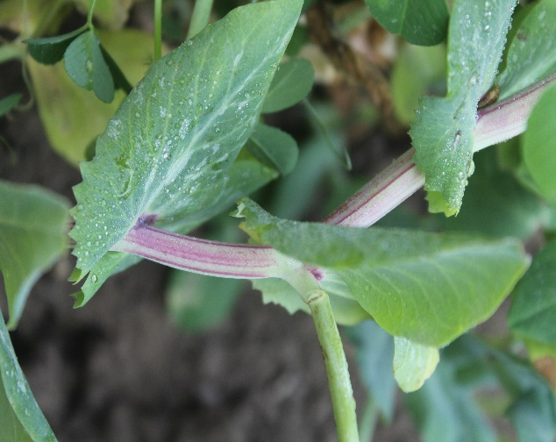 |  | 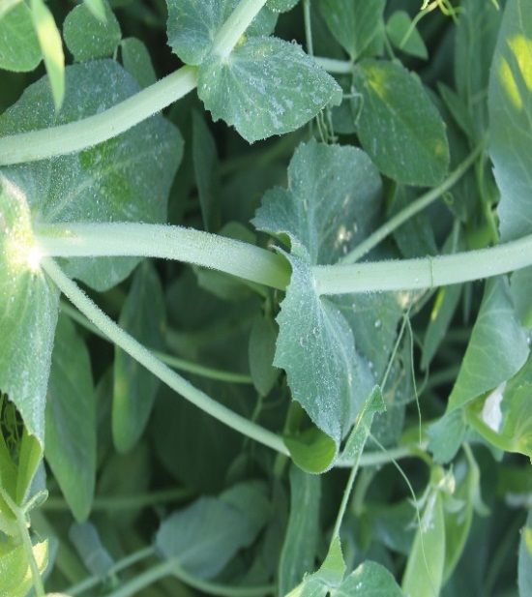
Present |  | Absent
Stem: Anthocyanin Colourations
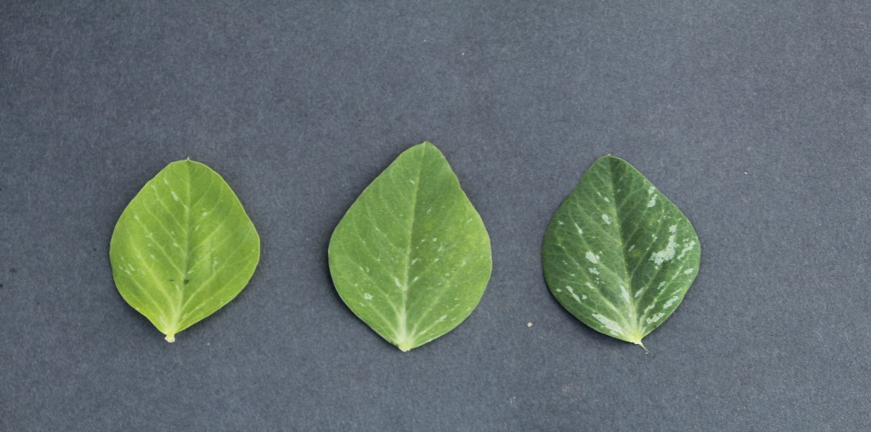
Light Green | Green |  | Dark Green
Foliage: Color
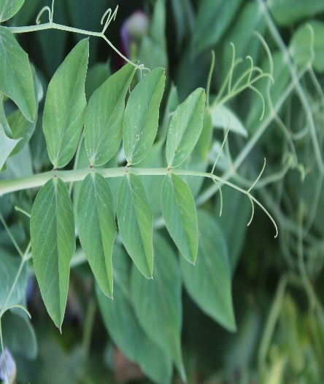 |  | 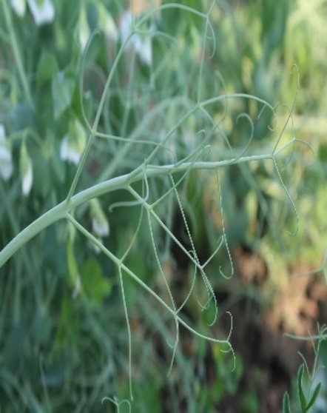
Present |  | Absent (Afila type)
Leaf: Leaflets

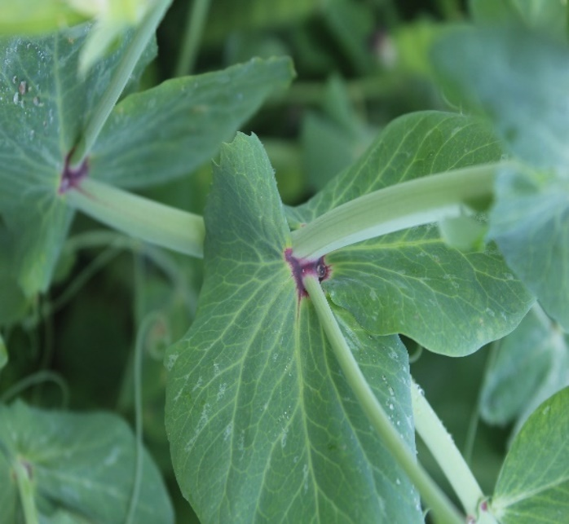 | 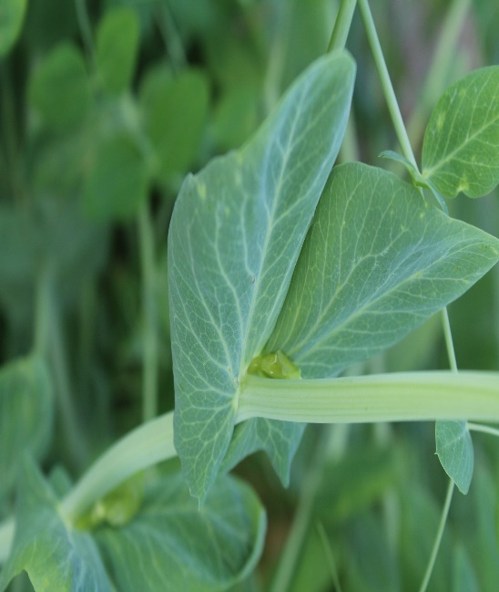
Purple | Green
Leaf: Axil colour
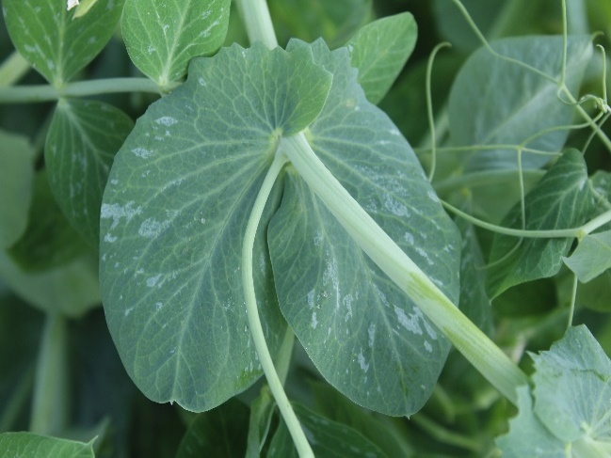 | 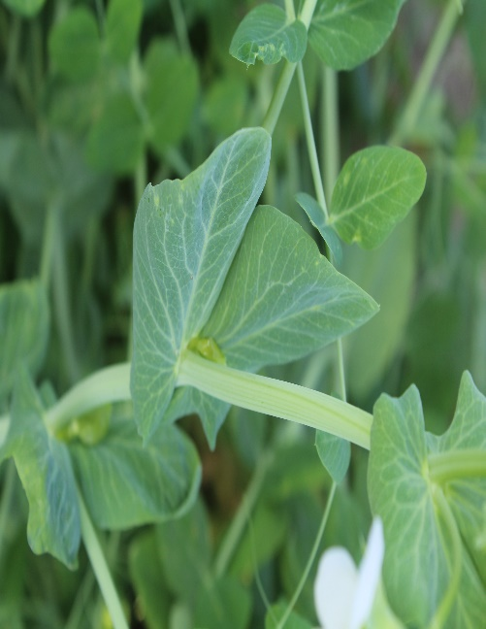
Present | Absent
Stipule: Rabbit eared stipule
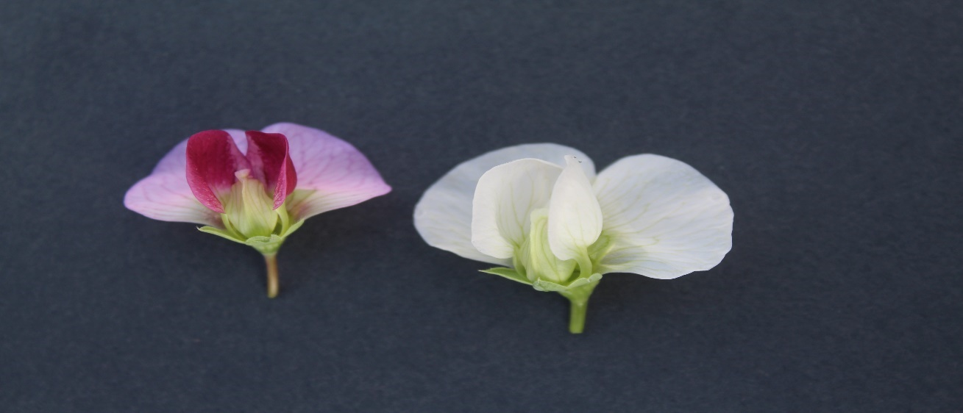
Purple | White
Flower: Standard petal colour

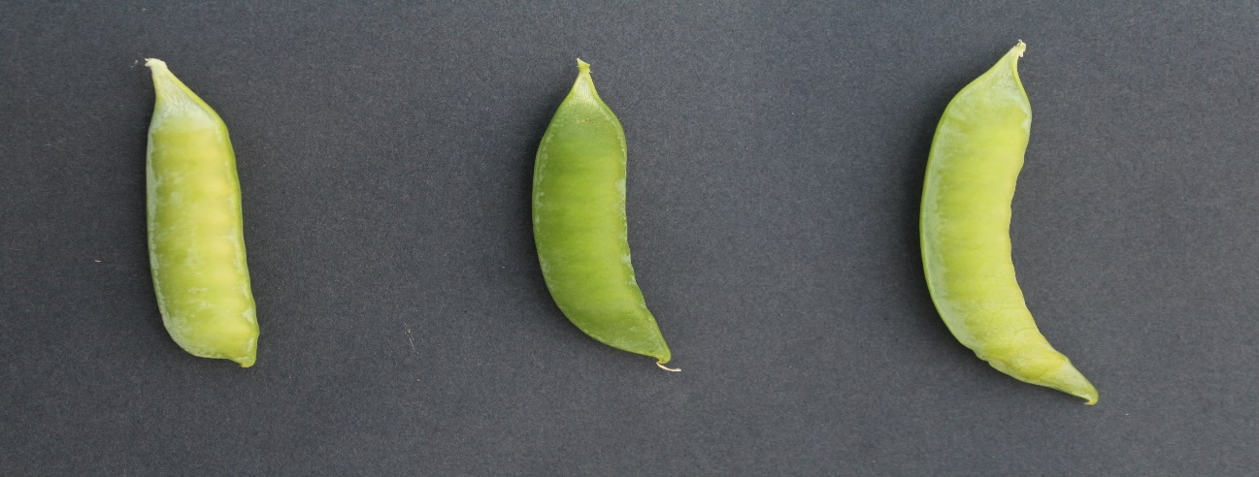
Absent | Weak |  | Medium
 | Pod: Curvature
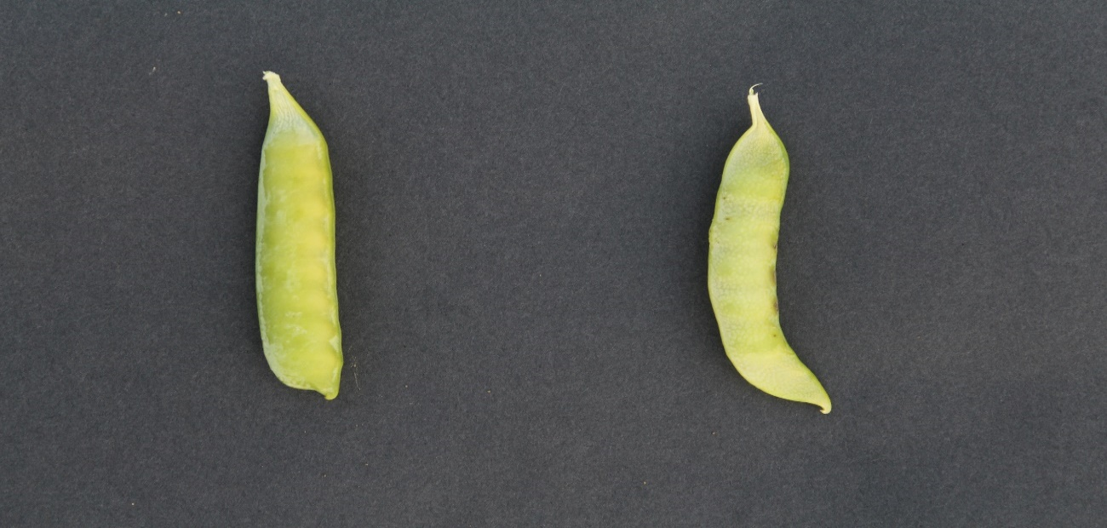
Blunt |  | Pointed
Pod: Shape of distal part

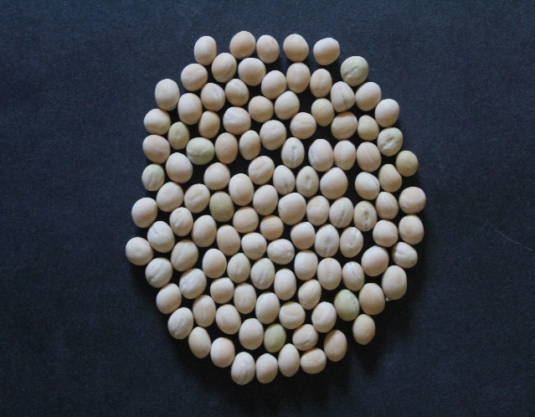 |  | 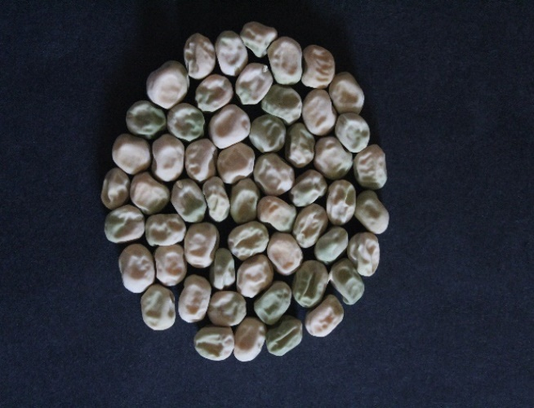
Smooth |  | Wrinkled
Seed: Surface
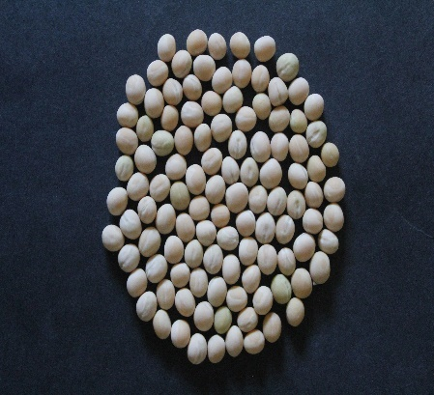 | 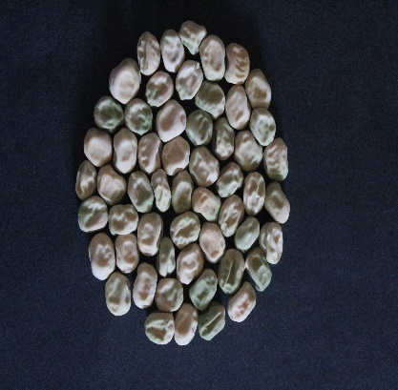 |  | 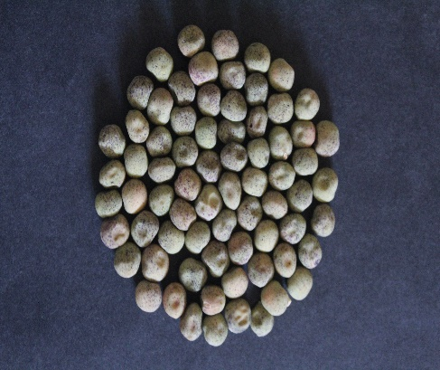
Spherical | Cylindrical |  | Dimpled
 | Seed: Shape
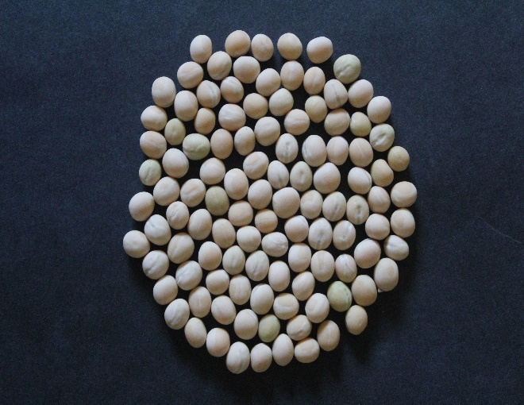 |  | 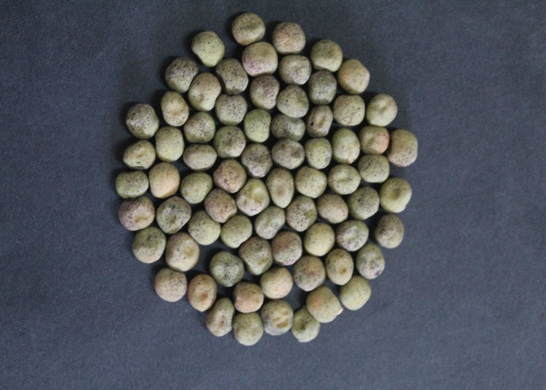
Absent |  | Present
Seed: Testa mottling
Plate 1: Morphological characterization

In the present investigation, all genotypes demonstrated ample variability for the majority of morphological traits viz., stem anthocyanin colouration, foliage colour, foliage waxy bloom, leaf leaflets, leaf axil colour, stipule rabbit eared, flower opening days, flower standard petal colour, number of pod per axil , pod curvature, pod shape of distal part, pod intensity of green colour, plant height, seed shape, seed surface, seed cotyledon colour, weight of 1000 seed, seed testa mottling and seed parchment except stipule type.
Greater variation was observed for traits such as foliage colour, pod intensity of green colour, plant height, stem anthocyanin colouration, leaf axil colour and flower standard petal colour, whereas seed testa mottling exhibited the least variation. These observations were consistent with the findings reported by Yadav et al. (2019) and Anand et al. (2024). Likewise, the variability noted in leaf leaflets, stipule rabbit-eared trait, number of pods per axil, pod curvature, pod intensity of green colour, seed shape, seed surface and seed cotyledon colour were in accordance with the reports of Gour et al. (2018) and Anand et al. (2024). Furthermore, variation in pod shape of the distal part and seed cotyledon colour aligned with the findings of Umar et al. (2014) and Gour et al. (2018).
Leaf axil and flower standard petal colour were observed to be purple, which was in line with the findings of Gour et al. (2018), Ouafi et al. (2016) and Umar et al. (2014). A blunt distal pod shape was recorded in 39 genotypes, corroborating the observations of Kalapchieva et al. (2021). Observations on stipule type and seed parchment were consistent with the reports of Theint et al. (2020), Bishnoi et al. (2023) and Anand et al. (2024). Notable variation was recorded for flower opening days, seed surface and seed cotyledon colour, which aligned with the findings of Srilatha et al. (2022). Similarly, results for plant height and 1000-seed weight were in agreement with Theint et al. (2020).
Conclusion
Morphological characterization indicated that all genotypes exhibited high degree of variability across the majority of morphological traits viz., foliage colour, leaf leaflets, leaf axil colour, stipule rabbit eared, flower opening days, flower standard petal colour, number of pods per axil, pod curvature, pod shape of distal part, pod intensity of green colour, plant height, seed shape, seed surface, seed cotyledon colour, weight of 1000 seed. Seed testa mottling, seed parchment and stem anthocyanin colouration were observed in five, five and three genotypes respectively, foliage waxy bloom were absent in three genotypes, whereas no variation was observed for stipule type.
Disclaimer (Artificial intelligence)
Author(s) hereby declare that NO generative AI technologies such as Large Language Models (ChatGPT, COPILOT, etc.) and text-to-image generators have been used during the writing or editing of this manuscript.

REFERENCES

- Able JA, Langridge P and Milligan AS. 2007. Capturing diversity in the cereals many options but little promiscuity. Trends in Plant Science 12(2): 71–79.
- Anand KJ, Singh SK, Nagre S, Patel T and Moitra P. 2024. Morphological characterization and diversity analysis in pea germplasm. Journal of Experimental Agriculture International 46(7): 189-99.
- Arumuganathan K and Earle ED. 1991. Nuclear DNA content of some important plant species. Plant Molecular Biology Reporter 9(3): 208–218.
- Bishnoi R, Marker S, Nayak A K, Basser P, Mayank and Sharma KK. 2023. Morphological characterization and morphological traits based genetic diversity analysis of farmer’s pea (Pisum sativum L) varieties of Uttar Pradesh using DUS descriptors, as per PPV and FRA, 2001. Legume Research 46(7): 830-836.
- Gour L, Dubey RK, Moitra PK, Singh SK, Shukla SS and Tiwari S. 2018.Genetic parameters exploration of pea genotypes using two environmental conditions. International Journal of Current Microbiology and Applied Sciences 7(9): 2067-2078.
- Kalapchieva S, Dintcheva T, Tringovska I, Vasileva V and Kosev V. 2021. Phenotypic diversity of garden peas for ecological agricultural production. Agricultural Sciences/Agrarni Nauki 13(29): 27-32.
- Luitel BP, Pun TB and Bhandari BB. 2021. Evaluation of growth and yield characters of garden pea genotypes at Dailekh, Mid-Western Nepal. Nepalese Horticulture 15(1): 24-33.
- Muhammad S, Bacha S, Arshad M, Din R and Ghafoor A. 2009. Genetic diversity for determining yield potential and selection criteria in Pisum sativum L genetic resources. Pakistan Journal of Botany 41(6): 2987-2993.
- Naghavi MR and Jahansouz MR. 2005. Variation in the agronomic and morphological traits of Iranian chickpea accessions. Journal of Integrative Plant Biology 47(4): 375-379.
- Ouafi L, Alane F, Rahal-Bouziane H and Abdelguerfi A. 2016. Agro-morphological diversity within field pea (Pisum sativum L.) genotypes. African Journal of Agricultural Research 11(40): 4039-4047.
- Srilatha L, Dubey RK and Singh SK. 2022. Morphological characterization of field pea (Pisum sativum L.) Frontiers in Crop Improvement 10(2): 126-133.
- Theint TT, Ravika, Yadav R and Suman. 2020. DUS Characterization of Field Pea Genotypes (Pisum sativum L.) Using Morphological Markers. International Journal of Current Microbiology and Applied Sciences 9(11): 1978- 1992.
- Umar HMI, Rehman SU, Bilal M, Naqvi AH, Manzoor SA, Ghafoor A, Khalid M, Iqbal MT, Qayyum A, Ahmad F and Irshad MA. 2014. Evaluation of genetic diversity in pea (Pisum sativu L.) based on morpho-agronomic characteristics for yield and yield associated traits. Journal of Biodiversity and Environmental Sciences 4(5): 321-328.
- Vavilov V. 1949. Phytogeographic basis of plant breeding. Botanika Chronika (Series II) 13(1): 13–54.
- Yadav RDS, Purushottam MG, Bhati J and Yadav P. 2019. Diagnostic characteristics of field pea varieties. International Journal of Consevation Sciences 7(4): 1701-1702.

