Original Research Article

Dissecting the Interrelationships Among Yield and Yield-Attributing Traits in Groundnut (Arachis hypogaea L.)

.
ABSTRACT

Groundnut (Arachis hypogaea L.) is a good animal feed and a significant source of oil and protein for human consumption. It has been demonstrated to improve digestive health and lower the chance of developing long-term conditions including diabetes and heart disease. When a complex trait yield is to be improved, a complete understanding of the genetic parameters of the various genotypes under study is required to formulate an effective breeding plan. This study aims to identify traits that directly and indirectly influence pod yield in groundnut genotypes and utilise them in future breeding programs to enhance yield potential. The current research was conducted at the Research Farm, Department of Genetics and Plant Breeding, R.V.S.K.V.V., College of Agriculture, Gwalior (M.P.), Kharif 2022. The study focused on 34 different groundnut genotypes. A line x tester mating design was employed, utilising 6 lines and 4 testers. All genotypes, including 10 parental lines and 24 F₁ hybrids, were cultivated using a Randomised Block Design (RBD) with three replications. Plant height (cm), number of branches per plant, number of pods per plant, 100 kernel weight (g), sound mature kernel (%), shelling outturn (%), pod yield per plant (g), and kernel yield per plant (g) were among the ten attributes for which data were gathered. Genotypic and phenotypic correlation coefficients, along with genotypic and phenotypic path coefficient analysis, were estimated. The analysis of variance revealed that the crosses exhibited significant variances, indicating the presence of genetic variability for all characters. The mean squares due to lines were significant for a few characters except for days to maturity, number of branches per plant, number of pods per plant, hundred-kernel weight and shelling outturn percentage. The mean square due to testers showed similar results and were significant for most of the traits, except days to 50 % flowering, days to maturity, plant height, hundred-kernel weight and shelling outturn percentage. Plant height, number of branches per plant, number of pods per plant, hundred-kernel weight, sound mature kernel, shelling outturn %, and pod yield per plant all significantly and favorably correlated with kernel yield per plant. Phenotypic path coefficient analysis revealed maximum positive direct effect was by pod yield per plant, number of branches per plant, days to 50% flowering, plant height, shelling outturn, number of pods per plant, and sound mature kernel. At the genotypic level, the maximum positive direct effect was contributed by days to 50% flowering, followed by pod yield per plant, number of branches per plant, plant height, sound mature kernel, shelling outturn percentage and number of pods per plant. The present study demonstrated significant genetic variability among the crosses for all traits, indicating ample scope for selection and improvement in groundnut. Furthermore, these findings suggest that selection based on pod yield per plant, number of branches, and days to 50% flowering would be effective for improving kernel yield in groundnut.

Keywords: Correlation coefficient analysis; Path coefficient analysis; Genetic variability

1. INTRODUCTION

“Groundnut (Arachis hypogaeaL.) is called ‘the king of oilseeds’. It is an important source of protein and oil for human consumption and serves as a valuable animal feed” (El-Saady et al., 2014). “Groundnut is known around the world by different names such as peanut, monkey nut, wonder nut, poor man's cashew nut, African nut, Chinese nut, Manila nut, jar nut, hawk nut, kipper’s nut, earth chestnut, goober pea, ground pea, ground bean” (Jain et al. 2016). It belongs to the subfamily Papilionaceae of the family Fabaceae. It is believed to have originated in South America, probably Brazil (Higgins, 1951) or Bolivia (Nwokolo, 1996).
The family history of groundnuts is well studied. There are 80 species under the genus Arachis. Most of these species are diploid (2n = 2x = 20), with only two being allotetraploids (Desmae et al., 2019). The cultivated groundnut is an allotetraploid (AABB, 2n = 4x = 40). The genome size of groundnut is 2.54 Gb (Bertioli et al., 2019). The A and B sub-genomes originated in their diploid progenitors, Arachis duranensis (A-genome) and Arachis ipaensis (B-genome) (Lu et al., 2018). Groundnut is also classified based on its reproductive pattern, pod morphology and vegetative branching. Arachis hypogaea subsp. hypogaea and Arachis hypogaea subsp. fastigiate are the two cultivated subspecies, which are further divided as follows: hypogaea (Virginia) and hirsuta, and subspecies fastigiata, further divided into fastigiata (Valencia), vulgaris (Spanish), peruviana and aequatoriana (Krapovickas & Gregory, 1994). It is a major oilseed crop of India and also an important agricultural export commodity. “Over 60% of global groundnut production is crushed for the extraction of oil for edible and industrial uses, while 40% is consumed as food and others” (Reddy et al., 2025). It is highly nutritious and provides a rich source of energy, including high levels of protein (25-30%), oil (45-50%), carbohydrate (20%), healthy fats, vitamins and minerals. “It is also a good source of fibre (5%), which has been shown to promote digestive health and reduce the risk of chronic diseases such as heart disease and diabetes” (Pramanik et al., 2019; Tomar et al., 2022; Sharma et al., 2023).
When a complex trait yield is to be improved, a complete understanding of the genetic parameters of the various genotypes under study is required to formulate an effective breeding plan (Makwana et al., 2023; Yami & Abtew, 2025). Correlation analysis helps to give an idea about the nature and magnitude of association between the different traits, which can be useful for the plant breeder as they look for traits positively correlated with yield that can be improved concurrently with yield (Gurjar et al., 2025). In 2022, Killi & Beycioğlu (2022) investigated ten registered peanut varieties for the analysis of correlation coefficients among pod yield, yield components, oil and protein content. The study revealed substantial and positive associations between pod yield and attributes such as pod number, pod weight, and hundred kernel weight. Similarly, Sridevi et al. (2022) studied 30 potential groundnut genotypes to explore correlations and path analysis of kernel yield and related traits. Notably, pod yield, mature pods, number of pods, and shelling percentage exhibited significant positive correlations with kernel yield. Path analysis confirmed their direct impact on kernel yield, suggesting that selecting these traits could effectively enhance groundnut kernel yield. Correlation coefficients benefit plant breeders during selection by providing a better understanding of the yield components. Indirect selection for highly heritable traits that are associated with grain yield has been used to increase grain production in a variety of crops. The plant breeder benefits from a positive correlation between desired traits since it assists in the simultaneous development of both traits. On the other hand, a negative correlation will prevent two characters with high values from expressing themselves simultaneously. In these circumstances, a financial compromise must be negotiated. Numerous agricultural species have seen widespread use of path analysis. This technique's information aids in both direct and indirect selection for genetic yield improvement (Dewey & Lu, 1959). Therefore, the present investigation was conducted with the objective of studying the interrelationships among yield and yield-attributing traits and to fix the selection criteria for yield improvement in groundnut.

2. MATERIAL AND METHODs

2.1 Experimental Site
The current research was conducted at the Research Farm of the Department of Genetics and Plant Breeding at the College of Agriculture, R.V.S.K.V.V., Gwalior (M.P), during the kharif season of 2022. The experimental field at the College of Agriculture is located at an altitude of 211.52 meters above mean sea level, with 6°23’ N latitude, and 78°19’ E longitude, with an elevation of 211.5 meters above sea level within the grid belt. In 2022 kharif, the temperature ranged from approximately 15°C to 42°C. Morning relative humidity remained consistently high, ranging from 80% to 95%, whereas evening humidity showed more variation, ranging from 45% to 55%. Rainfall exhibited high variation, reaching nearly 100 mm, while evaporation remained low and relatively constant, between 5 and 10 mm. Overall, the mornings were consistently humid, temperature variations were moderate, and rainfall events were intermittent but intense, contributing to low evaporation rates during the observed period. (Meteorological Observatory data, College of Agriculture, Gwalior).

2.2. Experimental Details
The study focused on 34 different genotypes. A line x tester mating design was employed, utilising 6 lines and 4 testers. All genotypes, including 10 parental lines and 24 F₁ hybrids, were cultivated using a Randomised Block Design (RBD) with three replications during the Kharif season of 2022. The research was conducted at the R.V.S.K.V.V. College of Agriculture’s research station in Gwalior. Seeds were sown at a depth of 2 to 3 cm, with a spacing of 30 cm between rows and 10 cm between plants. Tables 1 and 2 provide the lists of parental lines and hybrids, respectively.
Table 1. List of parental lines used in the present study.
Female (line) | Source | Male (tester) | Source
Nithya haritha (TCGS 1157) | RARS, Tirupati | TG-37A | BARC, Trombay
TG-86 | BARC, Trombay | SunOleic-95R | DGR, Junagarh
TG-87 | BARC, Trombay | GPBD-4 (Vikas) | DGR, Junagarh
TG-88 | BARC, Trombay | KDG-128 (Phule Warna) | DGR, Junagarh
Mallika (ICGH 00440) | Bikaner
Gangapuri | Own (R.V.S.K.V.V, Gwalior)

Table 2. List of hybrids used in the present study.
S.No. | F₁ HYBRIDS | S.No. | F₁ HYBRIDS
1. | TG-87 x TG-37 A | 13. | Gangapuri x TG 37A
2. | TG-87 x SunOleic-95R | 14. | Gangapuri x SunOleic-95R
3. | TG-87 x GPBD-4 | 15. | Gangapuri x GPBD-4
4. | TG-87 x KDG-128 | 16. | Gangapuri x KDG-128
5. | Nithya haritha x TG- 37A | 17. | TG-86 x TG 37 A
6. | Nithya haritha x SunOleic-95R | 18. | TG-86 x SunOleic-95R
7. | Nithya haritha x GPBD-4 | 19. | TG-86 x GPBD-4
8. | Nithya haritha x KDG-128 | 20. | TG-86 x KDG-128
9. | Mallika x TG-37A | 21. | TG-88 x TG- 37A
10. | Mallika x SunOleic-95R | 22. | TG-88 x SunOleic-95R
11. | Mallika x GPBD-4 | 23. | TG-88 x GPBD-4
12. | Mallika x KDG-128 | 24. | TG-88 x KDG-128

2.3 Statistical Analysis
Plant height (cm), number of branches per plant, number of pods per plant, 100 kernel weight (g), sound mature kernel (%), shelling outturn (%), pod yield per plant (g), and kernel yield per plant (g) were among the ten attributes for which data were gathered. The mean values for each trait underwent analysis of variance (ANOVA) to identify significant genotypic differences among the entries, following the method outlined by Panse & Sukhatme (1954). Genotypic and phenotypic variances were calculated using the formula proposed by Burton (1952). The heritability formula presented by Hanson et al. (1956) and the method by Johnson et al. (1955) were employed to calculate heritability and genetic advance estimates, respectively. These analyses were performed to quantify the extent of genetic variability and to assess the potential for genetic improvement among the examined genotypes. Path coefficient analysis was used to ascertain the relative contributions of several attributes to the overall correlation coefficients with kernel yield, as proposed by Wright (1934) and elaborated by Dewey & Lu (1959).

3. results and discussion

3.1 Analysis of Variance
The analysis of variance obtained (Table 3) shows that the crosses exhibit significant variances for all the characters, indicating that the crosses chosen were highly variable for all characters. Further, mean squares due to lines showed significant values for a few characters except for days to maturity (13.89), number of branches per plant (5.51), number of pods per plant (240.22), hundred kernel weight (25.90), and shelling outturn percentage (18.09). The mean square due to testers showed similar results, in that it was significant for most of the traits except days to 50 % flowering (2.04), days to maturity (3.43), plant height (18.53), hundred kernel weight (20.23) and shelling outturn percentage (27.32).

Table 3. Analysis of variance for different traits in groundnut.

Source of variance | df | DF | DM | PH | NBP | NPP | HKW | SMK | SO | PYP | KYP
Replicates | 2 | 0.18 | 0.26 | 2.34 | 0.03 | 0.01 | 0.184 * | 0.409 * | 0.03 | 0.00 | 0.022*
Crosses | 23 | 14.89** | 6.64** | 67.92** | 5.26** | 224.04** | 14.29** | 39.53** | 15.65** | 4.09** | 1.82**
Line Effect | 5 | 38.22 * | 13.89 | 152.77* | 5.51 | 240.22 | 25.90 | 102.49** | 18.09 | 9.82** | 2.87 *
Tester Effect | 3 | 2.04 | 3.43 | 18.53 | 18.57** | 710.41** | 20.23 | 68.38 * | 27.32 | 8.30** | 4.67 *
Line x Tester Effect | 15 | 9.68** | 4.86** | 49.51** | 2.51** | 121.38** | 9.23** | 12.77** | 12.51** | 1.34** | 0.91**
Error | 46 | 0.40 | 0.54 | 1.76 | 0.10 | 0.11 | 0.05 | 0.11 | 0.57 | 0.03 | 0.01
Total | 71 | 5.09 | 2.51 | 23.20 | 1.77 | 72.65 | 4.66 | 12.89 | 5.44 | 1.34 | 0.60
* Significant at p= 0.05, ** Significant at p=0.01. DF- Days to 50% flowering, DM- Days to maturity, PH- Plant height, NBP- Number of branches per plant, NPP- Number of pods per plant, HKW- Hundred kernel weight, SMK- Sound mature kernel, SO- Shelling outturn percentage, PYP- Pod yield per plant, KYP- Kernel yield per plant.

3.2 Correlation coefficient

3.2.1 Genotypic correlation coefficient

The Genotypic correlation coefficient revealed interesting insights (Table 4). The trait days to 50% flowering showed significant positive correlation with days to maturity (0.933**), non-significant negative correlation with hundred kernel weight (-0.121) and negative correlation with the remaining traits. Days to maturity showed a significant and negative correlation with all traits studied. Plant height showed the highest significant positive correlations with kernel yield (0.525**) and the lowest with shelling outturn percentage (0.203*). The number of branches per plant showed a strong positive correlation with characters like Kernel yield per plant (0.846**) and a least positive significant correlation with number of pods per plant (0.322**). The number of pods per plant showed the highest significant positive correlations with kernel yield per plant (0.445**) and the lowest with shelling outturn percentage (0.247*). Hundred kernel weight (g) demonstrated a strong and highly significant positive correlation with pod yield per plant (0.584**) and the least with sound mature kernel (0.347**). Sound mature kernel (%) showed highly significant and positive correlation with kernel yield per plant (0.750**) and lowest with shelling outturn percentage (0.610**). Shelling outturn percentage showed the highest significant and positive correlation with kernel yield per plant (0.707**) and pod yield per plant (0.662**). A highly significant positive correlation between pod yield per plant and kernel yield per plant (0.905**) was observed. Pod yield per plant also showed strong correlations with the number of branches per plant (0.780**), sound mature kernel (0.723**), shelling outturn percentage (0.662**), hundred kernel weight (0.584**), number of pods per plant (0.427**), and plant height (0.410**). While a significant negative correlation with days to flowering (-0.655**) and days to maturity (-0.710**). Kernel yield per plant (g) revealed a significant positive correlation with most traits. The highest significant and positive correlation was with pod yield per plant (0.905**). However, it showed a highly significant and negative correlation with days to 50% flowering (-0.634**) and days to maturity (0.740**).

Table 4: Estimation of Genotypic correlation coefficient.

 | DF | DM | PH | NBP | NPP | HKW | SMK | SO | PYP | KYP
DF | 1.00
DM | 0.933** | 1.00
PH | - 0.401** | -0.316** | 1.00
NBP | -0.398** | -0.485** | 0.375** | 1.00
NPP | -0.269** | -0.319** | 0.286** | 0.322** | 1.00
HKW | -0.121 | -0.246* | 0.241* | 0.603** | 0.360** | 1.00
SMK | -0.567** | -0.553** | 0.430** | 0.699** | 0.307** | 0.347** | 1.00
SO | -0.534** | -0.673** | 0.203* | 0.554** | 0.247* | 0.549** | 0.610** | 1.00
PYP | -0.655** | -0.710** | 0.410** | 0.780** | 0.427** | 0.584** | 0.723** | 0.662** | 1.00
KYP | -0.634** | -0.740** | 0.525** | 0.846** | 0.445** | 0.574** | 0.750** | 0.707** | 0.905** | 1.00
*Significant at p= 0.05, **Significant at p=0.01. DF- Days to 50% flowering, DM- Days to maturity, PH- Plant height, NBP- Number of branches per plant, NPP- Number of pods per plant, HKW- Hundred kernel weight, SMK- Sound mature kernel, SO- Shelling outturn percentage, PYP- Pod yield per plant, KYP- Kernel yield per plant.

3.2.2 Phenotypic correlation coefficient

The results obtained by phenotypic correlation coefficients, as depicted in Table 5, were like that shown by the genotypic correlation coefficient. Days to 50% flowering showed significant positive correlation with days to maturity (0.9055**), non-significant negative correlation with hundred kernel weight (-0.1186) and significant yet negative correlation with the remaining traits. Days to maturity showed a significant negative correlation with all traits studied. Plant height showed the highest significant positive correlations with kernel yield (0.5160**) and a non-significant positive relationship with shelling outturn percentage (0.1973). Number of branches per plant showed a strong positive correlation with characters like kernel yield per plant (0.846**) and a least positive significant correlation with number of pods per plant (0.3202**). The trait number of pods per plant showed the highest significant positive correlations with kernel yield per plant (0.4442**) and the lowest with shelling outturn percentage (0.2441*). Hundred kernel weight (g) revealed a strong and highly significant positive correlation with pod yield per plant (0.5811**) and least with sound mature kernel (0.3456**). Sound mature kernel (%) showed highly significant and positive correlation with kernel yield per plant (0.7468**) and lowest with shelling outturn percentage (0.602**). In turn, shelling outturn percentage showed the highest significant and positive correlation with kernel yield per plant (0.707**) and pod yield per plant (0.662**). A highly significant positive correlation between pod yield per plant and kernel yield per plant (0.9013**) was observed. While it showed a significantly negative correlation with days to flowering (-0.6245**) and days to maturity (-0.7213**).
The results thus obtained from correlation coefficient analysis give an insight into the intricate relationship between different traits and how they influence yield. The findings were like the once earlier reported by Zaman et al. (2011) and Rao et al. (2014). Similar findings were obtained in the current experiment; plant height, number of branches per plant, number of pods per plant, hundred kernel weight, sound mature kernel, shelling outturn percentage, and pod yield per plant all significantly and favorably correlated with kernel yield/plant. These characters, in turn, also showed significant positive intercorrelation among themselves. In conclusion, these traits affect yield directly or indirectly and thus can be used to improve yield. Also, days to 50% flowering and days to maturity shows negative correlation with kernel yield per plant. Similar results were observed by Khan et al. (2000), Meta & Monpara (2010), and Rathod & Toprope (2018).

Table 5: Estimation of the phenotypic correlation coefficient.

 | DF | DM | PH | NBP | NPP | HKW | SMK | SO | PYP | KYP
DF | 1.000
DM | 0.905** | 1.000
PH | -0.387** | -0.307** | 1.000
NBP | -0.391** | -0.473** | 0.371** | 1.000
NPP | -0.264** | -0.312** | 0.282** | 0.320** | 1.000
HKW | -0.118 | -0.237* | 0.239* | 0.596** | 0.358** | 1.000
SMK | -0.556** | -0.541** | 0.426** | 0.691** | 0.306** | 0.345** | 1.000
SO | -0.519** | -0.644** | 0.197 | 0.540** | 0.244* | 0.540** | 0.602** | 1.000
PYP | -0.643** | -0.690** | 0.406** | 0.772** | 0.426** | 0.581** | 0.719** | 0.653** | 1.000
KYP | -0.624** | -0.721** | 0.516** | 0.837** | 0.444** | 0.571** | 0.746** | 0.697** | 0.901** | 1.000
*Significant at p= 0.05, **Significant at p=0.01. DF- Days to 50% flowering, DM- Days to maturity, PH- Plant height, NBP- Number of branches per plant, NPP- Number of pods per plant, HKW- Hundred kernel weight, SMK- Sound mature kernel, SO- Shelling outturn percentage, PYP- Pod yield per plant, KYP- Kernel yield per plant.

3.3 Path coefficient analysis
Path coefficient analysis, originally developed by Wright, facilitates the examination of relationships between distinct independent and dependent components. It quantifies the direct influence of an independent variable (X) on a dependent variable (Y) while keeping other factors constant. In our case, as depicted in tables 6 and 7, diagonal values reveal the direct effects of yield-contributing traits on kernel yield, and off-diagonal values represent their indirect effects.
The results from the genotypic path coefficient analysis (Table 6 and fig. 1) revealed, the maximum positive direct effect was contributed by days to 50% flowering (0.5073) followed by pod yield per plant (0.3750), number of branches per plant (0.2718), plant height (0.2117), sound mature kernel (0.0929), shelling outturn (0.0370), and number of pods per plant (0.0321). The results obtained from phenotypic path coefficient analysis (Table 7 and fig. 2) revealed the maximum direct effect in the positive direction was by pod yield per plant (0.3790), number of branches per plant (0.3052), days to 50% flowering (0.2265), plant height (0.1761), shelling outturn (0.1099), number of pods per plant (0.0509) and sound mature kernel (0.0456). In conclusion, these are the traits that must be used while selection is being done for yield, particularly in the case of groundnut for kernel yield per plant. Similar recordings were reported by Rao et al. (2014), Kiranmai et al. (2016) and Mathews et al. (2000).

Table 6. Estimation of Genotypic Path Coefficient Analysis.

 | DF | DM | PH | NBP | NPP | HKW | SMK | SO | PYP | KYP
DF | 0.5073 | 0.4735 | -0.2036 | -0.2017 | -0.1363 | -0.0612 | -0.2878 | -0.2710 | -0.3324 | -0.6336
DM | -0.6245 | -0.6691 | 0.2112 | 0.3247 | 0.2136 | 0.1646 | 0.3700 | 0.4506 | 0.4748 | -0.7401
PH | -0.0849 | -0.0668 | 0.2117 | 0.0794 | 0.0604 | 0.0511 | 0.0910 | 0.0429 | 0.0868 | 0.5249
NBP | -0.1081 | -0.1319 | 0.1020 | 0.2718 | 0.0875 | 0.1638 | 0.1899 | 0.1505 | 0.2121 | 0.8457
NPP | -0.0086 | -0.0103 | 0.0092 | 0.0104 | 0.0321 | 0.0116 | 0.0099 | 0.0080 | 0.0137 | 0.4452
HKW | 0.0034 | 0.0069 | -0.0067 | -0.0168 | -0.0100 | -0.0279 | -0.0097 | -0.0153 | -0.0163 | 0.5735
SMK | -0.0527 | -0.0514 | 0.0399 | 0.0649 | 0.0285 | 0.0322 | 0.0929 | 0.0567 | 0.0672 | 0.7500
SO | -0.0198 | -0.0249 | 0.0075 | 0.0205 | 0.0092 | 0.0203 | 0.0226 | 0.0370 | 0.0245 | 0.7074
PYP | -0.2457 | -0.2661 | 0.1538 | 0.2926 | 0.1602 | 0.2191 | 0.2712 | 0.2481 | 0.3750 | 0.9054
Residual is 0.2272, Bold means direct effect
*Significant at p= 0.05, **Significant at p=0.01. DF- Days to 50% flowering, DM- Days to maturity, PH- Plant height, NBP- Number of branches per plant, NPP- Number of pods per plant, HKW- Hundred kernel weight, SMK- Sound mature kernel, SO- Shelling outturn percentage, PYP- Pod yield per plant, KYP- Kernel yield per plant.
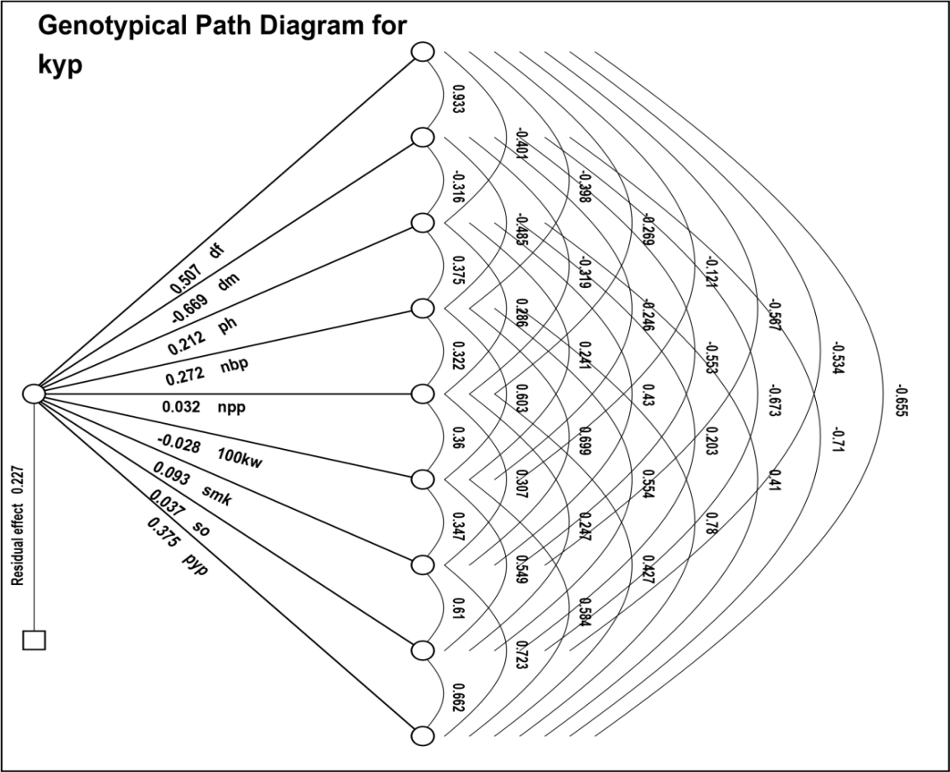
Fig. 1: Estimate of Genotypic path coefficient for 10 characters in groundnut (Arachis hypogaea L.)

Table 7. Estimation of Phenotypic Path coefficient analysis.
 | DF | DM | PH | NBP | NPP | HKW | SMK | SO | PYP | KYP
DF | 0.2265 | 0.2051 | -0.0878 | -0.0886 | -0.0600 | -0.0269 | -0.1261 | -0.1177 | -0.1457 | -0.6245
DM | -0.3265 | -0.3606 | 0.1108 | 0.1709 | 0.1126 | 0.0856 | 0.1951 | 0.2323 | 0.2491 | -0.7213
PH | -0.0683 | -0.0541 | 0.1761 | 0.0655 | 0.0498 | 0.0421 | 0.0752 | 0.0347 | 0.0716 | 0.5160
NBP | -0.1195 | -0.1446 | 0.1134 | 0.3052 | 0.0977 | 0.1820 | 0.2112 | 0.1649 | 0.2359 | 0.8378
NPP | -0.0135 | -0.0159 | 0.0144 | 0.0163 | 0.0509 | 0.0183 | 0.0156 | 0.0124 | 0.0217 | 0.4442
HKW | 0.0030 | 0.0061 | -0.0061 | -0.0152 | -0.0092 | -0.0255 | -0.0088 | -0.0138 | -0.0148 | 0.5710
SMK | -0.0254 | -0.0247 | 0.0194 | 0.0315 | 0.0139 | 0.0157 | 0.0456 | 0.0274 | 0.0328 | 0.7468
SO | -0.0571 | -0.0708 | 0.0217 | 0.0594 | 0.0268 | 0.0594 | 0.0662 | 0.1099 | 0.0718 | 0.6979
PYP | -0.2437 | -0.2617 | 0.1541 | 0.2928 | 0.1615 | 0.2202 | 0.2728 | 0.2476 | 0.3790 | 0.9013
Residual is 0.2731, Bold means direct effect
*Significant at p= 0.05, **Significant at p=0.01. DF- Days to 50% flowering, DM- Days to maturity, PH- Plant height, NBP- Number of branches per plant, NPP- Number of pods per plant, HKW- Hundred kernel weight, SMK- Sound mature kernel, SO- Shelling outturn percentage, PYP- Pod yield per plant, KYP- Kernel yield per plant.
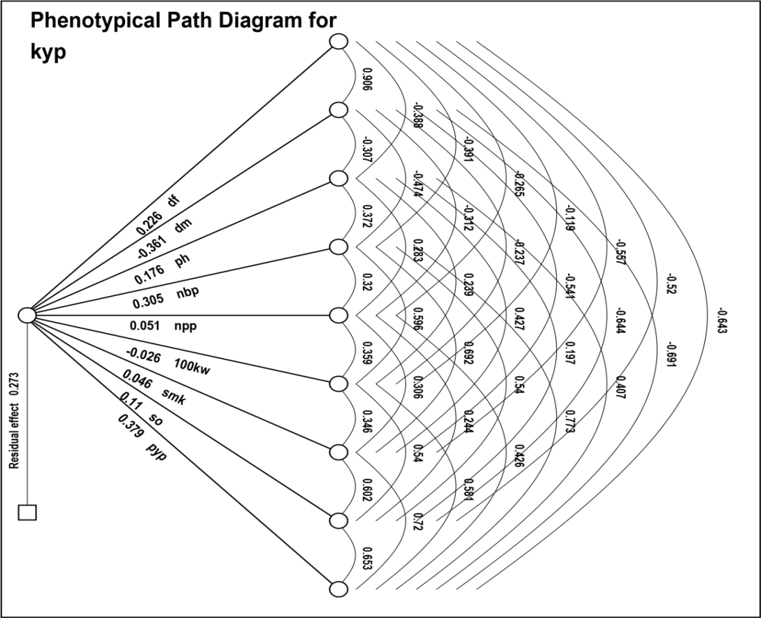
Fig. 2: Estimate of phenotypic path coefficient for 10 characters in groundnut (Arachis hypogaea L.)

4. Conclusion

The present study demonstrated significant genetic variability among the crosses for all traits, indicating ample scope for selection and improvement in groundnut. Correlation and path studies revealed that kernel yield per plant was positively and substantially associated with plant height, number of branches, number of pods, hundred-kernel weight, sound mature kernel %, shelling outturn, and pod yield per plant. Both phenotypic and genotypic path analyses emphasised the direct and positive contribution of pod yield per plant, number of branches, and days to 50% flowering toward kernel yield. Hence, these traits can serve as reliable selection criteria in future breeding programs aimed at enhancing kernel yield in groundnut.

Disclaimer (Artificial intelligence)
Author(s) hereby declare that NO generative AI technologies such as Large Language Models (ChatGPT, COPILOT, etc.) and text-to-image generators have been used during the writing or editing of this manuscript.

References ()

Bertioli, D. J., Jenkins, J., Clevenger, J., Dudchenko, O., Gao, D., Seijo, G., et al. (2019). The genome sequence of segmental allotetraploid peanut Arachis hypogaea. Nature Genetics, 51(5), 877–884.
Burton, G. W. (1952). Quantitative inheritance in grasses. In Proceedings of the Sixth International Grassland Congress (pp. 277–283). Pennsylvania, USA.
Desmae, H., Janila, P., Okori, P., Pandey, M. K., Motagi, B. N., Monyo, E., et al. (2019). Genetics, genomics and breeding of groundnut (Arachis hypogaea L.). Plant Breeding, 138(4), 425–444. https://doi.org/10.1111/pbr.12645
Dewey, J. R. & Lu, K. H. (1959). A correlation and path coefficient analysis of components of crested wheat grass seed production. Agronomy Journal, 51, 515-518.
El-Saady, A. M., El-Fouly, M. M., & El-Nour, E. A. A. A. (2014). Soil testing as a base for modifying fertilizer recommendations of groundnut. International Journal of Agriscience, 4, 313-320.
Gurjar, J. K., Meena, A. K., Yadav, M. R., & Rathore, J. S. (2025). Correlation and Path Coefficient Analysis of Yield and Its Component Traits in Groundnut (Arachis hypogaea L.). Journal of Experimental Agriculture International, 47(9), 170-177.
Hanson, G.H., Robinson, H.F. & Comstock, R.E. (1956). Biometrical studies on yield in segregating population. Agronomy Journal, 268-272.
Higgins, B. B. (1951). Origin and early history of the peanut. In The peanut: The unpredictable legume (pp. 118–127). Washington, DC: The National Fertilizer Association.
Jain, S., Singh, P. B. & Sharma, P. P. (2016). Correlation and path analysis in groundnut. International Journal of Current Research, 8(8), 35811-35813.
Johnson H. W., Robbinson H.F. & Comostock, R. E. (1955). Estimate of genetic and environmental variability in soybean. Agronomy Journal, 47, 314-318.
Johonson, H. W., Robinson, H. F., & Comostock, R. E. (1955). Estimates of Genetics and Environmental Variability in Soybeans. Agronomy Journal, 47(7), 314-318.
Khan, A., Rahim, M., Khan, M. I., & Tahir, M. (2000). Genetic variability and criterion for the selection of high-yielding peanut genotypes. Pakistan Journal of Agricultural Research, 16(1), 9–12.
Killi, F.& Beycioğlu, T. (2022). Genetic and environmental variability, heritability and genetic advance in pod yield, yield components, oil and protein content of peanut varieties. Turkish Journal Field Crop,27(1), 71-77. 10.17557/tjfc.1050448.
Kiranmai, M. S., Venkataravana, P. A., & Pushpa, H. D. (2016). Correlation and path analysis studies in groundnut under different environments. Legume Research, 39(6), 1048–1050.
Krapovickas, A., & Gregory, W. C. (1994). Taxonomía del géneroArachis (Leguminosae). Bonplandia, 8, 1–186.
Lu, Q., Li, H., Hong, Y., Zhang, G., Wen, S., Li, X., et al. (2018). Genome sequencing and analysis of the peanut B-genome progenitor (Arachisipaensis). Frontiers in Plant Science, 9, 604.
Makwana, K., Tiwari, S., Tripathi, M. K. & Patel V. (2023). Morphological diversity analysis of foxtail millet (Sateria Italica (L.) Beauv.) using qualitative and quantitative traits. Scientist, 2(2), 319-326.
Mathews, C., Nagda, A. K., & Sharma, U. C. (2000). A study of path analysis in groundnut. Madras Agricultural Journal, 87(7), 480–481.
Meta, H. R., & Monpara, B. A. (2010). Genetic variation and trait relationships in summer groundnut (Arachis hypogaea L.). Journal of Oilseeds Research, 26(2), 186–187.
Nwokolo, E. (1996). Peanut (Arachis hypogaea L.). In E. Nwokolo & J. Smartt (Eds.), Food and feed from legumes and oilseeds (pp. 49–63). Boston, MA: Springer US.
Panse, V. G., & Sukhatme, P. V. (1954). Statistical methods for agricultural workers (2nd ed.). Indian Council of Agricultural Research.
Pramanik, A., Tiwari, S., Tomar, R. S., Tripathi, M. K. & Singh, A. K. (2019). Molecular characterization of groundnut (Arachis hypogaea L.) germplasm lines and varietal set for yield and yield attributing traits. Indian Journal of Genetics and Plant Breeding, 79 (01), 56-65.
Rao, V. T., Venkanna, V., Bhadru, D., & Bharathi, D. (2014). Studies on variability, character association and path analysis on groundnut (Arachis hypogaea L.). International Journal of Pure and Applied Bioscience, 2(2), 194-197.
Rathod, S. S., & Toprope, V. N. (2018). Studies on variability, character association and path analysis in groundnut (Arachis hypogaea L.). International Journal of Pure and Applied Bioscience, 6(2), 1381–1388. https://doi.org/10.18782/2320-7051.5504
Reddy, V. R., Sravanti, K., Navatha, N., Vanisri, S., Goverdhan, M., Reddy, M. M., … Sreedhar, M. (2025). Correlation and Path Coefficient Analysis in Groundnut (Arachis hypogaea L.) Genotypes. Journal of Advances in Biology & Biotechnology, 28(10), 1276–1282.
Sharma, N., Tiwari, S., Tripathi, M. K., Gupta, N., Singh, S. & Sikarwar, R. S. (2023). Selection of groundnut germplasm lines based on yield, nutritional, antinutritional and antioxidant parameters. Scientist. 2(1), 96-105. DOI: https://doi.org/10.5281/zenodo. 7536324
Sridevi, S.; Meenakumari, B.; Manivannan, N.& Ravichandran, V. (2022). Assessment of genetic variability, character association and path analysis of kernel yield and yield components in groundnut (Arachis hypogaea L.). Electronic Journal of Plant Breeding, 13(2), 476-481.
Tomar, Y. S., Tiwari, S., Tripathi, M. K. & Singh, R. (2022). Genetic diversity assessment and cluster analysis of morphological yield attributing traits of groundnut (Arachis hypogaea L.). The Pharma Innovation, 11(6), 1444-1450.
Wright, S. (1934). The method of path coefficients. The annals of mathematical statistics, 5(3), 161-215.
Yami, A. S., & Abtew, W. G. (2025). Assessment of Genetic Variability for Yield and Yield‐Contributing Traits in Groundnut (Arachis hypogaea L.) Genotypes. Journal of Food Quality, 2025(1), 3370389.
Zaman, M. A., Tuhina-Khatun, M., Ullah, M. Z., Moniruzzamn, M., & Alam, K. H. (2011). Genetic variability and path analysis of groundnut (Arachis hypogaea L.). The Agriculturists, 9(1-2), 29-36.

Definitions, Acronyms, Abbreviations
RKB: Ravleen Kaur Badwal
RSS: Dr Ravendra Singh Sikarwar
R: Rohit
PC: Pavan Chouksey
BY: Bakeshwar Yadav
R.V.S.K.V.V.: Rajmata Vijayaraje Scindia Krishi Vishwa Vidyalaya
RBD: Randomised Block Design

