Case report
Management of acute spasmodic colic superimposed on chronic parasitic enteritis in a Kathiawari mare

ABSTRACT
Colic remains as an emergency condition in equines, characterized by acute abdominal pain due to various gastrointestinal or extra-gastrointestinal causes. Spasmodic colic is a functional disturbance associated with intestinal motility disorder, often present and recurrent sometimes however, can also be triggered by underlying chronic management issues. This report details the clinical management of a ten-year-old Kathiawari mare with acute abdominal pain through ten-day history of intermittent diarrhea. Diagnostic investigation revealed marked intestinal hypermotility and mild dehydration. Successful management involved a multimodal approach, including immediate fluid therapy with visceral analgesic (Flunixin meglumine), spasmolytic agent (Hyoscine butylbromide) and prophylactic antimicrobial coverage to address potential mucosal compromise. The case highlights the significance of neglected deworming protocols as a predisposing factor for spasmodic episodes via chronic inflammatory sensitization, underscoring the efficacy of rapid medical intervention in indigenous breeds.

Keywords: spasmodic colic, abdominal pain, intestinal motility disorder, Kathiawari mare, muscular contractions

INTRODUCTION
The management of equine colic requires a systematic diagnostic approach to differentiate between medical and surgical cases. Spasmodic colic accounts for approximately 40% of colic presentations and is characterized by painful, uncoordinated muscular contractions of the intestinal wall (Fereig, 2023). While often idiopathic or linked to acute stressors such as sudden diet changes (Cohen et al., 1999; Curtis et al., 2019), recurrent or "acute-on-chronic" presentations may stem from underlying issues such as parasitic burden or chronic enteritis.
Parasitic inflammation, particularly from larval migration or mucosal attachment, releases inflammatory mediators (e.g., histamine, cytokines) that sensitize the enteric nervous system (ENS). This sensitization predisposes the gut to hypermotile spasms even in the absence of physical impaction. This case report discusses the diagnosis and successful medical management of a mare presenting with acute spasmodic colic complications arising from a background of chronic parasitic enteritis and neglected preventative care.

Case Presentation

Case HISTORY AND OBSERVATION
A ten-year-old bay Kathiawari mare, weighing approximately 400 kg, was presented to the Veterinary College and Research Institute, Tirunelveli, with acute signs of colic. History revealed a significant ten days course of recurrent, mild abdominal discomfort and intermittent watery diarrhea, for which the owner had attempted unsuccessful self-medication. No previous history of colic reported. Crucially, the history indicated a lapse in preventive care: the animal was not up-to-date on vaccinations, and the last deworming had occurred 6 months earlier, exceeding the recommended interval.
Upon admission, the mare exhibited classic behavioral indicators of acute visceral pain, including restlessness, frequent flank watching, patchy sweating, frequent lying down and lateral recumbency.
Physical examination revealed signs of pain induced distress and mild hypoperfusion. The rectal temperature was recorded at 35.9 °C, this subnormal reading was attributed to poor peripheral perfusion .Cardiovascular assessment revealed tachycardia (81 beats/min) and tachypnea (36 breaths/min). The pulse was feeble and thready and the mucous membranes appeared injected (dark red), with a capillary refill time (CRT) of >3 seconds and skin tenting time of 4-6 seconds (mild dehydration).While these parameters initially raised concerns for endotoxemic shock, the clinical picture specifically the rapid fluctuation in pain intensity consistent with severe abdominal pain-mediated catecholamine release and subsequent peripheral vasospasm.
Auscultation of the abdomen revealed marked intestinal hypermotility, with >4 gut sounds per minute per quadrant (borborygmi) and intermittent grunting. No palpable abnormality found on rectal examination. The presence of hypermotility and diarrhea, combined with the absence of significant abdominal distension or gastric reflux, ruled out physical impaction or strangulating lesions, favoring a diagnosis of functional spasmodic disturbance.

DIAGNOSTIC ASSESSMENT
Diagnostic investigations were performed to assess systemic status. Hematology revealed a mild leukocytosis (WBC 12,200/µL) and eosinophilia may be attributed to physiological stress (leukogram) or underlying inflammation from chronic enteritis in accordance with Aiello & Moses, 2016. Hemoglobin (11.4 g/dL) and PCV (35.3%) were within the normal limits this was in concurrence with Aiello & Moses, 2016, may be as a result of compensatory mechanism due to chronic condition. Serum biochemistry may indicate pre-renal azotemia, evidenced by mild elevation of BUN (64.07 mg/dL) and Creatinine level (1.90 mg/dL)), due to dehydration and gastrointestinal protein catabolism (Aiello & Moses., 2016).
Based on the hypermotile gut sounds, history of neglected deworming, and clinical signs, the diagnosis was presumed as acute spasmodic colic.

DISCUSSION
A multimodal medical approach was implemented to stabilize the patient, relieve spasms, and address the underlying parasitic load. The maintenance fluid [calculated at approximately 60ml/kg BW [$Maintenance volume=400kg X 60ml/kg=24L$ )] was given (Constable et al., 2017). In the horse, the current approach is typically to administer a 10–20 ml/kg bolus of crystalloid followed by reassessment of indicators of perfusion (e.g., heart rate, capillary refill time, pulse quality, extremity temperature, systemic lactate, urination, blood pressure, etc.,), and intravascular volume (jugular fill). (Crabtree & Epstein, 2021). To address immediate hypovolemia and improve perfusion, an initial intravenous bolus of 5 L was administered. This solution comprised 3 L of Ringer’s Lactate for isotonic volume expansion and 2 L of dextrose normal saline. While isotonic crystalloids are the standard for rehydration, the addition of dextrose was elected to provide an immediate energy substrate for this catabolic patient, countering potential hypoglycemia associated with the prolonged ten-day history of anorexia and stress. Further the animal was provided with oral fluids gradually over a period of 24 hour once the spasm resolved. The oral route was prioritized to ensure direct hydration of the intestinal lumen and a critical factor in resolving the 10-day history of intermittent diarrhea. (Gregorio et al., 2016).
Visceral analgesia and anti-inflammatory support were provided via Flunixin meglumine (1.1 mg/kg IV). Concurrent antispasmodic therapy involved Hyoscine butylbromide (Buscowin®) at 0.3 mg/kg IV to competitively inhibit muscarinic acetylcholine receptors, effectively halting smooth muscle spasms (Roelvink et al., 1991; Borsha et al., 2025). Gastric mucosal protection was provided via Pantoprazole (1 mg/kg IV) to mitigate stress induced gastric acidity associated (Grady et al., 2024).
Broad-spectrum antibiotic coverage (Amoxicillin/Cloxacillin) was administered. While modern veterinary stewardship guidelines advocate for a One Health approach that generally restricts antibiotic use in uncomplicated colic (Grady et al., 2024), this case presented a specific exception, the ten-day history of diarrhea presents a significant risk of mucosal barrier compromise, increasing the likelihood of bacterial translocation across the gut wall. Therefore, prophylactic coverage was deemed critical to prevent the development of septicemia/peritonitis despite the absence of frank fever at presentation.
As the acute pain subsided and the mare displayed an interest in feed (approximately one hour post-treatment) after specific therapy for the spasmodic colic cause was initiated. A single dose of Fenbendazole (3 g PO) was administered for suspected parasitic etiology and an oral herbal antidiarrheal preparation (Diaroak, 30 g PO BID) was given for 5 days to aid mucosal recovery.
The mare demonstrated a rapid clinical response, with signs of pain and restlessness subsiding within 30 minutes of antispasmodic administration. Intestinal motility normalized, and appetite returned within one hour. The rapidity of the recovery necessitates a critical interpretation of the initial "shock" parameters; the injected mucous membranes and weak pulse were likely driven by severe pain-induced catecholamine release and an increase in vagal tone, which causes an increase in gut peristalsis and a propensity to spasm (Fereig., 2023) rather than true endotoxemic circulatory collapse. This interpretation is supported by the immediate improvement following analgesia without the need for massive volume expansion.
The diagnosis of spasmodic colic was confirmed by response to therapy with normal intestinal motility, no evidence of colic signs and exclusion of impaction or obstruction via the absence of gastric reflux or distension and absence of palpable abnormality in rectal examination. However, the etiology warrants careful consideration. Despite absence of a quantitative Fecal Egg Count (FEC) prior to treatment because therapy was initiated on an emergency basis.
Faecal examination revealed the Strongyle spp., egg. A dramatic cessation of symptoms following spasmolytic agent administration, a history of poor anthelmintic prophylaxis, the lack of recurrence of colic signs and improved faecal consistency following overdue anthelmintic (Fenbendazole) treatment indicates Strongyle spp., involvement. Verminous colic can be alleviated using potent anthelmintics such as oral administration of fenbendazole, ﬂuid therapy, anti-spasmodic, and antibiotic medicines (Gehlen et al., 2020; Fereig, 2023).
The ten-day history suggests that the acute spasms were not idiopathic but rather a secondary complication of chronic irritation which may be caused by Strongyle spp. Management factors, specifically poor deworming practices, are well-documented risk factors for such colic episodes (Cohen et al., 1999). The parasites live in the small and large intestines and can cause diarrhea, thriftiness, and colic. Strongyle infection have been reported to cause up to 81% of ileal impactions (Fereig., 2023)
Parasitic larvae are known to induce local inflammation and hypersensitivity of the enteric nervous system, lowering the threshold for spasmodic events (Fikri et al., 2023). In addition, the submucosal migration and mucosal penetration parasitic larvae is well-known to initiate changes in the ileal myoelectrical motion that could lead to the evolution of colic in equines. Hyperperistalsis of spasmodic colic in equines may arise due to an increase in the parasympathetic nerve tone under the effect of causative agents (Constable et al., 2017; Tharwat et al., 2025)
The Kathiawari breed is often noted for its high alertness and sensitivity; it is possible that this breed characteristic contributed to the exaggerated behavioral display of pain relative to the severity of the lesion. Weather changes, overexertion/excitement such as during thunderstorms, preparation for displaying, drinking cold water in hot weather, and sweating after work, feeding errors, feeding technique, and feed quantity and quality are all factors that predispose horse to colic (Constable et al., 2017; Mair & Sherlock., 2023).
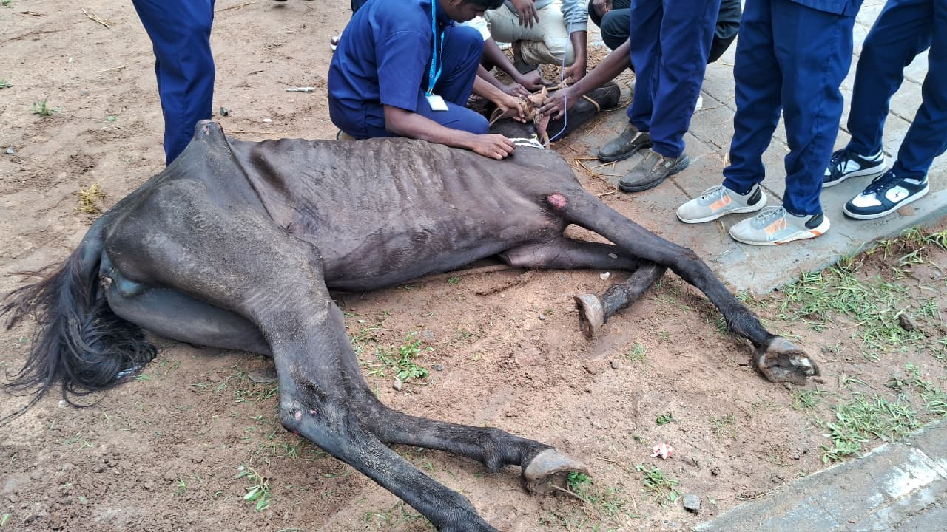 | 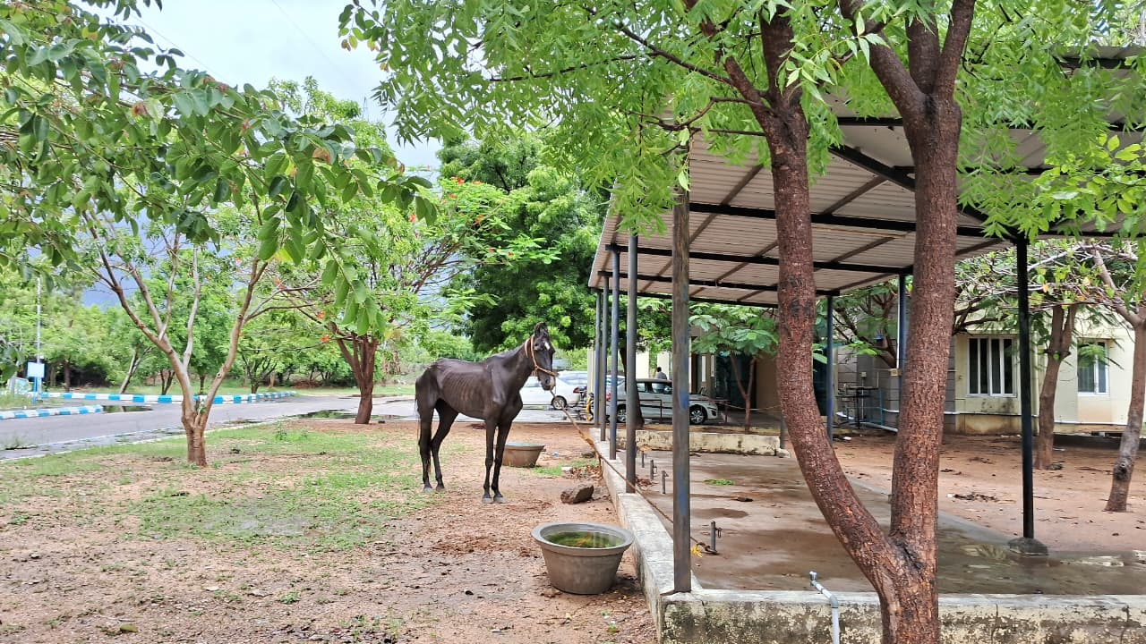
Fig.1 :Before treatment | Fig.2 : After treatment

Table 1 : Diagnostic Investigations

HAEMATOLOGY (Aiello & Moses, 2016).
 | OBSERVED VALUE | NORMAL VALUE
Hemoglobin (g/dl) | 11.4 | 10-16
PCV (%) | 35.3 | 27-43
RBC (m/cmm) | 6.89 | 6-10.4
Platelet (/cmm) | 185000 | 117000-256000
WBC (/cmm) | 12200 | 5.6-12.1
Neutrophils (%) | 57 | 52-70
Lymphocytes (%) | 34 | 21-42
Monocytes (%) | 3 | 0-6
Eosinophils (%) | 6 | 0-7
Basophils (%) | 0 | 0-2

SERUM BIOCHEMISTRY (Aiello & Moses., 2016).
 | OBSERVED VALUE | NORMAL VALUE
BUN (mg/dl) | 64.07 | 11-27
Creatinine (mg/dl) | 1.90 | 0.4-2.2
Total protein (g/dl) | 6.61 | 5.6-7.6
Albumin (g/dl) | 2.79 | 2.6-4.1
Glucose (mg/dl) | 97.8 | 62-134

CONCLUSION
This case illustrates that "spasmodic colic" in indigenous breeds may often be the acute presentation of a management failure. Successful management requires two-prolonged approach: immediate multimodal therapy to resolve life-threatening pain, followed by anthelmintic to eliminate the predisposing cause.

Conflict of Interest
The authors declare that there is no conflict of interest regarding the publication of this case report. The research was conducted in the absence of any commercial or financial relationships that could be construed as a potential conflict of interest.

Ethical Approval
Ethical approval was not required for this case report as all diagnostic and therapeutic procedures were part of routine clinical management. The study did not involve experimental interventions.

Disclaimer (Artificial intelligence)
The authors declare that artificial intelligence tools were used only to assist with language polishing, formatting, and structural organization of the manuscript. All clinical data, interpretations, and conclusions were generated by the authors, who retain full responsibility for the accuracy and integrity of the work.

Reference

- Aiello, S. E., & Moses, M. A. (Eds.). (2016). The Merck veterinary manual (11th ed.). Merck/Wiley. ISBN: 978-0-911-91061-2.
- Borsha, R. P., Hasan., M. & Zabbar, . M. A. (2025) Chronic spasmodic colic management in a thoroughbred horse: A case report from Bangladesh. Open Veterinary Journal, 15 (12), 6801-6804. doi:10.5455/OVJ.2025.v15.i12.58
- Cohen, N. D., Gibbs, P. G., & Woods, A. M. (1999). Dietary and other management factors associated with colic in horses. Journal of the American Veterinary Medical Association, 215(1), 53–60. PMID: 10397066
- Constable P.D., Hinchcliff K.W., Done S.H., Gruenberg W. 11th. St. Louis, Missouri, USA: Saunders (2017). Veterinary medicine: a textbook of the diseases of cattle, horses, sheep, pigs and goats.
- Crabtree, N. E., & Epstein, K. L. (2021). Current Concepts in Fluid Therapy in Horses. Frontiers in veterinary science, 8, 648774. https://doi.org/10.3389/fvets.2021.648774 PMID: 33855057 PMCID: PMC8039297 DOI: 10.3389/fvets.2021.648774
- Curtis, L., Burford, J. H., England, G. C. W., & Freeman, S. L. (2019). Risk factors for acute abdominal pain (colic) in the adult horse: A scoping review of risk factors, and a systematic review of the effect of management-related changes. PloS one, 14(7), e0219307. https://doi.org/10.1371/journal.pone.0219307 PMID: 31295284
- eISSN: 2703-1322
- Fereig, R. M. (2023). A review on equine colic: Etiology, differential diagnosis, therapy, and prevention. Ger. J. Vet. Res. 3 (4): 1-12. https://doi.org/10.51585/gjvr.2023.4.0063
- Fikri, F., Hendrawan, D., Wicaksono, A. P., Purnomo, A., Khairani, S., Chhetri, S., Maslamama, S. T., & Purnama, M. T. E. (2023). Incidence, risk factors, and therapeutic management of equine colic in Lamongan, Indonesia. Veterinary world, 16(7), 1408–1414. https://doi.org/10.14202/vetworld.2023.1408-1414 PMID: 37621536 PMCID: PMC10446712
- Gehlen, H., Wulke, N., Ertelt, A., Nielsen, M. K., Morelli, S., Traversa, D., Merle, R., Wilson, D., & Samson-Himmelstjerna, G. V. (2020). Comparative Analysis of Intestinal Helminth Infections in Colic and Non-Colic Control Equine Patients. Animals: an open access journal from MDPI, 10(10), 1916. PMID: 33086590 PMCID: PMC7603170 https://doi.org/10.3390/ani10101916
- Grady, K., Gould, E., & Tolbert, M. K. (2024). From theory to therapy: a One Health approach guides current and future acid suppressant use in veterinary medicine. Journal of the American Veterinary Medical Association, 262(10), 1305–1313. PMID: 39168146 https://doi.org/10.2460/javma.24.07.0434
- Gregorio, G. V., Gonzales, M. L., Dans, L. F., & Martinez, E. G. (2009). Polymer-based oral rehydration solution for treating acute watery diarrhoea. The Cochrane database of systematic reviews, (2), CD006519. PMID: 19370638 https://doi.org/10.1002/14651858.CD006519.pub2
- Mair, T., & Sherlock, C. (2023). Recurrent Colic: Diagnosis, Management, and Expectations. The Veterinary clinics of North America. Equine practice, 39(2), 399–417. https://doi.org/10.1016/j.cveq.2023.03.014 PMID: 37121784
- Roelvink, M. E., Goossens, L., Kalsbeek, H. C., & Wensing, T. (1991). Analgesic and spasmolytic effects of dipyrone, hyoscine-N-butylbromide and a combination of the two in ponies. The Veterinary record, 129(17), 378–380. https://doi.org/10.1136/vr.129.17.378 PMID: 1746114
- Tharwat, M., & Al-Sobayil, F. (2025). Equine colic: A comprehensive overview of the sonographic evaluation, diagnostic criteria, and management of different categories. Open veterinary journal, 15(3), 1116–1139. https://doi.org/10.5455/OVJ.2025.v15.i3.5 PMID: 40276205 PMCID: PMC12017722

