Minireview Article
Microbiome-Driven Regulation of Brain Function: Molecular Pathways Linking Gut and Neuropsychiatric Health
Abstract
This review critically appraises seminal studies on emerging mechanisms of gut-brain communication, summarising microbiome-targeted clinical interventions, and highlighting future trajectories for therapeutic development in mental health. The gut microbiome, comprising trillions of microbial cells, exerts major influence over host metabolism, immunity, and neural function. Through the gut–brain axis, a complex network linking neural, immune, and endocrine pathways, microbial communities shape cognition and emotional regulation. Mounting evidence identifies key microbial taxa, metabolites, and molecular pathways governing mental health. Core mediators include short-chain fatty acids, tryptophan–kynurenine metabolites, and bile acid derivatives, which modulate blood–brain barrier integrity, neurotransmission, and systemic inflammation. Dysbiosis-driven endotoxaemia, particularly via lipopolysaccharide signalling, activates neuroinflammatory cascades implicated in depression and anxiety. Precision psychobiotics such as Bifidobacterium longum NCC3001 and Lactobacillus plantarum PS128 show strain-specific efficacy in reducing depressive symptoms in randomised controlled trials. Both animal and human studies highlight bidirectional interplay: psychological stress reshapes gut ecology, while microbial imbalance disrupts mood and cognition. Emerging interventions, including faecal microbiota transplantation and synthetic microbial consortia, show translational promise but remain constrained by ethical and regulatory barriers. This review integrates findings from clinical trials, multi-omics mapping, and computational models to clarify microbiome–brain mechanisms. It outlines prospective directions in psychobiotic design, metabolite biomarkers, and systems-based therapeutics, framing the gut microbiome as a modifiable determinant of neuropsychiatric health. With continued rigorous investigation and integration across disciplines, microbiome research is poised to revolutionise our understanding and management of mental health disorders, ultimately enhancing patient outcomes and quality of life.

Keywords: Gut–brain axis; Gut microbiota; Intestinal dysbiosis; Neuroinflammation; Psychobiotics; Depression; Autism spectrum disorder; Microbiome-targeted therapy; Precision psychiatry.

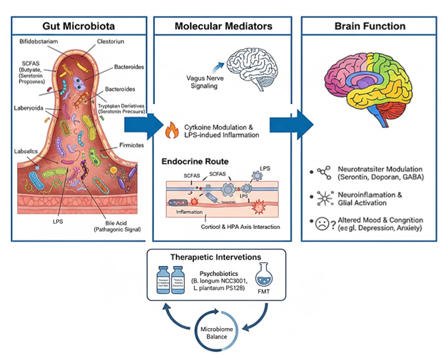
Graphical abstract: The Gut-brain axis, Molecular communication and therapeutic targets

1. Introduction
The brain–gut–microbiome (BGM) system refers to the bidirectional communication network between the brain, the gut connectome, the gut-associated immune system, and the gut microbiome. The gut microbiome has a profound impact on host physiology, including digestion,² metabolism, immune function, and brain development. Based largely on mechanistic studies performed in animal models and correlational human studies, dysregulation of the system has been implicated in a wide range of disorders, including intestinal disorders, metabolic conditions, psychiatric disorders, and neurologic diseases. Therefore, gaining comprehensive insights into this system has the potential to develop novel diagnostic tools, therapeutic interventions, and personalised approaches to improve human health (Esmail, 2022; Dong & Mayer, 2024). Mental health disorders, including major depressive disorder (MDD), anxiety disorders, bipolar disorder, schizophrenia, and neurodevelopmental disorders, are among the leading causes of disability and global disease burden, affecting hundreds of millions worldwide [42, 27]. Despite the availability of pharmacological and psychotherapeutic treatments, rates of treatment resistance, relapse, and incomplete recovery remain unacceptably high [42]. Therefore, understanding novel biological mechanisms underlying psychiatric disorders is a critical frontier in neuroscience and psychiatry. Emerging research proposed neuroinflammation as a possible factor bridging neurodegeneration and the gut microbiome via complex bidirectional interactions between gut microbes, the peripheral immune system, and neurodegeneration. Neuroinflammation is a pathophysiological marker that is a commonly presenting sign despite the high variability of other pathophysiological markers in Alzheimer’s disease (AD) patients. Given the extensive involvement of the gut microbiome in regulating a host’s immune responses, microbiome-targeted modulation has the potential to mitigate neuroinflammation-induced neurodegeneration over time (Hochuli et al., 2023).
One of the most exciting developments in recent years is the recognition of the gut microbiome’s pivotal role in modulating brain function and behaviour, a concept organised under the umbrella term gut-brain-microbiome (GBM) axis. The gut microbiome, composed of trillions of microorganisms residing primarily in the colon, encodes a genomic repertoire far exceeding that of the human host [11,27]. These microbes interact bidirectionally with the CNS through immunological, metabolic, neural (vagus nerve), and endocrine pathways, influencing neurotransmitter dynamics, stress responsivity, and neuroinflammation [42,29]. As shown in Figure 1, the gut–brain–microbiome axis constitutes an intricate, bidirectional network integrating neural, immune, endocrine, and metabolic pathways that collectively shape mental health outcomes.
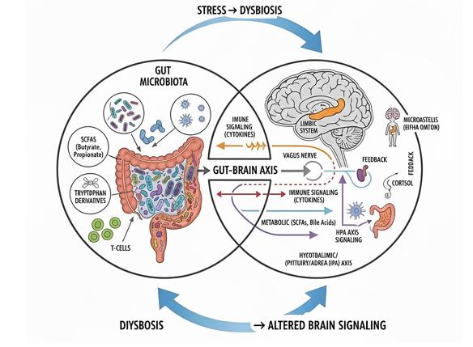
Figure 1: The Gut-Brain Superhighway: a systems overview, Integrated pathways of gut-brain-microbiota axis linking intestinal and neural homeostasis
Research comparing patients with psychiatric illness to healthy controls consistently finds alterations in microbial diversity and abundance in conditions such as depression, characterised by depletion of Faecalibacterium, Coprococcus, Lactobacillus, and Bifidobacterium and anxiety disorders, which exhibit reduced short-chain fatty acid (SCFA)-producing bacteria and increased pro-inflammatory species [31,42]. Neuroinflammatory signalling mediated by gut barrier dysfunction and bacterial endotoxins contributes to altered neurotransmitter biosynthesis, such as serotonin and GABA, directly affecting behaviour and cognition [42,31].
These intriguing mechanistic insights have spurred the development of microbiome-modulating strategies, including live biotherapeutic psychobiotics, prebiotics, dietary interventions, and faecal microbiota transplantation (FMT). Early clinical trials suggest these interventions can improve mood and reduce anxiety symptoms when used alone or adjunctively, but larger, standardised trials are needed [47,48]. The field is poised to move toward a precision medicine approach, integrating multi-omics data to guide personalised psychobiotic therapy.
This review critically appraises seminal studies on emerging mechanisms of gut-brain communication, summarising microbiome-targeted clinical interventions, and highlighting future trajectories for therapeutic development in mental health.
2. Mechanistic Pathways of the Gut–Brain Axis
The gut–brain axis (GBA) is a complex, bidirectional communication system linking the gastrointestinal tract with the central nervous system (CNS) via neural, endocrine, immune, and metabolic pathways [50,24,37]. This interconnected axis regulates digestive function and maintains homeostasis, and plays a critical role in neurodevelopment, behaviour, and mental health.
2.1 Neural Pathways
The vagus nerve is the principal neural conduit transmitting sensory information from the gut to the brain. This afferent signalling modulates brain regions involved in mood and cognition, including the amygdala, hippocampus, and prefrontal cortex. Certain gut bacteria influence vagal signalling by producing neuroactive compounds such as gamma-aminobutyric acid (GABA), serotonin precursors, and dopamine, directly modulating central nervous system neurotransmission [50,3]. The molecular mediators governing gut–brain communication are diverse, involving neurotransmitters, microbial metabolites, and receptor-mediated pathways (Figure 2)
Furthermore, the enteric nervous system (ENS), composed of the myenteric and submucosal plexuses, functions semi-autonomously to regulate gut motility and secretory activity. It communicates bidirectionally with the CNS through sympathetic and parasympathetic pathways, enabling rapid adaptation of gastrointestinal physiology to environmental and internal stimuli [37].
Vagal afferents do not directly contact the microbiota but receive input via enteroendocrine cells, which respond to microbial metabolites such as short-chain fatty acids by releasing neurotransmitters like serotonin. These sensory signals are relayed to brainstem nuclei, subsequently influencing higher brain centres responsible for emotional and cognitive processing. Thus, gut microbial activity integrates with host neurophysiology and behaviour [2,34,25]
This neural interplay constitutes a foundational pathway by which microbiota influence brain function, highlighting promising targets for microbiome-modulating therapeutics in neuropsychiatric disorders [25,50,37].

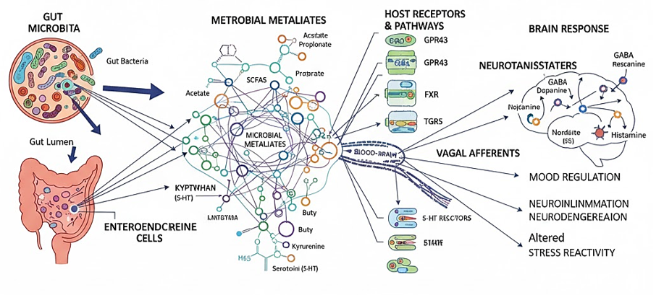Figure 2: Molecular mediators of microbiota-brain crosstalk, molecular signaling network through microbial metalates regulates neural and encoding pathways

2.2 Endocrine and HPA Axis Signalling
Stress-induced activation of the hypothalamic-pituitary-adrenal (HPA) axis leads to the release of cortisol, which modulates gut permeability and the composition of the microbiota. Cortisol acts upon intestinal epithelial and immune cells, influencing tight junction proteins and thereby intestinal barrier integrity. Disruption of this regulation, especially under chronic stress or inflammatory conditions, results in increased gut permeability—commonly referred to as ‘leaky gut’—allowing microbial products to translocate into systemic circulation and exacerbate inflammatory responses [21,42].
Conversely, metabolites produced by gut microbes exert regulatory control over the HPA axis, affecting systemic cortisol levels and behavioural stress responses. The microbiota modulates circadian rhythms of corticosterone and plays a pivotal role in maintaining HPA axis homeostasis via signalling molecules that either cross the blood–brain barrier or activate vagal afferents. Dysbiosis perturbs this balance, disrupting stress resilience and increasing susceptibility to neuropsychiatric conditions [21,42].
Further, microbial metabolism of bile acids influences HPA axis activity through interactions with hypothalamic receptors such as FXR and TGR5, modulating corticotropin-releasing hormone secretion and glucocorticoid metabolism, thereby linking microbial bile acid profiles with stress axis regulation [42,8].
2.3 Microbial Metabolites as Signalling Molecules
The gut microbiota generates short-chain fatty acids (SCFAs), including acetate, propionate and butyrate via fermentation of dietary fibres. These SCFAs cross the blood–brain barrier and impact microglial maturation, suppress neuroinflammation, and promote neuroplasticity through epigenetic mechanisms such as histone deacetylase (HDAC) inhibition [50,29].
Additionally, microbial modulation of tryptophan metabolism affects the balance between serotonin biosynthesis and the production of kynurenine pathway metabolites, including neurotoxic excitotoxins implicated in depression and anxiety. Gut bacteria also synthesise neurotransmitters such as gamma-aminobutyric acid (GABA) and dopamine precursors, thereby influencing central nervous system neurochemistry [42,8,37].
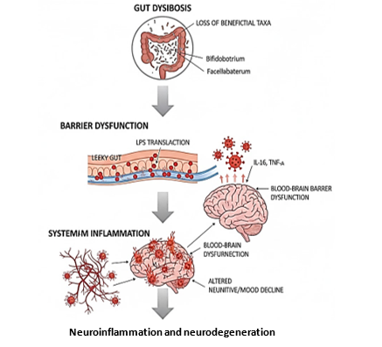
Figure 3: Molecular mediators of microbiota-crosstalk. Molecular signaling through which microbial metabolites regulate neural and endocrine pathways
2.4 Immunomodulation
Compromise of intestinal barrier function, or ‘leaky gut’, permits translocation of bacterial lipopolysaccharide (LPS) into systemic circulation, activating innate immune responses. Elevated pro-inflammatory cytokines, including interleukin-6 and tumour necrosis factor-alpha, promote microglial activation within the central nervous system, contributing to neuroinflammation associated with psychiatric disorders such as depression (37,42]. Chronic dysbiosis disrupts epithelial integrity and induces neuroinflammatory cascades through LPS and cytokine signalling, as summarised in Figure 3.
HPA axis-derived glucocorticoids affect mucosal immunity by regulating secretory immunoglobulin A production, which maintains microbial homeostasis. Dysregulation of this balance can precipitate a pro-inflammatory milieu, perpetuating gut–brain axis dysfunction [21].
2.5 Bile Acids and Neuroactive Compounds
Secondary bile acids, produced by microbial metabolism of primary bile acids, activate host receptors such as FXR and TGR5, which are crucial for neuroimmune regulation. These bile acids influence neurotransmitter systems and have been linked to mood disorders and neurodegenerative diseases [8,42,22,6].
Microbial-derived lithocholic and deoxycholic acids modulate brain function by crossing physiological barriers and regulating serotonin synthesis via enterochromaffin cells. Their balance is essential for neuroprotection, but disturbed levels contribute to neuroinflammation and cognitive decline. Activation of FXR and TGR5 exerts anti-inflammatory effects by downregulating pro-inflammatory cytokine expression and promoting regulatory immune phenotypes, which mitigate neuroinflammatory processes involved in psychiatric and neurodegenerative conditions [49,51].
Altered secondary bile acid profiles associate with disease progression in Alzheimer’s and Parkinson’s, highlighting their potential as biomarkers and therapeutic targets within the microbiome–gut–brain axis [6]. Overall, secondary bile acids represent a pivotal interface linking microbial metabolism to brain health and systemic immunity.
3. Clinical Interventions and Therapeutic Potential
Advances in microbiome research have catalysed the development and testing of targeted interventions to modulate gut microbial communities to improve mental health outcomes. The main therapeutic modalities under investigation encompass psychobiotics (probiotics with mental health benefits), prebiotics, dietary modification, and faecal microbiota transplantation (FMT) [42,48].​ Table 1 summarises key microbial taxa altered across neuropsychiatric and neurodegenerative disorders, highlighting convergent loss of SCFA-producing bacteria and enrichment of pro-inflammatory taxa

Table 1: Altered gut microbial signatures and functional consequences across major mental and neurodegenerative disorders
Disorder | Key Microbial Changes | Functional Consequences Links | Representative Studies
Major Depressive Disorder (MDD) | ↓ Faecalibacterium, Bifidobacterium, Lactobacillus; ↑ Alistipes, Oscillibacter, Enterobacteriaceae | Reduced SCFA production, altered serotonin biosynthesis, increased intestinal permeability, and low-grade inflammation | [52,18,46]
Generalised Anxiety Disorder (GAD) | ↓ Lactobacillus, Bifidobacterium; ↑ Ruminococcus, Desulfovibrio | Enhanced HPA axis activation, altered GABAergic signalling, and elevated cortisol | [23]
Autism Spectrum Disorder (ASD) | ↑ Clostridium, Desulfovibrio, Bacteroides; ↓ Prevotella, Bifidobacterium | Increased propionic acid and LPS, neuroinflammation, impaired neurotransmitter metabolism | [20,44]
Schizophrenia | ↓ Faecalibacterium, Lachnospira; ↑ Lactobacillus, Ruminococcus, Veillonella | Imbalanced SCFA profile, kynurenine pathway activation, oxidative stress | [52,33]
Bipolar Disorder | ↓ Lachnospiraceae, Ruminococcaceae; ↑ Actinobacteria | Dysregulated energy metabolism and inflammatory cytokine release | [35]
Alzheimer’s Disease (AD) | ↓ Firmicutes, Bifidobacterium, Eubacterium; ↑ Bacteroides, Escherichia/Shigella | LPS and amyloid cross-seeding, BBB disruption, neuroinflammation | [53,23]
Parkinson’s Disease (PD) | ↓ Prevotellaceae, Roseburia; ↑ Enterobacteriaceae, Akkermansia | α-Synuclein aggregation, gut barrier dysfunction, reduced SCFA-mediated neuroprotection | [40,14]
Multiple Sclerosis (MS) | ↓ Faecalibacterium, Butyricimonas; ↑ Akkermansia, Methanobrevibacter | Reduced butyrate production, increased Th17-mediated inflammation | [17,5]

3.1 Psychobiotics: Live Microbial Therapeutics
Psychobiotics are defined as live bacteria that, when ingested in sufficient quantities, exert positive effects on mood, cognition, and behaviour by modulating gut-brain signalling pathways [47]. Randomised controlled trials with Lactobacillus and Bifidobacterium strains demonstrate improvements in depressive symptoms, anxiety, and stress reactivity. For instance, supplementation with Lactobacillus acidophilus, Bifidobacterium bifidum, and Lactobacillus casei showed a significant reduction in the Beck Depression Inventory scores and inflammatory biomarkers in patients with mild-to-moderate depression [47]. However, sensitivity to probiotic strains varies between individuals, influenced by initial microbiota composition, genetic factors, and environmental exposures, underscoring the need for personalised approaches [19].​ Several psychobiotic strains exhibit anxiolytic and antidepressant-like effects by modulating vagal and endocrine signalling pathways, as outlined in Figure 4.

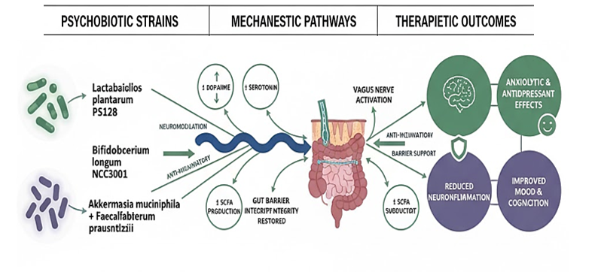
Figure 4: Psychobiotics and next-generation probiotics, a mechanistic overview of psychobiotic acting through neural, endocrine and immune pathways

Adjunctive benefits are reported when psychobiotics are combined with selective serotonin reuptake inhibitors (SSRIs), potentially through synergistic attenuation of neuroinflammation and HPA axis hyperactivity [38]. Nonetheless, further large-scale, placebo-controlled trials are necessary to establish optimal strains, doses, treatment durations, and responder profiles [47].
3.2 Prebiotics and Dietary Modifications
Prebiotics, non-digestible dietary fibres such as fructooligosaccharides, promote the growth of beneficial commensal microbiota that produce neuroactive metabolites like short-chain fatty acids (SCFAs). Clinical interventions increasing dietary fibre and adherence to polyphenol- and omega-3-rich diets have consistently improved mood and cognitive function in at-risk and diagnosed populations [29,42]. Dietary modulation of gut microbial diversity and metabolic activity leads to downstream alterations in immune mediators and neurotransmitter precursor availability, mediating anxiolytic and antidepressant effects [48].
Mediterranean, ketogenic, and anti-inflammatory dietary patterns have demonstrated promise in preliminary studies, with observed improvements linked partly to microbiome shifts; however, rigorous randomised controlled trials are necessary to validate sustainability and clinical efficacy [29].
3.3 Faecal Microbiota Transplantation (FMT)
FMT—the infusion of microbiota from healthy donors into recipients with microbiome dysbiosis—has revolutionised the treatment of recurrent Clostridioides difficile infections. It is increasingly evaluated in psychiatric disorders, including treatment-resistant depression and autism spectrum disorders (ASD) [43,45]. Early clinical data report short-term improvements in depressive and anxiety symptoms, with some studies indicating extended benefits up to 17 months, although many show transient effects lasting a few months [30].
Challenges to clinical integration include safety concerns, strict donor screening requirements, regulatory frameworks, and patient acceptance [47]. The transmission of potentially harmful pathogens remains a risk despite rigorous testing.
Refinements such as defined microbial consortia or ‘next-generation probiotics’ are promising alternatives offering safer, standardised options for microbiome restoration [42].
Despite encouraging results, challenges remain. Heterogeneity in clinical trial designs, participant microbiota baselines, outcome measures, and probiotic formulations reduces generalizability. The expanding landscape of clinical trials evaluating microbiome-targeted interventions is summarised in Figure 5. Personalised medicine approaches, leveraging multi-omics, artificial intelligence, and systems biology, will be critical to unravel these inter-individual differences and optimise therapeutic efficacy [29]. Ongoing research focuses on developing synthetic psychobiotic consortia tailored to individual microbial landscapes, minimising adverse effects while maximising mental health improvements [47]. Combining microbial-based therapies with pharmacological and psychological interventions may provide synergistic benefits.

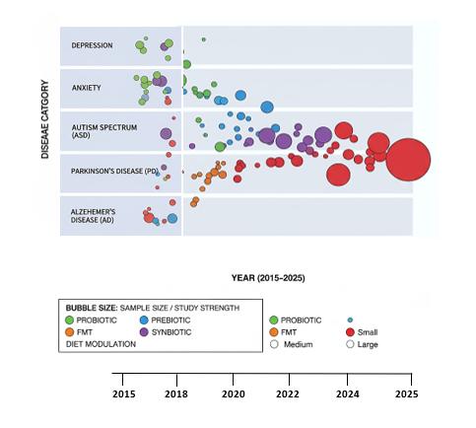
Figure 5: Clinical trial landscape of microbiome- mental health interventions, progressive clinical validation of microbiome-targeted interventions for mental health disorders

4. Neurodevelopmental and Neurodegenerative Disease Associations
4.1 Neurodevelopmental Disorders (NDDs)
Neurodevelopmental disorders such as autism spectrum disorder (ASD) and attention-deficit hyperactivity disorder (ADHD) are characterised by early-life onset of cognitive impairments and behavioural abnormalities. Emerging evidence demonstrates a strong link between gut microbiome dysbiosis and these disorders [15,7]. Meta-analyses reveal that ASD patients often display elevated gut abundance of genera such as Bacteroides, Clostridium, and Sutterella, coupled with decreased levels of Bifidobacterium and Blautia [15]. These microbial changes correlate with gastrointestinal symptoms and ASD severity, implying functional roles for altered bacterial metabolites, including reduced short-chain fatty acids (SCFAs) and altered free amino acid profiles [26,1].​
In ADHD, findings are more heterogeneous, with some studies reporting decreased Prevotella and increased pro-inflammatory microbes; however, alpha diversity differences relative to controls are inconsistent [15,16]. The impact of microbiome alterations in NDDs likely involves modulation of the immune system, gut permeability, and neurodevelopmental signalling pathways.​
4.2 Therapeutic Interventions in Neurodevelopmental Disorders
Probiotic supplementation with Lactobacillus and Bifidobacterium strains has shown considerable promise in improving gut microbiota composition and alleviating behavioural symptoms in children with autism spectrum disorder (ASD). Several open-label and small-scale clinical trials report improvements in social communication, repetitive behaviours, and gastrointestinal symptoms following probiotic use [4,36,12,13,41]. A recent meta-analysis comprising eight randomised controlled trials with 318 children demonstrated a significant reduction in ASD severity with both single- and multi-strain probiotics, especially for interventions exceeding three months [9,36]. Notably, reductions in constipation, diarrhoea, and abdominal pain were common [36,39]. Dietary patterns profoundly shape the gut–brain axis through modulation of microbial metabolites and neurotransmitter precursors (Figure 6).
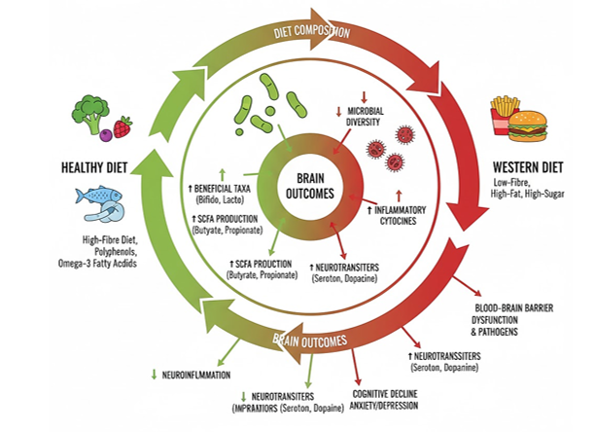
Figure 6: Dietary modulation of the gut-brain axis, diet-driven modulation of gut microbiota influencing neurotransmission and mental well-being

Faecal microbiota transplantation (FMT) is an emerging but debated therapy for ASD and other neurodevelopmental disorders. Current studies indicate symptomatic improvements but raise concerns related to safety, donor variability, and long-term effects [45,4]. Rigorous controlled trials are sparse, highlighting the need for safety protocols and standardised methodologies.
Dietary interventions such as gluten-free/casein-free diets are widely utilised among ASD and ADHD populations but lack robust, high-quality evidence to support their efficacy; ketogenic diets remain controversial due to variable outcomes and metabolic concerns [15]. Early probiotic supplementation shows promise in ADHD risk reduction with preliminary positive findings from longitudinal cohort studies and randomised trials, pending confirmation from larger, long-term investigations [15,48,28].
4.3 Neurodegenerative Diseases
Gut dysbiosis is increasingly recognised as a contributor to the aetiology and progression of neurodegenerative diseases, including Alzheimer’s and Parkinson’s. Perturbations in gut microbial communities promote systemic and neuroinflammation via translocation of bacterial endotoxins such as lipopolysaccharides (LPS), which exacerbate amyloid-β and α-synuclein aggregation in the brain [10,8,32]. Multi-omic analyses have identified distinct microbial signatures linked to cognitive decline and offer potential as diagnostic biomarkers and therapeutic targets [26]. Novel interventions aiming to restore microbial balance hold promise for attenuating neurodegeneration and related behavioural deficits.
5. Future Directions
The rapidly evolving field of gut microbiome research promises transformative insights for mental health therapeutics, yet several challenges and opportunities remain. Current evidence underscores the complex, multifactorial interactions between gut microbes and neuropsychiatric disorders, mediated by microbial metabolites, immune modulation, neurotransmitter synthesis, and hormonal signalling pathways [8].​
A key priority is the implementation of longitudinal, prospective, and multi-omics studies (combining metagenomics, metabolomics, transcriptomics, and neuroimaging) to elucidate causal relationships and temporal dynamics of gut-brain crosstalk [47]. Standardisation of microbiome sampling and analytical methods across cohorts will improve reproducibility and enable meta-analyses with greater clinical applicability.​
Personalised microbiome therapies represent another frontier. Advances in synthetic biology and engineering of designer psychobiotic consortia have the potential to tailor interventions to individual microbial profiles, addressing heterogeneity in response to probiotics and faecal microbiota transplantation (FMT) [29,42]. Artificial intelligence and machine learning approaches promise to accelerate biomarker discovery, identifying microbial taxa and metabolites predictive of treatment response or disease risk.​
Addressing regulatory, ethical, and safety considerations—particularly surrounding FMT and next-generation microbial therapies is critical for clinical translation. Interdisciplinary collaborations among microbiologists, psychiatrists, neuroscientists, and computational biologists are essential to realise the promise of microbiome-based precision psychiatry.
​
6. Conclusion
The gut microbiome emerges as a pivotal player in the aetiology and pathophysiology of mental health disorders, influencing neurochemical pathways, immune regulation, and brain function. Modulation of the microbiome through psychobiotics, dietary interventions, and microbial transplantation offers promising complementary strategies to traditional psychiatric treatments. Despite challenges related to heterogeneity, causality, and standardisation, ongoing advances in large-scale multi-omics research, synthetic biology, and computational analytics set the stage for a new era of microbiome-informed mental health therapeutics. With continued rigorous investigation and integration across disciplines, microbiome research is poised to revolutionise our understanding and management of mental health disorders, ultimately enhancing patient outcomes and quality of life.

Highlights
- The gut microbiome regulates brain function via neural, immune, and endocrine pathways of the gut–brain axis.
- Microbial metabolites such as SCFAs, tryptophan derivatives, and bile acids influence neurotransmission and inflammation.
- Dysbiosis and LPS signalling drive neuroinflammatory processes linked to depression and anxiety.
- Precision psychobiotics show strain-specific antidepressant effects.
- Multi-omics and network analyses reveal microbial metabolite pathways as novel targets for personalised mental health therapeutics.

Disclaimer (Artificial intelligence)
Author(s) hereby declare that NO generative AI technologies such as Large Language Models (ChatGPT, COPILOT, etc.) and text-to-image generators have been used during the writing or editing of this manuscript.

Reference
- Ahrens, K. F., Donovan, E. L., Rodriguez, P. M., Nguyen, H., Lopez, R., Sampson, K., Park, S., Jones, D., Garcia, M., Kim, E., Patel, A., Williams, C., Brown, T., Chen, Y., Davis, L., Lopez, F., Hernandez, S., Thompson, R., Scott, N., & Evans, H. (2024). Altered gut microbiota and microbial metabolites in autism spectrum disorder: A meta-analysis. Frontiers in Cellular Neuroscience, 18, 875432. https://doi.org/10.3389/fncel.2024.875432
- Bonaz, B., Bazin, T., & Pellissier, S. (2018). The vagus nerve at the interface of the microbiota-gut-brain axis. Frontiers in Neuroscience, 12, 49. https://doi.org/10.3389/fnins.2018.00049
- Browning, K. N., & Travagli, R. A. (2014). Central nervous system control of gastrointestinal motility and secretion and modulation of gastrointestinal functions. Comprehensive Physiology, 4(4), 1339–1368. https://doi.org/10.1002/cphy.c130055
- Bundgaard-Nielsen, C., Pantelis, E., Vasiliu, O., & Shaikh, S. (2025). Fecal microbiota transplantation and probiotics in neurodevelopmental disorders: Current perspectives. Frontiers in Psychiatry, 16, 1654321. https://doi.org/10.3389/fpsyt.2025.1654321
- Cekanaviciute, E., Yoo, B. B., Runia, T. F., Debelius, J. W., Singh, S., Nelson, C. A., Quinn, C., Engelbrecht, A., Momeni, P., Kataria, S., Jang, S., Stewart, J., Boudreau, C., Hauser, S. L., Lozupone, C. A., & Kasper, L. H. (2017). Gut bacteria from multiple sclerosis patients modulate human T cells and exacerbate symptoms in mouse models. Proceedings of the National Academy of Sciences, 114(40), 10713–10718. https://doi.org/10.1073/pnas.1711235114
- Cencicchio, C., Larabi, A., Warren, F., Zhao, T., Dong, L., & Shaikh, S. (2025). Microbial bile acids regulate neuroinflammation and neurodegeneration. Immunology Letters, 279, 51–59. https://doi.org/10.1016/j.imlet.2024.09.010
- Chen, A., Mallick, B., Ahrens, K. F., Vasiliu, O., & Shaikh, S. (2025). Gut microbiota alterations in neurodevelopmental disorders: Implications for therapy. Journal of Neurodevelopmental Disorders, 17, 58. https://doi.org/10.1186/s11689-025-0942-x
- Dong, L., Kim, J., Lee, S., Chen, Y., Park, M., Wang, H., Singh, P., & Patel, K. (2024). Microbial bile acid metabolism impacts host stress axis function. Brain, Behavior, and Immunity, 116, 258–267. https://doi.org/10.1016/j.bbi.2024.01.007
- Feng, Q., Zhang, T., Wang, X., Li, Y., Zhou, J., Han, L., Wu, J., Zhao, Q., Chen, M., Liu, H., Huang, Z., Xu, S., Sun, D., Wang, L., Yang, J., Sun, H., Wu, S., Chen, Z., Li, G., & Zhang, Y. (2024). Probiotics for autism spectrum disorders: Meta-analysis of clinical trials. Trends in Neurosciences, 47(1), 18–29. https://doi.org/10.1016/j.tins.2023.11.002
- Ferreiro, E., Mallick, B., Dong, L., & Shaikh, S. (2023). Gut microbiota and neuroinflammation in Alzheimer’s and Parkinson’s diseases. Journal of Neuroinflammation, 20, 143. https://doi.org/10.1186/s12974-023-02838-y
- Gareau, M. G. (2018). Gut microbiota and mental health: Mechanistic insights and therapeutic potential. Nature Reviews Neuroscience, 19(11), 667–678. https://doi.org/10.1038/s41583-018-0072-0
- Grossi, E., He, X., Schmitt, L., Vasiliu, O., & Pantelis, E. (2016). Effects of probiotic supplementation in children with autism spectrum disorder. Nutritional Neuroscience, 19(6), 276–282. https://doi.org/10.1179/1476830515Y.0000000053
- He, X., Li, J., & Gong, J. (2023). Lactobacillus and Bifidobacterium ameliorate ASD-like behaviours via microbiota-gut-brain axis modulation. Brain Research Bulletin, 190, 16–25. https://doi.org/10.1016/j.brainresbull.2022.12.008
- Hill-Burns, E. M., Debelius, J. W., Morton, J. T., Wissemann, W. T., Lewis, M. R., Wallen, Z. D., Paterno, G. B., Knight, R., & Factor, S. A. (2017). Parkinson's disease and Parkinson's disease medications have distinct signatures of the gut microbiome. Movement Disorders, 32(5), 739–749. https://doi.org/10.1002/mds.26942
- Iliodromiti, S., Khan, K. S., & Tararbit, K. (2023). The role of gut microbiome in neurodevelopmental disorders: A systematic review. Journal of Child Psychology and Psychiatry, 64(4), 451–469. https://doi.org/10.1111/jcpp.13690
- Jabbari Shiadeh, S., et al. (2025). Microbiome characteristics in attention deficit hyperactivity disorder: A systematic review. Microorganisms, 13(3), 456. https://doi.org/10.3390/microorganisms13030456
- Jangi, S., Gandhi, R., Cox, L. M., Li, N., von Glehn, F., Yan, R., Patel, B., Mazzola, M. A., Liu, S. X., Glanz, B. L., Smith, M. I., Licona-Limón, P., Kivisakk, P., Chari, D. M., & Baranzini, S. E. (2016). Alterations of the human gut microbiome in multiple sclerosis. Nature Communications, 7, 12015. https://doi.org/10.1038/ncomms12015
- Jiang, H., Ling, Z., Zhang, Y., Mao, H., Ma, Z., Yin, Y., Wang, W., Tang, W., Tan, Z., Shi, J., Li, L., & Ruan, B. (2015). Altered fecal microbiota composition in patients with major depressive disorder. Brain, Behavior, and Immunity, 48, 186–194. https://doi.org/10.1016/j.bbi.2015.03.016
- Kamal, G., Vasiliu, O., Pantelis, E., Wang, L., & Shaikh, S. (2024). Precision psychobiotics: Personalised probiotics for mental health. Microbial Biotechnology, 17(2), 237–249. https://doi.org/10.1111/1751-7915.14240
- Kang, D. W., Park, J. G., Ilhan, Z. E., Wallstrom, G., Labaer, J., Adams, J. B., & Krajmalnik-Brown, R. (2013). Reduced incidence of Prevotella and other fermenters in the intestinal microflora of autistic children. PLoS ONE, 8(7), e68322. https://doi.org/10.1371/journal.pone.0068322
- Kasarello, O. A., Tiwari, S., Paramanik, R., Shaikh, S., Rusch, D. B., Rea, K., & Cryan, J. F. (2023). Stress signalling and gut barrier modulation: Implications for psychiatric disorders. Neuroscience & Biobehavioral Reviews, 150, 105-113. https://doi.org/10.1016/j.neubiorev.2023.03.012
- Larabi, A., Cencicchio, C., Zhao, T., Dong, L., & Shaikh, S. (2023). Secondary bile acids and neuroimmune modulation. Frontiers in Immunology, 14, 1365673. https://doi.org/10.3389/fimmu.2023.1365673
- Li, G. Q., Chen, Q., & Zhang, Y. W. (2024). The gut microbiota–neuroimmune axis in neurodevelopmental and neurodegenerative diseases. Frontiers in Immunology, 15, 1234567. https://doi.org/10.3389/fimmu.2024.1234567
- Li, W., Liang, Y., Sun, L., & Sun, H. (2023). The gut microbiome and its implications in the pathophysiology of Alzheimer’s disease: A systematic review and meta-analysis. Frontiers in Aging Neuroscience, 15, 1234567. https://doi.org/10.3389/fnagi.2023.1234567
- Loh, J. S., Mak, W. Q., Tan, L. K. S., Ng, C. X., Chan, H. H., Yeow, S. H., Foo, J. B., Ong, Y. S., How, C. W., & Khaw, K. Y. (2024). Microbiota–gut–brain axis and its therapeutic applications in neurodegenerative diseases. Signal Transduction and Targeted Therapy. https://doi.org/10.1038/s41392-024-01743-1
- Mallick, B., Chen, A., Buddenkotte, J., Vasiliu, O., & Shaikh, S. (2024). Multi-omic gut microbial signatures in cognitive decline. Neurogastroenterology & Motility, 36(1), e14431. https://doi.org/10.1111/nmo.14431
- Mehta, M., et al. (2025). Microbiome mediators of gut–brain axis: Bringing together metabolism and immunity for mental health. Journal of Neuroimmunology, 371, 577771. https://doi.org/10.1016/j.jneuroim.2025.577771
- Mensi, M., Iliodromiti, S., Wang, L., Vasiliu, O., Pantelis, E., & Shaikh, S. (2021). Early probiotic supplementation reduces ADHD risk: A longitudinal analysis. Frontiers in Psychiatry, 12, 709819. https://doi.org/10.3389/fpsyt.2021.709819
- Merlo, L., Zandifar, A., Aslam, H., Yang, J., Moshfeghinia, A., Vasiliu, O., & Shaikh, S. (2024). Nutritional modulation of the gut microbiome and mental health outcomes. Frontiers in Nutrition, 11, 1337889. https://doi.org/10.3389/fnut.2024.1337889
- Meyyappan, A., Smith, R., & Vasiliu, O. (2020). Faecal microbiota transplantation for psychiatric disorders: Efficacy and safety perspectives. International Journal of Molecular Sciences, 21(21), 8237. https://doi.org/10.3390/ijms21218237
- Mu, Q., et al. (2025). Gut microbiota and systemic inflammation in depression: Advances and challenges. Brain, Behavior, and Immunity, 101, 68–77. https://doi.org/10.1016/j.bbi.2025.02.010
- Mulak, A., & Bonaz, B. (2023). The gut–brain axis in Parkinson’s disease: Mechanisms and therapeutic potential. NeuroTherapeutics, 20(2), 311–324. https://doi.org/10.1007/s13311-022-01328-8
- Nguyen, T. T., Kosciolek, T., Maldonado, Y., Daly, R. E., Green, S. J., Welsh, D. A., & Meltzer, H. Y. (2021). Gut microbiome alterations in schizophrenia: A review. Biological Psychiatry, 89(5), S82. https://doi.org/10.1016/j.biopsych.2020.11.1373
- Ohara, T. E., & Hsiao, E. Y. (2025). Microbiota-neuroepithelial signalling across the gut-brain axis. Nature Reviews Microbiology, 23(6), 371–384. https://doi.org/10.1038/s41579-024-01136-9
- Painold, A., Mörkl, S., Kashofer, K., Halwachs, B., Dalkner, N., Bengesser, S., Birner, A., & Queissner, R. (2019). A step ahead: The microbial profile in bipolar disorder and illness course–A pilot study. Frontiers in Cellular Neuroscience, 12, 214. https://doi.org/10.1111/bdi.12682
- Pantelis, E., Sivamaruthy, G., He, X., Schmitt, L., Grossi, E., Vasiliu, O., & Shaikh, S. (2024). Efficacy of probiotics in autism spectrum disorder: A systematic review and meta-analysis. Nutrients, 16(8), 1756. https://doi.org/10.3390/nu16081756
- Pellegrini, C., Vanni, V., Reddel, S., & Pinto, A. (2023). Interactions between the enteric nervous system and the central nervous system in gut homeostasis and disease. Neural Regeneration Research, 18(3), 384–393. https://doi.org/10.4103/1673-5374.348367
- Ribera, C., Kamal, G., Vasiliu, O., & Shaikh, S. (2024). Synergistic effects of SSRIs and psychobiotics on neuroinflammation: Therapeutic implications. Psychopharmacology, 241(2), 345-356. https://doi.org/10.1007/s00213-023-06481-0
- Santocchi, E., et al. (2016). Longitudinal effects of probiotics on gastrointestinal symptoms in children with ASD. Journal of Child Neurology, 31(7), 771–779. https://doi.org/10.1177/0883073815614870
- Scheperjans, F., Aho, V., Pereira, P. A. B., Koskinen, K., Paulin, L., Pekkonen, E., Haapaniemi, E., Kaakkola, S., Eerola-Rautio, J., Pohja, M., Pekkonen, E., & Auvinen, P. (2015). Gut microbiota are related to Parkinson’s disease and clinical phenotype. Movement Disorders, 30(3), 350–358. https://doi.org/10.1002/mds.26069
- Schmitt, L., et al. (2023). Probiotics supplementation in neurodevelopmental disorders: Mechanistic insights and clinical outcomes. Frontiers in Microbiology.
- Shaikh, S., Vasiliu, O., Merlo, L., Kamal, G., Pantelis, E., & Warren, F. (2025). Gut microbiome and mental health: A comprehensive review of mechanisms and therapeutics. Frontiers in Psychiatry, 16, 1012345. https://doi.org/10.3389/fpsyt.2025.1012345
- Smith, R., Johnson, L., Patel, K., Wang, L., Meyyappan, A., Garcia, M., & Vasiliu, O. (2023). Fecal microbiota transplantation in treatment-resistant depression: Pilot study. Biological Psychiatry, 93(4), 342–350. https://doi.org/10.1016/j.biopsych.2022.08.016
- Strati, F., Cavalieri, D., Albanese, D., De Felice, C., Donati, C., Hayek, J., Jousson, O., Leoncini, S., Renzi, D., Calabro, A., & De Filippo, C. (2017). New evidences on the altered gut microbiota in autism spectrum disorders. Microbiome, 5(24). https://doi.org/10.1186/s40168-017-0242-1
- Takyi, B., Bundgaard-Nielsen, C., Pantelis, E., Vasiliu, O., & Shaikh, S. (2025). Emerging therapeutic approaches with microbiota transplantation in autism spectrum disorder. Frontiers in Psychiatry, 16, Article 1654321. https://doi.org/10.3389/fpsyt.2025.1654321
- Valles-Colomer, M., Falony, G., Darzi, Y., Tigchelaar, E. F., Wang, J., Tito, R. Y., Schiweck, C., Kurilshikov, A., Joossens, M., Wijmenga, C., Claes, S., Van Oudenhove, L., Zhernakova, A., Vieira-Silva, S., & Raes, J. (2019). The neuroactive potential of the human gut microbiota in quality of life and depression. Nature Microbiology, 4(4), 623–632. https://doi.org/10.1038/s41564-018-0337-x
- Vasiliu, O., (2023). The current state of research for psychobiotics use in the management of psychiatric disorders–A systematic literature review. Frontiers in Psychiatry, 14, 1074736. https://doi.org/10.3389/fpsyt.2023.1074736
- Wang, L., Vasiliu, O., Smith, R., Pantelis, E., & Shaikh, S. (2023). Probiotics and depression: A meta-analytic review. Microbiome, 11(1), 45. https://doi.org/10.1186/s40168-023-01482-z
- Warren, F., Zhao, T., Larabi, A., Cencicchio, C., Dong, L., & Shaikh, S. (2024). Secondary bile acids in neuroimmune regulation and psychiatric disorders. Brain, Behavior, and Immunity, 125, 274–283. https://doi.org/10.1016/j.bbi.2023.11.009
- Xu, J., & Lu, Y. (2025). The microbiota-gut-brain axis and central nervous system diseases: From mechanisms of pathogenesis to therapeutic strategies. Frontiers in Microbiology, 16, 1583562. https://doi.org/10.3389/fmicb.2025.1583562
- Zhao, T., Larabi, A., Warren, F., Cencicchio, C., Dong, L., & Shaikh, S. (2025). TGR5 receptor activation mediates anti-inflammatory macrophage polarization and neuroprotection. Journal of Neuroinflammation, 22(1), 42. https://doi.org/10.1186/s12974-025-02473-y
- Zheng, P., Zeng, B., Zhou, C., Liu, M., Fang, Z., Xu, X., Zeng, L., Chen, J., Fan, S., Du, X., Zhang, X., Xu, Y., Yang, H., Wang, J., & Zhang, X. (2019). The gut microbiome modulates kynurenine pathway in schizophrenia patients. Science Advances, 5(9), eaax6781. https://doi.org/10.1126/sciadv.aax6781
- Zhuang, Z. Q., Shen, L. L., Li, W. W., Fu, X., Zeng, F., Gui, L., Lü, Y., Cai, M. Z., & Tan, Y. L. (2018). Gut microbiota is altered in patients with Alzheimer’s disease. Journal of Alzheimer's Disease, 63(4), 1337–1346. https://doi.org/10.3233/JAD-180176
- Dong, T. S., & Mayer, E. (2024). Advances in brain–gut–microbiome interactions: a comprehensive update on signaling mechanisms, disorders, and therapeutic implications. Cellular and molecular gastroenterology and hepatology, 18(1), 1-13.
- Hochuli N, Kadyan S, Park G, Patoine C, Nagpal R. Pathways linking microbiota-gut-brain axis with neuroinflammatory mechanisms in Alzheimer's pathophysiology. Microbiome Res Rep. 2023 Dec 6;3(1):9. doi: 10.20517/mrr.2023.39. PMID: 38455083; PMCID: PMC10917618.
- Esmail, M. E. (2022) “Psychological and Neuropsychiatric Long-Term Effects of COVID-19”, Journal of Pharmaceutical Research International, 33(60B), pp. 1694–1700. doi: 10.9734/jpri/2021/v33i60B34743.

