Review Article

A review on Milky Mushroom (Calocybe indica): Importance, Nutritive and Medicinal value, Cultivation Technology and Constraints in Current Scenario

Abstract
Mushroom is cultivated around the world in the present time become very popular. Increasing population of the country impacts on food production, nutritional security health, environmental and livelihood of the Populace. To signify the saying “waste to wealth” resource conservation implies the popular waste of crop grown to produce milky Mushroom. Milky mushroom has immense potential to be popularized among millions of vegetarian consumers due to its rich nutritional and medicinal attributes, as it provides all essential amino acids and minerals required by people of all age groups, ranging from children to lactating mothers. Milky mushroom contains several bioactive components that have been proven beneficial for patients suffering from hypertension, high blood sugar, gastrointestinal disorders, obesity, and cardiovascular diseases. It was first identified in West Bengal and cultivated on a wide range of substrates; however, it was not commercialized until 1998. In the meanwhile, Krishnamoorthy rediscovered the mushroom at Tamil Nadu in 1997 and standardized the protocol to lead commercial production. It has long shelf life to the tune of 5-7 days compared to another mushroom. In the present scenario, several challenges exist in milky mushroom cultivation, including the requirement of an appropriate casing material for its production. In addition, maintaining optimum temperature, moisture, and aeration conditions is often difficult to manage. A comprehensive and analytical review’s on various parameters in nutritional requirement to enhance the mushroom productivity have been outlined. Lignocellulosic biomass is also used as substrate. The mineral contents and non-enzymatic antioxidants show incomparable with Button & Oyster mushroom. Antioxidant bioassay using methanol extract of this mushroom adds flavour profile both in fresh and dried ones. Its extracts are reported to possess both anti-hyperglycaemic activity and anti-lipid peroxidation effects.
Keywords: Milky mushroom, Edible mushroom, Nutritive value, Shelf life, Tropical, Anti-hyperglycaemic effect, Substrate preparation, Spawn production

Introduction
“Calocybe indica P&C, commonly known as milky mushroom, dudh chatta, or summer mushroom, is a large-sized and highly palatable mushroom that was first reported in India” by Chandra (1976). “This mushroom is a highly attractive species characterized by large, milky-white sporophores and belongs to the family Tricholomataceae under the order Agaricales. It naturally grows on humus-rich soil beneath roadside trees in forest areas. In West Bengal, it is commonly collected from forests and sold in city and village markets due to its appealing, robust white sporocarps, good taste, and long shelf life. The mushroom thrives within a temperature range of 25–35 °C. The global population currently stands at approximately 7 billion and is increasing rapidly. It is projected to reach about 9 billion by 2050 and may rise to nearly 20 billion by 2100” (Livi-Bacci, 2012). “This rapid population growth, coupled with urbanization and a significant decline in arable land, poses serious challenges related to food security and human health. In this context, the conversion of lignocellulosic agricultural and forest residues into protein-rich mushrooms represents one of the most economical and sustainable biotechnological approaches to meeting the growing demand for dietary protein” (Hawksworth, 1991).
“The natural occurrence of milky mushroom in the plains of Tamil Nadu and Rajasthan has also been reported” (Doshi et al. 1989). “Despite dedicated efforts by several researchers, only limited success in its cultivation was achieved until 1998”. (Krishnamurthy, 2000) standardized complete commercial production techniques. The first milky-white mushroom variety, Calocybe indica P&C var. APK2, was released by TNAU, Coimbatore, India, in 1998.
“The optimum temperature range for cultivating this mushroom is 30–35 °C. Several researchers have reported that a temperature of 32 °C is ideal for spawn run, while maximum fruit body initiation occurs at around 30 °C with 90% relative humidity. A decline in yield has been observed at temperatures below 25 °C. Complete darkness is less favorable for fruit body formation, whereas diffused light promotes stipe elongation. Strandy and vigorous mycelial growth is achieved when the fungus is incubated under a light intensity of 600–800 lux. Maximum yield has been recorded when cased beds are incubated at approximately 1600 lux” (Doshi et al. 1989). At higher light intensities, stipe length is significantly reduced, while pileus diameter increases markedly. Additionally, during a survey conducted in the southwest monsoon season of 2009–2010 in Thiruvananthapuram district, Kerala, a new species of Calocybe, C. gambosa (Fr.) Donk, was collected and its pure culture was successfully isolated. The first report on wild occurrence of Calocybe indica P&C, commonly called “Dhuth chatta” (means “Milky white mushroom”) originated from India since for several decades people from West Bengal (Eastern Indian State) have collected these mushrooms and sold in local markets. The milky white colour and robust nature of this mushroom make it highly appealing to consumers (Fig. 1) (Vikineswary, 2013). “Milky white mushrooms are commonly found growing on humus-rich soils in agricultural fields and along roadsides in the tropical and subtropical regions of India, particularly in the plains of Tamil Nadu (a southern Indian state) and Rajasthan (located in western India). These mushrooms typically appear annually between May and August, coinciding with the onset of sufficient rainfall following a prolonged dry period. Calocybe indica is primarily a grassland, saprophytic species, deriving nutrients from dead organic matter, and occasionally forms ectomycorrhizal associations with plants such as Cocos nucifera, Borassus flabellifer, Tamarindus indicus, and Peltophorum ferruginum. Detailed studies have documented its physiological and cultural requirements, including optimal pH, temperature, carbon-to-nitrogen (C: N) ratio, light intensity, and substrate preferences for successful cultivation” (Doshi et al. 1989).
“Milky mushroom was cultivated using four different agro-residues, namely paddy straw, coir pith, wood shavings, and banana trash. The energy value of each substrate was calculated based on its cellulose, hemicellulose, and lignin contents. Among the substrates, coir pith exhibited the highest energy value (466 kcal per 100 g), followed by banana trash (435 kcal per 100 g), paddy straw (391 kcal per 100 g), and wood shavings (380 kcal per 100 g)” (Usha, 2007).
“Owing to its morphological resemblance to Agaricus bisporus (button mushroom), this mushroom has gained considerable popularity in the southern states of India and is gradually becoming popular in other countries such as China, Malaysia, and Singapore. Small-scale mushroom growers prefer cultivating this tropical mushroom because it is ideally suited to warm and humid climatic conditions (30–38 °C with 80–85% relative humidity). It has a longer shelf life without refrigeration and can be stored for up to seven days at room temperature. The mushroom retains a fresh appearance and does not turn brown or dark, unlike button mushrooms. During crop production, it shows lower susceptibility to contamination by competitor moulds and insect pests under controlled conditions. Moreover, the infrastructure required for its cultivation is affordable, and the cost of production is comparatively low, making it attractive for commercial and industrial production. The mushroom also has a short crop cycle (7–8 weeks) and a high biological efficiency of about 140% (140 kg fresh mushrooms per 100 kg dry substrate). Commercial-scale cultivation methods for this mushroom have been developed since the late 1990s” (Krishnamurthy, 2000).This review mainly focuses on the various aspects of milky white mushroom cultivation (viz., growth conditions, casing requirements, yield on different substrates), composition of milky white mushrooms, medicinal value of the mushroom and its future prospects with indications for certain researchable issues.
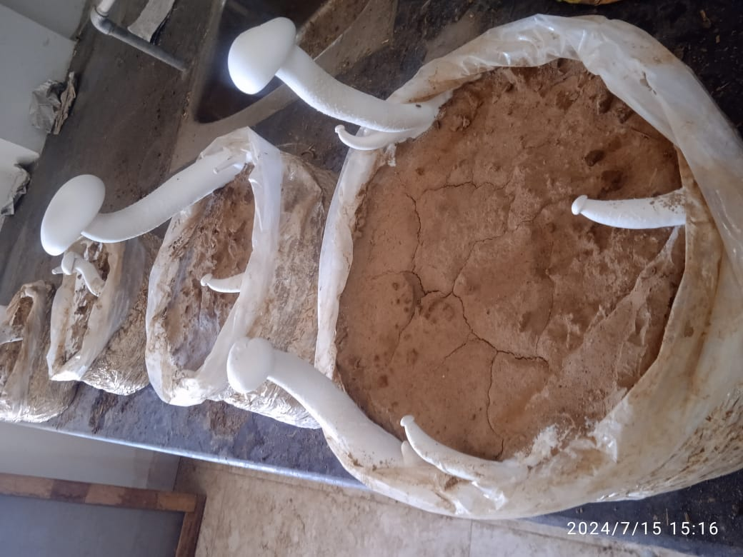 | 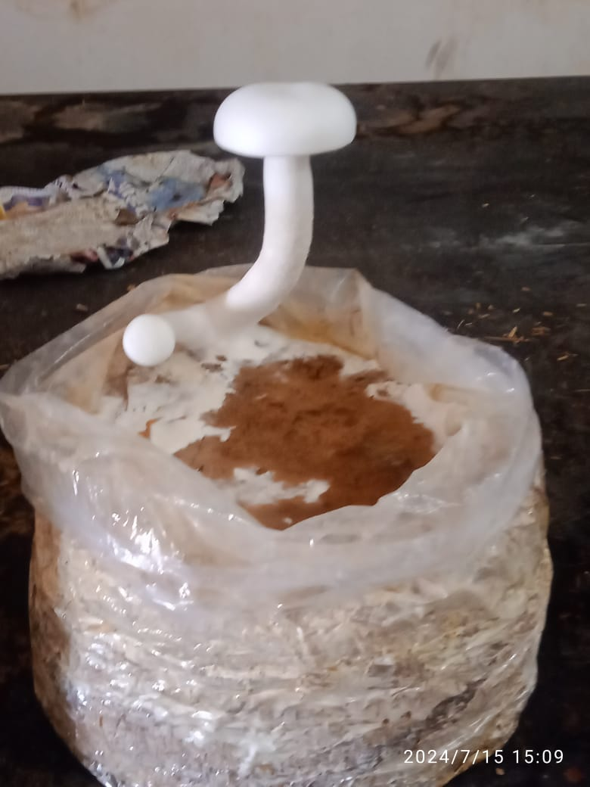
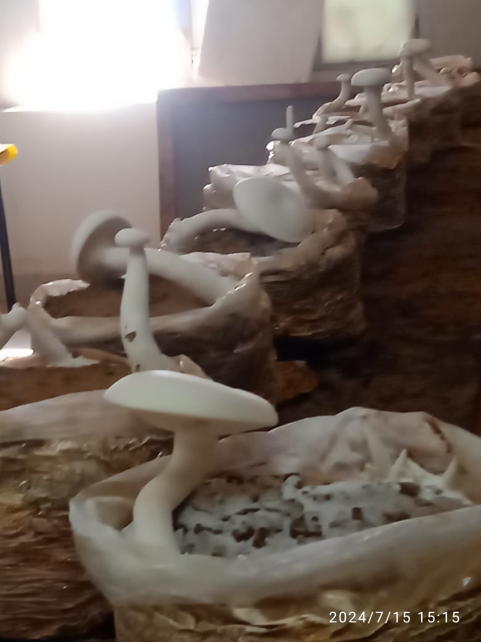 | 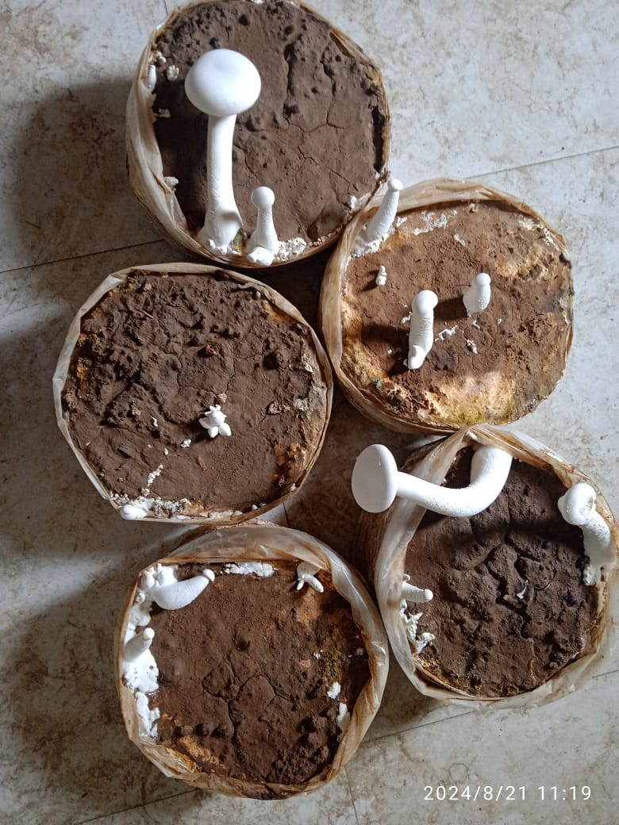

Fig 1. Milky white mushroom grown at Mushroom unit of VKSCoA, Dumraon, Buxar
Nutritive and Medicinal value
Overall, several studies have indicated that, among button, oyster, and milky white mushrooms, the milky white mushroom contains comparatively higher protein levels.
“Nutritive value of milky mushroom is comparable with other mushrooms. Mature fruit body of C. indica contains highest protein (17.2% on dry weight basis), while young pin heads carry the lowest proteins (15% on dry weight basis), 4.1% fat, 3.4% crude fibre and 64.26% carbohydrate on dry wt. basis. Mature fruit bodies contain about 4.0% soluble sugars, 2.9% starch, and 7.43% ash. The fruit body comprises 12 amino acids, namely alanine, aspartic acid, glutamine, glutamic acid, glycine, hydroxyproline, histidine, lysine, threonine, tyrosine, valine, arginine, and proline, of which glycine is predominant (10.8 g per 100 g protein). In addition, it contains essential mineral elements required for the human body, such as potassium, sodium, phosphorus, iron, and calcium. Owing to its alkaline ash and high fibre content, the mushroom is particularly suitable for individuals suffering from hyperacidity and constipation. Mushrooms have also been reported to possess therapeutic potential against several age-related disorders. Furthermore, milky mushroom has been reviewed to contain higher protein levels compared to button and oyster mushrooms. Milky mushroom comprises of higher dry matter (14.4%) and fibre content (61.1%). Milky mushroom also gave an account of higher sugars and fat (59.9% and 0.67%, respectively) contrasted with other edible mushrooms” (Crisan and Sands, 1978). Saranya et al. (2011) reported that the type of substrates and supplements used in mushroom cultivation significantly influence the composition, including antioxidant content. “The authors also observed enhanced levels of calcium, phosphorus, and iron in milky white mushrooms. β-glucans present in the dietary fibre of mushrooms have been reported to stimulate the immune system and exhibit antimutagenic, anticancer, and antitumour activities” (Crisan and Sands, 1978). “Milky white mushrooms are also rich sources of minerals such as calcium, potassium, magnesium, sodium, and phosphorus, along with trace elements including copper, iron, manganese, and zinc” (Mattila et al., 2001; Zahid et al., 2010). When used in combination with medicinal herbs, mushrooms are believed to play an important role in the management of diabetes without adverse side effects. Both hot and cold-water extracts of milky white mushroom powder have been evaluated for anti-hyperglycaemic activity in streptozotocin-induced diabetic rats. The extracts were administered orally for 45 days, after which insulin and glycosylated haemoglobin levels were assessed.
The results stipulated normal values at the end of treatment. Furthermore, positive effect on haematological parameters including increase in lymphocytes, platelets and Red blood cell (RBC) counts were perceived. The life span of treated rats was also found to be increased. Reactive oxygen species (ROS) and free radicals are implicated in the development of several diseases, including rheumatoid arthritis, cirrhosis, and life-threatening conditions such as cancer. Various vitamins, bioactive compounds, and antioxidant enzymes—such as vitamins E and C, polyphenols, carotenoids, glutathione, superoxide dismutase, and catalase—play a crucial role in neutralizing free radicals in the human body. Milky mushroom contains appreciable amounts of antioxidant vitamins, including vitamin A (0.275 mg g⁻¹) (Alam et al., 2008), vitamin C (1.03 mg 100 g⁻¹) (Selvi et al., 2007), vitamin E (tocopherol; 2.8 mg g⁻¹) (Mattila, 2000), and glutathione (0.025 nmol g⁻¹). “Vitamin C acts as an effective free radical scavenger and inhibitor of lipid peroxidation, whereas vitamin E functions as a membrane-protective antioxidant, safeguarding lipids and lipoproteins. Glutathione, the most abundant non-protein thiol in animal cells, exists in reduced (GSH) and oxidized (GSSG) forms and is essential for protein and DNA synthesis, regulation of enzymatic activities, and protection against oxidative stress” (Selvi et al., 2007). Mirunalini et al. (2012) and Babu and Rao (2013) reported “significant in vitro antioxidant activities of Calocybe indica extracts, demonstrating higher DPPH radical scavenging activity, reducing power, metal chelation, and hydrogen peroxide scavenging activity compared to Agaricus bisporus. Notably, the stipe of C. indica exhibited greater chelating ability, hydrogen peroxide scavenging activity, flavonoid content, and total phenolic content than the cap”.
Cultivation Technology of Milky mushroom
Spawn preparation
Spawn for milky mushroom can be prepared using standard technology on wheat grains (Joshi and Sagar, 2016). The cultivation technology was further refined by Theradimani et al. (2001). “Milky mushroom (Calocybe indica), owing to its ability to grow well at relatively high temperatures and its excellent shelf life, appears to be a promising alternative to other cultivated mushrooms. In view of these advantages, an experiment was conducted to evaluate the suitability of different grains as spawn substrates and their influence on yield parameters” (Senthilnambi et al., 2011). The results demonstrated that sorghum grains were superior to ragi grains, recording faster spawn run, higher yield, and a greater number of buttons harvested.
Substrate and Processing
A variety of substrates were tried out the cultivation of C. indica (Chandra, 1976; Nayak, 1979). They tried to induce fruit bodies in a number of growth media, consists of soil-sand, soil-sand-maize meal and soil-sand pulse powder. Attempts were taken to develop suitable substrate for higher production of C. indica. Purkayastha and Nayak (1981) grew C. indica on unsterilized, paddy straw-maize or wheat bran substrate. Purkayastha (1984) reported the use of chopped rice straw that was pre-soaked in water for 18–24 h and subsequently treated in hot water for 2–3 h. Doshi et al. (1993) evaluated “several basal substrates, including wheat straw, maize stalks, sorghum stalks, maize meal, rice meal, sorghum meal, and wheat bran, for the cultivation of Calocybe indica, and identified wheat straw as the most suitable substrate for fruit body production”. Krishnamoorthy and Muthusamy (1997) investigated “a range of substrates such as paddy straw, sorghum stalks, sugarcane bagasse, palmarosa grass, vetiver grass, groundnut haulms, soybean hay, and paddy straw compost for milky mushroom cultivation. Among these, paddy straw and maize stalks produced significantly higher yields, followed by sorghum stalks and vetiver grass. Palmarosa grass, soybean hay, and groundnut haulms also recorded good yields, with biological efficiency ranging from 94 to 99%. However, paddy straw compost was found unsuitable for the cultivation of milky mushroom. Further, substrates such as paddy straw and sorghum stalks were colonized more rapidly by the milky mushroom fungus compared to black gram hay, soybean hay, maize stalks, and finger millet straw. The study also revealed that coconut coir pith compost, paddy straw compost, and sawdust were unfavorable for the growth of C. indica”.
Salam et al. (2004) tested nine different combinations using retted, non-retted, composted coir pith in combination with paddy straw, spent mushroom substrate and neem cake in different composition. They found in their study that non-retted coir pith in combination with 75% paddy straw per formed excellent. Wheat straw is the best substrate amongst four different substrates tested for the sporophore yield of milky mushroom while saw dust was least preferred substrate observed by Tandon and Sharma (2006). Supplementation with wheat bran resulted in the higher yield whereas, soybean meal resulted the lowest yield. The new strain got more time for spawn run and primordial formation but out yielded the existing strain. Paddy straw and sugarcane bagasse were found to be best substrates with BE of 140 and 138%, respectively. The maximum yield/ kg substrate and biological efficiency were observed in a mixture of straw, followed by soybean and wheat straw. Efficacy of different substrates such as paddy straw, wheat straw, soybean straw, coconut coir pith, cotton waste and sugarcane baggage for the cultivation of milky mushroom was shown by Gitte et al. (2014). Among the six different substrates, wheat straw substrate was appeared superior with highest biological efficiency 146.3% subsequent by paddy straw.
Organic supplementation has been reported to significantly improve the yield of Calocybe indica. The addition of supplements such as maize meal, wheat bran, rice husk, and lucerne at levels of 5–7.5% (on substrate basis), either at the time of spawning or during casing, was found to enhance productivity. Salam et al. (2004) evaluated “retted, non-retted, and composted coir pith as substrates and observed the highest yields with retted coir pith”. Singh et al. (2010) investigated “the influence of various substrate preparation techniques, supplementation type and dose, casing materials, and cultural practices on the performance of C. indica”. Kumar et al. (2012) assessed “eleven different supplements, including wheat bran, soybean flour, pigeon pea powder, green gram powder, cottonseed cake, mustard cake, neem cake, and lentil powder”. Similarly, Alam et al. (2010) supplemented “paddy straw with 30% maize powder to improve mushroom yield. Among the tested supplements, soybean meal and cottonseed cake proved most effective, recording the highest increases in biological efficiency, with gains of 64.8% and 59.2%, respectively, over the control. Chemical disinfection of wheat straw with carbendazim (35 ppm) in combination with formaldehyde (1000 ppm) produced the highest yield, followed by hot water treatment. Among the supplements tested, incorporation of a 6% pulse mixture resulted in maximum yield, while gram husk at 4% ranked next. With respect to casing materials, a mixture of farmyard manure (FYM), rice bran husk (RBH), and coir pith in a 1:1:1 ratio was found to be the most effective, followed by a casing combination of burnt rice husk and farmyard manure (1:1)”. Sohliya et al. (2011) investigated “the influence of straw pasteurization duration and the application of gibberellic acid (GA₃) on the growth and yield of milky mushroom (Calocybe indica). The study involved direct steaming of straw for 30 minutes and 1 hour, along with pre-spawning application of GA₃ at three different concentrations. The results indicated that steaming and GA₃ treatment prolonged the mycelial colonization period and led to a reduction in yield; however, they enhanced the protein content of the fruiting bodies compared to the control. In contrast, the conventional practice of boiling the straw for one hour followed by sun drying resulted in superior yields compared to steaming”.
Casing
“Casing is a crucial agronomic operation in the cultivation of humicolous mushrooms, including the milky white mushroom. This practice plays a key role in inducing the transition from the vegetative growth phase to the reproductive stage. A well-structured and compact casing layer also helps restrict the accumulation and movement of harmful metabolic gases at the surface of the mushroom bed, thereby creating a more favorable environment for fruit body development. Thus, accumulation of high concentrations of carbon dioxide in the soil during fructification routinely results in yield depression” (Mac Cana, 1983). “Casing means cooling the top surface of bags after spawn run is over, with pasteurized casing material in thickness of about 2-3 cm. Casing provides mechanical support, maintains moisture, and facilitates the exchange of gases from the substrate. The casing material is uniformly applied as a 2–3 cm thick layer and moistened to saturation using a carbendazim and formaldehyde solution” (Doshi et al. 1993). “Numerous studies have documented the use of different casing materials in milky mushroom cultivation, reporting varied responses” (Sharma et al. 1997; Singh et al. 2007). Tandon et al. (2006) evaluated “four casing materials for Calocybe indica and identified a mixture of farmyard manure (FYM) and loam soil in a 3:1 ratio as the most suitable casing medium”. Nagaratna and Mallesha (2007) prepared “vermicompost-based casing materials using coir pith, crop residues, and horse manure, and analyzed them for microbial load, pH, nitrogen, and organic carbon content. Vermicompost alone and in combination with sand and soil was tested as casing material, with the sand + soil + coir pith vermicompost mixture producing the highest number of fruiting bodies, yield, and biological efficiency, followed by sand + soil + crop residue vermicompost”. Sharma et al. (1997) examined “several casing materials and their combinations, reporting spent biogas slurry (100% biological efficiency) and two-year-old cow dung (98.7% biological efficiency) as highly effective and acceptable casing substrates for milky mushroom cultivation”. Kumar et al. (2012) investigated “the influence of eleven organic supplements incorporated into substrates and casing mixtures on the yield of two milky mushroom strains (CI-6 and CI-4). The shortest duration for spawn run, pinhead initiation, and first harvest was observed in mustard cake–supplemented substrates. The highest yield was obtained from soybean flour–supplemented substrate, while neem cake–amended casing produced maximum yield in strains CI-6 and CI-4, respectively. Regarding casing thickness, a thinner layer (0.5 cm or 200 g) resulted in earlier pinhead formation and first harvest, whereas the highest yields were achieved with a casing thickness of 2.5 cm (1000 g) in both strains”. Gitte et al. (2014) evaluated “six types of casing materials and found soil mixed with sand to be the most effective casing medium for both paddy straw– and wheat straw–based substrates. Wheat straw combined with soil + sand casing resulted in the shortest periods for spawn run (15.67 days), pinhead initiation (28.67 days), and first harvest (33.67 days), along with the highest number of fruiting bodies (24.33), larger pileus diameter (7.66 cm), longer stipe length (7.86 cm), and maximum biological efficiency (146.3%)”.
Out of eight treatments of biofertilizers viz. Azotobacter and PSB i.e. phosphate solubilizing bacteria (Bacillus megaterium + Pseudomonas striata) and their combinations, highest fresh weight (20.52g) as well as dry weight (0.65g) of mycelium was acquired in consortium of Azotobacter and PSB (Bacillus megaterium + Pseudomonas striata) and also the nitrogen content of the casing found to be increased. The yield of mushroom enhanced from 12.89% to 79.81% attributable to inoculation of bio-fertilizers. These results stipulate that nitrogen fixing and phosphate solubilizing bacteria could enhance the quality of casing material.
Production
After casing, the mycelium generally takes about 10 days to colonize the surface of the casing layer once fresh air is introduced while optimal temperature and relative humidity are maintained. Prolonged exposure to light is required during this stage. Proper watering is crucial for obtaining a healthy and productive crop. During the rainy season, irrigation must be carefully regulated, and watering once a day is usually sufficient. In winter, twice-daily watering may meet the crop’s requirements. In contrast, summer cultivation demands more frequent and careful watering because of higher moisture loss, making it challenging to maintain the desired relative humidity and substrate moisture. These environmental adjustments stimulate fruit body initiation within 3–5 days, appearing initially as needle-like primordia that fully develop into mature mushrooms within approximately one week.
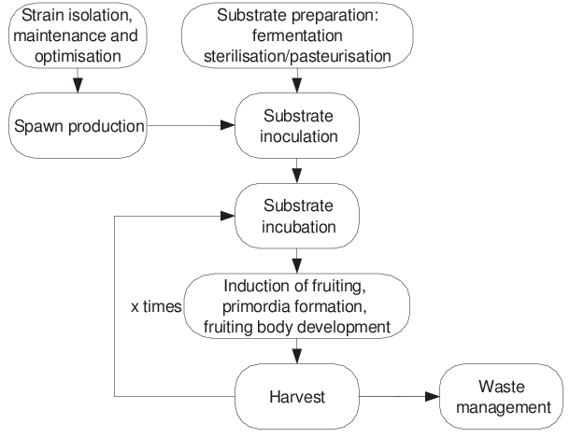
Fig. 2 General scheme of the main operational steps in mushroom production
“Temperature is regarded as the most critical environmental factor influencing mushroom growth and fruiting. Studies evaluating mycelial growth of the milky mushroom under in vitro conditions have shown that 35 °C is the optimum temperature. Investigations on light requirements during the cropping phase indicated that a daily photoperiod exceeding one hour is necessary for proper development” (Tandon et al. 2003, 2006). Theradimani et al. (2001) examined the influence of plant growth regulators on sporophore production and reported that spraying kinetin at 100 ppm resulted in uniform-sized sporophores with reduced stipe length, consistent pileus diameter, and enhanced yield. “Further studies assessing the effects of different light sources and coloured high-density polyethylene (HDPE) growth chambers demonstrated that chambers roofed with blue-coloured HDPE sheets and illuminated with blue incandescent light significantly improved sporophore yield in milky mushroom. Instances of poorly organized cultivation systems, such as thatched sheds or structures with tarpaulin roofs and brick walls, have also been documented, though with limited success” (Raja and Ganesh, 2012). “These structures often lack proper insulation, leading to fluctuations in critical growth parameters like temperature and relative humidity in response to external climatic conditions. A year-long study on milky mushroom production in such sheds using rice straw as substrate revealed that the highest yields were obtained during May and June, corresponding to the peak summer period in South India” (Kumar et al. 2012).
Shelf life and dehydration of milky mushroom
“Dehydration experiments on milky mushroom were carried out using three methods, namely room-temperature drying, oven drying at 55 °C, and sun drying. Polypropylene packaging (80–100 gauge) was found to be most suitable for storing sporophores at ambient conditions for 4–5 days under zero vent area, as well as under refrigerated storage. Mushrooms dried at room temperature retained a more appealing colour and better morphological characteristics. Although oven-dried samples showed superior rehydration capacity, they did not exhibit browning of the sporophores” (Pandey et al. 2002). The canned samples were periodically evaluated at monthly intervals for parameters such as protein content, vitamin C levels, moisture percentage, and drained weight. Analytical results of biochemical qualities of canned mushrooms in different caning media revealed a gradual decline during storage period of one year. Same trend was noticed with physical parameters such as moisture content and drained weight. Among the treatments, mushroom canned with tomato pulp from hybrid tomatoes exhibited better quality aspects. Amuthan et al. (1999) investigated “osmotic–air drying of milky mushroom by subjecting samples to osmotic treatment in common salt solutions of varying concentrations (10, 15, 20, and 25%), followed by dehydration in a fluidized bed dryer maintained at 55 °C and 60% relative humidity. The greatest moisture loss through osmosis was observed at the 25% salt concentration within six hours. Osmotically treated samples required a shorter drying time (about 170 minutes) compared to the control samples dried by air alone (195 minutes). Complete rehydration of mushrooms osmosed in 25% salt solution was achieved more rapidly, within approximately 50 minutes. In addition, osmotically dried samples exhibited a brighter colour compared to untreated ones”.
Antioxidant activity, assessed through DPPH radical scavenging, thiobarbituric acid (TBA) reactive substances, and total phenolic content, varied among fresh mushrooms. DPPH inhibition in fresh samples followed the order A. bisporus > V. volvacea > C. indica > P. ostreatus > L. edodes, while total phenolic content decreased in the order P. ostreatus > C. indica > V. volvacea > A. bisporus > L. edodes. The mushrooms were further analyzed after cooking by microwaving (2 minutes), boiling in water (5 minutes), and sautéing in sunflower oil (2 minutes). Both microwaving and boiling led to a reduction in antioxidant activity, likely due to the leaching of bioactive compounds, whereas sautéing caused a slight increase, presumably due to concentration effects during frying. TBA-reactive compounds decreased in all mushrooms across all cooking methods, indicating a reduction in carbonyl compound formation.
Major Constraints in Milky mushroom Production
Pandey et al. (2003) examined “the incidence of competitor moulds and pathogenic organisms during milky mushroom cultivation. Among the contaminants, Trichoderma harzianum emerged as the most serious weed mould during the spawn run phase. Cobweb disease caused by Dactylium dendroides was found to be highly destructive, resulting in complete crop failure. Application of carbendazim at 0.01% effectively managed both the weed mould and the pathogen without adversely affecting the mycelial growth of Calocybe indica. Although prochloraz manganese complex was effective against the pathogen, it significantly suppressed the mycelial growth of C. indica by 46.69%. Investigations into nematode inoculum sources indicated that wheat straw, chicken manure, and spent compost—commonly used as casing materials—were the major contributors to nematode persistence in Agaricus bisporus cultivation”.
Since chicken manure is not used in Calocybe indica nematodes were mainly disseminated in this mushroom through other two means. Besides, FYM, loam and platform soil also acted as source of nematode inoculum. Dipteran flies hovering in the farms also perpetuated nematodes from one bed/room to other in both the cases. Kumar et al. (2010) evaluated the damage potential of the nematodes Aphelenchoides swarupi and Aphelenchus avenae at an inoculum level of 1,000 individuals per 10 kg of compost in milky mushroom by introducing the nematodes at two stages, namely spawning and casing. Inoculation at the spawning stage did not result in notable mycelial degradation in C. indica. Nematode feeding activity was observed only after casing, leading to significant mycelial depletion at the pinhead initiation stage. Overall yield did not differ significantly among the nematode treatments, regardless of the species or the stage of inoculation. However, the flush pattern indicated that weekly yields remained unaffected up to the fourth week, after which fruit body production declined steadily from the fifth to the seventh week.
Conclusion
“Milky white mushrooms are tremendously competent for industrial mass production in humid tropical and subtropical regions of the world where, the average temperature ranges between 25⁰C and 35⁰C throughout the year” (Navathe et al. 2014). Apart from India, several regions across Africa, North America, South America, the Middle East, Southeast Asia, and Australia—where labour costs are relatively low—are well suited for the cultivation of milky white mushrooms. In tropical climates, the infrastructural requirements for temperature regulation, such as cooling and heating systems, are considerably less expensive for milky mushroom cultivation than for button mushroom production. Owing to its close resemblance to the button mushroom, along with advantages such as longer shelf life, higher yield potential, and an attractive milky white appearance, this mushroom is likely to gain a substantial share of the global market. Furthermore, milky white mushrooms are sturdy and adaptable, allowing production in a wide range of sizes, from small button-type mushrooms (averaging 35–40 g) to larger caps depending on consumer preference—flexibility that is rarely achievable with other commercially cultivated mushrooms worldwide.
“Mushroom industry has been expanded at the rate of 7 % during the last few decades. Mushroom production in India for the year 2013 is approximately 1,29,000 tons granting < 1% of total world production” (Sharma et al. 2017). “Milky white mushrooms are tremendously feasible for industrial production in humid tropical and subtropical regions of the world where, the average temperature ranges between 25 and 35 ⁰C throughout the year” (Navathe et al. 2014). Owing to its morphological emergence higher shelf life, higher productivity, white colour and low production cost, milky mushroom will have considerable acceptability in the world market. The mushroom has a resemblance to button mushroom, which may again help in harvesting the demand for this mushroom in the world.
Milky mushroom (Calocybe indica) can be cultivated on a broad spectrum of lignocellulosic substrates, including paddy, wheat, ragi, maize, bajra, and cotton straw; stalks and leaves; sugarcane bagasse; cotton and jute wastes; dehulled maize cobs; and tea or coffee residues. The crop requires a simple pasteurization method to eliminate undesirable microorganisms, which can be effectively achieved through steam or hot water treatment. After completion of the spawn run, the substrate bags are covered with a pasteurized casing layer that provides mechanical support, maintains moisture, and facilitates gas exchange from the substrate. Under favourable environmental conditions of 30–35 °C temperature and 80–90% relative humidity, the mycelium typically reaches the surface of the casing layer within about 10 days following the introduction of fresh air. Continuous light exposure is essential during this phase. These controlled environmental adjustments induce fruit body initiation within 3–5 days, appearing initially as needle-like primordia that develop into fully mature mushrooms in approximately one week.
Industrialization of the new postulation by mechanization and controlled environment production will be obligatory to further lowering the cost of production and escalating profit margins to mushroom producers. Mass production of mushrooms will be exploited to produce various processed mushrooms (dry, canned, pickled, and fried) in turn will increase the shelf life that could further be marketed in different area of the world as well.
Conflict of interest: The authors declare that they have no conflict of interest.
Disclaimer (Artificial intelligence)

Author(s) hereby declare that NO generative AI technologies such as Large Language Models (ChatGPT, COPILOT, etc.) and text-to-image generators have been used during the writing or editing of this manuscript.

References
- Alam, N., R. Amin, A. Khan, I. Ara, M.J. Shim, M.W. Lee and T.S. Lee. 2008. Nutritional analysis of cultivated mushrooms in Bangladesh: Pleurotus ostreatus, Pleurotus sajor-caju, Pleurotus florida and Calocybe indica. Mycobiology 36: 228–232.
- Amuthan, G., R. Visvanathan, R. Kailappan, and V.V. Sreenarayanan. 1999. Studies on osmo-air drying of milky mushroom, Calocybe indica. Mushroom Res 8(2):49-5.

- Babu, D.R. and G.N. Rao. 2013. Antioxidant properties and electrochemical behaviour of cultivated commercial Indian edible mushrooms. J Food Sci Technol 50: 301–308.

- Crisan, E.V. and A. Sands. 1978. Nutritional value. In: Chang ST, Hayes WA, eds. The biology and cultivation of edible mushrooms. New York: Academic Press. pp 137-165.

- Doshi, A., N. Sidana and B.P. Chakravarti. 1989. Cultivation of summer mushroom Calocybe indica (P&C) in Rajasthan. Mushroom Sci 12: 395–400.

- Hawksworth DL 1991. The fungal dimension of biodiversity: magnitude, significance, and conservation. Mycol Res; 95:641-55.

- Joshi, M. and A. Sagar. 2016. Evaluation of various substrates for spawn production and cultivation of Shiitake mushroom using Corn cobs. Mushroom Res 25(2): 119-124.

- Krishnamoorthy, A.S. and M. Muthusamy. 1997. Yield performance of Calocybe indica (P&C) on different substrates. Mushroom Res 6(1): 29-32.

- Kumar, R., G. Singh, P. Mishra and R. Singh. 2012. Effect of different organic supplements and casing mixtures on yield of two strains of milky mushroom (Calocybe indica). Indian Phytopathol 65: 399–403.

- Livi-Bacci M. A concise history of world population. 5th ed. Malden (MA): Wiley-Blackwell; 2012.

- Mattila, P., K. Könkö, M. Eurola, J.M. Pihlava, J. Astola, L. Vahteristo, V. Hietaniemi, J. Kumpulainen, M. Valtonen and V. Piironen. 2001. Contents of vitamins, mineral elements, and some phenolic compounds in cultivated mushrooms. J Agric Food Chem 49:2343-8.

- Nagaratna, G.K. and B.C. Mallesha. 2007. Use of vermicompost as casing material for cultivation of milky mushroom. Mushroom Res 16(2): 81-83.

- Navathe, S., P.G. Borkar and J.J. Kadam. 2014. Cultivation of Calocybe indica (P & C) in Konkan region of Maharashtra, India. World J Agric Res 2: 187–191.

- Pandey, M., T.N. Lakhanpal and R.P. Tewari. 2003. Cob-web disease and competitor moulds and their management during cultivation of the milky mushroom, Calocybe indica. Mushroom Res 12(1): 51-55.

- Purkayastha, R. P., and A. Chandra. 1974. A new species of edible mushroom from India. Trans British Mycology Society 62: 415-418.

- Raja, R.E. and P. Ganesh. 2012. Environmental factors influence on yield variation of Indian white summer mushroom (Calocybe indica). Int J Pharm Biol Arch 3: 1544–1546.

- Salam, Sherin A., D. Geeta, M. Suharban and H. Harikrishnan Nair. 2004. Coirpith – a non-conventional substrate for Calocybe indica (milky mushroom) production. Mushroom Res 13 (2): 60-64.

- Saranya, V., P. Madhanraj and A. Panneerselvam. 2011. Cultivation, composting, biochemical and molecular characterization of Calocybe indica (P&C). Asian J Pharm Res 1: 55–57.

- Selvi, S., P.U. Devi, S. Suja, S. Murugan and P. Chinnaswamy. 2007. Comparison of non-enzymic antioxidant status of fresh and dried form of Pleurotus florida and Calocybe indica. Pak J Nutr 6: 468–471.

- Senthilnambi, D., P. Balabaskar and A. Eswaran. 2011. Impact of different spawn substrates on yield of Calocybe indica. African Journal of Agricultural Research 6(16): 3946-3948.

- Sharma, S.S., A. Doshi, A. Trivadi and K.L. Kothari. 1997. Evaluation of the suitability of different casing material for Calocybe indica P&C. Mushroom Res 6: 81-82.

- Singh, A., V.P. Sharma, S. Kumar and A. Varshney. 2010. Effect of supplementation, casing material and substrate preparation method on Calocybe indica production. Mushroom Res 19(2): 86-89.

- Singh, M., A.K. Singh and R.K. Gautam. 2007. Effect of casing and supplementation on yield of milky mushroom (Calocybe indica). Indian Phytopath 60(2): 191-193.

- Sohliya, D.S., Robin Gogoi, K.C. Puzari, D.K. Sarmah and Chelleng Anuradha. 2011. Effect of steaming and gibberellic acid on growth, yield and nutritional quality of Calocybe indica. Indian Phytopath 64(1): 312-316.

- Tandon, G. and V.P. Sharma. 2006. Yield performance of Calocybe indica on various substrates and supplements. Mushroom Res 15(1): 33-35.

- Theradimani, M., B. Meena and A.K. Krishnamoorthy. 2001. Innovative techniques for the improvement of sporophore size and yield of milky mushroom (Calocybe indica). Mushroom Res 10 (1): 23-26.

- Usha, S. 2007. Energy value of different agroresidues used for cultivation of Calocybe indica (P & C). Agricultural Science Digest 7(1): 75-76.

- Vikineswary, S and Chang, S.T. 2013. Edible and medicinal mushrooms for sub-health intervention and prevention of lifestyle diseases. Tech Monitor :33-43.

- Zahid, M.K., Barua, S. and Haque, S.M. 2010. Proximate composition and mineral content of selected edible mushroom varieties of Bangladesh. Bangladesh J Nutr 22-23: 61-68.

