Original Research Article
Phytochemical screening and antioxidant potential of organic extracts of the leaves and flowers of Lippia multiflora Mold from Burkina Faso

Abstract :
Lippia multiflora Moldenke (Mold) is a plant belonging to the Verbenaceae family and is widely used for its therapeutic properties in traditional medicine. The objective of this study was to investigate the phytochemical composition and antioxidant activity of organic extracts from from its leaves and flowers. The extracts were obtained by maceration using solvents of increasing polarity. Phytochemical screening was carried out by Thin-Layer Chromatography(TLC) and test-tube assays. Total phenolic compounds (TPC), total flavonoids (TF), and condensed tannins (TC) were measured using colorimetric methods employing Folin-Ciocalteu reagent, aluminium trichloride, and sulfuric vanillin, respectively. The antioxidant activity of the extracts was evaluated using DPPH• and ABTS+• radical scavenging methods.
In the leaves, the TPC were 842.40 ± 10.69 μg GAE/mg of dry extract, compared to 870.23 ± 2.41 μg GAE/mg of dry extract in the flowers, for the dichloromethane extracts. Total flavonoid content was 202.78 ± 0.43 μg QE/mg of extract in the ethyl acetate leaf extract versus to 206.05 ± 2.09 μg QE/mg of dry extract of the same solvent in the flowers. Concerning condensed tannins, the content was 333.13 ± 10.91 mg TA/g of dry extract in the methanolic flower extract compared to 525.67 ± 6.46 mg TA/g of dry extract in the ethyl acetate leaf extract.
The IC50 values of the methanol extracts were 57.465 ± 0.28 μg/ml and 65.473 ± 2.44 μg/ml for flowers and leaves, respectively, compared to 16.585 ± 0.474 for ascorbic acid using the DPPH method. Using the ABTS method, the ethyl acetate extracts of flowers and leaves showed IC50 values of 37.349 ± 0.301 μg/ml and 39.173 ± 0.390 μg/ml, respectively, compared to 10.864 ± 0.029 μg/ml for ascorbic acid. The flowers were found to be richer in secondary metabolites and antioxidants than leaves, which are nevertheless more commonly used.
Keywords: Lippia multiflora, phytochemical screening, total phenolic compounds, flavonoids, condensed tannins, antioxidant activity

- Introduction
The traditional treatment of several diseases using plant extracts by populations in some developing countries is a very ancient practice, driven by both cultural and economic reasons (MINA et al., 2025). Indeed, the World Health Organization (WHO) reports that more than 80% of the population in developing world countries relies on traditional medicine to meet their primary healthcare needs (mondiale de la Santé, 2003). However, certain medicinal plants are used without scientific knowledge of their scientific of their biochemical and chemical data (Fleurentin, 2012, Danhabal et al., 2021). This lack of knowledge could lead to health risks (El Khasmi and Farh, 2022). Consequently, the WHO encourages intensified research in this field (OMS, 1995). Nowadays, more than 25% of medicines are derived from medicinal plants through the combination of modern technologies and traditional knowledge(Organization, 2002, mondiale de la Santé, 2003, Pascual et al., 2001).
The therapeutic properties of plants are attributed to the presence of the bioactive compounds they produce (El Hilah Fatima et al., 2015). These substances are synthesized by plants to protect themselves against external attacks (Kliebenstein, 2012, Li et al., 2020). Among these compounds are phenolic compounds, particularly flavonoids and tannins, which are known for their diverse and interesting biological properties, especially antioxidant properties. These chemical groups are highly sought after in cosmetics, pharmaceutical and food industries, as well as in the total synthesis of therapeutic agents in organic chemistry (Evano, 2008). As a result, the search for secondary metabolites, particularly natural antioxidants, and interest in medicinal plants has increased in recent years.
This is the case of Lippia multiflora, whose various organs are used in traditional medicine to treat numerous diseases (Masengo et al., 2021). Several studies have reported pharmacological properties such as antioxidant activity (Dabire et al., 2015), antimalarial, anti-inflammatory, analgesic, and antimicrobial (Evans, 2009) of organic extracts from the leaves, roots, and bark, (Tlhapi et al., 2025) and the essential oils from the leaves of Lippia multiflora (MASENGO et al., 2023, José-Rita et al., 2022). Despite the chemical studies conducted on different organs of Lippia multiflora, the flowers remain poorly investigated, although their study is necessary, considering their potential use. Moreover, several studies have demonstrated variability in bioactive compounds among different organs of the same species (Dif et al., 2015). The objective of this study was therefore to conduct a comparative study of the phytochemical composition and antioxidant potential of leaves and flowers of Lippia multiflora grown in Burkina Faso.
2. MatérielS AND Méthods
2.1. Plant materiel
The plant material included the leaves and flowers of Lippia multiflora was collected in October 2022 in Boassa in Ouagadougou municipality (N 12°17'29" and W 1°36'51") in Burkina Faso. After drying in the dark place and grinding into powder using a SK300 impact grinder, the vegetable powder was packaged in bags and stored in desiccators.

2.2. Methods
2.2.1 Preparation of extracts
The extracts were prepared by successive maceration using solvents of increasing polarity (Hexane (Hex), dichloromethane (DCM), ethyl acetate (AcOEt), and methanol (MeOH)) according to the method described by Ganamé (Ganamé et al., 2024). A mass of 100 g of powder from each plant organ was macerated in 3 x 1000 mL of each solvent successively. The extracts were filtered using filter paper. Solvents were evaporated under reduced pressure at 40 °C using a Büchi-type rotary evaporator, concentrated and transferred to petri dishes in the oven at 37º C. The dry extracts obtained were stored at 4 °C. Extraction yields were calculated using equation I below:
$$Extraction yield (\%)=\frac{m}{M}×100$$
Equation I : Extraction yield calculation formula
where m is the mass of extract obtained and M is the mass of the plant material used

2.2.2. Phytochemical screening Criblage phytochimique
Phytochemical screening was performed using thin-layer chromatography (TLC) and tube-tests assays according to literature methods (Sofowora, 1993), (Harborne, 1998), (Roger et al., 2011, Diouf et al., 2014, N’Guessan et al., 2009). Alkaloids, saponins, quinones, and phenolic compounds, including tannins and flavonoids, were investigated.

2.2.3. Total phenolics content (TPC)
Total phenolics content of the extracts was determined by the spectrophotometric method as described by Ozgen. (Ozgen et al., 2006) using the Folin-Ciocalteu reagent. Thus, a volume of 60 µl of extract was mixed with 60 µl of the Folin-Ciocalteu reagent. After eight minutes of reaction, 120 µl of a 7.5% solution of Na₂CO₃ was added in order to neutralise the residual reagent. The mixture was incubated in the dark at room temperature for 20 minutes. Absorbances were recorded at 765 nm using a microplate reader (spectrophotometer MP96, MULTISKAN Skyhigh), Contents were determined from the equation of calibration curve (y = 0.0218x + 0.103 with R2 = 0.9989), established with gallic acid taken as the standard and expressed in micrograms of Gallic Acid Equivalent per gram of dry extract (µg GAE/mg of dry extract). All analyses were performed in triplicate.

2.2.4. Total flavonoïds content
Total flavonoid content of the extracts was determined according to the spectrophotometric method using aluminum trichloride. (Dufour et al., 2007). A volume of 125 μL of a 2% methanolic aluminium chloride (AlCl₃) solution was added to 125 μL of an extract solution. After 20 minutes of incubation at room temperature, absorbances were recorded at 415 nm using a microplate reader (spectrophotometer MP96, MULTISKAN Skyhigh). A calibration curve was established by preparing a series of quercetin solutions (0 to 62.5 µg/mL) used as a reference. All preparations and analyses were performed in triplicate. Total flavonoid content was calculated from the equation y = 0.01x + 0.747 with R² = 0.9949, and expressed in micrograms of Quercetin Equivalent per milligram of dry extract (µg QE/mg dry extract).

2.2.5. Condensed tannins content
The content of condensed tannins was determined according to the method described by Julkunen-Titto (1985). One milliliter (mL) of a 4% vanillin solution in 70% sulfuric acid was added to 0.5 mL of extract. The resulting mixture was vigorously shaken and then incubated in a water bath at 30 °C for 15 minutes. Absorbance was measured at 500 nm against a blank consisting of the 4% vanillin solution in ethanol. The tests were carried out in triplicate for each sample. A stock solution of tannic acid was used as a standard to establish the calibration curve, the equation of which (y = 0.03222x - 0.00006; R² = 0.9991) was used for the quantification of condensed tannin contents. Values were expressed in milligrams of tannic acid equivalent per gram of dry matter (mg TAE/g of dry extract).

2.2.6. Evaluation of antioxidant activity
2.2.6.1. DPPH• test
Antioxidant activity of the extracts was evaluated using the DPPH• (2,2-diphenyl-1-picrylhydrazyl) assay described by Brand-Williams and modified by Ozgen. (Ozgen et al., 2006). The principle is based on the ability of an antioxidant compound to reduce the DPPH• radical. The reduction is characterised by the color change from purple (DPPH•) to yellow (DPPH-H) and can be quantified using a spectrophotometer at 517 nm. The change from purple to yellow is proportional to the antioxidant capacity (Figure 1).
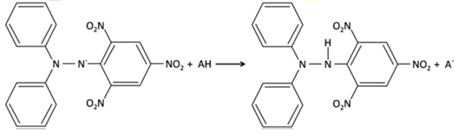
Figure 1: Reduction of the DPPH• radical ((2,2-diphenyl-1-picrylhydrazyl) by an antioxidant

A methanolic solution of the DPPH radical at 10⁻⁵ M was prepared. The absorbance of this solution was then measured. Ascorbic acid was used as a reference. To 50 µL of each extract at different concentrations, 200 μL of the DPPH• solution was added. The solutions were shaken and then incubated at room temperature in the dark for 20 minutes before measuring the absorbance at 517 nm. Absorbances were read using a microplate reader (spectrophotometer MP96, MULTISKAN Skyhigh). The blank consisted of a methanolic DPPH solution. DPPH inhibition was calculated according to Equation II below. The results are expressed in terms of IC50 (the concentration that inhibits 50% of the DPPH• radical).
$$I\left(\%\right)=\frac{[(Abs control-Abs sample)}{Absorbance control}x 100$$

Equation II : Calculation formula for the inhibition percentage
Where abs is the absorbance and I is the percentage inhibition

2.2.6.2. ABTS^{+ •} test
The method improved by Van den Berg et al., 1999 (van den Berg et al., 1999) was used. For the activation of the ABTS radical cation, a mass of 34.4 mg of ABTS was dissolved in 10 mL of distilled water. Then 6.7 mg of potassium persulfate was added, and the mixture was incubated in the dark at room temperature for 12 hours (Figure 2).
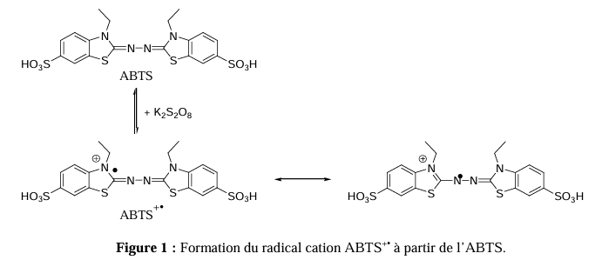
Figure 2 : Formation reaction of the ABTS+• radical cation by potassium persulfate and its reduction by an antioxidant
H
+

+

A-H

The absorbance of the solution was adjusted to 0.7 at 734 nm. 200 μL of this solution were mixed with 50 μL of the extract solutions at different concentrations ranging from 0 to 10 μg/mL. The mixture was shaken and kept in the dark for 15 minutes at 25 °C, and absorbances were measured at 734 nm using a microplate reader (spectrophotometer MP96, MULTISKAN Skyhigh). The control consisted of 200 μL of ABTS solution and 50 μL of methanol. IC50 values were calculated by plotting the calibration curve of the ABTS+• cation radical as a function of extract concentration using linear regression analysis. The IC50 of ascorbic acid, taken as a reference, was also determined.

3. RésultS AND Discussion
3.1. Extraction yield
The extraction yield results obtained by successive maceration with solvents of increasing polarity of the powder of L. multiflora leaves and flowers are presented in Figure 3. The results show that the extraction yield varies depending on the solvent used and the plant organ. Methanolic extracts register the highest yields, with 5.16% and 7.76% for leaves and flowers, respectively, followed by dichloromethane extracts of flowers (3.95%) and leaves (2.84%) and hexane extracts of flowers (2.04%) and leaves (1.506 %). The lowest yields are observed in ethyl acetate extracts of flowers (0.44%) and leaves (0.50%). The observed difference in yield indicates an unequal distribution of secondary metabolites in the plant's organs.(Dif et al., 2015, Abe et al., 2010, Danhabal et al., 2021). Thus, the flowers had a higher total yield than the leaves, 14.20% against 9.5%. The high yield for the flowers could suggest that they are richer in secondary metabolites, unlike the leaves, which are more commonly used (Masengo et al., 2021). The high yield of hexane extracts from the flowers compared to that of the leaves could be explained by the high presence of non-polar molecules, such as carotenoids or lipid molecules, in the flowers compared to the leaves. Ouattara et al.(Ouattara et al., 2022) obtained, with the leaves of the same plant, extraction yields, hexane (1.40%) and methanol (1.53%), lower than those in the present study. On the other hand, the yield of the dichloromethane extract (3.50%) was higher than ours (2.83%). This difference in results could be related to the organ used, the place of harvest, the drying time, or parameters related to the extraction, particularly the particle size of the crushed material, the volume-to-mass ratio of the crushed material, the stirring speed, or the structural diversity of the molecules present (Koné et al., 2017, Hasikić et al., 2025).

Figure 3 : Extraction yields of Lippia multiflora leaves and flowers

3.2. Phytochemical screening
The results of phytochemical screening carried out by CCM and through test-tube assays are deposited in Table 1. These results show that flavonoids, alkaloids, saponins, and tannins are present in both studied organs. However, considering the extraction solvents, tannins are absent in all hexane extracts. Alkaloids were detected in all dichloromethane and ethyl acetate extracts. Except for the hexane and DCM leaf extracts, quinones were identified in the other extracts. Several studies corroborate our results, notably those of Dabire et al., in 2015 (Dabire et al., 2015) and Allo (Allo et al., 2020), which showed the presence of flavonoids, tannins, saponins, alkaloids, and triterpenes in the leaves of Lippia multiflora harvested in Burkina Faso. As for the work of Ouattara (Ouattara et al., 2022), the presence of alkaloids in the dichloromethane and ethyl acetate extracts was not reported. These differences could be explained by the climate and environment (Koné et al., 2017).

Table 1 : Chemical groups found in extracts in the leaves and flowers of Lippia multiflora
Chemical groups | Extracts
Chemical groups | Leaves |  |  |  | Flowers
Chemical groups | Hex | DCM | AcOEt | MeOH | Hex | DCM | AcOEt | MeOH
Flavonoids | - | + | + | + | + | + | + | +
Alkaloids | - | + | + | - | - | + | + | -
Tannins | - | + | + | + | - | + | + | +
Saponosides | + | + | - | + | + | + | - | -
Quinones | - | - | + | + | + | + | + | +
+ : presence ; - : absence
3.3. Total phenolics content (TPC)
The results of the evaluation of the TPC content in the various extracts obtained from different plant organs are gathered in Table 2. TPC vary depending on the extraction solvent and the organ. For the the leaves, the dichloromethane extract exhibited the highest TPC, with a value of 842.40 ± 10.69 μg GAE/mg of dry extract, followed by the ethyl acetate extract, 825.34 ± 14.89 μg GAE/mg of dry extract. The methanolic and hexane extracts showed lower values of 75.59 ± 0.84 and 7.92 ± 0.74 μg GAE/mg of dry extract, respectively.

A similar trend was observed for the flower extracts, with values of 870.23 ± 2.41; 753.44 ± 4.11; 127.02 ± 1.57; and 7.01 ± 1.47 μg GAE/mg of dry extract for the dichloromethane, ethyl acetate, methanol, and hexane extracts, respectively.
The TPC values reported by Dabiré et al. (2015) for leaf extracts, 6.71 ± 0.00, 6.62 ± 0.40, and 71.17 ± 0.20 µg GAE/mg of dry extract for dichloromethane, ethyl acetate, and ethanol, respectively, were lower than those obtained in the present study (Dabire et al., 2015). These differences may be attributed to climatic conditions, the degree of organ maturation, or extraction-related factors, particularly particle size and extraction duration (Koné et al., 2017).

The decrease in phenolic compound content from the dichloromethane fraction in both leaves and flowers may be explained by the successive depletion of the plant matrix during extraction. The extracting power of the solvent depends not only on the physicochemical properties of the compounds present but also on hydrogen-bond interactions (Figure 4) between the solvent and the plant material (Chen et al., 2019, Al Mamari, 2021). Consequently, phenolic compounds extracted with ethyl acetate are considered more polar than those extracted with dichloromethane and less polar than those extracted with methanol (Dabire et al., 2015). Furthermore, when comparing the two organs of the same plant, flowers exhibited a slightly higher mean TPC value (439.43 ± 2.39 µg GAE/mg of dry extract) than leaves (437.81 ± 6.79 µg GAE/mg of dry extract). This difference may be attributed to an unequal distribution of secondary metabolites within the plant. Similar findings have been reported for extracts obtained from different organs of Grangéa madesapatana, Cynara cardunculus L., and Papaver rhoeas L (Danhabal et al., 2021), Kukic et al., (Kukić et al., 2008) and Dif, et al., 2015 (Dif et al., 2015) respectively, on extracts from different organs of Grangéa madesapatana, Cynara cardunculus L., and Papaver rhoeas L.
Overall, total phenolic compound content may be influenced by several factors, including geographical and climatic conditions, genetic variability, the degree of organ maturation, and the particle size of the plant material (Aganga and Mosase, 2001, Merouane et al., 2014, El Hazzat et al., 2015).
Table 2 : Total phenolic content of extracts from the leaves and flowers of Lippia multiflora
Extracts | Total phenolic compounds content (μg GAE/mg of extract)
Extracts | Leaves | Flowers
Hexane | 7.92 ± 0.74 | 7.01 ± 1.47
DCM | 842.40 ± 10.69 | 870.23 ± 2.41
AE | 825.34 ± 14.89 | 753.44 ± 4.11
MeOH | 75.59 ± 0.84 | 127.02 ± 1.57
GAE : gallic acid equivalent équivalent acide gallique ; DCM : Dichloromethane ; AE : Ethyl Acetate d’éthyle

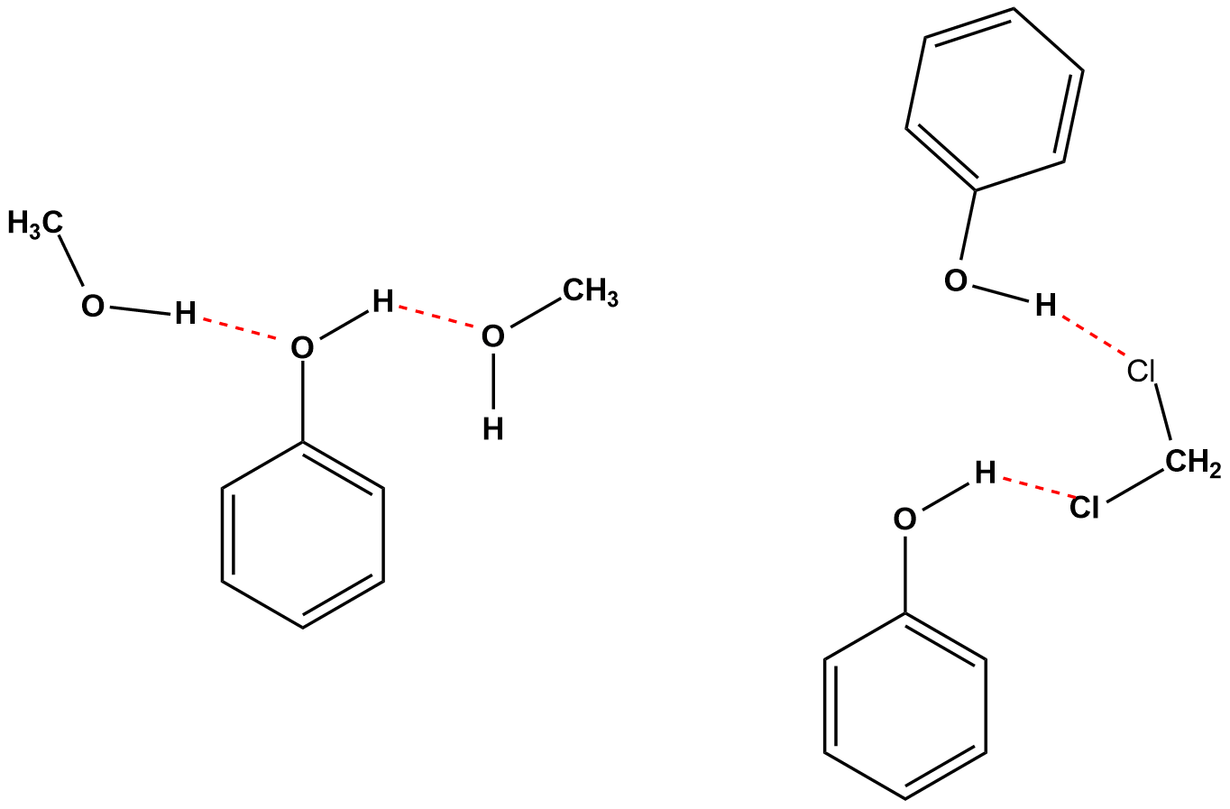
Figure 4: Intermolecular hydrogen bonding between phenolic compounds and extraction solvents (methanol and dichloromethane)

3.4. Flavonoids content (FT)
The results of the total flavonoid content (TFC) assay for the different extracts obtained from the leaves and flowers of Lippia multiflora are presented in Table 3. Flavonoid content varied depending on both the extraction solvent and the plant organ. Overall, the values ranged from 2.96 ± 0.14 to 206.05 ± 2.09 µg QE/mg of dry extract.
For the leaf extracts, the ethyl acetate fraction exhibited the highest flavonoid content (202.78 ± 0.43 µg QE/mg of dry extract), followed by the dichloromethane extract. The methanolic and hexane extracts showed lower values of 35.53 ± 1.74 and 5.25 ± 0.15 µg QE/mg of dry extract, respectively.
A similar trend was observed for the flower extracts, with flavonoid contents of 206.05 ± 2.09 µg QE/mg of dry extract for ethyl acetate, 164.47 ± 4.73 µg QE/mg of dry extract for dichloromethane, 49.31 ± 0.50 µg QE/mg of dry extract for methanol, and 5.80 ± 1.49 µg QE/mg of dry extract for hexane. These results indicate that the flowers are generally richer in flavonoids than the leaves.
Dabiré (Dabire et al., 2015) reported significantly lower total flavonoid contents in organic extracts of Lippia multiflora leaves, with values of 6.16 ± 0.10 µg QE/mg of extract for dichloromethane, 13.72 ± 0.20 µg QE/mg of dry extract for ethyl acetate, and 40.79 ± 0.20 µg QE/mg of dry extract for ethanol. The higher flavonoid contents observed in the present study may be attributed to differences in environmental conditions, plant material, or extraction parameters.
For both plant organs, the ethyl acetate extracts showed higher flavonoid contents than the other extracts. This could be explained by the presence of flavonoid compounds that are more soluble in ethyl acetate than in hexane or dichloromethane. The relatively low flavonoid contents observed in the methanolic extracts of both organs may be related to the matrix depletion effect resulting from successive extraction steps (Danhabal et al., 2021). Overall, the flowers exhibited a higher average flavonoid content (106.41 ± 2.20 µg QE/mg of dry extract) compared to the leaves (101.00 ± 1.31 µg QE/mg of dry extract).

Table 3 : Flavonoid content of leaf and flower extracts of Lippia multiflora (μg QE/mg of dry extract)
Extracts | Total flavonoid content (μg QE/mg of dry extract)
Extracts | Leaves | Flowers
Hexane | 5.25 ± 0.15 | 5.80 ± 1.49
DCM | 160.40 ± 2.90 | 164.47 ± 4.73
AE | 202.78 ± 0.43 | 206.05 ± 2.09
MeOH | 35.53 ± 1.74 | 49.31 ± 0.50
QE : Quercétine Equivalent

3.5. Condensed tanins content

The results of the evaluation of condensed tannin content in the different extracts from various organs are presented in Table 4. The contents range from 58.80 ± 1.79 to 525.67 ± 6.46 mg CE/g of dry extract. As for the leaf extracts, the ethyl acetate extract showed the highest content, 525.67 ± 6.46 mg CE/g of dry extract, followed by the dichloromethane and methanol extracts with respective values of 421.12 ± 3.11 and 178.88 ± 14.23 mg CE/g of dry extract. For flowers, the methanolic extract has the highest condensed tannin content, followed by the ethyl acetate and dichloromethane extracts with 333.13 ± 10.91; 310.35 ± 9.49; and 74.29 ± 1.79 mg CE/g of dry extract, respectively. The condensed tannin content of the leaves is higher than that of the flowers. These results are in agreement with those of Sérémé (Sérémé et al., 2008), who showed very low condensed tannin content in the flowers of several tannin-producing species.

Table 4: Condensed tannin content of leaf and flower extracts of Lippia multiflora (mg TA/g of dry extract)
Extracts | condensed tanins content (mg EAT/g of dry extract)
Extracts | Leaves | Flowers
Hexane | - | -
DCM | 421.12 ± 3.11 | 74.29 ± 1.79
AE | 525.67 ± 6.46 | 310.35 ± 9.49
MeOH | 178.88 ± 14.23 | 333.13 ± 10.91
ATE : acid tanique Equivalent

3.6 Antioxidant activity

The results of the antioxidant activity of the various extracts evaluated by the DPPH• and ABTS+• radical scavenging methods are reported in Table 5. The radical-scavenging activity varies depending on the organ and the extraction solvent. For the DPPH method, the methanolic extract of the flowers and leaves has the lowest inhibitory concentrations (IC50), which are 57.465 ± 0.28 μg/mL and 65.473 ± 2.44 μg/mL, respectively, compared to 16.585 ± 0.474 μg/mL for ascorbic acid taken as the standard. According to the method using the ABTS+• radical cation, the ethyl acetate extracts from both organs recorded the lowest IC50 values, with 37.349 ± 0.301 μg/mL and 39.173 ± 0.390 μg/mL, respectively, compared to 10.864 ± 0.029 μg/mL for ascorbic acid. The activity varies depending on the organ used, the polarity of the solvent, and the evaluation method. Analysis of the results showed that for both the DPPH and ABTS methods, all extracts reduced DPPH and ABTS radicals. The methanolic extracts of both organs showed a very high percentage of inhibition. According to the DPPH method, Tlhapi et al. (2025) also reported strong antioxidant activity of the methanolic extracts (Tlhapi et al., 2025) of the leaves of the same species obtained by successive maceration; similarly, the ethanolic leaf extract in the work of Dabiré et al. (2015) had an IC50 of 38.20 μg/mL. This strong activity was attributed to the presence of flavonoids and phenolic compounds such as 3′,4′-Dimethoxy-7-hydroxyflavone (figure 5A), 6-Gingerol (figure 5B), and Esmolol (figure 5C), identified in the methanolic extracts of Lippia multiflora leaves (Tlhapi et al., 2025), whose antioxidant activities have been proven The DCM extract of the two organs inhibits free radicals less. Dabiré et al. (2015) (Dabire et al., 2015) found similar results for their dichloromethane extract of Lippia multiflora leaves, also obtained by successive maceration with solvents of increasing polarity (Dabire et al., 2015). Furthermore, according to the ABTS+• radical cation reduction method, it was the ethyl acetate extracts that showed a very high activity against the ABTS^{+•} radical cation. However, all extracts from both organs were less active than ascorbic acid taken as a reference, regardless of the method used in this study. In view of these different results, the activity of plant extracts could depend not only on the solvent and extraction method, but also on environmental factors such as the physicochemical characteristics of the soil, temperature, humidity, and especially the organ used, the chemical composition, and the possible interactions between the compounds present in the extracts (Koné et al., 2017, Hasikić et al., 2025).
Table 5: Inhibitory concentration IC₅₀ (μg/ml) of flower and leaf extracts of Lippia multiflora
Extracts |  | IC₅₀ (μg/ml)
Organs | Solvents | DPPH• | ABTS^{•+}
Flowers | Hexane | ND | ND
Flowers | DCM | 199.066 ± 0.23 | 102.262 ± 0.104
Flowers | AcOEt | 106.057 ± 0.99 | 37.349 ± 0.301
Flowers | MeOH | 57.465 ± 0.28 | 45.127 ± 0.011
Leaves | Hexane | ND | ND
Leaves | DCM | 189.177 ± 0.08 | 191.383 ± 2.56
Leaves | AcOEt | 123.373 ± 0.14 | 39.173 ± 0.390
Leaves | MeOH | 65.473 ± 2.44 | 59.759 ± 0.117
AA |  | 16.585 ± 0.474 | 10.864 ± 0.029
ND : non determined ; AA : ascorbic acid

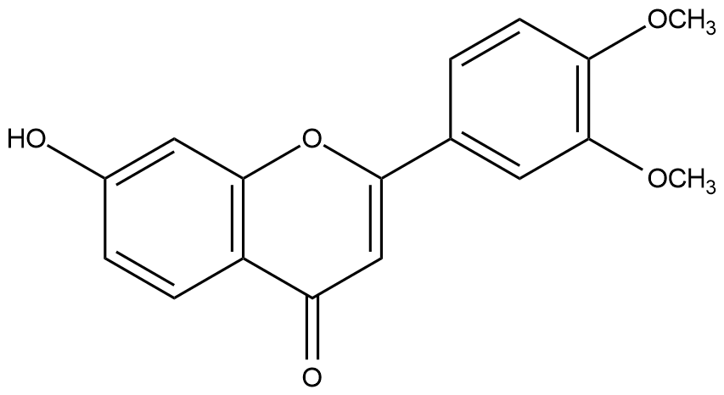
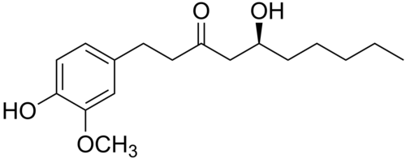
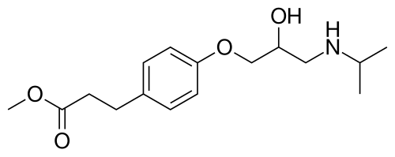

a B C
Figure 5: Structure of phenolic compounds identified in the methanolic extract of Lippia multiflora leaves from South Africa. A: 3′,4′-Dimethoxy-7-hydroxyflavone, B: 6-Gingerol, C: Esmolol

4. Conclusion
This study allowed to identify several chemical groups including phenolic compounds, flavonoids, condensed tannins, alkaloids, quinones, and saponins in extracts from the flowers and leaves. The dichloromethane and ethyl acetate flower extracts showed the highest levels of total phenolic compounds (870.23 ± 2.41 μg GAE/mg dry extract) and total flavonoids (206.05 ± 2.09 μg QE/mg dry extract) respectively, while the ethyl acetate leaf extract had the highest content of condensed tannins (525.67 ± 6.46 mg EAT/g dry extract). The flowers recorded the highest levels of total phenolic compounds and total flavonoids, whereas the leaves showed the highest content of condensed tannins. All extracts demonstrated the ability to inhibit radicals. However, the methanolic extract and the ethyl acetate extract of the flowers showed the greatest capacity to inhibit the DPPH• and ABTS+• radicals, respectively. Nevertheless, chromatographic methods would be necessary to separate and characterize the types of phenolic compounds and the molecules responsible for the antioxidant activities. These results indicate that the flowers and leaves are potential sources of natural antioxidants.

Disclaimer
The authors declare that no artificial intelligence technology such as large language models (ChatGPT, COPILOT, etc.) and text to image generators was used during the writing or editing of this manuscript.
COMPETING INTERESTS
Authors have declared that no competing interests exist

Références
ABE, E., DELYLE, S. G. & ALVAREZ, J. C (2010). Liquid-liquid extraction: theory, applications, difficulties. Annals of Analytical Toxicology, (2010). EDP Sciences, 51-59. DOI: 10.1051/ata/2010018
AGANGA, A. & MOSASE, K. 2001. Tannin content, nutritive value and dry matter digestibility of Lonchocarpus capassa, Zizyphus mucronata, Sclerocarya birrea, Kirkia acuminata and Rhus lancea seeds. Animal Feed Science and Technology, 91, 107-113.
AL MAMARI, H. H. 2021. Phenolic compounds: Classification, chemistry, and updated techniques of analysis and synthesis. Phenolic compounds-chemistry, synthesis, diversity, non-conventional industrial, pharmaceutical and therapeutic applications. IntechOpen.
ALLO, F. Y., KONAN, A. B., MÉITÉ, S. & DATTÉ, J. Y. (2020). Acute and sub-acute toxicity studies of the aqueous leaf extract of Lippia multiflora from the Bélier Region (Côte d’Ivoire). Asian Journal of Emerging Research, 2, 43-53. DOI: 10.21124/AJERPK.2020.43.53
CHEN, J., LI, Y., WANG, X. & LIU, W. (2019). Application of deep eutectic solvents in food analysis: A review. Molecules, 24, 4594. doi:10.3390/molecules24244594
DABIRE, C. M., BATIONO, R. K., HEMA, A., NEBIE, R. C., PALE, E., DHANABAL, S. & NACRO, M. (2015). Total phenolics content, flavonoids profiling and antioxidant activity of Lippia multiflora leaves extracts from Burkina Faso. Asian J. Plant Sci. Res, 5, 28-33.
DANHABAL, S., H ROGER, N. C., ELOI, P., ADAMA, H., K RÉMY, B., CONSTANTIN M, D. & ABDOULAYE, Y. (2021). phytochemical screening, total phenolics content and antioxydants potential of different parts of grangea maderaspatana from Burkina Faso. International Research Journal of Pure and Applied Chemistry, 22, 36-44.DOI: 10.9734/IRJPAC/2021/v22i1030439
DIF, M., BENCHIHA, H., MEHDADI, Z., BENALI-TOUMI, F., BENYAHIA, M. & BOUTERFAS, K. ​​(2015). Quantitative study of polyphenols in different organs. Phytotherapy, 13, 314-319. DOI 10.1007/s10298-015-0976-5
DIOUF, E., SAMB, A., SYLLA, O., KAFIA, A., DIOP, M., SECK, D. & NGUESSAN, K. (2014). Phytochemical and insecticidal test of three organic leaf extracts of Ficus thonningii on Callosobruchus maculatus Fabricius. International Journal of Biological and Chemical Sciences, 8, 2588-2596. DOI : http://dx.doi.org/10.4314/ijbcs.v8i6.20

DUFOUR, D., PICHETTE, A., MSHVILDADZE, V., BRADETTE-HÉBERT, M.-E., LAVOIE, S., LONGTIN, A., LAPRISE, C. & LEGAULT, J. (2007). Antioxidant, anti-inflammatory and anticancer activities of methanolic extracts from Ledum groenlandicum Retzius. Journal of Ethnopharmacology, 111, 22-28.
EL HAZZAT, N., IRAQI, R. & BOUSETA, A. (2015). Identification by GC-MS and GC-FID-O of volatile compounds in green olives of the "Picholine marocaine" variety: effect of geographical origin. International Journal of Biological and Chemical Sciences, 9, 2219-2233. DOI: http://dx.doi.org/10.4314/ijbcs.v9i4.40
EL HILAH FATIMA, F. B. A., DAHMANI, J., BELAHBIB, N. & ZIDANE, L. (2015). Ethnobotanical study of medicinal plants used in the treatment of respiratory system infections in the central Moroccan plateau. Journal of Animal & Plant Sciences, 25, 3886-3897.
EL KHASMI, M. & FARH, M. 2022. Impact of medicinal plants on the kidney. Moroccan Journal of Nephrology, 2, 32-40. DOI: https://dx.doi.org/10.4314/ijbcs.v13i3.33EVANO, G. (2008). Synthèse de produits naturels. l’actualité chimique, 20.
EVANS, C. (2009). In vivo antiplasmodial, analgesic and anti-inflammatory activities of the leaf extract of Lippia multiflora mold. Journal of Medicinal Plants Research, 3, 148-154.
FLEURENTIN, J. (2012). Ethnopharmacology in the service of therapeutics: sources and methods. Hegel, 2, 12-18. DOI: 10.4267/2042/47400
GANAMÉ, A., DABIRÉ, C. M., SORÉ, H., YOUGOUBO, A., SAWADOGO, A., KOALA, M., BATIONO, R. K., ROGER, N. C. & PALÉ, E. (2024). HPLC/MS identification of major flavonoids and antiplasmodial potential of Tridax procumbens L. extracts collected in Burkina Faso. J. Soc. Ouest-Afr. Chim, 53, 1-13.
HARBORNE, A. (1998). Phytochemical methods a guide to modern techniques of plant analysis, springer science & business media.
HASIKIĆ, A., DIVKOVIĆ, L., DŽAFIĆ, A., STARČEVIĆ, H., ĆURIĆ, S., AHMETOVIĆ, E., DJEDOVIĆ, B., HAUŠIĆ, S., KOLAREVIĆ, L. & IBIŠEVIĆ, M. (2025). Antioxidant Activity of Pomegranate Peel Extracts (lat. Punica granatum L.): Effects of Extraction Solvent and Technique on Antioxidant Activity. International Research Journal of Pure and Applied Chemistry, 26, 153-159. DOI: https://doi.org/10.9734/irjpac/2025/v26i4937
JOSÉ-RITA, B. J., BERTIN, G. K., IBRAHIME, S. K., YANNICK, K., ERICK-KÉVIN, B. G., RIPHIN, K. L., CEYLAN, R., DAVID, N. G. J., ZENGIN, G. & MIREILLE, D. (2022). Study of the chemical and in vitro cytotoxic activities of essential oils (EOs) of two plants from the Ivorian flora (Lippia multiflora and Zingiber officinale) and their antiviral activities against non-enveloped viruses. South African Journal of Botany, 151, 387-393. https://doi.org/10.1016/j.sajb.2022.03.053
KLIEBENSTEIN, D. J. (2012). Plant defense compounds: systems approaches to metabolic analysis. Annual review of phytopathology, 50, 155-173.
KONÉ, K. P. F. O., SORO, Y. & SIAKA, S. (2017). Determination of parameters influencing the hydro-alcoholic extraction yield of secondary metabolites from Alchornea cordifolia (Euphorbiaceae) and Tridax procumbens Linn (Asteraceae). Journal of the West African Chemical Society, 44, 15-22.
KUKIĆ, J., POPOVIĆ, V., PETROVIĆ, S., MUCAJI, P., ĆIRIĆ, A., STOJKOVIĆ, D. & SOKOVIĆ, M. (2008). Antioxidant and antimicrobial activity of Cynara cardunculus extracts. Food chemistry, 107, 861-868. https://doi.org/10.1016/j.foodchem.2007.09.005
LI, Y., KONG, D., FU, Y., SUSSMAN, M. R. & WU, H. (2020). The effect of developmental and environmental factors on secondary metabolites in medicinal plants. Plant Physiol Biochem, 148, 80-89. https://doi.org/10.1016/j.plaphy.2020.01.006
MASENGO, C., BONGO, G., ROBIJAONA, B., ILUMBE, G., KOTO-TE-NYIWA, J.-P. N. & MPIANA, P. (2021). Quantitative ethnobotanical study and sociocultural value of Lippia multiflora Moldenke (Verbenaceae) in Kinshasa, Democratic Republic of Congo. Moroccan Journal of Agricultural and Veterinary Sciences, 9.
MASENGO, C. A., NGBOLUA, J.-P. K.-T.-N., OMEONGA, S. L., NZUZI, N. P., ILUMBE, G. B. & MPIANA, P. T. (2023). Phytochemical study and evaluation of the anti-radical, anti-inflammatory, anti-sickle cell, and cytotoxic activity of Lippia multiflora Moldenke (Verbenaceae) leaves. Moroccan Journal of Agricultural and Veterinary Sciences, 11, 303-312.
MEROUANE, A., NOUI, A., ALI, K. N. B. & SAADI, A. (2014). Antioxidant activity of phenolic compounds from olive oil extracted by traditional methods. International Journal of Biological and Chemical Sciences, 8, 1865-1870. DOI: http://dx.doi.org/10.4314/ijbcs.v8i4.45
MINA, N. O., WALDJIRI, Z. T., RANEBAYE, D., BOURSELA, D., MBAIDE, Y. & NGUINAMBAYE, M. M. (2025). Ethnobotanical survey of antidiabetic plants in Mandoul Province, Chad. African Pharmacopoeia and Traditional Medicine, 24, 45-53.
WORLD HEALTH ORGANIZATION, A. (2003). Traditional Medicine: Report of the Secretariat. Traditional Medicine: Report of the Secretariat.
N’GUESSAN, K., KADJA, B., ZIRIHI, G., TRAORÉ, D. & AKÉ-ASSI, L. (2009). Phytochemical screening of some Ivorian medicinal plants used in the Krobou region (Agboville, Côte d'Ivoire). Sciences & Nature, 6.
WORLD HEALTH ORGANIZATION. 2002. WHO Strategy for Traditional Medicine 2002-2005. World Health Organization.
OUATTARA, L. P., MAIGA, I., BAZIE, B. V., ZERBO, M., BATIONO, K. R., ZONGO, C., SAVADOGO, A. & NEBIE, C. R. (2022). Phytochemical screening and antimicrobial activity of extracts of five aromatic and medicinal plants from Burkina Faso. International Journal of Biological and Chemical Sciences, 16, 2228-2237. DOI: https://dx.doi.org/10.4314/ijbcs.v16i5.32
OZGEN, M., REESE, R. N., TULIO, A. Z., SCHEERENS, J. C. & MILLER, A. R. (2006). Modified 2, 2-azino-bis-3-ethylbenzothiazoline-6-sulfonic acid (ABTS) method to measure antioxidant capacity of selected small fruits and comparison to ferric reducing antioxidant power (FRAP) and 2, 2 ‘-diphenyl-1-picrylhydrazyl (DPPH) methods. Journal of Agricultural and Food Chemistry, 54, 1151-1157. DOI: 10.1021/jf051960d
PASCUAL, M., SLOWING, K., CARRETERO, E., MATA, D. S. & VILLAR, A. (2001). Lippia: traditional uses, chemistry and pharmacology: a review. Journal of ethnopharmacology, 76, 201-214.
ROGER, K. G., CHRISTELLE, A. N. T., AKHANOVNA, M.-B. J. & YVES-ALAIN, B. (2011). CCM of selective extracts from 10 plants used in the traditional treatment of breast cancer in Ivory Cost. Eur J Sci Res, 63, 592-603.
SÉRÉMÉ, A., MILLOGO RASOLODIMBY, J., GUINKO, S. & NACRO, M. (2008). Concentration of tannins in the organs of tanniferous plants from Burkina Faso. Journal of the West African Chemical Society, 25, 55-61.
SOFOWORA, A. (1993). Recent trends in research into African medicinal plants. Journal of ethnopharmacology, 38, 197-208.
TLHAPI, D., MALEBO, N., MANDUNA, I. T., MAWUNU, M. & CHOKWE, R. C. (2025). Phytochemical Screening and Biological Activities of Lippia multiflora Moldenke. Molecules, 30, 2882. https://doi.org/10.3390/molecules30132882
VAN DEN BERG, R., HAENEN, G. R., VAN DEN BERG, H. & BAST, A. (1999). Applicability of an improved Trolox equivalent antioxidant capacity (TEAC) assay for evaluation of antioxidant capacity measurements of mixtures. Food chemistry, 66, 511-517.

