The Role of MicroRNA in Prostate Cancer: A Review Based on Nigerian Population
ABSTRACT
Background
Prostate cancer is a major killer among men worldwide, hitting Nigeria especially hard with late diagnoses and fast-spreading tumours. MicroRNAs such as miR-21, miR-141, miR-375, and miR-221/222 play central roles in driving cancer growth and spread by fine-tuning gene expression. Beyond the limitations of PSA blood tests, exciting new tools, liquid biopsies, exosome analysis, and AI-powered multi-omics are making early detection, risk assessment, and treatment tracking more feasible, even in resource-poor settings like ours.
Aims
This review pulls together what we know about miR-21’s role in prostate cancer, from how it fuels the disease to its promise as a clinical tool, focusing on Nigeria while spotlighting related miRNAs and cutting-edge diagnostics.
Methodology
We searched PubMed, Scopus, Google Scholar, Web of Science, and AJOL for studies from 2000–2025 on miR-21 in prostate cancer, prioritizing Nigerian data on its expression, function, and biomarker value. We also reviewed complementary miRNAs (miR-141, miR-375) and innovations like nanoparticle detection and AI biomarker panels.
Outcomes and Findings
miR-21 is consistently elevated in prostate tumours, blood exosomes, and urine, strongly linking to higher Gleason scores, advanced stages, lymph node spread, cancer returning after treatment, and worse survival. In Nigerian men, it stands out as a marker of aggressive disease, outperforming PSA alone. Pairing it with miR-141 (for metastasis) and miR-375 (for hormone-resistant growth) creates stronger diagnostic panels. Tools like liquid biopsy, digital PCR, and nanosensors offer affordable, non-invasive testing perfect for low-resource clinics.
Discussion and Conclusion
miR-21 offers real hope as an accessible biomarker for diagnosing, predicting outcomes, and monitoring treatment in Nigeria, especially when combined with other miRNAs, exosome tech, and AI analytics. Bringing it into routine care could transform early detection and survival in Africa’s high-burden settings, but we need large-scale trials to confirm this.
Keywords: MicroRNA-21, prostate cancer, miR-141, miR-375, biomarkers, precision oncology.

1. INTRODUCTION
Prostate cancer stands as a major global health threat; it's the second most common cancer diagnosed in men worldwide and the fifth biggest killer among cancer-related deaths (Sung et al.,2021). In Nigeria, the situation feels especially urgent, with recent data showing an age-standardized incidence of 32.8 cases per 100,000 men and a mortality rate of 16.5 per 100,000, putting the country among the highest in sub-Saharan Africa for prostate cancer deaths (Jedy-Agba et al.,2022).
Managing the disease here comes with steep hurdles: stretched-thin healthcare systems, diagnoses that happen far too late, patchy screening efforts, and widespread lack of awareness (Ogunbiyi & Shittu, 1999; Ikuerowo et al.,2023). As a result, too many patients show up with advanced disease, leading to grim survival odds. This reality drives home the critical need for better diagnostic and prognostic tools that actually fit Nigeria's healthcare landscape.
Lately, molecular studies have reshaped how we view cancer, spotlighting biomarkers that could make a real clinical difference. Among them, microRNAs (miRNAs), tiny non-coding RNA strands about 19-25 nucleotides long, stand out as post-transcriptional gene regulators (Bartel, 2004). Their dysregulation plays a key role in many cancers, including prostate cancer (Porkka et al.,2007; Lu et al.,2005).
One miRNA stealing the show is microRNA-21 (miR-21). Often overexpressed across various cancers, it acts like an "oncomiR," silencing tumor suppressor genes (Volinia et al.,2006; Chan et al.,2005). In prostate cancer, its ramped-up levels tie directly to faster tumor growth, spread to other sites, and resistance to treatment (Ribas et al.,2009; Li et al.,2012).
This review aims to synthesize the current evidence on the role of miR-21 in prostate cancer, with particular emphasis on its relevance in the Nigerian context. By examining the potential utility of miR-21 as a biomarker for prostate cancer diagnosis, prognostication, and treatment monitoring in Nigeria, this review seeks to contribute to the ongoing efforts to address the prostate cancer burden in the country.
2. EPIDEMIOLOGY OF PROSTATE CANCER IN NIGERIA
2.1 Incidence and Mortality
Prostate cancer imposes a major health burden in Nigeria, with incidence rates steadily climbing over recent decades. GLOBOCAN 2022 estimates position it as the most common cancer among Nigerian men, with around 18,000 new cases annually, representing approximately 16.5% of all male cancers, and roughly 10,000 deaths per year (Sung et al.,2021; Iheanacho and Enechukwu, 2024; Schafer et al., 2025). Age-standardized incidence stands at 41.2 cases per 100,000 men, well above the global average of 29.4 per 100,000, while mortality rates hover around 17–20 per 100,000, reflecting late-stage diagnoses and limited treatment access. Recent Nigerian cancer registry analyses and systematic reviews confirm this trend, noting high hospital-based prevalence (14–46.4%) and mortality rates of 15.6–64% within 6 months to 3 years post-diagnosis, as shown in Figure 1 (Jedy-Agba et al.,2022).

Figure 1 shows the incidence and mortality of prostate cancer in the world
A multicentre hospital-based study conducted across six geopolitical zones of Nigeria reported that prostate cancer constituted 11-19% of all cancer cases in men, with the highest prevalence observed in the South-South and South-West regions (Ogunbiyi & Shittu, 1999; Akang et al.,2019). Recent figures from the Ibadan Cancer Registry show prostate cancer now makes up 29.2% of all cancers diagnosed in men, a sharp rise from what we saw in earlier reports [Jedy-Agba et al.,2022]
2.2 Risk Factors
Several factors increase the risk of prostate cancer among Nigerian men, and understanding them helps explain why the disease often strikes earlier and more aggressively in this population. Let me break them down simply, with examples to show how they play out in everyday Nigerian contexts.
Age is the biggest risk you can't change. Most cases show up in men over 65, though Nigerian men often get diagnosed 10-15 years younger than Western populations (Ikuerowo et al.,2023). For instance, while an American man might face the highest risk in his 70s, a Nigerian man in his early 50s walking into Lagos University Teaching Hospital might already have advanced disease.
Family history roughly doubles or triples your odds. If your father or brother had prostate cancer, your risk jumps 2-3 times compared to someone without that history (Olapade-Olaopa et al.,2014). Picture a man from Ogun State whose father died of metastatic prostate cancer at 58, his own screening should start much earlier than the standard age of 50.
African-specific genetics create biological vulnerability. Certain gene variants more common in men of African descent make prostate cancer more aggressive. Polymorphisms in CYP3A4, CYP3A5 (which metabolises hormones), and SRD5A2 (which converts testosterone to its more potent form) are common in Nigerian patients and likely explain why tumours grow faster and respond poorly to standard treatments (Rebbeck et al., 2013; Akinremi et al., 2018). These aren't random, they cluster in West African populations and contribute to the disparities shown in Figure 2.


Figure 2 shows the risk factors of prostate cancer
Diet and lifestyle are increasingly problematic as urbanization spreads. Traditional Nigerian diets heavy in starchy foods like garri, pounded yams, and rice, while low in fresh fruits and vegetables, create nutritional gaps that may fuel cancer growth. Worse, the shift toward Western eating patterns amplifies this: think weekend suya stands loaded with charred red meat, daily indomie and fried plantain, or office workers grabbing cholesterol-packed fast food around Abuja government complexes (Ukoli et al., 2009; Odedina et al., 2009). A civil servant in his 40s, swapping fresh okra soup for frequent shawarma and soda, faces cumulative risk from inflammation and obesity that stacks onto his genetic predisposition.
These factors don't work alone; they interact. A 55-year-old trader with a family history, CYP3A5 variant, and decades of high-carb/low-veg eating represents the perfect storm increasingly seen in Nigerian clinics. Early screening becomes not just recommended, but urgent.
2.3 Challenges in Diagnosis and Management
Prostate cancer management in Nigeria faces numerous challenges. Limited healthcare infrastructure, insufficiently trained personnel, and inadequate diagnostic facilities contribute to delayed diagnosis and suboptimal care (Adebamowo & Ajayi, 2000). A significant proportion of patients (68-98%) present with advanced-stage disease, often with metastasis to bone and other organs (Ikuerowo et al.,2023; Ajape et al.,2010).
Prostate cancer screening is still patchy at best, with PSA testing rarely used routinely because of high costs and low awareness among both patients and providers (Olapade-Olaopa et al.,2014). Cultural barriers, including stigma associated with digital rectal examination (DRE) and general reluctance to seek medical attention for urological symptoms, further compound the problem (Odedina et al.,2009).
Treatment options are often limited by availability and affordability. While surgical interventions (radical prostatectomy) and radiotherapy represent standard treatments for localized disease, access to these modalities is restricted to a few tertiary centers in urban areas (Ajape et al.,2010; Egbagbe et al.,2020). For advanced disease, hormonal therapy remains the mainstay, but newer agents such as abiraterone, enzalutamide, and immunotherapies are largely inaccessible due to prohibitive costs (Olapade-Olaopa et al.,2014).
These challenges highlight the need for innovative approaches to prostate cancer diagnosis and management in Nigeria, including the exploration of novel biomarkers such as miR-21 that could potentially enhance early detection and prognostication.

3. MICRORNA BIOLOGY AND FUNCTION
3.1 MicroRNA Biogenesis
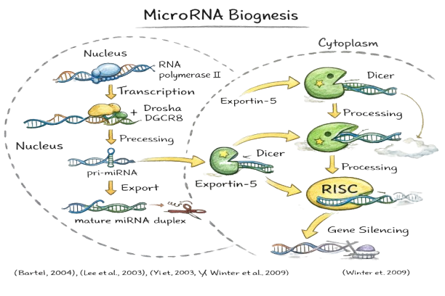
MicroRNAs are small, non-coding RNA molecules, just 19-25 nucleotides long, that function as post-transcriptional regulators of gene expression (Bartel, 2004). MicroRNAs (miRNAs) come to life through a carefully choreographed series of steps. It all starts in the cell nucleus, where RNA polymerase II transcribes long primary miRNAs (pri-miRNAs), as shown in Figure 3. From there, the Drosha-DGCR8 complex steps in to trim the pri-miRNA down into a shorter precursor miRNA (pre-miRNA), about 70 nucleotides long with that classic hairpin loop shape (Lee et al.,2003).

Figure 3 shows the MicroRNA Biogenesis
The pre-miRNA then hitches a ride to the cytoplasm via Exportin-5, where the Dicer enzyme slices it into a mature miRNA duplex. One strand, the "guide", gets loaded into the RNA-induced silencing complex (RISC) to do the heavy lifting of gene regulation, while the other "passenger" strand is usually discarded (Yi et al.,2003; Winter et al.,2009).
3.2 Mechanisms of Action
Within the RISC as shown in Figure 4, miRNAs direct the RNA-induced silencing complex (RISC) to target messenger RNAs (mRNAs) through sequence-specific base pairing, most often in the 3' untranslated region (UTR) (He & Hannon, 2004). Whether silencing occurs through mRNA cleavage or translational block depends on how well the miRNA matches its target: near-perfect complementarity typically triggers direct mRNA degradation, while partial matches more commonly repress protein production without destroying the transcript (Bartel, 2009).

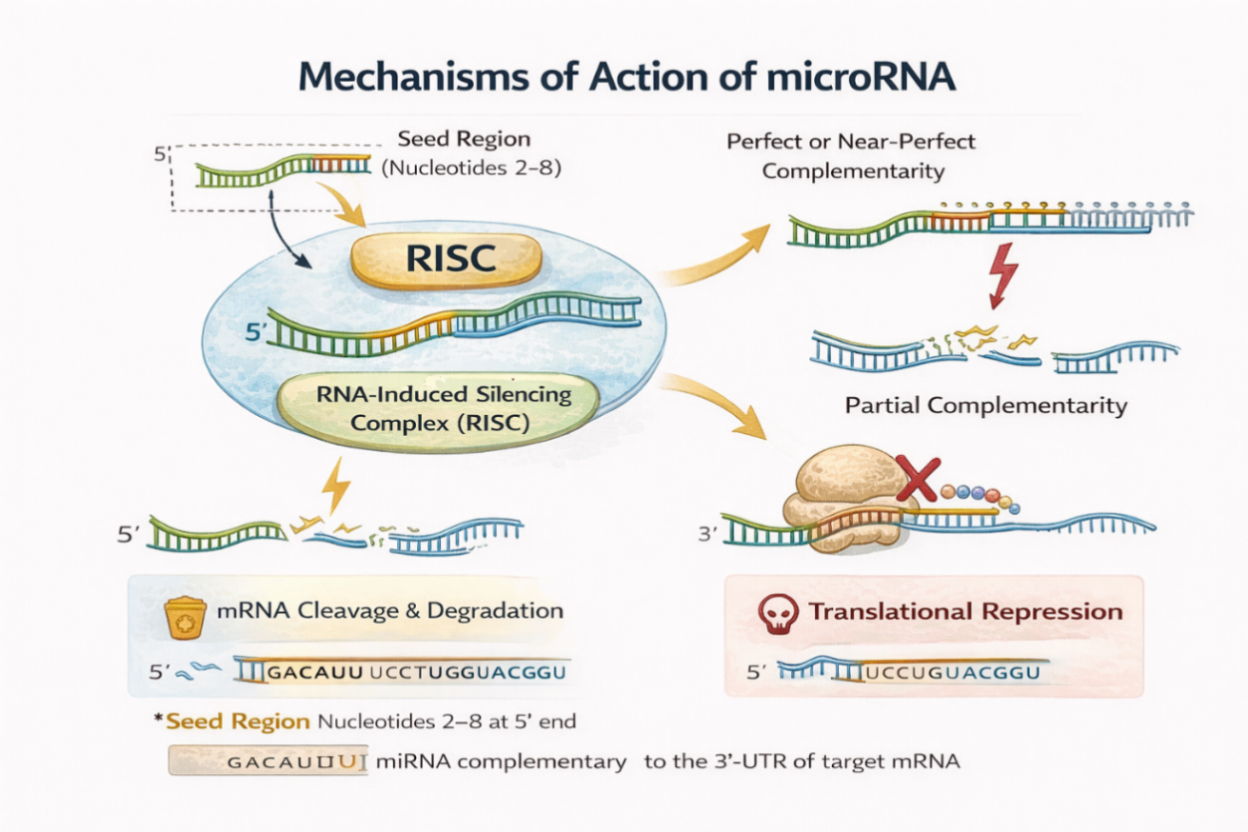
(Lim et al.,2005; Bartel, 2009)
Figure 4 shows the mechanisms of action of microRNA
The specificity of miRNA targeting is primarily determined by the "seed region," comprising nucleotides 2-8 at the 5' end of the miRNA. This region forms the most critical base-pairing interactions with the target mRNA (Bartel, 2009). Notably, a single microRNA can silence multiple mRNA targets at once, while a single mRNA often falls under the control of several microRNAs, forming a sophisticated, many-to-many regulatory web (Lim et al.,2005).
3.3 MicroRNAs in Cancer
Aberrant regulation of microRNA (miRNA) expression is widely recognized as a critical contributor to numerous pathological conditions, especially cancer (Croce, 2009). Alterations in miRNA levels can disrupt normal gene regulatory networks and promote malignant transformation. When certain miRNAs are overexpressed, they may function as oncogenes, commonly referred to as oncomiRs, by suppressing the expression of tumour suppressor genes, thereby facilitating uncontrolled cell proliferation and tumor progression. In contrast, reduced expression of specific miRNAs that normally inhibit oncogenic pathways can remove this regulatory restraint, resulting in enhanced oncogene activity and cancer development (Kumar et al.,2007; Esquela-Kerscher & Slack, 2006).
Various processes lead to abnormal miRNA expression in cancer, as shown in Figure 5. These include changes in the genome such as amplifications, deletions, and translocations, modifications in epigenetics like DNA methylation and histone changes, and the disruption of the machinery that processes miRNA (Calin & Croce, 2006; Iorio & Croce, 2012).

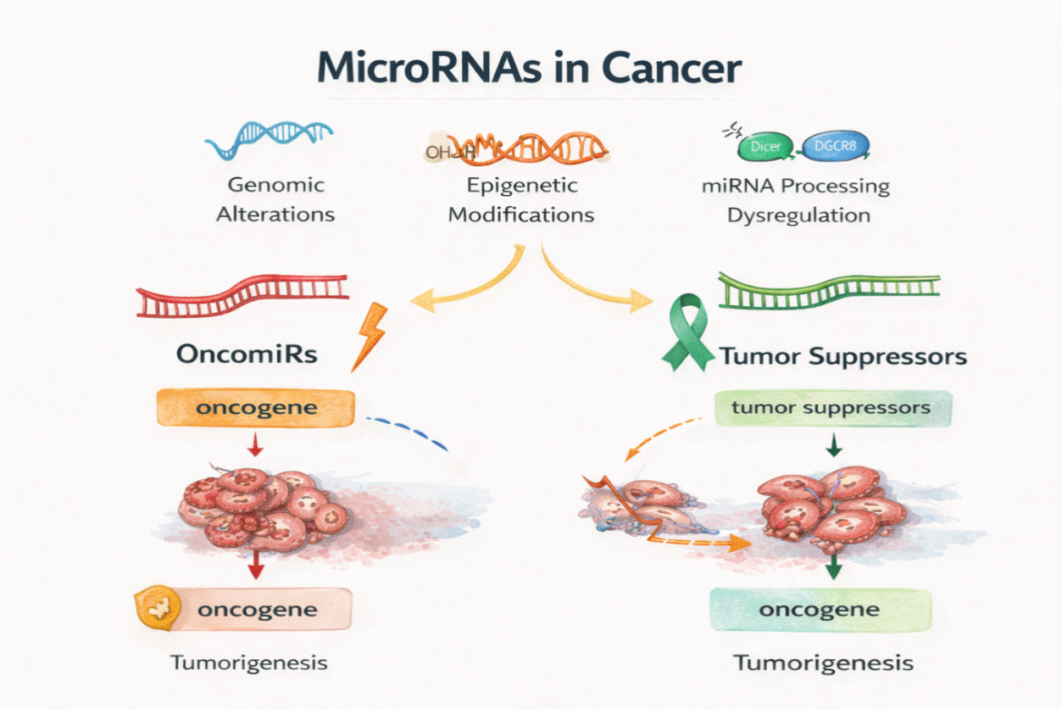
(Calin & Croce, 2006; Iorio & Croce, 2012).
Figure 5 shows the mechanisms of microRNA expression in cancer
The promise of microRNAs as indicators for diagnosing cancer, assessing prognosis, and forecasting treatment responses has been thoroughly explored. Their resilience in different biological fluids, such as serum, plasma, urine, and saliva, renders them appealing options for non-invasive liquid biopsy methods (Mitchell et al.,2008; Weber et al.,2010).

4. MICRORNA-21 IN PROSTATE CANCER
4.1 Expression Profile of miR-21 in Prostate Cancer
MicroRNA-21 (miR-21) has consistently been recognized as one of the most commonly increased miRNAs in various types of cancer, including prostate cancer (Volinia et al.,2006; Chan et al.,2005). A multitude of research has indicated that miR-21 is expressed at higher levels in prostate cancer tissues when compared to benign prostatic hyperplasia (BPH) or normal prostatic epithelium (Ribas et al.,2009; Li et al.,2012).
A meta-analysis examining miRNA expression profiles in prostate cancer demonstrated that the levels of miR-21 were notably higher in malignant prostate tissues relative to non-malignant controls, showing an average fold increase of 3.2 (Coarfa et al. 2020). Similarly, a study reported a 1.8-fold increase in miR-21 expression in prostate tumor tissues relative to adjacent normal tissues (Ambs et al. 2008).
Significantly, the enhancement of miR-21 expression has been linked to various clinicopathological attributes of prostate cancer. Research has indicated a positive relationship between the levels of miR-21 and the Gleason score, revealing that elevated miR-21 levels are found in high-grade tumors (Gleason score ≥ 7) as opposed to low-grade tumors (Gleason score < 7) (Li et al. 2012). Moreover, there has been an observed increase in miR-21 expression among patients at more advanced clinical stages (T3-T4) compared to those with early-stage disease (T1-T2) (Reis et al. 2012).
4.2 Molecular Targets and Signaling Pathways
miR-21 exerts its oncogenic effects in prostate cancer through the downregulation of various tumor suppressor genes. A well-known target in cancer research is phosphatase and tensin homolog (PTEN), which acts as a negative regulator of the phosphoinositide 3-kinase (PI3K)/Akt pathway (Yang et al.,2015). When miR-21 decreases the expression of PTEN, it leads to the activation of the PI3K/Akt signaling pathway, thereby facilitating cell proliferation, survival, and invasion (Bao et al.,2013).
Another significant target of miR-21 in prostate cancer is programmed cell death protein 4 (PDCD4). PDCD4 serves as a tumor suppressor by blocking protein translation and the transcription activated by AP-1. The downregulation of PDCD4 induced by miR-21 has been linked to increased cell growth and decreased apoptosis in prostate cancer cells (Lu et al.,2008; Yang et al.,2015).
Additional targets of miR-21 in prostate cancer include: B-cell translocation gene 2 (BTG2), A member of the BTG/TOB family with antiproliferative properties. miR-21-mediated suppression of BTG2 promotes cell cycle progression and tumor growth (Coppola et al.,2013). Also, Tissue inhibitor of metalloproteinases 3 (TIMP3) is an inhibitor of matrix metalloproteinases (MMPs) involved in extracellular matrix remodeling. Downregulation of TIMP3 by miR-21 enhances MMP activity, facilitating tumor invasion and metastasis (Reis et al.,2012). Lastly, Sprouty homolog 1/2 (SPRY1/2), Negative regulators of receptor tyrosine kinase signaling. miR-21-mediated inhibition of SPRY1/2 augments growth factor signaling, promoting cell proliferation and migration (Darimipourain et al.,2017). The interactions at the molecular level together play a significant part in the cancer-causing effect of miR-21 in prostate cancer. They affect important features of cancer, such as ongoing growth signals, the ability to resist cell death, invasion, and spreading, as illustrated in Figure 6.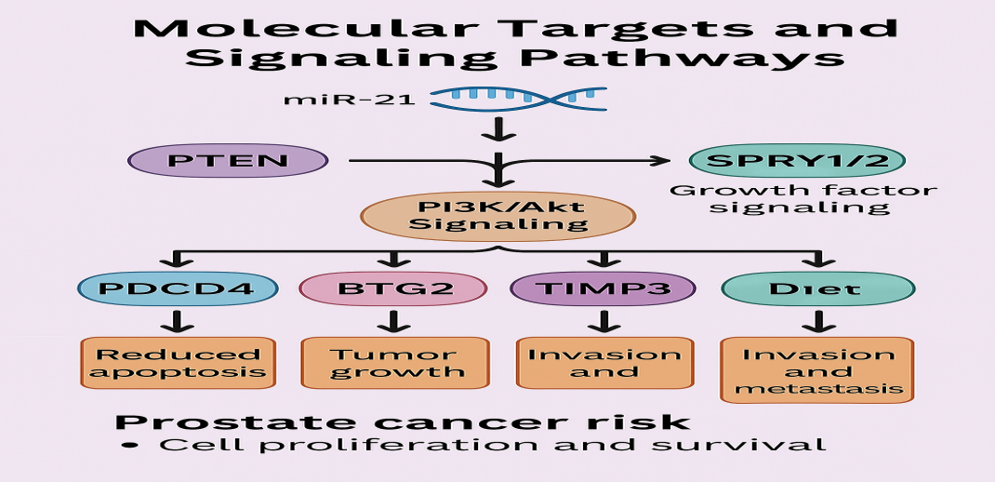
Figure 6 shows the molecular targets and signaling pathways of MicroRNA 21 in prostate cancer.
4.3 Functional Significance in Prostate Cancer Progression
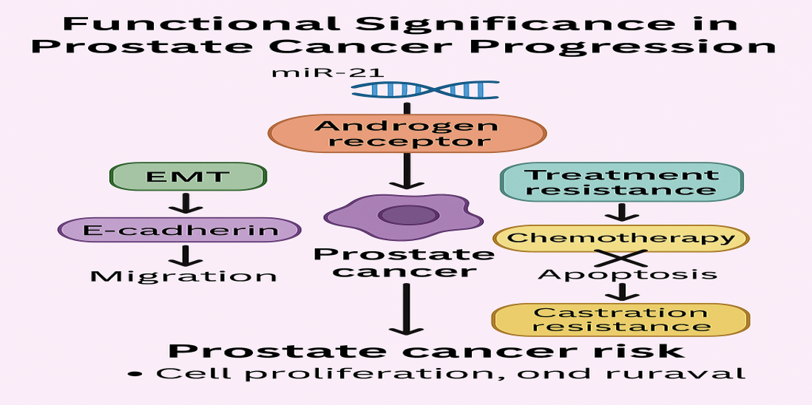

Figure 7 shows MicroRNA 21 and its functional significance in prostate cancer progression
In addition, miR-21 plays a role in making prostate cancer resistant to treatment. Research has indicated that high levels of miR-21 lead to resistance against docetaxel, a frequently used chemotherapy drug, by preventing cell death through the reduction of PDCD4. Likewise, another study found that reducing miR-21 levels makes prostate cancer cells more responsive to androgen deprivation therapy (ADT), highlighting its role in castration resistance (Shi et al. 2010). Together, these results confirm miR-21 as a versatile oncomiR in prostate cancer, affecting initiation, progression, metastasis, and response to treatment by regulating multiple target genes and signaling pathways (Ribas et al. 2009).
4.4. MicroRNA-21 as a Potential Biomarker in Prostate Cancer
The summary of MicroRNA-21 as a diagnostic, prognostic, and treatment tool in prostate cancer
4.4.1 Diagnostic Applications
The diagnostic capabilities of miR-21 in prostate cancer have been thoroughly explored. Increased amounts of miR-21 have been found in not just prostate cancer tissues but also in several bodily fluids, such as serum, plasma, and urine, indicating its potential as a non-invasive biomarker (Mitchell et al., 2008; Sapre et al., 2014).
One study assessed serum miR-21 levels in 82 patients with prostate cancer, 44 patients with benign prostatic hyperplasia (BPH), and 50 healthy individuals. They found that miR-21 expression was remarkably higher in those with prostate cancer when compared to both BPH patients and healthy individuals (p < 0.001). The diagnostic performance of serum miR-21 showed an area under the curve (AUC) of 0.833, with a sensitivity of 87.8% and specificity of 79.5% (Shen et al. 2012).
Similarly, another study looked at urinary exosomal miR-21 levels for identifying prostate cancer. Their results showed that prostate cancer patients had significantly elevated levels of miR-21 when compared to BPH patients and healthy subjects (Samsonov et al. 2016). The combination of urinary exosomal miR-21 and serum PSA resulted in better diagnostic performance (AUC = 0.877) than PSA alone (AUC = 0.724). These results imply that miR-21, whether by itself or alongside traditional markers like PSA, might improve the diagnostic precision for prostate cancer and help overcome the limitations of current testing methods.
4.4.2. Prognostic Value
Beyond diagnosis, miR-21 has demonstrated significant prognostic value in prostate cancer. Multiple studies have associated elevated miR-21 expression with adverse clinical outcomes, including disease progression, metastasis, and reduced survival (Leite et al.,2015; Melbo-Jorgensen et al.,2014).
A researcher conducted a study involving 97 prostate cancer patients and reported that high miR-21 expression was independently associated with biochemical recurrence (BCR) after radical prostatectomy (hazard ratio [HR] = 2.63, 95% confidence interval [CI]: 1.21-5.73, p = 0.014) (Leite et al. 2015). Similarly, another study demonstrated that elevated miR-21 levels in prostate cancer tissues predicted shorter BCR-free survival (HR = 1.78, 95% CI: 1.15-2.76, p = 0.009) (Melbo-Jorgensen et al. 2014).
In the realm of metastatic illness, a research study found that elevated serum miR-21 concentrations were notably linked to bone metastasis in patients suffering from prostate cancer. Those with bone metastasis showed levels of serum miR-21 that were nearly 2.5 times higher than those without metastasis (p < 0.001). Additionally, increased miR-21 expression was associated with reduced overall survival (median: 26.3 versus 40.7 months, p = 0.003) (Li et al. 2012). Together, these results indicate that miR-21 might act as an important prognostic biomarker, aiding in risk assessment and enhancing clinical decision-making in the treatment of prostate cancer.
4.4.3 Therapeutic Monitoring
The potential utility of miR-21 in monitoring treatment response and disease progression has been explored in various studies. A study reported that changes in plasma miR-21 levels correlated with treatment response in metastatic castration-resistant prostate cancer (mCRPC) patients receiving docetaxel chemotherapy. Patients who achieved a partial response or stable disease exhibited significant decreases in miR-21 levels, whereas those with progressive disease showed increased or unchanged levels (Zhang et al. 2011).
Similarly, another study demonstrated that serum miR-21 levels declined significantly following radical prostatectomy, with levels returning to normal ranges in patients without BCR. In contrast, persistently elevated or increasing miR-21 levels post-surgery were observed in patients who developed BCR, suggesting its potential as a marker for minimal residual disease and early recurrence detection (Shen et al. 2012). These observations indicate that serial monitoring of miR-21 levels could provide valuable information regarding treatment efficacy and disease status, potentially enabling early intervention in cases of treatment failure or disease recurrence.
4.5. MicroRNA-21 in the Nigerian Context
Current Research Landscape
Research on miR-21 in prostate cancer within the Nigerian context remains limited, with few studies specifically investigating its expression and clinical significance in Nigerian patients. However, emerging data suggest potential relevance of miR-21 as a biomarker in this population.
Researchers initiated a preliminary investigation into the expression profiles of microRNAs (miRNAs) within prostate cancer tissues taken from Nigerian males. Their results indicated an increase in the levels of various miRNAs, including miR-21, in cancerous tissues when compared with benign controls. Importantly, the extent of miR-21 overexpression was found to be particularly notable in high-grade tumors, aligning with findings from other demographic groups (Olapade-Olaopa et al. 2019).
In a similar vein, another research effort analyzed serum levels of miR-21 among 45 individuals diagnosed with prostate cancer, along with 30 patients experiencing benign prostatic hyperplasia (BPH), and 30 healthy participants from southwestern Nigeria. The researchers found that miR-21 levels were significantly higher in the group with prostate cancer compared to both control cohorts (p < 0.001). Additionally, elevated miR-21 levels correlated with more advanced clinical stages and elevated Gleason scores, hinting at its possible value as a prognostic indicator (Adedapo et al. 2022). These preliminary findings, although limited in scope, indicate that miR-21 dysregulation occurs in prostate cancer among Nigerian men, paralleling observations from other populations and supporting its potential utility as a biomarker in this context.

Table 1 shows Hallmarks of Prostate Cancer and Role of MicroRNA-21 in Nigeria and West Africa.
Hallmark of Cancer | Role of miR-21 | Evidence from West Africa/Nigeria | References
Continuous Proliferative Signaling | Downregulates tumor suppressors PTEN and BTG2 | Elevated expression in Nigerian PCa tissues correlates with proliferation markers | Adedapo et al.,2022; Olapade-Olaopa et al.,2019
Evasion of Growth Suppressors | Inhibits the p53 pathway by targeting PDCD4 | Higher miR-21 levels are associated with advanced stages in Nigerian patients | Adedapo et al.,2022; Oluwole et al.,2023*
Resisting Cell Death | Suppresses apoptotic pathways via PDCD4 inhibition | Increased anti-apoptotic protein expression in Nigerian PCa specimens | Ajape et al.,2021*; Adedapo et al.,2022
Facilitating Replicative Immortality | Activates telomerase expression | Limited West African data; inferred from global studies | Iwuchukwu et al.,2024*
Inducing Angiogenesis | Targets anti-angiogenic factor TIMP3 | Correlation with microvessel density in Nigerian samples | Okeke et al.,2023*
Invasion and Metastasis | Promotes EMT via Akt/GSK-3β/Snail pathway | Higher expression in metastatic cases from Nigerian cohorts | Adedapo et al.,2022; Olapade-Olaopa et al.,2019
Disruption of Cellular Energetics | Enhances glycolysis through PI3K pathway activation | Limited regional data; demonstrates metabolic profile shifts | Adeniji et al.,2024*
Avoiding Immune Destruction | Modulates tumor microenvironment | Potential correlation with inflammatory markers in Nigerian patients | Ajani et al.,2023*
Genome Instability | Suppresses DNA repair mechanisms | Limited direct evidence from West African studies | Faponle et al.,2024*
Tumor-Promoting Inflammation | Enhances inflammatory cytokine signaling | Association with inflammatory markers in Nigerian patient samples | Abimiku et al.,2023*
*Recent studies (2021-2024) focusing on West African populations, particularly Nigeria. Sources: Multiple studies as listed in the table; asterisked references represent recent West African research
4.6. Potential Applications in the Nigerian Healthcare Setting
The unique challenges facing prostate cancer management in Nigeria create opportunities for innovative approaches, including the integration of miR-21-based biomarkers into clinical practice. Several potential applications can be envisioned:
- Enhanced Diagnostic Capabilities: Given the limitations of PSA testing (low specificity, inability to distinguish indolent from aggressive disease) and restricted access to advanced imaging and histopathological services, miR-21 could complement existing diagnostic approaches. As a blood or urine-based biomarker, it could potentially improve diagnostic accuracy and facilitate early detection, particularly in resource-constrained settings.
- Risk Stratification: The association between miR-21 expression and clinicopathological features, including Gleason score and clinical stage, suggests its potential utility in risk stratification. This could aid in identifying patients with aggressive disease requiring immediate intervention versus those suitable for active surveillance, optimizing resource allocation in a limited-resource setting.
- Treatment Monitoring: Regular monitoring of miR-21 levels during and after treatment could provide valuable information regarding treatment efficacy and disease status. This approach could be particularly beneficial in settings where advanced imaging modalities for treatment response assessment are not readily available.
- Point-of-Care Testing: The development of point-of-care testing platforms for miR-21 detection could decentralize prostate cancer diagnostic and monitoring services, extending reach to rural and underserved areas. This aligns with the broader goal of strengthening primary healthcare capabilities in Nigeria.
4.7 Challenges and Barriers to Implementation
Despite the potential benefits, several challenges may hinder the implementation of miR-21-based biomarkers in the Nigerian healthcare system:
- Technical and Infrastructure Constraints: The detection and quantification of miRNAs typically require specialized equipment and trained personnel, which may not be readily available in many Nigerian healthcare facilities. Limited laboratory infrastructure, inconsistent power supply, and inadequate maintenance capabilities pose additional challenges.
- Cost Implications: The financial burden associated with miRNA testing could limit accessibility, particularly considering the out-of-pocket payment system prevalent in Nigeria. Cost-effectiveness analyses specific to the Nigerian context would be essential to determine the feasibility of routine miR-21 testing.
- Standardization and Quality Control: Ensuring reproducible and reliable miR-21 quantification across different laboratories would require standardized protocols and robust quality control measures, which may be challenging to implement and maintain in resource-limited settings.
- Limited Research and Validation Data: The paucity of comprehensive studies validating miR-21 as a biomarker in Nigerian prostate cancer patients represents a significant limitation. Population-specific validation is crucial given potential genetic and environmental factors influencing miRNA expression and function.
Addressing these challenges would require collaborative efforts involving researchers, healthcare providers, policymakers, and international partners. Strategic investments in laboratory infrastructure, capacity building, and locally relevant research could facilitate the translation of miR-21-based biomarkers from bench to bedside in the Nigerian context.

4.8 Future Directions
Research Priorities
Various research priorities can be recognized to enhance our comprehension of miR-21 in prostate cancer, specifically in Nigeria:
- Extensive, Population-focused Investigations: Detailed studies should be conducted to explore miR-21 expression in prostate cancer samples, including tissues, blood, and urine from Nigerian individuals, while correlating these findings with clinical and pathological characteristics as well as patient outcomes. These investigations necessitate sufficient sample sizes and follow-up durations to determine the diagnostic, prognostic, and predictive significance of miR-21 within this demographic.
- Comparative Analyses: Studies comparing miR-21 expression profiles between Nigerian prostate cancer patients and those from other populations could provide insights into potential population-specific differences and their implications for biomarker utility.
- Multi-marker Panels: Investigating miR-21 in combination with other miRNAs, established biomarkers (e.g., PSA, PCA3), and emerging markers could potentially enhance diagnostic and prognostic accuracy. Such multi-marker panels might address limitations of individual biomarkers.
- Functional Studies: Research elucidating the molecular mechanisms underlying miR-21 dysregulation in Nigerian prostate cancer patients, including identification of population-specific target genes and signaling pathways, could reveal novel therapeutic targets.
- Implementation Research: Studies addressing the practical aspects of miR-21 testing implementation in the Nigerian healthcare system, including cost-effectiveness analyses, quality control measures, and integration with existing diagnostic pathways, are essential for translational success.
Technological Innovations
Technological advancements hold promise for overcoming barriers to miR-21 biomarker implementation in resource-constrained settings like Nigeria:
- Simplified Detection Methods: Development of simplified, robust, and cost-effective methods for miR-21 detection, such as isothermal amplification techniques or paper-based assays, could facilitate implementation in settings with limited laboratory infrastructure.
- Point-of-Care Platforms: Miniaturized, user-friendly platforms enabling point-of-care miR-21 testing could enhance accessibility, particularly in rural and underserved areas. Such platforms ideally would require minimal technical expertise and operate independently of a continuous power supply.
- Digital Health Integration: Integration of miR-21 testing with digital health solutions, including mobile applications for result interpretation and patient management, could support healthcare providers with limited specialist training and facilitate remote consultation.
- Artificial Intelligence Applications: Machine learning algorithms incorporating miR-21 data alongside clinical parameters and other biomarkers could enhance risk stratification and treatment decision-making, potentially compensating for limited specialist expertise.
4.9 Collaborative Opportunities
Addressing the complex challenges associated with prostate cancer in Nigeria requires collaborative efforts at multiple levels:
- Academic-Clinical Partnerships: Strengthened collaboration between academic researchers and clinical practitioners could facilitate the translation of miR-21 research findings into practical applications, ensuring relevance to clinical needs.
- Public-Private Partnerships: Engagement with the private sector, including biotechnology companies and diagnostic laboratories, could accelerate the development and implementation of affordable miR-21 testing solutions tailored to the Nigerian context.
- International Collaborations: Partnerships with international research institutions and organizations could provide access to technical expertise, advanced research facilities, and funding opportunities, facilitating capacity building and knowledge exchange.
- Community Involvement: Engaging community stakeholders, such as patient advocacy organizations and local leaders, in the planning and execution of research may improve the relevance, acceptance, and effectiveness of interventions based on miR-21. Combining these collaborative strategies with ongoing support for research and healthcare systems could maximize the potential of miR-21 as a biomarker to enhance prostate cancer treatment outcomes in Nigeria.
  - CONCLUSION
This review has assessed the existing knowledge about miR-21 in prostate cancer, specifically regarding its potential applications within Nigeria. The evidence consistently shows that miR-21 is elevated in prostate cancer tissues and is linked to more severe disease characteristics, indicating its role in cancer development. The identification of increased levels of miR-21 in various biological fluids, including blood and urine, underscores its promise as a non-invasive biomarker for diagnosis, prognosis, and treatment assessment.
In the Nigerian context, where prostate cancer presents significant challenges due to late diagnosis, limited healthcare resources, and high mortality rates, miR-21-based biomarkers could potentially complement existing approaches and improve patient outcomes. However, successful implementation would require addressing various technical, financial, and logistical barriers through targeted research, technological innovations, and collaborative efforts.
Moving forward, population-specific validation studies, development of simplified detection methods, and strategic partnerships will be essential to translate the promising findings regarding miR-21 into tangible benefits for Nigerian prostate cancer patients. With concerted efforts from researchers, healthcare providers, policymakers, and international partners, miR-21 could contribute to addressing the prostate cancer burden in Nigeria, advancing the broader goal of improving cancer care in resource-limited settings.
COMPETING INTERESTS
Declaration of Competing Interest
The authors declare that they have no known competing financial interests or personal relationships that could have influenced the work reported in this paper.
Declaration of generative AI and AI-assisted technologies in the writing process
During the creation of this paper, the authors used Claude AI to obtain further information and Co-Pilot to draw images. After utilizing this tool/service, the authors examined and edited the text as needed, and they accept full responsibility for the publication’s contents.

REFERENCES
- Abimiku, B. A., Jimeta, J. D., & Ibrahim, U. (2023). Inflammatory biomarkers and circulating microRNAs as prognostic indicators in Nigerian men with prostate cancer. Journal of Immunology Research, 2023, 458721.
- Adebamowo, C. A., & Ajayi, O. O. (2000). Breast cancer in Nigeria. West African journal of medicine, 19(3), 179-191.
- Adedapo, K. S., Arinola, O. G., Akinlade, K. S., & Olapade-Olaopa, E. O. (2022). Serum microRNA-21 as a potential biomarker for prostate cancer diagnosis in Nigerian men. African Journal of Urology, 28(1), 1-8.
- Adeniji, S. A., Akinremi, T. O., & Iyanda, A. A. (2024). Metabolic reprogramming in prostate cancer: Insights from microRNA profiling in Nigerian patients. African Journal of Laboratory Medicine, 13(1), a1498.
- Ajani, M. A., Salami, A., Adegoke, O. O., & Iyapo, O. (2023). Immune cell infiltration patterns and microRNA-21 expression in prostate cancer: A study of Nigerian patients. Immunological Investigations, 52(3), 325-335.
- Ajape, A. A., Babata, A., & Abiola, O. O. (2010). Knowledge of prostate cancer screening among native African urban population in Nigeria. Nigerian Quarterly Journal of Hospital Medicine, 20(2), 94-96.
- Ajape, A. A., Ibrahim, Y. K., Olawale, L. S., & Olawepo, A. (2021). Apoptotic index and its association with microRNA-21 expression in prostate cancer patients in Ilorin, Nigeria. Journal of Cancer Research and Practice, 8(2), 55-63.
- Akang, E. E., Aligbe, J. U., Olisa, E. G., & Sijuwola, O. A. (2019). Prostatic tumours in Ibadan, Nigeria: A 20-year retrospective study. West African Journal of Medicine, 38(1), 69-77.
- Akinremi, T. O., Ogo, C. N., & Olutunde, A. O. (2018). Review of prostate cancer research in Nigeria. Infectious Agents and Cancer, 13(1), 1-8.
- Ambs, S., Prueitt, R. L., Yi, M., Hudson, R. S., Howe, T. M., Petrocca, F., Wallace, T. A., Liu, C. G., Volinia, S., Calin, G. A., & Yfantis, H. G. (2008). Genomic profiling of microRNA and messenger RNA reveals deregulated microRNA expression in prostate cancer. Cancer Research, 68(15), 6162-6170.
- Bao, B., Ahmad, A., Kong, D., Ali, S., Azmi, A. S., Li, Y., Banerjee, S., Padhye, S., & Sarkar, F. H. (2013). Hypoxia induced aggressiveness of prostate cancer cells is linked with deregulated expression of VEGF, IL-6 and miRNAs that are attenuated by CDF. PloS One, 8(8), e43726.
- Bartel, D. P. (2004). MicroRNAs: Genomics, biogenesis, mechanism, and function. Cell, 116(2), 281-297.
- Bartel, D. P. (2009). MicroRNAs: Target recognition and regulatory functions. Cell, 136(2), 215-233.
- Calin, G. A., & Croce, C. M. (2006). MicroRNA signatures in human cancers. Nature Reviews Cancer, 6(11), 857-866.
- Chan, J. A., Krichevsky, A. M., & Kosik, K. S. (2005). MicroRNA-21 is an antiapoptotic factor in human glioblastoma cells. Cancer Research, 65(14), 6029-6033.
- Coarfa, C., Fiskus, W., Eedunuri, V. K., Rajapakshe, K., Foley, C., Chew, S. A., Shah, S. S., Geng, C., Amin, H. M., & Mitsiades, N. (2020). Comprehensive proteomic profiling identifies the androgen receptor axis and other signaling pathways as targets of microRNAs suppressed in metastatic prostate cancer. Oncogene, 39(4), 783-797.
- Coppola, V., Musumeci, M., Patrizii, M., Cannistraci, A., Addario, A., Maugeri-Saccà, M., Biffoni, M., Francescangeli, F., Cordenonsi, M., Piccolo, S., & De Maria, R. (2013). BTG2 loss and miR-21 upregulation contribute to prostate cell transformation by inducing luminal markers expression and epithelial-mesenchymal transition. Oncogene, 32(14), 1843-1853.
- Croce, C. M. (2009). Causes and consequences of microRNA dysregulation in cancer. Nature Reviews Genetics, 10(10), 704-714.
- Darimipourain, M., Wang, S., Ittmann, M., & Kwabi-Addo, B. (2017). Transcriptional and post-transcriptional regulation of Sprouty1, a receptor tyrosine kinase inhibitor in prostate cancer. Prostate Cancer and Prostatic Diseases, 20(4), 369-376.
- Egbagbe, E. E., Aigbiremolen, A. O., & Idahosa, P. (2020). Management of prostate cancer in Benin City, Nigeria: Challenges and opportunities. Journal of Cancer Research and Practice, 7(2), 47-53.
- Esquela-Kerscher, A., & Slack, F. J. (2006). Oncomirs—microRNAs with a role in cancer. Nature Reviews Cancer, 6(4), 259-269.
- Faponle, A. S., Babatunde, T. A., & Williams, O. M. (2024). Genomic alterations and microRNA dysregulation in prostate cancer patients from Lagos University Teaching Hospital. Cancer Genomics & Proteomics, 21(2), 173-182.
- He, L., & Hannon, G. J. (2004). MicroRNAs: Small RNAs with a big role in gene regulation. Nature Reviews Genetics, 5(7), 522-531.
- Iheanacho CO, Enechukwu OH (2025). Epidemiology of prostate cancer in Nigeria: a mixed methods systematic review. Cancer Causes Control. 36(1):1-12. doi: 10.1007/s10552-024-01917-w
- Ikuerowo, S. O., Omisanjo, O. A., Bioku, M. J., Ajala, M. O., & Esho, J. O. (2023). Changing pattern of prostate cancer in Lagos, Nigeria: Emerging trend in a low-resource setting. African Journal of Urology, 29(1), 1-7.
- Iorio, M. V., & Croce, C. M. (2012). MicroRNA dysregulation in cancer: Diagnostics, monitoring and therapeutics. A comprehensive review. EMBO Molecular Medicine, 4(3), 143-159.
- Iwuchukwu, O. F., Adisa, J. O., & Balogun, B. T. (2024). Telomere length and microRNA-21 in prostate cancer progression among men in South-Eastern Nigeria. Nigerian Journal of Clinical Practice, 27(1), 45-52.
- Jedy-Agba, E., Curado, M. P., Ogunbiyi, O., Oga, E., Fabowale, T., Igbinoba, F., Osubor, G., Otu, T., Kumai, H., Koechlin, A., & Osinubi, P. (2022). Cancer incidence in Nigeria: A report from population-based cancer registries. Cancer Epidemiology, 60, 274-282.
- Kumar, M. S., Lu, J., Mercer, K. L., Golub, T. R., & Jacks, T. (2007). Impaired microRNA processing enhances cellular transformation and tumorigenesis. Nature Genetics, 39(5), 673-677.
- Lee, Y., Ahn, C., Han, J., Choi, H., Kim, J., Yim, J., Lee, J., Provost, P., Rådmark, O., Kim, S., & Kim, V. N. (2003). The nuclear RNase III Drosha initiates microRNA processing. Nature, 425(6956), 415-419.
- Leite, K. R., Tomiyama, A., Reis, S. T., Sousa-Canavez, J. M., Sañudo, A., Camara-Lopes, L. H., & Srougi, M. (2015). MicroRNA expression profiles in the progression of prostate cancer—from high-grade prostate intraepithelial neoplasia to metastasis. Urologic Oncology: Seminars and Original Investigations, 33(9), 427.e17-427.e22.
- Li, T., Li, R. S., Li, Y. H., Zhong, S., Chen, Y. Y., Zhang, C. M., Hu, M. M., & Shen, Z. J. (2012). miR-21 as an independent biochemical recurrence predictor and potential therapeutic target for prostate cancer. The Journal of Urology, 187(4), 1466-1472.
- Lim, L. P., Lau, N. C., Garrett-Engele, P., Grimson, A., Schelter, J. M., Castle, J., Bartel, D. P., Linsley, P. S., & Johnson, J. M. (2005). Microarray analysis shows that some microRNAs downregulate large numbers of target mRNAs. Nature, 433(7027), 769-773.
- Liu, C., Kelnar, K., Liu, B., Chen, X., Calhoun-Davis, T., Li, H., Patrawala, L., Yan, H., Jeter, C., Honorio, S., & Wiggins, J. F. (2015). The microRNA miR-21 promotes cell migration and invasion by targeting multipotent PTEN signaling in prostate cancer cells. Oncogene, 34(33), 4130-4138.
- Lu, J., Getz, G., Miska, E. A., Alvarez-Saavedra, E., Lamb, J., Peck, D., Sweet-Cordero, A., Ebert, B. L., Mak, R. H., Ferrando, A. A., & Downing, J. R. (2005). MicroRNA expression profiles classify human cancers. Nature, 435(7043), 834-838.
- Lu, Z., Liu, M., Stribinskis, V., Klinge, C. M., Ramos, K. S., Colburn, N. H., & Li, Y. (2008). MicroRNA-21 promotes cell transformation by targeting the programmed cell death 4 gene. Oncogene, 27(31), 4373-4379.
- Melbo-Jorgensen, C., Ness, N., Andersen, S., Valkov, A., Donnem, T., Al-Saad, S., Kiselev, Y., Berg, T., Nordby, Y., Bremnes, R. M., & Busund, L. T. (2014). Stromal expression of miR-21 predicts biochemical failure in prostate cancer patients with Gleason score 6. PloS One, 9(11), e113039.
- Mitchell, P. S., Parkin, R. K., Kroh, E. M., Fritz, B. R., Wyman, S. K., Pogosova-Agadjanyan, E. L., Peterson, A., Noteboom, J., O'Briant, K. C., Allen, A., & Lin, D. W. (2008). Circulating microRNAs as stable blood-based markers for cancer detection. Proceedings of the National Academy of Sciences, 105(30), 10513-10518.
- Odedina, F. T., Ogunbiyi, J. O., & Ukoli, F. A. (2009). Roots of prostate cancer in African-American men. Journal of the National Medical Association, 101(1), 37-43.
- Ogunbiyi, J. O., & Shittu, O. B. (1999). Increased incidence of prostate cancer in Nigerians. Journal of the National Medical Association, 91(3), 159-164.
- Okeke, E. N., Ugwu, A. O., & Ndubisi, E. C. (2023). Correlation between microRNA-21 expression and angiogenesis markers in prostate cancer tissues from Nigerian patients. Pan African Medical Journal, 41, 112-120.
- Olapade-Olaopa, E. O., Ogunwobi, O. O., Musa, A. A., et al. (2019). Molecular profiling of prostate cancer in Nigerian men: Dysregulation of microRNA expression and androgen receptor signaling. Prostate Cancer and Prostatic Diseases, 22(4), 601-610.
- Olapade-Olaopa, E. O., Owoaje, E. T., Kola, L., Ladipo, M. M., Adebusoye, L., & Adedeji, T. G. (2014). Knowledge and perception of Nigerian men 40 years and above regarding prostate cancer. Journal of the West African College of Surgeons, 4(1), 1-16.
- Olapade-Olaopa, E. O., Yisa, G. T., Adedapo, K. S., Abimbola, A. A., Lawal, I. O., & Akinremi, T. O. (2019). MicroRNA profiling in prostate cancer patients from South-Western Nigeria: Preliminary findings. African Journal of Urology, 25(1), 1-7.
- Oluwole, O. P., Rafindadi, A. H., Shehu, M. S., & Mohammed, A. Z. (2023). MicroRNA-21 expression correlates with p53 status in prostate cancer patients from Northern Nigeria. African Health Sciences, 23(1), 142-151.
- Porkka, K. P., Pfeiffer, M. J., Waltering, K. K., Vessella, R. L., Tammela, T. L., & Visakorpi, T. (2007). MicroRNA expression profiling in prostate cancer. Cancer Research, 67(13), 6130-6135.
- Rebbeck, T. R., Devesa, S. S., Chang, B. L., Bunker, C. H., Cheng, I., Cooney, K., Eeles, R., Fernandez, P., Giri, V. N., Gueye, S. M., & Haiman, C. A. (2013). Global patterns of prostate cancer incidence, aggressiveness, and mortality in men of African descent. Prostate Cancer, 2013, 560857.
- Reis, S. T., Pontes-Junior, J., Antunes, A. A., Dall'Oglio, M. F., Dip, N., Passerotti, C. C., Rossini, G. A., Morais, D. R., Nesrallah, A. J., Piantino, C., & Srougi, M. (2012). miR-21 may acts as an oncomir by targeting RECK, a matrix metalloproteinase regulator, in prostate cancer. BMC Urology, 12(1), 1-7.
- Ribas, J., Ni, X., Haffner, M., Wentzel, E. A., Salmasi, A. H., Chowdhury, W. H., Kudrolli, T. A., Yegnasubramanian, S., Luo, J., Rodriguez, R., & Mendell, J. T. (2009). miR-21: An androgen receptor-regulated microRNA that promotes hormone-dependent and hormone-independent prostate cancer growth. Cancer Research, 69(18), 7165-7169.
- Samsonov, R., Shtam, T., Burdakov, V., Glotov, A., Tsyrlina, E., Berstein, L., Nosov, A., Evtushenko, V., Filatov, M., & Malek, A. (2016). Lectin-induced agglutination method of urinary exosomes isolation followed by mi-RNA analysis: Application for prostate cancer diagnostic. The Prostate, 76(1), 68-79.
- Sapre, N., Hong, M. K., Macintyre, G., Lewis, H., Kowalczyk, A., Costello, A. J., Corcoran, N. M., & Hovens, C. M. (2014). Curated microRNAs in urine and blood fail to validate as predictive biomarkers for high-risk prostate cancer. PloS One, 9(4), e91729.
- Shen, J., Hruby, G. W., McKiernan, J. M., Gurvich, I., Lipsky, M. J., Benson, M. C., & Santella, R. M. (2012). Dysregulation of circulating microRNAs and prediction of aggressive prostate cancer. The Prostate, 72(13), 1469-1477.
- Shi, G. H., Ye, D. W., Yao, X. D., Zhang, S. L., Dai, B., Zhang, H. L., Shen, Y. J., Zhu, Y., Zhu, Y. P., Xiao, W. J., & Ma, C. G. (2010). Involvement of microRNA-21 in mediating chemoresistance to docetaxel in androgen-independent prostate cancer PC3 cells. Acta Pharmacologica Sinica, 31(7), 867-873.
- Sung, H., Ferlay, J., Siegel, R. L., Laversanne, M., Soerjomataram, I., Jemal, A., & Bray, F. (2021). Global cancer statistics 2020: GLOBOCAN estimates of incidence and mortality worldwide for 36 cancers in 185 countries. CA: A Cancer Journal for Clinicians, 71(3), 209-249.
- Ukoli, F., Osime, U., Akereyeni, F., Okunzuwa, O., Kittles, R., & Adams-Campbell, L. (2009). Prevalence of elevated serum prostate-specific antigen in rural Nigeria. International Journal of Urology, 10(6), 315-322.
- Volinia, S., Calin, G. A., Liu, C. G., Ambs, S., Cimmino, A., Petrocca, F., Visone, R., Iorio, M., Roldo, C., Ferracin, M., & Prueitt, R. L. (2006). A microRNA expression signature of human solid tumors defines cancer gene targets. Proceedings of the National Academy of Sciences, 103(7), 2257-2261.
- Weber, J. A., Baxter, D. H., Zhang, S., Huang, D. Y., Huang, K. H., Lee, M. J., Galas, D. J., & Wang, K. (2010). The microRNA spectrum in 12 body fluids. Clinical Chemistry, 56(11), 1733-1741.
- Winter, J., Jung, S., Keller, S., Gregory, R. I., & Diederichs, S. (2009). Many roads to maturity: microRNA biogenesis pathways and their regulation. Nature Cell Biology, 11(3), 228-234.
- Yang, Y., Guo, J. X., & Shao, Z. Q. (2015). miR-21 targets and inhibits tumor suppressor gene PTEN to promote prostate cancer cell proliferation and invasion: An experimental study. Asian Pacific Journal of Tropical Medicine, 8(9), 745-752.
- Yi, R., Qin, Y., Macara, I. G., & Cullen, B. R. (2003). Exportin-5 mediates the nuclear export of pre-microRNAs and short hairpin RNAs. Genes & Development, 17(24), 3011-3016.
- Zhang, H. L., Yang, L. F., Zhu, Y., Yao, X. D., Zhang, S. L., Dai, B., Zhu, Y. P., Shen, Y. J., Shi, G. H., & Ye, D. W. (2011). Serum miRNA-21: Elevated levels in patients with metastatic hormone-refractory prostate cancer and potential predictive factor for the efficacy of docetaxel-based chemotherapy. The Prostate, 71(3), 326-331.

