Original Research Article
Effect of Carica Papaya (Paw-Paw) Leaf Extract on the Histology of the Pancreas in the Tramadol-Induced Male Wistar Rats

ABSTRACT
Tramadol, a synthetic opioid analgesic, is frequently misused for non-medical purposes, resulting in several adverse effects, including pancreatic toxicity. The pancreas, due to its dual exocrine and endocrine functions, is highly vulnerable to drug-induced oxidative stress and inflammation. Carica papaya leaves contain phytochemicals with antioxidant and anti-inflammatory properties that may help protect organs from such damage. This study assessed the protective effects of Carica papaya leaf extract on the pancreatic histology in tramadol-induced Wistar rats. Fifteen (15) Wistar rats (mixed gender, weighing 150-200g) were randomly divided into five groups (n=3). Group A served as the control and received distilled water. Group B received tramadol (50 mg/kg) for 14 days only. Group C received tramadol (50 mg/kg) for 14 days, followed by Vitamin C (500 mg/kg). Groups D and E received tramadol (50 mg/kg) for 14 days, followed by Carica papaya leaf extract at doses of 200 mg/kg and 400 mg/kg, respectively. The plant material was shade-dried, extracted with aqueous methods, and subjected to preliminary phytochemical screening. Acute toxicity (LD50) was determined using Lorke's method. At the end of the experiment, the pancreas was harvested for histological analysis. Phytochemical screening revealed the presence of flavonoids, alkaloids, tannins, saponins, phenols, and glycosides. The LD50 of the extract was above 5000 mg/kg, indicating it is practically non-toxic. Histological analysis showed that tramadol caused notable acinar cell degeneration, necrosis, and inflammatory infiltration. Treatment with Carica papaya leaf extract, particularly at 400 mg/kg, improved pancreatic histoarchitecture, with reduced inflammation and restoration of acinar and islet cell integrity. Carica papaya leaf extract demonstrated a significant protective potential against tramadol-induced pancreatic damage in Wistar rats. These protective effects are likely due to its rich phytochemical composition and antioxidant properties. The findings support its potential as a safe, affordable, and accessible natural prophylaxis for drug-induced pancreatic toxicity.
Keywords: Carica Papaya, Tramadol, Pancreas, Histology, phytochemical

1.0 INTRODUCTION
The pancreas is a vital organ that performs both endocrine and exocrine functions crucial to metabolic regulation and digestion [1,2,3]. By secreting hormones such as insulin and glucagon through the islets of Langerhans, the pancreas maintains glucose homeostasis, while the exocrine acinar cells produce digestive enzymes essential for nutrient absorption [4,5,6]. Structural or functional impairment of the pancreas can therefore cause serious metabolic disturbances, including diabetes mellitus and digestive disorders. Growing exposure to xenobiotics and pharmaceutical agents has raised concerns about drug-induced pancreatic toxicity and its long-term health effects [7,8].
Tramadol is a widely used synthetic opioid analgesic prescribed for moderate to severe pain due to its perceived safety and efficacy [9,10,11]. However, prolonged or indiscriminate use of tramadol has been associated with various adverse effects involving the liver, kidneys, nervous system, and endocrine organs [12,13]. Nakhaee et al., [14] suggest that tramadol induces oxidative stress by increasing the production of reactive oxygen species and weakening natural antioxidant defences. These processes may lead to cellular degeneration, inflammation, and structural distortion in several tissues, including the pancreas, thereby impairing both its endocrine and exocrine functions. Recently, there has been increased interest in using medicinal plants as alternative or complementary therapies for managing drug-induced organ toxicity. Carica papaya (paw-paw) is a tropical plant widely used in traditional medicine across many parts of the world [15,16]. The leaves of Carica papaya are rich in bioactive phytochemicals, including flavonoids, alkaloids, phenols, saponins, and vitamins, which are reported to possess antioxidant, anti-inflammatory, antidiabetic, and cytoprotective properties [17, 18, 19]. These pharmacological activities suggest that Carica papaya leaf extract may help protect tissues against oxidative damage and restore normal cellular architecture.
Previous experimental studies have demonstrated the beneficial effects of Carica papaya leaf extract in reducing oxidative stress and histological damage in organs such as the liver and kidneys. Ajibade et al., [20] observed that the aqueous extract of C. papaya leaf ameliorated hepatic damage induced in the liver of Streptozotocin (STZ)-induced diabetic adult Wistar rats. Oji et al., [21] discovered that Carica papaya and Newbouldia laevis leaves extracts have ameliorating effects on diabetes and increased serum levels of haematological parameters and sperm quality.
Despite these reported benefits, there is a paucity of data on the histological effects of Carica papaya leaf extract on the pancreas under conditions of tramadol-induced toxicity. This study, therefore, aims to investigate the effect of Carica papaya (paw-paw) leaf extract on the histology of the pancreas in tramadol-induced male Wistar rats.
2.0 MATERIALS AND METHODS
2.1 Collection and Identification of Plant Material
Fresh leaves of Carica papaya were collected from Okigwe, Imo State, Nigeria. The collection was in the early hours of the day to minimize moisture loss and preserve phytoconstituents. Sufficient quantities of leaves were harvested to ensure a continuous supply of extract for the duration of the experiment period.
2.2 Preparation of Plant Extract
Fresh leaves of Carica papaya were collected from a healthy plant and authenticated by a qualified botanist in the Department of Botany. The leaves were thoroughly washed under running tap water to remove dirt and debris, followed by rinsing with distilled water to eliminate surface contaminants. The cleaned leaves were air-dried at room temperature in the shade for a period of 10–14 days until a constant weight was obtained, in order to preserve the bioactive constituents and prevent photodegradation.
The dried leaves were then pulverized into a fine powder using an electric blender and stored in an airtight container until extraction. A measured quantity of the powdered leaves (e.g., 200 g) was soaked in a known volume of distilled water (e.g., 1,000 mL) in a clean glass container. The mixture was stirred thoroughly and allowed to stand for 24–48 hours at room temperature with intermittent shaking to enhance the extraction of the soluble constituents.
After the maceration period, the mixture was filtered first through a clean muslin cloth and then through Whatman No. 1 filter paper to obtain a clear filtrate. The filtrate was concentrated by evaporation using a water bath maintained at 40–50°C until a semi-solid residue was obtained. The concentrated extract was allowed to cool and then stored in a sterile, airtight container at 4°C until required for experimental use. The percentage yield of the extract was calculated, and appropriate doses were prepared by reconstituting the extract in distilled water before administration to the experimental animals.
2.3 Animals Experimental Design
A total of 15 healthy adult male Wistar rats, weighing between 180–250 g, were used for this study. The animals were obtained from a standard animal house and allowed to acclimatize for two weeks before the commencement of the experiment. During the acclimatization and experimental periods, the rats were housed in clean, well-ventilated cages under standard laboratory conditions (12-hour light/dark cycle, temperature of 25 ± 2 °C) and were provided with standard rat chow and water ad libitum. All experimental procedures were carried out in accordance with established guidelines for the care and use of laboratory animals.
The rats were randomly assigned to five experimental groups, with each group containing an equal number of animals:
- Group I (Normal Control): Rats received distilled water only and served as the negative control.
- Group II (Tramadol Control): Rats were administered tramadol only to induce pancreatic toxicity (50mg/kg).
- Group III (Tramadol + Vitamin C): Rats received tramadol followed by Vitamin C.
- Group IV (Tramadol + Low Dose Extract): Rats received tramadol followed by a low dose of aqueous Carica papaya leaf extract (200mg/kg).
- Group V (Tramadol + High Dose Extract): Rats received tramadol followed by a high dose of aqueous Carica papaya leaf extract (400mg/kg).
The treatment was administered orally for 28 days using oral gavage.
2.5 Tissue Collection and Histological Processing
At the end of the 28-day experiment, the rats were sacrificed under anaesthesia and the pancreas was excised, rinsed in normal saline, and fixed in 10% buffered formalin for 24–48 hours. The tissues were then processed routinely through graded alcohol dehydration, xylene clearing, and paraffin wax embedding. Sections of 4–5 µm thickness were cut, mounted on glass slides, and stained using the Hematoxylin and Eosin (H&E) technique. The stained sections were examined under a light microscope, and photomicrographs were taken to evaluate histological changes in the pancreatic tissue.
2.6 Data analysis
Data were subjected to statistical analysis using the SPSS Statistics software (Statistical Package for Social Science) (Version 25), and relevant statistical values were obtained. Final and initial weights for each group were compared using an independent-samples t-test. One-way analysis of variance (ANOVA) was carried out, and values were presented as mean ± SEM.
3. RESULTS
Table 1 shows the phytochemical analysis of Carica papaya leaf extract, which revealed the presence of saponins and phenolic compounds, including flavonoids, tannins, alkaloids, and phenols. These compounds are known to exhibit various biological effects on the body. The saponins, in particular, are known to possess anti-inflammatory and antioxidant properties. Flavonoids were present in high concentrations (++), which are recognised for their anti-inflammatory and antioxidant effects. Alkaloids were moderately abundant (+) and contributed to the resolution of lipid peroxidation and fibrosis. Tannins and phenols were present in moderate quantities (++) and contribute to the mitigation of lipid peroxidation and fibrosis.
Fig. 1: showing normal pancreatic histoarchitecture with well-preserved exocrine acini and intact endocrine islets of Langerhans. No evidence of inflammation, necrosis, or fibrosis is observed. (Hematoxylin and Eosin stain; ×400). Fig. 2: showing marked histopathological alterations characterized by acinar cell degeneration, inflammatory cell infiltration, fibrosis, and areas of necrosis, indicating severe pancreatic injury. (Hematoxylin and Eosin stain; ×400). Fig. 3: showing partial restoration of pancreatic architecture with reduced inflammatory infiltration and moderate regeneration of acinar and islet cells, though mild structural distortion persists. (Hematoxylin and Eosin stain; ×400). Fig. 4: showing slight histological improvement with reduced inflammation; however, areas of acinar degeneration, hypoperfusion, and nuclear pyknosis are still evident, indicating limited protective effect at this dose. (Hematoxylin and Eosin stain; ×400). Fig. 5: showing marked restoration of pancreatic histoarchitecture with well-preserved acinar cells and active islets of Langerhans, indicating strong dose-dependent protective and regenerative effects of the extract. (Hematoxylin and Eosin stain; ×400).
Table 1: Phytochemical Composition of Carica papaya Leaves
Phytochemical | Qualitative Presence | Relative Abundance (mg/g)
Flavonoid | +++ | 23.5±2.1
Alkaloid | ++ | 15.2±1.3
Tannis | ++ | 10.8±0.9
Saponin | +++ | 18.6±1.5
Phenol | ++ | 12.3±1.2

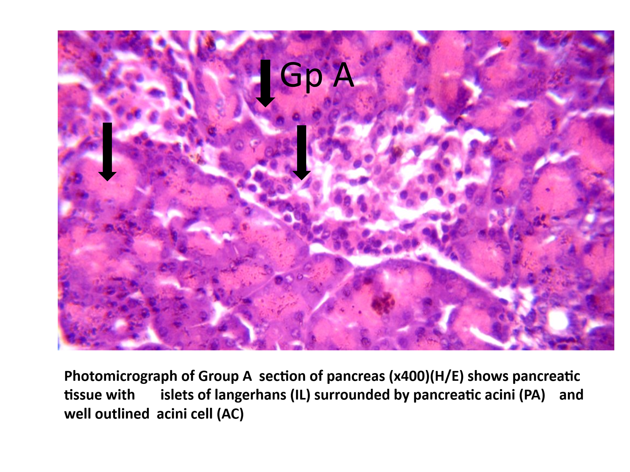
Fig.1 shows pancreatic tissue with islets of Langerhans (IL) surrounded by pancreatic acini (PA) and well outlined acini cell (AC).

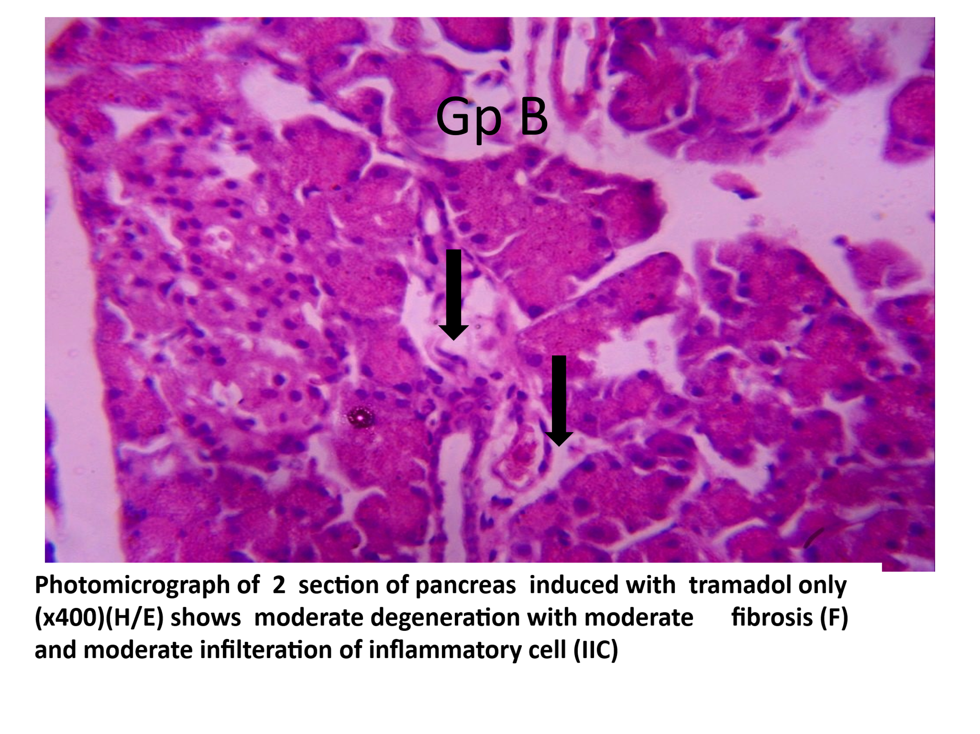
Fig. 2 shows a moderate degeneration of moderate fibrosis (F) and moderate infiltration of inflammatory cells (IIC).
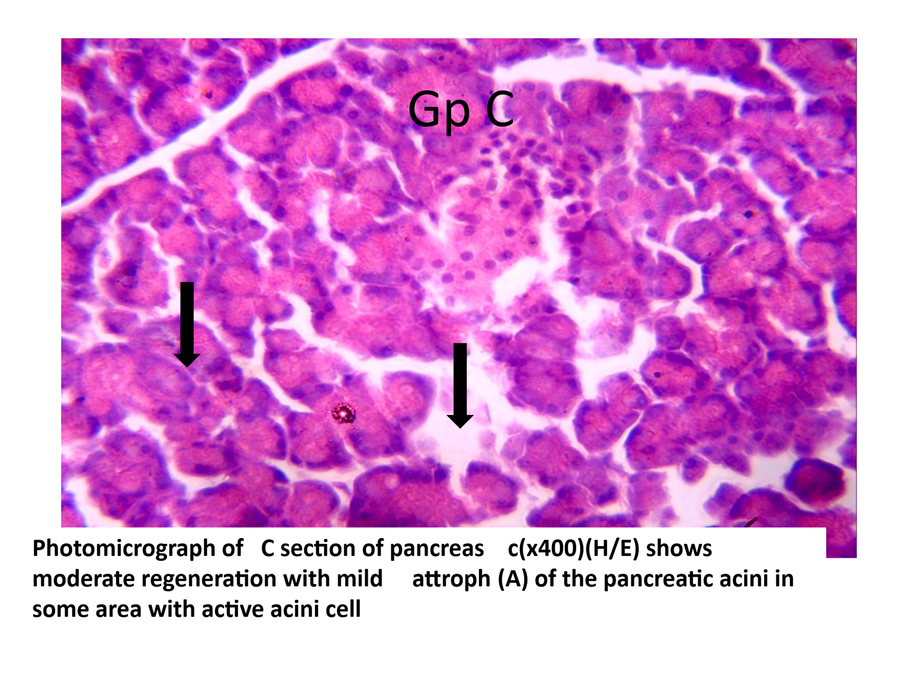
Fig.3 shows moderate regeneration with mild atrophy (A) of the pancreatic acini in some areas with active acini cells.

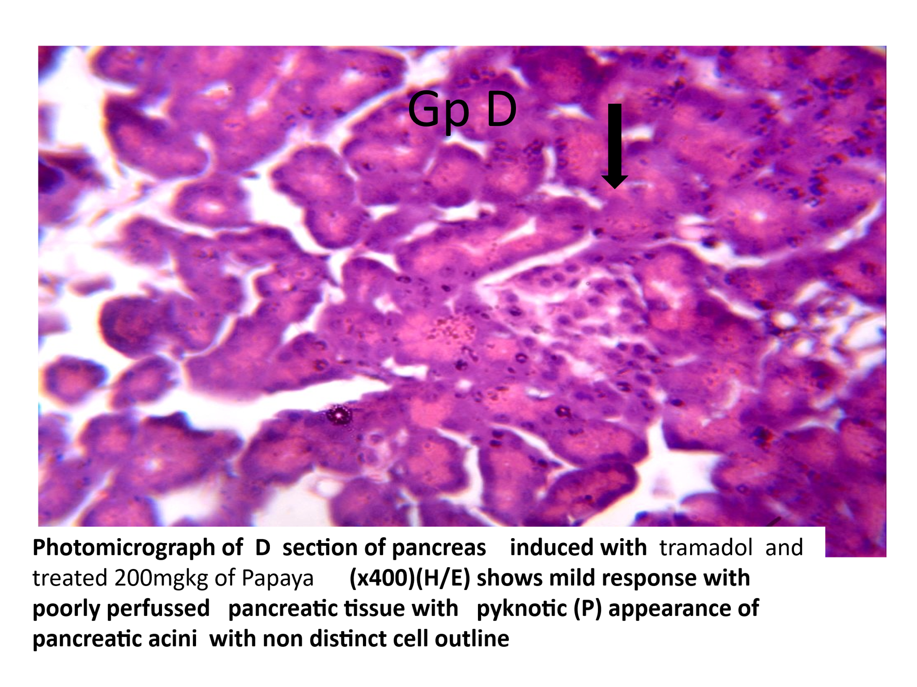
Fig. 4 shows a mild response with poorly perfused pancreatic tissue with pyknotic (P) appearance of pancreatic acini with a non-distinct cell outline.
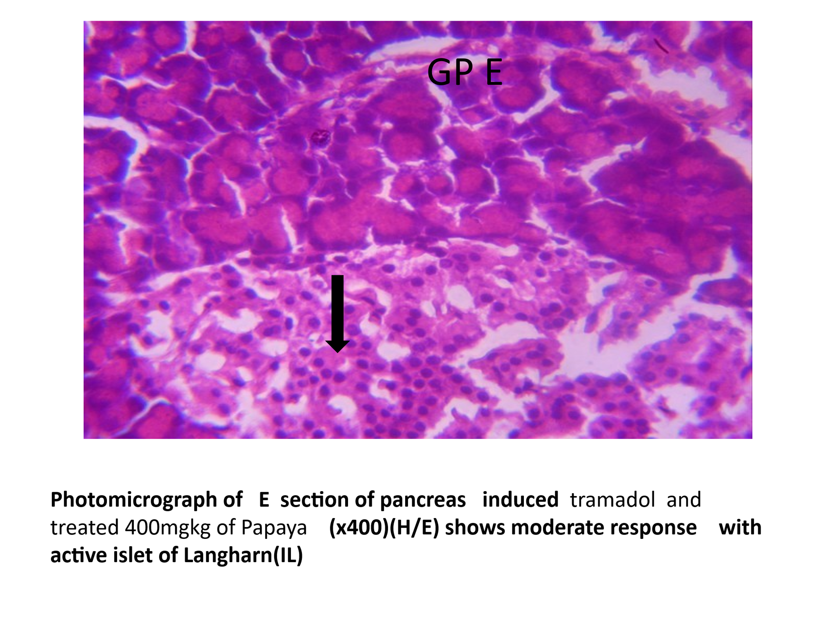
Fig. 5 shows a moderate response with an active islet of Langerhans (IL).

4. DISSCUSION
The pancreas of the control group (Figure 1) showed normal histoarchitecture, characterised by intact exocrine acini and well- defined islets of Langerhans. This observation aligns with the normal structural organisation of the pancreas described in previous anatomical and histological studies [1–3]. The preservation of both endocrine and exocrine components confirms the physiological baseline against which pathological changes were compared. In contrast, rats administered tramadol alone (Figure 2) exhibited severe pancreatic injury marked by acinar degeneration, inflammatory cell infiltration, fibrosis, and necrosis. These changes indicate oxidative stress–mediated tissue damage and chronic inflammatory response. Tramadol has been reported to induce the generation of reactive oxygen species (ROS) and impair antioxidant defence mechanisms, leading to cellular degeneration in metabolically active organs such as the pancreas [12–14]. Acinar cells are particularly vulnerable due to their high protein synthesis and enzymatic activity, explaining the pronounced exocrine damage observed.
Treatment with Vitamin C following tramadol exposure (Figure 3) resulted in notable histological improvement, with reduced inflammation and partial restoration of acinar and islet architecture. Vitamin C is a well- established antioxidant that scavenges free radicals and stabilises cellular membranes, thereby mitigating oxidative tissue injury [14]. The observed recovery supports earlier findings that antioxidant therapy can attenuate drug- induced pancreatic toxicity. Rats treated with tramadol followed by 200 mg/kg Carica papaya leaf extract (Figure 4) showed mild histological improvement compared to the tramadol- only group. Although inflammatory infiltration was reduced, residual acinar degeneration, nuclear pyknosis, and hypoperfusion were still evident. This suggests that while the extract exerts a protective effect, the lower dose may be insufficient to fully counteract tramadol- induced oxidative and inflammatory damage. Similar dose- dependent responses have been reported in studies examining plant- based antioxidants in organ toxicity models [20, 20,21].
Notably, rats treated with tramadol followed by 400 mg/kg Carica papaya leaf extract (Figure 5) demonstrated near-complete restoration of pancreatic histoarchitecture. Both exocrine acini and endocrine islets appeared well preserved, with minimal inflammatory changes. This pronounced protective effect is likely attributable to the rich phytochemical composition of Carica papaya leaves, including flavonoids, phenols, saponins, alkaloids, and tannins, as confirmed by the phytochemical analysis. These compounds are known to possess strong antioxidant and anti-inflammatory properties that reduce lipid peroxidation, inhibit fibrosis, and promote cellular regeneration [15-17,22,23].
Flavonoids and phenolic compounds, which were present in relatively high concentrations in the extract, have been shown to protect pancreatic tissue by neutralizing ROS and modulating inflammatory signaling pathways. Saponins and alkaloids further contribute to membrane stabilization and reduction of cellular necrosis. The comparable histological outcomes observed between the high-dose Carica papaya group and the Vitamin C group reinforce the potential of Carica papaya leaf extract as a natural antioxidant therapy.
Overall, the findings indicate that Carica papaya leaf extract confers significant, dose-dependent protection against tramadol-induced pancreatic injury. The histological recovery observed supports its traditional medicinal use and highlights its potential role in managing drug-induced pancreatic toxicity.
CONCLUSION
Tramadol caused significant pancreatic damage in male Wistar rats, characterized by marked histological alterations. Treatment with aqueous Carica papaya leaf extract produced a dose-dependent protective effect, with the 400 mg/kg dose markedly restoring normal pancreatic architecture, comparable to Vitamin C. The protective action is attributed to the extract’s rich antioxidant and anti-inflammatory phytochemicals. These findings suggest that Carica papaya leaf extract is a safe and promising natural agent for mitigating tramadol-induced pancreatic toxicity.
Disclaimer (Artificial intelligence)

Author(s) hereby declare that NO generative AI technologies such as Large Language Models (ChatGPT, COPILOT, etc.) and text-to-image generators have been used during the writing or editing of this manuscript.

REFERENCE
- Mostafa A, Gantsova EA, Serova OV, Mohammad T, Deyev IE. Interaction between Endocrine and Exocrine Pancreas. Journal of Evolutionary Biochemistry and Physiology. 2024 Mar;60(2):792-801. DOI: 10.1134/S0022093024020273
- Sharopov S. PANCREAS: FUNCTIONS, DISORDERS, AND ITS PHYSIOLOGICAL ROLE IN MAMMALIAN ORGANISMS. Естественные науки в современном мире: теоретические и практические исследования. 2024 Dec 23;3(12):121-5. https://doi.org/10.5281/zenodo.14545661
- Elsayed Ateia, H. M., Ahmed Ahmed, S. M., Abdelrahman, S. A., & Reda, S. M. (2025). Pancreas: Anatomy, Histology and Physiology. Zagazig University Medical Journal, 31(1). DOI: 10.21608/zumj.2024.327569.3631
- Mann E, Sunni M, Bellin MD. Secretion of insulin in response to diet and hormones. Pancreapedia: The Exocrine Pancreas Knowledge Base. 2020 Dec 23. DOI: 10.3998/panc.2020.16
- Al-Suhaimi EA, Aljfary MA, Khan FA. Endocrine pancreas and glucose metabolism. InEmerging concepts in endocrine structure and functions 2022 Apr 21 (pp. 247-285). Singapore: Springer Nature Singapore. DOI: 10.1007/978-981-16-9016-7_8
- Hu C, Chen Y, Yin X, Xu R, Yin C, Wang C, Zhao Y. Pancreatic endocrine and exocrine signaling and crosstalk in physiological and pathological status. Signal transduction and targeted therapy. 2025 Feb 14;10(1):39. https://doi.org/10.1038/s41392-024-02098-3
- Karpińska M, Czauderna M. Pancreas—its functions, disorders, and physiological impact on the mammals’ organism. Frontiers in physiology. 2022 Mar 30;13:807632. doi: 10.3389/fphys.2022.807632
- Sosnowski K, Nehring P, Przybyłkowski A. Pancreas and adverse drug reactions: a literature review. Drug Safety. 2022 Sep;45(9):929-39. DOI: 10.1007/s40264-022-01204-0
- Barakat A. Revisiting tramadol: a multi-modal agent for pain management. CNS drugs. 2019 May 1;33(5):481-501. DOI: 10.1007/s40263-019-00623-5
- Ogbemudia B, Qu G, Henson C, Esfandiary L, Przkora R, Victor S. Tramadol use in perioperative care and current controversies. Current Pain and Headache Reports. 2022 Mar;26(3):241-6. DOI: 10.1007/s11916-022-01021-1
- Seidmohammadi K, Haghshenas H, Moghaddam S, Kargar Jahromi H, Delam H. The Effectiveness of Tramadol in Pain Relief in Chronic Diseases: A Review Based on Clinical Trials. Journal of Pain & Palliative Care Pharmacotherapy. 2025 Jan 2;39(1):139-61. DOI: 10.1080/15360288.2024.2411239
- Nakhaee S, Hoyte C, Dart RC, Askari M, Lamarine RJ, Mehrpour O. A review on tramadol toxicity: mechanism of action, clinical presentation, and treatment. Forensic Toxicology. 2021 Jul;39(2):293-310. https://doi.org/10.1007/s11419-020-00569-0
- Doostmohammadi M, Rahimi HR. ADME and toxicity considerations for tramadol: from basic research to clinical implications. Expert Opinion on Drug Metabolism & Toxicology. 2020 Jul 2;16(7):627-40 DOI: 10.1080/17425255.2020.1776700
- Nakhaee S, Farrokhfall K, Miri-Moghaddam E, Foadoddini M, Askari M, Mehrpour O. The effects of quercetin on seizure, inflammation parameters and oxidative stress in acute on chronic tramadol intoxication. BMC Pharmacology and Toxicology. 2021 Oct 19;22(1):59. DOI: 10.1186/s40360-021-00532-8
- Heena D, Sunil T. Carica papaya: Potential implications in human health. Current Traditional Medicine. 2019 Dec 1;5(4):321-36. DOI:10.2174/2215083805666190705170022
- Iipinge LN, Gabriel NN, Iitembu JA. Pawpaw (Carica papaya) Extracts. Emerging Sustainable Aquaculture Innovations in Africa. 2023 May 11:197. DOI: 10.1007/978-981-19-7451-9_8
- Babalola BA, Akinwande AI, Otunba AA, Adebami GE, Babalola O, Nwufo C. Therapeutic benefits of Carica papaya: A review on its pharmacological activities and characterization of papain. Arabian Journal of Chemistry. 2024 Jan 1;17(1):105369. https://doi.org/10.1016/j.arabjc.2023.105369
- Jiao M, Liu C, Prieto MA, Lu X, Wu W, Sun J, García-Oliveira P, Tang X, Xiao J, Simal-Gandara J, Hu D. Biological functions and utilization of different part of the papaya: a review. Food Reviews International. 2023 Oct 3;39(9):6781-804. https://doi.org/10.1080/87559129.2022.2124415

- Shoyshob TZ, Heya IA, Afrin N, Enni MA, Asha IJ, Moni A, Hannan MA, Uddin MJ. Protective Mechanisms of Carica papaya Leaf Extract and Its Bioactive Compounds Against Dengue: Insights and Prospects. Immuno. 2024 Dec 12;4(4):629-45. https://doi.org/10.3390/immuno4040037
- Ajibade J, Fakunle PB, Adetunji TJ, Kehinde BD. Protective effects of aqueous extract of Carica papaya leaf on the liver of Streptozotocin (STZ)-Induced diabetic adult Wistar rats. Asian Journal of Research in Medical and Pharmaceutical Sciences. 2019 Aug 7;7(4):1-2. DOI: 10.9734/ajrimps/2019/v7i430127

- Oji IN, Ukwa AJ, Nancy NO, Jamike EC, Ugochukwu AA, Adaukwu OE. Combined Effect of Ethanolic Leaf Extracts of Carica papaya and Newbouldia laevis on Hematological Parameters and Sperm Quality of Alloxan-Induced Rats. Diabetes. 2022;11:13. DOI: 10.51244/IJRSI.2022.9304

- dos Santos Freire J, dos Santos Fernandes BC, da Silva JA, da Silva Araújo JR, de Almeida PM, da Costa Júnior JS, da Silva JN, de Freitas SD, Martins FA. Phytochemical and antioxidant characterization, cytogenotoxicity and antigenotxicity of the fractions of the ethanolic extract of in Poincianella bracteosa (Tul.) LP Queiroz. Journal of Toxicology and Environmental Health, Part A. 2020 Dec 16;83(23-24):730-47. https://doi.org/10.1080/15287394.2020.1824136
- Abd’quadri-Abojukoro AN, Nkadimeng SM, McGaw LJ, Nsahlai IV. Phytochemical composition and cytotoxicity of ethanolic extracts of some selected plants. Journal of Applied Animal Research. 2022 Dec 31;50(1):656-65. DOI:10.1080/09712119.2022.2119979

