Fear of Missing Out as a Neuropsychiatric Vulnerability Syndrome in Adults: A Conceptual Review Integrating Anxiety, Predictive Cognition, Emotional Dysregulation and Digital Allostatic Load

Abstract
Fear of Missing Out (FOMO) has become a defining psychological experience of the digital era. Although widely studied in relation to social media use and problematic smartphone behaviour, FOMO has rarely been examined through a neuropsychiatric lens, particularly in adult populations. Existing research predominantly conceptualizes FOMO as a situational motivator or behavioural correlate, underestimating its role as a chronic cognitive-emotional vulnerability. The present article advances a novel framework positioning FOMO as a neuropsychiatric vulnerability syndrome characterized by persistent anticipatory anxiety, predictive cognitive overload, attentional fragmentation, emotional dysregulation, and cumulative digital allostatic load. This study employed a structured narrative-conceptual review methodology. A targeted literature search was conducted across PsycINFO, PubMed, and Scopus using predefined keywords related to FOMO, anxiety vulnerability, predictive processing, emotional regulation, adult development, and digital stress. Articles were screened for relevance to adult populations and neuropsychiatric mechanisms, with priority given to empirical studies, longitudinal research, and theoretical integrations published in peer-reviewed journals. Findings were critically synthesized through thematic analysis to identify recurring cognitive, emotional, and developmental mechanisms, which were subsequently integrated into a unified vulnerability model. Drawing upon psychological, cognitive, developmental, and neuropsychiatric scholarship, this review demonstrates how FOMO operates as a sustained vulnerability mechanism rather than a transient digital concern. Adult developmental contexts are emphasized, highlighting how identity consolidation, career pressures, and perceived irreversibility of choices intensify FOMO-related distress. By reframing FOMO as a syndrome-level vulnerability embedded within adult cognitive-emotional functioning, this article contributes a theoretically advanced perspective to contemporary neuropsychiatric discourse.
Keywords: Fear of missing out; adult mental health; anxiety vulnerability; predictive cognition; emotional dysregulation; digital allostatic load; neuropsychiatry

Introduction
The rapid integration of digital technologies into everyday life has profoundly reshaped human cognition, emotion, and social interaction. Smartphones and social networking platforms enable continuous access to information, opportunities, and interpersonal connection, but they also introduce persistent psychological demands. Among the most salient psychological phenomena emerging from this transformation is Fear of Missing Out (FOMO), commonly defined as a pervasive apprehension that others may be experiencing rewarding events from which one is absent (Przybylski et al., 2013).
Initially discussed as a cultural or motivational phenomenon, FOMO has since been linked to a range of psychological outcomes, including anxiety, stress, emotional instability, attentional disruption, and reduced well-being (Elhai et al., 2018; Wolniewicz et al., 2018). Despite this expanding literature, theoretical integration of FOMO within neuropsychiatric frameworks remains limited. Most studies conceptualize FOMO as an antecedent or consequence of problematic digital behaviour, rather than as a psychological vulnerability with broader implications for adult mental health.
This gap is particularly striking given that adulthood represents a period marked by identity consolidation, long-term commitments, and heightened responsibility. In such contexts, concerns about missed opportunities may carry greater psychological weight than during earlier developmental stages. Persistent exposure to alternative life trajectories through digital media may therefore amplify anxiety, dissatisfaction, and emotional instability in adults.
The present article addresses this gap by advancing a comprehensive conceptual framework that positions FOMO as a neuropsychiatric vulnerability syndrome in adults. Rather than treating FOMO as a transient digital concern, this review conceptualizes it as a sustained cognitive-emotional state involving anticipatory anxiety, predictive processing failure, attentional fragmentation, emotional dysregulation, and cumulative digital allostatic load.

Methodological Orientation of the Review
This article adopts a narrative - conceptual review approach, synthesizing findings from psychology, psychiatry, cognitive science, and digital mental health research. Literature was drawn from peer-reviewed journals focusing on FOMO, anxiety, attentional processes, emotional regulation, adult development, and technology-related stress. Priority was given to studies involving adult samples, theoretical reviews, and high-impact empirical work. The goal of this review is not exhaustive enumeration of studies, but theoretical integration and model development. Such an approach is particularly suited to emerging constructs like FOMO, where empirical findings outpace conceptual clarity. Although this review does not follow full PRISMA systematic review procedures, structured selection criteria and thematic synthesis were employed to enhance transparency and reproducibility.

Study Selection and Synthesis Procedure
A structured narrative review approach was employed to enhance methodological transparency. Literature searches were conducted in PsycINFO, PubMed, and Scopus using combinations of the following keywords: “Fear of Missing Out,” “FOMO,” “anxiety,” “predictive processing,” “emotional regulation,” “adult development,” “technostress,” and “digital stress.”
Inclusion criteria were:
- Peer-reviewed empirical or theoretical articles
- Adult or mixed-age samples with adult data reported
- Explicit measurement or conceptual discussion of FOMO
- Relevance to cognitive, emotional, or neuropsychiatric processes
Exclusion criteria included:
- Studies exclusively on adolescents without adult interpretation
- Non-peer-reviewed reports
- Purely descriptive digital usage statistics without psychological measures
Studies were screened for conceptual relevance, and findings were synthesized thematically across four domains:
- Anxiety vulnerability
- Predictive cognition
- Emotional dysregulation
- Digital allostatic load

Table 1. Empirical Studies Examining Fear of Missing Out (FOMO) and Related Psychological Processes
Author(s) and Year | Sample Characteristics | Design | Key Variables | Major Findings | Relevance to Vulnerability Model
Przybylski et al. (2013) | 1,013 adults (18-62 yrs) | Cross-sectional | FOMO, psychological needs, well-being | FOMO associated with unmet relatedness, competence, autonomy needs; linked to lower well-being | Foundational motivational basis of FOMO
Alt (2015) | 200+ university students | Cross-sectional | Academic motivation, media use, FOMO | FOMO associated with lower intrinsic motivation and greater media engagement | Early behavioural-motivational framing
Baker et al. (2016) | 237 adults | Cross-sectional | FOMO, depression, mindfulness, physical symptoms | FOMO positively correlated with depression and somatic complaints; negatively with mindfulness | Emotional dysregulation pathway
Elhai et al. (2016) | 452 adults | Cross-sectional | FOMO, anxiety, depression, smartphone use | FOMO predicted anxiety and depression beyond smartphone use frequency | Independent anxiety vulnerability factor
Wolniewicz et al. (2018) | 308 adults | Cross-sectional | FOMO, negative affect, fear of evaluation | FOMO associated with negative affect and fear of positive/negative evaluation | Cognitive-affective schema overlap
Dempsey et al. (2019) | 462 adults | Mediation model | Social anxiety, FOMO, rumination | FOMO mediated relationship between social anxiety and problematic Facebook use | Rumination and anticipatory anxiety link
Milyavskaya et al. (2018) | 327 adults | Longitudinal & daily diary | FOMO, mood, daily experience | FOMO predicted daily negative affect and attentional distraction | Supports chronic vulnerability conceptualization
Brailovskaia et al. (2018/2019) | Adult Facebook users | Cross-sectional | FOMO, addictive use, narcissism | Higher FOMO associated with addictive platform engagement | Behavioural maintenance mechanism
Rozgonjuk et al. (2020) | Working adults | Mediation model | FOMO, social media disorder, productivity | FOMO mediated relationship between social media disorder and impaired work productivity | Occupational digital stress pathway
Servidio (2021) | 397 adults | Cross-sectional | Maximization, self-esteem, FOMO | FOMO mediated link between maximizing tendencies and problematic smartphone use | Decision-related anticipatory vulnerability
Stead & Bibby (2017) | 500+ adults | Cross-sectional | Personality traits, FOMO, well-being | Neuroticism positively associated with FOMO; FOMO linked to lower subjective well-being | Trait-based vulnerability dimension
Franchina et al. (2018) | Adolescents (included for mechanism insight) | Cross-sectional | FOMO, social comparison, phubbing | FOMO predicted problematic social media behaviours | Social monitoring reinforcement cycle
Elhai et al. (2020) | Chinese young adults | Mediation model | Depression, anxiety, FOMO, smartphone use | FOMO mediated relationship between anxiety/depression and problematic smartphone use | Emotional dysregulation mediator
Wilmer et al. (2017) | Review of adult samples | Narrative review | Smartphone use, cognition | Heavy smartphone use linked to attentional deficits | Supports attentional entropy construct
Ophir et al. (2009) | Adult media multitaskers | Experimental | Media multitasking, cognitive control | High multitaskers showed poorer attentional control | Cognitive overload relevance
Mark et al. (2008) | Adult employees | Experimental workplace study | Interruptions, stress, productivity | Frequent digital interruptions increased stress and reduced efficiency | Digital allostatic load component

Table 2. Methodological Characteristics of Reviewed FOMO Studies
Characteristic | Observed Pattern
Predominant design | Cross-sectional
Longitudinal studies | Limited but emerging
Experimental designs | Rare
Adult-only samples | Moderate representation
Clinical samples | Minimal
Mediation models | Increasingly common
Objective cognitive measures | Limited
This structured synthesis informed development of the proposed vulnerability framework.

Conceptual Origins and Evolution of Fear of Missing Out
Fear of Missing Out was initially conceptualized within the framework of self-determination theory, which emphasizes the role of unmet needs for relatedness, competence, and autonomy in psychological distress (Deci & Ryan, 2000). Przybylski et al. (2013) argued that FOMO reflects anxiety arising from perceived deficits in social connection and self-worth, motivating individuals to remain continuously connected to others’ activities.
Subsequent research confirmed associations between FOMO and excessive social media engagement, compulsive checking behaviours, and reduced life satisfaction (Alt, 2015; Wegmann et al., 2017). However, early conceptualisations largely framed FOMO as a motivational driver of digital behaviour, overlooking its cognitive and emotional complexity.
More recent scholarship suggests that FOMO operates as a sustained cognitive-emotional state rather than a situational response (Elhai et al., 2020). Adults experiencing high FOMO report persistent anticipatory worry, difficulty disengaging from digital cues, and chronic dissatisfaction with present experiences. This shift necessitates a reconceptualisation of FOMO as an internalized vulnerability embedded within cognitive and emotional regulation systems.

Epidemiological and Statistical Trends in Adult FOMO
Large-scale empirical investigations increasingly demonstrate that Fear of Missing Out (FOMO) is not a marginal or developmentally restricted phenomenon, but a widespread psychological experience among adults in digitally saturated societies. Population-based surveys across North America, Europe, and Asia suggest that between 40% and 70% of adults report moderate to high levels of FOMO, particularly among individuals engaged in frequent smartphone and social media use.
In a foundational large-scale study of 1,013 adults aged 18 to 62 years, Przybylski et al. (2013) employed a cross-sectional survey design to develop and validate the original FOMO scale. Their findings demonstrated that higher FOMO scores were significantly associated with unmet psychological needs (relatedness, competence, autonomy) and lower overall life satisfaction. Importantly, these associations persisted independently of overall social media usage frequency, suggesting that FOMO reflects a dispositional motivational vulnerability rather than a simple behavioural artifact.
Subsequent epidemiological studies have consistently linked FOMO to emotional distress indicators in adult samples. In a study of 237 adults, Baker et al. (2016) reported that FOMO was positively correlated with depressive symptoms and physical health complaints, and negatively associated with mindfulness. These findings indicate that FOMO may reflect broader emotional dysregulation and reduced present-moment awareness, both of which are transdiagnostic risk factors for internalizing psychopathology.
Extending this work, Elhai et al. (2016) conducted a cross-sectional study involving 452 adults examining relationships between FOMO, anxiety, depression, and problematic smartphone use. Using hierarchical regression analyses, the authors found that FOMO significantly predicted both anxiety and depressive symptoms even after controlling for smartphone use frequency. Effect sizes were moderate, and FOMO accounted for unique variance beyond digital engagement behaviours. In a subsequent investigation, Elhai et al. (2018) further demonstrated that FOMO was strongly associated with negative affect and problematic smartphone behaviours, reinforcing the construct’s emotional and behavioural relevance.
Similarly, Wolniewicz et al. (2018), in a study of 308 adults, reported that FOMO was strongly associated with negative affect and both fear of positive and negative evaluation. Their mediation analyses suggested that evaluative fears partially explained the relationship between FOMO and problematic smartphone behaviours. This pattern aligns FOMO with established anxiety-spectrum cognitive schemas, particularly hypervigilance to social evaluation.
Workplace and occupational contexts also reveal epidemiological relevance. In a sample of working adults, Rozgonjuk et al. (2020) found that FOMO mediated the relationship between social media use disorder symptoms and impaired productivity. These findings suggest that FOMO-related anticipatory monitoring may extend beyond personal distress into functional impairment in adult life domains.
Longitudinal evidence further strengthens the case for FOMO as a stable vulnerability. In a multi-wave daily diary and longitudinal study of 327 adults, Milyavskaya et al. (2018) found that individuals high in trait FOMO experienced consistently elevated daily negative affect and attentional distraction across measurement periods. Importantly, FOMO predicted mood fluctuations over time rather than merely co-occurring with them, suggesting temporal stability and reinforcing its conceptualization as a chronic vulnerability rather than a transient emotional state.
Additionally, research examining problematic social networking behaviours indicates that FOMO may contribute to compulsive engagement patterns. Brailovskaia et al. (2019) reported significant associations between problematic Facebook use and maladaptive engagement tendencies in adult samples, suggesting that FOMO-related processes may function as maintaining factors in addictive digital behaviours.
Meta-analytic trends and cross-national investigations report moderate effect sizes between FOMO and anxiety-related constructs (typically r = .25–.40) (Dempsey et al., 2019; Servidio, 2021), comparable to established cognitive vulnerability factors. Age-stratified analyses further indicate that FOMO-related distress may intensify in adulthood, where perceived opportunity costs and life-course irreversibility carry greater psychological weight.
Collectively, these epidemiological findings justify conceptualizing FOMO as a population-level mental health risk marker embedded within adult cognitive-emotional functioning, rather than a niche behavioural concern limited to adolescents.

Table 3. Epidemiological Indicators of Adult FOMO
Indicator | Empirical Trend
Prevalence | 40-70% report moderate-high FOMO
Anxiety correlation | Moderate, independent of screen time
Developmental pattern | Stronger effects in later adulthood
Temporal stability | Moderate-high stability over time
Clinical relevance | Linked to stress, burnout, and anxiety

Collectively, these epidemiological trends justify the need to conceptualize FOMO as a population-level mental health risk factor rather than a niche behavioural concern.

FOMO and Anxiety-Prone Cognitive Styles
A growing body of empirical research links Fear of Missing Out (FOMO) with anxiety-related cognitive processes, particularly anticipatory worry, intolerance of uncertainty, and heightened sensitivity to social evaluation. These features closely resemble core characteristics of generalized anxiety and social anxiety disorders, suggesting that FOMO may function as a cognitive vulnerability factor rather than merely a secondary consequence of excessive digital engagement.
In a cross-sectional study of 452 adults, Elhai et al. (2016) examined associations between FOMO, anxiety, depression, and problematic smartphone use. Using validated measures of state and trait anxiety alongside hierarchical regression analyses, the authors found that FOMO significantly predicted both anxiety and depressive symptoms even after controlling for smartphone use frequency. Importantly, FOMO accounted for unique variance beyond digital behaviour indicators, supporting the interpretation that it reflects an anticipatory cognitive–emotional style rather than simply a behavioural by-product of screen time. The persistence of this association after statistical controls suggests that FOMO may operate as an independent vulnerability marker within adult anxiety profiles.
Further clarifying this mechanism, Dempsey et al. (2019) investigated 462 adults to determine whether FOMO mediated the relationship between social anxiety and problematic Facebook use. Using mediation modelling, they found that FOMO significantly explained the association between social anxiety symptoms and maladaptive social media engagement. Individuals with elevated social anxiety reported greater fears of exclusion and missed experiences, which in turn predicted compulsive monitoring behaviours. These findings position FOMO as a cognitive intermediary linking pre-existing anxiety schemas with dysregulated digital behaviour, reinforcing its role as an anticipatory vulnerability construct.
Similarly, Wolniewicz et al. (2018) examined 308 adults and reported strong positive associations between FOMO and both fear of negative evaluation and fear of positive evaluation. Their analyses indicated that individuals high in FOMO demonstrate broad evaluative sensitivity, reflecting hypervigilance toward potential shifts in social standing or inclusion. This bidirectional evaluative concern parallels established cognitive models of anxiety, in which attentional bias toward socially salient or threatening stimuli sustains emotional distress.
Longitudinal findings further support the stability of this anxiety-prone cognitive pattern. In a multi-wave daily diary study, Milyavskaya et al. (2018) found that trait FOMO predicted consistent elevations in daily negative affect and attentional distraction across time. Rather than fluctuating purely in response to situational digital exposure, FOMO demonstrated trait-like persistence, suggesting that it may represent a stable anticipatory orientation toward potential loss of rewarding experiences.
Collectively, these findings indicate that FOMO is characterized by persistent anticipatory worry about exclusion, heightened intolerance of uncertainty regarding social opportunities, and sustained vigilance toward evaluative feedback. In adulthood, these tendencies may be amplified by career pressures, relational commitments, and perceived opportunity costs, where missed opportunities are interpreted not as temporary absences but as irreversible losses. Such cognitive appraisals may intensify anxiety cycles and contribute to emotional dysregulation.
From a neuropsychiatric perspective, the convergence of anticipatory worry, evaluative sensitivity, and persistent negative affect suggests that FOMO may operate within established anxiety circuitry involving sustained prediction error, attentional bias, and impaired cognitive control. Conceptualizing FOMO as an anxiety-prone cognitive style therefore strengthens its positioning as a neuropsychiatric vulnerability rather than a situational digital response.

Predictive Processing Failure and Cognitive Overload
Contemporary cognitive neuroscience emphasizes predictive processing as a foundational principle of brain functioning, whereby individuals continuously generate and update expectations about future events in order to minimize uncertainty and reduce prediction error (Clark, 2013; Friston, 2010). Within this framework, psychological well-being depends on the brain’s capacity to achieve predictive closure - that is, the successful resolution of uncertainty through reliable environmental feedback. When prediction errors remain unresolved, heightened arousal and vigilance may persist, increasing vulnerability to anxiety-related states.
Digital environments present unique challenges to predictive systems. Infinite scrolling interfaces, intermittent notifications, and continuous streams of alternative social opportunities create conditions of sustained informational uncertainty. Under such conditions, individuals high in FOMO may experience repeated activation of predictive circuits without sufficient resolution, resulting in chronic anticipatory monitoring.
Empirical findings from cognitive and media multitasking research provide indirect but compelling support for this mechanism. In an experimental study comparing heavy and light media multitaskers, Ophir et al. (2009) assessed 262 adults using cognitive control tasks measuring attentional filtering and working memory. Heavy media multitaskers demonstrated significantly poorer performance on task-switching and attentional control measures, suggesting difficulty suppressing irrelevant stimuli. These deficits indicate increased susceptibility to environmental distraction and impaired cognitive gating - processes directly relevant to sustained digital monitoring behaviours associated with FOMO.
Similarly, a comprehensive review of adult samples by Wilmer et al. (2017) synthesized findings across multiple experimental and correlational studies examining smartphone use and cognitive functioning. The authors concluded that frequent smartphone engagement was associated with reduced attentional capacity, increased distractibility, and impaired working memory performance. Although not exclusively focused on FOMO, these findings suggest that chronic digital engagement may tax executive control systems responsible for regulating predictive uncertainty and attentional allocation.
Workplace-based experimental evidence further supports the cognitive load hypothesis. In a field study examining digital interruptions among adult employees, Mark et al. (2008) found that frequent task-switching and interruptions significantly increased self-reported stress and reduced task efficiency. Participants required extended periods to return to baseline concentration after interruptions, indicating cumulative cognitive cost. From a predictive processing perspective, repeated interruptions prevent completion of cognitive cycles, sustaining unresolved anticipatory states.
Emerging evidence also links FOMO directly to problematic smartphone use and emotional dysregulation through predictive anticipation mechanisms. In a mediation study of Chinese young adults, Elhai et al. (2020) found that FOMO mediated the relationship between anxiety symptoms and problematic smartphone use severity. Individuals with higher anxiety reported greater anticipatory concern about missing experiences, which in turn predicted compulsive smartphone engagement. This mediation pattern suggests that FOMO may serve as a cognitive amplifier of prediction error in digital contexts, driving repeated checking behaviours aimed at uncertainty reduction.
Collectively, these findings support the interpretation that FOMO reflects a maladaptive predictive state characterized by persistent monitoring for potentially rewarding information. Unlike adaptive anticipation, which resolves once sufficient information is obtained, FOMO appears to sustain prediction error by reinforcing the belief that additional checking may yield socially or personally significant updates. This cyclical activation of predictive systems may contribute to cognitive overload, attentional fragmentation, and executive fatigue.
From a neuropsychiatric standpoint, unresolved predictive uncertainty is associated with heightened arousal, impaired attentional control, and emotional dysregulation (Bishop, 2007; Carleton, 2016). When digital environments continuously stimulate anticipatory circuits without closure, cumulative cognitive strain may emerge. This state aligns with the concept of digital allostatic load, in which repeated cognitive activation without recovery contributes to psychological vulnerability.
In adulthood, where occupational responsibilities and long-term commitments already impose significant cognitive demands, the additive burden of sustained predictive monitoring may be particularly destabilizing. Thus, FOMO can be conceptualized not merely as a social concern, but as a cognitive overload mechanism embedded within predictive processing systems, increasing susceptibility to anxiety-related neuropsychiatric outcomes.

Attentional Entropy and Emotional Dysregulation
Attentional entropy refers to the dispersion of cognitive resources across multiple competing stimuli, resulting in fragmentation of sustained focus and diminished regulatory control. In digitally saturated environments, individuals are continuously exposed to notifications, curated social updates, and algorithmically prioritized content streams. For individuals high in FOMO, this informational abundance may amplify attentional instability by sustaining vigilance toward potential alternative experiences.
Empirical research demonstrates that FOMO is strongly associated with heightened emotional reactivity and difficulty disengaging from socially salient cues. In a study examining social media behaviour and emotional processes, Franchina et al. (2018) surveyed adolescents and young adults using validated measures of FOMO and problematic social media engagement. Their findings indicated that higher FOMO scores significantly predicted compulsive checking behaviours and phubbing tendencies, even after controlling for overall social media use frequency. Importantly, FOMO was associated with increased negative emotional states following social comparison exposure, suggesting that attentional orientation toward curated digital content may exacerbate dissatisfaction and envy.
Extending these findings to adult populations, Rozgonjuk et al. (2020) conducted mediation analyses in a working adult sample to examine relationships between FOMO, social media use disorder symptoms, and productivity impairment. Results indicated that FOMO significantly mediated the relationship between problematic social media use and functional impairment at work. Individuals reporting elevated FOMO exhibited increased attentional distraction and difficulty maintaining task focus. These findings suggest that FOMO may contribute to entropy-like dispersion of attentional resources, undermining executive control in real-world occupational contexts.
Evidence also supports a link between FOMO and broader emotional dysregulation. In a cross-sectional study of adults, Baker et al. (2016) found that higher FOMO was associated with greater depressive symptoms and reduced mindfulness. The negative association with mindfulness is particularly notable, as mindfulness reflects the capacity for sustained present-moment attention and emotional regulation. Reduced present-centered awareness among high-FOMO individuals suggests a cognitive shift toward hypothetical alternatives and social contingencies, potentially depleting regulatory resources necessary for emotional stability.
Similarly, Elhai et al. (2018) demonstrated that FOMO was significantly associated with negative affect and problematic smartphone use severity. Using regression analyses, the authors found that individuals reporting higher FOMO also reported elevated levels of emotional distress and impulsive engagement with digital platforms. This pattern suggests that attentional preoccupation with potential missed experiences may sustain negative affective states, reinforcing compulsive monitoring cycles.
Longitudinal evidence further supports the relationship between FOMO and persistent affective disturbance. In a multi-wave daily diary study, Milyavskaya et al. (2018) found that trait FOMO predicted daily fluctuations in negative mood and attentional distraction across time. Individuals high in FOMO experienced greater daily dissatisfaction even when controlling for daily social interactions. This finding indicates that emotional dysregulation associated with FOMO is not solely reactive to specific events, but may reflect a stable cognitive-affective orientation characterized by sustained comparative appraisal and anticipatory concern.
From a neuropsychiatric perspective, emotional dysregulation is widely recognized as a transdiagnostic vulnerability underlying anxiety and depressive disorders (Gross & Jazaieri, 2014). Attentional fragmentation depletes executive control resources necessary for adaptive emotional modulation. When cognitive resources are persistently allocated toward monitoring external alternatives, fewer resources remain available for reappraisal, emotional processing, and present-focused engagement.
Within this framework, FOMO can be conceptualized as an amplifier of attentional entropy. By sustaining readiness for alternative possibilities, FOMO increases susceptibility to emotional reactivity, envy, dissatisfaction, and chronic evaluative comparison. Over time, repeated cycles of attentional dispersion and affective instability may contribute to cumulative digital allostatic load, increasing vulnerability to internalizing psychopathology.
In adulthood, where sustained focus and emotional regulation are critical for occupational performance and relational stability, this entropy-driven dysregulation may carry particularly significant functional consequences. Thus, FOMO may represent not merely a motivational concern, but a cognitive–affective destabilization process embedded within attentional and emotional control systems.

Adult Developmental Context and Intensification of FOMO
Adulthood is characterized by identity consolidation, long-term commitments, and increased responsibility (Erikson, 1968). Within this developmental context, missed opportunities are often interpreted as irreversible losses rather than temporary absences. Digital platforms intensify this perception by continuously presenting alternative life trajectories.
Research suggests that adults engage in digital social comparison through a lens of achievement, progress, and life satisfaction, intensifying self-evaluation and existential concern (Stead & Bibby, 2017). Unlike adolescents, who often perceive future opportunities as abundant, adults experience FOMO against a backdrop of perceived finality, amplifying psychological distress.
This developmental perspective underscores the need to treat adult FOMO as a distinct mental health concern rather than an extension of adolescent digital behaviour.

Digital Allostatic Load: An Integrative Concept
Allostatic load refers to the cumulative physiological and psychological cost of chronic adaptation to stress. FOMO contributes to a form of digital allostatic load by sustaining hypervigilance, cognitive overload, and emotional strain over time.

Table 4. Components of Digital Allostatic Load in FOMO
Domain | Manifestation
Cognitive | Mental fatigue, attentional overload
Emotional | Chronic dissatisfaction, anxiety
Behavioural | Compulsive checking, monitoring
Neuropsychiatric | Increased vulnerability to anxiety

This construct integrates multiple pathways into a unified framework explaining how chronic FOMO may erode psychological resilience in adults.

Protective Factors: Resilience and Metacognitive Awareness
Not all individuals experiencing FOMO develop psychological distress. Psychological resilience plays a critical moderating role by enhancing tolerance for uncertainty, cognitive flexibility, and emotional regulation (Smith et al., 2008). Resilient individuals are better able to contextualize digital information and disengage from compulsive monitoring.
Metacognitive awareness further enables individuals to recognize FOMO-related thoughts without acting upon them. Studies indicate that resilience and self-regulation buffer the relationship between FOMO and anxiety, emotional exhaustion, and problematic digital engagement (Brailovskaia et al., 2018).

Integrated Conceptual Model
The reviewed literature supports an integrated model in which FOMO functions as a neuropsychiatric vulnerability syndrome. In this model, predictive uncertainty and anxiety drive persistent monitoring behaviour, leading to cognitive overload and attentional entropy. Emotional dysregulation emerges as cognitive resources are depleted, while cumulative digital allostatic load increases vulnerability to anxiety-related disorders.

Table 5. Behavioural vs Neuropsychiatric Conceptualisation of FOMO
Dimension | Behavioural View | Vulnerability Syndrome View
Duration | Situational | Chronic
Core process | Social monitoring | Predictive anxiety
Clinical relevance | Limited | High
Intervention focus | Screen time | Cognition & emotion

To synthesize the multi-level evidence reviewed above, Figure 1 presents an integrated neurocognitive vulnerability model of adult Fear of Missing Out (FOMO). Figure 2 conceptualises FOMO as a cascading process beginning with widespread population-level exposure within digitally saturated environments and progressing through identifiable cognitive, executive, and affective mechanisms. These interacting processes cumulatively generate digital allostatic load, thereby increasing vulnerability to anxiety-spectrum and mood-related symptoms. Figure 3 translates this mechanistic cascade into clinically observable markers and intervention targets, positioning FOMO not merely as a behavioural correlate of social media use but as a modifiable neurocognitive risk state within adult mental health frameworks.

Figure 1. Multi-Level Neurocognitive Vulnerability Model of Fear of Missing Out in Adults
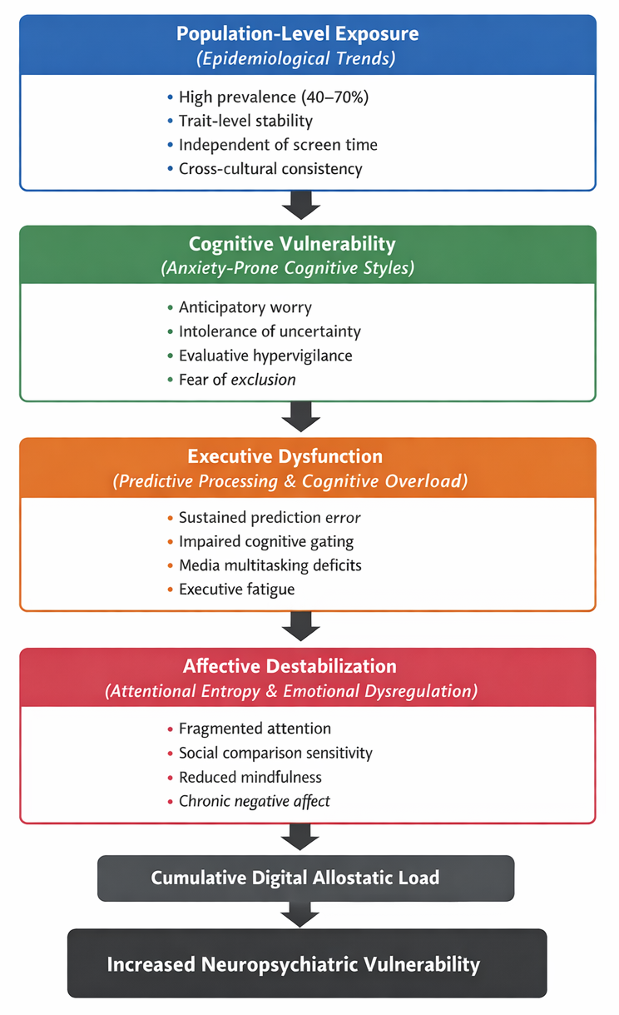

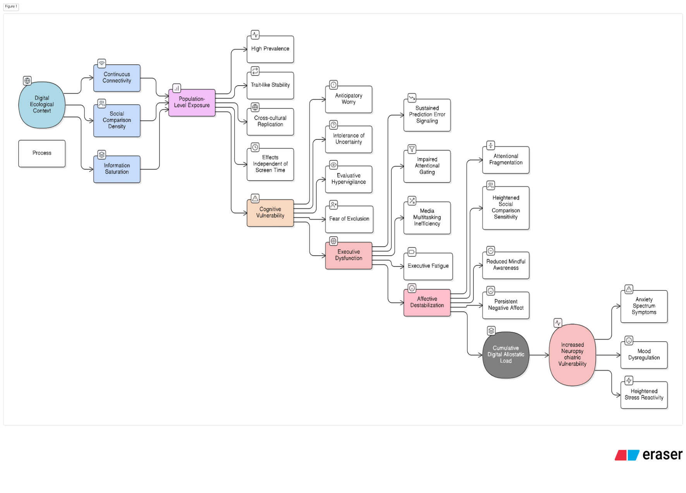
Figure 2. Digital Ecological Context and Neuropsychiatric Vulnerability

Figure 3. Clinical Translation Framework
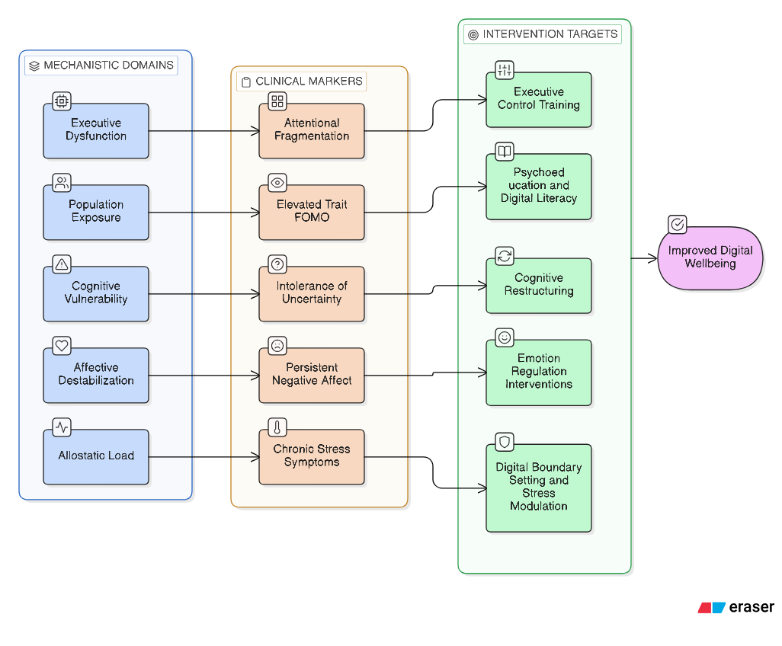
This framework advances the reconceptualisation of FOMO from a transient digital phenomenon to a syndrome-level vulnerability embedded within adult cognitive-affective regulation systems.

Conceptual Propositions
- Fear of Missing Out functions as a sustained neuropsychiatric vulnerability rather than a situational digital response.
- FOMO reflects failure of predictive cognitive economy under conditions of continuous digital input.
- Attentional entropy mediates the relationship between FOMO and emotional dysregulation.
- Emotional dysregulation contributes to anxiety vulnerability in adults experiencing high FOMO.
- Digital allostatic load represents the cumulative psychological cost of chronic FOMO.
- Adult developmental context amplifies the neuropsychiatric impact of FOMO.
- Psychological resilience moderates the relationship between FOMO and adverse mental health outcomes.
The following propositions further elaborate the neurocognitive mechanisms underlying FOMO:
- FOMO may be conceptualized as a maladaptive predictive state that prevents cognitive and emotional closure.
- Persistent prediction error mediates the relationship between digital environments and anxiety vulnerability.
- FOMO contributes to attentional entropy by sustaining readiness for alternative possibilities.
- Emotional dysregulation in FOMO reflects depletion of cognitive control resources.
- Digital allostatic load represents the cumulative neuropsychiatric cost of unresolved predictive uncertainty.

Implications for Neuropsychiatric Research and Practice
  - Research Implications
Future research should move beyond cross-sectional designs and examine FOMO as a longitudinal vulnerability marker for anxiety and mood disorders. Studies employing experience sampling and ecological momentary assessment may clarify how predictive uncertainty and emotional dysregulation unfold in real time. Neurocognitive research could investigate associations between FOMO and attentional control networks, default mode activity, and emotion regulation circuitry. Measurement development is another priority. Existing FOMO scales primarily capture behavioural concern; refined instruments assessing predictive uncertainty, anticipatory anxiety, and emotional exhaustion would advance construct validity (Przybylski et al., 2013; Elhai et al., 2020). These directions position FOMO as a construct of direct relevance to neuropsychiatric vulnerability research.

2. Clinical Implications
Clinically, FOMO-related cognitions should be routinely assessed in adults presenting with anxiety, burnout, or stress-related complaints. Cognitive-behavioural interventions may target intolerance of uncertainty, rumination, and maladaptive prediction cycles (Carleton, 2016; Nolen-Hoeksema et al., 2008). Mindfulness-based approaches can enhance present-moment engagement and reduce anticipatory vigilance. Therapeutic work may also focus on restoring predictive closure by helping individuals define boundaries around information sufficiency and digital engagement. Such interventions align with emerging models of digital mental health care. Such approaches align with transdiagnostic neuropsychiatric models of anxiety and stress.

3. Public Mental Health and Digital Policy Implications
At the population level, digital literacy programs should incorporate education about FOMO as a psychological vulnerability rather than a personal failure. Platform-level design changes - such as reduced infinite scrolling, delayed notifications, and well-being prompts - may help mitigate predictive overload (Tarafdar et al., 2019). Workplace mental health initiatives should address FOMO-driven hyperavailability norms that contribute to cognitive overload and emotional exhaustion among adults. This reframing supports population-level neuropsychiatric prevention strategies.

Conclusion
Fear of Missing Out represents a significant and under-theorized psychological challenge in the digital age. This conceptual review advances a novel neuropsychiatric framework positioning FOMO as a vulnerability syndrome characterized by anticipatory anxiety, predictive cognitive failure, attentional fragmentation, emotional dysregulation, and cumulative digital allostatic load. In adulthood, where identity, commitment, and meaning are central developmental concerns, FOMO assumes heightened psychological significance. Recognising FOMO as a syndrome rather than a symptom provides a foundation for more precise research, assessment, and intervention strategies, contributing to improved mental health outcomes in digitally saturated societies.
Recommendations:
This review proposes the following recommendations:
1. Include FOMO screening in adult anxiety assessments.
2. Develop FOMO-specific subscales targeting predictive uncertainty.
3. Examine FOMO longitudinally as a risk marker.
4. Integrate FOMO into techno-stress models.
5. Target rumination in FOMO-focused interventions.
6. Emphasize predictive closure in therapy.
7. Promote metacognitive awareness of digital triggers.
8. Incorporate FOMO education in digital literacy programs.
9. Design workplace norms limiting constant availability.
10. Encourage notification minimalism.
11. Promote present-focused attentional training.
12. Study FOMO across adult life stages.
13. Examine neurocognitive correlates of FOMO.
14. Differentiate adaptive vs maladaptive anticipation.
15. Treat FOMO as a public mental health concern.

Disclaimer (Artificial intelligence)

Author hereby declares that Figure 1 was generated using ChatGPT (GPT-5.2, OpenAI) based on structured textual specifications provided by the author. Figures 2 and 3 were generated using Eraser (https://app.eraser.io; web-based graphical editor, version current at time of use). All conceptual content, figure structure, scientific interpretation, and final revisions were developed by the author; AI and software tools were used solely for visual rendering.

References
- Alt, D. (2015). College students’ academic motivation, media engagement and fear of missing out. Computers in Human Behavior, 49, 111-119. https://doi.org/10.1016/j.chb.2015.02.057
- Baker, Z. G., Krieger, H., & LeRoy, A. S. (2016). Fear of missing out: Relationships with depression, mindfulness, and physical symptoms. Translational Issues in Psychological Science, 2(3), 275-282. https://doi.org/10.1037/tps0000075
- Bishop, S. J. (2007). Neurocognitive mechanisms of anxiety: An integrative account. Trends in Cognitive Sciences, 11(7), 307-316. https://doi.org/10.1016/j.tics.2007.05.008
- Brailovskaia, J., Margraf, J., & Köllner, V. (2019). Addicted to Facebook? Relationship between Facebook Addiction Disorder, duration of Facebook use, and narcissism in an inpatient sample. Psychiatry Research, 273, 52–57. https://doi.org/10.1016/j.psychres.2019.01.015
- Carleton, R. N. (2016). Into the unknown: A review and synthesis of contemporary models involving uncertainty. Journal of Anxiety Disorders, 39, 30-43. https://doi.org/10.1016/j.janxdis.2016.02.007
- Clark, A. (2013). Whatever next? Predictive brains, situated agents, and the future of cognitive science. Behavioral and Brain Sciences, 36(3), 181-204. https://doi.org/10.1017/S0140525X12000477
- Deci, E. L., & Ryan, R. M. (2000). The “what” and “why” of goal pursuits: Human needs and the self-determination of behavior. Psychological Inquiry, 11(4), 227-268. https://doi.org/10.1207/S15327965PLI1104_01
- Dempsey, A. E., O’Brien, K. D., Tiamiyu, M. F., & Elhai, J. D. (2019). Fear of missing out (FoMO) and rumination mediate relations between social anxiety and problematic Facebook use. Addictive Behaviors Reports, 9, 100150. https://doi.org/10.1016/j.abrep.2018.100150
- Elhai, J. D., Levine, J. C., Dvorak, R. D., & Hall, B. J. (2016). Fear of missing out, need for touch, anxiety and depression are related to problematic smartphone use. Computers in Human Behavior, 63, 509-516. https://doi.org/10.1016/j.chb.2016.05.079
- Elhai, J. D., Yang, H., Fang, J., Bai, X., & Hall, B. J. (2020). Depression and anxiety symptoms are related to problematic smartphone use severity in Chinese young adults: Fear of missing out as a mediator. Addictive Behaviors, 101, 105962. https://doi.org/10.1016/j.addbeh.2019.04.020
- Erikson, E. H. (1968). Identity: Youth and crisis. Norton.
- Franchina, V., Vanden Abeele, M., van Rooij, A. J., Lo Coco, G., & De Marez, L. (2018). Fear of missing out as a predictor of problematic social media use and phubbing behavior among Flemish adolescents. International Journal of Environmental Research and Public Health, 15(10), 2319. https://doi.org/10.3390/ijerph15102319
- Friston, K. (2010). The free-energy principle: A unified brain theory? Nature Reviews Neuroscience, 11(2), 127-138. https://doi.org/10.1038/nrn2787
- Gross, J. J., & Jazaieri, H. (2014). Emotion, emotion regulation, and psychopathology: An affective science perspective. Clinical Psychological Science, 2(4), 387-401. https://doi.org/10.1177/2167702614536164
- Mark, G., Gudith, D., & Klocke, U. (2008). The cost of interrupted work: More speed and stress. Proceedings of the SIGCHI Conference on Human Factors in Computing Systems, 107–110. https://doi.org/10.1145/1357054.1357072
- McEwen, B. S. (2007). Physiology and neurobiology of stress and adaptation: Central role of the brain. Physiological Reviews, 87(3), 873-904. https://doi.org/10.1152/physrev.00041.2006
- Milyavskaya, M., Saffran, M., Hope, N., & Koestner, R. (2018). Fear of missing out: Prevalence, dynamics, and consequences of experiencing FOMO. Motivation and Emotion, 42(5), 725-737. https://doi.org/10.1007/s11031-018-9683-5
- Nolen-Hoeksema, S., Wisco, B. E., & Lyubomirsky, S. (2008). Rethinking rumination. Perspectives on Psychological Science, 3(5), 400-424. https://doi.org/10.1111/j.1745-6924.2008.00088.x
- Ophir, E., Nass, C., & Wagner, A. D. (2009). Cognitive control in media multitaskers. Proceedings of the National Academy of Sciences, 106(37), 15583-15587. https://doi.org/10.1073/pnas.0903620106
- Przybylski, A. K., Murayama, K., DeHaan, C. R., & Gladwell, V. (2013). Motivational, emotional, and behavioral correlates of fear of missing out. Computers in Human Behavior, 29(4), 1841-1848. https://doi.org/10.1016/j.chb.2013.02.014
- Rozgonjuk, D., Sindermann, C., Elhai, J. D., Montag, C., & Hall, B. J. (2020). Fear of missing out (FoMO) and social media’s impact on daily-life and productivity at work: Do WhatsApp, Facebook, Instagram, and Snapchat use disorders mediate that association? Addictive Behaviors, 110, 106487. https://doi.org/10.1016/j.addbeh.2020.106487
- Servidio, R. (2021). Fear of missing out and self-esteem as mediators of the relationship between maximization and problematic smartphone use. Current Psychology, 40(7), 3351-3360. https://doi.org/10.1007/s12144-019-00317-0
- Smith, B. W., Dalen, J., Wiggins, K., Tooley, E., Christopher, P., & Bernard, J. (2008). The brief resilience scale: Assessing the ability to bounce back. International Journal of Behavioral Medicine, 15(3), 194-200. https://doi.org/10.1080/10705500802222972
- Stead, H., & Bibby, P. A. (2017). Personality, fear of missing out and problematic internet use and their relationship to subjective well-being. Computers in Human Behavior, 76, 534-540. https://doi.org/10.1016/j.chb.2017.08.016
- Tarafdar, M., Cooper, C. L., & Stich, J. F. (2019). The technostress trifecta—techno eustress, techno distress and design: Theoretical directions and an agenda for research. Information Systems Journal, 29(1), 6-42. https://doi.org/10.1111/isj.12169
- Wegmann, E., Oberst, U., Stodt, B., & Brand, M. (2017). Online-specific fear of missing out and internet-use expectancies contribute to symptoms of internet-communication disorder. Addictive Behaviors Reports, 5, 33-42. https://doi.org/10.1016/j.abrep.2017.04.001
- Wilmer, H. H., Sherman, L. E., & Chein, J. M. (2017). Smartphones and cognition: A review of research exploring the links between mobile technology habits and cognitive functioning. Frontiers in Psychology, 8, 605. https://doi.org/10.3389/fpsyg.2017.00605
- Wolniewicz, C. A., Tiamiyu, M. F., Weeks, J. W., & Elhai, J. D. (2018). Problematic smartphone use and relations with negative affect, fear of missing out, and fear of negative and positive evaluation. Psychiatry Research, 262, 618-623. https://doi.org/10.1016/j.psychres.2017.09.058

