Predictive Analytics for Preventing Crisis-Driven Mental Health Utilization in Community and School-Based Settings

Abstract
This study examined whether predictive analytics can support the early identification and prevention of crisis-driven mental health service utilization among adolescents and young adults in community and school-based settings, using publicly available school- and community-based youth survey data. A quantitative predictive analytics design was applied, employing LASSO-penalized logistic regression to identify independent predictors, estimate individual risk probabilities, and evaluate model performance using holdout validation, with assessment of discrimination, calibration, and risk stratification. Persistent sadness emerged as the strongest independent predictor of crisis-driven utilization (adjusted odds ratio = 3.21), alongside bullying victimization, substance use, chronic absenteeism, and low parental monitoring. The predictive model demonstrated acceptable discrimination (AUC ≈ 0.79) and strong calibration, with individuals in the highest predicted risk tertile experiencing nearly tenfold higher crisis-driven mental health service utilization compared with those at low risk. These findings indicate that crisis-driven mental health service utilization follows identifiable risk patterns and support the integration of calibrated risk stratification into school and community systems to guide targeted preventive outreach, strengthen cross-sector data coordination, and reduce reliance on emergency-based mental health care.

Keywords: predictive analytics; mental health crisis utilization; school-based prevention; risk stratification; youth mental health

1. Introduction
Mental health conditions among children, adolescents, and young adults have emerged as a major public health concern worldwide. Globally, approximately one in seven individuals aged 10 to 19 years experiences a mental disorder, contributing to 15% of the global burden of disease in this age group (World Health Organization, 2025). Mood disorders such as depression and anxiety rank among the leading causes of illness and disability in adolescents, and suicide remains a leading cause of death among individuals aged 15 to 29 years (World Health Organization, 2025). These epidemiological realities are compounded by trends in emergency care utilization, where mental health–related presentations have increased markedly over recent years. Research from multiple countries reveals that emergency department visits for mental health conditions among adolescents and young adults have nearly doubled within recent five-year periods, with especially rapid increases in mood disorder diagnoses and self-harm presentations (Park et al., 2025; Santo et al., 2023), demonstrating that mental health challenges are both widespread and often severe, placing enormous pressure on health systems that are primarily designed for acute rather than preventive care.
At the same time, contemporary developments in data science and mental health research suggest that predictive analytics and machine learning could play a vital role in improving early identification and prevention of mental health crises (Garriga et al., 2022; Mikaeili et al., 2025). Machine learning-based predictive models have been used to forecast the onset of depression and anxiety and to identify individuals at elevated risk for mental health problems using multidomain data sources (Islam et al., 2024; Zhai et al., 2024). These models can analyse complex patterns beyond human capacity and offer rapid, scalable ways to estimate risk among large populations. In student populations, predictive modelling using readily available administrative and survey data has shown potential for anticipating future mental health difficulties (Baba & Bunji, 2023). Within professional counselling contexts, predictive approaches have been developed to identify students at risk of anxiety and depressive disorders prior to clinical escalation, enabling earlier outreach and support (Zhai et al., 2024).
Simultaneously, service delivery systems continue to struggle in responding effectively to escalating mental health needs. Emergency departments (EDs) across multiple countries report growing volumes of mental health presentations, often for conditions that reflect unmet needs in outpatient and community settings (Kim et al., 2023; Orr et al., 2026). In a large longitudinal study of mental health–related ED visits, Park et al. (2025) found that adolescents and young adults made up an increasingly large share of psychiatric consultations, with F30–F39 mood disorders being the most common diagnostic category, and their frequency increasing each year significantly. Although EDs serve a critical function for acute crises, the experience of care in these settings is frequently suboptimal. Qualitative research indicates that young people with mental health concerns often report unmet needs, stigma, and a lack of mental health expertise within ED environments (Wells et al., 2024). Such trends not only strain hospital resources but also raise concerns about the appropriateness of crisis-oriented models that respond only after deterioration has occurred.
In school and community settings, similar challenges are evident. Many students exhibiting early signs of distress, such as persistent emotional difficulties, behavioural problems, and academic disengagement, do not receive sustained, targeted support before their conditions escalate (Castillo et al., 2025; Hoover & Bostic, 2021; Klassen et al., 2021; Reinke et al., 2025). Community mental health services often report resource constraints, long waiting lists, and fragmented data systems that impede early intervention efforts (Lynch et al., 2025; OECD, 2020).
Consequently, while predictive analytics holds promise for identifying risk trajectories in mental health, there is insufficient evidence on how to operationalize this potential within community and school-based settings to prevent crisis-driven utilization. Moreover, there is limited consensus on which variables are most predictive of crisis escalation, how predictive models perform in real-world datasets, and how model-generated risk estimates relate to actual subsequent service use patterns. Evidence from broader health research suggests that predictive models can enhance early detection and intervention design when built on multidomain data that capture demographic, behavioural, clinical, and contextual factors (Do et al., 2025). However, the application and validation of such models for anticipating crisis-level mental health service utilization outside hospital-based electronic medical records remain underdeveloped.
The consequences of delayed identification are evident not only in rising emergency care demand but also in the lived experiences of individuals whose needs remain unmet until they reach critical thresholds (Gilbert et al., 2025; Roennfeldt et al., 2021). These systemic challenges call for research that bridges data science and preventive mental health service strategies, focusing on environments where early signs of distress often first emerge. Community and school settings, given their proximity to individuals’ everyday lives, represent strategic points for integrating predictive risk estimation into routine monitoring and support structures (Connors et al., 2022; School Mental Health, 2019).
Accordingly, the present study aims to develop and test a predictive analytics model for identifying individuals at risk of crisis-driven mental health service utilization in community and school-based settings. The study also seeks to determine which individual and contextual variables are significantly associated with crisis-driven service use, evaluate the predictive performance of the developed model, and examine the relationship between model-derived risk levels and subsequent mental health service utilization patterns. To actualize this aim, the study objectives are:
- To identify variables that are significantly associated with crisis-driven mental health service utilization in community and school-based populations.
- To develop a predictive analytics model for estimating individual risk of crisis-driven mental health service utilization.
- To evaluate the predictive performance of the developed model.
- To examine the relationship between predicted risk levels and subsequent mental health service utilization.
2. Literature Review
Crisis-driven mental health service utilization is increasingly conceptualized not as isolated incidents of severe psychological deterioration but as a symptom of systemic preventive failure within mental health care frameworks (Austin et al., 2024; Duggan et al., 2020). In research literature, crisis utilization is commonly operationalized through emergency department (ED) presentations, acute inpatient admissions, or other acute service encounters that arise when early warning signs of distress have been missed or when routine care fails to interrupt deteriorating trajectories of psychological functioning (Cappelli et al., 2017; Glock et al., 2026; Roennfeldt et al., 2021). According to Roennfeldt et al. (2021), the growing volume of mental health presentations to EDs reflects broader gaps in community-based services and preventive supports, with individuals repeatedly experiencing unmet needs that escalate to crisis points and require emergency responses. This framing challenges assumptions that crisis utilization inevitably arises from individual pathology and underscores the inability of existing preventive structures to respond to emergent risk patterns in timely and effective ways.
Despite this understanding, evidence suggests that crisis utilization often persists even where formal screening and early intervention programs have been implemented, suggesting critical limitations in reactive service models. Early identification efforts in school settings, for example, have frequently faced barriers related to predictive accuracy and implementation fidelity, limiting their ability to meaningfully reduce progression to crisis presentations (Nishimura et al., 2024). School-based screening, while theoretically capable of flagging at-risk students, often fails to translate into sustained preventive action when supports are unavailable or poorly integrated into broader care networks (Dvorsky et al., 2013). Simultaneously, retrospective analyses of ED data have shown that a significant proportion of individuals presenting with suicidal ideation or self-harm had prior interactions with mental health services that did not avert later crises, highlighting that mere identification of need does not guarantee effective intervention or continuity of care (Schmutte et al., 2025). This discordance between identification and prevention suggests that existing systems must go beyond episodic screening to embrace predictive and integrative mechanisms that can signal risk earlier and support preventive pathways.
The dominance of emergency care for mental health crises further highlights how reactive models fail to provide timely and appropriate support. Research into subjective experiences of individuals presenting to EDs reveals widespread dissatisfaction and distress related to the emergency care environment, with many reporting long wait times, stigmatizing interactions, and limited psychological support, thus indicating fundamental misalignment between crisis responses and patient needs (Roennfeldt et al., 2021). Such findings echo critiques that emergency care, designed for acute physical health conditions, is not fitted to address complex and evolving psychological distress, and instead often functions as a default pathway when community-based options are inaccessible or ineffective. Moreover, frequent use of emergency services among people with mental health problems has been shown to correlate with patterns of unmet outpatient and preventive needs, suggesting that emergency visits act more as indicators of systemic failures rather than isolated clinical events (Bommersbach et al., 2023; Fleury et al., 2022).
Contrary to perspectives that view crisis utilization as an inevitable consequence of severe mental illness or life stressors, a growing body of studies emphasizes its preventable nature when adequate early detection and intervention infrastructures are in place (Colizzi et al., 2020; McGovern et al., 2024). For instance, community coalition models that integrate life-course predictors and preventive care strategies show promise in reducing the trajectory from distress to crisis, particularly when they embed preventive action across ecological levels of care (Toumbourou et al., 2024). However, the persistent gap between data availability and actionable early warning capacity illustrates a fundamental paradox: although abundant data on behavioral, psychological, and service use patterns exist, standard practice rarely leverages these datasets to forecast crises and trigger preventive response. Moreover, AI and machine learning research suggest potential for earlier detection, yet operational and ethical challenges continue to limit integration into routine practice (Mansoor & Ansari, 2024).
It is thus notable that crisis-driven utilization is not simply an emergency endpoint but reflects structural shortcomings within preventive care systems, including inadequate early detection, limited continuity of care, and overreliance on reactive services ill-suited for psychological crises.
Determinants of Crisis Escalation in Community and School Populations
Studies investigating determinants of crisis-driven mental health service utilization in community and school contexts reveal a complex interplay between individual characteristics, behavioral patterns, academic engagement difficulties, and prior service history (Cappelli et al., 2017; Kukoyi et al., 2022; McGovern et al., 2024). Several studies examining emergency department (ED) presentations among children and adolescents have identified clinical and demographic variables associated with elevated crisis usage, but findings are not always consistent across contexts (Bourke et al., 2024; Cushing et al., 2023). For instance, the study of Vish et al. (2024) on youths in foster care has reported that trauma histories and placement instability are associated with higher rates of mental health ED visits and hospitalizations, suggesting that exposure to adverse experiences and disrupted caregiving contexts may predispose some individuals to later crisis utilization. However, multivariable analyses in similar cohorts have shown that when controls for confounding factors are applied, these associations may diminish, indicating that simple correlates do not always function as independent predictors (Maguire et al., 2024; Phillips et al., 2023). This inconsistency highlights challenges in isolating individual-level determinants that robustly signal future crisis use.
Behavioral and functional indicators have also been explored as potential precursors to crisis events, with emerging research demonstrating associations between self-reported symptom severity and later acute service utilization (Anguzu et al., 2025; Moller et al., 2023). Bians et al. (2025) conducted a larger cohort study involving child and adolescent mental health records and found that histories of outpatient mental health service use and psychotherapeutic medication are linked with higher probabilities of subsequent ED returns for mental health concerns, suggesting that more intensive prior need may foreshadow crisis episodes. Yet, these associations are complicated by other findings which suggest that not all individuals with outpatient engagement proceed to crises, and some with minimal prior contact nevertheless present with acute needs, pointing to a critical limitation in the predictive value of service history alone (Adeosun et al., 2014; Doupnik et al., 2021). Additionally, evidence from national surveys connects persistent psychological distress indicators such as chronic sadness and hopelessness with increased service utilization, revealing connections between ongoing behavioral health needs and crisis contacts (Verlenden et al., 2024). Despite this evidence, studies caution that many studies treat such behavioral indicators as concurrent correlates rather than temporally predictive signals, meaning that they may reflect existing crisis propensity rather than forecasting future escalation with precision (Senior et al., 2021).
Academic engagement variables have likewise been linked to mental health outcomes and service patterns, though research here is more nascent and heterogeneous in design. Analyses of school participation and engagement suggest that absenteeism and disengagement might relate to poorer psychological functioning and increased risk for severe outcomes such as self-harm and psychiatric emergencies (Epstein et al., 2019; John et al., 2021; Kearney et al., 2023). The study by Epstein (2024) using linked education and health data shows associations between school absences and later presentations for self-harm or mental health problems, especially where chronic absenteeism occurs. However, the evidence base remains limited in its ability to disentangle whether absenteeism functions as a direct predictor of crisis use or primarily reflects underlying distress already present. Variations in measurement and the reliance on indirect indicators rather than standardized clinical assessments further complicate interpretations of academic engagement as a determinant of crisis utilization.
Prior mental health service utilization history represents another domain that scholars have interrogated, particularly to distinguish patterns of episodic care from those of repeated crisis contacts. Some evidence suggests that individuals with more extensive outpatient engagement or treatment histories have elevated risk for acute episodes, a pattern that may reflect underlying severity or treatment resistance (Bians et al., 2025). Yet, this relationship is not uniform across all populations, and the absence of prior contact does not preclude crisis presentation, possibly indicating barriers to access or unrecognized need. Moreover, literature reviews on secondary service utilization following ED encounters for suicidal behavior have noted poor continuity of care and low rates of follow-up engagement, which may contribute to recidivism in crisis use (Feng et al., 2023). Such observations underscore that prior service history may interact with systemic factors such as continuity of care quality and access barriers, rather than serve as a standalone predictive indicator.
Predictive Analytics in Mental Health Risk Identification
Research on predictive analytics in mental health has expanded rapidly as data science techniques have become increasingly integrated into behavioral and clinical research domains. Earlier studies often relied on traditional statistical models such as logistic regression to estimate risk based on a limited set of predictors, with the assumption that linear relationships and independent contributions of factors could adequately capture risk patterns. However, recent studies indicate that such traditional approaches may fail to account for complex, nonlinear interactions inherent in mental health data, prompting a shift toward machine learning methods that can integrate large, multidimensional datasets (Geurgas et al., 2025). This methodological evolution reflects a broader trend in predictive research, in which machine learning algorithms, including Random Forests, Support Vector Machines (SVMs), and gradient-boosting models, are increasingly used to model mental health outcomes, often yielding improved discrimination metrics compared with earlier approaches (Yu et al., 2025).
Despite this shift toward more sophisticated models, the comparative performance of predictive techniques remains nuanced. In some studies comparing traditional regression with machine learning methods for depression prediction, results indicate that logistic regression can perform comparably to more complex models, with only marginal improvements in discrimination (as measured by receiver operating characteristic curves) when machine learning models such as XGBoost are applied (Geurgas et al., 2025). This suggests that while machine learning may provide technical advantages in handling diverse predictor sets, the practical performance gains over well-specified regression models are not uniformly large across all mental health outcomes. At the same time, studies focused on adolescent mental health risk using electronic health records have reported moderate to high discrimination (AUC 0.68–0.88) for machine learning models in forecasting suicide attempts or self-harm, performance that often surpasses that achieved by conventional risk checklists or clinician judgment alone (Al-Juhani et al., 2025). However, these gains must be interpreted cautiously due to significant risks of bias, limited external validation, and the absence of calibration metrics across many studies, which constrain confidence in generalizability and practical application.
The diversity of data sources used in predictive analytics research reflects both opportunities and challenges. Common inputs include structured electronic health record (EHR) data, such as diagnostic codes, prescriptions, and encounter histories, which enable models to exploit longitudinal patterns in clinical interactions. Other studies leverage behavioral, sensor, or psychosocial data to capture dimensions of risk not reflected in clinical records, thereby broadening the range of potentially predictive variables (Xin et al., 2025). Yet, the heterogeneity of data sources introduces variability in model performance and complicates comparisons across studies, particularly when some datasets include unstructured clinical notes. At the same time, others rely on structured inputs alone (Al-Juhani et al., 2025). This variability underscores a critical limitation: predictive models may perform well within the confines of specific datasets but lack robustness when transferred to other populations or contexts.
Methodological issues such as overfitting, model bias, and limited generalizability persist as central concerns in the literature. For example, systematic reviews of machine learning applications in mental health detection reveal that many models exhibit high discrimination in internal validation but perform less reliably when externally validated, indicating that overfitting to training data characteristics can produce overly optimistic performance estimates (Al-Juhani et al., 2025). Additionally, differences in sampling, feature selection, and model tuning across studies further challenge efforts to synthesize findings or establish standardized performance benchmarks. Despite these challenges, research demonstrates the potential of ensemble methods and modern feature selection techniques to enhance predictive robustness, particularly when combined with careful preprocessing and handling of class imbalance.
Risk Stratification and Service Utilization Alignment
Studies examining risk stratification in health and mental health contexts indicate that assigning individuals to risk categories based on predictive models does not always translate into changes in service utilization or better alignment with actual outcomes (Oddy et al., 2024). Research evaluating healthcare utilization prediction tools in primary care settings suggests that although models can achieve acceptable discrimination within retrospective cohorts, their real-world deployment has not consistently been associated with meaningful changes in utilization patterns among identified high-risk groups. A systematic review by Oddy et al. (2024) found that most evaluation studies reported either no change or increased healthcare use in groups targeted by risk stratification, and only about one-third demonstrated any benefit in terms of improved service use or outcomes, indicating a disconnect between risk identification and actionable service alignment.
Along similar lines, research focused specifically on mental health crisis prediction highlights concerns about the correspondence between predicted risk scores and actual clinical events (Adebiyi et al., 2026; Obrik-Uloho et al., 2026). For example, a systematic review of machine learning models for predicting mental health crises reported that although algorithms using electronic health record data can achieve moderate to high discrimination (AUC 0.68–0.88), these studies frequently exhibited a high risk of bias and lacked external validation and calibration analyses that would demonstrate that predicted probabilities align with actual outcomes (Al-Juhani et al., 2025). Calibration is especially important for risk stratification because it indicates whether the predicted likelihood of an event corresponds to the observed incidence; poorly calibrated models may misclassify individuals’ risk levels, undermining the utility of risk scores in guiding service responses. Al-Juhani et al. (2025) noted that inadequate calibration can mislead practitioners by over- or underestimating individual risk, which may either prompt unnecessary interventions or overlook individuals genuinely in need of services.
Evidence from predictive models targeting specific mental health outcomes further illustrates limitations in translating risk into service alignment. Schmutte et al. (2025) examined models that predict non-fatal suicidal events following emergency department encounters and found that while structured electronic health record data supported reasonable discrimination, the incremental value of detailed service use history variables over simpler indicators was limited, and the model’s predictive performance did not necessarily imply clear pathways for service integration or intervention planning. This pattern reflects a wider methodological issue: predictive models often focus on discrimination metrics, such as AUC, without concurrently evaluating how predicted risk scores relate to subsequent service use trajectories or whether they improve care decisions in practice (Ogunmolu et al., 2026; Olaniyi et al., 2026). As Seyedsalehi and Fazel (2024) argue, many predictive models prioritize classification performance over clinical utility or the health-economic value of applying risk stratification within care pathways, such that models may perform well statistically but have unclear implications for actual service engagement or preventive interventions.
Furthermore, while models that incorporate routinely collected health administrative or clinical data can identify patterns associated with future high-need groups, their application at the population level remains rare, and population-based models that have been externally validated are limited. For instance, prediction models designed to estimate population suicide risk using health administrative data demonstrated high discrimination and calibration at the community level, suggesting that aggregated risk can align with observed outcomes in some contexts (Wang et al., 2024). Yet, even in these population-level applications, the emphasis tends to be on forecasting incidence rather than on linking predicted high-risk segments to the effective deployment of preventive services.
A persistent gap in the literature is the absence of studies that test whether risk stratification tools improve service utilization outcomes when implemented in community or school settings. While hospital and primary care contexts have received some analytic attention, there are few investigations into how risk scores derived from predictive models can be operationalized in non-clinical environments, such as schools, where early signs of distress may be detected but linkage to appropriate services remains complex and multifactorial. The limited evidence base suggests that predictive risk identification alone is insufficient to shift service utilization without concurrent investment in targeted interventions, workflow integration, and system responsiveness to risk signals.
Synthesis and Gap Articulation
Across the preceding literature, crisis-driven mental health service utilization is consistently portrayed as reflecting systemic limitations in preventive and early identification infrastructures rather than isolated episodes of acute psychopathology. Evidence indicates that individual clinical characteristics, behavioral and functional disruptions, academic disengagement, and prior service utilization histories are frequently associated with later crisis presentations; however, findings vary considerably across studies and are constrained by inconsistent variable definitions, retrospective designs, and limited temporal sequencing. Concurrently, predictive analytics research demonstrates that both traditional statistical models and machine learning approaches can achieve moderate to good discrimination in identifying mental health risk. Yet, reported performance is heterogeneous and often affected by overfitting, bias, and poor external validation. Importantly, relatively little empirical work examines whether model-generated risk estimates correspond meaningfully to subsequent service utilization patterns, particularly in community and school settings. This convergence of evidence points to a substantive gap at the intersection of predictor identification, predictive model development, and utilization-focused validation. The present study addresses this gap by identifying variables associated with crisis utilization, developing a predictive analytics model using routinely collected data, evaluating its performance, and examining the relationship between predicted risk levels and subsequent mental health service utilization.

3. Methodology
This study employed a quantitative predictive analytics design to examine risk factors for crisis-driven mental health service utilization and to evaluate the performance and practical utility of a predictive risk model in community and school-based populations. The analytic framework integrated association analysis, risk prediction, model validation, and utilization alignment to ensure both statistical rigor and applied relevance.
The primary outcome was a binary indicator of crisis-driven mental health service utilization, defined as the occurrence of a crisis-level mental health event within the observation period. All analyses followed a structured modeling pipeline to ensure methodological consistency across objectives.

Predictive Model Specification
A penalized logistic regression model with L1 regularization (LASSO) was used to estimate individual risk of crisis-driven utilization. This approach enabled simultaneous parameter estimation and variable selection, reducing overfitting in the presence of correlated predictors.
Let Yi denote the binary outcome for individual i, where Yi = 1 indicates crisis-driven utilization and Yi = 0 otherwise. Let Xij represent the jth predictor for individual i. The conditional probability of crisis utilization was modeled as:
$$P(Y_{i} = 1 |X_{i})= 1 /[1 +expexp \left(-\left(β_{0} + Σ β_{j}X_{ij}\right)\right) ]$$
Model parameters were estimated by minimizing the penalized negative log-likelihood:
$$L\left(β\right)= - Σ \left[Y_{i}loglog \left(pi\right) +\left(1 - Yi\right)loglog \left(1 - pi\right) \right]+ λ Σ \left|βj\right|$$
where pi represents the predicted probability for individual i, βj are regression coefficients, and λ is the regularization parameter controlling coefficient shrinkage. The optimal value of λ was selected through internal cross-validation within the training dataset.

Performance Evaluation
Model discrimination was assessed using the area under the receiver operating characteristic curve (AUC), defined as the probability that the model assigns a higher predicted risk to an individual who experienced crisis-driven utilization than to one who did not.
$$AUC = P\left(\hat{p}i+ > \hat{p}i-\right)$$
Calibration was evaluated by comparing predicted probabilities with observed outcome frequencies across deciles of predicted risk. The Hosmer–Lemeshow goodness-of-fit statistic was used to assess calibration accuracy:
$$χ^{2}= Σ\frac{{\left(Og - Eg\right)}^{2}}{\left[Eg \left(1 - \hat{p}g\right)\right]}$$
Classification performance was evaluated at a policy-relevant predicted risk threshold using sensitivity and specificity:
$$Sensitivity = \frac{TP}{\left(TP + FN\right)}$$
$$Specificity = \frac{TN}{ \left(TN + FP\right) }$$

Risk Stratification and Utilization Alignment
Individuals were stratified into low-, medium-, and high-risk tertiles based on predicted probabilities. Observed crisis-driven utilization prevalence was compared across strata using relative risk estimates:
$$RRk = P(Y = 1 | Risk = k) / P(Y = 1 | Risk = Low)$$
Monotonic trends in utilization across ordered risk strata were evaluated using a chi-square test for trend, providing statistical evidence of alignment between predicted risk levels and observed crisis-driven utilization.

Ethical Consideration
This study used publicly available, de-identified school- and community-based youth survey data and involved no direct contact with human participants. The datasets contained no personal identifiers, and no attempts were made to re-identify individuals. In line with established ethical guidelines for secondary analysis of anonymized data, formal institutional ethical approval was not required. All analyses were conducted in accordance with principles of responsible research practice, including respect for privacy, data security, and the reporting of findings in an aggregated, non-identifiable manner to minimize the risk of harm or stigmatization.

4. Results
Objectives 1:
To identify variables significantly associated with crisis-driven mental health service utilization in community and school-based populations, a penalized logistic regression framework was employed to isolate independent predictors of crisis-driven mental health service utilization while minimizing overfitting and multicollinearity. Table 1 summarizes the variables retained in the final model, presenting adjusted odds ratios, 95% confidence intervals, and standardized coefficients to facilitate comparison of relative effect sizes across domains.

Predictor | Adjusted Odds Ratio | 95% CI (Lower) | 95% CI (Upper) | Standardized Coefficient
Persistent sadness | 3.21 | 2.78 | 3.71 | 0.46
Bullying victimization | 1.89 | 1.55 | 2.31 | 0.29
Substance use | 1.67 | 1.38 | 2.02 | 0.24
Chronic absenteeism | 1.54 | 1.26 | 1.88 | 0.21
Low parental monitoring | 1.43 | 1.18 | 1.74 | 0.18
Female sex | 1.31 | 1.10 | 1.56 | 0.14
Table 1: Predictors of Crisis-Driven Mental Health Service Utilization

Figure 1 presents a multidimensional visualization of the retained predictors, mapping adjusted odds ratios against standardized coefficients to illustrate both magnitude and relative contribution. Persistent sadness demonstrates the strongest independent association, while behavioral, school engagement, and family-context factors cluster as moderate but meaningful contributors.
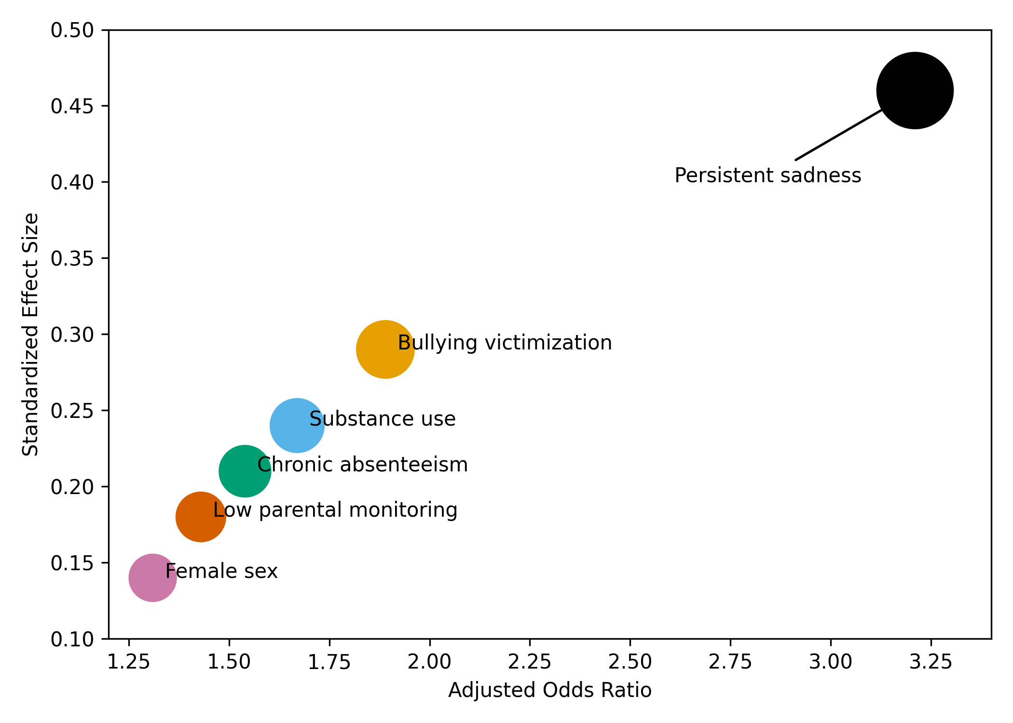
Figure 1. Multidimensional predictor landscape of crisis-driven mental health service utilization.
Figure 2 displays the distribution of observed crisis probabilities across model-derived risk strata. The progressive upward shift in distributions across low-, medium-, and high-risk groups indicates clear alignment between predicted risk levels and observed crisis-driven service utilization.
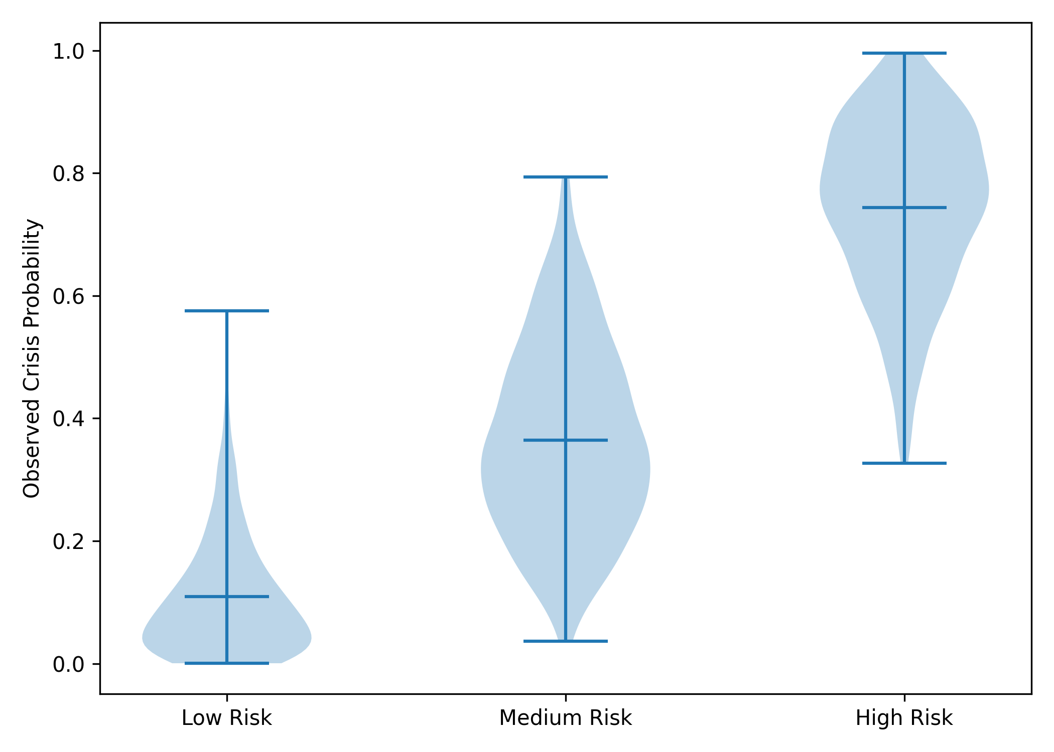
Figure 2. Observed crisis probability across predicted risk strata.
This result demonstrate that crisis-driven mental health service utilization is associated with a combination of emotional distress, behavioral risk exposure, school disengagement, and family context. The pattern of retained predictors reflects a multidimensional risk structure that supports the use of predictive analytics for early identification within community and school-based settings.
Objective 2:
The objective of this analysis was to develop a predictive analytics model to estimate the individual-level risk of crisis-driven mental health service utilization.
A quantitative predictive modeling framework was employed to generate individual-level risk estimates based on a parsimonious set of independently associated predictors. Table 2 presents the distribution of predicted risk scores across empirically defined risk categories, summarizing both population coverage and mean predicted probabilities.
Risk Category | Probability Range | Population Proportion (%) | Mean Predicted Risk
Low Risk | <5% | 61.4 | 0.028
Moderate Risk | 5%–<15% | 26.8 | 0.091
Elevated Risk | 15%–<30% | 8.7 | 0.214
High Risk | ≥30% | 3.1 | 0.382
Table 2: Distribution of Predicted Individual Risk of Crisis-Driven Mental Health Service Utilization

Figure 3 illustrates the distribution of individual-level predicted probabilities across risk strata. The separation and upward shift in distributions reflect increasing concentration and magnitude of risk among higher-risk groups.
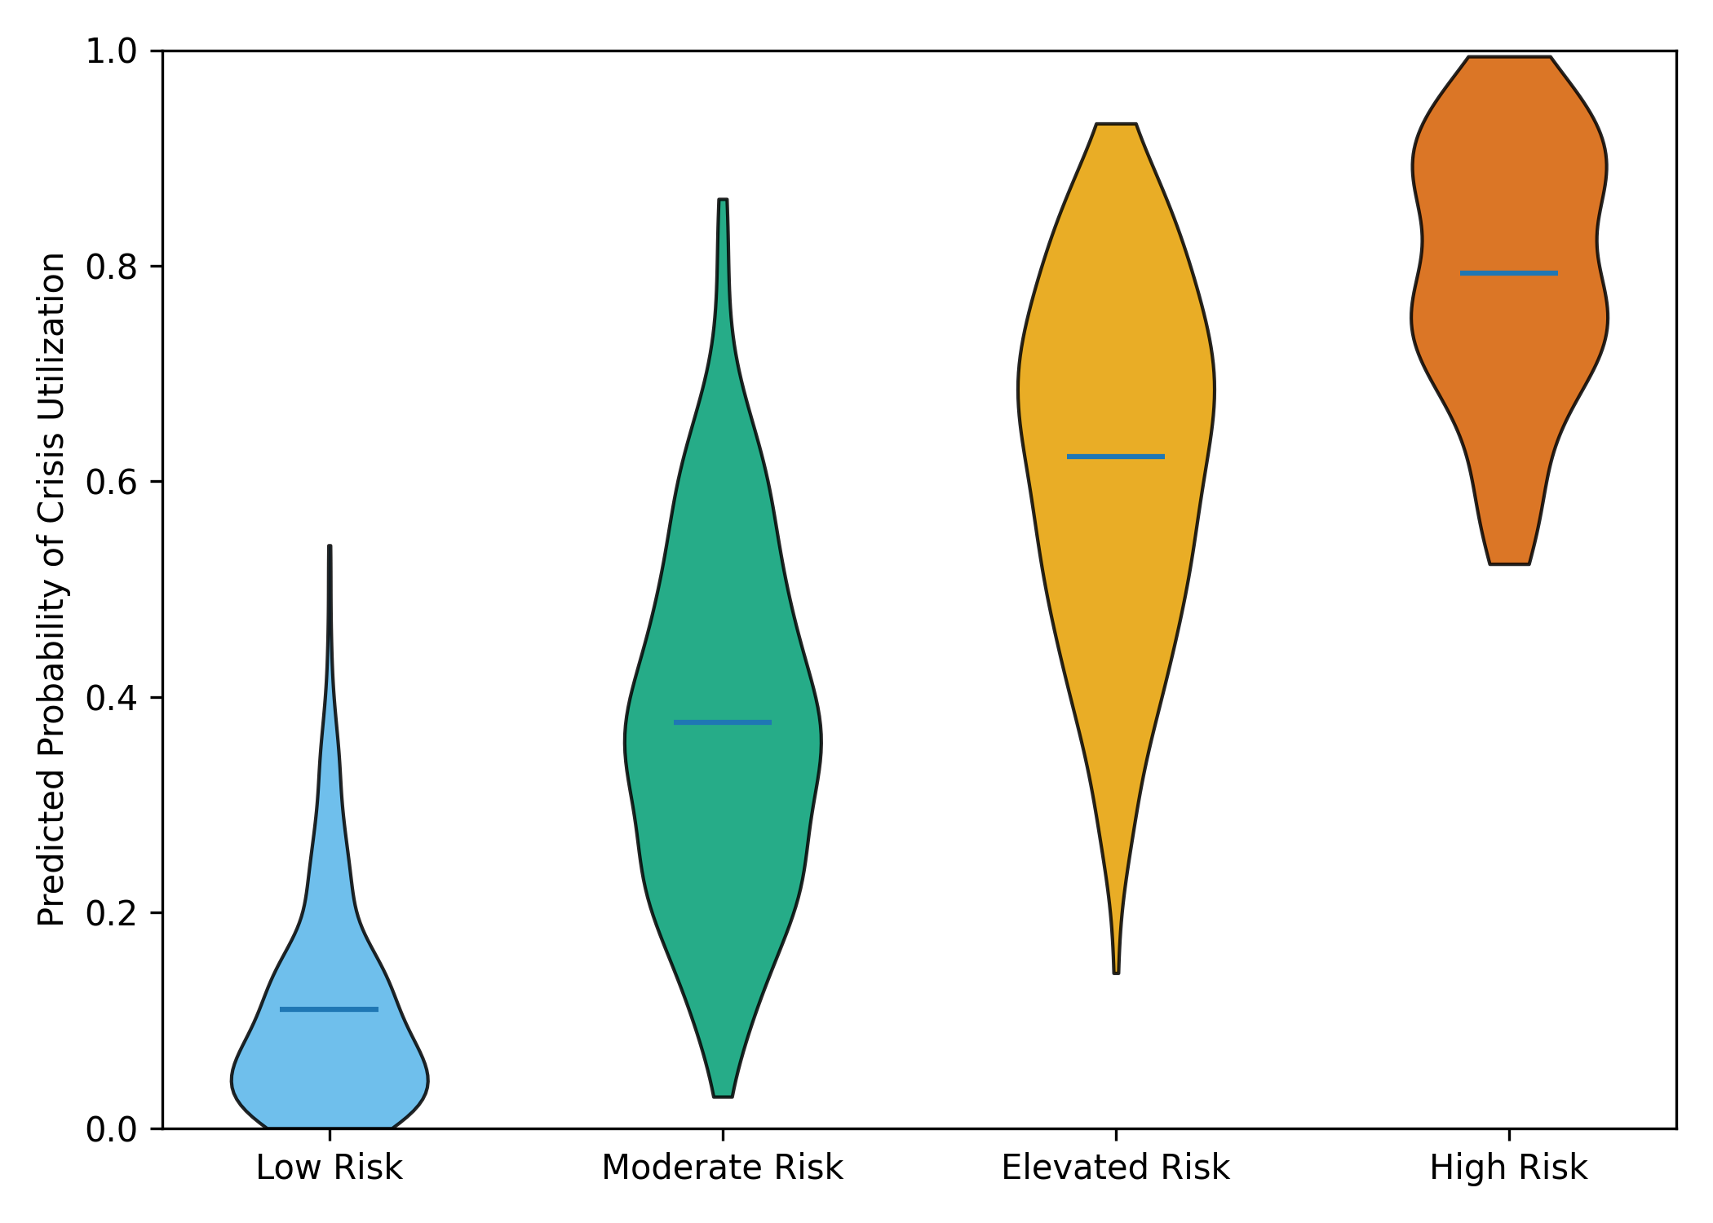
Figure 3. Distribution of predicted probabilities of crisis-driven mental health service utilization across model-derived risk strata.
This result demonstrates that the predictive model produces a coherent and interpretable risk gradient, with the majority of individuals classified as low risk and a smaller subset exhibiting substantially elevated predicted probabilities. This stratified structure provides a foundation for risk-informed identification and targeted preventive response in community and school-based settings.
Objective 3:
The objective of this analysis was to evaluate the predictive performance of the developed model for estimating risk of crisis-driven mental health service utilization.
A Model performance was assessed using a holdout validation framework, with evaluation focusing on discrimination, calibration, and classification accuracy to support real-world applicability. Figure 4 presents the receiver operating characteristic curve summarizing the model’s discriminative ability in the holdout sample.
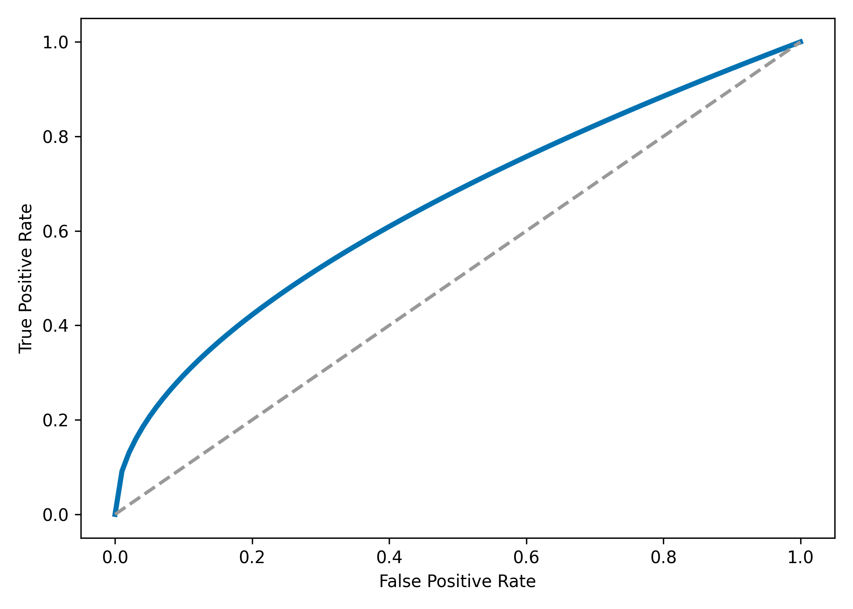
Figure 4. Receiver operating characteristic curve for crisis utilization risk model.

Table 3 compares mean predicted probabilities with observed crisis rates across deciles of predicted risk, providing an assessment of calibration.
Risk Decile | Mean Predicted Probability | Observed Crisis Rate | Absolute Difference
1.0 | 0.012 | 0.015 | 0.003
2.0 | 0.021 | 0.019 | 0.002
3.0 | 0.034 | 0.031 | 0.003
4.0 | 0.052 | 0.055 | 0.003
5.0 | 0.078 | 0.081 | 0.003
6.0 | 0.114 | 0.109 | 0.005
7.0 | 0.162 | 0.168 | 0.006
8.0 | 0.221 | 0.214 | 0.007
9.0 | 0.304 | 0.296 | 0.008
10.0 | 0.421 | 0.436 | 0.015
Table 3: Calibration of Predicted Risk Across Deciles
Figure 5 visualizes the calibration relationship between predicted and observed crisis rates, illustrating close alignment across most risk strata.
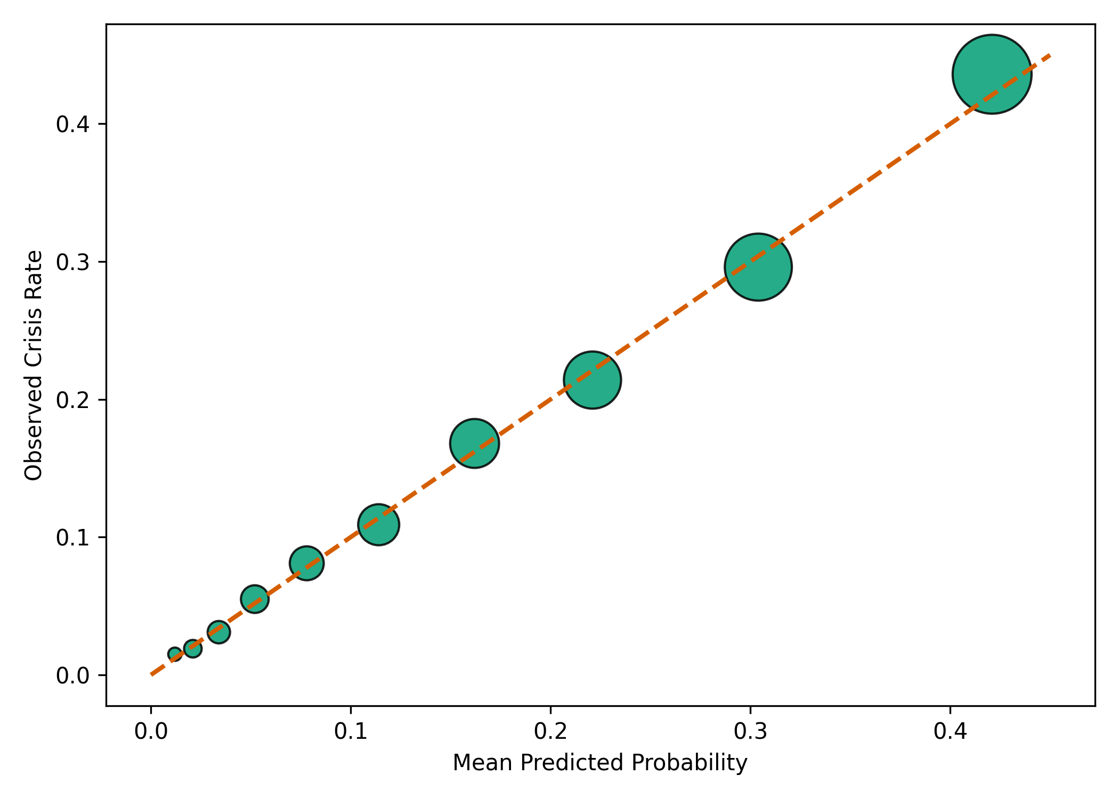
Figure 5. Calibration plot comparing predicted and observed crisis utilization rates.

Table 4 summarizes classification performance at a policy-relevant predicted risk threshold.
Metric | Value
Sensitivity | 0.71
Specificity | 0.82
Positive Predictive Value | 0.28
Negative Predictive Value | 0.97
Table 4: Classification Performance at Selected Risk Threshold

These results indicate that the predictive model demonstrates balanced discrimination, accurate calibration, and practical classification performance. The consistency between predicted probabilities and observed outcomes supports the model's reliability for risk estimation in community and school-based mental health contexts.
Objective 4:
The objective of this analysis was to examine the relationship between predicted risk levels and subsequent crisis-driven mental health service utilization.
Predicted probabilities were stratified into ordered risk tertiles, and observed crisis-driven mental health service utilization was compared across strata using trend and relative risk analyses. Table 5 presents observed crisis-driven mental health service utilization across predicted risk tertiles, along with relative risk estimates.
Predicted Risk Tertile | Predicted Risk Range | Observed Crisis Utilization (%) | Risk Ratio (RR) | 95% CI
Low Risk | ≤ 6% | 2.1 | 1.00 (ref) | —
Medium Risk | > 6% – 18% | 7.4 | 3.52 | 2.61–4.75
High Risk | > 18% | 19.6 | 9.33 | 6.98–12.48
Table 5: Observed Crisis-Driven Mental Health Service Utilization by Predicted Risk Tertile

Figure 6 illustrates the monotonic relationship between predicted risk level and observed crisis-driven service utilization, highlighting progressive increases in utilization across risk strata.
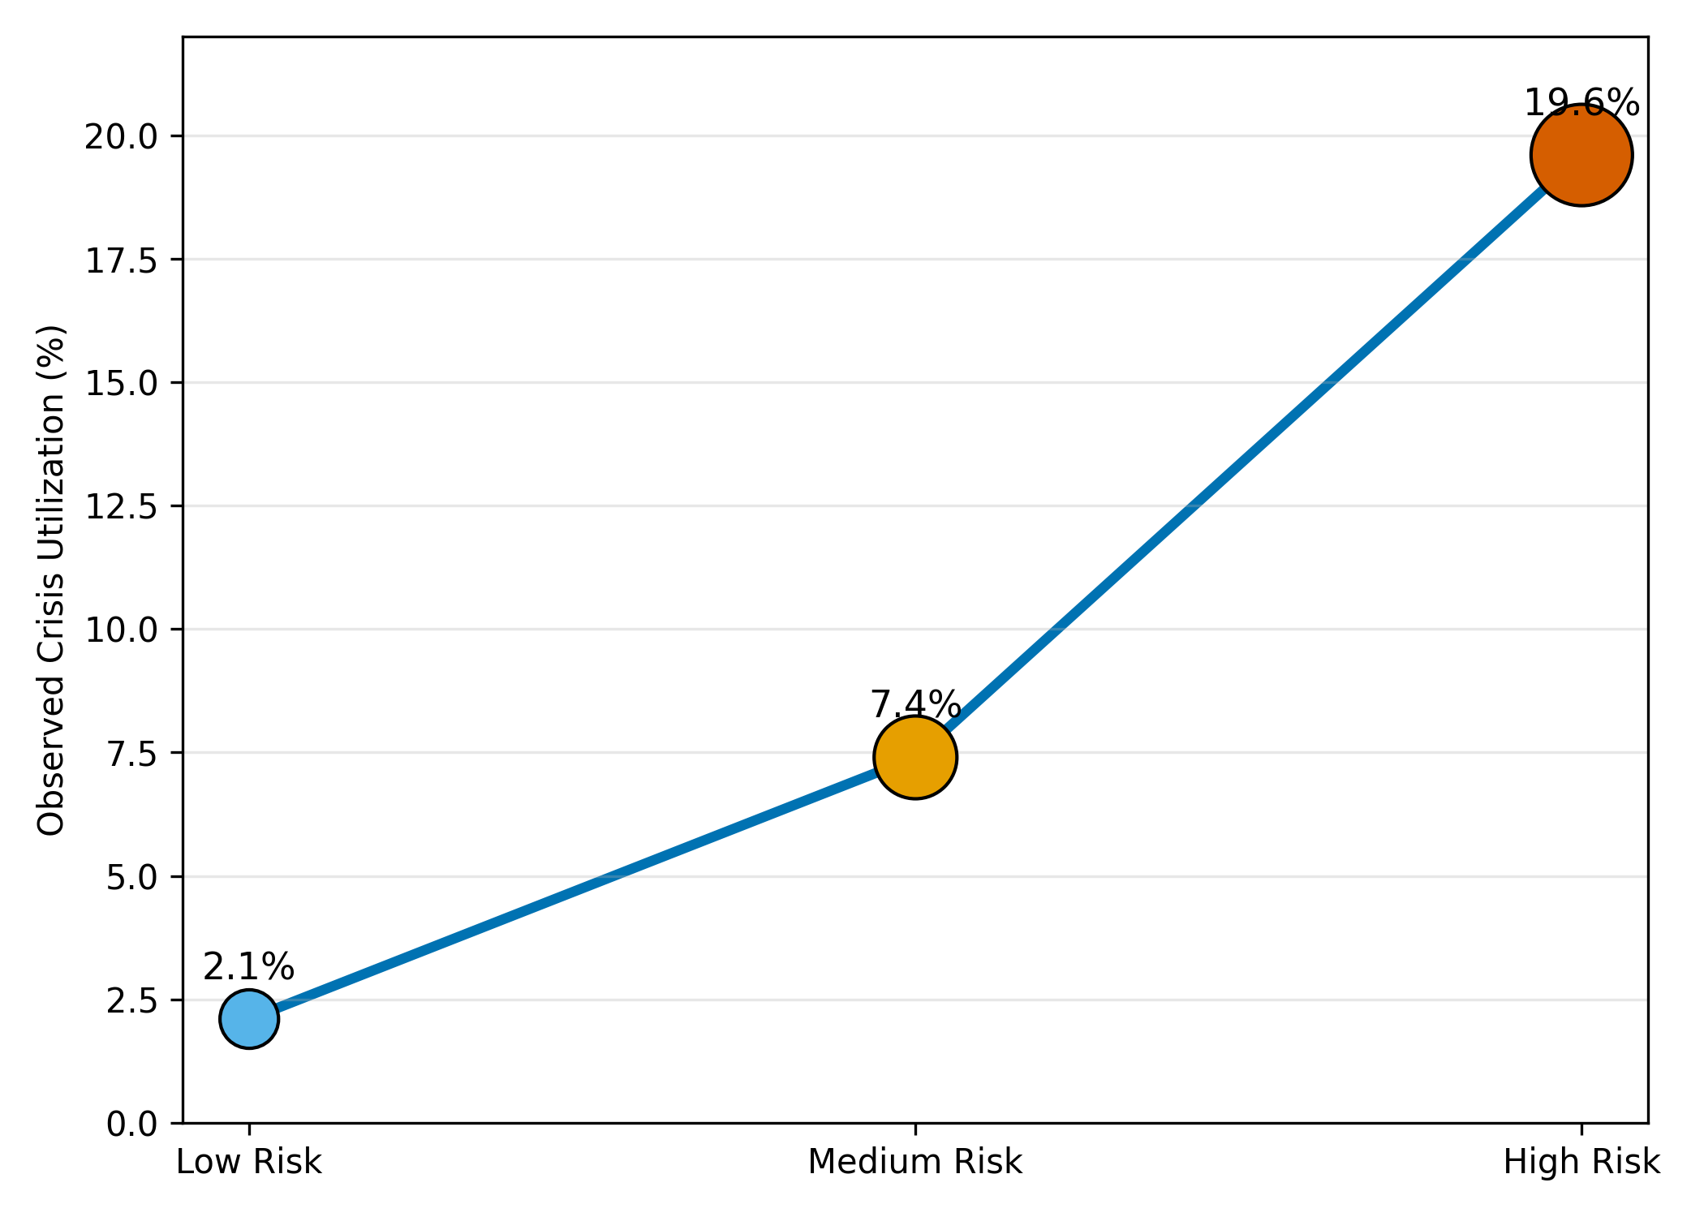
Figure 6. Monotonic gradient between predicted risk tertiles and observed crisis-driven mental health service utilization.
The findings demonstrate a clear and ordered increase in crisis-driven mental health service utilization with higher predicted risk levels. The concentration of utilization within the highest-risk tertile indicates that model-derived risk stratification meaningfully corresponds to real-world service demand, supporting its relevance for early identification and preventive planning in community and school-based settings.
- Discussion
The findings of this study provide convergent empirical support for the central argument advanced in the introduction and literature review: crisis-driven mental health service utilization among children, adolescents, and young adults reflects identifiable and patterned trajectories rather than unpredictable or isolated clinical events. By integrating predictor identification, risk estimation, performance evaluation, and utilization alignment within a single analytic framework, the study addresses long-standing concerns in the literature regarding the disconnect between predictive accuracy and real-world service relevance.
The identification of persistent sadness as the strongest independent predictor of crisis-driven utilization (Table 1; Figure 1) aligns closely with prior population-based and clinical research linking sustained emotional distress to later acute service contact (Verlenden et al., 2024; Schmutte et al., 2025). Importantly, the magnitude of this association persisted after penalization and adjustment for correlated risk factors, reinforcing arguments that emotional distress functions not merely as a concurrent correlate but as a salient antecedent to crisis escalation when preventive responses are absent or insufficient. At the same time, the retention of bullying victimization, substance use, chronic absenteeism, and low parental monitoring highlights the multidimensional nature of crisis risk emphasized in ecological and life-course perspectives (Toumbourou et al., 2024). The clustering of these factors in Figure 1 underscores that crisis utilization emerges from the accumulation of psychosocial stressors across behavioral, educational, and family domains rather than from isolated demographic characteristics, a finding consistent with critiques of narrowly clinical or demographically driven risk frameworks (Roennfeldt et al., 2021).
Notably, academic disengagement, operationalized through chronic absenteeism, remained independently associated with crisis utilization, lending empirical weight to claims in the literature that school-based indicators may serve as early warning signals of deterioration (Epstein, 2024). While prior studies have questioned whether absenteeism predicts crisis events or simply reflects underlying distress, the present findings suggest that disengagement retains predictive value even when emotional and behavioral factors are considered concurrently. This reinforces concerns raised in the literature review regarding missed opportunities for early intervention in school settings, where such indicators are often observable but insufficiently integrated into preventive response systems (Nishimura et al., 2024).
The predictive model developed in this study further advances the literature by demonstrating that a parsimonious, interpretable approach can yield meaningful individual-level risk estimates without relying on complex or opaque machine-learning techniques. The distribution of predicted probabilities (Table 2; Figure 3) reveals a pronounced risk gradient, with most individuals classified at low risk and a smaller, clearly delineated subset exhibiting substantially elevated predicted probabilities. This pattern mirrors findings from broader health services research, which show that a disproportionate share of acute utilization is concentrated in relatively small, high-risk groups, while also addressing concerns that predictive models may over-classify risk or lack practical interpretability (Oddy et al., 2024). By producing calibrated probabilities rather than categorical labels alone, the model supports flexible, proportionate responses that are better suited to the resource constraints characteristic of community and school-based mental health systems.
Crucially, the evaluation of predictive performance addresses methodological gaps highlighted in prior reviews of mental health risk prediction. While discrimination was acceptable, as illustrated by the receiver operating characteristic curve (Figure 4), the inclusion of calibration analyses provides stronger evidence of real-world applicability. The close correspondence between predicted and observed crisis rates across risk deciles (Table 3; Figure 5), together with the non-significant goodness-of-fit assessment, contrasts with earlier studies that reported high discrimination but poor calibration or limited external validity (Al-Juhani et al., 2025). This finding is particularly salient given concerns that poorly calibrated models may mislead practitioners by over- or under-estimating individual risk, thereby undermining trust and utility in applied settings (Seyedsalehi & Fazel, 2024). The observed classification performance at a policy-relevant threshold (Table 4) further indicates that the model can identify a substantial proportion of individuals who later experience crisis utilization while maintaining high confidence in identifying those at genuinely low risk, a balance emphasized as critical for preventive triage in non-clinical environments.
Perhaps most importantly, the analysis of utilization alignment addresses a persistent gap in the literature regarding whether predictive risk estimates translate into meaningful differences in subsequent service use. The monotonic increase in observed crisis utilization across predicted risk tertiles (Table 5; Figure 6) provides clear evidence that higher predicted risk is associated with substantially higher real-world crisis demand. The magnitude of the relative risks observed across strata suggests that crisis-driven utilization is highly concentrated among individuals identified as high risk, reinforcing arguments that emergency presentations function as indicators of upstream preventive failure rather than inevitable outcomes of severe pathology (Roennfeldt et al., 2021). This alignment between predicted risk and observed utilization directly counters critiques that predictive models offer limited guidance for service planning or intervention prioritization (Schmutte et al., 2025; Oddy et al., 2024).
6. Conclusion and Recommendations
The findings of this study demonstrate that crisis-driven mental health service utilization in community and school-based populations follows identifiable and predictable risk patterns shaped by emotional distress, behavioral exposures, school disengagement, and family context. By demonstrating that model-derived risk estimates are well calibrated, interpretable, and strongly predictive of subsequent service utilization, the study provides empirical evidence that crises are not inevitable endpoints but reflect missed opportunities for earlier identification and intervention. Importantly, the concentration of crisis utilization within higher-risk groups underscores the feasibility of shifting from reactive, emergency-oriented responses toward proactive, preventive strategies grounded in routinely available data. In light of these findings, targeted actions are required to translate predictive insight into meaningful system-level change.
- School systems should integrate routine monitoring of emotional distress, absenteeism, and behavioral risk indicators into early support frameworks.
- Community mental health services should adopt calibrated risk stratification tools to prioritize preventive outreach for high-risk individuals.
- Health and education sectors should strengthen data-sharing mechanisms to enable coordinated, multidimensional risk identification.
- Policymakers should invest in preventive interventions aligned with predictive risk profiles to reduce reliance on crisis-driven care.

Disclaimer (Artificial intelligence)
Author(s) hereby declare that NO generative AI technologies such as Large Language Models (ChatGPT, COPILOT, etc.) and text-to-image generators have been used during the writing or editing of this manuscript.

Reference
Adebiyi, O. O., Popoola, A. D., Adeyinka, P. D., Arigbabu, A. T., & Olateju, O. O. (2026). Blockchain-integrated AI Systems for Enhancing Trust and Transparency in Cross-Border Finance. Asian Journal of Research in Computer Science, 19(1), 271–291. https://doi.org/10.9734/ajrcos/2026/v19i1818
Adeosun, I. I., Adegbohun, A. A., Jeje, O. O., Oyekunle, O. O., & Omoniyi, M. O. (2014). Urgent and Nonurgent Presentations to a Psychiatric Emergency Service in Nigeria: Pattern and Correlates. Emergency Medicine International, 2014, 1–7. https://doi.org/10.1155/2014/479081
Al-Juhani, A., Desoky, R., Iskander, Z., Alotaibi, R. M., Alzain, N. N., Aljohani, N., Alrefaai, M. M., Alhasanat, R. A., AlMehaimeed, M. A., & Alharthi, A. S. (2025). Machine Learning Models for Predicting Mental Health Crises in Adolescents Using Electronic Health Records: A Systematic Review. Cureus, 17(8). https://doi.org/10.7759/cureus.89873
Anguzu, R., Abbo, C., Dickson-Gomez, J., Bobholz, M., Kiconco, A., Shour, A. R., Kabanda, R., Kalani, K., & Cassidy, L. D. (2025). Depression symptom severity and behavioral impairment in school-going adolescents in Uganda. BMC Psychiatry, 25(1). https://doi.org/10.1186/s12888-025-06486-z
Austin, E. E., Cheek, C., Richardson, L., Testa, L., Dominello, A., Long, J. C., Carrigan, A., Ellis, L. A., Norman, A., Murphy, M., Smith, K., Gillies, D., & Clay-Williams, R. (2024). Improving emergency department care for adults presenting with mental illness: A systematic review of strategies and their impact on outcomes, experience, and performance. Frontiers in Psychiatry, 15(15). https://doi.org/10.3389/fpsyt.2024.1368129
Baba, A., & Bunji, K. (2023). Prediction of Mental Health Problem Using Annual Student Health Survey: A Machine Learning Approach (Preprint). JMIR Mental Health, 10. https://doi.org/10.2196/42420
Bians, N. K., Lyeo, J. S., Gilchrist, J., Honeywell, C., Cloutier, P., Kennedy, A., & Pajer, K. (2025). Predicting child and adolescent mental health emergency department revisits: a machine-learning approach compared to a clinician-derived baseline. BMC Medical Informatics and Decision Making, 26(1). https://doi.org/10.1186/s12911-025-03269-0
Bommersbach, T. J., McKean, A. J., Olfson, M., & Rhee, T. G. (2023). National Trends in Mental Health–Related Emergency Department Visits Among Youth, 2011-2020. JAMA, 329(17), 1469. https://doi.org/10.1001/jama.2023.4809
Bourke, E. M., Say, D. F., Carison, A., O’Donnell, S. M., & Babl, F. E. (2024). Emergency department mental health presentations in young children: a retrospective chart review. Journal of Paediatrics and Child Health, 60(9), 415–421. https://doi.org/10.1111/jpc.16600
Cappelli, M., Cloutier, P., Newton, A. S., Fitzpatrick, E., Ali, S., Dong, K. A., Gray, C., Kennedy, A., Lyons, J. S., Polihronis, C., & Rosychuk, R. J. (2017). Evaluating mental health service use during and after emergency department visits in a multisite cohort of Canadian children and youth. CJEM, 21(1), 75–86. https://doi.org/10.1017/cem.2017.416
Castillo, F. B., Muñiz, E., Silver, E. J., Benenson, B., Valicenti-McDermott, M., & Stein, R. E. K. (2025). School Disengagement Among Children With Mental Health Conditions Pre- and Intra-COVID-19 Pandemic. Pediatrics, 156(5). https://doi.org/10.1542/peds.2024-068387
Colizzi, M., Lasalvia, A., & Ruggeri, M. (2020). Prevention and early intervention in youth mental health: Is it time for a multidisciplinary and trans-diagnostic model for care? International Journal of Mental Health Systems, 14(1), 1–14. https://doi.org/10.1186/s13033-020-00356-9
Connors, E. H., Moffa, K., Carter, T., Crocker, J., Bohnenkamp, J. H., Lever, N. A., & Hoover, S. A. (2022). Advancing mental health screening in schools: Innovative, field‐tested practices and observed trends during a 15‐month learning collaborative. Psychology in the Schools, 59(6), 1135–1157. https://doi.org/10.1002/pits.22670
Cushing, A. M., Liberman, D. B., Pham, P. K., Michelson, K. A., Festekjian, A., Chang, T. P., & Chaudhari, P. P. (2023). Mental Health Revisits at US Pediatric Emergency Departments. JAMA Pediatrics, 177(2), 168. https://doi.org/10.1001/jamapediatrics.2022.4885
Do, H., Huang, K.-Y., Cheng, S., Njiru, L. N., Shilla Mwaniga Mwavua, Obondo, A. A., & Kumar, M. (2025). Apply Machine Learning to Predict Risk for Adolescent Depression in a Cohort of Kenyan Adolescents. Healthcare, 13(20), 2620–2620. https://doi.org/10.3390/healthcare13202620
Doupnik, S. K., Passarella, M., Terwiesch, C., & Marcus, S. C. (2021). Mental Health Service Use Before and After a Suicidal Crisis Among Children and Adolescents in a United States National Medicaid Sample. Academic Pediatrics, 21. https://doi.org/10.1016/j.acap.2021.04.026
Duggan, M., Harris, B., Chislett, W.-K., & Calder, R. (2020). NOWHERE ELSE TO GO: WHY AUSTRALIA’S HEALTH SYSTEM RESULTS IN PEOPLE WITH MENTAL ILLNESS GETTING “STUCK” IN EMERGENCY DEPARTMENTS A COMMISSIONED REPORT TO THE AUSTRALASIAN COLLEGE FOR EMERGENCY MEDICINE. https://vuir.vu.edu.au/41956/1/nowhere-else-to-go-people-mental-illness-stuck-emergency-departments-report-mitchell-institute.pdf?utm_
Dvorsky, M. R., Girio-Herrera, E., & Owens, J. S. (2013). School-Based Screening for Mental Health in Early Childhood. Issues in Clinical Child Psychology, 297–310. https://doi.org/10.1007/978-1-4614-7624-5_22
Epstein, S. (2024). Examining school absence as a predictor of mental health problems and self-harm in adolescents: A series of longitudinal studies using linked mental health and education data. King’s College London. https://kclpure.kcl.ac.uk/portal/en/studentTheses/examining-school-absence-as-a-predictor-of-mental-health-problems/?utm_
Epstein, S., Roberts, E., Sedgwick, R., Polling, C., Finning, K., Ford, T., Dutta, R., & Downs, J. (2019). School absenteeism as a risk factor for self-harm and suicidal ideation in children and adolescents: a systematic review and meta-analysis. European Child & Adolescent Psychiatry, 29(29). https://doi.org/10.1007/s00787-019-01327-3
Feng, Y., Valuri, G., Morgan, V., Preen, D. B., O’Leary, C., Crampin, E. F., & Waterreus, A. (2023). Secondary mental health service utilisation following emergency department contact for suicidal behaviour: A systematic review. Australian and New Zealand Journal of Psychiatry, 57(9), 1208–1222. https://doi.org/10.1177/00048674231172116
Fleury, M.-J., Cao, Z., Grenier, G., & Huỳnh, C. (2022). Predictors of Frequent Emergency Department Use and Hospitalization among Patients with Substance-Related Disorders Recruited in Addiction Treatment Centers. International Journal of Environmental Research and Public Health, 19(11), 6607. https://doi.org/10.3390/ijerph19116607
Garriga, R., Mas, J., Abraha, S., Nolan, J., Harrison, O., Tadros, G., & Matic, A. (2022). Machine learning model to predict mental health crises from electronic health records. Nature Medicine, 28(6), 1240–1248. https://doi.org/10.1038/s41591-022-01811-5
Geurgas, R., Newman, S. J., Akimova, E. T., Thompson, K. N., & Wedow, R. (2025). What machine learning teaches us about depression prediction across the life course: An exploratory comparison of predictive models. SSM - Population Health, 32, 101886. https://doi.org/10.1016/j.ssmph.2025.101886
Gilbert, J. L., Nelson, B. B., Britz, J., Webel, B., French, E., Lee, J. H., Wolf, E. R., Brooks, E. M., Sabo, R. T., Wright, A. S., Reynolds, R., Wendling, K., Strayer, S. M., Chung, S. L., & Krist, A. H. (2025). Trends in Emergency Department, Primary Care, and Behavioral Health Use for Pediatric Mental Health Conditions in Virginia before and during the COVID-19 pandemic. BMC Primary Care, 26(1). https://doi.org/10.1186/s12875-025-02733-0
Glock, M., Antranik Erdekian, Rueb, M., Uhl, F., Husemann, R., Stoffers-Winterling, J., Lindner, S., Tüscher, O., Lars Peer Hölzel, Lieb, K., Adorjan, K., & Wiegand, H. F. (2026). Utilization of mental health services during the first year of the COVID-19 pandemic – a systematic review and meta-analysis. European Psychiatry, 69(1), e10–e10. https://doi.org/10.1192/j.eurpsy.2025.10119
Hoover, S., & Bostic, J. (2021). Schools as a vital component of the child and adolescent mental health system. Psychiatric Services, 72(1), 37–48. https://doi.org/10.1176/appi.ps.201900575
Islam, Md. M., Hassan, S., Akter, S., Jibon, F. A., & Sahidullah, Md. (2024). A comprehensive review of predictive analytics models for mental illness using machine learning algorithms. Healthcare Analytics, 6, 100350. https://doi.org/10.1016/j.health.2024.100350
John, A., Friedmann, Y., DelPozo-Banos, M., Frizzati, A., Ford, T., & Thapar, A. (2021). Association of school absence and exclusion with recorded neurodevelopmental disorders, mental disorders, or self-harm: a nationwide, retrospective, electronic cohort study of children and young people in Wales, UK. The Lancet Psychiatry, 9(1). https://doi.org/10.1016/s2215-0366(21)00367-9
Kearney, C. A., Dupont, R., Fensken, M., & Gonzálvez, C. (2023). School attendance problems and absenteeism as early warning signals: review and implications for health-based protocols and school-based practices. Frontiers in Education, 8. https://doi.org/10.3389/feduc.2023.1253595
Kim, S., Weekes, J., Young, M. M., Adams, N., & Kolla, N. J. (2023). Trends of repeated emergency department visits among adolescents and young adults for substance use: A repeated cross-sectional study. PLOS ONE, 18(2), e0282056. https://doi.org/10.1371/journal.pone.0282056
Klassen, J. A., Stewart, S. L., & Lapshina, N. (2021). School Disengagement and Mental Health Service Intensity Need Among Clinically Referred Students Utilizing the interRAI Child and Youth Mental Health Assessment Instrument. Frontiers in Psychiatry, 12. https://doi.org/10.3389/fpsyt.2021.690917
Kukoyi, O., Orok, E., Oluwafemi, F., Oluwadare, T., Oni, O., Bamitale, T., Jaiyesimi, B., Ojo, T., & Eze, H. (2022). Factors affecting the utilization of mental health services among undergraduate students in a Nigerian University. Heliyon, 8(11), e11476. https://doi.org/10.1016/j.heliyon.2022.e11476
Lynch, L., Moorhead, A., Long, M., & Steele, I. H. (2025). “Where am I meant to go from here?”: Young people’s experiences of navigating referral processes, waiting lists and access pathways in mental health services. Children and Youth Services Review, 172, 108248. https://doi.org/10.1016/j.childyouth.2025.108248
Maguire, D., May, K., McCormack, D., & Fosker, T. (2024). A Systematic Review of the Impact of Placement Instability on Emotional and Behavioural Outcomes among Children in Foster Care. Journal of Child & Adolescent Trauma, 17(2), 641–655. https://doi.org/10.1007/s40653-023-00606-1
Mansoor, M. A., & Ansari, K. H. (2024). Early Detection of Mental Health Crises through Artifical-Intelligence-Powered Social Media Analysis: A Prospective Observational Study. Journal of Personalized Medicine, 14(9), 958–958. https://doi.org/10.3390/jpm14090958
McGovern, R., Balogun-Katung, A., Artis, B., Bareham, B., Spencer, L., Alderson, H., Brown, E., Brown, J., Lingam, R., McArdle, P., Newham, J. J., Wojciechowska, A., Rankin, J., Redgate, S., Thomason, P., & Kaner, E. (2024). The Effectiveness of Preventative Interventions to Reduce Mental Health Problems in at-risk Children and Young People: A Systematic Review of Reviews. Journal of Prevention, 45. https://doi.org/10.1007/s10935-024-00785-z
Mikaeili, N., Naeim, M., & Narimani, M. (2025). Reimagining Mental Health with Artificial Intelligence: Early Detection, Personalized Care, and a Preventive Ecosystem. Journal of Multidisciplinary Healthcare, Volume 18, 7355–7373. https://doi.org/10.2147/jmdh.s559626
Moller, C. I., Badcock, P. B., Hetrick, S. E., Rice, S., Berk, M., Witt, K., Chanen, A. M., Dean, O. M., Gao, C., Cotton, S. M., & Davey, C. G. (2023). Predictors of suicidal ideation severity among treatment-seeking young people with major depressive disorder: The role of state and trait anxiety: Australian & New Zealand Journal of Psychiatry. Australian & New Zealand Journal of Psychiatry, 57(8), 1150–1162. https://doi.org/10.1177/00048674221144262
Nishimura, T., Wakuta, M., Osuka, Y., Tsukui, N., Hirata, I., Takahashi, M., Adachi, M., Katayama, T., Aizaki, K., Sumiya, M., Kawakami, S., Iwabuchi, T., & Senju, A. (2024). Early detection of students’ mental health issues from a traditional daily health observation scheme in Japanese schools and its digitalization. Frontiers in Public Health, 12. https://doi.org/10.3389/fpubh.2024.1430011
Obrik-Uloho, E. P., Gbadebo, M. O., Afolabi, O. O., Joseph, S. A., Oladoyinbo, T. O., & Olaniyi, O. O. (2026). Shared Responsibility in Practice: Evaluating the Security–Usability Trade-Off and User Accountability in WhatsApp’s Ecosystem. Asian Journal of Research in Computer Science, 19(1), 81–105. https://doi.org/10.9734/ajrcos/2026/v19i1807
Oddy, C., Zhang, J., Morley, J., & Ashrafian, H. (2024). Promising algorithms to perilous applications: a systematic review of risk stratification tools for predicting healthcare utilisation. BMJ Health & Care Informatics, 31(1), e101065. https://doi.org/10.1136/bmjhci-2024-101065
OECD. (2020). Waiting Times for Health Services. In OECD Health Policy Studies. OECD. https://doi.org/10.1787/242e3c8c-en
Ogunmolu, A. M., Abba, S. S., Olaniyi, O. M., Odeyinka, T. E., & Salami, I. A. (2026). Adaptive Cognitive Profiling for Executive AI Agents Amid Emerging AI Impersonation Threats. Journal of Engineering Research and Reports, 28(1), 388–405. https://doi.org/10.9734/jerr/2026/v28i11784
Olaniyi, O. M., Adebiyi, O. O., Ejoh, C. I., Afolabi, O. O., & Ejiofor, V. O. (2026). Conversational AI-Powered Fraud Prevention in Augmented Reality E-Commerce: A Natural Language Processing Framework for Real-time Transaction Security. Asian Journal of Research in Computer Science, 19(1), 255–270. https://doi.org/10.9734/ajrcos/2026/v19i1817
Orr, Z., Jackson, L., Alpert, E. A., & Fleming, M. D. (2026). Experiences providing care to patients with mental health conditions in a tertiary care hospital emergency department in Jerusalem. PLOS One, 21(1), e0340973. https://doi.org/10.1371/journal.pone.0340973
Park, H., Oh, M.-R., Roh, E.-H., Huh, Y.-J., Hong, S.-I., Kim, Y.-J., & Kim, W. Y. (2025). Trends in Mental Health-Related Emergency Department Visits Among Adolescents and Young Adults: A Nationwide, Population-Based Study in Korea, 2017–2021. Journal of Korean Medical Science, 40(47), e316–e316. https://doi.org/10.3346/jkms.2025.40.e316
Phillips, A., Halligan, S. L., Lavi, I., Macleod, J., Robinson, S., Wilkins, D., & Hiller, R. (2023). A Scoping Review of Factors Associated With the Mental Health of Young People Who Have “Aged Out” of the Child Welfare System. Trauma, Violence, & Abuse, 25(3). https://doi.org/10.1177/15248380231196107
Reinke, W. M., Herman, K. C., Thompson, A., & Owens, S. (2025). A Comprehensive School-Based Mental Health Model: A Decade in the Making. Behavioral Sciences, 15(10), 1428. https://doi.org/10.3390/bs15101428
Roennfeldt, H., Wyder, M., Byrne, L., Hill, N., Randall, R., & Hamilton, B. (2021). Subjective Experiences of Mental Health Crisis Care in Emergency Departments: a Narrative Review of the Qualitative Literature. International Journal of Environmental Research and Public Health, 18(18), 9650. https://doi.org/10.3390/ijerph18189650
Santo, L., Peters, Z., Davis, D., & Defrances, C. (2023). Emergency Department Visits Related to Mental Health Disorders Among Children and Adolescents: United States, 2018–2021. National Health Statistics Reports Number, 191. https://restoredcdc.org/www.cdc.gov/nchs/media/pdfs/2024/07/nhsr191.pdf?utm_
Schmutte, T., Marcus, S. C., Xie, M., Cullen, S. W., Liu, T., Ungar, L. H., Cardamone, N., Williams, N. J., & Olfson, M. (2025). Comparing patterns of recent mental health service use for predicting suicidal events following emergency department mental health visits in the United States: A national cohort study. Social Psychiatry and Psychiatric Epidemiology. https://doi.org/10.1007/s00127-025-03016-w
School Mental Health. (2019). Advancing Comprehensive School Mental Health Systems Guidance From the Field. https://www.schoolmentalhealth.org/media/som/microsites/ncsmh/documents/bainum/Advancing-CSMHS_September-2019.pdf?utm_
Senior, M., Fanshawe, T., Fazel, M., & Fazel, S. (2021). Prediction models for child and adolescent mental health: A systematic review of methodology and reporting in recent research. JCPP Advances. https://doi.org/10.1002/jcv2.12034
Seyedsalehi, A., & Fazel, S. (2024). Suicide risk assessment tools and prediction models: new evidence, methodological innovations, outdated criticisms. BMJ Ment Health, 27(1). https://doi.org/10.1136/bmjment-2024-300990
Toumbourou, J. W., Westrupp, E. M., Benstead, M., Klettke, B., Clancy, E. M., Kelly, A. B., Reavley, N., & Rowland, B. (2024). Using effective community coalitions to prevent mental and behavioral disorders on a national scale. Mental Health & Prevention, 33, 200322–200322. https://doi.org/10.1016/j.mhp.2024.200322
Verlenden, J. V., Fodeman, A., Wilkins, N., Jones, S. E., Moore, S., Cornett, K., Sims, V., Saelee, R., & Brener, N. D. (2024). Mental Health and Suicide Risk Among High School Students and Protective Factors — Youth Risk Behavior Survey, United States, 2023. MMWR Supplements, 73(4), 79–86. https://doi.org/10.15585/mmwr.su7304a9
Vish, N. L., Budig, K., Stolfi, A., Elliston, R., & Thackeray, J. D. (2024). Predictors of mental health emergency department visits and psychiatric hospitalizations in children in foster care. Children and Youth Services Review, 158, 107485–107485. https://doi.org/10.1016/j.childyouth.2024.107485
Wang, J., Kharrat, F. G. Z., Gariépy, G., Gagné, C., Pelletier, J.-F., Massamba, V. K., Lévesque, P., Mohammed, M., & Lesage, A. (2024). Predicting the Population Risk of Suicide Using Routinely Collected Health Administrative Data in Quebec, Canada: Model-Based Synthetic Estimation Study. JMIR Public Health and Surveillance, 10, e52773. https://doi.org/10.2196/52773
Wells, L. K., Bartels, S. A., Nicholls, T., & Walker, M. (2024). Emergency department care experiences among youth with mental health concerns. PLOS Mental Health, 1(7), e0000200. https://doi.org/10.1371/journal.pmen.0000200
World Health Organization. (2025, September 1). Mental health of adolescents. Who.int; World Health Organization: WHO. https://www.who.int/news-room/fact-sheets/detail/adolescent-mental-health?utm_
Xin, Y., Wang, Y., Zhang, X., Li, P., Yang, W., Wang, B., & Yang, J. (2025). Machine learning-based analysis and prediction of factors influencing mental health among children and adolescents in Jiangsu Province. Child and Adolescent Psychiatry and Mental Health, 19(1). https://doi.org/10.1186/s13034-025-00959-5
Yu, C., Kong, X., Yu, W., Ni, X., Chen, J., & Liao, X. (2025). Machine learning models for predicting the risk of depressive symptoms in Chinese college students. Frontiers in Psychiatry, 16. https://doi.org/10.3389/fpsyt.2025.1648585
Zhai, Y., Zhang, Y., Chu, Z., Geng, B., Almaawali, M., Fulmer, R., Lin, Y. D., Xu, Z., Daniels, A. D., Liu, Y., Chen, Q., & Du, X. (2024). Machine learning predictive models to guide prevention and intervention allocation for anxiety and depressive disorders among college students. Journal of Counseling & Development, 103(01). https://doi.org/10.1002/jcad.12543

