ASCARIS LUMBRICOIDES CAUSING COLO-COLIC INTUSSUSCEPTION IN A CHILD - A RARE CASE

ABSTRACT
Intussusception is the commonest cause of emergency abdominal surgery in infants globally. It is the telescoping of bowel into another portion of bowel. Most intussusceptions are ileo-colic and idiopathic in origin, with exceptional causes being Meckel's diverticulum, intestinal polyps, and lymphomas. Affected infants often present with intermittent inconsolable crying, reflex vomiting, and passage of red currant jelly-like stool. Here, we present a rare case of colo-colic intussusception with a clump of roundworms serving as the pathological lead point in an older child in Sub-Saharan Africa. A laparotomy was performed, and a stoma was fashioned at the site of obstruction after milking out the clumps of worms. The case highlights that parasitic infection, which is faeco-orally transmitted, can be a cause of a surgical abdomen with its attending problems. This serves to raise awareness of this rare cause among health care providers and the importance of preventive health, with a focus on adequate hygiene, proper sanitation, and appropriate sewage disposal, as well as prompt and proper treatment of ascariasis in the Tropics.
Keywords: Ascaris, infection, intestinal nematode, abdominal surgery
INTRODUCTION
Ascariasis is an infection caused by Ascaris lumbricoides, the most common intestinal nematode that affects humans. It is endemic in tropical and subtropical areas like Nigeria, Ethiopia, and Demorcratic Republic of Congo (DRC) with warm and humid climate conditions, especially in rural settings with poor sanitation, inadequate personal hygiene, and open defaeation. It is transmitted via the faeco-oral route, and children between 2 and 10 years are the commonly affected individuals. Most worm infections are asymptomatic, but severe parasitic infestation can cause serious complications such as intestinal obstruction, volvulus, intussusception, or migration to the biliary tract. In more than 90% of intussusception cases, the cause is idiopathic. Rare causes, such as Merkel's diverticulum, polyps, lymphoma, and parasitosis, account for 6-8% of cases. Here, we report a case of intestinal obstruction due to colo-colic intussusception from entrapped Ascaris lumbricoides.

CASE PRESENTATION
A 4-year-old boy was brought to the Emergency Paediatric Unit (EPU) of a tertiary hospital in South West Nigeria on account of intermittent abdominal pain, several episodes of bilious vomiting, and passage of red currant jelly-like stool of 3 days duration. There was associated abdominal swelling, but there was no fever. He belonged to an artisan family with a low socio-economic status. He lived with his parents and his three elder siblings in a rented 2-room apartment. Their source of water was a well, and their mother often patronized food vendors. Their mode of sewage disposal was open dumping. On physical examination, he was acutely ill-looking, irritable, and moderately dehydrated, with a temperature of 36 degrees, pulse of 96 beats per minute, and respiratory rate of 24 cycles per minute. The abdomen was distended with diffuse tenderness and with a palpable olive-shaped mass in the left iliac fossa. Routine investigations at the Emergency Paediatric Unit revealed the following: Packed Cell Volume of 40%; White Blood Cell count of 9000/mm3; Neutrophil 69%; Lymphocyte 26%; Eosinophil count 5%; Platelet count 230,000 /µL, and low serum K 2.6mmol/L, and normal renal parameters. Multiple air-fluid levels detected on X-ray suggested intestinal obstruction. Abdominal ultrasound study showed a concentric pattern of hyperechoic and hypoechoic areas representing alternating layers of mucosa, submucosa, and muscularis. This represents the classical target sign on the transverse view. He was resuscitated with 4.3% dextrose in 1/5th saline, parenteral antibiotics, and placed on a nasogastric tube and urethral catheter. A laparotomy performed revealed colo-colic intussusception with the descending colon telescoping into the sigmoid colon. The telescopic portion was found to be gangrenous and resected, and a divided colostomy was performed. A clump of Ascaris lumbricoides was milked out of the stoma site. The colostomy started functioning on post-operative day 2 and was commenced on graded oral feeds. Two doses of Tab Albendazole, 6 weeks apart, were given post-operatively for complete elimination of the worms. The caregivers were taught about stoma care. The postoperative period was not eventful, and the patient was discharged on the 8th postoperative day. The histology result reviewed at the clinic showed hyperplastic mucosa-associated lymphoid tissue with an extensive area of necrosis, haemorrhage, and congestion of vascular channels. Three months postoperatively, after the midline wound had healed, he was admitted for bowel preparation and colostomy and colostomy takedown after an appropriate blood work-up. He was discharged on post-operative day 5, with no adverse sequelae.
Figure 1: Gangrenous descending colon after reduction of colo-colic intussusception
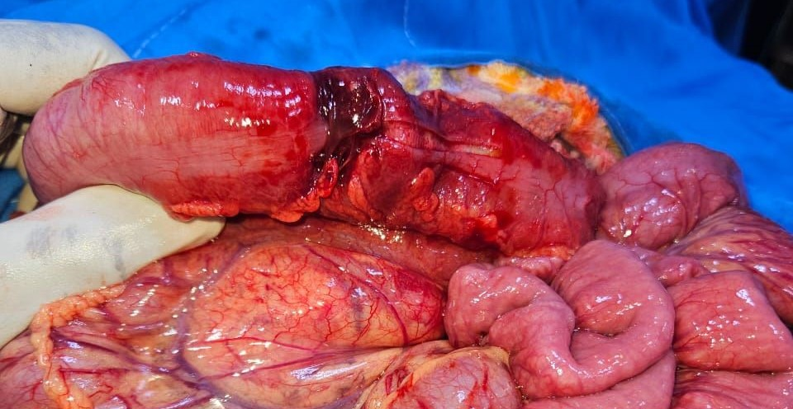

Figure 2: A transverse supra-umbilical incision with a worm (dark arrow) from the functioning stoma, and a mucous stoma (green arrow) covered by an abdominal pack
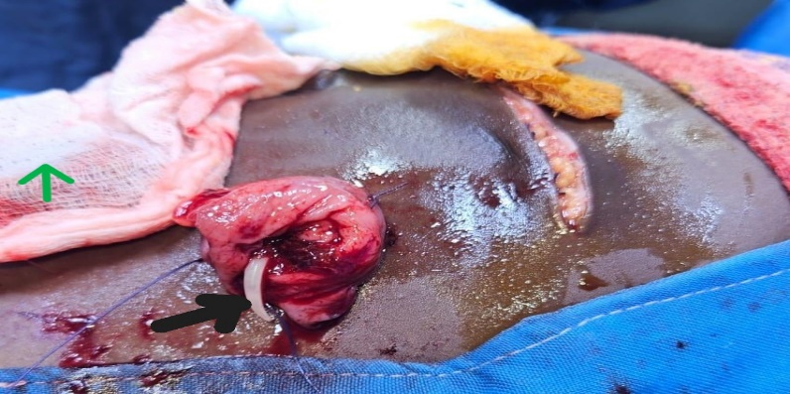
Figure 3: Divided colostomy and a sutured supra-umbilical scar
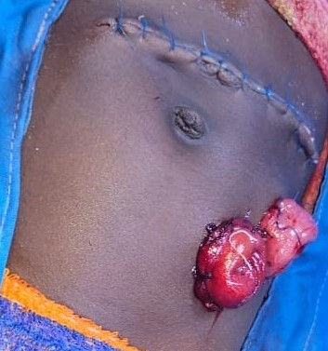

DISCUSSION
Ascariasis is an intestinal infection caused by the roundworm Ascaris lumbricoides, impacting up to 1.5 billion people globally.^{1,2} It occurs commonly in the tropics and sub-tropics among individuals from low socio-economic classes with poor hygiene, inadequate sanitation, and ineffective sewage disposal, as reported in the index patient.^{1,2}
Ascaris is transmitted via the fecal-oral route. Infection occurs when embryonated eggs from contaminated food, hands, and utensils are ingested. Once in the small bowel, they hatch into larvae that penetrate the bowel wall and migrate through the liver, and heart into the lungs, where they are coughed up and re-ingested and continue their way to the small intestine, where they mature. Reinfection occurs only when contaminated eggs are ingested. An adult female worm can produce approximately 240,000 eggs each day. Humans are the primary reservoir and the only definitive host for Ascaris lumbricoides.^{3,4}
The prevalence and intensity of roundworm infestation typically peak between 2 and 10 years, as observed in the index case, but often decline after 15 years. the smaller bowel lumen and the often high parasitic load, though the index patient’s age was a bit lower. ^{2,3,5} Ascariasis is usually mild and asymptomatic, but chronic infestation may cause malnutrition.^{2,3} Severe infestation may cause intestinal obstruction, intussusception, gastrointestinal bleeding, gangrenous bowel, or rarely biliary obstruction, cholangiohepatitis, or pancreatitis, which require urgent intervention.^{1,7} The bowel edema and spasmodic contraction due to host inflammatory response from worm-derived anaphylaxins, as well as the entanglement of worms, usually obstruct the distal ileum.^{1,4-5} If this persists, the bolus of the worm may serve as a fulcrum for intussusception or volvulus.^{1,4}
Intussusception involves the telescoping of a bowel segment into the lumen of the adjacent bowel.² It is the commonest cause of emergency abdominal surgery in infants, but it can affect older paediatric age groups.³ Most intussusceptions in children are idiopathic, and approximately 8% are attributable to PLPs.⁸ Examples of PLPs are polyps, hematomas, Meckel’s diverticulum, adhesions, and tuberculosis.^{8,9} Intussusception due to ascariasis is uncommon and can be ileoileal, ileojejunal, or jejunojejunal, but colonic complications are scarcely reported.⁴ Gebreselasie et al reported a jejuno-jejunal intussusception that reduced spontaneously in a 10-year-old girl.¹⁰
Children with intussusception often present with abdominal pain, vomiting, and passage of red currant jelly stool.^{3,9} A sausage-shaped mass may be felt on abdominal examination, and abdominal ultrasound is very sensitive for the diagnosis of intussusception.² A target or doughnut sign with concentric hyper- and hypoechoic rings is a classical sign on the axial view of ultrasonography. ^{2,11} Ascaris may show a thick echogenic strip with a central anechoic tube without acoustic shadowing, or the characteristic railway sign, winding road, or inner tube sign on ultrasound.^{4, 12}
Most cases of ascariasis are managed non-operatively with antihelminthics such as Albendazole or Mebendazole. ¹ Partial intestinal obstructions from ascariasis can also be non-operatively managed with bowel rest, NG tube bowel decompression, fluid and electrolyte correction with the use of anti-helminthic after resolution of obstructive symptoms.^{1,2,4,13} In most cases of complete obstruction, volvulus, or bowel perforation, surgical interventions such as manual milking of the worms outside the bowel, enterotomy, resection, and primary anastomosis may be performed.^{1,10} A case of stoma formation (ileostomy) similar to the index case (who had colostomy) was reported by Manzoor et al in a prospective study in a child with small bowel volvulus from Ascaris lumbricoides.⁶
Conclusion
A high degree of suspicion, timely diagnosis, and appropriate treatment can prevent bowel ischaemia and associated morbidity and mortality from complicated ascariasis.¹ Ensuring adequate hygiene and sanitation, and periodic deworming on detection of ova/ cysts on microscopic analysis are appropriate preventive measures.¹
Consent
As per international standards or university standards, patient(s) written consent has been collected and preserved by the author(s).

Disclaimer (Artificial intelligence)
Author(s) hereby declare that NO generative AI technologies such as Large Language Models (ChatGPT, COPILOT, etc) and text-to-image generators have been used during writing or editing of manuscripts.

REFERENCE
- Khan MN, Khan I, Alvi E, Ahmad I. Intestinal intussusception due to entrapped Ascaris lumbricoides in a 13-year-old male patient. Cureus. 2023 Jan;15(1). DOI: 10.7759/cureus.33909
- Titare PU, Sonawane BD, Rathod PB, Tembhekar NG. Intussusception due to entrapped ascaris: an ultrasound case report. Journal of Evolution of Medical and Dental Sciences. 2014 Oct 27;3(56):12848-53.
- Sekmenli T, Ciftci I, Emiroglu HH, Koplay M. A Case of Ascariasis Mimicking Jejunal Intussusception. Journal of Contemporary Medicine 2015;5(2): 123-126
- Siviero I, Almeida UV, Penna CR, Puglia EB, Simoes BC. Abdominal complications of ascariasis in childhood. Jornal de Pediatria. 2024 Sep 23;100(5):460-7.
- François KM, Emmanuel MK, Mukakala AK, Monga RM, Mwenda FK, Milinganyo EW et al. The package of Ascaris, a rare cause of intestinal occlusion: About a case and review of literature. Int. J. Surg. Sci. 2026;10(1):23-26. DOI: https://doi.org/10.33545/surgery.2026.v10.i1.A.1274
- Manzoor T, Ahmed R, Yaqoob E. Intestinal Obstruction Due To Ascariasis In Children. Dialogues in Cardiovascular Medicine. 2024 Oct 10;29:1-4.
- Vafaeimanesh J. Intussusception in pregnancy caused by Ascariasis; Report of a rare case. Govaresh. 2019 Dec 30;24(4):247-9.
- Niang FG, Ndong A, Attia A, Draidry I, DIOP AN. Intestinal intussusception and obstruction due to entrapped Ascaris. Int J Case Rep Images. 2021;12:1-5.
- Karatepe O, Tükenmez M, Hünerli K, Citlak G, Salmaslioglu A, Battal M et al. Ascaris as a leading point for small-bowel intussusception in an adult: a rare cause of intussusception. The American Journal of Emergency Medicine. 2008 Mar 1;26(3):381-e3.
- Gebreselassie HA, Semegn ZA, Kergo EN, Swenet AY. Small bowel intussusceptions secondary to Ascaris lumbricoides in a child: a case report. Journal of Pediatric Surgery Case Reports. 2025 Sep 12:103108.
- Nikolić H, Palčevski G, Saina G, Peršić M. Chronic intussusception in children caused by Ascaris lumbricoides. Wiener klinische Wochenschrift. 2011 Apr 19;123(9-10):294-6.
- Niang I, Kayembe A, Diop CT, Ly M, Niang FG, Ndong A et al. A case of ultrasound diagnosis of intestinal ascariasis clinically simulating intussusception. Open Access Library Journal. 2020 Oct 1;7(10):1-5.
- Mishra PK, Agrawal A, Joshi M, Sanghvi B, Shah H, Parelkar SV. Intestinal obstruction in children due to Ascariasis: A tertiary health centre experience. African Journal of Paediatric Surgery. 2008 Jul 1;5(2):65-70.

