Diagnostic Practices and Adequacy in the Management of Uncomplicated Malaria Among Health Facilities in Buea, Cameroon

.
ABSTRACT (Arial, Bold, 11 font, left aligned, caps)

Background: In Cameroon, artemisinin-based combination therapy (ACT) and parasitological confirmation before treatment are the national standards for managing uncomplicated malaria. However, effective implementation at the point of care is critical for patient outcomes and preventing drug resistance. This study evaluated the real-world clinical diagnostic approaches and the adequacy of antimalarial prescriptions for uncomplicated malaria in the Buea Health District (BHD).
Methods: A cross-sectional study was conducted from February to April 2022 in 31 public and private health facilities in the BHD. Data were collected from 251 patients presenting with fever or a history of fever who were diagnosed with uncomplicated malaria. Variables included patient demographics, symptoms, diagnostic test results (RDT/microscopy), and details of the prescribed antimalarial. Prescription adequacy was assessed against national guidelines.
Results: The majority of patients were female (56.6%) with a mean age of 18.8 years. Fever (81.3%) and headache (86.1%) were the most common symptoms. Most patients (93.2%) underwent a parasitological test, with microscopy being the most frequent. Overall, 46.2% had a positive thick blood smear and 22.3% a positive RDT. Artemisinin-based combination therapy was prescribed in 93.1% of cases, with Artemether-Lumefantrine (AL) being the most common (53.4%), followed by Artesunate-Amodiaquine (ASAQ) (36.8%). However, a significant portion of ACT treatments (35.5%) were initiated before laboratory confirmation. Documentation of prescription details was high for galenic form and duration (93.2%) but lower for posology (84.1%). Crucially, only 42.6% of all malaria cases were managed in full adherence to national guidelines.
Conclusion: While diagnostic testing and ACT use for uncomplicated malaria are high in the BHD, a substantial gap remains between practice and policy. The prevalent use of presumptive treatment and the suboptimal overall adherence to guidelines highlight the need for targeted interventions, including continued prescriber training and strengthened supply chain management, to optimize malaria case management and preserve ACT efficacy.

Keywords: Malaria, uncomplicated, diagnostic tests, drug prescriptions, artemisinin-based combination therapy, Cameroon.

(Note: 1. Case Reports should follow the structure of Abstract, Introduction, Presentation of Case, Discussion, Conclusion, Acknowledgements, Competing Interests, Authors’ Contributions, Consent (where applicable), Ethical approval (where applicable), and References plus figures and/or tables. Abstract (not more than 250 words) of the Case reports should have the following sections: Aims, Presentation of Case, Discussion and Conclusion. Only Case Reports have word limits: Papers should not exceed 2000 words, 20 references or 5 figures. Other Type of papers have no word limits.
2. Review papers may have different headings of the sections and are exempted from following these suggestions.
3. Research Papers and Short Notes should follow the structure of Abstract, Introduction, Methodology, Results and Discussion, Conclusion, Acknowledgements, Competing Interests, Authors’ Contributions, Consent (where applicable), Ethical approval (where applicable), and References plus figures and/or tables.)

1. INTRODUCTION (Arial, Bold, 11 font, left aligned, caps)

Malaria remains a leading cause of morbidity and mortality in sub-Saharan Africa, disproportionately affecting vulnerable populations such as children under five and pregnant women, and imposing a significant economic burden on households and health systems (World Health Organization (WHO, 2023). In Cameroon, the disease is hyperendemic, accounting for a substantial proportion of outpatient visits and hospital admissions, which often leads to catastrophic health expenditures for families (Nsai et al., 2021; PMI, 2024). The clinical trajectory for patients is frequently complicated by delayed care, misdiagnosis, and inappropriate treatment, underscoring the critical need for optimized case management at the point of service (Okebe et al., 2022).
The global strategy for effective malaria control hinges on two pillars: prompt, accurate diagnosis and the administration of highly effective treatment. In response to widespread resistance to monotherapies, Cameroon adopted Artemisinin-based Combination Therapy (ACT) as the first-line treatment for uncomplicated malaria, in line with WHO recommendations (WHO, 2015). The national policy specifically prioritizes Artesunate-Amodiaquine (ASAQ) and Artemether-Lumefantrine (AL). Concurrently, the paradigm has shifted from presumptive treatment based on clinical symptoms to the mandatory parasitological confirmation of all suspected cases using either rapid diagnostic tests (RDTs) or microscopy (WHO, 2015, 2023). This "test-and-treat" approach is fundamental to ensuring that patients receive correct and timely therapy, prevents the misuse of antimalarials for non-malarial fevers, and safeguards the efficacy of ACTs by reducing unnecessary drug pressure (Boyce et al., 2022).
However, a persistent chasm exists between national policy and clinical practice. Studies across Cameroon have documented ongoing challenges, including stock-outs of RDTs and ACTs, prescriber reliance on clinical judgment over test results, and the use of non-recommended antimalarials, including injectables for simple cases (Antonio-Nkondjio et al., 2019; Mangham-Jefferies et al., 2014). A recent study within the Buea Health District specifically highlighted prescriber-related factors, such as knowledge gaps and diagnostic decision-making processes, that influence case management (Nnoko et al., 2025). For the patient, these system and provider-level failures can result in out-of-pocket costs for ineffective drugs, delayed appropriate care, exposure to adverse drug events, and ultimately, poorer health outcomes. The quality of the patient's journey—from the initial diagnostic test to the clarity of prescription instructions—is a crucial determinant of treatment adherence and clinical recovery (Biswas et al., 2021). This is especially urgent in the context of emerging artemisinin resistance in Africa (Balikagala et al., 2021).
While the study by Nnoko et al. (2025) provided valuable insights from the prescriber's perspective in the Buea Health District, a complementary, patient-centered analysis is needed to complete the picture. Understanding the actual diagnostic and treatment experiences of febrile patients is essential to identify the real-world bottlenecks that impede effective care.
Therefore, this study aimed to evaluate the management of uncomplicated malaria in the Buea Health District from the patient's vantage point. It specifically assessed the clinical diagnostic pathways patients underwent and the adequacy of the antimalarial prescriptions they received, benchmarking these practices against national guidelines to identify critical gaps and inform targeted quality improvement interventions.

2. material and methods / experimental details/methodology (Arial, Bold, 11 font, left aligned, caps)

2.1 Study Design and Setting
A cross-sectional, health facility-based study was conducted between February and April 2022 in the Buea Health District (BHD) of the South-West Region of Cameroon. The study was carried out in 31 health facilities (15 public and 16 private) to capture a representative snapshot of care across the district's diverse healthcare providers.
2.2 Study Population and Sampling
The study focused on two key groups: The primary population consisted of patients presenting at participating health facilities with fever or a history of fever in the previous 48 hours, who received a presumptive or confirmed diagnosis of uncomplicated malaria. Inclusion criteria required residency in the endemic area for over six months. Patients were consecutively recruited. The sample size was determined using Cochran's formula at a 95% confidence level (Z=1.96), an anticipated malaria prevalence of 30% (P=0.30) (Apinjoh et al., 2007), and a 5% margin of error (d=0.05). This calculation produced a minimum target of 323 patients. Ultimately, 251 patients who satisfied all inclusion criteria were included in the final analysis.
To provide context for the patient data, all consenting physicians, nurses, and midwives actively consulting in the selected facilities were enrolled (n=63), as previously reported by Nnoko et al. (2025).
2.3 Data Collection
Data were collected using pre-tested, structured questionnaires. For the patient-focused analysis, data were extracted from clinical records and through interaction with patients or their guardians. Key variables collected included: Socio-demographic characteristics (age, sex), presenting signs and symptoms documented at consultation, type of diagnostic test requested (if any) and its result (RDT or microscopy), comprehensive details of the prescribed antimalarial (drug name, galenic form, dosage, posology, and treatment duration), and timing of treatment relative to diagnostic testing.
2.4 Data Analysis
Data were entered into Microsoft Excel 2013 and analyzed using SPSS software. Descriptive statistics (frequencies, percentages, means, and standard deviations) were used to summarize patient demographics, diagnostic pathways, and treatment profiles. The analysis focused on patient-centered outcome measures: (1) the proportion of febrile patients who underwent parasitological testing (testing rate), (2) the proportion of test-positive patients treated with a recommended ACT (ACT prescription rate), and (3) the overall adequacy of the prescription, determined by comparing the drug, dosage, form, and treatment duration against the Cameroonian National Malaria Control Programme guidelines.
3. results and discussion

3.1 Characteristics of patients
The Figure reveals a gender disparity in patient demographics across healthcare sectors in BHD. In both the public and private sectors, female patients outnumber males, with the private sector showing the most pronounced imbalance with Female constituting 64.2% against 35.8% male (Figure 1). The public sector is more balanced but still female-dominant at 54.5%. Overall, when combining both sectors, females represent 56.6% of the total patient population.
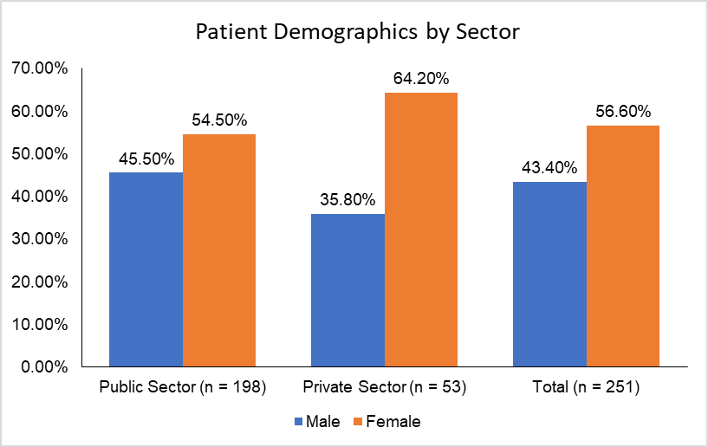
Figure 1: Demographic characteristic of uncomplicated malaria patient in the Buea Health District
3.2 Symptoms or signs presented by patients
In the Buea Health District, uncomplicated malaria patients predominantly presented with fever (81.3%) and headache (86.1%), confirming these as hallmark symptoms across both public and private health facilities (Table 1). Joint pain was moderately common (42.2%), while gastrointestinal symptoms like vomiting (9.6%), anorexia (15.5%), and diarrhoea (19.1%) appeared with lower frequency (Table 1). Notably, symptoms such as nausea (2.8%), asthenia (1.2%), and dizziness (1.2%) were rare, and insomnia and dyspnea were entirely absent (Table 1). The private sector showed slightly higher proportions for vomiting, anorexia, and diarrhoea (Table 1). Overall, the symptom profile aligns with classical uncomplicated malaria presentations, with some variability that may reflect co-infections or individual health-seeking behaviours.
Table 1: Sign and Symptoms of patients at the Buea Health District
Symptom | Public Health (n = 198) (%) | Private Health (n = 53) (%) | Total (n = 251) (%)
Fever | 161 (81.3) | 44 (83.0) | 204 (81.3)
Headache | 171 (86.4) | 45 (84.9) | 216 (86.1)
Joint pain | 86 (43.4) | 20 (37.7) | 106 (42.2)
Nausea | 6 (3.0) | 1 (1.9) | 7 (2.8)
Vomiting | 18 (9.1) | 6 (11.3) | 24 (9.6)
Asthenia | 3 (1.5) | 0 (0.0) | 3 (1.2)
Anorexia | 28 (14.1) | 11 (20.8) | 39 (15.5)
Diarrhea | 36 (18.2) | 12 (22.6) | 48 (19.1)
Cough | 31 (15.7) | 8 (15.1) | 39 (15.5)
Catarrh | 8 (4.) | 2 (3.8) | 10 (4.0)
Odynophagia | 7 (3.5) | 1 (1.9) | 8 (3.2)
Abdominal pain | 26 (13.1) | 7 (13.2) | 33 (13.1)
Dizziness | 3 (1.5) | 0 (0.0) | 3 (1.2)
Insomnia | 0 (0.0) | 0 (0.0) | 0 (0.0)
Dyspnea | 0 (0.0) | 0 (0.0) | 0 (0.0)
Chills | 5 (2.5) | 0 (0.0) | 5 (2.0)
Sweat | 1 (0.5) | 0 (0.0) | 1 (0.4)
Chest pain | 1 (0.5) | 0 (0.0) | 1 (0.4)
*Others | 6 (3.0) | 4 (7.5) | 10 (4.0)

In the Buea Health District, the clinical diagnosis of uncomplicated malaria overwhelmingly centers on uncomplicated malaria, which accounts for 70.5% of all cases, indicating it is the most commonly identified and likely the most straight forward to manage (Figure 2). A notable proportion of patients (28.7%) were diagnosed with uncomplicated malaria accompanied by other conditions (Figure 2). In contrast, diagnoses of clinical malaria and poorly treated malaria were rare each (0.4%), and suspected malaria was entirely absent from the dataset. This distribution highlights a diagnostic focus on uncomplicated malaria presentations, with limited recognition or documentation of atypical or mismanaged cases, which may reflect either effective early detection or gaps in diagnostic sensitivity.
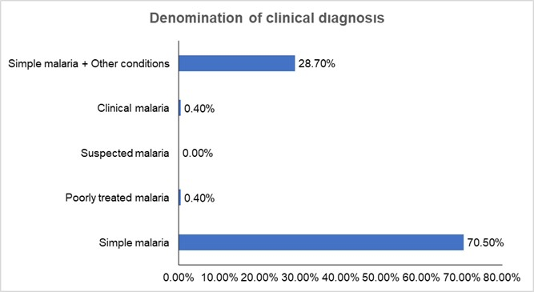
Figure 2: Denomination of clinical diagnosis
3.3 Diagnosis base on laboratory result
Clinical and biological laboratory results show high testing coverage across both public and private sectors, with 93.2% of patients undergoing diagnostic tests (Figure 3). Public health facilities (93.4%) slightly outperform private ones (92.5%) in test completion and in requesting tests (71.2% and 68.5% respectively). Positive thick blood smear results dominate (46.2%) overall, especially in public facilities (48.7%), indicating a high burden of confirmed malaria cases (Figure 3). Rapid Diagnostic Tests (RDTs) also show notable positivity (22.3%), with public health again leading (23.7%). Interestingly, negative results for both smear and RDT are minimal, reinforcing the clinical suspicion of malaria in most cases.
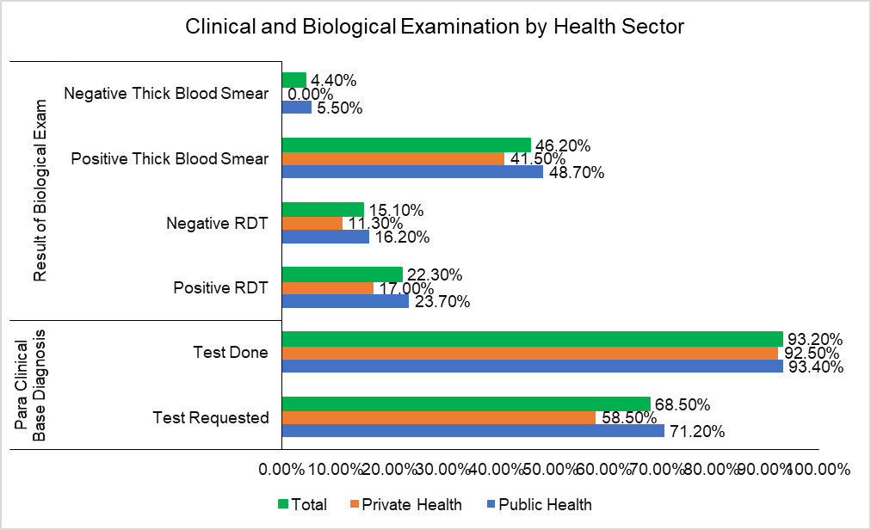
Figure 3: Clinical and biological examination by health sectors in Buea Health District
3.4 Antimalaria use in treatment of uncomplicated malaria
Figure 4 illustrates antimalarial treatment practices show a strong reliance on Artemisinin-based Combination Therapy (ACT), which was administered in 92.43% of cases. Notably, over half of these treatments (56.97%) were given after diagnostic results, while a significant portion (35.46%) were initiated before results (Figure 4). Artemether/Lumefantrine (AL) was the most commonly used ACT regimen (21.91%), with slightly more cases treated before results (12.30%) than after (9.61%). Other regimens like ASAQ and DHA/PQP were used sparingly, and monotherapies appeared in mixed combinations but at low frequencies.
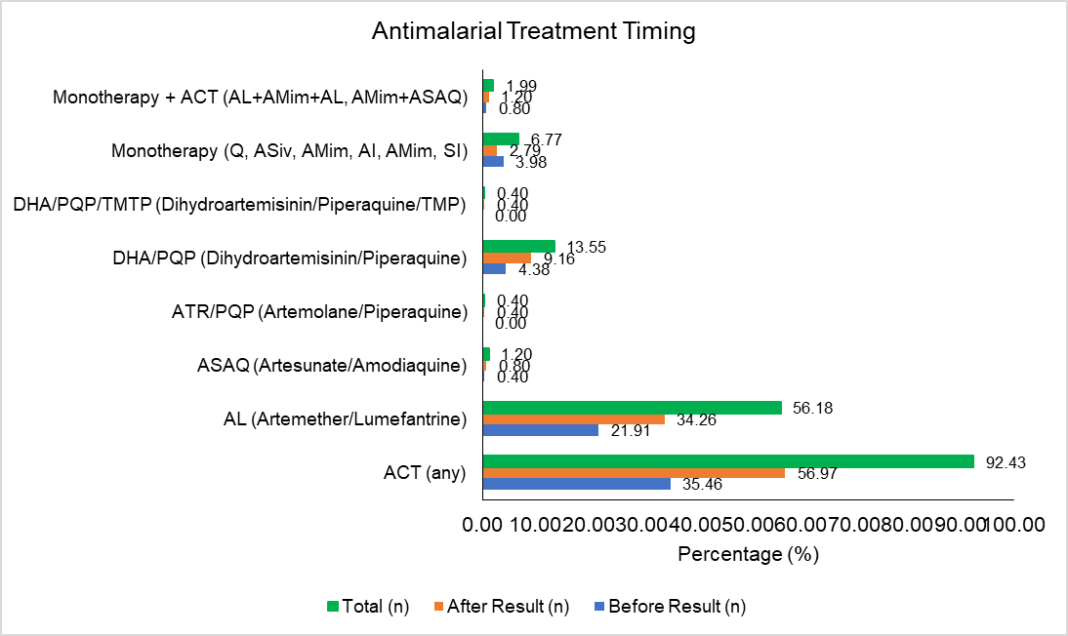
Figure 4: Antimalaria use in treatment of uncomplicated malaria
3.5 Adequate prescription in function of antimalarial prescribe
Uncomplicated malaria treatment follows standardized WHO guidelines, emphasizing Artemisinin-based Combination Therapies (ACTs) to ensure parasite clearance and curb resistance. Table 2 presents the distribution of ACT prescriptions across five key treatment parameters. Overall, ACTs were prescribed in 93.2% of cases, with consistent documentation of galenic form, dosage, quantity, and treatment duration (Table 2). Among specific ACTs, artemether-lumefantrine (AL) was the most frequently prescribed (53.4%), followed by artesunate-amodiaquine (ASAQ) at 36.8%. Less commonly used combinations included DHA/PQP (5.6%), DHA/PQP/TMTP and ATR/PQP (0.9%) each, while AS/MQ was not prescribed at all (Table 2). Notably, posology was slightly less consistently recorded (84.1%) compared to other parameters (Table 2). A small proportion of prescriptions involved non-standard or adjunct formulations such as injectable artesunate (ASiv), amodiaquine syrup (AMim), or oral quinine (Oral Q), with treatment duration documented in 7.3% of these cases (Table 2).
Table 2: Adequate prescription in respect to antimalarial prescribe
Variables | Galenic Form (n, %) | Dosage (n, %) | Quantity (n, %) | Posology (n, %) | Treatment Duration (n, %)
ACT Prescribe | 234 (93.2) | 234 (93.2) | 234 (93.2) | 211 (84.1) | 234 (93.2)
AL | 126 (53.4) | 126 (53.8) | 126 (53.8) | 108 (51.2) | 126 (53.8)
ASAQ | 89 (36.8) | 89 (38.0) | 89 (38.0) | 86 (40.8) | 89 (38.0)
DHA/PQP | 13 (5.6) | 13 (5.6) | 13 (5.6) | 13 (6.2) | 13 (5.6)
DHA/PQP/TMTP | 2 (0.9) | 2 (0.9) | 2 (0.9) | 2 (0.9) | 2 (0.9)
AS/MQ | 0 | 0 | 0 | 0 | 0
ATR/PQP | 2 (0.9) | 2 (0.9) | 2 (0.9) | 2 (0.9) | 2 (0.9)
AL+AMim, ASAQ+AMim | 0 | 0 | 0 | 0 | 2 (0.9)
ASiv, AMim or sirop, Oral Q | 7 (3.0) | 16 (6.8) | 16 (6.8) | 15 (7.1) | 17 (7.3)
AL: artemether/lumefantrine, ASAQ: artesunate/amodiaquine, DHA/PQP: dihydroartemisinin/piperaquine, ATR/PQP: arterolane/piperaquine, AS/MFQ: artesunate/mefloquine, AS/SP: artesunate/sulfadoxine/pyrimethamine, ASiv: Intravenous artesunate, AMim: Intramuscular artemether
3.6 Rationalization of ACT: Global evaluation on prescription
Figure 5 reveals critical gaps in malaria diagnosis and treatment adequacy. Despite 95.1% of patients undergoing biological examination and 81.3% presenting with fever, and only 25.8% had a positive rapid diagnostic test (RDT). None of those with positive RDT or thick blood smear results were placed on treatment. However, among those treated, the quality of care was relatively high: 100% received adequate treatment duration and galenic form appropriate for age, 94.6% had correct posology, and 86% were correctly treated with ACT (Figure 5). Prescription rationalization stood at 42.6%.
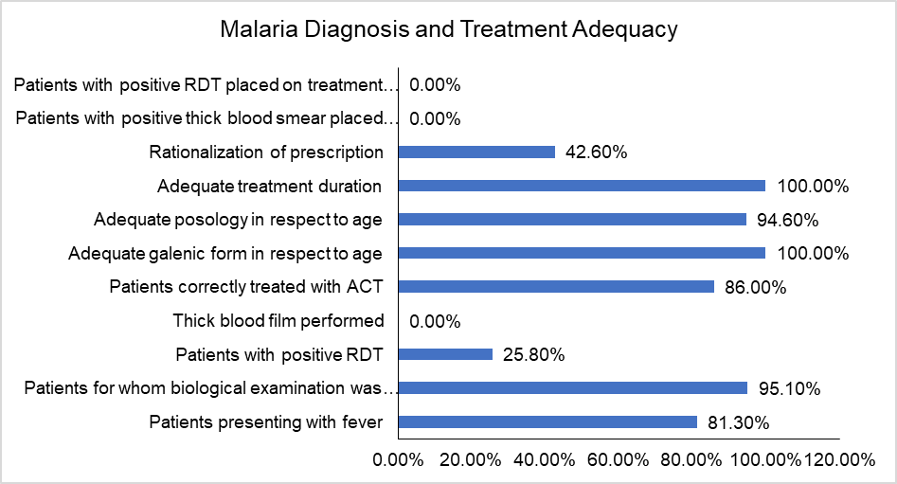
Figure 5: The rationalize use of anti-malaria
4. DISCUSSION
In the Buea Health District, patient demographics showed a clear gender disparity, with females comprising the majority across both public and private healthcare sectors. This pattern mirrors broader healthcare utilization trends, where women demonstrate higher healthcare-seeking behavior than men—a finding consistently reported in sub-Saharan Africa and other developing regions (Pineault et al., 2017; Chapnkem, 2019; Tessema et al., 2022).
Women's predominance likely stems from their greater health service needs tied to reproductive and maternal care, alongside higher health awareness and preventive care uptake. In private facilities, this female dominance appears even more pronounced, potentially reflecting socioeconomic and cultural influences on healthcare preferences, where women may prioritize urgent needs addressable through paid services (Tessema et al., 2022). Despite barriers like cost and access, women's larger patient share underscores the need for gender-sensitive healthcare planning and resource allocation to promote equity. This aligns with studies by Pineault et al. (2017) and Daher et al. (2021), which emphasize integrating gender considerations for balanced service delivery.
Malaria patients in Buea primarily presented with fever and headache—classic hallmarks of Plasmodium falciparum infection, the dominant species in Cameroon and sub-Saharan Africa (PMI, 2024). These symptoms serve as key indicators for uncomplicated malaria and often guide presumptive diagnosis in endemic areas (Tessema et al., 2022).
The moderate occurrence of joint pain and lower prevalence of gastrointestinal symptoms (vomiting, anorexia, diarrhoea) reflect malaria's variable clinical spectrum, influenced by host immunity, age, and co-infections (Dondorp et al., 2020). Slightly higher gastrointestinal symptom rates in private facilities may indicate differences in patient profiles, reporting practices, or health-seeking behavior, as private clinics often attract those with persistent or atypical symptoms (Chapnkem, 2019). The rarity of nausea, asthenia, dizziness, and complete absence of insomnia and dyspnoea further support uncomplicated malaria predominance, emphasizing symptom-based screening alongside differential diagnosis for atypical cases.
Uncomplicated malaria diagnoses predominated, aligning with national trends where Plasmodium falciparum drives most cases (PMI, 2024). The 28.7% of uncomplicated cases with comorbidities highlights clinical overlap with other endemic diseases, while rare clinical/poorly treated malaria and absent suspected cases suggest effective early detection or diagnostic/documentation limitations—consistent with NIS, NMCP, and ICF (2023) findings that <30% of febrile children are tested nationally, favoring clinical over parasitological confirmation.
Buea, in a medium-risk zone per WHO/PMI stratification, prioritizes rapid uncomplicated case management under the Health Sector Strategy (2016–2027) and PMI’s End Malaria Faster framework. Yet, underreported atypical/mismanaged cases may mask diagnostic challenges amid declining P. falciparum therapeutic efficacy and emerging resistance in Cameroon (Antonio-Nkondjio et al., 2019), necessitating stronger protocols and surveillance.
Buea Health District (BHD) data show robust malaria testing across public/private sectors, with public facilities achieving slightly higher completion/initiation rates. This mirrors Jerene et al. (2012) and Argaw et al. (2015) in endemic areas, where public systems ensure better coverage. Predominant positive thick smears, especially publicly, confirm heavy malaria burden matching Cameroon's elevated prevalence (Karunamoorthi, 2009; Missoup et al., 2025).
Rapid Diagnostic Tests (RDTs) also showed significant positivity rates, with public facilities leading—consistent with the high accuracy and reliability of publicly procured RDTs in Cameroon, though performance varies by transmission intensity and facility type (Hopkins et al., 2017; Ali et al., 2021). The minimal proportion of negative smear and RDT results strongly validates clinical suspicion in suspected cases, highlighting effective diagnostic targeting to curb over-treatment and enhance case management (Ige et al., 2014; Mortazavi et al., 2025). Overall, this high diagnostic coverage and positivity underscore the persistent malaria burden in BHD and affirm the vital roles of thick smear microscopy and RDTs in surveillance and control.
Antimalarial treatment in BHD predominantly relied on artemisinin-based combination therapy (ACT), used in most cases and aligning with WHO recommendations for uncomplicated Plasmodium falciparum malaria (WHO, 2018). Over half of treatments followed diagnostic confirmation, indicating test-based management adherence, while a notable portion began empirically due to clinical urgency.
Artemether-lumefantrine (AL) was the most common ACT, with slightly more pre-confirmation use than post-confirmation—mirroring findings from Teklemariam et al. (2017) and Kamya et al. (2025) on its efficacy, rapid parasite clearance, and first-line status in sub-Saharan Africa. Artesunate-amodiaquine (ASAQ) and dihydroartemisinin-piperaquine (DHA-PPQ) were used sparingly, reflecting regional preferences and availability (Zongo et al., 2020). Documentation was thorough for galenic form, dosage, quantity, and duration, though posology lagged slightly—a frequent clinical challenge (Zongo et al., 2020).
Adjunct therapies (e.g., injectable artesunate, amodiaquine syrup, oral quinine) appeared infrequently, suggesting minor deviations. Among treated cases, quality was strong: all had appropriate duration, galenic form, posology, and ACT use, though rationalization was suboptimal. These results show robust ACT protocol adherence but highlight the need to strengthen diagnosis-treatment linkage for optimal management and reduced drug waste (Teklemariam et al., 2017; Zongo et al., 2020).
Public sector strengths derive from standardized protocols, free diagnostics through NMCP procurement, and mandatory staff training, though occasional stockouts affected of cases (Visser et al., 2022). Private sector gaps stem from profit incentives prioritizing rapid consultations, inconsistent RDT quality from commercial suppliers, and limited adherence to national guidelines absent regulatory oversight—exacerbated by high patient volumes demanding quick service (Zongo et al., 2020). Shared challenges across both include weak diagnosis-treatment linkage and posology documentation gaps, driven by workload pressures (WHO, 2024).
5. Conclusion

Malaria case management in the Buea Health District shows strong diagnostic coverage and widespread use of recommended treatments, particularly artemisinin-based combination therapies. Clinical presentations were consistent with classical malaria symptoms, and laboratory testing was routinely implemented across both public and private sectors. However, gaps remain between diagnostic confirmation and treatment initiation, with some confirmed cases not receiving therapy. While treatment quality was generally high among those treated, documentation inconsistencies and limited prescription rationalization suggest areas for improvement. These findings highlight the need for better alignment between diagnostic outcomes and therapeutic decisions to enhance malaria control and patient care effectiveness.
AcknowledgEments

We extend our deepest gratitude to all study participants for their willingness to provide essential information, and other necessary data for this research.

Competing interests

The authors declare no competing interests.

Authors’ Contributions

This work was carried out in collaboration between all authors. Authors NSA and EMC designed the study. Authors NSA, DOB, AFD, ENBE and NES carried out the experiments. Author NSA and ENBE performed the statistical. Author NSA, DOB, AFD, ENBE and NES wrote the first draft of the manuscript. Authors NSA, NES and ENBE managed the analyses of the study. Authors NSA, DOB, AFD, ENBE and NES managed the literature searches. Authors NSA, NES and EMC revised the manuscript. All authors read and approved the final manuscript.

Ethical Considerations
Ethical approval was obtained from the Institutional Review Board of the University of Douala (CEI-Udo/801/02/2022/T). Administrative authorization was secured from the Regional Delegation of Public Health (Ref: R11/MINSANTE/SWR/DPH/PS/648).

Conscent

The study was conducted in strict adherence to ethical principles. Written informed consent (or assent for minors with guardian consent) was obtained from all participants after a detailed explanation of the study's purpose, procedures, benefits, and risks. All data collected were kept confidential; participant identifiers were removed and replaced with codes known only to the research team. The data were used solely for the purpose of this research and were securely stored and destroyed upon the study's completion.

Disclaimer (Artificial intelligence)

Author(s) hereby declare that NO generative AI technologies such as Large Language Models (ChatGPT, COPILOT, etc.) and text-to-image generators have been used during the writing or editing of this manuscript.

References

- Ali I.M., Nji A.M., Bonkum J.C., Moyeh M.N., Carole G.K., Efon, A., Dabou S., Tchuenkam V.P.K., Tah C., Kengne J.-P.C., Achu D.F., Bigoga J.D., Mbacham W.F. (2021). Diagnostic Accuracy of CareStart™ Malaria HRP2 and SD Bioline Pf/PAN for Malaria in Febrile Outpatients in Varying Malaria Transmission Settings in Cameroon. Diagnostics, 11:1556. https://doi.org/10.3390/diagnostics11091556
- Antonio-Nkondjio, C., Ndo, C., Njiokou, F., Bigoga J.D., Awono-Ambene P., Etang J., Ekobo A.S., Wondji C.S. (2019). Review of malaria situation in Cameroon: technical viewpoint on challenges and prospects for disease elimination. Parasites Vectors 12, 501 (2019). https://doi.org/10.1186/s13071-019-3753-8
- Apinjoh, T. O., Mbunwe, E., Yafi, C., Besingi, R., Awah, N., Anchang-Kimbi, J., & Achidi, E. A. (2008). Febrile status, malaria parasitaemia and gastrointestinal helminthiasis in school children resident at different altitudes in south-western Cameroon. Annals of Tropical Medicine & Parasitology, 102(2), 103–118. https://doi.org/10.1179/136485908X252287
- Argaw MD (2015). Knowledge and practice on malaria diagnosis and treatment among healthcare providers working in private health facilities in Ethiopia: A cross-sectional facility-based survey. Malaria World Journal, 6(10): 1-8. https://doi.org/10.5281/zenodo.10870388
- Balikagala, B., Fukuda, N., Ikeda, M., Katuro, O. T., Tachibana, S. I., Yamauchi, M., … & Mita, T. (2021). Evidence of artemisinin-resistant malaria in Africa. New England Journal of Medicine, 385(13), 1163–1171. https://doi.org/10.1056/NEJMoa2101746
- Biswas, S., Banerjee, S., & Kaur, P. (2021). Determinants of patient adherence to antimalarial medicines: A systematic review of evidence from sub-Saharan Africa. Journal of Multidisciplinary Healthcare, 14, 99–115. https://doi.org/10.2147/JMDH.S291944
- Boyce, M. R., & O’Meara, W. P. (2017). Use of malaria RDTs in various health contexts across sub-Saharan Africa: a systematic review. BMC Public Health, 17, 470. https://doi.org/10.1186/s12889-017-4398-1
- Chapnkem W.C. (2019). Perceptions of Access to Healthcare in Cameroon by Women of Childbearing Age. PhD thesis. Walden University
- Hopkins H., Bruxvoort K.J., Cairns M.E., Chandler C.I.R., Leurent B., Evelyn K Ansah E.K., Baiden F., Kimberly A Baltzell et al. (2017). Impact of introduction of rapid diagnostic tests for malaria on antibiotic prescribing: analysis of observational and randomised studies in public and private healthcare settings. BMJ, 356:j1054 http://dx.doi.org/10.1136/bmj.j1054
- Jerene D., Fentie G., Teka M., Girma S., Chibsa S., Teka H., Reithinger R. (2012). The role of private health facilities in the provision of malaria case management and prevention services in four zones of Oromia Regional State, Ethiopia. International Health, 4(1):70–73. https://doi.org/10.1016/j.inhe.2011.11.001
- Kamya M.R., Nankabirwa J.I., Ebong C., Asua V., Kiggundu M., Orena S., Okitwi M., Tukwasibwe S., Agaba B., Kyabayinze D et al. (2025). Efficacies of artemether–lumefantrine, artesunate–amodiaquine, dihydroartemisinin–piperaquine, and artesunate–pyronaridine for the treatment of uncomplicated Plasmodium falciparum malaria in children aged 6 months to 10 years in Uganda: a randomised, open-label, phase 4 clinical trial. The Lancet Infectious Diseases, 19. https://doi.org/10.1016/S1473-3099(25)00407-4
- Karunamoorthia K. & Bekele M. (2009). Prevalence of malaria from peripheral blood smears examination: A1-year retrospective study from the Serbo Health Center, Kersa Woreda, Ethiopia. Journal of Infection and Public Health, 2:171—176
- Mangham-Jefferies, L., Hanson, K., Mbacham, W., Onwujekwe, O., & Wiseman, V. (2014). Mind the gap: knowledge and practice of providers treating uncomplicated malaria at public and mission health facilities, pharmacies and drug stores in Cameroon and Nigeria. Health Policy and Planning, 30(9), 1129–1141. https://doi.org/10.1093/heapol/czu118
- Marilyne Daher M., Al Rifai M., Kherallah R.Y., Rodriguez F., Mahtta D., Michos E.D., Khan S.U., Petersen L.A., Virani S.S. (2021). Gender disparities in difficulty accessing healthcare and cost-related medication non-adherence: The CDC behavioural risk factor surveillance system (BRFSS) survey. Preventive Medicine, 153:106779. https://doi.org/10.1016/j.ypmed.2021.106779
- Missoup V.O., Suh P.F., Ndjebakal C.N., Tagne D., Poumachu Y., Joko S., Djilla A.K., Njiokou F., Mbacham W., Wondji C. & Ndo C. (2025). Malaria infection prevalence and diagnostic performance of the Abbott Bioline Malaria Ag P.f/Pan rapid test in rural populations of Central Cameroon. Scientific Reports, 15:27930. https://doi.org/10.1038/s41598-025-13688-8
- Mortazavi SE, Lugaajju A, Ivarsson A-C, Karlsson Söbirk S, Norrgren H and Persson KEM (2025) High rate of false positive malaria rapid diagnostic tests in a district hospital in Uganda. Front. Malar. 3:1545825. https://doi.org/10.3389/fmala.2025.1545825
- National Institute of Statistics (NIS), National Malaria Control Programme (NMCP), and ICF. 2023. Cameroon Malaria Indicator Survey 2022. Key Indicators Report. Yaounde, Cameroon, and Rockville, Maryland, USA: NIS, NMCP, and ICF.
- Nnoko, S. A., Bate, D. O., Abuuchiche, F. B. I., Enow, N. B. E., Ntungwe, E. S., & Eboumbou, M. C. (2025). Assessment of Prescribers’ Knowledge, Diagnostic Decision-Making, and Rational Antimalarial Drug Use in the Management of Uncomplicated Malaria in the Buea Health District, Cameroon. Journal of Advances in Medical and Pharmaceutical Sciences, 27(11), 116–133. https://doi.org/10.9734/jamps/2025/v27i11832
- Visser, M. T., Zonneveld, R., Peto, T. J., van Vugt, M., Dondorp, A. M., & van der Pluijm, R. W. (2022). Are national treatment guidelines for falciparum malaria in line with WHO recommendations and is antimalarial resistance taken into consideration? - A review of guidelines in non-endemic countries. Tropical medicine & international health : TM & IH, 27(2), 129–136. https://doi.org/10.1111/tmi.13715
- Nsai, S. F., Tchouaket, E. N., & Ama Moor, V. J. (2021). The economic burden of malaria in Cameroon: A systematic review. PLOS ONE, 16(11), e0258749. https://doi.org/10.1371/journal.pone.0258749
- Okebe, J., Mwesigwa, J., & Mokuolu, O. A. (2022). The socioeconomic burden of malaria in children: A systematic review and meta-analysis. BMJ Global Health, 7(3), e007532. https://doi.org/10.1136/bmjgh-2021-007532
- Pineault R., Da Silva R.B., Provost S., Fournier M., Alexandre Prud’homme A., Levesque J.F. (2017). Do Gender-Predominant Primary Health Care Organizations Have an Impact on Patient Experience of Care, Use of Services, and Unmet Needs? The Journal of Health Care Organization, Provision, and Financing Volume 54: 1 –9. https://doi.org/10.1177/0046958017709688
- PMI Cameroon Malaria Profile (2024). Available: https://mesamalaria.org/wp-content/uploads/2025/04/CAMEROON_Malaria_Profile_PMI_FY_2024.pdf Accessed 03/10/2025
- Teklemariam M., Assefa A., Kassa M., Mohammed H., Mamo H. (2017). Therapeutic efficacy of artemether-lumefantrine against uncomplicated Plasmodium falciparum malaria in a high-transmission area in northwest Ethiopia. PLoS ONE12(4): e0176004. https://doi.org/10.1371/journal.pone.0176004
- Tessema ZT, Worku MG, Tesema GA, Alamneh T.S., Teshale A.B., Yeshaw Y., Alem A.Z., Ayalew H.G., Liyew A.M. (2022). Determinants of accessing healthcare in Sub- Saharan Africa: a mixed- effect analysis of recent Demographic and Health Surveys from 36 countries. BMJ Open, 12: e054397. https://doi.org/10.1136/bmjopen-2021-054397
- World Health Organization (2025). WHO guidelines for malaria, 13 August 2025. World Health Organization. http://dx.doi.org/https://doi.org/10.2471/B09514. License: CC BY-NC-SA 3.0 IGO
- World Health Organization. (2015). Guidelines for the treatment of malaria (3rd ed.). WHO Press. ISBN: 9789241549127. Available at: WHO publication
- World Health Organization. (2023). World malaria report 2023. WHO Press. Available at: WHO malaria report 2023
- World Health Organization. (2024). Guidelines for malaria, 3rd edition. Geneva: WHO. https://www.who.int/publications/i/item/9789240091872
- Zongo I., Compaoré Y.D., Nikiéma F., Zongo M., Barry N., Somé F.A., Kaboré N., Ouédraogo J.B. (2020). Efficacy of artemether-lumefantrine and artesunate-amodiaquine as first line therapy of uncomplicated malaria in Burkina Faso, 11 years after policy change, Pan African Medical Journal, 35:68 https://doi.org/10.11604/pamj.2020.35.68.20849

Reference to Web-resource or Electronic articles.
- Hugo, J. T., & Mondal, S. C. (2006). Parallels between tissue repair and embryo morphogenesis: A conceptual framework. Global Health, 16, 4. https://doi.org/10.1186/1744-8603-1-14

- Anonymous. (2006). Parallels between tissue repair and embryo morphogenesis: A conceptual framework. Globalization and Health, 16(4). http://www.globalizationandhealth.com/content/1/1/14

