Case report
Familial Cleidocranial Dysplasia: A Case of Two Siblings

Abstract
Cleidocranial dysplasia (CCD) is a rare hereditary skeletal disorder affecting bones formed by intramembranous ossification. It is most commonly inherited in an autosomal dominant pattern and is associated with mutations in the RUNX2 (CBFA1) gene, which plays a critical role in osteoblast differentiation and skeletal development. Clinically, CCD is characterized by hypoplastic or absent clavicles, delayed closure of cranial sutures, and multiple dental abnormalities. Dental manifestations are often the most prominent features and include delayed exfoliation of primary teeth, delayed or failed eruption of permanent teeth, multiple impacted and supernumerary teeth, malocclusion, and maxillary hypoplasia.
This case series reports two siblings diagnosed with cleidocranial dysplasia, highlighting familial occurrence and variability in clinical expression. Both patients presented with complaints of missing permanent teeth and retained deciduous teeth since childhood. Extraoral examination revealed characteristic craniofacial features, including depressed zygomatic arches and a concave facial profile suggestive of mandibular prognathism. Intraoral and radiographic evaluations revealed multiple impacted and supernumerary teeth, supporting the diagnosis of CCD.

These cases emphasize the importance of thorough clinical and radiographic assessment in patients presenting with delayed tooth eruption and multiple missing teeth. Early recognition by dental professionals is crucial for timely multidisciplinary management and genetic counselling. Documentation of familial cases contributes to better understanding of the phenotypic spectrum of cleidocranial dysplasia and aids in improving diagnostic awareness.
Keywords:
Cleidocranial dysplasia; RUNX2 mutation; Supernumerary teeth; Impacted teeth; Delayed tooth eruption; Maxillary hypoplasia; Familial occurrence; Case series.
Introduction
Cleidocranial dysplasia (CCD) is a rare hereditary skeletal disorder. It primarily affects bones formed by intramembranous ossification. The condition is most commonly inherited in an autosomal dominant pattern.^{[1]} However, sporadic cases have also been reported. Mutations in the RUNX2 (CBFA1) gene are recognized as the underlying cause. This gene plays a crucial role in osteoblast differentiation and normal skeletal development.^{[2]}
Clinically, CCD is characterized by a classic triad. This includes hypoplastic or absent clavicles, delayed closure of cranial sutures, and multiple dental abnormalities. Among these features, craniofacial and dental findings are often the most prominent. In many cases, they are the primary reason patients seek professional care.^{[3]}
Common dental manifestations include delayed exfoliation of primary teeth. Delayed or failed eruption of permanent teeth is frequently observed. Multiple impacted and supernumerary teeth are also characteristic findings. Malocclusion and maxillary hypoplasia are commonly associated. These abnormalities affect both function and esthetics. They can also have a significant impact on the patient’s quality of life. Consequently, dental professionals often play a key role in the early identification of this condition.^{[4]}
Despite its distinctive clinical features, cleidocranial dysplasia remains underdiagnosed. This is particularly true in resource-limited settings. Limited access to genetic testing and multidisciplinary care contributes to delayed diagnosis. Reports describing familial occurrence, especially among siblings, are relatively rare in the dental literature. However, such reports are important. They reinforce the hereditary nature of the disorder and highlight the need for family screening and genetic counselling.^{[4,5]}
This case series describes two siblings diagnosed with cleidocranial dysplasia. It highlights familial occurrence and variability in clinical and dental manifestations. The purpose of this report is to increase awareness of this rare condition. It also emphasizes the importance of comprehensive clinical and radiographic evaluation. Furthermore, it underscores the role of dental professionals in early diagnosis and coordinated management.
Case Series
Case 1
A 24-year-old male patient reported to the Department of Oral Medicine and Radiology with the chief complaint of missing permanent teeth and difficulty in mastication. The patient stated that several permanent teeth had failed to erupt since childhood, with persistence of deciduous teeth. There was no history of pain, trauma, or previous dental treatment related to the missing teeth. The medical history was non-contributory. Family history revealed that a maternal family member had similar dental complaints. The patient denied any history of consanguineous marriage among parents.
On extraoral examination, the patient exhibited a concave facial profile with a broad and square forehead. Depressed zygomatic arches were noted bilaterally. The mandible appeared prognathic, contributing to the characteristic facial appearance. Shoulder examination suggested increased mobility, raising suspicion of clavicular hypoplasia.(Fig .1)
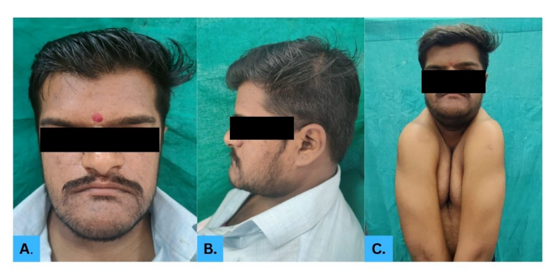

Figure1: Clinical features of Case 1.
(A) Extraoral frontal view showing frontal prominence.
(B) Extraoral lateral view showing a concave facial profile.
(C) Shoulder approximation demonstrating increased shoulder mobility.

Intraoral examination revealed multiple retained deciduous teeth and several missing permanent teeth. The erupted teeth showed malalignment and spacing. Clinical mobility was present, with grade II mobility noted in a few teeth and grade I mobility in others. Generalized plaque accumulation with associated marginal gingival inflammation was noted. The gingiva appeared erythematous and edematous, particularly in the anterior region. No other soft tissue abnormalities were observed.(Fig.2)
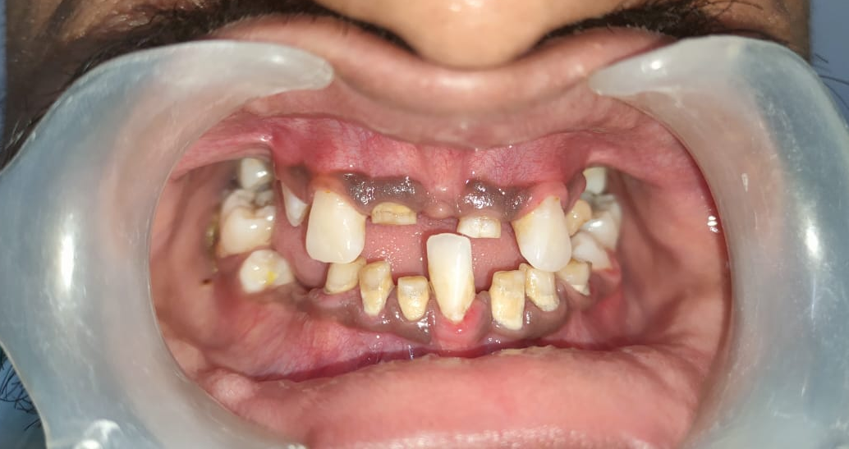

Figure 2: Intraoral frontal view revealing multiple retained deciduous teeth, missing permanent teeth, malalignment and spacing.
Radiographic evaluation using an orthopantomogram (OPG) revealed multiple unerupted permanent teeth in both maxillary and mandibular arches, along with retained deciduous teeth. Numerous supernumerary teeth were observed, particularly in the anterior and premolar regions. The permanent teeth exhibited delayed eruption and incomplete root formation in some areas. The alveolar bone pattern appeared normal, with no evidence of cystic or periapical pathology. The lateral cephalogram demonstrates an altered facial profile with maxillary hypoplasia and relative mandibular prognathism, suggestive of a skeletal Class III pattern. These radiographic findings were suggestive of a generalized disturbance in tooth eruption.(Fig.3)
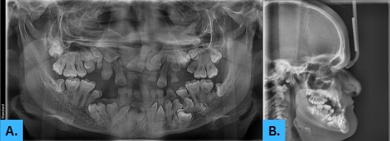

Figure 3:
(A) Orthopantomogram showing multiple impacted and unerupted permanent teeth with retained deciduous and supernumerary teeth.
(B) Lateral cephalogram demonstrating midface hypoplasia with relative mandibular prognathism, consistent with cleidocranial dysplasia.

PA chest radiograph demonstrated bilateral hypoplasia with partial discontinuity of the clavicles, permitting medial approximation of the shoulders. Radiographic evaluation of the hand–wrist revealed shortened and broad phalanges with short, robust metacarpals consistent with brachydactyly, along with lateral angulation of the digits suggestive of clinodactyly. Delayed and incomplete ossification of the carpal bones was noted, indicating delayed skeletal maturation.(Fig.4)

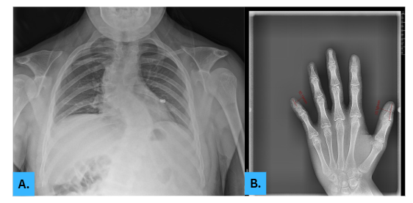

Figure 4:
(A) PA chest radiograph showing bilaterally hypoplastic, partially absent clavicles with a discontinuous (dumbbell-shaped) appearance.
(B) Hand–wrist radiograph demonstrating shortened and broad phalanges with short metacarpals and delayed carpal ossification, consistent with brachydactyly and delayed skeletal maturation.
Based on the combination of clinical features, dental findings, and radiographic evidence, a provisional diagnosis of cleidocranial dysplasia was made.
Case 2
The second case involved the younger sibling of Case 1, a 19-year-old female patient who reported to the Department of Oral Medicine and Radiology with the chief complaint of missing permanent teeth and delayed eruption since childhood. The patient stated that the absence of permanent teeth had been present since birth, with persistence of deciduous teeth. She also reported that her elder brother had similar dental complaints, suggesting a familial pattern. The medical history was non-contributory and no systemic illness was reported. The patient did not give a history of trauma or previous dental treatment.
Extraoral examination revealed a characteristic craniofacial appearance. Bilaterally depressed zygomatic arches are present. The mandible appeared prognathic, resulting in a concave facial profile. General facial appearance was suggestive of a syndromic presentation.(Fig.5)
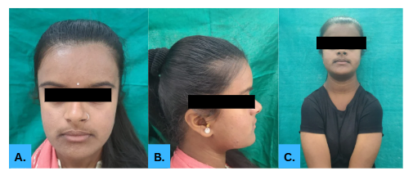

Figure 5:
(A) Extraoral frontal view showing prominence of the frontal region.
(B) Extraoral lateral view demonstrating a concave facial profile.
(C) Shoulder approximation showing increased shoulder mobility suggestive of clavicular hypoplasia/aplasia.

Intraoral examination revealed multiple retained deciduous teeth and several missing permanent teeth. The erupted teeth were irregularly positioned, with spacing evident. Occlusion was deranged. The gingival tissues appeared mildly inflamed, with slight redness and loss of normal stippling in the anterior region. No evident periodontal pockets or suppuration were observed at the time of examination.(Fig.6)

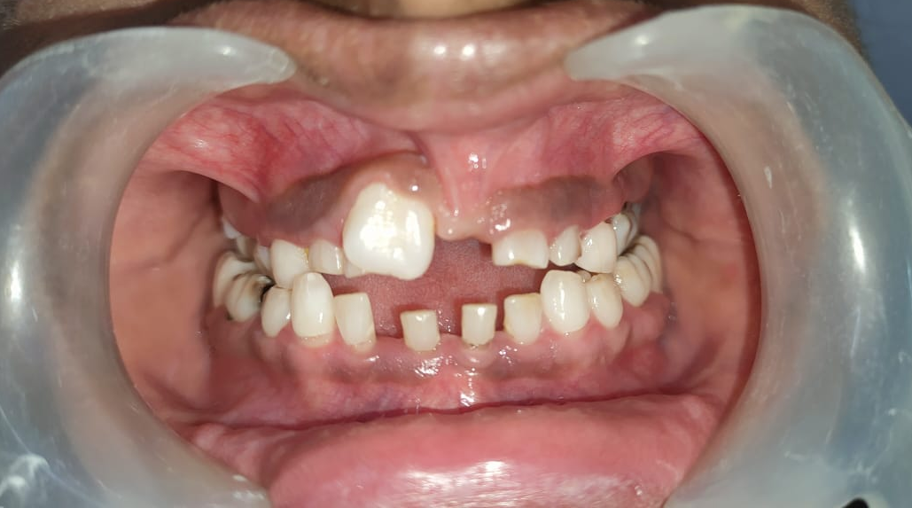

Figure 6: Intraoral view showing retained primary teeth, missing permanent teeth, spacing, and malalignment.
Radiographic evaluation with an orthopantomogram (OPG) revealed multiple unerupted permanent teeth in both the maxillary and mandibular arches, along with retained deciduous teeth. Several supernumerary teeth were also noted, particularly in the anterior and premolar regions with no associated cystic or periapical pathology. The lateral cephalometric radiograph reveals a compromised facial profile characterized by midfacial deficiency and a relatively prominent mandible, producing a Class III skeletal relationship. These findings were consistent with a generalized disturbance in tooth eruption.(Fig.7)
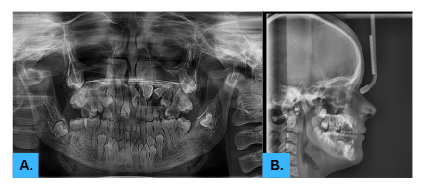

Figure 7:
(A) Orthopantomogram showing multiple unerupted and impacted permanent teeth with retained deciduous teeth and supernumerary teeth in both arches
(B) Lateral Cephalogram (LC): Mid-facial retrusion with relative mandibular prognathism and altered craniofacial skeletal proportions.

The radiographic skeletal survey including PA chest and hand–wrist views demonstrating generalized osseous developmental changes. The chest radiograph shows bilateral clavicular hypoplasia predominantly involving the lateral segments with a narrow, bell-shaped thoracic cage and laterally placed small scapulae, with mildly reduced bone density. The hand–wrist radiograph reveals delayed skeletal maturation with reduced carpal ossification centers, slender metacarpals and phalanges, cortical thinning, widened growth plates, and delayed epiphyseal fusion, indicating a radiographic bone age lag.(Fig.8)
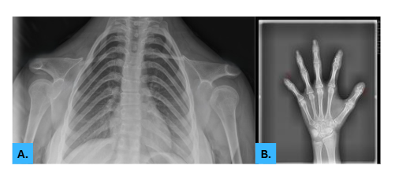

Figure 8:
(A) PA chest radiograph showing bilateral clavicular hypoplasia with a narrow, bell-shaped thoracic cage and laterally positioned small scapulae.
(B) Hand–wrist radiograph showing delayed skeletal maturation with reduced carpal ossification centers and diminutive metacarpals and phalanges.

Considering the occurrence of similar findings in both siblings, the cases were diagnosed as familial cleidocranial dysplasia. The patient was advised a multidisciplinary treatment approach involving oral surgery, orthodontics, and prosthodontics. Genetic counselling and long-term follow-up were recommended.

Discussion:
Cleidocranial dysplasia (CCD) is a rare skeletal dysplasia most often inherited in an autosomal-dominant pattern and classically linked to pathogenic variants in RUNX2, a key transcription factor for osteoblast differentiation and normal craniofacial development. In dental practice, CCD is frequently suspected first because oral findings are prominent and often the patient’s main concern. Dental involvement is reported in the majority of affected individuals and commonly includes prolonged retention of deciduous teeth, delayed or failed eruption of permanent teeth, multiple impacted teeth and supernumerary teeth.^{[1,4]}
In the present case series, the occurrence in two siblings supports the hereditary nature of CCD and emphasizes the need for family screening and counselling. Familial clustering and variable expressivity within the same family have been well documented; reports describing multiple affected siblings highlight that the phenotype may differ in severity even among closely related individuals. Our cases showed the typical craniofacial pattern (frontal bossing, depressed zygomatic region, concave profile with apparent mandibular prognathism) along with characteristic dentition findings (retained primary teeth, multiple unerupted/impacted permanent teeth, and supernumerary teeth), closely aligning with established craniofacial and dental descriptions of CCD.^{[4,5]}
The main differentials considered for this presentation include pyknodysostosis, mandibuloacral dysplasia, hypophosphatasia, and other syndromic causes of delayed eruption and skeletal anomalies. Pyknodysostosis can mimic CCD radiographically and clinically; however, it is typically associated with generalized osteosclerosis and acro-osteolysis rather than clavicular hypoplasia with classic dental hyperdontia/impactions. Broader differential lists for CCD also include rare craniofacial-skeletal syndromes such as Crane–Heise syndrome and Yunis–Varon syndrome, which carry additional systemic features not seen in our patients.^{[6,7]}
Management in CCD is challenging because treatment is long-term and staged, requiring coordination between oral surgery, orthodontics, and prosthodontics. Decisions around timing of surgical exposure/extraction, orthodontic traction, and definitive rehabilitation must be individualized based on tooth position, number of supernumeraries, root development, and patient priorities. Delayed diagnosis can increase complexity, prolong treatment, and worsen functional and psychosocial impact.
In summary, documenting CCD in siblings reinforces the importance of recognizing a familial pattern when multiple impacted/supernumerary teeth and delayed eruption coexist with characteristic craniofacial features. Early identification by dental clinicians can enable timely multidisciplinary care and appropriate genetic counselling for affected families.
Conclusion
Familial cleidocranial dysplasia presents with characteristic craniofacial and dental findings. Early recognition by dental professionals is essential to enable timely multidisciplinary management, reduce treatment complexity, and provide appropriate genetic counselling for affected families.
Consent: Informed consent obtained from the patients

Disclaimer (Artificial intelligence)

Author(s) hereby declare that NO generative AI technologies such as Large Language Models (ChatGPT, COPILOT, etc.) and text-to-image generators have been used during the writing or editing of this manuscript.

References:
- Dhobley AA, Thombre AV, Ghatage D, Patil RI. Cleidocranial Dysplasia: A Rare Case Report. J Pharm Bioallied Sci. 2023 Jul;15(Suppl 2):S1335-S1337.
- Takarada T, Nakazato R, Tsuchikane A, Fujikawa K, Iezaki T, Yoneda Y, Hinoi E. Genetic analysis of Runx2 function during intramembranous ossification. Development. 2016 Jan 15;143(2):211-8.
- Jaruga A, Hordyjewska E, Kandzierski G, Tylzanowski P. Cleidocranial dysplasia and RUNX2-clinical phenotype-genotype correlation. Clin Genet. 2016 Nov;90(5):393-402
- Thaweesapphithak S, Termteerapornpimol K, Wongsirisuwan S, Chantarangsu S, Porntaveetus T. The impact of RUNX2 gene variants on cleidocranial dysplasia phenotype: a systematic review. J Transl Med. 2024 Dec 3;22(1):1099.
- Farrow E, Nicot R, Wiss A, Laborde A, Ferri J. Cleidocranial Dysplasia: A Review of Clinical, Radiological, Genetic Implications and a Guidelines Proposal. J Craniofac Surg. 2018 Mar;29(2):382-389.
- Mestre VF, Spoladori IC, Osiak LB, Paiva WJM, Ferreira de Lima RL, Silveira BC, Salles MJS. Clinical, radiographic, and genetic observations in 2 families with cleidocranial dysplasia. Gen Dent. 2022 Jul-Aug;70(4):59-66.
- Kaur H, Gupta K, Tiwari P. Cleidocranial dysplasia: Radiological mimic of pyknodysostosis - A case report. SA J Radiol. 2018 Jun 14;22(1):1326.
- Joueidi F, Joueidi A, Nusair Y, Al Mutairi F, Al Hayek S. Continuous supernumerary teeth development in cleidocranial dysplasia post-surgical extraction–A novel case report. Advances in Oral and Maxillofacial Surgery. 2023 Dec 1;12:100452.
- Mabrouk Y, Ammar S, Labidi A, Mansour L, Ghoul S. Dental Prosthetic Treatments in Cleidocranial Dysplasia: Case Report and Literature Review. Case Reports in Dentistry. 2020;2020(1):8910798.

