Case Report
Microscope Assisted Management of Symptomatic Internal Root Resorption in a Mandibular Premolar: 1 Year Outcome

ABSTRACT
Although rare, internal resorption is a pathology that can severely compromise the structural integrity of a tooth if not diagnosed and treated early. In this case report, symptomatic internal resorption detected in the mandibular right second premolar (#45) of an 18-year-old patient was managed with operating microscope-assisted endodontic treatment performed under high magnification. Following clinical and radiographic evaluation, thorough canal disinfection was performed under the operating microscope. The resorptive defect was carefully filled with mineral trioxide aggregate (MTA) using the micro-apical placement (MAP) system. Root canal obturation was completed with a thermoplastic gutta-percha technique. Post-treatment, the patient’s symptoms completely resolved, and 12-month follow-up radiographs revealed no pathological findings in the periapical tissues. This case demonstrates that endodontic treatment performed under an operating microscope, using MTA placed with the MAP system and thermoplastic obturation techniques, can achieve successful clinical and radiographic outcomes in cases of symptomatic internal resorption.
Keywords: Internal root resorption, operating microscope, MTA, thermoplastic obturation, endodontic treatment
INTRODUCTION
Internal resorption is a rare pathology characterized by the resorptive destruction of dentin resulting from inflammation of the pulpal tissue. Although most cases are asymptomatic, progression of the lesion may lead to pain, structural weakening of the tooth, and, if left untreated, tooth loss (1).
Radiographically, internal resorption appears as well-defined, oval or round radiolucent areas within the root canal system, and distinguishing it from external resorption is critical for appropriate treatment planning. Misdiagnosis can lead to inadequate treatment approaches and adversely affect prognosis (2). In this context, the use of an operating microscope allows direct visualization of the resorptive areas, enhancing diagnostic accuracy and enabling a more controlled treatment process (3).
The primary goal in the treatment of internal resorption is to halt the resorptive process, disinfect the canal system effectively, and achieve a fluid-tight seal the resorptive defect. For this purpose, mineral trioxide aggregate (MTA) is widely preferred in cases of internal resorption due to its biocompatibility, high sealing ability, and capacity to promote hard tissue formation (4).
Due to the irregular anatomy of resorptive defects, the root canal obturation technique is also a critical factor affecting treatment success. Thermoplastic gutta-percha techniques provide better adaptation to complex canal anatomies, improving the homogeneity of the filling and reducing the risk of microleakage (5).
The aim of this case report is to present the treatment of a tooth diagnosed with symptomatic internal resorption using MTA and thermoplastic gutta-percha techniques under an operating microscope, along with the clinical and radiographic outcomes after one year of follow-up.

CASE REPORT
An 18-year-old systemically healthy female patient presented to our clinic with a complaint of pain in the region of the mandibular right second premolar (tooth #45, FDI system). The patient’s medical history revealed no previous endodontic treatment on the affected tooth. Clinical examination revealed percussion sensitivity on tooth #45, while palpation and periodontal probing showed no pathological findings.
Periapical radiographic examination revealed a well-defined radiolucent area within the root canal system of tooth #45, consistent with internal root resorption (Figure 1). Based on the clinical and radiographic findings, a diagnosis of symptomatic internal root resorption was established, and endodontic treatment was planned. Cone-beam computed tomography (CBCT) was not performed, as conventional periapical radiographs clearly demonstrated the internal resorptive defect and no features suggestive of external cervical resorption were observed. Prior to treatment, the patient was informed about the procedure, and written informed consent was obtained.
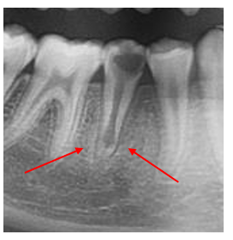
Figure 1. Preoperative periapical radiograph of tooth #45 showing a well-defined radiolucent area within the root canal system, consistent with internal resorption.
After administration of local anesthesia and isolation with a rubber dam, the access cavity was prepared under magnification using an operating microscope (Zumax OMS2380, Zumax Medical Co., Ltd., Suzhou, China). Working length determination was performed using an electronic apex locator (Woodpex 3 Apex Locator, Woodpecker Medical Instrument Co., Ltd., Guilin, China) and was confirmed radiographically. Chemomechanical preparation was carried out using a rotary nickel–titanium file system (EndoArt Touch Blue, EndoArt, Türkiye), accompanied by irrigation with 2.5% sodium hypochlorite (NaOCl) (Microvem, Istanbul, Türkiye) and 17% EDTA (Microvem, Istanbul, Türkiye) using manual irrigation throughout the procedure.
Following completion of canal preparation, the root canal system was dried with sterile paper points. The resorptive defect was sealed with a premixed bioceramic material, NeoPUTTY MTA (Avalon Biomed Inc., Bradenton, FL, USA), which was carefully delivered into the defect using a micro-apical placement system (MAP System, Dentsply Sirona, York, USA) under operating microscope magnification (Figure 2). Calcium hydroxide was not used as an inter-appointment medicament, as the immediate placement of MTA was considered sufficient to achieve sealing and structural stabilization of the resorptive defect. A temporary restoration was placed, and the tooth was left undisturbed for three days to allow adequate setting of the MTA.
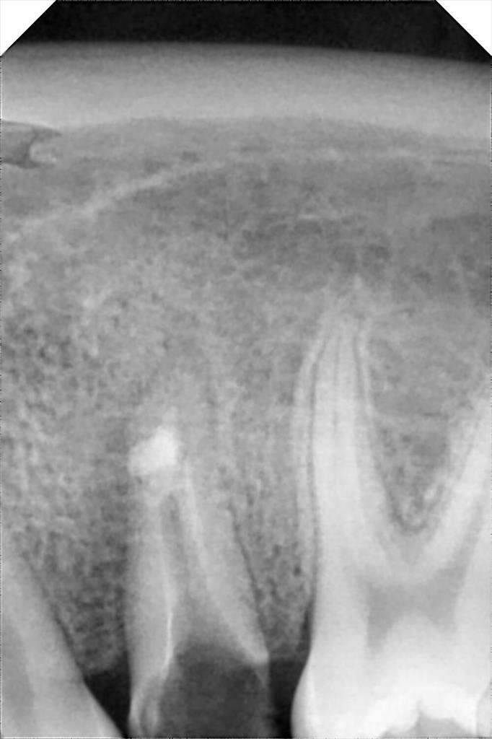
Figure 2. Placement of mineral trioxide aggregate (NeoPUTTY MTA) in the resorptive defect using the micro-apical placement (MAP) system under operating microscope magnification.

At the subsequent appointment, the setting of the MTA was confirmed by gentle probing under magnification using the operating microscope. Root canal obturation was then completed using a thermoplastic injectable gutta-percha technique based on the continuous wave condensation method with a thermoplastic injectable gutta-percha system (Woodpecker Fast Fill, Woodpecker Medical Instrument Co., Ltd., Guilin, China). The tooth was subsequently restored with an appropriate coronal restoration. Postoperative periapical radiography demonstrated a homogeneous root canal filling and a fluid-tight seal of the resorptive defect (Figure 3).
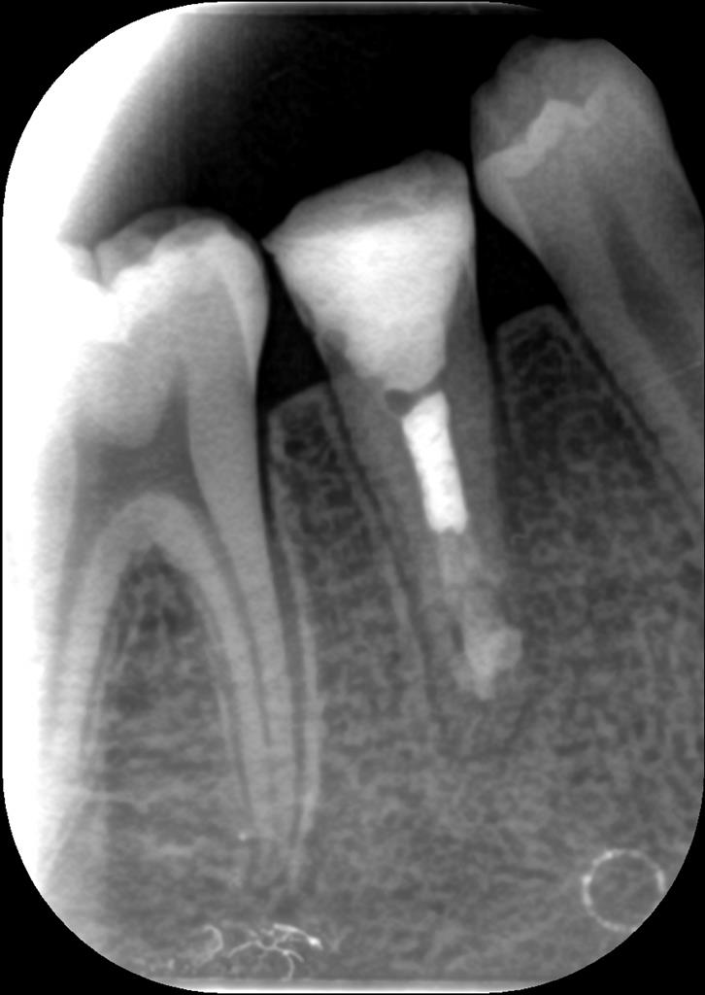
Figure 3. Postoperative periapical radiograph showing a homogeneous root canal filling and fluid-tight sealing of the resorptive defect.

The patient reported satisfaction with the treatment outcome and absence of symptoms during the follow-up period. At the 12-month clinical and radiographic follow-up, the tooth remained asymptomatic, and no pathological changes were observed in the periapical tissues, confirming a successful and stable treatment outcome (Figure 4).
. 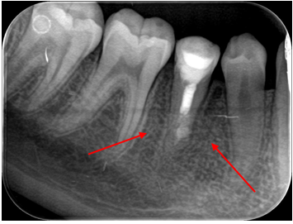
Figure 4. 12-month follow-up periapical radiograph demonstrating maintained obturation integrity and absence of periapical pathology.
Clinical Tips
Magnification with an operating microscope is highly beneficial for accurate identification and management of internal resorptive defects, allowing controlled material placement and minimizing the risk of iatrogenic errors.
The use of a micro-apical placement (MAP) system enables precise delivery of bioceramic materials into resorptive cavities and helps prevent overextension of MTA beyond the defect margins.
Premixed bioceramic materials such as NeoPUTTY MTA provide handling advantages and predictable setting characteristics, making them suitable for internal resorption cases requiring localized repair.
Confirmation of MTA setting under magnification prior to obturation is recommended to ensure material stability and prevent disruption during thermoplastic filling procedures.
Thermoplastic injectable gutta-percha techniques facilitate three-dimensional obturation of irregular canal anatomies associated with internal resorption defects.

DISCUSSION
Internal resorption is a rare but clinically significant pathology characterized by resorptive destruction of dentin due to inflammatory processes in the pulpal tissue. Although most cases are asymptomatic, advanced lesions may present with pain and structural weakening of the tooth, and prognosis can be adversely affected if early diagnosis is not established (6). Therefore, accurate diagnosis and appropriate treatment are critical in cases of internal resorption.
Radiographically, internal resorption appears as well-defined radiolucent areas within the root canal system, which is an important feature for distinguishing it from external resorption. However, differentiating between these two types of resorption is not always straightforward, and misdiagnosis may lead to inappropriate treatment planning (7). In this case, clinical and radiographic findings supported the diagnosis of internal resorption, and endodontic treatment was planned.
The use of an operating microscope provides enhanced illumination and magnification, allowing direct visualization of the resorptive defect and facilitating controlled placement of repair materials. Microscope-assisted endodontic treatment has been reported to improve procedural accuracy and reduce the risk of iatrogenic complications, particularly in teeth with complex internal resorptive anatomy (8). Accordingly, an operating microscope was utilized in the present case to enhance visualization and enable precise management of the resorptive area.
The primary goal in treating internal resorption is to halt the resorptive process and achieve a fluid-tight seal of the resorptive defect. For this purpose, mineral trioxide aggregate (MTA) is widely used in internal resorption cases due to its biocompatibility, high sealing ability, and capacity to promote hard tissue formation (9). In the present case, MTA was selected to seal the resorptive defect, allowing sufficient time for the material to set.
One of the concerns associated with mineral trioxide aggregate is its potential to cause tooth discoloration, particularly in esthetically critical areas. However, discoloration is generally considered clinically insignificant in posterior teeth such as mandibular premolars. In addition, newer premixed bioceramic materials have been reported to exhibit a lower discoloration potential compared to conventional MTA formulations, mainly due to differences in material composition (10). In the present case, a premixed bioceramic MTA formulation was preferred, considering both the posterior location of the tooth and the reported advantages of newer bioceramic materials in terms of color stability.
The irregular anatomy of resorptive defects can make it challenging to achieve a homogeneous root canal filling. Therefore, the obturation technique is a key factor directly affecting treatment success. Thermoplastic gutta-percha techniques offer better adaptation to complex canal anatomies, providing advantages in filling resorptive areas (11). In this case, following MTA placement, the root canal obturation was completed using a thermoplastic gutta-percha technique to enhance the homogeneity and seal of the filling.
Several case reports in the literature have documented successful treatment of internal resorption (12),(13). In this case, the complete resolution of symptoms and the absence of pathological findings on one-year clinical and radiographic follow-up support the effectiveness of the applied treatment approach. Nevertheless, it should be noted that long-term follow-up is essential for evaluating the prognosis of internal resorption cases.

CONCLUSION
Early diagnosis and appropriate endodontic management of internal resorption are crucial to preserve the functional integrity of the tooth. In this case, a tooth diagnosed with symptomatic internal resorption was successfully treated with MTA placement followed by thermoplastic gutta-percha obturation, achieving favorable clinical and radiographic outcomes. The complete resolution of symptoms and absence of pathological findings during one-year follow-up further support the effectiveness of this treatment approach. However, long-term clinical and radiographic follow-up remains necessary to assess prognosis in such cases.
DISCLAIMER (ARTIFICIAL INTELLIGENCE)

Author(s) hereby declare that NO generative AI technologies such as Large Language Models (ChatGPT, COPILOT, etc.) and text-to-image generators have been used during the writing or editing of this manuscript.
Consent
Written informed consent for publication of the clinical details and radiographic images was obtained from the patient. According to institutional policy, ethical committee approval was not required for single-patient case reports.

REFERENCES
1. Gadzhula N, Povsheniuk A, Cherepakha O. DIAGNOSIS OF INTERNAL ROOT RESORPTION: CLINICAL MANIFESTATIONS AND RADIOLOGICAL FEATURES. East Ukr Med J. 2024;12(1):106-115. doi:10.21272/eumj.2024;12(1):106-115
2. Sharki A, Ali A. Root Resorption in the Permanent Teeth. A Review. Cumhur Dent J. 2023;26(3):321-327. doi:10.7126/cumudj.1228236
3. Low JF, Dom TNM, Baharin SA. Magnification in endodontics: A review of its application and acceptance among dental practitioners. Eur J Dent. 2018;12(04):610-616. doi:10.4103/ejd.ejd_248_18
4. Mittal N, Dhakad C, Sharma S, et al. Management of Internal Root Resorption With Mineral Trioxide Aggregate in Mandibular Molar: A Case Report. Cureus. 2025;17. doi:10.7759/cureus.96174
5. Sadat SMAE, Chew HP, Fok A, Elashiry MM, ElShenawy AM, Saber S. Quality of different obturation techniques to fill perforating internal root resorption: a micro-computed tomographic study. BMC Oral Health. 2024;24(1):784. doi:10.1186/s12903-024-04518-w
6. Patel S, Saberi N, Pimental T, Teng P. Present status and future directions: Root resorption. Int Endod J. 2022;55(Suppl 4):892-921. doi:10.1111/iej.13715
7. Hellyer P. Root resorption. Br Dent J. 2023;234(7):517-517. doi:10.1038/s41415-023-5768-y
8. Kiraz G, İbiloğlu A, Mumcu AK, Kurnaz S. The use of magnification in endodontic treatments by endodontists: results of a questionnaire. BMC Oral Health. 2025;25(1):242. doi:10.1186/s12903-025-05599-x
9. Pereira da Costa R, Quaresma SA, Lopes FC, et al. Management of a perforating internal root resorption using mineral trioxide aggregate: a case report with 5-year follow-up. Aust Endod J J Aust Soc Endodontology Inc. 2020;46(3):452-457. doi:10.1111/aej.12436
10. Al-Hiyasat AS, Ahmad DM, Khader YS. The effect of different calcium silicate-based pulp capping materials on tooth discoloration: an in vitro study. BMC Oral Health. 2021;21(1):330. doi:10.1186/s12903-021-01677-y
11. Yazdi KA, Aminsobhani M, Alemi P. Comparing the Ability of Different Materials and Techniques in Filling Artificial Internal Resorption Cavities. Eur Endod J. 2018;4(1):21-27. doi:10.14744/eej.2018.13008
12. Dianat O, Zadsirjan S, Jabbari S, Ghorbanzadeh S. Treatment of Perforating Internal Root Resorption with MTA and Management of Discoloration Caused By MTA: A Case Report. Sch J Dent Sci. 2016;3(6):180-183. doi:10.21276/sjds.2016.3.6.6
13. Mirzaie A, Zargar N, Shahhosseini R. Hybrid Approach to Manage Inflammatory Internal Root Resorption: A Case Report. Iran Endod J. 2025;20(1):e18. doi:10.22037/iej.v20i1.46677

