RARE MANDIBULAR OCCURRENCE OF PSAMMOMATOID JUVENILE OSSIFYING FIBROMA: A Case Report
ABSTRACT:
Psammomatoid juvenile ossifying fibroma (PsJOF) is an uncommon benign fibro-osseous lesion known for its locally aggressive behaviour and characteristic involvement of the paranasal sinuses and orbital region. Occurrence within the mandible is rare and represents a departure from its usual sinonasal distribution. The present report documents an unusual case of mandibular PsJOF in a 16-year-old male patient. Clinically, the patient presented with a gradually enlarging mandibular swelling associated with facial asymmetry and cortical expansion. Cone beam computed tomography revealed a well-circumscribed expansile lesion exhibiting mixed radiolucent–radiopaque density, internal septations, cortical thinning with focal perforation, and displacement of the inferior alveolar canal. Histopathological evaluation showed a highly cellular fibrous connective tissue stroma containing numerous psammoma body–like ossicles, establishing the diagnosis of PsJOF. Surgical management consisted of complete lesion excision with thorough curettage while preserving adjacent vital structures, followed by meticulous postoperative surveillance. This case highlights the diagnostic challenge posed by atypical mandibular involvement and emphasizes the need for comprehensive clinico-radiographic and histopathologic correlation, along with long-term follow-up, owing to the lesion’s aggressive nature and risk of recurrence.

Keywords: Psammomatoid juvenile ossifying fibroma, fibro-osseous lesion, maxilla, sinonasal distribution

INTRODUCTION
Ossifying fibroma is a benign fibro-osseous lesion characterized by replacement of normal bone with fibrous tissue containing mineralized material. Juvenile ossifying fibroma (JOF) represents an uncommon variant with aggressive behaviour and a predilection for children and adolescents ^{[1]}JOF has been described by several synonymous terms and primarily involves the craniofacial skeleton, especially the paranasal sinuses, maxilla, ethmoid, and frontal bones.^{[2,4]}The psammomatoid variant (PsJOF) predominantly affects extragnathic craniofacial bones, while mandibular involvement is rare, accounting for approximately 10% of reported cases.^{[3,6]} Compared with conventional ossifying fibroma, JOF exhibits rapid growth, cortical expansion, and a higher recurrence rate, warranting its recognition as a distinct clinicopathologic entity. El-Mofty classified JOF into trabecular and psammomatoid subtypes based on histopathologic and anatomical differences.^{[1]} Given the limited number of documented mandibular cases, reporting such atypical presentations is clinically relevant and contributes to a broader understanding of the lesion’s variable behaviour. This report aims to highlight the diagnostic and therapeutic challenges of mandibular psammomatoid juvenile ossifying fibroma through detailed clinical, radiological, and histopathological correlation.

CASE REPORT
A 16-year-old male presented with a six-month history of swelling in the lower left back region of jaw. The swelling was initially small in size which gradually increased over period of six months and caused evident gross facial asymmetry. It was not associated with pain and discharge. Past dental history revealed a similar swelling and its management at same site two years back. There was no history of trauma.
Extraoral examination revealed a diffuse swelling on left side of face extending from left corner of mouth to anerior border of sternocleidomastoid muscle anteroposteriorly and superoinferiorly from the ala–tragus line to the inferior border of the mandible measuring approximately 5.5 × 4 cm (Fig. 1 a & b). On palpation, the swelling was firm to hard in consistency and tender. No palpable lymphadenopathy was present.
Intraoral examination showed well-defined, erythematous gingival overgrowth extending from 33 to 38 teeth region, with obliteration of buccal and lingual vestibule. Indentations of opposite teeth was seen on occlusal aspect of growth. On palpation the growth was fibrous, tender and was not associated with bleeding and discharge. 31, 32, 41, and 42 was grade I mobile (Fig. 2). Based on clinical findings provisional diagnosis of peripheral ossifying fibroma was made, while pyogenic granuloma, peripheral giant cell granuloma, and irritational fibroma was considered as clinical differentials.
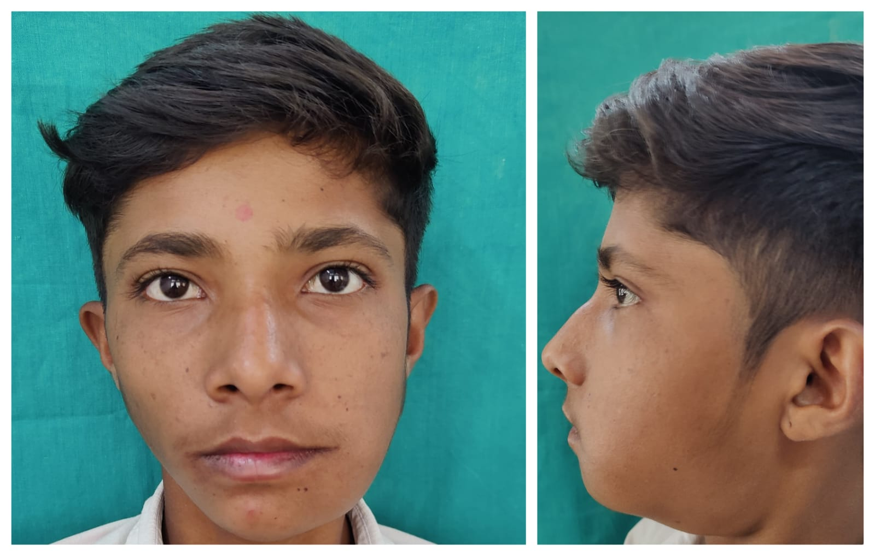
b
a
Fig. 1 a) Frontal profile showing swelling. b) Lateral profile showing swelling

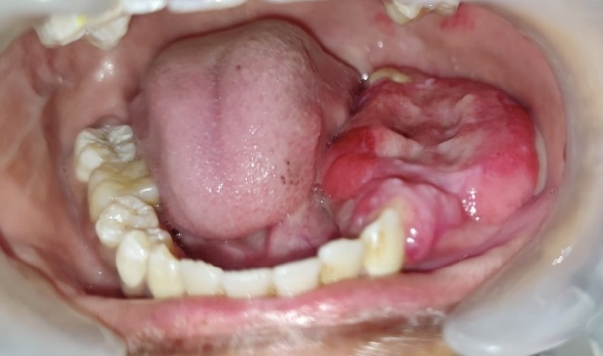
Fig.2. Intraoral photograph showing gingival enlargement and buccal vestibule obliteration
For radiographic investigation CBCT was done. Curved planar reconstruction showed multilocular, mixed radiolucent-radiopaque lesion in left posterior mandible extending from 33 to 38 (Fig.3). Axial section showed marked expansion of buccal and lingual cortical plates with thinning and perforation (Fig 4a). Coronal section showed displacement of 37 superiorly (Fig. 4b). Sagittal section revealed displaced 34 inferiorly which is present in lesion. It also showed displacement of inferior alveolar nerve canal inferiorly along with ballooning of lower border and angle of mandible (Fig. 4 c &d). Based on CBCT findings radiographic diagnosis was given as cemento-ossifying fibroma and radiographic differentials were Calcifying Epithelial Odontogenic Tumor (CEOT), Calcifying Epithelial Odontogenic Cyst (CEOC) and Fibrous Dysplasia.
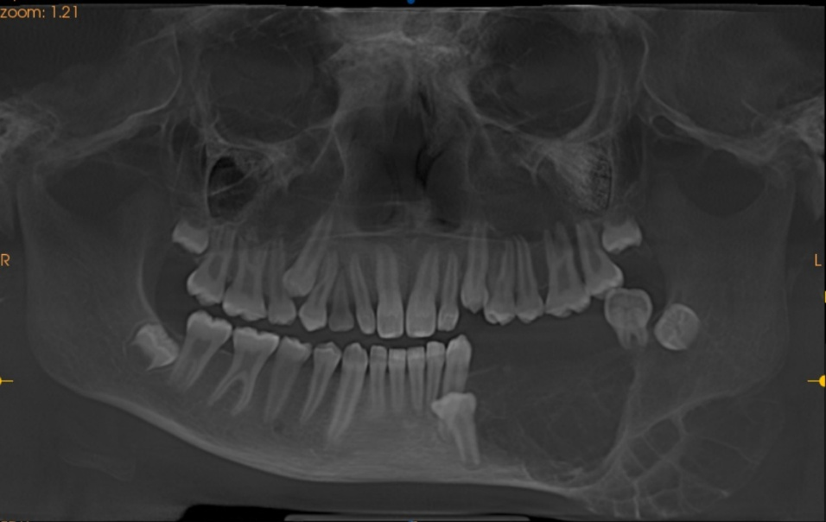
Fig. 3 Curved Planar Reconstruction showing multilocular lesion in left posterior mandible
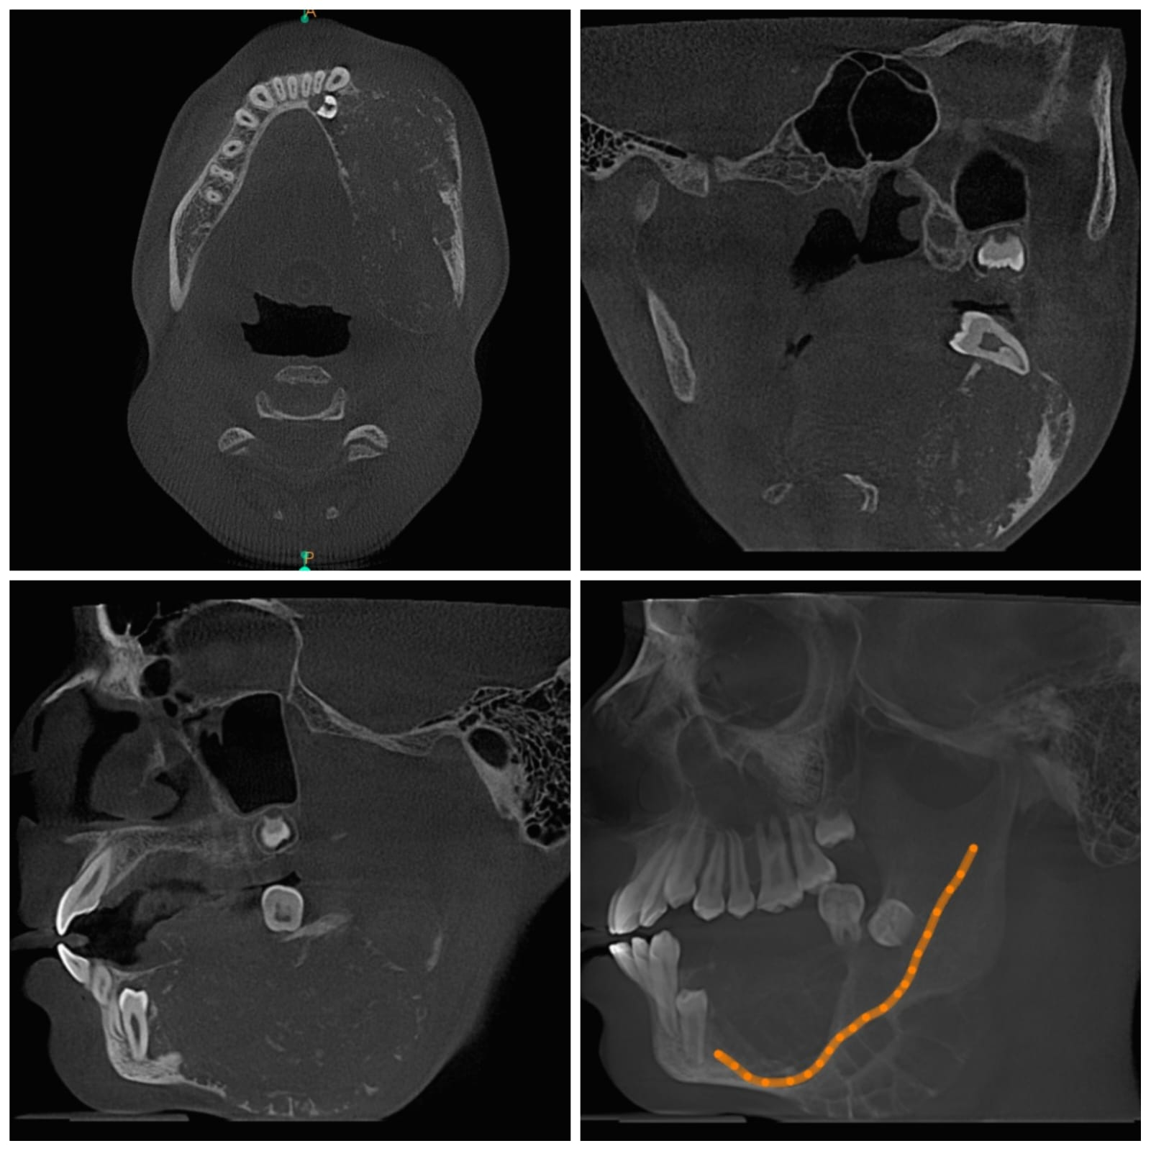
d
c
b
a
Fig. 4 a) Axial section showing expansion and perforation of buccal and lingual cortical plates. b) Coronal section showing lesion with displaced 37. c) Sagittal section showing displaced 34 present in lesion. d) Sagittal section showing displaced IANC and erosion of lower border of mandible.
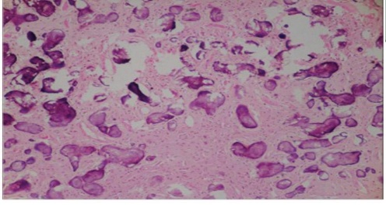
Biopsy was done. Microscopic examination revealed a highly cellular fibrous stroma containing numerous proliferated spindly to stellate shaped fibroblastic cells. Cells show bland morphology without any evidence of atypia. round to ovoid basophilic intervening bony trabeculae and foci of ossification are seen. The lesion was well-circumscribed and encapsulated, with no evidence of cellular atypia or malignancy (Fig.5). Based on histopathological features final diagnosis was given as psammomatoid juvenile ossifying fibroma.

Fig. 5 Photomicrograph showing basophilic foci of ossification with fibrous stroma

Considering the aggressive nature and recurrence potential of psammomatoid juvenile ossifying fibroma, the lesion was treated by complete surgical excision under general anaesthesia, followed by thorough curettage and peripheral ostectomy to eliminate residual lesional tissue. The excised specimen was submitted for histopathological examination.
The patient was evaluated at 7 days, 1 month, 3 months, and 6 months following surgery. Clinical and radiographic assessments demonstrated uneventful healing with no evidence of residual lesion or recurrence, and facial symmetry was satisfactorily re-established (Fig. a and b)
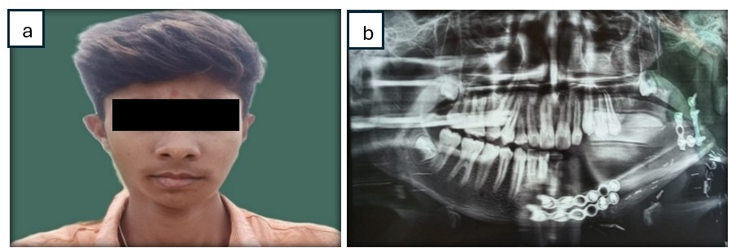
Fig. 6. Three months Follow-up. a) Extraoral clinical photo b) Orthopantomogram

DISCUSSION
Ossifying fibroma is an uncommon benign fibro-osseous neoplasm of bone, first described in the late nineteenth century, with standardized terminology established in the early twentieth century. When it occurs in children and adolescents, it is designated juvenile ossifying fibroma (JOF), reflecting its aggressive growth potential and distinctive biological behaviour. Based on histopathological features, JOF is subclassified into trabecular and psammomatoid variants, the latter being considerably less common ^{[1,3]}.
Psammomatoid juvenile ossifying fibroma (PsJOF) demonstrates a marked predilection for the paranasal sinuses, particularly the frontal and ethmoidal sinuses, while mandibular involvement remains rare ^{[4,6]} This case is noteworthy due to its mandibular presentation, which represents an uncommon site and poses diagnostic and therapeutic challenges. Reported mandibular cases in the literature often exhibit rapid expansion, cortical destruction, and a higher tendency for recurrence, frequently requiring aggressive surgical resection ^{[5,7]} In contrast, the present case demonstrated preservation of the inferior mandibular border and absence of neurosensory deficit despite its considerable size, allowing a conservative surgical approach.
Clinically, PsJOF may remain asymptomatic during its early stages and is frequently detected only after achieving significant dimensions. This indolent growth pattern contributes to diagnostic delay, particularly in mandibular cases where the lesion may mimic odontogenic cysts or tumors ^{[6,8]} In the present case, the painless and slowly progressive swelling initially masked the aggressive nature of the lesion, highlighting a common diagnostic pitfall. Radiographically, PsJOF typically presents as a well-defined expansile lesion with variable internal density and internal septations, features that overlap with ameloblastoma, central giant cell granuloma, and other fibro-osseous lesions ^{[7,9]} Therefore, radiographic findings must be interpreted in conjunction with histopathological features.
Histopathological examination remains the cornerstone of diagnosis. The presence of numerous psammoma-like ossicles embedded within a highly cellular fibrous stroma composed of spindle-shaped fibroblastic cells is considered characteristic of PsJOF and was instrumental in confirming the diagnosis in this case ^{[1,2]}
Surgical excision is the treatment of choice for PsJOF; however, the extent of surgery should be individualized. While aggressive resection is advocated for recurrent or extensively destructive lesions, conservative excision may be appropriate in select cases with intact mandibular continuity and no neural involvement ^{[5,7]} In the present case, conservative surgical management was chosen based on these favourable anatomical factors. The satisfactory postoperative healing and absence of recurrence during follow-up support the suitability of this approach.
Given the locally aggressive nature and high recurrence potential of PsJOF, long-term clinical and radiographic follow-up is essential ^{[7]} Early diagnosis, accurate histopathological assessment, and tailored surgical management are critical to achieving favourable outcomes, particularly in rare mandibular presentations.
CONCLUSION
Juvenile psammomatoid ossifying fibroma (JPOF) is a rare, rapidly progressive osteolytic lesion that is often misdiagnosed, especially when it occurs outside the paranasal sinuses, as in mandibular cases. It requires complete surgical excision, as incomplete removal can lead to recurrence. Because of its locally aggressive behaviour and high recurrence potential, long-term follow-up is essential. Accurate diagnosis relies on careful clinical, radiographic, and histopathologic evaluation to address its diagnostic and therapeutic challenges. Mandibular PsJOF, though rare, should be considered in aggressive mixed lesions in young patients to avoid misdiagnosis and inadequate treatment.

CONSENT
As per international standards or university standards, patient(s) written consent has been collected and preserved by the author(s).
Ethical Approval:
As per international standards or university standards written ethical approval has been collected and preserved by the author(s).

DISCLAIMER (ARTIFICIAL INTELLIGENCE)
Author(s) hereby declare that NO generative AI technologies such as Large Language Models (ChatGPT, COPILOT, etc) and text-to-image generators have been used during writing or editing of this manuscript.

REFERENCES
- El-Mofty S. Psammomatoid and trabecular juvenile ossifying fibroma of the craniofacial skeleton: two distinct clinicopathologic entities. Oral Surg Oral Med Oral Pathol Oral Radiol Endod. 2002;93:296-304.
- Saiz-Pardo-Pinos AJ, Olmedo-Gaya MV, Prados-Sánchez E, Vallecillo-Capilla M. Juvenile ossifying fibroma: a case study. Med Oral Patol Oral Cir Bucal. 2004;9:454-8.
- Toro C, Milles W, Zerman N. Aggressive ossifying fibroma with massive mandibular involvement: differential diagnosis and management. Int J Pediatr Otorhinolaryngol. 2006;70:167-72.
- Park S, Lee BJ, Lee JH. Juvenile ossifying fibroma: a clinicopathologic study of 8 cases. Korean J Pathol. 2007;41:373-9.
- Smith SF, Newman L, Walker DM, Papadopoulos H. Juvenile aggressive psammomatoid ossifying fibroma: case report and literature review. J Oral Maxillofac Surg. 2009;67:200-6.
- Keles B, Duran M, Uyar Y. Juvenile ossifying fibroma of the mandible: a case report. J Oral Maxillofac Res. 2010;1:e5.
- Abuzinada S, Alyamani A. Management of juvenile ossifying fibroma in the maxilla and mandible. J Maxillofac Oral Surg. 2010;9:91-5.
- Sarode SC, Sarode GS, Waknis P, Patil A. Juvenile psammomatoid ossifying fibroma: review of literature. Oral Oncol. 2011;47:1110-6.
- Brannon RB, Fowler CB. Benign fibro-osseous lesions: a review of current concepts. Adv Anat Pathol. 2001;8:126-43.
- Shah A, Lone P, Latoo S. Psammomatoid juvenile ossifying fibroma of the jaw bones: case report. J Oral Maxillofac Pathol. 2011;15:326-9.
- Ruwandi HG, Weerasinghe N, Wijesuriya PC, Jayasooriya PR. Juvenile ossifying fibroma: clinico-pathological analysis. J Diagn Pathol. 2016;11:14-21.
- Makek M. Clinical pathology of fibro-osseous lesions of the facial skeleton. Karger. 1983.

