Management of endo-periodontal lesion of mandibular anterior teeth: a case report

Abstract

Endo-periodontal lesions remain a challenging clinical entity due to the complex anatomical and pathological relationship between the pulp and the periodontium. Case reports highlighting sequential endodontic and periodontal management can help clinicians understand appropriate treatment planning and prognosis. This manuscript attempts to reinforce the concept of addressing the endodontic component prior to periodontal intervention. With appropriate revisions, the case could contribute useful clinical insight for general practitioners and postgraduate students. The intimate physiological connection between the periodontium and the dental pulp significantly increases the complexity of managing combined endo-periodontal lesions. Achieving a successful outcome requires the total eradication of pathogens from both the periodontal and endodontic systems. These lesions are frequently encountered in clinical settings; if left unaddressed, an endodontic infection will inevitably compromise the periodontium, and vice versa. This report presents a tooth with combined endodontic-periodontal involvement treated with a staged approach: first root canal therapy, then flap surgery. Post-operative evaluation at nine months revealed significant clinical attachment gain.

Keywords
Endo–perio lesions, root canal treatment, periodontal open flap, prognosis

Introduction

The connection between periodontium and dental pulp are anatomically linked via the apical foramen, dentinal tubules, and various lateral or accessory canals. These pathways facilitate the spread of infection between the two structures, often leading to combined endo-perio lesions that account for over half of all tooth loss. [1] Endo periodontal lesion or endo-perio is used to describe lesions this inflammation can be found in the tissues surrounding the teeth and in the pulp. This interrelation between periodontal disease and pulpal diseases was first described by Simring [2]. Periodontal breakdown typically progresses from the cervical to the apical region, while endodontic infection generally spreads coronally from the apex. Perio-endo lesions are inherently complex with diverse etiologies. Successful management and long-term outcomes hinge on an accurate diagnosis. To achieve an optimal prognosis, a multidisciplinary approach is essential, integrating restorative, endodontic, and periodontal interventions as needed.[3] Pulpal pathology is a known cause of periodontal inflammation; however, whether periodontal disease can trigger pulpal infection is still contentious. Opinions remain polarized regarding the extent to which periodontal pathogens can affect the health of the dental pulp. [4,5]
classification
The classification system was proposed by Simon, Glick, and Frank in 1972, comprising the following categories. [6]
1. Primary endodontic lesion
2. Primary periodontal lesion
3. Primary endodontic lesion with secondary periodontal involvement
4. Primary periodontal lesion with secondary endodontic involvement
5. Truly combined lesion.

Case report
A 28-year-old man came to get services in Peri odontology unit, Department of Endodontic, Faculty of Dentistry, University of Health Sciences Laos. The patient presented with swelling and pain localized to tooth #41, accompanied by purulent discharge persisting for three weeks. Hematological investigations were unremarkable, and the patient was a non-smoker. Initially, a seven-day course of systemic antibiotic therapy (Amoxicillin 500 mg) was prescribed. Upon clinical re-evaluation one week later, tooth #41 exhibited a deep periodontal pocket (PPD=8 mm) on the lingual aspect, while the labial PPD remained within normal limits (2 mm). Radiographic analysis confirmed a periapical lesion associated with tooth #41, leading to a diagnosis of an endodontic-periodontal involvement (Fig-1). (Truly combined lesion). Twice times for Root canal treatment by Calcium Hydroxide 30 days and then root canal filling by gutta-perch was performed and periodontal open flap technique, After anesthetizing with local anesthesia was done by 2% adrenaline with in epinephrine 1:100 000, A full-thickness flap was elevated, initiated by an intrasulcular incision extending from the mesial line angle of #43 to #33 on the lingual aspect. A vertical 'hockey-stick' release was executed within the keratinized tissue at the mesial border—specifically between the papillae of #41 and #31. The flap was reflected to expose the residual alveolar bone. Following elevation, meticulous debridement of granulation tissue was performed using Gracey curettes #3 and #4, followed by comprehensive scaling and root planing of the exposed root surfaces, and the flap is then apically repositioned and suturing 4-0 nylon. Medicine (drug suspension): Amoxicillin 500 mg, 2 tablets time 3 per day during 7 days; Ibuprofen 400 mg, 1 tablet every 6 or 8 hours after meal during 5 days; Chlorhexidine gluconate 0.12% rinse one a day during 2 weeks; and also asked the patient to give oral health hygiene after that recall for checkup in 10 days and also asked the patient to give oral health hygiene. Subsequent to the intervention, the patient attended regular follow-up visits at months 1, 3, 6, and 9. Clinical findings confirmed that the probing depths had normalized, consistently measuring around 3 mm

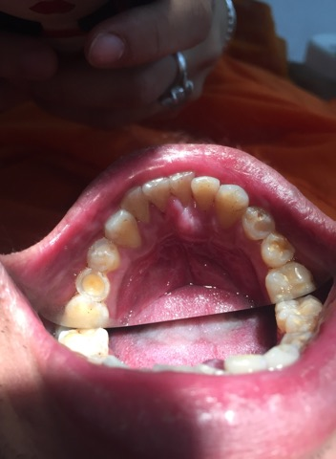
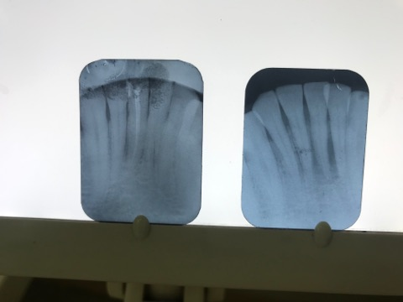
B
A

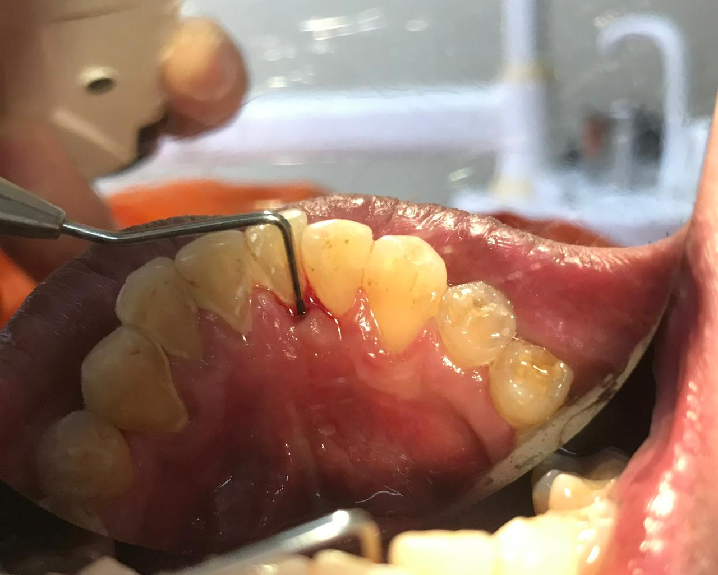
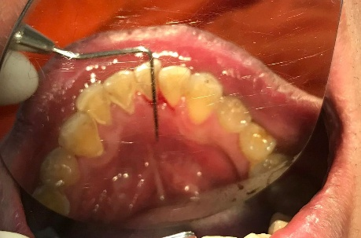

D
C

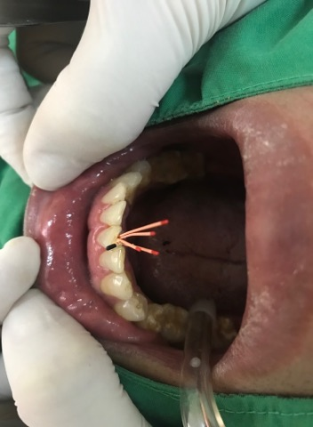
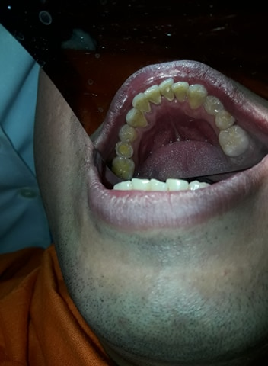

F
E

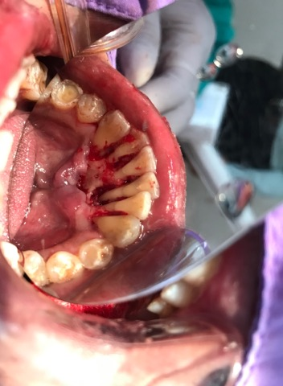
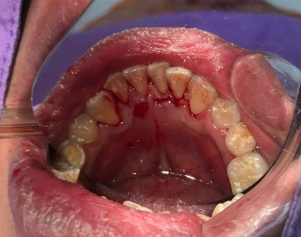

H
G

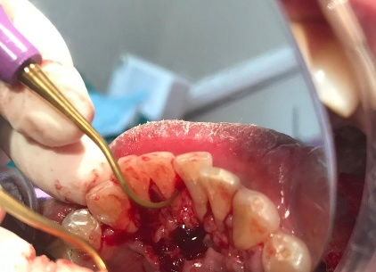
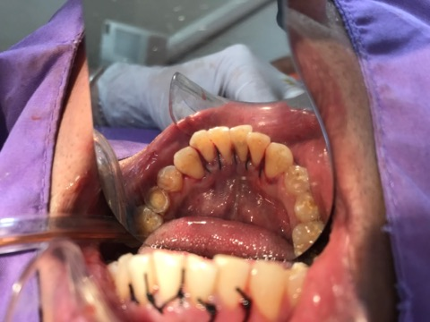

J
I
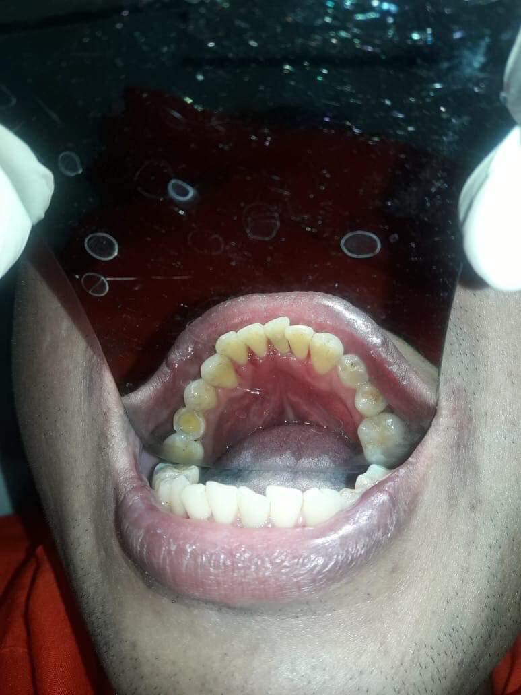
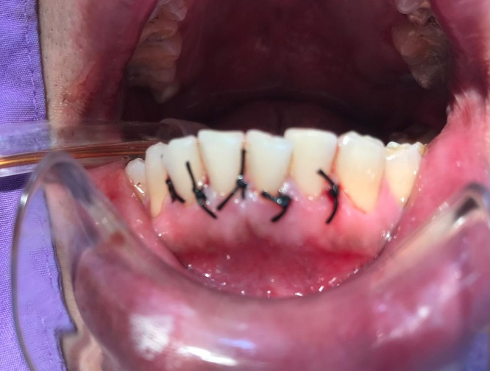
L
K
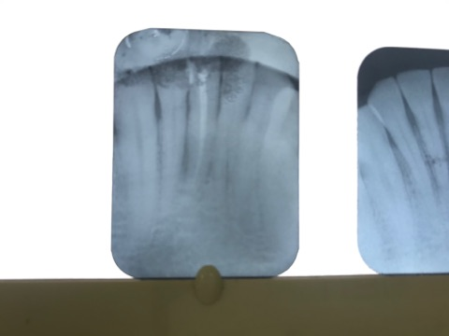
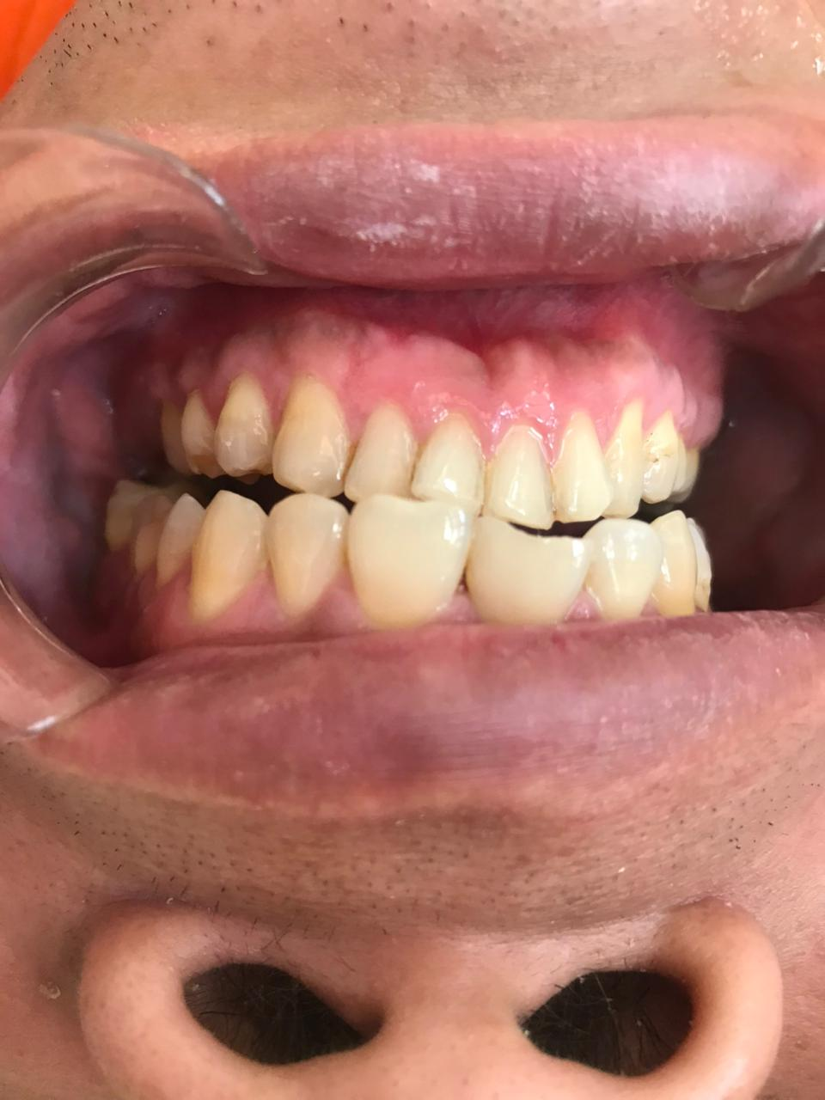

M
N

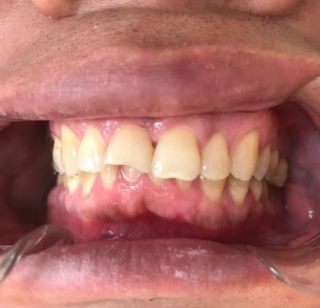

O

Figure 1 :(A) Initial x-ray of tooth #41 with chronic inflammation around root, (B) periapical abscess, chronic infection, pain, swelling and pus, (C, D) Preoperative probing, PPD=8 mm (E, F) Root canal treatment by Calcium Hydroxide 30 days and then root canal filling by gutta-perch, (G, H) Full-thickness flap raised, (I) Gracey curettes #3 and #4 were employed to instrument the defect area. This was followed by comprehensive scaling and root planing of the accessible root surface area. (J, K) suturing with 4-0 nylon, (L, M.N.o) the 9-month follow-up, substantial osseous regeneration was observed within the previously identified bony defects. and tooth not mobility.
Discussion:
Diagnosing and managing teeth with endo-perio lesions remains a complex undertaking. Precision in the initial assessment is vital for effective treatment planning. However, the coexistence of endodontic and periodontal tissue loss continues to be a prevalent hurdle in modern practice, as the combined destruction can obscure the diagnosis and negatively influence long-term tooth retention [7,8]. Combined endodontic and periodontal treatments facilitate effective recovery of endo-perio lesions. [9,10]. Treating combined endo-perio lesions requires a dual focus on endodontic and regenerative periodontal therapies. The standard sequencing involves canal disinfection first, followed by a monitoring period. The surgical objective is to eliminate necrotic debris and stimulate the growth of new hard and soft tissues. In the present case-a primary endodontic lesion with secondary periodontal complications-surgery was performed after successful endodontic therapy. At the 9-month review, the results demonstrated marked bone regeneration within the osseous defects
Conclusion:
The treatment outcomes and follow-up of this case, it can be concluded that favorable clinical results are achievable when endodontic intervention precedes periodontal therapy. Successful management of a combined endo-perio lesion necessitates addressing both pathological origins to ensure comprehensive healing of the involved tissues.
Consent
As per international standards or university standards, patient(s) written consent has been collected and preserved by the author(s).
Ethical approval
The case report was submitted and approved by University of Health Sciences, Vientiane, Lao PDR

Disclaimer (Artificial intelligence)

Author(s) hereby declare that NO generative AI technologies such as Large Language Models (ChatGPT, COPILOT, etc.) and text-to-image generators have been used during the writing or editing of this manuscript.
( use some ChatGPT, COPILOT, etc.)

REFERENCES
1. Narang S, Narang A, Gupta R. A sequential approach in treatment of perio-endo lesion. J Indian Soc Periodontol 2011; 15:177–80.
2. Simring M, Goldberg M. The pulpal pocket approach: retrograde periodontitis. JPeriod. 1964;35:22-48.
3. Parolia A, Gait TC, Porto IC, Mala K. Endo‑perio lesion: A dilemma
from 19 th until 21 st century. Journal of Interdisciplinary Dentistry.
2013 Jan 1;3(1):2.
4. Seltzer S, Bender IB, Ziontz M. The interrelationship of pulp and periodontal disease. Oral Surg Oral Med Oral Pathol 1963;16:1474‑90

5. Xia M, Qi Q. Bacterial analysis of combined periodontal-endodontic lesions by polymerase chain reaction denaturing gradient gel electrophoresis. J Oral Sci. 2013;55(4):287-91.
6. Simon JH, Glick DH, Frank AL. The relationship of endodontic‑Periodontic lesions. J Periodontol. 1972;43:202‑8.
7. Harrington GW, Steiner DR, Ammons WF. The periodontal‑endodontic controversy. Periodontol 2000 2002;30:123‑30
8. Gomes BPFA, Berber VB, Kokaras AS, Chen T, Paster BJ. Microbiomes of endodontic-periodontal lesions before and after chemomechanical preparation. J Endod.
2015;41(12):1975-84.
9. de Lima Dantas LTB, Carvalho IF, Lima DVdSC, da Silva Ribeiro M, Martins ÂG, Cerqueira JDM. Current approaches to the diagnosis and treatment of endoperiodontal lesions. J Dent Public Health. 2019;10(2):135-146
10. Miao H, Chen M, Otgonbayar T, Zhang SS, Hou MH, Wu Z, et al. Papillary reconstruction and guided tissue regeneration for combined periodontal-endodontic lesions caused by palatogingival groove and additional root: a case report. Clin Case Rep. 2015;3(12):1042-9.

