Case Report

Management of endo-periodontal lesion of mandibular anterior teeth-a case report

Endo-periodontal lesions remain a challenging clinical entity due to the complex anatomical and pathological relationship between the pulp and the periodontium. Case reports highlighting sequential endodontic and periodontal management can help clinicians understand appropriate treatment planning and prognosis. This manuscript attempts to reinforce the concept of addressing the endodontic component prior to periodontal intervention. With appropriate revisions, the case could contribute useful clinical insight for general practitioners and postgraduate students. The relationship between periodontium and pulp makes the treatment of combined endo-periodontal lesions more challenging. It involves successful elimination of both periodontal and endodontic lesion. Endo–perio lesions are a common finding in dental practice. Progression of an endodontic lesion, if allowed, leads to periodontal involvement or vice versa. This is a case series of a case of the endodontic lesion with periodontal involvement that has been treated by performing root canal treatment followed by flap surgery. The tooth was first endodontically treated that was followed by periodontal treatment. Nine months postoperatively, there was a significant gain in clinical attachment level.

Keywords
Endo–perio lesions, root canal treatment, periodontal open flap

Introduction

The connection between periodontics and the pulp has been well addressed. The embryonic, anatomical, and functional interrelationships are defined by the lateral, dentinal tubules and accessory canals, and apical foramen, and they might be assumed for the combined problems responsible for more than 50% of tooth mortality.[1] Endo periodontal lesion or endo-perio is used to describe lesions this inflammation can be found in the tissues surrounding the teeth and in the pulp. This interrelation between periodontal disease and pulpal diseases was first described by Simring [2,10]. Periodontal and pulpal structures are anatomically related through apical foraminal, dentinal tubules, lateral, apical foramen, accessory, secondary and canals dentinal tubules, these means of communication from one structure to another is responsible for possibility of pulpal disease [3,4].
Classification
The most commonly used classification was given by Simon, Glick, and Frank in 1972, which includes:[5]
1. Primary endodontic lesion
2. Primary periodontal lesion
3. Primary endodontic lesion with secondary periodontal involvement
4. Primary periodontal lesion with secondary endodontic involvement
5. Truly combined lesion.

Case report
A 28-year-old man came to get services in Peri odontology unit, Department of Endodontic, Faculty of Dentistry, University of Health Sciences. Complained of swelling and pain around tooth #31 associated with pus discharge for 3 weeks. At the first visit, the existing systemic antimicrobial therapy (amoxicillin 500 mg) was administered for seven days. During the detailed clinical examination after 1 week, the Lingual surface of tooth #31 presented with deep pocket (PPD=8 mm) and labial surface (PPD=2mm) by prob, The radiographic assessment demonstrated periapical endodontic lesion of tooth #31. The diagnosis was made by the presence of periapical endodontic lesion (Truly combined lesion). Root canal treatment by Calcium Hydroxide 30 days and then root canal filling by gutta-perch was performed and periodontal open flap technique, After anesthetizing with local anesthesia: ubistesin 4% with adrenaline 1:200 000, a full thickness flap was reflected starting with intramuscular incision mesial line of #43 to the mesial line angle of #33 at the Lingual aspect and a vertical hokey-stick incision in the keratinized tissue was performed at the mesial aspect of the flap – between the papilla of teeth #31 and #41. The reflection of the full thickness flap extended to the residual alveolar bone. After reflection, thorough granulation and debridement was done at the defect area using Gracey’s curette #3 and #4. Also, thorough scaling and root planning was carried out on the exposed root surface area of the defect, and the flap is then apically repositioned and suturing 4-0 nylon. Medicine (drug suspension): Amoxicillin 500 mg, 2 tablets time 3 per day during 7 days; Ibuprofen 400 mg, 1 tablet every 6 or 8 hours after meal during 5 days; Chlorhexidine gluconate 0.12% rinse one a day during 2 weeks; and also asked the patient to give oral health hygiene after that recall for checkup in 10 days and also asked the patient to give oral health hygiene. After treatment, the patient was recalled periodically at 1, 3, 6 and 9 months. Clinical examination showed that PD recovered to within a normal range (approximately 3 mm),
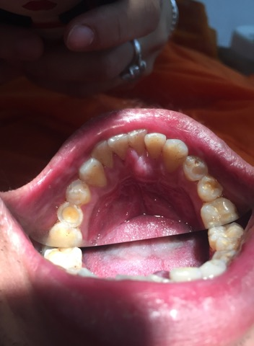
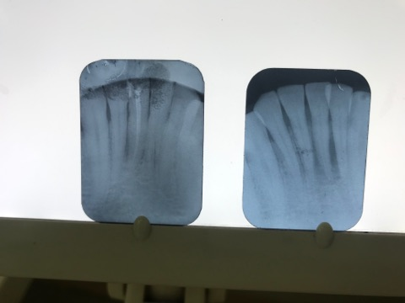
B
A

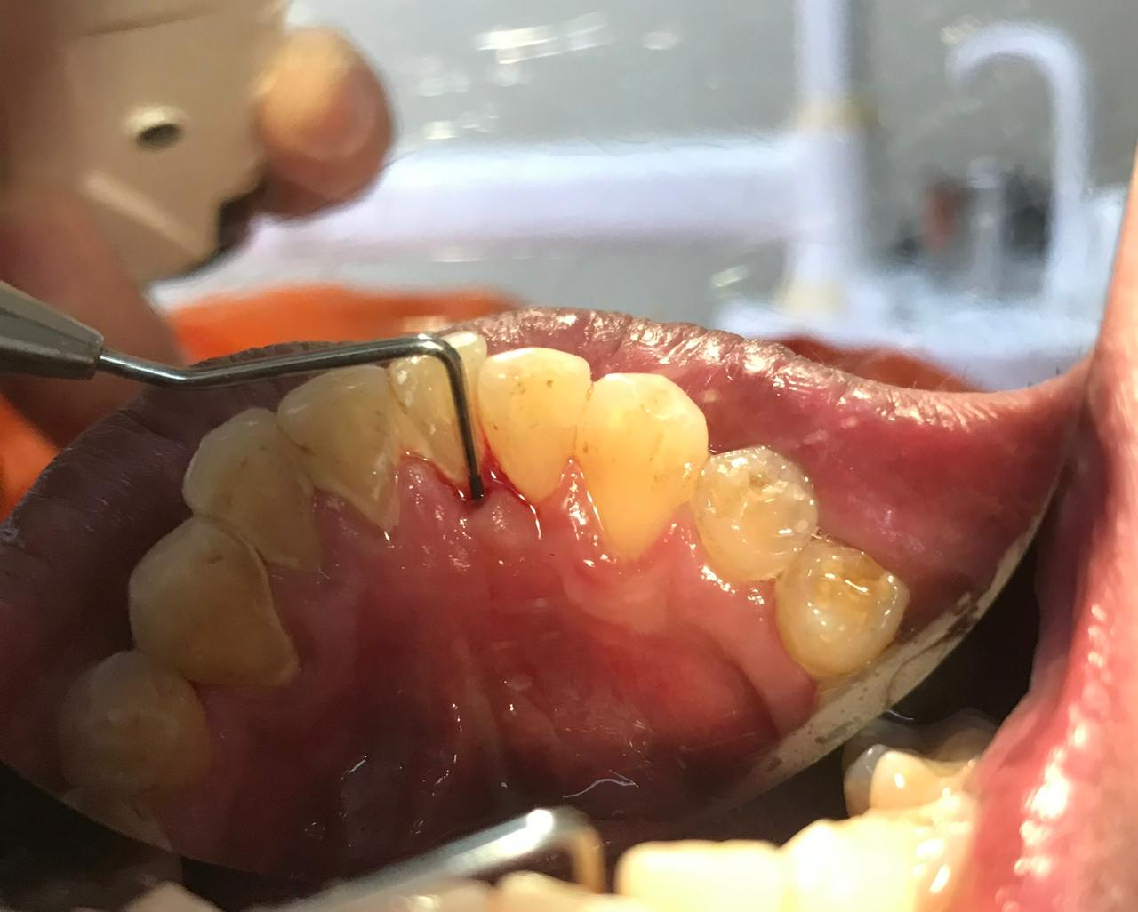
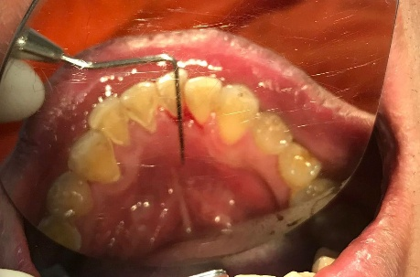

D
C

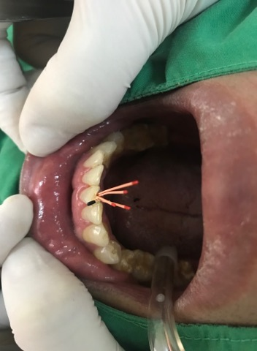
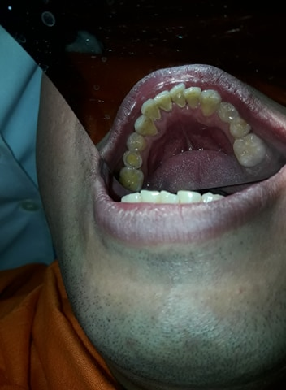

F
E
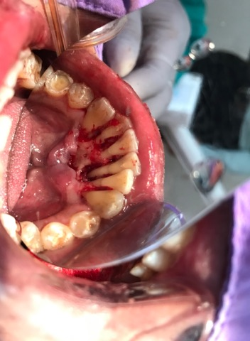
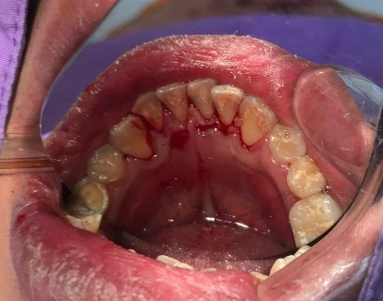

H
G

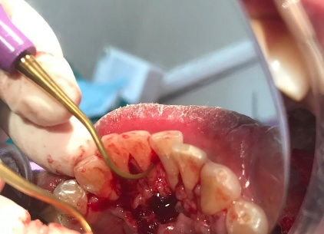
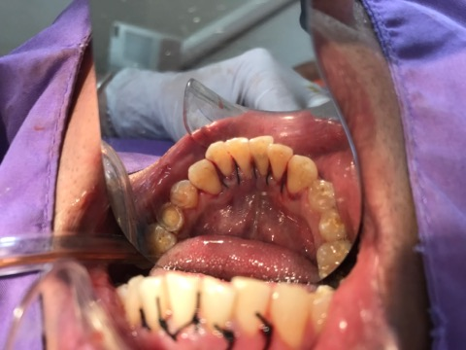

J
I
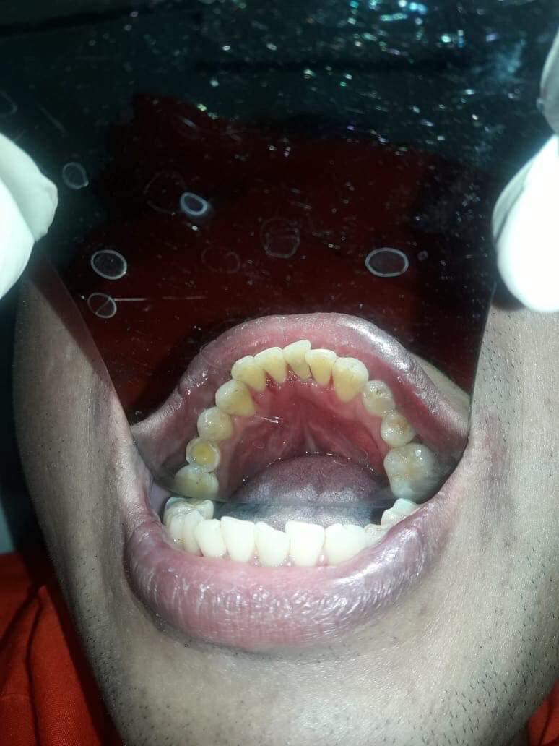
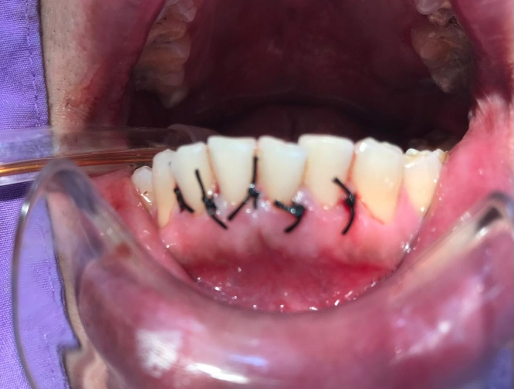
L
K
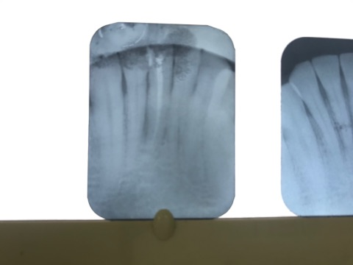
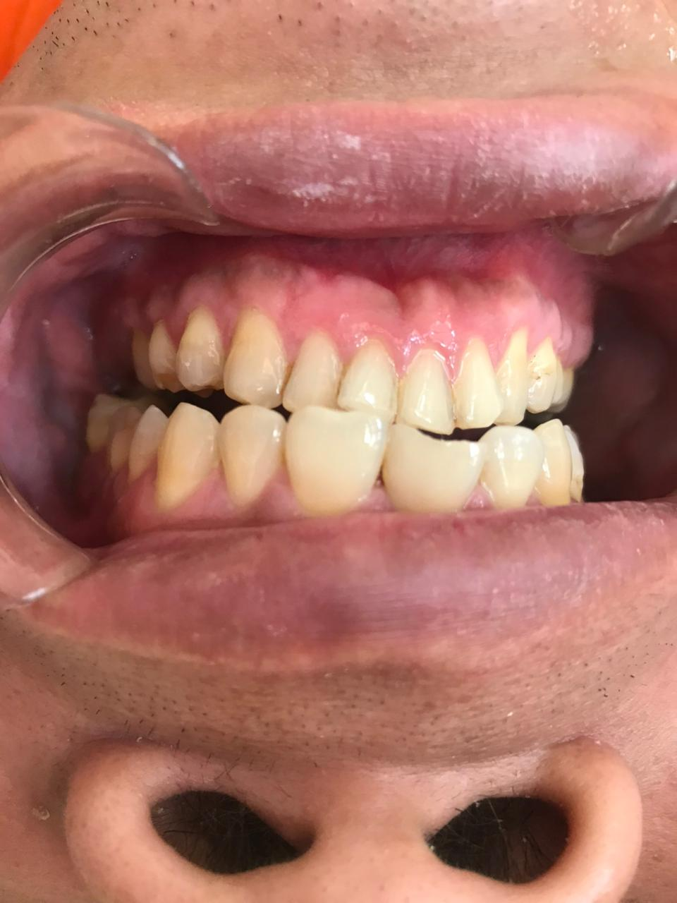

M
N

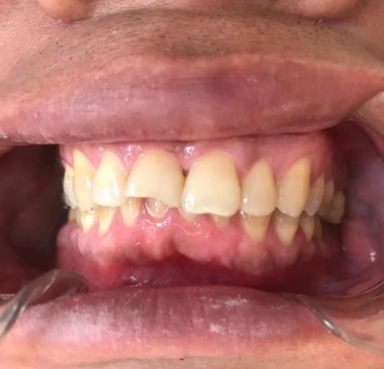

O

Figure: (A) Initial x-ray of tooth 41 with chronic inflammation around root, (B) periapical abscess, chronic infection, pain, swelling and pus, (C, D) Preoperative probing, PPD=8 mm (E, F) Root canal treatment by Calcium Hydroxide 30 days and then root canal filling by gutta-perch, (G, H) Full-thickness flap raised, (I) the defect area using Gracey’s curette #3 and #4. scaling and root planning was carried out on the exposed root surface area of the defect (J, K) suturing with 4-0 nylon, (L, M.N.o) The results post 9 months have shown a significant amount of bone fill in the bony defect areas and tooth not mobility.
Discussion:
The diagnosis and prognosis of the tooth having endo–perio lesions present a challenge to the clinicians. Correct diagnosis is important to determine the treatment and long-term prognosis. However, treating a complex endodontic periodontal lesion is still one of the most common challenges in today’s clinical practice. The simultaneous existence of endodontium and periodontium tissue destruction can complicate the diagnosis and subsequently affect the prognosis of the involved teeth [6,7]. Combined endodontic and periodontal therapy promote successful healing of an endo periodic lesion [8,9]. Treatment of endo–perio lesion requires both endodontic treatment and periodontal regenerative treatment. The treatment strategy is to first focus on debridement and disinfection of the root canal system, followed by an observation period. The goal of periodontal surgery is to remove all necrotic tissues from the surgical site and facilitate the regeneration of hard and soft tissue along with the formation of new attachment apparatus. In the reported cases, the established diagnosis in the case was primarily endodontic with secondary periodontal lesion Endodontic therapy was done and followed by periodontal surgery, the bony defect was present and there was a furcation. The results post 9 months have shown a significant amount of bone fill in the bony defect areas and in furcation involvement region also.
Conclusion:
With the treatment and follow-up of the present case, it is possible to conclude that there is clinical success when endodontic treatment is performed before periodontal treatment, since the primary need for therapy of an Endo periodontal lesion is to treat the two origins of the lesion.

COMPETING INTERESTS DISCLAIMER:
Authors have declared that they have no known competing financial interests OR non-financial interests OR personal relationships that could have appeared to influence the work reported in this paper.

Disclaimer (Artificial intelligence)

Author(s) hereby declare that NO generative AI technologies such as Large Language Models (ChatGPT, COPILOT, etc.) and text-to-image generators have been used during the writing or editing of this manuscript.

REFERENCES
1. Narang S, Narang A, Gupta R. A sequential approach in treatment of perio-endo lesion. J Indian Soc Periodontol 2011; 15:177–80.
2. Simring M, Goldberg M. The pulpal pocket approach: retrograde periodontitis. JPeriod. 1964;35:22-48.
3. Xia M, Qi Q. Bacterial analysis of combined periodontal-endodontic lesions by polymerase chain reaction denaturing gradient gel electrophoresis. J Oral Sci. 2013;55(4):287-91.
4. Simon JH, Glick DH, Frank AL. The relationship of endodontic‑Periodontic lesions. J Periodontol. 1972;43:202‑8.
5. Harrington GW, Steiner DR, Ammons WF. The periodontal‑endodontic controversy. Periodontol 2000 2002;30:123‑30
6. Xia M, Qi Q. Bacterial analysis of combined periodontal-endodontic lesions by polymerase chain reaction denaturing gradient gel electrophoresis. J Oral Sci. 2013;55(4):287-91.
7. Gomes BPFA, Berber VB, Kokaras AS, Chen T, Paster BJ. Microbiomes of endodontic-periodontal lesions before and after chemomechanical preparation. J Endod.
2015;41(12):1975-84.
8. de Lima Dantas LTB, Carvalho IF, Lima DVdSC, da Silva Ribeiro M, Martins ÂG, Cerqueira JDM. Current approaches to the diagnosis and treatment of endoperiodontal lesions. J Dent Public Health. 2019;10(2):135-146
9. Miao H, Chen M, Otgonbayar T, Zhang SS, Hou MH, Wu Z, et al. Papillary reconstruction and guided tissue regeneration for combined periodontal-endodontic lesions caused by palatogingival groove and additional root: a case report. Clin Case Rep. 2015;3(12):1042-9.
10. Herrera, D., Retamal‐Valdes, B., Alonso, B., & Feres, M. (2018). Acute periodontal lesions (periodontal abscesses and necrotizing periodontal diseases) and endo‐periodontal lesions. Journal of clinical periodontology, 45, S78-S94.

