Designing a Multi-Scale, Process-Oriented and Covariate-Guided Sampling Strategy for Capturing Spatial Heterogeneity of Soil Organic Carbon in Sahelian Semi-Arid Agroecosystems

.
ABSTRACT
Soil organic carbon (SOC) plays a central role in soil fertility, ecosystem resilience, and climate regulation, particularly in semi-arid drylands where degradation pressures are increasing. In Sahelian sandy agroecosystems, SOC distribution is highly heterogeneous due to interacting influences of sparse vegetation cover, sandy parent materials, biogenic structures, and subtle topographic gradients. Conventional random or systematic grid-based sampling designs often fail to capture short-range variability and localized carbon hotspots, potentially compromising spatial inference and digital soil mapping accuracy.
This study proposes a multi-scale, process-oriented, and covariate-guided sampling framework tailored to Sahelian semi-arid environments. The approach integrates the SCORPAN conceptual model with high-density radial transect sampling around biogenic structures at the local scale and landscape-scale environmental stratification based on NDVI classes, soil reflectance indices (BI, BSI, RI), and terrain attributes. Sampling points were proportionally allocated across environmentally homogeneous strata to ensure balanced representation of vegetation gradients, exposed sandy surfaces, and micro-topographic conditions.
The proposed design enhances environmental representativeness, reduces sampling bias, and strengthens the ecological coherence of SOC spatial assessment. By explicitly accounting for nested spatial processes, the framework provides a transferable methodological foundation for soil surveys, carbon stock estimation, and digital soil mapping applications in semi-arid drylands facing climate variability and land degradation pressures.

Keywords: Soil organic carbon; sampling design; Sahel; SCORPAN; NDVI classes; soil reflectance indices; spatial heterogeneity; semi-arid soils.

1. INTRODUCTION

Soil organic carbon (SOC) is a fundamental determinant of soil fertility, ecosystem resilience, and climate regulation (Lal, 2004; Chenu et al., 2014; Wiesmeier et al., 2024). It plays a central role in nutrient cycling, aggregate stability, water retention capacity, and long-term agricultural productivity. In the context of climate change mitigation, land degradation neutrality, and sustainable intensification, accurate assessment and monitoring of SOC stocks have become critical scientific and policy priorities, particularly in vulnerable dryland regions (Bossio et al., 2023; FAO, 2023; Minasny et al., 2023).
In semi-arid Sahelian agroecosystems, SOC spatial distribution is highly heterogeneous and shaped by interacting environmental and biological drivers. Sandy parent materials with low clay content limit organo-mineral stabilization processes, while sparse and discontinuous vegetation cover results in uneven organic matter inputs (Vajra et al., 2026). Agroforestry mosaics and localized biogenic structures, including tree canopies and biological concentration zones, generate discrete carbon hotspots embedded within extensive mineral-dominated sandy matrices. These combined factors produce nested spatial variability across scales, from micro-scale enrichment patterns to broader landscape gradients (Jenny, 1941; Sollins et al., 1996; Lehmann & Kleber, 2015; Wiesmeier et al., 2024).
Capturing this spatial heterogeneity remains methodologically challenging. Conventional soil sampling approaches, such as simple random sampling or systematic grid designs, may inadequately represent short-range gradients and rare ecological units characteristic of heterogeneous drylands (Brus & de Gruijter, 1997). In sandy environments marked by clustered vegetation patches and exposed mineral surfaces, under-sampling of biologically influenced zones can compromise spatial inference and reduce the reliability of SOC estimation (Pouladi et al., 2023).
Recent advances in digital soil mapping (DSM) emphasize covariate-driven sampling strategies guided by soil-forming factors and environmental predictors (McBratney et al., 2003; Minasny et al., 2013; Radočaj et al., 2024). Satellite-derived spectral indices, vegetation metrics, and terrain attributes provide spatially continuous covariates capable of capturing vegetation dynamics, mineral exposure gradients, and topographic redistribution processes influencing SOC variability (Zanini et al., 2024; Ji et al., 2024; Cui et al., 2025). However, methodological adaptations specifically tailored to sandy Sahelian agroecosystems remain limited.
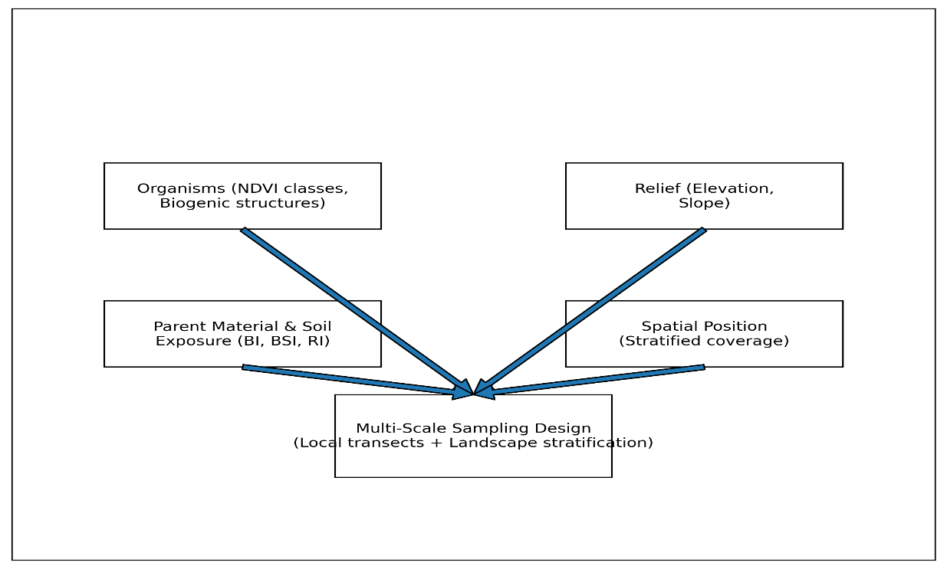
This study therefore proposes a multi-scale, process-oriented, and covariate-guided sampling framework designed to improve spatial representativeness, ecological coherence, and methodological robustness in Sahelian semi-arid systems.

Fig 1. Conceptual SCORPAN-based multi-scale sampling framework adapted to Sahelian sandy agroecosystems.

2. MATERIALS AND METHODS

2.1 Study Area Characteristics
The study area is located within a Sahelian semi-arid agroecosystem characterized by predominantly sandy soils derived from aeolian and sedimentary parent materials. Land use is structured around agroforestry systems, cultivated fields, fallow lands, and circular biogenic structures that locally modify soil properties. Vegetation cover is discontinuous and spatially heterogeneous, reflecting seasonal rainfall variability and anthropogenic management practices.
Terrain gradients are generally subtle but ecologically significant, influencing micro-topographic redistribution processes such as runoff, sediment deposition, and moisture concentration. The coexistence of vegetated patches and exposed mineral-dominated sandy surfaces generates strong spatial contrasts in soil properties. These environmental characteristics justify the implementation of a structured and process-oriented sampling design capable of capturing nested spatial variability.

2.2 Process-Based Conceptual Framework

2.2.1 SCORPAN as Theoretical Basis

The sampling strategy follows the SCORPAN conceptual model (McBratney et al., 2003), which extends Jenny’s soil-forming factors by incorporating spatially explicit predictive variables. The framework integrates Soil, Climate, Organisms, Relief, Parent material, Age, and spatial position as determinants of soil variability.

In Sahelian sandy agroecosystems, climate and parent material remain relatively homogeneous at the landscape scale, thereby reducing large-scale pedogenic contrasts. However, organisms-including tree canopies, vegetation patches, and biogenic structures-strongly regulate localized organic matter inputs. Relief, even when subtle, governs sediment redistribution, moisture dynamics, and micro-scale stabilization processes.

Aligning sampling allocation with SCORPAN ensures representation of dominant soil-forming processes while maintaining theoretical consistency with digital soil mapping methodologies.

2.2.2 Ecological Processes Governing SOC in Sahelian Sandy Systems

SOC heterogeneity in Sahelian semi-arid agroecosystems results from interacting ecological and pedological mechanisms operating at nested spatial scales.

First, localized biological concentration processes play a dominant role. Tree canopies and biogenic soil structures act as spatial carbon accumulation nodes by enhancing litter deposition, root biomass density, and soil faunal activity, thereby increasing localized organic matter inputs and promoting discrete enrichment zones.

Second, rapid mineralization processes occur in exposed sandy soils. High surface albedo combined with sparse vegetation cover promotes elevated soil temperatures and enhanced aeration, accelerating microbial decomposition rates and reducing SOC persistence.
Third, micro-topographic redistribution processes contribute to SOC spatial patterns. Even minor relief gradients regulate runoff-driven sediment transport, fine particle accumulation, and moisture redistribution, influencing both organic matter stabilization and erosion dynamics (Minasny et al., 2013).
Finally, limited organo-mineral stabilization capacity characterizes sandy Sahelian soils. Low clay content reduces the formation of stable organo-mineral complexes, limiting physical and chemical protection of organic matter and increasing vulnerability to decomposition (Sollins et al., 1996; Lal, 2022).
The proposed sampling design explicitly incorporates these interacting processes by combining high-density local sampling around biological hotspots with landscape-scale environmental stratification based on vegetation, soil reflectance, and terrain covariates.

2.3 Multi-Scale Sampling Strategy

2.3.1 Local-Scale High-Density Sampling
Radial transects were established around selected biogenic structures to quantify short-range horizontal gradients in SOC distribution. Sampling points were positioned at predefined and standardized distance intervals from the structure center to ensure consistent spatial coverage.
Vertical sampling across multiple soil depths was implemented to capture depth-dependent variability and assess vertical SOC distribution patterns.
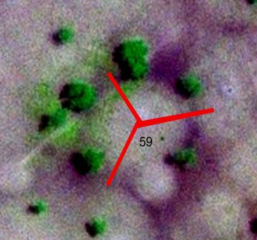
This high-resolution approach enables detection of micro-scale heterogeneity frequently overlooked by conventional systematic grid-based surveys, particularly in patch-structured dryland systems.

Figure 2. Radial transect-based local sampling scheme targeting micro-scale variability around biogenic structures.

2.3.2 Landscape-Scale Environmental Stratification
Landscape stratification was conducted using satellite-derived spectral indices and terrain attributes selected based on ecological and pedological relevance.

2.3.2.1 NDVI Classes
NDVI values were classified into four ecological categories specifically calibrated to vegetation density gradients characteristic of Sahelian semi-arid landscapes:
- Class 1 (NDVI < 0.15): Bare sandy soils and highly degraded surfaces with negligible vegetation cover and minimal organic inputs.
- Class 2 (0.15 ≤ NDVI < 0.30): Sparsely vegetated areas including fallow lands and low-biomass croplands.
- Class 3 (0.30 ≤ NDVI < 0.50): Moderately vegetated zones associated with agroforestry systems and seasonal crop development.
- Class 4 (NDVI ≥ 0.50): Relatively dense vegetation cover corresponding to tree canopies and localized biomass concentration patches.
These thresholds were selected to reflect the constrained productivity typical of semi-arid ecosystems, where NDVI values rarely reach those observed in humid climates. This classification enhances ecological interpretability and improves vegetation-driven stratification of SOC variability.

2.3.2.2 Soil Reflectance Indices
To refine discrimination of mineral-dominated sandy surfaces and organically influenced zones, multiple soil reflectance indices were derived from satellite imagery.
Brightness Index (BI)
The Brightness Index quantifies overall surface reflectance intensity and is typically associated with exposed sandy substrates characterized by high albedo and low organic matter content.
Bare Soil Index (BSI)
The Bare Soil Index enhances detection of exposed soil surfaces by combining visible and near-infrared spectral information. Elevated BSI values indicate strong mineral exposure and limited vegetation cover.
Redness Index (RI)
The Redness Index highlights variations in soil coloration often linked to iron oxide content and surface mineralogy, contributing to discrimination of surface heterogeneity.
Integrated Role of Reflectance Indices
The combined application of BI, BSI, and RI strengthens environmental stratification in exposed sandy environments. While NDVI captures vegetation-driven carbon inputs, reflectance indices capture mineral surface properties and exposure gradients.
Together, these indices improve detection of:
- Bare sandy soils with low organic inputs
- Degraded mineral-dominated surfaces
- Transitional partially vegetated zones
- Biologically influenced patches
Their integration enhances ecological representativeness and supports covariate-guided sampling allocation.

2.3.2.3 Terrain Attributes

Elevation and slope were extracted from a digital elevation model (DEM) to account for runoff redistribution, sediment transport, and micro-topographic moisture accumulation processes influencing SOC spatial patterns (Minasny et al., 2013). These terrain attributes were incorporated as covariates to capture subtle topographic controls on water flow pathways, fine particle deposition, and localized carbon stabilization mechanisms. Even under low-relief Sahelian conditions, small variations in elevation and slope can regulate hydrological redistribution processes, thereby contributing to spatial contrasts in SOC accumulation and persistence.

2.4 Sampling Allocation Procedure
Sampling allocation followed a structured four-step protocol:
- Extraction and preprocessing of environmental covariates from satellite imagery and digital elevation data.
- Classification of environmentally homogeneous strata through combined NDVI, reflectance, and terrain thresholds.
- Proportional allocation of sampling points across identified strata to ensure balanced environmental representation.
- Field validation and adjustment of sampling locations based on accessibility constraints, land-use patterns, and logistical feasibility.
This hybrid allocation strategy integrates quantitative environmental stratification with expert field interpretation, enhancing ecological representativeness while maintaining operational efficiency.

3. RESULTS AND DISCUSSION

3.1 Combined Stratification Logic
Environmental strata were defined by integrating three complementary dimensions: NDVI class, soil reflectance class (BI, BSI, RI), and terrain class. This combined stratification approach enabled the delineation of ecologically meaningful spatial units reflecting vegetation density, mineral surface exposure, and micro-topographic influence.
The integration of vegetation and reflectance indices was particularly relevant in sandy Sahelian environments characterized by discontinuous vegetation cover and frequent bare soil exposure. NDVI captured biomass-driven variability, whereas soil reflectance indices improved discrimination of mineral-dominated substrates and degraded sandy surfaces. Recent syntheses show that bare-soil-related indices (including BSI/BI families) are tightly linked to soil surface conditions and can support soil property mapping when used carefully and consistently (Chen et al., 2025). Empirical studies further report that NDVI tends to correlate positively with SOC while BSI correlates negatively, reinforcing the complementarity of combining vegetation greenness and bare soil exposure in stratification logic (Sajjad et al., 2025).
Terrain attributes further refined stratification by accounting for runoff redistribution and sediment accumulation processes. Such covariate-guided stratification is conceptually aligned with the SCORPAN framework and the foundational DSM perspective that prediction and sampling should be anchored in environmental controls rather than purely geometric spacing (McBratney et al., 2003). In parallel, recent methodological work highlights that integrating covariates already at the sample planning stage improves the characterization of soil chemical variability and can enhance downstream modelling (Pusch et al., 2023).
This stratification logic is also consistent with GIS-based soil studies demonstrating that soil properties often exhibit strong spatial variability and are better represented when sampling explicitly accounts for environmental heterogeneity. For instance, Gehlot et al. (2023) documented marked spatial variability of soil macronutrients and chemical properties at sub-district scale in Ujjain Tehsil, supporting the practical value of spatially explicit stratification to improve representativeness and reduce inference bias across contrasted soil units (Gehlot et al., 2023).
Sampling density was proportionally allocated across these combined strata to ensure balanced representation of vegetated hotspots, exposed sandy surfaces, and transitional ecological units. This proportional allocation reduced the risk of over-representing dominant land units while ensuring inclusion of rare but ecologically significant classes. This objective is consistent with feature-space coverage principles and covariate-wise sampling designs increasingly recommended for DSM calibration (Wadoux et al., 2019; Žížala et al., 2024).

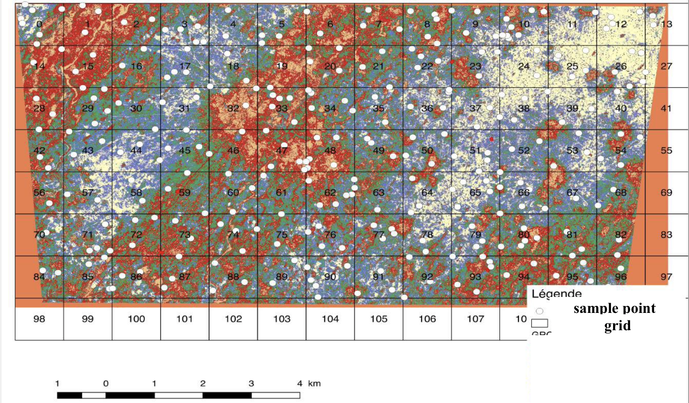

Figure 3. Combined environmental stratification using NDVI classes, soil reflectance indices (BI, BSI, RI), and terrain attributes guiding sampling allocation.
3.2. Allocation Procedure

Sampling allocation was implemented through a structured four-step procedure designed to ensure methodological transparency and ecological coherence.
First, relevant environmental covariates were extracted from satellite imagery and digital elevation models, including vegetation indices, soil reflectance indices, and terrain attributes.

Second, these covariates were used to define environmentally homogeneous strata through ecological classification.

Third, sampling points were proportionally distributed across the identified strata to guarantee balanced representation of vegetation density gradients, soil exposure classes, and topographic conditions.

Finally, field validation was conducted to adjust sampling locations according to accessibility constraints, land-use patterns, and logistical feasibility.

This hybrid framework combines data-driven environmental stratification with expert ecological interpretation. By integrating quantitative classification and field-based adjustment, the design enhances spatial representativeness while maintaining operational efficiency in heterogeneous Sahelian agroecosystems.

3.3. Operational Considerations

Sampling density was optimized to balance spatial representativeness and logistical feasibility. In semi-arid contexts where field access and resource constraints are significant, excessive sampling may not translate into proportional gains in spatial inference.
Bias-reduction strategies included deliberate representation of rare ecological classes and avoidance of clustering in easily accessible zones such as roadsides or village peripheries. This approach mitigates spatial bias commonly associated with convenience-based sampling.
The proportional stratification logic aligns with Digital Soil Mapping (DSM) methodological recommendations emphasizing covariate-guided sampling and representation of environmental variability (McBratney et al., 2003; Minasny et al., 2013). In addition, sampling design studies show that DSM calibration benefits when samples are well spread not only in geographic space but also in multivariate covariate (feature) space, particularly when machine learning models are used (Wadoux et al., 2019). Where exhaustive covariate layers are available, covariate-optimized designs (e.g., cLHS and related feature-space approaches) are widely recognized as effective strategies to improve representativeness while maintaining operational feasibility (Minasny & McBratney, 2006).
Finally, rigorous comparison frameworks have been proposed to evaluate sampling designs using repeated sampling distributions of map quality indices, underlining that “good” designs are those that consistently deliver robust predictive performance rather than merely appearing well distributed visually (Wadoux & Brus, 2021).

3.4. Originality in the Sahelian Context
This study introduces methodological innovations specifically adapted to sandy Sahelian agroecosystems.

First, the explicit integration of biogenic structures into sampling logic addresses a critical but often overlooked driver of SOC heterogeneity in drylands. Biological hotspots constitute discrete zones of carbon concentration embedded within mineral-dominated sandy matrices.

Second, the emphasis on soil reflectance indices is particularly relevant in exposed sandy environments where mineral brightness strongly influences surface spectral signatures. Their combined use with NDVI improves environmental discrimination.

Third, NDVI thresholds were calibrated to semi-arid vegetation ranges rather than adopting thresholds derived from humid environments. This improves ecological interpretability and stratification relevance.

Fourth, the nested multi-scale design simultaneously captures micro-scale variability around biological structures and broader landscape-scale gradients.

Finally, the operational adaptation of SCORPAN theory to sandy dryland conditions strengthens the conceptual coherence of the framework.

To our knowledge, few methodological frameworks have explicitly integrated biogenic structures, soil reflectance indices, and SCORPAN-based stratification within a unified multi-scale sampling design tailored to Sahelian agroecosystems.

3.5 Environmental Representativeness and Scale Interaction
The combined multi-scale sampling framework demonstrated enhanced environmental representativeness across interacting spatial gradients. By integrating NDVI classes, soil reflectance indices, and terrain attributes within a proportional allocation scheme, the design ensured balanced coverage of vegetated hotspots, exposed sandy substrates, and transitional ecological units.
This result confirms that environmental stratification improves representation of patch-structured SOC variability typical of semi-arid drylands. In Sahel sandy systems, SOC distribution is not spatially continuous but organized around localized biological concentration zones embedded within extensive mineral-dominated matrices. Conventional grid-based sampling may underrepresent such discrete high-carbon patches, leading to spatial bias.
The interaction between NDVI and soil reflectance indices revealed complementary explanatory roles. NDVI captured biomass-driven organic inputs and vegetation-controlled carbon accumulation, whereas reflectance indices enhanced detection of mineral exposure and degraded surfaces. This complementarity strengthens the ecological coherence of the stratification logic and aligns with recent SOC-DSM syntheses emphasizing the integration of remote-sensing predictors (including vegetation and bare-soil information) to improve SOC spatial modelling (Radočaj et al., 2024). More broadly, DSM reviews of SOC mapping also underline the central role of covariate selection and open remote-sensing data streams in improving large-area SOC products (Lamichhane et al., 2019; Radočaj et al., 2024) and in global soil information systems (de Sousa et al., 2020/2021).
Moreover, independent evidence from other regions shows that chemical soil attributes can vary sharply across space, and that spatially informed designs are essential to capture heterogeneity reliably. In Madhya Pradesh, Gehlot et al. (2023) reported clear spatial differentiation of macronutrients and chemical properties, supporting the principle that sampling should be guided by spatial structure rather than convenience or uniform spacing alone (Gehlot et al., 2023).
The nested design allowed simultaneous representation of micro-scale variability around biogenic structures and broader landscape-scale gradients. Such hierarchical structuring reflects the scale-dependent behavior of SOC in dryland ecosystems, where biological hotspots and mineral surfaces coexist within short spatial distances. Termites and other soil engineers are widely recognized as drivers of soil physical and chemical heterogeneity through the creation of biogenic structures and redistribution of soil materials (Jouquet et al., 2011). Recent work further shows that the spatial expression and impacts of termite-related structures can be environmentally mediated and spatially heterogeneous, reinforcing the relevance of explicitly integrating these biogenic drivers within sampling logic (Jouquet et al., 2022; Ou et al., 2025).
From an operational perspective, proportional allocation across combined strata reduced clustering bias and minimized over-representation of easily accessible zones. This strengthens the reliability of spatial inference and supports subsequent digital soil mapping calibration.
Overall, the results demonstrate that coupling process-based understanding (SCORPAN framework) with covariate-guided environmental stratification enhances both methodological robustness and ecological interpretability in heterogeneous Sahelian sandy agroecosystems (McBratney et al., 2003; Minasny et al., 2013).

Conclusion
A structured, process-oriented, multi-scale sampling strategy significantly enhances the spatial representativeness of soil organic carbon (SOC) in heterogeneous Sahelian sandy agroecosystems. By integrating SCORPAN principles with ecological process understanding, explicit targeting of biogenic structures, and covariate-guided environmental stratification, the proposed framework establishes a strong conceptual and operational link between soil-forming factors and sampling allocation.

The nested design effectively captures both micro-scale biological hotspots and broader landscape-scale gradients, thereby reducing sampling bias and improving environmental coverage across vegetation, mineral exposure, and terrain contrasts. This integration strengthens the robustness of SOC spatial inference and enhances the ecological coherence of digital soil mapping initiatives.

Beyond methodological contributions, the framework provides a transferable foundation for soil monitoring, carbon stock assessment, and sustainable land management strategies in semi-arid drylands increasingly affected by climate variability and land degradation.

COMPETING INTERESTS DISCLAIMER:
Authors have declared that they have no known competing financial interests OR non-financial interests OR personal relationships that could have appeared to influence the work reported in this paper.

Disclaimer (Artificial intelligence)
Author(s) hereby declare that NO generative AI technologies such as Large Language Models (ChatGPT, COPILOT, etc.) and text-to-image generators have been used during the writing or editing of this manuscript.

References

- Arrouays, D., Deslais, W., & Badeau, V. (2002). Contribution of soil organic carbon to carbon sequestration. Comptes Rendus Geoscience, 334, 549–556.
- Bossio, D. A., Cook-Patton, S. C., Ellis, P. W., Fargione, J., Sanderman, J., Smith, P., et al. (2023). The role of soil carbon in natural climate solutions. Global Change Biology, 29, 1–15.
- Brus, D. J., & de Gruijter, J. J. (1997). Random sampling or geostatistical modelling? Geoderma, 80, 1–18.
- Chenu, C., Angers, D. A., Barré, P., Derrien, D., Arrouays, D., & Balesdent, J. (2014). Increasing organic carbon stocks in agricultural soils. Agriculture, Ecosystems & Environment, 188, 147–155.
- Cui, Z., Li, Y., Zhang, X., et al. (2025). Integrating Sentinel-2 time-series data and ensemble models for soil organic carbon mapping. Sensors, 25, 2184.
- FAO. (2023). Global Soil Organic Carbon Sequestration Potential Map (GSOCseq). Rome, Italy: Food and Agriculture Organization of the United Nations.
- Gehlot, Y., Aakash, Gallani, R., Jadon, P., Singh, V., Kamle, S., … Mandloi, S. (2023). Spatial variability of soil macronutrients and chemical properties in Ujjain Tehsil of Ujjain District of Madhya Pradesh, India. International Journal of Plant & Soil Science, 35(21), 325–335. https://doi.org/10.9734/ijpss/2023/v35i213980
- Jenny, H. (1941). Factors of soil formation: A system of quantitative pedology. McGraw-Hill.
- Ji, X., Chen, Y., Zhang, H., & Li, Z. (2024). Digital mapping of soil organic carbon using Sentinel-2 spectral indices. Ecological Indicators, 142, 112654.
- Lal, R. (2004). Soil carbon sequestration impacts on global climate change and food security. Science, 304, 1623–1627.
- Lal, R. (2022). Soil organic matter and water retention. Journal of Soil and Water Conservation, 77, 256–263.
- Lehmann, J., & Kleber, M. (2015). The contentious nature of soil organic matter. Nature, 528, 60–68.
- McBratney, A. B., Mendonça Santos, M. L., & Minasny, B. (2003). On digital soil mapping. Geoderma, 117, 3–52.
- Minasny, B., & McBratney, A. B. (2006). A conditioned Latin hypercube method for sampling in the presence of ancillary information. Computers & Geosciences, 32, 1378–1388.
- Minasny, B., Malone, B. P., & McBratney, A. B. (2013). Digital mapping of soil carbon. Advances in Agronomy, 118, 1–47.
- Minasny, B., Malone, B. P., McBratney, A. B., Angers, D. A., Arrouays, D., Chambers, A., et al. (2023). Global soil organic carbon assessment and implications for land management. Nature Communications, 14, 1–10.
- Nait-Taleb, O., Benslama, M., & Chenchouni, H. (2025). Spectral index analysis for soil degradation monitoring. Frontiers in Soil Science, 5, 1553887.
- Pouladi, N., & Triantafilis, J. (2023). Digital soil mapping of soil organic carbon: A systematic review. Catena, 232, 107409.
- Radočaj, D., Gašparović, M., & Jurišić, M. (2024). Remote sensing data in digital soil organic carbon mapping: A review. Agriculture, 14, 1005.
- Sollins, P., Homann, P., & Caldwell, B. A. (1996). Stabilization and destabilization of soil organic matter: Mechanisms and controls. Geoderma, 74, 65–105.
- Vajra Hyndavi, S. D. R., Sankati, J., Cherukuri, P., & Balachnadra, Y. (2026). Enhancing soil nutrient use efficiency using organic manure for sustainable soil health management. In O. R. Devi, J. Sankati, A. J. Prince, & N. Kumar (Eds.), Sustainable crop intensification and soil health management (pp. 242–268). Ninetales Publishings.
- Wiesmeier, M., Mayer, S., Paul, C., Don, A., Franko, U., Hübner, R., et al. (2024). Soil organic carbon sequestration and climate change mitigation. Global Change Biology, 30, 1–17.
- Zanini, M., Castaldi, F., & Casa, R. (2024). Soil reflectance composites for digital soil mapping. Remote Sensing, 17, 89.

