Genetic Variability and Trait Association Analysis in Sesame (Sesamum indicum L.)

Abstract
Analysis of variance, PCV, GCV, heritability, genetic advance, and Correlation gives the information about mutual association between two variables on the basis of which breeders can select superior genotypes for seed yield. The present investigation was conducted to study the phenotypic and genotypic variability among the genotypes and to estimate genetic advance, correlation coefficient among the characters and on yield of sesame. The study was conducted during summer 2024 at RARS, Polasa, Jagtial, to evaluate genetic variability among fifteen sesame (Sesamum indicum L.) genotypes. Analysis of variance revealed significant differences among the genotypes for all traits studied. The highest genotypic coefficient of variation (GCV) and phenotypic coefficient of variation (PCV) was observed for the number of capsules per plant. Number of branches per plant and number of capsules per plant exhibited high heritability along with high genetic advance (GAM), suggesting these traits are primarily controlled by additive gene effects. Therefore, phenotypic selection for these traits could be effective for future breeding programmes.
Keywords: Genetic variability; heritability; genetic advance as percent of mean, Sesamum.
Introduction
Sesame (Sesamum indicum L.) is an ancient oilseed crop and an economically very important crop, but it has been neglected and underutilized compared with other crop species; consequently, there is still much room for its genetic improvement (Pandey et al., 2021). It is the oldest oilseed crop, is widely grown during the rainy season with inadequate management and is often subject to the vagaris of rainfall. Sesame is renowned for its exceptional oil quality. The crop is primarily grown for its seeds, which have the highest oil content (44–55%), protein content (22-25%), and are rich in antioxidants like sesamin (0.4–1.1%), sesamolin (0.3–0.6%), and are resistant to oxidation because they contain tocopherols and lignans, which are endogenous antioxidants (Sonia et al., 2024). Sesame seeds are the rich source of fat, proteins, minerals, Ca and Fe. High percentage of unsaturated fatty acids are found in sesame oil i.e. oleic acid and linoleic acid. Keeping quality of sesame oil is more due to the high percentage of antioxidant present in it. Sesame oil is used in industrial purpose like insecticides, pharmaceutical and paints(Sharma and Chauhan, 1984). Sesame is very famous food additive in Indian household to enhance food flavor (For improvement in a particular trait of the sesame crop, the genetic variability present in the crop needs to be assessed and exploited. Analysis of variance, PCV, GCV, heritability, genetic advance, and Correlation gives the information about mutual association between two variables on the basis of which breeders can select superior genotypes for seed yield. This manuscript is important for the scientific and plant breeding community as it provides clear evidence of substantial genetic variability among sesame genotypes under field conditions. By identifying key yield contributing traits with high heritability and genetic advance, the study offers reliable selection criteria for improving sesame productivity. The findings contribute to a better understanding of the genetic architecture of economically important traits in sesame and can directly support the development of high yielding varieties through efficient breeding strategies. The present investigation was conducted to study the phenotypic and genotypic variability among the genotypes and to estimate genetic advance, correlation coefficient among the characters and on yield of sesame.
2. MATERIALS AND METHODS
The study was conducted at Regional Agricultural Research Station, Polasa, Jagtial, during summer 2024. A total of fifteen sesame genotypes of diverse origin were taken for the present study. The fifteen genotypes were raised in Randomized Block Design (RBD) with three replications. Each genotype was sown in ten rows of three metres length with inter-row spacing of 30 cm and intra row spacing of 15 cm. Sowing was done by dibbling the seed at 2-3 cm depth. Recommended agronomic practices and need based plant protection measures were undertaken. Observations were recorded on five randomly selected plants per replication. The following characters were observed and recorded. Days to 50 percent flowering, Plant height at maturity (cm), Number of branches per plant, Number of capsules per plant, 1000 seed weight (g) and Seed yield (kg/ha). Data from five plants of each genotype were averaged replication wise and mean data was used for statistical analysis. Mean, range and coefficient of variation were also estimated. GCV and PCV were calculated as per Burton and de Vane (1953), heritability (broad sense) as per Allard (1960) and genetic advance and GAM according to Johnson et al. (1955), and correlation coefficient analysis by Robinson et al., (1951). Estimates of heritability and genetic advance as a percentage of the mean (GAM) were also computed. According to the classification by Sivasubramanian and Madhavamenon (1973), both phenotypic and genotypic coefficients of variation are categorized as high (>20%), moderate (10–20%), and low (<10%). Heritability (h²) estimates were classified by Johnson et al.(1955) as low (0–30%), medium (30–60%), and high (>60%). Similarly, genetic advance as a percentage of mean was categorized by Johnson et al. 1995 as low (<10%), moderate (10–20%), and high (>20%). All statistical analyses were conducted using R software version 4.5.1
3. RESULTS AND DISCUSSION
The numerical data collected on quantitative characters were statistically analyzed and showed highly significant differences among the genotypes under study for all the nine traits viz., days to 50 percent flowering, plant height at maturity (cm), number of branches per plant, number of capsules per plant, 1000 seed weight (g) and seed yield (kg/ha) indicating the presence of considerable genetic variability among the experimental material under study. PCV was slightly higher than GCV for all the characters revealing the presence of environmental influence on the expression of these characters under study (Table 1). The high genotypic and phenotypic coefficient of variation was observed for number of capsules per plant (21.83 and 23.7). It indicating substantial genetic variability with minimal environmental influence, making this trait highly amenable to improvement through simple selection methods similar finding reported by Padmaja et al., (2026), and Gayathri et al., (2025) and Ashfaq et al. (2025).
Moderate GCV (17.69) and high PCV (23.00) was observed in number of branches per plant. Similar findings were recorded by Vamshi et al. (2021). Low GCV and moderate PCV were observed for plant height (5.72, 11.07) and seed yield (8.29, 12.75). Similar results were found by Rajitha et al. (2021) and Mahla et al. (2024) for plant height and Pavani et al. (2020) for seed yield. Low GCV and PCV was observed for days to 50% flowering (5.01, 6.70) and days to maturity (2.43, 2.63) and test weight (5.94, 6.63). The small difference between these two estimates might be due to less environmental influence on this character This is in consonance with the findings of Padmaja et al., 2026, Gayathri et al., (2025) Ashfaq et al. (2025) for days to 50% flowering and days to maturity and Pavani et al. (2020) for test weight
Heritability and Genetic Advance as Percent of Mean
Heritability reflects the proportion of total phenotypic variation that can be attributed to genetic factors, whereas genetic advance estimates the expected improvement in a trait through selection. Together, these parameters provide valuable insights for plant breeders in designing effective strategies to develop improved crop varieties. Broad-sense heritability helps determine the extent to which observed variation is genetically controlled. Genetic advance, on the other hand, predicts thelevel of improvement achievable in future generations through selection and serves as a useful tool for enhancing genetic gain in breeding programmes.
High heritability with (85.0) accompanied by high genetic advance as a percentage of the mean (41.36) indicate that additive gene action is predominant, making them highly responsive to selection for number of capsules per plant. These results are similar with the findings of Swapna et al. 2024 and Padmaja et al., 2026. Moderate heritability with high genetic advance as per cent of mean for number of branches per plant (59.0, 35.90). Swapna et al. (2024) and Ashfaq et al. (2025) reported high genetic advance as per cent of mean. Moderate heritability was reported by Rajitha et al. (2021) and Mitkari et al. (2023). It indicates direct selection for the number of branches per plant would be highly effective for improving yield. Similar results with the findings of Menzir (2012). Moderate heritability with moderate genetic advance as per cent of mean for seed yield (42.0, 11.12). These results are similar with the findings of Abate et al. (2015). High heritability with moderate genetic advance as per cent of mean for test weight (80.0, 10.95) These results were in agreement with Mitkari et al. (2023). Hence, direct selection would be ineffective for the improvement of this trait and further improvement would be possible through heterosis breeding.

Moderate heritability with low genetic advance as per cent of mean for days to maturity (56.0, 7.73), plant height (27, 6.10). The results of the present investigation were in accordance with Abate et al. (2015). Thouseem et al. (2022) for days to maturity and plant height results were in conformity with the findings of Saxena and Bisen (2017) and Mahla et al. (2024). Moderate heritability with low genetic advance as per cent of mean for days to 50% of flowering (56.0, 7.73). Moderate heritability and low genetic advance as percent of mean of this trait indicates that this trait is governed by non additive gene effects play an important role in the expression of this trait. Therefore, the results indicated a little scope for further improvement through individual plant selection. These results are similar with the findings of Bindu et al. (2014) and Mahla et al.2024 (Table 2).
Correlation coefficients
The estimates of correlation coefficients between seed yield and other yield contributing traits were given in Table 2. Relative higher magnitude of correlation coefficients indicating a strong heritable association among various yield contributing characters. Therefore, selection based on the phenotype would be effective for yield improvement. The number of capsules per plant had positive significant correlation with seed yield (0.705). These results are similar with the findings of Padmaja et al., 2026 and Maheetha et al., 2025. Days to maturity exhibited significant positive association with days to 50% flowering (0.802). These results are similar with the findings of Maheetha et al., 2025. This type of character association indicates the improvement in seed yield can be achieved by improving the characters like number of capsules per plant.

Table 1. Variability parameters, heritability and genetic advance as per cent of mean for yield and yield component traits
S.No. | Character | Range | General Mean | Vg | Vp | Coefficient of variation |  | Heritability (%) | Genetic advance as per cent of mean
 |  |  |  |  |  | GCV (%) | PCV (%) | (Broad Sense) | Genetic advance as per cent of mean
1 | Days to 50% flowering | 31-39 | 35.76 | 3.21 | 5.74 | 5.01 | 6.7 | 56.00 | 7.73
2 | Plant height (cm) | 86-119 | 99.85 | 32.65 | 122.13 | 5.72 | 11.07 | 27.00 | 6.1
3 | Days to maturity | 87-95 | 90.8 | 4.85 | 5.71 | 2.43 | 2.63 | 85.00 | 4.61
4 | Number of branches per plant | 3-6 | 3.89 | 0.47 | 0.8 | 17.69 | 23 | 59.00 | 28.01
5 | Number of capsules per plant | 53-105 | 72.04 | 247.25 | 292.12 | 21.83 | 23.72 | 85.00 | 41.36
6 | Seed yield (Kg/ha) | 812-1091 | 916.71 | 5779.29 | 13652.57 | 8.29 | 12.75 | 42.00 | 11.12
7 | Test weight (g) | 2.93-3.57 | 3.16 | 0.04 | 0.04 | 5.94 | 6.63 | 80.00 | 10.95

Table 2. Correlation of seed yield with other yield component traits in sesame
 | Days to 50% flowering | Plant height (cm) | Days to maturity | Number of branches per plant | No. of capsules/  Plant | Test weight | Seed yield
Days to 50% flowering | 1.000 | -0.097 | 0.802 *** | 0.057 | -0.058 | -0.111 | 0.032
Plant height (cm) |  | 1.000 | -0.133 | -0.019 | 0.123 | 0.100 | 0.140
Days to maturity |  |  | 1.000 | -0.131 | 0.010 | 0.023 | 0.054
Number of branches per plant |  |  |  | 1.000 | -0.095 | -0.038 | -0.053
No. of capsules/Plant |  |  |  |  | 1.000 | 0.016 | 0.705***
Test weight |  |  |  |  |  | 1.000 | 0.127
Seed yield |  |  |  |  |  |  | 1.000

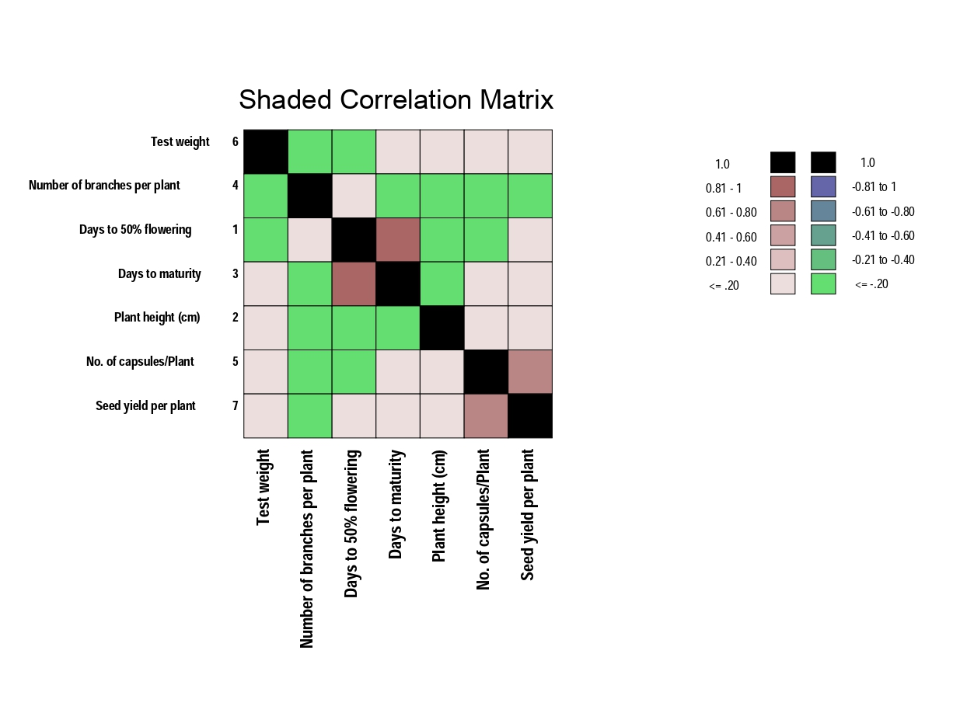

Conclusion
The study revealed that traits viz., number of capsules per plant are to be given more importance during selection programme and direct selection for seed yield through these traits could be effective for seed yield improvement in sesame.

Disclaimer (Artificial intelligence)

Author(s) hereby declare that NO generative AI technologies such as Large Language Models (ChatGPT, COPILOT, etc.) and text-to-image generators have been used during the writing or editing of this manuscript.

References
Abate M, Mekbib F. Assessment of genetic variability and character association in Ethiopian low altitude sesame (Sesamum indicum L.) genotypes. J Adv Stud Agric Biol Environ Sci. 2015;2(3):55-66.
Allard RW. Principles of Plant Breeding. New York: John Wiley & Sons; 1960.
Ashfaq, M., Jhansi Rani, K., Padmaja, D., Yadav, P., & Kiran Betha, U. (2025). Assessment of genetic variability and character association among agromorphological and nutritional quality traits of sesame (Sesamum indicum L.) genotypes. International Journal of Advanced Biochemistry Research, 9, 727-732. https://doi.org/10.33545/26174693.2025.v9 .i2j.3871.
Bindu, M.R., Sushamakumari, P., Indira, M., Vilasini, T.N., Seeja, S. and Achamma Yohannan, Ansu (2014). Genetic variability, heritability and genetic advance for yield and its components in sesame (Sesamum indicum L.). Internat. J. Plant Sci., 9 (1): 167-169
Burton GW, de Vane EH. Estimating heritability in Tall Fescue (Festuca arundinacea) from replicated clonal material. Agron J. 1953;45:481-7.
Burton, G.W. (1952) Quantitative Inheritance in Grass Pea. Proc. 6th Grassl. Cong. Vol. 1, 277-283
Fisher, R., A. and Yates, F. 1938. Statistical Tables for Biological, Agricultural and Medical Research (first ed.), London: Oliver & Boyd. Johnson, H. W., Robinson, H. F. and Comstock, R. E. 1955. Estimates of genetic and environmental variability in soybean. Agronomy Journal, 47: 314–318.
Gayathri, R., Padmaja, D., Rani, K. J., Yadav, P., & Balram, N. (2025). Exploration of genetic parameters for yield and quality traits among genotypes of sesame (Sesamum indicum L.). International Journal of Advanced Biochemical Research, 9(8S), 678-682. https://doi.org/10.33545/26174693.2025.v9 .i8Sk.5233
Johnson, H. W., Robinson, H. F., & Comstock, R. E. (1955). Estimates of genetic and environmental variability in soybeans. Agronomy Journal, 47, 314-318. https://doi.org/10.2134/agronj1955.00021962004700070009x
Maheetha P., Jahagirdar J.E. and Deshpande D.P. 2025. Study Of Correlation And Path Analysis In Sesame (Sesamum indicum L.) Plant Archives 25 (1,) : 948-952
Mahla NU, Jagtap PK, Patel HR. Genetic variability and association among yield and yield related traits of sesame (Sesamum indicum L.) genotype. Int J Plant Soil Sci. 2024;36(2):197-206.
Menzir A (2012). Phenotypic variability, divergence analysis and heritability of characters in sesame (Sesamum indicum L.) genotypes. Nature Science;10(10):117-126]. (ISSN: 1545-0740). http://www.sciencepub.net/nature .
Mitkari, S. B., Wankhade, M. P., Ghuge, S. B., Udawant, S. S., & Tirkar, A. N. (2023). Correlation analysis for seed yield and its related attributes in genotypes of sesame (Sesamum indicum L.). The Pharma Innovation Journal. https://www.thepharmajournal.com/archive s/2023/vol12issue12/PartA/12-12-10 999.pdf.
Padmaja, D., N. Balram, and G. Sreenivas. 2026. “Assessment of Genetic Variability and Trait Correlations in Sesame Genotypes Using Morphological Characters”. Journal of Experimental Agriculture International 48 (1):134-39.
Pandey BB, Ratnakumar P, B UK, Dudhe MY, Lakshmi GS, Ramesh K and Guhey A (2021) Identifying Traits Associated With Terminal Drought Tolerance in Sesame (Sesamum indicum L.) Genotypes. Front. Plant Sci. 12:739896. doi: 10.3389/fpls.2021.739896.
Panse VG, Sukhatme PV. Statistical Methods for Agricultural Workers. New Delhi: ICAR; 1985. p. 235 46.
Pavani K, Lal Ahamed M, Ramana JV, Sirisha ABM. Studies on genetic variability parameters in sesame (Sesamum indicum L.). Int J Chem Stud 2020;8(4):101-104. DOI: 10.22271/chemi.2020.v8.i4b.9673
Rajitha D, T Srikanth, D Padmaja, & T Kiran Babu. (2021). Genetic variability and heritability studies among genotypes of sesame (Sesamum indicum L.): Genetic Variability And Heritability Studies Among Genotypes Of Sesame. Journal of Oilseeds Research, 38(1). https://doi.org/10.56739/jor.v38i1.136826.
Robinson HF, Comstock RE, Harvey PH. Genotypic and phenotypic correlation in corn and their implication in selection. Agron J. 1951;43:282-287.
Saxena K and Bisen R 2017. Genetic variability, heritability and genetic advance for the phenotypic traits in sesame (Sesamum indicum L.). International Journal of Pure and Applied Bio-Science, 5(2): 1126-1131. DOI: https://doi.org/10.18782/2320-7051.2836.
Sharma, R. K., & Chauhan, R. P. S. (1984). Genetic architecture of yield and its components in sesame (Sesamum indicum L.). Indian Journal of Agriculture Science, 54(1), 1–5.
Sivasubramanian S, Madhavamenon P. Genotypic and phenotypic variability in rice. Madras Agric J. 1973;60:1093-6.
Sonia E, Ratnakumar P, Pandey BB, Ramesh K, Reddy SN, Hemalatha V, Sravanthi A. L., John Daniel P. S., Manikanta Ch. L. N., Ramya K. T., Anusha P. L., Y. Praduman, Padmaja D. The influence of plant growth modulators on physiological yield and quality traits of sesame (Sesamum indicum L.) cultivars under rainfed conditions. Agric Res. 2024;13:436–49 . https://doi.org/10.1007/s40003-024-00704-y.
Swapna, B., Srikanth, T., Padmaja, D., & Srinivasnaik, S.2024). Unveiling genetic variability and breeding potential for yield enhancement in sesame (Sesamum indicum L.). Journal of Scientific Research and Reports, 30(12), 361-368. https://doi.org/10.9734/jsrr/2024/v30i12268 0
Thouseem N, Arya K, Gayathri G, Anju Mariam Joseph. Genetic variability, heritability and genetic advance for seed yield and yield associated traits in White seeded sesame (Sesamum indicum L.). Pharma Innovation 2022;11(6):385-388.

Vamshi P, Ramya KT, Prasad MS, Ramana JV, Kumhar SR. Genetic variability studies for yield and yield attributes in breeding lines of sesame (Sesamum indicum L.). J Oilseeds Res. 2021;38(3):240-3.

