Tillage and nitrogen fertilization effects on growth of rabi maize

Abstract
The improper tillage operations and irrational nitrogen fertilizer application has become a major threat to soil health resulting in environmental problems. Soil tillage practices suitable for agroecological region along with optimum nitrogen fertilizer application is a prerequisite for proper growth and higher yields of maize. In this study field experiment was conducted during rabi 2022 to detect combined effect of tillage systems (zero tillage-ZT, reduced tillage-RT and conventional tillage-CT) and nitrogen fertilization levels (75% N, 100% N and 125% N) on growth and yield of rabi maize succeeding soybean. Growth parameters including dry matter production, SPAD readings, CGR and AGR at different growth stages of crop are significantly highest with convention tillage compared to reduced and zero tillage. Similarly, among N fertilization levels, 125% N application showed higher growth parameters which is on par with 100% N and lower growth with 75% N application. Hence conventional or reduced tillage with 100% N may be followed for proper growth, yield and economic benefits.

Key words; Soil tillage systems, nitrogen fertilization, maize, growth

Introduction
Cereals are the major source of food all over the world, maize is third important cereal crop after wheat and rice cultivated over a large area due to its several beneficial uses. Maize grain is also a staple food which supply approximately 2/3 calories and proteins either directly or indirectly for humans and animals (Simic et al., 2020). It is gaining huge importance due to its multiple uses, as grain having high nutritional value due to presence of proteins, vitamins and antioxidants, such as carotenoids, phenols and tocopherols. Biomass is used as raw material in industry, feed and fodder. Maize is primarily cultivated as kharif crop in India, though it is also grown as rabi crop in southern and eastern India due to prevailing favorable climatic conditions and gaining higher yields (Gogoi et al., 2025). Globally maize is cultivated in area of 203.22 m ha where as in India it is cultivated over 11 m ha with productivity of 3410 kg ha⁻¹ (USDA, 2024). In Telangana maize is grown in area of 2.03 lakh ha (MOAFW, 2023-24).
Among various agronomic practices tillage of soil is the prominent one which having numerous effects on soil properties such as water retention, soil aeration, temperature and nutrient availability (Wozniak and Rachon, 2020). Hence, proper soil tillage helps in enhancing the crop growth and yield by developing good underground root distribution which enhance nutrient absorption (Chen et al., 2026). Recent advanced techniques of tillage such as conservation tillage practices adding many benefits to the farmer (Sumitra et al., 2025). Reduced tillage and zero tillage practices are being followed by many farmers in recent times due to their advantages in reducing soil erosion, soil moisture conservation, adding organic carbon and also reducing cost on fuel and labor (Chetan et al., 2022). Hence there is need to understand suitable tillage system for the maize crop to gain higher growth and yields specific to soil and climatic condition.
Compared to other cereals maize is high nutrient demanding crop due to production of heavy biomass above the ground. Among several nutrients nitrogen is most indispensable nutrient plays key role in plant growth and development (Singh et al., 2022); hence time, method and rate of nitrogen application are important practices which show huge impact on the maize crop (Davies et al., 2020, Hammad et al., 2018). As the Indian soils are mostly low in nitrogen levels there is always a need of applying nitrogen fertilizers to replenish the soil nitrogen content. Response of maize crop to nitrogen is very high so, farmers always try to apply high amount of N fertilizers to obtain maximum yields. The excessive use of fertilizers, especially nitrogen fertilizers, leads to loss of nitrogen (leaching, denitrification, volatilization and surface runoff) causing environmental problems such as soil acidification, water pollution and eutrophication. Simultaneously decreases nitrogen use efficiency (Li et al., 2023).
To enhance NUE, organic carbon content and reduce soil erosion relies on selecting suitable tillage system and optimum nitrogen fertilizer application rate. The aim of present study was to investigate the impact of different soil tillage practices and nitrogen fertilization levels on growth of rabi maize succeeding soybean.

Material and methods
The experiment was carried out at Agricultural Research Station, Karimnagar, Telangana during rabi 2022. Which is located in Northen Telangana zone at an altitude of 259.15 m above mean sea level, it comes under semi-arid tropical zone (SAT) according to trolls’ classification. Weakly mean maximum and minimum temperature is 24.9ºC and 18ºC over crop duration. Total rainfall received over crop period is 64 mm and average evaporation was 2.7 mm per day. The soil of experimental field is sandy loam with 78% sand, 10% silt and 12% clay in sample from 0-30 cm depth and nutrient status is low in available N (198 kg ha⁻¹), high in available P (26.4 kg ha⁻¹) and K (335 kg ha⁻¹).
The experiment consisted of 27 plots arranged in split plot design with 3 replications. The main plots were three soil tillage systems: zero tillage (ZT), reduced tillage (RT) and conventional tillage (CT). Subplots are with three nitrogen fertilization levels: 75% N,100% N and 125% N while phosphorus and potassium were applied 100% to all treatments equally. Crop is sown during rabi season succeeding soybean with a spacing of 60 X 20 cm and other management practices were commonly done to all treatment. For growth analysis five plants from each plot selected randomly, oven dried at 65^{O}C temperature for 24 hours to obtain dry weight, chlorophyll content is determined by using chlorophyll meter (Konica Minolta SPAD 502 plus) from healthy leaves. The data obtained was statistically analyzed by using split plot design (Gomez and Gomez, 1984).

Results and discussion

SPAD Chlorophyll meter readings
SPAD readings show the real time chlorophyll content in the leaves, the effect of soil tillage system and nitrogen fertilization on SPAD readings at different growth stages was show in fig. 1, where interaction showed no significant effect.
Upon reviewing the data, it is evident that, conventional tillage treatment at different growth stages (60.7, 50.7, 29.8) exhibited significantly highest SPAD chlorophyll meter readings and it is statistically comparable to reduced tillage (56.8, 47.0, 26.3). In turn Zero tillage treatment recorded significantly lowest SPAD chlorophyll meter readings (53.2, 44.0, 23.4), which is statistically comparable to reduced tillage at silking, dough and physiological maturity stages respectively. Higher chlorophyll content by conventional tillage due to decreasing bulk density which enhances water and nutrient uptake (Topa et al., 2021). With conventional tillage, there was a notable increase in the mineral nitrogen content, which subsequently led to a heightened level of leaf greenness and improved canopy light absorption (Ramadhan, 2022).
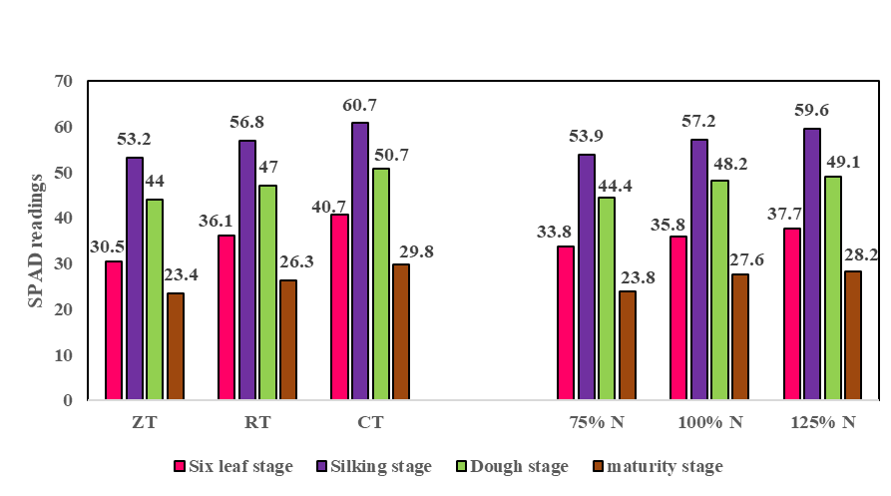
The treatment utilizing 125% N exhibited significantly highest SPAD values (59.6, 49.1, 28.2) which is statistically on par with 100% N application (57.2, 48.2, 27.6). While significantly lowest in 75% N application (53.9, 44.4, 23.8) respectively at silking, dough and physiological maturity stages. Chlorophyll content is an important indicator of plant nitrogen status, as the nitrogen is the component of chlorophyll porphyrin ring. SPAD readings indicate the leaf greenness and its nitrogen content (Li et al., 2022). This might be due to the fact that distribution of more N evenly during each growth stage resulted in maintenance of higher auxin level which in turn resulted in better plant growth parameters and likely contributed to the chlorophyll content in the leaves (Shivashankar et al., 2025). These lines are in agreement with the findings of Stesi et al. (2020), Liu et al. (2011).

Figure 1. SPAD readings of maize as influenced by soil tillage systems and N fertilization levels at different growth stages

Dry matter production (g m⁻²)
Dry matter accumulation increased consistently at six leaf, silking, dough and physiological maturity stages and was found to be significantly influenced by tillage and nitrogen levels. While interaction effect was found non- significant.
At silking stage, the maize crop with conventional tillage recorded significantly highest dry matter production (709.1 g m⁻²) which is on par with reduced tillage (644.6 g m⁻²) and significantly lowest was noticed in zero tillage treatment (545.4 g m⁻²). While at six leaf, dough and physiological maturity stages, the dry matter production recorded significantly highest in conventional tillage with 87.7, 1058.0 and 1220.1 g m⁻² respectively. This was followed by reduced tillage (72.8, 930.0, 1077.3 g m⁻² respectively) which in turn recorded significantly higher dry matter production over zero tillage (61.3, 788.2 and 925.9 g m⁻² respectively). As conventional tillage increases availability of nutrients, moisture, microbial activity (Nugroho et al., 2023) and lower weed interference enhanced biomass production. The results are in accordance with the findings of Kumar et al. (2018). Higher dry matter accumulation noted with conventional tillage due to favorable soil conditions Kumar et al., (2025).

The effect of nitrogen levels on maize crop reveals that 125% N application exhibited significantly increased dry matter production of 666.5, 968.8 and 1122.6 g m⁻² at silking, dough and physiological maturity stages respectively. It is on par favorably to maize crop utilizing 100% N with 644.1, 941.3 and 1090.2 g m⁻² at silking, dough and physiological maturity stages respectively. While, significantly lowest dry matter production was recorded with 75% N application at all growth stages with 69.6, 588.5, 866.1 and 1010.6 g m⁻² respectively. The increase in dry matter with increase of nitrogen application due to increase in biomass, leaf area index and improved solar radiation assimilation (Cheng et al., 2025). As nitrogen is major component of photosynthates which result in biomass enhancement (Meena et al., 2021). Further, an extension of the time it takes for the plants to attain maturity can be used to explain why dry matter output increased with higher nitrogen application rates. Assefa et al. (2019) reported similar results.
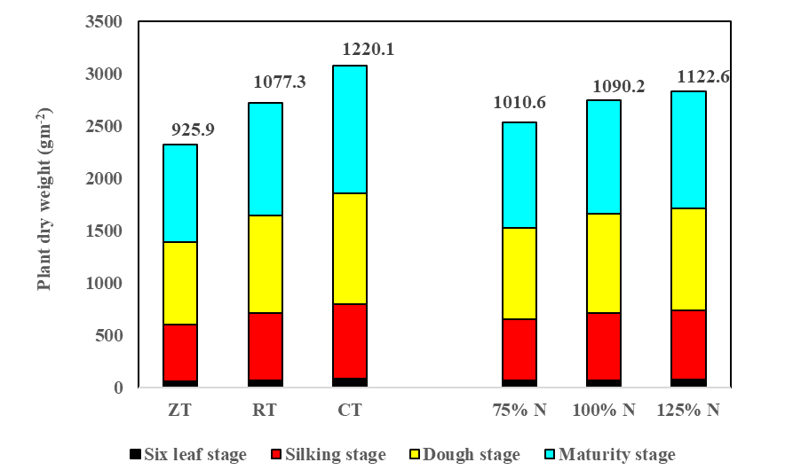

Figure 2. Dry matter production of maize as influenced by soil tillage systems and N fertilization levels at different growth stages.
Crop growth rate (CGR): (g m⁻² day⁻¹)
The crop growth rate of maize crop was significantly affected by different tillage and nitrogen levels at six leaf, silking, dough and at physiological maturity stages (Table. 1). While interaction was non-significant.
Maize crop growth rate was increased rapidly up to silking stage and further, the rate of growth was reduced. In the context of different tillage practices, maize crop with conventional tillage demonstrated significantly superior crop growth rate from six leaf to silking and from silking to dough stages (172.6 and 96.9 g m⁻² day⁻¹ respectively) which is statistically on par with minimum tillage (158.8 and 79.3 g m⁻² day⁻¹). In turn minimum tillage was on par with zero tillage (134.5 and 67.4 g m⁻² day⁻¹) from six leaf to silking and from silking to dough stages respectively. While up to six leaf and up to physiological maturity stages highest crop growth rate was recorded under conventional tillage (24.4 and 45.0 g m⁻² day⁻¹ respectively). This was followed by reduced tillage (20.2 and 40.9 g m⁻² day⁻¹ respectively). Significantly lowest was noticed in zero tillage treatment (17.0 and 38.3 g m⁻² day⁻¹ respectively).
Increased nitrogen application (125% N) resulted in the highest crop growth rate (21.7 g m⁻² day⁻¹), followed by 100% N (20.6 g m⁻² day⁻¹) and 75% N application (19.3 g m⁻² day⁻¹) upto six leaf stage. Similarly, six leaf to silking, silking to dough and dough to physiological maturity stages, the crop growth rate with 125% N application (163.5, 84.0, 42.7 g m⁻² day⁻¹) were statistically comparable to 100% N application (158.3, 82.5, 41.4 g m⁻² day⁻¹ respectively). While significantly lowest growth rate was found with 75% N application (144.1, 77.1, 40.1 g m⁻² day⁻¹). The increase in crop growth rate might be due to higher LAI, assimilation of more photons, improved capacity for sunlight capture, higher photosynthesis and enhanced dry matter production. Similar findings were reported by Stesi et al. (2020), Javeed et al. (2014), Hammad et al. (2011).

Absolute growth rate (g day⁻¹)
The Absolute growth rate of maize crop was significantly affected by different tillage and nitrogen management practices at six leaf, silking, dough and physiological maturity stages (Table.1).
The absolute growth rate in maize crop was increased rapidly up to silking stage and further, the rate of growth was reduced. Conventional tillage demonstrated significantly superior absolute growth rate from six leaf to silking and from silking to dough stages (20.7 and 11.6 g m⁻² day⁻¹ respectively) which is statistically on par with reduced tillage (19.1 and 9.5 g m⁻² day⁻¹ respectively). In turn reduced tillage was on par with zero tillage 16.2 and 8.1 g m⁻² day⁻¹ at respective stages. While up to six leaf and dough to physiological maturity stages highest absolute growth rate was recorded under conventional tillage (2.9 and 5.4 g m⁻² day⁻¹ respectively). This was followed by reduced tillage (2.4 and 4.9 g m⁻² day⁻¹ respectively). Significantly lowest absolute growth rate was noticed in zero tillage treatment (2.0 and 4.6 g m⁻² day⁻¹ respectively).
Among different nitrogen levels, treatments with 125% N application recorded significantly highest absolute growth rate (19.6, 10.1, 5.1 g day⁻¹) and it is statistically on par with 100% N application treatment (19.0, 9.9, 5.0 g day⁻¹) respectively from six leaf to silking, silking to dough and dough to physiological maturity stage. While significantly lowest was noticed with 75 % N application (17.3, 9.2 and 4.8 g day⁻¹) respectively.
Table 1. Absolute growth rate (g day⁻¹) at different growth stages as influenced by tillage and nitrogen management practices in maize succeeding soybean crop.

Treatment | Up to Six  leaf stage |  | Six leaves to  Silking stage |  |  | Silking to  Dough stage |  | Dough to  Physiological  maturity stage
Tillage practices
 | CGR | AGR | CGR |  | AGR | CGR | AGR | CGR | AGR
ZT | 17.0 | 2.0 | 134.5 |  | 16.2 | 67.4 | 8.1 | 38.3 | 4.6
RT | 20.2 | 2.4 | 158.8 |  | 19.1 | 79.3 | 9.5 | 40.9 | 4.9
CT | 24.4 | 2.9 | 172.6 |  | 20.7 | 96.9 | 11.6 | 45.0 | 5.4
SEm± | 0.2 | 0.03 | 6.6 |  | 0.8 | 6.1 | 0.7 | 0.2 | 0.02
CD (0.0.5) | 0.8 | 0.13 | 26.7 |  | 3.2 | 25.4 | 3.0 | 0.9 | 0.10
Nitrogen levels
75% N | 19.3 | 2.3 | 144.1 | 17.3 |  | 77.1 | 9.2 | 40.1 |  | 4.8
100% N | 20.6 | 2.5 | 158.3 | 19.0 |  | 82.5 | 9.9 | 41.4 |  | 5.0
125% N | 21.7 | 2.6 | 163.5 | 19.6 |  | 84.0 | 10.1 | 42.7 |  | 5.1
SEm± | 0.1 | 0.02 | 3.8 | 0.5 |  | 2.1 | 0.3 | 0.4 |  | 0.05
CD (0.0.5) | 0.4 | 0.05 | 11.8 | 1.4 |  | 4.5 | 0.8 | 1.4 |  | 0.17
Tillage practices at same level of nitrogen levels
SEm± | 0.3 | 0.04 | 8.5 | 1.0 |  | 6.8 | 0.8 | 0.6 |  | 0.08
CD (0.05) | NS | NS | NS | NS |  | NS | NS | NS |  | NS
Nitrogen levels at same level of tillage practices
SEm± | 0.3 | 0.06 | 11.5 | 1.4 |  | 10.6 | 1.3 | 0.4 |  | 0.04
CD (0.05) | NS | NS | NS | NS |  | NS | NS | NS |  | NS

Interaction effect due to different tillage and nitrogen levels on absolute growth rate was found to be non-significant. At different crop growth stages, variation in absolute growth rate were observed because of differences in dry matter production per plant, higher dry matter production was responsible for more value of AGR. Less dry matter production per plant which is related with low absolute growth rate and Plant grown under conventional tillage improves aerobic condition which helped in absorption of nutrient and moisture. It resulted into more dry matter production. Similar results were also found by Kumar et al. (2022), Singh et al. (2022), Amanullah et al. (2010).

Correlation (Pearson’s correlation) analysis among growth parameters

Correlation analysis among different growth parameters of the maize crop showed significantly positive correlation (table 2). Dry matter production of the maize is positively correlated with LAI, SPAD chlorophyll readings, CGR and AGR.

Table 2. Correlation analysis among dry matter production, LAI, SPAD readings, CGR and AGR.

Growth analysis | Dry | LAI | SPAD readings | CGR | AGR
DM | 1
LAI | 0.99** | 1
SPAD readings | 0.96** | 0.95** | 1
CGR | 0.98** | 0.98** | 0.94** | 1
AGR | 0.98** | 0.99** | 0.95** | 0.99** | 1

Conclusion
Soil tillage system and nitrogen fertilization on rabi maize succeeding soybean showed significant effect on growth of crop. From the findings of experiment, it is concluded that conventional tillage system has shown higher growth compared to reduced and zero tillage systems by exhibiting various positive effects on the soil properties favorable for plant growth. While 125% nitrogen fertilization has given higher crop growth which is on par with 100% N, hence going with 100% N is the best option in according to economic benefits.

Disclaimer (Artificial intelligence)

Author(s) hereby declare that NO generative AI technologies such as Large Language Models (ChatGPT, COPILOT, etc.) and text-to-image generators have been used during the writing or editing of this manuscript.

References
- Amanullah, H., Marwat, K.B., Shah, P., Maula, N and Arifullah, S. (2010). Nitrogen levels and its time of application influence leaf area, height and biomass of maize planted at low and high density. Pakistan Journal of Botany. 41(2): 761-768.
- Assefa, K and Mekonnen, Z. (2019). Effect of level and time of nitrogen fertilizer application on growth, yield and yield components of maize (Zea mays L.) at Arba Minch, Southern Ethiopia. African Journal of Agricultural Research. 14(33): 1785-1794.
- Chen, R., Liu, Y., Zhang, X., Geng, G., Yu, L., Xu, Y., ... & Wang, Y. (2026). Mechanisms of AMF-mediated correlation between nutrient uptake and soil micropatterns in sugar beet plants under rotational and continuous cropping soil environments. Journal of Cleaner Production, 539, 147422.
- Cheng, Y., Chen, X. Y., Ren, H., Zhang, J. W., Zhao, B., Ren, B. Z., & Liu, P. (2025). Deep nitrogen fertilizer placement improves the yield of summer maize (Zea mays L.) by enhancing its photosynthetic performance after silking. BMC Plant Biology, 25(1), 172.
- Chetan, F., Rusu, T., Calugar, R.E., Chețan, C., Şimon, A., Ceclan, A., Bardaș, M. and Mintaș, O.S. (2022). Research on the interdependence linkages between soil tillage systems and climate factors on maize crop. Land, 11(10): 1731.
- Davies, B., Coulter, J.A. and Pagliari, P.H. (2020). Timing and rate of nitrogen fertilization influence maize yield and nitrogen use efficiency. Plos one, 15(5), p.e0233674.
- Gogoi, D., Bordoloi, D., Sarma, A. and Barua, N.S. (2025). Correlation and path analysis of early inbred lines of maize (Zea mays L.) for yield and yield related Traits. Indian Journal of Plant Genetic Resources, 38(01):123-130.
- Gomez, K. A and Gomez, A. A. (1986). Statistical Procedures for Agricultural Research, 2nd edition, a Willey. International Science Publication. New York (USA).
- Hammad, H. M., Ahmad, A., Azhar, F., Khaliq, T., Wajid, A., Nasim, W and Farhad, W. (2011). Optimizing water and nitrogen requirement in maize (Zea mays L.) under semiarid conditions. Pakistan Journal Botany. 43(6): 2919-2923.
- Hammad, H.M., Abbas, F., Ahmad, A., Farhad, W., Wilkerson, C.J. and Hoogenboom, G., (2018). Evaluation of timing and rates for nitrogen application for optimizing maize growth and development and maximizing yield. Agronomy Journal, 110(2): 565-571.
- Javeed, H.M.R., Zamir, M.S.I., Nadeem, M., Qamar, R., Shehzad, M., Sarwar, M.A and Iqbal, S. (2014). Response of maize phenology and harvest index to tillage and poultry manure. Pakistan Journal of Agricultural Sciences. 51(3): 633-638.
- Kumar, A., Behera, U.K., Dhar, Shiva., Shukla, Livleen., Bhatiya, Arti., Meena, M.C., Gupta, G and Singh, R.K. (2018). Effect of tillage, crop residue and phosphorus management practices on the productivity and profitability of maize (Zea mays. L) cultivation in Inceptisols. Indian Journal of Agricultural Sciences. 88(10): 1558-1567.
- Kumar, D.S., Malik, G.C., Banerjee, M. and Saren, B.K. (2025). Influence of Tillage and Nutrient Management on Growth and Yield of Maize: A Review. Journal of Scientific Research and Reports, 31(1), pp.677-689.
- Kumar, S., Rana, S.S., Sharma, N and Sharma, A. (2022). Growth analysis and yield evaluation under tillage and weed management practices in maize-wheat cropping system. Environment Conservation Journal. 24(2): 257-265.
- Li, C., Zhao, C., Zhao, X., Wang, Y., Lv, X., Zhu, X. and Song, X. (2023). Beneficial effects of biochar application with nitrogen fertilizer on soil nitrogen retention, absorption and utilization in maize production. Agronomy, 13(1), p.113.
- Li YY, Ming B, Fan PP, Liu Y, Wang KR, Hou P, Li SK, Xie RZ (2022). Effects of nitrogen application rates on the spatiotemporal variation of leaf SPAD readings on the maize canopy. The Journal of Agricultural Science 160, 32–44
- Liu, K and Wiatrak, P. (2011). Corn (Zea mays L.) plant characteristics and grain yield response to N fertilization programs in no-tillage system. American Journal of Agricultural and Biological Sciences. 6(1): 72-179
- Meena, R. K., Reddy, K. S., Gautam, R., Maddela, S., Reddy, A. R., & Gudipalli, P. (2021). Improved photosynthetic characteristics correlated with enhanced biomass in a heterotic F1 hybrid of maize (Zea mays L.). Photosynthesis Research, 147(3), 253-267.
- MOAFW. (2024). Ministry of Agriculture and Farmers Welfare (MOAFW). Annual Report. New Delhi, Government of India.
- Nugroho, P. A., Juhos, K., Prettl, N., Madarasz, B., & Kotroczó, Z. (2023). Long-term conservation tillage results in a more balanced soil microbiological activity and higher nutrient supply capacity. International Soil and Water Conservation Research, 11(3), 528-537.
- Ramadhan, M.N. (2022). Yield performance of wheat under different practices of tillage and integrated inorganic and organic fertilizers. Earth and Environmental Science.1060(1): 012090
- Shivashankar, K., Potdar, M.P., Gawdiya, S., Golshetti, A., Kanade, A.K., Balol, G., Biradar, D.P., Math, K.K., Al-Ansari, N., El-Hendawy, S. and Mattar, M.A. (2025). SPAD dynamics in maize crop with precision nitrogen management under rain-fed and irrigated conditions. Scientific Reports, 15(1), p.22842.
- Simic, M., Dragicevic, V., Mladenovic Drinic, S., Vukadinovic, J., Kresovic, B., Tabakovic, M. and Brankov, M. (2020). The contribution of soil tillage and nitrogen rate to the quality of maize grain. Agronomy, 10(7): 976.
- Singh, A., Hidangmayum, A., Tiwari, P., Singh, B. N., & Dwivedi, P. (2022). How the soil nitrogen nutrient promotes plant growth—a critical assessment. New and Future developments in microbial biotechnology and bioengineering, 99-118.
- Singh, P., Bhatnagar, A., Singh, V.K., Singh, G and Singh, V. (2022). Effect of sowing method, nitrogen and GABA on growth dynamics of maize (Zea mays L.) under excess soil moisture stress. The Pharma Innovation Journal. 11(9): 2997-3001.
- Stesi, S., Karthikeyan, R and Maragatham, R.S.D.N. (2020). Response of enhanced dose and differential time of nitrogen application on growth and physiological parameters of irrigated hybrid maize (Zea mays L.). International Journal of Chemical Studies. 8(1): 657-661.
- Sumitra, G., Rajkumara, S., & Lamani, K. D. (2025). Effect of Conservation Tillage and Residue Mulch on Weed Dynamics and Productivity of Wheat Crop. Indian Journal of Agricultural Research, 59(10).
- Topa, D., Cara, I. G., & Jitareanu, G. (2021). Long term impact of different tillage systems on carbon pools and stocks, soil bulk density, aggregation and nutrients: A field meta-analysis. Catena, 199, 105102.
- USDA. (2024). United States Department of Agriculture. Agricultural Statistics. Washington, D.C.: United States Government Publishing Office.
- Wozniak, A. and Rachon, L., (2020). Effect of tillage systems on the yield and quality of winter wheat grain and soil properties. Agriculture, 10(9): 405.

