Aggressiveness and virulence of three species of Colletotrichum spp. in Cassava cultivars produced in the Northern region of Brazil

Abstract: Cassava (Manihot esculenta Crantz) can be affected by several diseases, among which anthracnose stands out. Despite its importance, few studies have been conducted on aggressiveness and virulence in cassava-producing areas of northern Brazil. Isolates of three species of Colletotrichum (C. musicola, C. chrysophillum, and C. truncatum) were obtained from collections of diseased cassava plants previously collected in the states of Tocantins and Pará. Inoculation was performed on the leaves of nine cassava cultivars grown in pots. The inoculated plants were kept in a humid chamber for 48 hours at a temperature of 25°C and after two days, the first symptoms appeared on the leaves. All inoculated Colletotrichum species caused symptoms of anthracnose on the leaves. Although C. musicola was, in general, the most aggressive species, there was a significant difference in virulence between C. chrysophillum and C. truncatum. Among the studied cultivars, “Água morna” proved to be more resistant, showing the lowest values for both aggressiveness and virulence measures. The “Lagoão” cultivar was the most susceptible in both variables. Currently, there are no recommendations for the effective control of anthracnose in cassava; however, the results obtained in the present work confirmed the variation in aggressiveness and virulence of Colletotrichum species that infect cassava, as well as the existence of possible sources of resistance. These results provide important information in the management of anthracnose and in the implementation of a genetic improvement program aimed at the development of cultivars resistant to anthracnose in commercial tropical areas.
Keywords: Anthracnose; Manihot esculent; resistance; pathogenicity.
INTRODUCTION

Cassava (Manihot esculenta Crantz) is a widely adaptable crop and plays a key role in food security and income generation for small farmers worldwide. Currently, it is the second most produced and the most exported starch in the world; its uses extend as a raw material in several industrial products and animal feed (Santos et al., 2024; Vilpoux, 2024). It is a crop that develops from the rootstock of previous crops and is a rustic root that can survive in adverse conditions, e.g., drought and acidic/low fertility soil (Gonçalves et al., 2024). Thus, is being cultivated in underdeveloped or developing countries, especially in Africa, Southeast Asia, and Latin America.
In Brazil, cassava is one of the most important crops exploited by farmers in the north and northeast of the country (Cruz et al., 2021; Visses et al., 2018). However, the growing demands for cassava have resulted in changes in the cultivation system and the expansion of commercial areas, resulting in different management practices that can influence the severity and incidence of diseases caused by pathogens. Thus, anthracnose has become one of the main diseases of economic importance for cassava cultivation in the productive regions (Morais et al., 2013; Oliveira et al., 2020). The symptoms of anthracnose disease are characterized by necrotic lesions, irregular in shape, distributed along the leaf blade, which can cause damage to both the leaves and the stems of the plants (Bragança et al., 2016; Sangpueak et al., 2018). It affects their productivity and makes cutting unavailable for planting, especially in large-scale production systems. And is known that various pathogen agents causing this disease, mainly the Species of the genus Colletotrichum, are considered among the most important phytopathogens in several crops of economic interest, such as fruit, leguminous, including cassava (Barbieri et al., 2017; Lima et al., 2015; Liu et al., 2019).
There are currently several records of Colletotrichum species related to cassava, including C. plurivorum, C. karstii, C. fructicola, C. siamense, C. musicola, C. C. chrysophillum, and C. truncatum that were found in the symptomatic tissues of cassava leaves (Liu et al., 2019; Machado, Veloso, et al., 2021; Machado et al., 2022; Machado, Vieira, et al., 2021). The fungus Colletotrichum siamense and C. theobromicola have also been reported to cause anthracnose in two species of wild cassava (Oliveira et al., 2018); existing the possibility of extenders to cassava commercial crops. In contrast, there also exist reports of resistance of cassava cultivars to anthracnose caused by these pathogens (Amusa, 2001; Kunkeaw et al., 2010). It is therefore important to evaluate, on the one hand, the ability of the pathogens to attack and colonize the host, and, it is known that plants as well as, the tolerance or resistance of certain genotypes or cultivars to these diseases.
Although there are several reports of Colletotrichum species related to cassava, there is no information on the aggressiveness and virulence of the Colletotrichum species (C. truncatum, C. musicola and C. chrysophillum) recently identified in producing areas in northern Brazil, which cause the anthracnose disease. Therefore, this study aimed to determine the aggressiveness and virulence of three Colletotrichum species as well as the susceptibility of different cassava cultivars.

MATERIAL AND METHODS

Origin of isolates and pathogenicity
The isolates of C. truncatum, C. musicola and C. chrysophillum used in this work belong to the collection of "Mycotheque of the Phytopathology Laboratory" at the Universidade Federal do Tocantins (UFT), Campus Gurupi, Tocantins, Brazil. The isolates were previously obtained from diseased plants collected in several municipalities in the states of Pará and Tocantins.

Preparation of cassava seedlings
Initially, nine cassava stalks were selected and collected; four “table cassava” cultivars (Kiriris, Todo Tempo, Água Morna, and Vassourinha) and five “industry cassava” cultivars (Formosa, Amansa Burro, Mulatinha, Sergipe, and Lagoão) from the agricultural field of the Instituto Federal de Educação Ciência e Tecnologia from Pará – IFPA, in the city of Conceição do Araguaia. These cultivars are recommended for cultivation in the Brazilian north region (Machado, Veloso, et al., 2021; Machado et al., 2022; Machado, Vieira, et al., 2021). A susceptible cassava cultivar was included as a positive check to confirm successful infection by Colletotrichum species. After, stalks of each cultivar were planted individually in plastic pots of capacity eight litters contend 2000g of substrate previously prepared (2000g soil of horizont b of an oxisol + dolomitic limestone 1.3g/kg + calcium sulphate dihydrate 0.65g/kg). The pots were maintained under greenhouse conditions and the humidity in the vases was maintained daily until the time of inoculation of the seedlings.

Aggressiveness assay of Colletotrichum species to cassava cultivars
Aggressiveness assays were performed on the same nine cultivars described above and inoculated artificially and individually with isolates of Colletotrichum musicola, Colletotrichum chrysophillum and Colletotrichum truncatum. For this we applied the methodology porpoise by Cavalcante et al. (2019); briefly, were prepared and cultivated spore suspension of the pathogen in Potato Dextrose Agar - PDA culture medium (Potato 200 g; Dextrose 20 g; Agar 20 g.L⁻¹) for 15 days in a growth chamber at 20ºC ± 1ºC and a photoperiod of 12 hours. After this period, 15 mL of distilled and autoclaved water was added and after that the spore mass was homogenized. Then, gauze was used to filter and remove impurities such as culture medium or colony fragments and the concentration was adjusted to 1 x 10 ⁶ conidia mL⁻¹ using the Neubauer chamber. Leaves of 90-day-old cassava plants grown under greenhouse conditions and free of disease symptoms were inoculated with the spore suspension using a hand sprayer. Disease development was monitored at 12 h intervals after inoculation to record the onset of symptoms and to identify early infection by the different Colletotrichum species. After 48 h, when visible symptoms were established, aggressiveness was evaluated in three plants per cultivar and treatment using visual estimates based on the rating scale proposed by (Cavalcante et al., 2019).

Virulence assay of Colletotrichum spp. to cassava cultivars
The same plants, after the evaluation of aggressiveness, were transferred to a greenhouse where they remained for 10 days of evaluation. Every 48 hours the severity defined as the percentage of diseased leaf area was determined in three plants of each cultivar with visual estimates obtained with the aid of a rating scale where: 0 = healthy plant; 1 = less than 1% of the diseased leaf area; 3 = 1 to 5% of the diseased leaf area; 5 = 6 to 25% of the diseased leaf area; 7 = 26 to 50% of the diseased leaf area; and 9 = more than 50% of the diseased leaf area (Dalcin et al., 2022; Santos et al., 2005). Virulence of each species of Colletotrichum on a given cassava cultivar was measured 10 days after inoculation, considering a total of ten random lesions per repetition.

Statistical analysis
Differences in the aggressiveness and virulence of each species to the same cultivar were submitted to a one-way Analysis of Variance test (ANOVA) (P < 0.05) with Sigma Plot 12.5 software. The evolution of virulence was submitted to Measures Repeated Analysis procedure (SAS. 9.1). All data were tested for normality and homogeneity test, and when need transformed were done using $(\sqrt{n+1}.5$). When it was not possible to homogenize the dates Kruskal-Wallis test was also used (P < 0.05).

RESULTS
4.1. Aggressiveness of Colletotrichum spp. to cassava cultivars
In the initial pathogenicity test in the cassava cultivar, it was verified that all three species of Colletotrichum inoculated were pathogenic and thus all steps of Koch's Postulates were completed. The aggressiveness of each Colletotrichum species after two days of inoculation was assessed for all cassava cultivars (Table 1). However, considering each cultivar individually, there were differences in relation to the pathogen species. The cultivar Amansa burro (H= 9.71; df= 2; P= 0.008) was the most susceptible to C. musicola and the cultivar Kiriris (H= 9.76; df= 2; P= 0.008) and Formosa (H= 9.39; df= 2; P= 0.009) to C. chrysophillum (Figure 1).

Table 1. Aggressiveness of Colletotrichum species to cassava cultivars two days after the inoculation.

Cultivars | Aggressiveness (mm)
Cultivars | C. musicola | C. chrysophillum | C. truncatum
Água Morna | 1.67±0.67a | 2.33±0.67a | 1.00±0.00a
Amansa Burro | 4.33±1.33a | 2.33±0.67a | 1.00±0.00a
Formoso | 2.33±0.67a | 4.33±0.67a | 1.67±0.67a
Kiriris | 1.67±0.67a | 3.67±0.67a | 1.00±0.00a
Lagoão | 2.33±0.67a | 5.00±0.00a | 2.33±0.67a
Mulatinha | 3.00±0.00a | 3.67±0.67a | 1.67±0.67a
Vassourinha | 3.67±0.67a | 3.00±0.00a | 3.67±0.67a
Sergipe | 2.33±0.67a | 2.33±0.67a | 2.33±0.67a
Todo Tempo | 2.33±0.67a | 3.67±0.67a | 3.00±0.00a
*The same letter in the column does not differ significantly from each other according to Tukey's test (P < 0.05).

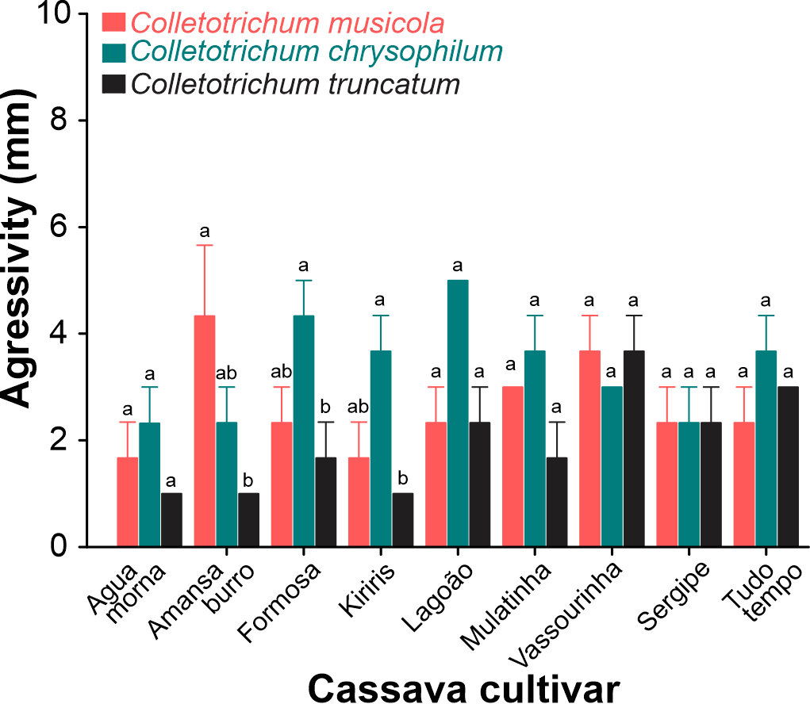
Figure 1. Aggressiveness of three Colletotrichum species to cassava cultivars two days after the inoculation. Different letters on the upper bars of the same cassava cultivar differ significantly from each other according to Tukey's test (P < 0.05). Observations were continued up to 10 days after inoculation to assess the aggressiveness and intensity of infection of each Colletotrichum species on different cassava cultivars.
4.2. Virulence evolution.
The virulence of Colletotrichum species fungus was affected significantly by the species of the fungi, cultivar and the interaction between these (Table 2). Similarly, significant effects of time and the interaction between time and fungi, time and cassava cultivar and time and fungi and cassava cultivar were recorded (Table 2). In C. musicola, an increase in the virulence to Formoso, Lagoão, Sergipe and Todo Tempo (Figure 2A); for C. chrysophillum, this was observed in Mulatilha and Kiriris (Figure 2B) and for C. truncatum for Lagoão, Sergipe and Todo Tempo (Figure 2C).
Table 2. Repeated measures analysis of variance (ANOVA) between subjects for the virulence evolution of the fungus Colletotrichum species on nine cassava cultivars.

Variation source |  | df | F | P
between subjects
Fungi (F) |  | 2 | 14.37 | <.0001
Cassava Cultivars (CC) |  | 8 | 6.45 | <.0001
F vs CC |  | 16 | 4.01 | <.0001
Error |  | 54 | - | -
Within-subject effects | df_{den} | df_{num} | Wilks’ lambda | F | P
Time (T) | 51 | 4 | 0,1805 | 57,88 | <.0001
T vs F | 102 | 8 | 0,6100 | 3,57 | <.0011
T vs CC | 189.67 | 32 | 0,2347 | 2,85 | <.0001
T vs F vs CC | 201.93 | 64 | 0.0868 | 2,74 | <.0001

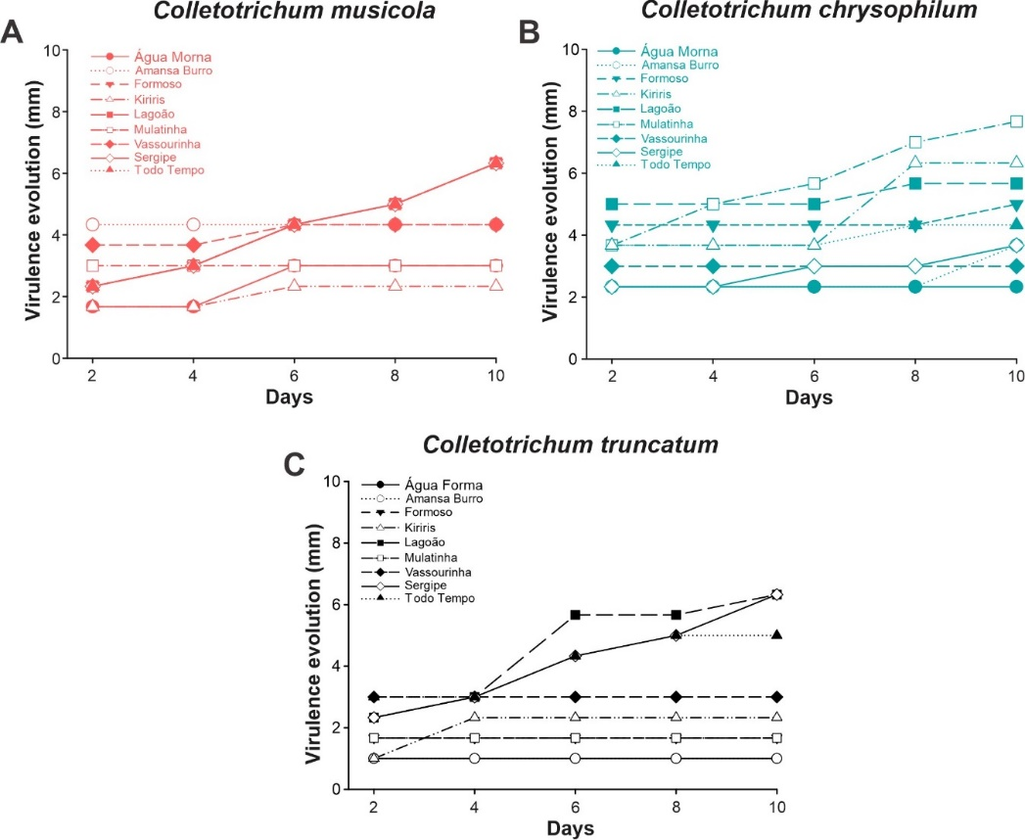
Figure 2. Evolution of virulence of Colletotrichum musicola (A), Colletotrichum chrysophillum (B) and Colletotrichum truncatum (C) in different cassava cultivars.

On the other hand, each cultivar individually had differences in relation to the pathogen species virulence. The species C. truncatum was less virulent to Água Morma (F= 7.91; df= 2; P= 0.005), Formosa (F= 7.8; df= 2; P= 0.021), and Mulatinha (H= 6.88; df= 2; P= 0.01), cassava cultivar (Figure 3); on the others cultivars was not find differences were found when exposed to the Colletotrichum specie.
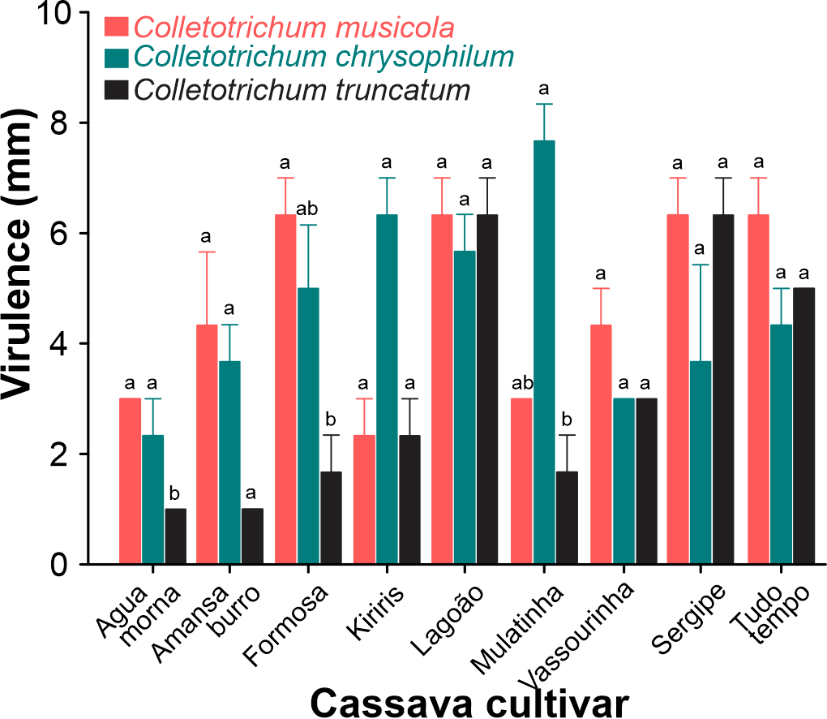
Figure 3. Virulence of three Colletotrichum species on a given cassava cultivar ten days after the inoculation. Different letters on the upper bars of the same cassava cultivar differ significantly from each other (P < 0.05).

DISCUSSION
The Colletotrichum musicola, C. chrysophillum and C. truncatum are causing anthracnose in cassava in the northern region of Brazil. Our results are the first to evaluate the aggressiveness and virulence of these species of Colletotrichum in cassava cultivars produced in commercial areas of municipalities in the states of Pará and Tocantins. We find that the three species of Colletotrichum were aggressive and virulent to cassava crops; however, the C. truncatum specie was less aggressive cassava cultivars.
The capacity aggressive of C. musicola and C. chrysophillum and C. truncatum to all cassava cultivars here evaluated demonstrates the susceptibility of this crop to fungi species. In this sense exist records of others species of Colletotrichum attacking Manihot sculenta, being reported C. gloeosporioides f.sp. manihotis, C. plurivorum, C. karstii, C. fructicola, C. siamense and C. theobromicola (Amusa, 2001; Bragança et al., 2016; Kunkeaw et al., 2010; Liu et al., 2019; Oliveira et al., 2018; Sangpueak et al., 2018). More recently in Brazil, were reported anthracnose in cassava caused by C. chrysophillum, C. musicola and C. truncatum (Machado, Veloso, et al., 2021; Machado et al., 2022; Machado, Vieira, et al., 2021). Although Colletotrichum species colonized all the cassava cultivars here evaluated, the aggressiveness of C. truncatum was lower in three cultivars; in contrast to the report by Liu et al. (2019), where C. truncatum was most aggressive to cassava crops in China. It is known that during the colonization process, the pathogens seek to overcome intrinsic barriers to infection with production of enzymes for degradation of the structural material and cellular constituents. It has been reported that for successful infection and ability to cause anthracnose disease by Colletotrichum is aided by production of phytotoxic metabolites that have been vary with the host plant and the Colletotrichum species (García-Pajón & Collado, 2003; Joshi, 2018; Vieira et al., 2019). Therefore, this resistance to C. truncatum could be associate with the impossibility of this specie to overcome the chemical and physical defense in these specific cassava cultivars. However, was suggested that Colletotrichum species including C. truncatum could be show a quiescent period before causing disease and started to colonize the cells when the environmental conditions and host physiology were conducive to completing the disease cycle (De Silva et al., 2017; García-Pajón & Collado, 2003; Joshi, 2018; Rampersad & Teelucksingh, 2012). And Ranathunge et al. (2012) reported a quiescent stage in C. truncatum after initial infection of chili (Capsicum annuum) fruit with no apparent symptoms until six days after inoculation.
However, it is known that the virulence of Colletotrichum species was dependent on the species and cassava cultivar; here, the three species were virulent; the cultivars of Agua Morma, Formosa and Mulatinha were less affected by C. truncatum. Although the colonization phase of pathogens in plants could be successful, the capacity to maintain itself and reproduce continuously in the host can be a challenge. And this permanence depends on the effectors of the pathogen to suppress or avoid the immune systems of the host, as well as manipulate the metabolism to increase the availability of nutrients for the pathogen (Vleeshouwers & Oliver, 2014). It is known that the phytopathogenic fungi colonization phase includes one enzymatic process and mechanical penetration (Villa-Rivera et al., 2017). However, it is known that plants under pathogen attack commonly use two patterns of immunity; one innate associate to recognition of pathogen-/microbe, and a highly specific immune system, in which plant resistance proteins can recognize pathogen elicitors or effector proteins (Jones & Dangl, 2006). In cassava, several defense mechanisms can act simultaneously and restrict the attack of species of the genus Colletotrichum. These cultivars may possess chemical defenses that could, for instance, increase peroxidase activity. The capacity to increase the peroxidase activity; enzymes that contribute to the lignin synthesis around the dark brown lesion formed, increasing the mechanical resistance. Thus was reported that fungal infections are associated with an increase in peroxidase activity in cassava plants (Bruggen et al., 1990; Fokunang, Dixon, Ikotun, Akem, et al., 2002), and resistant plants accumulate most phenolic compounds when exposed to C. truncatum (Chongo et al., 2002). In addition, cassava plants can release toxic cyanogenic compounds, imposing resistance to pathogenic invasion by fungi (Fokunang, Dixon, Ikotun, Asiedu, et al., 2002); since cyanide is toxic to many microorganisms, to prevent to cells from using oxygen (de Oliveira et al., 2017). This information obtained can be used as an important tool in the management of anthracnose and in the implementation of a genetic improvement program aimed at developing cultivars for resistance to anthracnose in commercial tropical areas.

CONCLUSION
The results of this study confirmed that Colletotrichum musicola, C. chrysophillum, and C. truncatum are causal agents of anthracnose in cassava cultivated in the northern region of Brazil. All three species were able to infect the evaluated cassava cultivars, but differences in aggressiveness and virulence were observed among the fungal species and among cultivars.
Colletotrichum musicola and C. chrysophillum showed higher aggressiveness and virulence in most cultivars, while C. truncatum was less aggressive and less virulent in some cultivars, especially Água Morna, Formosa, and Mulatinha. Among the cultivars, Água Morna showed the lowest disease levels, indicating a higher level of resistance, whereas Lagoão was the most susceptible.
These results demonstrate the existence of variability in both pathogen behavior and cultivar response to anthracnose. The identification of less susceptible cultivars provides useful information for disease management and for breeding programs aimed at developing cassava cultivars with resistance to anthracnose in tropical production areas.
Declarations:
Ethics approval and consent to participate:
The authors are committed to upholding the integrity of the scientific record and maintaining the integrity of the research and its presentation. All of the material is owned by the authors and/or no permissions are required.
Consent for publication All authors agreed with the content and that all gave explicit consent to submit and that all obtained consent from the responsible authorities at the organization where the work has been carried out.
Conflict of Interest Statement:
The authors have no conflict of interest to declare that is relevant to this article.

Disclaimer (Artificial intelligence)
No Artificial Intelligence chatgpt or other AI tool was used in this article

References

- Amusa, N. A. (2001). Screening of cassava and yam cultivars for resistance to anthracnose using toxic metabolites of Colletotrichum species. Mycopathologia, 150(3), 137-142.

- Barbieri, M. C. G., Ciampi-Guillardi, M., Moraes, S. R. G., Bonaldo, S. M., Rogério, F., Linhares, R. R., & Massola, N. S. (2017). First report of Colletotrichum cliviae causing anthracnose on soybean in Brazil. Plant Disease, 101(9), 1677-1677.

- Bragança, C. A. D., Silva, L. L., Haddad, F., & Oliveira, S. A. S. (2016). First report of Colletotrichum fructicola causing anthracnose in cassava (Manihot esculenta) in Brazil. Plant Disease, 100(4), 857.

- Bruggen, P. v. d., Gregoire, D., & Maraite, H. (1990). Temperature-induced alterations in the expression of susceptibility of cassava to Colletotrichum gloeosporioides f. sp. manihotis. Journal of Phytopathology, 130(1), 46-58.

- Cavalcante, G. R. S., Barguil, B. M., Vieira, W. A. S., Lima, W. G., Michereff, S. J., Doyle, V. P., & Câmara, M. P. S. (2019). Diversity, prevalence, and virulence of Colletotrichum species associated with lima bean in Brazil. Plant Disease, 103(8), 1961-1966.

- Chongo, G., Gossen, B., & Bernier, C. (2002). Infection by Colletotrichum truncatum in resistant and susceptible lentil genotypes. Canadian Journal of Plant Pathology, 24(1), 81-85.

- Cruz, I. A., Santos Andrade, L. R., Bharagava, R. N., Nadda, A. K., Bilal, M., Figueiredo, R. T., & Romanholo Ferreira, L. F. (2021). Valorization of cassava residues for biogas production in Brazil based on the circular economy: An updated and comprehensive review. Cleaner Engineering and Technology, 4, 100196.

- Dalcin, M. S., Dias, B. L., Viteri Jumbo, L. O., Oliveira, A. C. S. S., Araújo, S. H. C., Moura, W. S., . . . Santos, G. R. (2022). Potential action mechanism and inhibition efficacy of Morinda citrifolia essential oil and octanoic acid against Stagonosporopsis cucurbitacearum infestations. Molecules, 27(16), 5173.

- de Oliveira, E. J., de Oliveira, S. A. S., Boas, S. A. V., Hohenfeld, C. S., & da Silva Santos, V. (2017). Selection of cassava accessions with multiple resistance to pathogens associated with root rot disease. Euphytica, 213(8), 185.

- De Silva, D. D., Crous, P. W., Ades, P. K., Hyde, K. D., & Taylor, P. W. J. (2017). Life styles of Colletotrichum species and implications for plant biosecurity. Fungal Biology Reviews, 31(3), 155-168.

- Fokunang, C. N., Dixon, A. G. O., Ikotun, T., Akem, C. N., & Tembe, E. A. (2002). Rapid screening method of cassava cultivars for resistance to Colletotrichum gloeosporioides f.sp. manihotis. Journal of Phytopathology, 150(1), 6-12.

- Fokunang, C. N., Dixon, A. G. O., Ikotun, T., Asiedu, R., Tembe, E. A., & Akem, C. N. (2002). In vitro, greenhouse and field assessments of cassava lines for resistance to anthracnose disease caused by Colletotrichum gloeosporioides f.sp. manihotis. Mycopathologia, 154(4), 191-198.

- García-Pajón, C. M., & Collado, I. G. (2003). Secondary metabolites isolated from Colletotrichum species [10.1039/B302183C]. Natural Product Reports, 20(4), 426-431.

- Gonçalves, L. d. O., Julião, S. M. S., Zago, L., & Santana, I. (2024). Cassava, an illustrious (un)known: Consumption of recipes with the root and its derived products. International Journal of Gastronomy and Food Science, 35, 100812.

- Jones, J. D. G., & Dangl, J. L. (2006). The plant immune system. Nature, 444(7117), 323-329.

- Joshi, R. (2018). A Review on Colletotrichum spp. Virulence mechanism against host plant defensive factors. Journal of Medicinal Plants Studies, 6(6), 64-67.

- Kunkeaw, S., Worapong, J., Smith, D. R., & Triwitayakorn, K. (2010). An in vitro detached leaf assay for pre-screening resistance to anthracnose disease in cassava (Manihot esculenta Crantz). Australasian Plant Pathology, 39(6), 547-550.

- Lima, N. B., Lima, W. G., Tovar-Pedraza, J. M., Michereff, S. J., & Câmara, M. P. S. (2015). Comparative epidemiology of Colletotrichum species from mango in northeastern Brazil. European Journal of Plant Pathology, 141(4), 679-688.

- Liu, X., Shi, T., Li, B., Cai, J., Li, C., & Huang, G. (2019). Colletotrichum species associated with cassava anthracnose in China. Journal of Phytopathology, 167(1), 1-9.

- Machado, S. d. C. S., Veloso, J. S., Câmara, M. P. S., Campos, F., Sarmento, R. d. A., Giongo, M. V., & dos Santos, G. R. (2021). First report of Colletotrichum chrysophillum Causing cassava anthracnose in Brazil. Plant Disease, 105(4), 1196-1196.

- Machado, S. d. C. S., Veloso, J. S., Camara, M. P. S., Campos, F. S., Damascena, J. F., de Souza Ferreira, T. P., . . . Santos, G. R. (2022). Occurrence of Colletotrichum musicola causing anthracnose on Manihot esculenta. Plant Disease, 106(10), 2758.
- Machado, S. d. C. S., Vieira, W. A. S., Duarte, I. G., Amaral, A. G. G., Veloso, J. S., Câmara, M. P. S., & dos Santos, G. R. (2021). First report of Colletotrichum truncatum causing anthracnose in cassava in Brazil. Plant Disease, 105(11), 3745.

- Morais, M. d. S., Nascimento, L. C. d., Moreira, K. A., Cavalcanti, M. d. S., & Oliveira, N. T. d. (2013). Levantamento e avaliação da incidência das doenças da mandioca no estado da Paraíba. Summa Phytopathologica, 39, 204-206.

- Oliveira, S. A. S., Silva, L. L., Diamantino, M. S. A. S., & Ferreira, C. F. (2018). First report of Colletotrichum theobromicola and C. siamense causing anthracnose on cultivated and wild cassava species in Brazil. Plant Disease, 102(4), 819-819.

- Oliveira, S. A. S., Silva, L. L., Nascimento, D. d. S., Diamantino, M. S. A. S., Ferreira, C. F., & de Oliveira, T. A. S. (2020). Colletotrichum species causing cassava (Manihot esculenta Crantz) anthracnose in different eco-zones within the Recôncavo Region of Bahia, Brazil. Journal of Plant Diseases and Protection, 127(3), 411-416.

- Rampersad, S. N., & Teelucksingh, L. D. (2012). Differential responses of Colletotrichum gloeosporioides and C. truncatum isolates from different hosts to multiple fungicides based on two assays. Plant Disease, 96(10), 1526-1536.

- Ranathunge, N. P., Mongkolporn, O., Ford, R., & Taylor, P. W. J. (2012). Colletotrichum truncatum Pathosystem on Capsicum spp: infection, colonization and defence mechanisms. Australasian Plant Pathology, 41(5), 463-473.

- Sangpueak, R., Phansak, P., & Buensanteai, N. (2018). Morphological and molecular identification of Colletotrichum species associated with cassava anthracnose in Thailand. Journal of Phytopathology, 166(2), 129-142.

- Santos, A. D., Bandeira e Sousa, M., Alves, A. A. C., & Oliveira, E. J. d. (2024). Environmental factors influence the production of flowers and fruits of cassava. Scientia Horticulturae, 323, 112498.

- Santos, G. R. d., Café-Filho, A. C., Leão, F. F., César, M., & Fernandes, L. E. (2005). Disease progress and crop losses due to watermelon gummy stem blight. Horticultura Brasileira, 23, 228-232.

- Vieira, A., Diniz, I., Loureiro, A., Pereira, A. P., Silva, M. C., Várzea, V., & Batista, D. (2019). Aggressiveness profiling of the coffee pathogen Colletotrichum kahawae. Plant Pathology, 68(2), 358-368.

- Villa-Rivera, G. M., Conejo-Saucedo, U., Lara-Marquez, A., Cano-Camacho, H., Lopez-Romero, E., & Zavala-Paramo, G. M. (2017). The role of virulence factors in the pathogenicity of Colletotrichum sp. Current Protein & Peptide Science, 18(10), 1005-1018.

- Vilpoux, O. F. (2024). Chapter 2 - Cassava starch processing units: comparison of industrial technologies from China, Thailand, and Brazil. In M. P. Cereda & O. F. Vilpoux (Eds.), Starch Industries: Processes and Innovative Products in Food and Non-Food Uses (pp. 9-35). Academic Press.

- Visses, F. d. A., Sentelhas, P. C., & Pereira, A. B. (2018). Yield gap of cassava crop as a measure of food security - an example for the main Brazilian producing regions. Food Security, 10(5), 1191-1202.

- Vleeshouwers, V. G. A. A., & Oliver, R. P. (2014). Effectors as tools in disease resistance breeding against biotrophic, hemibiotrophic, and necrotrophic plant pathogens. Molecular Plant-Microbe Interactions®, 27(3), 196-206.

