A Clinical Case Report of Guillain-Barre Syndrome in Adult patient

.
ABSTRACT

Introduction: Guillain–Barré syndrome (GBS) is an uncommon, acute autoimmune condition affecting the peripheral nervous system, marked by rapidly progressive, symmetrical muscle weakness and loss of deep tendon reflexes. It frequently occurs following an antecedent infectious episode. Prompt diagnosis and early initiation of immunomodulatory treatment are critical in limiting disease severity and preventing potentially life-threatening complications.
Case Presentation: A 46-year-old male presented with acute onset, gradually progressive weakness beginning in both lower limbs and later involving the upper limbs, accompanied by difficulty in grasping objects and swallowing. The patient also had respiratory symptoms suggestive of a recent infection. Laboratory evaluation revealed leukocytosis with predominant neutrophilia and significantly elevated C-reactive protein levels.
Discussion: The diagnosis of Guillain–Barré syndrome was made based on the characteristic clinical presentation supported by laboratory findings. Management included intravenous immunoglobulin therapy administered for five consecutive days, along with supportive care and antibiotic therapy for suspected aspiration pneumonia. The patient showed progressive neurological improvement during treatment.
Conclusion: This case underscores the significance of early identification and timely intravenous immunoglobulin therapy, along with a multidisciplinary management approach, in achieving favorable outcomes in patients with Guillain–Barré syndrome.

Keywords: [Guillain-Barre Syndrome; Acute flaccid paralysis; Ascending weakness Intravenous Immunoglobulin, peripheral nervous system }

1. INTRODUCTION
Guillain–Barré syndrome (GBS) is an acute, immune-mediated disorder affecting the peripheral nervous system. It is characterized by rapidly progressive, symmetrical muscle weakness accompanied by diminished or absent deep tendon reflexes. The condition typically follows a monophasic course and often develops after a recent infectious illness. GBS primarily involves peripheral nerves and nerve roots, resulting in impaired nerve conduction and neuromuscular dysfunction. In severe cases, patients may develop respiratory failure and autonomic disturbances^{[¹˒²]}.
  - Epidemiology:

GBS has an estimated worldwide incidence of approximately 1–2 cases per 100,000 individuals annually. It can affect people of all age groups; however, the incidence is higher among older adults and shows a slight male predominance. Evidence from systematic reviews and global epidemiological analyses has consistently demonstrated a male predominance in different populations. The precise cause of this pattern is not fully understood; however, factors such as variations in immune function between sexes, hormonal influences, and differences in exposure to infectious agents have been suggested. In addition, age-related changes in immune regulation and repeated exposure to infections may partly explain the greater occurrence of GBS among adults ^{[3,4]}. Although uncommon, GBS is recognized as one of the leading causes of acute flaccid paralysis globally and frequently requires admission to intensive care units for close monitoring and management^{[¹˒²]}.

  - Immunopathogenesis:

The pathogenesis of Guillain–Barré syndrome is believed to involve a post-infectious autoimmune mechanism triggered by molecular mimicry. Antigens from preceding infectious agents resemble components of peripheral nerves, leading to the production of antibodies that cross-react with neuronal gangliosides such as GM1(Ganglioside with sialic acid), GD1a (Ganglioside with 2 sialic acids, subtype 1a), and GQ1b (Ganglioside with 4 sialic acids, subtype 1b). This immune response activates the complement system and promotes macrophage-mediated inflammation, resulting in demyelination or axonal damage of peripheral nerves^{[5}˒^{6]}.

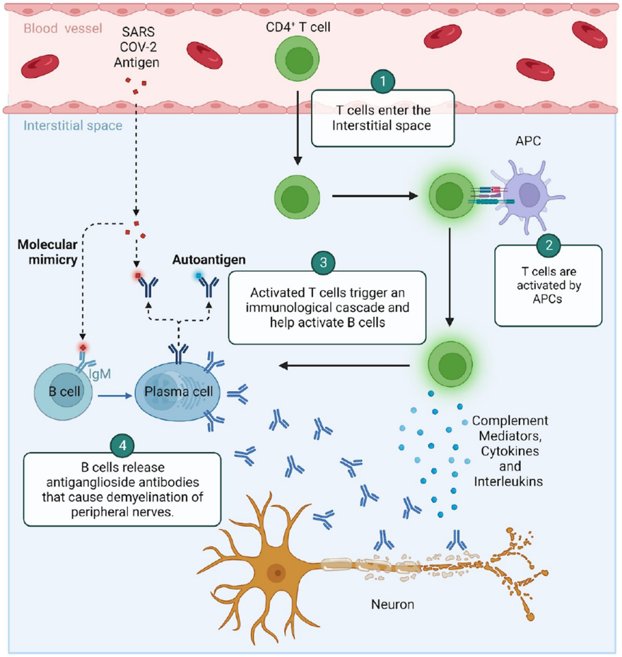
FIG. 1. Pathophysiology of Guillain-Barre syndrome ^{[13]}

  - Clinical Variants and subtypes:

Guillain–Barré syndrome encompasses multiple clinical variants that differ in pathological and electrophysiological features. Acute inflammatory demyelinating polyneuropathy (AIDP) is the most common form in Western countries and is primarily associated with immune-mediated demyelination^{[²˒7]}.

Axonal variants, including acute motor axonal neuropathy (AMAN) and acute motor-sensory axonal neuropathy (AMSAN), are more frequently observed in Asian populations and are often linked to more severe disease^{[²˒7]}.
Miller Fisher syndrome is a distinct variant characterized by ophthalmoplegia, ataxia, and areflexia and is strongly associated with the presence of anti-GQ1b antibodies^{[²˒7]}.
  - Clinical features:
- Guillain–Barré syndrome typically presents with progressive, symmetrical muscle weakness that starts in the lower extremities and ascends toward the upper limbs.
- Deep tendon reflexes are commonly diminished or completely absent early in the disease course.
- Sensory symptoms, including tingling sensations “paresthesia” and neuropathic pain, may accompany motor weakness.
- Autonomic nervous system involvement can occur, resulting in cardiac rhythm disturbances, fluctuations in blood pressure, and urinary retention.
- Cranial nerve involvement is frequently noted, with facial nerve weakness being one of the most common features^{[¹˒9]}.
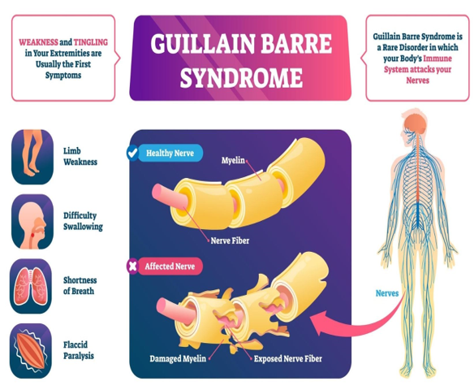
FIG. 2. Clinical features of Guillain-Barre syndrome ^{[14]}

  - Diagnosis:
The diagnosis of Guillain–Barré syndrome is primarily clinical and is supported by investigative findings. Cerebrospinal fluid analysis often reveals albuminocytologic dissociation, particularly after the first week of symptom onset. Nerve conduction studies play a crucial role in confirming the diagnosis and in differentiating between demyelinating and axonal subtypes. Serological testing for anti-ganglioside antibodies may assist in identifying specific clinical variants^{[6˒10]}.
  - Preceding infections:
Approximately two-thirds of patients with GBS report a history of antecedent infection occurring one to three weeks prior to the onset of neurological symptoms. Campylobacter jejuni is the most commonly implicated pathogen, especially in axonal forms of the disease. Other associated infectious agents include Mycoplasma pneumoniae, cytomegalovirus, Epstein–Barr virus, and influenza virus^{[8˒9]}.

  - Management/Treatment:

Management of Guillain–Barré syndrome involves specific immunomodulatory therapy along with comprehensive supportive care. Intravenous immunoglobulin (IVIG) and plasma exchange are equally effective in reducing disease severity and promoting recovery when initiated early^{[12]}. Supportive treatment focuses on respiratory monitoring, prevention of complications, pain management, and coordinated multidisciplinary rehabilitation to improve functional outcomes^{[²˒11]}.

  - Prognosis:

Most patients with Guillain–Barré syndrome show gradual recovery over several months; however, recovery may be prolonged in severe cases or in axonal variants. Approximately 15–20% of individuals may experience persistent neurological deficits such as residual weakness or fatigue. Mortality rates are low but are primarily associated with respiratory failure and autonomic complications. Early diagnosis and timely initiation of treatment significantly improve patient outcomes^{[¹˒5]}.
2. case presentation

A previously healthy 46-year-old male patient was admitted to Ballari Medical College and Research Centre (BMCRC) with complaints of sudden-onset, gradually progressive weakness of both lower limbs for 8 days, followed by involvement of both upper limbs for the past 6 days, presenting as difficulty in reaching overhead objects and gripping a glass. He also complained of difficulty in swallowing for the past 3 days, associated with regurgitation of food. Additionally, he had cough with whitish, non-blood-stained expectoration for 5 days.

Social history: Alcoholic

Past history: No comorbidities

Personal and diet history: His diet was mixed (vegetarian and non-vegetarian), the patient appetite was reduced, his sleep was disturbed and his bowel and bladder were regular and normal.

Family history: Nothing significant

The patient’s blood pressure was recorded at 130/80 mmHg, and the pulse rate was 98 beats per minute. Oxygen saturation was 94% on room air. The random blood glucose level was 116 mg/dL. The patient was conscious and oriented. On respiratory examination, bilateral normal vesicular breath sounds were present, bilateral Crepts positive. Cardiovascular examination revealed normal S1 and S2 heart sounds. Per abdominal examination showed a soft and non-tender abdomen.
Table 1. Laboratory examination of the patient
PARAMETERS | D1 | D3 | D7 | D14 | D15 | D18 | REFERENCE
HEMATOLOGY
Hemoglobin | 14.4 | 13.8 | 13.7 | 15.5 | 15.2 | 14.5 | 13-18gm/dL
Total WBC count | 17810 | 10800 | 16020 | 13100 | 10220 | 10670 | 4000-11000cells/cumm
Neutrophils | 85 | 83 | 90 | 87 | 75 | 82 | 40-70%
Lymphocytes | 10 | 10 | 04 | 10 | 21 | 10 | 20-40%
Eosinophils | 03 | 03 | 04 | 03 | 02 | 04 | 3-6%
Monocytes | 03 | 04 | 02 | 0 | 02 | 04 | 2-10%
Basophils | 0 | 0 | 0 | 0 | 0 | 0 | 0-1%
RBC count | 4.84 | 4.84 | 4.87 | 5.39 | 5.37 | 5.11 | 4.5-6.0 million/mm³
Platelet count | 4.35 | 5.64 | 4.87 | 3.50 | 3.63 | 4.70 | 1.5-4.5lakh/ mm³
MPV | 7.6 | 8.5 | 8.15 | 9.1 | 8.5 | 8.2 | 7-11fl
PCV | 43.7 | 44.2 | 42.1 | 47.8 | 46.5 | 43.8 | 45-55%
MCV | 90.3 | 91.5 | 88.6 | 88.8 | 86.6 | 85.7 | 80-100fl
MCH | 29.8 | 28.5 | 29.0 | 28.8 | 28.4 | 28.5 | 27-34pg
MCHC | 33.6 | 31.2 | 32.7 | 32.4 | 32.8 | 33.3 | 31-36%
RDW-CV | 12.9 | 13.0 | 12.7 | 13.4 | 13.0 | 12.6 | 11.5-14.5%
PDW-CV | 19.7 | 10.4 | 20.3 | 12.1 | 20.6 | 19.8 | 10-18%
Random blood sugar | 70 | - | 97 |  | 98 | - | 70-140mg/dl
S. ELECTROLYTE
Sodium blood | 139 | 136 | 135 | 145 | 141 | 140 | 136-145mEq/L
Potassium blood | 4.1 | 3.6 | 4.0 | 4.2 | 4.0 | 3.7 | 3.48-5mEq/L
Chloride blood | 99 | 103 | 101 | 101 | 97 | 101 | 96-106mEq/L
LIVER FUNCTION TEST
Total protein | 7.5 | - | - | 6.7 | - | 6.1 | 6-8.3g/dl
Albumin | 4.1 | - | - | 3.4 | - | 3.1 | 3.2-5.4g/dl
Globulin | 3.3 | - | 3.4 | 3.2 | 3.0 | 3.0 | 2.5-3g/dl
A/G ratio | 1.2 | - | 0.9 | 1.0 | 1.1 | 1.0 | 1.2-1.5
Bilirubin Total | 0.8 | - | 0.3 | 0.3 | 0.3 | 0.4 | 0.2-1.2mg/dl
Bilirubin Conjugated | 0.3 | - | 0.2 | 0.2 | 0.2 | 0.2 | 0.1-0.4mg/dl
Bilirubin Unconjugated | 0.5 | - | 0.2 | 0.1 | 0.1 | 0.2 | 0.2-0.7mg/dl
Alanine Tran  aminase | 10 | - | 13 | 24 | 22 | 23 | 0-45IU/L
Aspartate Transaminase | 16 | - | 28 | 26 | 24 | 19 | 0-40IU/L
Alkaline Phosphatase | 71 | - | 56 | 68 | 63 | 60 | 20-140U/L
RENAL PROFILE  Serum Creatinine | 1.2 | 0.9 | 0.7 | 1.0 | 1.0 | 0.9 | 0.7-1.4mg/dl
Blood urea | 36 | 44 | 28 | 28 | 35 | 22 | 15-45mg/dl
CRP | 78.6 | - | 81.4 | - | - | - | 0-6mg/L

Table 2. Treatment regimen in hospital
SL NO | MEDICATION | DOSE | ROUTE | FREQUENCY | DAYS
1 | INJ CEFTRIAXONE | 1g | IV | 1-0-1 | D1-D2
2 | INJ METRONIDAZOLE | 500mg | IV | 1-1-1 | D1-D2
3 | INJ PANTOPRAZOLE | 40mg | IV | 1-0-0  (Oral dose was given after patient’s stabilization till D19) | D1-D5  (Oral dose was given after patient’s stabilization till D19)
4 | IV FLUIDS | 2.NS | IV | - | D1-D19
5 | NEB IPRAVENT | 2cc | Inhalation | 1-1-1 | D1-D10
6 | NEB BUDECORT | 2cc | Inhalation | 1-1-1 | D1-D10
7 | INJ PIPRACILLIN TAZOBACTUM | 4.5g | IV | 1-1-1 | D2-D19
8 | INJ IVIG | 0.4 g/kg/dose | IV | For 5 consecutive days | 5 DAYS
9 | TAB AZITHROMYCIN | 500mg | PO | 1-0-0 | D3-D8
10 | INJ THIAMINE | 2amp in 25%dextrose | IV | 1-1-1 | D1-D19
11 | INJ PARACETAMOL | - | IV | - | D1-D10
12 | NEB DUOLIN + BUDECORT | - | Inhalation | - | D11-D19
13 | INJ ONDANSETRON | 4mg | IV | - | D11-D13

Table 3. Physician Notes
- DAY 2:  BP: 110/70 mmHg  PR: 95bpm  SPO2: 97% under RA | - DAY 3:  BP: 130/90 mmHg  PR: 96bpm  SPO2: 97% under RA | - DAY 4:  BP: 140/80 mmHg  PR: 123bpm  SPO2: 97% under RA
- DAY 5:  BP: 100/60 mmHg  PR: 112bpm  SPO2: 99% under RA | - DAY 6:  BP: 130/90 mmHg  PR: 105bpm  SPO2: 99% under RA | - DAY 7:  BP: 110/70 mmHg  PR: 132bpm  SPO2: 96% under RA

Table 4. Discharge Medications
SL NO | MEDICATION | DOSE | ROUTE | FREQUENCY | DAYS
1 | TAB AMOXICILLIN-POTASSIUM CLAVULNATE | 625 mg | PO | 1-0-1 | 3days
2 | T PANTOPRAZOLE | 40mg | PO | 1-0-0 | 3days
3 | T ONDANSETRON | 4mg | PO | 1-0-0 | 3days
4 | T METRONIDAZOLE | 500mg | PO | 1-1-1 | 3days
5 | SYP AMBROXOL | 5ml | PO | 1-1-1 | 3days

3. DISCUSSION

Guillain-Barré syndrome is an uncommon acute disorder of the nervous system in which the body’s immune response damages peripheral nerves, leading to gradually worsening muscle weakness. It is frequently preceded by an infection that triggers an abnormal immune reaction, causing the immune system to attack nerve tissues. This damage may affect the myelin sheath or the axon itself, which interferes with normal nerve signal transmission and produces symmetrical weakness, usually beginning in the limbs. In certain cases, involvement of cranial nerves and respiratory muscles can occur, resulting in problems such as difficulty in swallowing or breathing. Here is a 46-year-old male patient showing complaints of ascending symmetrical weakness of B/L upper and lower limbs, difficulty in swallowing and some respiratory symptoms. The clinical findings observed in this patient align with c symptom the characteristic symptom pattern of Guillain-Barre Syndrome. Recent respiratory infection can also be considered as antecedent infection supports triggering Guillain-Barre Syndrome. Elevated inflammatory markers such as CRP (C-Reactive protein) indicates presence of immune or inflammatory process. Neurological symptoms of limb weakness, difficulty in gripping objects, swallowing difficulty suggests involvement of motor and cranial nerves. Early recognition of cranial nerve involvement is crucial part. Other objective evidences showed leukocytosis and neutrophilia which reflects systemic inflammatory response common in early phases of GBS. Therapeutic management here focused on immune-modulation, antibiotic use, supportive care and prevention of further complication. Initiation of Intravenous Immunoglobulin (IVIG) was done to suppress autoimmune-mediated nerve damage. IVIG is a standard first line therapy to treat GBS and improves neurological recovery by neutralizing pathogenic antibodies.
Antibiotic treatment with Ceftriaxone, Metronidazole, Piperacillin-Tazobactam was given to manage suspected secondary infection that is Aspiration Pneumonia, evidenced by cough, expectoration, leukocytosis and raised CRP. Other supportive treatments such as analgesics, nebulizers, vitamin supplements have helped improve nerve function and overall recovery, metabolic balance and overall recovery. This case highlights importance of early clinical detection, diagnosis and overall multidisciplinary approach in managing GBS.
4. CONCLUSION
This case is a classic presentation of Guillain-Barre Syndrome associated with progressive muscle weakness. Early identification, timely intervention plays vital a role to prevent severe complication such as respiratory failure and long-term neurological disability. Patient’s hospital stays and treatment highlights importance of rational immune therapy with supportive care in improving the recovery outcomes. Although some patients may experience long-term residual weakness, early treatment can enhance functional recovery and improve patient’s quality of life.

Consent

As per international standards or university standards, patient(s) written consent has been collected and preserved by the author(s).

Disclaimer (Artificial intelligence):

(Artificial Intelligence) Author(s) hereby declares that NO generative AI technologies such as Large Language Models (ChatGPT, COPILOT, etc) and text-to-image generators have been used during writing or editing of this manuscript.

References

- Willison HJ, Jacobs BC, van Doorn PA. Guillain–Barré syndrome. Lancet. 2016;388(10045):717–27.
- Hughes RA, Cornblath DR. Guillain–Barré syndrome. Lancet. 2005;366(9497):1653–66.
- Sejvar JJ, Baughman AL, Wise M, Morgan OW. Population incidence of Guillain-Barré syndrome: a systematic review and meta-analysis. Neuroepidemiology. 2011;36(2):123-133.
- Chen Y, et al. Global, regional, and national burden of Guillain-Barré syndrome from 1990 to 2019. J Neuroinflammation. 2021;18:250.
- Yuki N, Hartung HP. Guillain–Barré syndrome. N Engl J Med. 2012;366(24):2294–304.
- van den Berg B, Walgaard C, Drenthen J, Fokke C, Jacobs BC, van Doorn PA. Guillain–Barré syndrome: pathogenesis, diagnosis, treatment and prognosis. Nat Rev Neurol. 2014;10(8):469–82.
- Mori M, Kuwabara S, Yuki N. Fisher syndrome: clinical features, immunopathogenesis and management. Expert Rev Neurother. 2012;12(1):39–51.
- Jacobs BC, Rothbarth PH, van der Meché FG, Herbrink P, Schmitz PI, de Klerk MA, et al. The spectrum of antecedent infections in Guillain–Barré syndrome: a case-control study. Neurology. 1998;51(4):1110–5.
- Dimachkie MM, Barohn RJ. Guillain–Barré syndrome and variants. Neurol Clin. 2013;31(2):491–510.
- Asbury AK, Cornblath DR. Assessment of current diagnostic criteria for Guillain–Barré syndrome. Ann Neurol. 1990;27(Suppl 1):S21–4.
- Plasma Exchange/Sandoglobulin Guillain–Barré Syndrome Trial Group. Randomised trial of plasma exchange, intravenous immunoglobulin, and combined treatments in Guillain–Barré syndrome. Lancet. 1997;349(9047):225–30.
- Haber P, Sejvar J, Mikaeloff Y, DeStefano F. Vaccines and Guillain–Barré syndrome. Drug Saf. 2009;32(4):309–23.
- Pathophysiology of Guillain–Barré syndrome [Internet]. Google Drive; c2024 [cited 2026 Jan 31]. Available from: https://share.google/PdecnWiD7RlT6eB5r
- Clinical features of Guillain–Barré syndrome [Internet]. Google Drive; c2024 [cited 2026 Jan 31]. Available from: https://share.google/W0qUDQnB772Y8IUSr

