Phenytoin Toxicity Presenting with Gait Disturbance and Cerebellar Signs: A Case Report

.
ABSTRACT

Introduction: Phenytoin is a widely used antiepileptic drug with a narrow therapeutic index and dose-dependent non-linear pharmacokinetics. Even minor changes in metabolism or protein binding may precipitate toxicity and neurological manifestations may mimic cerebellar or cerebrovascular disorders, creating diagnostic confusion.

Case Presentation: A 26-year-old woman with a 15-year history of seizure disorder on phenytoin and levetiracetam presented with one week of progressive gait instability, bilateral lower limb weakness and impaired coordination. She had a history of posterior circulation stroke one month earlier. Neurological examination revealed reduced power in both lower limbs (3/5) and impaired finger–nose testing bilaterally. Laboratory investigations were largely unremarkable except for an elevated serum phenytoin level of 35 µg/mL (therapeutic range 10–20 µg/mL). Phenytoin was discontinued, and the patient was managed with levetiracetam, valproate, supportive care and monitoring, resulting in marked clinical improvement.

Conclusion: Phenytoin toxicity should be suspected in patients on chronic therapy who develop new-onset cerebellar signs or neurological deterioration. Therapeutic drug monitoring and early drug withdrawal are crucial to prevent complications and avoid misdiagnosis.

Keywords: Antiepileptic drugs, Cerebellar dysfunction, Phenytoin toxicity, Therapeutic drug monitoring.

1. INTRODUCTION
Phenytoin is a hydantoin derivative and one of the earliest antiepileptic drugs (AEDs) introduced into clinical practice for the management of generalized tonic–clonic and focal seizures. Despite the development of newer antiepileptic agents, phenytoin continues to be widely prescribed, particularly in resource-limited settings, owing to its efficacy and cost-effectiveness. However, its use is complicated by a narrow therapeutic index and significant interindividual pharmacokinetic variability.^{[1]}
Phenytoin demonstrates dose-dependent, non-linear (Michaelis–Menten) pharmacokinetics due to saturation of hepatic metabolism mediated primarily by CYP2C9 and CYP2C19 enzymes. As metabolic pathways become saturated, small increments in dosage can result in disproportionate increases in serum concentration, predisposing patients to toxicity.^{[1,2]} The accepted therapeutic serum concentration ranges from 10–20 µg/mL; concentrations exceeding this range are associated with concentration-dependent neurological adverse effects.^{[2]}
Phenytoin exerts its antiepileptic action through use-dependent blockade of voltage-gated sodium channels, stabilizing neuronal membranes and limiting repetitive firing. At supratherapeutic levels, excessive sodium channel inhibition produces central nervous system depression. Clinical manifestations of toxicity are classically neurological and include nystagmus, ataxia, dysarthria, tremor, altered sensorium and in severe cases, coma.^{[2,3]} Gait disturbance is a prominent clinical feature of phenytoin-induced cerebellar toxicity and may present as progressive unsteadiness and broad-based gait. Such gait ataxia can mimic posterior circulation stroke, leading to diagnostic delay.^{[2,3]} Chronic toxicity may mimic cerebellar or brainstem pathology, leading to diagnostic challenges.^{[3]}
Predisposing factors for phenytoin toxicity include drug–drug interactions, hypoalbuminemia, hepatic dysfunction, renal impairment, genetic polymorphisms affecting metabolism and prolonged therapy resulting in accumulation.^{[1,2]} Because of its nonlinear pharmacokinetics and variable protein binding, therapeutic drug monitoring (TDM) remains essential to ensure safety and optimize treatment outcomes.^{[1,4]}
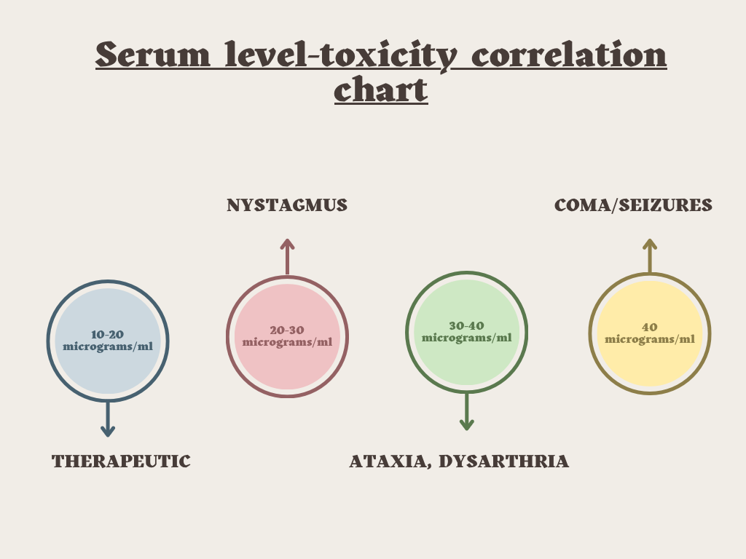Figure 1. Relationship between serum phenytoin concentration and neurological manifestations (created by authors based on published literature).^{[5,6]}
Early identification of toxicity and timely dose adjustment are critical to prevent potentially irreversible neurological complications. This case report highlights a clinically significant presentation of phenytoin toxicity, emphasizing the importance of vigilant monitoring and careful pharmacotherapeutic management.
This report also highlights how phenytoin toxicity may mimic posterior circulation stroke and reinforces the importance of therapeutic drug monitoring to prevent misdiagnosis and unnecessary interventions.
2. CASE PRESENTATION

A 26-year-old female patient was admitted to the female medical ward of a tertiary care hospital with complaints of progressive bilateral lower limb weakness and gait instability for one week. She also reported difficulty in bringing food to her mouth, suggestive of impaired coordination. She was a known case of seizure disorder for the past 15 years and was on Levetiracetam 500mg twice daily and Phenytoin 100mg (1-0-2). She had history of posterior circulation stroke one month prior to the present admission.
On examination her BP was 110/80 mmHg, Pulse rate was 91 bpm and SpO₂ was 95% on room air.
Table 1: SYSTEMIC EXAMINATION
CNS : The patient was conscious and oriented (GCS: E₄ V₅ M_{6).} Pupils were bilaterally equal and reactive to light.
- Motor examination showed normal tone in all four limbs.
- Power was 4/5 in both upper limbs and 3/5 in both lower limbs. Deep tendon reflexes were 2+ bilaterally.
- Plantar responses were mute. Cerebellar examination revealed impaired finger-nose test bilaterally.
- Dysdiadochokinesia was absent.

Laboratory investigations were performed as shown in Table 2.
TABLE 2 LABORATORY PARAMETERS
SL NO | TESTS | PARAMETERS | RESULTS ON ADMISSION | REFERENCE RANGE
1 | COMPLETE BLOOD COUNT | HEMOGLOBIN | 12.2 | 12.5-16 g/dL
 |  | TOTAL WBC COUNT | 11640 | 4000-11000 cells/cumm
 |  | NEUTOPHILS | 71 | 40-70 %
 |  | RBC COUNT | 4.27 | 4.5-5.5 million/cumm
 |  | PDW-CV | 19.4 % | 10-18 %
2 | LIVER FUNCTION TESTS | TOTAL PROTEIN | 5.6 | 5-8.3 g/dL
 |  | GLOBULIN | 2.3 | 2.5-3 g/dL
 |  | BILIRUBIN UNCONJUGATED | 0.1 | 0.2-0.7 mg/dL
3 | RENAL FUNCTION TESTS | SERUM CREATININE | 0.6 | 0.7-1.4 mg/dL
4 | BIOCHEMISTRY | RANDOM BLOOD SUGAR | 60 | 70-140 mg/dL
5 | SERUM PHENYTOIN LEVEL TEST |  | 35 µg/mL | 10-20 µg/mL

Based on the clinical findings and elevated serum phenytoin concentration, the diagnosis of phenytoin toxicity was established in a known case of seizure disorder with history of posterior circulation stroke.
Phenytoin was continued initially as the cause of neurological worsening was unclear; however, it was discontinued immediately after the serum phenytoin level (35 µg/mL) confirmed toxicity.
TABLE-3 TREATMENT CHART
SL NO | NAME OF THE MEDICATIONS | DOSE | ROUTE | FREQUENCY | DURATION
1 | INJ LEVETIRACETAM | 500mg | IV | 1-0-1 | DAY 1-3(500mg), DAY 4-6(750mg)
2 | INJ. PHENYTOIN | 100mg | IV | 1-0-1 | DAY 1-3; discontinued after serum phenytoin level confirmed toxicity.
3 | TAB. ASPIRIN | 75mg | PO | 0-1-0 | DAY 1-3
4 | TAB. ATORVASTATIN | 40mg | PO | 0-0-1 | DAY 1-3
5 | INJ. MVI+DNS |  | IV | 1-0-0 | DAY 1-6
6 | INJ. VALPROATE | 1g/500 | IV | STAT/1-0-1 | DAY 1-3
7 | INJ. TRAMADOL | 100ml | IV | SOS | DAY 3-6
8 | INJ. IRON SUCROSE | 100mg in 100ml NS | IV | 1-0-0 | DAY 3 ONLY

TABLE – 4 DISCHARGE MEDICATIONS
SL NO | NAME OF THE MEDICATION | DOSE | ROUTE | FREQUENCY
1 | TAB.LEVETIRACETAM | 500mg | PO | 1-0-1
2 | TAB.ATORVASTATIN | 40mg | PO | 0-0-1
3 | TAB.ASPIRIN | 75mg | PO | 0-1-0
4 | TAB.B COMPLEX |  | PO | 0-1-0
5 | SYP.MULTIVITAMIN | 5ml | PO | 1-1-1
6 | TAB.CLOPIDOGREL | 75mg | PO | 0-1-0
Recommended to review after 2 weeks.
SUMMARY
The patient showed clinical improvement at the time of discharge. It was identified that patient’s serum phenytoin level was elevated at 35 µg/mL (therapeutic range: 10-20 µg/mL). For this reason phenytoin was stopped on day 4 and treatment was continued with levetiracetam and valproate.
3. DISCUSSION

Phenytoin remains a commonly prescribed antiepileptic drug, particularly in resource-limited settings, due to its clinical efficacy and affordability. However, it is associated with a narrow therapeutic index and dose-dependent non-linear (Michaelis–Menten) pharmacokinetics.^{[1,2]} As hepatic metabolic pathways become saturated, small variations in dose, metabolism or drug interactions can lead to disproportionate increases in serum concentrations and subsequent toxicity. Neurological manifestations are the most frequent features of phenytoin toxicity and include nystagmus, dysarthria, tremor, ataxia and cerebellar dysfunction, which may closely resemble acute cerebrovascular or posterior circulation pathology.^{[2,3,7]} In the present case, the patient developed progressive gait disturbance and impaired coordination and her serum phenytoin concentration was markedly elevated (35 µg/mL), confirming supratherapeutic exposure.^{[2,3]} Although she had a recent posterior circulation stroke, the clinical pattern supported drug-induced neurotoxicity rather than residual neurological deficit. Residual stroke deficits are typically stable or gradually improving, whereas phenytoin toxicity often presents as subacute and progressive cerebellar dysfunction.^{[3,7]} The diagnosis was further strengthened by the patient’s clinical improvement following discontinuation of phenytoin (positive dechallenge), which is a key pharmacovigilance indicator supporting causality. A potential contributing factor in this case could be the concomitant use of aspirin during hospitalization. Aspirin may displace phenytoin from plasma protein binding sites, increasing the free (pharmacologically active) fraction of phenytoin. This interaction is clinically relevant because toxicity may occur even when total serum levels are only moderately elevated, especially in individuals with altered albumin status.^{[2]} Therefore, clinicians should maintain awareness of drug–drug interactions and consider measuring free phenytoin concentrations when toxicity is suspected.^{[2,4]} This case highlights the importance of therapeutic drug monitoring during long-term phenytoin therapy, particularly in patients with pre-existing neurological disease where toxicity can mimic disease progression or recurrence.^{[4,7]} Early identification, prompt withdrawal of the offending drug and transition to safer alternatives such as levetiracetam can result in rapid clinical improvement and prevent potentially irreversible neurological complications.^{[2,3,8]} Overall, this report reinforces the need for vigilant monitoring and individualized pharmacotherapy when managing chronic seizure disorders with phenytoin.

4. CONCLUSION
Phenytoin toxicity should be considered in patients receiving long-term therapy who present with new-onset cerebellar signs such as gait instability and impaired coordination. Due to its narrow therapeutic index and non-linear pharmacokinetics, toxicity may occur even without dose escalation and may mimic posterior circulation stroke. Therapeutic drug monitoring is essential for early identification and prompt discontinuation of phenytoin can result in rapid clinical improvement. This case reinforces the importance of clinical vigilance and individualized pharmacotherapy to prevent serious neurological complications.
CONSENT
As per international standards or university standards, patient(s) written consent has been collected and preserved by the author(s).
DISCLAIMER (ARTIFICIAL INTELLIGENCE)
Author(s) hereby declare that NO generative AI technologies such as Large Language Models (ChatGPT, COPILOT, etc) and text-to-image generators have been used during writing or editing of this manuscript.
REFERENCE
- Patsalos PN, Berry DJ. Pharmacokinetic and pharmacodynamic properties of phenytoin. Clin Pharmacokinet. 2013;52(7):519-536. Available from: https://www.ncbi.nlm.nih.gov/pmc/articles/PMC2902172/
- Suddock JT, Cain MD. Phenytoin toxicity. StatPearls [Internet]. Treasure Island (FL): StatPearls Publishing; 2024. Available from: https://www.ncbi.nlm.nih.gov/books/NBK482444/
- Thanacoody RHK. Phenytoin poisoning. Clin Med (Lond). 2016;16(6):601-604. Available from: https://www.ncbi.nlm.nih.gov/pmc/articles/PMC6292145
- Eadie MJ. Therapeutic drug monitoring—antiepileptic drugs. Br J Clin Pharmacol. 2001;52(Suppl 1):11S-20S. Available from: https://www.ncbi.nlm.nih.gov/pmc/articles/PMC1873678/
- Awasthi A, Agrawal N, Chakraborty PP, Maiti A. Phenytoin toxicity. BMJ Case Rep. 2022;15(11):e253250.
- Olson KR. Antiepileptic drug poisoning. Emerg Med Clin North Am. 2014;32(1):41–60.
- Brostoff JM, Birns J, McCrea D. Phenytoin toxicity: an easily missed cause of cerebellar syndrome. J Clin Pharm Ther. 2008;33(2):211-214.
- Ohmori H, Ogura H, Yasuda M, Nakamura S, Hatta T, Kawano K, et al. Developmental neurotoxicity of phenytoin on granule cells and Purkinje cells in mouse cerebellum. J Neurochem. 1999;72(4):1497-1506.

