PRIMARY AMENORRHEA WITH AUTOIMMUNE THYROIDITIS IN AN ADOLESCENT FEMALE: A SUSPECTED TURNER’S SYNDROME

.
ABSTRACT
Introduction:
Turner syndrome is a chromosomal disorder caused by partial or complete absence of one X chromosome and is commonly associated with short stature, gonadal dysgenesis, and endocrine abnormalities. Primary amenorrhea is a frequent presenting feature in adolescent females. Individuals with Turner syndrome are also at increased risk of developing autoimmune disorders, particularly autoimmune thyroid disease. Early recognition is essential to prevent long-term complications and ensure appropriate management.
Case Presentation:
A 17-year-old adolescent female presented with cough, fever, decreased appetite, and facial puffiness, along with a history of primary amenorrhea. Clinical evaluation and laboratory investigations revealed anemia, inflammatory markers elevation, gonadal hormone abnormalities, and thyroid dysfunction. Imaging studies demonstrated absence of the uterus, and ultrasonography of the neck was suggestive of Hashimoto’s thyroiditis. Based on the clinical, hormonal, and radiological findings, a diagnosis of suspected Turner syndrome was considered. Karyotyping was advised for definitive confirmation during the next follow-up visit.
Discussion:
Primary amenorrhea with absent uterus and associated autoimmune thyroiditis strongly suggests Turner syndrome. Autoimmune thyroid disease is the most common autoimmune condition associated with Turner syndrome, attributed to X-chromosome haploinsufficiency and immune dysregulation. Delayed diagnosis, especially in patients lacking classic phenotypic features, is common and may lead to missed opportunities for early hormonal intervention and surveillance of comorbidities.
Conclusion:
This case emphasizes the need to consider Turner syndrome in adolescent females presenting with primary amenorrhea and autoimmune thyroid disease, even in the absence of classical physical features. Early clinical suspicion, timely cytogenetic evaluation, and a multidisciplinary approach are crucial for optimal management and improved quality of life.
Keywords:Turner syndrome; Primary amenorrhea; Autoimmune thyroiditis; Hashimoto’s thyroiditis; Adolescent female; Gonadal dysgenesis

1. INTRODUCTION

“Turner syndrome is a rare condition characterized by female hypergonadotropic hypogonadism, infertility, short stature, endocrine and metabolic disorders, an increased risk of autoimmune disease, as well as other medical conditions such as `cardiovascular disease, The condition, which is associated with a completely or partially missing X chromosome, was first described ~100 years ago by three independent clinicians, Seresevskij, Ullrich and Turner”.^{[1]} “TS is primarily caused by the complete or partial loss of one X chromosome, with the most common karyotype being 45”.^{[2]}

Epidemiology-
It is the only viable monosomy syndrome in humans, with an incidence of approximately 1 in 4,000 to 1 in 2,500 live female births.^{[2]}

Etiology–
Turner syndrome is caused by complete or partial absence of one X chromosome in a phenotypic female, leading to abnormal growth and gonadal development.
Main etiological factors:
- Chromosomal nondisjunction- During meiosis or early mitosis (sporadic, not inherited)
- Cytogenetic abnormalities- Monosomy X (45,X) – most common, Mosaicism (e.g., 45,X/46,XX or 45,X/46,XY) and Structural abnormalities of the X chromosome
- Gene haploinsufficiency- Loss of genes that escape X-inactivation, Especially SHOX gene (Xp22) → short stature and skeletal abnormalities
- Ovarian determinant gene loss- Deletions involving POF1 (Xq26–q28) and POF2 (Xq13.3–q21.1), Disruption of genes such as FMR1 and BMP15 → leads to gonadal failure and primary amenorrhea ^{[3]}

Pathophysiology–^{[1]}
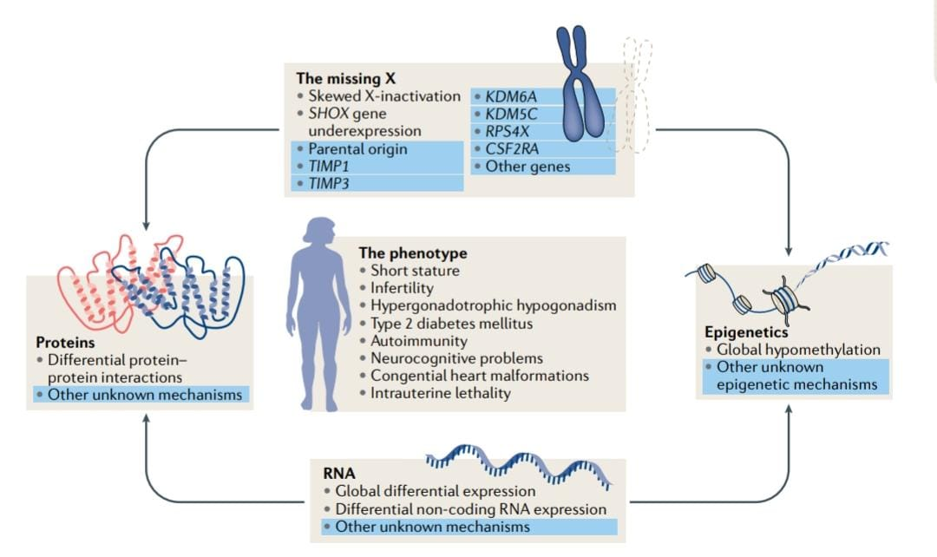
Fig 01 – Pathophysiology of Turner’s Syndrome
Clinical manifestation^{[4]} –
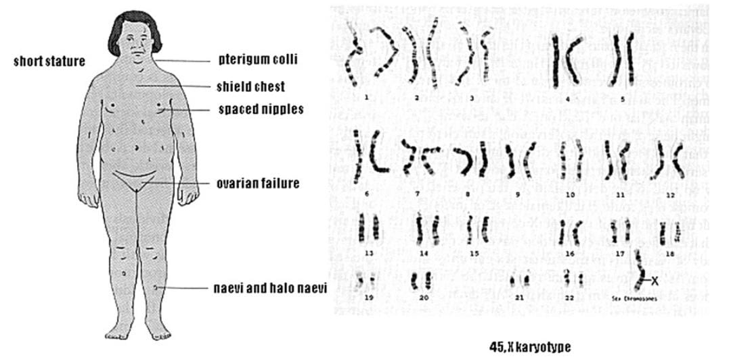
Fig 02 - Clinical manifestation of Turner’s Syndrome

Diagnosis–
- Cytogenetic confirmation- Presence of complete or partial loss of one X chromosome, Confirmed by karyotype analysis, Common karyotypes [45,X (monosomy X), Mosaicism (e.g., 45,X/46,XX or 45,X/46,XY)and Structural abnormalities (ring X, isochromosome X, Xp or Xq deletions)], At least 30 metaphase cells should be analyzed, Buccal smear is insufficient and If karyotype is normal but suspicion remains → FISH for low-level mosaicism
- Phenotypic features consistent with Turner syndrome- Short stature, Gonadal dysgenesis or ovarian insufficiency, Female phenotype (males should never be diagnosed with TS), May present as:Neonatal lymphedema, webbed neck, Childhood short stature, Adolescent primary amenorrhea or pubertal delay.
- Special diagnostic considerations- If Y chromosome material is suspected → perform FISH or DNA studies and Presence of Y material carries a risk of gonadoblastoma (~12%), requiring prophylactic gonadectomy.^{[5]}
Complications of Turner’s syndrome-
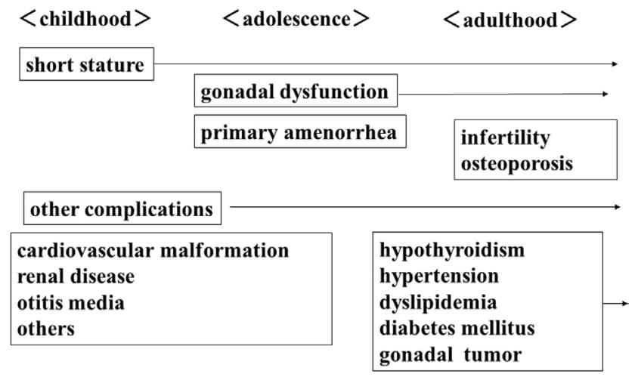
Fig 03 – Complications of Turner’s syndrome
Treatment–
“Patients with TS therefore require a multidisciplinary approach with a team including endocrinologists, gynecologists, cardiologists, otolaryngologists and psychologists. Almost all patients require hormonal replacement therapy (HRT) to maintain satisfactory sex development and bone health. Key issues encountered in adulthood, such as infertility, should be taken into consideration much earlier in life, to prepare the TS patient for further consequences and consider early strategies for fertility preservation”.^{[7]}
TS is a multifaceted condition that affects multiple organ systems in females, necessitating a multidisciplinary approach to patient care-
- Growth Promotion- Growth Hormone (GH) therapy- Started in early childhood when growth failure is evidentand improves growth velocity and increases final adult height
- Puberty Induction & Maintenance- Estrogen replacement therapy- Initiated around 11–12 years of age and induces secondary sexual characteristics and pubertal development, Progesterone- Added after estrogen-induced uterine development or onset of breakthrough bleeding and maintains regular menstrual cycles
- Gonadal & Fertility Management- Most patients have ovarian failure and Fertility options
- Prevention of Osteoporosis- Adequate estrogen replacement, Calcium and vitamin D supplementation and Weight-bearing exercises
- Management of Associated Conditions- Cardiac anomalies → regular cardiology follow-up, Renal anomalies → renal evaluation, Thyroid disorders → regular thyroid screening, Hearing and vision problems → periodic assessment and Metabolic issues (obesity, diabetes, hypertension) → lifestyle modification and medical management
- Psychosocial Support- Educational and psychological support and Counseling for self-esteem, social skills, and transition to adult care ^{[8]}
Clinical practice guidelines for turner’s syndrome.
- Diagnosis & genetics:
Diagnose Turner syndrome (TS) in phenotypic females with complete or partial absence of one X chromosome and typical clinical features. Test females with suggestive signs. Perform gonadectomy if Y-chromosome material is present.
- Growth & puberty:
Start growth hormone (GH) early (ideally 4–6 years). Use standard GH dosing, adjust by growth response and IGF-I. Begin estrogen replacement at 11–12 years, increase gradually; add progesterone after breakthrough bleeding or 2 years of estrogen.
- Fertility & pregnancy:
Counsel early about reduced fertility. Consider fertility preservation in selected patients. Pregnancy requires strict cardiovascular screening and multidisciplinary care; avoid pregnancy in women with high aortic risk.
- Cardiovascular health:
Perform cardiac imaging (TTE/CMR) at diagnosis and periodically thereafter. Monitor aortic size lifelong. Manage hypertension aggressively and restrict high-risk sports in those with aortic dilatation.
- Transition to adult care:
Use a planned, staged transition from pediatric to adult services beginning in adolescence, with coordinated pediatric–adult teams.
- Lifelong surveillance:
Regular monitoring for hearing loss, thyroid disease, diabetes, dyslipidemia, liver and renal disease, bone health, celiac disease, and psychosocial issues. Care should be delivered through specialist multidisciplinary clinics.
- Neurocognitive & psychosocial care:
Integrate psychological assessment and support, ensure educational/vocational accommodations, and support healthy psychosocial development^{[9]}

2. CASE PRESENTATION-
A 17-year-old female patient was admitted to vijayanagara institute of medical science (VIMS), Ballari (Karnataka) with chief complaints of cough with expectoration since 15 days, fever since 15 days – mild to moderate grade and raise of temperature in the evening, decreased appetite since 15 days and facial puffiness since 5 days.
Social history – No habits.
Past history – H/O Primary Amenorrhea and K/C/O Admission for similar complaints 1 year back.
Family history – Nothing significant.
On Examination -
The patient’s blood pressure was recorded at 90/60 mmHg, and the pulse rate was 130 beats per minute. Oxygen saturation was 90% on room air. The random blood glucose level was 118 mg/dL. The patient was conscious and oriented. On respiratory examination, bilateral normal vesicular breath sounds were present. Cardiovascular examination revealed normal S1 and S2 heart sounds. Per abdominal examination showed a soft and non-tender abdomen.

PARAMETERS | RESULT (23-12-25) | RESULT (24-12-25) | RESULT (25-12-25) | REFERENCE RANGE
Haemoglobin | 7.8 |  |  | 13-18gm/dl
WBC | 11410 |  |  | 4000-11000 cells/cumm
Platelet | 5.39 |  |  | 1.5-4.5 lacs/cumm
Blood Urea | 20 |  |  | 15-45mg/dl
Serum creatinine | 0.7 |  |  | 0.7-1.4mg/dl
Total bilirubin |  | 0.6 |  | 0.1-1 mg/dl
SGPT/ALT |  | 17 |  | 0-35 U/L
SGOT/AST |  | 27 |  | 0-35 U/L
Alkaline Phosphatase (ALP) |  | 233 |  | 30-120 U/L
Total protein |  | 7.1 |  | 6-8.3 g/dl
Albumin |  | 3.5 |  | 3.2-5.4 g/dl
CRP | 76.4 |  |  | 0-6 mg/dl
FSH (Follicle Stimulating Hormone) |  |  | 1.99 | 4-10 IU/mL
LH (Luteinizing Hormone) |  |  | 0.43 | 2-12 IU/mL
Cortisol |  |  | 25.1 | 5-25 microgram/dl
FT₃ |  |  | 2.28 | 2.0-4.4 pg/ml
TSH |  |  | 1.81 | 0.4-4.0 mIU/L
FT₄ |  |  | 0.67 | 0.8-1.8 ng/dl
Urine albumin | Traces
Urine microscopy | 1-2 pus cells
LDH | 680 |  |  | 140-280 U/L
Serum folic acid | 8.46 |  |  | 2.5-20 ng/ml
Serum ferritin | 2455 |  |  | 11-307 ng/ml
Vitamin B₁₂ | 523 |  |  | 211-911 pg/ml
Table 1. Laboratory examination of the patient
- Other investigations – Chest X – ray :- B/L Non-homogenous opacities, USG abdomen & pelvis :- Uterus absent, Peripheral smear study :- Microcytic Hypochromic and USG neck :- Hashimoto’s Thyroiditis.

SL.NO | NAME OF MEDICATIONS | DOSE | ROUTE | FREQUENCY
01 | INJ. CEFTRIAXONE | 1 gm | IV | BID FOR 3 DAYS
02 | INJ. PANTOPRAZOLE | 40 mg | IV | OD FOR 3 DAYS
03 | INJ. ONDANSETRON | 4 mg | IV | BID FOR 3 DAYS
04 | INJ. PARACETAMOL | 100 ml | IV | TID FOR 3 DAYS
05 | TAB. DOXYCYCLINE | 100 mg | PO | BID FOR 3 DAYS
06 | TAB. IRON FOLIC ACID | 333 mg | PO | BID FOR 3 DAYS
07 | TAB. FOLIC ACID | 5 mg | PO | OD FOR 3 DAYS
08 | INJ. MULTIVITAMIN | 1 PINT NS | IV | OD ON 3rd DAY
Table 2. Treatment regimen in hospital

3. discussion
Turner syndrome (TS) is a chromosomal disorder characterized by partial or complete monosomy of one X chromosome and presents with a wide spectrum of clinical manifestations involving growth, gonadal development, endocrine function, and autoimmunity. Primary amenorrhea is one of the most common presenting features in adolescent females with TS, often prompting further endocrine and genetic evaluation.
In the present case, a 17-year-old female presented with long-standing primary amenorrhea along with recurrent infections and features suggestive of autoimmune thyroid disease, raising a strong clinical suspicion of Turner syndrome. The absence of the uterus on ultrasonography, along with hypogonadotropic findings (low FSH and LH levels), indicates gonadal dysgenesis, a hallmark feature of TS. Cytogenetic confirmation is essential for the definitive diagnosis of Turner syndrome. In the present case, karyotyping analysis was advised to the patient during the current admission and planned for the next follow-up visit to confirm the suspected chromosomal abnormality and to assess for possible mosaicism.
Although hypergonadotropic hypogonadism is classically described in Turner syndrome, hormonal patterns may vary depending on age, mosaicism, and residual ovarian function. Delayed recognition of TS is common, especially in adolescents who present primarily with amenorrhea rather than overt dysmorphic features or short stature, as seen in this patient. This emphasizes the need for a high index of suspicion in females with unexplained primary amenorrhea.
A notable finding in this case is the coexistence of autoimmune thyroiditis (Hashimoto’s thyroiditis), demonstrated by ultrasonographic findings and altered thyroid hormone levels (low FT4 with normal TSH). Autoimmune disorders are significantly more prevalent in individuals with Turner syndrome compared to the general population. Lleo et al. (2012) reported that autoimmune thyroid disease is the most frequent autoimmune condition associated with TS, affecting up to 30–50% of patients, with Hashimoto’s thyroiditis being more common than Graves’ disease. The findings in our patient are consistent with this observation, supporting the strong association between Turner syndrome and thyroid autoimmunity.
When compared with the study by Lleo et al., our case mirrors the reported increased susceptibility to autoimmune diseases due to X-chromosome haploinsufficiency and immune dysregulation. The loss of immune-regulatory genes located on the X chromosome is thought to impair central and peripheral immune tolerance, predisposing TS patients to autoimmune conditions. Similar to previously reported cases, our patient did not initially present with overt hypothyroid symptoms, highlighting the importance of routine thyroid screening in suspected or confirmed Turner syndrome cases.
In addition to endocrine abnormalities, the patient exhibited anemia with microcytic hypochromic blood picture and markedly elevated serum ferritin levels, likely reflecting anemia of inflammation in the setting of an acute infective process. Elevated CRP and LDH further support an ongoing inflammatory state. Recurrent infections, as noted in this patient’s history, have also been reported in Turner syndrome, possibly related to immune dysregulation.
Early diagnosis of Turner syndrome is critical for timely initiation of growth hormone therapy, estrogen replacement, and monitoring for associated comorbidities such as cardiovascular anomalies, metabolic disorders, osteoporosis, and autoimmune diseases. In the present case, delayed diagnosis resulted in missed opportunities for early growth and pubertal induction. This aligns with literature emphasizing that many Turner syndrome patients without classic phenotypic features are diagnosed late during adolescence.
Overall, this case highlights the clinical heterogeneity of Turner syndrome and reinforces the importance of considering TS in adolescent females presenting with primary amenorrhea and autoimmune thyroiditis. Early cytogenetic evaluation, multidisciplinary management, and long-term follow-up are essential to improve clinical outcomes and quality of life in such patients.

4. Conclusion
This case highlights the importance of considering Turner syndrome in adolescent females presenting with primary amenorrhea, even in the absence of classic phenotypic features. The coexistence of autoimmune thyroiditis in this patient further supports the well-established association between Turner syndrome and autoimmune disorders. Clinical findings such as absent uterus on imaging, gonadal dysfunction, and thyroid abnormalities strongly pointed toward a suspected diagnosis of Turner syndrome.
Although cytogenetic confirmation could not be performed during the current hospital admission, karyotyping was advised for the subsequent follow-up visit to establish a definitive diagnosis and assess for possible mosaicism. This case underscores the challenges of delayed diagnosis and limited access to genetic testing in routine clinical practice.
Early recognition of Turner syndrome is crucial to enable timely hormonal replacement therapy, appropriate screening for associated comorbidities, and multidisciplinary management. Increased awareness among clinicians regarding atypical presentations can facilitate early diagnosis, improve long-term health outcomes, and enhance quality of life in affected individuals.

CONSENT
As per international standards, parental written consent has been collected and preserved by the author(s).

DISCLAIMER (ARTIFICIAL INTELLIGENCE)
Author(s) hereby declare that NO generative AI technologies such as Large Language Models (ChatGPT, COPILOT, etc) and text-to-image generators have been used during writing or editing of this manuscript.

COMPETING INTERESTS
Authors have declared that no competing interests exists.

References
- Gravholt CH, Viuff MH, Brun S, Stochholm K, Andersen NH. Turner syndrome: mechanisms and management. Nat Rev Endocrinol. 2019;15(10):601–614.
- Ding F, Xu J, Xiong J, Li Q, Cheng Z, Deng L. Epidemiological analysis of Turner syndrome in children aged 0–14 years: global, regional, and national perspectives (1990–2021). Front Endocrinol (Lausanne). 2025;16:1552300.
- Zhong Q, Layman LC. Genetic considerations in the patient with Turner syndrome—45,X with or without mosaicism. Fertil Steril. 2012;98(4):775–779.
- Lleo A, Moroni L, Caliari L, Invernizzi P. Autoimmunity and Turner’s syndrome. Autoimmun Rev. 2012;11(8):A538–A543. doi:10.1016/j.autrev.2011.11.015.
- Loscalzo ML. Turner syndrome. Pediatr Rev. 2008;29(7):219–227.
- Sakakibara H. Transition of women with Turner syndrome from pediatrics to adult health care: current situation and associated problems. Front Pediatr. 2017;5:28.
- Więcek M, Donaldson M, Gawlik-Starzyk A. Editorial: Transition to adulthood in Turner syndrome. Front Endocrinol (Lausanne). 2024;15:1431972.
- Khan N, Farooqui A, Ishrat R. Turner syndrome: where are we? Orphanet J Rare Dis. 2024;19:314.
- Gravholt CH, Andersen NH, Conway GS, Dekkers OM, Geffner ME, Klein KO, et al.; Turner Syndrome Study Group. Clinical practice guidelines for the care of girls and women with Turner syndrome: proceedings from the 2016 Cincinnati International Turner Syndrome Meeting. Eur J Endocrinol. 2017;177(3):G1–G70.
- Wolff DJ, Van Dyke DL, Powell CM; ACMG Laboratory Quality Assurance Committee Working Group. Laboratory guideline for Turner syndrome. Genet Med. 2010;12(1):52–55.
- Aversa T, De Sanctis L, Faienza MF, Gambineri A, Balducci A, D’Aprile R, et al. Transition from pediatric to adult care in patients with Turner syndrome in Italy: a consensus statement by the TRAMITI project. J Endocrinol Invest. 2024;47(7):1585–1598.

