Original Research Article

SPATIO TEMPORAL ASSESSMENT OF URBAN HEAT ISLAND DYNAMICS USING GEOSPATIAL TECHNIQUES: A CASE STUDY OF KOZHIKODE, KERALA.

ABSTRACT
Across India, medium-sized towns frequently experience unplanned urban growth and the ensuing environmental problems. In addition to notable reductions in water bodies and vegetation cover, unchecked, rapid urbanisation has led to a marked expansion of built-up areas. Such transformations of once-green urban landscapes have intensified environmental risks and exacerbated climate-related issues. Geospatial technology is a powerful tool for quantifying land-cover transformations and the resulting temperature increase. The present study investigates the spatio-temporal dynamics of urban temperature rise and its association with accelerated urban growth and resultant land-use/land-cover (LULC) transformations in the Kozhikode city region, from 1993 to 2023. To quantify these LULC changes, a combination of remote sensing and Geographic Information System (GIS)-based analytical techniques (Various spectral indices (NDMI, NDII, GNDVI, NDbaI) and Land surface temperature) was employed. The study reveals a pronounced intensification of built-up land and a corresponding depletion of vegetation cover. The mean GNDVI value decreased from 0.53 in 1993 to 0.51 in 2023. Similarly, the moisture index showed a declining trend. It transformed from 0.27 in 1993 to 0.23 in 2023. Conversely the bareness index and impervious index showed a marked acceleration over the research period. It transformed into -0.43 in 1993 to -0.17 in 2023 and -0.43 in 1993 to -0.17 in 2023 respectively. The steadily increasing land-surface temperature readings during the research period provide further evidence of accelerating urban warming in the study area. The mean Land Surface Temperature value accelerated into 35.59°C in 2023 from 29.24°C in 1993. The spatial analysis of Land Surface Temperature (LST) reveals that elevated temperature zones are predominantly concentrated in intensively built-up areas, particularly within the 5 km buffer surrounding the city core. The findings clearly indicate that regions characterised by higher built-up density function as urban heat island (UHI) zones within the city.
KEY WORDS: Urban heat island, Geospatial technology, Land Surface Temperature, GNDVI, NDMI, NDII, NDBaI

INTRODUCTION
Over the past century, urbanisation has been one of the most significant global phenomena, reshaping societies, economies, and environments. While the process itself is not new, its scale, speed, and consequences in the modern era are unprecedented. The world’s urban population has expanded exponentially, contributing to the formation of megacities, altering human interaction with the environment, and creating challenges and opportunities for development. According to the United Nations World Urbanisation Prospects 2018, the proportion of the world’s urban population was only 30% in the 1950s, increased to 55% in 2018, and is projected to reach 68% by 2050. Urbanisation boosts economic growth and quality of life in rising and developing nations. Conversely, unplanned urban growth may result in significant alterations to Land Use and Land Cover (LULC) patterns, particularly the conversion of flora, water bodies, and agricultural areas into concrete surfaces. (Ding & Shi, 2013; Vadakkuveettil & Grover, 2023).
Existing towns and cities are expanding due to rapid industrialisation and population growth, which alter the topography and warm the surface, turning cities into thermal hotspots (Li et al., 2022) and leading to UHI. Urban heat island (UHI) is a phenomenon in which the air temperature in an urban area is higher than that of its rural surroundings, and the temperature differential between a city's heat centre and its rural environs indicates the extent of the UHI (Chang & Li, 2014). The anthropogenic heat generated by industry, transportation, and residential buildings exacerbates the effects of UHI. The city's dense concentration of buildings influences electrical conductivity and energy exchange which in turn affects the local climate. The higher temperatures in urban heat islands may alter precipitation patterns, boost pollutant levels, and increase the need for air conditioning. As a result, many studies on urban climatology have focused heavily on the extent and distribution of UHI effects. (Yuan & Bauer, 2007).
Remote sensing (RS) and geographic information systems (GIS) have enhanced the capacity to track and predict variations in the Earth's surface temperature (Roy et al., 2022). ASTER, MODIS, and Landsat are only a few of the satellite sensors that use the spectral signatures of materials across various wavelength bands to detect changes in the unique features of land-surface materials. (Guha et al., 2022). The present study employed different spectral indices (Green Normalised Difference Vegetation Index, (GNDVI), Normalised Difference Impervious Index (NDII), Normalised Difference Bareness Index (NDBaI) and Normalised Difference Moisture Index (NDMI) retrieved from LANDSAT imageries to uncover the urban temperature rise in the Kozhikode city region
Although it measures the Green band of the electromagnetic spectrum rather than the Red band, the Green Normalized Difference Vegetation Index is quite similar to the NDVI (Normalised Difference Vegetation Index). (Basso et al., 2019) The green band is more sensitive to changes in chlorophyll content. Therefore, when it comes to displaying dense and mature vegetation, the Green NDVI has an edge over the NDVI. GNDVI is more suitable for the Kozhikode city region due to its mature vegetation cover and dense canopy. (Grover et al., 2024). The normalised difference impervious index is suitable for assessing urban ecological transformations. (Wang et al., 2015). The rapid and precise estimation of impervious surface areas enables effective detection of urban dynamics. Impervious surfaces are surfaces that do not allow water infiltration and are primarily associated with transportation and building rooftops. (Yuan & Bauer, 2007). Thermal infrared data can be used to extract impervious surfaces because of their distinct thermal reactivity relative to other land-cover types. (Lu & Weng, 2006).
The distribution and alteration of bare land are significant ecological indicators of anthropogenic and physiological environmental effects. (Hongmei Zhao & Xiaoling Chen, 2005). Remotely sensed imagery is an effective tool for monitoring and detecting changes in bare land. NDMI is an efficient tool for estimating vegetation moisture in an area (Abdulkadir, 2021). Traditionally, the NIR-to-SWIR ratio is used to calculate it. SWIR is sensitive to plant water content and to leaf mesophyll structure. NIR measures the dry matter content and internal structure of the leaf from its light reflectance. (Grover et al., 2024). The correlation between various spectral indices and Land surface temperature provides a comprehensive understanding of ecological transformations and temperature rise in an urban area, and the present study sought to uncover the warming reality of the Kozhikode city region.
STUDY AREA
The present study focused on the Kozhikode city region. It is the major urban centre on the Malabar coast and geographically stands between. Historically it has been a significant centre of trade and cultural heritage, and the Arabian Sea has underlined the city’s strategic importance over the centuries. The Kozhikode city region comprises Kozhikode Corporation, Feroke, Ramanattukara, and Kunnamangalam Municipalities, and 10 panchayaths: Kadalundy, Vazhayoor, Perumanna, Peruvayal, Kuruvattoor, Kakkodi, Chelannur, Thalakkulathur, Atholi, and Chemancheri. The study area experiences a hot, humid climate, with a very hot season from March to May. The south-west monsoon accounts for 60% of annual rainfall (Town and Country Planning Department, 2017), and the study area is endowed with abundant water resources. Three major rivers, Korappuzha, Chaliyar and most importantly Kallai, have influenced the development of the city.
Urban growth in the Kozhikode city region is increasing rapidly. Numerous factors have influenced the city's urban expansion including intrastate migration and land-use changes driven by the real estate industry. (Grover et al., 2024). According to UN-Habitat and the Lincoln Institute of Land Policy, Kozhikode is the fastest-growing urban habitat in India (Wihbay, 2016). According to a study conducted by the Economist Intelligence Unit (EIU), Kozhikode was among the fastest-growing urban areas in the world. (Navaneeth et al., 2021). Because of its reputation as the fastest-growing urban centre, the Kozhikode city region is selected for the present study.
Picture 1- Kozhikode city region, the site of the study

MATERIALS AND METHODS
The methodological framework of the current study consists of three stages: 1) Data acquisition and processing, 2) Retrieval of spectral indices and LST, and 3) Statistical Analysis.
Data Acquisition and Processing
The satellite imagery data used in the present study were collected from four different LANDSAT sensors: LANDSAT 5 (Thematic Mapper), LANDSAT 7 (Enhanced Thematic Mapper +), LANDSAT 8 (Operational Land Imager and Thermal Infrared Sensor), and LANDSAT 9 (OLI and TIRS). The Landsat imagery was downloaded from the United States Geological Survey. The data description of satellite images is given in Table 1.

TABLE 1-- Description of satellite images Data
SENSOR | Path/Row | Cloud Coverage (%) | Scene center  Time | Date of Acquisition | Spatial Resolution
LANDSAT 5 (TM) | 145/052 | 9% | 04:39:10 | 1993-01-23 | 30 M
LANDSAT 7 (ETM+) | 145/052 | 3% | 05:05:56 | 2003-01-27 | 30 M
LANDSAT 8 (OLI&TIRS) | 145/052 | 3.28% | 05:08:58 | 2013-12-16 | 30 M
LANDSAT 9 (OLI&TIRS) | 145/052 | 6.9% | 05:17:32 | 2023-03-23 | 30 M
There is a requirement of data pre-processing. It includes radiometric and atmospheric corrections.
Retrieval of Spectral Indices and LST
Green Normalised Difference Vegetation Index was retrieved from satellite imagery with the following equation.
GNDVI = NIR-GREEN/NIR+GREEN
Where NIR represents the Near Infrared band (band 4 in Landsat 5 and Landsat 7, band 5 in Landsat 8; Landsat 9) and GREEN represents the green band of the visible spectrum. The GNDVI typically ranges between +1 and -1. +1 indicates healthier vegetation; conversely -1 indicates the absence of vegetative cover. The normalised difference impervious index can be obtained as follows.
NDII =VIS-TIR/VIS+TIR
Where VIS refers to visible bands like blue, green, and red, and TIR represents the Thermal infrared band (band 6 in Landsat 5 and 7, band 10 and band 11 in Landsat 8 and Landsat 9). This index ranges between 0 to 1. The normalised difference bareness index can be computed through the given formula,
NDBaI = SWIR-TIR/SWIR+TIR

Where SWIR represents the short-wave infrared band (band 5 in Landsat 5 and Landsat 7, band 6 in Landsat 8 and Landsat 9), on the other hand, TIR is the Thermal infrared band. (band 6 in Landsat 5 and Landsat 7, band 10 & band 11 in Landsat 8 and Landsat 9). The NDBaI index ranges from +1 to -1, with positive values indicating increasing bareness. The following equation was utilised to compute the Normalised Difference Moisture Index
NDMI = NIR -SWIR/ NIR +SWIR
Where NIR =Near Infrared, SWIR = Short Wave Infrared. Similar to the bareness index, the NDMI also ranges from -1 to +1, with positive values indicating higher moisture content in plants and negative values indicating lower moisture content.
LST retrieved from the Thermal bands of Landsat imagery with the use of Remote sensing and a GIS plugin.
Statistical Analysis
To investigate the correlation and spatial pattern of LST and other spectral indices,
Spearman's Rank Correlation coefficient was employed with SPSS Software. The Spearman rank correlation analyses the association between two variables and serves as the non-parametric equivalent of Pearson's correlation. The Spearman rank correlation coefficient can be computed in the following manner,
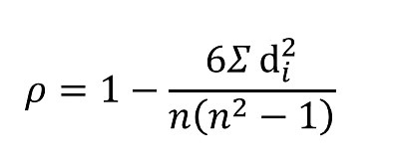
P = Spearman’s rank correlation coefficient.
di = Difference between the two ranks of each observation
n = Number of observations
Two tailed significance tests were utilized to evaluate all reported Spearman correlations and statistically significant relationships were identified at the 5 % and 1 % significance level.
RESULTS AND DISCUSSIONS
Spatio-temporal analysis of LST
Trend analysis of land surface temperature (LST) is a significant indicator of temperature rise, and the increase in LST is a clear indication of the planet's warming. In the Kozhikode city region, the mean LST increased considerably within the last three decades. This substantial increase in LST drove the temperature surge in the city and has strong implications for the surrounding environment. The highest LST is clustered at the city core, whereas the southern portion of the city exhibits a comparatively lower land surface temperature. The presence of water bodies, including Chaliyar and Kallayippuzha, and the greener spaces in the southern part do not increase LST emittance. The city core region experienced the maximum LST compared to its counterpart.
Picture 2- The mean LST in the Kozhikode city region for the last three decades (1993-2023)
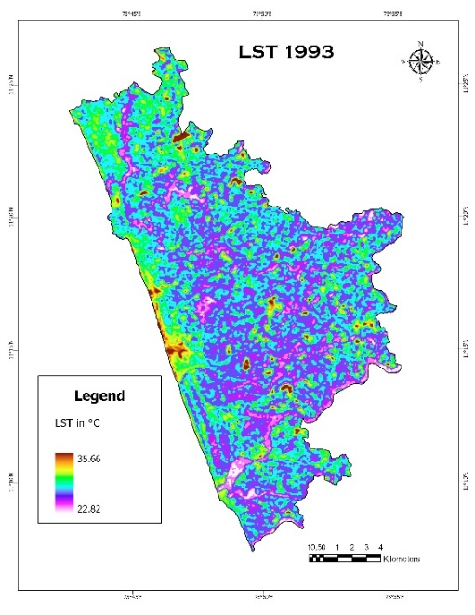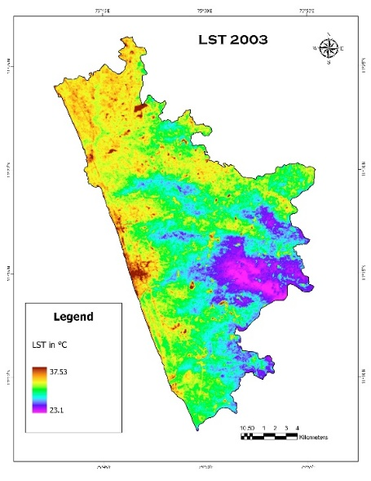
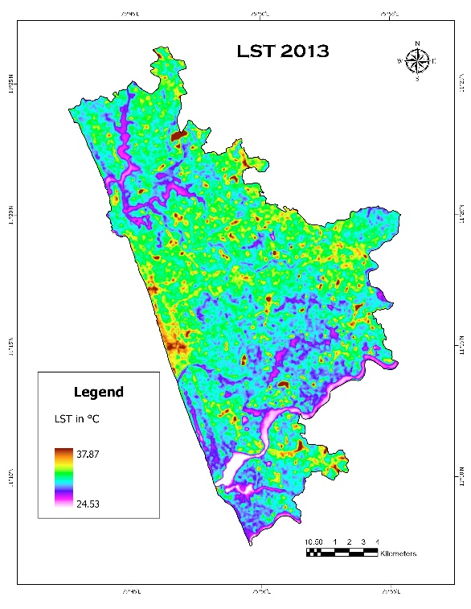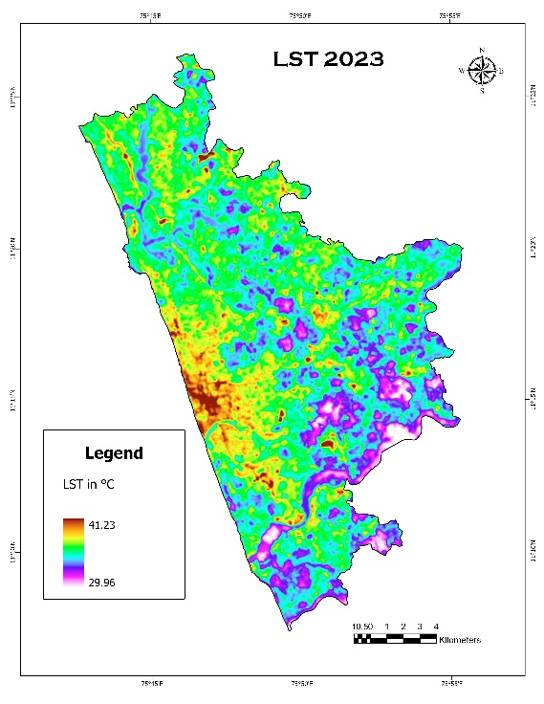
From 1993 to 2023, the mean land surface temperature in the Kozhikode city region increased by 6.35 °C. This sharp, definite upward trend reveals the city's warming over the decades. In 1993, the Kozhikode city region exhibited a maximum LST of 35.66 °C and a minimum of 22.82 °C. it increased to 41.23° C and 29.96° C respectively in 2023.The most dramatic increase in temperature, from 31.2° C to 35.59° C, occurred between 2013 and 2023. Land-use land-cover changes across the study area, and the comparatively higher proportion of built-up land in recent years, have severely affected the rate of temperature rise. The maximum temperature in 1993 was 35.66 °C, but in 2023 the average temperature was 35.59 °C. It is clear evidence of the changes in the city’s thermal behaviour over recent decades
Table 2- DESCRIPTIVE STATISTICS OF LST
LST | YEAR | MAXIMUM VALUE | MINIMUM VALUE | MEAN VALUE
LST | 1993 | 35.66 | 22.82 | 29.24
LST | 2003 | 36.67 | 23.1 | 29.88
LST | 2013 | 37.87 | 24.53 | 31.2
LST | 2023 | 41.23 | 29.96 | 35.59

The energy balance of the surface is significantly changed when natural landscapes (forests, grasslands, and wetlands) are transformed into urbanised surfaces (buildings, highways, and parking lots). Materials with strong thermal conductivity and poor albedo, such as metal, concrete, and asphalt, are commonly found on urban surfaces. Temperatures are higher on these surfaces because they absorb and retain heat more effectively than natural surfaces. Additional heat is released into the urban environment by human activities such as energy use, transportation, and industrial processes. While air-conditioning and heating systems release warm air into the environment, vehicles also release heat through exhaust gases. The UHI effect is exacerbated by anthropogenic heat, particularly in areas with high population density. Rising temperatures in cities have far-reaching consequences across sectors, including the environment, public health, energy consumption, and economic development.

FIGURE 1 Temporal Variations of LST

Figure 1 illustrates the spatial distribution of Land Surface Temperature (LST) across the study area. A clear decline in LST is observed from the urban core toward the peripheral zones. The 5 km buffer zone surrounding the city centre consistently exhibits the highest mean LST values across all time periods analysed. This thermal intensity decreases with increasing distance from the urban core, consistent with a typical urban–rural temperature gradient.
Figure 2- Buffer zones of Kozhikode city for the last three decades (1993-2023)
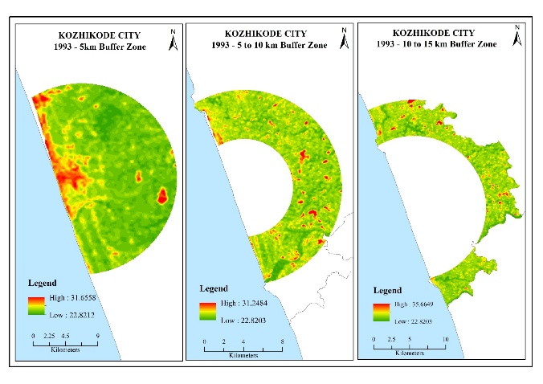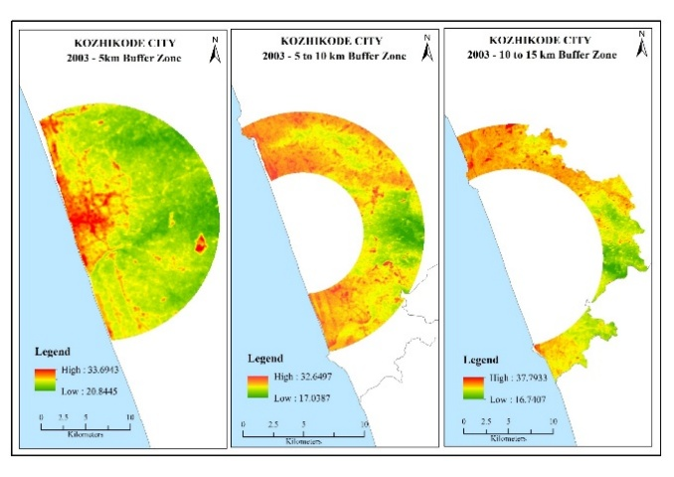
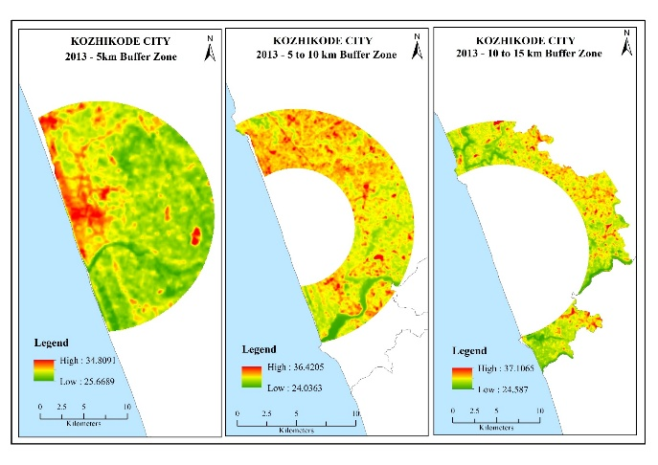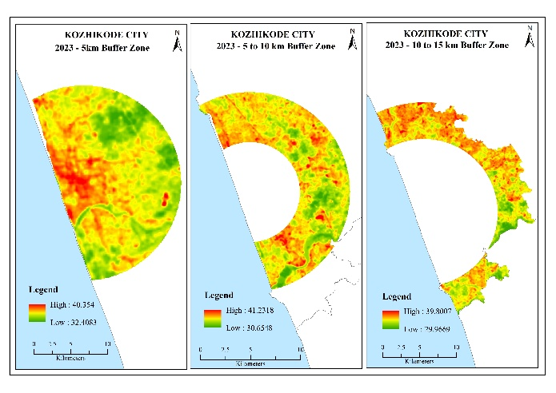
Table 2 presents the mean Land Surface Temperature (LST) values across three concentric buffer zones (5 km, 10 km, and 15 km) from the city core for the years 1993, 2003, 2013, and 2023. A consistent spatial pattern is observed over the study period, with mean LST values highest within the 5 km buffer zone and gradually decreasing with increasing distance from the urban core. In 1993, the mean LST was 25.16°C at 5 km, 24.86°C at 10 km, and 24.42°C at 15 km. This spatial gradient persisted over subsequent years, with temperatures steadily increasing due to urban expansion and associated land-use changes.
By 2023, the mean LST reached 35.89°C in the 5 km zone, indicating a substantial increase of 10.73°C since 1993. Compared with the 20 km zone, the 10 km and 15 km zones showed slightly lower increases of 9.72°C and 9.87°C, respectively. These trends reflect the intensification of the Urban Heat Island (UHI) effect, particularly in the central urban areas, and underline the impact of urbanisation on local thermal environments.
Table 3- Mean LST for different buffer zones
Distance in  Buffers | MEAN LST IN ° C
Distance in  Buffers | 1993 | 2003 | 2013 | 2023
5 KM | 25.16 | 25.55 | 28.99 | 35.89
10 KM | 24.86 | 24.93 | 28.69 | 34.58
15 KM | 24.42 | 24.72 | 28.54 | 34.29

Spatio-temporal Variations of Normalised Difference Satellite Indices
The temporal and spatial fluctuations in normalised difference spectral indices, as well as their correlation with Land surface temperature (LST), offer critical insights into the warming patterns of the Kozhikode city region. Among these, changes in the Green Normalised Difference Vegetation Index provide a clear indicator of mature vegetation status and health. As shown in Table 3, the mean GNDVI declined from 0.53 to 0.51, indicating a notable reduction in mature-vegetation cover in the study area. Rising surface temperatures appear to be linked to this loss of vegetation, which could have broader environmental repercussions, such as declining biodiversity and worsening air quality. The spatial distribution of GNDVI values indicates that comparatively lower values are concentrated in the south-western sector of the city, corresponding to the urban core. In contrast, higher GNDVI values are predominantly observed in the northern and north-eastern sectors, where the intensity of urban expansion remains relatively limited. This spatial pattern clearly represents the distribution of mature vegetation and highlights its inverse relationship with urban growth.
The Normalised Difference Moisture Index (NDMI), which serves as an indicator of vegetation moisture content and overall water availability, exhibits a consistent declining trend over the study period. A downward shift in NDMI values reflects progressive depletion of soil and vegetation moisture, indicating intensifying water stress driven by urban growth, land-use transformations, and climatic variability. The mean NDMI value decreased from 0.27 in 1993 to 0.13 in 2023, signifying a substantial reduction in moisture availability. This marked decline not only suggests increasing aridity but also points to the potential onset of drought-like conditions in the region. Collectively, these patterns underscore the mounting environmental pressures associated with rapid urban expansion.
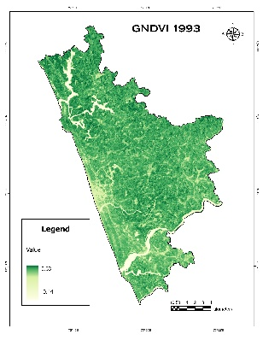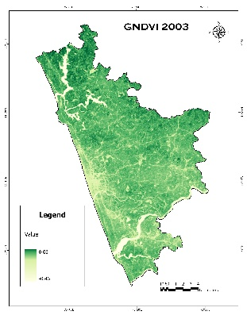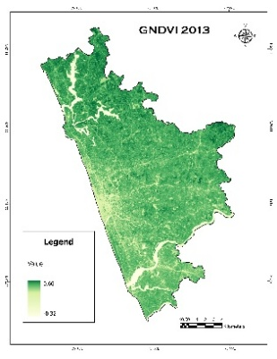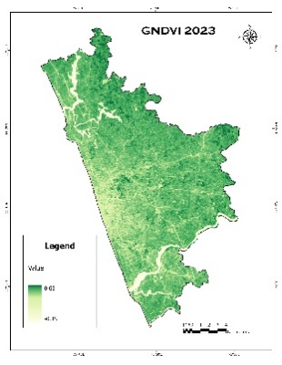
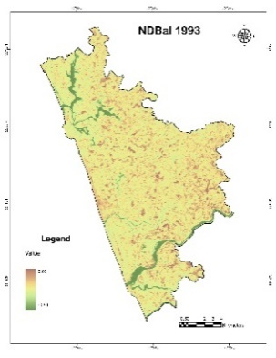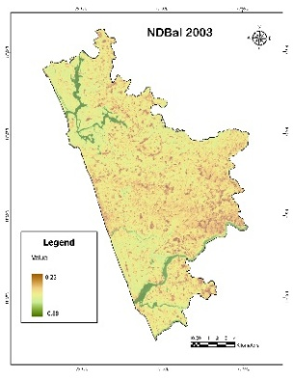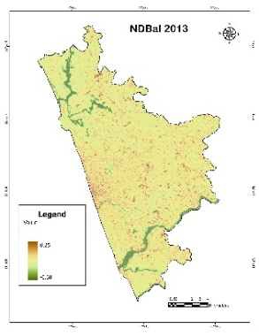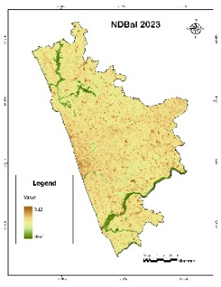
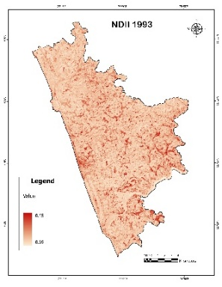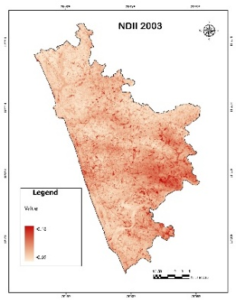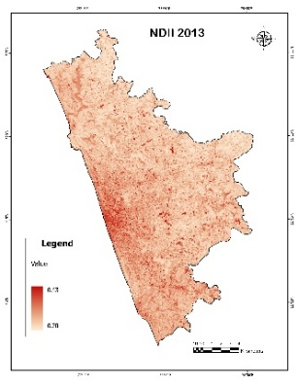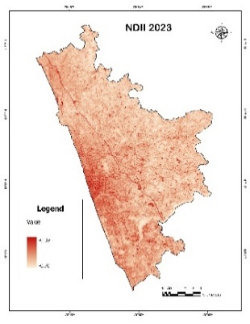
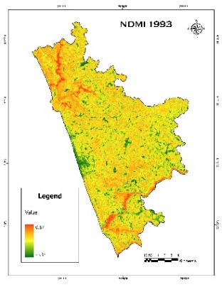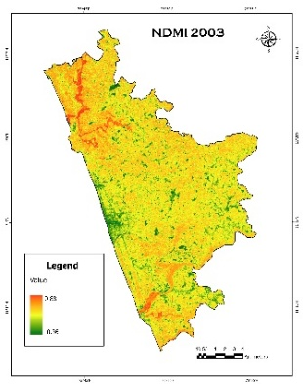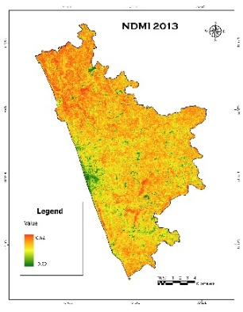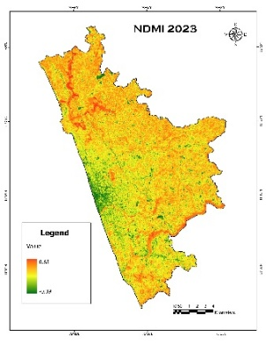
Fig 3- Green Normalised Difference Vegetation Index (GNDVI), Normalised Difference Impervious Index (NDII), Normalised Difference Bareness Index (NDBaI), Normalised Difference Moisture Index (NDMI) value
In parallel, the Normalised Difference Impervious Index (NDII), which quantifies the proportion of impervious surfaces such as roads, buildings, and other urban infrastructure, demonstrates a pronounced increasing trend over the study period, with mean values rising from -0.57 in 1993 to -0.54 in 2023. This upward trajectory is indicative of intensifying urbanisation, in which natural land cover is progressively replaced by built-up surfaces, including concrete and asphalt. The proliferation of impervious areas alters natural hydrological processes by reducing groundwater recharge, enhancing surface runoff, and elevating flood susceptibility. Furthermore, the expansion of built-up surfaces contributes to higher land-surface temperatures, thereby intensifying the urban heat island effect.
The Normalised Difference Bareness Index likewise showed an increased tendency in the study area, similar to the Normalised Difference Impervious Index. The NDBaI for Kozhikode city increased from -0.43 in 1993 to -0.17 in 2023. This trend indicates a significant increase in bare or sparsely vegetated terrain over the past three decades, which may signal accelerated urbanisation and land degradation. The conversion of vegetation or natural land coverings into exposed or built-up surfaces is reflected in the rise in the bareness index. This can exacerbate soil erosion, reduce surface moisture retention, and alter the microclimate within a given area.
Table 4: DESCRIPTIVE STATISTICS OF SPECTRAL INDICES
spectral Indices | Year | Maximum value | Minimum value | Mean Value | Spearman rank correlation coefficient with LST
GNDVI | 1993 | 0.63 | 0.44 | 0.53 | -0.294
GNDVI | 2003 | 0.66 | 0.46 | 0.56 | -0.121
GNDVI | 2013 | 0.66 | 0.32 | 0.49 | -0.052
GNDVI | 2023 | 0.65 | 0.38 | 0.51 | -0.244
NDII | 1993 | -0.45 | -0.69 | - 0.57 | 0.484
NDII | 2003 | -0.48 | -0.69 | -0.58 | 0.331
NDII | 2013 | -0.43 | -0.70 | - 0.56 | 0.270
NDII | 2023 | -0.39 | -0.70 | - 0.54 | 0.388
NDbaI | 1993 | 0.07 | -0.94 | -0.43 | 0.564
NDbaI | 2003 | 0.23 | -0.88 | -0.32 | 0.416
NDbaI | 2013 | 0.25 | -0.68 | -0.21 | 0.456
NDbaI | 2023 | 0.27 | -0.61 | -0.17 | 0.383
NDMI | 1993 | 0.87 | -0.33 | 0.27 | -0.629
NDMI | 2003 | 0.88 | -0.36 | 0.26 | -0.582
NDMI | 2013 | 0.62 | -0.328 | 0.14 | -0.484
NDMI | 2023 | 0.65 | -0.39 | 0.13 | -0.426

Over the 1993–2023 period, Kozhikode City has experienced significant environmental changes driven by urbanisation. Declines in GNDVI and NDMI indicate reductions in mature vegetation and moisture content, while increases in NDII and NDBaI reflect the expansion of impervious and bare surfaces. These trends collectively highlight the intensifying impact of urban growth on the city’s biophysical environment including vegetation loss, soil exposure, and altered hydrological and microclimatic conditions.

CORRELATION BETWEEN SPECTRAL INDICES AND LAND SURFACE TEMPERATURE
The correlation between diverse spectral indices and land surface temperature provides a comprehensive assessment of the interplay between potential urban heat and land cover-related environmental dynamics. The Spearman's rank correlation coefficient between GNDVI and LST is -0.294, -0.121, -0.052, and -0.244 for the years 1993, 2003, 2013, and 2023, respectively. This statistically significant, moderately negative correlation indicates a relationship between potential urban heat and mature-vegetation stress. The observed decline in mature vegetation over these decades appears to be a contributing factor to rising urban temperatures in the study area. In contrast, the relationship between NDII and LST is statistically significant and positive. The substantial increase in impervious surfaces across the study area has contributed to rising land surface temperature. The Spearman’s rank correlation coefficients between NDII and LST are 0.484, 0.331, 0.270, and 0.388 for 1993, 2003, 2013, and 2023, respectively. This positive relationship underscores the influence of urbanisation on local thermal conditions.
Similar to NDII, the Bareness Index also exhibited a positive correlation with land surface temperature. This relationship underscores that the increase in exposed soil and non-vegetated surfaces has significantly intensified surface heating and the subsequent temperature rise. The densely built-up environments of the Kozhikode city region exhibit higher land surface temperatures, associated with greater impervious and barren land cover. The Spearman's rank correlation coefficient between land surface temperature and the normalised difference bareness index is 0.564, 0.416, 0.456, and 0.383 for the years 1993, 2003, 2013, and 2023, respectively. This positive link demonstrates that local thermal stress is exacerbated by urbanisation and the conversion of vegetated land, creating environmental problems for medium-sized towns such as Kozhikode that are expanding rapidly.
The vanishing of urban green spaces and water bodies through urban expansion in the thriving Kozhikode city region reduces moisture content and leads to a strong negative correlation between the normalised difference moisture index and land surface temperature. The Spearman's rank correlation coefficient between NDMI and LST in the Kozhikode city region is -0.629, -0.582, -0.484, and -0.426 for the years 1993, 2003, 2013, and 2023, respectively. Although surface moisture is a major factor in reducing land surface temperature in the Kozhikode city region, its impact has waned over the last three decades due to rapid urban expansion and a decline in naturally occurring moisture-retaining land cover, as evidenced by a consistently negative correlation across all decades.
CONCLUSION
This study examined the complex interplay between unplanned urban expansion, the resulting changes in land use and land cover, and the spatiotemporal fluctuations in land surface temperature in the Kozhikode city region. The spatio-temporal analysis of various satellite indices, including GNDVI, NDBI, NDII, NDBaI, reveals a pronounced intensification of built-up and, accompanied by a considerable depletion of vegetation cover. The steadily increasing land-surface temperature readings during the research period provide further evidence of accelerating urban warming in the study area. The spatial analysis of Land Surface Temperature (LST) reveals that elevated temperature zones are predominantly concentrated in intensively built-up areas, particularly within the 5 km buffer surrounding the city core. The findings clearly indicate that regions characterised by higher built-up density function as urban heat island (UHI) zones within the city. It is imperative that policymakers and urban planners holistically address the physical and socio-human aspects of urban heat phenomena to promote sustainability in the rapidly growing medium-sized town of Kozhikode.

Disclaimer (Artificial intelligence)

Author(s) hereby declare that NO generative AI technologies such as Large Language Models (ChatGPT, COPILOT, etc.) and text-to-image generators have been used during the writing or editing of this manuscript.

REFERENCE
1)Al Shawabkeh, R., AlHaddad, M., Al-Fugara, A., Al-Hawwari, L., Al-Hawwari, M. I., Omoush, A., & Arar, M. (2024). Modeling the impact of urban land cover features and changes on the land surface temperature (LST): The case of Jordan. Ain Shams Engineering Journal, 15(2), 102359. https://doi.org/10.1016/j.asej.2023.102359.
2) Grover, A., Vadakkuveettil, A., Chen, R., & Wu, J. (2024). Warming reality of Kozhikode Urban Area: Uncovering the heat of built-up expansion and vegetation loss. Environmental Challenges, 17, 101016. https://doi.org/10.1016/j.envc.2024.101016
3) Rendana, M., Idris, W. M. R., Rahim, S. A., Abdo, H. G., Almohamad, H., Dughairi, A. A. A., & Al-Mutiry, M. (2023). Relationships between land use types and urban heat island intensity in Hulu Langat district, Selangor, Malaysia.
4) Vadakkuveettil, A., & Grover, A. (2023). Bi-temporal characterization of terrestrial temperature in relation to urban land use land cover dynamics and policies in Kozhikode Urban Area, India. Land Use Policy, 132, 106782. https://doi.org/10.1016/j.landusepol.2023.106782
5)Ghouri, A. Y., Khan, A., Iftikhar, D., Rasheed, F., Muzamil, R., Tabasum, S., Baig, R., & Expert, R. (2022). Analytical Study of Land Surface Temperature with NDVI, NDBI, and NDBaI of Vehari District and Detect the UHI in Vehari City, Pakistan. 8(3).
6) Guha, S., Govil, H., Taloor, A. K., Gill, N., & Dey, A. (2022). Land surface temperature and spectral indices: A seasonal study of Raipur City. Geodesy and Geodynamics, 13(1), 72–82. https://doi.org/10.1016/j.geog.2021.05.002
7) Li, X., Stringer, L. C., & Dallimer, M. (2022). The Impacts of Urbanisation and Climate Change on the Urban Thermal Environment in Africa. Climate, 10(11), 164. https://doi.org/10.3390/cli10110164
8) Navaneeth, A., Sreeda, P., Vishnu Maya, T. M., Sanusree, P. S., & Harikumar, P. S. (2021). Evaluation of the challenges in water governance through citizen’s perception and Water Quality Index: A case study of a fast-growing city in India. H2Open Journal, 4(1), 336–351. https://doi.org/10.2166/h2oj.2021.106
9)Basso, M., Stocchero, D., Ventura Bayan Henriques, R., Vian, A. L., Bredemeier, C., Konzen, A. A., & Pignaton De Freitas, E. (2019). Proposal for an Embedded System Architecture Using a GNDVI Algorithm to Support UAV-Based Agrochemical Spraying. Sensors, 19(24), 5397. https://doi.org/10.3390/s19245397.
10) Zhao, M., Cai, H., Qiao, Z., & Xu, X. (2016). Influence of urban expansion on the urban heat island effect in Shanghai. International Journal of Geographical Information Science, 30(12), 2421–2441. https://doi.org/10.1080/13658816.2016.1178389
11) Wang, Z., Gang, C., Li, X., Chen, Y., & Li, J. (2015). Application of a normalized difference impervious index (NDII) to extract urban impervious surface features based on Landsat TM images. International Journal of Remote Sensing, 36(4), 1055–1069.
12)Chang, C.-R., & Li, M.-H. (2014). Effects of urban parks on the local urban thermal environment. Urban Forestry & Urban Greening, 13(4), 672–681. https://doi.org/10.1016/j.ufug.2014.08.001
13)Ding, H., & Shi, W. (2013). Land-use/land-cover change and its influence on surface temperature: A case study in Beijing City. International Journal of Remote Sensing, 34(15), 5503–5517. https://doi.org/10.1080/01431161.2013.792966.
14) Yuan, F., & Bauer, M. E. (2007). Comparison of impervious surface area and normalized difference vegetation index as indicators of surface urban heat island effects in Landsat imagery. Remote Sensing of Environment, 106(3), 375–386. https://doi.org/10.1016/j.rse.2006.09.003
15)Lu, D., & Weng, Q. (2006). Use of impervious surface in urban land-use classification. Remote Sensing of Environment, 102(1–2), 146–160. https://doi.org/10.1016/j.rse.2006.02.010
16) Hongmei Zhao & Xiaoling Chen. (2005). Use of normalized difference bareness index in quickly mapping bare areas from TM/ETM+. Proceedings. 2005 IEEE International Geoscience and Remote Sensing Symposium, 2005. IGARSS ’05., 3, 1666–1668. https://doi.org/10.1109/IGARSS.2005.1526319
17)Carlson, T. N., & Traci Arthur, S. (2000). The impact of land use — land cover changes due to urbanization on surface microclimate and hydrology: A satellite perspective. Global and Planetary Change, 25(1–2), 49–65. https://doi.org/10.1016/S0921-8181(00)00021-7
https://doi.org/10.1080/01431161.2015.1007250

