Monitoring and Assessment of Agricultural Drought Using Satellite Data: Case Study in Afaj District, Al-Qadisiya Governorate, Southern Iraq

ABSTRACT:
This study aims to analyze the spatiotemporal changes in drought severity in Afaj District of Al-Qadysia Governorate, Southern Iraq, using Sentinel 2 satellite data NDVI, NDWI, and NDDI indices for 2019 and 2025. The study area has a desert climate with long, hot summers and a mean annual temperature of 29.85 °C, while winter is short and mild. Rain falls between November and April, and the mean annual rainfall is less than 30 mm. The results revealed a significant correlation between the satellite indices (NDVI, NDWI, and NDDI), and they showed a wide temporal-spatial variation. Five land-use types were identified in the study area: weak vegetation, moderate vegetation, urban land, bare land, and water bodies. The area for all land cover classes decreased between 2019 and 2025, except for bare land, which increased by 28%. The study area was classified into five drought classes using the NDDI index, including: very low, low, moderate, high, and very high drought severity. The high drought severity occurred mainly in the wetlands and the surrounding area, located in the northeast part of the study area. The study area is highly affected by moderate drought severity levels in both years (40% and 60% of the total area in 2019 and 2025, respectively). The results emphasized that there would be a more severe drought in 2025 than in 2019. The expansion of severely affected land has led to a reduction in agricultural and urban land in 2025 . The decline in agricultural land is attributed to land degradation and reduced productivity caused by water scarcity and increased salt accumulation in the soil. This has prompted reverse migration from the countryside to the city as farmers seek to secure livelihoods
Keywords: Drought, land degradation, land use, satellite,

Highlights:
- Satellite indices are a powerful tool for the assessment of drought severity
- Most of the Afaj district suffers from drought severity
- Drought severity in the study area is affected by meteorological and Human factors
- The study area is suffering from climatic change and Drought severity.

- Introduction
Droughts are among the most far-reaching natural hazards in the world. They negatively affect all areas of the economy, including agricultural production, domestic water use, all other industries that use water, and the energy sector in large areas of the world(WB,2024), and harm production, socioeconomic development, food security, and the ecological environment (Hereher et al., 2022). Drought is a natural and human phenomenon that occurs in nearly all climate zones, and the concepts surrounding it are unclear and undefined. Drought results from the interplay between rain, heat, and evapotranspiration; it is a deficiency in precipitation over an extended period (NOAA, 2020). Additionally, Drought can be defined as prolonged water scarcity, whether atmospheric, surface, or subsurface water, that leads to soil degradation, desertification, vegetation destruction, sandstorms, wildfires, and other disaster phenomena (Wang, et al., 2020; Alahacoon and Edirisinghe, 2022; Sharifi, 2020).
Generally, droughts are classified into four categories (Belal et al., 2014; Chandrasekara et al., 2021; Guo, et al., 2020), include: Meteorological droughts are categorized according to deficits in precipitation; agricultural droughts are based on deficits in soil moisture, reduced water availability for irrigation, and overall water stress on crops (Elusma, et al. 2022).; hydrologic droughts are based on deficits in stream flow, decline in reservoirs, lakes, streams, rivers, and ground water level; and socio-economic droughts occur when the demand of multifarious commodities for water exceeds the supply, and it is based on the impact of drought conditions (meteorological, agricultural, or hydrological drought) on the supply and demand of some economic goods. Agricultural drought poses severe threats to food security by significantly reducing crop yields and disrupting food supply chains(Khalili, et al., 2024).
Due to the complexity of the drought phenomena and the need for their descriptions in applications, several indices have been proposed for drought assessment; each of these indices addresses a specific aspect of drought. Several different indices have been developed to quantify a drought, each with its own strengths and weaknesses. For example, the standardized precipitation index (SPI; McKee, et al., 1993); soil moisture drought index (SMDI; Hollinger et al., 1993); vegetation condition index (VCI; Liu and Kogan, 1996); Normalized Difference Vegetation index(NDVI; Rouse, et al.,1973 );Normalized Differences Water index(NDWI; Paniagua, et al.,2020) . Normalized Difference Drought Index (NDDI; Charat, et al.,2009). Vegetation is the first feature that can be affected by drought; as a result, remote sensing indices have been developed for the quantification of drought based on brightness values of the land cover types. Many of the vegetation indices are introduced using ratios of visible, near-infrared, and mid-infrared portions of the electromagnetic spectrum (Tucker, 1979; Goward, et al., 1991 and Yang, et al., 1998). The use of vegetation indices is one of the most practical approaches for drought monitoring using satellite data. Normalized Difference Vegetation Index (NDVI), Normalized Difference Water Index (NDWI), and Normalized Difference Drought Index (NDDI) are effective tools for studying environmental changes, analyzing vegetation cover, and assessing drought conditions.
Iraq is due to the climate change consequences as the fifth-most vulnerable country to climate breakdown [UN,2022] and the water policies of the neighboring countries. For many decades, Iraq has suffered from low averages of rainfall and snowfall due to climate change consequences, not only in the middle and south parts but even in the northern part, which should receive (400 - 1000) mm of rainfall (Saeed, 2015). Iraq has been subjected to critical drought events throughout the last 2 decades that have significantly influenced the water resources conditions and the ecosystem productivity (Jameel, et al.,2023). The whole of Iraq is prone to droughts, and the severity of droughts has increased over the past decades(UNDP,2022). This study aims to analyze the spatiotemporal distribution of drought severity in Afaj District of Al-Qadisyia Governorate, Southern Iraq, using Sentinel 2 satellite data, and applying NDVI, NDWI, and NDDI indices over an annual period.
The main objectives of this study are to: 1) Analyze the spatiotemporal distribution of drought severity classes in the Afaj District of Al-Qadysia Governorate, Southern Iraq, using Sentinel-2 satellite data and applying the NDVI, NDWI, and NDDI indices for 2019 and 2025), 2)To show the impacts of drought severity on land cover/ land use changes; and 3) Prepare maps for the temporal-spatial distribution of drought severity classes in the study area. The years 2019 and 2025 were chosen in this study to assess and monitor drought in the study area because they represent the driest and wettest years, respectively, during the last decade.
2. Materials and Methodology:
2.1. Location of the Study Area
The Afaj is one district of Al- Qadiysia governorate, located about 370 km southeast of Baghdad between latitude 31◦14′ N and longitude 46◦19′ E ( Figure 1). The study area has a desert climate with long, hot summers and a mean annual temperature of 29.85 °C, while winter is short and mild. Rain falls between November and April, and the mean annual rainfall is less than 30 mm, classified as a subtropical desert climate(BWh)( Figure 2). The Euphrates and Al-Gharraf (branch of the Tigris) rivers, in addition to the marshes, cross the province. The main land use land cover classes in the study area are weak vegetation, moderate vegetation, urban land, bare land, and water bodies. Al-Qadisiya governorate has been highly affected by climate change over the last two decades, as reflected by Marsh drones. Shifting of agricultural land, and increasing in salt affected soils.
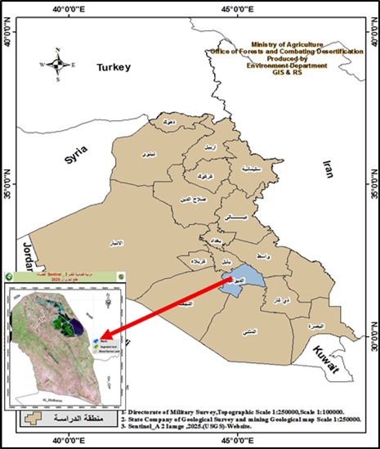
Figure 1: location of the study area

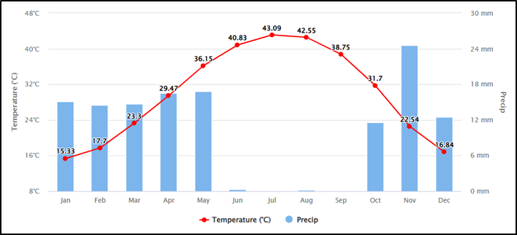
Figure 2: Mean Annual Rainfall and Temperature in Al- Qadysia Governorate

2.2. Satellite Data
In this research, the spatiotemporal variations of agricultural drought in the study area were analyzed using Sentinel-2 satellite images with a 10 m spatial resolution, for 2019 and 2025, captured in June from the USGS Earth Explorer (NASA LPDAAC Collection). The two years were used in this study to illustrate the variation in drought severity in the Afaj district. Remote sensing techniques were employed to calculate the NDDI (normalized difference drought index) using the NDVI (normalized difference vegetation index) and NDWI (normalized difference water index) (Figure 2). Figure 3 shows the flow diagram calculation of drought severity in the study area using NDDI.
NDVI and NDWI were used to calculate Drought Severity as the crop plants' reflectance features vary due to physiological and morphological changes resulting from water stress in plants and soils. The NDVI, which describes vegetation cover and density, plays an important role in maintaining the balance of ecosystems(Xiong and Wang, 2022) . The NDVI was calculated using the following formula ( Rouse et al,1973) :
𝑁𝐷𝑉𝐼=𝜌𝑁𝐼𝑅−𝜌𝑅 /𝜌𝑁𝐼𝑅+𝜌𝑅
Where:
ρNIR : spectral reflectance band near-infrared (band 3)
ρR : spectral reflectance band red (band 8)

The NDVI value ranges from -1 to +1. If the NDVI value is closer to 1, it indicates that the vegetation cover in the area is getting denser. On the other hand, if NDVI is closer to -1, the site has a non-vegetative surface such as built-up land, open land, and water. Areas with high vegetation cover generally correlate positively with water stored in the soil ( Lazo, et al., 2019).

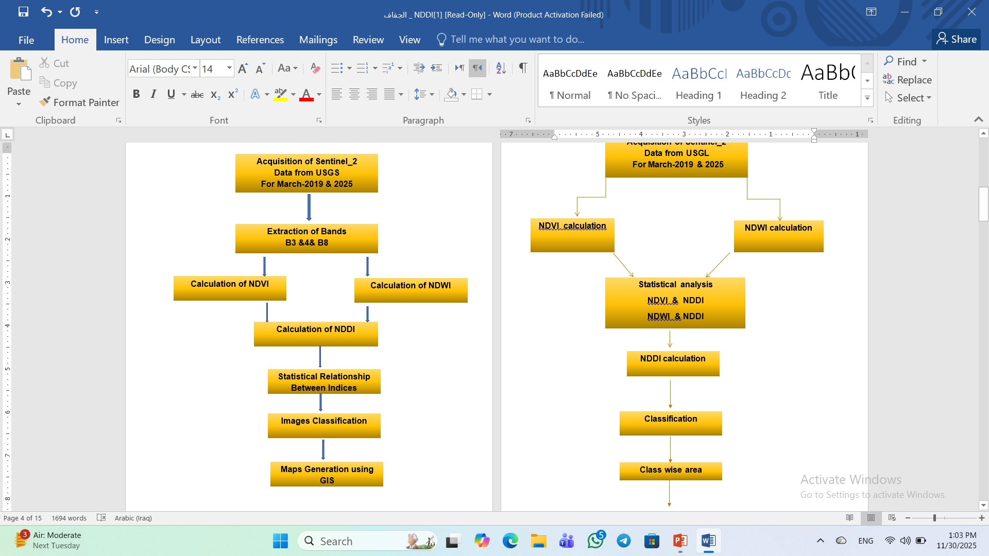
Figure 3: Flow diagram for NDDI calculation and drought severity in the study area
NDWI-Normalized Difference Water Index (NDWI), which was used to identify the presence of open water features by remote sensing using short Near-Infrared (NIR) and green (G) bands ( McFeeters, 1996). The NDWI calculation formula (Paniagua, et al.,2020) is:
𝑁𝐷𝑊𝐼=𝜌G−𝜌𝑆𝑊𝐼𝑅 / 𝜌G+𝜌𝑆𝑊𝐼𝑅
where
ρG : Green band(band 3)
ρSWIR : Short infrared band(band 8)

The value of the NDWI ranges from −1 to 1. Theoretically, NDWI values above 0 represent water bodies and NDWI values below 0 indicate non-water-body areas (McFeeters, 1996). However, in reality, water bodies can also have NDWI values < 0 due to the presence of bare sediment in some rivers, lakes, and seas. Generally, NDVI shows a negative relationship with NDWI. Which means, when NDVI values are low, NDWI values tend to increase, indicating higher drought intensity due to reduced vegetation. Conversely, as NDVI increases, NDWI values gradually decrease. Gu, et al., (2007) found that NDWI had a quicker response to drought conditions than NDVI. The average NDWI was consistently lower than 0.3 under drought conditions and higher than 0.4 under non-drought conditions.

NDDI: NDDI has been applied worldwide, concluding that it is a complementary tool to determine drought behavior more efficiently compared to other methodologies (Mongkolsawatet al., 2009; Renza et al., 2010; Lee et al., 2016; Khampeera et al., 2018; Tavazohi and Ahmadi, 2018; Le Hung and Tuyen, 2019; Aksoy and Sertel, 2021; Dobri et al., 2021). The Normalized Difference Drought Index (NDDI) was created by Gu et al. (2007a) and their collaborators in 2007. The primary objective of creating this index was to develop a tool capable of capturing the behavior and intensity of the drought, combining more than one index to study the phenomenon. A combination of NDVI and NDWI outcomes NDDI that gives more precision in drought monitoring than NDVI alone, both of which are sensitive to the presence of vegetation and the presence of water in an area, using the following formula( Charat et al.,2009) :
𝑁𝐷𝐷𝐼 = 𝑁𝐷𝑉𝐼 –𝑁𝐷𝑊𝐼 / 𝑁𝐷𝑉𝐼 +𝑁𝐷𝑊𝐼
Where:
NDVI: Normalized Difference Vegetation Index
NDWI: Normalized Difference Water Index

High NDDI values indicate drought conditions, in which both NDVI and NDWI are low, whereas low NDDI values indicate non-drought conditions, in which both NDVI and NDWI are higher. Because NDDI incorporates information on both vegetation vitality and water content, it is a more sensitive indicator of drought than NDVI or NDWI alone for drought monitoring in grasslands in the United States [Gu et al., 2007b] and for crop conditions in China (Cheng and Jian, 2008). In contrast, the minimum NDDI value indicates no drought or water scarcity. When NDDI decreases, NDVI and NDWI increase, indicating high vegetation with sufficient water (Du et al., 2018).
2.3. Software:
Drought analysis using Sentinel-2 satellite data was carried out in the Quantum GIS software package (QGIS 3.16.4). Using this software, all drought-classified indices for the Afaj district were derived, the class-wise area was computed, and thematic maps were created for visual comparison

3. Results and Discussion
3.1. Spatial distribution of Land cover/ land use in the study area using NDVI
The normalized difference vegetation index (NDVI) is a simple graphical tool used to assess vegetation cover on Earth's surface through remote sensing. NDVI values vary with climate, soil, and topography; therefore, more productive ecosystems display different radiometric properties compared to less productive ones. The NDVI has certain advantages over other vegetation indices, since it is less dependent on soil properties (Lemenkova, 2015), The NDVI is sensitive to vegetation density and plant chlorophyll activity (Alhumaima and Abdullaev, 2020).
The results (Figure 4) revealed that the NDVI values for the study area range between –0.24 in the water body area, located in the northeastern part of the study area, and 0.50, representing the vegetated land distributed across different locations in the study area. The study area was classified into five land cover categories, including: weak vegetation, moderate vegetation, urban land, bare land, and water bodies. Urban and bare lands are the most prevalent land cover types, while water bodies are the least common in the study area (Figure 4). These findings reflect the impact of drought conditions and the water crisis in the region. The spatio-temporal dynamics of vegetation cover is largely driven by climate factors, such as climate change and human activities, deforestation/reforestation, and topographic parameters (Lin, et al., 2020; Matas-Granados, ,, 2022).

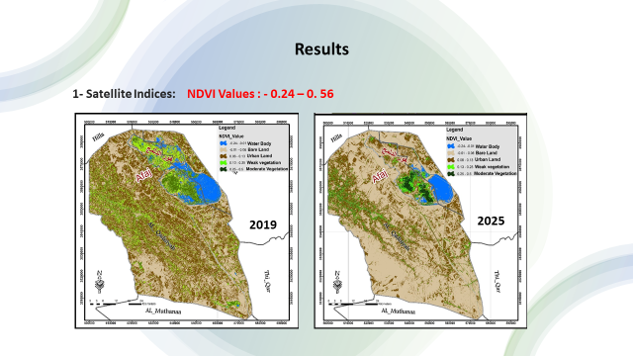
Figure 4: Tempo-spatial land cover changes for 2019 and 2025, using NDVI

3.2 Change detection of Tempo-spatial land cover changes for 2019 and 2025 Using NDVI
The temporal-spatial changes of land covers within the study area are shown in Table 1 and Figure 5. The results emphasized positive and negative tempo-spatial changes of land cover classes in the study area. The area for all land cover classes decreased between 2019 and 2025, except for bare land, which increased by 28%. While the vegetated classes, urbane land, and water body decreased by 3%,7%, 16%, and 2%, respectively. These changes are due to the impact of drought conditions as a result of climate conditions, leading to loss of available moisture by increasing temperature and evapotranspiration, and a decrease in the amount of Rainfall (Muhaimeed, et al. 2025a).

Table 1: Tempo-spatial land cover changes for 2019 and 2025 Using NDVI
Land cover | Moderate vegetation |  | Weak Vegetation |  | Urban land |  | Bare Land |  | Water Body
Land cover | Area km² | Area % | Area km² | Area % | Area km² | Area % | Area km² | Area  % | Area km² | Area % | Total  Area km²
2019 | 209.22 | 5% | 486.58 | 12% | 1792.65 | 43% | 1523.80 | 36% | 189.71 | 4% | 4201.96
2025 | 85.95 | 2% | 182.93 | 5% | 1138.21 | 27% | 2682.34 | 63% | 112.54 | 3% | 4201.96
Change Dedication | -123.26 | -3% | -303.65 | -7% | -654.44 | -16% | 1158.52 | +27% | - 77.17 | - 1%

Figure 5: Tempo-spatial of land cover/Land use changes in 2019 and 2025 using NDVI

3.3 Calculation of NDWI and NDDI for the study area
NDWI values for the study area in 2019 and 2025 were calculated using the following equation:

𝑁𝐷𝑊𝐼=𝜌G−𝜌𝑆𝑊𝐼𝑅 / 𝜌G+𝜌𝑆𝑊𝐼𝑅
where
ρG : Green band(band 8)
ρSWIR : Short infrared band(band 3)
The results in Figure 6 emphasized that the NDWI values ranged from ( -0.51 to 0.14), higher values of NDWI indicate that the area has an area with water, whereas the value below 0 indicates that the area is not a water area. Areas with positive value ranges indicate that the region is not drought-resistant because it contains water.

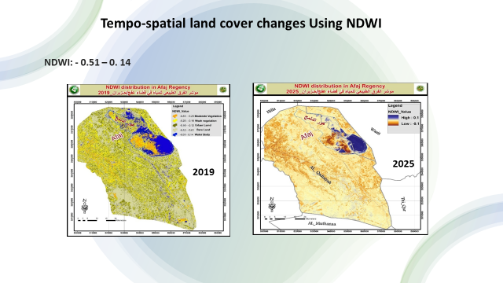
Figure 6: Tempo-spatial distribution of NDWI in the study area in 2019 and 2025/

3.4 Change detection of Tempo-spatial land cover changes for 2019 and 2025 Using NDDI
3.4.1 Calculation of NDDI index for the study area

The Normalized Difference Drought Index was calculated using the two indices (NDVI and NDWI), both of which are sensitive to the presence of vegetation and the presence of water in an area, using the following formula(Charat, et al.,2009) :

𝑁𝐷𝐷𝐼 = 𝑁𝐷𝑉𝐼 –𝑁𝐷𝑊𝐼 / 𝑁𝐷𝑉𝐼 +𝑁𝐷𝑊𝐼 (3)
Where:
NDVI: Normalized Difference Vegetation Index
NDWI: Normalized Difference Water Index

The NDDI values for the study area ranged from <- 2.0 to <3.0. Positive NDDI values indicate more intense drought (drier conditions) and decreased vegetation health, often associated with drought stress. In contrast, negative values suggest healthier vegetation with sufficient moisture, clouds, or the presence of water[( Salas-Martinez, et al., 2023).
The results of statistical analysis between the studied indices using 600 sample points revealed a high positive relationship between NDVI and NDWI, with a correlation coefficient (r) of 0.6936, and R² =0.725. In contrast, the correlations were highly significant between NDVI and NDWI with NDDI, with a correlation coefficient(r)= -0.694 and -0.897, and R²= 0.5818 and 0.8912, respectively (Figure 7). These results are in agreement with those found by (Artikanur, et al., 2022; Halin , 2018). When the NDVI value is low but not negative, the NDDI tends to be high, indicating relatively high drought severity in the area due to the absence of vegetation. However, when the NDVI value is negative, the NDDI value will be low because the site has a water surface. Meanwhile, when the NDVI value is high, the NDDI value tends to be low because a lot of vegetation can store water in the area. Vegetation is a good medium for water and soil conservation (Huang, et al., 2022). These results emphasize that using NDDI is a useful approach to assessing drought severity in the study area.

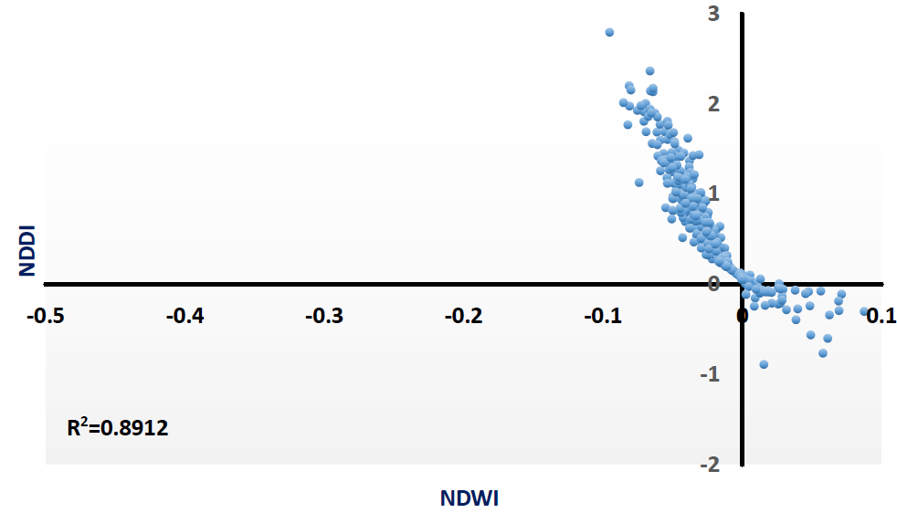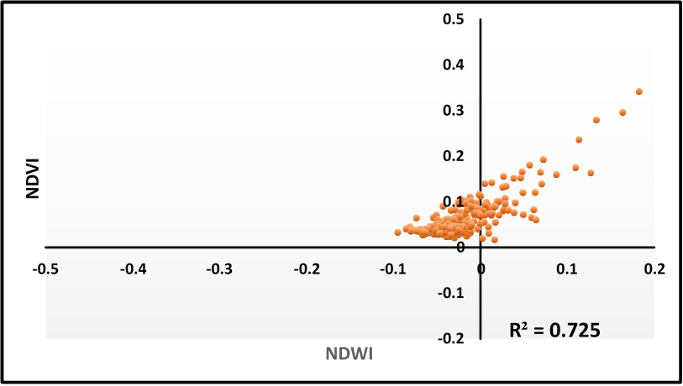

Figure 7: Statistical Relationship between Indices for the study area

Generally, NDDI is a more sensitive indicator for drought than the above two indicators, i. e. NDVI and NDWI. Where the maximum value of NDDI indicates drought conditions, at the same time, NDVI and NDWI become low. In contrast, the minimum NDDI value indicates no drought or non-water scarcity conditions. When NDDI becomes low, NDVI and NDWI values increase, indicating high vegetation with sufficient water (Du, et al.,2018)

3.4.2. Calculation of Drought Severity using NDDI
The spatial and temporal Drought Severity changes in the Afaj district were evaluated using remote sensing techniques, as crop plant reflectance features vary due to physiological and morphological changes resulting from water stress in plants and soil. The main remote sensing indices are NDVI, NDWI, and NDDI. The study area was classified into five drought classes using the NDDI index (Table 2). These classes include: very low, low, moderate, high, and very high drought severity. High and very high severe classes occur mainly within and around the marshland area, located in the northeast part of the study area (Figure 8). Generally, the low drought severity level has the broadest area, 93% of the total area. The vegetation density potentially causes the low severity index due to cultivated land use, while the high and very high classifications are in the settlement area.

Table 2: Classes of Drought severity in the study area using NDDI index
Drought Severity | NDDI Value
Very low Drought | -2 <
Low Drought | -2 - -1
Moderate Drought | -1 - 0
High Drought | 0 - 1
Very High Drought | 1 - <3

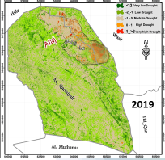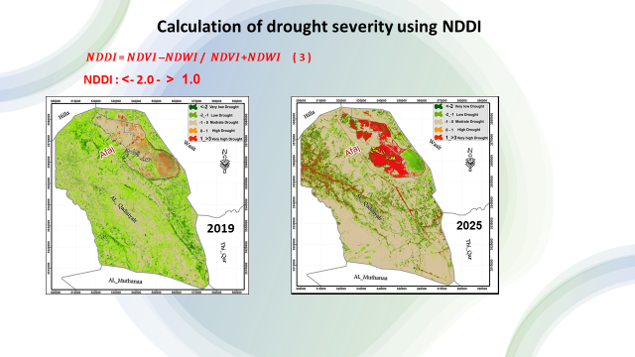
Figure 8: Tempo-spatial distribution of drought severity classes in the study area for 2019 and 2025

3.5. Tempo-spatial changes of drought severity in the study are for 2019 and 2025
Drought maps were prepared for comparison for both years (2019 and 2025) in the study area are presented in Fig. 8. The study area was classified into five drought severity classes, including very low, low, moderate, high, and very high drought severity. The high drought severity occurred mainly in the wetlands and the surrounding area, located in the northeast part of the study area. The results (Figures 9 and Table 3) indicated temporal-spatial changes in drought severity in the study area. The study area is highly affected by moderate drought severity levels in both years( 40% and 60% of the total area in 2019 and 2025, respectively). The results emphasized that a more severe drought in 2025 than in 2019, consistent with meteorological and human factors (Muhaimeed, et al. 2025b).
Analysis of the results shows that in 2019, half the area (48%) of the study area experienced moderate to high drought severity, and this share increased to 75% in 2025 (Table 3). The expansion of severely affected land has led to a reduction in agricultural and urban land in 2025 (Figure 9). The decline in agricultural land is attributed to land degradation and reduced productivity caused by water scarcity and increased salt accumulation in the soil. This has prompted reverse migration from the countryside to the city as farmers seek to secure livelihoods. Comparing the data in Table 1 for land covers in 2019 and 2025 shows that the total area of vegetated and urban land decreased by 10% and 17%, respectively, while bare land increased by 27%. These results demonstrate changes in land cover types over time due to increased drought intensity, accompanying water scarcity, and land degradation. The rise in drought severity over time is strongly influenced by water flow and withdrawal, reflecting local water storage in the marshland area and local demand and deficit, mainly for land cultivation.

Table 3: Changes of drought severity in the study area for 2019 and 2025
Time | Very_ Low |  | Low |  | Moderate |  | High | Very_ High
Time | Area km² | Area % | Area km² | Area % | Area km² | Area % | Area km² | Area % | Area km² | Area % |  | Total  Area km²
2019 | 465.77 | 11 | 1734.41 | 41 | 1883.64 | 45 | 84.10 | 2 | 33.10 | 1 |  | 4201.96
2025 | 411.65 | 10 | 648.42 | 15 | 2509.79 | 60 | 177.37 | 4 | 454.7 | 11 |  | 4201.96
Change Dedication | -54.12 | -1 | 1085.99 | -26 | 626.10 | 15 | 93.27 | 2 | 77.17 | 10

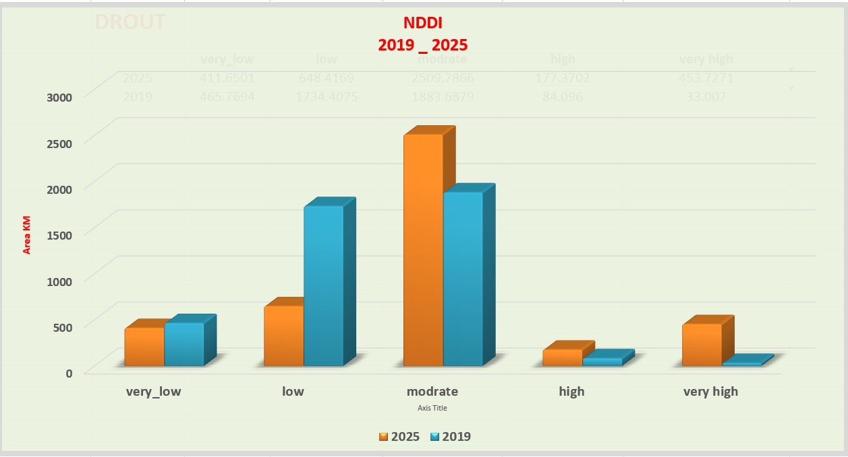
Figure 9: Changes of drought severity in the study area for 2019 and 2025

Conclusions:
The result revealed a highly significant Statistical correlation between NDVI, NDWI, and NDDI, which can be used as a useful tool to evaluate drought severity in dry regions. The NDDI calculated with Sentinel-2 images is a powerful indicator for monitoring and quantifying drought severity under dry conditions, where lower precipitation and higher environmental temperature occur yearly. Five drought levels were recognized in the study area, with dominance for the moderate and high drought severity. The results emphasized the impacts of drought severity on the tempo-spatial changes in the total area of the dominant land covers, reflected by the increase in the total area of bare land over time. The main reason for drought severity in the study area is climate change, reflected by a decrease in rainfall and an increase in the amount of moisture due to the rise in mean annual temperature and evapotranspiration

Acknowledgement
The authors would like to express their gratitude to the Office of Forests and Combating Desertification, Ministry of Agriculture, for supporting this work.

Author Contributions
Ahmad Salih Muhaimeed: Supervision, Validation, Methodology, Writing - original draft, Writing - review & editing
Bassam K. Abdul Jabbar: Review & editing
Faisal Ka. Alsaidi: Review & editing
Rash S. Mahmood : Data curation, Formal Analysis, Investigation, Methodology

Conflict of interest
The authors declare that the research was conducted in the absence of any commercial or financial relationships that could be construed as a potential conflict of interest

Data availability statement
The raw data supporting the conclusion of this article will be made available by the authors, without undue reservation.

Funding
The work was supported by the Office of Forestry and Combating Desertification. Ministry of Agriculture- Iraq

Disclaimer (Artificial intelligence)
Author(s) hereby declare that NO generative AI technologies, such as Large Language Models (ChatGPT, COPILOT, etc.) or text-to-image generators, have been used during the writing or editing of this manuscript.

References:
- Aksoy, S., and Sertel, E. (2021). “Comparison of drought monitoring indices derived from MODIS and CHIRPS data using Google Earth Engine,” in 9th Global Conference on Global Warming (GCGW-2021), Croatia, August 1-4, 2021.
- Alahacoon, N. and M. Edirisinghe,( 2022). A comprehensive assessment of remote sensing and traditional-based drought monitoring indices at global and regional scales. Geomatics, Natural Hazards Risk, 13: 1: 762–799. doi: 10.1080/19475705.2022.2044394.
- Alhumaima,A,S. and S.M. Abdullaev.( 2020).Tigris Basin Landscapes: sensitivity of Vegetation Index NDVI to climate variability derived from observational and reanalysis data. Earth Interact., 24 (7) (2020), pp. 1-18. https://doi.org/10.1175/EI-D-20-0002.1

- Artikanur,S.D. Widiatmaka, Y. Setiawan, and Marimin.( 2021). Normalized Difference Drought Index (NDDI) computation for mapping drought severity in Bojonegoro Regency, East Java, Indonesia. IOP Conf. Series: Earth and Environmental Science. 1109 – 012027.
- doi:10.1088/1755-1315/1109/1/012027
- Belal AA, El-Ramady HR, Mohamed ES, Saleh AM. 2014. Drought risk assessment using remote sensing and GIS techniques. Arab J Geosci. 7(1):35–53. doi: 10.1007/s12517-012- 0707-2.
- Chandrasekara,S.S., H.H. Kwon, M. Vithanage, J. Obeysekera, T.W. Kim.(2021).
- Drought in South Asia: A review of drought assessment and prediction in South Asian countries.Atmosphere, 12 (3) .369.https://doi.org/10.3390/atmos12030369
- Charat M, Wattanakij N, Kamchai T, Mongkolsawat K and Chuyakhai D 2009 Exploration of Spatio-Temporal Drought Patterns Using Satellite-Derived Indice for Crop Management in Northeastern Thailand. (Beijing: Asian association on remote sensing).
- Cheng-Lin, L.; Jian-Jun, W. Crop drought monitoring using MODIS NDDI over mid-territory of China. In Proceedings of the IGARSS 2008—2008 IEEE International Geoscience and Remote Sensing Symposium, Boston, MA, USA, 7–11 July 2008; Volume 3, p. III-883. [Google Scholar]

- Dobri, R.-V., Sfîcă, L.,Amihăesei, V.-A., Apostol, L., and Ţîmpu, S. (2021). Drought extent and severity on arable lands in Romania derived from the normalized difference drought index (2001–2020). Remote Sens. Environ. 13 (8), 1478. doi:10.3390/rs13081478

- Du,T.L.T., D. Du Bui, M.D. Nguyen, H. Lee. (2018). Satellite-based, Multi-Indices for Evaluation of Agricultural Droughts in a Highly Dynamic Tropical Catchment, vol. 10, Central Vietnam, Water (Switzerland (2018), 10.3390/w10050659
- Elusma M, Tung CP, Lee CC. (2022). Agricultural drought risk assessment in the Caribbean region: the case of Haiti. Int J Disaster Risk Reduct. 83:103414. doi: 10.1016/j.ijdrr.2022. 103414.

- Goward, S.N. Markham, B. Dye, D.G. Dulaney, W. and Yang, J. (1991). Normalized difference vegetation index measurements from AVHRR. Remote Sensing of Environment, 35, 257-277
- Gu, Y.; Hunt, E.; Wardlow, B.; Basara, J.B.; Brown, J.F.; Verdin, J.P.( 2007a). Evaluation of MODIS NDVI and NDWI for vegetation drought monitoring using Oklahoma Mesonet soil moisture data. Geophys. Res. Lett. , 35. [Google Scholar] [CrossRef].
- Gu, Y., Brown, J. F., Verdin, J. P., and Wardlow, B. (2007b). A five-year analysis of MODIS NDVI and NDWI for grassland drought assessment over the central Great Plains of the United States. Geophys. Res. Lett. 34 (6), 064077–L6416. doi:10.1029/ 2006GL029127
- Guo Y, Huang S, Huang Q, Leng G, Fang W, Wang L, Wang H. 2020. Propagation thresholds of
- meteorological drought for triggering hydrological drought at various levels. Science of the Total Environment, 712, 136502(
- Halin, H. (2018). Influence of product quality on satisfaction customer of semen baturaja in palembang at PT Semen Baturaja (persero) Tbk JEMG 3 167–182.
- Hereher,M. , A. Alghmdi, K. Mseddi , and A.El Kenawy.( 2022). Remote sensing of vegetation prolonged drought at the salt playas of Hail – Saudi Arabia.The Egyptian Journal of Remote Sensing and Space Science.25: 135-145. https://doi.org/10.1016/j.ejrs.2022.01.006
- Hollinger, S.E., S. A. Isard, and M. R. Welford.( 1993).A New Soil Moisture Drought Index For Predicting Crop Yields.Eighth Conference on Applied Climatology.

- Huang, B, Yuan Z, Zheng M, Liao Y, Nguyen K L, Nguyen T H, Sombatpanit S and Li D. (2022). Soil and water conservation techniques in tropical and subtropical Asia: A Review Sustain. 14
- Jameel, M., Hameed, S., Shemal, K., Al-Ansari, N. and Abed, S.A. (2023). Spatial and Temporal Assessment of Drought in the Northern Prone of Iraq Using Standardized Precipitation Index. Engineering, 15, 691-708. https://doi.org/10.4236/eng.2023.1510047

- Jiang,J. and T. Zhou.2023). Agricultural drought over water-scarce Central Asia aggravated by internal climate variability. nature geoscience:16, pages154–161
- Khalili, P. , M. Konar , M. Faramarzi.( 2024).Modelling the impacts of future droughts and post-droughts on hydrology, crop yields, and their linkages through assessing virtual water trade in agricultural watersheds of high-latitude regions .Journal of Hydrology 639 (2024) 131530.https://doi.org/10.1016/j.jhydrol.2024.131530

- Khampeera, A., Yongchalermchai, C., and Techato, K. (2018). Drought monitoring using drought indices and GIS techniques in Kuan Kreng peat swamp, Southern Thailand. Walailak J. Sci. Technol. 15 (5), 357–370. doi:10. 48048/wjst.2018.2723
- Laosuwan, T., Sangpradid, S., Gomasathit, T. & Rotjanakusol, T. (2016). Application of Remote Sensing Technology for Drought Monitoring in Mahasarakham Province, Thailand. International Journal of Geoinformatics, 12(3), 17-25.
- Lazo P X, Mosquera G M, McDonnell J J and Crespo P 2019 The role of vegetation, soils, and precipitation on water storage and hydrological services in Andean Páramo catchments J. Hydrol. 572 805–19

- Le Hung, T., and Tuyen, V. D. (2019). Application of remote sensing technique for
- drought assessment based on normalized difference drought index, a case study of Bac
- Binh district, Binh Thuan province (Vietnam). Russ. J. Earth Sci. 19 (2), 1–9. doi:10.
- 2205/2018ES000647
- Lee, S.-J., Cho, J., Hong, S., Ha, K.-J., Lee, H., and Lee, Y.-W. (2016). On the
- relationships between satellite-based drought index and gross primary production in the
- North Korean croplands, 2000–2012. Remote Sens. Lett. 7 (8), 790–799. doi:10.1080/
- 2150704X.2016.1187315
- Lemenkova,P. ( 2015).Analysis of Landsat NDVI time series for detecting degradation of vegetation Geoecology and Sustainable Use of Mineral Resources, from Science to Practice Proceedings of the 3 Rd International Conference of Young Scientists (2015), pp. 978-98
- Lin,X., J. Niu, R. Berndtsson, X. Yu, L. Zhang, X. Chen( 2020).NDVI dynamics and its response to climate change and reforestation in northern China.Rem. Sens., 12 (2020), p. 4138. https://doi.org/10.3390/rs12244138
- Matas-Granados, M. Pizarro, L. Cayuela, D. Domingo, D. Gómez, M.B. García.( 2022).Long-term monitoring of NDVI changes by remote sensing to assess the vulnerability of threatened plants Biol. Conserv., 265 . https://doi.org/10.1016/j.biocon.2021.109428
- McFeeters, S.K., 1996, The use of normalized difference water index (NDWI) in thedelineation of open water features. International Journal of Remote Sensing, 17, pp.1425–1432
- McKee TB, Doesken NJ, Kleist J (1993) The relationship of drought frequency and duration to time scales. Proceedings of the 8th Conference on Applied Climatology. California. pp 179–183
- Muhaimeed, A.S., , M. S. Nassar1 ,B. A.Katalan,( 2025a). The Threat of Climate Change to Vegetation Health and Land Degradation in Iraq's Diverse Climatic Environment.American Journal of Agriculture and Forestry.13: 4: 198-217.
- https://doi.org/10.11648/j.ajaf.20251304.14
- Muhaimeed, A.S., M. S. Nassar1 ,B. A.Katalan,( 2025b). The Impact of Climate Change on Moisture Balance and Land Degradation in the Region of Southern Iraq. International Journal of Agriculture Innovations and Research.13: 6:2319-1473
- NOAA( National Oceanic and Atmospheric Administration). 2020. Drought. U.S. Department of Commerce.
- Panagoulia,D. and G. Dimou 1998.Definition and effects of Droughts. Conference on Mediterranean Water Policy: building on existing experience, Mediterranean Water Network
- Paniagua M T, Villalba J and Pasten M.( 2020). Spatial-temporal distribution of drought in the western region of Paraguay (2005-2017) Int. Arch. Photogramm. Remote Sens. Spat. Inf. Sci. ISPRS Arch. 42 327–30
- Renza, D., Martinez, E., Arquero, A., and Sanchez, J. (2010). “Drought estimation maps by means of multidate Landsat fused images,” in Proceedings of the 30th EARSeL Symposium, Paris, France, 2010-05-31.
- Saeed, M.A. (2015) Agro Meteorology in Kurdistan Region—Iraq: A Contemporary History.

- Salas-Martínez F, Valdés-Rodríguez OA, Palacios-Wassenaar OM, Márquez-Grajales A and Rodríguez-Hernández LD. (2023), Methodological estimation to quantify drought intensity based on the NDDI index withLandsat8multispectral images in the central zone of the Gulf of Mexico. Front. Earth Sci. 11:1027483. doi: 10.3389/feart.2023.1027483
- Shariﬁ, A. ( 2020). Flood mapping using relevance vector machine and SAR data: A case study from Aqqala, Iran,” J. Indian Soc. Remote Sens.48: 9: 1289–1296. doi: 10.1007/s12524-020-01155-y
- Tavazohi, E., and Ahmadi, M. (2018). Assessment of drought in the Zayandehroud
- basin during 2000-2015 using NDDI and SPI indices. Fresenius Environ. Bul
- Tucker, C. J. (1979). Red and photographic infrared linear combinations for monitoring vegetation. Remote Sensing Environmental, 8:127–150.
- United Nations. (2022).Migration, Environment, and Climate Change in Iraq. https://iraq.un.org/en/194355-migration-environment-and-climate-change-iraq
- UNDP.(2022). Institutional Survey and Assessment Report for Drought Early Warning in Iraq.
- Wang, F.,Z. Wang , H. Yang, D. Di, Y. Zhao , Q. Liang , Z. Hussain .(2020). Comprehensive evaluation of hydrological drought and its relationships with meteorological drought in the Yellow River basin, China,” J. Hydrol., 584, Art. no. 124751, doi:10.1016/j.jhydrol.2020.124751.
- Xiong, Y. and Wang H.( 2022). Spatial relationships between NDVI and topographic factors at multiple scales in a watershed of the Minjiang River, China Ecol. Inform. 69 101617

