Seasonal Assessment of CH₄ and CO₂ Concentrations and IPCC Tier 1 Carbon Footprint Estimation in Benue State, Nigeria

ABSTRACT
This study investigates greenhouse gas (GHG) emissions across diverse land-use types in Benue State, Nigeria, focusing on methane (CH₄) and carbon dioxide (CO₂) dynamics. Using calibrated gas detectors (MSA ALTAIR 4XR and PTM600-S) and meteorological instruments, weekly air samples were collected from 23 sites spanning agricultural, residential, commercial, and industrial zones between May and October 2025. Results show seasonal variability, with CH₄ concentrations ranging from 1.48–2.67 ppm and CO₂ from 415.3–498.2 ppm. Elevated CH₄ levels were observed in farmland and industrial areas, particularly during the wet season, while CO₂ concentrations peaked in industrial and residential zones, reflecting anthropogenic activities such as fuelwood use, transport, and industrial combustion. Multiple linear regression analysis revealed wind speed as a significant predictor of CH₄ variability (p < 0.05), with the model explaining approximately 27% of the observed variability (R² ≈ 0.27), whereas CO₂ concentrations were primarily driven by persistent emission sources rather than short-term meteorological conditions. IPCC Tier 1 emission estimates indicate that households contribute the largest share of Benue’s carbon footprint (260,000 kg CO₂e/year), followed by commercial transport (210,000 kg CO₂e/year), agriculture (222,500 kg CO₂e/year), and industries (150,000 kg CO₂e/year). Overall, the state’s partial carbon footprint was estimated at 842,500 kg CO₂e/year, based on selected activities rather than a complete statewide emission profile, with agriculture and households together accounting for over half of emissions. Although modest compared to Nigeria’s national inventory, these findings highlight Benue’s agrarian intensity and vulnerability to rising emissions. The study underscores the need for localized, data-driven mitigation strategies—such as improved biomass energy alternatives, sustainable rice cultivation practices, and industrial emission controls—to reduce GHG outputs and align with Nigeria’s broader climate commitments and global sustainability goals. However, the findings should be interpreted with limitations in mind related to the use of Tier 1 emission factors, the selected activity coverage, and the temporal scope of sampling.

Keywords: Greenhouse Gases, Methane, Carbon Dioxide, Carbon footprint, Benue State

1. INTRODUCTION
Human activities have driven atmospheric concentrations of greenhouse gases (GHGs) to levels not seen in human history, particularly carbon dioxide and methane (IPCC, 2021). Carbon dioxide remains the dominant long-lived greenhouse gas because of fossil fuel combustion and industrial processes, while methane, though shorter-lived, is far more potent per unit mass and is rising rapidly from agriculture, waste, and fossil fuel sources (Olczak et al., 2023). Recent methodological guidance emphasizes the continued use of updated global warming potential metrics for methane as outlined in the Sixth Assessment Report of the Intergovernmental Panel on Climate Change, known as Intergovernmental Panel on Climate Change, which refines radiative forcing estimates and improves comparability across inventories (IPCC 2021).
In Benue State, Nigeria, elevated carbon dioxide (CO₂) and methane (CH₄), emissions from wood-based burnt brick production and daily activities such as fuelwood use and transportation exacerbate local and regional climate impacts, accelerating phenomena like rising temperatures, altered precipitation patterns, and ecosystem degradation, which threaten agricultural productivity and livelihoods in this agrarian hub (Agera et al., 2017; Tembe et al., 2016). Despite increasing attention, significant uncertainties remain in regional methane source attribution across Africa, highlighting the need for more localized measurements and inventories (van Hove et al., 2025)
Carbon footprints in Nigeria, and specifically in Benue State, reflect the combined impacts of agriculture, energy use, and land management practices on greenhouse gas (GHG) emissions. Agriculture remains the dominant source of methane (CH₄) emissions, particularly from livestock and rice cultivation, while land use change and biomass burning contribute significantly to CO₂ outputs (Climate TRACE, 2025). The critical role of these gases underscores the urgency of monitoring and mitigating their emissions, as their combined effects intensify global climate vulnerabilities, necessitating localized strategies to reduce carbon footprints and promote sustainable practices in high-emission zones like Benue State (PA, 2007). The study aims to measure CH₄ and CO₂ levels across various sectors, determine the region's carbon footprint, and provide data-driven recommendations for environmental management and policy within the state. Thus, assessing CH₄ and CO₂ levels in Benue provides critical insights into Nigeria’s broader carbon footprint, highlighting the need for localized strategies that align with national climate commitments and global sustainability goals. By focusing on CH₄ and CO₂ levels and calculating the carbon footprint in Benue State, this assessment will offer a baseline, helping to map how local agricultural practices, emissions sources, and possibly land-use changes contribute to global-scale climate risks.
2. MATERIALS AND METHODS
2.1 Materials
The MSA ALTAIR 4XR , PTM600-S, AOPUTTRIVER AP-881M / AP-6000GH, Pt6508, and Ultrak 495 100 Lap Memory Timer.
Study area
The study was conducted in Benue State, Nigeria, from May 2025 to October, 2025. Benue state has a land area of 2,882km² with a population of 4,253,641 people. It has twenty-three (23) local government areas. Benue State lies within the lower river Benue in the Middle Belt region of Nigeria. Its geographic coordinates are longitude 7° 47’ and 10° 0’ East. Latitude 6° 25’ and 8° 8’ North; and shares boundaries with five other states, namely, Nasarawa to the north, Taraba to the east, Cross-River to the south, Enugu to the south-west, and Kogi State to the west. Agriculture is the mainstay of the inhabitants, engaging over 75% of the population. The State is the nation’s acclaimed food basket due to its rich agricultural produce, which includes yams, rice, beans, cassava, sweet potatoes, maize, soybeans, sorghum, millet, sesame, and cocoyams. Many of the inhabitants also engage in trading, while a reasonable number of them are civil servants (Mbah et al., 2016).
Sampling
Twenty-three (23) sampling sites were carefully selected and reflected diverse locations of agricultural practices Commercial activities, industrial areas, and residential areas. Air samples were collected weekly, 2-4 m above ground, over a 6-month period to capture different seasons.
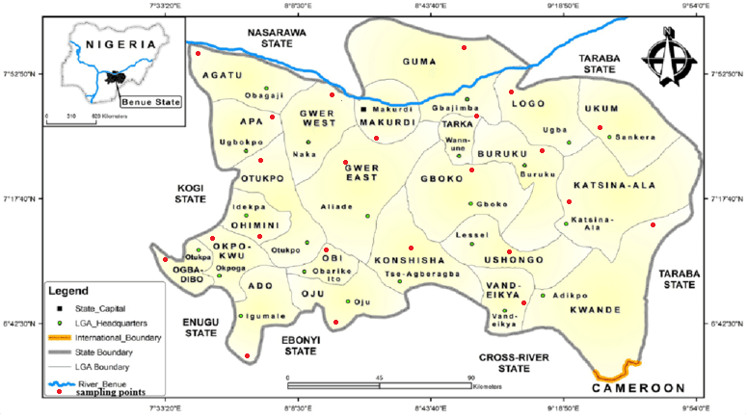
Map 1: Map of Benue State showing the location of the sample points.
Source; https://www.benuepride.com/history/

2.2 Analysis of Meteorological Parameters
The twenty-three (23) local government areas were selected for the study in varying locations of farmlands, dumpsites, commercial, and residential areas. The AOPUTTRIVER AP-881M was used to determine the temperature, and Pt6508 was used to measure relative humidity. Before data collection, all instruments were carefully calibrated to ensure accuracy and quality assurance. Readings were collected at each sampling site three times, with each collection period lasting 5 to 15 min and timed using the Ultrak 495 100 timer stopwatch. The AP-6000GH wind speed will be used to assess the wind speed. These readings were taken at intervals of 2 to 3 h for a period of one week according to Ediagbonya and Olabiyi (2024).

2.3 Analysis of Carbon Dioxide (CO₂) and Methane (CH₄)
The instruments (MSA ALTAIR 4XR and PTM600-S ) were calibrated against standard gas concentrations following manufacturer guidelines, with verification before each sampling session. Gas concentrations were measured at 2–3-hour intervals between 8 AM and 4 PM for one week at each site to minimize diurnal variations (Ediagbonya et al., 2024). The MSA ALTAIR 4XR measured CO₂, while the PTM600-S measured CH₄ concentrations.

3. RESULTS AND DISCUSSION
Table 1.0: Seasonal variation of meteorological parameters and greenhouse gas concentrations across different land-use types in Benue State
Location | Season | Meteorological Parameters |  |  | Greenhouse Gases
Location | Season | Temperature  (°C) | Relative humidity (%) | Wind speed (m/s) | Methane  (ppm) | Carbon dioxide  (ppm)
commercial | dry | 35.66 ± 0.02 | 43.00±0.10 | 4.23±0.50 | 1.70±0.04 | 452.8±0.97
commercial | dry | 34.66±0.20 | 45.32±0.01 | 2.13±0.03 | 2.02± 0.11 | 457.2±1.00
commercial | wet | 32.33±0.05 | 49.00±0.00 | 3.13±0.21 | 1.60±0.21 | 460.1± 0.21
commercial | wet | 30.33±0.30 | 52.00±0.12 | 3.73±0.11 | 1.55±1.00 | 455.5± 0.33
farmlands | dry | 35.32±0.11 | 33.66±0.10 | 6.02±0.01 | 1.77±0.23 | 435.0±1.71
farmlands | dry | 37.33±0.44 | 30.00±0.01 | 5.00±0.00 | 1.60±0.50 | 452.8± 0.30
farmlands | wet | 30.35±0.26 | 58.60±0.00 | 4.22±1.05 | 2.31±0.23 | 441.2±0.90
farmlands | wet | 32.50±0.10 | 54.01±0.02 | 3.34±0.11 | 1.95±1.22 | 460.6± 0.89
residential | dry | 29.66±0.20 | 45.33±0.10 | 3.01±0.10 | 1.58±0.61 | 438.6± 2.12
residential | dry | 31.33±0.04 | 44.00±0.01 | 4.90±0.01 | 1.06±0.33 | 443.4±0.67
residential | wet | 32.66±0.33 | 48.00±0.00 | 2.00±0.00 | 1.70±2.12 | 447.0±0.22
residential | wet | 31.34±0.22 | 53.00±0.11 | 2.66±0.21 | 1.09±0.44 | 440.8±0.31
industries | dry | 36.10±0.30 | 39.66±0.10 | 5.20±0.10 | 2.48±0.72 | 415.3± 2.02
industries | dry | 35.00±0.00 | 40.00±0.01 | 5.32±0.01 | 1.91±0.12 | 422.6± 1.15
industries | wet | 31.33±0.05 | 53.30±0.00 | 5.01±0.00 | 1.13±0.30 | 416.4± 0.74
industries | wet | 30.30±0.10 | 56.22±0.02 | 5.90±0.20 | 2.67±0.61 | 438.2±0.52
Ambient Air Quality |  |  |  |  | 2.00 | 420

Table 2.0 Multiple Linear Regression Coefficients Relating Meteorological Parameters to CH₄ and CO₂ Concentrations
Predictor | CH₄ Coefficient | p-value | CO₂ Coefficient | p-value
Intercept | −5.28 | 0.182 | 450.92 | 0.002*
Temperature (°C) | 0.14 | 0.120 | 0.55 | 0.827
Relative Humidity (%) | 0.04 | 0.100 | 0.00 | 0.998
Wind Speed (m s⁻¹) | 0.12 | 0.235 | −6.47 | 0.042*
*Significant at p < 0.05

Figure 1.0: Seasonal Variation of (a) (b) and (c) Across Land-use Types

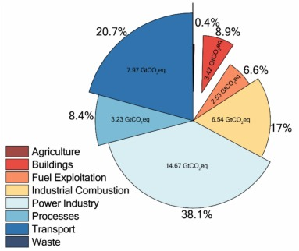
Figure 2.0 Global Greenhouse Gas Emissions by Sector
(Source: Mikalai 2024)

Discussion
Recent urban methane mapping studies demonstrate strong spatial variability and mixed emission sources in rapidly developing cities, reinforcing the importance of localized monitoring frameworks (Asare et al., 2025). The seasonal variation of meteorological parameters and greenhouse gas concentrations across the different land-use types is presented in Table 1.0. Ambient temperature showed a clear seasonal pattern, with higher values recorded during the dry season (29.66–37.33 °C) than during the wet season (30.30–32.66 °C) across all locations. This pattern reflects increased solar radiation and reduced cloud cover during the dry season, which is characteristic of tropical climates (Ayoade, 2004; Nigerian Meteorological Agency, 2020). Industrial and farmland areas consistently recorded higher temperatures (Figure 1.0a) than residential zones, likely due to reduced vegetation cover, exposed surfaces, and heat generated from industrial activities, a phenomenon commonly associated with land-use modification and surface energy balance changes (Oke, 1987; Arnfield, 2003). Relative humidity showed an inverse seasonal trend, with higher values observed during the wet season (48.00–58.60%) compared to the dry season (30.00–45.33%). The elevated wet-season humidity reflects increased atmospheric moisture associated with rainfall and cloud formation, while lower dry-season values are linked to higher temperatures and reduced moisture availability (Ayoade, 2004)(See figure 1.0b). Lower relative humidity in farmland areas during the dry season may be attributed to sparse vegetation cover and enhanced evapotranspiration, which can influence atmospheric stability and pollutant behavior (Seinfeld and Pandis, 2016). Wind speed varied across locations and seasons, ranging from 2.00 to 6.02 m s⁻¹. Farmland and industrial areas generally recorded higher wind speeds than residential and commercial locations, likely due to greater surface openness and fewer obstructions to airflow (Figure 1.0c). Such conditions promote enhanced dispersion of atmospheric constituents, reducing localized pollutant buildup but facilitating regional transport (Jacob and Winner, 2009). Seasonal variations in wind speed are consistent with synoptic-scale circulation patterns typical of tropical regions (Nigerian Meteorological Agency, 2020).
Methane (CH₄) concentrations ranged from 1.06 to 2.67 ppm, slightly above the reported global ambient background levels of approximately 1.8–2.0 ppm (IPCC, 2021). Lower methane concentrations were generally observed in residential and commercial areas, whereas higher values were found in farmland and industrial zones. Elevated methane levels in agricultural areas, particularly during the wet season, may be linked to microbial activity in moist soils, the decomposition of organic matter, and agricultural practices such as fertilizer application and biomass handling (Conrad, 2009; IPCC, 2019). High methane concentrations in industrial areas suggest localized emissions, waste management, and possible gas leakage, as reported in previous urban and industrial studies (USEPA, 2022). Carbon dioxide (CO₂) concentrations varied from 415.3 to 460.6 ppm across the study area. Residential and commercial locations showed moderately elevated CO₂ levels relative to the ambient reference value of approximately 420 ppm, reflecting traffic density, human activities, and energy consumption (IPCC, 2021). Farmland CO₂ concentrations remained close to background levels, with slight increases potentially linked to soil respiration and nearby anthropogenic sources (Raich and Schlesinger, 1992). Industrial areas recorded the highest CO₂ concentrations, particularly during the wet season, which may be attributed to increased fuel combustion, industrial processes, and reduced vertical mixing under humid atmospheric conditions (Seinfeld and Pandis, 2016; Jacob and Winner, 2009). This directly corresponds to the dominant global shares from industrial processes, power, and combustion-related sectors shown in Figure 2.0.
Overall, the results indicate that land-use type and season exert strong control over both meteorological conditions and greenhouse gas concentrations. Industrial and farmlands contribute noticeably to elevated methane and carbon dioxide levels, while meteorological parameters such as temperature, relative humidity, and wind speed modulate the dispersion, accumulation, and transport of these gases. Although the observed concentrations largely fall within expected ambient ranges, the spatial and seasonal variability highlights the influence of localized emissions and climatic dynamics in shaping greenhouse gas distributions in rapidly developing environments. Localized greenhouse gas assessments are increasingly recognized as essential for improving national inventories, given the large discrepancies observed between bottom-up and satellite-derived estimates (Chen et al., 2023).
Multiple linear regression was applied to evaluate the influence of meteorological parameters on CH₄ and CO₂ concentrations across the different locations. Temperature, relative humidity, and wind speed served as predictor variables, while measured CH₄ and CO₂ concentrations were treated as dependent variables. For methane, the model explained approximately 27% of the observed variability (R² ≈ 0.27). As shown in Table 2.0, wind speed was the only significant predictor (p < 0.05), exhibiting a negative relationship with CH₄ concentrations. Temperature and relative humidity were not significant, indicating that short-term atmospheric mixing, rather than surface-level thermal or moisture conditions, largely governs ambient methane variability. These findings are consistent with prior studies in agricultural and peri-urban environments, where wind-driven dispersion regulates observed methane levels from soils, rice paddies, and waste sources (Conrad, 2009; Zhang et al., 2020). In contrast, CO₂ concentrations displayed weak associations with meteorological variables, with no predictors reaching statistical significance. This suggests that CO₂ levels are predominantly determined by persistent anthropogenic emissions - including transport, residential fuel use, and industrial activity - rather than short-term weather fluctuations (Turnbull et al., 2015; Pataki et al., 2007). Thus, these results show methane concentrations are sensitive to wind-driven dispersion, whereas carbon dioxide levels are primarily shaped by emission source intensity. This suggests that the greenhouse gas measurements in the mixed urban–agricultural settings in Benue State are dependent on the meteorological conditions and the source of the emissions. Emerging research demonstrates that combining ground measurements, remote sensing, and modeling approaches can significantly improve methane emission estimates in complex agricultural landscapes (van Hove et al., 2025)

Table 3.0 Benue State – IPCC Tier 1–Aligned Emission Estimates
Locations | Activity | Source  Category | GHG | Emission Factor (IPCC Tier 1) | Emissions  (kg/year) | Emissions  (kg CO₂e/year)
Commercial | Road transport, power generation for shops and offices, small-scale commercial cooking, and fuel use by generators | Traffic, anthropogenic sources | CO₂ |  | 210,000 | 210,000
  2.6 kg CO₂/L fuel (IPCC default for diesel/petrol, aggregated)
Farmlands | Crop cultivation, fertilizer use, and residue management | Rice agriculture, biomass burning | CO₂ |  | 85,000 | 85,000
  1.0 (direct CO₂ reporting, Tier 1)
Farmlands | Rice paddies (flooded fields) |  | CH₄ | 1.30 kg CH₄/ha/day (IPCC default, seasonal avg) | 5,500 | 137,500
  Rice agriculture
Residential | Fuelwood and charcoal combustion, kerosene and gas stoves, household generators, open burning of domestic waste | Energy, biomass burning | CO₂ | 112 kg CO₂/GJ (IPCC default for biomass & fossil mix) | 260,000 | 260,000
Industries | Manufacturing, processing, waste handling, energy production | Waste treatment, | CO₂ | 74 kg CO₂/GJ (IPCC default for light industrial fuel oil/diesel) | 150,000 | 150,000

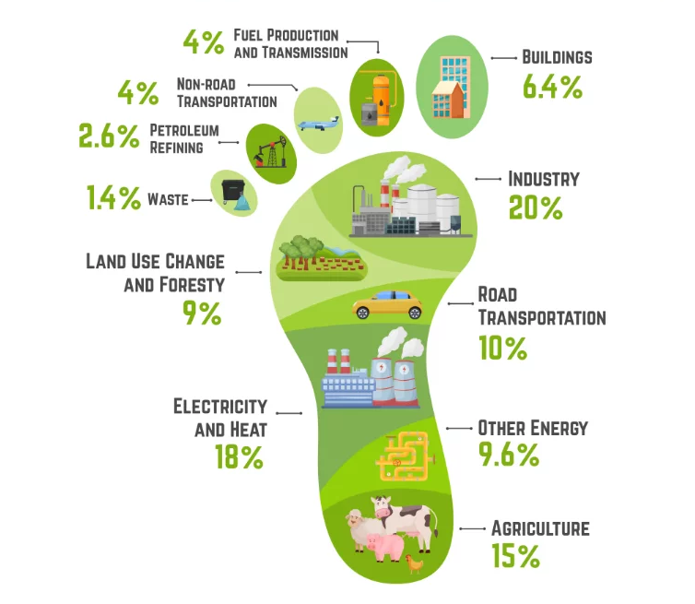
Figure 3.0 Global Carbon Footprint
Source: carbontrail 2025

Figure 4.0 Benue State Emission Profile of CO₂ and CH₄ Across Key Sectors
The emission estimates for Benue State, aligned with IPCC Tier 1 methodologies, reveal distinct patterns across key locations, highlighting the contributions of CO₂ and CH₄ from activities such as transport, agriculture, residential energy use, and industrial processes. These estimates, derived from default emission factors for diesel/petrol (2.6 kg CO₂/L), biomass combustion (112 kg CO₂/GJ), and methane from rice paddies (1.30 kg CH₄/ha/day), provide a baseline understanding of greenhouse gas (GHG) dynamics in the state (IPCC, 2006). Results indicate that residential activities generate the highest emissions, at 260,000 kg CO₂e/year, primarily from the use of fuelwood, charcoal, and household generators. This is followed by commercial road transport and power generation at 210,000 kg CO₂e/year, agricultural farmlands contributing a combined 222,500 kg CO₂e/year (split between 85,000 kg CO₂ from crop cultivation and 137,500 kg CO₂e from CH₄ in rice paddies), and industries at 150,000 kg CO₂e/year from manufacturing and energy production. Notably, CH₄ emissions from flooded rice fields show a significant non-CO₂ contributor, amplified by its global warming potential of 25 over a 100-year horizon, converting 5,500 kg CH₄ to 137,500 kg CO₂e.
Results from each location show that agriculture accounts for approximately 26% of the total emissions (222,500 kg CO₂e/year), driven largely by rice cultivation and residue management. Transport, embedded within the commercial category, represents about 25% (210,000 kg CO₂e/year), reflecting fuel-intensive activities like road traffic and generator use. Industry contributes 18% (150,000 kg CO₂e/year), linked to waste handling and fuel oil combustion, while households dominate at 31% (260,000 kg CO₂e/year), underscoring the reliance on biomass and fossil fuels for cooking and electricity in residential settings. This distribution suggests a heavy dependence on traditional energy sources and agricultural practices, with households and agriculture together comprising over half of the emissions, potentially exacerbated by population growth and expanding farmland in Benue State.
The total carbon footprint for Benue State, based on these key locations, sums to 842,500 kg CO₂e/year (or approximately 843 tonnes CO₂e/year). This figure represents a partial profile focused on selected activities and may underestimate broader contributions, such as from land-use changes or waste sectors not fully captured here. With Benue's projected population around 6.1 million in 2022 (extending to similar levels in 2025), this translates to roughly 0.14 kg CO₂e per capita annually from these sources, indicating a relatively low-intensity footprint per person but one that could scale with demographic and economic pressures (City Population, 2024).
In comparison with national and regional estimates, Benue's profile aligns with Nigeria's broader GHG trends, where agriculture contributes about 24% of total emissions, similar to the 26% observed here (Emission Index, 2024) but surpasses the global average of 15% (Figure 3.0), underscoring its agrarian intensity and echoing Nigeria’s national trend of 24%. Nationally, Nigeria's total GHG emissions reached 328,496 kt CO₂e (excluding land use, land-use change, and forestry) in 2022, with agriculture at 77,981 kt CO₂e, energy (including transport and residential) at 141,377 kt CO₂e, and industry at 12,044 kt CO₂e (Federal Republic of Nigeria, 2024). Benue's estimated 843 tonnes CO₂e appears modest against this backdrop - representing less than 0.001% of the national total - likely due to the focused scope of these Tier 1 calculations on specific activities rather than a comprehensive inventory. Regionally, within sub-Saharan Africa, where methane from agriculture and biomass burning are prominent, Benue's rice paddy CH₄ emissions show patterns seen in other agrarian states, though national data show agriculture's share has grown by 75% from 2000 to 2022, suggesting potential upward trajectories for Benue without interventions (Federal Republic of Nigeria, 2024). These comparisons emphasize the need for refined, state-specific inventories to better contextualize local contributions amid Nigeria's overall emissions growth. Globally, industry (20%), electricity and heat (18%), and transport (14%) dominate emissions (Figure 3.0), but in Benue, agriculture is the clear driver. With Nigeria’s agricultural emissions rising 75% since 2000, Benue risks following suit—making localized, data-rich inventories essential to curb future growth and align with global mitigation priorities.
4. Conclusion
This study provides valuable state-level empirical data on methane (CH₄) and carbon dioxide (CO₂) concentrations in Benue State, Nigeria—an agrarian region where greenhouse gas monitoring remains limited. By integrating field measurements with IPCC Tier 1 emission estimates, the study provides localized evidence to support national greenhouse gas inventory refinement and climate mitigation planning. The seasonal analysis across multiple land-use types strengthens understanding of how agricultural practices, residential energy use, and industrial activities influence atmospheric GHG variability in developing regions. Such data-driven regional assessments are essential for improving sub-national climate accountability and informing targeted mitigation strategies in rapidly developing economies. Strengthening regional greenhouse gas datasets remains critical for improving mitigation planning and reducing uncertainties in climate projections across developing regions.
Acknowledgment
The authors sincerely acknowledge the Tertiary Education Trust Fund (TETFund), Nigeria, for funding this research. The support provided was instrumental to the successful execution of the fieldwork, data analysis, and overall completion of the study.
Authors’ Contributions
Gabriel Tordue Buluku conceived and designed the study, supervised field sampling, carried out the statistical analyses, and drafted the manuscript. Peter Agorye Adie helped with the study design, carried out field measurements and instrument calibration, and helped with data interpretation and revision of the manuscript. Ternande Clement supervised the laboratory and analytical work and ensured data quality control. Iortile Moses Terhile assisted in the field data collection, data management, and statistical analysis. Agber Cyprian Ternenge conducted the literature review, assisted in the calculations of the carbon footprint and the IPCC Tier 1 estimates, and provided input in the revision of the manuscript. All authors read and approved the final manuscript.
Disclaimer (Artificial intelligence)

Author(s) hereby declare that NO generative AI technologies such as Large Language Models (ChatGPT, COPILOT, etc.) and text-to-image generators have been used during the writing or editing of this manuscript.

References
- Arnfield, A. J. (2003). Two decades of urban climate research: A review of turbulence, exchanges of energy and water, and the urban heat island. International Journal of Climatology, 23(1), 1–26.
- Asare, E. A., Abdul-Wahab, D., Asamoah, A., Dampare, S. B., Wahi, R., Kaufmann, E. E., Ngaini, Z., Klutse, C. K., Klutse, N. A. B., Buah-Kwofie, A., & Omorinoye, O. A. (2025). Methane mapping in Greater Accra: Isotopic signatures and mobile detection techniques in a developing urban landscape. Sustainable Chemistry One World, 5, 100036.
- Ayoade, J. O. (2004). Introduction to climatology for the tropics (2nd ed.). Spectrum Books.
- Bateki, C. A., Muchenje, V., & Nkosi, B. D. (2023). Challenges in modeling livestock methane emissions in sub-Saharan Africa under diverse feeding systems. Agricultural Systems, 211, 103742.
- Chen, Z., Jacob, D. J., Nesser, H., Sulprizio, M. P., Lorente, A., Varon, D. J., Lu, X., Shen, L., Qu, Z., Penn, E., & Yu, X. (2023). Global methane emissions inferred from satellite observations reveal large discrepancies with national inventories. Nature Climate Change, 13, 1101–1108.
- Climate TRACE. (2025). Climate TRACE emissions inventory (April 2025 release). https://climatetrace.org
- Conrad, R. (2009). The global methane cycle: Recent advances in understanding microbial processes. Environmental Microbiology Reports, 1(5), 285–292.
- Ediagbonya, T. F., & Olabiyi, A. O. (2024). Greenhouse gas levels (CH₄ and CO₂) in Lagos State and Oyo State, Nigeria. Discover Environment, 2, 4.
- IPCC. (2019). 2019 refinement to the 2006 IPCC guidelines for national greenhouse gas inventories. Intergovernmental Panel on Climate Change.
- IPCC. (2021). Climate change 2021: The physical science basis. Cambridge University Press.
- Nigerian Meteorological Agency. (2020). Annual climate review report. NiMet.
- Olczak, M., Piebalgs, A., & Tomaszewski, K. (2023). A global review of methane policies and mitigation strategies. Joule, 7(2), 245–261.
- Pataki, D. E., Bowling, D. R., & Ehleringer, J. R. (2007). The seasonal cycle of carbon dioxide and its isotopic composition in an urban atmosphere: Anthropogenic and biogenic effects. Journal of Geophysical Research: Atmospheres, 112, D12306.
- Seinfeld, J. H., & Pandis, S. N. (2016). Atmospheric chemistry and physics: From air pollution to climate change (3rd ed.). Wiley.
- Sibiya, N. P., Garland, R. M., & Clulow, A. D. (2024). Satellite detection of regional methane trends across South African provinces from 2019–2023. Remote Sensing of Environment, 306, 113964.
- Turnbull, J. C., Karion, A., Fischer, M. L., Faloona, I., Guilderson, T., Lehman, S. J., Miller, B. R., Miller, J. B., Montzka, S. A., Sherwood, T., Saripalli, S., Sweeney, C., & Tans, P. P. (2015). Toward quantification and source sector identification of fossil fuel CO₂ emissions from an urban area: Results from the INFLUX experiment. Journal of Geophysical Research: Atmospheres, 120(1), 292–312.
- Ueyama, M., Iwata, H., & Harazono, Y. (2025). Urban greenhouse gas emissions and the complexity of source attribution in rapidly developing cities. Environmental Research Letters, 20(3), 034012.
- van Hove, M., van der Laan-Luijkx, I. T., & Peters, W. (2025). Reducing uncertainties in African methane budgets using integrated observation systems. Environmental Research Letters, 20, 015006.
- Zhang, Y., Gautam, R., Panday, A. K., & Holben, B. N. (2020). Seasonal variability of aerosols and their climatic impacts in West Africa. Atmospheric Chemistry and Physics, 20, 10241–10256.

