Production of Bio-Briquettes from Agricultural Waste

Abstract
This study focuses on the production and characterization of bio-briquettes using locally available agricultural residues such as rice husk, sugarcane bagasse, cotton stalk, coconut shell, groundnut shell, banana peel, corn cobs, and sawdust. The utilization of agricultural waste for briquette production offers a sustainable solution to increasing energy demand while reducing environmental pollution caused by open burning and improper disposal of biomass residues. The briquette production process involves systematic steps including collection, drying, size reduction, mixing with natural binders, compaction, drying, cooling, and quality assessment. The produced bio-briquettes were evaluated for key fuel properties such as moisture content, ash content, volatile matter, fixed carbon, density, calorific value, and combustion efficiency. The produced bio-briquettes were evaluated for key fuel properties such as moisture content (10%), ash content (6%), volatile matter (72%), fixed carbon (12%), density (231 kg/m³), and calorific value (3686 kcal/kg). The results indicate that bio-briquettes possess good mechanical strength, satisfactory calorific value, low smoke emission, and efficient burning characteristics, making them a reliable renewable energy source. The use of agricultural residues for briquette production not only minimizes waste disposal problems but also contributes to reduced greenhouse gas emissions, rural employment generation, and energy security. Hence, bio-briquettes serve as an eco-friendly, cost-effective, and sustainable alternative to conventional fossil fuels.
Keywords: Bio-briquettes, Agricultural residues, Biomass energy, Renewable energy, Waste utilization, Sustainable fuel.
1.Introduction
Today, energy is one of the most important needs for humanity, and its demand has increased rapidly due to increased energy consumption, depletion of fossil fuels, and environmental degradation (Chen & Usman, 2025). Fuels are essential because they can be burned to produce energy. The world is facing major problems such as the need for fuel efficiency, unstable oil prices, global warming, energy security, poverty, and future energy requirements. Currently, about 80–90% of global energy requirements are met by fossil fuels, but by 2040, the use of renewable energy resources is expected to increase significantly (Owusu and Asumadu-Sarkodie, 2016). To fulfil these requirements, there is a continuous need to develop alternative fuels that are renewable, inexpensive, eco-friendly, sustainable, and economically competitive, with lower greenhouse gas emissions (Kamala, 2021).
Bio-briquettes are solid biofuels produced by compressing biomass residues into dense, compact forms that can be used for cooking, heating, and industrial applications (Kaliyan & Morey, 2009). Agricultural residues such as rice husk, sugarcane bagasse, groundnut shell, coconut shell, cotton stalk, corn cobs, banana peel, and sawdust are generated in large quantities, especially in rural and agricultural regions. These materials are often underutilized or openly burned, leading to severe environmental pollution and loss of potential energy resources (Widjaya et al., 2022). Converting these residues into bio-briquettes provides an effective solution for waste management while simultaneously producing a clean and renewable source of energy (Sanchez, 2022).
The process of bio-briquette production involves several systematic steps, including collection of raw materials, drying to reduce moisture content, size reduction, mixing with suitable binders, compaction using briquetting machines, and final drying and cooling. The quality and performance of bio-briquettes are influenced by factors such as moisture content, particle size, binder type, compaction pressure, and feedstock composition (Marreiro et al., 2021). Natural binders such as starch-rich biomass and lignin-containing materials enhance the mechanical strength and durability of briquettes, often eliminating the need for synthetic binders (Idris et al., 2021).
Several studies have reported that briquettes produced from agricultural waste exhibit favorable fuel properties, including high calorific value, low ash content, low smoke emission, and improved combustion efficiency (Oladeji, 2010). For instance, coconut shell and groundnut shell-based briquettes possess high fixed carbon and calorific value, making them suitable for both domestic and industrial energy applications (Olaleru et al., 2025). Additionally, proper densification through mechanical or hydraulic briquetting machines significantly improves fuel handling, storage, and transportation efficiency (Nikiforov et al., 2023).
Fossil fuels dominate the world's energy consumption, including transportation, chemicals, and materials generation. Conversely, using conventional energies has resulted in massive environmental damage and climate change(Godif Alene Geberehiet et.al.,2025).Therefore, the present study focuses on the production and evaluation of bio-briquettes from locally available agricultural wastes, aiming to assess their fuel properties and potential as an eco-friendly and cost-effective alternative to conventional energy sources.

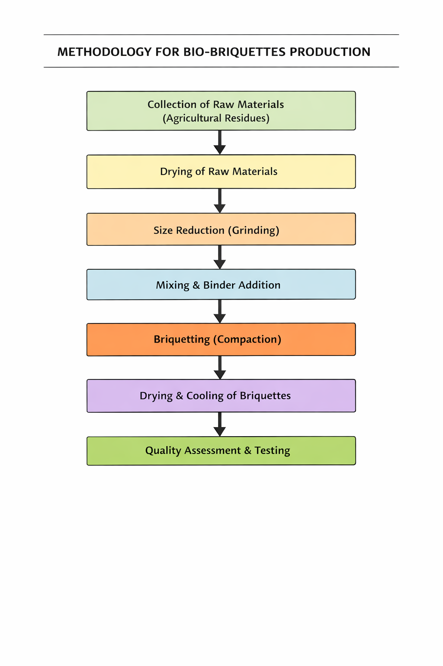
Figure:-1 Methodology flowchart

2.0 Materials and Methods
2.1.Collection of Raw Materials
The materials such as rice husk, corn cobs, saw dust, banana peel, cotton stalk, coconut shell, groundnut shell, and sugarcane bagasse are wastes collected from farmers, mills, etc., which are usually thrown away as waste.
Rice Husk: Rice husk was collected from the Dr. M. S. Swaminathan Field Laboratory at Paavai Engineering College.
Saw Dust: Saw dust was collected from sawmills in the nearby area of Pachal Village, Namakkal District.
Coconut Shell: It was collected from domestic areas where it is thrown away as waste in our village, Pachal Village, Namakkal District.
Cotton Stalk: It was collected from farmers in Puthuchathiram Village, Namakkal District.
Groundnut Shell: It was collected from a mill in Kattuputhur Town, Tiruchirappalli (Trichy) District of Tamil Nadu.
Sugarcane Bagasse: It was obtained from Salem Co-operative Sugar Mill, Velur–Mohanur Road, Namakkal, Tamil Nadu.
Banana Peel: It was collected from farmers in Puthuchathiram Village, Namakkal District.
Corn Cobs: It was collected from Namakkal Farmer Producers Union near Paavai Engineering College, Namakkal.
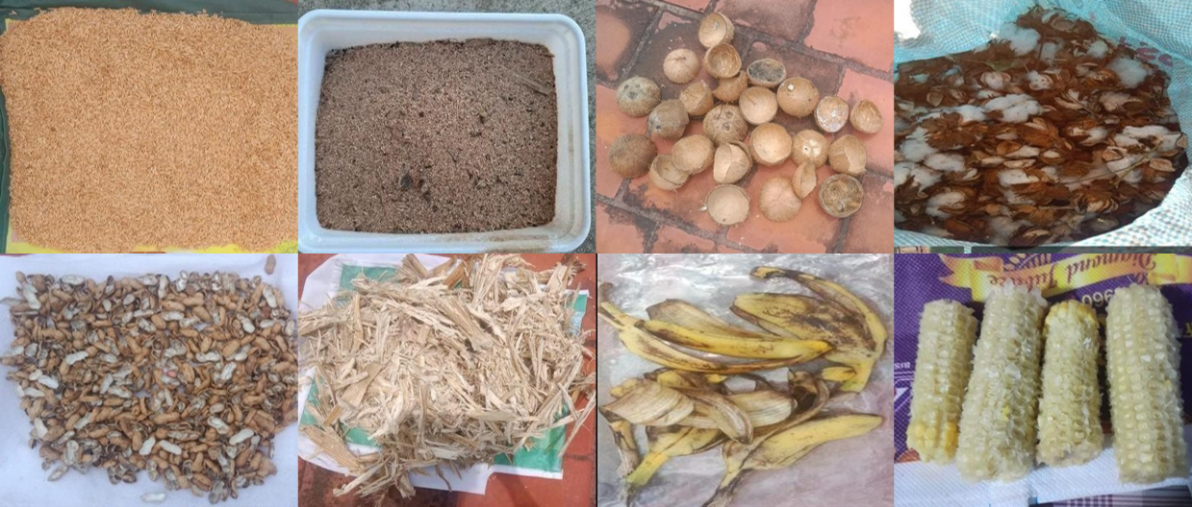
Fig.2.Raw Materials for Briquettes
Drying of Raw Materials
The collected biomass materials, including rice husk, sawdust, cotton stalk, groundnut shell, sugarcane bagasse, banana peel, corn cobs, and coconut shell, were initially dried under sunlight for several days to reduce the moisture content. After sun drying, the materials were further dried in a hot air oven at 100°C for 1 hour to remove any remaining moisture and to achieve the required moisture level for briquetting. The dried biomass materials were then cooled to room temperature and stored in airtight containers until further processing.
Size Reduction
The dried biomass materials, including rice husk, sawdust, cotton stalk, groundnut shell, sugarcane bagasse, banana peel, corn cobs, and coconut shell, were subjected to size reduction using a pulverizer. The materials were fed into the pulverizer and ground into fine particles through the action of high-speed rotating blades. The pulverized material was then passed through a sieve of 0.50 mm mesh size to obtain uniform particle size suitable for briquetting. The sieved biomass was collected and stored in airtight containers until further use.
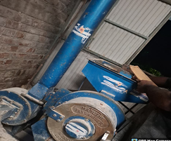
Figure:3 Pulveriser
Mixing and Binder Addition
Banana peel powder was used as a natural binder in this study. The dried banana peels were pulverized and mixed with water (10–20% of binder weight) to form a uniform paste. The binder was added to the pulverized biomass, mainly sawdust, at a proportion of 5–15% (w/w) and mixed thoroughly to ensure uniform distribution. The binding was facilitated by the presence of lignin in sawdust and starch and lignin in banana peel powder (Emaga et al., 2007). The prepared mixture was used for briquette production.
Compaction
The pulverized biomass materials, including rice husk, sawdust, sugarcane bagasse, groundnut shells, and corn cobs, with moisture content below 10%, were used for briquette production. The prepared biomass mixture was filled into the cylindrical moulds of a briquetting machine. The material was compressed using a hydraulic press at a pressure of 10–30 MPa to form dense briquettes. The compressed briquettes were ejected from the moulds and subsequently dried to remove residual moisture and improve their strength and stability.
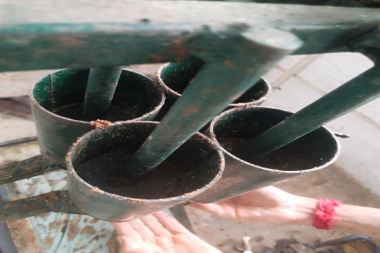
Figure: 4. Briquetting machine

Drying and Cooling
The briquettes were initially subjected to natural air drying by placing them on drying racks under ambient conditions with adequate ventilation. This method allows gradual moisture removal and prevents surface cracking.After drying, the briquettes were allowed to cool naturally to room temperature.
2.2. Proximate Analysis
Study of proximate analysis of biomass was carried out for determination of moisture content, volatile matter, fixed carbon content and ash content in the biomass. The proximate analysis of the biomass and briquettes was carried out as follows,
- Moisture content
- Volatile matter
- Ash content
- Fixed carbon
- Calorific value

Moisture content (M.C)
The moisture content played an important role in the formation of briquette and subsequently its combustion. The crucible was placed in an electric hot air-oven maintained at 105 ± 5°C as per ASTM D-3174.
M. C. percent = [(W1-W2) / W1] × 100
Volatile matter (V.M)
Volatile matter was determined by keeping the dried sample obtained after moisture content determination in a closed crucible at 925 plus/minus 20 deg °C for seven minutes in a muffle furnace as per ASTM D-3175. The difference in the weight due to loss of volatiles was taken as the volatile matter present in the sample on percentage basis. The volatile matter of sample was calculated by following equation.

V.M. percent = [(loss in weight due to removal of volatile matter) / (weight of sample taken)] x 100
Ash content (A.C)
The residual samples obtained after volatile matter determination were heated gradually in a muffle furnace to 700 ± 50°C for half an hour as per ASTM D- 3174. The crucible was taken out, cooled first in air, then in desiccator and weighed. Heating, cooling and weighing was repeated till constant weight was obtained. The weight of residue was reported as the ash content of the sample on percentage basis.
A.C. per cent = [(Weight of ash left) / (Weight of sample taken)] x 100

Fixed carbon (F.C)
The fixed carbon content was the value obtained after subtracting the value of moisture content; volatile matter and ash content from the hundred percent, gives the percentage of fixed carbon.
Percent of F.C. =100 - (VM + MC + AC)
Calorific Value (C.V)
Calorific value is a fundamental property used to evaluate the energy potential of fuels. It represents the total amount of heat released during the complete combustion of a fuel. This parameter helps in comparing different fuels based on their energy efficiency. In biomass and wood fuels, calorific value is influenced by moisture, ash, and carbon content.
C.V (MJ/Kg) = 0.3536(F.C) + 0.1559(V.M) - 0.0078(A.C)

3.0. Results and Discussion
Table:-1. Moisture content of Briquettes
Sample  No | Weight of Sample Before Oven Drying  W1 (g) | Weight of Sample After Oven Drying  W2(g) | Moisture In Percentage  (%)
1 | 100 | 91 | 9%
2 | 120 | 108 | 10%
3 | 150 | 133.5 | 11%
Average in percentage |  |  | 10%

Table:-2.Volatile Matter of the briquettes
Sample  No | Weight of Sample Taken (g) | Loss in Weight (g) | Volatile Matter In Percentage (%)
1 | 100 | 70 | 70%
2 | 120 | 86.4 | 72%
3 | 150 | 111 | 74%
Average in percentage |  |  | 72%

Table:-3 Ash content of the briquette
Sample  No | Weight of Sample Taken (g) | Weight of Ash Left (g) | Ash Content In Percentage (%)
1 | 100 | 5 | 5%
2 | 120 | 7.2 | 6%
3 | 150 | 10.5 | 7%
Average in percentage |  |  | 6%

Table:-4 Fixed carbon of the briquette
Sample  No | Moisture Content In  (%) | Volatile Matter  In (%) | Ash Content In (%) | Fixed Carbon  In(%)
1 | 9 | 70 | 5% | 16%
2 | 10 | 72 | 6% | 12%
3 | 11 | 74 | 7% | 8%
Average in percentage |  |  |  | 12%

Table:-5.Calorific Value of the briquette

Sample  No | Fixed Carbon In  (%) | Volatile Matter  In (%) | Ash Content In (%) | Calorific Value  In (MJ/Kg) | Calorific Value  In (Kcal/Kg)
1 | 16 | 70 | 5 | 16.53 | 3950
2 | 12 | 72 | 6 | 15.42 | 3685
3 | 8 | 74 | 7 | 14.32 | 3422
Average in percentage |  |  |  |  | 3686

Table:-6 Analysis of various bio-fuel
(Paramasivan,et.al.,(2019), Peter sahupala, et.al.,(2018)
Proximate Analysis | Analysis of Wood | Analysis of our Briquette | 60 Mesh Coal Briquette | 80 Mesh Coal Briquette
Moisture Content | ~7% | 10% | 9.16% | 8.66%
Ash Content | ~5% | 6% | 6.18% | 7.21%
Volatile Matter | ~15% | 72% | 37.04% | 43.86%
Fixed Carbon | ~85% | 12% | 718.64% | 20.78%

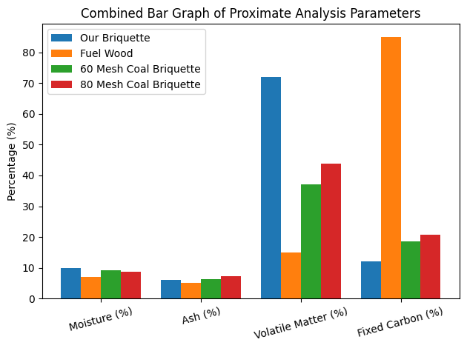
The proximate analysis of fuel wood, developed biomass briquettes, and coal briquettes (60 and 80 mesh) provides a clear comparison of their combustion characteristics and suitability for domestic and small-scale thermal applications. Key parameters—moisture content, ash content, volatile matter, and fixed carbon—serve as indicators of ignition behavior, flame characteristics, burn duration, and overall thermal efficiency.
Figure:-5 Comparative analysis of various Briquettes
Moisture directly affects ignition time and energy efficiency. Fuel wood, with ~7% moisture, demonstrates faster ignition, whereas the developed biomass briquette contains slightly higher moisture at 10%. Coal briquettes show intermediate values (60 mesh: 9.16%, 80 mesh: 8.66%), with the 80 mesh variant benefiting from finer particle compaction and better drying. Although higher moisture in the biomass briquette may reduce initial calorific efficiency, the values remain within the commercial range of 8–12%, confirming suitability for domestic use. The comparison indicates that all fuels are adequately dried, ensuring efficient energy release during combustion.
Ash content reflects the non-combustible residue, affecting slagging and maintenance. Fuel wood exhibits the lowest ash (5%), whereas the developed briquette has 6%, comparable to coal briquettes (60 mesh: 6.18%, 80 mesh: 7.21%). The slightly higher ash in the 80 mesh coal briquette may result from finer particles concentrating minerals. The developed briquette’s ash content is manageable, indicating that residue accumulation will not hinder operational performance.
Volatile matter is a critical determinant of ignition ease and flame intensity. The developed biomass briquette shows an exceptionally high volatile matter content of 72%, significantly higher than fuel wood (15%) and coal briquettes (60 mesh: 37.04%, 80 mesh: 43.86%). High volatile content ensures rapid ignition and intense flame formation, making the biomass briquette ideal for short-duration heating and domestic cooking. However, it may produce more smoke if airflow is inadequate. Coal briquettes, with moderate volatile content, offer more controlled and stable combustion, emphasizing longer, steady burn rather than immediate flame intensity.
Fixed carbon indicates the fraction responsible for sustained heat output. Fuel wood’s fixed carbon (~85%) suggests long burn duration, while the biomass briquette has only 12%, implying a shorter, volatile-driven combustion cycle. Coal briquettes, particularly the 60 mesh type (47.62%), provide superior char combustion, offering prolonged heating. The 80 mesh coal briquette shows 20.78% fixed carbon, demonstrating moderate burn duration. This comparison underscores the distinction between biomass fuels, which favor quick ignition and flame, and coal-based fuels, which support extended heating applications.
The energy content of the briquettes ranged from 14.32 MJ/kg (3422 kcal/kg) to 16.53 MJ/kg (3950 kcal/kg), averaging 15.42 MJ/kg (3686 kcal/kg). Sample 1 (16.53 MJ/kg) provides the highest energy output, highlighting variation in fuel density and composition. These values fall within the typical range for biomass briquettes (14–20 MJ/kg), confirming their practical applicability for domestic and small-scale thermal systems.
The developed biomass briquette exhibits a balanced profile for domestic cooking: acceptable moisture, moderate ash, very high volatile matter, and moderate calorific value. Its combustion is characterized by easy ignition and intense flames, but lower fixed carbon limits prolonged heat retention. Coal briquettes, conversely, provide extended heating due to higher fixed carbon, with the 60 mesh variant particularly suited for applications requiring longer burn durations. The analysis emphasizes that biomass briquettes are a renewable and sustainable alternative to coal, offering efficient energy delivery with manageable ash and strong initial combustion, making them viable for small-scale and household thermal applications.
Conclusion
The production of bio-briquettes from agricultural waste such as rice husk, sawdust, sugarcane bagasse, groundnut shell, coconut shell, cotton stalk, banana peel, and corn cobs proved to be an efficient, sustainable, and eco-friendly method of generating renewable energy. The study successfully demonstrated that these locally available residues can be converted into high-density, energy- rich briquettes through processes such as drying, size reduction, mixing with natural binders, compaction, and drying. The briquettes produced exhibited good combustion characteristics, acceptable calorific value, low smoke emission, and improved durability. This project highlights the significant potential of agricultural residues in reducing environmental pollution caused by open burning and waste disposal. Furthermore, bio-briquettes serve as an economic alternative to fossil fuels, providing benefits such as cost-effectiveness, reduced greenhouse gas emissions, and enhanced rural energy security. Thus, the project not only supports sustainable waste management but also contributes to clean energy production, rural employment generation, and overall environmental conservation.

Disclaimer (Artificial intelligence)

Author(s) hereby declare that generative AI technologies such as Large Language Models (ChatGPT, COPILOT, etc.) and text-to-image generators have been used during the writing or editing of this manuscript.

References
1. Arachchige, U. S. P. R. (2021). “Briquettes production as an alternative fuel” Nature Environment and Pollution Technology, 20(4), 1661–1668. https://doi.org/10.46488/NEPT.2021.v20i04.029
2. Sanchez, P. D. C., Aspe, M. M. T., & Sindol, K. N. (2022). “An overview on the production of bio-briquettes from agricultural wastes: Methods, processes, and quality” Journal of Agricultural and Food Engineering, 3(1), 1–17. https://doi.org/10.37865/jafe.2022.0036
3. Winata, A. A., Ihwan, M. Y., Irawan, C., Wijayanti, H., Dharma Putra, M., & Al Muttaqii, M. (2025). Potential production and characterization of charcoal-based bio-briquettes from ulin wood waste as an alternative sustainable energy resource. Journal of Chemical Technology and Metallurgy, 60(4), 595–608. https://doi.org/10.59957/jctm.v60.i4.2025.7
4. Ibrahim, M. S., Bello, S., & Ibrahim, A. (2020). “Biomass briquettes as an alternative source of cooking fuel towards green recovery post COVID-19.” Saudi Journal of Engineering and Technology, 5(6), 285–290. https://doi.org/10.36348/sjet.2020.v05i06.005
5. Jadhav, P. V., Dashore, S., & Chaudhary, K. (2015) “Biomass briquette system: Pollution free thermal energy resources” International Journal of Innovative Research in Science, Engineering and Technology, 5(1), 1165–1171. https://doi.org/10.15680/IJIRSET.2015.0501102
6. Kpalo, S. Y., & Zainuddin, M. F. (2020). “Briquettes from agricultural residues: An alternative clean and sustainable fuel for domestic cooking in Nasarawa State, Nigeria” Energy and Power, 10(2), 40–47. https://doi.org/10.5923/j.ep.20201002.03
7. Geberehiet, G. A., Gebreegziabher, T., Mekonen, A. G., Hagos, G. K., & Gebresilasie, T. N. (2025). “Development of briquettes suitable for energy generation from residue of sorghum stalk and groundnut husk” Materials for Renewable and Sustainable Energy, 14(2), Article 35. https://doi.org/10.1007/s40243-025-00309-7
8. Oyebamiji, O. O., Olaleru, A. S., Oyeleke, R. B., & Ofodile, L. N. (2025)“Evaluation and characterization of biochar and briquettes from agricultural wastes for sustainable energy production” Waste Management Bulletin, 3(3), Article 100198. https://doi.org/10.1016/j.wmb.2025.100198
9. Sriram, M., Nandagopal, G., Anandhavelu, S., & Ramesh, J. (2022). “Experimental investigation of biomass briquettes from agri waste and forest waste” Journal of Engineering, Management & Medical Sciences, 8(3), 1–9. https://doi.org/10.46632/jemm/8/3/1
10. Kelwade, A., Gaikwad, D., Kelwade, S., Vishwakarma, L., & Jaiswal, P. (2025). “Biomass briquettes from agriculture waste”. International Journal of Innovations in Engineering and Science, 10(3), 17–20. https://doi.org/10.46335/IJIES.2025.10.3.4
11. Kumari, M., & Singh, J. (2022), “Environmental, social and economic impacts of briquetting plant and briquettes” Journal of Wastes and Biomass Management, 4(1), 32–40. https://doi.org/10.26480/jwbm.01.2022.32.40
12. Ezeokolie, E. D., Maduoma, T. U., Akpotabor, E. M., Akanni, O., Garbati, A. A., Odeh, A. A., Chukwu, P. M., Achoronye, F. N., & Esonwune, J. N. (2024). “Production and optimization of briquette (solid fuels) from waste biomass using industrial starch as binder”. European Journal of Sustainable Development Research, 8(4), Article em0270. https://doi.org/10.29333/ejosdr/15138
13. Chen, N., & Usman, M. (2025). Energy use, energy depletion, and environmental degradation: Exploitation of natural resources. Natural Resources Forum, 49(4), 3984–3995. https://doi.org/10.1111/1477-8947.12591
14. Kaliyan, N., & Morey, R. V. (2009). Factors affecting strength and durability of densified biomass products. Biomass and Bioenergy, 33(3), 337–359. https://doi.org/10.1016/j.biombioe.2008.08.005
15. Oladeji, J. T. (2010). Fuel characterization of briquettes produced from corncob and rice husk residues. The Pacific Journal of Science and Technology, 11(1), 101–106.

