Economic and Productivity Impacts of Climate-Responsive Soybean Farming Practices in Semi-Arid Telangana, India

.
ABSTRACT

Aims: To evaluate the effectiveness of different climate change adaptation practices on the productivity and profitability of soybean cultivation in a semi-arid region of Telangana and to identify the most economically viable climate-resilient practice for enhancing farmers’ income.
Study design: A comparative and analytical research design was adopted.
Place and Duration of Study: The study was conducted in Adilabad district of Telangana state during the agricultural year June 2025 to October 2025.
Methodology: A purposive sampling technique was used to select 90 soybean farmers, categorized into three groups of 30 farmers each based on adaptation practices: (A) proper sowing window with medium-duration varieties, (B) late sowing with medium-duration varieties, and (C) late sowing with long-duration varieties. Primary data were collected using structured interview schedules. The data were analyzed using descriptive statistics, standard cost concepts, Adaptation Strategy Use Index (ASUI) to assess the extent of adaptation, and partial budget analysis to estimate economic gains from alternative practices.
Results: Farmers perceived significant climatic changes, particularly delayed monsoon onset and erratic rainfall, adversely affecting soybean production. Common adaptation strategies included timely sowing, intercropping, and improved irrigation scheduling. Among the three practices, farmers adopting proper sowing within the recommended window with medium-duration varieties (Practice A) achieved higher yields and superior economic returns. Partial budget analysis indicated that Practice A generated an additional net profit of ₹8,706.88 per hectare compared to late sowing practices (Practices B and C), demonstrating greater economic viability under climate variability.
Conclusion: Sowing soybean within the optimal window using medium-duration varieties is the most effective climate-resilient strategy under semi-arid conditions. Wider promotion of this practice through targeted extension interventions and climate-responsive policy support can enhance farm income and strengthen resilience to climate variability.

Keywords: Climate change, soybean, adaptation strategies, partial budget analysis
1. INTRODUCTION

Climate change poses a major threat to agricultural productivity, especially in rainfed regions like the Northern Telangana Zone (NTZ), where smallholder farmers rely heavily on seasonal monsoons. The unpredictability of rainfall, rising temperatures and extreme weather events have already begun to impact cropping patterns and yield stability in the region. Soybean, a key oilseed crop grown under rainfed conditions, is particularly sensitive to climate variability, with changes in rainfall timing and intensity leading to significant reductions in productivity and economic returns (Sinha et al., 2025). Recent assessments predict that yields of soybean in semi-arid regions of India could decline by 10–20% if adaptive measures are not implemented (Rana et al., 2014). Given the vulnerability of soybean farming to climatic stressors, there is an urgent need to promote resilient agricultural practices that can help farmers to sustain productivity and livelihoods. Selection of suitable soybean cultivars based on agro-climatic conditions plays a crucial role in improving productivity and resilience under climate variability (Corbellini et al., 2024). Adaptation strategies such as Broad Bed and Furrow (BBF) technology, timely sowing, use of medium-duration and drought-tolerant varieties, efficient irrigation scheduling and intercropping have been found effective in mitigating climate-related risks (Dupare et al., 2021). However, the adoption of the strategies like BBF is often constrained by limited access to suitability to soil conditions, feasibility and institutional support.
Soybean is cultivated in an area of 401435 Acres in Telangana in the year 2024 (Government of Telangana, Department of Agriculture weekly report). Adilabad district occupied major portion of 71226 Acres in the same year. But during the Kharif season, Adilabad experiences significant weather changes primarily due to the southwest monsoon. The region receives most of its annual rainfall (1000–1200 mm) between June and September, which is crucial for rainfed agriculture. The season begins with high temperatures and dry conditions, followed by the onset of monsoon rains that bring cooler temperatures and increased humidity. However, rainfall distribution can be uneven, with dry spells or heavy downpours affecting crop growth. Soybean, a major Kharif crop in the district, is highly sensitive to these fluctuations, delayed rains can affect germination, while excess moisture may lead to pest and disease outbreaks. Thus, monsoon variability has a direct impact on soybean productivity in the region. Kumar and Saxena (2025) employed benefit-cost analysis and found that most climate-smart interventions exhibited positive net economic returns, highlighting the feasibility of Climate Smart Agriculture adoption in rainfed systems under climatic stress. This study was undertaken to understand farmers’ perceptions of climate change, assess the adaptive practices currently in use and analyze the economic viability of these interventions in the context of Adilabad district, Telangana. The insights from this study aim to inform future extension and policy frameworks supporting climate-resilient soybean cultivation.

2. material and methods

Study Area
Adilabad district was selected due to prominence in soybean cultivation in Telangana and it lies between 18°40′N to 19°55′N latitude and 77°47′E to 79°20′E longitude. It shares its northern boundary with the state of Maharashtra. The region is characterized by black cotton and red soils and receives an average annual rainfall ranging from 1000 to 1200 mm. It is home to several tribal communities and presents significant opportunities for research in agriculture, climate adaptation and natural resource management. The present study was undertaken in three mandals i.e., Boath, Bela, and Jainad of Adilabad district. These mandals were purposively selected due to their prominence in soybean area during the agricultural year 2024–25.
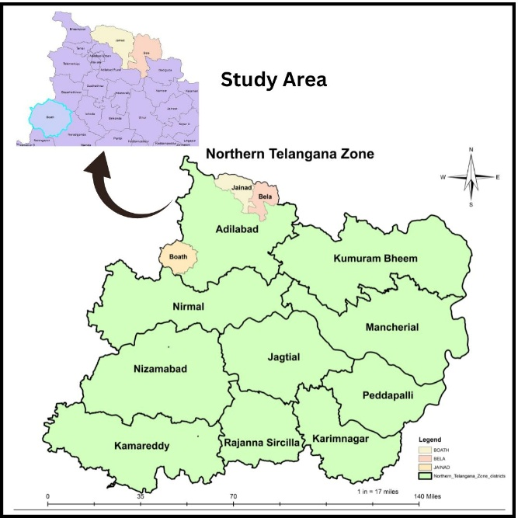
Figure 1. Study Area of Adilabad district of Northern Telangana Zone

Sampling size
Ninety soybean farmers were categorized into three groups
Group A: Sowing in proper window & medium duration varieties.
Group B: Late sowing & medium duration varieties
Group C: Late sowing & long duration varieties.
Random sampling technique was used for selection of 30 farmers each adopting these three types of practices. Hence, the total sample becomes 90 for the study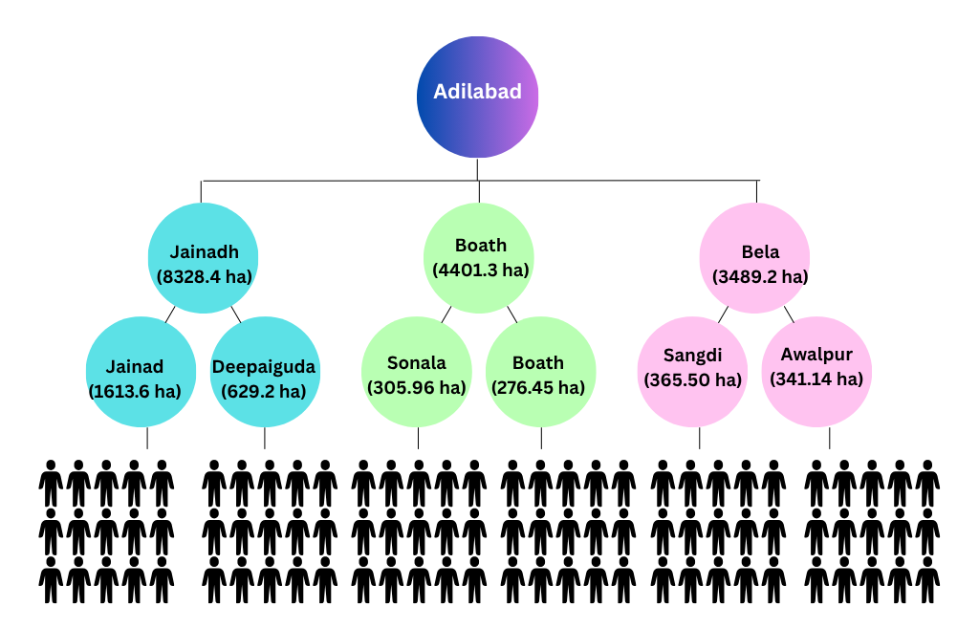
Figure 2. Sampling procedure of sample farmers

Data Collection and Analysis
Data was collected using structured schedules and analyzed through cost concepts, Adaptation Strategy use Index (ASUI), simple averages, Garrette ranking and partial budget analysis.
Adaptation Strategy Use Index (ASUI)
This involves the use of four-point Likert scale.
The four-point Likert scale was used for evaluation of frequency of using Climate-Smart Agricultural Practices (CSAPs) by soybean producers and the four-point Likert scale was categorized as: frequently used (3), occasionally used (2), rarely used (1), and not used (0), respectively following guidelines from Alabi and Anekwe 2023.

The adaptive strategy use model for the level of use of using Climate-Smart Agricultural Practices (CSAPs) is given as:
$$ASUI=[\left(N1*3\right)+\left(N2*2\right)+\left(N3*1\right)+\left(N4*0\right)]/M$$

Where:
N_{1​} = Number of soybean producers that frequently used CSAPs
N₂​ = Number of soybean producers that occasionally Used CSAPs
N_{3​} = Number of soybean producers that rarely used CSAPs
N₄​ = Number of soybean producers that did not used CSAPs
M=Total sample
ASUI = Adaptive Strategy Use Index
Partial budget analysis:
To examine the impact of adoption of climate resilient practice i.e., cultivating medium duration varieties in proper sowing window over late sowing with medium and long duration varieties, partial budgeting technique was used to determine added costs, added returns, reduced cost and reduced returns to ascertain the net gain. This helps to know the impact of cultivating medium duration varieties in proper sowing window over late sowing with medium and late sowing with long duration varieties following guidelines from Shelema et al., 2024.
$$Net change in profit due to adoption of cultivating medium duration varieties in proper sowing$$
$$window = (Added returns + reduced cost) - (Added costs + reduced returns)$$

3. results and discussion

Figure 3 shows India Soybean area and Table 1 shows area, production and productivity between 2014–15 and 2020–21. India’s soybean area rose 10.42% (from 10.91 to 12.06 m ha), production grew 16.84% (from 3.21 to 3.64 m t) and productivity jumped 11.7% (from 951 to 1,126 kg/ha). Only production’s 3.20% Compound Annual Growth Rate (CAGR) was statistically significant; area (1.42%) and productivity (3.50%) were not. A high R² (0.72) for production contrasts with low R² values for area (0.27) and productivity (0.19), indicating that output gains were driven more by expanded acreage than by yield improvements.

Table 1: Trends in Area, Production and Productivity of Soybean in India (Source: https://www.sopa.org)
Year | Area (000 ha) | Production (000 Mt) | Productivity (kg/ha)
2014-15 | 10911 | 321 | 951
2015-16 | 11605 | 315 | 738
2016-17 | 11183 | 350 | 1177
2017-18 | 10329 | 344 | 1058
2018-19 | 11131 | 361 | 1192
2019-20 | 12193 | 399 | 921
2020-21 | 12060 | 364 | 1126
% change | 10.42 | 16.84 | 11.7
CAGR | 1.42^{NS} | 3.20** | 3.50^{NS}
R-Square | 0.27 | 0.72 | 0.19
Intercept | 202.04 | 145.74 | 47.56
t-value | 1.37 | 3.58 | 1.08

Figure 4 presents Telangana soybean area and Table 2 represents trends in its area, production and productivity from 2014-15 to 2022-23. Soybean area in Telangana declined by 20.76%, production dropped sharply by 210.09%, while productivity increased by 34.98%. The CAGR was negative for area (-5.02%) and production (-12.32%), both statistically significant, whereas productivity showed a significant positive CAGR of 6.08%. R² values indicate moderate fits for area (0.35) and production (0.45), and a strong fit for productivity (0.69). These trends suggest that despite shrinking area and declining output, yield improvements have been notable, pointing toward better crop management or technology adoption.

Table 2: Trends in Area, Production and Productivity of Soybean in Telangana (Source: https://www.sopa.org)
Year | Area (ha) | Production (tonnes) | Productivity (kg/ha)
2014-15 | 242517 | 37455 | 1067
2015-16 | 242802 | 41933 | 1063
2016-17 | 276543 | 11514 | 1271
2017-18 | 152289 | 11241 | 1584
2018-19 | 148113 | 13800 | 1545
2019-20 | 172092 | 18307 | 1791
2020-21 | 161895 | 10579 | 1483
2021-22 | 152614 | 10570 | 1698
2022-23 | 201066 | 13523 | 1635
% change | -20.76 | -210.09 | 34.98
CAGR | -5.02* | -12.32* | 6.08***
R-Square | 0.35 | 0.45 | 0.69
Intercept | 82.67 | 56.07 | 82.82
t-value | -1.93 | -2.4 | 3.94

Figure 5 depicts Adilabad Soybean area and Table 3 explains its trend in area, production, productivity between 2016-17 and 2022-23. Soybean area in Adilabad increased by 16.06%, production rose by 28.15%, and productivity improved by 14.56%. The CAGR was positive for area (8.19%), production (10.62%), and productivity (2.31%), though none were statistically significant. R² values were low for area (0.24), production (0.33), and productivity (0.18), indicating weak trend reliability. Overall, growth in production was mainly supported by area expansion, with moderate improvement in yields.

Table 3: Area, Production and Productivity of Soybean in Adilabad (Source: https://www.aps.dac.gov.in)
Year | Area(ha) | Production (tonnes) | Productivity (kg/ha)
2016-17 | 45795 | 62052 | 1350
2017-18 | 19459 | 30006 | 1540
2018-19 | 26451 | 41369 | 1560
2019-20 | 37263 | 67218 | 1800
2020-21 | 31687 | 42675 | 1350
2021-22 | 41146 | 73900 | 1800
2022-23 | 54555 | 86361 | 1580
% change | 16.06 | 28.15 | 14.56
CAGR | 8.19^{NS} | 10.62 ^{NS} | 2.31 ^{NS}
R-Square | 0.24 | 0.33 | 0.18
Intercept | 35.9 | 60.88 | 73.4
t-value | 1.25 | 1.58 | 1.03

Figure 6 shows soybean productivity in Adilabad, Telangana and India and it is evident that soybean productivity in Adilabad consistently outperformed the national average from 2015–16 onward, with the exception of 2014 –15 when it lagged by 14.58%. The productivity advantage ranged from 12.81% to as high as 48.83% (in 2019–20). While India’s productivity fluctuated between 738 and 1,177 kg/ha, Adilabad achieved higher and more stable yields, peaking at 1,800 kg/ha in 2019 – 20 and 2021 – 22. This reflects better agronomic performance and efficiency in Adilabad, contributing significantly to Telangana’s higher average productivity.

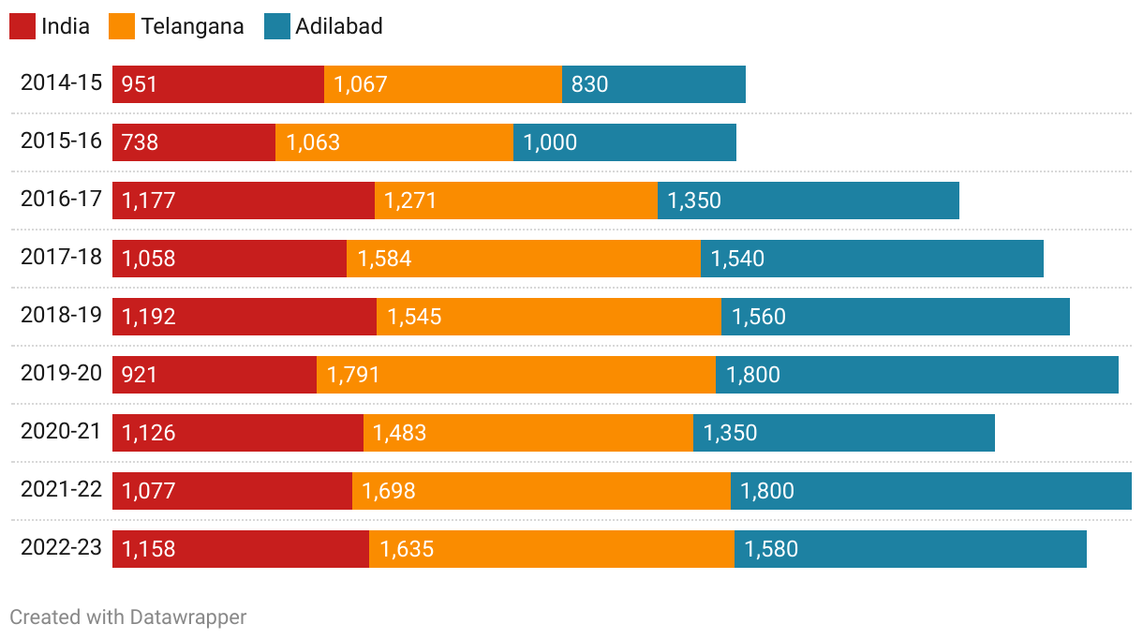
Fig 6. Comparison of Adilabad Soybean productivity with India
Figure 7 presents the cropping pattern of sample farmers. In the Kharif season, all 90 sample farmers cultivated soybean with an average landholding of 3.6 ha. Cotton was grown by 69 farmers (average of 3.26 ha), while 9 farmers followed a cotton+redgram intercropping system (1.86 ha average). During the Rabi season, bengalgram was the most preferred crop, grown by 58 farmers (2.99 ha), followed by jowar (48 farmers, 2.42 ha) and maize (15 farmers, 2.1 ha). This indicates a dominant preference for soybean in Kharif and bengalgram in Rabi, reflecting region-specific agro-climatic suitability and market preferences.

Figure 7: Cropping pattern of sample farmers (n=90)

Figure 8 depicts the perception of farmers on climate change by showing the per cent farmers opined as increased or decreased to the statement. The other percentage farmers opined as neutral to the statement. The majority of farmers perceived notable climate changes affecting agriculture. About 66% reported a delay in monsoon, and 90% observed unpredictable rains during the crop period. Uneven rainfall distribution (88%) and rising temperatures (80%) were also widely acknowledged. Over 72% noticed increased hot winds, while long dry spells were reported by 54% members. Perceptions were more mixed for early cessation of monsoon, natural disasters, drought, and floods, with significant shares indicating either a decrease or no change. Overall, farmers strongly perceived erratic and extreme weather events, especially rainfall irregularities and temperature rise, as key climate change indicators affecting their farming.

Figure 8. Farmers perception on climate change

Figure 9 shows that soybean farmers have adopted a diverse array of adaptation strategies to address climate-induced stresses. In response to pest and disease outbreaks, timely application of pesticides and fungicides was the most favoured approach (ASUI: 1.56), corroborating findings by Heinrichs et al. (2019), who noted the effectiveness of timely chemical control in minimizing yield losses. The use of resistant varieties (0.66) also featured prominently, aligning with suggestions by Sinha et al. (2025), who emphasized varietal resistance as a sustainable pest management strategy. To combat low rainfall, farmers prioritized irrigation during critical stages like flowering and pod formation (2.3), adjustment of sowing time (1.84), and intercropping (1.5). Similar practices have been recommended by Mpala and Simatele (2024), Wang & Ren (2025) as adaptive responses to rainfall variability in dryland agriculture. Under excess rainfall, water drainage through pumping (3), proper plant spacing (0.59) and short-duration crop varieties (0.8) were adopted. These are consistent with recommendations of Muthiah et al. (2025) where better field management practices help to reduce waterlogging stress. Against high temperature stress, timely irrigation (3) and micro-nutrient sprays (1.11) were effective, in line with the findings of Venugopalan et al. (2022), who found that micronutrient application improved heat tolerance. During cold spells, nutrient sprays (1.11) remained as an important coping strategy, which also aligns with strategies discussed in climate resilience studies. To tackle weed pressure, farmers most frequently employed inter-cultivation and weedicides (ASUI: 3 each), followed by proper land preparation (2.66). These are standard yet effective approaches endorsed in integrated weed management research (Riemens et al., 2022). These adaptation strategies highlight a judicious mix of traditional knowledge and improved agricultural practices, aimed at sustaining soybean productivity amidst increasing climatic challenges.
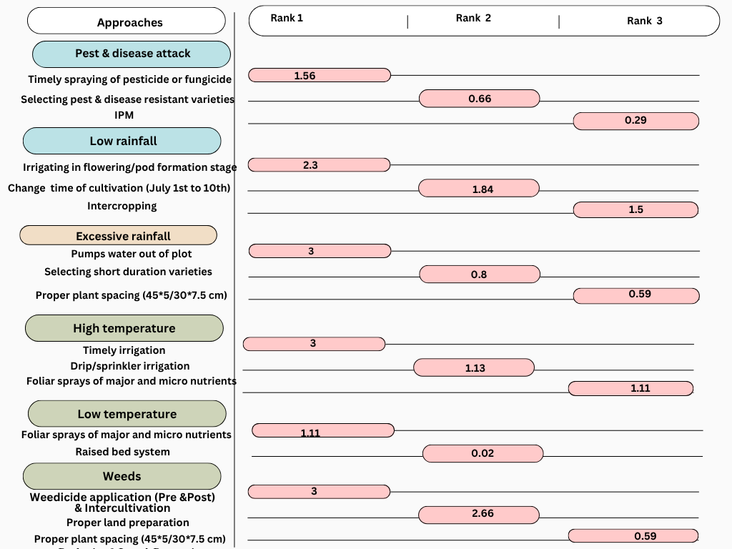
Figure 9. Adaptation strategies used by soybean farmers

Figure 10 presented the comparison of input utilization pattern of soybean farmers in three categories and revealed that farmers practicing sowing in the proper window with medium duration varieties (A) used significantly less seed (75.08 kg/ha) compared to late sowing with medium (81.13 kg/ha) and long duration varieties (83.33 kg/ha), supported by Fazily 2021, and Coley et al., 2023 that seed rate increases with delay in sowing with t-tests showing high significance (p<0.001). Similarly, human labor (51.99 mandays/ha) and bullock labor (0.75 cattle pair/ha) were significantly higher in timely sown crops (A) than in late sown medium duration varieties (B) human labor (46.81 mandays/ha) and bullock labor (0.88 cattle pair/ha) and late sown late duration varieties (C) human labor (46.63 mandays/ha) and bullock labor (0.88 cattle pair/ha). Machine power usage showed no significant difference across groups with 10.67, 10.78 and 10.7 hours/ha in timely sown crops (A), late sown medium duration varieties (B) and late sown late duration varieties (C) respectively. Manure application occurred only in group A (0.38 tonnes/ha). Fertilizer use was highest in group A (331.25 kg/ha) and lowest in late sowing with long duration varieties (195.83 kg/ha), with significant differences across all comparisons (p<0.05 to p<0.001) (Fig. 11). Overall, timely sowing with medium duration varieties was associated with more efficient and higher input utilization supported by Madias et al., 2021 and Eseigbe et al., 2024.

Table 4 explained the comparison of cost components in three types of practices and revealed that both operational and fixed costs were statistically similar across all three practices. Total operational costs ranged from Rs. 59,946.26 per hectare in late sowing with long duration varieties to Rs. 61,768.76 per hectare in proper window sowing with medium duration varieties, with no significant differences observed (t-test: 0.99 NS for A vs. B, 1.58 NS for A vs. C, and 0.59 NS for B vs. C). Likewise, fixed costs showed minimal variation, ranging from Rs. 30,211.69 to Rs. 31,666.16 per hectare, with t-test results also indicating no significant differences. Consequently, the total cultivation costs were almost identical across the groups, varying only between Rs. 90,157.94 and Rs. 92,419.63 per hectare, confirming that differences in cost structure were negligible. Total operational and fixed costs did not differ significantly, resulting in similar total cultivation costs across all groups (Rs. 90,000 to Rs. 92,000).
Table 4: Comparison of cost of cultivation of soybean farmers: (n=90)
S. No. | Cost component | Sowing in proper window & Medium duration varieties | Late sowing & Medium duration varieties | Late sowing & Long duration varieties | t-test (A&B) | t-test (A&C) | t-test (B&C)
Variable costs
I | Human labour | 19265.63 (20.89) | 17673.44 (19.12) | 17581.77 (19.5) | 4.39*** | 4.54*** | 0.22 ^{NS}
1 | Bullock labour | 4166.67 (4.52) | 4291.67 (4.64) | 3791.67 (4.21) | 0.72^{NS} | 1.8* | 2.52***
2 | Machine labour | 13252.08 (14.37) | 13803.4 (14.94) | 13803.4 (15.31) | 1.65 ^{NS} | 1.65 ^{NS} | -
3 | Seed | 7978.92 (8.65) | 8559.4 (9.26) | 9185.83 (10.19) | - | - | -
4 | FYM | 791.67 (0.86) | 0 (0) | 0 (0) | - | - | -
5 | Fertilizers | 5841.67 (6.34) | 5620.85 (6.08) | 5621.84 (6.23) | 0.99 ^{NS} | 0.99 ^{NS} | -
6 | Plant protection chemicals | 7675 (8.32) | 8113.85 (8.78) | 7245.9 (8.04) | 1.79* | 1.55 ^{NS} | 3.54***
7 | Miscellaneous | 708.33 (0.77) | 636.4 (0.69) | 689.68 (0.76) | 2.76*** | 0.97 ^{NS} | 2.48**
8 | Interest on working capital | 2088.8 (2.27) | 2054.47 (2.22) | 2027.17 (2.25) | 0.59 ^{NS} | 0.92 ^{NS} | 0.34 ^{NS}
9 | Total operational costs | 61768.76 (66.99) | 60753.47 (65.74) | 59946.26 (66.49) | 0.99 ^{NS} | 1.58 ^{NS} | 0.59 ^{NS}
Fixed costs
1 | Rental value of owned land | 11863.33 (12.87) | 11863.33 (12.84) | 11863.33 (13.16) | - | - | -
2 | Depreciation | 709.18 (0.77) | 728.85 (0.79) | 728.85 (0.81) | - | - | -
3 | Interest on fixed capital | 70.92 (0.08) | 72.89 (0.08) | 72.89 (0.08) | - | - | -
 | Total fixed costs | 30438.43 (33.01) | 31666.16 (34.26) | 30211.69 (33.51) | 1.65 ^{NS} | 0.33 ^{NS} | 1.98 **
 | Total cost | 92207.18 (100) | 92419.63 (100) | 90157.94 (100) | 0.16 ^{NS} | 0.81 ^{NS} | 0.97 ^{NS}

Figure 11 results showed that the total cost of cultivation was statistically similar across all three practices, with values ranging from Rs. 90,157.94 per hectare in late sowing with long duration varieties to Rs. 92,419.63 per hectare in late sowing with medium duration varieties. The gross returns in Rs. per ha were observed to be more for practice A (Rs. 103266) and it was followed by practice B (Rs. 93578) and C (Rs. 744666) respectively. This was observed mainly because of yield advantage in practice A. Similarly, the highest net returns were observed for practice A (Rs. 11059 per ha) when compared with practice B (Rs. 1159). In contrast to this, negative net returns were observed for practice C (Rs.15492) and it was mainly due to low yields.

Partial budget analysis in Table 5 showed that practice B incurs a slightly higher total added cost (Rs. 59,680/ha) than Practice A (Rs. 58,679/ha), mainly due to increased labour, seed, and input expenses. However, practice A generates significantly higher returns from produce sales (Rs. 1,03,266/ha) compared to practice B (Rs. 93,578/ha). The net profit increase is about Rs. 8,707 per hectare. This suggests that despite the marginally higher costs, sowing in the proper time with medium duration varieties offers better economic benefits, making it a more profitable and climate-resilient option for soybean farmers (Eseigbe et al., 2024).

Table 5: Partial budgeting of climate resilient technologies and others in soybean cultivation Partial budget analysis of Practice A: Proper Window & Medium Duration vs Practice B: Late Sowing & Medium Duration:
S.No. | Practice A: Proper Sowing Window & Medium Duration | Rs./ha | S.No. | Practice B: Late Sowing & Medium Duration | Rs./ha
I | Added Costs |  | I | Reduced Costs
I | A. Human labour | 19265.63 | I | A. Human labour | 17673.44
I | B. Bullock labour | 4166.67 | I | B. Bullock labour | 4291.67
I | C. Tractor power | 13252.08 | I | C. Tractor power | 13803.40
I | D. Seed | 7978.92 | I | D. Seed | 8559.40
I | E. FYM and fertilizers | 6633.34 | I | E. FYM and fertilizers | 5620.85
I | F. Plant protection chemical | 7675.00 | I | F. Plant protection chemical | 8113.85
I | G. Miscellaneous expenses | 708.33 | I | G. Miscellaneous expenses | 636.40
I | Total Added Cost | 59679.97 | I | Total Reduced Cost | 58699.01
II | Added Returns |  | II | Reduced Returns
II | A. Returns from sale of the produce | 103266.10 | II | A. Returns from sale of the produce | 93578.26
II | B. Premium | 0 | II | B. Premium | 0
II | Total Added Returns | 103266.10 | II | Total Reduced Returns | 93578.26

Table 6 of partial budget analysis results showed that practice A incurred a total added cost of Rs. 59,680/ha, slightly higher than practice C at Rs. 57,919/ha. However, returns from produce sales are much higher for practice A (Rs. 1,03,266/ha) compared to practice C (Rs. 74,666/ha). The net change in profit when switching from practice C to practice A is Rs. 26,840/ha, indicating that proper sowing time with medium duration varieties substantially improves profitability despite slightly higher costs. This clearly shows that adopting cultivating in proper sowing window and medium duration varieties is economically more beneficial than late sowing with long duration varieties proper sowing within the optimal window ensures crops receive favourable weather conditions throughout growth, leading to higher yields. Medium-duration varieties mature timely, reducing exposure to late-season stresses like drought or pest attacks. This results in better productivity and market returns, outweighing the slightly higher cultivation costs (Ma et al., 2018).

Table 6: Partial budget analysis of Practice A: Proper Window & Medium Duration Practice C: Late Sowing & Long Duration
S.No. | Practice A: Proper Sowing Window & Medium Duration | Rs./ha | S.No. | Practice C: Late Sowing & Long Duration | Rs./ha
I | Added Costs |  | I | Reduced Costs
I | A. Human labour | 19265.63 | I | A. Human labour | 17581.77
I | B. Bullock labour | 4166.67 | I | B. Bullock labour | 3791.67
I | C. Tractor power | 13252.08 | I | C. Tractor power | 13803.40
I | D. Seed | 7978.92 | I | D. Seed | 9185.83
I | E. FYM and fertilizers | 6633.34 | I | E. FYM and fertilizers | 5620.85
I | F. Plant protection chemical | 7675.00 | I | F. Plant protection chemical | 7245.90
I | G. Miscellaneous expenses | 708.33 | I | G. Miscellaneous expenses | 689.68
I | Total Added Cost | 59679.97 | I | Total Reduced Cost | 57919.10
II | Added Returns |  | II | Reduced Returns
II | A. Returns from sale of the produce | 103266.10 | II | A. Returns from sale of the produce | 74665.52
II | B. Premium | 0 | II | B. Premium | 0
II | Total Added Returns | 103266.10 | II | Total Reduced Returns | 74665.52

Table 7 results further revealed that farmers practicing late sowing with medium duration varieties gain a net profit advantage of Rs. 18,133 per hectare over those using late sowing with long duration varieties. This higher profitability is mainly due to better returns from the produce, despite slightly higher costs. Thus, medium duration varieties are more economically beneficial than long duration varieties under late sowing conditions. The higher profitability of medium-duration varieties than late sowing is due to their better adaptability to shortened growing periods, leading to higher yields and marketable surplus. They reduce the risk of terminal drought or pest/disease damage, which often affects long-duration varieties. Additionally, earlier harvests allow timely crop marketing, fetching better prices (Gathiye et al., 2025).

Table 7: Partial budget analysis of Practice B: Late Sowing & Medium Duration vs Practice C: Late Sowing & Long Duration
S.No. | Practice B: Late Sowing & Medium Duration | Rs./ha | S.No. | Practice C: Late Sowing & Long Duration | Rs./ha
I | Added Costs |  | I | Reduced Costs
I | A. Human labour | 17673.44 | I | A. Human labour | 17581.77
I | B. Bullock labour | 4291.67 | I | B. Bullock labour | 3791.67
I | C. Tractor power | 13803.40 | I | C. Tractor power | 13803.40
I | D. Seed | 8559.40 | I | D. Seed | 9185.83
I | E. FYM and fertilizers | 5620.85 | I | E. FYM and fertilizers | 5620.85
I | F. Plant protection chemical | 8113.85 | I | F. Plant protection chemical | 7245.90
I | G. Miscellaneous expenses | 636.40 | I | G. Miscellaneous expenses | 689.68
I | Total Added Cost | 58699.01 | I | Total Reduced Cost | 57919.10
II | Added Returns |  | II | Reduced Returns
II | A. Returns from sale of the produce | 93578.26 | II | A. Returns from sale of the produce | 74665.52
II | B. Premium | 0 | II | B. Premium | 0
II | Total Added Returns | 93578.26 | II | Total Reduced Returns | 74665.52

4. Conclusion

The analysis revealed contrasting soybean trends across scales, while India shows modest growth driven mainly by area expansion, Telangana faces shrinking area and production but improving yields, with Adilabad district exhibiting the most promising yield and area growth. Farmers’ strong awareness of climate change is matched by diverse adaptive strategies. Timely sowing with medium duration varieties emerge as a critical climate resilient practice enhancing input efficiency and potentially boosting profitability in soybean farming.

Disclaimer (Artificial intelligence)

Author(s) hereby declare that NO generative AI technologies such as Large Language Models (ChatGPT, COPILOT, etc.) and text-to-image generators have been used during the writing or editing of this manuscript.

References

- Alabi, O. O. and Anekwe, C. E. (2023). Economics of climate smart agricultural practices used by smallholder sorghum producers in Nigeria. Australian Journal of Science and Technology, 7(1), 65–71.
- Corbellini, Marcos & Bobek, Daniel & Toledo, José & Ferreira, Lenio & Cordeiro, Dthenifer & Gilio, Thiago & Teodoro, Larissa & Teodoro, Paulo & Tardin, Flavio. (2024). Geographical adaptability for optimizing the recommendation of soybean cultivars in the Brazilian Cerrado. Scientific Reports. 14. 10.1038/s41598-024-63809-y.
- Dupare, B., Sharma, P., Billore, S.D. and Verma, S. (2021). Changes in agricultural scenario of Madhya Pradesh with special reference to soybean in changed climatic scenario: A study on farmers' perception. Journal of Oilseeds Research, 37(4). https://doi.org/10.56739/jor.v37i4.136759
- Eseigbe, O.B., Kamara, A.Y., Miko, S., Omoigui, L.O., Solomon, R., Adeleke, M. A., Tofa, A. I. and Bebeley, J.F. (2024). The Impact of Planting Dates on the Performance of Soybean Varieties [Glycine max (L.) Merr.] in the Nigerian Savannas. Agronomy, 14(10), 2198. https://doi.org/10.3390/agronomy14102198.
- Fazily, T. (2021). Effect of Sowing Dates and Seed Rates on Growth and Yield of Different Wheat Varieties: A Review. International Journal of Agricultural Science and Technology. 8. 10-26. 10.47856/ijaast.2021.v08i3.002.
- Gathiye G.S., Kushwaha H.S., Chauhan S.S., Mandloi D.S., Dhakad S.S., Verma V. (2025). Productivity, Profitability and Monetary Net Return Use Efficiency of Need based Soybean (Glycine max) Cropping Systems under Vertisols in Malwa Plateau of India. Legume Research, 48(1): 137-142. doi: 10.18805/LR-4932.
- Government of Telangana, Department of Agriculture. (2024, September 25). Season and Crop Coverage Report:Vanakalam–2024 (as on 25.9.2024). Commissionerate of Agriculture, Telangana State. Retrieved from https://agri.telangana.gov.in/open_record_view.php?ID=1327
- Heinrichs, E. and Muniappan, R. (2019). Integrated pest management for tropical crops: soyabeans. CAB Reviews: Perspectives in Agriculture, Veterinary Science, Nutrition and Natural Resources, 13. 10.1079/PAVSNNR201813055.
- Kumar, Anuj, and Swami Prasad Saxena. (2025). “Climate-Smart Agriculture Practices in the Indo-Gangetic Plain: A Micro-Level Cost-Benefit Perspective”. Asian Journal of Agricultural Extension, Economics & Sociology 43 (6):259-66. https://doi.org/10.9734/ajaees/2025/v43i62781.
- Ma, S. C., Wang, T. C., Guan, X. K. and Zhang, X. (2018). Effect of sowing time and seeding rate on yield components and water use efficiency of winter wheat by regulating the growth redundancy and physiological traits of root and shoot. Field Crops Research, 221, 166–174. https://doi.org/10.1016/j.fcr.2018.02.028
- Madias, A., Di Mauro, G., Vitantonio-Mazzini, L.N., Gambin, B.L. and Borrás, L. (2021). Environment quality, sowing date, and genotype determine soybean yields in the Argentinean Gran Chaco. European Journal of Agronomy, 123, 126217. https://doi.org/10.1016/j.eja.2020.126217
- Mpala, T.A. and Simatele, M.D. (2024) Climate-smart agricultural practices among rural farmers in Masvingo district of Zimbabwe: perspectives on the mitigation strategies to drought and water scarcity for improved crop production. Frontiers in Sustainable Food Systems. 7:1298908. doi: 10.3389/fsufs.2023.1298908
- Muthiah, K., Arunya, K.G., Sridhar, V. and Patakamuri, S.K. (2025). Heavy Rainfall Impact on Agriculture: Crop Risk Assessment with Farmer Participation in the Paravanar Coastal River Basin. Water, 17(5), 658. https://doi.org/10.3390/w17050658
- Rana, R., Chander, N., Sharma, R., Sood, R. and Sharma, J.D. (2014). Modeling impacts and adaptations of climate change on soybean (Glycine max) production in Himachal Pradesh, India. Indian Journal of Agricultural Sciences, 84(10), 1172–1177. https://doi.org/10.56093/ijas.v84i10.44115
- Riemens, M., Sonderskov, M., Moonen, A.-C., Storkey, J., and Kudsk, P. (2022). An integrated weed management framework: A pan-European perspective. European Journal of Agronomy, 133, 126443. https://doi.org/10.1016/j.eja.2021.126443
- Shelema, A., Hruy, G., and Mengesha, B. (2024). Farm partial budget analysis of onion for the application of nitrogen and spacing in Southern Tigray, Ethiopia. Asian Journal of Agricultural and Horticultural Research, 11(2), 109-116.

- Sinha, D., Abid, R., Riaz, A., Thokchom, S., Iddumu, V., Sekhar, G., Khan, B., Haider, Z., Gulrez, S., Rashid, M., Ajmal, W., Ghazanfar, S., Seal, S., Kadam, A. and Bhattacharya, R. (2025). Impact of climate change on the yield of oilseed crops. In Y. Suryawanshi, M. Shahnawaz, J. Parihar, R. A. Dar, S. Samyal, and A. B. Ade (Eds.), Climate Change and Sustainable Agriculture (Chapter 7). Wiley. https://doi.org/10.1002/9781394186426.ch7
- Venugopalan, V.K, Nath R, Sengupta K, Pal A.K, Banerjee S, Banerjee P, Chandran M.A.S, Roy S, Sharma L, Hossain, A. and Siddique K.H.M. (2022) Foliar Spray of Micronutrients Alleviates Heat and Moisture Stress in Lentil (Lens culinaris Medik) Grown Under Rainfed Field Conditions. Frontiers in Plant Science, 13:847743. doi: 10.3389/fpls.2022.847743
- Wang, L. and Ren, W. (2025). Drought in agriculture and climate-smart mitigation strategies. Cell Reports Sustainability, 2025, 100386. https://doi.org/10.1016/j.crsus.2025.100386

