Observed compound heat–particulate pollution events in an Amazonian city during the extreme 2023 drought: evidence from a low-cost monitoring network

.
ABSTRACT

Heatwaves are intensifying globally under anthropogenic climate change and increasingly co-occur with degraded air quality, forming compound environmental hazards with amplified impacts on human health. While such heat–pollution interactions have been widely documented in mid-latitude regions, observational evidence from tropical rainforest environments remains scarce. This study examines the relationship between heatwaves and particulate matter (PM₂.₅ and PM₁₀) in Santarém, an urban center in the central Amazon, using continuous observations from a low-cost monitoring network and meteorological data collected throughout 2023. Heatwaves were identified using the CTX90pct index based on long-term maximum temperature records, and daily particulate concentrations were analyzed through descriptive statistics, categorical classification, and regression modeling. Both PM fractions exhibited substantially higher concentrations during heatwave periods, particularly in the late dry season under severe drought and biomass-burning conditions. Mean PM₁₀ increased from 17.1 to 25.4 µg m⁻³ and PM₂.₅ from 9.5 to 15.8 µg m⁻³ on heatwave days, accompanied by a shift toward higher pollution categories. Multiple linear regression identified air temperature as the dominant driver of particulate variability, while relative humidity exerted a mitigating effect. Heatwave occurrence was significantly associated with increased PM₁₀ concentrations, whereas PM₂.₅ responded mainly through enhanced extremes. Logistic regression further indicated that elevated PM₁₀ concentrations on the preceding day increased the probability of heatwave onset, suggesting that coarse particles act as indicators of pre-heatwave atmospheric stagnation Overall, the results demonstrate that heatwaves in the Amazon are embedded within broader periods of atmospheric degradation characterized by dry, stagnant conditions that promote particulate accumulation. These findings provide the first observational evidence of compound heat–pollution events in an Amazonian city and highlight the need for integrated heat and air-quality monitoring and early-warning strategies to reduce public-health risks in tropical regions.

Keywords: Amazon rainforest; Air pollution; Compound climate hazards; Biomass burning; Thermal extremes; Low-cost sensors; Urban atmosphere.

1. INTRODUCTION

Heatwaves have emerged as one of the most critical climate-related hazards of the twenty-first century, with increasing frequency, duration, and severity driven by anthropogenic climate change (Hoegh-Guldberg et al., 2018; Haines & Ebi, 2019; Perkins-Kirkpatrick & Lewis, 2020; Martinez-Villalobos et al., 2025). These extreme thermal events exert profound impacts on human health, ecosystems, agriculture, and urban systems, especially in tropical regions where baseline temperatures are already high and physiological thresholds are frequently exceeded (Luber & McGeehin, 2008; Xu et al., 2016; Smith et al., 2023; Tasan et al., 2025). Globally, heatwaves have been linked to escalating economic losses, amplified wildfire activity, and unprecedented mortality during compound climate extremes in Europe, China, Australia, and North America (Williams et al., 2019; Xu et al., 2024; Du et al., 2024; PoshtMashhadi et al., 2025).

In Brazil and South America, a growing body of literature has documented significant increases in heatwave frequency, duration, spatial extent, and intensity over recent decades. National-scale analyses reveal a widespread intensification of heat extremes across multiple Brazilian climatic regions since the late twentieth century (Bitencourt et al., 2016; Geirinhas et al., 2018; Bitencourt et al., 2020; Oliveira et al., 2021; Medeiros et al., 2025). Regional studies have further highlighted exceptional heatwave episodes in central and southern South America, including the October 2020 event and the unprecedented winter and spring heatwaves of 2023, which were associated with large-scale circulation anomalies and extreme dryness (Marengo et al., 2022; Costa et al., 2022; Marengo et al., 2025). At the city scale, Brazilian urban areas have experienced increasingly frequent and intense heatwaves, with documented impacts on human thermal comfort and excess mortality (Geirinhas et al., 2019; Oliveira et al., 2021; Mandú et al., 2020a; Souza et al., 2025).

Concurrently with the intensification of heat extremes, ambient air pollution — particularly fine (PM₂.₅) and coarse (PM₁₀) particulate matter — has become a major global environmental and public-health concern (Tran et al., 2023). Numerous studies have demonstrated that particulate pollution increases cardiovascular, respiratory, and all-cause mortality, with health risks substantially amplified under extreme heat conditions (Bell et al., 2008; Liu et al., 2016; Jacobs et al., 2018; Kinney & Pinkerton, 2022; Yan et al., 2024; He et al., 2025). In tropical regions, particulate concentrations are strongly modulated by seasonal biomass burning, atmospheric stagnation, and boundary-layer dynamics, rendering the interaction between heatwaves and air pollution particularly complex (Bherwani et al., 2021).

Recent international studies emphasize that heatwaves and elevated particulate matter often occur simultaneously, mutually reinforcing atmospheric stability, photochemical activity, and pollutant accumulation (Gong et al., 2024; Xu et al., 2024; Tseng et al., 2024; Ma et al., 2025). Such compound heat-pollution episodes were documented during the 2022 megadrought and heatwave events in China, when extreme heat enhanced PM₂.₅ formation and severely limited pollutant dispersion (Liu et al., 2023; Zhou et al., 2023a). These findings underscore that heatwaves are not isolated thermal extremes but are often embedded within broader periods of atmospheric degradation characterized by dry, stagnant, and poorly ventilated conditions (Sun et al., 2025).

In the Amazon Basin, however, empirical evidence linking heatwaves and particulate pollution remains remarkably scarce, despite the region’s pronounced vulnerability to fire-driven aerosol emissions and extreme thermal anomalies during El Niño years. Severe droughts associated with oceanic warming and land-use change have intensified biomass burning and smoke transport across vast areas of the basin, leading to substantial increases in PM₂.₅ and PM₁₀ concentrations with implications for visibility, radiative forcing, cloud microphysics, and population exposure (Tian et al., 2022). Recent studies indicate that the most extreme Amazonian heatwaves tend to occur under exceptionally dry conditions, characterized by suppressed convection, weak surface winds, and reduced atmospheric ventilation (Costa et al., 2022; Medeiros et al., 2025). Yet, the extent to which heatwaves modulate air quality in Amazonian cities — or whether degraded air-quality conditions precede and signal heatwave onset — remains largely unexplored.

Understanding these interactions is particularly relevant for mid-sized Amazonian cities such as Santarém, where rapid urban expansion, regional smoke transport, and increasing thermal extremes converge to create environments of elevated environmental and health risk. While many cities in the Northern Hemisphere benefit from long-term reference-grade air-quality monitoring networks, most Amazonian municipalities lack such infrastructure, limiting the assessment of pollutant dynamics and population exposure. Recent local initiatives based on low-cost sensor networks have begun to address these gaps, enabling continuous measurements of particulate matter and meteorological variables and providing unprecedented observational coverage during the extreme climatic conditions of 2023.

Scientific evidence from other regions suggests that heatwaves promote particulate accumulation by enhancing atmospheric stability, shallowing the boundary layer, accelerating photochemical reactions, and reducing wet removal processes (Gong et al., 2024; Yan et al., 2024). Conversely, elevated particulate levels — particularly coarse-mode particles — may precede heatwave onset by signaling dry, stagnant, and high-pressure conditions favorable to extreme thermal anomalies (Zhou et al., 2023a). Given that Amazonian heatwaves are frequently associated with severe drought and suppressed ventilation, the potential for compound heat-pollution events represents a major environmental and public-health concern in the region.

Despite substantial advances in the characterization of heatwaves in Brazil and South America, no previous study has quantitatively examined the relationship between heatwaves and particulate matter in the Brazilian Amazon using continuous, ground-based observations. The year 2023—marked by one of the strongest warming anomalies of recent decades and severe regional drought linked to El Niño—therefore provides a critical natural laboratory for investigating these interactions.

Based on this context, the present study tests the following hypotheses: (i) heatwave days are associated with systematically higher concentrations of PM₂.₅ and PM₁₀ compared to non-heatwave conditions; (ii) particulate matter concentrations, particularly PM₁₀, increase preferentially during heatwave periods due to enhanced atmospheric stagnation and dry conditions; and (iii) elevated particulate levels on the preceding day act as indicators of atmospheric conditions conducive to heatwave onset. Accordingly, this study aims to (1) characterize the temporal behavior of PM₂.₅ and PM₁₀ during heatwave and non-heatwave periods in Santarém throughout 2023; (2) quantify the response of particulate pollution to extreme heat conditions using regression-based approaches; and (3) assess whether antecedent aerosol concentrations contribute to the onset of heatwaves. By integrating local observations with established conceptual frameworks, this work provides the first observational assessment of compound heat-pollution interactions in an Amazonian city and addresses a critical knowledge gap in climate-risk research for tropical rainforest environments.

2. material and methods
2.1 Study area

Santarém is situated in the western part of Pará State, in northern Brazil, located along the right bank of the Tapajós River, near its confluence with the Amazon River. The municipality lies roughly midway between the region’s two major metropolitan centers, Manaus and Belém, at approximately 800 km from each. Santarém is the third largest urban center in the state, following Belém and Ananindeua. The municipality covers an area of 17,898.389 km² and has an estimated population of 331,937 inhabitants. Its geographic coordinates are 2°24’52’’ S and 54°42’36’’ W, and its location is shown in Figure 1.

According to the Köppen–Geiger climate classification updated by Peel et al. (2007), Santarém presents an Am-type tropical monsoon climate characterized by two well-marked annual seasons. The wettest months extend from December to May, when rainfall peaks, while the June–November period corresponds to the regional dry season (Reboita etal., 2010; Alvares et al., 2013). The annual mean air temperature exceeds 26 °C, and large-scale atmospheric systems strongly influence the distribution of precipitation. During austral autumn, the Intertropical Convergence Zone (ITCZ) plays a dominant role (Souza et al., 2009; Santos et al., 2024), while the South Atlantic Convergence Zone (SACZ) is more active during the austral summer (Carvalho et al., 2004; Laureanti et al., 2024). Transitional months frequently experience the passage of Squall Lines (SLs), commonly triggered by sea-breeze interactions along the northern coastal zone (Tapajos et al., 2013; Sousa et al., 2021).

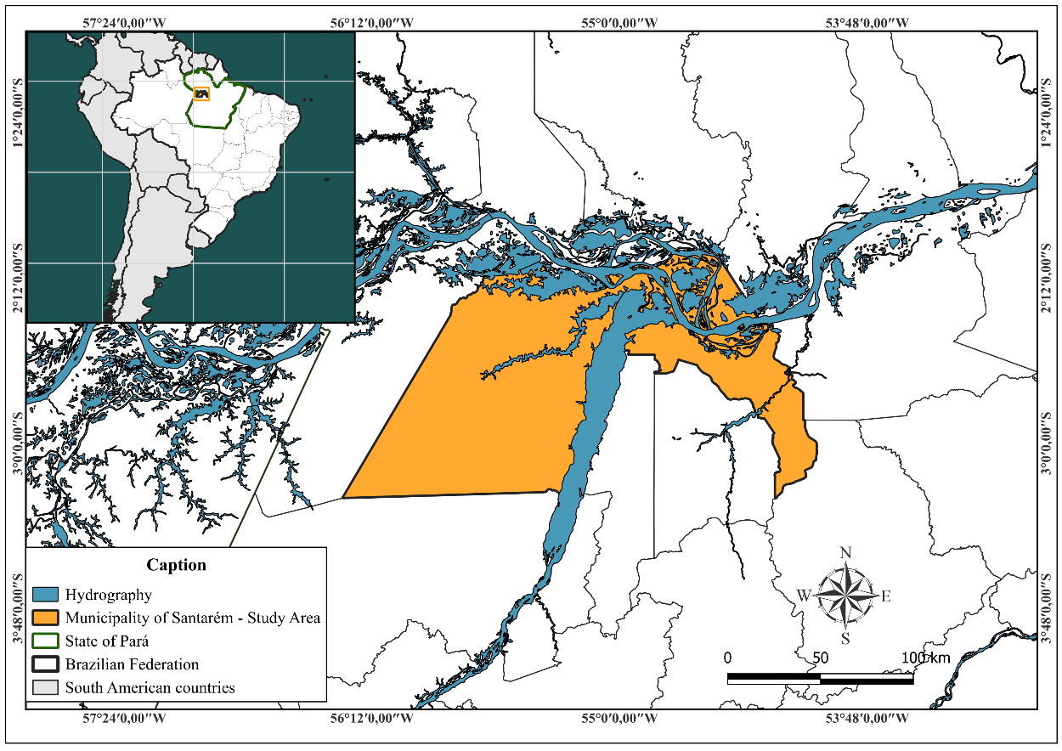
Fig.1. Study area.

2.2 Data collection and instrumentation

Data used in this study were obtained from the environmental monitoring kits developed under the Pilot Innovation Network for Air Quality Monitoring in the Western Region of Pará – Guardians of the Air project. Each kit integrates low-cost atmospheric sensors designed to measure variables relevant to air-quality assessment, including the AM2302 (air temperature and relative humidity) and the SDS011 (PM₂.₅ and PM₁₀). Figure 2 illustrates the configuration adopted in the field. The AM2302 was installed on the outer side of the protective enclosure to ensure direct exposure to ambient atmospheric conditions. To facilitate a constant inflow of air toward the particulate matter chamber, a narrow plastic tube was attached to the device, directing airflow to the SDS011 inlet located inside the compartment. All sensors were connected to an Arduino Uno microcontroller housed within the enclosure and linked via jumper wires responsible for the power supply and signal transmission.

The monitoring network comprises 25 fixed sampling locations distributed throughout the municipality, among the available monitoring sites within the network, one urban location was selected based on the availability of a continuous daily time series throughout the entire year of 2023, with no significant data gaps. This criterion was essential to ensure a consistent comparison between heatwave and non-heatwave days. The selected site is located in a densely occupied urban area, representative of typical population exposure conditions. It is emphasized that the analysis focuses on relative contrasts associated with extreme events, rather than on absolute compliance with regulatory air quality thresholds. Results should therefore be interpreted as representative of temporal dynamics rather than spatial variability. The initiative began in 2022 and was funded by the Fundação Amazônia de Amparo a Estudos e Pesquisas (FAPESPA) in partnership with the Federal University of Western Pará (UFOPA). The project aims to expand the availability of local air-quality indicators for Santarém, addressing regional gaps in environmental monitoring infrastructure. This dataset is presented and described by Almeida et al., (2025). The atmospheric variables selected—temperature, relative humidity, PM₂.₅ and PM₁₀ concentrations are key parameters for evaluating air-quality conditions and their potential impacts on human exposure.

For this study, we used hourly measurements collected between January and December 2023, corresponding to the period in which the monitoring kits operated continuously and produced complete daily records suitable for analysis.

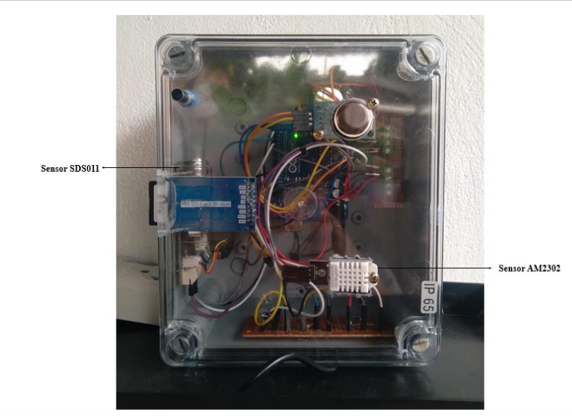
Fig. 2. Monitoring kit from the project “Pilot Innovation Network for Air Quality Monitoring in the Western Region of Pará – Guardians of the Air”. Source: Almeida et al., (2025)

The use of low-cost sensors represents a practical alternative for air-quality monitoring in regions where reference-grade stations are scarce or absent, such as the Amazon Basin. Nevertheless, these instruments are subject to known limitations that must be acknowledged. The SDS011 optical particle sensor may exhibit reduced accuracy under conditions of very high relative humidity, which can affect light scattering and lead to particle overestimation, as well as potential saturation during extreme pollution episodes. Similarly, the AM2302 sensor is sensitive to radiative heating and local ventilation conditions.

To mitigate these limitations, this study relies on daily aggregated values rather than high-frequency measurements, a widely adopted procedure to reduce random noise and short-term sensor instability. In addition, the analysis focuses on relative contrasts between heatwave and non-heatwave periods, rather than absolute concentration thresholds, which minimizes the influence of systematic sensor bias. Previous validation and intercomparison analyses conducted within the monitoring network indicate that, despite their limitations, the sensors reliably capture temporal variability and pollution episodes at daily timescales (Almeida et al., 2025).

Therefore, while absolute concentration values should be interpreted with caution, the observed patterns and statistical relationships are considered robust for assessing relative changes in particulate matter associated with heatwave conditions.

This study employed daily records of maximum air temperature from the conventional meteorological station no. 82246, located in Belterra, Pará (2°37'48"S; 54°57'00"W), for the period from January 1990 to December 2024. The data were obtained from the Brazilian National Institute of Meteorology (INMET) through the Meteorological Database for Teaching and Research (BDMEP).

Following Phase I of the Quality Assurance (QA) and Quality Control (QC) framework proposed by Faybishenko et al. (2022), raw time series were inspected for timestamp consistency, duplicated records, and temporal ordering. All timestamps were converted to a uniform time standard (UTC), and duplicated or non-ordered entries were flagged before further analysis. Physical plausibility checks were first applied to all variables. PM₂.₅ and PM₁₀ concentrations were constrained to non-negative values, while temperature and relative humidity were limited to physically meaningful ranges. Outliers and extreme values were identified using a rolling quantile approach, consistent with Faybishenko et al. (2022), which allows the detection of anomalous values while preserving seasonal variability. Values exceeding the upper and lower empirical quantiles were flagged but not automatically removed. Rather than removing anomalous observations, all suspect values were flagged and retained, ensuring transparency and enabling subsequent sensitivity analyses. To minimize the influence of short-lived spikes and measurement noise inherent to low-cost sensors, all analyses were conducted on daily aggregated values, which is consistent with the post-QA/QC processing recommended by Faybishenko et al. (2022). The proportion of flagged observations was below 3% for all variables, indicating overall data stability. No gap-filling or statistical imputation was applied, as the analyses focused on daily aggregated values with sufficient data coverage.

The meteorological station of Belterra was used as the reference for heatwave identification due to data availability and regional climatic representativeness. The percentile-based heatwave definition adopted in this study requires a minimum of 30 years of continuous temperature records to ensure statistical robustness and climatological consistency, a criterion widely applied in Brazil and internationally (Bitencourt et al., 2016; Geirinhas et al., 2018; Bitencourt et al., 2020; Medeiros et al., 2025). However, the automatic meteorological station of Santarém was established only in 2007, providing an insufficient temporal record for the reliable estimation of long-term temperature percentiles necessary for heatwave counts.

Previous studies have demonstrated that the western Pará region exhibits no significant spatial differences in temperature variability at the regional scale. Using cluster analysis, Araújo et al. (2022) and Mandú et al. (2022) showed that Santarém, Belterra, and surrounding areas belong to the same climatic cluster, characterized by homogeneous thermal variability and shared synoptic controls. These findings support the use of the Belterra station—located in proximity to Santarém and possessing a long, continuous temperature record—as a representative reference for heatwave detection in the study area.

Therefore, the adoption of the Belterra station ensures methodological consistency with established heatwave definitions while preserving the regional climatic representativeness necessary for the analysis of extreme thermal events affecting Santarém.

Heatwave events were identified using daily maximum temperature records from the local conventional meteorological station. Detection followed the CTX90pct index proposed by Perkins & Alexander (2013), widely applied in Brazilian climatological studies (e.g., Geirinhas et al., 2019; Bitencourt et al., 2020). Under this criterion, a heatwave corresponds to any period of at least three consecutive days in which the daily maximum temperature exceeds the 90th percentile of the local climatological distribution.

To address the pronounced annual cycle of maximum temperature in the central Amazon, percentile thresholds were calculated separately for each calendar day using a 15-day moving window. The climatological reference period used to compute percentiles spans 1991–2020, which is the last climatological period used in Brazil by INMET. For a given day d, the threshold was derived from all maximum temperature values recorded within a ±7-day interval around d across all years of the reference period:

$A_{d}=U_{y=1991}^{2020}U_{i=d-7}^{d+7}T_{y,i}$,

Where $T_{y,i}$irepresents the maximum temperature observed on day i of year y.
This method smooths the seasonal cycle and provides more stable percentile estimates, as recommended by Perkins & Alexander (2013).

- C5L scheme, with categories 0–5
- WHO/COMS categories, based on global health guidelines.
Relative frequencies of each category were computed for heatwave and non-heatwave periods, enabling comparison of pollution severity under different thermal conditions.

Table 1. Categorization of PM_{2.5}.
Categorization 5 limits (C5L) |  | Categorization WHO (COMS)
Categories | Concentration (µg m⁻³) | Categories | Concentration  (µg m⁻³)
0 | 1 – 3 | 0 | Below 15
1 | 4 – 6 | 0 | Below 15
2 | 7 – 10 | 0 | Below 15
3 | 11 – 14 | 1 | Above 15
4 | 15 – 18 | 1 | Above 15
5 | ≥ 19 | 1 | Above 15

Table 2. Categorization PM₁₀
Categorization 5 limits (C5L) |  | Categorization WHO (COMS)
Categories | Concentration (µg m⁻³) | Categories | Concentration  (µg m⁻³)
0 | 1–5 | 0 | Below 45
1 | 6–12 | 0 | Below 45
2 | 13–20 | 0 | Below 45
3 | 21–30 | 1 | ≥ 45
4 | 31–40 | 1 | ≥ 45
5 | ≥ 41 | 1 | ≥ 45

Although the WHO/COMS air-quality categories provide an internationally recognized framework for health-based assessment, their limited number of concentration thresholds may constrain the characterization of pollution variability in regions with highly dynamic particulate regimes. Previous studies conducted in the eastern Amazon have shown that particulate matter concentrations frequently fluctuate within and between the WHO guideline intervals, particularly during biomass-burning and extreme-dryness periods (Almeida et al., 2025). In such contexts, a finer categorical resolution is required to adequately capture shifts in pollution severity. Therefore, the C5L classification scheme, which subdivides particulate matter concentrations into five ordinal categories, was adopted as the primary framework for regime analysis, allowing a more sensitive discrimination of pollution conditions across heatwave and non-heatwave periods. The WHO/COMS categories were retained as a complementary reference to facilitate comparison with global health guidelines and existing international studies.

All statistical analyses were conducted using daily aggregated variables. After quality control proposed by Faybishenko et al., (2022), the daily means of PM₂.₅, PM₁₀, air temperature (T), and relative humidity (RH) were computed. These variables formed the basis for the descriptive, categorical, and regression analyses described below.

To quantify the influence of meteorological conditions and heatwave occurrence on particulate matter levels, separate multiple linear regression models were fitted for daily PM₂.₅ and PM₁₀ concentrations. Each model used temperature, relative humidity, and a binary heatwave indicator (HW = 1 for heatwave days; 0 otherwise) as predictors.

The general form of the linear regression model can be written as:

$$RH_{t}+βY_{t}=β_{0}+β_{1}T_{t}+β_{2_{3}}HW_{t}+ϵ_{t},$$
Where:

$Y_{t}$= PM₂.₅ or PM₁₀ concentration on the day t,

$T_{t}$= daily mean air temperature (°C),

$RH_{t}$= daily mean relative humidity (%),

$HW_{t}$= heatwave indicator (0/1),

$β_{0}$= intercept,

$β_{1}$,$β_{2}$,$β_{3}$= regression coefficients,

$ϵ_{t}$= random error term.

Model parameters were estimated using ordinary least squares (OLS). Assumptions of linearity, homoscedasticity, and normality of residuals were inspected through standard diagnostic procedures (Hu et al., 2019).

To investigate whether atmospheric and pollution conditions on the previous day influence the start of a heatwave, a logistic regression model was fitted (DelSole & Tippett, 2022). The response variable indicated whether a given day represented the first day of a heatwave:

$${HW}_{t}^{(start)}= \{1, if day t is the onset of a heatwave 0, otherwise.$$

The logistic model takes the form:

$$\text{logit}\left(P\left(HW_{t}^{\left(\text{start}\right)}=1\right)\right) =α_{0}+α_{1}PM{2.5}_{t-1}+α_{2}PM{10}_{t-1}+α_{3}T_{t-1}+α_{4}RH_{t-1},$$

Where:

$logit\left(p\right)=ln\left(\frac{p}{1-p}\right)$.

Thus, the probability of a heatwave starting on day tis:

$$P\left(HW_{t}^{\left(\text{start}\right)}=1\right)=\frac{1}{\left\{-{\left( α\right\}}_{0}+α_{1}PM{2.5}_{t-1}+α_{2}PM{10}_{t-1}+α_{3}T_{t-1}+α_{4}RH_{t-1}\right)}$$

Parameters were estimated via maximum likelihood, and model adequacy was evaluated using the residual deviance and Akaike Information Criterion (AIC).

All statistical processing, visualization, and modeling were performed using R free software, employing the tidyverse, lubridate, and broom packages. Statistical significance was assessed at p < 0.05 (Wilks, 2011). All statistical analyses are designed to assess associations rather than causal relationships, given the observational nature of the data.

3. results and discussion

Figure 3 presents the daily mean concentrations of PM₁₀ (top panel) and PM₂.₅ (bottom panel) throughout 2023, with gray shaded areas marking the periods in which heatwave events occurred, 8 heatwave events were identified. Overall, PM₁₀ concentrations remained mostly between 5 and 25 µg m⁻³ during the wet season and early dry season, increasing substantially from September onward and reaching values above 40 µg m⁻³ in late October and early November. PM₂.₅ followed a similar seasonal pattern, with relatively low values (typically 2–12 µg m⁻³) in the first half of the year and a pronounced peak during the same late-dry-season interval. The shading of heatwave periods allows for a clear temporal comparison between extreme thermal conditions and variations in particulate matter.

A marked seasonal behavior is evident, with both PM fractions showing lower concentrations during the wet months due to enhanced wet scavenging and reduced biomass burning activity. As the region transitions into the dry season, concentrations begin to rise steadily, culminating in the highest values during October–November, months typically associated with severe drought and intense fire activity in the Amazon. Notably, many heatwave episodes coincide with periods of increasing particulate concentrations, particularly from August onward. This temporal alignment indicates that heatwave conditions favor the buildup of atmospheric pollutants through atmospheric stagnation, weakened ventilation, reduced humidity, and the persistence of smoke from regional fires. The strongest PM peaks occur during the most intense heatwave of 2023, highlighting the potential for extreme heat to exacerbate air pollution through both meteorological mechanisms and emission-related processes.

Although PM₁₀ and PM₂.₅ exhibit similar seasonal cycles, the fine fraction (PM₂.₅) shows greater relative variability during heatwave periods, consistent with its sensitivity to secondary aerosol formation and biomass burning emissions. Taken together, the results illustrate that heatwaves and elevated particulate matter often co-occur in this Amazonian environment, suggesting a synergistic interaction in which extreme heat and poor air quality reinforce each other. These findings underscore the importance of integrated monitoring strategies, particularly during years affected by regional drought or El Niño conditions, when both thermal stress and pollution levels are likely to intensify simultaneously.

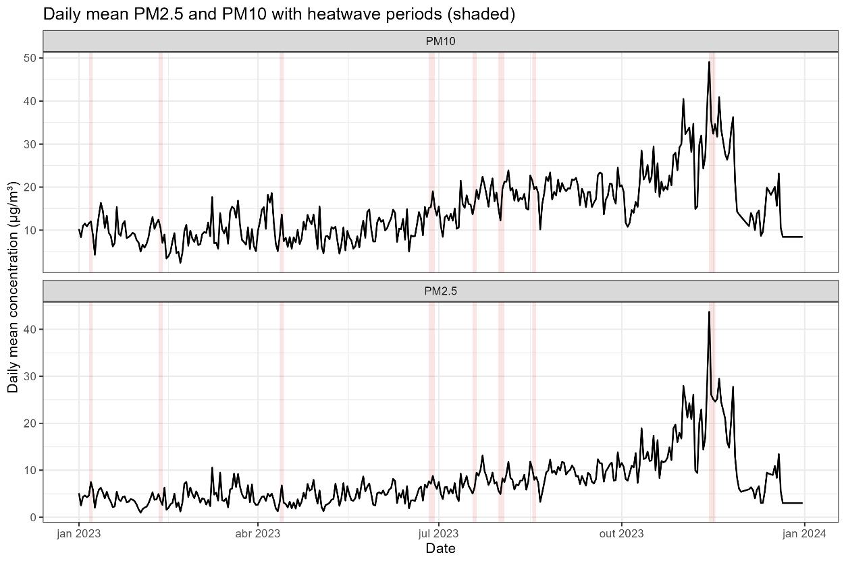
Fig. 3. Daily mean PM₁₀ (top panel) and PM_{2.5} (bottom panel) concentrations in 2023. Grey shaded areas indicate heatwave periods.

Table 3 summarizes the daily mean concentrations of PM₂.₅, PM₁₀, temperature, and relative humidity during heatwave and non-heatwave days in 2023. Overall, heatwave days exhibited substantially higher particulate matter levels compared with non-heatwave conditions. Daily mean PM₂.₅ increased from 9.50 µg m⁻³ on non-heatwave days to 15.8 µg m⁻³ during heatwaves, while PM₁₀ rose from 17.1 µg m⁻³ to 25.4 µg m⁻³. These increases were accompanied by slightly higher temperatures (32.4 °C vs. 31.6 °C) and lower relative humidity (69.4% vs. 71.7%), consistent with the expected meteorological environment that favors heatwave formation (Choi & Lee, 2019).

The larger standard deviations observed for PM₂.₅ (21.1 µg m⁻³) and PM₁₀ (22.9 µg m⁻³) during heatwaves indicate greater day-to-day variability, reflecting rapid changes in atmospheric stability, boundary-layer dynamics, and regional fire activity. Together, these results show that heatwaves in Santarém during 2023 were systematically associated with degraded air quality, characterized by higher concentrations of fine and coarse particulate matter and meteorological conditions conducive to atmospheric accumulation of pollutants. Although the number of heatwave days is limited, these events correspond to the most extreme thermal conditions of the year, which are precisely the focus of this study.

Table 3. Daily mean PM2.5, PM10, temperature, and relative humidity during non-heatwave and heatwave days.
Period | n days | PM_{2.5} mean (µg/m³) | PM_{2.5} SD | PM₁₀ mean (µg/m³) | PM₁₀ SD | Temp mean (°C) | RH mean (%)
Non-heatwave | 338 | 9.50 | 10.70 | 17.10 | 12.90 | 31.6 | 71.7
Heatwave | 27 | 15.80 | 21.10 | 25.40 | 22.90 | 32.4 | 69.4

Table 4 presents the mean concentrations of PM₂.₅ and PM₁₀ on the previous day (lag-1) for heatwave and non-heatwave periods. Both pollutants exhibit substantially higher values on the days preceding heatwave events. Lag-1 PM₂.₅ increases from 9.50 µg m⁻³ during non-heatwave conditions to 16.0 µg m⁻³ before heatwaves, while lag-1 PM₁₀ rises from 17.0 µg m⁻³ to 25.9 µg m⁻³.

This systematic elevation in antecedent pollution suggests that atmospheric conditions conducive to heatwave onset—such as reduced ventilation, stagnant boundary-layer dynamics, and persistent dry weather—also favor the accumulation of particulate matter. The results imply that deteriorating air quality often precedes heatwaves, reinforcing the notion of compound meteorological-air pollution stressors in the region.

Table 4. Daily mean lag-1 (previous-day) PM_{2.5} and PM₁₀ concentrations by period.
Period | Lag-1 PM2.5 (µg/m³) | Lag-1 PM10 (µg/m³)
Non-heatwave | 9.50 | 17.00
Heatwave | 16.00 | 25.90

The boxplots in Figure 4 compare the distributions of daily mean PM₂.₅ and PM₁₀ concentrations during heatwave and non-heatwave days in 2023. For PM₂.₅, the median concentration during heatwave periods is slightly higher than during non-heatwave periods, although the interquartile ranges overlap considerably. However, heatwave days exhibit a noticeably broader spread of values, with several high-end outliers exceeding 25–30 µg m⁻³ and one extreme event surpassing 40 µg m⁻³. This indicates that while typical PM₂.₅ levels do not differ drastically between the two regimes, the probability of extreme fine-particle pollution increases substantially during heatwaves. This behavior is consistent with meteorological conditions commonly associated with heatwaves—such as reduced atmospheric ventilation, stagnant air masses, and enhanced photochemical activity—which favor the accumulation and formation of fine aerosols.

For PM₁₀, the contrast between periods is more pronounced. The median and interquartile range are both higher during heatwave days, indicating systematically elevated concentrations of coarse and fine particulate material. Outliers also reach higher values during heatwaves, with maximum concentrations approaching 45–50 µg m⁻³. These results suggest that heatwave conditions contribute to both increased baseline PM₁₀ levels and a greater likelihood of extreme pollution events. The enhancement of PM₁₀ during heatwaves may reflect a combination of factors, including increased soil and dust resuspension under drier conditions, intensified biomass burning activity in the region, and reduced wet scavenging due to prolonged dry weather (Kalisa et al., 2018).

Together, the two boxplots show that both PM₂.₅ and PM₁₀ tend to increase during heatwaves, but the effect is more systematic and robust for PM₁₀, whereas PM₂.₅ shows a stronger increase primarily in its upper tail (extreme events). This pattern highlights a potentially important interaction between thermal extremes and air quality in the Amazonian environment, in which heatwaves not only elevate thermal stress but also amplify exposure to hazardous particulate matter. Such co-occurrence reinforces the need for integrated environmental monitoring and early-warning systems during periods of extreme heat.

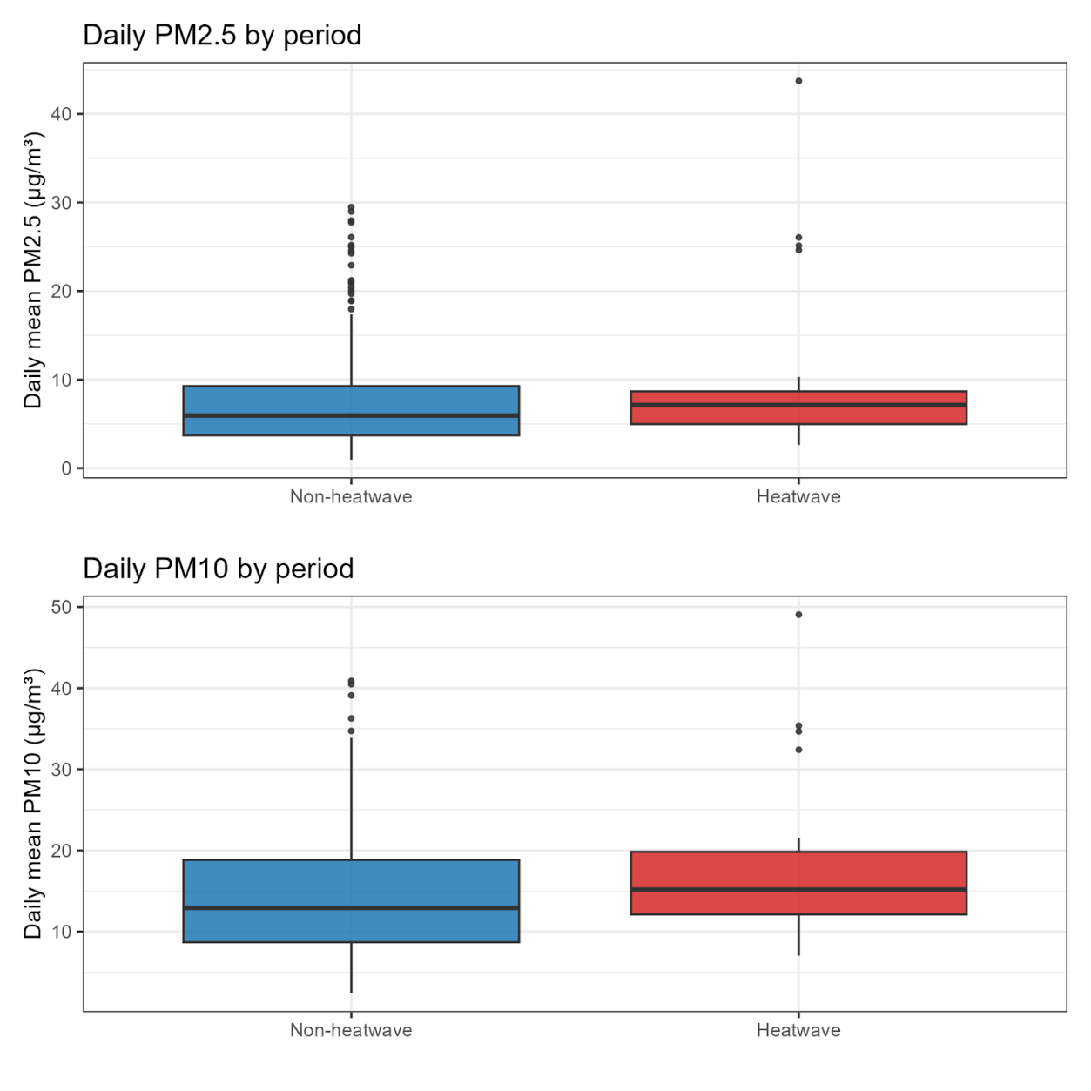
Fig. 4. Distribution of daily mean PM_{2.5} (top) and PM₁₀ (bottom) concentrations during heatwave and non-heatwave days.

The C5L distribution of daily PM₁₀ concentrations shows a pronounced shift toward higher pollution categories during heatwave periods compared with non-heatwave days. Under non-heatwave conditions, the majority of days fall within C5L 1 (6–12 µg m⁻³) and C5L 2 (13–20 µg m⁻³), with very few occurrences in the highest categories. In contrast, heatwave days display a substantial increase in the frequency of C5L 2 and C5L 3 (21–30 µg m⁻³), together accounting for more than half of all heatwave observations. Notably, the upper categories—C5L 4 (31–40 µg m⁻³) and C5L 5 (≥41 µg m⁻³)—are predominantly associated with heatwave events, with minimal representation during non-heatwave periods. This distribution highlights that heatwaves not only elevate the central tendency of PM₁₀ concentrations but also substantially increase the likelihood of high- and very high-pollution days. The shift toward higher C5L classes during heatwaves aligns with meteorological conditions that promote pollutant accumulation, such as stagnant air masses, reduced boundary-layer mixing, and enhanced regional emissions during dry and hot periods. These findings emphasize that heatwaves constitute a compounded environmental hazard, intensifying both thermal stress and particulate pollution exposure.

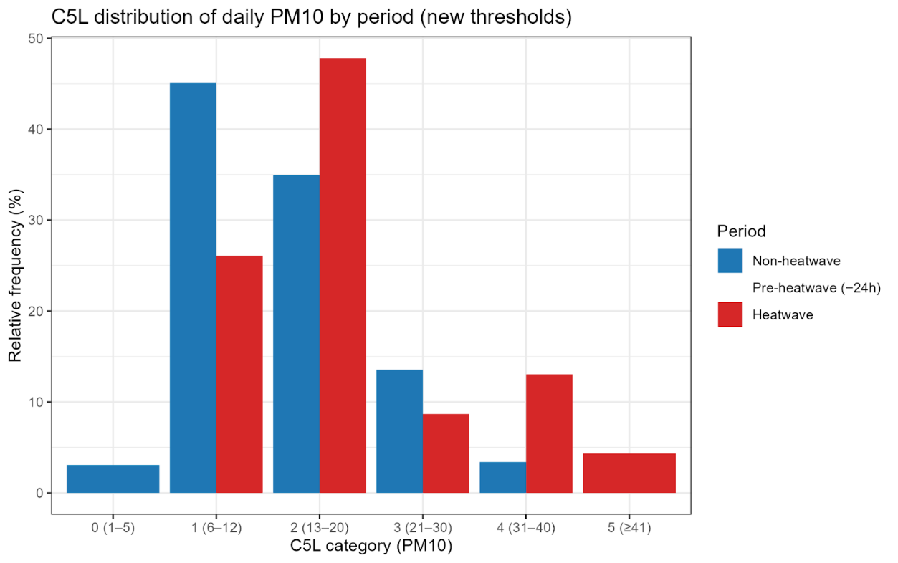
Fig. 5. Relative frequency of daily PM10 concentrations classified under the C5L.

The C5L classification of daily PM₂.₅ concentrations reveals clear differences between heatwave and non-heatwave periods. During non-heatwave days, the distribution is more dispersed across the lower categories, with a substantial proportion of days falling in C5L 0 (1–3 µg m⁻³) and C5L 1 (4–6 µg m⁻³). In contrast, heatwave days exhibit a strong shift toward higher PM₂.₅ categories. Nearly half of all heatwave days fall in C5L 2 (7–10 µg m⁻³), compared with only about one-third of non-heatwave days. More importantly, the highest categories—C5L 4 (15–18 µg m⁻³) and C5L 5 (≥19 µg m⁻³)—are markedly more frequent during heatwaves. Category 5, which represents the most polluted conditions in this classification, occurs roughly three times more often during heatwaves than during non-heatwave days.

This pattern indicates that heatwaves are not only associated with increased median PM₂.₅ levels but also substantially elevate the likelihood of days with moderate to high pollution. Such a shift is consistent with the meteorological characteristics of heatwaves—reduced atmospheric mixing, persistent dry conditions, and enhanced local and regional emissions—which collectively favor the accumulation of fine particulate matter. The increased frequency of high-category PM₂.₅ during heatwave events highlights a potentially important compound hazard, in which extreme heat and air pollution co-occur and may jointly intensify risks to public health (Zhou et al., 2023b).

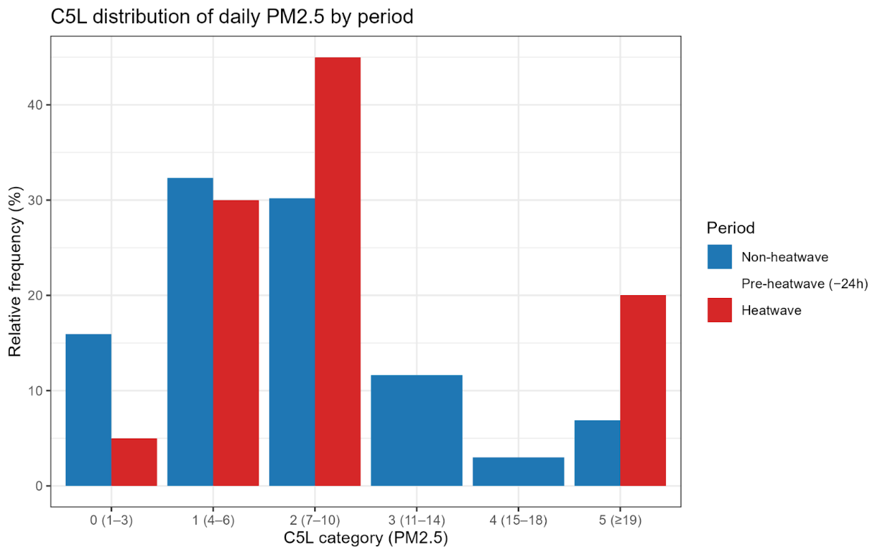
Fig. 6. Relative frequency of daily PM2.5 concentrations according to the C5L classification.

Table 6 presents the multiple linear regression model developed to estimate daily PM₂.₅ concentrations as a function of local meteorological conditions and the occurrence of heatwaves. The model explains approximately 22% of the daily variability in PM₂.₅ (R² = 0.228; adjusted R² = 0.221) and is statistically significant overall (p < 0,001). Temperature exhibited the strongest positive association with PM₂.₅, with an estimated increase of 2.295 µg m⁻³ per 1 °C rise (p < 0,001), indicating that warmer days tend to favor higher fine particulate concentrations, possibly due to enhanced atmospheric stability and pollutant accumulation.

Relative humidity showed a significant negative effect (estimate = −0.324; p = 0.009), consistent with humidity-induced particle removal mechanisms such as deposition and hygroscopic growth followed by sedimentation. The heatwave indicator displayed a positive but marginally non-significant coefficient (estimate = 3.701; p = 0.080), suggesting that PM₂.₅ concentrations may increase during heatwave days, although the evidence does not reach the 5% significance threshold. Taken together, these results highlight temperature as the dominant driver of short-term PM₂.₅ variability in the region, while humidity and extreme heat events exert secondary but meaningful influences.

Model diagnostics indicated that the residuals exhibited an approximately normal distribution and no systematic patterns, suggesting an adequate model fit. Multicollinearity among predictor variables was assessed and remained within acceptable limits.

Table 5. Regression model predicting daily PM2.5 concentrations.
Variable | Estimate | Std. Error | t-value | p-value
Intercept | −39.70 | 21.61 | −1.84 | 0.067
Temperature (°C) | 2.295 | 0.458 | 5.01 | < 0,0001
Relative humidity (%) | −0.324 | 0.124 | −2.62 | 0.009
Heatwave (binary) | 3.701 | 2.109 | 1.75 | 0.080

Table 5 summarizes the multiple linear regression model used to predict daily PM₁₀ concentrations based on meteorological variables and heatwave occurrence. The model explains approximately 27% of the day-to-day variability in PM₁₀ (R² = 0.274; adjusted R² = 0.268) and is statistically significant overall (p < 0,0001). Temperature again emerges as the dominant predictor, with PM₁₀ increasing by 3.364 µg m⁻³ for each 1 °C rise in air temperature (p > 0,001). This strong positive association suggests enhanced particulate accumulation under warmer and likely more stagnant atmospheric conditions. Relative humidity shows a negative and statistically significant effect (estimate = −0.293; p = 0.040), consistent with physical mechanisms that promote particle removal at higher moisture levels.

Notably, unlike the PM₂.₅ model, the heatwave indicator is significant at the 5% level (estimate = 4.957; p = 0.041), indicating that PM₁₀ concentrations tend to increase during heatwave days. This result supports the notion that extreme heat conditions can exacerbate particulate pollution, potentially through increased resuspension of coarse particles, enhanced emissions, or reduced atmospheric dispersion. Overall, the model reinforces temperature as the primary driver of coarse particulate variability, with humidity and heatwaves acting as secondary contributors.

Table 6. Regression model predicting daily PM10 concentrations.
Variable | Estimate | Std. Error | t-value | p-value
Intercept | −68.13 | 24.73 | −2.76 | 0.006
Temperature (°C) | 3.364 | 0.525 | 6.41 | < 0,001
Relative humidity (%) | −0.293 | 0.142 | −2.07 | 0.040
Heatwave (binary) | 4.957 | 2.414 | 2.05 | 0.041

Table 7 presents the lag-1 predictors of heatwave onset derived from a logistic regression model expressed in odds ratios. The model evaluates whether atmospheric and particulate conditions on the previous day influence the likelihood of a heatwave beginning on the following day. Among the predictors, PM₂.₅ lag-1 exhibits a statistically significant negative association (estimate = −0.172; p = 0.032), indicating that higher fine-particle concentrations on the previous day are associated with slightly reduced odds of heatwave initiation. In contrast, PM₁₀ lag-1 shows a significant positive effect (estimate = 0.181; p = 0.015), suggesting that elevated coarse particulate levels on the preceding day increase the probability of a heatwave starting.

This divergent behavior between fine and coarse fractions may reflect differences in their meteorological sensitivity or emission processes, with coarse particles often enhanced under dry and stagnant pre-heatwave conditions. Temperature and relative humidity at lag-1 display no statistically significant effects (p = 0.928 and p = 0.867, respectively), indicating that previous-day meteorological conditions alone do not substantially predict the onset of a heatwave. The model shows reasonable performance (residual deviance = 180.32; AIC = 190.32), highlighting PM₁₀ as the most relevant early-day atmospheric indicator of forthcoming heatwave events in the study region.

In the logistic regression analysis, lagged PM₁₀ concentrations were associated with an increased probability of heatwave onset, as indicated by the estimated odds ratios. Overall model performance was evaluated using goodness-of-fit metrics, indicating a consistent predictive capability.

Table 7. Lag-1 predictors of heatwave onset (odds ratios).
Variable | Estimate | Std. Error | z-value | p-value
Intercept | −2.950 | 9.647 | −0.31 | 0.760
PM2.5 lag-1 | −0.172 | 0.080 | −2.14 | 0.032
PM10 lag-1 | 0.181 | 0.074 | 2.45 | 0.015
Temperature lag-1 | −0.019 | 0.213 | −0.09 | 0.928
RH lag-1 | −0.009 | 0.054 | −0.17 | 0.867

The results reveal a direct compound interaction between extreme heat and degraded air quality in Santarém during 2023, consistent with the growing scientific evidence that heatwaves and particulate pollution frequently co-occur and mutually intensify their impacts on human health and atmospheric processes. Numerous studies have demonstrated that extreme heat alters atmospheric stability, suppresses boundary-layer mixing, and enhances stagnation, thereby facilitating the accumulation of pollutants near the surface (Haines & Ebi, 2019; Yan et al., 2024; Gong et al., 2024). Our findings align with this framework, both PM₂.₅ and PM₁₀ showed substantial increases during heatwave days, particularly in the late dry season, when drought conditions and biomass burning were most intense—an environmental configuration typical of Amazonia during years influenced by El Niño and regional fire activity (Zhou et al., 2023a; Han et al., 2024). This approach is consistent with previous regional studies and minimizes potential biases associated with short observational records, ensuring robust heatwave characterization in data-scarce tropical regions (Pascal et al., 2021; Ren et al., 2024).

The C5L categorical analysis reinforces this interpretation by showing a pronounced shift toward higher pollution classes during heatwaves for both PM₁₀ and PM₂.₅. Similar categorical transitions toward high-risk air-quality states during heatwaves have been widely reported, particularly in rapidly urbanizing or biomass-burning regions (Huang et al., 2024; Singh et al., 2020). These compound events—where high temperatures and high particulate levels occur simultaneously—are known to pose disproportionate health risks, leading to elevated cardiopulmonary morbidity and mortality (Haines & Ebi, 2019; Liu et al., 2016). For Amazonian populations, where exposure to smoke during the dry season is recurrent, the superposition of thermal stress and particle pollution represents a critical environmental and public-health challenge.

Regression results show that temperature is the dominant predictor of both PM fractions, a pattern consistent with mechanistic studies linking heat to enhanced atmospheric stagnation and reduced dilution (Gong et al., 2024; Zhou et al., 2023a). The negative role of humidity in reducing particulate concentrations also matches global findings showing that higher moisture increases deposition and reduces particle lifetime (Yan et al., 2024). Importantly, the heatwave indicator was significant for PM₁₀, suggesting that coarse particles—such as dust and mechanically resuspended material—respond strongly to the extremely dry and stable conditions preceding and during heatwaves. Similar dynamics have been reported in studies of the 2022 heatwave in China, where PM₁₀ increased sharply under extreme dryness (Xu et al., 2024).

The lag-1 logistic regression provides a crucial temporal perception; elevated PM₁₀ levels on the previous day increased the likelihood of a heatwave starting. This reinforces the argument that coarse particles are linked to pre-heatwave atmospheric stagnation. Zhang et al. (2024) observed increases in aerosols before major heatwave events in China during 2022, suggesting that pollution can act as an early atmospheric signal of deteriorating meteorological conditions. The weak negative association of PM₂.₅ lag-1 with heatwave onset may reflect its dependence on fire emissions, which are not uniformly synchronized with heatwave initiation.

The moderate coefficients of determination obtained for the regression models are consistent with expectations for atmospheric systems influenced by multiple interacting processes, including emissions, regional transport, boundary-layer dynamics, and synoptic-scale circulation. Such values are commonly reported in observational air-quality studies and do not undermine the robustness of the identified associations. Model diagnostics indicated no critical multicollinearity among predictors and no evidence of residual autocorrelation affecting the main results.

Furthermore, the relationships identified in this study should be interpreted as statistical associations rather than direct causal links. Although the temporal structure of the lag-1 analysis provides insight into pre-heatwave atmospheric conditions, the observational nature of the dataset precludes definitive causal inference. Nevertheless, the consistency of the results across multiple analytical approaches supports the interpretation of compound heat-pollution dynamics in the study region.

Although the associations identified here are not intended to imply direct causality, the consistency of the results across descriptive, categorical, and regression-based analyses supports the interpretation of compound heat–pollution dynamics operating under dry and stagnant atmospheric conditions.

This study presents several strengths, including the use of continuous, ground-based observations during an exceptionally warm and dry year, the application of a rigorous QA/QC framework, and the explicit focus on compound heat-pollution interactions in an Amazonian urban environment, a region that remains largely underrepresented in the literature. The comparative design adopted here, contrasting heatwave and non-heatwave conditions, enhances the robustness of the results by reducing the influence of systematic sensor biases. Nevertheless, some limitations should be acknowledged. The analysis is based on a single urban monitoring site and relies on low-cost sensors, which may introduce measurement uncertainties and limit spatial representativeness. In addition, the absence of boundary-layer observations and the observational nature of the data prevent direct causal inference. Despite these constraints, the consistency of the observed patterns and their agreement with established physical mechanisms support the relevance of the findings and their contribution to advancing the understanding of compound climate hazards in tropical rainforest cities.

Overall, the findings demonstrate that heatwaves in Santarém are not isolated meteorological extremes but occur within a broader framework of degraded atmospheric conditions, aligning with international literature showing that climate change is amplifying the frequency, duration, and intensity of compound heat-pollution events (Hoegh-Guldberg et al., 2018; Haines & Ebi, 2019; Williams et al., 2019; Wang et al., 2025; Cardone et al., 2025). Given the expected intensification of heat extremes under continued warming, alongside increasing fire vulnerability in Amazonia, these compound hazards demand integrated monitoring strategies and predictive systems that jointly consider thermal stress and particulate pollution. Such approaches will be essential for protecting public health in the region.

4. Conclusion

This study provides evidence that heatwaves in Santarém during 2023 were systematically associated with degraded air quality, characterized by substantial increases in both PM₂.₅ and PM₁₀ concentrations. The strong temporal alignment between extreme heat and elevated particulate levels indicates the presence of compound heat-pollution events driven by shared meteorological and environmental processes. Warmer and drier conditions favored atmospheric stagnation, reduced boundary-layer ventilation, and the persistence of biomass-burning emissions, creating an environment conducive to simultaneous thermal stress and air-quality deterioration.

Regression analyses identified air temperature as the dominant driver of daily particulate variability, while relative humidity exerted a mitigating influence consistent with enhanced removal processes. Heatwave occurrence showed a significant association with increased PM₁₀ concentrations, suggesting that coarse particles respond particularly strongly to the extremely dry and stable conditions prevailing during heatwaves. Moreover, the lagged analysis revealed that elevated PM₁₀ concentrations on the preceding day increased the probability of heatwave onset, highlighting the potential role of coarse particulate matter as an early indicator of atmospheric stagnation conducive to extreme thermal events.

These findings highlight the growing vulnerability of Amazonian urban populations to compound climate hazards, especially during years marked by severe drought and intensified biomass burning. In regions where reference-grade air-quality monitoring remains limited, the integration of low-cost sensor networks with meteorological observations offers a viable pathway for identifying periods of heightened environmental risk. The results emphasize the need for integrated monitoring and early-warning systems that jointly consider thermal extremes and air pollution, rather than treating these stressors in isolation.

In this context, the observed coupling between extreme heat and particulate pollution highlights the practical value of integrating air-quality indicators into heatwave monitoring and early-warning frameworks for Amazonian cities.

While this analysis is based on a single year of observations, the exceptional climatic conditions of 2023 provide valuable insight into processes likely to become more frequent under continued warming. Future research should extend this approach to multi-year datasets, incorporate additional pollutants and boundary-layer diagnostics, and explore direct links with health outcomes. Such efforts will be essential for informing climate-adaptation strategies and protecting public health in tropical rainforest cities increasingly exposed to compound heat-pollution hazards. These findings highlight the relevance of integrating heatwave monitoring with air-quality observations to support early-warning systems and public-health strategies in Amazonian cities.

Disclaimer (Artificial intelligence)

Author(s) hereby declare that NO generative AI technologies such as Large Language Models (ChatGPT, COPILOT, etc.) and text-to-image generators have been used during the writing or editing of this manuscript.

References

- Hoegh-Guldberg, O., Jacob, D., Bindi, M., Brown, S., Camilloni, I., Diedhiou, A., ... & Zougmoré, R. B. (2018). Impacts of 1.5 C global warming on natural and human systems. In Global warming of 1.5 C.: An IPCC Special Report (pp. 175-311). IPCC Secretariat.

- Haines, A., & Ebi, K. (2019). The imperative for climate action to protect health. New England journal of medicine, 380(3), 263-273.

- Perkins-Kirkpatrick, S. E., & Lewis, S. C. (2020). Increasing trends in regional heatwaves. Nature communications, 11(1), 3357.

- Martinez-Villalobos, C., Fu, D., Loikith, P. C., & Neelin, J. D. (2025). Accelerating increase in the duration of heatwaves under global warming. Nature Geoscience, 18(8), 716-723.

- Luber, G., & McGeehin, M. (2008). Climate change and extreme heat events. American journal of preventive medicine, 35(5), 429-435.

- Xu, Z., FitzGerald, G., Guo, Y., Jalaludin, B., & Tong, S. (2016). Impact of heatwave on mortality under different heatwave definitions: a systematic review and meta-analysis. Environment international, 89, 193-203.

- Smith, K. E., Burrows, M. T., Hobday, A. J., King, N. G., Moore, P. J., Sen Gupta, A., ... & Smale, D. A. (2023). Biological impacts of marine heatwaves. Annual review of marine science, 15(1), 119-145.

- Tasan, M., Dąbrowska, J., & Michałowska, K. (2025). Surface urban heat islands during heatwaves: Thermal impacts on the built environment in selected polish cities. Building and Environment, 113603.

- Williams, A. P., Abatzoglou, J. T., Gershunov, A., Guzman‐Morales, J., Bishop, D. A., Balch, J. K., & Lettenmaier, D. P. (2019). Observed impacts of anthropogenic climate change on wildfire in California. Earth's Future, 7(8), 892-910.

- Xu, W., Yuan, W., Wu, D., Zhang, Y., Shen, R., Xia, X., ... & Liu, J. (2024). Impacts of record-breaking compound heatwave and drought events in 2022 China on vegetation growth. Agricultural and Forest Meteorology, 344, 109799.

- Du, H., Yan, M., Liu, X., Zhong, Y., Ban, J., Lu, K., & Li, T. (2024). Exposure to concurrent heatwaves and ozone pollution and associations with mortality risk: a nationwide study in China. Environmental health perspectives, 132(4), 047012.

- PoshtMashhadi, A., Maghsoodi, A. I., & Wood, L. C. (2025). The impact of extreme temperatures on emergency department visits: A systematic review of heatwaves, cold waves, and daily temperature variations. Science of the Total Environment, 970, 178869.

- Bitencourt, D. P., Fuentes, M. V., Maia, P. A., & Amorim, F. T. (2016). Frequência, duração, abrangência espacial e intensidadedas ondas de calor no brasil. Revista Brasileira de Meteorologia, 31, 506-517.

- Geirinhas, J. L., Trigo, R. M., Libonati, R., Coelho, C. A., & Palmeira, A. C. (2018). Climatic and synoptic characterization of heat waves in Brazil. International Journal of Climatology, 38(4), 1760-1776.

- Bitencourt, D. P., Fuentes, M. V., Franke, A. E., Silveira, R. B., & Alves, M. P. (2020). The climatology of cold and heat waves in Brazil from 1961 to 2016. International Journal of Climatology, 40(4), 2464-2478.

- Oliveira, D. S. D., Costa, P. D. P., Bezerra, L. M., Avila, A. M. H. D., & Faria, E. C. D. (2021). Hotter, longer and more frequent heatwaves: an observational study for the Brazilian city of Campinas, SP. Revista Brasileira de Meteorologia, 36(2), 305-316.

- Medeiros, F. J., Chebly, S. B., de Araújo, G. R. G., de Brito Neto, F. A., & Lima, K. C. (2025). Heatwaves in the Northern Brazil Region: Current and Future Perspectives. International Journal of Climatology, e70144.

- Marengo, J. A., Ambrizzi, T., Barreto, N., Cunha, A. P., Ramos, A. M., Skansi, M., ... & Salinas, R. (2022). The heat wave of October 2020 in central South America. International Journal of Climatology, 42(4), 2281-2298.

- Costa, D. F., Gomes, H. B., Silva, M. C. L., & Zhou, L. (2022). The most extreme heat waves in Amazonia happened under extreme dryness. Climate Dynamics, 59(1), 281-295.

- Marengo, J. A., Costa, M. C., Cunha, A. P., Espinoza, J. C., Jimenez, J. C., Libonati, R., ... & Salinas, R. (2025). Climatological patterns of heatwaves during winter and spring 2023 and trends for the period 1979–2023 in central South America, Frontiers in Climate, 7, 1529082.

- Geirinhas, J. L., Trigo, R. M., Libonati, R., Castro, L. C., Sousa, P. M., Coelho, C. A., ... & Magalhaes, M. D. A. F. (2019). Characterizing the atmospheric conditions during the 2010 heatwave in Rio de Janeiro marked by excessive mortality rates. Science of the Total Environment, 650, 796-808.

- Mandú, T. B., dos Santos Gomes, A. C., Costa, G. B., & Neves, T. T. D. A. T. (2020a). Avaliação de tendência nas ondas de calor registradas em Manaus/AM, Brasil. Revista Brasileira de Climatologia, 27, 405-425.

- Souza, V. S., de Assis, E. S., & de Almeida Albuquerque, T. T. (2025). Caracterização de ondas de calor da cidade de João Pessoa/PB por três diferentes definições. Revista Brasileira de Climatologia, 37, 843-868.

- Tran, H. M., Tsai, F. J., Lee, Y. L., Chang, J. H., Chang, L. T., Chang, T. Y., ... & Chuang, H. C. (2023). The impact of air pollution on respiratory diseases in an era of climate change: A review of the current evidence. Science of the Total Environment, 898, 166340.

- Bell, M. L., Davis, D. L., & Fletcher, T. (2008). A retrospective assessment of mortality from the London smog episode of 1952: the role of influenza and pollution. In Urban ecology: An International perspective on the interaction between humans and nature (pp. 263-268). Boston, MA: Springer US.

- Liu, C., Yang, C., Zhao, Y., Ma, Z., Bi, J., Liu, Y., ... & Chen, R. (2016). Associations between long-term exposure to ambient particulate air pollution and type 2 diabetes prevalence, blood glucose and glycosylated hemoglobin levels in China. Environment international, 92, 416-421.

- Jacobs, E. T., Burgess, J. L., & Abbott, M. B. (2018). The Donora smog revisited: 70 years after the event that inspired the clean air act. American journal of public health, 108(S2), S85-S88.

- Kinney, P. L., & Pinkerton, K. E. (2022). Heatwaves and air pollution: a deadly combination. American Journal of Respiratory and Critical Care Medicine, 206(9), 1060-1062.

- Bherwani, H., Kumar, S., Musugu, K., Nair, M., Gautam, S., Gupta, A., ... & Kumar, R. (2021). Assessment and valuation of health impacts of fine particulate matter during COVID-19 lockdown: a comprehensive study of tropical and sub tropical countries. Environmental Science and Pollution Research, 28(32), 44522-44537.

- Gong, H., Ma, K., Hu, Z., Dong, Z., Ma, Y., Chen, W., ... & Wang, L. (2024). Attribution of the August 2022 extreme heatwave in Southern China: role of dynamical and thermodynamical processes. Bulletin of the American Meteorological Society, 105(1), E193-E199.

- Tseng, W. L., Chen, Y. C., Wang, Y. C., Tseng, H. Y., & Hsu, H. H. (2024). Compound spatial extremes of heatwaves and downstream air pollution events in East Asia. Atmospheric Research, 312, 107772.

- Ma, K., Fang, F., Lin, Y., Tong, F., He, C., Yao, Y., ... & Li, R. (2025). Association of compound exposure to heat wave and ozone pollution with cause-specific cardiopulmonary mortality: A space-time-stratified case-crossover study. Environmental Research, 122635.

- Liu, Y., Yuan, S., Zhu, Y., Ren, L., Chen, R., Zhu, X., & Xia, R. (2023). The patterns, magnitude, and drivers of unprecedented 2022 mega-drought in the Yangtze River Basin, China. Environmental Research Letters, 18(11), 114006.

- Zhou, B., Hu, S., Peng, J., Li, D., Ma, L., Zheng, Z., & Feng, G. (2023a). The extreme heat wave in China in August 2022 related to extreme northward movement of the eastern center of SAH. Atmospheric Research, 293, 106918.

- Sun, J., Graf, R., Wrzesiński, D., Luo, Y., Zhu, S., Di Nunno, F., ... & Granata, F. (2025). Impact of extreme atmospheric heat events on river thermal dynamics and heatwaves. Journal of Hydrology, 659, 133292.

- Tian, C., Yue, X., Zhu, J., Liao, H., Yang, Y., Lei, Y., ... & Cao, Y. (2022). Fire-climate interactions through aerosol radiative effect in a global chemistry-climate-vegetation model. Atmospheric Chemistry and Physics Discussions, 2022, 1-25.

- Yan, H., Tang, W., Wang, L., Huang, S., Lin, H., Gu, L., ... & Zhao, X. (2024). Ambient PM2. 5 components are associated with bone strength: evidence from a China multi-ethnic study. The Journal of Clinical Endocrinology & Metabolism, 109(1), 197-207.

- He, Z., Wu, Z., Herzog, O., Hei, J., Li, L., & Li, X. (2025). Compound health effects and risk assessment of extreme heat and ozone air pollution under climate change: A case study of 731 urban areas in China. Sustainable Cities and Society, 119, 106084.

- Peel, M. C., Finlayson, B. L., & McMahon, T. A. (2007). Updated world map of the Köppen-Geiger climate classification. Hydrology and earth system sciences, 11(5), 1633-1644.

- Reboita, M. S., Gan, M. A., Rocha, R. P. D., & Ambrizzi, T. (2010). Regimes de precipitação na América do Sul: uma revisão bibliográfica. Revista brasileira de meteorologia, 25, 185-204.

- Alvares, C. A., Stape, J. L., Sentelhas, P. C., Gonçalves, J. D. M., & Sparovek, G. (2013). Köppen’s climate classification map for Brazil. Meteorologische zeitschrift, 22(6), 711-728.

- Souza, E. B. D., Lopes, M. N., da Rocha, E. J., Souza, J. R. S., Cunha, A. C. D., Silva, R. R. D., ... & Vitorino, M. I. (2009). Precipitação sazonal sobre a Amazônia oriental no período chuvoso: observações e simulações regionais com o RegCM3. Revista Brasileira de Meteorologia, 24, 111-124.

- Santos, C. A. G., dos Santos, D. C., Neto, R. M. B., de Oliveira, G., dos Santos, C. A. C., & da Silva, R. M. (2024). Analyzing the impact of ocean-atmosphere teleconnections on rainfall variability in the Brazilian Legal Amazon via the Rainfall Anomaly Index (RAI). Atmospheric Research, 307, 107483.

- Carvalho, L. M., Jones, C., & Liebmann, B. (2004). The South Atlantic convergence zone: Intensity, form, persistence, and relationships with intraseasonal to interannual activity and extreme rainfall. Journal of climate, 17(1), 88-108.

- Laureanti, N. C., Chou, S. C., Nobre, P., & Curchitser, E. (2024). On the relationship between the South Atlantic Convergence Zone and sea surface temperature during Central-East Brazil extreme precipitation events. Dynamics of Atmospheres and Oceans, 105, 101422.

- Tapajós, R., Machado, W., Aguiar, D., Bota, B., Weidemann, K., Furtado Neto, A., Silva, R. da, & Fitzjarrald, D. (2013). Brisa do Rio Tapajós e sua Influência na Atmosfera. Ciência E Natura, 35, 487–490.

- Sousa, A. C., Candido, L. A., & Satyamurty, P. (2021). Convective cloud clusters and squall lines along the coastal Amazon. Monthly weather review, 149(11), 3589-3608.

- Mandú, T. B., Gomes, A. C. D. S., & Coutinho, M. D. L. (2020b). Caracterização do conforto térmico da cidade de Santarém–PA. Revista Geonorte, 11(37), 279-291.

- Almeida, D. O, dos Santos Gomes, A. C., Batalha, S. S. A., da Silva, G. V., Mandú, T. B., Silva, R. P. T., ... & Dias, G. S. (2025). Variabilidade na Qualidade do Ar: Uma Abordagem Comparativa entre Zonas Urbana e Periurbana em Santarém, Pará. Revista Brasileira de Geografia Física, 18(02), 863-879.

- Faybishenko, B., Versteeg, R., Pastorello, G., Dwivedi, D., Varadharajan, C., & Agarwal, D. (2022). Challenging problems of quality assurance and quality control (QA/QC) of meteorological time series data. Stochastic environmental research and risk assessment, 36(4), 1049-1062.

- Araújo, G. R. G., Frassoni, A., Sapucci, L. F., Bitencourt, D., & de Brito Neto, F. A. (2022). Climatology of heatwaves in South America identified through ERA5 reanalysis data. International Journal of Climatology, 42(16), 9430-9448.

- Mandú, T. B., da Silva Nascimento, A. L., da Silva, E. A., de Andrade, M. U. G., de Melo, M. H. B., & dos Santos Gomes, A. C. (2022). Climatologia das Ondas de Calor Registradas no Estado do Pará, Brasil. Revista Brasileira de Geografia Física, 15(5), 2525-2543.

- Perkins, S. E., & Alexander, L. V. (2013). On the measurement of heat waves. Journal of climate, 26(13), 4500-4517.

- Hu, Y. H., Yu, S. C., Qi, X., Zheng, W. J., Wang, Q. Q., & Yao, H. Y. (2019). An overview of multiple linear regression model and its application. Zhonghua yu Fang yi xue za zhi [Chinese Journal of Preventive Medicine], 53(6), 653-656.

- DelSole, T., & Tippett, M. (2022). Statistical methods for climate scientists. Cambridge University Press.

- Wilks, D. S. (2011). Statistical methods in the atmospheric sciences (Vol. 100). Academic press.

- Choi, N., & Lee, M. I. (2019). Spatial variability and long-term trend in the occurrence frequency of heatwave and tropical night in Korea. Asia-Pacific Journal of Atmospheric Sciences, 55(1), 101-114.

- Kalisa, E., Fadlallah, S., Amani, M., Nahayo, L., & Habiyaremye, G. (2018). Temperature and air pollution relationship during heatwaves in Birmingham, UK. Sustainable cities and society, 43, 111-120.

- Zhou, W., Wang, Q., Li, R., Zhang, Z., Wang, W., Zhou, F., & Ling, L. (2023b). The effects of heatwave on cognitive impairment among older adults: Exploring the combined effects of air pollution and green space. Science of The Total Environment, 904, 166534.

- Han, L., Yu, C. W., & Cao, S. J. (2024). Synergistic control of air pollution and heat waves in the urban built environment: Challenges and opportunities. Indoor and Built Environment, 33(3), 417-421.

- Pascal, M., Wagner, V., Alari, A., Corso, M., & Le Tertre, A. (2021). Extreme heat and acute air pollution episodes: A need for joint public health warnings?. Atmospheric environment, 249, 118249.

- Ren, N., Huang, H., Liu, B., Wu, C., Xiang, J., Zhou, Q., ... & Jiang, Y. (2024). Interactive effects of atmospheric oxidising pollutants and heat waves on the risk of residential mortality. Global Health Action, 17(1), 2313340.

- Huang, Z., Tan, X., & Liu, B. (2024). Relative contributions of large‐scale atmospheric circulation dynamics and anthropogenic warming to the unprecedented 2022 Yangtze River Basin heatwave. Journal of Geophysical Research: Atmospheres, 129(4), e2023JD039330.

- Singh, N., Singh, S., & Mall, R. K. (2020). Urban ecology and human health: implications of urban heat island, air pollution and climate change nexus. In Urban ecology (pp. 317-334). Elsevier.

- Zhang, D., Huang, Y., Zhou, B., Wang, H., & Sun, B. (2024). Who is the major player for 2022 China extreme heat wave? Western Pacific Subtropical high or South Asian high?. Weather and Climate Extremes, 43, 100640.

- Wang, W., Hao, Y., Peng, M., Yan, J., Xu, L., Yu, H., ... & Meng, F. (2025). Individual and combined effects of heatwaves, air pollution, green spaces, and blue spaces on depressive symptoms incidence. Journal of Environmental Psychology, 102684.

- Cardone, B., Di Martino, F., Mauriello, C., & Miraglia, V. (2025). A Fuzzy-Based Model to Detect Hotspots of Air Pollutants During Heatwaves in Urban Settlements. Sensors, 25(7), 2160.

